Customer Service Application

(CSA)

Screen Package



**Integrated Registration Services (IRES)**

OMB Clearance Package OMB# 0960-0596

Note:

Screens captures with the blue bar are the latest UEF IRES/CSA screens. Screens captures with the red bar are the ones that we were not able to reproduce in the latest UEF format.

Table of Contents

**1.** **CSA Home** 4

**2.** **Multiple User IDs Found** 4

**3.** **User Information for [User ID]** 5

**4.** **New User Information - Add Foreign User** 5

**5.** **New User Information - Add New/Pending User ID** 6

**6.** **New User Information - No SSN FoundUser ID** 6

**7.** **New User Information - Numi Failed** 7

**8.** **Users for Company** 8

**9.** **Employer Information** 9

**10.** **Add Services - NO SERVICES AVAILABLE** 9

**11.** **Add Services - With Services** 10

**12.** **Service Status** 10

**13.** **Deactivate Services** 11

**14.** **Block** 11

**15.** **Block – Error** 12

**16.** **Confirmation of Blocking** 12

**17.** **Manage Pending Services** 13

**18.** **Update Employer Information - Employer information updated successfully** 13

**19.** **Update Employer Information - EIF & MEF failure** 14

**20.** **Update Employer Information - EIF Failure** 14

**21.** **Reestablish Employer / Employee Relationship** 15

**22.** **User History** 16

**23.** **User History - for SSN** 17

**24.** **Employer History** 18

**25.** **Remove Employer** 19

**26.** **Employer Address Search** 19

**27.** **Add/Update Employer Address - CBSV Address** 20

**28.** **Add/Update Employer Address - Other Address** 20

**29.** **Report of Contact – Global** 21

**30.** **Specialized Services - No Services Available** 22

**31.** **Exclusive Special Services - No Services Available** 22

**32.** **Exclusive Special Services - No Employer Info** 23

**33.** **Exclusive Special Services - With Services** 23

**34.** **Exclusive Special Services - With Services – Error** 24

**35.** **Unblock Search** 24

**36.** **MEF & EIF Check – Failure** 25

**37.** **Unblock** 25

**38.** **Select Suite – BSO** 26

**39.** **Select Suite – AR** 27

**40.** **Confirmation of Remove Employer** 27

**41.** **Confirmation of Adding Services - ATTORNEY FEE** 28

**42.** **Confirmation of Adding Services - INTERNET REPRESENTATIVE PAYEE** 28

**43.** **Confirmation of Adding Services - CONSENT BASED SERVICES – SSNVS** 28

**44.** **Confirmation of Adding Services - WAGE REPORTING WEB SERVICE FOR CONSOLIDATORS** 29

**45.** **Confirmation of Unblocking** 29

**46.** **Confirmation of Deactivating Services** 30

**47.** **Confirmation of Reestablish Employer / Employee Relationship** 30

**48.** **Record ID Information** 31

**49.** **Print Activation Code for eFolder** 32

**50.** **View Activation Code for eFolder** 33

# **CSA Home**

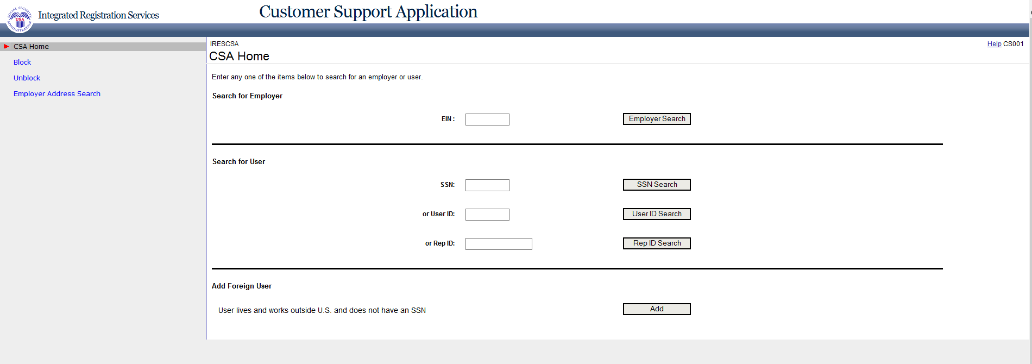

# **Multiple User IDs Found**

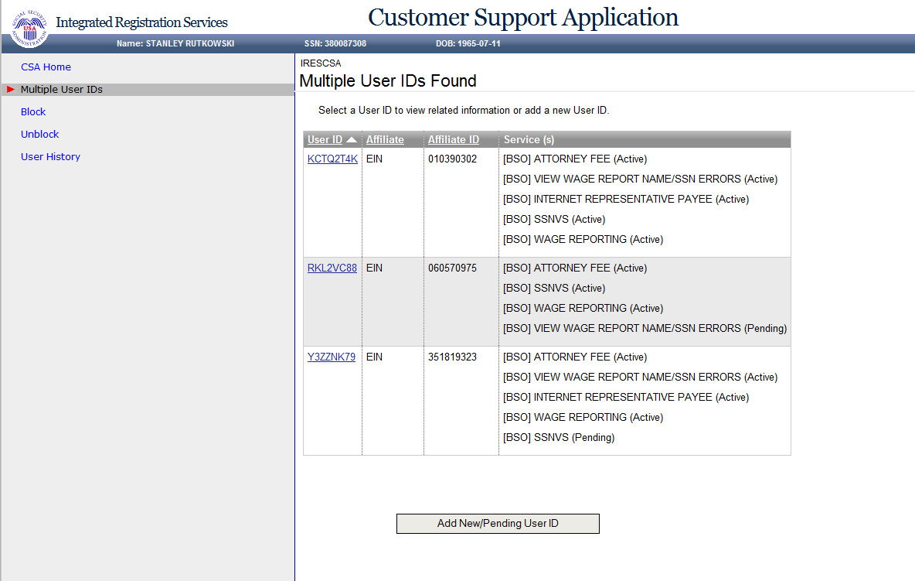

# **User Information for [User ID]**

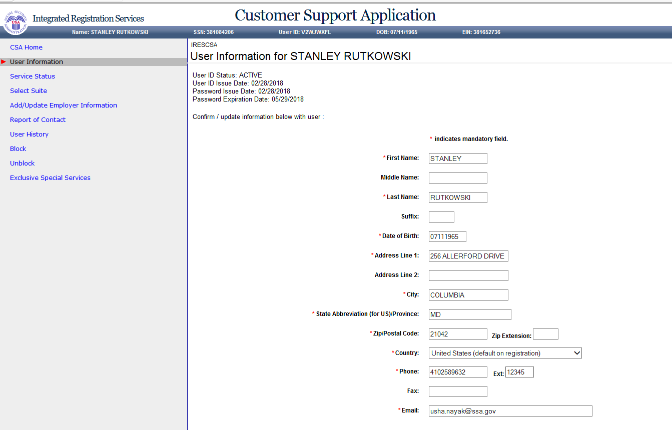

# **New User Information - Add Foreign User (update)**

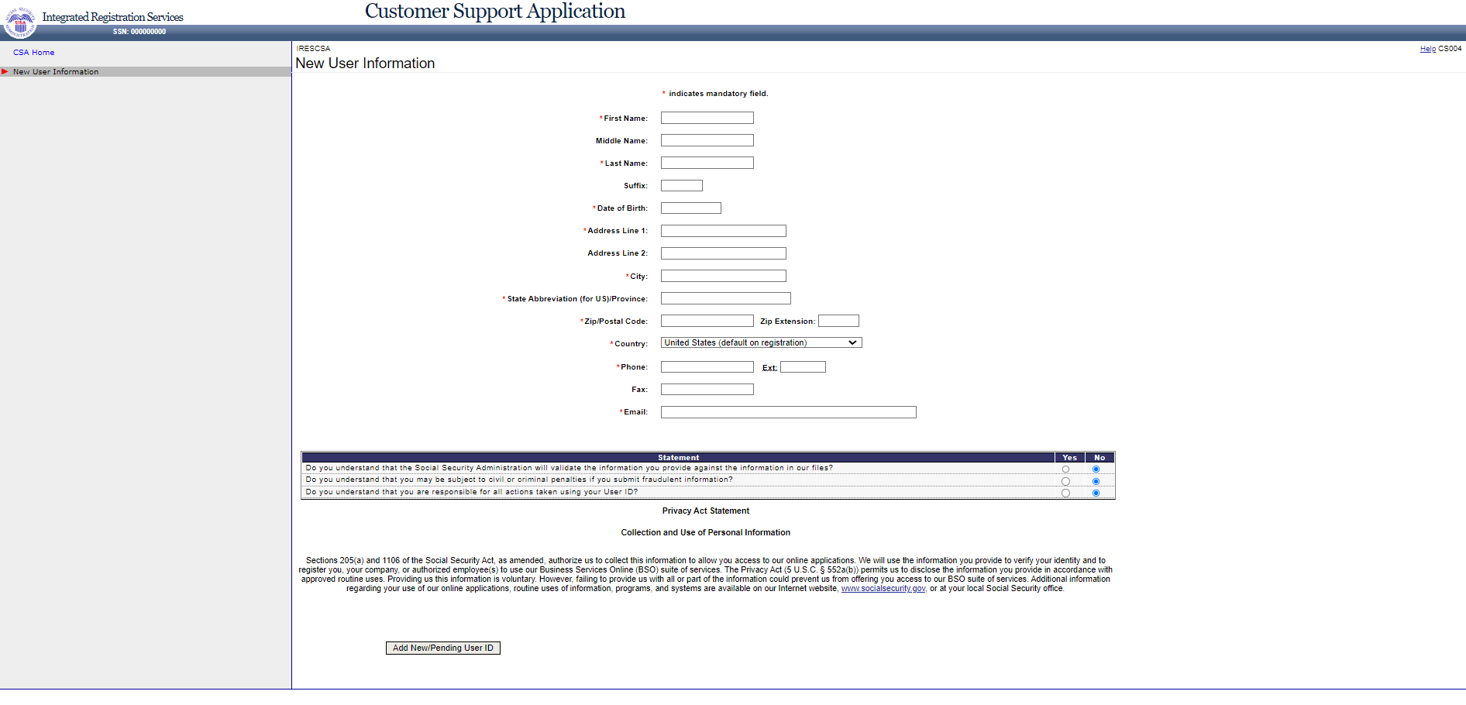

# **New User Information - Add New/Pending User ID (update)**

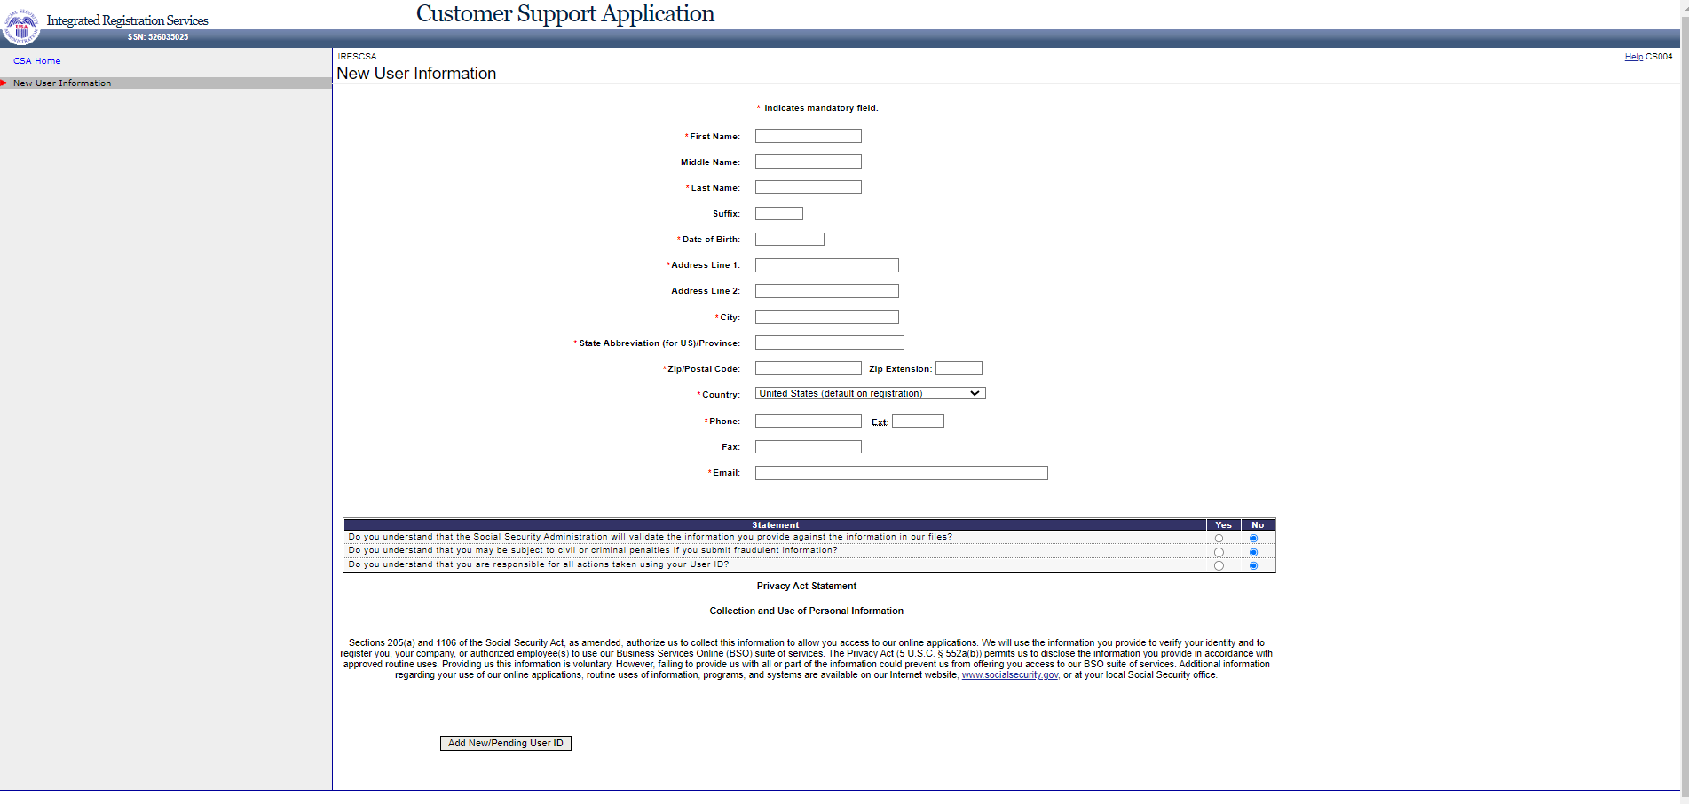

# **New User Information - No SSN FoundUser ID (update)**



# **New User Information - Numi Failed**

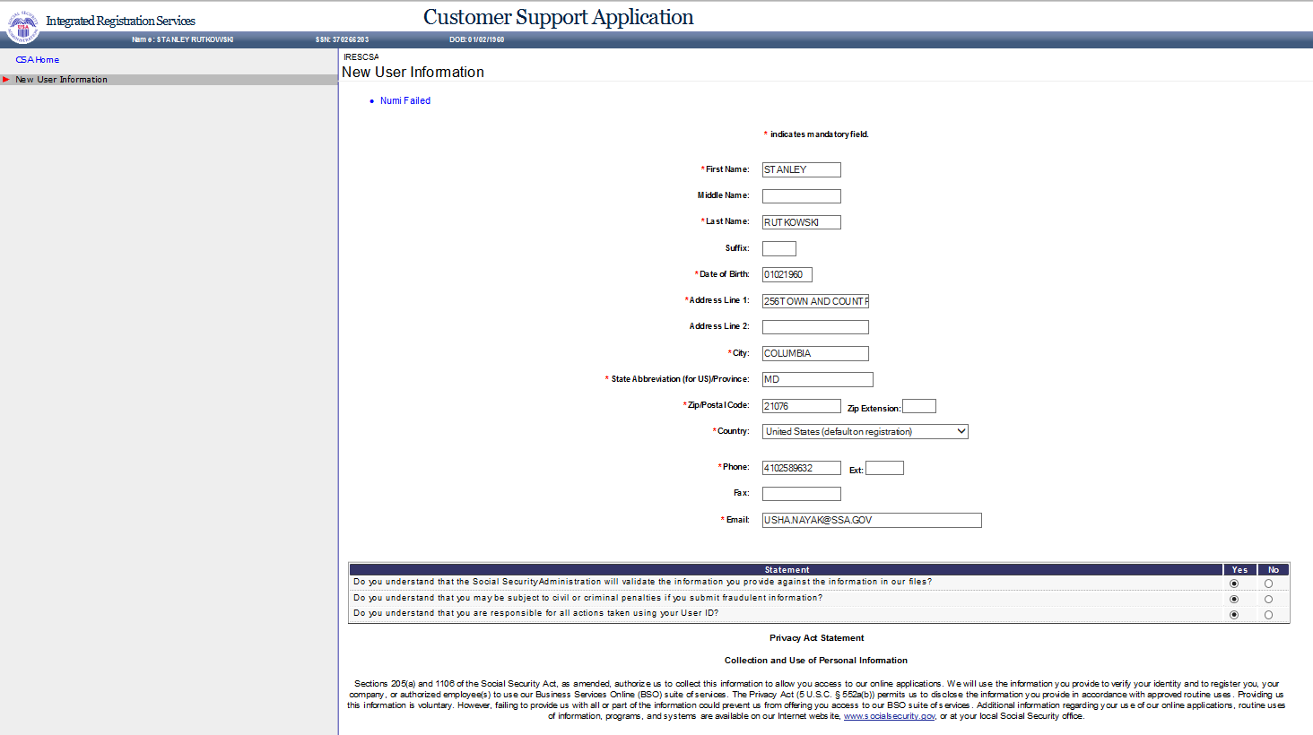

# **Users for Company**

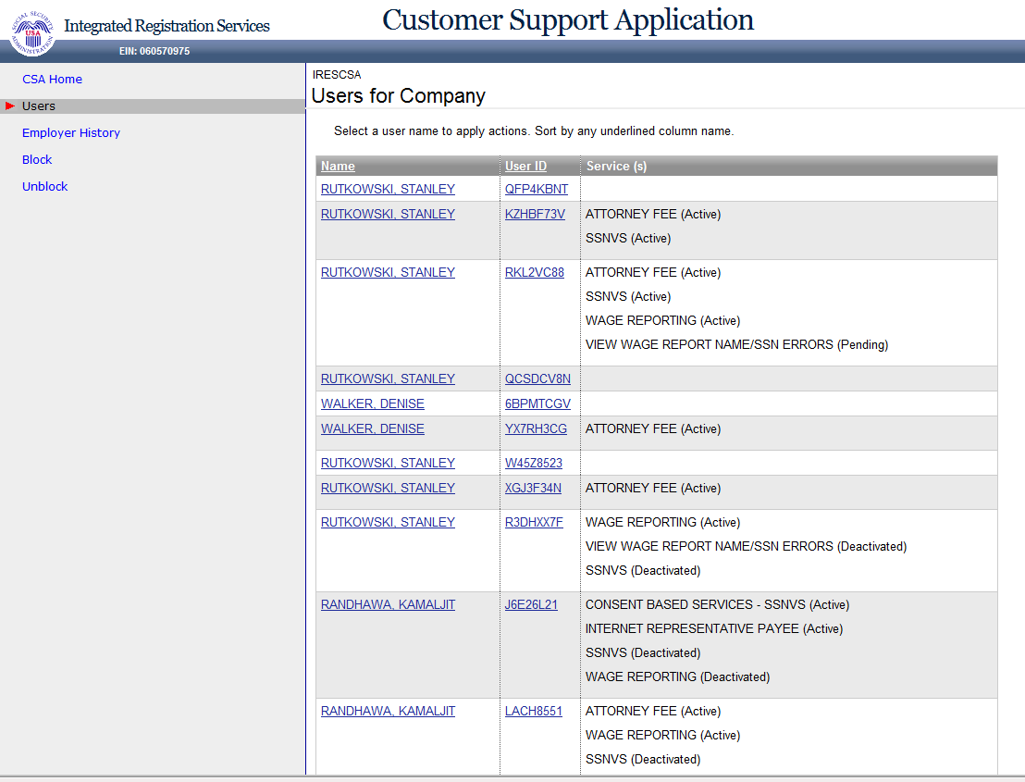

# **Employer Information (update)**

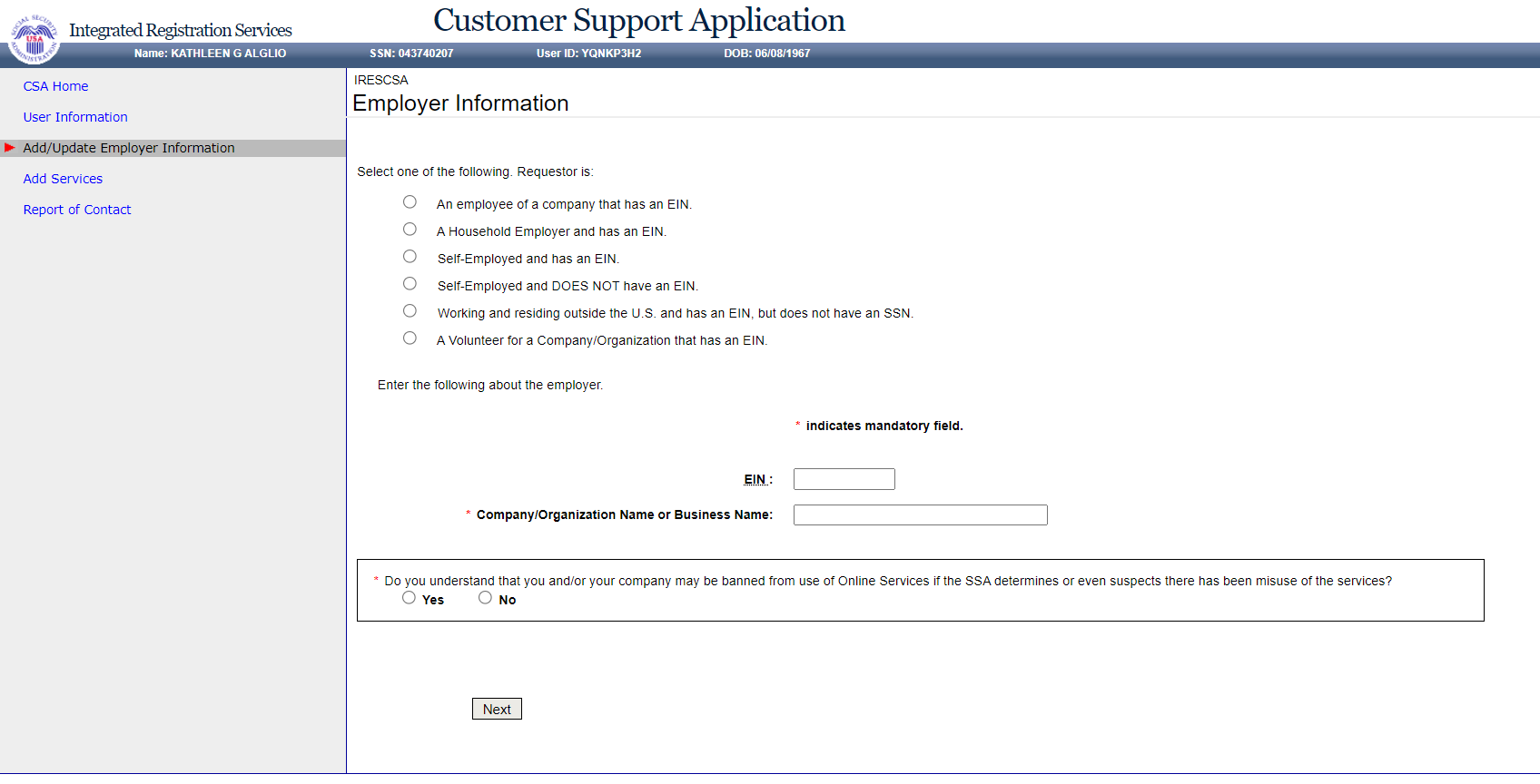

# **Add Services - NO SERVICES AVAILABLE (update)**

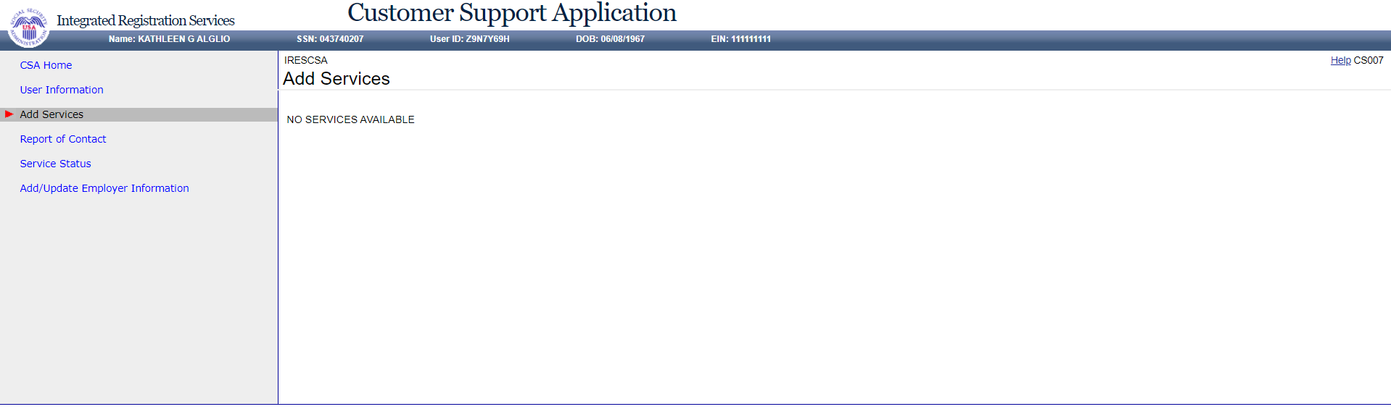

# **Add Services - With Services**

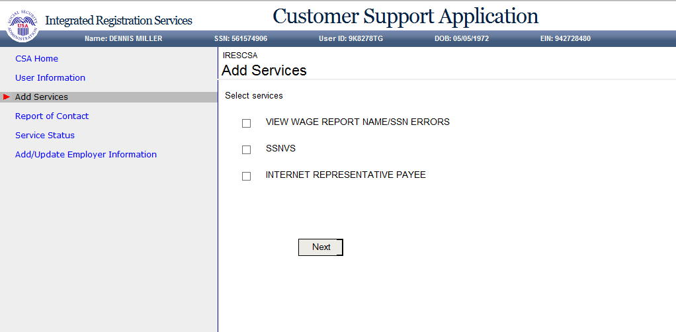

# **Service Status**

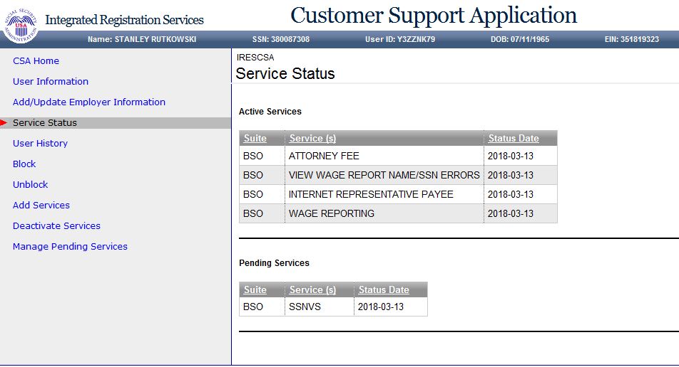

# **Deactivate Services**

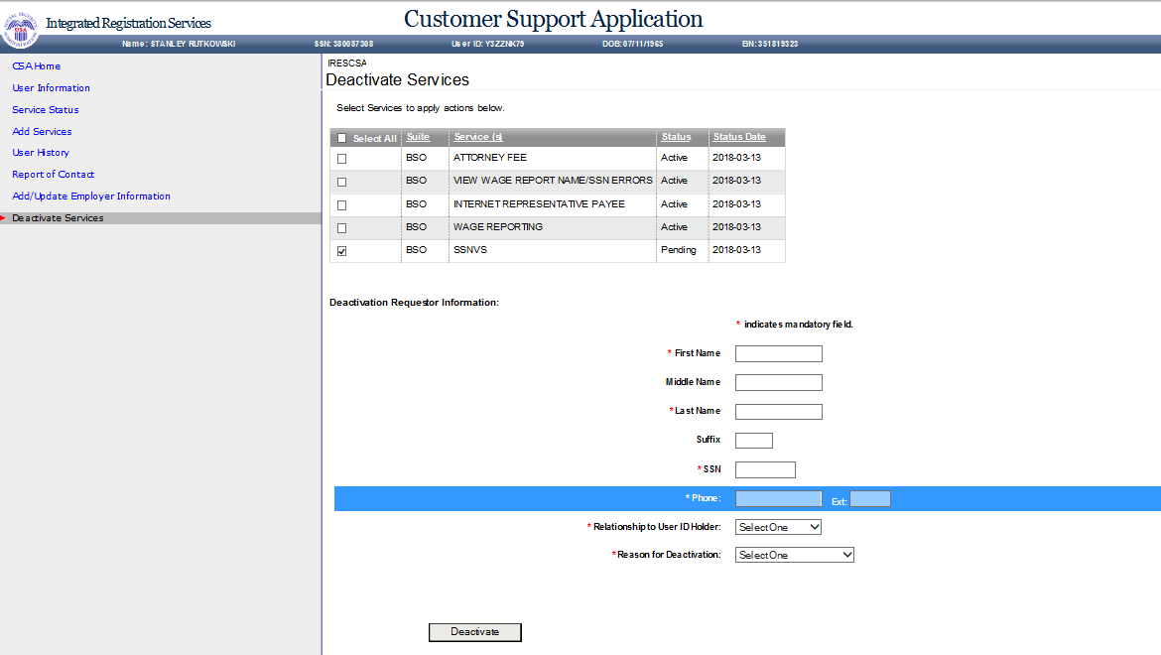

# **Block (update)**

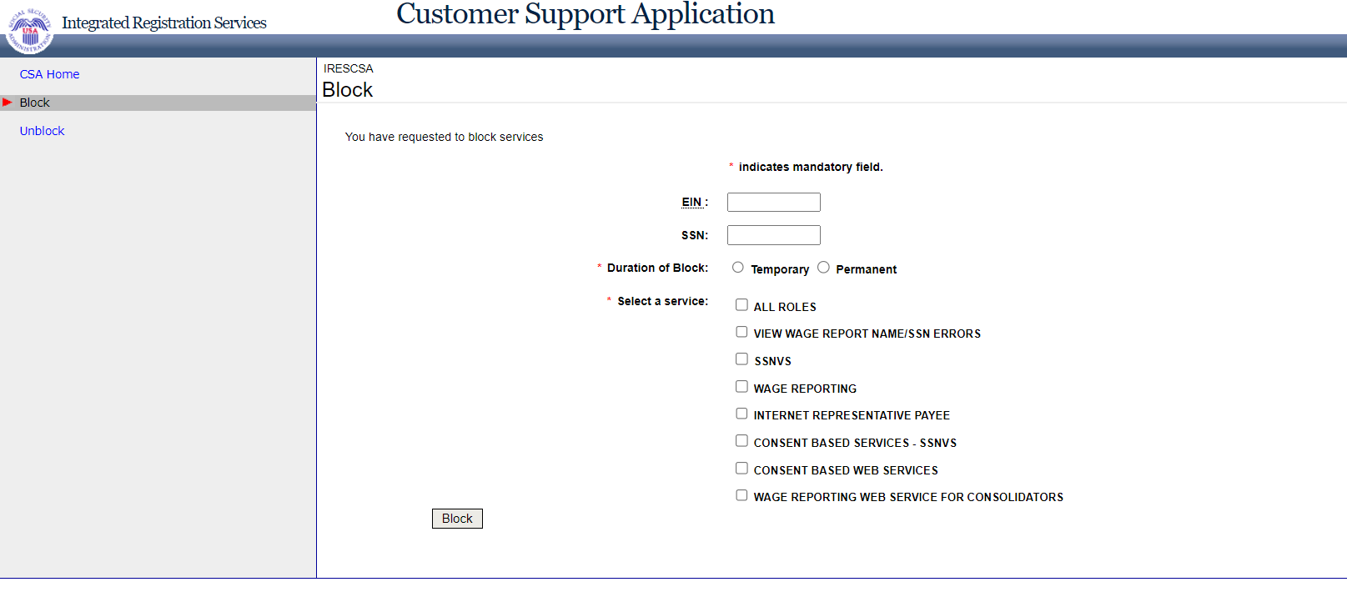

# **Block – Error (update)**

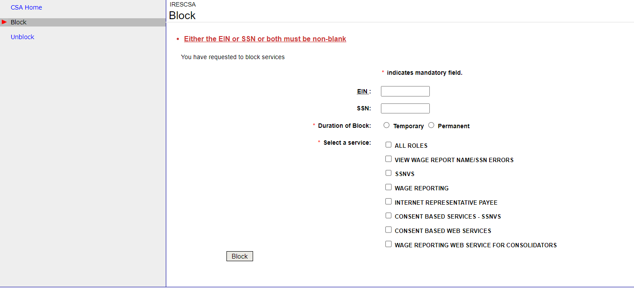

# **Confirmation of Blocking (update)**

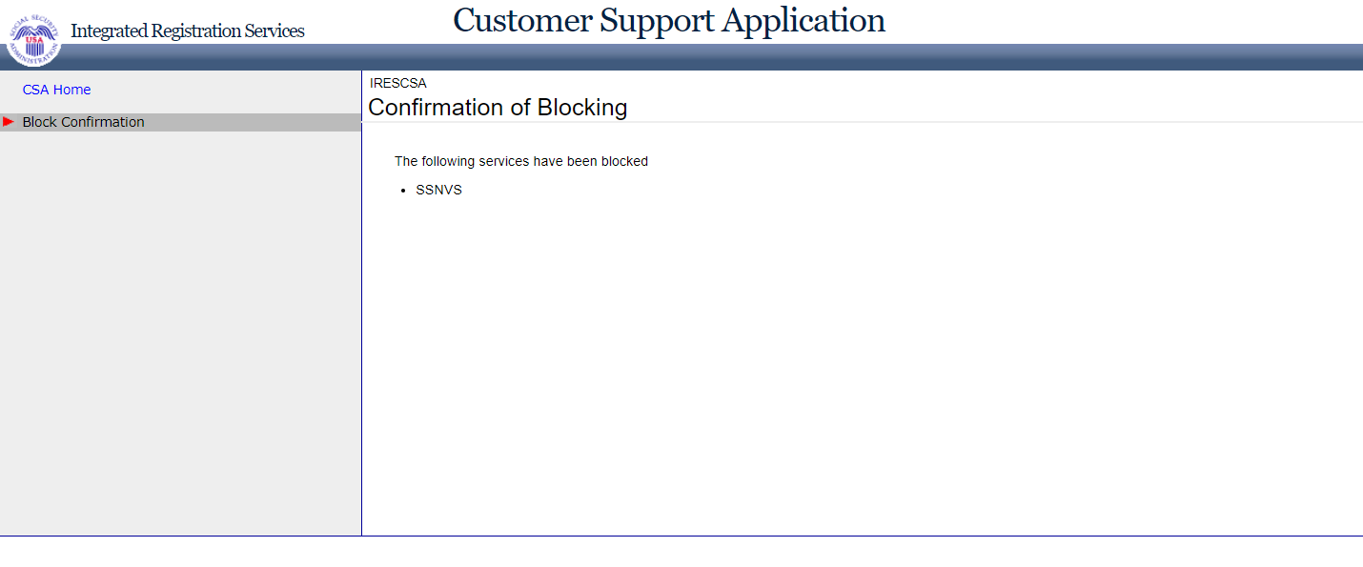

# **Manage Pending Services (update)**

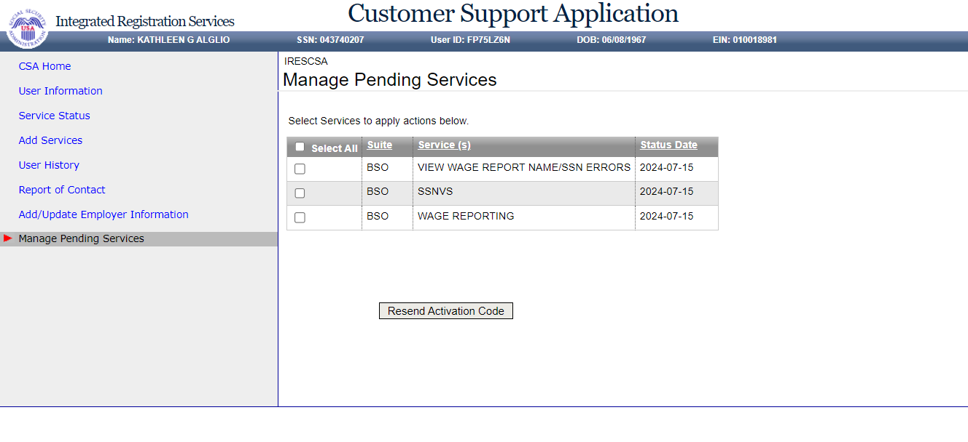

# **Update Employer Information - Employer information updated successfully (update with message)**

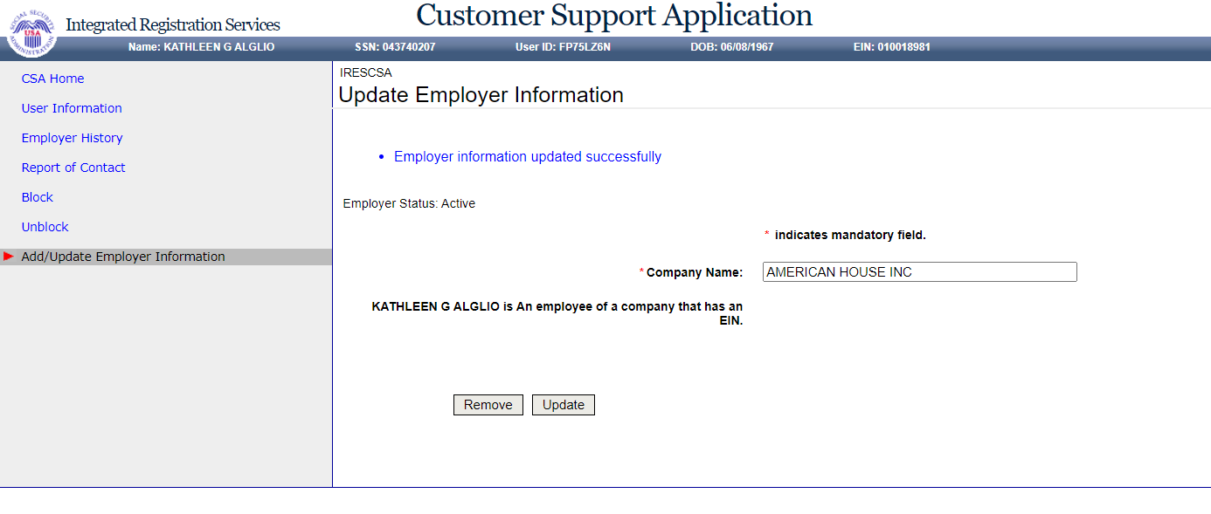

# **Update Employer Information - EIF & MEF failure (update)**

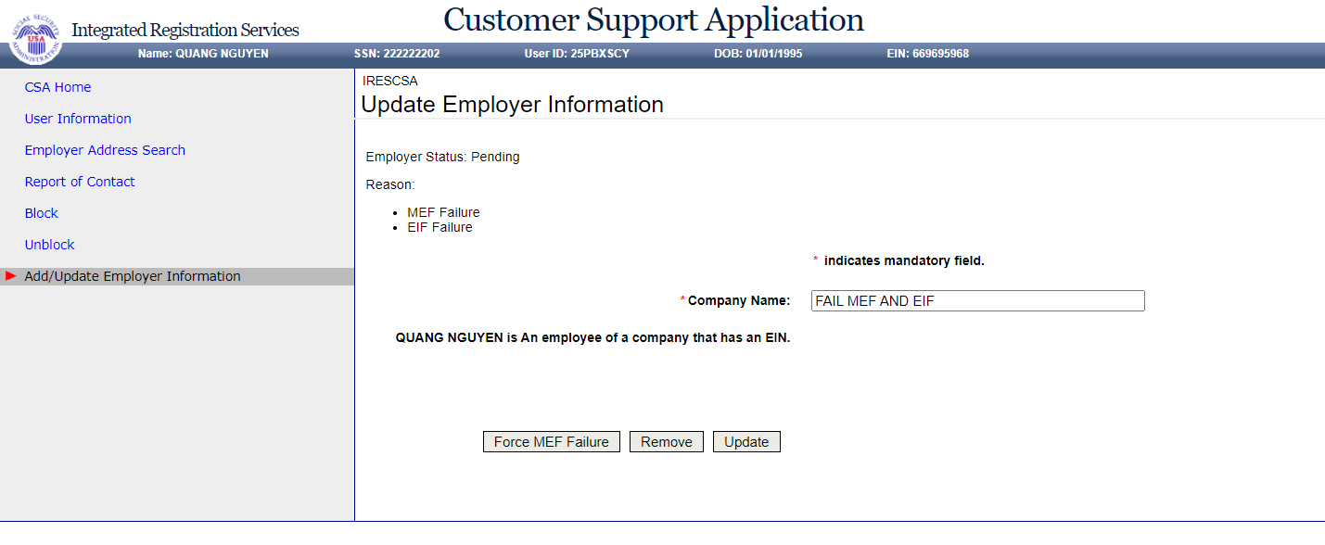

# **Update Employer Information - EIF Failure (update)**

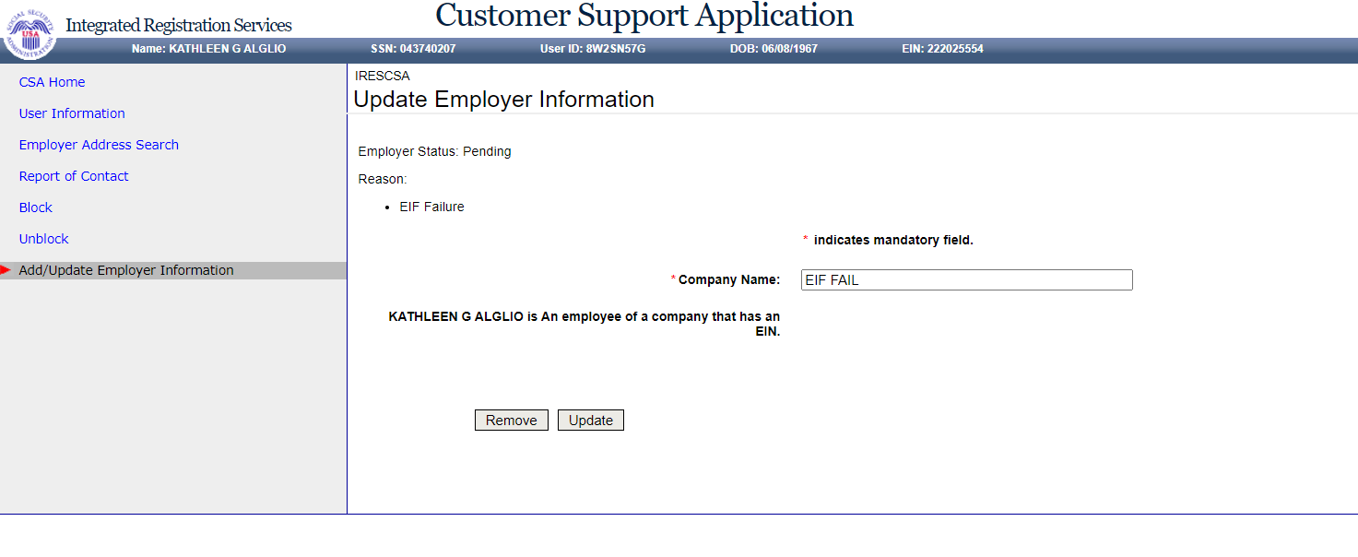

# **Reestablish Employer / Employee Relationship (update)**

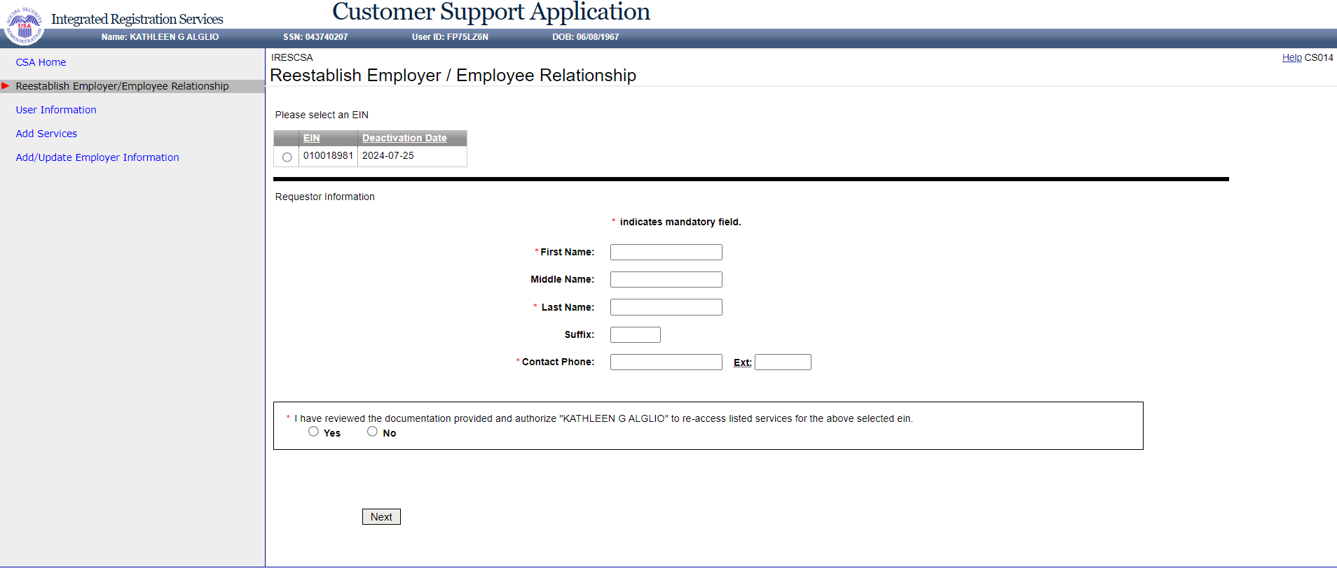

# **User History**

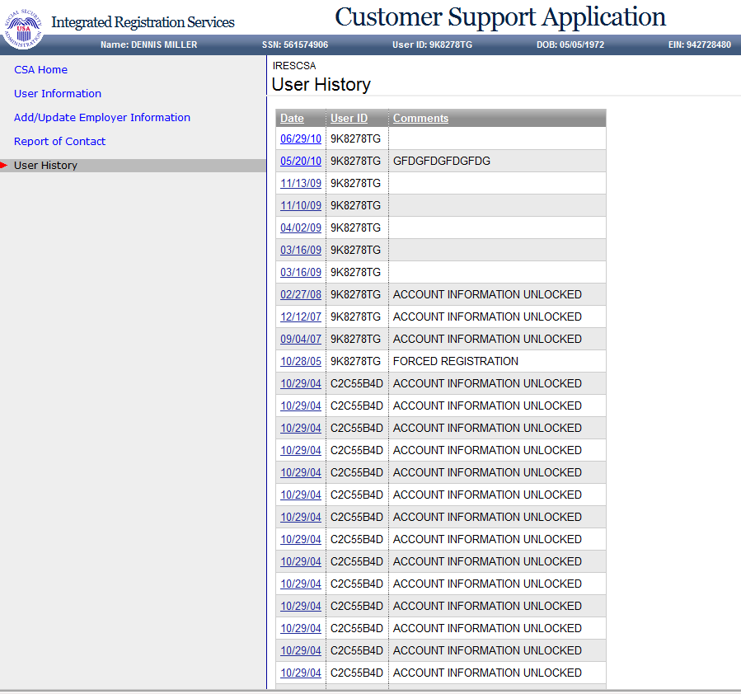

# **User History - for SSN**

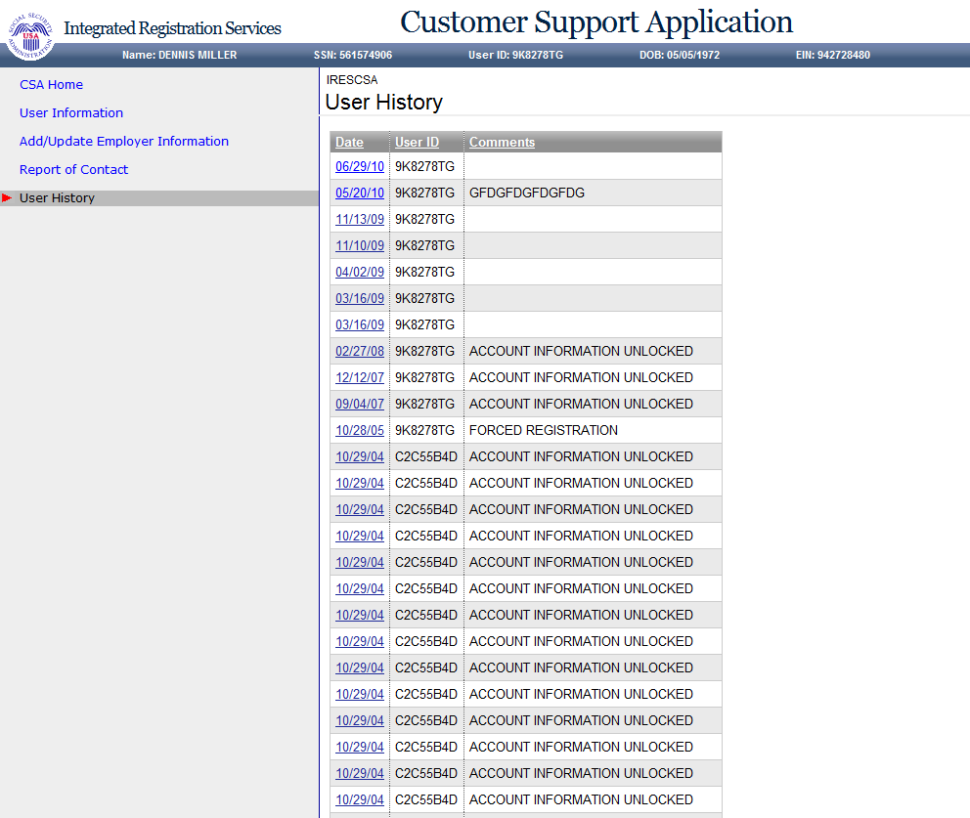

# **Employer History**

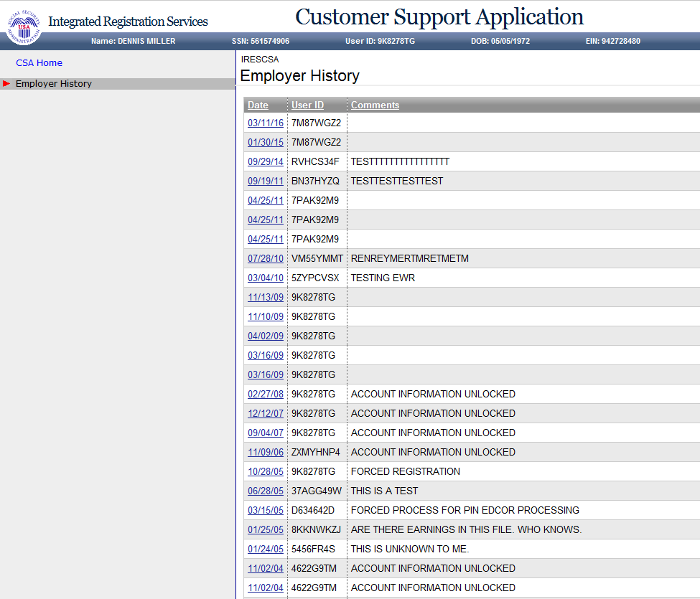

# **Remove Employer (update)**

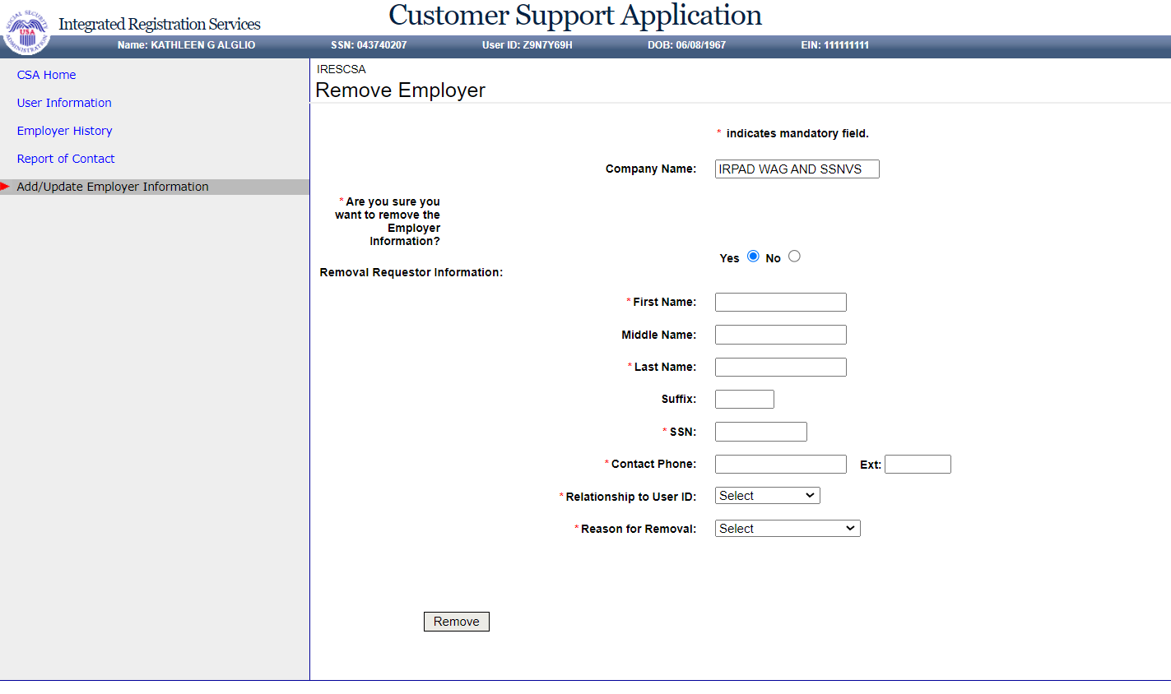

# **Employer Address Search**

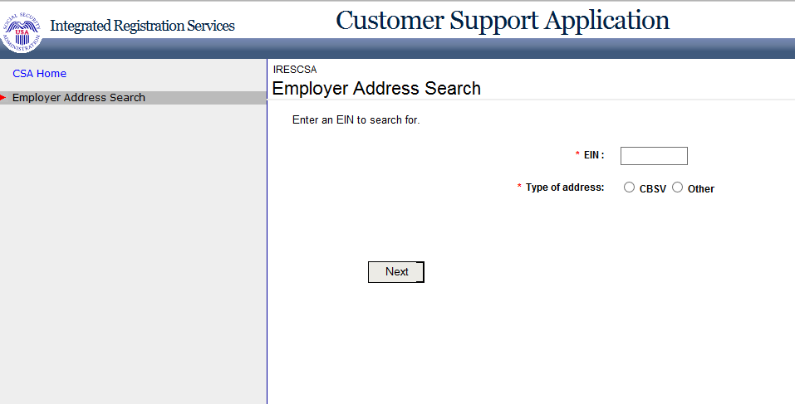

# **Add/Update Employer Address - CBSV Address**

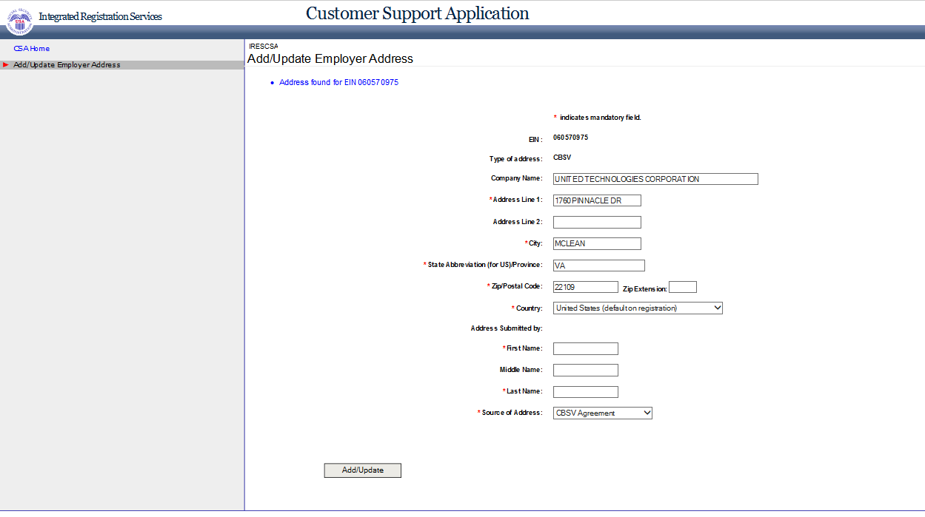

# **Add/Update Employer Address - Other Address**

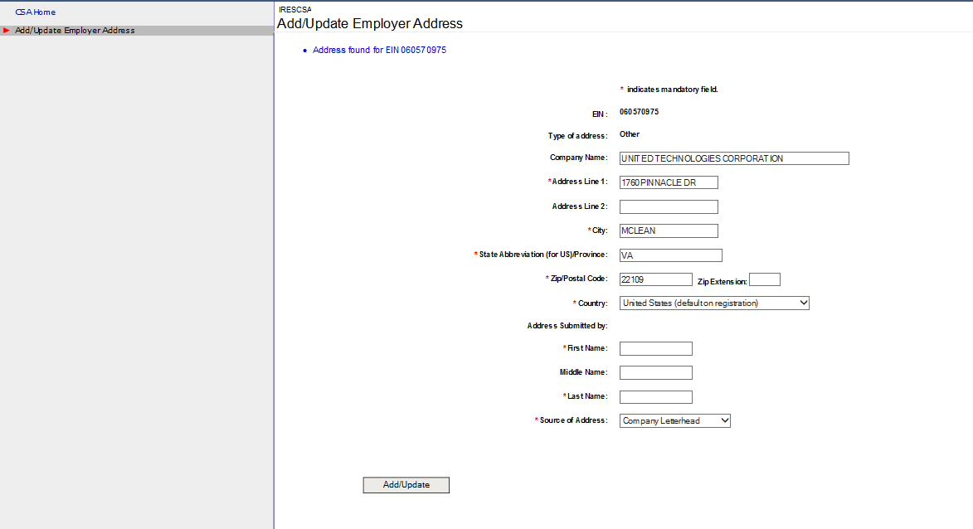

# **Report of Contact – Global (update)**

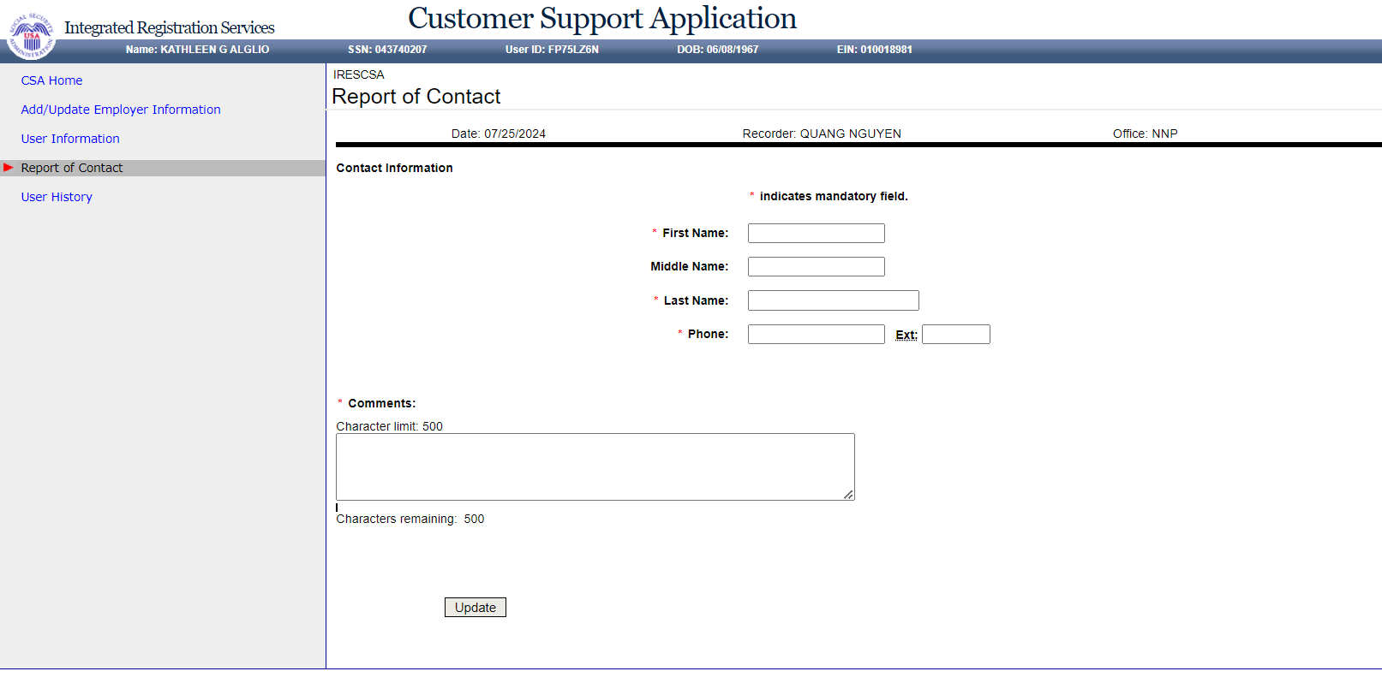

# **Specialized Services - No Services Available (not exist, CS020A was for the "external developers" role that never got implemented per Jason Cortezzo comment)**

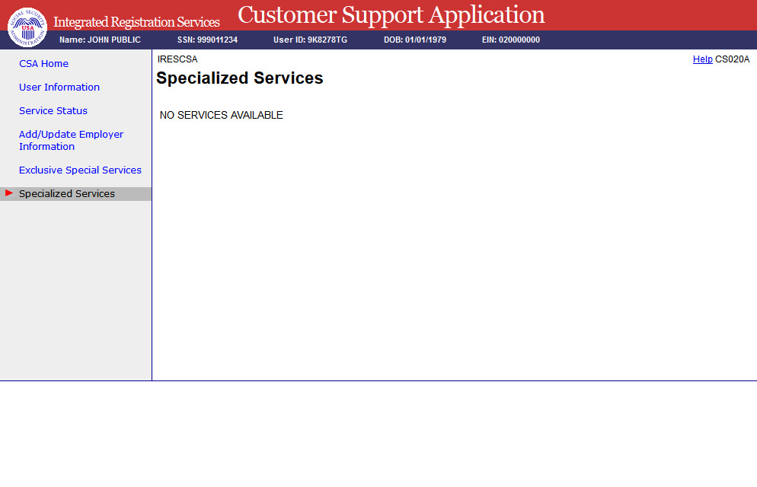

# **Exclusive Special Services - No Services Available**

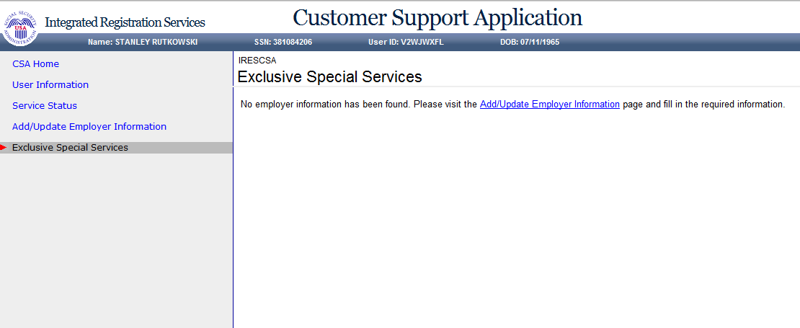

# **Exclusive Special Services - No Employer Info**

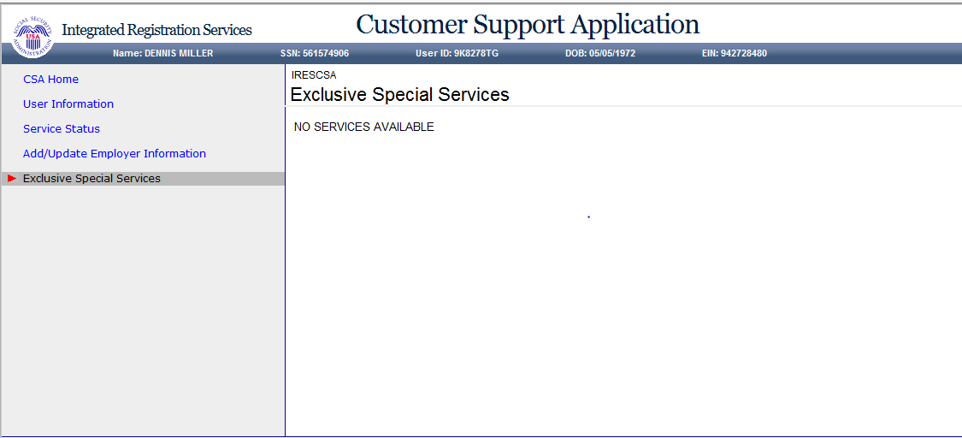

# **Exclusive Special Services - With Services (update)**

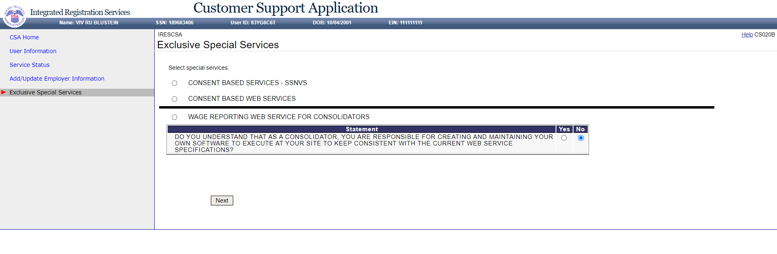

# **Exclusive Special Services - With Services – Error (update)**

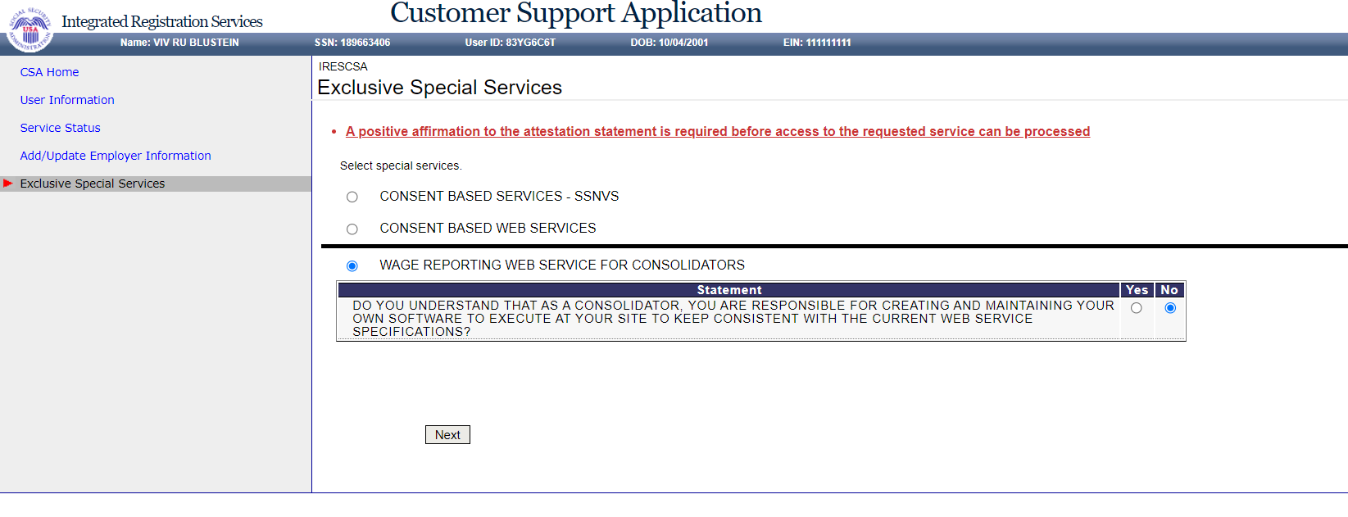

# **Unblock Search**

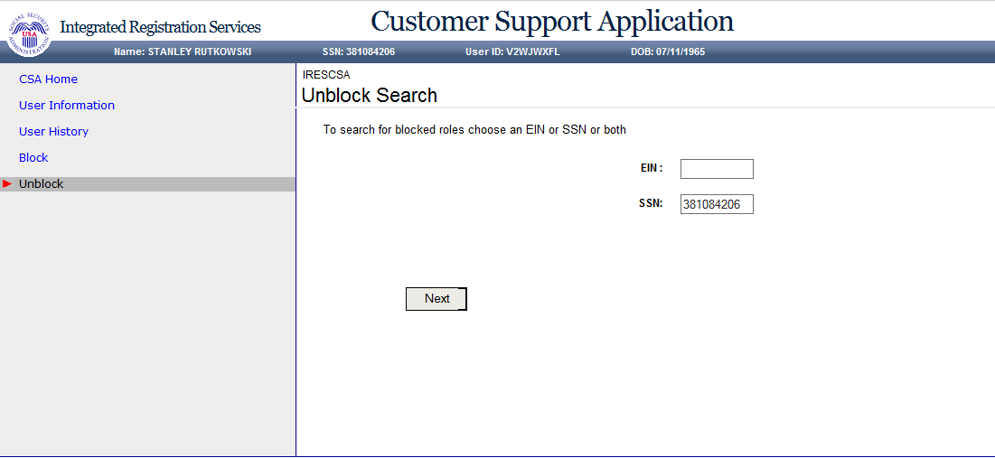

# **MEF & EIF Check – Failure (update)**

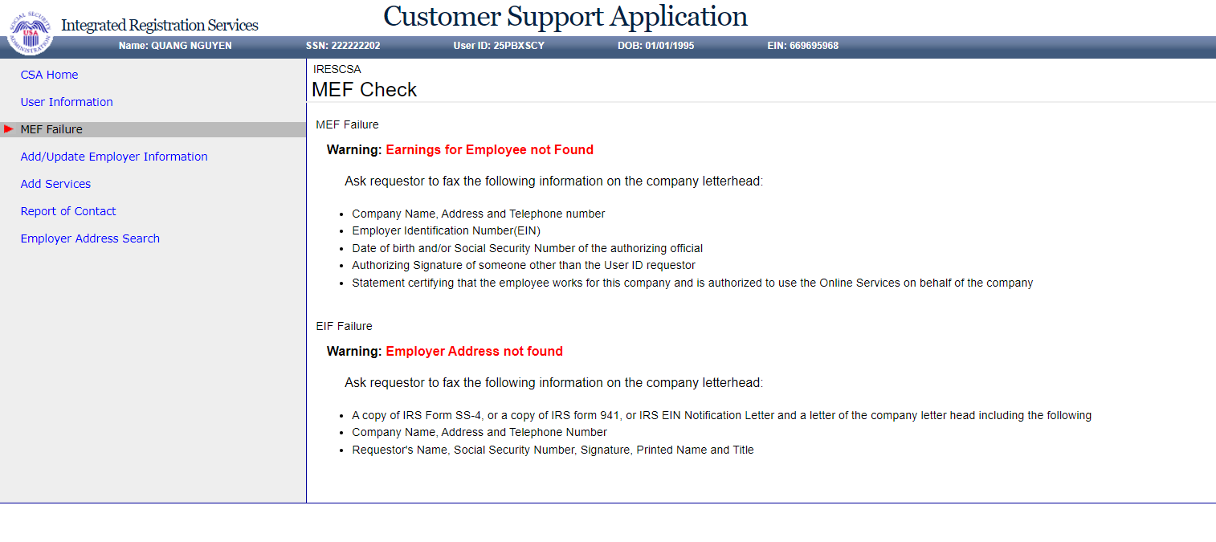

# **Unblock**

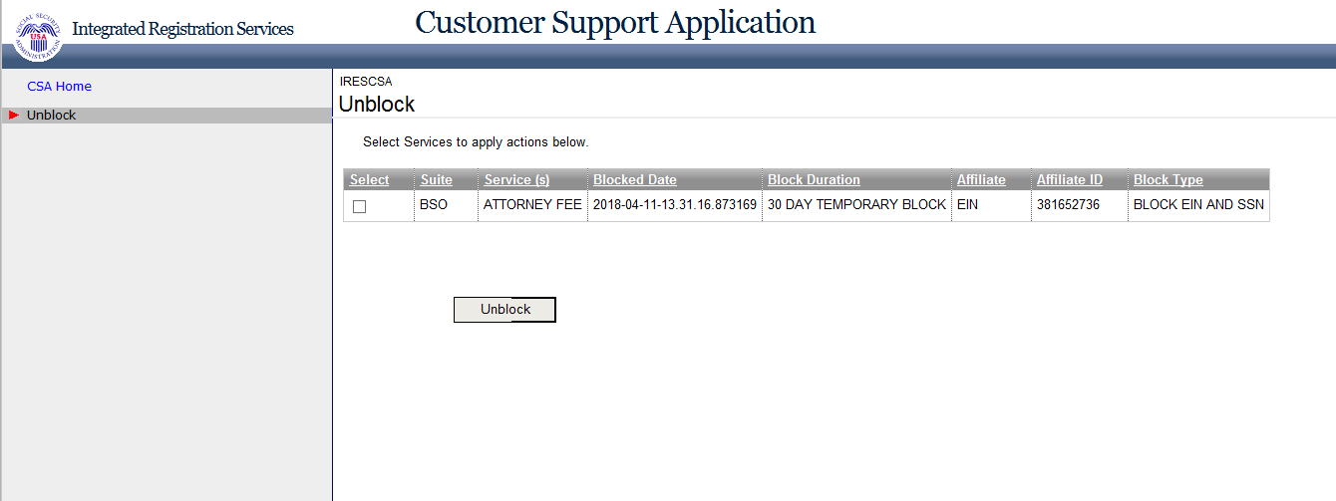

# **Select Suite – BSO (update)**

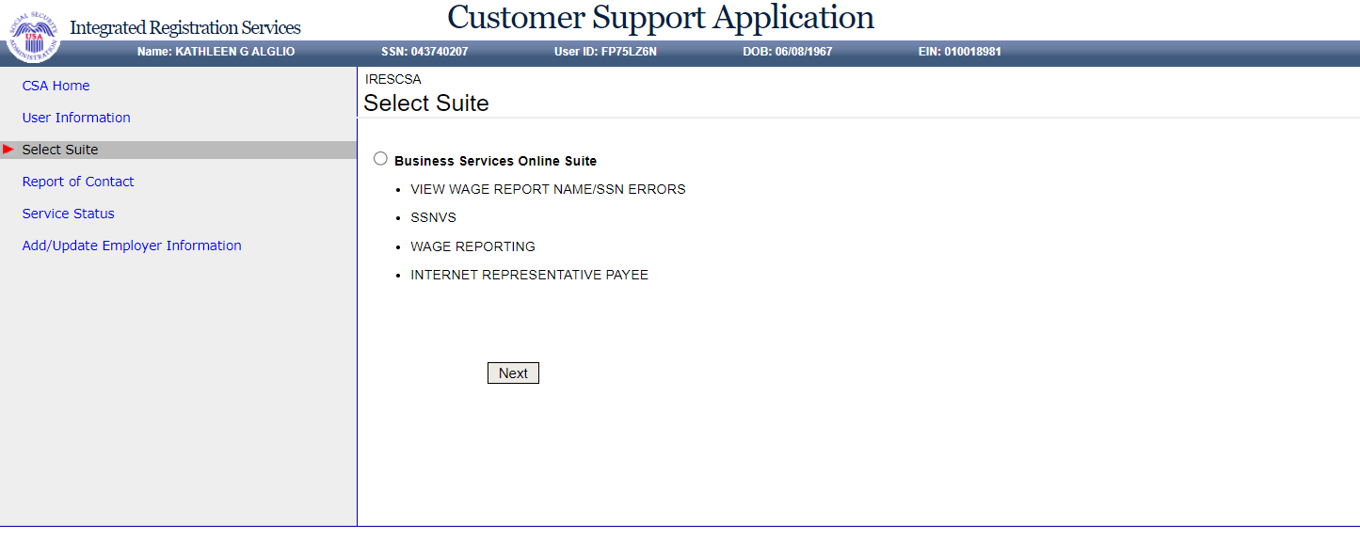

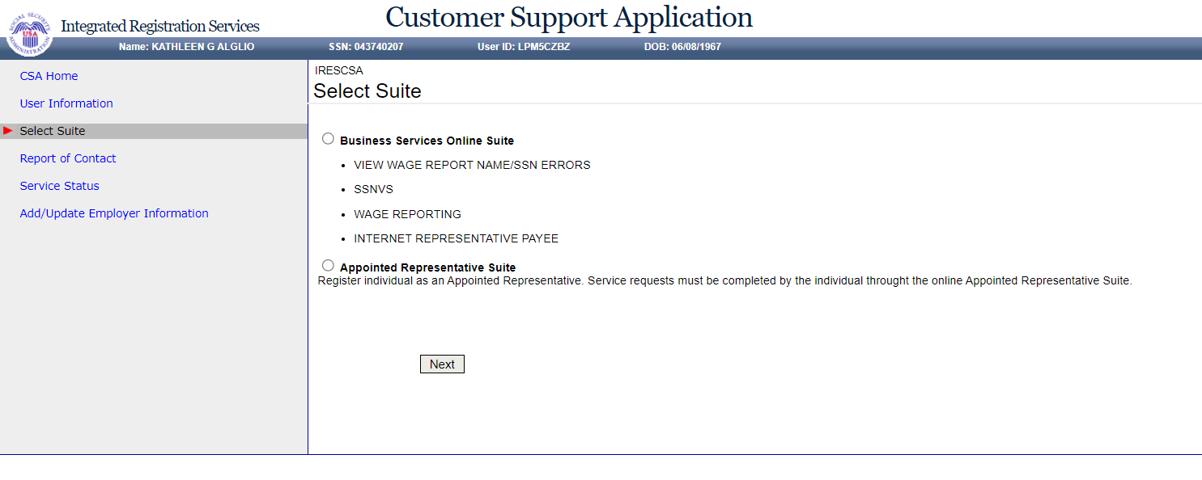

# **Select Suite – AR (it does not exist)**

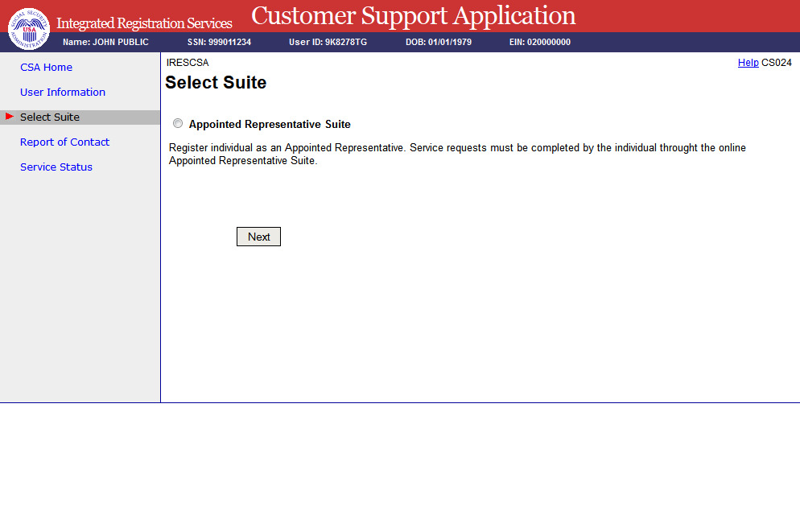

# **Confirmation of Remove Employer**

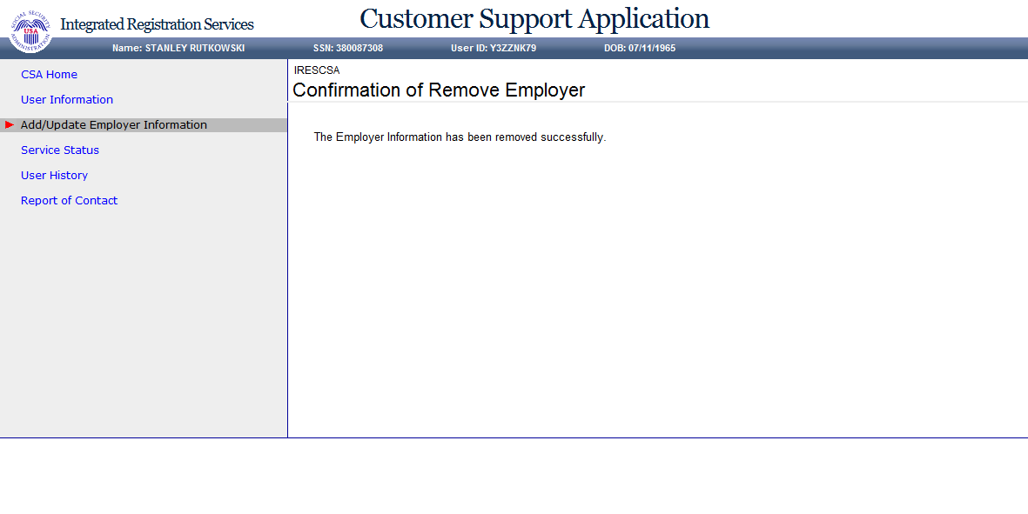

# **Confirmation of Adding Services - ATTORNEY FEE**

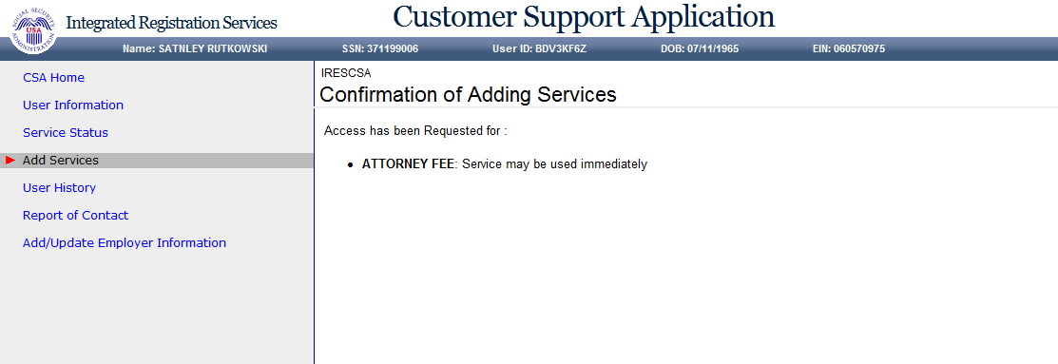

# **Confirmation of Adding Services - INTERNET REPRESENTATIVE PAYEE**

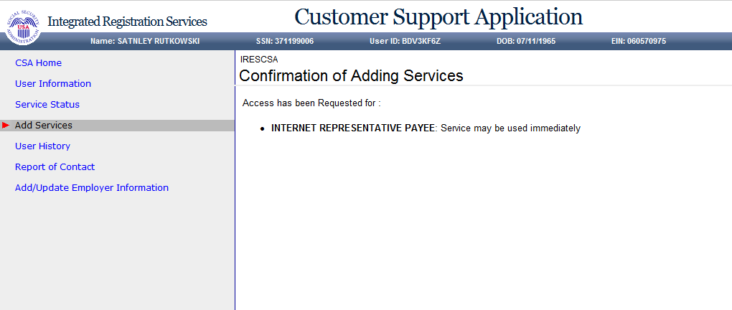

# **Confirmation of Adding Services - CONSENT BASED SERVICES – SSNVS**

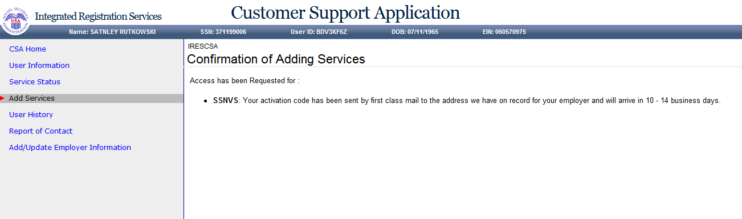

# **Confirmation of Adding Services - WAGE REPORTING WEB SERVICE FOR CONSOLIDATORS**

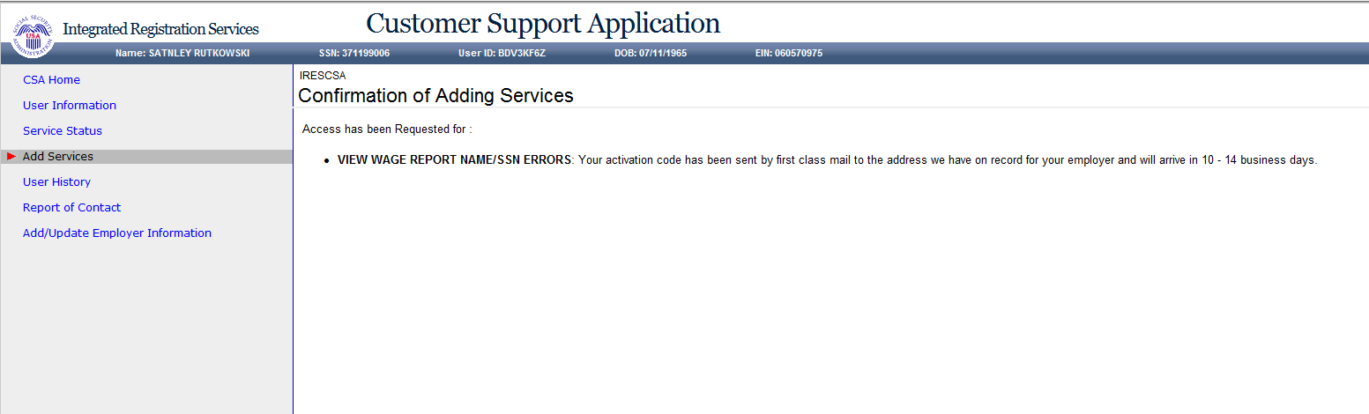

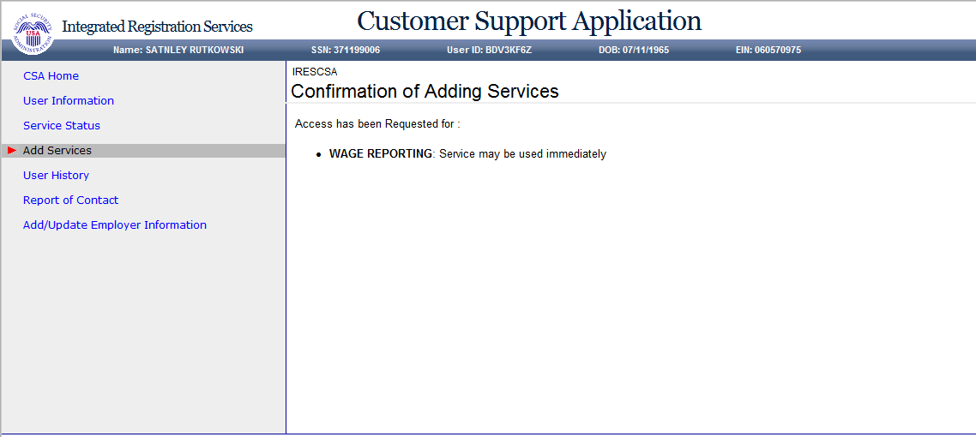

# **Confirmation of Unblocking**

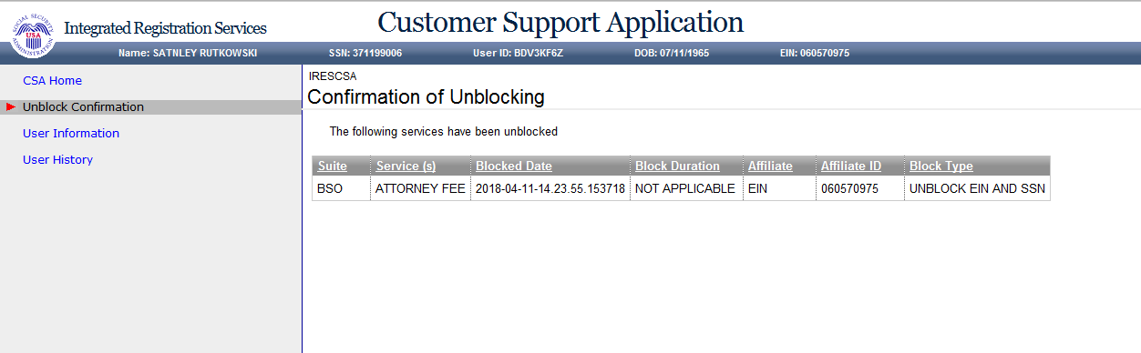

# **Confirmation of Deactivating Services**

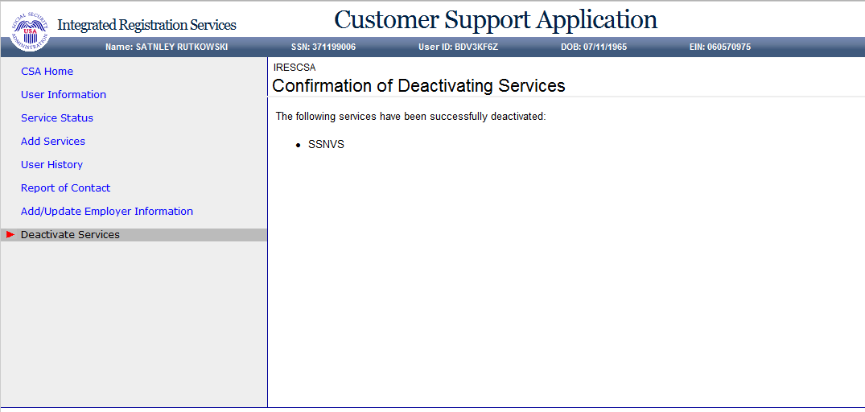

# **Confirmation of Reestablish Employer / Employee Relationship**

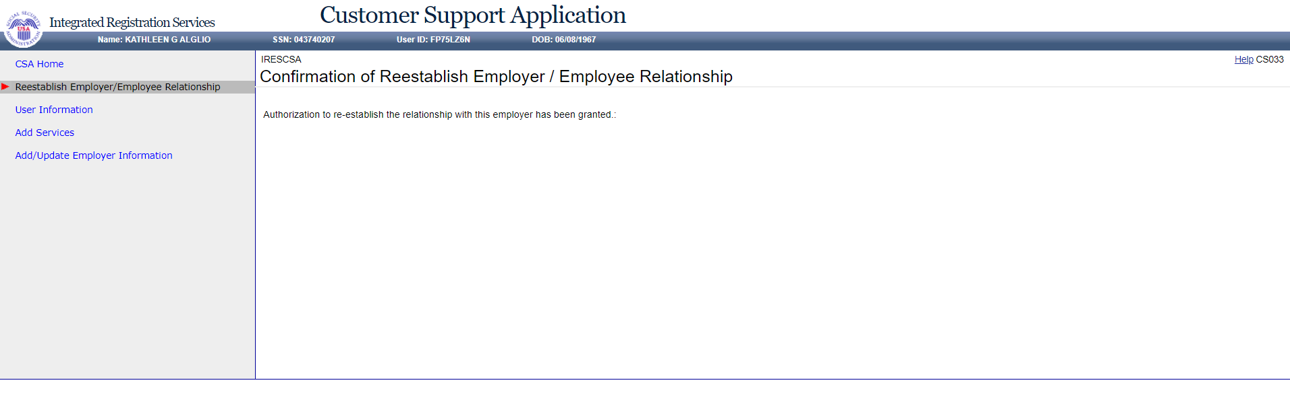

# **Record ID Information (update)**

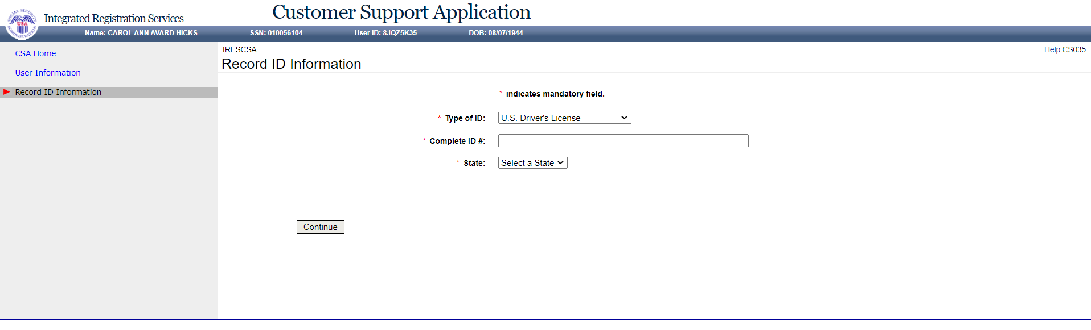

# **Print Activation Code for eFolder (update)**

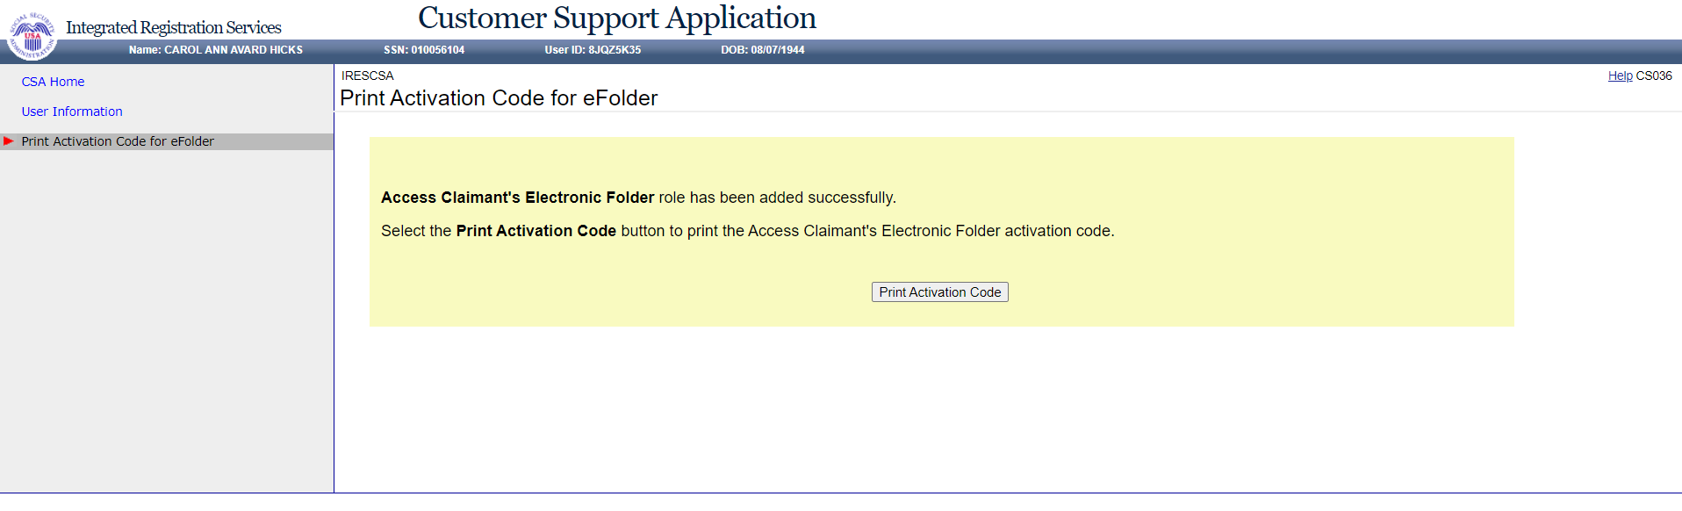

# **View Activation Code for eFolder (update)**

