Integrated Registration Services (IRES)
Internet Screen Package



Integrated Registration Services (IRES)

OMB Clearance Package OMB# 0960-0626

Revision History
Date | Document  Version | Release # | Description | Author(s)
04/16/18 | 1.3 |  | Updated all screens with exception of the ones related to cell phone updates (additional test data required). | Quaid Mehirdel
04/13/18 | 1.2 |  | Updated Screen to # 70 | Quaid Mehirdel
04/11/18 | 1.1 |  | Updated Screen #’s 4-8 | Quaid Mehirdel
04/10/18 | 1.0 |  | Started to sync screens with current VAL. | Quaid Mehirdel

Table of ContentS
Revision History 2
Table of ContentS 3
Screen requirements 6
1.0 Log In to BSO 7
2.0 Forgot Password 8
3.0 Log Out of BSO 9
4.0 User Registration Attestation 10
5.0 Create a Login Account – Step 1: Provide Information 11
6.0 Create a Login Account – Step 2: Create Your Password 12
7.0 Create a Login Account – Step 3: Review & Submit 13
8.0 Create a Login Account – Step 4: Print your User ID 14
9.0 Complete Phone Registration Attestation 15
10.0 Complete Phone Registration 16
11.0 Complete Phone Registration - Successful 17
12.0 BSO User Registration, Login, and Employer Information Help Topics 18
13.0 View/Edit Account Information 21
14.0 Edit Personal & Contact Information 22
15.0 Edit Personal & Contact Information – Confirmation 23
16.0 Edit Security Questions & Answers 24
17.0 Edit Security Questions & Answers – Confirmation 25
18.0 Request Access to BSO Services – Select Suite of Services 26
19.0 Request Access to BSO Services – Employer Information is required 27
20.0 Request Access to BSO Services – Employer Information Not Available (MEF Failure) 28
21.0 Request Access to BSO Services - Employer Address Not Available (pending EIN Address) 29
22.0 Request Access to BSO Services - Age Restriction 30
23.0 Request Access to BSO Services - Employer Information (Page 1 of 3) 31
24.0 Request Access to BSO Services - Report Wages to Social Security/View Wage Report Name/SSN Errors (Page 2 of 3) 32
25.0 25. Request Access to BSO Services - Social Security Number Verification Service (SSNVS) (Page 3 of 3) 33
26.0 Request Access to BSO Services - Complete Form SSA-1694 Business Taxpayer Information Form (Page 4 of 4) 34
27.0 Request Access to BSO Services - Internet Representative Payee (Page 5 of 5) 35
28.0 Request Access to BSO Services - Request Summary 36
29.0 Request Access to BSO Services Confirmation 37
30.0 Main Menu-Without Services 38
31.0 Main Menu-With Services 39
32.0 Social Security Number Verification Service 40
33.0 Form SSA-1694 Request for Business Entity Taxpayer Information 41
34.0 Internet Representative Payee Accounting 42
35.0 Enter Activation Code(s) for the Appointed Representative 43
36.0 Appointed Representative Services - Main Menu 44
37.0 View / Edit Services – No Services Available 45
38.0 Request New Services 46
39.0 Remove Access to BSO Services 47
40.0 Remove Access to BSO Services Successful 48
41.0 Activate Access to BSO Services - No Services Available 49
42.0 Activate Access to BSO Services 50
43.0 Activate Access to BSO Services Successful 51
44.0 View Pending Services - Re-Request Activation Code - Without Services 52
45.0 View Pending Services - Re-Request Activation Code - With Services 53
46.0 View Pending Services - Confirmation of Activation Code Notice Re-Request 54
47.0 Enter Text-Enabled Cell Phone 55
48.0 Employer Information Attestation 56
49.0 Add Employer 57
50.0 Add Employer Information Successful 58
51.0 Update Your Employer Information 59
52.0 Update Your Employer Information 60
53.0 Remove Your Employer Information 61
54.0 Remove Your Employer Information Successful 62
55.0 View/Edit Account 63
56.0 Edit Personal & Contact Information 64
57.0 Edit Personal & Contact Information – Confirmation 65
58.0 Change Text-enabled Cell Phone Number - Option 1 Selected 66
59.0 Change Text-enabled Cell Phone Number - Step 1: Enter One-Time Password 67
60.0 Change Text-enabled Cell Phone Number - Step 2: Provide a New Cell Phone Number 68
61.0 Change Text-enabled Cell Phone Number - Step 2: Provide a New Cell Phone Number – Fail 69
62.0 Change Text-enabled Cell Phone Number - Step 3: Verify your New Cell Phone Number 70
63.0 Change Text-enabled Cell Phone Number - Step 3: Verify your New Cell Phone Number - Fail 71
64.0 Change Text-enabled Cell Phone Number - Step 4: Confirmation 72
65.0 Change Text-enabled Cell Phone Number - Option 2 Selected 73
66.0 Change Text-enabled Cell Phone Number - Step 1: Enter One-Time Password 74
67.0 Change Text-enabled Cell Phone Number - Option 3 Selected 75
68.0 Change Text-enabled Cell Phone Number - Request a Notice to Change your Cell Phone Number 76
69.0 Change Text-enabled Cell Phone Number - A notice will be mailed to you to change your text-enabled cell phone number 77
70.0 Edit Security Questions 78
71.0 Edit Security Questions – Confirmation 79
72.0 Change Password 80
73.0 Password Change Successful 81
74.0 Disable Account 82
75.0 Disable Account – Error 83
76.0 Disable Account – Confirmation 84
77.0 User Identification Deactivated 85
78.0 Forgot Password Update Successful 86
79.0 Request Password by Mail 87
80.0 Password by Mail Success 88
81.0 Change Password 89
82.0 Password Change Successful 90
83.0 Reached Limit of Attempts 91
84.0 Already Registered 92
85.0 System Failure 93
86.0 Paperwork Reduction Act Statement – Online Registration 94
87.0 Paperwork Reduction Act Statement – Phone Registration 95
88.0 Privacy Act Statement 96

Screen requirements
This document contains the all the screen shots for IRES Internet only. The screen shots are based on what was in the Validation environment as of July 2021.

Log In to BSO (update)
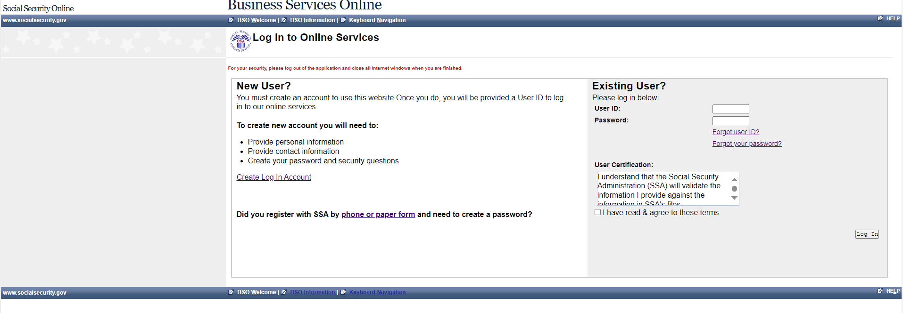

Forgot Password
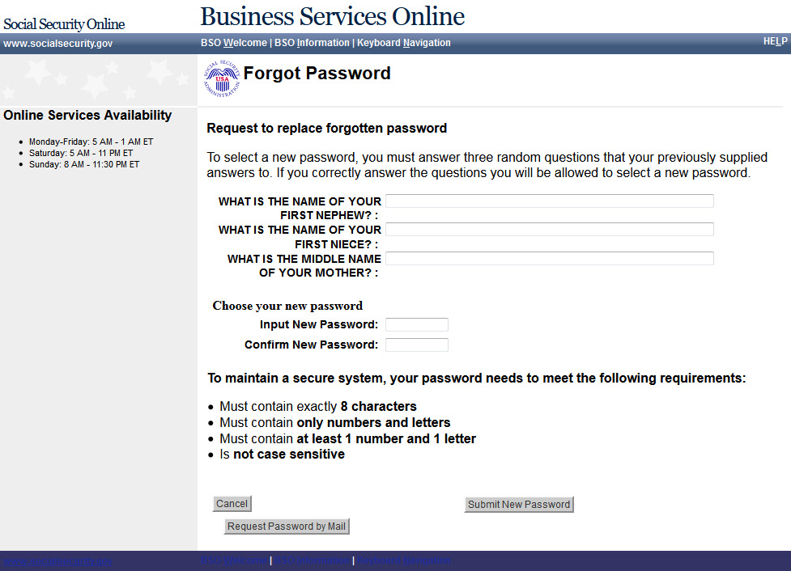

Log Out of BSO (update)
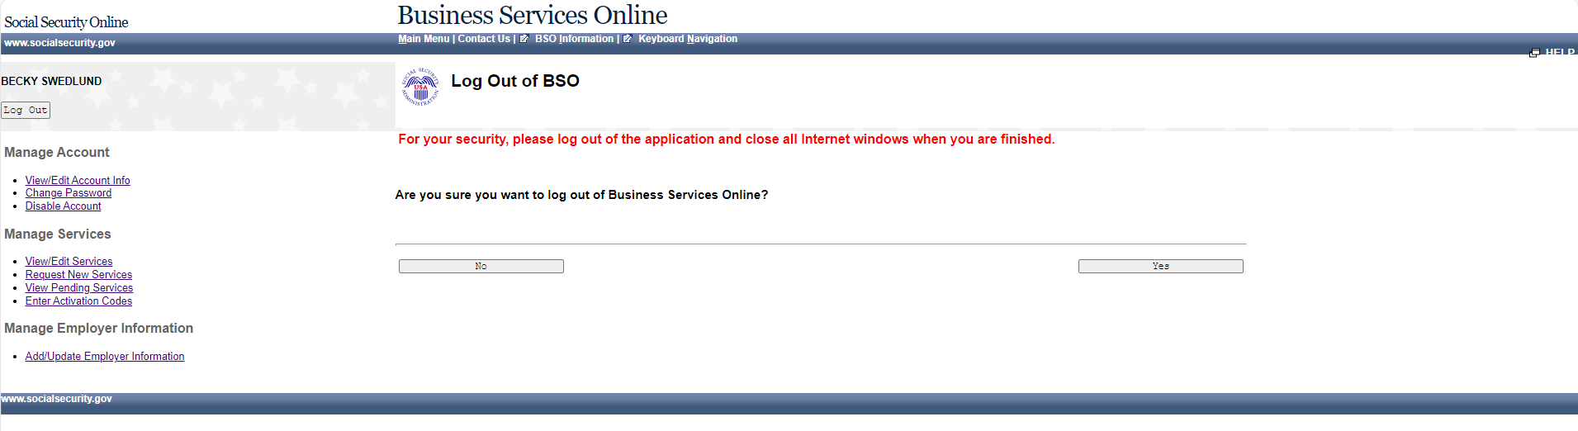

User Registration Attestation (update)
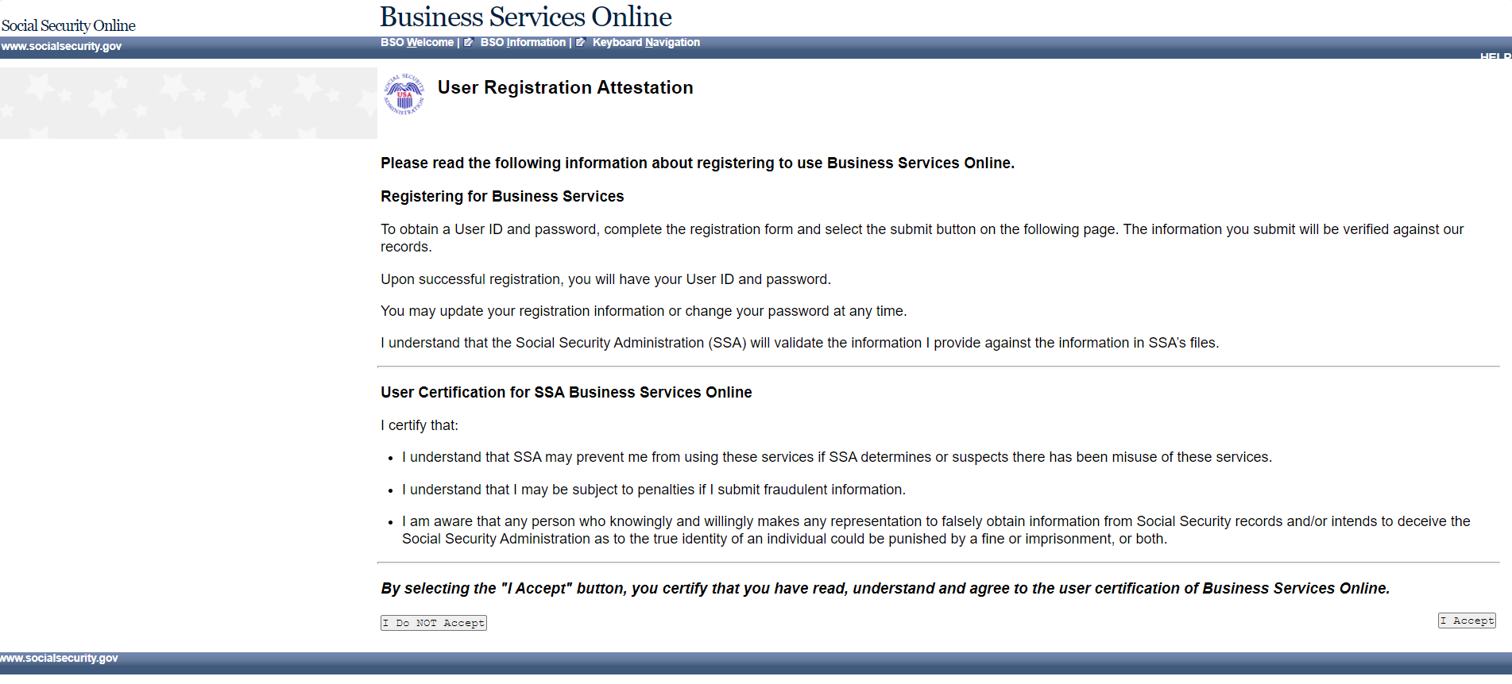

Create a Login Account – Step 1: Provide Information (update)
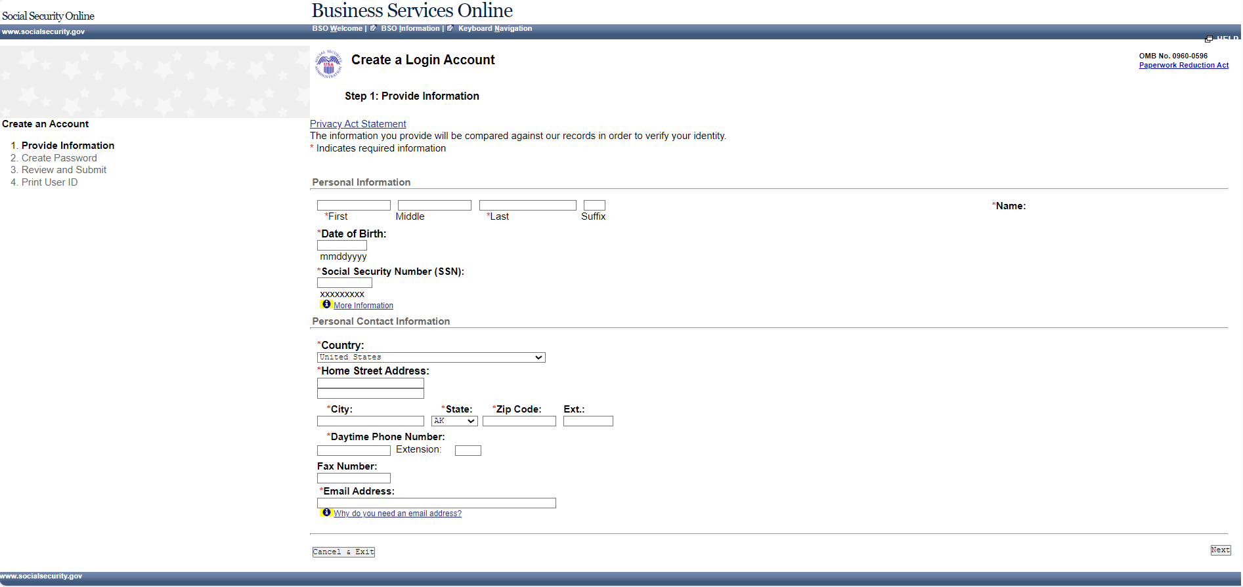

Create a Login Account – Step 2: Create Your Password (update)
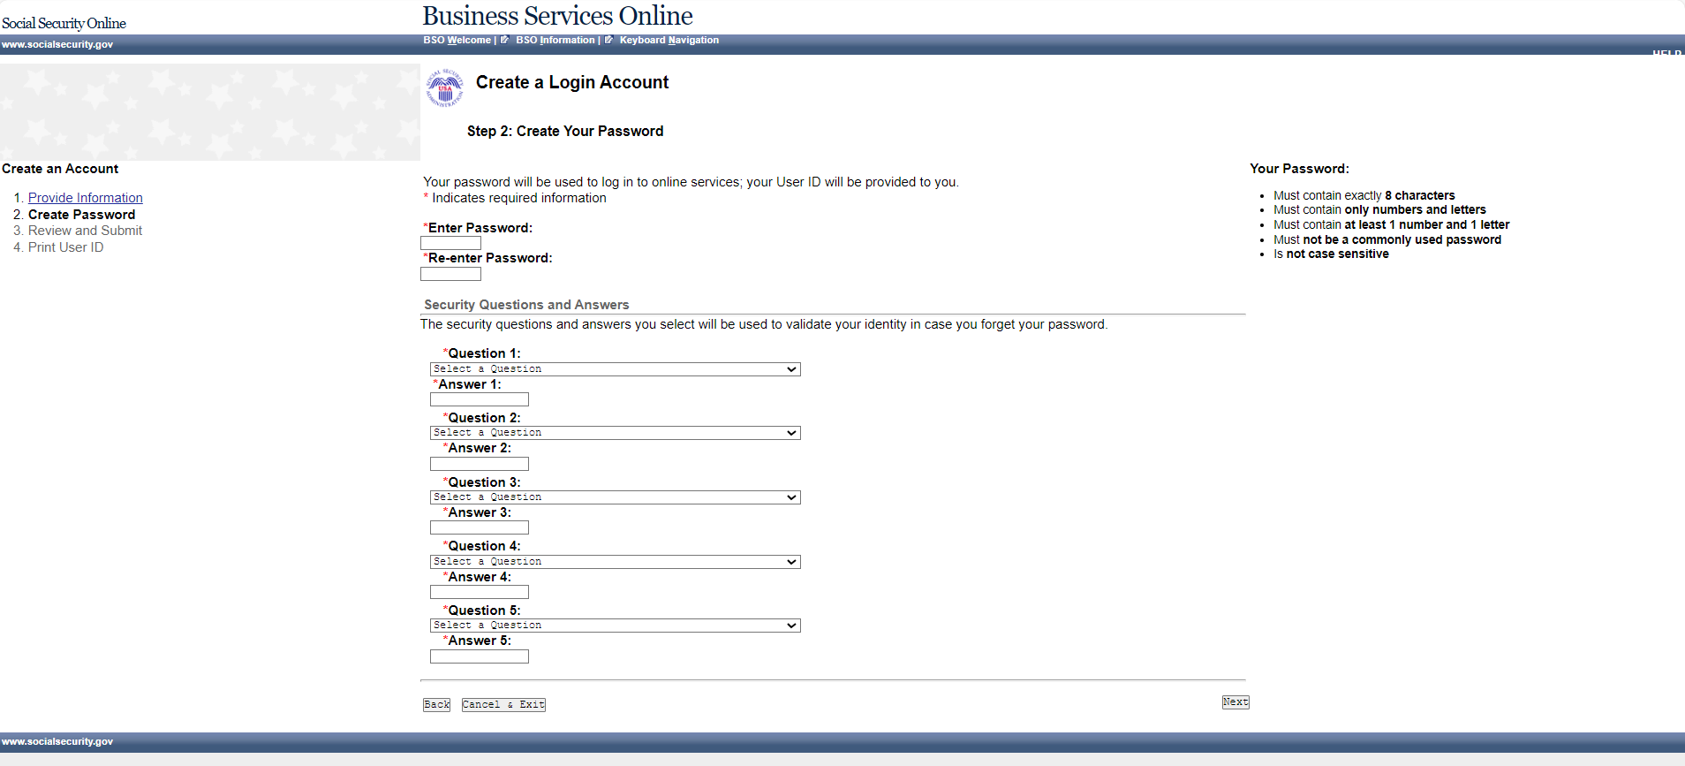

Create a Login Account – Step 3: Review & Submit (update)
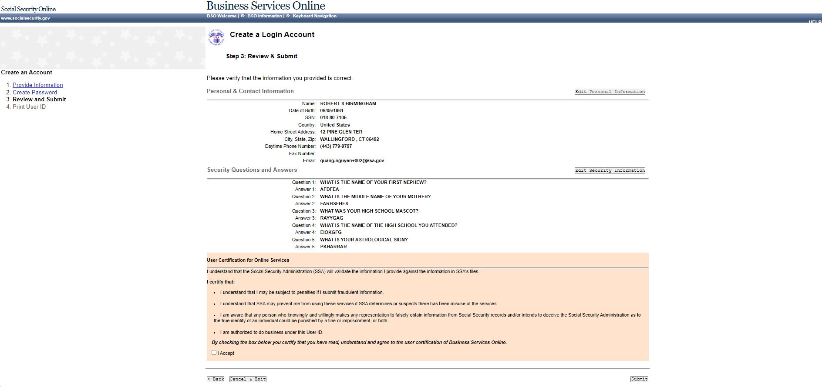

Create a Login Account – Step 4: Print your User ID (update)
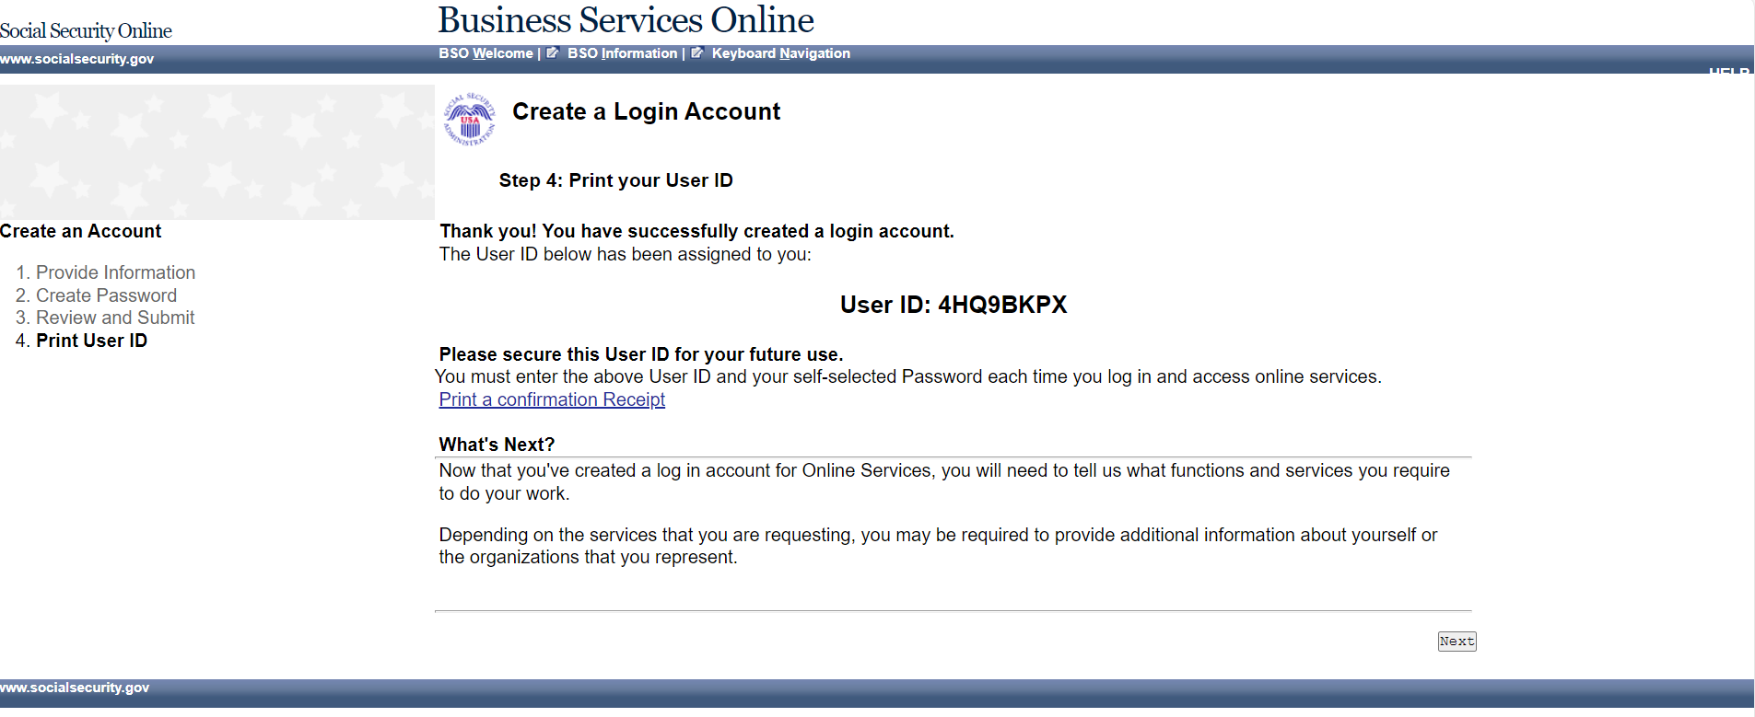

Complete Phone Registration Attestation (update)
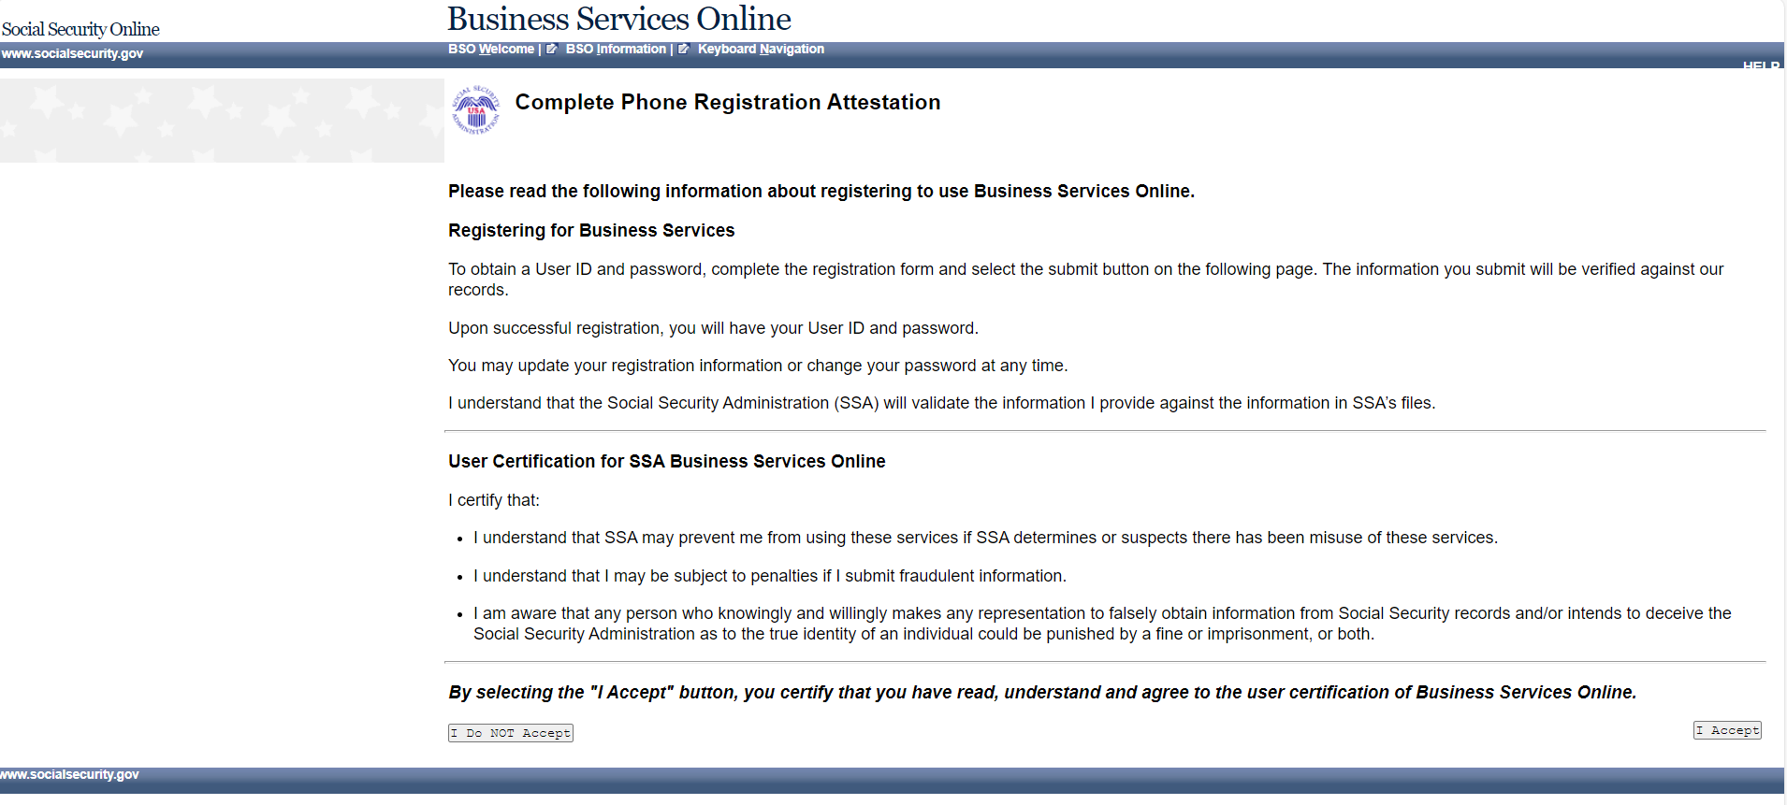

Complete Phone Registration (update)
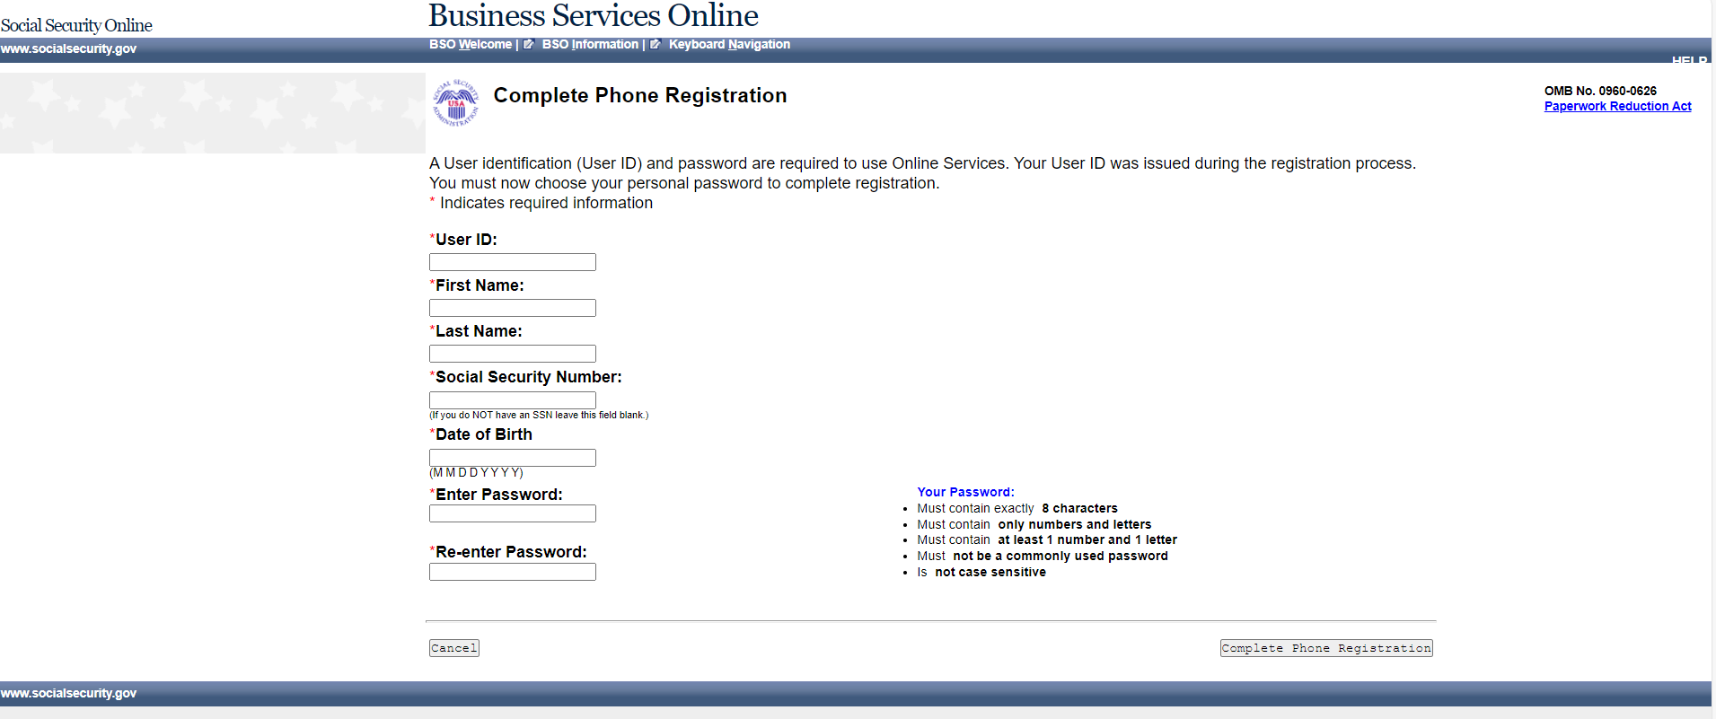

Complete Phone Registration - Successful (update)
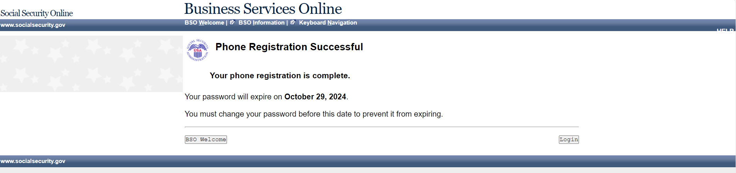

BSO User Registration, Login, and Employer Information Help Topics (update)

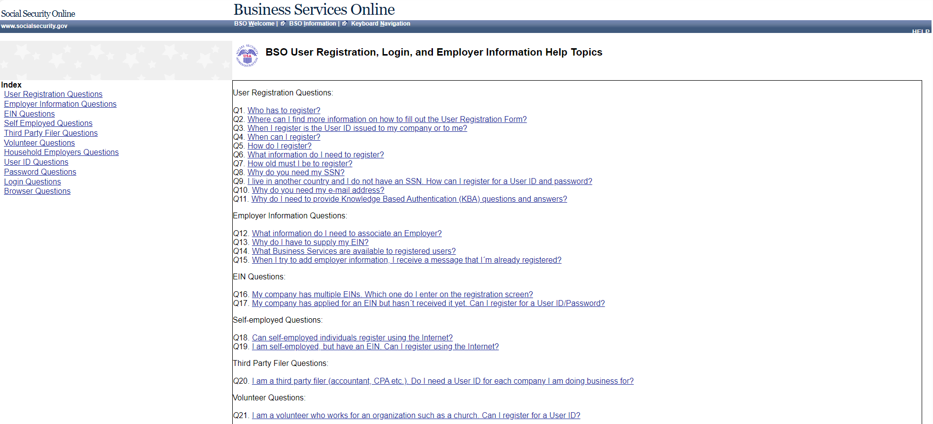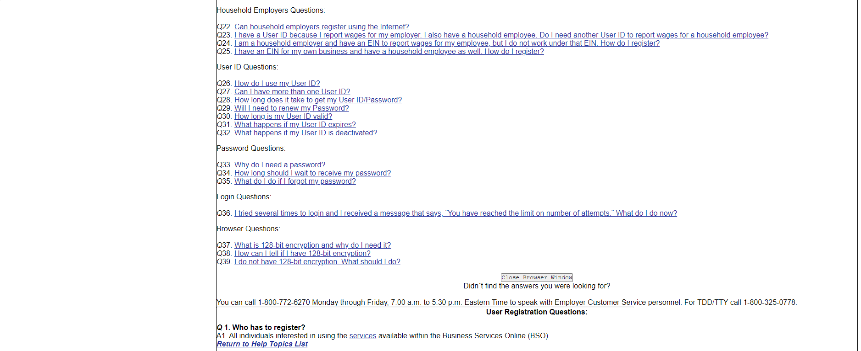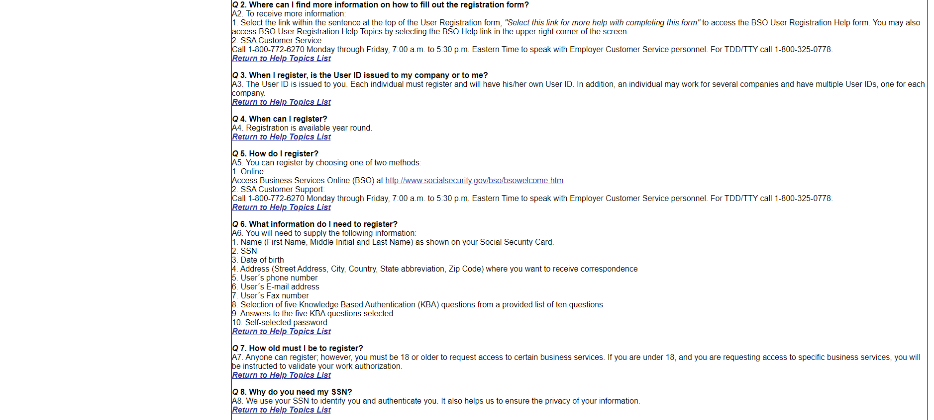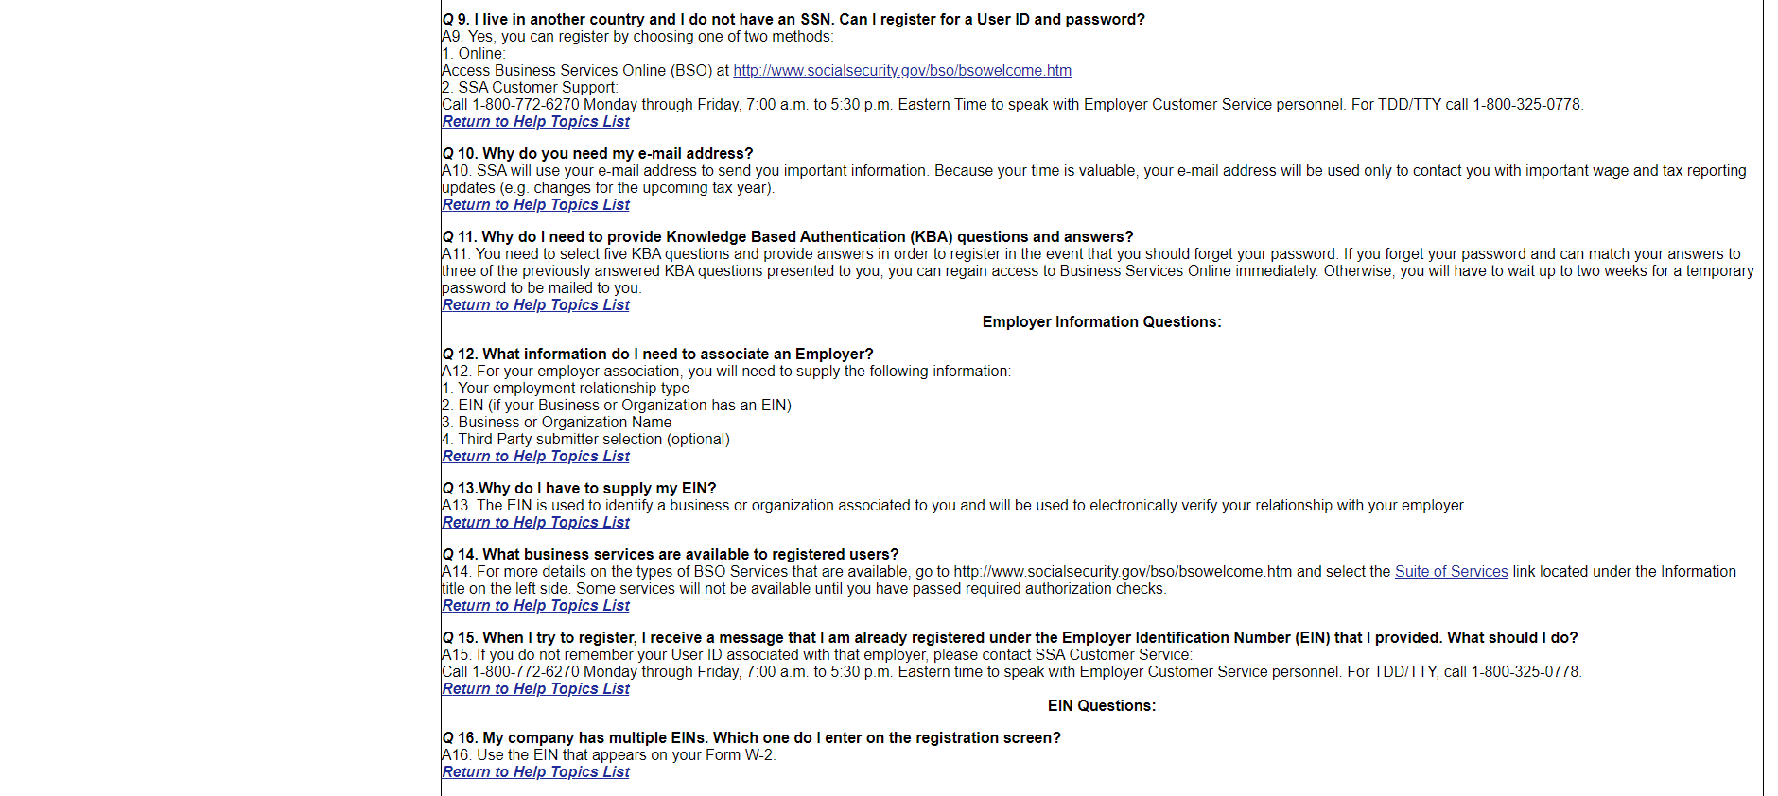

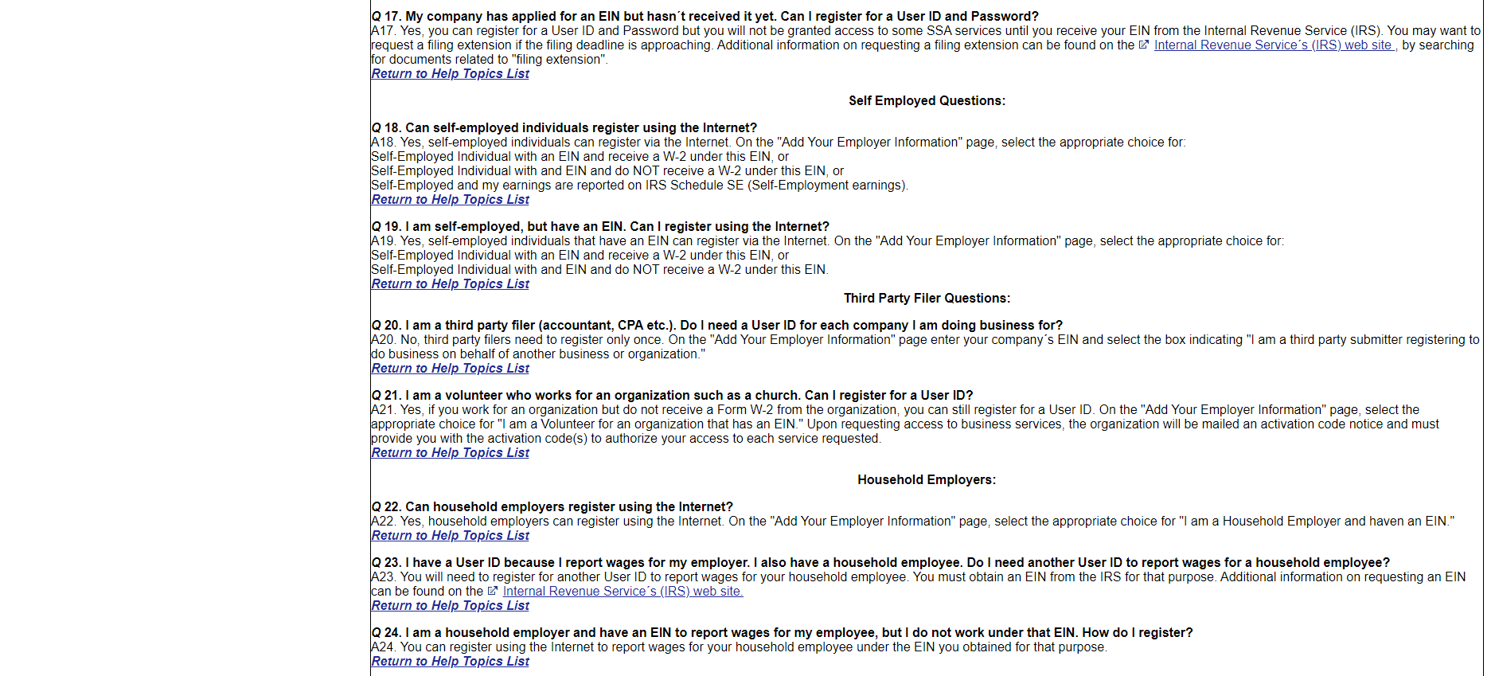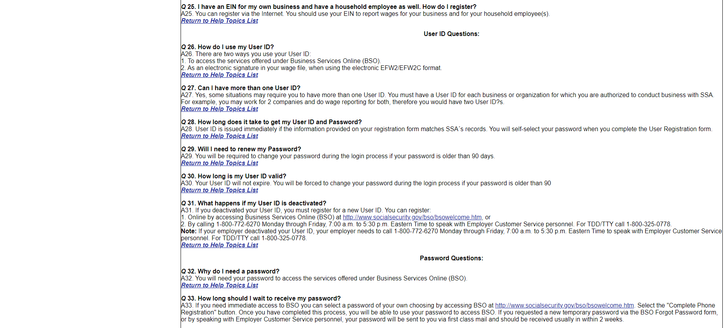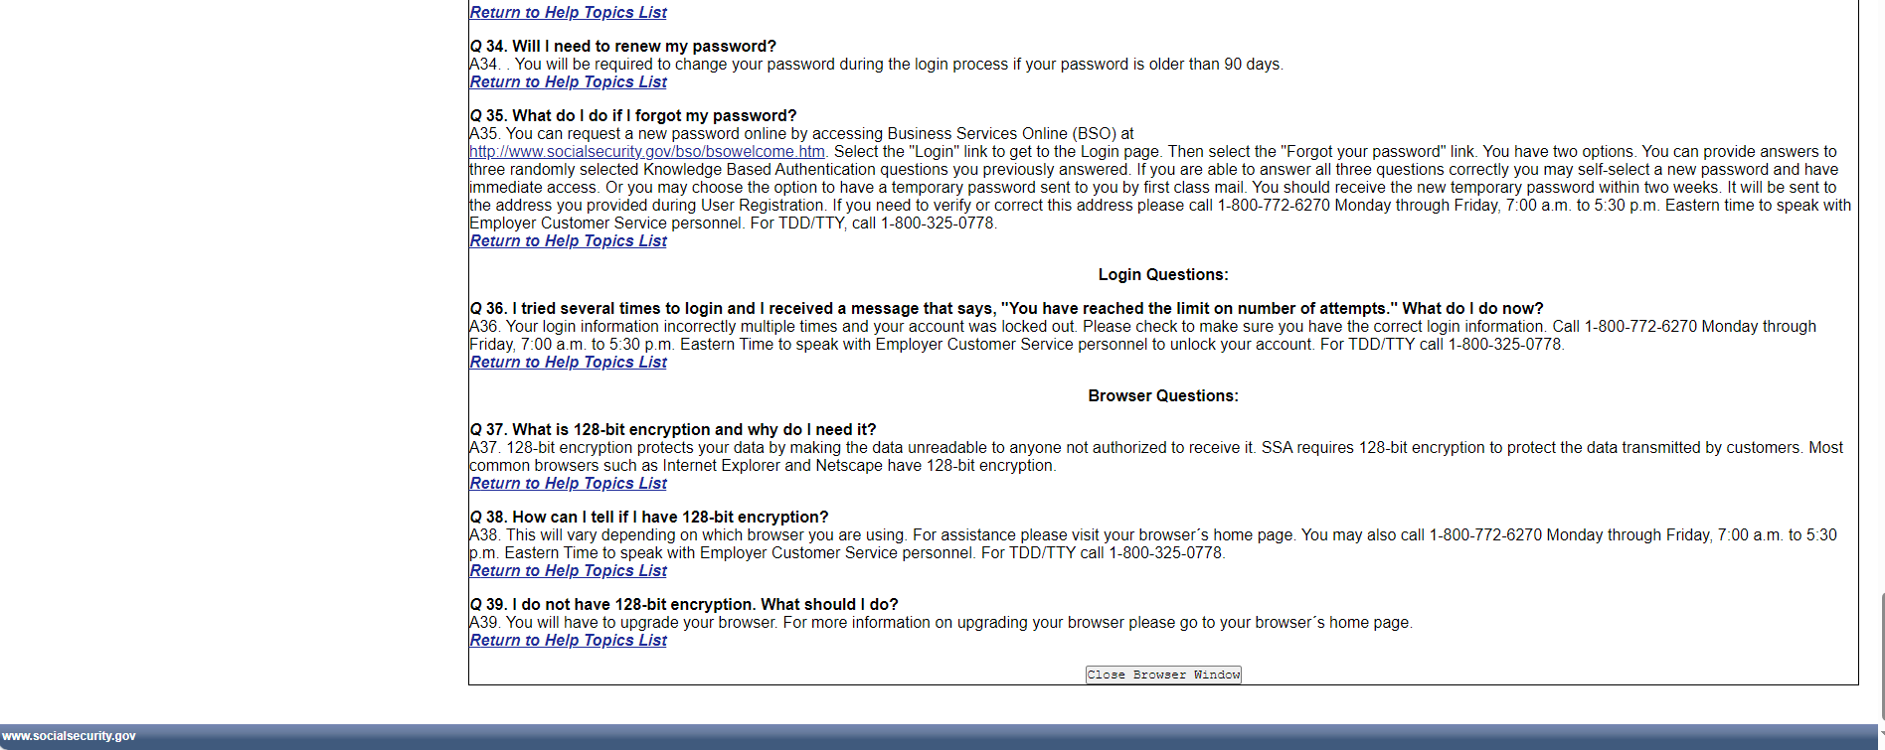

View/Edit Account Information (update)
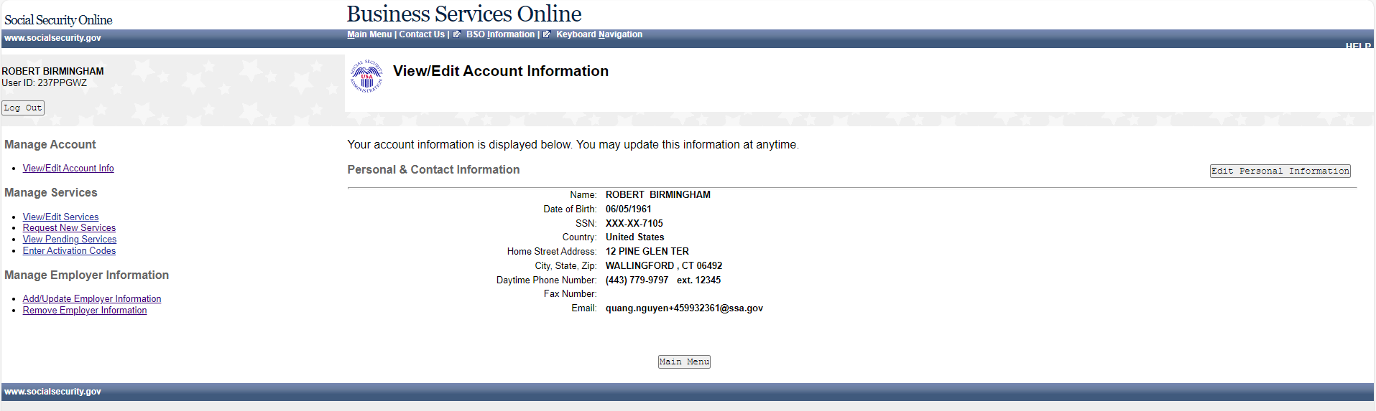

Edit Personal & Contact Information (update)
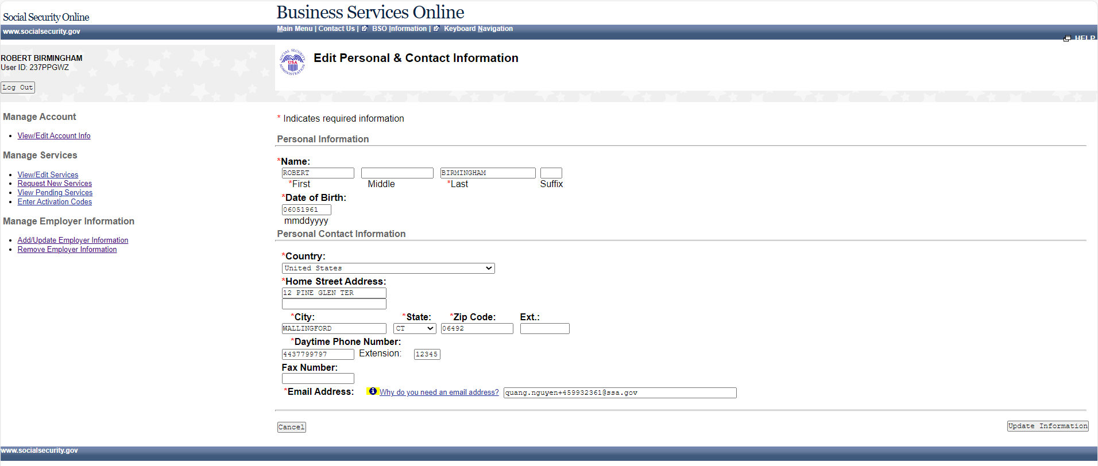

Edit Personal & Contact Information – Confirmation (update)
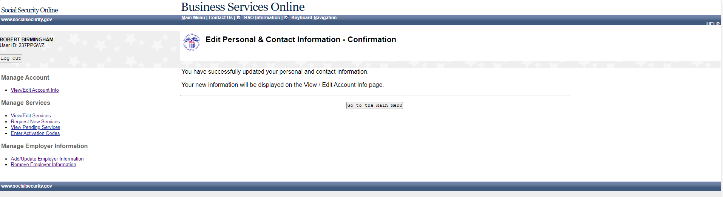

Edit Security Questions & Answers (update)
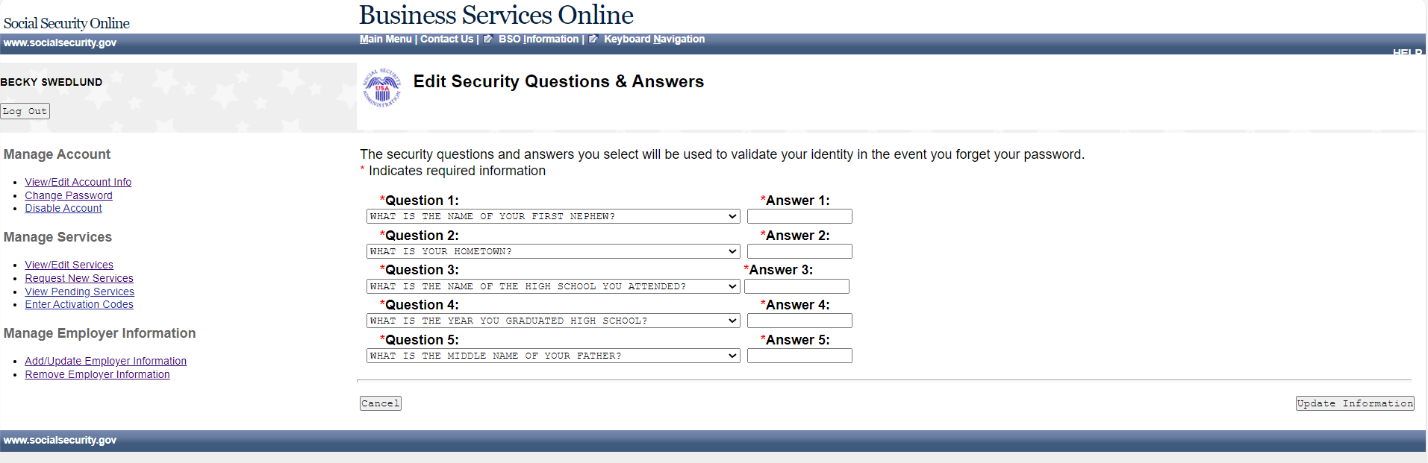

Edit Security Questions & Answers – Confirmation (update)
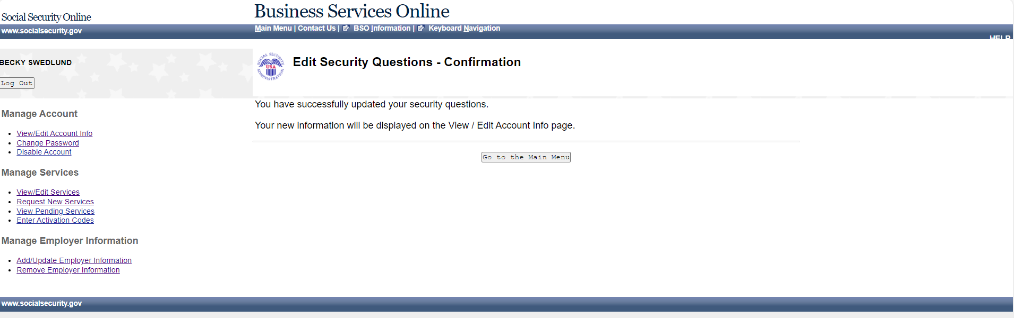

Request Access to BSO Services – Select Suite of Services (update)
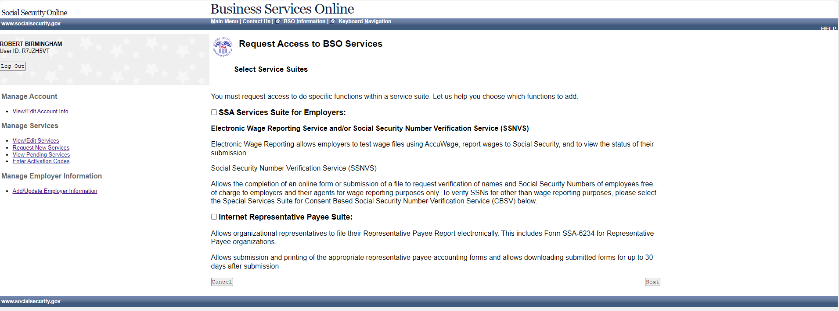

Request Access to BSO Services – Employer Information is required (update)

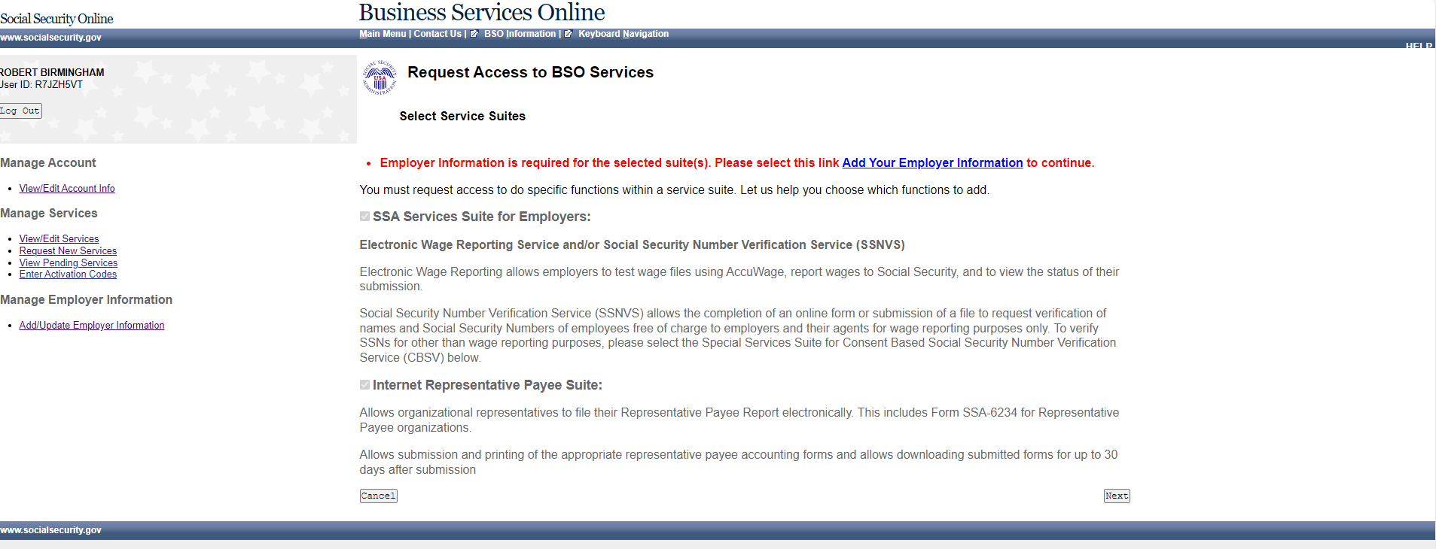

Request Access to BSO Services – Employer Information Not Available (MEF Failure)
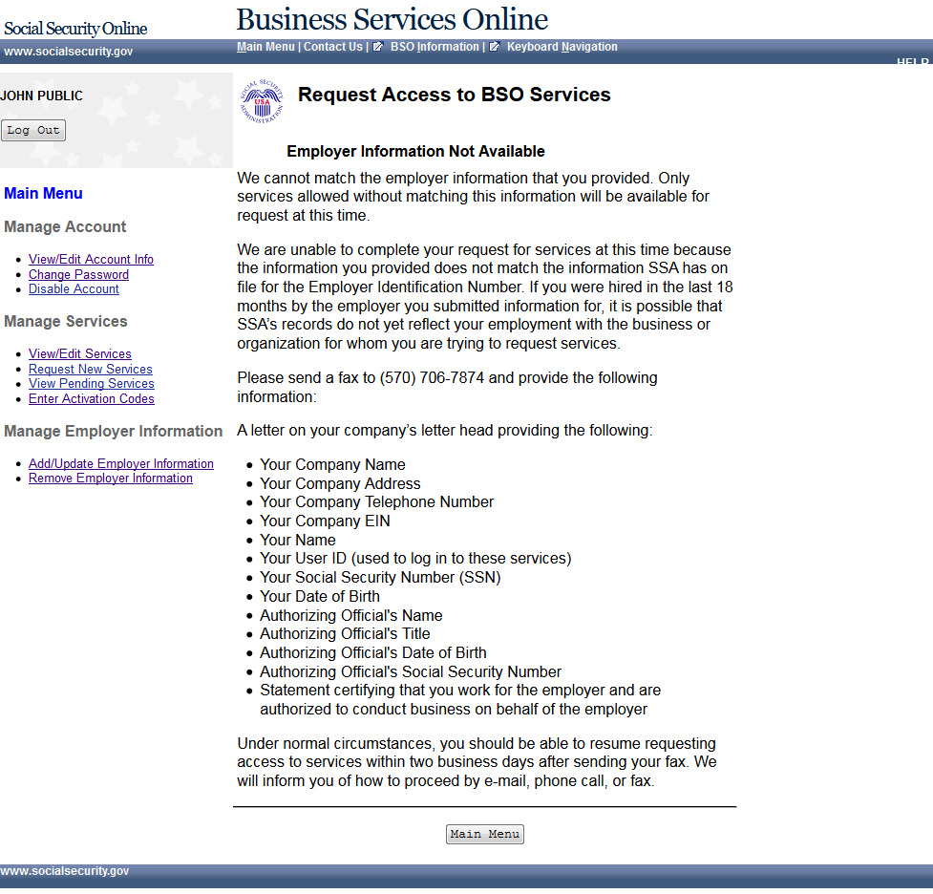

Request Access to BSO Services - Employer Address Not Available (pending EIN Address)
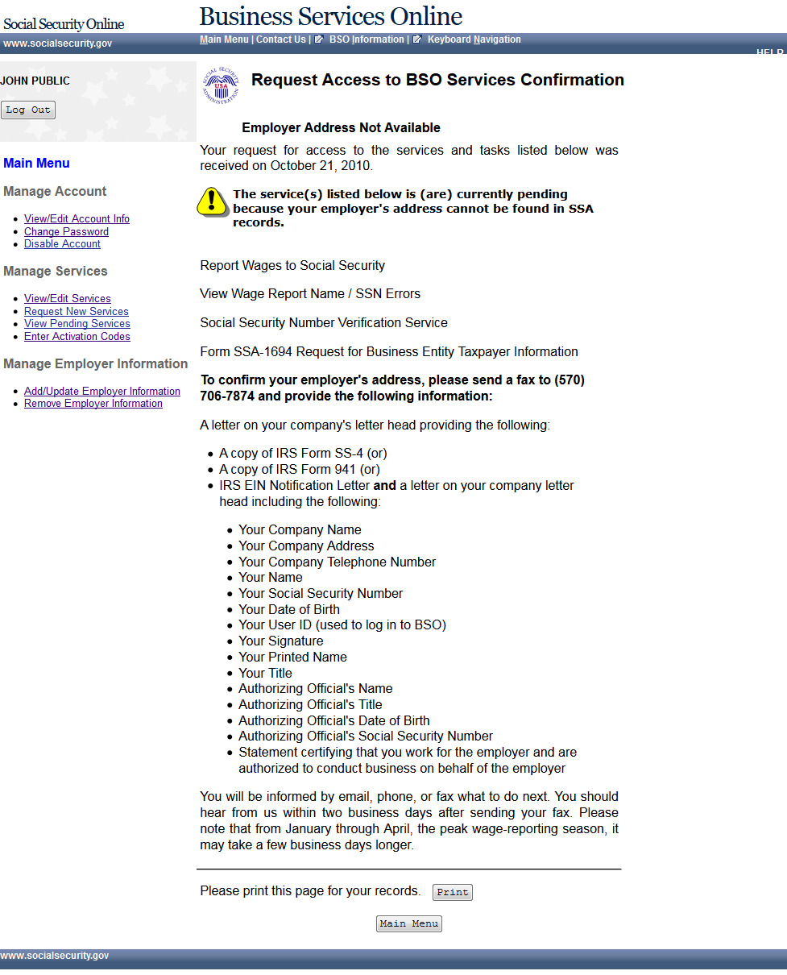

Request Access to BSO Services - Age Restriction
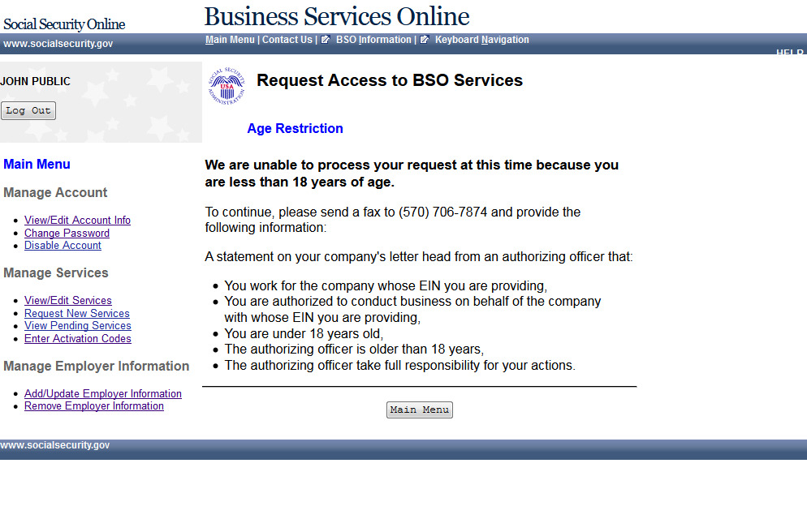

Request Access to BSO Services - Employer Information (Page 1 of 3)
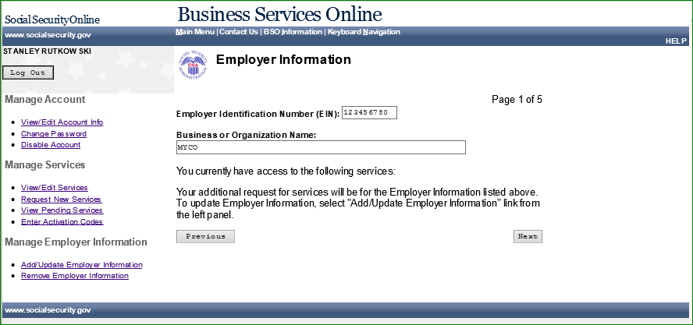

Request Access to BSO Services - Report Wages to Social Security/View Wage Report Name/SSN Errors (Page 2 of 3) (update)
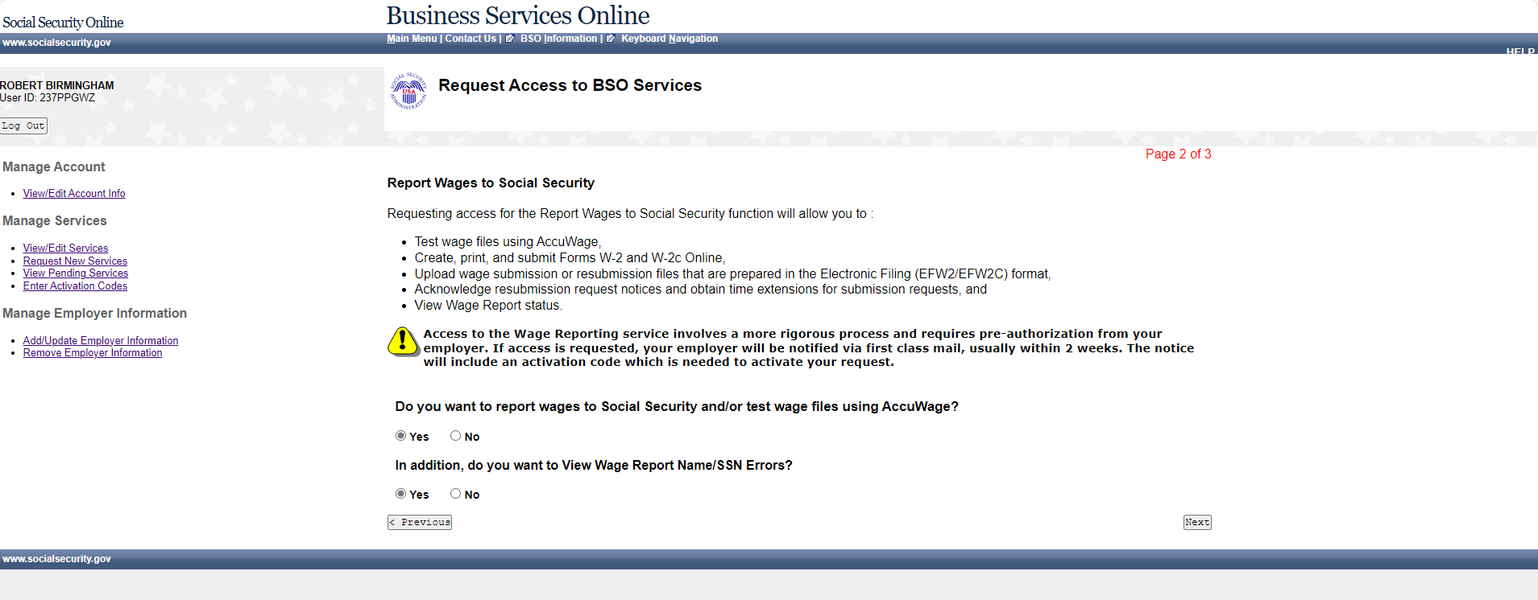

25. Request Access to BSO Services - Social Security Number Verification Service (SSNVS) (Page 3 of 3) (update)
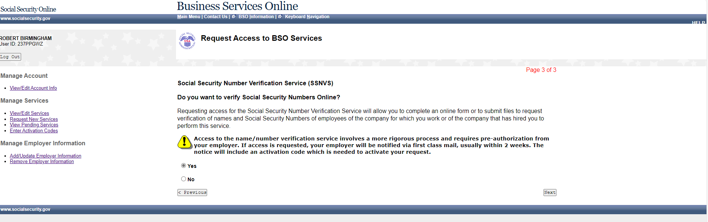

Request Access to BSO Services - Complete Form SSA-1694 Business Taxpayer Information Form (Page 4 of 4)
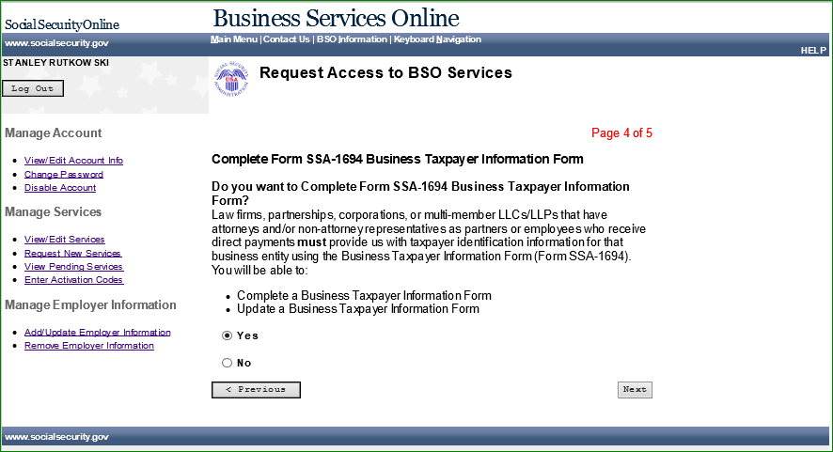

Request Access to BSO Services - Internet Representative Payee (Page 5 of 5)
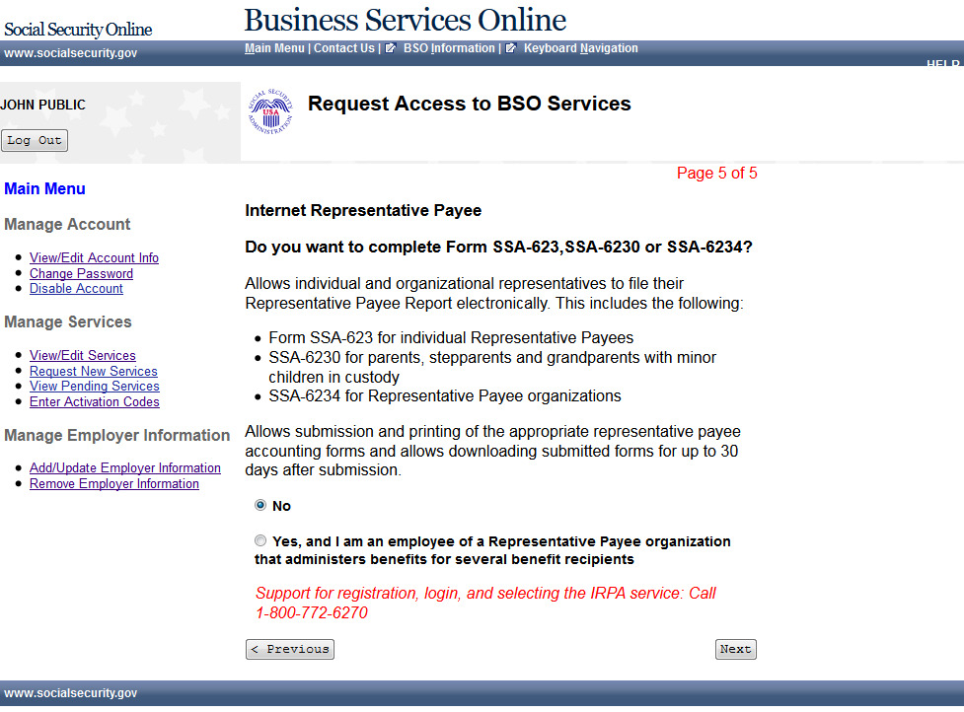

Request Access to BSO Services - Request Summary (update)
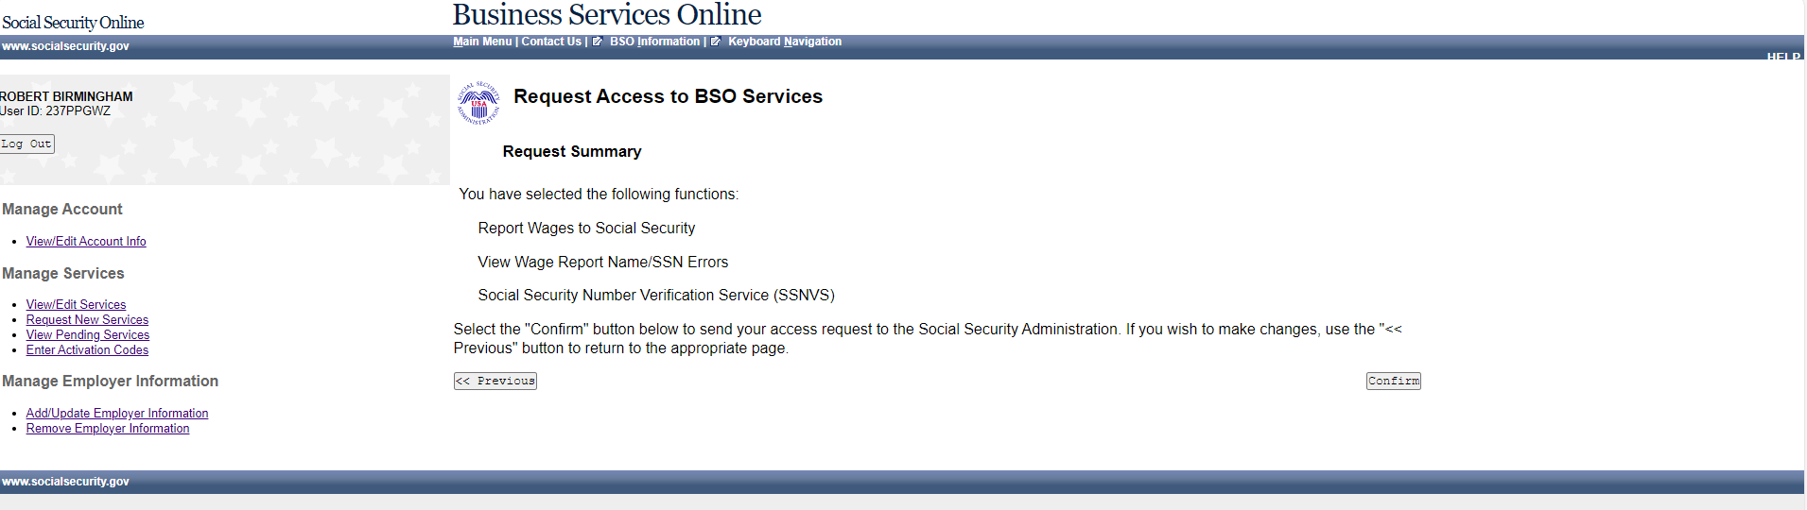

Request Access to BSO Services Confirmation (update)
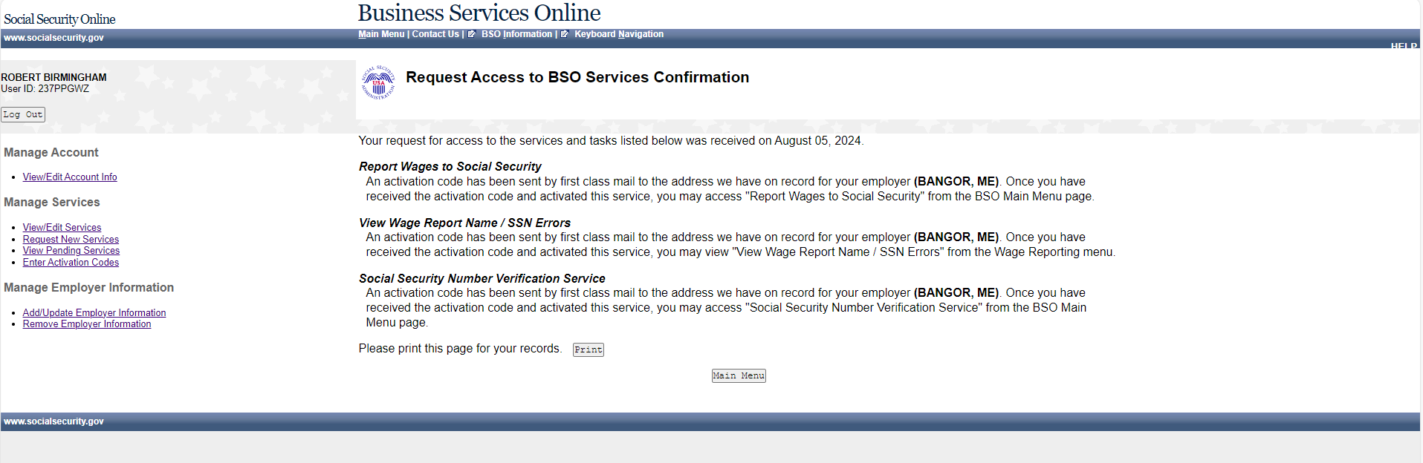

Main Menu-Without Services (update)
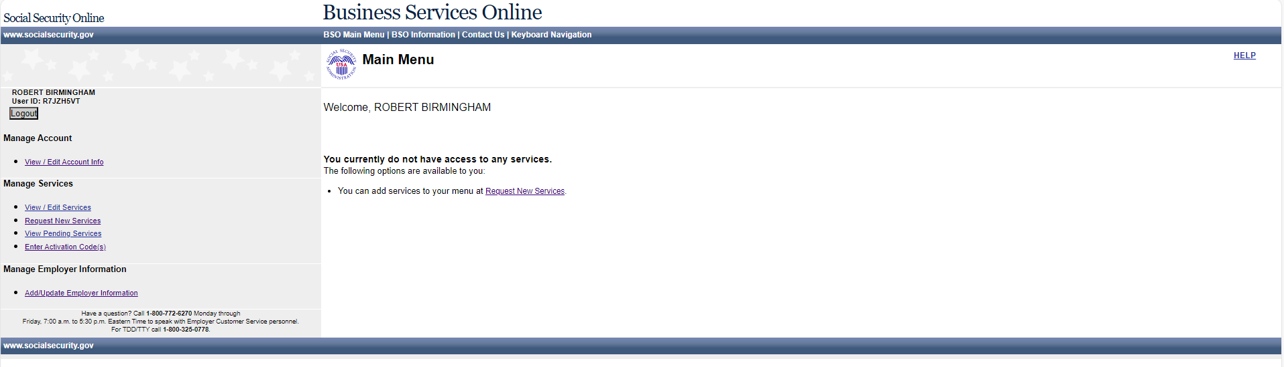

Main Menu-With Services
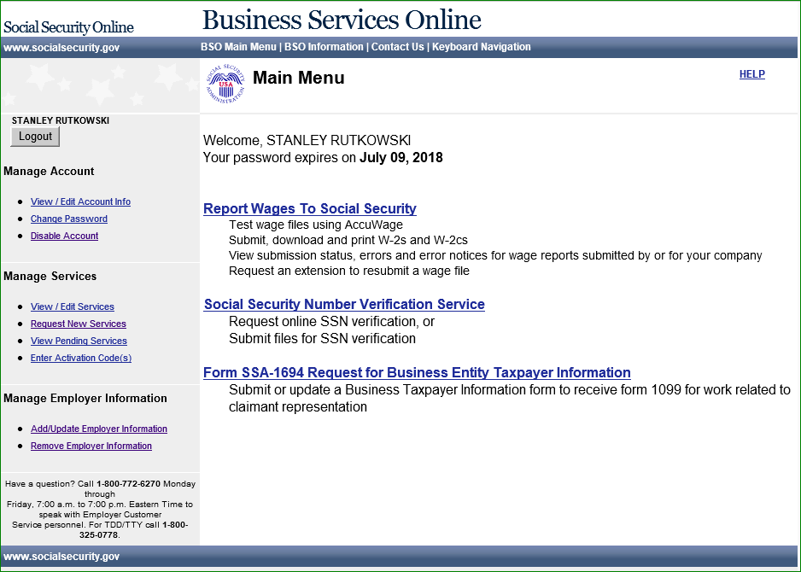

Social Security Number Verification Service
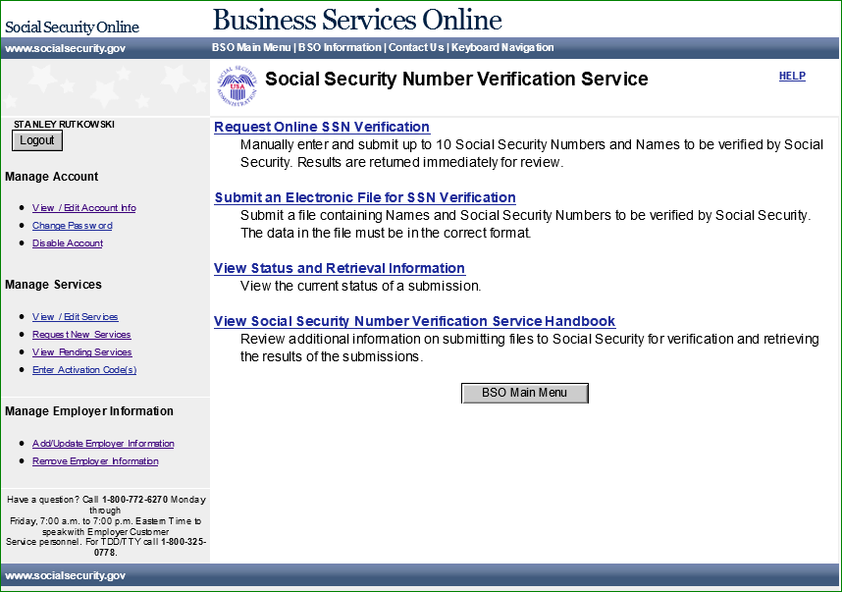

Form SSA-1694 Request for Business Entity Taxpayer Information
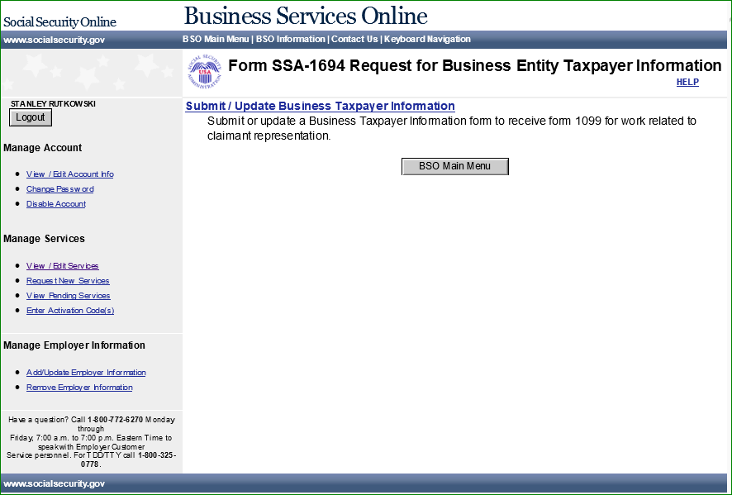

Internet Representative Payee Accounting (update)
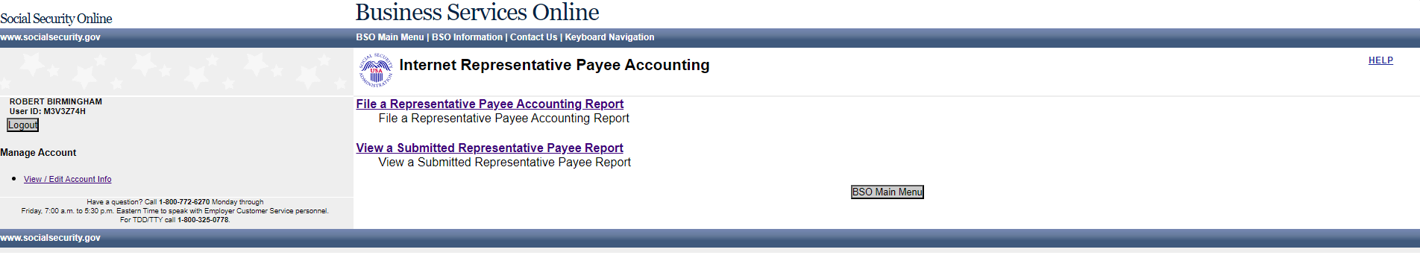

Enter Activation Code(s) for the Appointed Representative
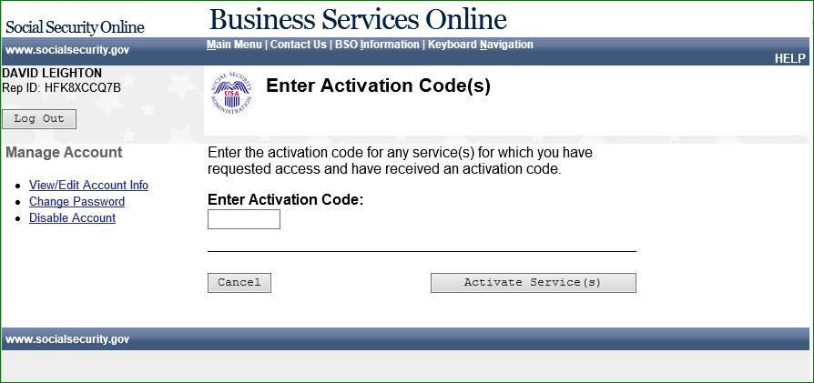

Appointed Representative Services - Main Menu (update)
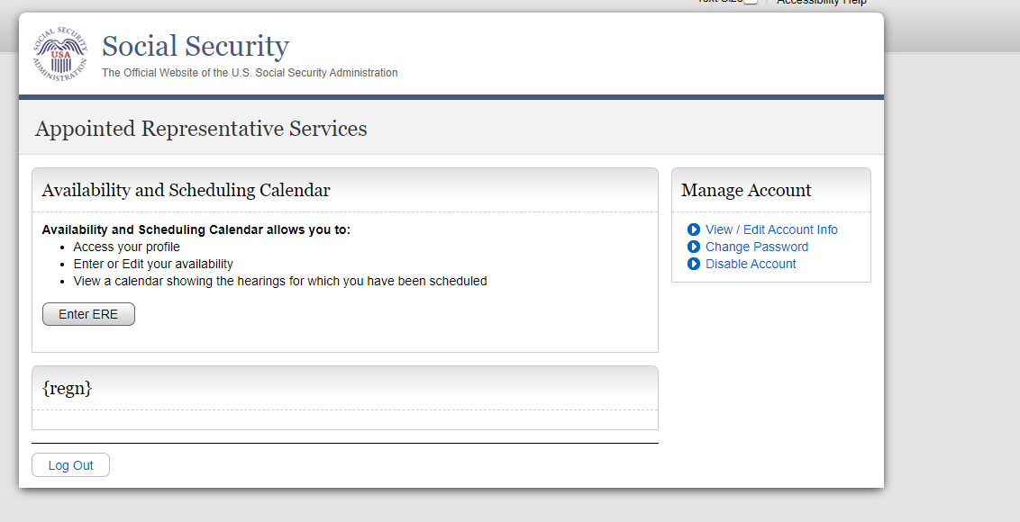

View / Edit Services – No Services Available (update)
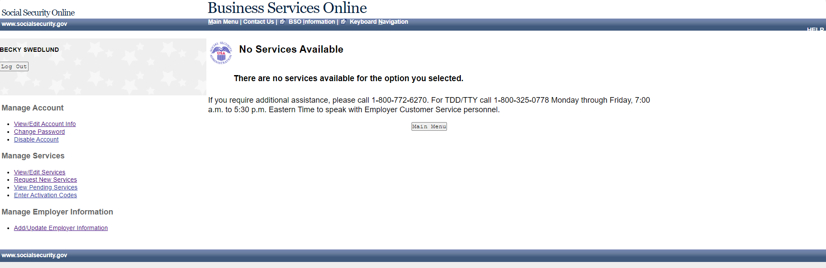

Request New Services (update)
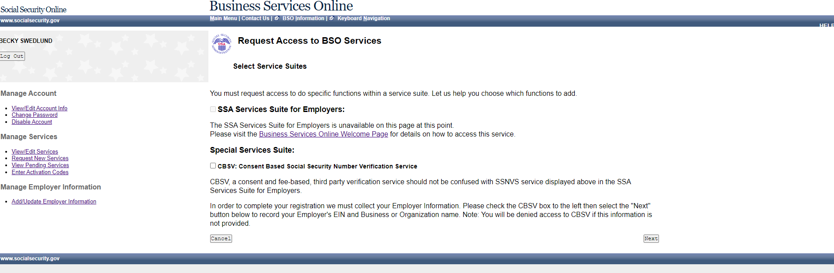

Remove Access to BSO Services
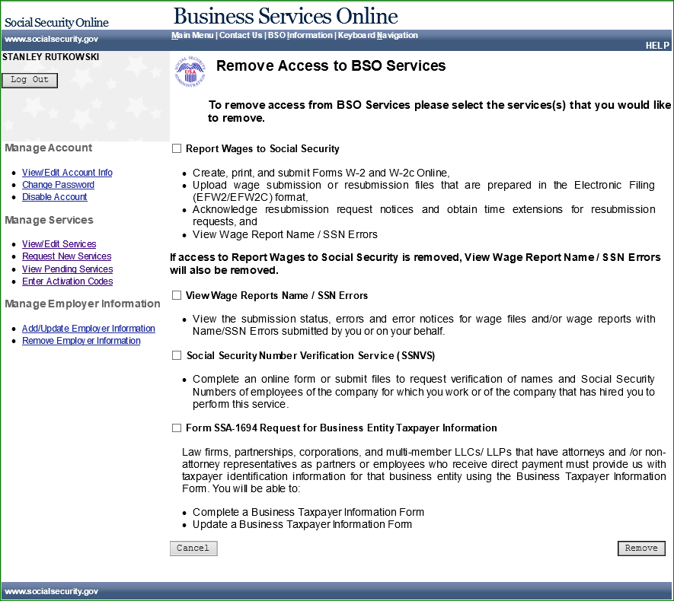

Remove Access to BSO Services Successful
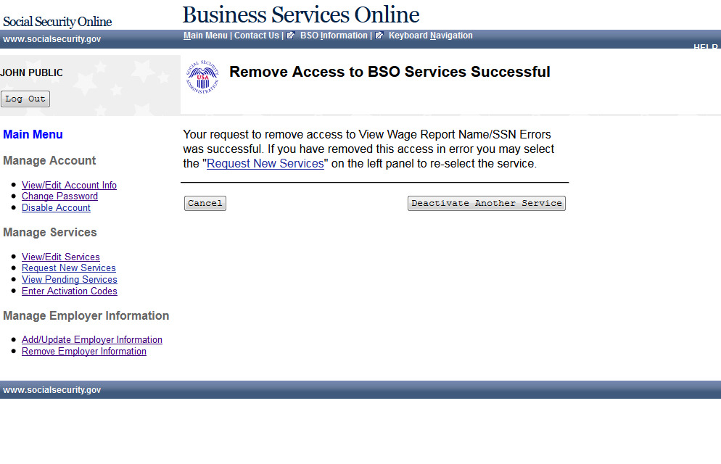

Activate Access to BSO Services - No Services Available
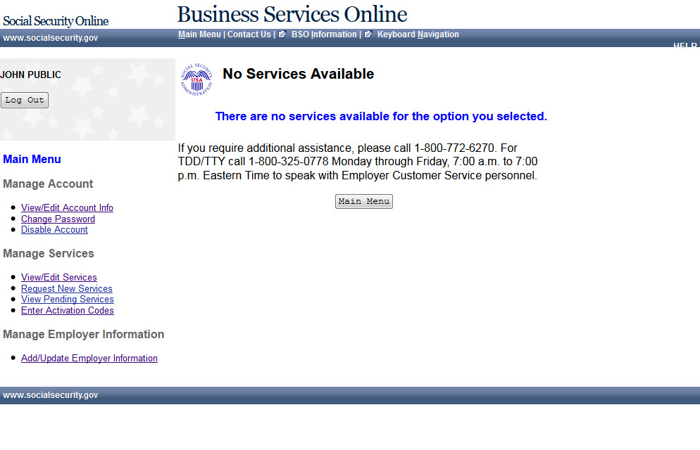

Activate Access to BSO Services
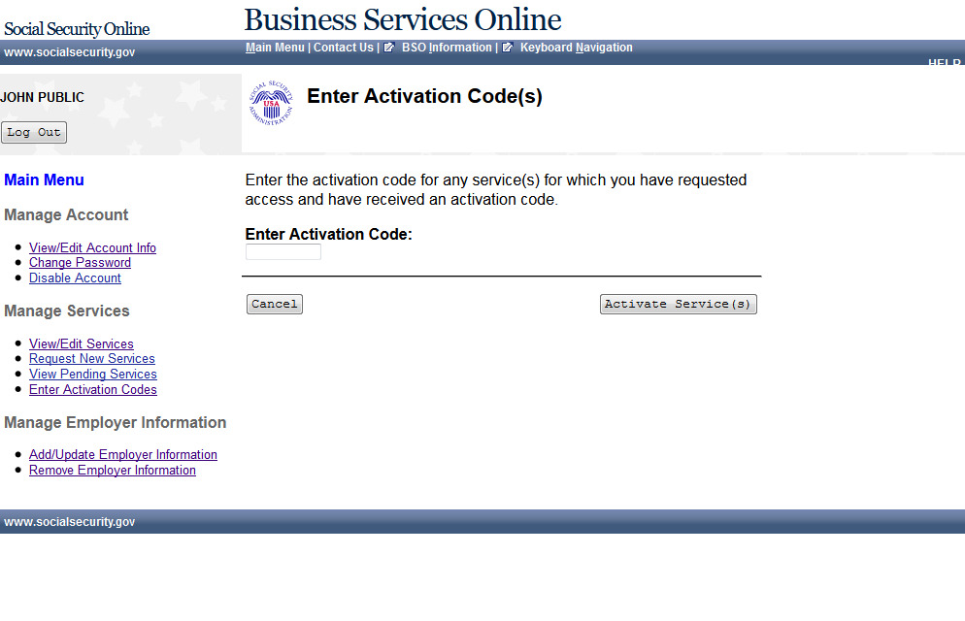

Activate Access to BSO Services Successful
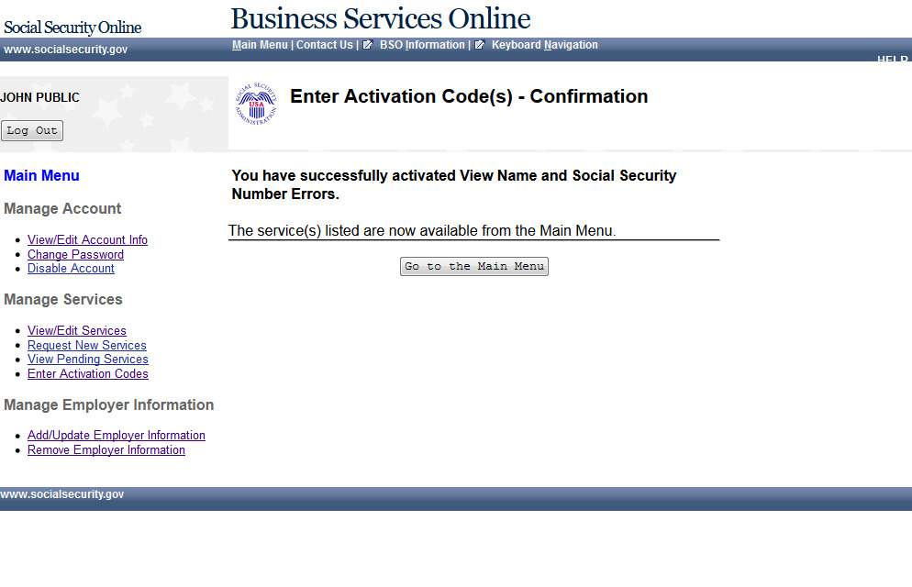

View Pending Services - Re-Request Activation Code - Without Services
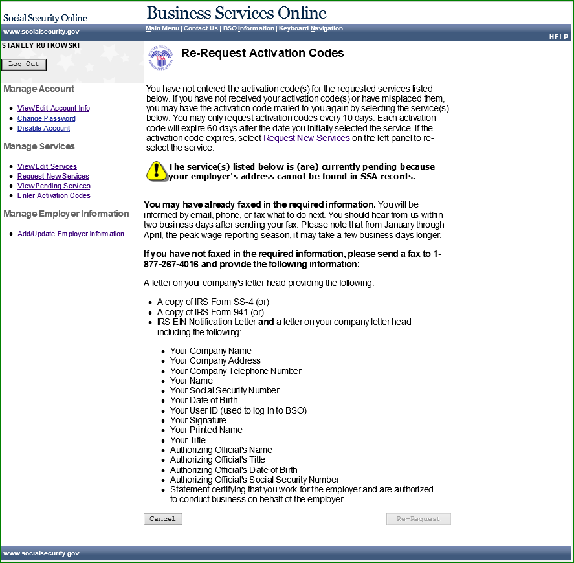

View Pending Services - Re-Request Activation Code - With Services
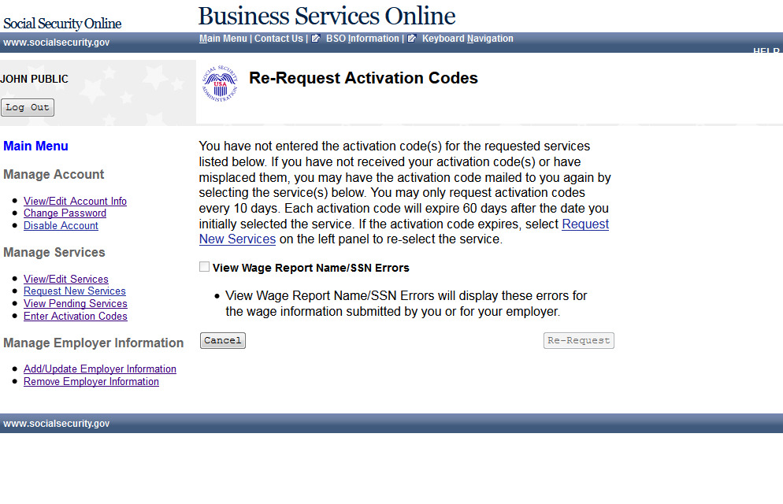

View Pending Services - Confirmation of Activation Code Notice Re-Request
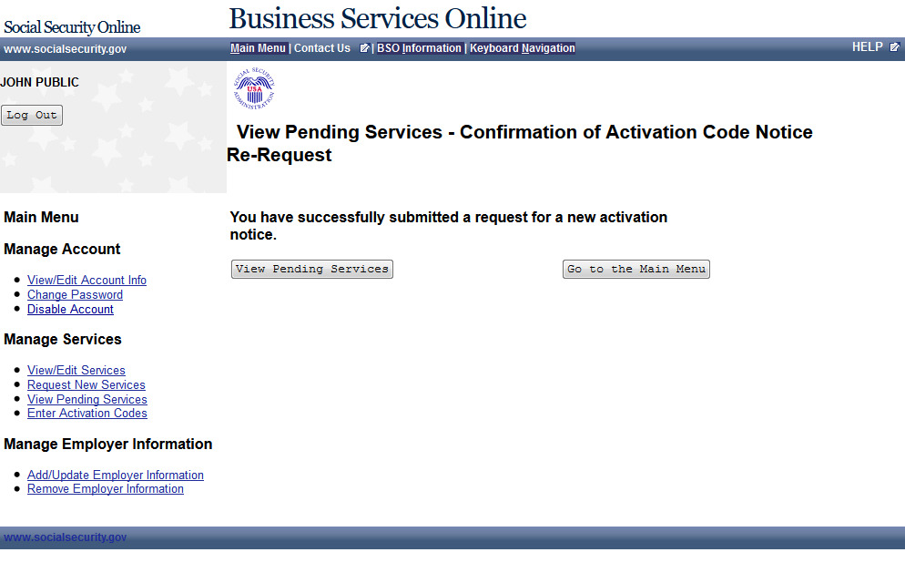

Enter Text-Enabled Cell Phone
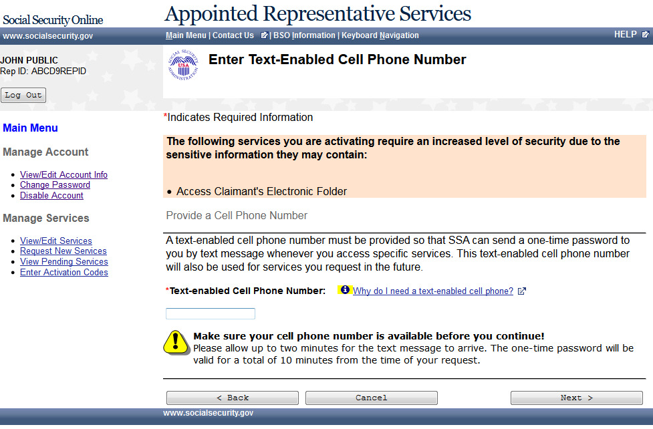

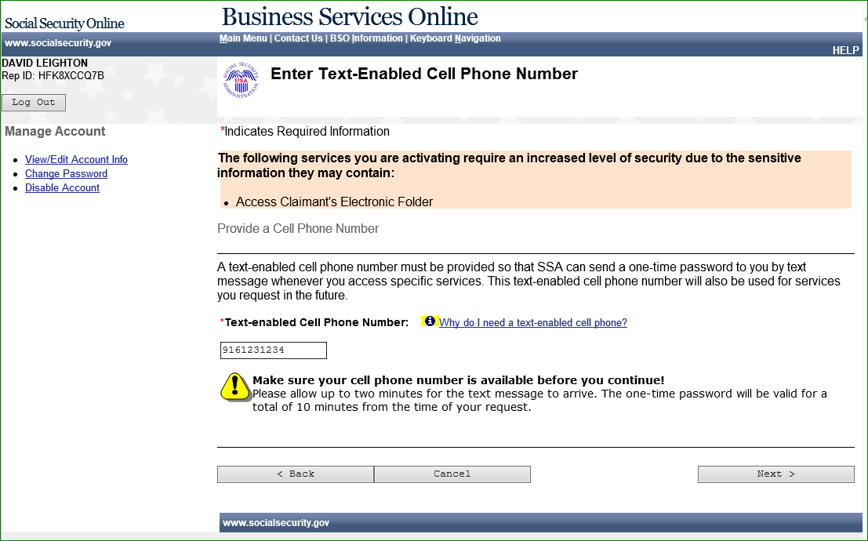

Employer Information Attestation (update)
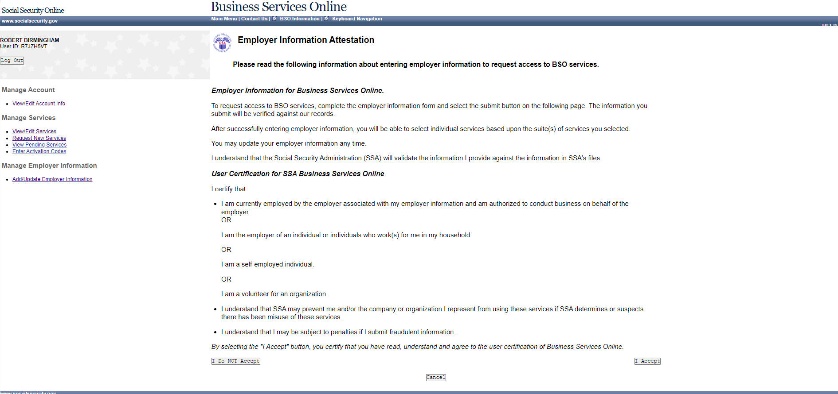

Add Employer
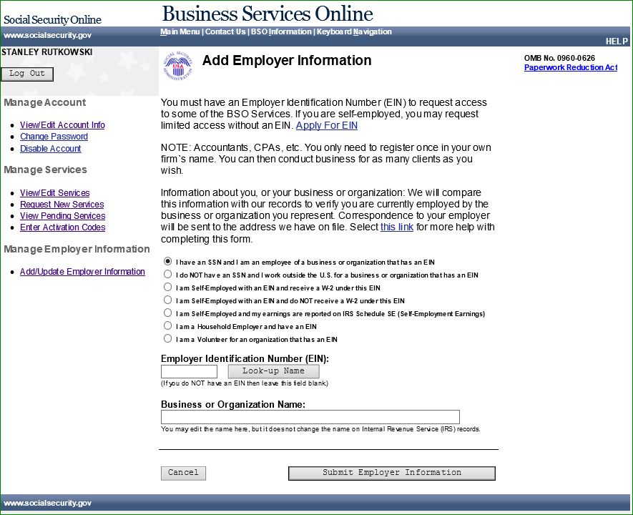

Add Employer Information Successful (update)
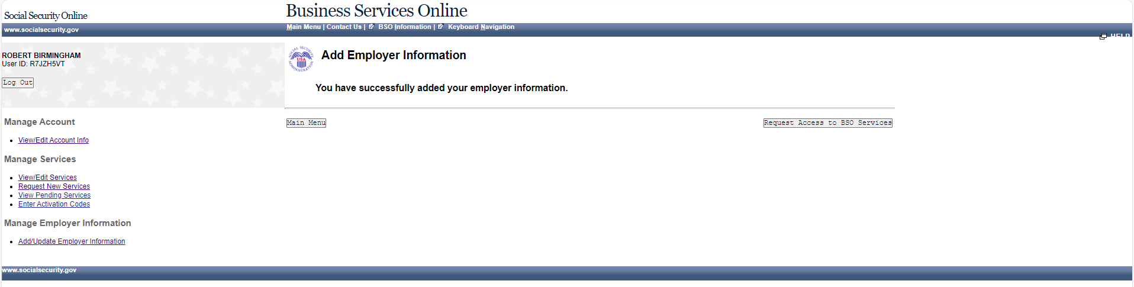

Update Your Employer Information (update)
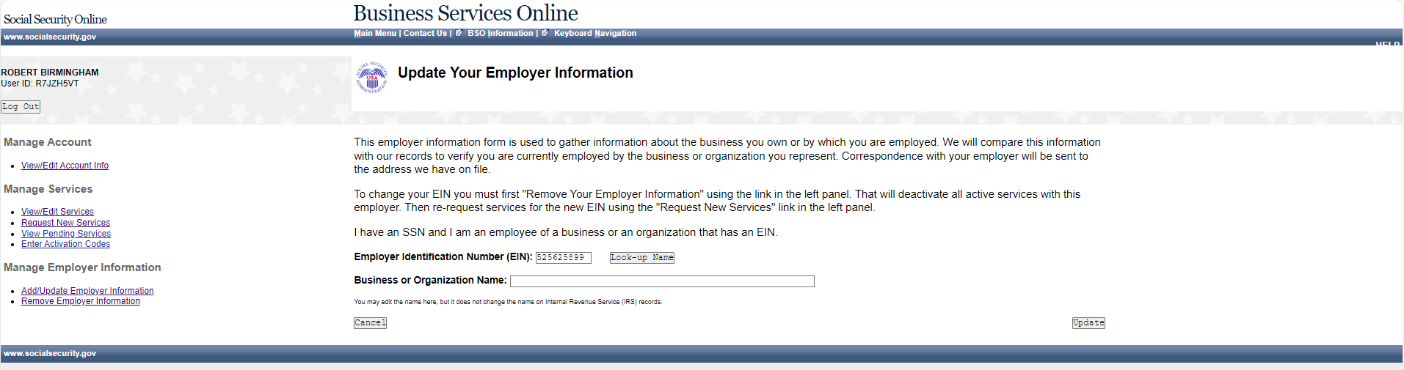

Update Your Employer Information (update)
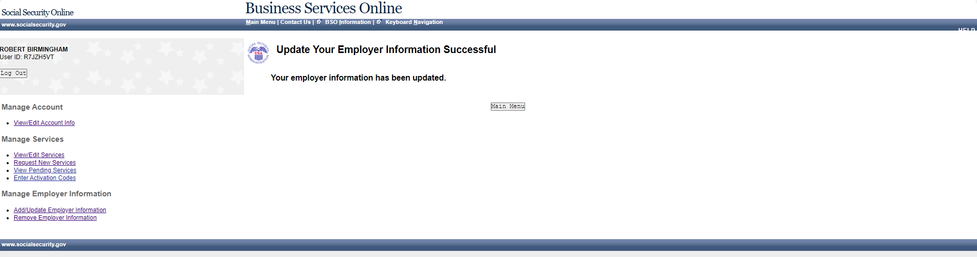

Remove Your Employer Information (update)
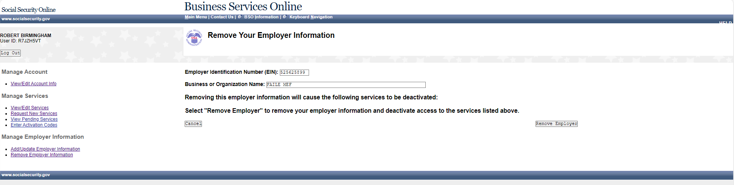

Remove Your Employer Information Successful (update)
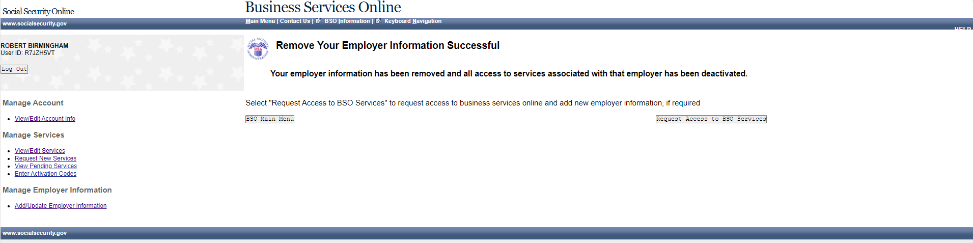

View/Edit Account (update)
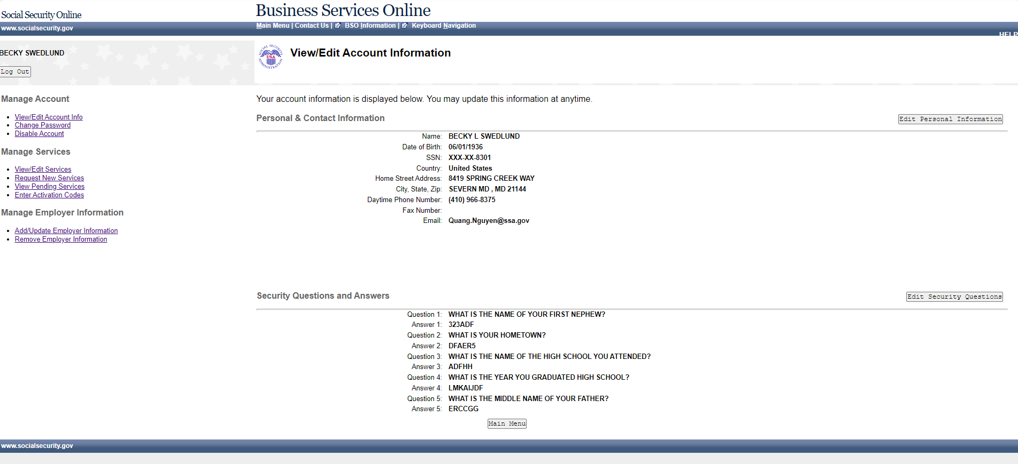

Edit Personal & Contact Information (update)
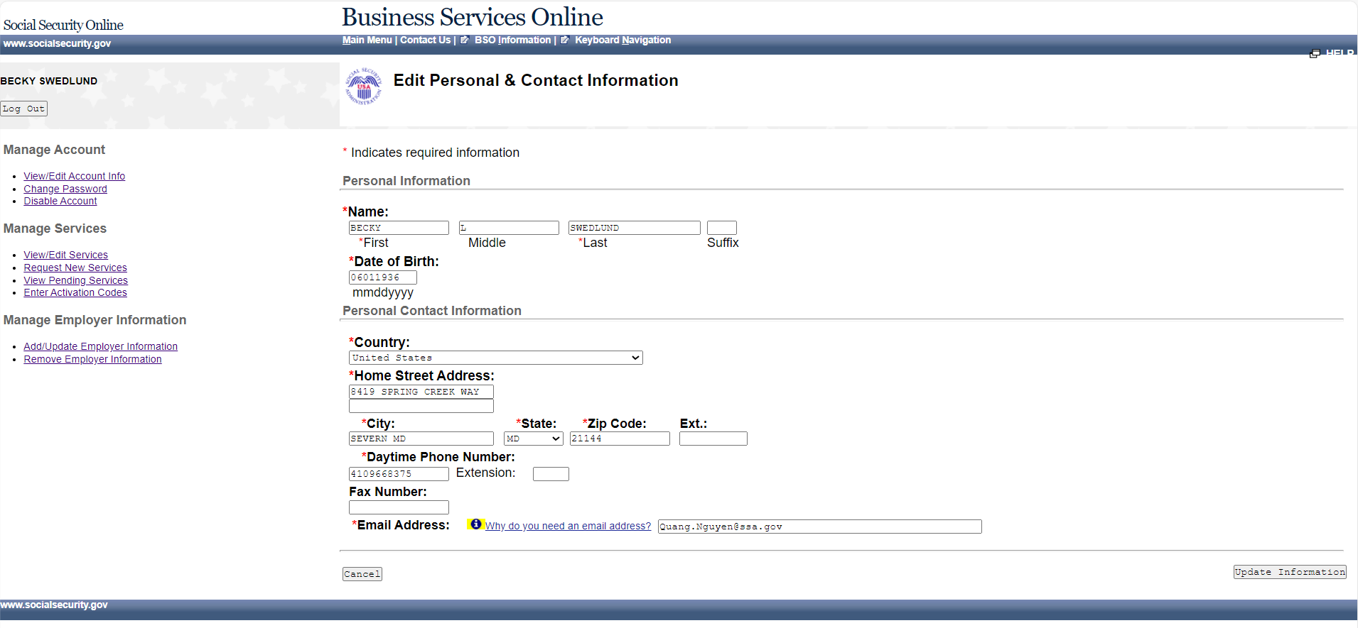

Edit Personal & Contact Information – Confirmation (update)
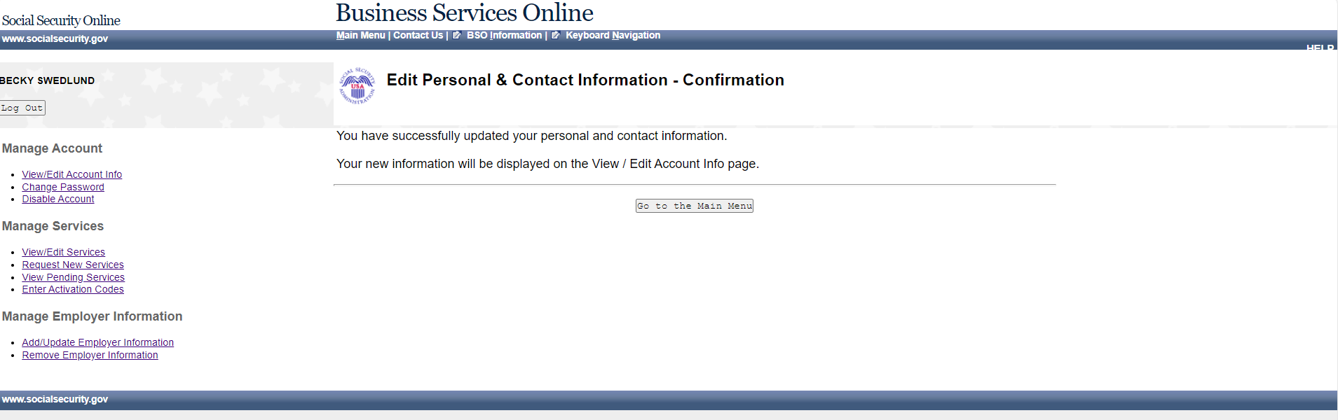

Change Text-enabled Cell Phone Number - Option 1 Selected
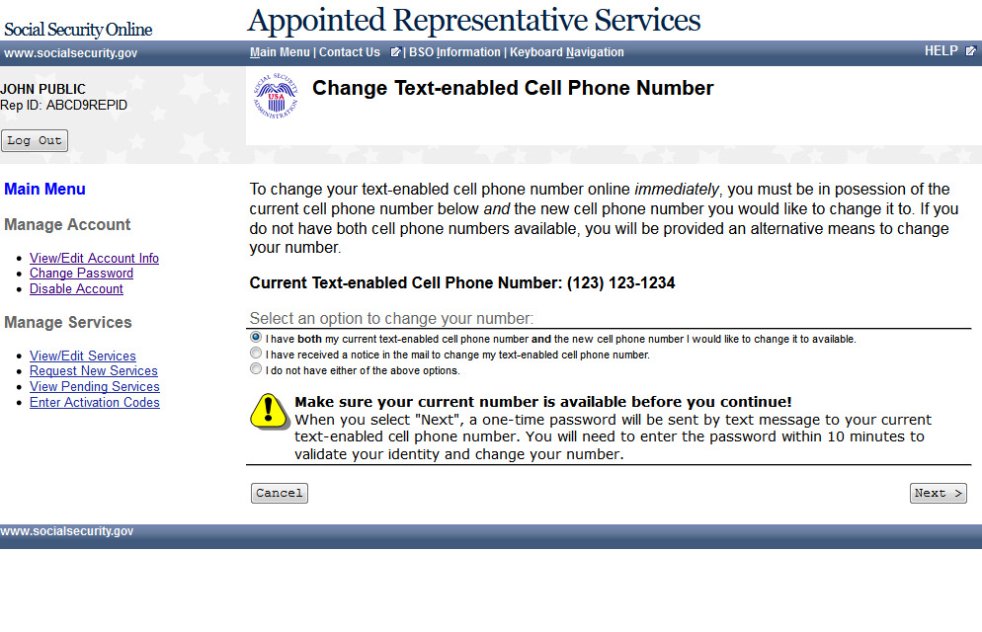

Change Text-enabled Cell Phone Number - Step 1: Enter One-Time Password
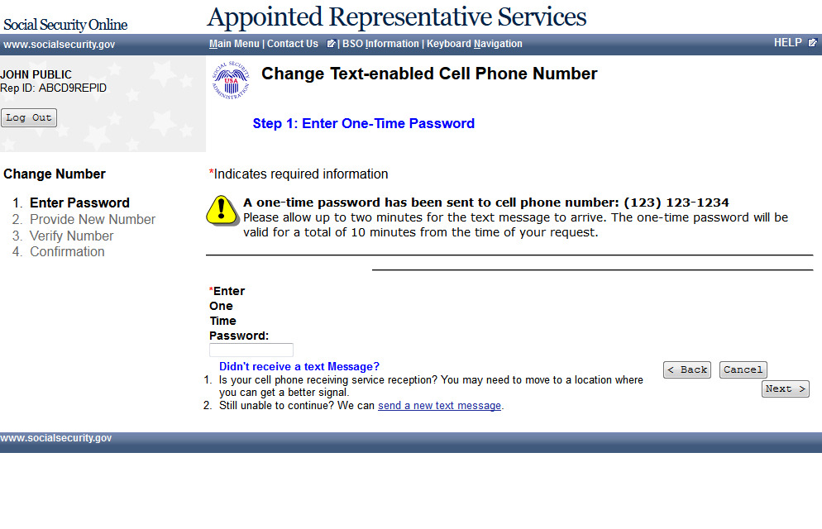

Change Text-enabled Cell Phone Number - Step 2: Provide a New Cell Phone Number
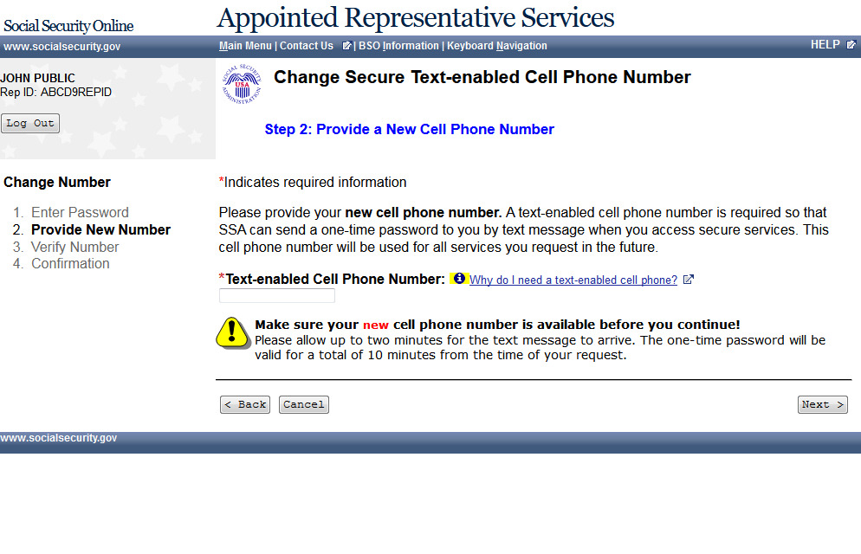

Change Text-enabled Cell Phone Number - Step 2: Provide a New Cell Phone Number – Fail
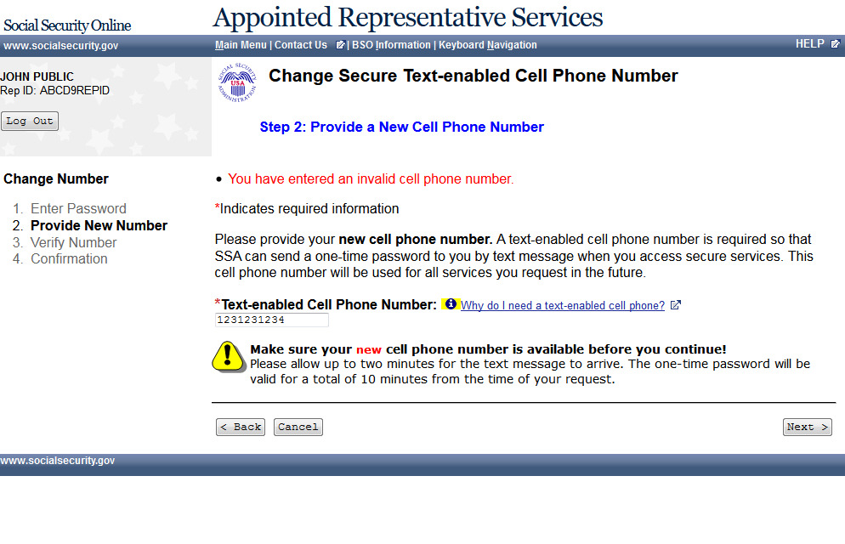

Change Text-enabled Cell Phone Number - Step 3: Verify your New Cell Phone Number
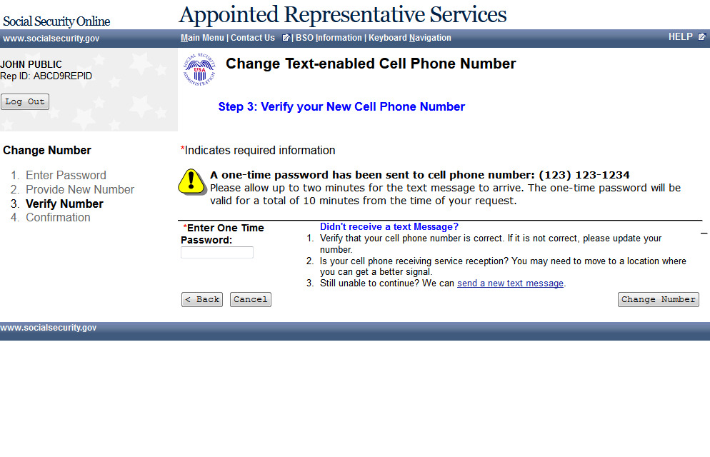

Change Text-enabled Cell Phone Number - Step 3: Verify your New Cell Phone Number - Fail
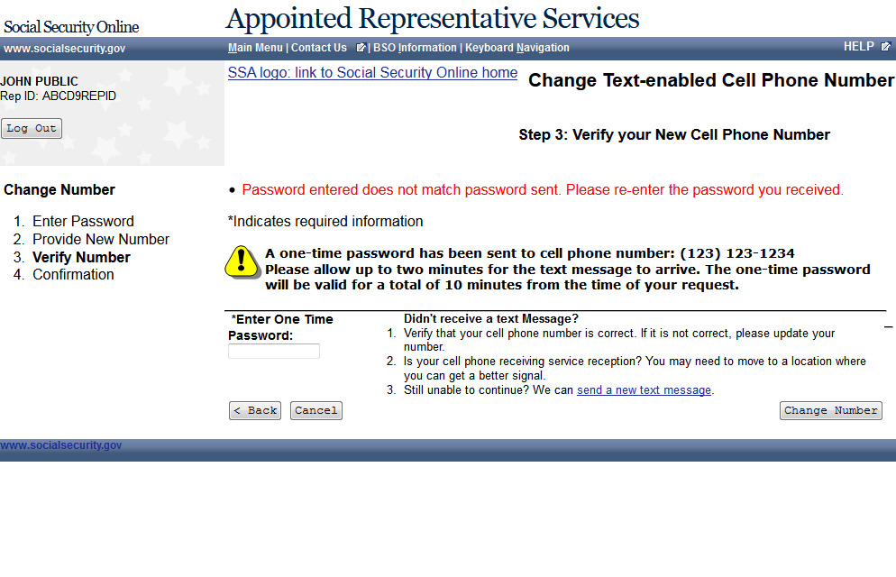

Change Text-enabled Cell Phone Number - Step 4: Confirmation
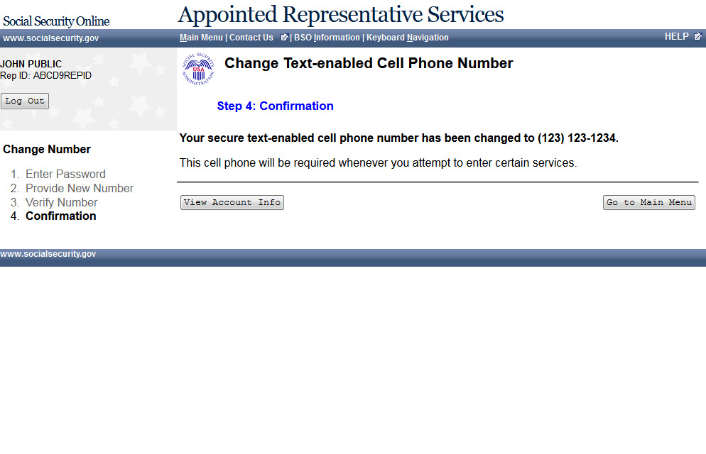

Change Text-enabled Cell Phone Number - Option 2 Selected
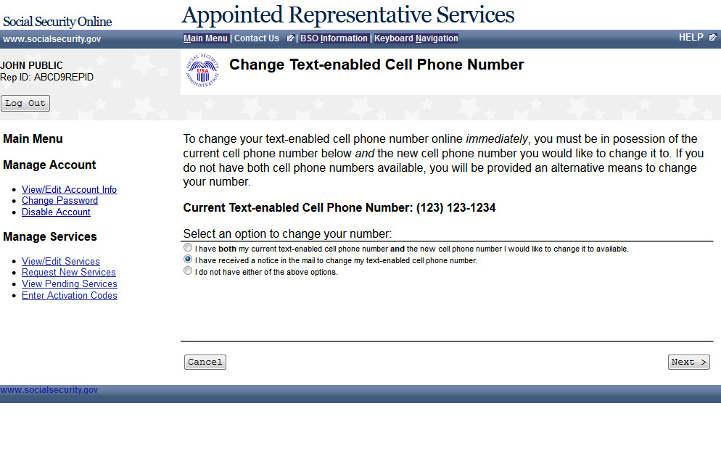

Change Text-enabled Cell Phone Number - Step 1: Enter One-Time Password
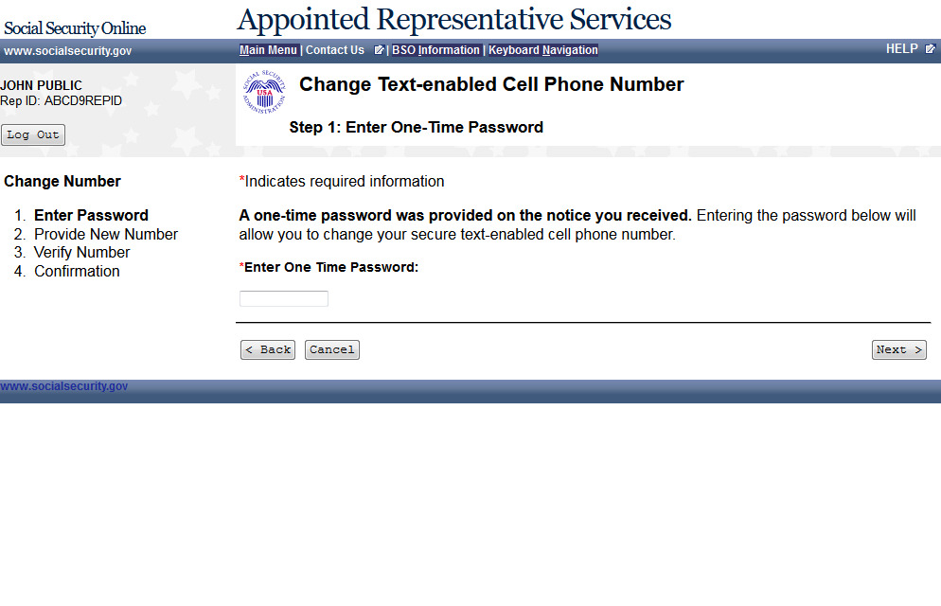

Change Text-enabled Cell Phone Number - Option 3 Selected
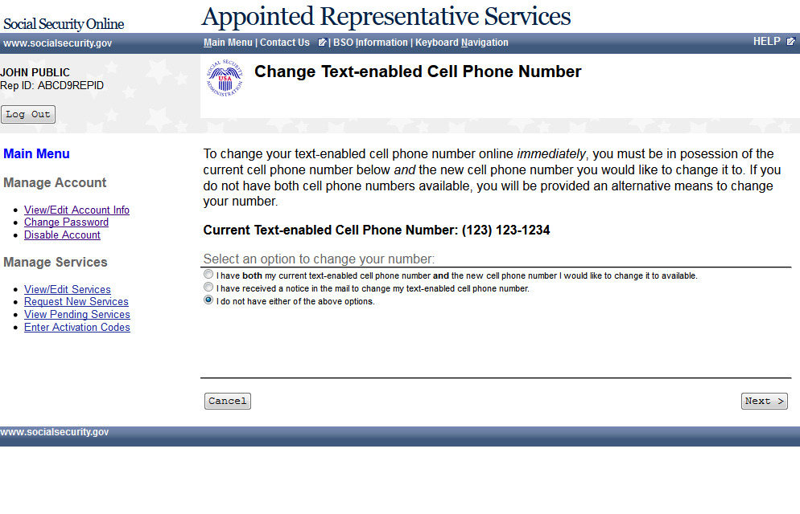

Change Text-enabled Cell Phone Number - Request a Notice to Change your Cell Phone Number
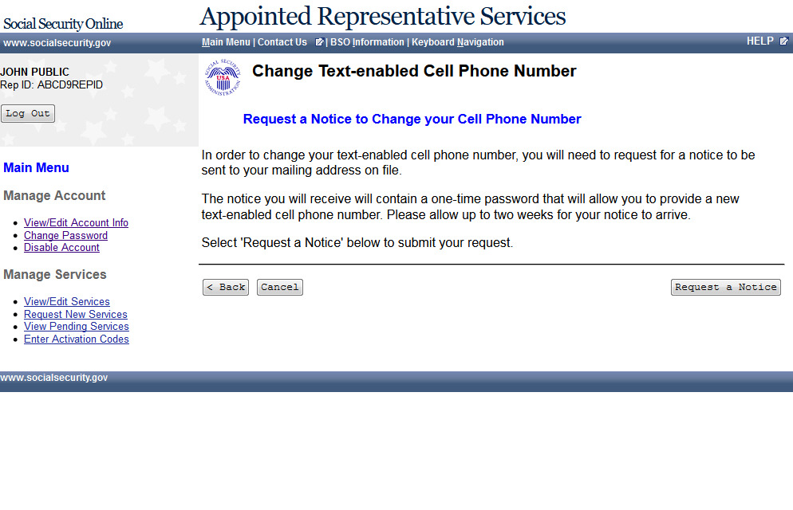

Change Text-enabled Cell Phone Number - A notice will be mailed to you to change your text-enabled cell phone number
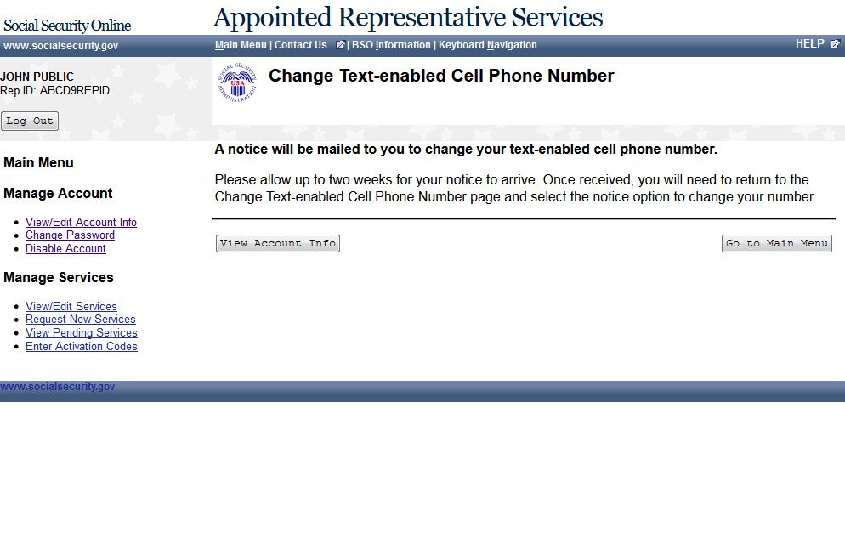

Edit Security Questions
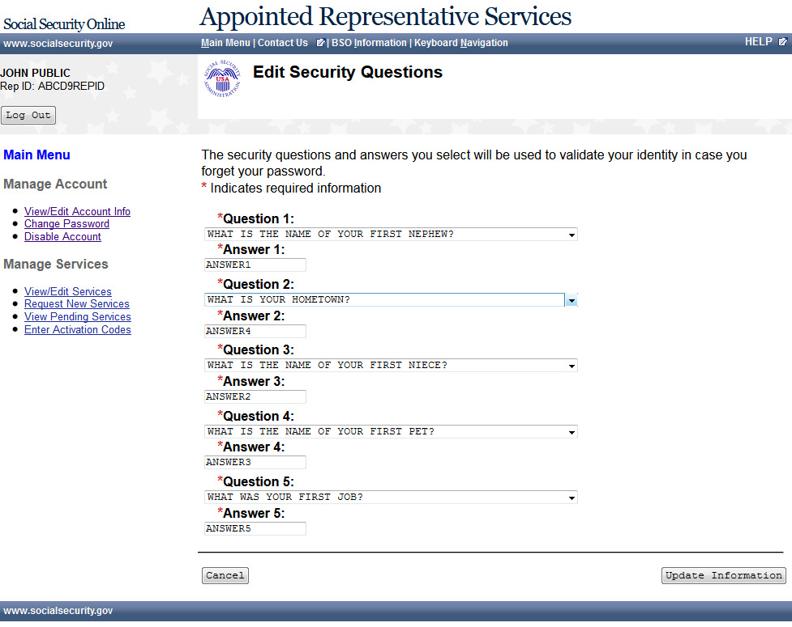

Edit Security Questions – Confirmation
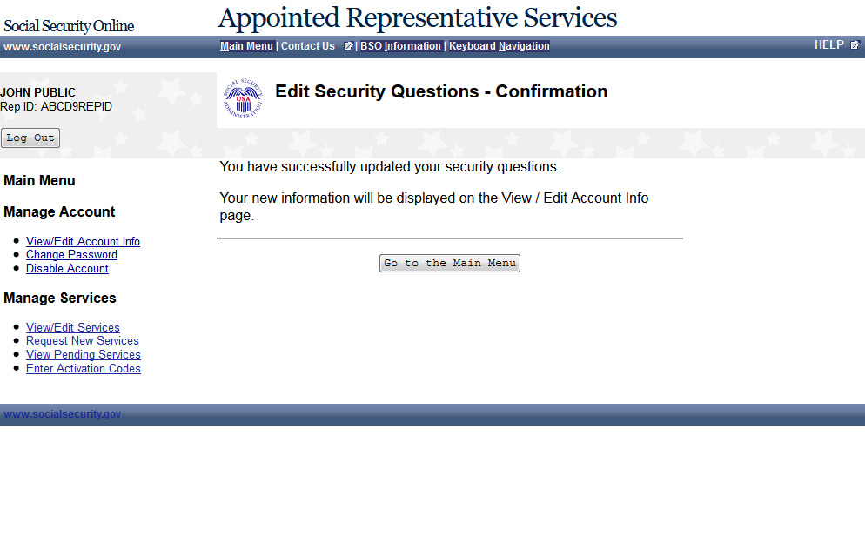

Change Password- (update)
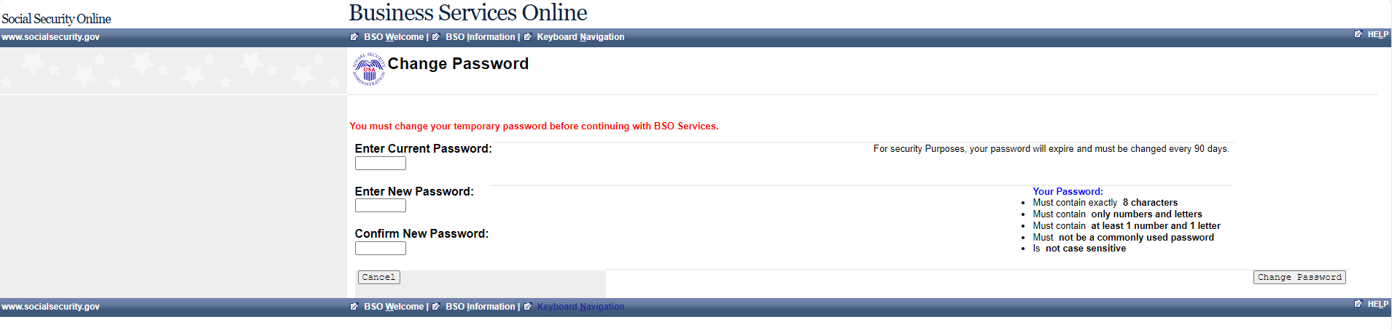

Password Change Successful (update)
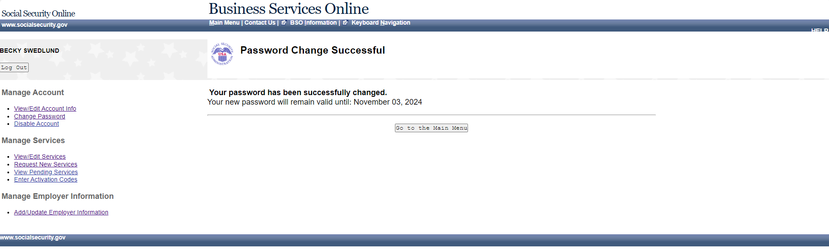

Disable Account (update)
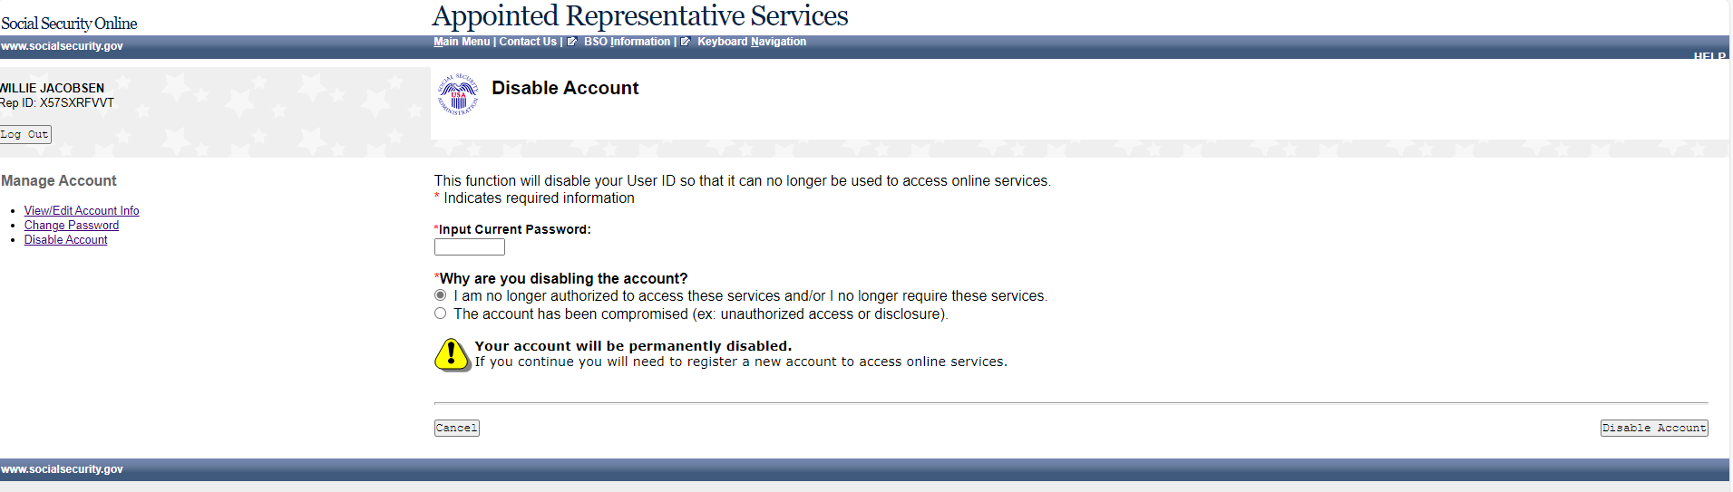

Disable Account – Error (update)
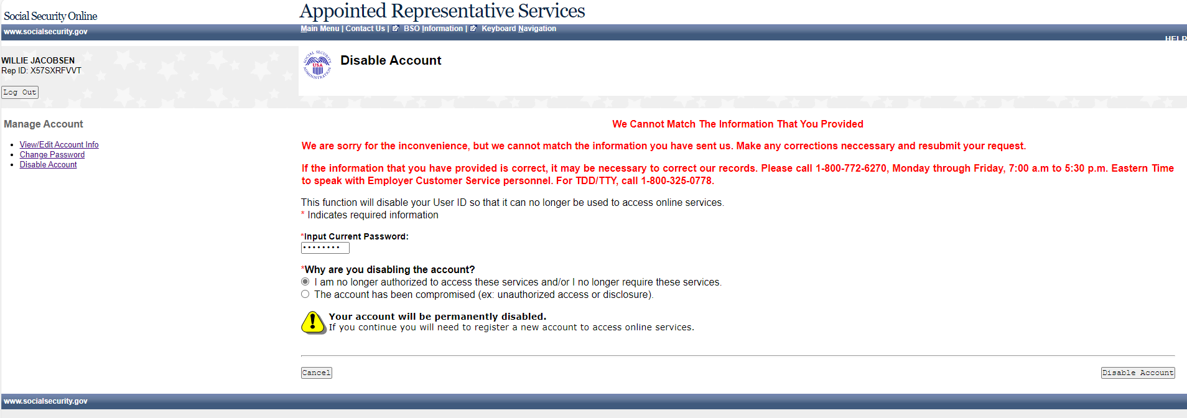

Disable Account – Confirmation

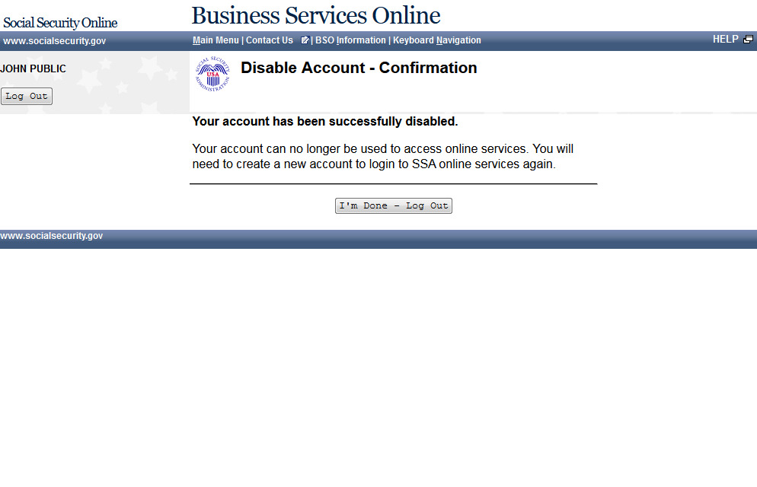

User Identification Deactivated (update)

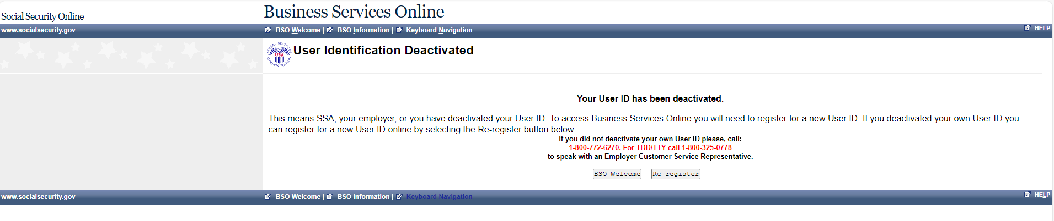

Forgot Password Update Successful

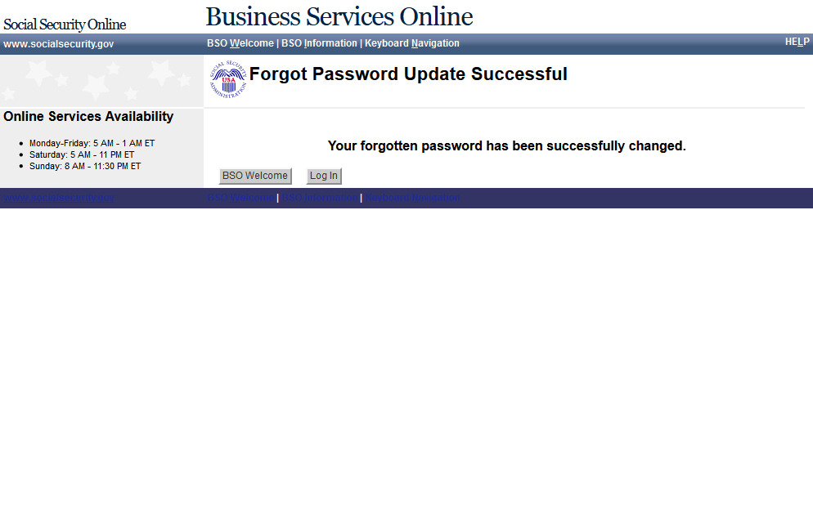

Request Password by Mail (update)
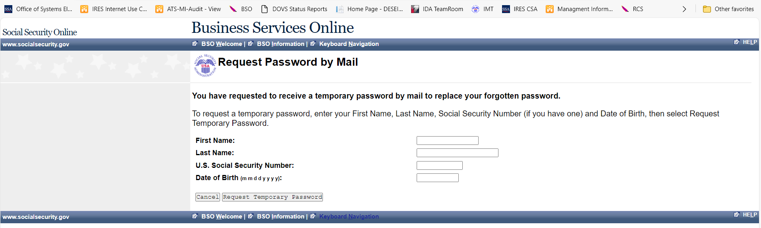

Password by Mail Success (update)

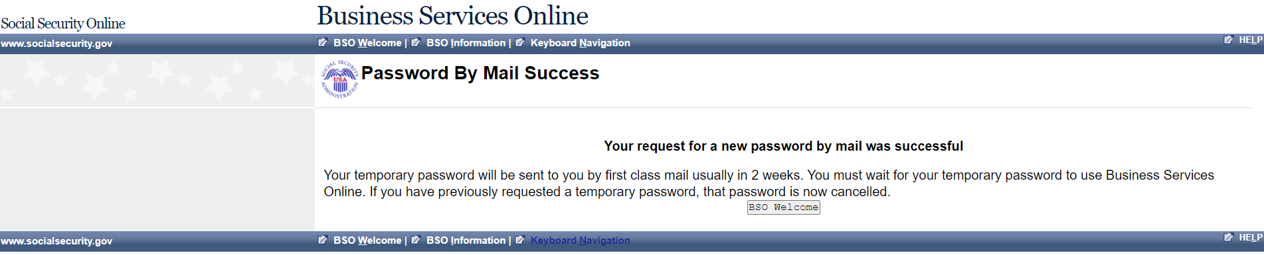

Change Password (update)
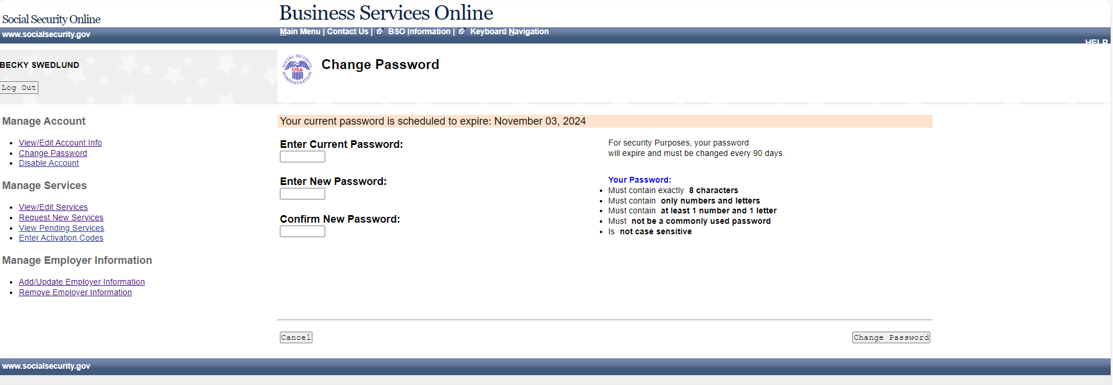

Password Change Successful (update)
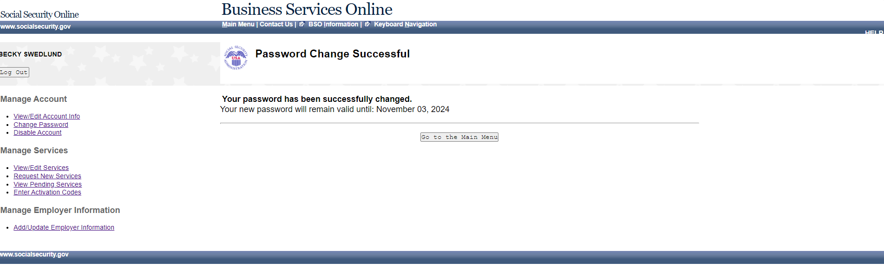

Reached Limit of Attempts (update)
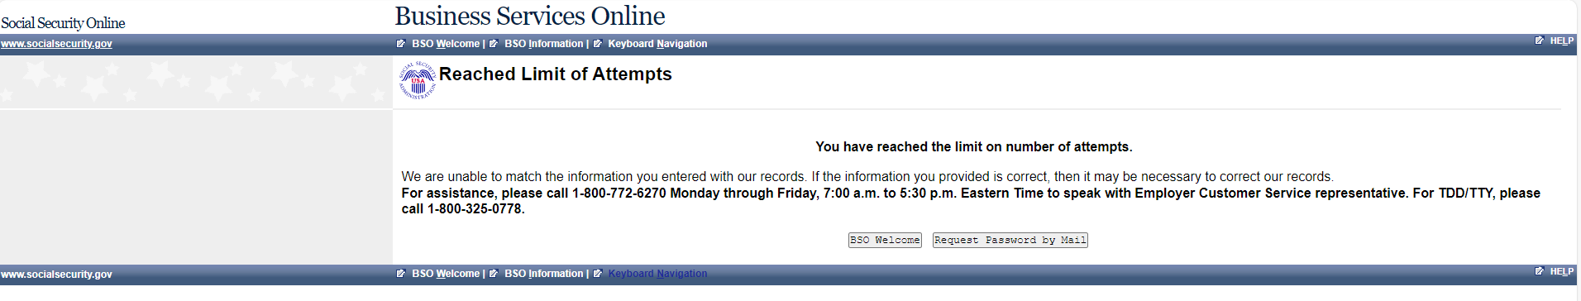

Already Registered (update)
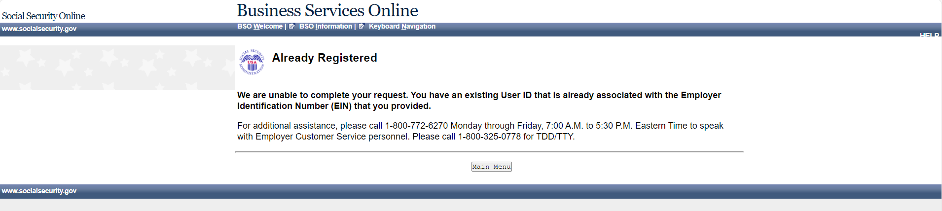

System Failure (update)

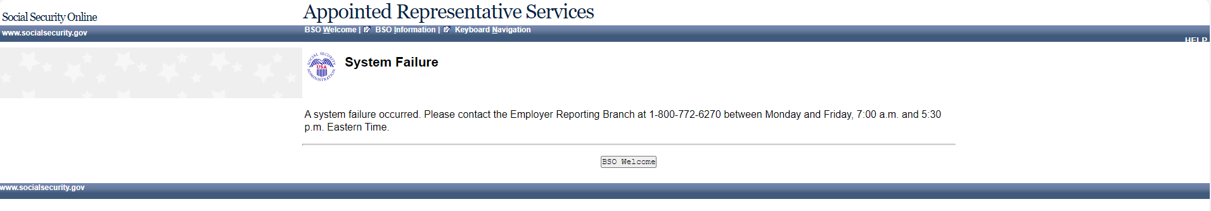

Paperwork Reduction Act Statement – Online Registration (update)
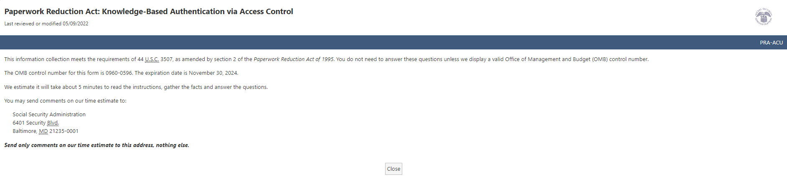

Paperwork Reduction Act Statement – Phone Registration (update)
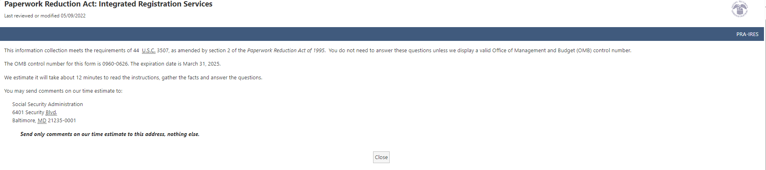

Privacy Act Statement
