Pathways to Work Evidence Clearinghouse Website- Customer Service Feedback Survey
We propose to use Touchpoints (Touchpoints - Product Overview (v2) (digital.gov)), a .gov platform provided as a shared service by the U.S. General Services Administration, to administer the customer service feedback survey.
Touchpoints has multiple options, but we propose to embed the survey within the Pathways to Work website. This option will add a small tab in the lower right of the screen that says, “Click here to leave feedback.” (See Exhibit A.)
This will pop up a small modal window (see Exhibit B) within the Pathways website that would take the individual through a series of 6 questions for which we have the following proposed language:
    - I am satisfied with the Pathways to Work website. [Radio buttons]
      - Strongly disagree
      - Disagree
      - Neutral
      - Agree
      - Strongly agree

    - In the past year, I have used information from the Pathways to Work website to inform a decision about a policy, program, and/or practice. [Radio buttons]
      - Strongly disagree
      - Disagree
      - Neutral
      - Agree
      - Strongly agree

    - How can we improve the Pathways to Work website? [Open text field]
PAPERWORK REDUCTION ACT OF 1995 (Pub. L. 104-13) STATEMENT OF PUBLIC BURDEN:
The purpose of this information collection is to inform potential enhancements to the Pathways to Work website. Public reporting burden for this collection of information is estimated to average 5 minutes per respondent, including the time for reviewing instructions, gathering and maintaining the data needed, and reviewing the collection of information. This is a voluntary collection of information. An agency may not conduct or sponsor, and a person is not required to respond to, a collection of information subject to the requirements of the Paperwork Reduction Act of 1995, unless it displays a currently valid OMB control number. The OMB # is 0970-0401 and the expiration date is 5/31/2027. If you have any comments on this collection of information, please contact PathwaysClearinghouse@abtglobal.com.

Would you like to take two more minutes to answer more questions to help us improve the Pathways to Work website? [Blue Button: Yes, keep going] [Gray Button: No, only submit these responses]
If users click [Blue Button: Yes, keep going], then present these questions:
    - The Pathways to Work website provided me with the information I needed.
      - Strongly disagree
      - Disagree
      - Neutral
      - Agree
      - Strongly agree

    - I was able to find information quickly and easily on the Pathways to Work website.
      - Strongly disagree
      - Disagree
      - Neutral
      - Agree
      - Strongly agree

    - Why did you visit the Pathways to Work website today? (Optional) [Open text field]

Exhibits

Exhibit A

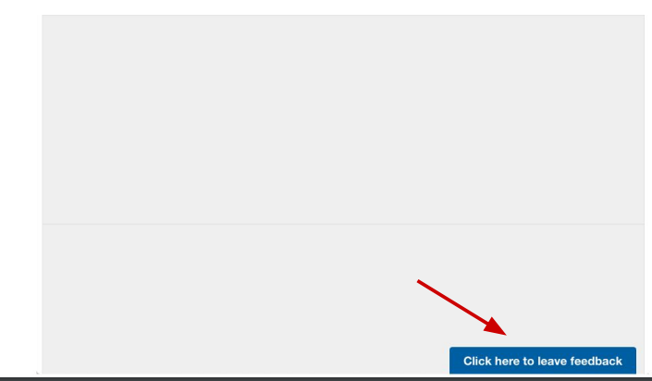

Exhibit B

