**Appendix B.**

**Family Input Project Description and Pilot Test Flier**

|  |  |
| --- | --- |
| TANF and Child Support Moving Forward:  Further Incorporating Family Input | |
| **What is the back-ground for the study?** | Seeking and obtaining feedback from families on how programs can better operate, improve services, and serve future families can create more effective and equitable social programs. Some federally funded human services programs already seek and incorporate feedback from families, particularly in the fields of child welfare, youth homelessness prevention, teen pregnancy prevention, and home visiting programs. Additionally, Tribal communities have often used storytelling as a way to capture families’ perspectives. However, obtaining and using input from families to inform program service delivery and operational improvements appears to be much less common in the Temporary Assistance for Needy Families (TANF) and child support programs. |
| **What is the study’s focus?** | Through this study, the Office of Planning, Research, and Evaluation (OPRE) in the Administration for Children and Families at the U.S. Department of Health and Human Services seeks to (1) understand how TANF, child support, and other human services programs gather and use input from the families they have served, currently serve, or could serve for program improvement; (2) identify ways for TANF and child support programs to incorporate family input for program improvement; and (3) identify the successes and challenges these programs face in gathering and using family input.  This study will explore approaches to gathering family input, create program resources to support programs in gathering and using family input, engage TANF and child support programs in formative learning cycles to test and refine the resources, and report on findings. OPRE has contracted with Mathematica and its partner, MEF Associates, to design and conduct the study. |
| **How will the study be conducted?** | The TANF and Child Support Moving Forward: Further Incorporating Family Input study includes several key activities:   * Conduct knowledge development activities, such as literature scans and consultations with key informants, to better understand the usage of family input in State, Tribal, and Local TANF and child support programs. * Convene and consult with an Expert Work Group consisting of members with diverse identities and experiences, including TANF and child support program staff and former or current families, to provide input and feedback on major study activities. * In partnership with the Expert Work Group, develop family input resources to support TANF and child support programs to design, obtain, and analyze input from the families they serve to inform program improvement. * Pilot the family input resources with several TANF and child support programs. * Update and re-publish the family input resources based on pilot test findings. |
| **When will the study happen?** | The study began in September 2021 and will continue through September 2026. |
| **What will the study produce?** | The study team will develop family input resources that can help TANF and child support programs design, obtain, and analyze family input to improve their programs. A final report will be produced that summarizes the process used to develop the family input resources and synthesizes lessons learned through the course of the study; the family resources prepared by the study team will be appended to the final report. |
| **To find out more** | **Contact the Mathematica project director:** *Pamela Holcomb* at (202) 250-3573 or [PHolcomb@mathematica-mpr.com](mailto:PHolcomb@mathematica-mpr.com). **Contact the OPRE project officer:** *Lisa Zingman* at [Lisa.Zingman@acf.hhs.gov](mailto:Lisa.Zingman@acf.hhs.gov) |

Pilot test opportunity

What is the [Family Input Study](https://www.acf.hhs.gov/opre/project/tanf-and-child-support-moving-forward-lessons-learned-covid-19-pandemic-and-further)?

What are the benefits of participating?

Sponsored by the Office of Planning, Research & Evaluation (OPRE), this study seeks to: (1) understand how TANF, child support, and other human services programs gather and use family input for program improvement; (2) identify ways for TANF and child support programs to incorporate family input for program improvement; and (3) identify the successes and challenges these programs face in gathering and using family input. OPRE has contracted with Mathematica and its subcontractor, MEF Associates, to conduct the study.

Access to resources that will help you improve your program

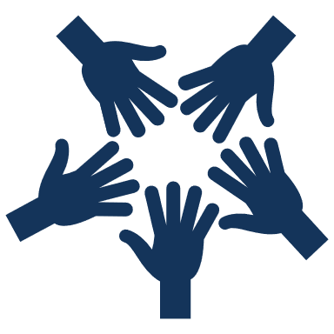What is being piloted?

Elevate family voice in program changes

The study has developed a toolkit to support programs in planning for and engaging families in program improvement. The toolkit (“Family Input Resources”) includes original and curated resources, guides, and tools for administrators and practitioners of TANF and child support programs.

Take the guesswork out of making changes aimed at improving family outcomes

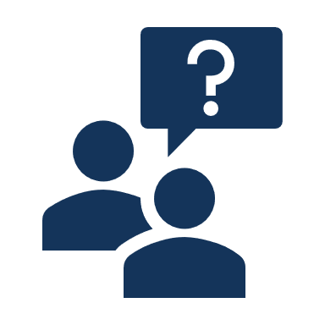**The study is seeking TANF and child support programs run by states, tribes, territories, and counties to pilot test the toolkit. During the 12-month pilot test period, participating programs will lead a program improvement effort using the Family Input Resources toolkit and input from the families they serve to guide their effort.**

Monthly guidance and support from study team coaches

What are the expectations of participating?

TANF and child support programs that would like to pilot test the Family Input Resources toolkit must commit to:

* Leading one or more improvement efforts that include gathering input from families.
* Referencing and using the Family Input Resources toolkit to support the improvement effort(s).
* Meeting with study team coaches for technical assistance and encouragement at least monthly over the 12-month pilot testing period.
* Sharing the progress, successes, and challenges of the program improvement effort with study team coaches.
* Providing feedback to the study team about the Family Input Resources toolkit and your experiences with the program improvement effort through a brief monthly survey (one staff person only), interviews (twice during the pilot testing period), and a focus group (a few months after pilot testing ends).

We’re interested in pilot testing the Family Input Resources! What now?

**Please complete this expression of interest form [hyperlink] by [date].**

The study team will review all expressions of interest and may follow up with you to learn more about your program and interest in participating and to share more details about the pilot. The study team will select eight programs to participate, ensuring a diversity of program types, locations, experience engaging families for their feedback, and areas for improvement. The study team will follow up with al programs that express interest to indicate whether they were selected or not.

What is the timeline?

**[months] 2023**

Programs submit expressions of interest; study team follows up with some programs

**[months] 2024 - 2025**

Focus group with program staff ~4 months after pilot ends

**[months] 2024**

Pilot testing ends after 12 months; interviews with program staff

**During pilot test**

Monthly coaching; brief monthly survey (one staff person); interviews with program staff after 6 months

**[months] 2023**

Participating programs start pilot testing

**[months] 2023**

Study team finalizes site selection

