Instrument 7. DDDRP participant photo release and instructions

This guide is about a voluntary photo sharing activity for people receiving diapers from [local diaper program].

Invitation to Participate and Introduction
Westat is working with [local diaper program] to study what is working and not working for families in the program. We invite you to share photos and other images that will help us better understand and tell your story as a [local diaper program] participant. This opportunity is unpaid; we will give you credit if we use your image but we will not pay you to provide an image.

What Photos to Share
Pictures add to stories. We are interested in seeing your photos that show:
- how needing diapers has affected you or your child
- how you and your family feel when you have a good diaper supply
- your experiences with the [local diaper program]
We are interested in both the happy parts and the hard parts of your story.

How to Participate
To participate:
Step 1. Take a photo. You can photograph places, objects, people, or your own art. Do not include photos of people’s faces. Art may include a drawing, sculpture, or painting.
Step 2. Take a screenshot. After you take a photo, expand the photo so it takes up most of your screen. Take a screenshot of the photo. A screenshot is a picture of your phone or computer screen. A screenshot will not include any saved information about where you took the photo. This is to protect your privacy and the privacy of people in the photo. If you do not know how to take a screenshot, you can Google “take a screenshot” and your phone model (such as “iPhone 9”). Every phone is a little different. You can also ask a focus group leader or email us (diapereval@westat.com) for help learning how!
Step 3. Email the screenshot to diapereval@westat.com. Please include:
- The screenshot of the photo.
- One or two sentences about why you shared this photo or how it makes you feel. We may use your description as a caption in reports and presentations (see the next section for examples).
- If you would like us to share your name with the photo. If you want to share your name, tell us how you would like us to show it. You can use your full name or initials. For example, you can use Molly Smith, M. Smith, or Molly S. If you do not want your name to show at all, we will say “Photo submitted by a program participant.”
Step 4. Look for our reply message. When you send a screenshot, we will try to reply within a day to remind you how we will use the images. We will ask you to say if you agree and understand.
Step 5. Reply to our message. If you agree, please give your permission for us to use the photo by replying “Yes” and your full name. We can only consider your image for publication if you reply “Yes” and include your name. The information we will send is included at the end of this guide (see “Photo Release” section” if you want to review before sending the photos to us).

Examples
Here are some examples of possible photos and descriptions:
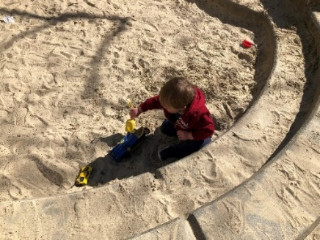  When I have enough diapers, I feel like I can take my son to the park to play. It’s nice to spend time with other parents and get fresh air. | 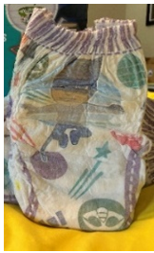  I wish the diaper program carried pull-ups. My toddler is still potty training and pull-ups are even more expensive than diapers. | 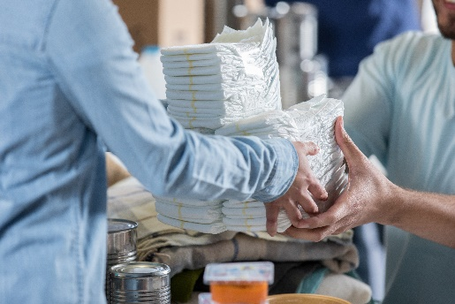  The diaper bank has been helpful for me. It gives our family an option when we run short on diapers.

Your Rights
Submitting photos is voluntary. You do not have to take part in this activity. You can choose to share or not share images.

Things to Consider When Submitting Your Photos
Your photos may be used in public reports or presentations available on the internet. Other people may see these photos. Please only share photos you would feel comfortable being shared broadly on the internet.
Before you submit any photos or images, we ask that you follow these guidelines:
- Do not share photos that include the faces of people, including those under the age of 18 (infants, children, or teenagers).
- Do not share photos that include other identifying information, like street addresses.
- Do not share photos of anything illegal, that could suggest anyone, child, or adult, is in danger, or that may be viewed as inappropriate or offensive.
Westat reserves the right to not use or publish any photos or images that do not follow the guidelines above.

Photo Release
This is the statement we will send to you. We are sharing it here so you can review it in advance and decide whether you agree with it.
By responding to this email, I agree that the images I submitted are photos that I took and that I hold all rights to the images. I irrevocably grant Westat, its employees, subsidiaries, affiliates, sponsors, agents, partners, assigns, and successors (the “Grantees”) the right to use my photo(s) and preferred name in all forms and media for any purpose related to the Diaper Distribution Demonstration and Research Pilot (“Research Project”), including but not limited to public reports, presentations or displays that may be broadly distributed and accessible on the internet or used for internal purposes by the Administration for Children and Families.
I understand that researchers, students, government workers, and people from my community, among others, may see the photo(s) I took as part of this Research Project. I hereby release and hold harmless the Grantees from any and all claims that may arise regarding the use of my photo(s), including any claims of defamation, invasion of privacy, or infringement of moral rights, rights of publicity, or copyright.
I understand and agree that Westat is not obligated to use my photo(s). I understand and agree that I will not have an opportunity to review the final products before they are published or distributed, and Westat may edit, reformat, or otherwise alter the photo(s) for these purposes without my inspection, further consent, or approval. In consideration for this Photo Release, I understand and agree that my submission will support and further the Research Project and I have no expectation of payment or other direct benefits for sharing these photo(s) with the Research Project.
I certify that I have read this Photo Release and fully understand the meaning and intent of it, intending to be legally bound by this authorization, and I am over the age of 18.

If You Have Concerns about the Project
If you have any questions about the study, you can call Dr. Allison Hyra, the Project Director, at (703) 822-4639.

