Form Approved

OMB No. 0990-0379

Exp. Date 10/31/2026

**OIG HHS.gov Feedback Survey Content**

Internal note: pages and questions not numbered. The OMB number and expiration date will be on every page of the survey. This is an optional survey that visitors can decide to respond to if they click on a “Feedback” button. This is a customized version of an approved feedback survey currently in use by HHS with successful results.

# Page 1 - Intro Text & Why Visit

Help us improve the OIG.HHS.gov website

This survey should take no more than 3 minutes to complete. We will use your answers to improve the experience for the people who use the OIG.HHS.gov website.

This survey is conducted in accordance with Executive Order 12862. With the possible exception of email address, the survey does not collect personal information. Fields that are required include an asterisk (*).

For immediate help, contact us.

Why did you visit OIG.HHS.gov today?* Select all that apply.

[Radio buttons, randomized but Other listed last]

* To learn about HHS OIG
* To learn more about consumer alerts, or fraud and abuse laws
* To file a complaint or report fraud
* To research excluded individuals and entities (LEIE database)
* To find an OIG HHS report or recommendation
* To learn more about compliance
* Other (Please specify). [Smaller text below] Do not include personal information.

[text field]

[Back / Next buttons]

*Form Approved OMB# 0990-0379 Exp. Date 10/31/2026 [links to public protection clause found in the first page footer of this document]*

# 

# Page 2 – Specific Goal

What specifically were you looking for?

[Smaller text below] *Do not include personal information.*

[Text Area]

[Back / Next buttons]

*Form Approved OMB# 0990-0379 Exp. Date 10/31/2026 [links to public protection clause found in the first page footer of this document]*

# Page 3 – Statement agreements – Select all that apply.

I was able to find what I was looking for.

The pages I have read were easy to understand.

[Check box ]

The pages I have read were up to date.

[Check box ]

The pages I have read allow me to take action.

[Check box ]

[Back / Next buttons]

*Form Approved OMB# 0990-0379 Exp. Date 10/31/2026 [links to public protection clause found in the first page footer of this document]*

# Page 4 – Improve Experience

How can we improve your experience with the OIG.HHS website?

[Smaller text below] Do not include personal information.

[Text Area]

[Back / Next buttons]

*Form Approved OMB# 0990-0379 Exp. Date 10/31/2026 [links to public protection clause found in the first page footer of this document]*

# 

# Page 5 - Audience

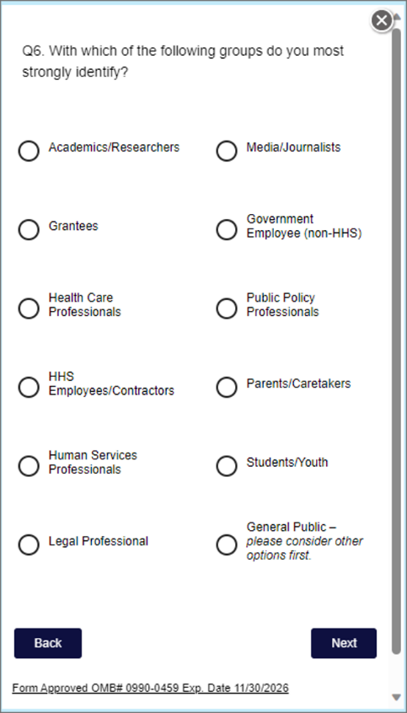In order to better understand your preferences, with which of the following groups do you most strongly identify?

[Radio buttons]

* Media/Journalists
* Advocacy Groups
* Government Employees/Contractors
* Congressional Staff
* Compliance/Legal
* Law Enforcement
* Healthcare – Large Org or Service Provider
* Healthcare – Practitioner or Small Practice
* Public Policy Professionals
* Guardians/Caretakers
* Students/Youth
* General Public *– please consider other options first.*

[Back / Next buttons]

*Form Approved OMB# 0990-0379 Exp. Date 10/31/2026 [links to public protection clause found in the first page footer of this document]*

[Note: This question will be implemented in 2 columns as per the example screenshot above which has been approved and used successfully at hhs.gov.]

# Page 6 – Email for feedback

If you provide your email address, it may be used to contact you about future feedback studies about ways to improve OIG.HHS.gov. Your email address will not be linked to your responses and will be deleted upon the completion of any participation in feedback studies or after one year of inactivity. You will only be contacted about future feedback studies, not for other purposes. [The underlined link will direct the user to a “Personally Identifiable Information (PII) Voluntarily Submitted to HHS” section on our Privacy Page. See last page of this document for content.]

For immediate help not related to providing feedback on OIG.HHS.gov, contact us.

Would you like us to contact you for your feedback on ways to improve the OIG.HHS.gov website for visitors?

[Radio buttons]

* Yes
* No

*[If* ***yes*** *to above, show the following email address line. If* ***no*** *do not show or require.]*

Email address*

[Email field]

[Back / Submit buttons]

*Form Approved OMB# 0990-0379 Exp. Date 10/31/2026 [links to public protection clause found in the first page footer of this document]*

# Page 7 – Thank you!

We value your feedback! Thank you for helping us improve the OIG.HHS.gov.website

[Exit survey button]

*Form Approved OMB# 0990-0379 Exp. Date 10/31/2026 [links to public protection clause found in the first page footer of this document]*

# Other OIG.HHS.GOV Website Content Linked to From the Survey

**Personally Identifiable Information (PII) Voluntarily Submitted to HHS-OIG**

Users do not have to provide personally identifiable information to visit HHS-OIG websites.

If you choose to provide us with additional information about yourself through an e-mail message, form, survey, etc., we will only retain the information if needed to respond to your question or to fulfill the stated purpose of the communication.

However, note that all communications addressed to HHS-OIG are maintained, as required by law, for historical purposes. These communications are retained for a period of seven years (unless subject to a litigation or other preservation hold) or when no longer needed for business use. All communications addressed to HHS-OIG are protected by the Privacy Act which restricts our use of them yet permits certain disclosures. If user information is submitted and is to be maintained in a Privacy Act system of records, a Privacy Act Notice will be provided. We maintain and disposition information submitted electronically as required by the Federal Records Act and the National Archives and Records Administration's (NARA) records schedules. It may be subject to disclosure in certain cases (for example, if required by a Freedom of Information Act (FOIA) request, court order, or Congressional access request, or if authorized by a Privacy Act SORN).

**Survey Disclaimer**

According to the Paperwork Reduction Act of 1995, no persons are required to respond to a collection of information unless it displays a valid OMB control number. The valid OMB control number for this information collection is 0990-0379. The time required to complete this information collection is estimated to average 3 minutes per response, including the time to review instructions, search existing data resources, gather the data needed, to review and complete the information collection. If you have comments concerning the accuracy of the time estimate(s) or suggestions for improving this form, please write to: U.S. Department of Health & Human Services, OS/OCIO/PRA, 200 Independence Ave., S.W., Suite 336-E, Washington D.C. 20201, Attention: PRA Reports Clearance Officer