Survey Questions

Language Assistance Symbol Survey
Current as of 8/8/24

Please note all italicized text in yellow are just for instruction to set up the survey and should NOT be included in the survey.
The survey will be created in 20 point, bold, block, font to accommodate for individuals with vision impairment.
All questions should lead to the next, unless otherwise noted.
This first question should appear by itself.
Please select a language for the survey: (Answer will route user to survey in selected language)
- English
- Arabic - عربي
- Chinese Traditional - 中國傳統的
- Chinese Simplified - 简体中文
- French - Français
- Korean - 한국인
- Spanish - Español
- Tagalog
- Vietnamese - Tiếng Việt
(The following will be the demographic questions in the user’s chosen language)
Thank you for participating in this survey. This survey should take no longer than 15 minutes to complete. This survey will ask you to look at symbols and answer questions about how well they indicate that a person who does not speak English well needs help communicating with other people. The symbols are intended to let people know that language assistance services, such as interpretation or translation services, are available.
Please answer these questions to see if you qualify to complete the survey:
- What is your race and/or ethnicity?
  - American Indian or Alaska Native
  - Asian
  - Black or African American
  - Hispanic or Latino
  - Middle Eastern or North African
  - Native Hawaiian or Pacific Islander
  - White
- What state or territory do you reside? (The following should be a drop-down menu)
- American Samoa
- Alabama
- Alaska
- Arizona
- Arkansas
- California
- Colorado
- Connecticut
- Delaware
- Florida
- Guam
- Georgia
- Hawaii
- Idaho
- Illinois
- Indiana
- Iowa
- Kansas
- Kentucky
- Louisiana
- Maine
- Maryland
- Massachusetts
- Michigan
- Minnesota
- Mississippi
- Missouri
- Montana
- Nebraska *Nevada
- New Hampshire
- New Jersey
- New Mexico
- New York
- North Carolina
- North Dakota
- Northern Mariana Islands
- Ohio
- Oklahoma
- Oregon
- Pennsylvania
- Puerto Rico
- Rhode Island
- South Carolina
- South Dakota
- Tennessee
- Texas
- US Virgin Islands
- Utah
- Vermont
- Virginia
- Washington
- Washington D.C.
- West Virginia
- Wisconsin
- Wyoming
- Other (Free-Text)
- What is your age? (User Inputs Age. If 18 or older move to next question. If under 18 go to exit page)
- Do you speak a language other than English at Home?
- Yes
- No (Skip to Question #7 )
- What is this language? (free text)
- How well do you speak English?
- Very Well
- Well
- Not Well
- Not at All
(Exit page response) Thank you for answering these questions. At this time, you do not qualify to take our survey.
(After the demographics questions are answered, the following survey should appear in the user’s chosen language)
Thank you for participating in this survey. We are interested in your thoughts about several symbols.
For this survey, you will view symbols that are designed to help someone who does not speak English well to let others know that they need help to communicating with other people. The symbols are intended to let people know that language assistance services, such as interpretation or translation services, are available.
The questions will ask you to view a symbol and share more information about your response. The final question will ask you to rate all the symbols in order from best to worst.
Symbol A
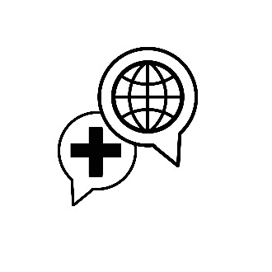
- What does this symbol mean to you? (free text)
- How well does this symbol indicate that language assistance services, such as interpretation or translation services, are available?
  - Very good
  - Good
  - Fair
  - Poor
  - Very poor
- Please share more information about why you chose your response for question 2. (free text)
- Does the symbol remind you of any negative thoughts or experiences?
  - Yes
  - No
- If you answered yes to question four, what does the symbol remind you of and why? (free text)
- How would you change the symbol to better indicate that language assistance services (i.e., interpretation or translation services) are available for individuals who need help communicating? (free text)

Symbol B
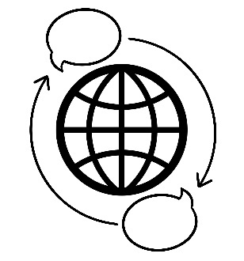
- What does this symbol mean to you? (free text)
- How well does this symbol signify that language assistance services, such as interpretation or translation services, are available?
  - Very good
  - Good
  - Fair
  - Poor
  - Very poor
- Please share more information about why you chose your response for question 2. (free text)
- Does the symbol remind you of any negative thoughts or experiences?
  - Yes
  - No
- If you answered yes to question four, what does the symbol remind you of and why? (free text)
- How would you change the symbol to better signify that language assistance services (i.e., interpretation or translation services) are available for individuals who need help communicating? (free text)

Symbol C
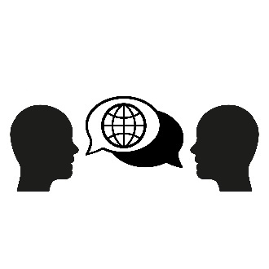
- What does this symbol mean to you? (free text)
- How well does this symbol signify that language assistance services, such as interpretation or translation services, are available?
  - Very good
  - Good
  - Fair
  - Poor
  - Very poor
- Please share more information about why you chose your response for question 2. (free text)
- Does the symbol remind you of any negative thoughts or experiences?
  - Yes
  - No
- If you answered yes to question four, what does the symbol remind you of and why? (free text)
- How would you change the symbol to better signify that language assistance services (i.e., interpretation or translation services) are available for individuals who need help communicating? (free text)

Symbol D
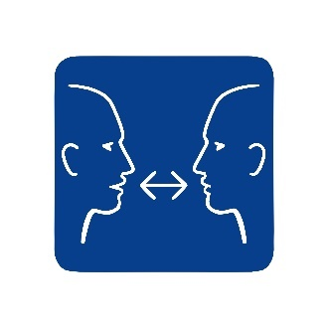
- What does this symbol mean to you? (free text)
- How well does this symbol signify that language assistance services, such as interpretation or translation services, are available?
  - Very good
  - Good
  - Fair
  - Poor
  - Very poor
- Please share more information about why you chose your response for question 2. (free text)
- Does the symbol remind you of any bad or negative thoughts or experiences?
  - Yes
  - No
- If you answered yes to question four, what does the symbol remind you of and why? (free text)
- How would you change the symbol to better signify that language assistance services (i.e., interpretation or translation services) are available for individuals who need help communicating? (free text)

Symbol E
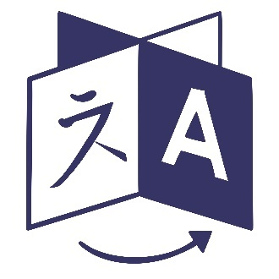

- What does this symbol mean to you? (free text)
- How well does this symbol signify that language assistance services, such as interpretation or translation services, are available?
  - Very good
  - Good
  - Fair
  - Poor
  - Very poor
- Please share more information about why you chose your response for question 2. (free text)
- Does the symbol remind you of any negative thoughts or experiences?
  - Yes
  - No
- If you answered yes to question four, what does the symbol remind you of and why? (free text)
- How would you change the symbol to better signify that language assistance services (i.e., interpretation or translation services) are available for individuals who need help communicating? (free text)

Symbol F
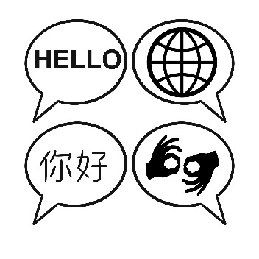

- What does this symbol mean to you? (free text)
- How well does this symbol signify that language assistance services, such as interpretation or translation services, are available?
  - Very good
  - Good
  - Fair
  - Poor
  - Very poor
- Please share more information about why you chose your response for question 2. (free text)
- Does the symbol remind you of any negative thoughts or experiences?
  - Yes
  - No
- If you answered yes to question four, what does the symbol remind you of and why? (free text)
- How would you change the symbol to better signify that language assistance services (i.e., interpretation or translation services) are available for individuals who need help communicating? (free text)

Please rank the symbols from 1 to 6. One means that you think the symbol best represents language assistance services, such as interpretation or translation services, are available. Six means that you think the symbol is the worst at representing that language assistance services, such as interpretation or translation services, are available. (allow input of numbers)
Symbol A
Symbol B

Symbol C
Symbol D
Symbol E
Symbol F
(End Statement to Appear after Survey Complete)
We appreciate you taking the time to complete our survey. Thank you.

Appendix 2: Survey Question Flow Chart
