**Attachment A. 2023 SSV Unmoderated Cognitive Testing – Proposed Screens**

Consent screen:

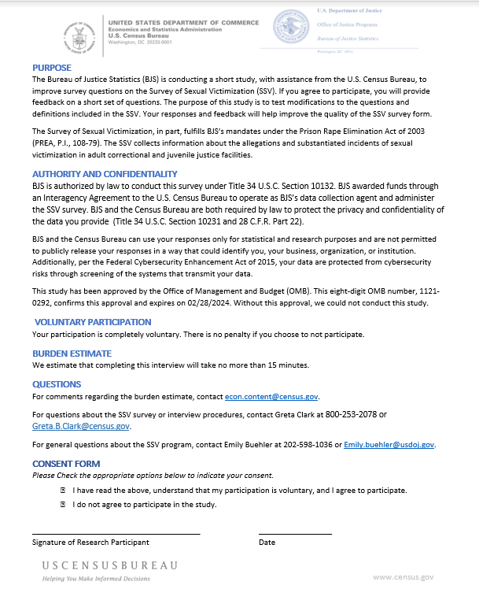

Thank you for agreeing to participate. Before looking at a few questions with new items being considering for the SSV, there are a few background questions about you.

Do you have experience completing the SSV?

* No
* Yes
  + [If Yes to Do you have experience completing the SSV] When completing the SSV, about how many hours do you spend working on the SSV? This estimate, in hours, should include the time spent gathering, entering, and submitting the data.

[TEXT BOX FOR OPEN ANSWER] ___________________________________________

Let’s look at some new items that are being considering for the SSV.

NOTE: SSV-IA/SSV-IJ: [If R completes the IA incident form for adult inmates, they will see the word “inmate” in the question. If R completes the IJ incident form for juveniles, they will see the word “youth.” Their form path will depend on their e-mail address and link from the scheduler.]

**Definitions for sex and gender identity categories**

Some additional categories are being considered for sex and gender identity in addition to the categories of Male and Female. Below are definitions for some of the new answer categories. Please read over the definitions and answer the questions below.

**Sex and gender identity categories**

**Intersex:** A person whose sexual or reproductive anatomy or chromosomal pattern does not seem to fit typical definitions of male or female. Intersex medical conditions are sometimes referred to as disorders of sex development.

**Gender nonconforming:** A person whose appearance or manner does not conform to traditional societal gender expectations.

**Transgender:** A person whose gender identity (i.e., internal sense of feeling male or female) is different from the person’s assigned sex at birth.

Do you find these definitions easy to understand?

* Yes
* No
  + [If No to Do you find these definitions easy to understand] What would you like to see better explained?

[TEXT BOX FOR OPEN ANSWER] ___________________________________________

Are there any other sex or gender identity terms you would like to see included and defined here?

[TEXT BOX FOR OPEN ANSWER] ________________________________________________________

Do you use any of the following terms in your facility’s records to describe the sex and/or gender identity of inmates/youth? Please select all that apply.

* Intersex
* Gender nonconforming
* Transgender
* None of the above

Victim Sex and Gender Identity

Please look over the questions and answer categories for the victim’s sex and gender identity and answer the questions below.

What was the victim’s sex?

Male

Female

Intersex

What was the victim’s gender identity?

Male

Female

Transgender

Gender nonconforming

Unknown

Do the categories shown here match your system’s records for sex of inmates/youth?

* Yes
* No
  + [If No to Do the categories shown here match your system’s records for sex of inmates/youth] What are the answer categories in your system’s records for the sex of inmates/youth?

[TEXT BOX FOR OPEN ANSWER] __________________________________________

Does your record system include the gender identity of inmates/youth?

* Yes
  + [If Yes] Do the categories shown here match your system’s records for gender identity of inmates/youth?
    - Yes
    - No
* No
  + [If No] What other categories are included in your system’s records?

[TEXT BOX FOR OPEN ANSWER] __________________________________________

Do you have any thoughts about a two-question format for reporting sex and gender identity of an/a inmate/youth?

* No
* Yes
  + [If Yes] [TEXT BOX FOR OPEN ANSWER] _______________________________________

Victim Race or Ethnicity – Version A

The next two questions ask about the victim’s race or ethnicity. Please look over the questions and answer categories for the victim’s race or ethnicity and answer the questions below.

What is the victim’s race or ethnicity? (Select [X] all that apply.)

□ White

□ Hispanic or Latino

□ Black or African American

□ Asian

□ American Indian or Alaska Native

□ Middle Eastern or North African

□ Native Hawaiian or Pacific Islander

Do the race or ethnicity categories shown here match your system’s records?

* Yes
* No
  + [If No] What are the race or ethnicity categories in your system’s records?

[TEXT BOX FOR OPEN ANSWER] __________________________________________

[If No to the previous question on Do the race or ethnicity categories shown here match your system’s records] How would you answer this question if your race or ethnicity categories differ from the ones shown here? [TEXT BOX FOR OPEN ANSWER] __________________________________________

Do your system’s records include the category of Middle Eastern or North African for inmates/youth?

* Yes
* No

Does your record system for inmates/youth allow you to select more than one category for race or ethnicity?

* Yes
* No
* Don’t Know

**Victim Race or Ethnicity – Version B**

This question is an alternate version of the question about race or ethnicity. Please look over the question and answer categories and answer the questions below.

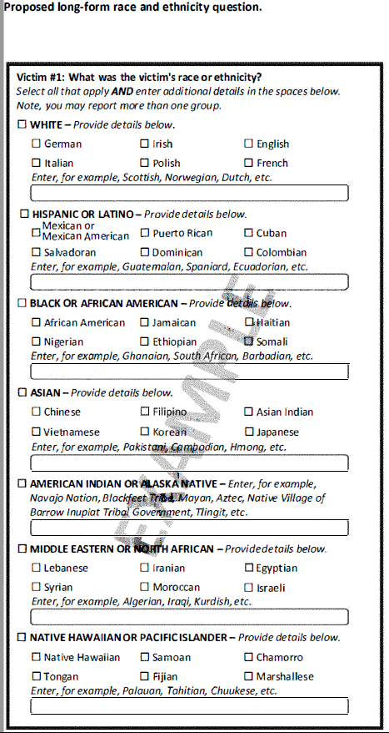

Would you be able to provide data about the race or ethnicity of an/a inmate/youth to the level of detail requested here?

* Yes
* No
* [If No] How would you go about answering this question if it appeared on the SSV? [TEXT BOX FOR OPEN ANSWER] ___________________________________________________

Now that you’ve seen two versions of a question on race or ethnicity, which version would you be able to answer with accuracy for inmate/youth victims at your facility?

* Version A
* Version B
* No preference

**Victim Disability**

At the time of the incident, had the victim been identified as having –

|  |  |  |
| --- | --- | --- |
|  | Yes | No |
| 1. A serious and persistent mental illness |  |  |
| 1. A cognitive impairment or intellectual disability |  |  |
| 1. A physical impairment or disability |  |  |

Do you have records for inmates/youth include disability status or any mention of whether or not an inmate/youth has a disability of any kind?

* Yes
  + [If Yes] Do your records for inmates/youth include the types of disabilities mentioned in the answer categories for this question?
    - Yes
    - No
* No
* [If No] How would you go about answering this question about an inmate/youth’s disability status? [TEXT BOX FOR OPEN ANSWER] _________________________________________________

Are you able to easily access information about an inmate/youth’s disability at the time of the incident?

* Yes
* No

Are there any terms that you would like to see further defined or explained in this question?

* No
* Yes
  + [If Yes] Which terms? [TEXT BOX FOR OPEN ANSWER] ___________________________________

**Staff Sex and Gender Identity**

Please look over the questions and answer categories for the staff perpetrator’s sex and gender identity and answer the questions below.

What was the staff perpetrator’s sex?

Male

Female

Intersex

What was the staff perpetrator’s gender identity?

Male

Female

Transgender

Gender nonconforming

Unknown

Do the categories shown here match your system’s records for sex of staff??

* Yes
* No
  + [If No to Do the categories shown here match your system’s records for sex of inmates/youth] What are the answer categories in your records system for the sex of staff? [TEXT BOX FOR OPEN ANSWER] _____________________________________

Does your record system include the gender identity of staff?

* Yes
  + [If Yes] Do the categories shown here match your system’s records for gender identity of staff?
    - Yes
    - No
* No
  + [If No] What other categories are included in your system’s records for staff?

[TEXT BOX FOR OPEN ANSWER] __________________________________________

Do you have any thoughts about a two-question format for reporting sex and gender identity of staff?

* No
* Yes
  + [If Yes] [TEXT BOX FOR OPEN ANSWER] _______________________________________

Which records are easier for you to access?

* Records for inmates/youth
* Records for staff

**Staff Race or Ethnicity – Version A**

The next two questions ask about the staff perpetrator’s race or ethnicity. Please look over the questions and answer categories for the staff’s race or ethnicity and answer the questions below.

What is the staff perpetrator’s race or ethnicity? (Select [X] all that apply.)

□ White

□ Hispanic or Latino

□ Black or African American

□ Asian

□ American Indian or Alaska Native

□ Middle Eastern or North African

□ Native Hawaiian or Pacific Islander

Do the race or ethnicity categories shown here match your system’s records?

* Yes
* No
  + [If No] What are the race or ethnicity categories in your system’s records for staff?

[TEXT BOX FOR OPEN ANSWER] __________________________________________

[If No to the previous question on Do the race or ethnicity categories shown here match your system’s records] How would you answer this question if your race or ethnicity categories for staff differed from the ones shown here? [TEXT BOX FOR OPEN ANSWER] ________________________________________

Do your system’s records include the category of Middle Eastern or North African for staff?

* Yes
* No

Does your record system for staff allow the option to select more than one category for race or ethnicity?

* Yes
* No
* Don’t Know

**Staff Race or Ethnicity – Version B**

This question is an alternate version of the question about race or ethnicity. Please look over the question and answer categories and answer the questions below.

What is the staff perpetrator’s race or ethnicity?



Would you be able to provide data about the race or ethnicity of a staff perpetrator to the level of detail requested here?

* Yes
* No
* [If No] How would you go about answering this question if it appeared on the SSV? [TEXT BOX FOR OPEN ANSWER] ___________________________________________________

Now that you’ve seen two versions of a question on race or ethnicity, which version would you be able to answer with accuracy for staff perpetrators at your facility?

* Version A
* Version B
* No preference

**Wrap-Up**

Is there anything else that you would like to share about the items or about the SSV in general?

* No
* Yes [TEXT BOX FOR OPEN ANSWER] _____________________________________________

Thank you for you for your time. We appreciate your feedback.