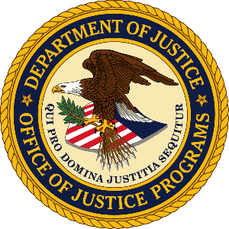

**U.S. Department of Justice**

Office of Justice Programs

*Bureau of Justice Statistics*

*Washington, D.C. 20531*

**MEMO TO:** Amy Reimer-Anderson

Office of the Chief Statistician

Office of Management and Budget

**THROUGH:** Kevin M. Scott, PhD

Acting Director, BJS

**FROM:** Devon B. Adams

Deputy Director, Policy Division

**SUBJECT:** Submission of non-substantive modification for the Generic Clearance for Cognitive, Pilot and Field Studies for Bureau of Justice Statistics Data Collection Activities (OMB #1121-0339)

**DATE:** September 16, 2024

This memo concerns a non-substantive modification to increase the burden hours on the Generic Clearance for Cognitive, Pilot and Field Studies for Bureau of Justice Statistics Data Collection Activities (OMB #1121-0339).

In both the 60- and 30-day notices published in the Federal Register in late 2018 and early 2019, a total of 20,000 burden hours was estimated. However, at some point during the approval process, the number of burden hours was set at 15,000. With the approval in September of BJS’s most recent generic clearance, a total of 14,594 hours has been used. The current generic clearance does not expire until April 30, 2025, and BJS has several more anticipated projects in the pipeline under this generic. BJS is actively working to renew the current generic earlier than April 2025, but in the interim we are requesting an approval to add 3,000 burden hours to the currently approved collection.

The total responses will remain at 30,000, but the number of burden hours is requested to increase to 18,000 hours.

If there are any questions concerning this request, please contact Devon Adams, Deputy Director, Policy Division, Bureau of Justice Statistics, at (202) 598-0349 or by email at [Devon.Adams@usdoj.gov](mailto:Devon.Adams@usdoj.gov).