Justification for Non-material or Non-substantive Change to Currently Approved Collection

AGENCY: Employee Benefits Security Administration (EBSA)

TITLE: Request For Assistance from DOL

STATUS: OMB Control Number: 1210-0146 Exp. Date: 04/30/2027

The Department of Labor (Department) is submitting the addition of a new checkbox selection, a corresponding data field, and a minor text change to EBSA’s existing “request for assistance” website form as a non-material/non-substantive change request. OMB Control Number 1210-0146 is scheduled to expire on April 30, 2027. The Department is not making any other changes to the form.

Section 523 of the Employee Retirement Income Security Act (ERISA), as added by the SECURE 2.0 Act of 2022, requires the Department to create an online searchable database called the “Retirement Savings Lost and Found” within two years of the enactment date. This database will help connect missing participants and other individuals who have lost track of their retirement benefits with retirement plans that may be holding such benefits. Section 523(c)(2) requires the Department to “allow any individual to contact the Secretary to opt out of inclusion in the Retirement Savings Lost and Found.”

This opt-out function will be accomplished by minor changes to EBSA’s existing “request for assistance” website form (https://www.askebsa.dol.gov/webintake/).

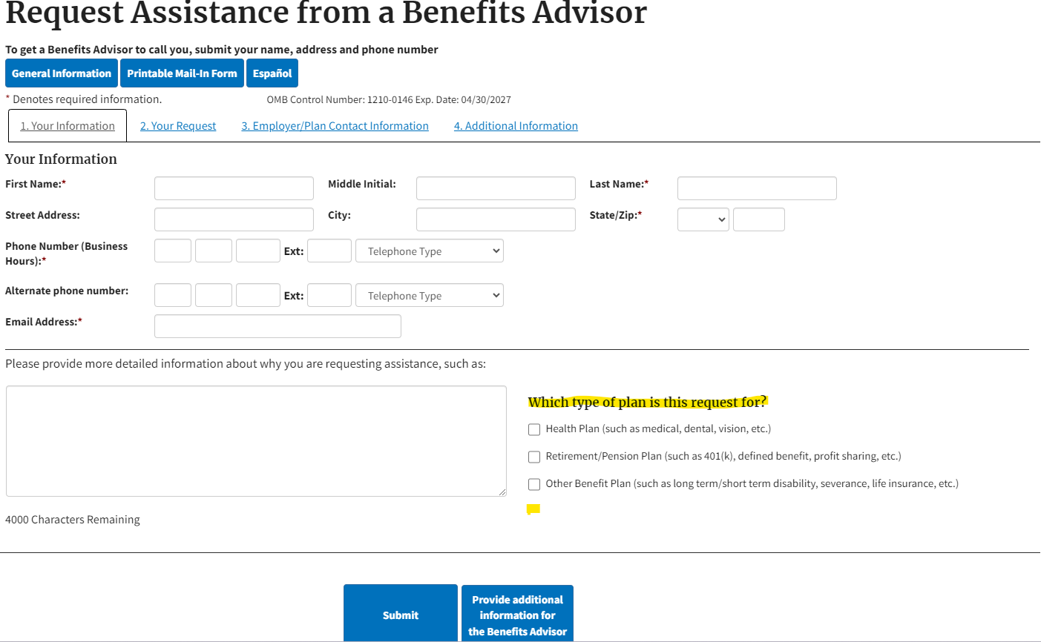
Specifically, EBSA plans to make the following non-substantive changes:

- Modify text of “Which type of plan is this request for?” to read “What is this request for?”
- Add new checkbox to the list, as follows: “Opt Out of Retirement Savings Lost & Found”
- Add new four-character numerical field underneath the checkbox in 2 above (when selected) that reads: “Last 4 Digits of Social Security Number”

Once submitted, an opt-out request will be routed to appropriate Departmental personnel for completion.

