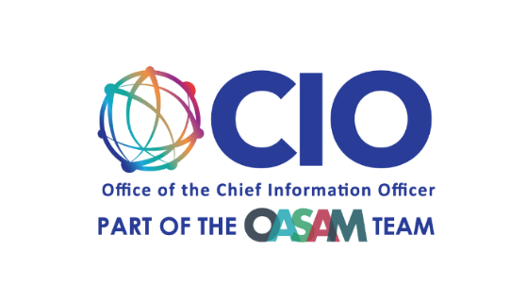

Recruitment Survey for collection 1
EBSA Lost and Found Portal

EBSA Lost and Found Design Review Focus Group Recruitment Survey
Recruitment survey questions for possible focus group participants. All fields are required.

- Email Address
We are collecting your email address so we may contact you to inform you if you have been selected as a participant.

- What city and state are you located in?

- Which of the following best describes you?
  - Asian or Pacific Islander
  - Black or African American
  - Hispanic or Latino
  - Native American or Alaskan Native
  - White or Caucasian
  - Multiracial or Biracial
  - Not listed here

- Please select your age group
  - 30 - 40
  - 40 - 50
  - 50 - 60
  - 60 and over

- Have you had at least two jobs where your employer provided retirement benefits?
An employer-sponsored retirement plan is a workplace benefit offered by some companies to help provide workers with income in retirement (ex: a pension, 401k, 403b etc.).
  - Yes
  - No
  - I'm not sure.

- Do you have any type of visual impairment that affects your ability to see colors, shapes, or details?
Please select one option that best applies to you.
  - Yes, I have colorblindness.
  - Yes, I have another visual disability.
  - No, I do not have any visual impairment.

