**Introduction**

**Allegation Details**

**Suspect Entity Details**

**Documents**

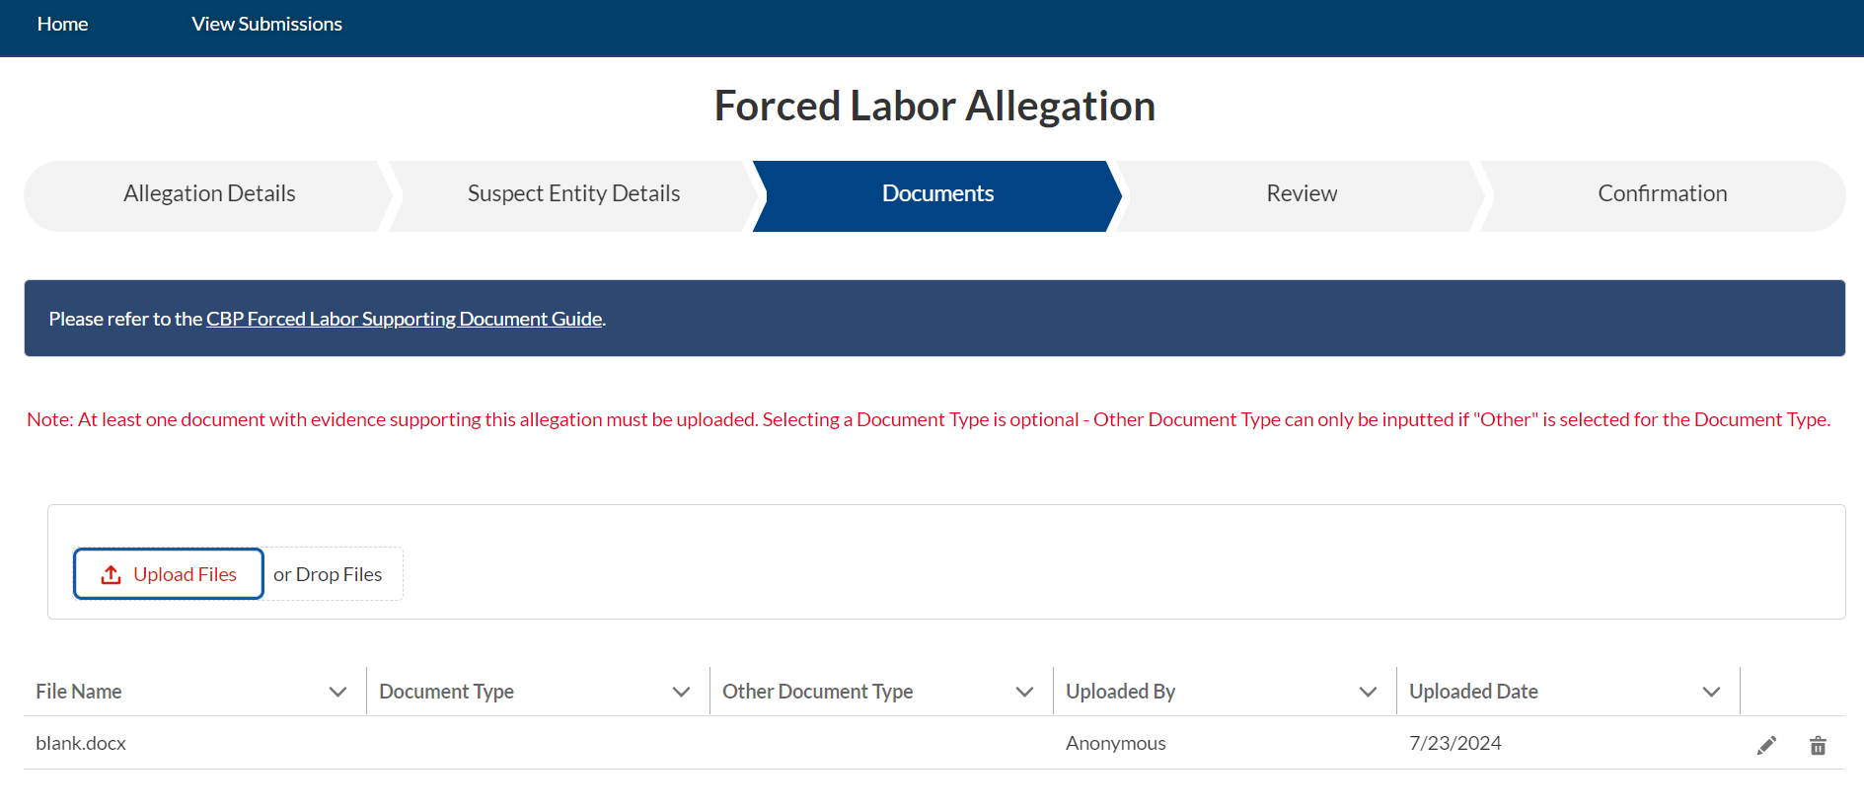



**Review**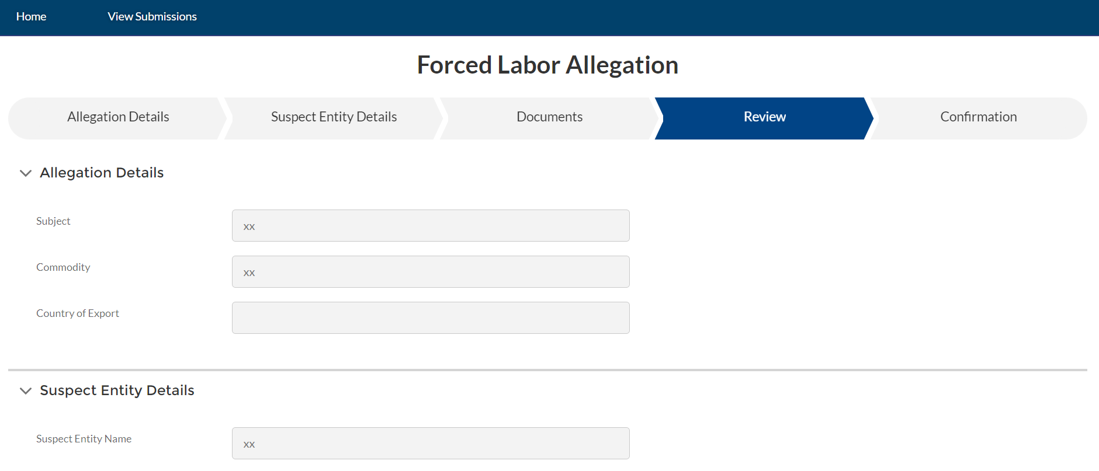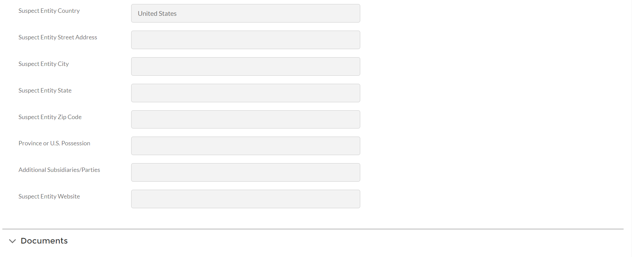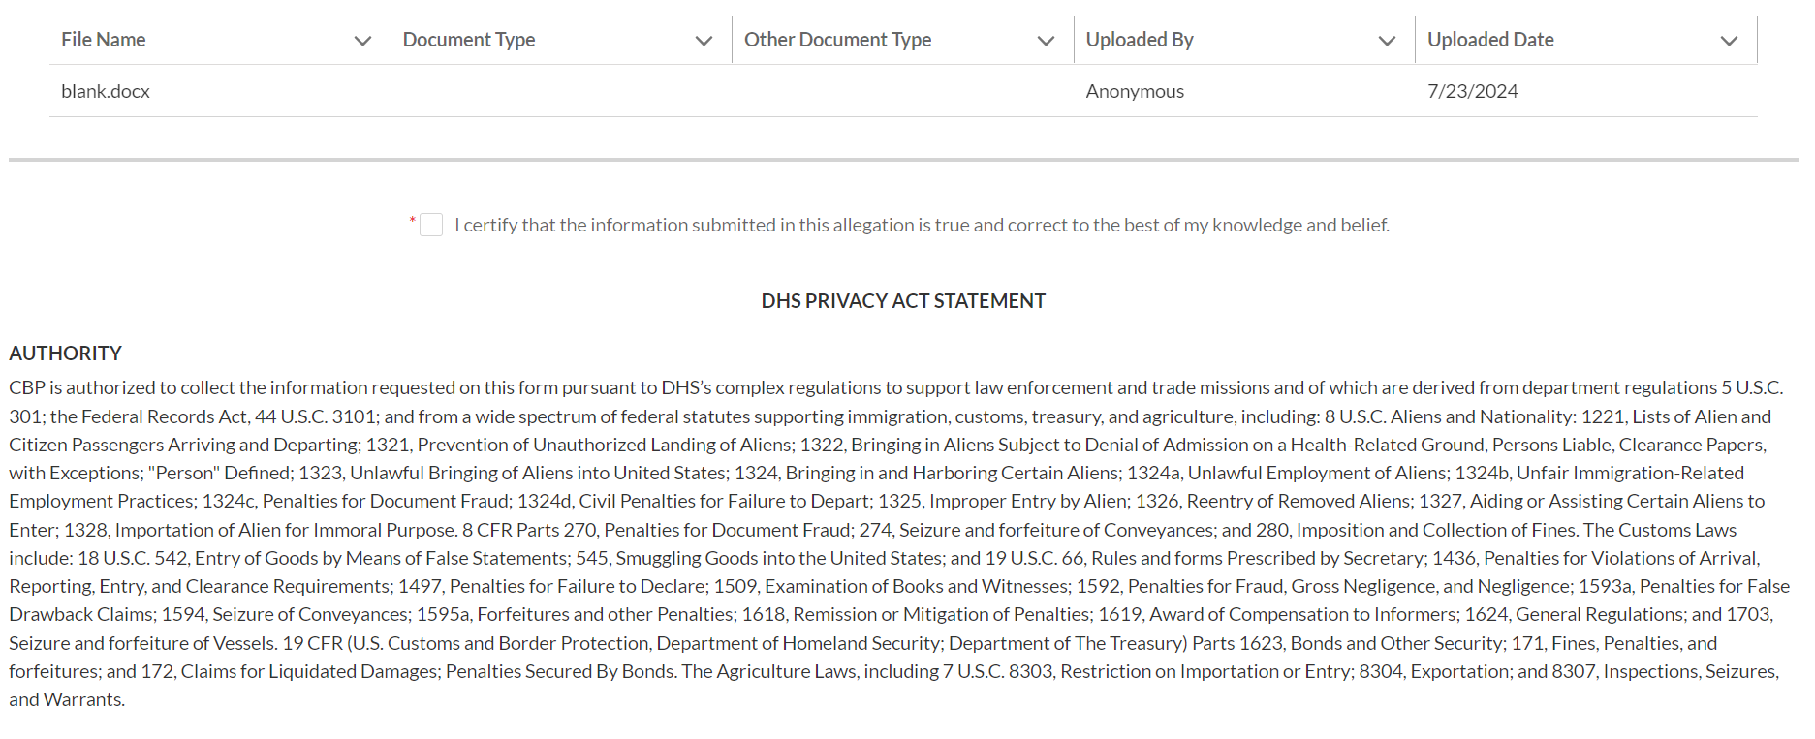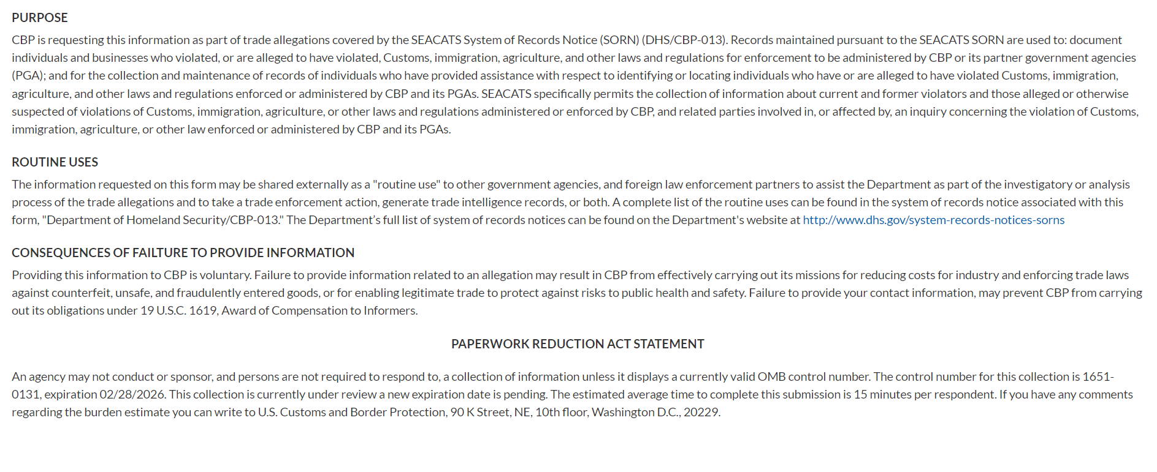

**Confirmation**

