Additional changes to the 2025-26 FAFSA form

**Page 1:** In the Mail Your FAFSA Form section, we added a sentence instructing the user to include all pages, even if they are blank.

**Page 2:** Updated state deadlines in consultation with state aid partners.

**Page 6:** In the Signatures section, we removed the reference to signing electronically with an FSA ID, since that doesn’t apply to a paper application. Highlighted text is what was changed and now says “by signing this application, you authorize . . .”

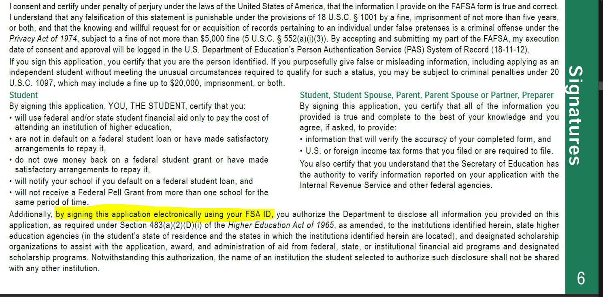

**Questions 20, 28, 38, and 45:** Added an instruction to the Income Earned from Work field indicating that if the value for that field is a negative number to enter zero.

Also updated the tax line reference numbers in these questions for the Income earned from work, Income tax paid, and Education credits fields after confirmation from the IRS.

**Question 37:** Updated the sixth response option to add “or they were not required to file under the Internal Revenue Code” for clarity.