The process in place since July 1, 2024, for reporting Prison Education Programs (PEPs) requires schools to complete both the *Prison Education Program Application* (OMB Control Number 1845-0171) and the *Application for Approval to Participate in the Federal Student Financial Aid Programs (E-App)*(OMB Control Number 1845-0012). This is communicated in the instructions at the end of the *Prison Education Program Application* which state “In addition to this Prison Education Program Application, The E-App must be completed and submitted.”

The change we are requesting is to merge the *Prison Education Program Application* questions into the *E-App*. The result will be the elimination of the need for schools to complete two separate applications.

The PEP questions will conditionally display in the Locations and Educational Programs sections of the *E-App*.

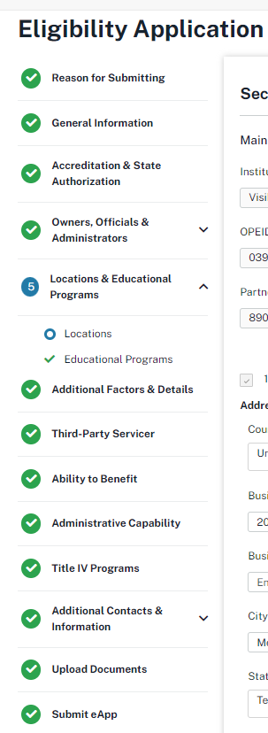

To accomplish the merger of the application questions, we will add a single new question that doesn’t currently appear on either application.

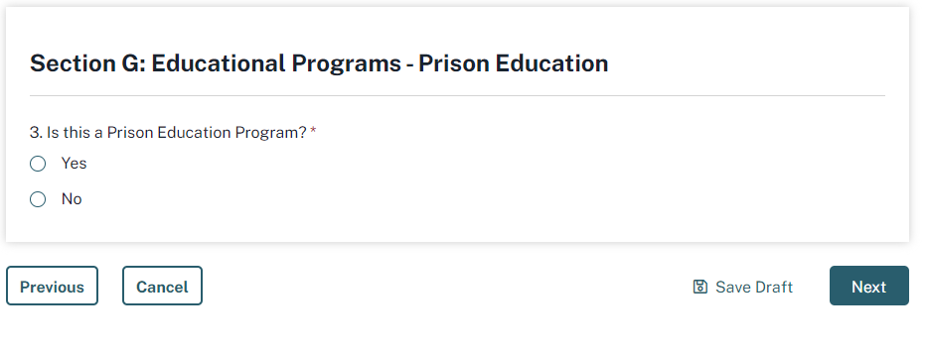

For schools completing the *E-App* who are **not** **reporting a PEP**, the burden increase will be select no to the new question for each new educational program being added to their application:

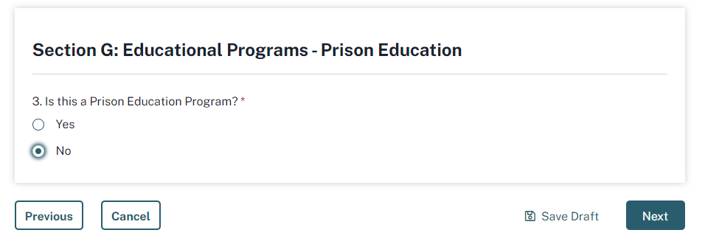

For schools completing the *E-App* to **report a PEP**, the questions from the *Prison Education Program Application* will appear in the *E-App*, eliminating the need to complete the *Prison Education Program Application* and attach it to the *E-App*. This will reduce the burden on schools as they will be using a format they are familiar with, their demographic and contact information will be pre-populated, and they will not need to save and upload a separate application.

The PEP questions will display conditionally as follows.

Under the locations section, when entering the correctional facility currently, they answer the following existing question, then provide additional details about the facility on the separate *Prison Education Program Application*. With the merger of the two applications, when they answer this current *E-App* question affirmatively:

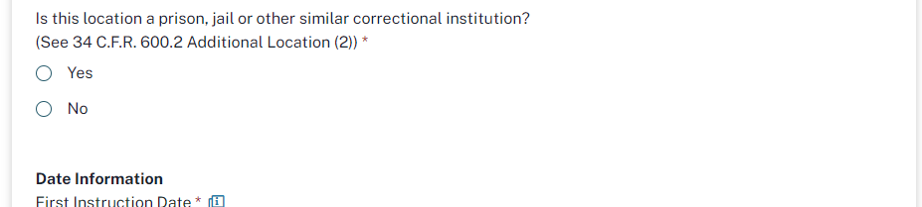

The screen will redisplay with a question from the *Prison Education Program Application* displayed on the same screen:

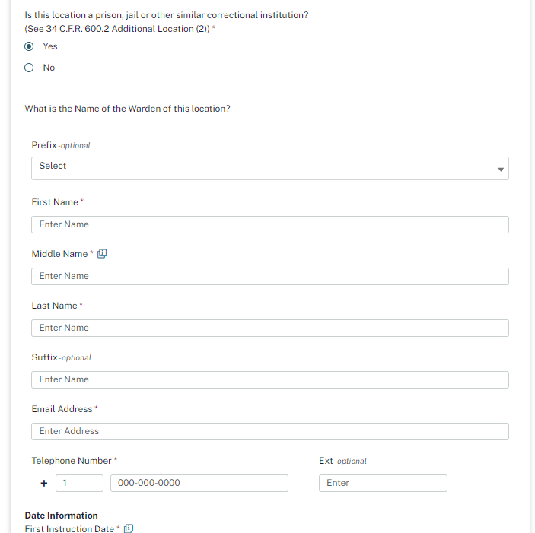

And a second question from the *Prison Education Program Application* displayed on the next screen, which only displays if the location is a correctional facility:

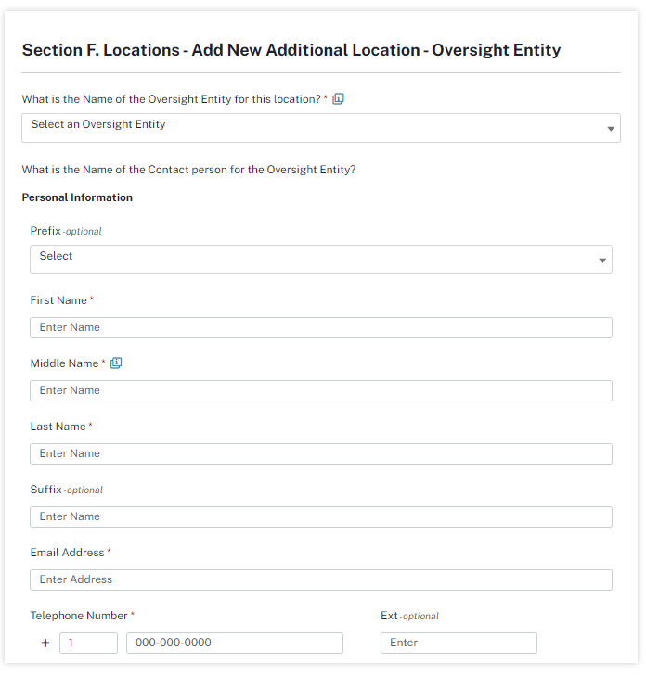

When completing this question, the school will be given the opportunity to select the oversight entity from our list of state and federal entities, or to enter another entity if necessary (currently, the entity name must be typed into the *Prison Education Program Application*):

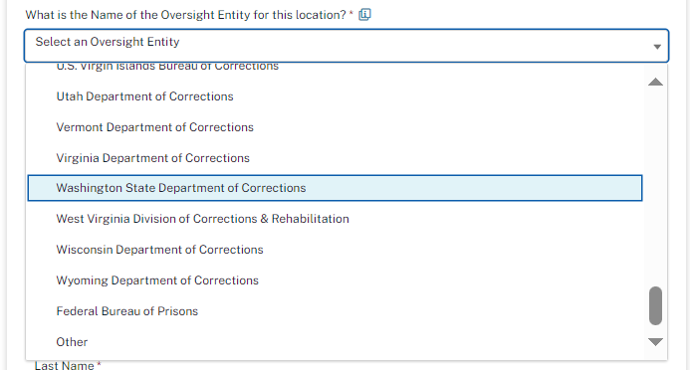

After entering the Warden and the Oversight Entity details for the correctional facility, the school will continue with the standard *E-App* questions for additional locations which include the opportunity to enter additional information in a text field.

The next step in the application process is the completion of the educational program information about the PEP.

When the school answers the single new question in the affirmative:

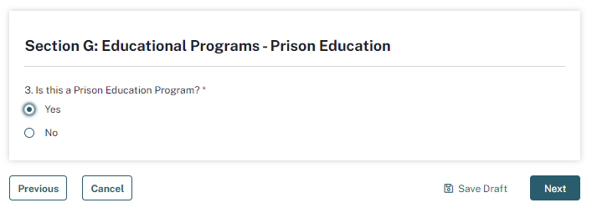

The questions from the *Prison Education Program Application* will display after moving to the next screen:

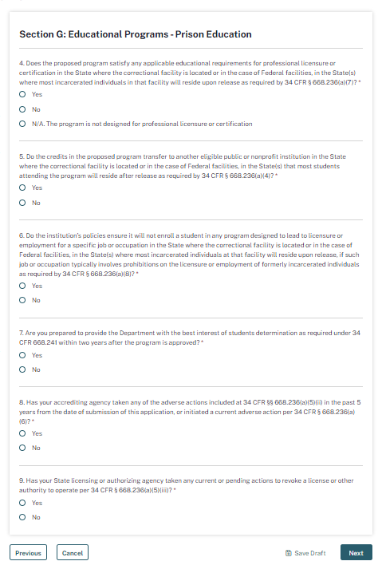

When answering question 5 about the transferability of credits, if the answer is yes, the screen will redisplay with added question 5b from the *Prison Education Program Application*:

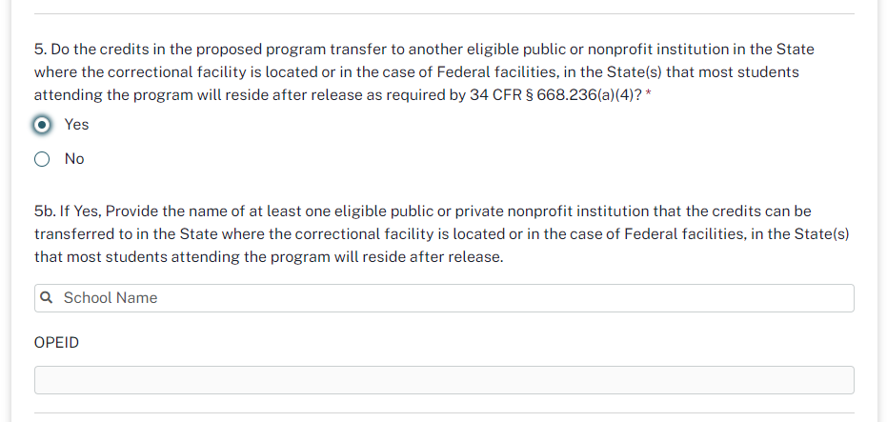

When the school begins typing the School Name in question 5b, they will be presented with appropriate options to select from our database of eligible institutions:

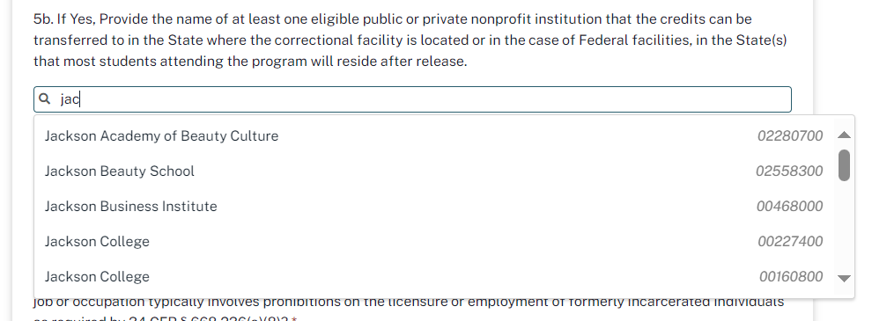

On the next screen, the school will select the correctional facility location(s) where the PEP is to be offered, rather than entering them as is done on the *Prison Education Program Application*:

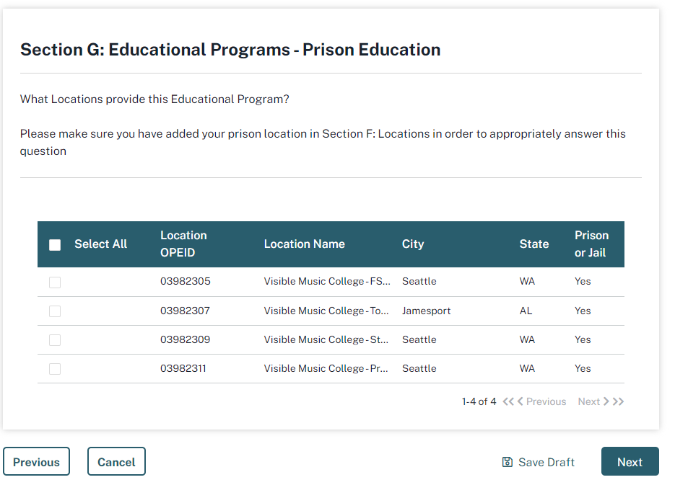

After completing the PEP specific questions and identifying where the PEP will be offered, the school will continue with the standard *E-App* questions for educational programs which include the opportunity to enter additional information in a text field.

Finally, prior to submitting the application, the *E-App* will clearly identify for the school all the required attachments which they will upload through the *E-App* (these are the same attachments required with the current *Prison Education Program Application*, but which are uploaded through yet a third system – the Common Origination and Disbursement (COD) system):

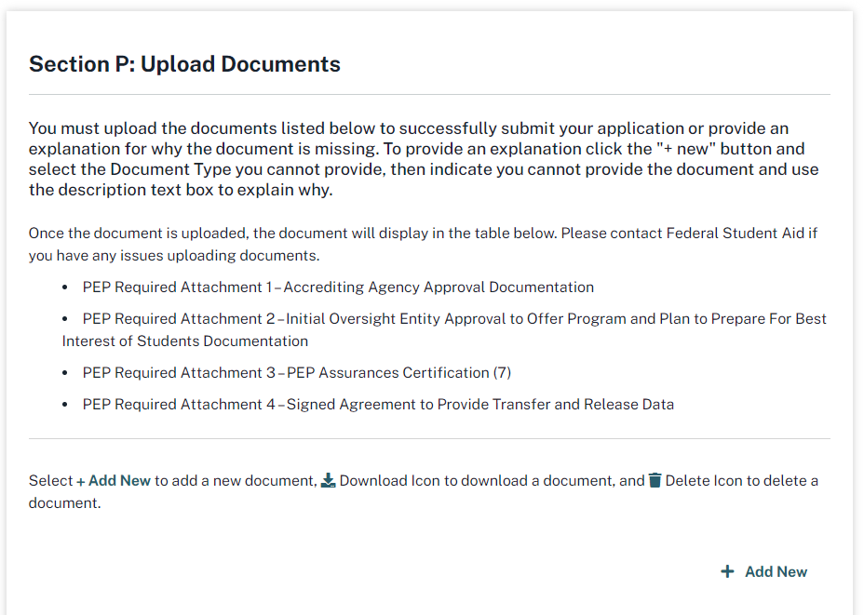

The *Prison Education Program Application’s* OMB Control Number 1845-0171 will continue to be used for only Section 4 of the current *Prison Education Program Application*. Section 4 collects the certification of the Oversight Entity regarding their compliance with the PEP requirements, and is uploaded through the E-App as *PEP Required Attachment 4 - PEP Assurances Certification*.