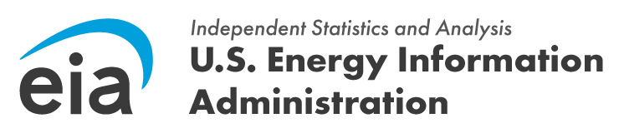

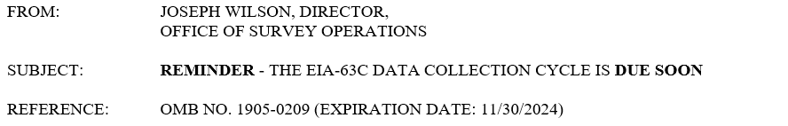

Dear (Respondent)

This is a reminder that the May 2024 reporting period for the EIA-63C closes on June 28, 2024. These data are collected pursuant to the Federal Energy Administration (FEA) Act of 1974, Public Law 93-275, and response to this survey is mandatory under the FEA Act.

Thank you for your time and effort in diligently completing this form. We appreciate your timely submission of May data by June 28, 2024.

Please log into the U.S. Energy Information Administration Respondent Submission Portal to access the form and submit your data. The survey cycle can be accessed from the U.S. Energy Information Administration Respondent Submission Portal Home or To Do tab.

If you have any questions or concerns, please contact the U.S. Energy Information Administration Customer Care Center via e-mail at EIA4USA@eia.gov, or call 1-855-EIA-4USA (1-855-342-4872) Monday through Friday, 8:00 AM - 6:00 PM ET.

