Supplemental Supporting Statement – Part A

**FRUIT, NUTS, AND SPECIALTY CROPS**

**Substantive Change**

OMB No. 0535-0039

This substantive change is being submitted as a supplemental supporting statement for program changes. Every 5 years NASS conducts a program review following the completion of the Census of Agriculture. The program changes balance resources across all of the programs included in the annual estimating program, which represents over 400 individual reports across multiple Information Collection Requests (ICRs). This substantive change is to accommodate the program changes that affect this ICR.

The methodology, publication dates, and data collection plan does not change from these program changes.

This change include some non-substantive changes for the 2024 Maple Syrup Inquiry based on the 2023 survey and the 2024 Table Olive Crop inquiry. The non-substantive changes are:

**Maple Syrup Inquiry**

FROM:

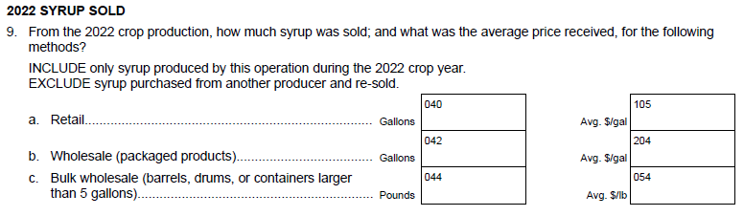

TO:

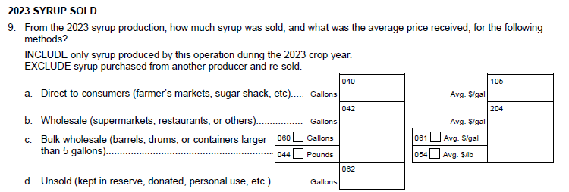

**Table Olive Crop Inquiry**

FROM:

TO:

**A. JUSTIFICATION**

**1. Explain the circumstances that make the collection of information necessary. Identify any legal or administrative requirements that necessitate the collection. Attach a copy of the appropriate section of each statute and regulation mandating or authorizing the collection of information.**

NASS maintains an annual estimating program for a vast array of commodities, covering the crop, economic, and livestock sectors of agriculture.

Every five years NASS conducts a program review following the completion of the Census of Agriculture. The primary purpose is to ensure that the NASS annual estimating program targets commodities and states most relevant based on the latest available information. The program review is announced and stakeholder input is requested.

The primary source of information for the program review is the Census of Agriculture, since it is the most comprehensive source of data; however, we also take into consideration estimates from the current annual estimating program and administrative data.

The program changes balance resources across all of the programs included in the annual estimating program, which represents over 400 individual reports.

**2. Indicate how, by whom, and for what purpose the information is to be used. Except for a new collection, indicate the actual use the agency has made of the information received from the current collection.**

There are no changes from the original approval for the purposes of program changes.

**3. Describe whether, and to what extent, the collection of information involves the use of automated, electronic, mechanical, or other technological collection techniques or other forms of information technology, e.g., permitting electronic submission of responses, and the basis for the decision for adopting this means of collection. Also describe any consideration of using information technology to reduce burden.**

There are no changes from the original approval for the purposes of program changes.

**4. Describe efforts to identify duplication. Show specifically why any similar information already available cannot be used or modified for use for the purposes described in Item 2 above.**

There are no changes from the original approval for the purposes of program changes.

**5. If the collection of information impacts small businesses or other small entities (Item 5 of OMB Form 83-I), describe any methods used to minimize burden.**

There are no changes from the original approval for the purposes of program changes.

**6. Describe the consequence to Federal program or policy activities if the collection is not conducted or is conducted less frequently, as well as any technical or legal obstacles to reducing burden.**

There are no changes from the original approval for the purposes of program changes.

**7. Explain any special circumstances that would cause an information collection to be conducted in a manner inconsistent with the general information guidelines in 5 CFR 1320.5.**

There are no changes from the original approval for the purposes of program changes.

**8. Provide a copy and identify the date and page number of publication in the Federal Register of the agency's notice, required by 5 CFR 1320.8 (d), soliciting comments on the information collection prior to submission to OMB. Summarize public comments received in response to that notice and describe actions taken by the agency in response to these comments.**

The Federal Register Notice soliciting comments was published on September 8, 2023, on page 62047-62048. NASS did not receive any public comments.

**Describe efforts to consult with persons outside the agency to obtain their views on the availability of data, frequency of collection, the clarity of instructions and record-keeping, disclosure, or reporting format (if any), and on the data elements to be recorded, disclosed, or reported.**

There are no changes from the original approval for the purposes of program changes.

**9. Explain any decision to provide any payment or gift to respondents.**

There are no changes from the original approval for the purposes of program changes.

**10. Describe any assurance of confidentiality provided to respondents and the basis for the assurance in statute, regulation, or agency policy.**

There are no changes from the original approval for the purposes of program changes.

**11. Provide additional justification for any questions of a sensitive nature.**

There are no changes from the original approval for the purposes of program changes.

**12. Provide estimates of the hour burden of the collection of information. The statement should indicate the number of respondents, frequency of response, annual hour burden, and an explanation of how the burden was estimated. If this request for approval covers more than one form, provide separate hour burden estimates for each form and aggregate the hour burdens in Item 13 of OMB Form 83-I. Provide estimates of annualized cost to respondents for the hour burdens for collections of information, identifying and using appropriate wage rate categories.**

There are no changes from the original approval for the purposes of program changes.

**13. Provide an estimate of the total annual cost burden to respondents or record-keepers resulting from the collection of information.**

There are no changes from the original approval for the purposes of program changes.

**14. Provide estimates of annualized cost to the Federal government; provide a description of the method used to estimate cost which should include quantification of hours, operational expenses, and any other expense that would not have been incurred without this collection of information.**

There are no changes from the original approval for the purposes of program changes.

**15. Explain the reasons for any program changes or adjustments reported in Items 13 or 14 of the OMB Form 83-I (reasons for changes in burden).**

There are no changes in estimated burden from the original approval for the purposes of program changes.

**16. For collections of information whose results will be published, outline plans for tabulation and publication. Address any complex analytical techniques that will be used. Provide the time schedule for the entire project, including beginning and ending dates of the collection of information, completion of report, publication dates, and other actions.**

There are no changes in publications and publication schedule from the original approval for the purposes of program changes.

Changes will be made on state level data that will be published in NASS reports as summarized below by commodity.

*Citrus Fruits*

Lemons – Full Program: FL

*Non-Citrus Fruits*

Cherries (sweet) – Full Program: MI

Cherries (tart) – Drop: NY, WA, WI

Grapes – Full Program: NY, OR

Peaches – Drop: WA

Raspberries – Full Program: OR

*Tree Nuts*

No changes

*Specialty Crops*

Maple Syrup – Full Program: CT, IN, MA, MN, OH, WV

where

Annual Program – Acreage & Production estimates

Full Program – Acreage & Production estimates including forecasted production (when applicable)

Drop – No acreage, production, forecast estimates will be set.

**17. If seeking approval to not display the expiration date for OMB approval of the information collection, explain the reasons that display would be inappropriate.**

No approval is requested for non-display of the expiration date.

**18. Explain each exception to the certification statement identified in Item 19, “Certification for Paperwork Reduction Act Submissions” of OMB Form 83-I.**

There are no exceptions to the certification statement.

February 2024