**Non-substantive Change Request**

**0535-0039 – Fruit, Nut, and Specialty Crops Surveys**

**FRUIT AND NUT PRODUCTION AND DISPOSITION INQUIRY - February 2025**

NASS is requesting a non-substantive change to the Fruit and Nut Production and Disposition Inquiry questionnaire. The change would add Hazelnuts to the commodities asked about on the questionnaire. This change would only affect Oregon and would take place in February of 2025.

The Survey Team believes that this change is necessary in order to collect data on hazelnut production and disposition in Oregon. This data is not currently being collected, and the Survey Team believes that it would be valuable to have this information.

These changes will not impact the current sample size or respondent burden.

Revised Master questionnaire has been loaded to ROCIS.

New Hazelnut Questions

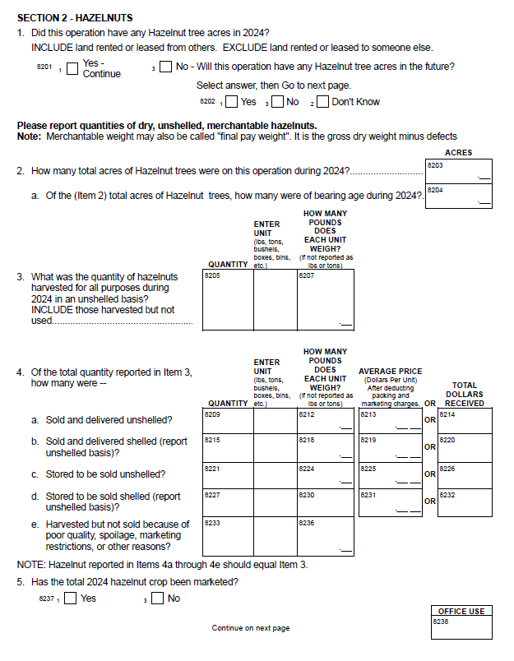

Hazelnut publication tables:

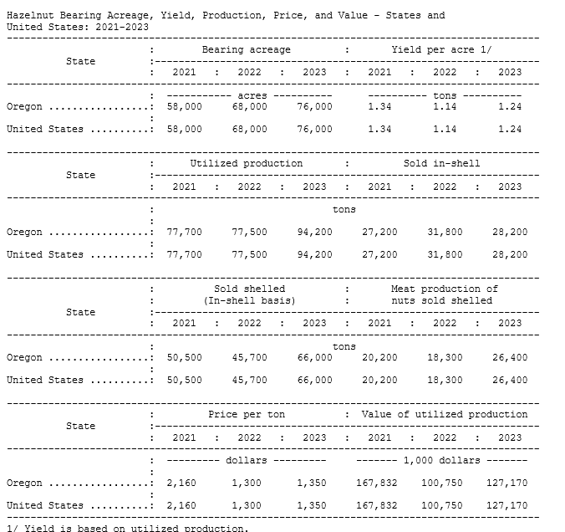

**Non-substantive Change Request**

**0535-0039 – Fruit, Nut, and Specialty Crops Surveys**

**Hop Questionnaires– 2025**

NASS is requesting a non-substantive change to all Hop questionnaires. The NASS Hop Survey Team proposes updating the titles of all Hops Survey questionnaires. The new titles will begin with the word "Hops," followed by the rest of the title. This change is purely administrative and will not alter the substance of the questionnaires.

From:

Hop Grower Survey - May

August Forecast of Hop Acreage and Production –

Hop Acreage and Production – November

To:

Hops Grower Survey - May

Hops Acreage and Production – August Forecast

Hops Production Disposition and Income – November

These changes will not impact the questionnaire content, current sample size or respondent burden.

The revised questionnaires have been loaded to ROCIS.