Request for Nonsubstantive Change
ICR 0579-0040
October 8, 2024

APHIS conducted a review of VS Form 17-36, Inspection Report of Establishment for Immediate Slaughter Import Animals, and requests approval for 8 nonsubstantive changes.

Summary of changes include:
- Reducing total number of pages from 6 to 4.
- Field numbered 1 to 38 1 to 41.
- Updated instructions which address all fields (blocks) to aid respondents in filling out the form.
- Deletion of additional resources that should not be included on the form but will be provided as a separate document.

The changes do not affect response time or burden.

Change 1:
CURRENT - Page 1 - fields number from fields 1 through 23.
Total number of pages is 6.

FUTURE – Page 1 - Added two fields shifted numbering to 1 through 25.
Total number of pages is 4; reduced by 2; explained in Change 8.

Change 2:
CURRENT – Page 1 - Items 6 through 12
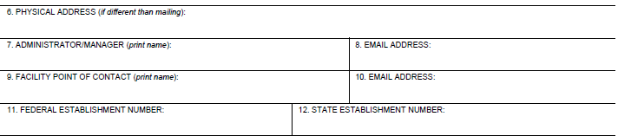

FUTURE – Page 1 - Items 6 through 13
- Added form field 7 to capture the establishment phone number.
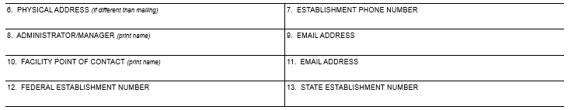

Change 3:
CURRENT – Page 1 - Item 13 through 16
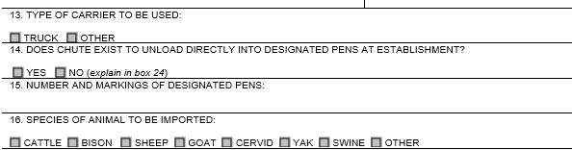

FUTURE – Page 1 - Items 14 through 17
- Item 15 - Added (explain in block 26).
- Item 17 – Alphabetized animal species; added species “Water Buffalo”.
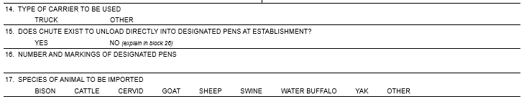

Change 4:
CURRENT – Page 1 - Item 18

FUTURE – Page 1 - Item 19 and 20
- Adjust item numbering; added field to capture signature of FSIS Inspector/Veterinarian.

Change 5:

CURRENT – Page 1 - Items 19 through 23
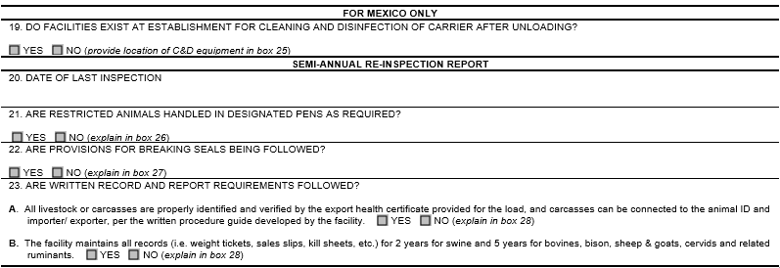

FUTURE – Page 1 - Items 21 through 25
- Adjusted item numbering.
- Adjusted block numbering within parenthesis for items 21, 23, 24, 25A, 25B.
- Changed second title “SEMI-ANNUAL RE-INSPECTION REPORT” to “INSPECTION REPORT”.
- Item 23A, now 25A, reads “All livestock or carcasses are…” to “All livestock (except swine) or carcasses are…”.
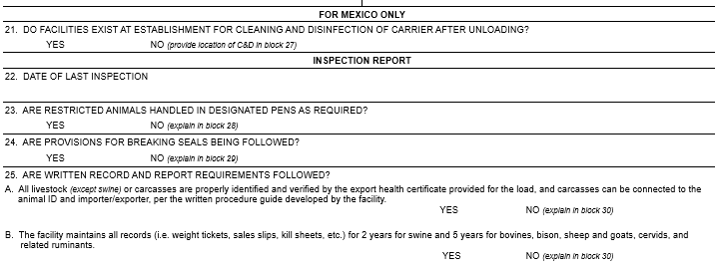

Change 6:
CURRENT – Page 2 - Items 24 through 29
- No screenshot provided.
FUTURE – Page 2 - Items 26 through 31
- No screenshot provided.
- Adjusted item numbering.
- Adjusted the block number reference in items 26, 27, 28, 29, 30 and 31.
- Changed heading at top of page from “EXPLANATION” to “EXPLANATION (do not leave blank unless NA is selected)”.

Change 7:
CURRENT – Page 2 – Items 30 through 38
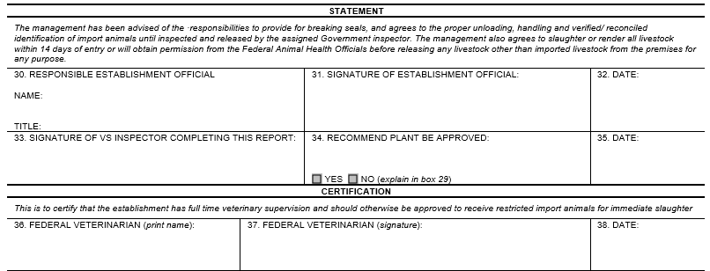

FUTURE – Page 2 – Items 32 through 41
- Changed paragraph under 1st heading, STATEMENT from “…slaughter or render all livestock with 14 days…” to “…slaughter or properly dispose of all livestock within 14 days…”.
- Item 33 is now Item 36.
- Item 34 is now Item 38; changed field name from RECOMMEND PLANT BE APPROVED to RECOMMEND ESTABLISHMENT BE APPROVED.
- Item 35 is new; PRINTED NAME OF VS INSPECTOR COMPLETING REPORT
- Item 36 is now item 39: field name changed from FEDERAL VETERINARIAN (print name) to PORT SERVICES VETERINARIAN (print name).
- Item 37 is now item 40: field name changed from FEDERAL VETERINARIAN (signature) to PORT SERVICES VERERINARIAN (signature).
- Item 38 is now item 41:
- Changed paragraph under 2nd heading, CERTIFICATION, changed “…the establishment has full time veterinary supervision and should otherwise…” to “…the establishment has full-time veterinary supervision or oversight and should otherwise…”
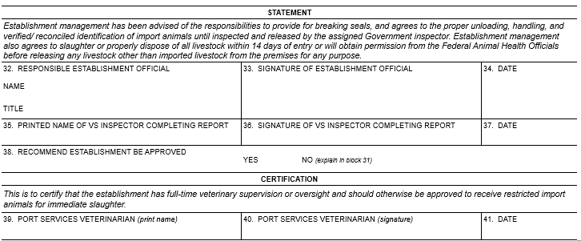

Change 8:

CURRENT – Pages 3 and 4
Instructions for Box 2, 10, 11, 18
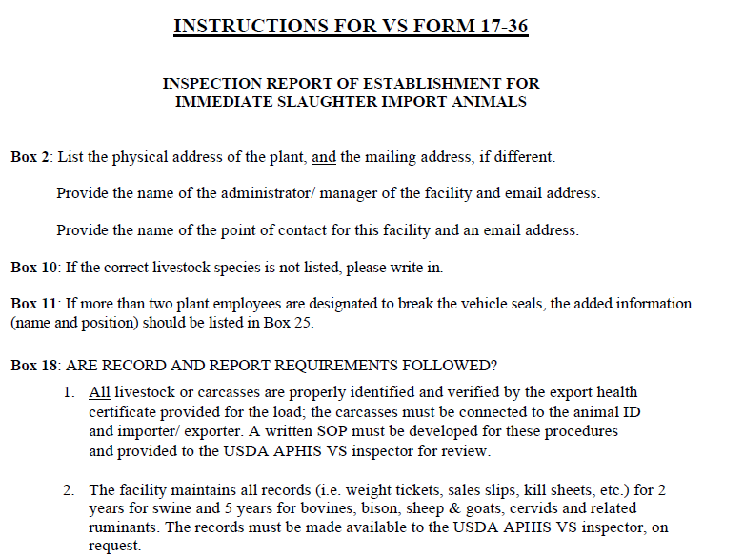

FUTURE – Pages 3 and 4.
- Partial screenshot provided.
- Instructions were updated and now address all fields (blocks) on form to aid respondents in completing the form.
- Deleted the following information, reducing number of pages from 6 to 4.
  - Deleted General Questions and Answers.
  - Deleted Flowchart; this will now be provided as a separate document.
  - Deleted Northern Border Ports Contact List; this will now be provided as a separate document.
