NONSUBSTANTIVE CHANGE REQUESTS
ICR 0579-0101
July 2024

APHIS conducted a review of three forms: 1) VS Form 5-13 Owner/Hauler Statement for Sheep and Goats, 2) VS 5-29 Cooperative State-Federal Scrapie Control Program, and 3) VS 5-29A Scrapie Test Record Continuation Sheet and requests approval for nonsubstantive changes.

The changes are the result of modifying several sections of the forms and screenshots are included display the changes.

The changes do not affect response time or burden.

- VS Form 5-13 changes requested (Owner/Hauler Statement for Sheep and Goats)
  - Section: Group Lot ID Number - Delete two lines.
  - Section: Declaration - Changed section heading; Added 4 rows.
  - Sections: Point of Origin and Name and Address of Destination
Deleted “Other Contact (optional)” from both sections.
CURRENT
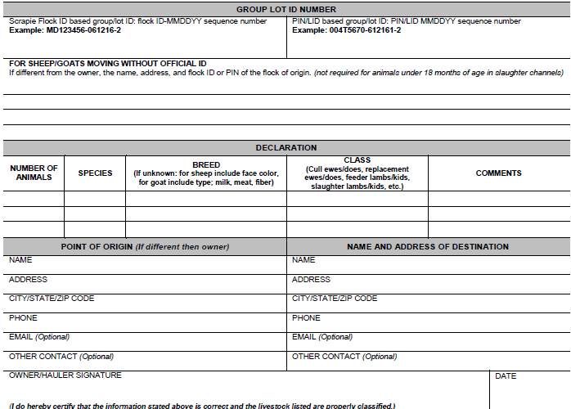

FUTURE
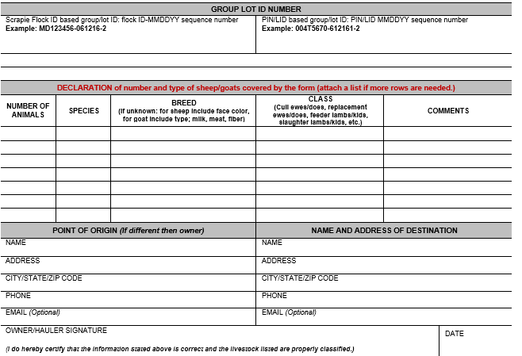

- VS form 5-29 changes requested (Cooperative State – Federal Scrapie Control Program)
  - Change “Referral No.” to “Referral No (e.g. COBTP05012023¹)”
  - Change “Person ID (Veterinarian/SNGD)” to “VET ACCRED #/Person ID”.
  - Moved field “County of Flock”.
  - Removed fields “Sec.” and “Farm No.”

CURRENT
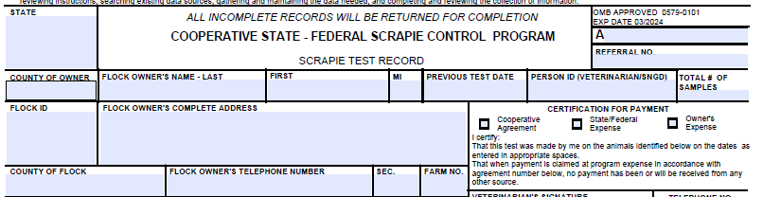

FUTURE
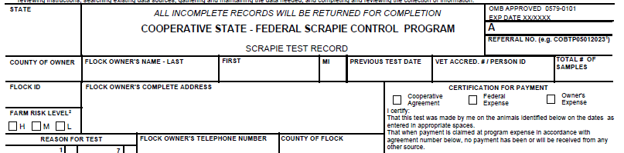

  - Reason for Test: Number of options changed from 10 to 12.
  - Test Type: Options available updated.
CURRENT
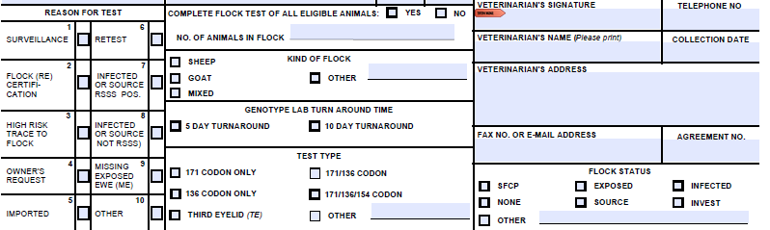

FUTURE
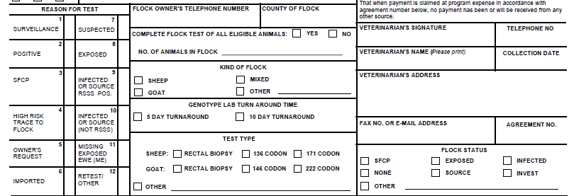

  - Changed “3rd Eyelid Info” to “Rectal Biopsy Sample Loc (circle one#)³”.

CURRENT FUTURE
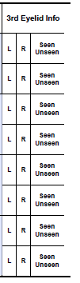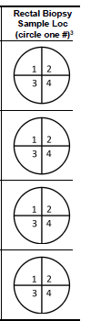

  - Removed reference about “Circle if the 3rd eyelid tissue came from…” and inserted explanation to footnotes 1, 2, and 3.

CURRENT
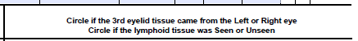

FUTURE
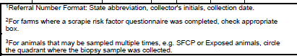

- VS form 5-29A changes requested (Scrapie Test Record Continuation Sheet)
  - Changed table heading “3rd Eyelid Info” to “Rectal Biopsy Sample Loc (circle #)1”, and changed how to record information requested.
  - Instructions below table updated.
CURRENT FUTURE
