Focus Group Moderator Guide
Non-Participant Groups:
Target Time ≈ 90 minutes of discussion &
respondents asked to log on 30 minutes before start time

- Introduction (15 minutes]
- Moderator introduction
- Remind respondents to be in a quiet place
- If you need to step away, do so briefly and come back as soon as possible
- Anonymity
- Rules for participation online (all opinions count, no wrong answers)
- Grab a few pieces of paper and a pen or pencil.
- Introduction – Share your first name, where you live, with whom you live (people, pets, plants, etc.)

- Warm-Up & Food Decision-Making (10 minutes)
- To start, take a moment and think of your top 1-3 concerns for your family at this stage in life.
  - [MODERATOR GO AROUND SCREEN]
  - What makes those your top concern(s)?
  - [FOR PREGNANT/INFANT AND MIXED GROUPS- IF FEEDING FAMILY NOT MENTIONED] Where does “feeding your family” fall among your concerns? What makes you say that?
    - What comes to mind when I say, “feeding your family”?
    - In other words, what parts of “feeding your family” are a concern, if any? [PROBE: Cost, health, nutrition, access to food]
    - What parts of feeding your family are a source of pride?
  - [FOR AGE 1-5 AND MIXED GROUPS - IF FEEDING FAMILY NOT MENTIONED] Where does “feeding your family” fall among your concerns? What makes you say that?
    - What comes to mind when I say, “feeding your family”?
    - In other words, what parts of “feeding your family” are a concern, if any? [PROBE: Cost, health, nutrition, access to food]
    - What parts of feeding your family are a source of pride?

- Now I want to talk specifically about healthy eating. When I say, “healthy eating” what are the words and phrases that come to mind? Type all of the words and phrases that come to mind when I say that phrase in the chat box.
  - [MODERATOR TO ALLOW UNAIDED RESPONSE VIA CHAT; ALSO NOTE IF RESPONDENTS SEEM CONFUSED ABOUT THE PHRASE “HEALTHY EATING”]

  - [GO AROUND SCREEN:] What were the first few words/phrases that came to your mind? Why those?

  - When, if at all, do you think about healthy eating?
    - For yourself?
    - For members of your family?
    - What, if anything, makes it important for you (and your family) to do?

  - When you think about healthy eating, what, if anything, makes it hard for you (and your family) to do?
    - [IF NECESSARY:] What are the barriers/challenges/obstacles that make it difficult for you and your child(ren) to eat healthy?
    - What would help you and your child(ren) to eat healthier?
    - What specific elements of eating healthy are you most concerned about?
[LISTEN FOR COMPONENTS OF WIC: access to food/formula, personalized nutrition counseling, breastfeeding support, BUT DO NOT PROBE AT THIS TIME]

  - Where do you go for help or support with healthy eating, if anywhere? [MODERATOR, PROBE ON: health care workers, word of mouth, online research, social media influencers/experts]

- WIC Awareness and Brand Perceptions (10 minutes)

- Now I want to shift gears a bit and talk about WIC. By a show of hands, how many of you have heard about WIC?
  - [FOR THOSE WHO HAVE HEARD OF WIC] What do you know about it? Please take a moment, and in the chat, please type, in your own words, what WIC is. If you are unsure, please type that in the chat, too. [SHOW CHAT, MODERATOR GO AROUND SCREEN, BUT DO NOT PROBE INTO SPECIFICS]

  - We will talk more about WIC in a moment, but before we do, from where or from whom have you heard about WIC?
    - [TAKE HAND COUNT FOR INFORMATION SOURCES MENTIONED]
    - [IF “OTHER PEOPLE” MENTIONED:]
      - Are these individuals currently enrolled in WIC or have they been enrolled in WIC recently?
      - By a show of hands, how many of you have heard about WIC from someone who has been enrolled in WIC within the past year? [TAKE HAND COUNT]

ASK ALL
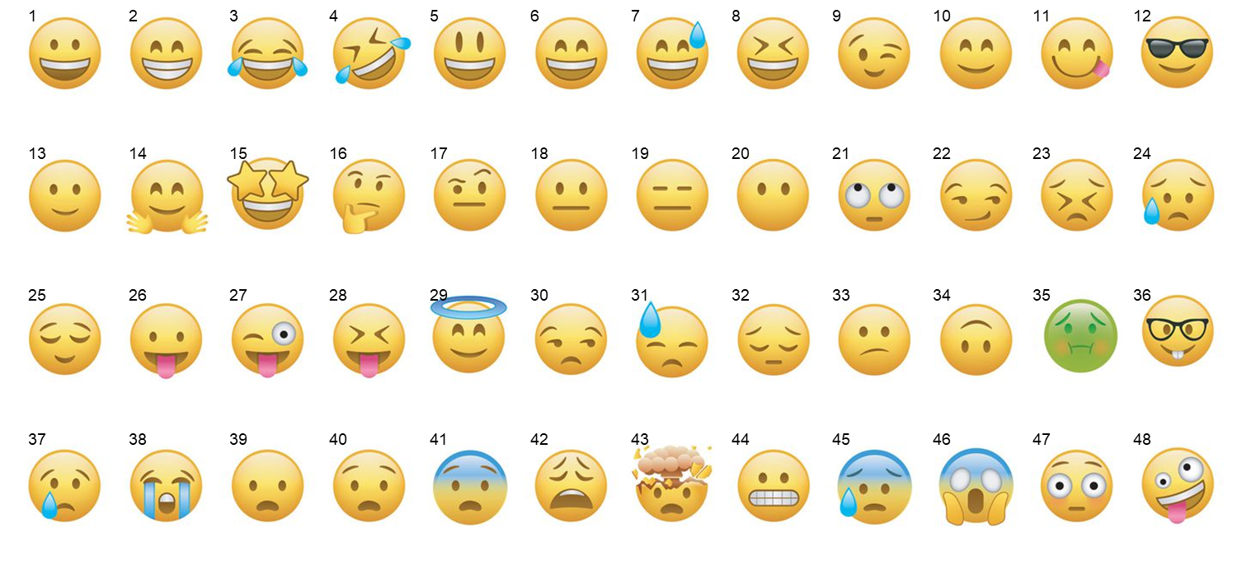
- I am going to show you a list of emojis on the screen. I want you to pick the emoji that best represents how you feel about WIC.
- What made you choose that emoji?
  - What does it say about WIC?
- When you have heard other people talk about WIC, what emojis would they use?
  - What made you select that emoji?
  - What are they saying?

- POLL: Next, I am going to share two statements. Please rate your agreement with each statement on a scale of 1 to 5, where a 1 means strongly disagree, and a 5 means strongly agree, and you can use any number from 1 to 5.
  - [STATEMENT 1] WIC is for someone like me.
    - [START WITH AGREE, THEN NEUTRAL, THEN DISAGREE] What makes you say that?
    - How do you know? In other words, what gives you the sense that WIC is/is not for someone like you?

  - [STATEMENT 2] WIC is a good value.
    - [START WITH AGREE, THEN NEUTRAL, THEN DISAGREE] What makes you say that?
    - [IF AGREE:] What specific parts of WIC make it a good value in your eyes?
    - [IF NEUTRAL, DISAGREE:] In what way(s) is WIC not a good value?
    - [IF NEUTRAL, DISAGREE:] What would make it a good value from your perspective.

- Earlier, we talked about what you have heard about WIC and from where/whom. From where or from whom would you like to hear more about WIC?
  - [ALLOW FOR UNAIDED RESPONSES]
  - [PROBE:] What about from health care providers/workers?
    - [IF NOT PREVIOUSLY MENTIONED:] Have any health care providers/workers talked to you about WIC? What did they say?
    - What would you hope to learn from health care providers/workers about WIC?
    - How, if at all would the information coming from health care providers/workers be different than what you might hear from friends or family members about WIC?

- Eligibility and Enrollment (15 minutes)

- Now we are going to talk about signing up for WIC.

- Who is WIC for?
  - How do you know who WIC is for?
  - How do you know if you are eligible for WIC?
    - Where would you go to find out?

- What have you heard about signing up for WIC?
  - Where have you heard that?

- Let’s look at the requirements for someone to be able to participate in WIC. I am going to show you two options and obtain your initial reactions about each.

[MODERATOR, ROTATE OPTIONS ACROSS GROUPS]

OPTION L: The Special Supplemental Nutrition Program for Women, Infants, and Children (WIC) is a federally-funded program of the Food and Nutrition Service of the United States Department of Agriculture serving low and moderate income pregnant, breastfeeding, and postpartum women, infants, and children up to age five who are found to be at nutritional risk.

OPTION D (CO): To qualify for WIC, you must live in [STATE] and be a:
- Pregnant woman.
- Mom breastfeeding a baby under 1 year of age.
- New mom who had a baby or was pregnant in the past 6 months.
- Infant
- Child younger than 5 years.
WIC welcomes all parents and caregivers! If you are a dad, grandparent, foster parent or any caregiver of a child under 5 years of age, you may get WIC for your child.

You do not have to be a U.S. citizen to be eligible for the WIC program.
WIC is open to many incomes including working and non-working families. If you are on Medicaid, TANF, SNAP or FDPIR, you can be automatically income eligible. If you do not qualify for these programs, you may still qualify for WIC by meeting the income guidelines for your household.

[FOR FIRST OPTION SHOWN]
  - What are your initial reactions to this information?
  - What, if anything, about this information surprised you? What was it, specifically?
  - What, if anything, do you find confusing or unclear?
  - POLL: On a scale of 1 to 5, where a 1 means you are not confident at all, and a 5 means you are very confident, and you can use any number from 1 to 5, after reading this information, how confident are you that WIC is for someone like you or your family?
    - [GET RESPONSES FROM PARTICIPANTS]
    - [IF RESPONSE LESS THAN 5:] What parts make you not sure if you/your child would qualify for WIC?
  - What questions or concerns do you have about what it takes for someone to qualify for WIC? [LISTEN FOR AND PROBE ON: Nutritional risk, income requirement, government program]

[SECOND OPTION SHOWN]
- What are your initial reactions to this information?
- What, if anything, about this information surprised you? What was it, specifically?
- What, if anything, do you find confusing or unclear?
- [SHOW BOTH VERSIONS ON SCREEN:] Which version do you prefer? What makes you say that?

- WIC Value and Benefits (35 minutes)

- Next let’s talk about the services WIC offers. We are going to make a list. In the chat box, type any services that WIC offers. [REVIEW CHAT]

- [IF NECESSARY:] WIC’s primary benefits and services are the foods available through WIC, breastfeeding support, nutrition counseling, and referrals to other healthcare and community or social services.

We are going to briefly talk about each of these benefits and services.
  - Let’s start with the benefit of receiving foods through WIC.
    - What are the positives associated with the fact that WIC participants receive foods through WIC?
    - What questions or concerns do you have about this benefit?
    - Now I have some more information about the foods WIC participants can receive. Take a look at this image [POST IN CHAT]

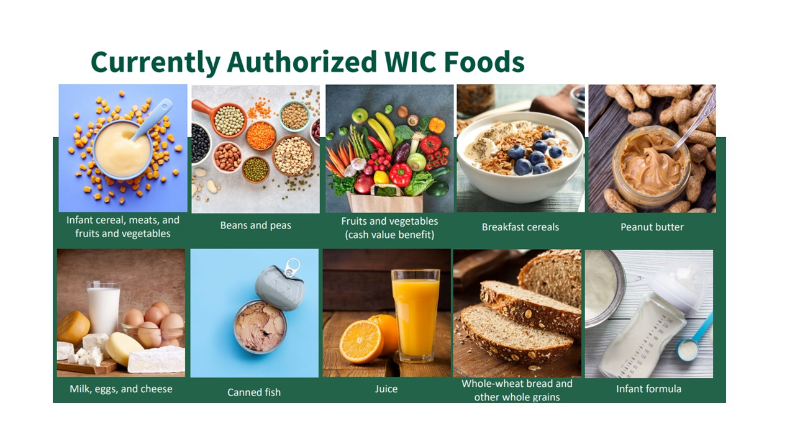
      - What is your reaction to seeing this image? What does it say about this benefit?
      - What, if anything, surprises you about the foods WIC participants can receive?
      - How important is it that WIC offers this service? What makes you say that?
      - How valuable would this service be to you and your family? What makes you say that? What makes this service valuable or not valuable to you? [MODERATOR: emphasize value]
      - What remaining questions or concerns do you have about this benefit, if any?

  - What about breastfeeding support?
  - What do you know about this benefit?
  - [IF NECESSARY:] Just so we are on the same page, WIC provides one-on-one breastfeeding support with a breastfeeding counselor. This individual can answer questions or concerns WIC participants have, including how to maintain their goals when participants return to work. WIC also provides free access to supplies like breast pumps and the opportunity to connect with breastfeeding peer counselors. (Language from ME WIC)
  - What is your reaction to this information?
  - What stands out as a positive? A negative?
  - What, if anything, surprised you?
  - What remaining questions or concerns do you have about this benefit, if any?
  - How important is it that WIC offers this benefit/service? What makes you say that?
  - How valuable would this service be to you and your family? What makes you say that? What makes this service valuable or not valuable to you? [MODERATOR: emphasize value]

  - What about personalized advice on nutrition?
  - What do you know about this service?
  - How helpful do you think this service would be? What makes you say that?
  - [IF NECESSARY:] Just so we are on the same page, WIC provides one-on-one, personalized meetings with nutrition experts who specialize in nutrition for mothers and their children. This advice often includes practical nutrition information and everyday healthy living tips for WIC participants and their families. (Language from CA WIC)
  - What about this benefit/service stands out as a positive? A negative?
  - What, if anything, surprised you about this benefit/service?
  - How important is it that WIC offers this benefit/service? What makes you say that?
  - How valuable is this benefit/service? What makes you say that? What makes this benefit/service valuable or not valuable to you? [MODERATOR: emphasize value]
  - [IF NECESSARY:] In many areas, these discussions can take place over the phone or via Zoom. How would having remote meetings (i.e., not in person) change how valuable this service would be to you, if at all?

  - What about referrals for health care and/or other community services?
  - What do you know about this service?
  - [IF NECESSARY:] WIC staff members can refer participants to community services such as low-cost medical or dental care, health insurance, child care, and other services that can benefit the whole family. (Language from WIC CO).
  - What about this benefit/service stands out as a positive? A negative?
  - What, if anything, surprised you about this benefit/service?
  - How important is it that WIC offers this benefit/service? What makes you say that?
  - How valuable is this benefit/service? What makes you say that? What makes this benefit/service valuable or not valuable to you? [MODERATOR: emphasize value]

- Next, we are going to look at some more information about WIC. First, I am going to show you 4 different ways of describing WIC benefits/services. As you read through the information, on your scratch sheet of paper write down anything that jumps out at you in a positive or negative way. Also write down anything that seems confusing. Then, pick the one that stands out to you the most in a positive way.

[NOTE: THIS SECTION IS DESIGNED TO EXPLORE MESSAGE CONCEPTS/AVENUES AND FIND OUT WHAT COMPONENTS OF MESSAGES AND MESSAGING FRAMES ARE MOST COMPELLING. THIS INFORMATION WILL INFORM A CREATIVE AND MESSAGING BRIEF]

[ORDER OF MESSAGES WILL BE ROTATED ACROSS GROUPS]
- V – WIC is a nutrition program that provides free benefits to pregnant women, new moms, and families with children up to age 5. All WIC members receive healthy foods, personalized nutrition advice (including those with specific dietary needs), 1-on-1 breastfeeding support, and referrals to health and social services at no cost.
- B – WIC touches the lives of nearly half of all babies born in the United States each year. Millions of new moms participate in WIC breastfeeding support and take advantage of personalized nutrition advice and healthy foods for the whole family, plus referrals to health and dental care or other community resources.
- E – Apply to participate in WIC, and you will find a team committed to supporting you with the tools and assistance you need to make healthy choices in pregnancy and give your children up to age 5 a healthy start to life—1-on-1 breastfeeding support, healthy foods, personalized nutrition advice, and referrals to health care and other services.
- H – Pregnant or raising a child younger than 5 years old? WIC helps to make this time of life a little easier with nutritious foods, 1-on-1 breastfeeding support, personalized healthy eating guidance for the family—including specific dietary needs—and referrals to health care and social services. Let WIC lighten your load!

- POLL FOR 1 THAT STANDS OUT IN A POSITIVE WAY – What about that statement made it stand out to you over the others?

- POLL FOR 1 THAT STANDS OUT IN A NEGATIVE WAY – What about that statement made it fall to the bottom of the four statements?
- [MODERATOR: Only ask for each statement as time allows:]
    - What is your reaction to this? How do you feel after seeing it?
      - What, if anything, do you like about it?
      - What, if anything, do you dislike about it?
      - What does this tell you about WIC?
    - What, if anything, did you find confusing in these statements?
    - Which, if any, of the statements were surprising to you? What makes you say that? [IF NOT MENTIONED, PROBE:]
      - [B] What about the fact that WIC helps about ½ of all babies in the United States? Did you realize the program was that big? What, if anything does that mean to you?]
      - [V] What do you think about the phrase, “at no cost”? How important is that aspect of WIC? What makes you say that?
      - [H] Do you agree/disagree that WIC can help make this time in your and your child’s lives a little easier? What makes you say that?
      - [E] Do you believe that WIC provides a team committed to supporting the people enrolled in WIC? What makes you say that?

- Now we have some more information about WIC. Again, as you read through the information, on your scratch sheet of paper write down anything that jumps out at you in a positive or negative way. Also write down anything that seems confusing. Then, on your scratch sheet of paper, write down the letters of up to 2 statements that are most convincing to you as reasons to participate in WIC.

[MODERATOR: Once everyone is done selecting their preferred messages, have respondents type the letters in the chat.]

[ORDER OF STATEMENTS WILL BE ROTATED ACROSS GROUPS]

- N – The healthy foods WIC provides at no cost to WIC participants are based on the latest nutrition guidelines to support your and your family’s health and well-being.
- P – WIC members have one-on-one meetings with WIC staff who are experts in nutrition for moms during pregnancy and breastfeeding, and for infants, toddlers, and preschoolers. These experts provide advice and resources based each member’s—and their child’s—personal needs.
- T – WIC has transitioned to electronic benefits. Your family will receive a debit-like card that covers the cost of WIC-approved foods for your family. The eWIC card makes shopping more convenient and more efficient.
- W – WIC is listening and is improving in many ways to help families. In addition to shopping with the eWIC card, many meetings with WIC staff can take place online.
- F – Today’s WIC helps families save even more money than before. WIC has increased the amount of money WIC families can use at the grocery store (online or in-store) for fruits and vegetables and still at no cost to them.
- C – WIC’s breastfeeding services include one-on-one coaching with breastfeeding experts, support groups, and access to free breast pumps.
- G – “I encourage my friends to get WIC. At WIC, I get personalized nutrition advice from experts who can give me ideas about meal planning for me and my family. They also help me to make sure my picky eaters are eating healthy.” – WIC Mom
- M – “WIC helps my family save money because the free, healthy foods give me room in my budget to pay other bills or buy other things my family needs.”– WIC Mom
- R – WIC helps get children ready to start school: children who receive WIC benefits demonstrate improved intellectual development.

- POLL FOR UP TO 2 MOST CONVINCING TO PARTICIPATE IN WIC.
FOR THE MESSAGES THAT RANK HIGHEST IN THE POLL ASK:
      - What is your reaction to this? How do you feel after seeing it?
      - What do you like about it?
      - What, if anything, do you dislike about it?

- POLL FOR UP TO 2 LEAST CONVINCING TO PARTICIPATE IN WIC.
FOR THE MESSAGES THAT RANK LOWEST IN THE POLL ASK:
      - What is your reaction to this? How do you feel after seeing it?
      - What did you dislike about it?
      - What, if anything, do you like about it?

- Looking at this list of statements,
  - Which, if any, of these statements did you find confusing?
  - Which, if any, of the statements was surprising to you? What makes you say that?
  - [MODERATOR, PROBE ON WIC MOM (WORD OF MOUTH)]: You will notice that a few of these statements are written to show that it is information coming from a WIC Mom, or an individual who is already enrolled in WIC.
        - If you are thinking about applying for WIC, how helpful would it be to you to get the perspectives of someone who is currently enrolled in WIC? What makes you say that?
        - Could social media be a way for you to get information from current WIC participants? What makes you say that? [MODERATOR, IF NECESSARY, NOTE WIC Facebook groups, etc.]

  - [AFTER DISCUSSING eWIC MESSAGE ASK] Did you know WIC has electronic benefits through a debit type card?
        - What is your reaction?
        - How important is that to you?
        - What questions or concerns do you have, if any?

- POLL: We have looked at a lot of information about WIC today. After seeing all of this information, on a scale of 1 to 5, where a 1 means you would definitely not apply, and a 5 means you definitely would apply, and you can use any number from 1 to 5, how likely are you to apply for WIC?
  - [MODERATOR GOES AROUND FROM 5 TO 1] What makes you say that?
  - What makes you most want to participate in WIC?
    - What is the biggest benefit?
    - What would make you think about applying?
  - What questions or concerns do you still have?
    - What would keep you from applying?
  - Imagine for a moment that you enrolled in WIC, and you’re in the grocery store shopping with your WIC debit type card.
    - How do you think you would feel on that shopping trip?
    - What about that experience would make you feel that way?
  - Earlier in our discussion we looked at emojis for how you feel about WIC and emojis to describe the way other people talk about WIC. In other conversations that I have held, I’ve heard some people have negative feelings about being associated with WIC.
    - What do you think about that?
    - Do you feel there are negative associations with participating in WIC? How so?
    - Would that keep you from applying to WIC? What makes you say that?

- Wrap-up/False Close (5 minutes)

Thank you for all of the information you have provided.
- WRITE: While I check with my colleagues to make sure they do not have any additional questions, please look at the screen and answer the question in the chat.
  - MODERATOR READ AND SHOW ON SCREEN:
  - In your own words, what is the most important information to share when trying to convince people to apply for WIC?

Thanks again! To thank you for your time, you will receive a $75 gift card as a token of appreciation. Have a great evening.

