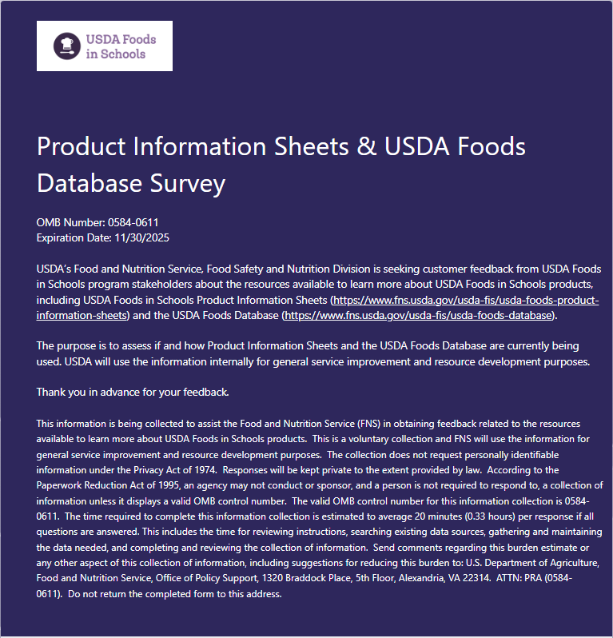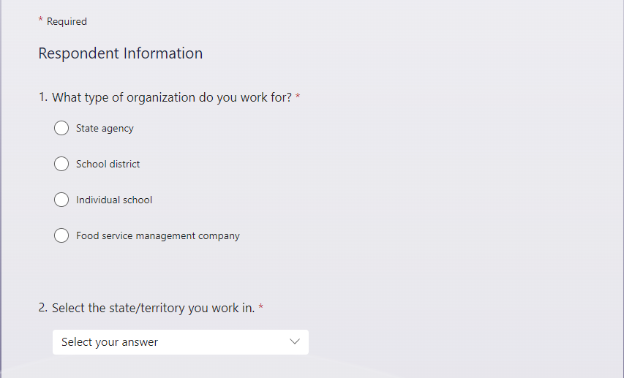
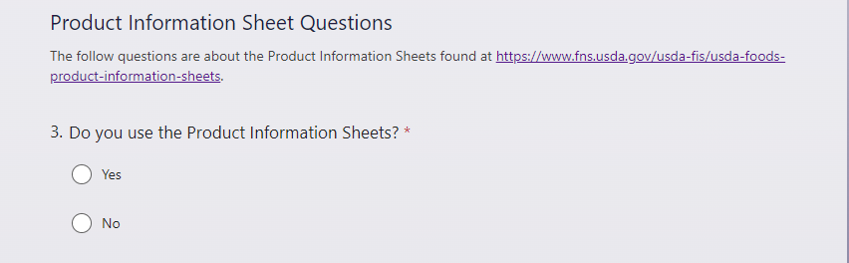
Note: The questions that follow depend on answer to the above question. Below are two #4 questions; one if the answer is No, and the other if the answer is Yes. If No is selected, that is the final question for this section. If Yes is selected, then questions 5-9 are available to answer.
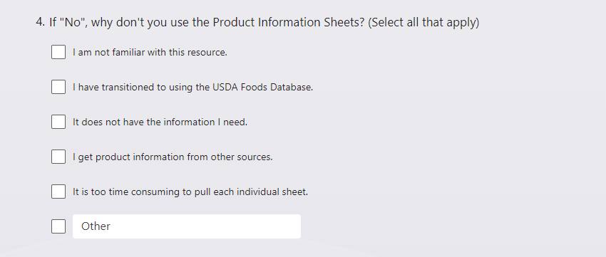
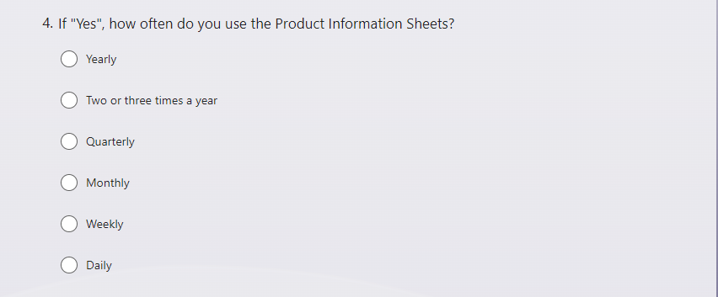
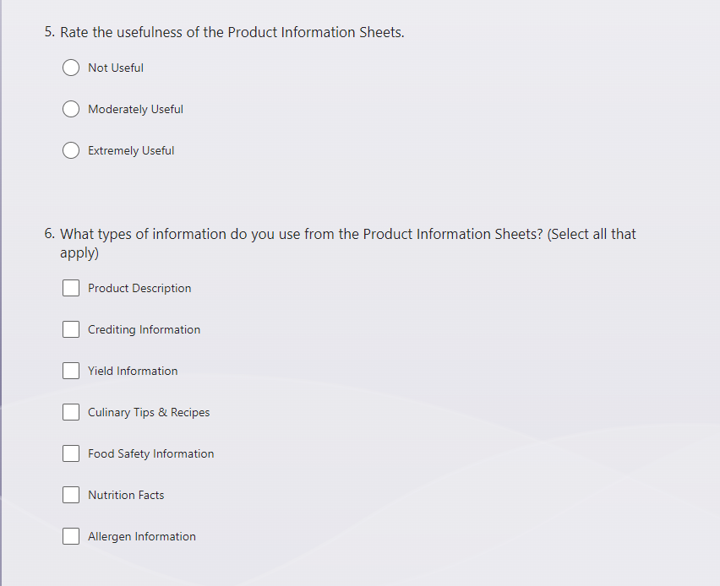
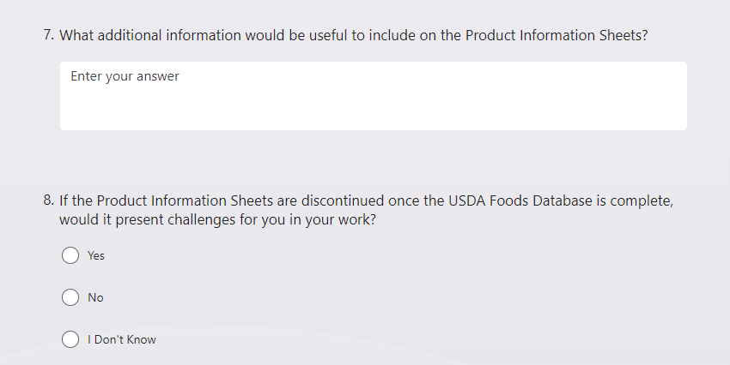
Note: Question 9 is only presented if the answer to question 8 is Yes.
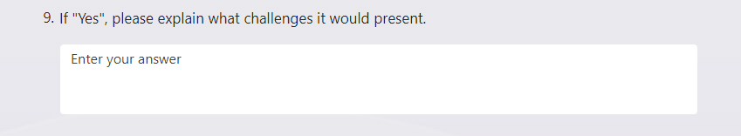
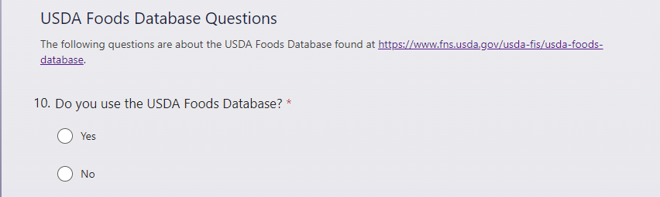
Note: The questions that follow depend on answer to the above question. Below are two sets of questions; one if the answer is No, and the other if the answer is Yes. If No is selected, then the first set of questions 11-13 remain for this section. If Yes is selected, then the second set of questions 11- are available to answer.
If the respondent answers “No” to question 10, the following questions are asked:
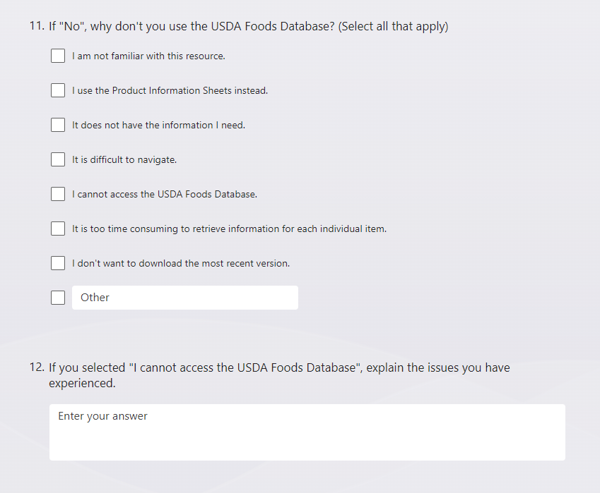
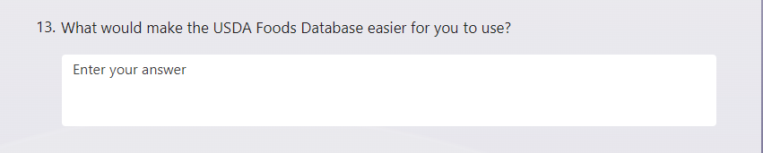
If the respondent answers “Yes” to question 10, the following questions are asked:
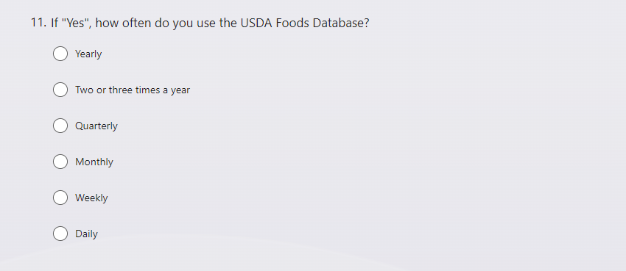
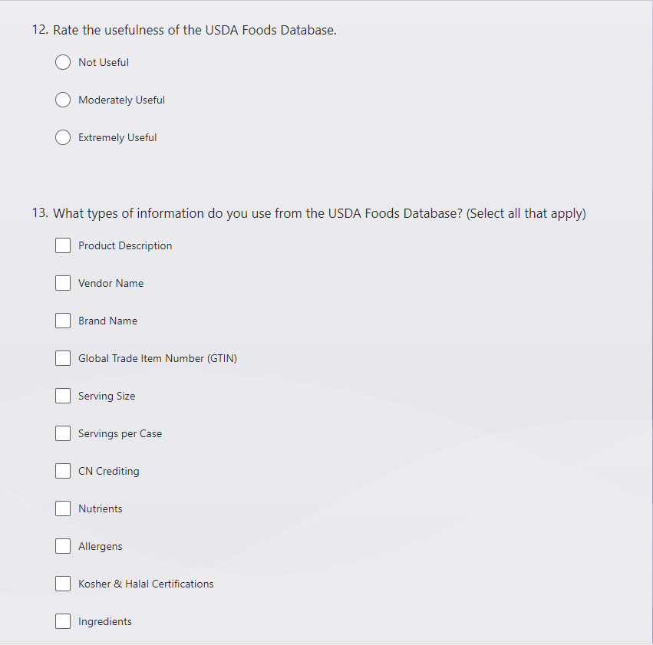

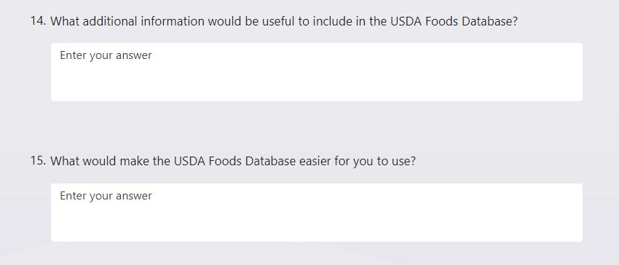
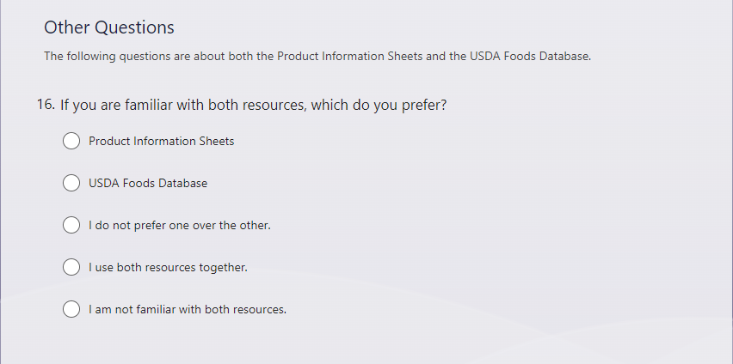
Note: If Product Information Sheets or USDA Foods Database is selected for the question above, then question 17-18 are asked. If any of the other answer options are selected, only question 18 is asked.
