Attachment C:
FNS-843- Report of Disqualification from Participation: Institution and Responsible Principals/Individuals

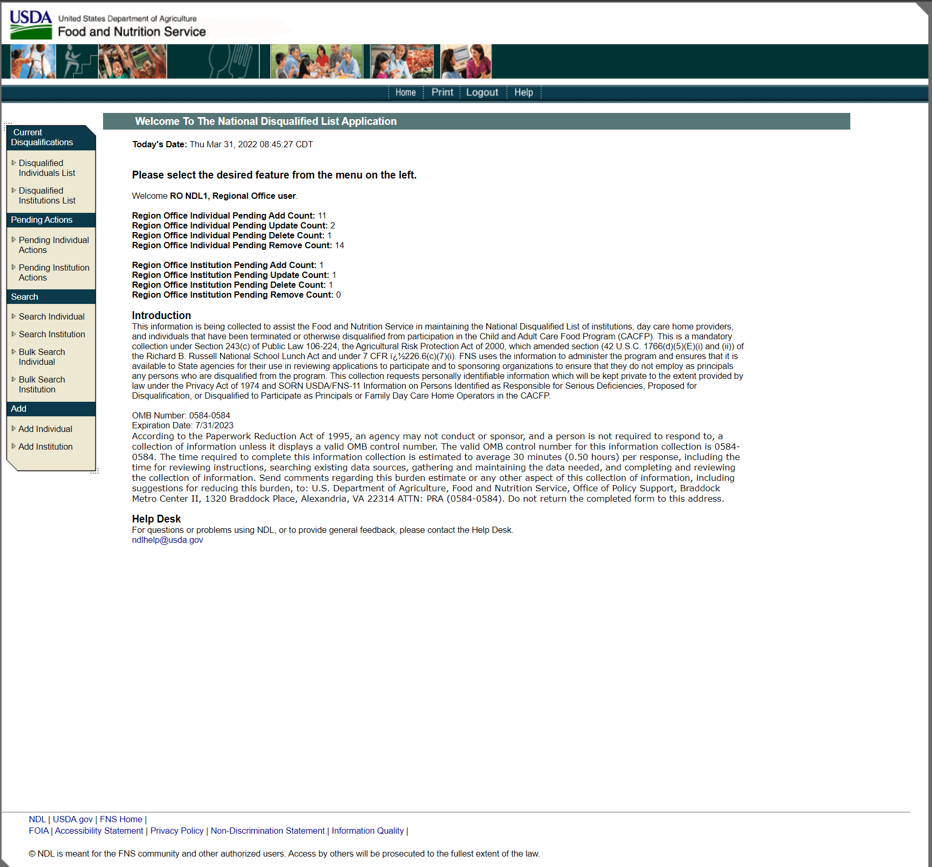

Attachment A-1
FNS-843- Report of Disqualification from Participation: Institution and Responsible Principals/Individuals

