OMB No: 0910-0915 Expiration Date: 06/30/2026
Paperwork Reduction Act Statement: According to the Paperwork Reduction Act of 1995, an agency may not conduct or sponsor, and a person is not required to respond to a collection of information unless it displays a valid OMB control number. The public reporting burden for this collection of information has been estimated to average 30 minutes per response. Send comments regarding this burden estimate or any other aspects of this collection of information, including suggestions for reducing burden to PRAStaff@fda.hhs.gov.

ATTACHMENT 9: ExPECTT 3 Youth Survey: Follow-up waves

The Real Cost Campaign Outcomes Evaluation Study: Cohort 3 (Outcomes Study)

[PROGRAMMING NOTES:
- THE RESPONSE OPTION, “PREFER NOT TO ANSWER” WILL NOT BE INCLUDED UNTIL A RESPONDENT TRIES TO SKIP A QUESTION WITHOUT RESPONDING. IF ANY ITEM IS LEFT UNANSWERED, THE ERROR MESSAGE WILL SAY “PLEASE PROVIDE AN ANSWER TO THIS QUESTION. IF YOU WOULD PREFER NOT TO ANSWER, PLEASE SELECT THE OPTION ‘PREFER NOT TO ANSWER.” IN LOWERCASE LETTERS, AND PREFER NOT TO ANSWER WILL DISPLAY AT THE BOTTOM OF THE ANSWER CHOICES, CODED 999.
- QUESTIONS MARKED WITH AN ASTERISK WILL ONLY BE ASKED AT BASELINE]

Preloaded Variables

Variable Name | Description | Values
SAMPLE_TYPE | Sample type depending if participant comes from the longitudinal cohort or replenishment sample | 1 = longitudinal sample  2 = replenishment sample
BL_DOB | Date of Birth from baseline survey if sample_type = 1. Value is missing if sample_type = 2. | [mm/dd/yyyy]
SOCIALMEDIA | Identifies if case was a social media case during baseline | 0 = No  1 = Yes  . = (replenishment sample)
EST_AGE_BL | Estimated age based on the BL DOB | Age in years  Missing for sample_type = 2
PARENT_PERM | Variable from screener, indicates if parental permission was collected or not. | 0 = Not collected  1 = Collected
isNE_AL | Indicator variable to identify cases from Nebraska or Alabama | 0 = No  1 = Yes

PROGRAMMING CHECKPOINT
IF SAMPLE_TYPE = 1 (longitudinal) AND EST_AGE_BL >= 11 AND EST_AGE_BL < 14, THEN GO TO PARENTAL_PERMISSION

IF SAMPLE_TYPE = 1 (longitudinal) AND EST_AGE_BL >= 14, THEN GO TO INTRO_A

IF SAMPLE_TYPE = 2 (replenishment) AND PARENT_PERM = 0, THEN GO TO PARENTAL_PERMISSION.

IF SAMPLE_TYPE = 2 (replenishment) AND PARENT_PERM = 1, THEN GO TO INTRO_A

[INSERT PARENTAL_PERMISSION]

Section A: Demographics
[PROGRAMMING NOTE: PREFER NOT TO ANSWER WILL NOT BE ALLOWED FOR AGE. IF A RESPONDENT TRIES TO SKIP THE BIRTHDATE QUESTION, THE ERROR MESSAGE WILL SAY “YOUR DATE OF BIRTH IS REQUIRED TO CONFIRM THAT YOU ARE ELIGIBLE TO COMPLETE THIS SURVEY. IF YOU HAVE ANY QUESTIONS, PLEASE [IF SOCIALMEDIA = 0 AND EST_BL_AGE< 18 (< 19 IN AL/NE), DISPLAY: “HAVE YOUR PARENT/GUARDIAN”] CONTACT US AT 1-866-800-9177.”]

INTRO_A1. [IF PARENT PERMISSION WAS NOT REQUIRED]
The first part of the survey asks you some general questions about yourself.

ASK: All respondents

INTRO_A2. [IF PARENT PERMISSION WAS REQUIRED]

From this screen forward, the questions should be answered by the selected child ([CHILD1NAME]).

The first part of the survey asks you some general questions about yourself.

ASK: All respondents

A1_1.
What is your ([CHILD1NAME]’s) date of birth? Please provide accurate information to this question. Remember that your responses to this survey will not be shared with anyone outside of the study team and will remain private and confidential.
__________ (3 DROPDOWN BOXES WITH: ((1)Month (2) dd (3) yyyy)

A1_1b.
To be sure we have the right information, please enter your ([CHILD1NAME]’s) date of birth again.
__________ (3 DROPDOWN BOXES WITH: ((1)Month (2) dd (3) yyyy)

[PROGRAMMER: A1_1 AND A1_1b ARE SHOWN IN THE SAME SCREEN.
CONFIRM THAT DOB IN A1_1 AND A1_1B MATCH. IF NOT, DISPLAY: These dates do not match. Please reenter your date of birth.]
[PROGRAMMER; DISPLAY YEARS 2000 – 2025]

ASK: All respondents

CHECKPOINT CHK1

IF SAMPLE_TYPE = 1 (longitudinal) AND A1_1 = BL_DOB, THEN CHK1 = 1. GO TO CHK3.
IF SAMPLE_TYPE = 1 AND A1_1 NOT EQUALS BL_DOB, THEN CHK1 = 2. GO TO EXIT1.
IF SAMPLE_TYPE = 2 (replenishment), THEN CHK1 = missing. GO TO A1_2.

A1_2. [IF SAMPLE_TYPE = 2]
That would make you [CALCULATED AGE] years old, is that correct?
- Yes
- No

ASK: Respondents who did not take baseline

CHECKPOINT CHK2

IF SAMPLE_TYPE = 2 (replenishment) AND A1_2 = 1, THEN CHK2 = 1. GO TO CHK3.
IF SAMPLE_TYPE = 2 AND A1_2 = (2 or PNTA), THEN CHK2 = 2. GO TO EXIT1.

COMPUTE RESPONDENT AGE (RAGE)
IF (SAMPLE_TYPE = 1 AND CHK1 = 1) OR (SAMPLE_TYP2 = 2 AND CHK2 = 1), THEN
CALCULATE AGE (RAGE) BASED ON DATE OF INTERVIEW AND A1_1.

CHECKPOINT CHK3

IF SAMPLE_TYPE = 2 AND (RAGE < 11 OR RAGE > 17), GO TO EXIT1
IF RAGE >= 11 AND RAGE <14, GO TO YOUTH_ASSENT
IF RAGE >= 14 AND ((isNE_AL = 0 AND RAGE <18) OR (isNE_AL = 1 AND RAGE < 19)), GO TO YOUTH_ASSENTTN
IF SAMPLE_TYPE = 1 AND ((isNE_AL = 0 AND RAGE >= 18) OR (isNE_AL = 1 AND RAGE >= 19)), GO TO YOUTHCONSENT

EXIT1. [IF (SAMPLE_TYPE = 1 AND A1_1 NOT EQUAL BL_DOB) OR
(SAMPLE_TYPE = 2 AND (A1_2 = (2 or PNTA) OR RAGE < 11 OR RAGE > 17))]

Thank you. We need to ask a few follow-up questions before continuing the survey. Please [IF SOCIALMEDIA = 0 AND EST_AGE_BL< 18 (< 19 IN AL/NE), DISPLAY: “have your parent/guardian”] contact us at 1-866-800-9177.

ASK: Respondents who enter an age that is not consistent with the age entered at baseline or who indicate their calculated age is incorrect a second time.

[INSERT ASSENT / CONSENT ATTACHMENTS]

INTRO
This survey is all about you.

Your thoughts, your opinions, your experiences.

We want to know about some of your beliefs, attitudes and behaviors. We will ask about media use and about your use of substances that may be illegal for you to buy or use in your state, such as tobacco and marijuana. Even if you don’t use tobacco or marijuana, we want to know what you think. Finally, we will also ask about your experiences in school and in your home.

It will take about 30 minutes for you to complete this survey. Please take your time and answer as honestly and thoughtfully as you can. Please take the survey in a place where no one can look over your shoulder and view your answers.

Your responses will be combined with those of others who are taking this survey before the data are reported. This will be done to ensure your identity and responses will not be revealed.

ASK: All respondents

Section B: Tobacco Use Behavior and Other Substance Use

INTRO_B.
Now we want to know about your experiences with tobacco products.

ASK: All respondents

The next questions are about vapes. You may also know them as e-cigarettes.

These products are battery-powered and produce vapor or aerosol instead of smoke. They contain nicotine liquid, sometimes called "e-liquid" or "e-juice," although the amount of nicotine can vary and some may not contain any nicotine at all.

Some can be bought as one-time, disposable products, while others can be bought as re-usable kits that are rechargeable. Some common brands include JUUL, Vuse, Puff Bar, NJOY, and blu.

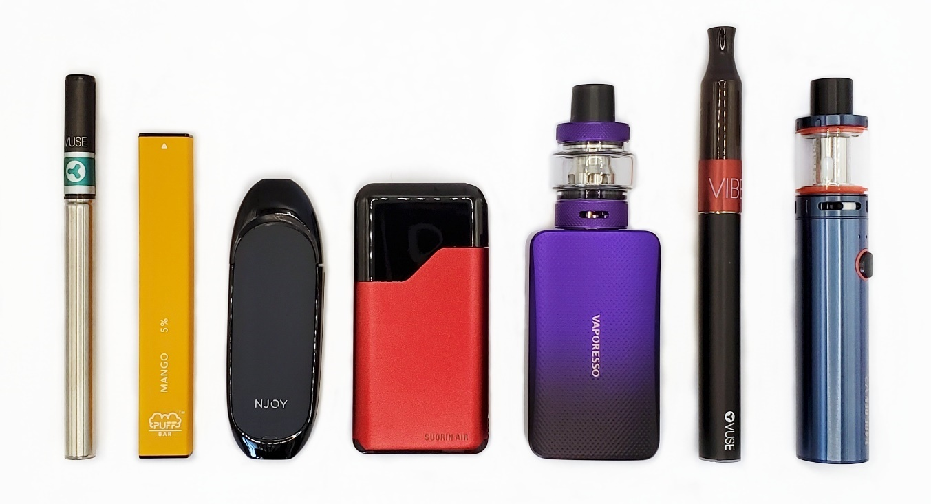
Please do not include vaping marijuana/THC/CBD/Delta 8 with these products when answering the questions in this section.

B1.
Have you ever tried vaping nicotine, even one time?
- Yes
- No

ASK: All respondents

B2. [IF B1=1 OR 999]
In the past 30 days, on how many days did you vape nicotine?
________ days [RANGE 0-30]

ASK: Respondents who have ever tried vaping or PNTA

B3. [IF B1=1 OR B2=1-30]
How old were you the first time you used a vape with nicotine?
________ years old [DO NOT ALLOW AGE > PARTICIPANT AGE]

IF B3 > CURRENT AGE, DISPLAY ERROR MESSAGE: “Before you said your DOB was X/X/X, which would make you X years old. Please check your answer.”

ASK: Respondents who have ever tried vaping or PNTA

B4_1. [IF B2=1-30]
On the days that you can vape nicotine freely, how soon after you wake up do you vape?
- 0-5 minutes
- 6-15 minutes
- 16-30 minutes
- 31-60 minutes
- 61-120 minutes
- 121 or more minutes

ASK: Respondents who are current vape users

B24. [IF B2=1-30]
On average, how many times a day do you vape nicotine, whether you take one puff or several?
__________ times [RANGE 0-9,999]

ASK: Respondents who are current vape users

B25. [IF B2=1-30]
Each time you vape nicotine, about how many puffs do you take?
_________ puffs [RANGE 0-999]

ASK: Respondents who are current vape users

B26. [IF B2=1-30]
In the past 6 months, have you stopped vaping nicotine for one day or longer because you were trying to quit for good?
- Yes
- No

ASK: Respondents who are current vape users

B4_2. [IF B2=1-30]
Are you seriously thinking about stopping vaping nicotine altogether?
- Yes, within the next 30 days
- Yes, not within the next 30 days but sometime in the next 6 months
- Yes, not within the next 6 months but sometime in the next year
- Yes, but not within the next year
- No, I am not seriously thinking about stopping forever

[PROGRAMMER: DISPLAY OPTION “[98] Don’t know” IF QUESTION IS SKIPPED (TOGETHER WITH PNTA)]

ASK: Respondents who are current vape users
INTRO_CIG1.
Thanks for your answers! Now we want to ask you a few questions about smoking cigarettes.

ASK: All respondents

B5.
Have you ever tried smoking cigarettes, even one or two puffs?
- Yes
- No

ASK: All respondents

B6. [IF B5=1 OR 999]
In the past 30 days, on how many days did you smoke cigarettes?
________ days [RANGE 0-30]

ASK: Respondents who have ever tried smoking or PNTA

B7_rev. [IF B6=1-30]
In the past 30 days, what type of cigarettes did you usually smoke?
- Regular only
- More regular than menthol
- Both regular and menthol, equally
- More menthol than regular
- Menthol only

ASK: Respondents who are current cigarette smokers
B8. [IF B6=1-30]
In the past 30 days, on the days you smoked, how many cigarettes did you smoke per day?
- Less than 1 cigarette per day
- 1 cigarette per day
- 2 to 5 cigarettes per day
- 6 to 10 cigarettes per day
- 11 to 20 cigarettes per day
- More than 20 cigarettes per day

ASK: Respondents who are current cigarette smokers
B9. [IF B5=1 OR 999]
About how many cigarettes have you smoked in your entire life? Your best guess is fine.
- 0 cigarettes
- 1 or more puffs but never a whole cigarette
- 1 cigarette
- 2 to 5 cigarettes
- 6 to 15 cigarettes (about 1/2 a pack total)
- 16 to 25 cigarettes (about 1 pack total)
- 26 to 99 cigarettes (more than 1 pack, but less than 5 packs)
- 100 or more cigarettes (5 or more packs)

ASK: Respondents who have ever tried smoking or PNTA

B10. [IF B5=1 OR B9=2-8]
How old were you the first time you smoked a cigarette?
________ years old [DO NOT ALLOW AGE > PARTICIPANT AGE]

IF CURRENT_AGE < AGE SELECTED AT B10, DISPLAY THE FOLLOWING HARD ERROR MESSAGE IN LOWERCASE LETTERS.
BEFORE YOU SAID YOUR DOB WAS [IF CHECKPOINT = 1 FILL A1_2; IF CHECKPOINT_2 = 1 FILL A1_4; ELSE FILL A1_2A_PARENT2), WHICH WOULD MAKE YOU [CURRENT_AGE] YEARS OLD. PLEASE CHECK YOUR ANSWER.

ASK: Respondents who have ever tried smoking

INTRO_OTP.
Now we want to ask you a few questions about using other tobacco products.

ASK: All respondents

The next questions are about smokeless tobacco, such as dip, chewing tobacco, snuff, or snus. Common brands include Copenhagen, Grizzly, Skoal, and Red Seal.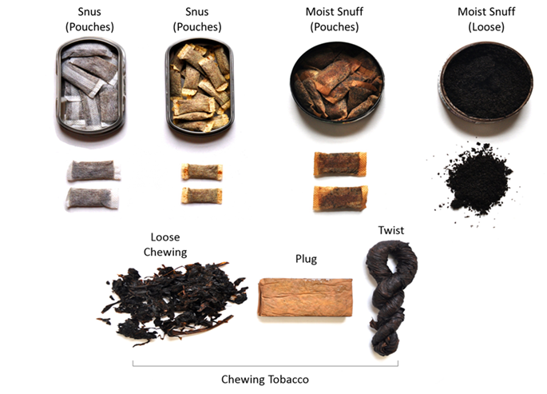

B11.
Have you ever used smokeless tobacco, even just a small amount?
- Yes
- No

ASK: All respondents

B12. [IF B11=1 OR 999]
In the past 30 days, on how many days did you use smokeless tobacco?
________ days [RANGE 0-30]

ASK: Respondents who have ever used smokeless tobacco or PNTA

The next questions are about using cigar products. Please do not include using cigars with marijuana (sometimes known as blunts) in your answers. Cigar products include:
- Large cigars, which include common brands such as Macanudo, Romeo y Julieta, Arturo Fuente, and Garcia Y Vega.
- Cigarillos, which can come with and without a wooden or plastic tip. Some common brands are Black & Mild, Swisher Sweets, Backwoods, Dutch Masters, White Owl, and Game Cigars.
- Little cigars, which are the same size and shape as cigarettes, and often include a filter. Some brands include Djarum, Cheyenne, Talon, and 305s.

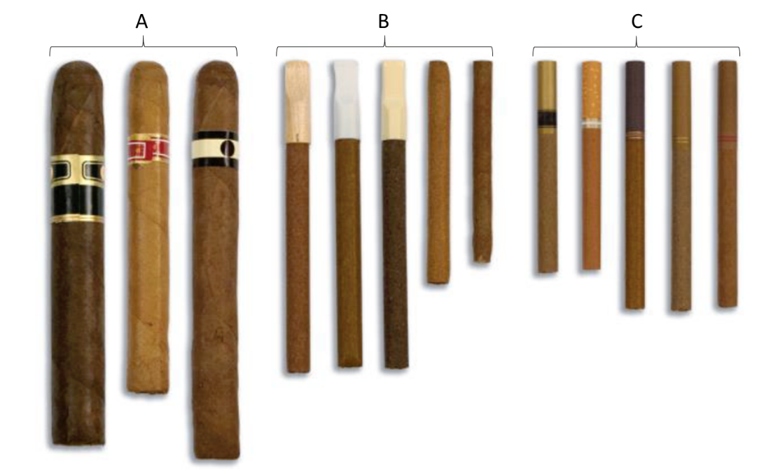

B13.
Have you ever smoked large cigars, cigarillos, or little cigars even one time?
- Yes
- No

ASK: All respondents
B14. [IF B13=1 OR 999]
In the past 30 days, on how many days did you smoke any type of cigar (including large cigars, cigarillos, or little cigars)? Please do not include using cigars with marijuana (sometimes known as blunts) in your answers.
________ days [RANGE 0-30]

ASK: Respondents who have ever smoked large cigars, cigarillos, or little cigars, or PNTA

The next questions are about smoking tobacco in a hookah, which is a type of water pipe. It is
sometimes also called a "narghile" pipe. People smoke shisha or hookah tobacco in a hookah.
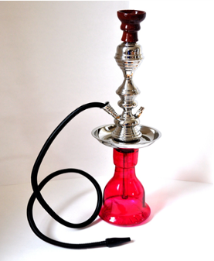

B16.
Have you ever tried smoking tobacco out of a hookah, even one time? Please do not include smoking marijuana/THC/CBD/Delta 8 when answering this question.
- Yes
- No

ASK: All respondents

B17. [IF B16=1 OR 999]
In the past 30 days, on how many days did you smoke tobacco out of a hookah? Please do not include smoking marijuana/THC/CBD/Delta 8 when answering this question.
________ days [RANGE 0-30]

ASK: Respondents who have ever tried smoking tobacco out of a hookah or PNTA

The next questions are about “nicotine pouches” such as Zyn, on!, Rogue, or Velo. These small, flavored pouches contain nicotine. Users place them in their mouth. Nicotine pouches are different from other smokeless tobacco products such as snus, dip, or chewing tobacco, because they do not contain any tobacco leaf.

Please do not think about other forms of smokeless tobacco, such as chewing tobacco, snuff, dip, snus, or dissolvable tobacco when answering these questions.
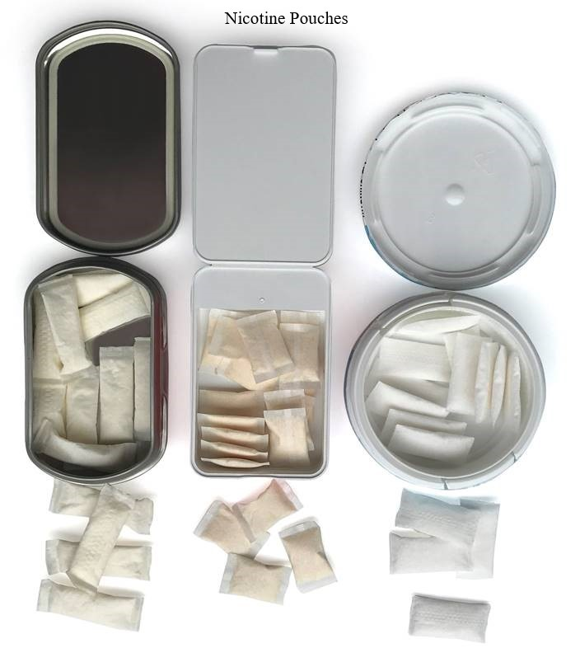

B18.
Have you ever used a nicotine pouch, even just one time?
- Yes
- No

ASK: All respondents

B19. [IF B18=1 OR 999]
In the past 30 days, on how many days did you use a nicotine pouch?
________ days [RANGE 0-30]

ASK: Respondents who have ever used a nicotine pouch or PNTA

INTRO_MJ.
Next, we would like to ask about your use of marijuana (also known as cannabis, pot, weed, hash, or kush). Please include all forms of marijuana. Some examples include dried herb, edibles, oils, hash or kief, concentrates (wax, shatter, budder), drinks, and tinctures.

ASK: All respondents

B20.
Have you ever tried marijuana, even one time? Please do not include CBD when answering this question.
- Yes
- No

ASK: All respondents

B21. [IF B20=1 OR 999]
In the past 30 days, on how many days did you use marijuana? Please do not include CBD when answering this question.

________ days [RANGE 0-30]

ASK: Respondents who have ever tried marijuana or PNTA

B22. [IF B1=1 OR 999]
Earlier in the survey, you said that you have tried vaping at least one time. What type of products have you ever vaped? Select all that apply.
  - Marijuana (THC, CBD, or Delta 8), such as concentrates, hash oils, or dabs
  - Nicotine
  - Zero nicotine e-liquids (nicotine-free, just flavoring)

ASK: Respondents who have ever tried vaping or PNTA

B23. [IF B2>0 OR 999]
In the past 30 days, what did you usually vape? Select all that apply.
- THC
- CBD
- Delta 8
- Nicotine
- Zero nicotine e-liquids (nicotine-free, just flavoring)
- Other (please specify)
9. Don’t know
ASK: Respondents who currently vape

Section C: Tobacco Use Intentions/Curiosity/Willingness to Use

INTRO_CVAPE.
You’re doing great! Now we want you to think about what you might do in the future.

ASK: All respondents

C1_1.
Thinking about the future…
Do you think that you will vape nicotine soon?
- Definitely yes
- Probably yes
- Probably not
- Definitely not

ASK: All respondents

C1_2.
Thinking about the future…
Do you think you will vape nicotine at any time in the next year?
- Definitely yes
- Probably yes
- Probably not
- Definitely not

ASK: All respondents

C1_3.
Thinking about the future…
If one of your best friends were to offer you a vape with nicotine, would you use it?
- Definitely yes
- Probably yes
- Probably not
- Definitely not
ASK: All respondents

c1_4. [IF B1=2]
Are you curious about vaping nicotine?
- Definitely yes
- Probably yes
- Probably not
- Definitely not

ASK: Respondents who have never tried vaping nicotine

C1_5.
Do you think you will be vaping nicotine 5 years from now?
- Definitely will
- Probably will
- Probably will not
- Definitely will not

ASK: All respondents

C2.
PROGRAMMER: RANDOMIZE ORDER OF THE C2 SERIES.]
Suppose you were in the following situation. You are at a party and many of your friends are vaping nicotine. You are offered a vape with nicotine by a person you like very much.

C2_1. How likely is it you would take the vape and try it?
C2_2. How likely is it you would say no thanks?
C2_3. How likely is it you would leave the situation?

- Not at all likely
- A little likely
- Somewhat likely
- Very likely
- Extremely likely

ASK: All respondents
C3.
In the next 30 days, do you think you will obtain a vape with nicotine for your own personal use?

1  (Definitely will not obtain one to use it) | 2 | 3 | 4 | 5 | 6 | 7 | 8 | 9 | 10  (Definitely will obtain one to use it)

ASK: All respondents

C4. [PROGRAMMER: RANDOMIZE ORDER OF THE C4 SERIES.]

Please tell us how much you agree or disagree with the following statements.

C4_1. In the next year I do not intend to vape nicotine.
C4_2. In the next year I will try not to vape nicotine.
C4_3. In the next year I will not start vaping nicotine.

  - Strongly disagree
  - Disagree
  - Neutral
  - Agree
  - Strongly agree

ASK: All respondents

C5.
Do you think using vapes with nicotine is less harmful, about the same, or more harmful than smoking cigarettes?
  - Less harmful
  - About the same
  - More harmful

ASK: All respondents

C6.
Please indicate the number that best describes how you feel about vaping nicotine.
Vaping nicotine is…

C6_1. | Unattractive | 1 | 2 | 3 | 4 | 5 | Attractive
C6_2. | Not Cool | 1 | 2 | 3 | 4 | 5 | Cool
C6_3. | Boring | 1 | 2 | 3 | 4 | 5 | Fun
C6_4. | Not meant for someone like me | 1 | 2 | 3 | 4 | 5 | Meant for someone like me
C6_5. | Childish | 1 | 2 | 3 | 4 | 5 | Grown-up

ASK: All respondents

INTRO_CCIG.
Shifting gears, now think about cigarettes and what you might do in the future.

ASK: All respondents

C7_1.
Thinking about the future…
Do you think that you will smoke a cigarette soon?
- Definitely yes
- Probably yes
- Probably not
- Definitely not

ASK: All respondents

C7_2.
Thinking about the future…
Do you think you will smoke a cigarette at any time in the next year?
- Definitely yes
- Probably yes
- Probably not
- Definitely not

ASK: All respondents

C7_3.
Thinking about the future…
If one of your best friends were to offer you a cigarette, would you smoke it?
- Definitely yes
- Probably yes
- Probably not
- Definitely not

ASK: All respondents

C7_4. [IF B5=2]
Are you curious about smoking a cigarette?
  - Definitely yes
  - Probably yes
  - Probably not
  - Definitely not

ASK: Respondents who have never smoked cigarettes

C8.
[PROGRAMMER: RANDOMIZE ORDER OF THE C8 SERIES.]
Suppose you were in the following situation. You are at a party and many of your friends are smoking cigarettes. You are offered a cigarette by a person you like very much.

C8_1. How likely is it you would take the cigarette and try it?
C8_2. How likely is it you would say no thanks?
C8_3. How likely is it you would leave the situation?

  - Not at all likely
  - A little likely
  - Somewhat likely
  - Very likely
  - Extremely likely

ASK: All respondents

INTRO_CALCOHOL.
Finally, we want you to think about alcohol and what you might do in the future.

ASK: All respondents

C9.
[PROGRAMMER: RANDOMIZE ORDER OF THE C9 SERIES.]
Suppose you were in the following situation. You are at a party and many of your friends are drinking alcohol. You are offered an alcoholic drink by a person you like very much.

C9_1. How likely is it you would take the alcoholic drink and try it?
C9_2. How likely is it you would say no thanks?
C9_3. How likely is it you would leave the situation?

- Not at all likely
- A little likely
- Somewhat likely
- Very likely
- Extremely likely

ASK: All respondents

CUTEBRK1. Thank you for all of your answers so far. You’re doing great!
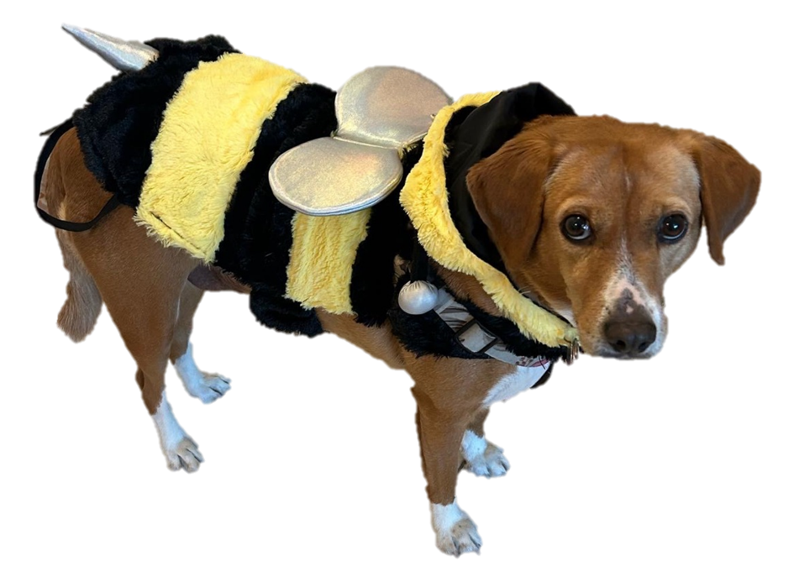

ASK: All respondents

Section D: Unintended Consequences

INTRO_D.
We will now ask you your opinions about vapes. This is not a test of your scientific knowledge. We just want to know your opinions.

ASK: All respondents

D1.
Please tell us how much you agree or disagree with the following statement.

Vaping nicotine can increase your risk for developing an anxiety disorder.
- Strongly disagree
- Disagree
- Neutral
- Agree
- Strongly agree

ASK: All respondents

D2.
Imagine you have a friend who vapes nicotine every day. Your friend is thinking about starting to smoke cigarettes as a way to quit vaping and wants to know if you think it’s a good or bad idea. What would you tell them?
- I think it's a good idea to switch to cigarettes.
- I think it's a bad idea to switch to cigarettes.
- I’m unsure if it’s a good or bad idea to switch to cigarettes.
ASK: All respondents

Section E: Campaign Targeted Constructs

INTRO_E. Next, we’d like to ask you some questions about things that might happen to you or other people when they vape nicotine.

ASK: All respondents

Electronic Nicotine Delivery Systems
E1.
[USE SCROLLING LIST. RANDOMIZE ORDER OF THE E1 SERIES.]
Please tell us how much you agree or disagree with the following statements.
E1_1. The metals in vapes will cause permanent damage to the user’s lungs.
E1_2. The metals in vapes will cause organ damage.
E1_3. The metals in vapes poison the user’s body.

  - Strongly disagree
  - Disagree
  - Neutral
  - Agree
  - Strongly agree

ASK: All respondents

E2.
[USE SCROLLING LIST. RANDOMIZE ORDER OF THE E2 SERIES.]
E2_1. If you were to vape a few days a week, how likely is it that you personally would poison your body with the metals in vapes?
E2_2. If you were to vape a few days a week, how likely is it that you personally would permanently damage your lungs by inhaling metal particles?
E2_3. If you were to vape a few days a week, how likely is it that you personally would inhale metals that will cause organ damage?

- Not at all likely
- A little likely
- Somewhat likely
- Very likely
- Extremely likely

ASK: All respondents

TRANSITION1_E. Next, we’d like to ask you some questions about how your family and friends might feel if you vape nicotine.

E3.
[USE SCROLLING LIST. RANDOMIZE ORDER OF THE E3 SERIES.]
Please tell us how much you agree or disagree with the following statements.

E3_1. If I vape, my family will be disappointed in me.
E3_2. If I vape, my family will feel like I’m always breaking their trust.
E3_4. If I vape, I will not live up to my family’s expectations.

- Strongly disagree
- Disagree
- Neutral
- Agree
- Strongly agree

ASK: All respondents

E4.
[USE SCROLLING LIST. RANDOMIZE ORDER OF THE E4 SERIES.]
Please tell us how much you agree or disagree with the following statements.

E4_1. If I vape, my friends will be very disappointed in me.
E4_2. If I vape, I will never live up to my friends’ expectations.
E4_3. If I vape, my friendships will be negatively impacted.

- Strongly disagree
- Disagree
- Neutral
- Agree
- Strongly agree

ASK: All respondents

[Programmer: randomize assignment of ATTNCHK1 and ATTNCHK2. Generate a random number. Half of the sample will receive ATTNCHK1 here and ATTNCHK2 later. The other half will receive the variables in the reverse order.]

ATTNCHK1
To show us that you’re paying attention, please select Lunch as the answer to this question.

Which of the following is your favorite subject in school?
  - Hieroglyphics
  - Recess
  - Math
  - Lunch
  - History of Pottery

ASK: All respondents

ATTNCHK2.

How often have you piloted a spaceship in the past 30 days? To show us that you’re paying attention, please select Always as the answer to this question.

- Always
- Often
- Sometimes
- Rarely
- Never

TRANSITION2_E. Thanks for your responses! We’d now like to ask you some more questions about things that might happen to you or other people when they vape nicotine.

ASK: All respondents

E5.
[USE SCROLLING LIST. RANDOMIZE ORDER OF THE E5 SERIES.]
Please tell us how much you agree or disagree with the following statements.

E5_1. If I vape, I will never become the person I want to be.
E5_2. If I vape, I will never be able to perform well at things that are important to me.
E5_4. If I vape, I will never be able to achieve my goals.
- Strongly disagree
- Disagree
- Neutral
- Agree
- Strongly agree
ASK: All respondents
E7.
[USE SCROLLING LIST. RANDOMIZE ORDER OF E7 ITEMS.]
Please tell us how much you agree or disagree with the following statements.

E7_2. If I vape, I will feel worried about hurting my body
E7_3. If I vape, I will feel responsible if anything bad happens.
E7_4. If I vape, I will feel like I am acting recklessly.

- Strongly disagree
- Disagree
- Neutral
- Agree
- Strongly agree

ASK: All respondents

E8.
[USE SCROLLING LIST. RANDOMIZE ORDER OF THE E8 SERIES.]
Please tell us how much you agree or disagree with the following statements.

E8_1. If I vape, I feel that other people will judge me.
E8_2. If I vape, I feel that other people will criticize me.
E8_3. If I vape, I feel that other people will think I messed up.

- Strongly disagree
- Disagree
- Neutral
- Agree
- Strongly agree

ASK: All respondents

E9.
[USE SCROLLING LIST. RANDOMIZE ORDER OF E9_1-E9_8.]
Please tell us how much you agree or disagree with the following statements.

E9_2. If I vape, I will criticize myself.
E9_3. If I vape, I will feel gross about myself.
E9_4. If I vape, I will be embarrassed.

- Strongly disagree
- Disagree
- Neutral
- Agree
- Strongly agree

ASK: All respondents
E19.
[USE SCROLLING LIST. RANDOMIZE ORDER OF THE E19 SERIES.]
Please tell us how much you agree or disagree with the following statements.

E19_1. When people vape, the chemicals they inhale will cause a lot of harm to their lungs.
E19_2. When people vape, the chemicals they inhale may damage their DNA.
E19_3. The chemicals in vapes will cause permanent damage to the user’s body.
E19_4. When people vape, they inhale chemicals that cause cancer.
E19_5. When people vape, the chemicals they breathe in may/can cause harm to their lungs.
E19_6. Vaping may make people breathe in chemicals that damage their bodies.
E19_7. When people vape, they breathe in chemicals that may/can cause cancer.

- Strongly disagree
- Disagree
- Neutral
- Agree
- Strongly agree

ASK: All respondents

E20.
[USE SCROLLING LIST. RANDOMIZE ORDER OF THE E20 SERIES.]

E20_1. If you were to vape a few days a week, how likely is it that you personally would inhale chemicals that cause a lot of harm to your lungs?
E20_2. If you were to vape a few days a week, how likely is it that you personally would inhale chemicals that may damage your DNA?
E20_3. If you were to vape a few days a week, how likely is it that you personally would inhale chemicals that will cause permanent damage to your body?
E20_4. If you were to vape a few days a week, how likely is it that you personally would inhale chemicals that cause cancer?
E20_5. If you were to vape a few days a week, how likely is it that you personally would breathe in chemicals that may cause harm to your lungs?
E20_6. If you were to vape a few days a week, how likely is it that you personally would breathe in chemicals that damage your body?
E20_7. If you were to vape a few days a week, how likely is it that you personally would breathe in chemicals that may cause cancer?

- Not at all likely
- A little likely
- Somewhat likely
- Very likely
- Extremely likely

ASK: All respondents

E24. If you were to vape a few days a week, how likely is it that you personally would be controlled by nicotine?

- Not at all likely
- A little likely
- Somewhat likely
- Very likely
- Extremely likely

ASK: All respondents.

E25. If you were to vape a few days a week, how likely is it that you would harm your overall health?

- Not at all likely
- A little likely
- Somewhat likely
- Very likely
- Extremely likely

ASK: All respondents.

E26.
[USE SCROLLING LIST. RANDOMIZE ORDER OF THE E26 SERIES.]
Please tell us how much you agree or disagree with the following statements.

E26_5. Vaping may cause nicotine cravings that make people lose out on sleep.
E26_6. Vaping may cause nicotine cravings that make people struggle to get enough sleep.
E26_7. Vaping may cause nicotine cravings that make people feel tired all day.

- Strongly disagree
- Disagree
- Neutral
- Agree
- Strongly agree

ASK: All respondents.

E27.
[USE SCROLLING LIST. RANDOMIZE ORDER OF THE E27 SERIES.]

E27_5. If you were to vape a few days a week, how likely is it that you personally would lose out on sleep because of nicotine cravings?
E27_6. If you were to vape a few days a week, how likely is it that you personally would struggle to get enough sleep because of nicotine cravings?
E27_7. If you were to vape a few days a week, how likely is it that you personally would feel tired all day because of nicotine cravings?

- Not at all likely
- A little likely
- Somewhat likely
- Very likely
- Extremely likely

ASK: All respondents.

E28.
[USE SCROLLING LIST. RANDOMIZE ORDER OF THE E28 SERIES.]
Please tell us how much you agree or disagree with the following statements.

E28_1. Vaping causes serious damage to the user's vital organs.
E28_2. Vaping is very harmful to your internal organs.
E28_3. Vaping is toxic to the body's major organs.
E28_4. Vaping may cause damage to the user’s vital organs.
E28_5. Vaping may be harmful to your internal organs.
E28_6. Vaping may be toxic to to the body’s major organs.
E28_7. Vaping may be damaging to the body’s major organs.

- Strongly disagree
- Disagree
- Neutral
- Agree
- Strongly agree

ASK: All respondents.

E29.
[USE SCROLLING LIST. RANDOMIZE ORDER OF THE E29 SERIES.]

E29_1. If you were to vape a few days a week, how likely is it that you personally would have vital organs that are seriously damaged?
E29_2. If you were to vape a few days a week, how likely is it that you personally would have internal organs that are harmed a lot?
E29_3. If you were to vape a few days a week, how likely is it that you personally would find vapes to be toxic to your body's major organs?
E29_4. If you were to vape a few days a week, how likely is it that you personally would have vital organs that are damaged?
E29_5. If you were to vape a few days a week, how likely is it that you personally would have internal organs that are harmed?
E29_6. If you were to vape a few days a week, how likely is it that you personally would have major organs that are damaged?

- Not at all likely
- A little likely
- Somewhat likely
- Very likely
- Extremely likely

ASK: All respondents.

E30.
[USE SCROLLING LIST. RANDOMIZE ORDER OF THE E30 SERIES.]
Please tell us how much you agree or disagree with the following statement.

E30_1. When teenagers vape, their brains don't develop normally.

- Strongly disagree
- Disagree
- Neutral
- Agree
- Strongly agree

ASK: All respondents.
E31.
[USE SCROLLING LIST. RANDOMIZE ORDER OF THE E31 SERIES.]

E31_1. If you were to vape a few days a week, how likely is it that you personally would have a brain that won't develop normally?

- Not at all likely
- A little likely
- Somewhat likely
- Very likely
- Extremely likely

ASK: All respondents.

E32.
[USE SCROLLING LIST. RANDOMIZE ORDER OF THE E32 SERIES.]
Please tell us how much you agree or disagree with the following statements.

E32_1. Vaping permanently damages the lungs.
E32_3. Vaping makes it harder to breathe.
E32_4. Lungs damaged by vaping can never fully recover.

- Strongly disagree
- Disagree
- Neutral
- Agree
- Strongly agree

ASK: All respondents.

E33.
[USE SCROLLING LIST. RANDOMIZE ORDER OF THE E33 SERIES.]

E33_1. If you were to vape a few days a week, how likely is it that you personally would have lungs that are permanently damaged?
E33_3. If you were to vape a few days a week, how likely is it that you personally would find it harder to breathe?
E33_4. If you were to vape a few days a week, how likely is it that you personally would have lungs that never fully recover?

- Not at all likely
- A little likely
- Somewhat likely
- Very likely
- Extremely likely

ASK: All respondents.
E34.
[USE SCROLLING LIST. RANDOMIZE ORDER OF THE E34 SERIES.]
Please tell us how much you agree or disagree with the following statements.

E34_1. A nicotine addiction is something people would need professional help to stop using nicotine.
E34_2. A nicotine addiction makes a person crave nicotine nonstop.
E34_3. A person who is addicted to nicotine will get anxious if they can’t get nicotine when they want to.

- Strongly disagree
- Disagree
- Neutral
- Agree
- Strongly agree

ASK: All respondents.

E53.
[USE SCROLLING LIST. RANDOMIZE ORDER OF THE E53 SERIES.]
Please tell us how much you agree or disagree with the following statements.

E53_1. Vaping may cause nicotine withdrawal that makes people feel nervous more often.
E53_2. Vaping may lead to nicotine withdrawal that makes people feel on edge more than usual.
E53_4. Vaping may cause nicotine withdrawal that makes people feel more worried than usual.

- Strongly disagree
- Disagree
- Neutral
- Agree
- Strongly agree

ASK: All respondents.

E54.
[USE SCROLLING LIST. RANDOMIZE ORDER OF THE E54 SERIES.]

E54_1. If you were to vape a few days a week, how likely is it that you personally wouldfeel nervous more often than usual because of withdrawal from nicotine?
E54_2. If you were to vape a few days a week, how likely is it that you personally would feel on edge more than usual because of withdrawal from nicotine?
E54_4. If you were to vape a few days a week, how likely is it that you personally would feel more worried than usual because of withdrawal from nicotine?

- Not at all likely
- A little likely
- Somewhat likely
- Very likely
- Extremely likely

ASK: All respondents.

E55. [USE SCROLLING LIST. RANDOMIZE ORDER OF THE E55 SERIES.]
Please tell us how much you agree or disagree with the following statements.

E55_1. Nicotine addiction can change a person’s behavior for the worse.
E55_2. Nicotine addiction can make a person act differently than they normally would.
E55_3. Nicotine addiction can cause someone to make bad choices they normally would not make.

- Strongly disagree
- Disagree
- Neutral
- Agree
- Strongly agree

ASK: All respondents.

E35.
[USE SCROLLING LIST. RANDOMIZE ORDER OF THE E35 SERIES.]

E35_1. If you were to use nicotine a few days a week, how likely is it that you personally would crave nicotine nonstop?
E35_2. If you were to use nicotine a few days a week, how likely is it that you personally would feel extremely anxious if you can’t get nicotine whenever you want to?
E35_3. If you were to use nicotine a few days a week, how likely is it that you personally would need professional help to stop using nicotine?

- Not at all likely
- A little likely
- Somewhat likely
- Very likely
- Extremely likely

ASK: All respondents.

E56.
[USE SCROLLING LIST. RANDOMIZE ORDER OF THE E56 SERIES.]

E56_1. If you were to become addicted to nicotine, how likely is it that you personally would change your behavior for the worse?
E56_2. If you were to become addicted to nicotine, how likely is it that you personally wouldact differently than you normally would?
E56_3. If you were to become addicted to nicotine, how likely is it that you personally would make bad choices you normally would not make?

- Not at all likely
- A little likely
- Somewhat likely
- Very likely
- Extremely likely

ASK: All respondents.

E57.
[USE SCROLLING LIST. RANDOMIZE ORDER OF THE E57 SERIES.]
Please tell us how much you agree or disagree with the following statements.

E57_1. Vaping nicotine can make people need more nicotine to get the same effect.
E57_2. Vaping nicotine can make a person crave nicotine nonstop.
E57_3. Vaping nicotine can make a person need nicotine every day.

- Strongly disagree
- Disagree
- Neutral
- Agree
- Strongly agree

ASK: All respondents.

E58.
[USE SCROLLING LIST. RANDOMIZE ORDER OF THE E58 SERIES.]

E58_1. If you were to vape a few days a week, how likely is it that you personally would need to vape more nicotine to get the same effect?
E58_2. If you were to vape a few days a week, how likely is it that you personally would crave vaping nicotine nonstop?
E58_3. If you were to vape a few days a week, how likely is it that you personally would need to vape nicotine every day?

- Not at all likely
- A little likely
- Somewhat likely
- Very likely
- Extremely likely

ASK: All respondents.

E67.
[USE SCROLLING LIST. RANDOMIZE ORDER OF THE E67 SERIES.]
How much would the following affect your life?

E67_1. Being addicted to nicotine because of vaping.
E67_2. Harm from toxic ingredients because of vaping.
E67_3. Damage to your organs because of vaping.
E67_4. Problems with anxiety because of vaping.
E67_5. Having trouble sleeping because of vaping.

- Not at all
- A little
- Somewhat
- Quite a bit
- Very much

ASK: All respondents.

E68.
[USE SCROLLING LIST. RANDOMIZE ORDER OF THE E68 SERIES.]

E68_1. If you were to vape a few days a week, how likely is it that you personally would be addicted to nicotine because of vaping?
E68_2. If you were to vape a few days a week, how likely is it that you personally would experience harm from toxic ingredients because of vaping?
E68_3. If you were to vape a few days a week, how likely is it that you personally would have damage to your organs because of vaping?
E68_4. If you were to vape a few days a week, how likely is it that you personally would
experience problems with anxiety because of vaping?
E68_5. If you were to vape a few days a week, how likely is it that you personally would have trouble sleeping because of vaping?

- Not at all likely
- A little likely
- Somewhat likely
- Very likely
- Extremely likely

ASK: All respondents.

CUTEBRK2. You’re doing great! Keep it up!

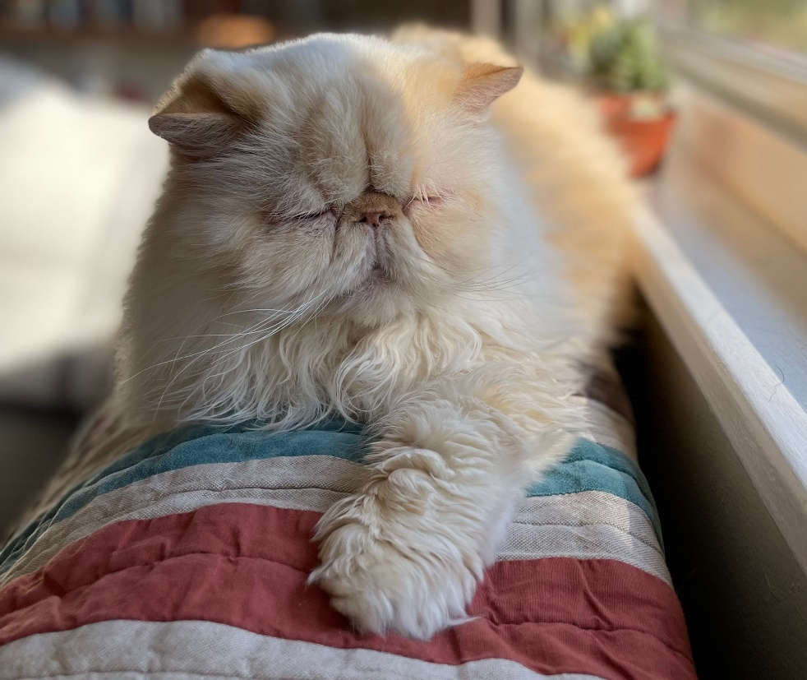

ASK: All respondents

Section F: Exposure/Awareness of Ads

[PROGRAMMING NOTE: DISPLAY: FILL DATE = DATE THAT IS 3 MONTHS BEFORE CURRENT DATE.]

INTRO_F.
Now we want to ask you about some slogans or logos you may have seen on TV or online.


F1. In the past 3 months, that is since [FILL DATE], have you seen or heard the following slogan or logo?

The Real Cost
- Yes
- No
- Not sure

ASK: All respondents

F2. In the past 3 months, that is since [FILL DATE], have you seen or heard the following slogan or logo?
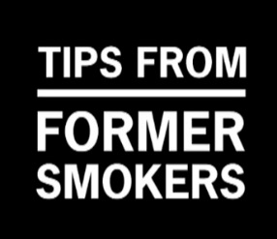
Tips from Former Smokers (Tips)
- Yes
- No
- Not sure

ASK: All respondents


F3. In the past 3 months, that is since [FILL DATE], have you seen or heard the following slogan or logo?

truth
- Yes
- No
- Not sure

ASK: All respondents
F4.

In the past 3 months, that is since [FILL DATE], have you seen or heard the following slogan or logo?

GenZ Vape Free
- Yes
- No
- Not sure

ASK: All respondents

F14. [IF F1 = 1]
[INSERT TRC LOGO]

In the past 3 months, that is since [FILL DATE], have you seen or heard any messages about the harms of vaping from The Real Cost?
  - Yes
  - No
  - Not sure

F15. [IF F1 = 1]
[INSERT TRC LOGO]

In the past 3 months, that is since [FILL DATE], have you [SEEN/HEARD] any [MESSAGES/ ADS/ AUDIO CLIPS] about [PRODUCT CONSEQUENCE] from The Real Cost on [PLATFORM / CHANNEL]?
  - Yes
  - No
  - Not sure

Please tell us how much you agree or disagree with the following statements about The Real Cost.

F10a.
[INSERT TRC LOGO]
The Real Cost gives me information I want.
- Strongly disagree
- Disagree
- Neutral
- Agree
- Strongly agree

ASK: All respondents.

F11a.
[INSERT TRC LOGO]
The Real Cost helps me understand how tobacco can influence me.
- Strongly disagree
- Disagree
- Neutral
- Agree
- Strongly agree

ASK: All respondents.

F12a.
[INSERT TRC LOGO]
The Real Cost is for people like me.
- Strongly disagree
- Disagree
- Neutral
- Agree
- Strongly agree

ASK: All respondents.

F13a.
[INSERT TRC LOGO]
If I saw something from The Real Cost, I would check it out.
- Strongly disagree
- Disagree
- Neutral
- Agree
Strongly agree
ASK: All respondents.

Aided Awareness

INTRO_AWARE.
Now we would like to show you some advertisements that have been shown in the U.S.
Once you have viewed the [INSERT ADVERTISEMENT TYPE: VIDEO OR SCREENSHOT], please click on the forward arrow below to
continue with the survey.

ASK: All respondents

F5_X. [IF VIDEO AD, DISPLAY VIDEO/SCREENSHOT; IF STATIC AD, SKIP TO F6_X]

ASK: All respondents

F6_X.
Apart from this survey, how frequently have you seen this ad in the past 3 months, that is since [FILL DATE]?
- Never
- Rarely
- Sometimes
- Often
- Very Often

ASK: All respondents

Attention

F7_X. [IF F6_X = 2, 3, 4, OR 5]
How much do you agree with the following statement: Apart from this survey, when this ad played, I really paid attention to it.
- Strongly disagree
- Disagree
- Neutral
- Agree
- Strongly agree

ASK: Respondents who saw the ad at least rarely in the past 3 months

F8_X. [IF F6_X = 2, 3, 4, OR 5;
RANDOMIZE ORDER OF RESPONSE OPTIONS F8_X_1 – F8_X_8]

When watching this ad, how often have you…

 |  | Never | Once | More than once
F8_X_1 | Turned the sound on or turned the volume up | 1 | 2 | 3
F8_X_2 | Turned the sound off or turned the volume down | 1 | 2 | 3
F8_X_3 | Clicked on the ad | 1 | 2 | 3
F8_X_4 | Scrolled past the ad | 1 | 2 | 3
F8_X_5 | Skipped the ad once given the option | 1 | 2 | 3
F8_X_6 | Watched the full ad | 1 | 2 | 3
F8_X_7 | Made the ad full screen | 1 | 2 | 3
F8_X_8 | Replayed the ad | 1 | 2 | 3

ASK: Respondents who saw the ad at least rarely in the past 3 months

Certainty of Exposure

F9_X. [IF F6_X = 2, 3, 4, OR 5]
Apart from this survey, how certain are you that you have seen this ad before?
- Very certain
- Somewhat certain
- Not at all certain

ASK: Respondents who saw the ad at least rarely in the past 3 months

[PROGRAMMER: RANDOMIZE ASSIGNMENT OF ATTENTION CHECK ITEMS. DISPLAY THE ITEM THAT WAS NOT DISPLAYED EARLIER]

ATTNCHK1
To show us that you’re paying attention, please select Lunch as the answer to this question.

Which of the following is your favorite subject in school?
- Hieroglyphics
- Recess
- Math
- Lunch
- History of Pottery

ASK: All respondents
ATTNCHK2.

How often have you piloted a spaceship in the past 30 days? To show us that you’re paying attention, please select Always as the answer to this question.
- Always
- Often
- Sometimes
- Rarely
- Never

ASK: All respondents

Section G: Media Use

INTRO_G.
Next, we’d like to ask you about your use of TV and other media.

ASK: All respondents

G1.
How often do you personally use the following to [STREAM MUSIC, PODCASTS ETC., AND/OR WATCH MEDIA, TELEVISION SHOWS, OR VIDEOS, ETC.]?

 | Never | Sometimes | A lot
G1_1. Platform 1 | ₁ | ₂ | ₃
G1_2. Platform 2 | ₁ | ₂ | ₃
G1_3. Platform 3 | ₁ | ₂ | ₃
G1_4. Platform 4 | ₁ | ₂ | ₃
G1_5. Platform 5 | ₁ | ₂ | ₃
G1_6. Platform 6 | ₁ | ₂ | ₃
G1_7. Platform 7 | ₁ | ₂ | ₃
G1_8. Platform 8 | ₁ | ₂ | ₃
G1_9. Platform 9 | ₁ | ₂ | ₃
G1_10. Platform 10 | ₁ | ₂ | ₃

ASK: All Respondents

G2. [IF G1_X [PLATFORM] =2 OR 3]
When you watch [PLATFORM], are there video advertisements during the shows?
- Yes, there are video ads
- No, there are no video ads at all
- Not sure if there are video ads

ASK: Respondents who report watching [PLATFORM] sometimes or a lot

G3_X. [IF G1_X [PLATFORM] =2 OR 3; REPEAT THIS QUESTION AS NEEDED FOR NUMBER OF VIDEO PLATFORMS]
When you watch [MEDIA, TELEVISION SHOWS, VIDEOS, ETC.] on your [PLATFORM] do you ever see video advertisements?
- Yes, I see video ads
- No, I do not see video ads
- I’m not sure if I see video ads

ASK: Respondents who report watching [PLATFORM] Sometimes or a lot

G3_BX. [IF G1_X=2 OR 3 AND IS AUDIO PLATFORM; REPEAT AS NEEDED FOR NUMBER OF PLATFORMS]
When you listen to [PLATFORM] do you ever hear advertisements?
- Yes, I hear ads
- No, I do not hear ads
- I’m not sure if I hear ads

ASK: Respondents who report using [PLATFORM] to stream music sometimes or a lot

[PROGRAMMING NOTE: RANDOMIZE ORDER THAT G5 SERIES IS DISPLAYED]

G5_1.
How often do you watch television shows?
- Several times a day
- About once a day
- 3-5 days a week
- 1-2 days a week
- Every few weeks
- Less often
- Never

ASK: All respondents

G5_2.
How often do you use [PLATFORM]?
- Several times a day
- About once a day
- 3-5 days a week
- 1-2 days a week
- Every few weeks
- Less often
- Never

ASK: All respondents

G5_3.
How often do you use [PLATFORM]?
- Several times a day
- About once a day
- 3-5 days a week
- 1-2 days a week
- Every few weeks
- Less often
- Never

ASK: All respondents

G5_4.
How often do you use [PLATFORM]?
- Several times a day
- About once a day
- 3-5 days a week
- 1-2 days a week
- Every few weeks
- Less often
- Never

ASK: All respondents

G5_5.
How often do you use [PLATFORM]?
- Several times a day
- About once a day
- 3-5 days a week
- 1-2 days a week
- Every few weeks
- Less often
- Never

ASK: All respondents.

G5_6.
How often do you use [PLATFORM]?
- Several times a day
- About once a day
- 3-5 days a week
- 1-2 days a week
- Every few weeks
- Less often
- Never

ASK: All respondents.
G5_7.
How often do you use [PLATFORM]?
- Several times a day
- About once a day
- 3-5 days a week
- 1-2 days a week
- Every few weeks
- Less often
- Never

ASK: All respondents.

G5_8.
How often do you use [PLATFORM]?
- Several times a day
- About once a day
- 3-5 days a week
- 1-2 days a week
- Every few weeks
- Less often
- Never

ASK: All respondents.

G6.
Have you ever seen content posted on social media promoting or selling a vaping product?
- Yes
- No

ASK: All respondents.

G7.
[IF G6=1 OR 999]
In the past week, how often did you see content posted on social media promoting or selling a vaping product?
- More than once a day
- About once a day
- A few times in the past week
- About once in the past week
- More than a week ago

ASK: Respondents who indicated having seen promotional content or PNTA

Section H: Other

INTRO_H.
Thanks for all your answers so far! We have just a few more questions for you.

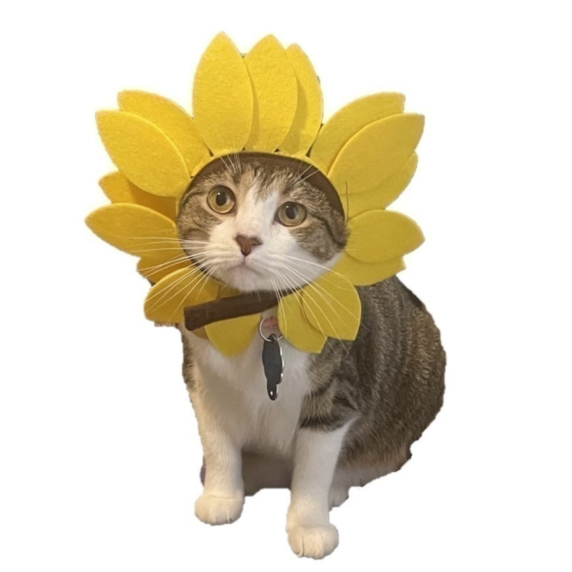

ASK: All respondents

H1.
Other than you, has anyone who lives with you used any of the following in the past 30 days? Select all that apply.
- Cigarettes
- Smokeless tobacco, such as chewing tobacco, snuff, snus (rhymes with goose) or dip, such as [NAME TOP BRANDS]
- Cigars, cigarillos, or little cigars such as [NAME TOP BRANDS]
- Tobacco out of a water pipe (also called “hookah”)
- Electronic vaping products or electronic cigarettes with nicotine, such as [NAME TOP BRANDS]
- Nicotine pouches such as [NAME TOP BRANDS]
- Any other form of tobacco
- No, no one who lives with me has used any form of tobacco during the past 30 days
- I do not live with anyone else

ASK: All respondents

H2. [Source: BSSS-4]
Please tell us how much you agree or disagree with the following statements.

H2_1. I would like to explore strange new places.
- Strongly disagree
- Disagree
- Neutral
- Agree
- Strongly agree

H2_2. I like to do frightening things.
- Strongly disagree
- Disagree
- Neutral
- Agree
- Strongly agree

H2_3. I like new and exciting experiences, even if I have to break the rules.
- Strongly disagree
- Disagree
- Neutral
- Agree
- Strongly agree

H2_4. I prefer friends who are exciting and unpredictable.
- Strongly disagree
- Disagree
- Neutral
- Agree
- Strongly agree

ASK: All respondents

H3. [Source: PHQ-4]
In the past 2 weeks, how often have you been bothered by the following problems?

 |  | Not at all | Several days | More than half the days | Nearly every day
H3_1. | Feeling nervous, anxious or on edge. | ₀ | ₁ | ₂ | ₃
H3_2. | Not being able to stop or control worrying. | ₀ | ₁ | ₂ | ₃
H3_3. | Little interest or pleasure in doing things. | ₀ | ₁ | ₂ | ₃
H3_4. | Feeling down, depressed, or hopeless. | ₀ | ₁ | ₂ | ₃

ASK: All respondents

H4. Do you play sports on a team?
- Yes
- No

ASK: All respondents.

H5. Do you attend school outside of your home?
- Yes
- No

ASK: All respondents.

H6. [IF H5 = 1]
How well would you say you have done in school?
- Much better than average
- Better than average
- Average
- Below average
- Much worse than average

ASK: All respondents who attend school outside of their home.

H7. [IF H5 = 1]
Please tell us how much you agree or disagree with the following statement.

I feel close to people at my school.
- Strongly Disagree
- Disagree
- Neutral
- Agree
- Strongly Agree

ASK: All respondents who attend school outside of their home.

H8. [IF H5 = 1]
Please tell us how much you agree or disagree with the following statement.

I am happy to be at my school.
- Strongly Disagree
- Disagree
- Neutral
- Agree
- Strongly Agree

ASK: All respondents who attend school outside of their home.

H9. [IF H5 = 1]
Please tell us how much you agree or disagree with the following statement.

I feel like I am a part of my school.
- Strongly Disagree
- Disagree
- Neutral
- Agree
- Strongly Agree

ASK: All respondents who attend school outside of their home.

H10.
How far do you think you will go in school?
- I don’t plan to go to school anymore
- 9th grade
- 10th grade
- 11th grade
- 12th grade or GED
- Some college or technical school but no degree
- Technical school degree
- College degree
- Graduate school, medical school, or law school

ASK: All respondents.

These next questions ask about how you feel about your current relationship with your parents or guardians.

H11.
Thinking about the adult or adults you live with, how satisfied are you with the way you communicate with each other?
- Not at all satisfied
- Not very satisfied
- Somewhat satisfied
- Quite satisfied
- Very satisfied
- Not applicable

ASK: All respondents.

H12.
How close do you feel to the adult or adults you live with?
- Not at all close
- Not very close
- Somewhat close
- Quite close
- Very close
- Not applicable

ASK: All respondents.

H13.
Are you: Mark all that apply.
- Female
- Male
- Transgender, non-binary, or another gender identity

ASK: All respondents

H14_rev.

What is your race and/or ethnicity? [Select all that apply and enter additional details in the spaces below]

- American Indian or Alaska Native – Provide details below.
♦ Enter, for example, Navajo Nation,
Blackfeet Tribe of the Blackfeet Indian Reservation of Montana, Native Village of
Barrow Inupiat Traditional Government, Nome Eskimo Community, Aztec, Maya, etc.
______________
- Asian – Provide details below.
♦ Chinese ♦ Asian Indian ♦ Filipino
♦ Vietnamese ♦ Korean ♦ Japanese
♦ Enter, for example, Pakistani, Hmong, Afghan, etc.
______________
- Black or African American – Provide details below.
♦ African American ♦ Jamaican ♦ Haitian
♦ Nigerian ♦ Ethiopian ♦ Somali
♦ Enter, for example, Trinidadian and Tobagonian, Ghanaian, Congolese, etc.
____________________
- Hispanic or Latino – Provide details below.
♦ Mexican ♦ Puerto Rican ♦ Salvadoran
♦ Cuban ♦ Dominican ♦ Guatemalan
♦ Enter, for example, Colombian, Honduran, Spaniard, etc.
___________________
- Middle Eastern or North African – Provide details below.
♦ Lebanese ♦ Iranian ♦ Egyptian
♦ Syrian ♦ Iraqi ♦ Israeli
♦ Enter, for example, Moroccan, Yemeni, Kurdish, etc.
____________________
- Native Hawaiian or Pacific Islander – Provide details below.
♦ Native Hawaiian ♦ Samoan ♦ Chamorro
♦ Tongan ♦ Fijian ♦ Marshallese
♦ Enter, for example, Chuukese, Palauan, Tahitian, etc.
____________ __________
- White – Provide details below.
♦ English ♦ German ♦ Irish
♦ Italian ♦ Polish ♦ Scottish
♦ Enter, for example, French, Swedish, Norwegian, etc.
_______________________

ASK: All respondents

H15_1. [IF H14=4]
In general, do you usually speak…
- Only Spanish
- Spanish more than English
- Spanish and English equally
- English more than Spanish
- English only

ASK: Respondents who are Hispanic or Latino

H15_2. [IF H14=4]
When you watch TV, what type of programming do you usually watch?
- Only Spanish
- Spanish more than English
- Spanish and English equally
- English more than Spanish
- English only

ASK: Respondents who are Hispanic or Latino

H16.
Which of the following best represents how you think of yourself? Select all that apply.
- Straight or heterosexual
- Bisexual
- Gay or lesbian
- Pansexual
- Queer
- Asexual
- I am not sure yet
- Something else [Open Text]

ASK: All respondents

H17.
How much money does your family have?
- Not enough to get by
- Just enough to get by
- Only have to worry about money for fun or extras
- Never have to worry about money

ASK: All respondents

THANKS
To thank you for completing the survey, we will mail you a [IF BEFORE [ADD DATE] FILL: $30 incentive; ELSE (ON AND AFTER [ADD DATE]) FILL: $25 incentive] to the address provided.

Would you like to receive cash or a Visa gift card?
- Cash
- Visa gift card
- I do not wish to receive the incentive.

ASK: All Respondents

[INCENTIVE] [IF THANKS = 1 OR THANKS = 2]

We will mail your [IF BEFORE [ADD DATE] FILL: $30] [IF THANKS_ = 1 in cash] [IF THANKS Visa gift card]; ELSE (ON AND AFTER [ADD DATE]) FILL: $25 [IF THANKS = 2 Visa gift card]] within 1-2 weeks.
- Next

ASK: Respondents who did not decline the incentive

[RECEIPT PAGE]
[IF STATUS=2690-Complete] Thank you for taking this survey. This survey was done for the Food and Drug Administration (FDA). FDA studies people’s beliefs about tobacco and nicotine products. This study looked at your tobacco use behaviors as well as your beliefs around tobacco. We wanted to know what you thought about cigarettes and vapes.

We asked you to provide your opinions around some statements on vapes and cigarettes. Some of the statements we asked you about were made up for this study and are not facts.

If you or a loved one wants to quit tobacco or learn more about its harms, you can call your state’s quitline at 1-800-QUIT-NOW (1-800-784-8669) or visit https://teen.smokefree.gov/ to learn more about Smokefree Teen, a free web, text, and app-based program for quitting smoking run by the National Cancer Institute.

If you or a loved one needs assistance with mental health you can call SAMHSA’s National Helpline 1-800-662-HELP (4357) or send a text message to 435748 (HELP4U). This is a confidential, free, 24-hour-a-day, 365-day-a-year, information service, in English and Spanish, for individuals and family members facing mental and/or substance use disorders.

If you or someone you know is suicidal or in emotional distress, contact the National Suicide Prevention Lifeline. Trained crisis workers are available to talk 24 hours a day, 7 days a week. 1-800-273-TALK (8255) or Live Online Chat.

Thank you for taking time to complete this survey.

[IF STATUS=2405-Refusal by Youth] Thank you for your time.

ASK: All respondents

