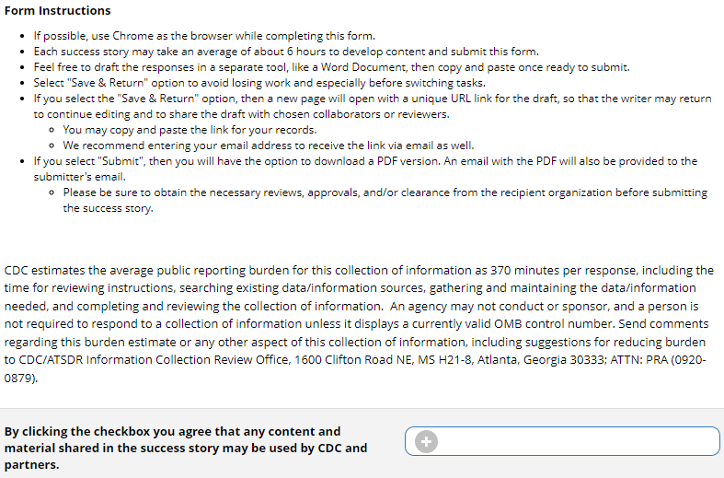

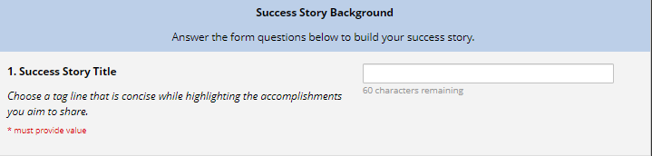

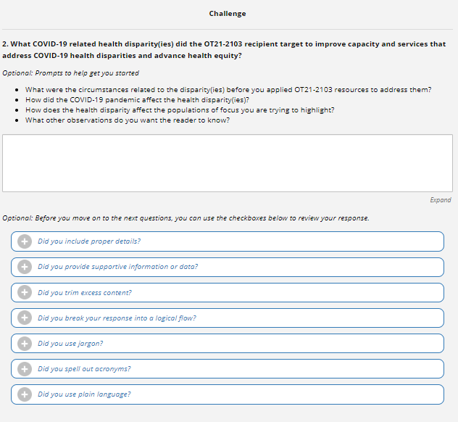

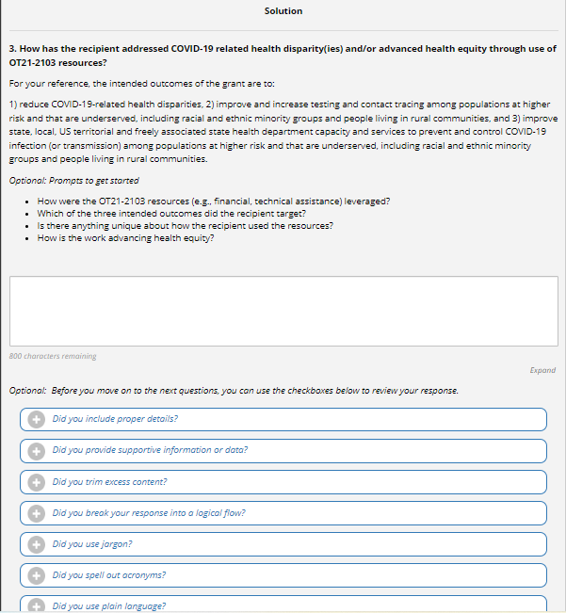

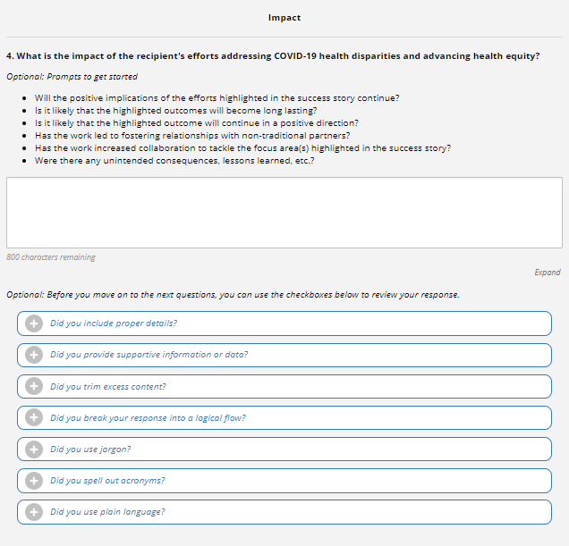

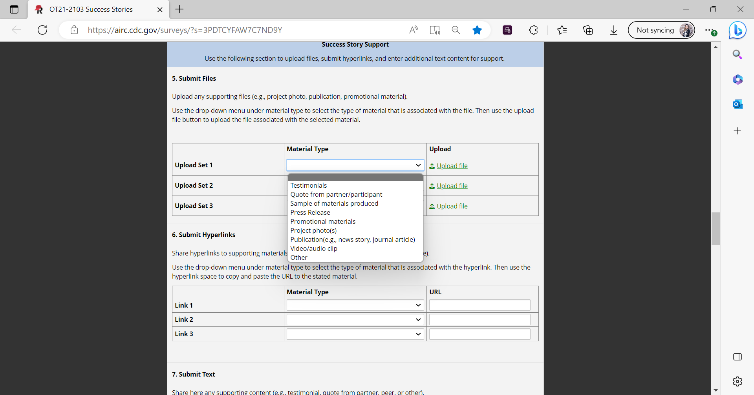

*Screenshot above demonstrates the drop-down list included in this section of the form.*

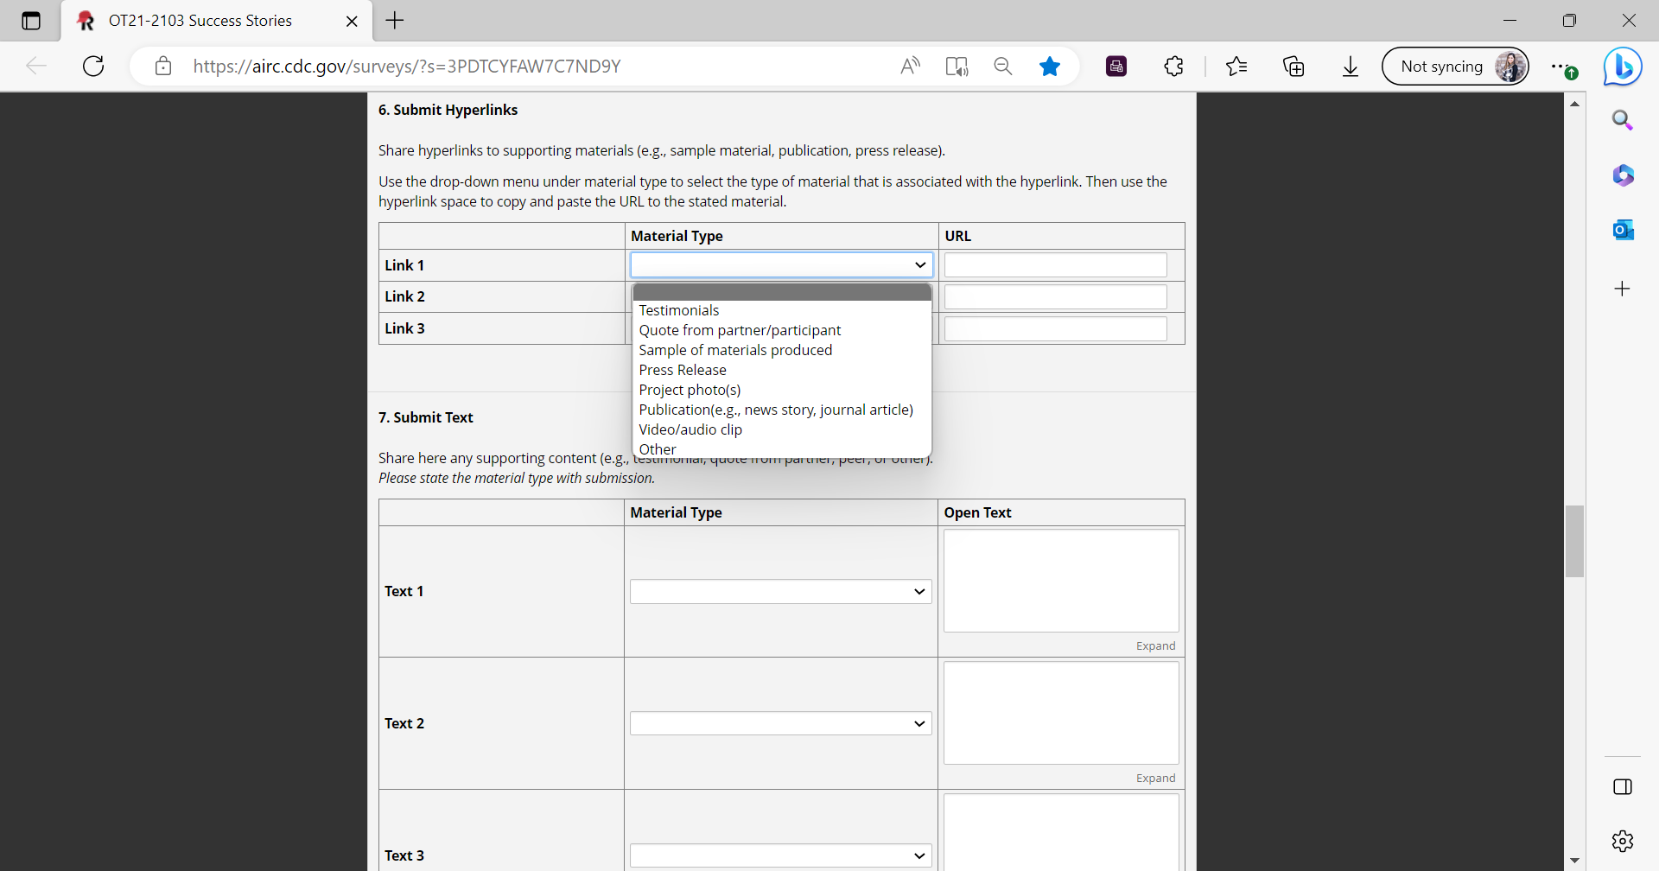

*Screenshot above demonstrates the drop-down list included in this section of the form.*

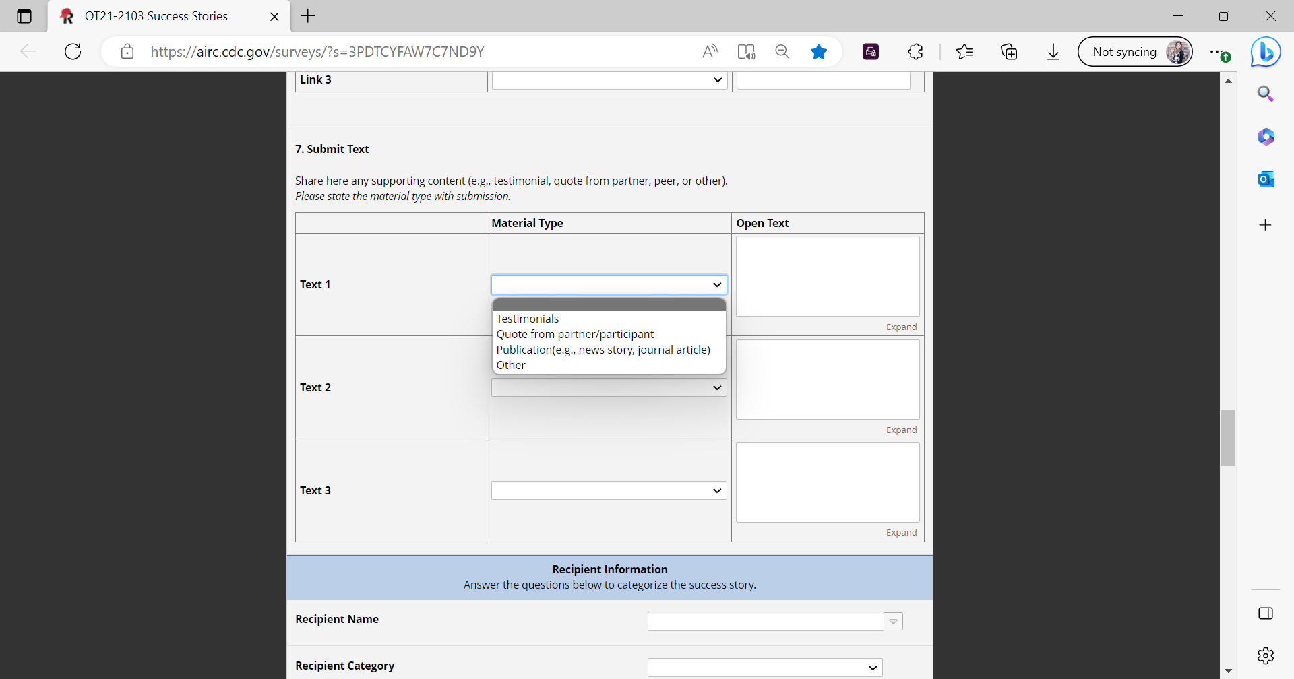

*Screenshot above demonstrates the drop-down list included in this section of the form.*



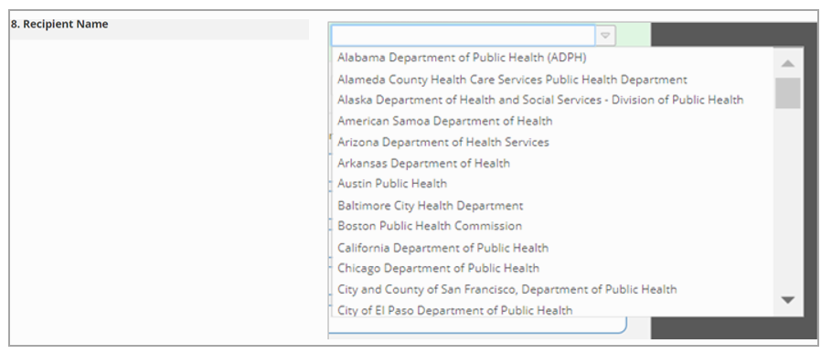*Screenshot above demonstrates the drop-down list included in this section of the form.*

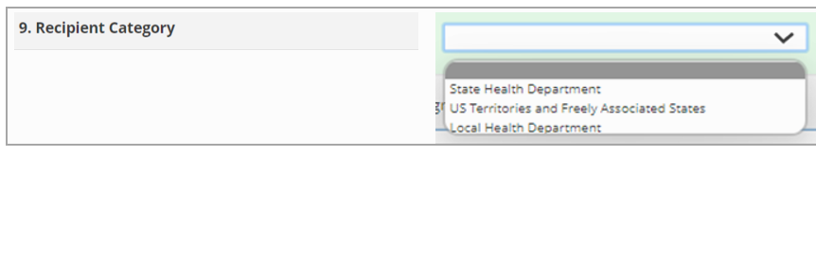  
*Screenshot above demonstrates the drop-down list included in this section of the form.*



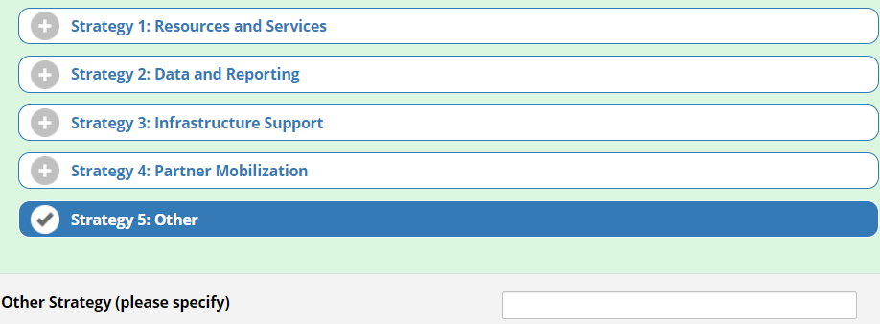

*Screenshot above demonstrates the branching logic if “Strategy 5: Other” is selected.*



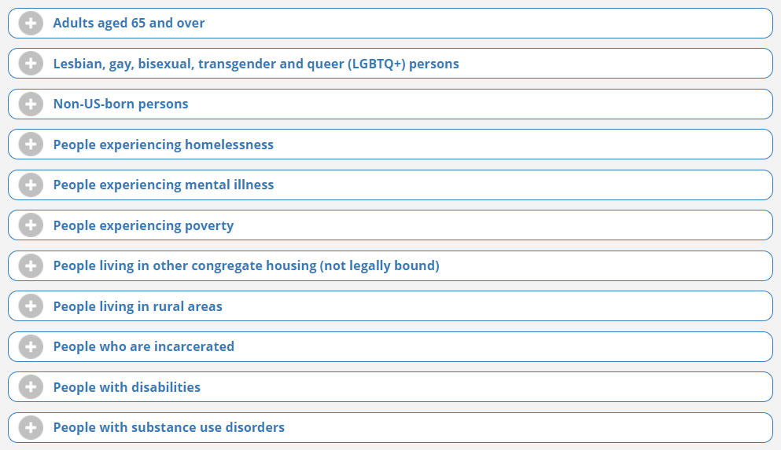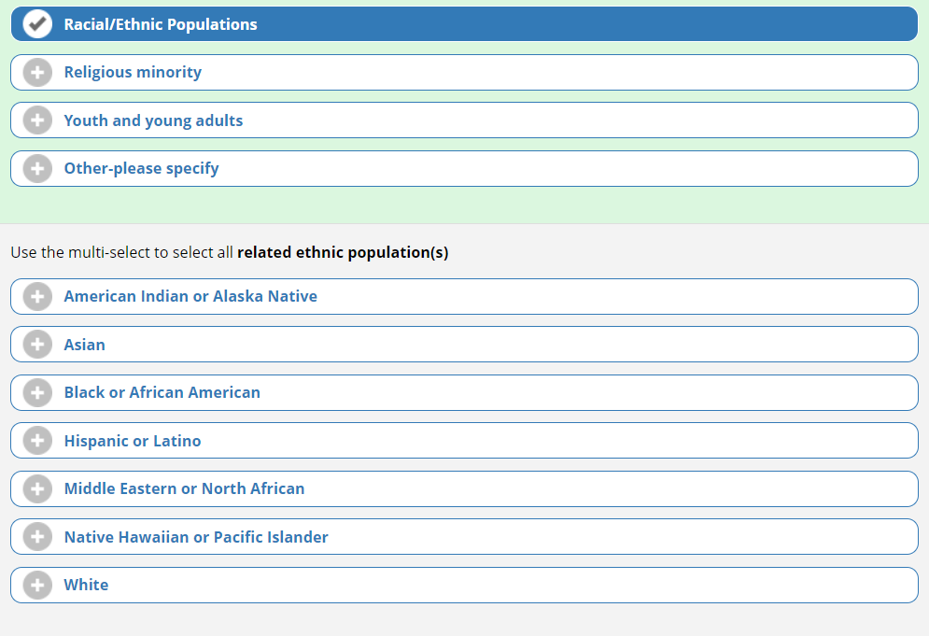

*Screenshot above demonstrates the branching logic, if “Ethical/Racial Populations” is selected.*

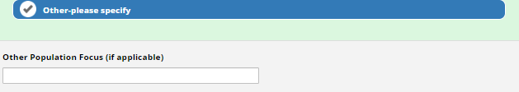  
*Screenshot above demonstrates the branching logic, if “Other” is selected.*

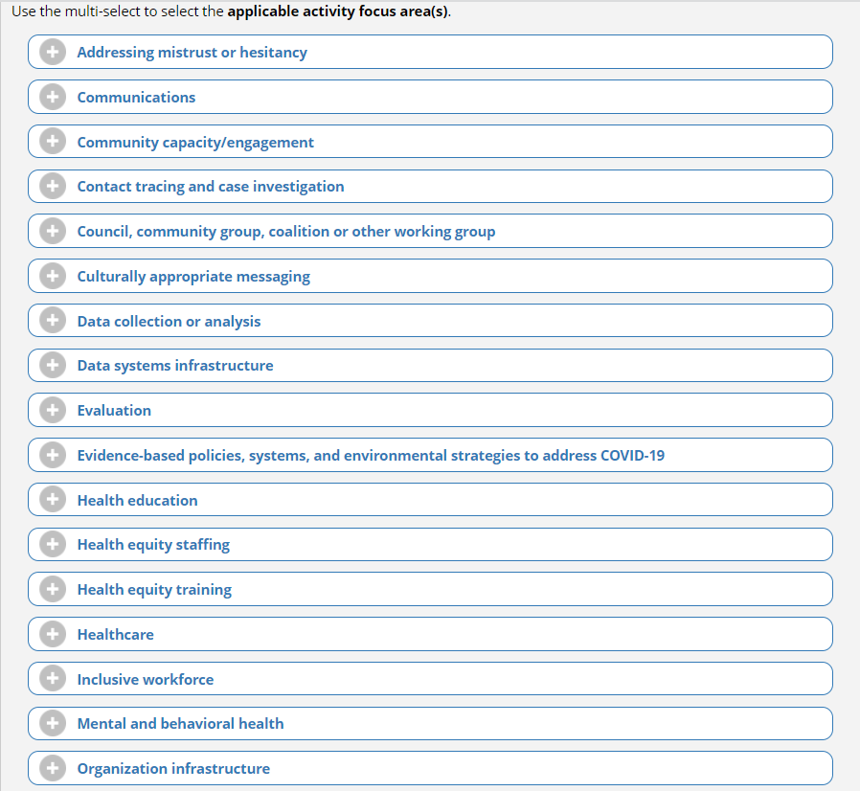

*Screenshot above demonstrates the branching logic, if “Partnerships” is selected.*

  
*Screenshot above demonstrates the branching logic, if “Other” is selected.*

