**Attachment B: Instrument: Web Version**

[Space is reserved at the top of each page for CDC logo pending approval of licensing agreement.]

Screen 1

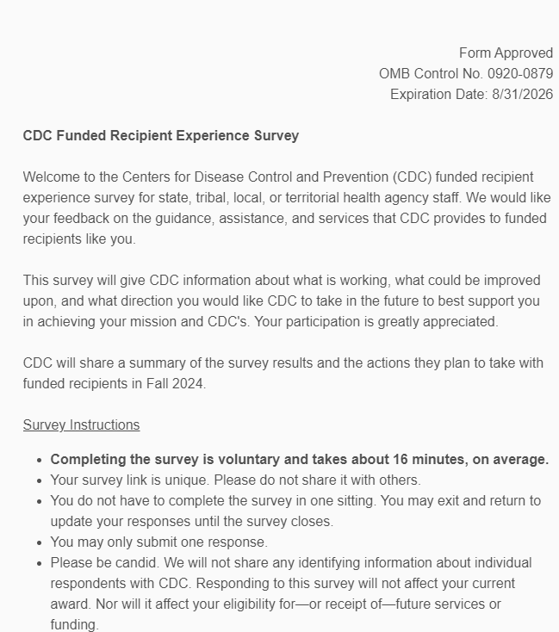

Screen 1 Continued

Screen 2

Screen 3

Screen 4

Screen 5

Screen 6

Screen 7

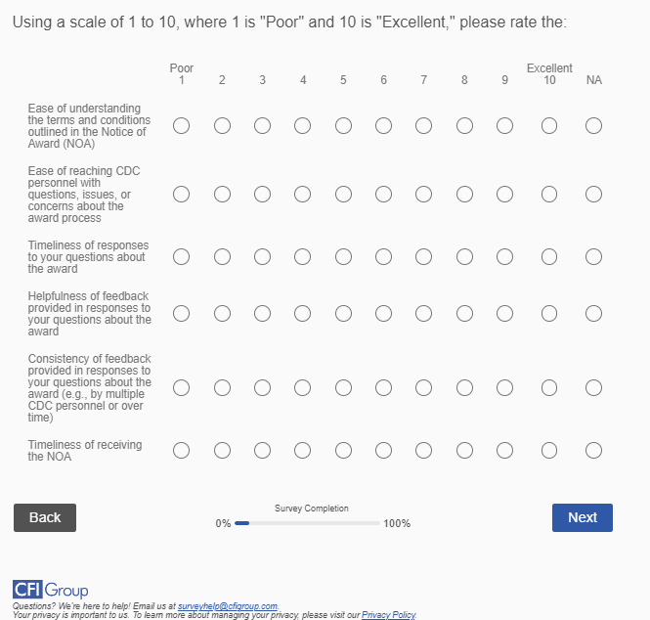

Screen 8

Screen 9

Screen 10

Screen 11

Screen 12

Screen 13

Screen 14

Screen 15

Screen 16

Screen 17

Screen 18

Screen 19

Screen 20

Screen 21

Screen 22

Screen 23

Screen 24

Screen 25

Screen 26

Screen 27

Screen 28

Screen 29

Screen 30

Screen 31

Screen 32

Screen 33

Screen 34

Screen 35

Screen 36

Screen 37

Screen 38

Screen 39

Screen 40

Screen 41

Screen 42

Screen 43

Screen 44

Screen 45

Screen 46

Screen 47

Screen 48

Screen 49

Screen 50

Screen 51

Screen 52

Screen 53

Screen 54

Screen 55

Screen 56

Screen 57

Screen 58

Screen 59

Screen 60

Screen 61

Screen 62

