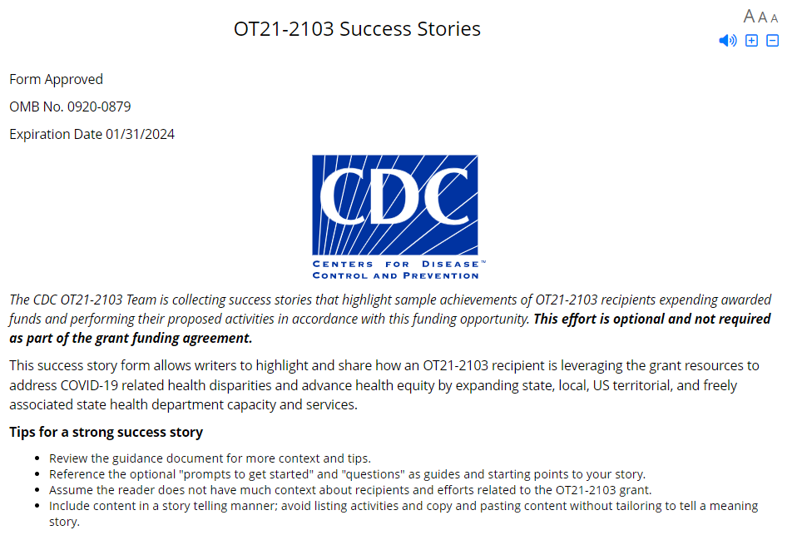
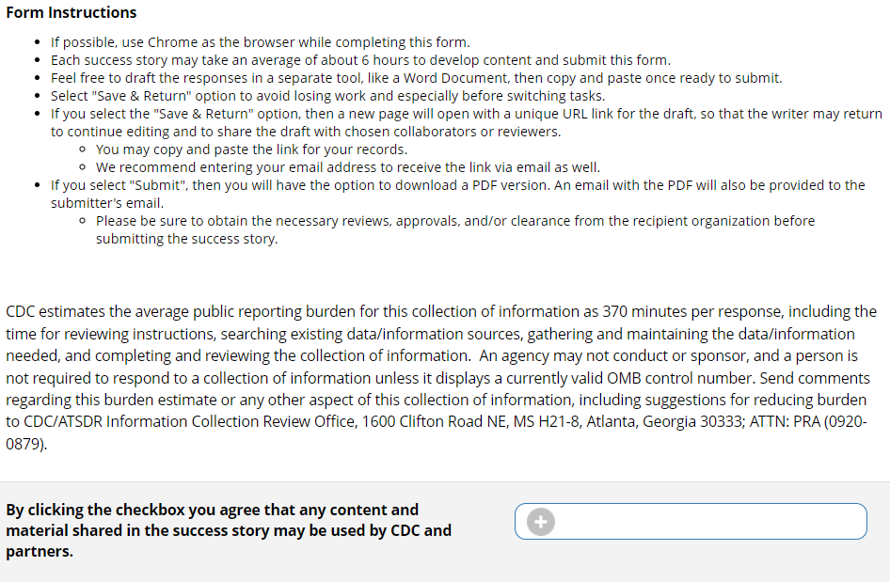

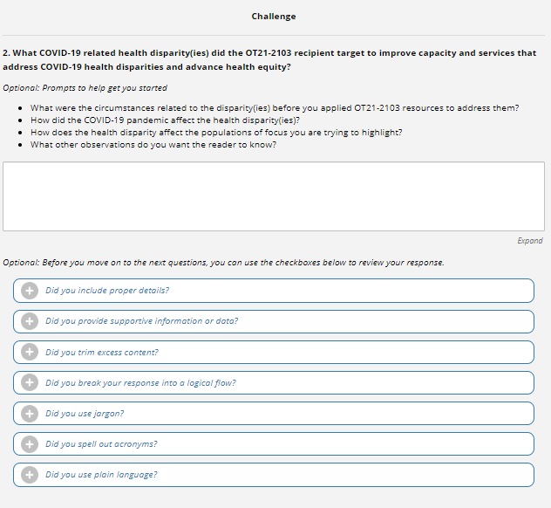

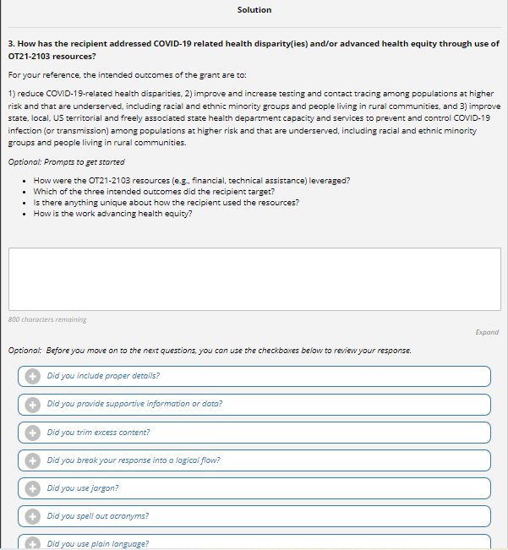
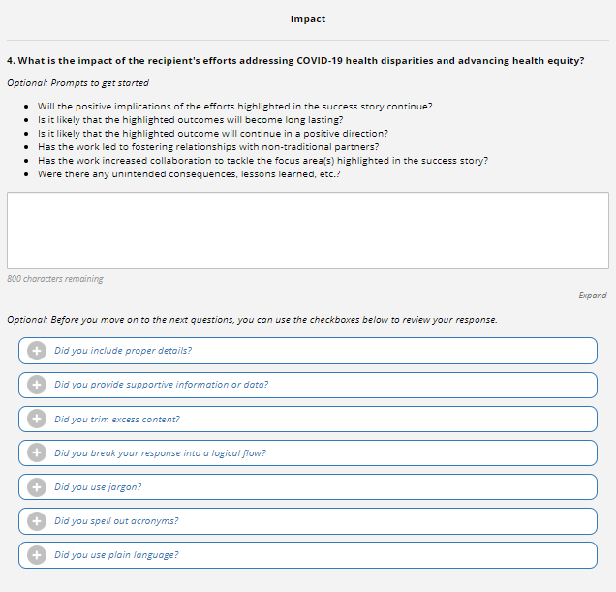
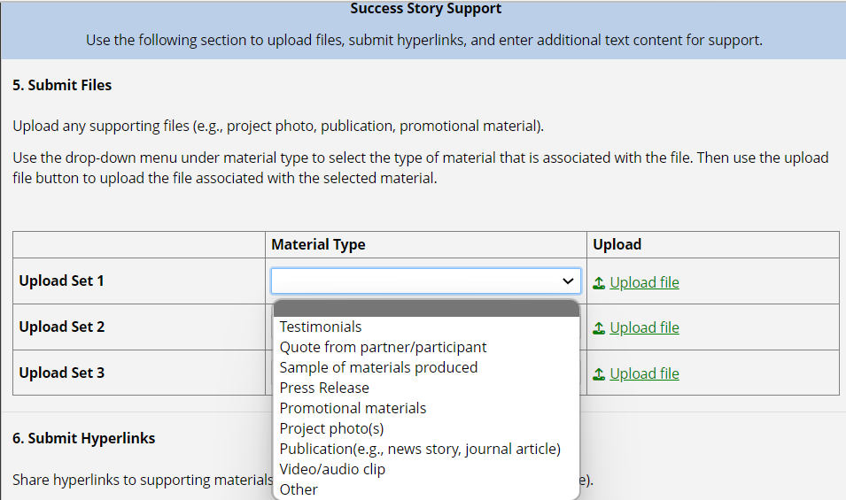
Screenshot above demonstrates the drop-down list included in this section of the form.

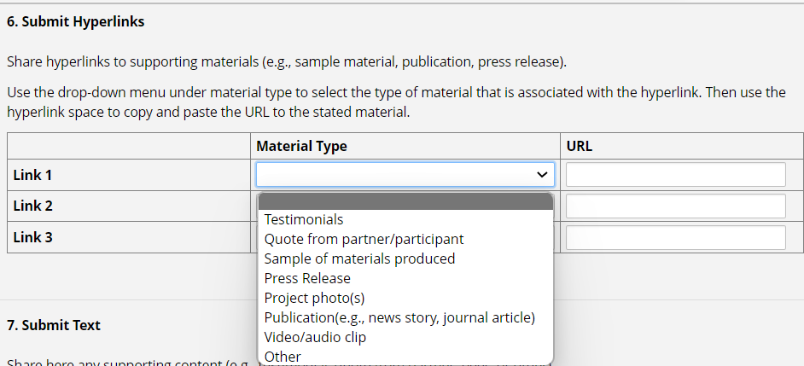
Screenshot above demonstrates the drop-down list included in this section of the form.
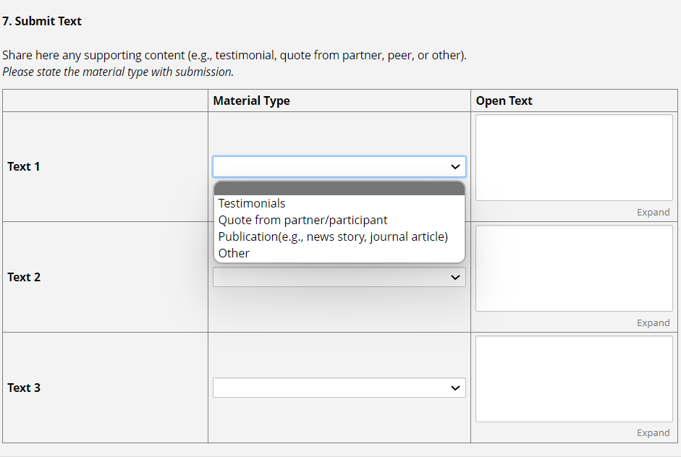
Screenshot above demonstrates the drop-down list included in this section of the form.

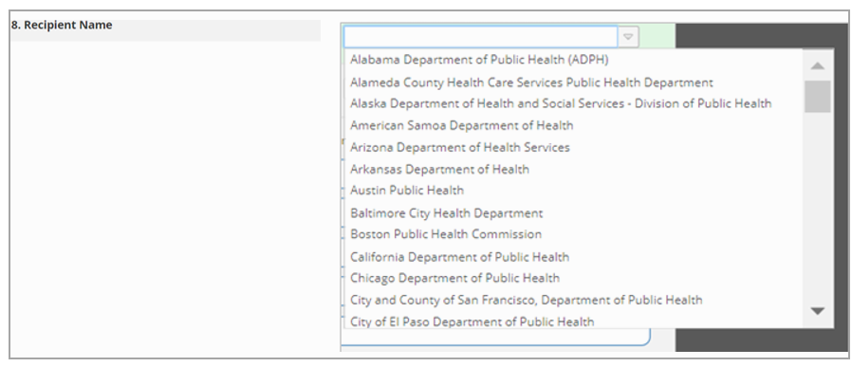Screenshot above demonstrates the drop-down list included in this section of the form.
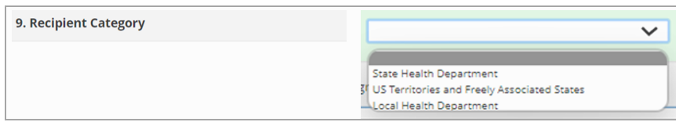
Screenshot above demonstrates the drop-down list included in this section of the form.
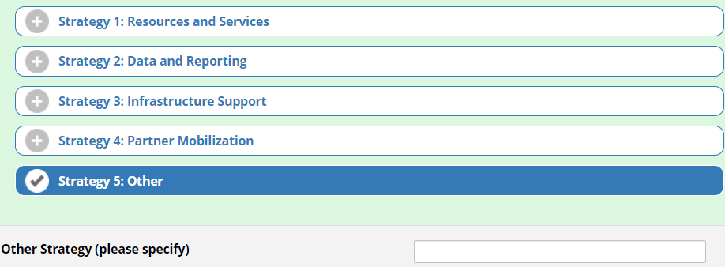
Screenshot above demonstrates the branching logic if “Strategy 5: Other” is selected.
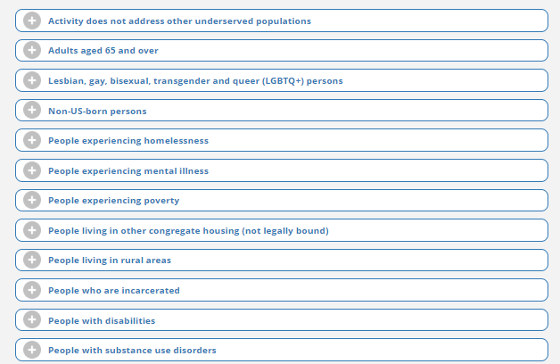
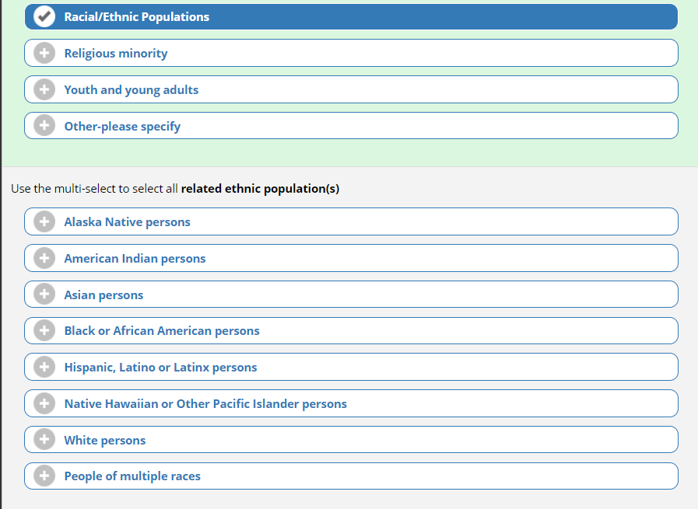
Screenshot above demonstrates the branching logic, if “Ethical/Racial Populations” is selected.
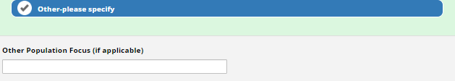
Screenshot above demonstrates the branching logic, if “Other” is selected.
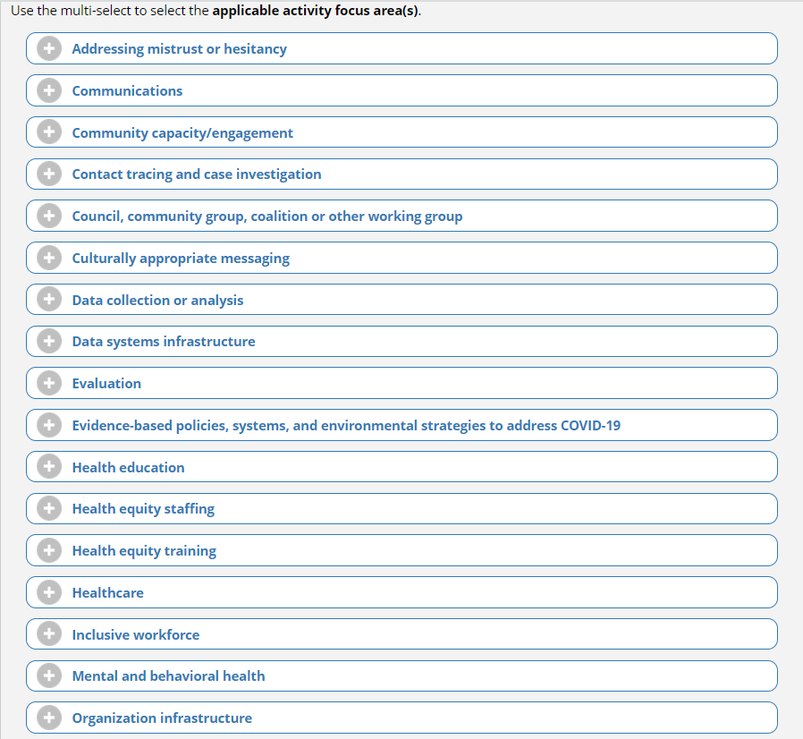
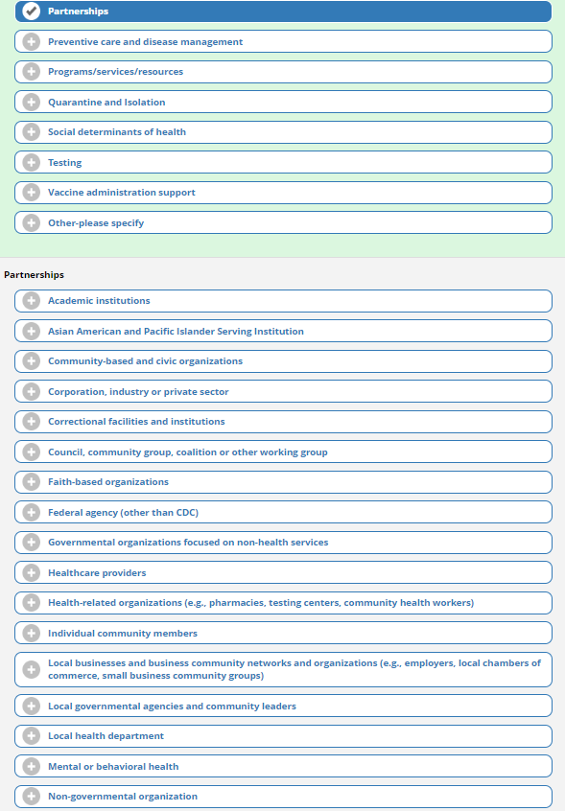
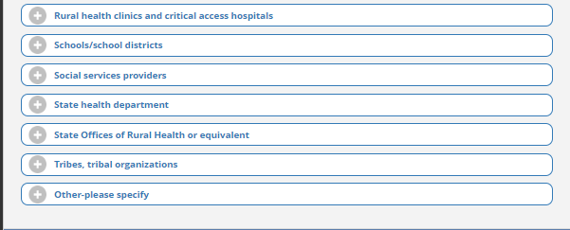
Screenshot above demonstrates the branching logic, if “Partnerships” is selected.

Screenshot above demonstrates the branching logic, if “Other” is selected.
