**mChoice CleverCap Onboarding Guide**

Below is the app welcome screen. You will hit “Sign in” at baseline. Your account will be set up before enrollment into the study and login credentials will be sent to the email that you provide. A study team member will help you log into and become familiar with the app.

**It is important to note that once you log into the app, there is no automatic time out. You must manually log out of the app through use of the side menu bar every time you want to be logged out of the app to maintain confidentiality.**

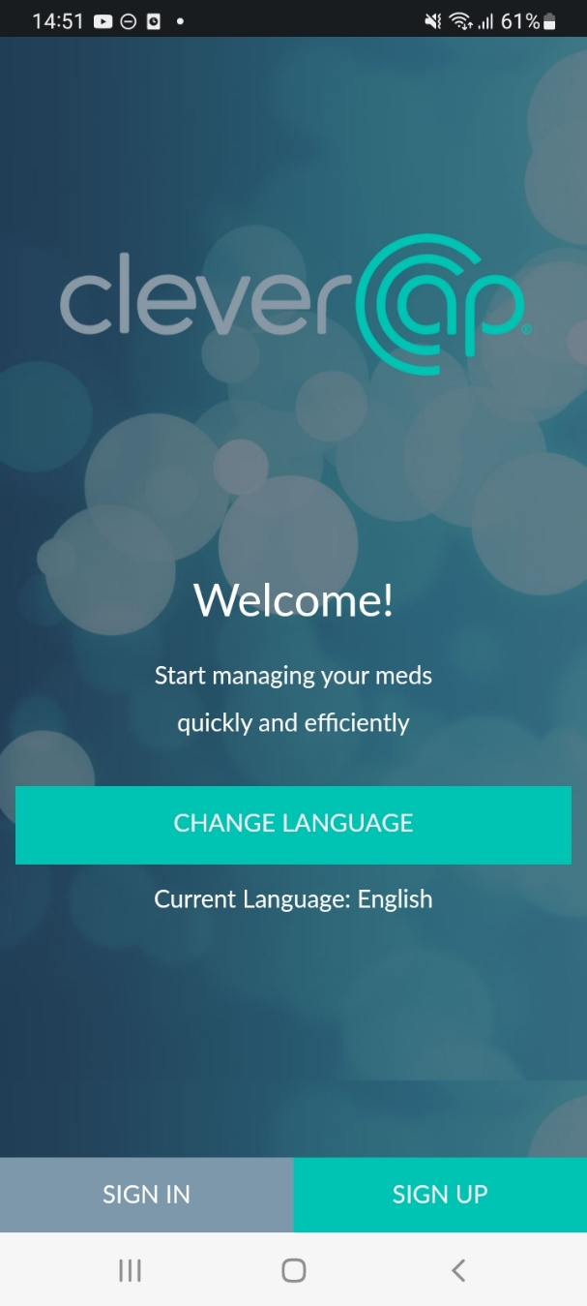Below is the side menu bar. By tapping the three lines, you can navigate to “Dashboard,” “My Alerts,” “My Stats,” “My Account,” “Support,” “Options,” “Chat,” and “Videos and Information” (all explained further below) or you can log out.

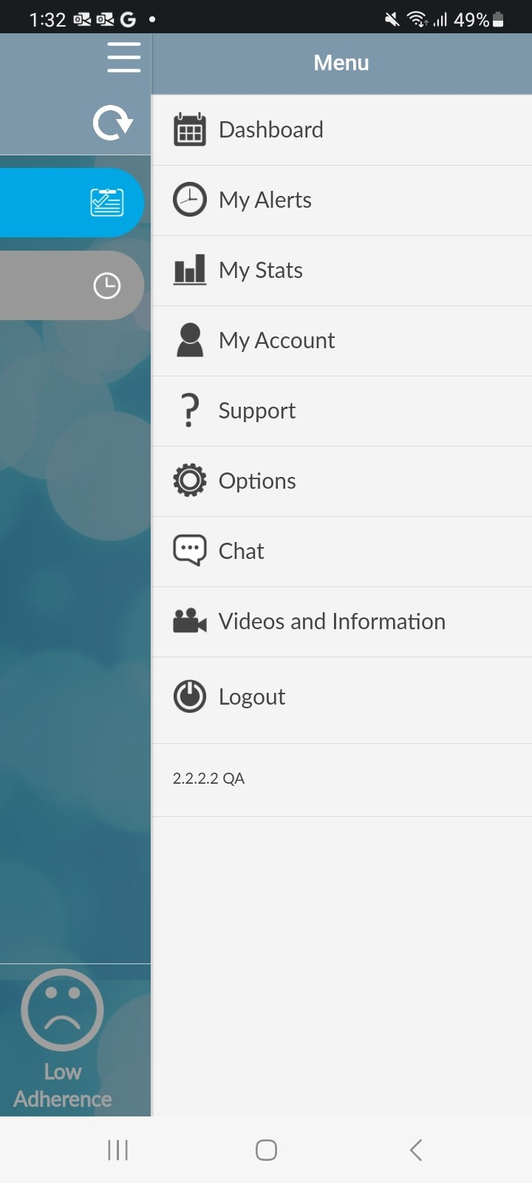

**Dashboard**

The Dashboard page is the homepage of the CleverCap application. Here, you can enter your sexual activity and manually log that you took your medication. The dashboard displays pending, taken, missed, or off-schedule doses.

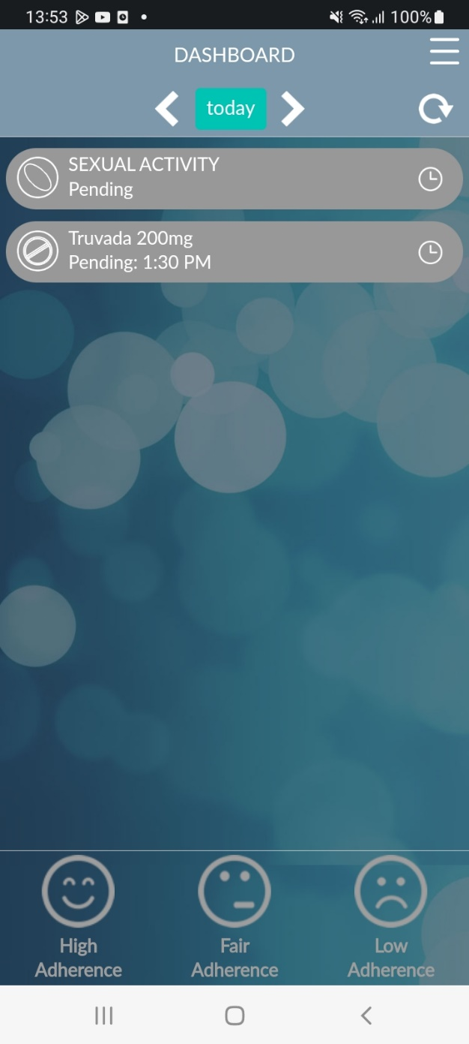

**Sexual Activity**

By clicking ‘Add event’ on the sexual activity log, you can enter recent sexual activity information. The questions, pictured below, will appear.

For participants who are taking **on-demand PrEP**, logging a sexual activity will trigger an additional pop-up question that states “Did you take your first 2 pill dose?” If ‘yes,’ reminders for the 2 subsequent 2-1-1 doses (24 and 48 hours after sexual activity) will be enabled. If ‘no,’ you will receive a private message within the app about post-exposure prophylaxis (PEP). Screenshots are included below.

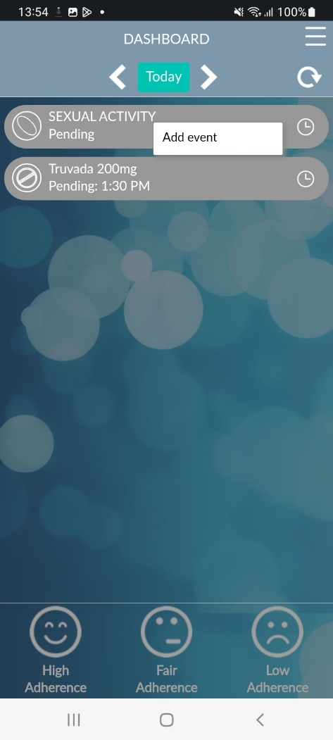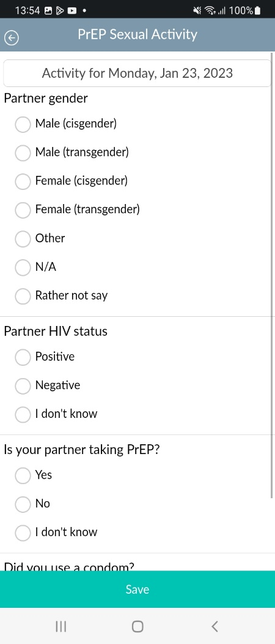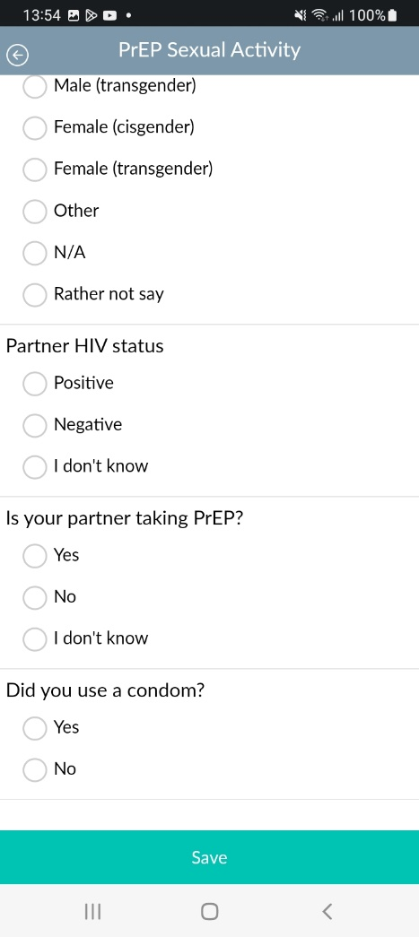

Once an event is added, you will have the option to either view, edit, or delete the event.

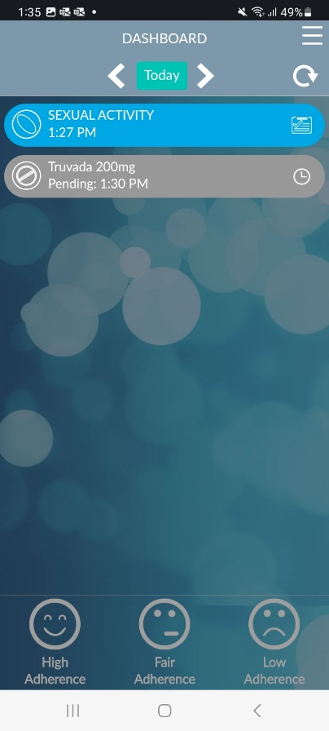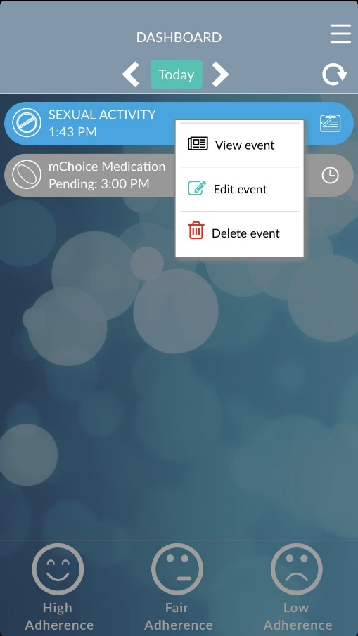

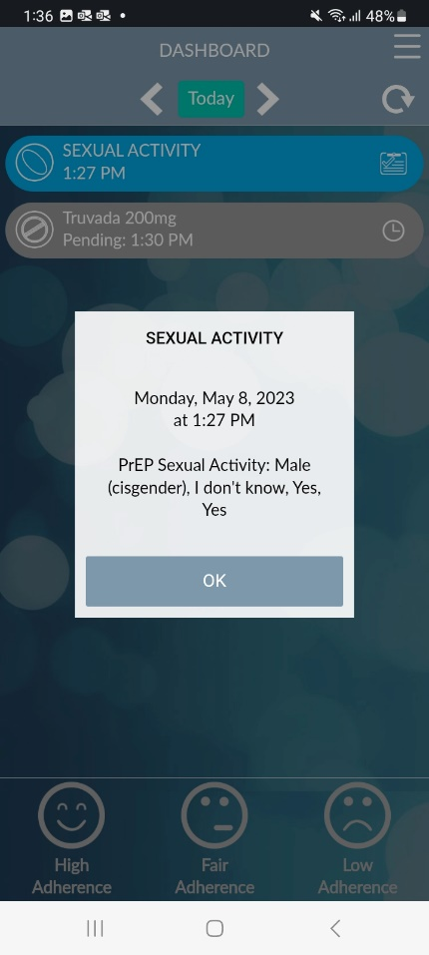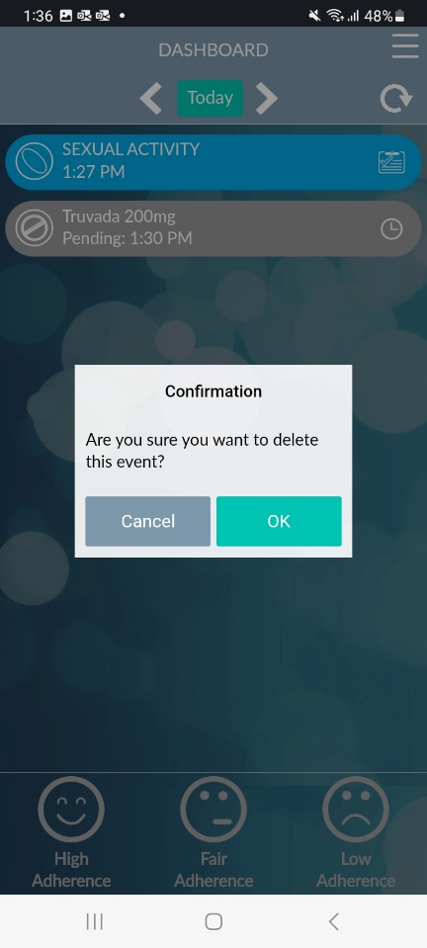

**For On-demand/2-1-1: After logging a sexual activity**

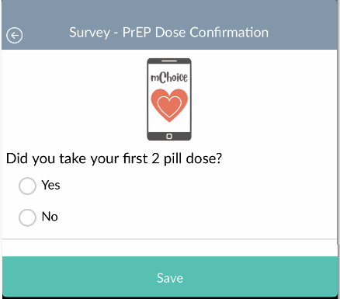

**PEP Pop-up Message (For participants taking on-demand PrEP)**

If you did not take 2 pills prior to engaging in/documenting a sexual activity, you will see the below message.

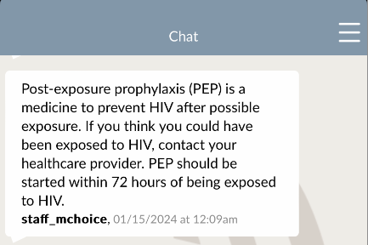

**Dose**

By clicking on the medication/dose, you can enter that you have taken your medication.

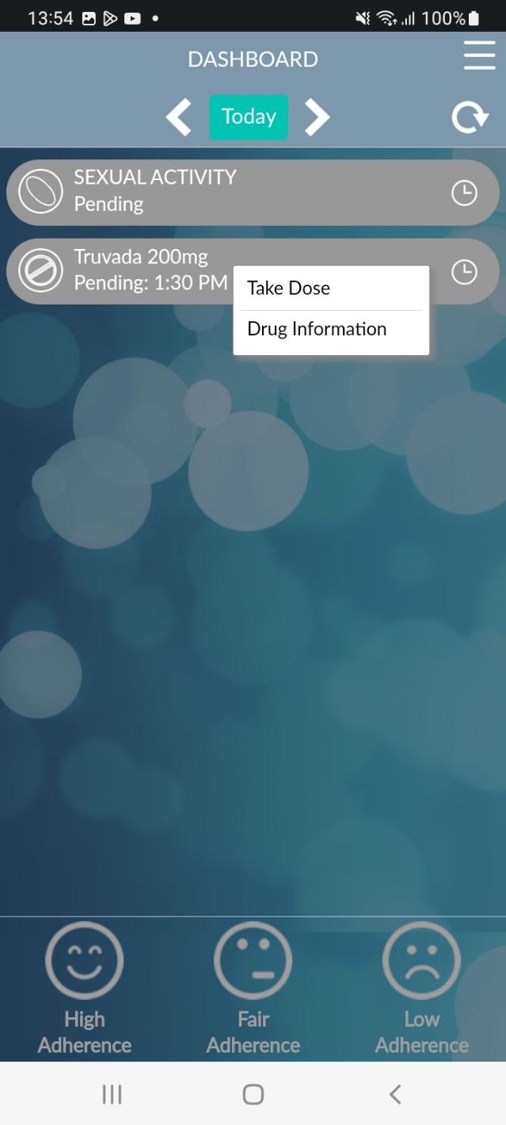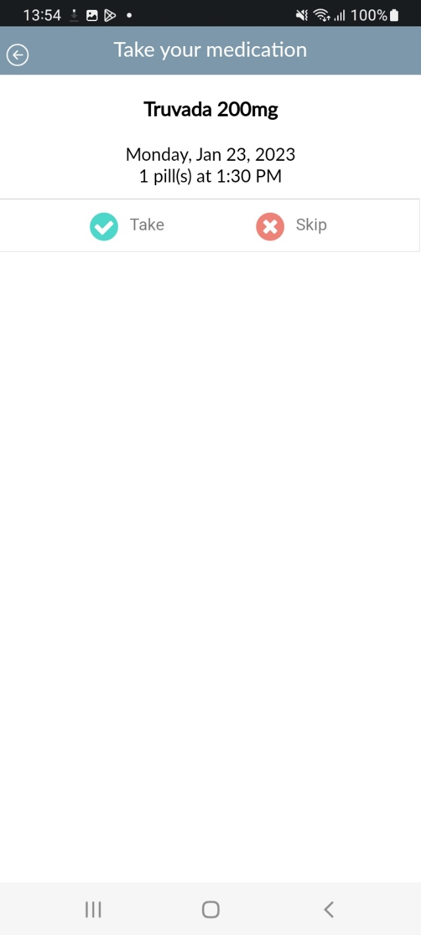

**My Alerts**

The “My Alerts” page allows you to add alert settings, by clicking ‘Add Alert.’

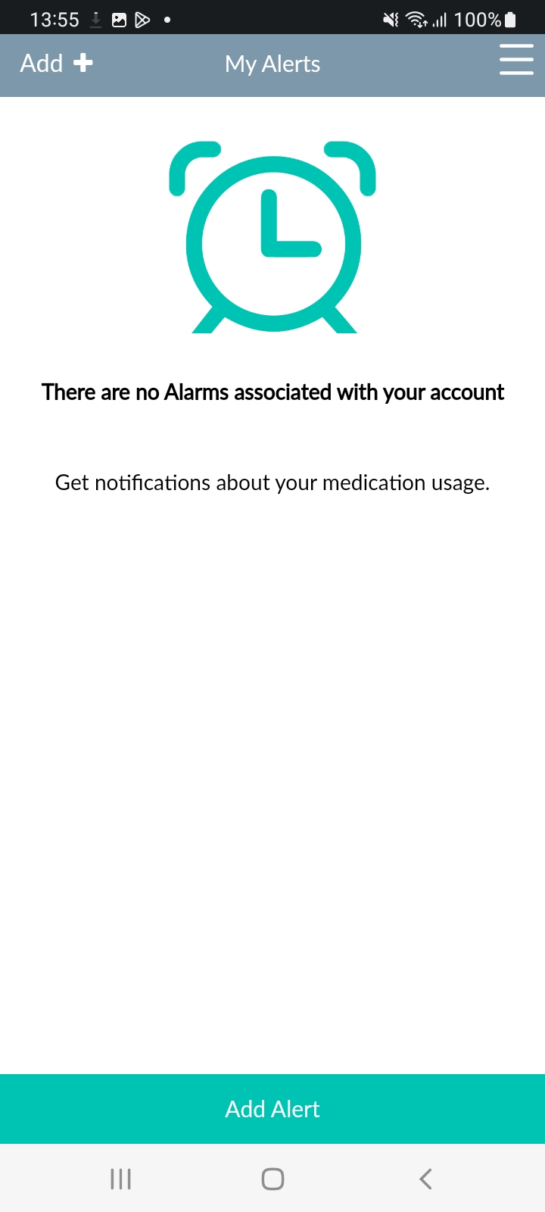

**Add Alert**

On the “Add Alert” page, you can customize your alerts and choose to notify a study team member about late or missed medication dosing, i.e. if you took your medication off-schedule or missed a dose.

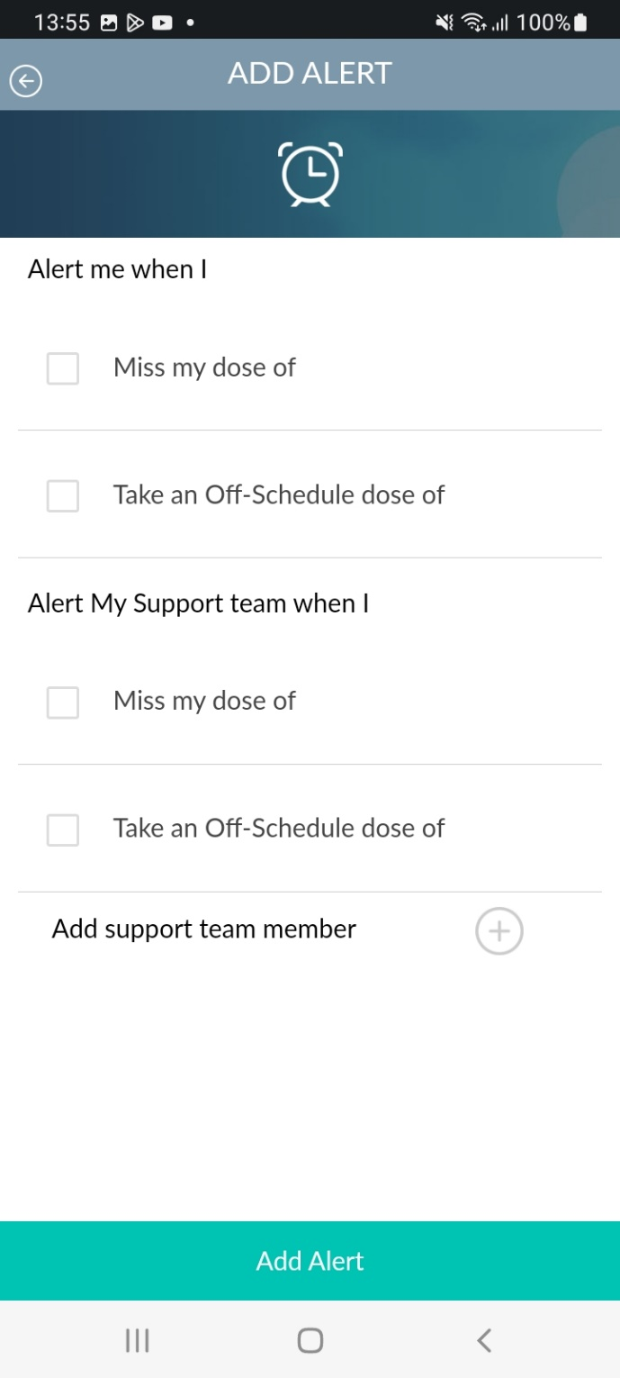

**My Stats**

The “My Stats” page shows monthly usage data.

This page can be used by participants on **daily oral PrEP** who would like to see monthly adherence information.

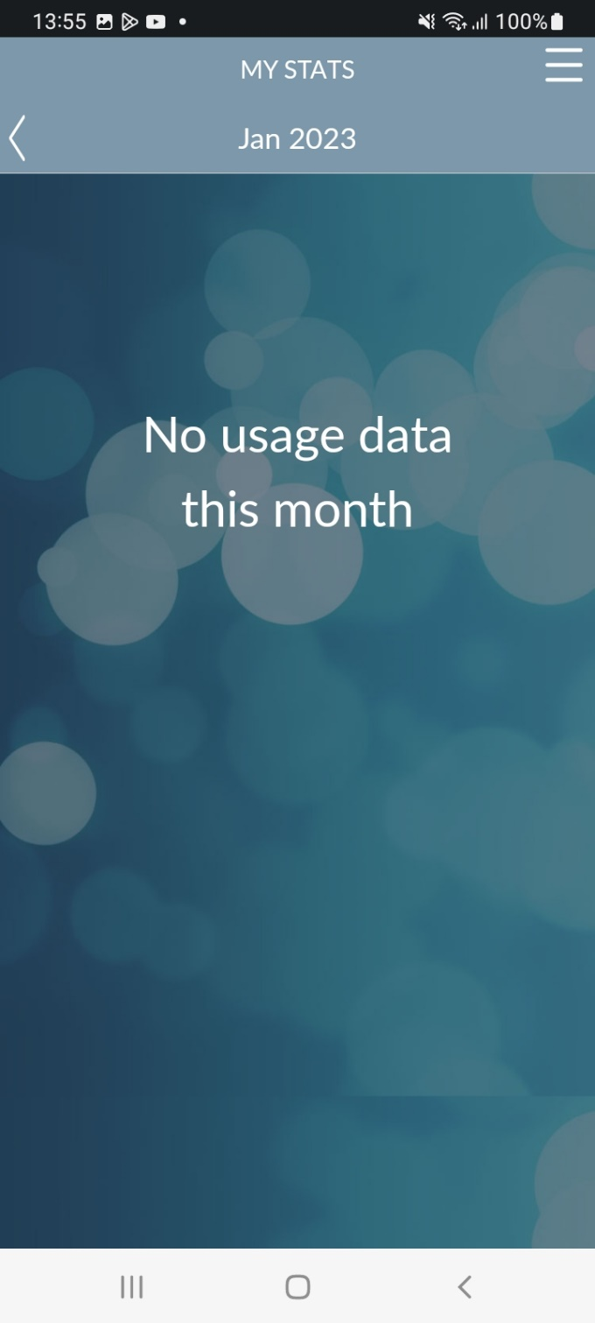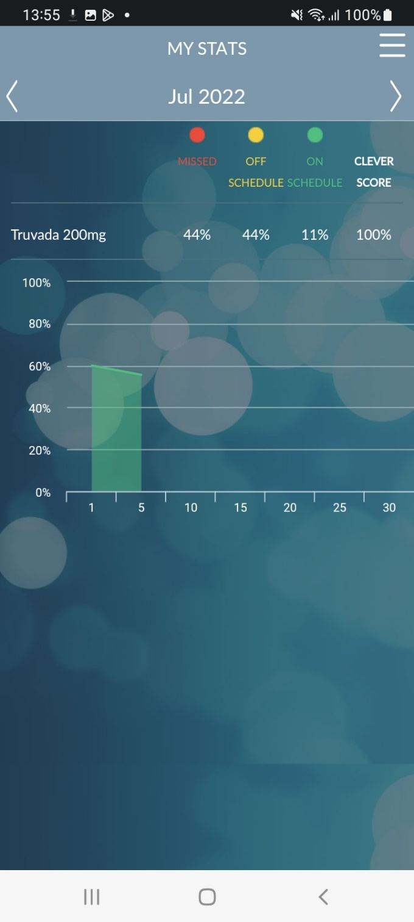

**My Account**

The “My Account” page shows details of the account such as username, name, and email. On this page, you can click ‘Edit’ to edit your account information or you can click ‘Change Password’ to change your password.

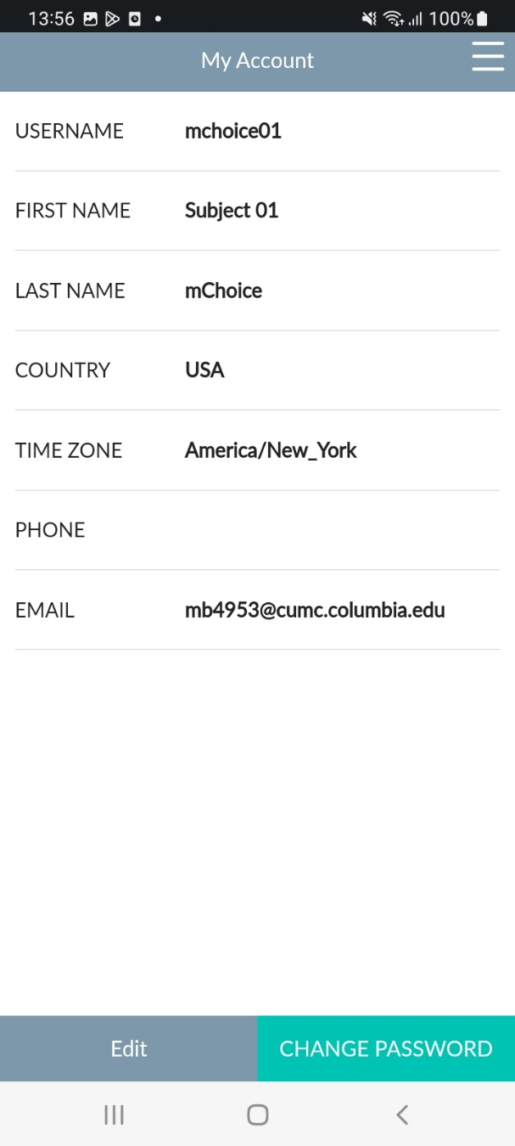

**Support**

The “Support Page” contains a link to CleverCap Frequently Asked Questions (FAQs), and the mChoice support phone number.

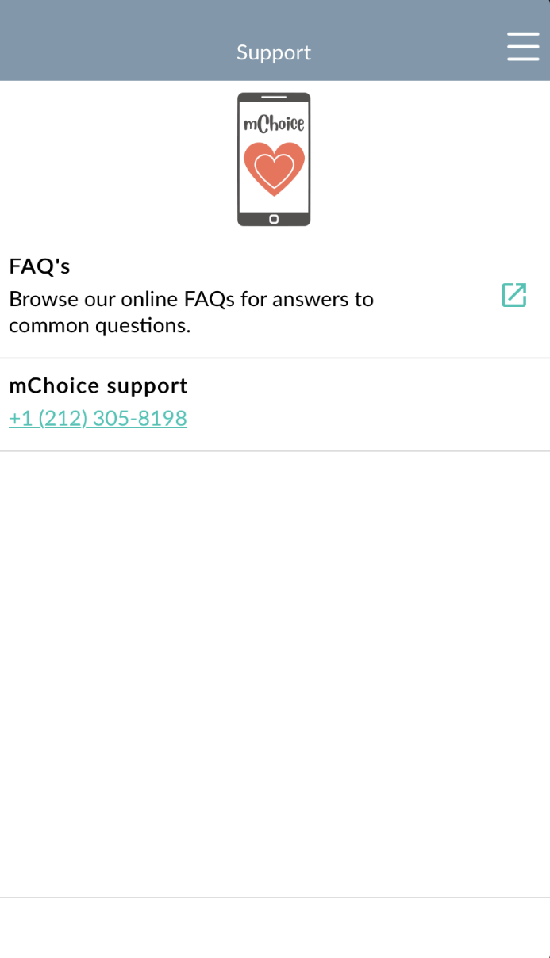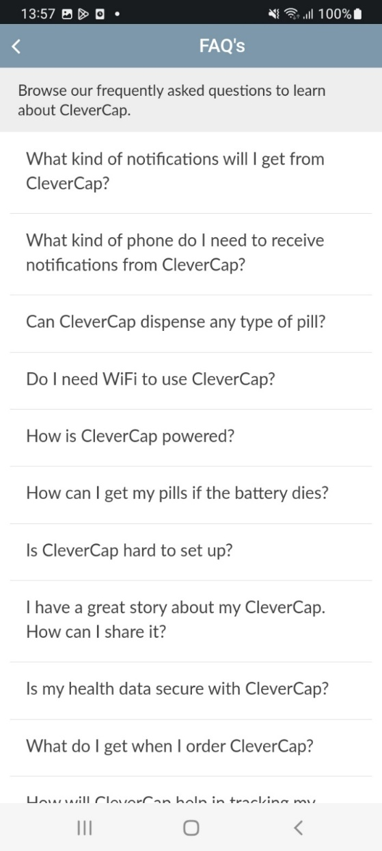

**Options**

The “Options” page allows you to enable reminders for taking your medication or select English or Spanish as the language for the app.

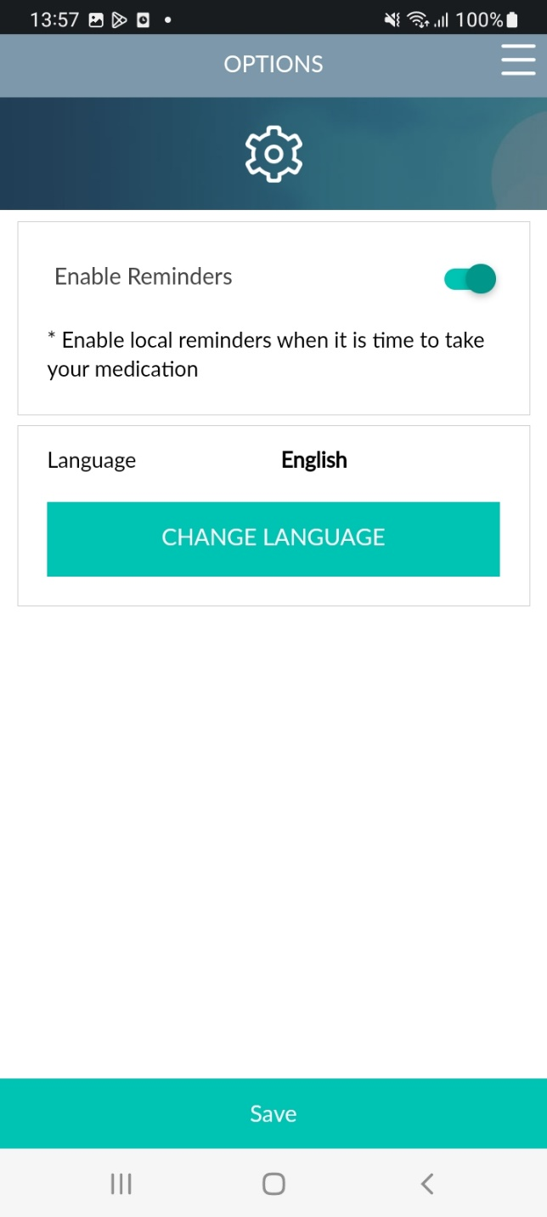

**Chat**

The “Chat” page allows you to communicate with the study team about questions or concerns. You will be alerted to any new messages from the study team with a confidential notification (see below). Please note that once you click on the notification, it will direct you to the app’s chat. To avoid someone else viewing the message on your phone, make sure you log out of the app and lock your phone.

For participants on **injectable PrEP**, you will receive injection reminders from the study staff in the chat.

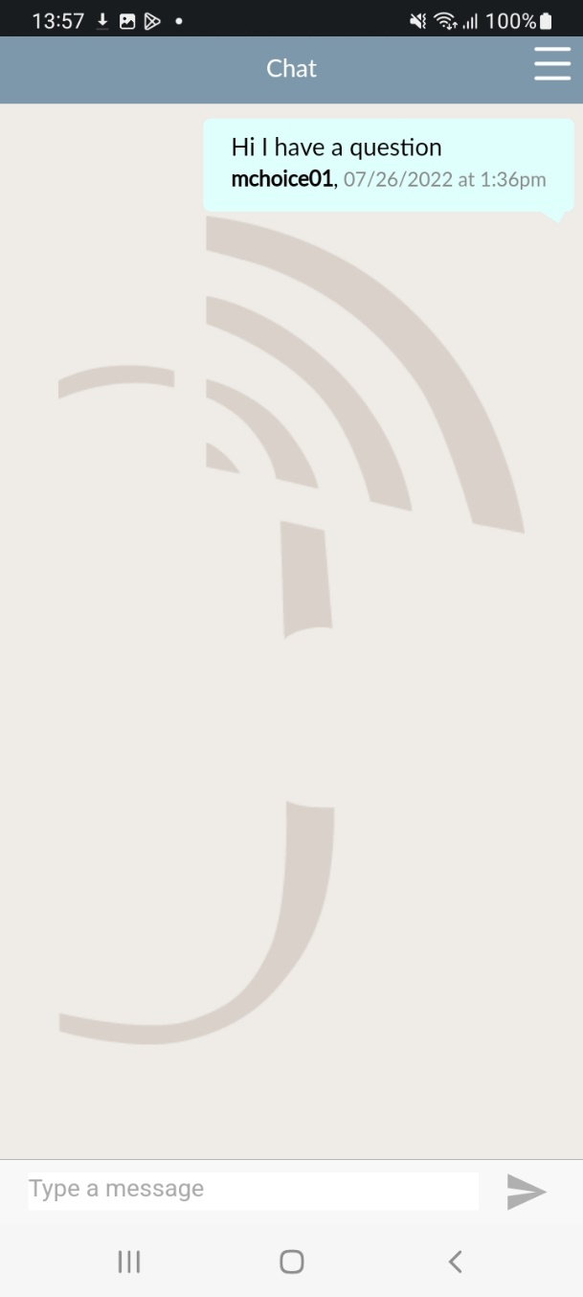

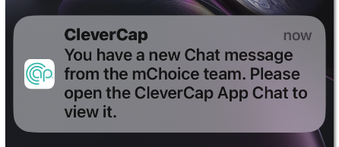

**Videos and Information**

The “Videos and Information” page contains links to CDC videos and information related to HIV, pre-exposure prophylaxis (PrEP), and post-exposure prophylaxis (PEP).

