PrEP Learning Module Link: https://live.easygenerator.com/review/course/56aba2a1-464b-4e10-b4dd-da1b1522cf93/

PrEP Learning Module Overview
Provider participants in the mChoice will complete the online EPICC+ provider training. This series of online modules will be completed through an e-learning software called Easygenerator. Study team members are able to track providers’ progress through the modules through Easygenerator’s dashboard. We highlight uses of each interactive feature below within brief summaries of each learning module.
Providers will log into Easygenerator using an email address and password. Once logged in, they will see the screen below. This screen will display the different learning modules included within Easygenerator. Providers will access the modules by clicking on the specific module and can view their progress in completing the questions within the module.
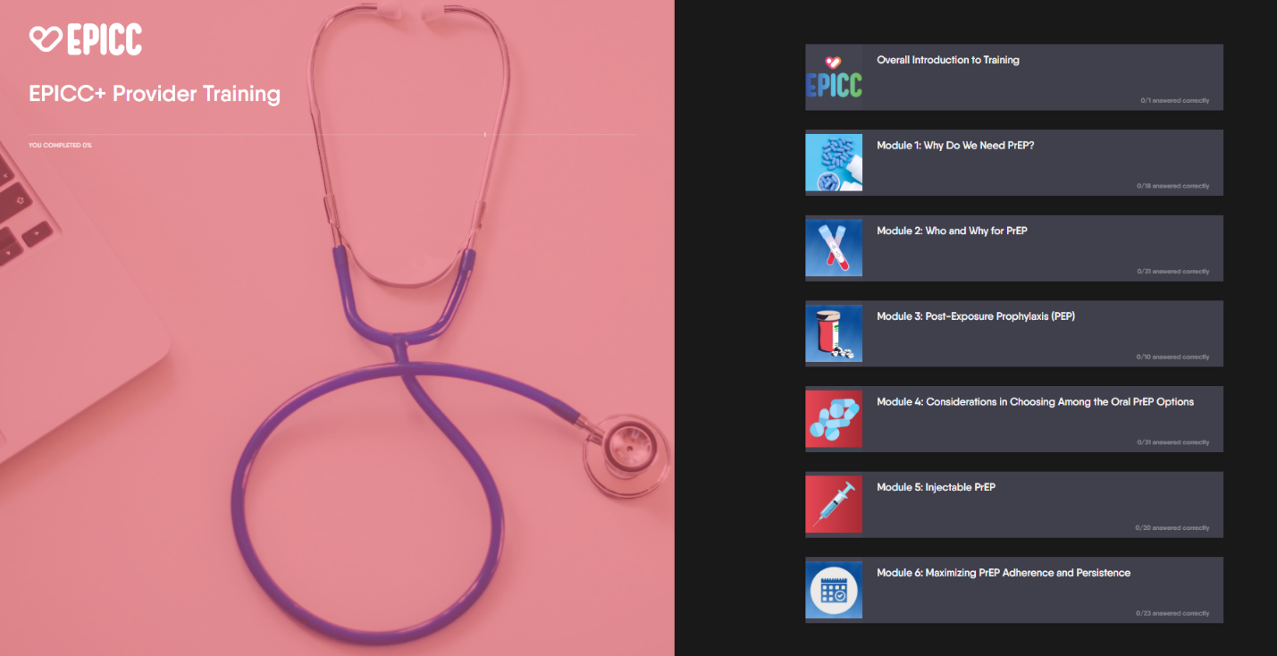

Module 1: Why do we need PrEP?
This module describes the HIV epidemic in the United States highlighting the Ending the HIV Epidemic (EHE) plan, reviews Pre-exposure Prophylaxis (PrEP) uptake in the United States, and PrEP’s effectiveness. One of the interactive elements in this module is called Ranking Text. We ask providers to rank regions of the United States based on where they think HIV is most prevalent. If the provider ranks the text correctly or incorrectly, they will see an explanation. In the screenshot below, the text was ranked incorrectly.

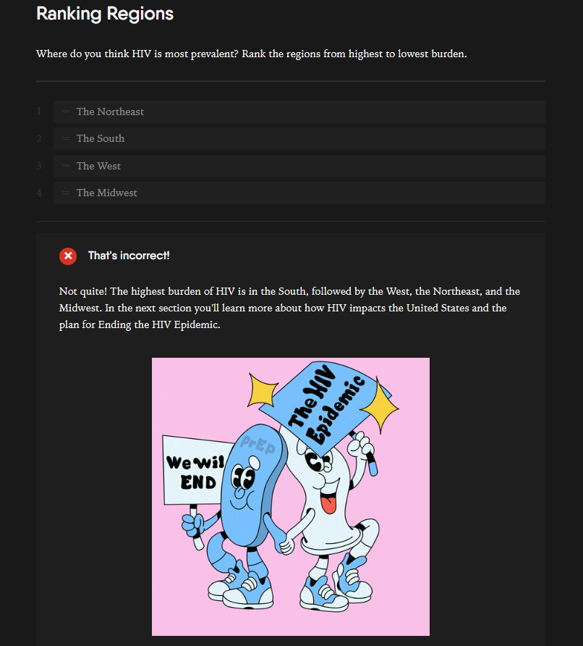
Another interactive element used throughout the modules is the hot spot feature on images. Providers can hover over a hot spot to view additional relevant information to that area within the image. In module 1, we used this feature to show the number of HIV diagnoses within each EHE priority county.
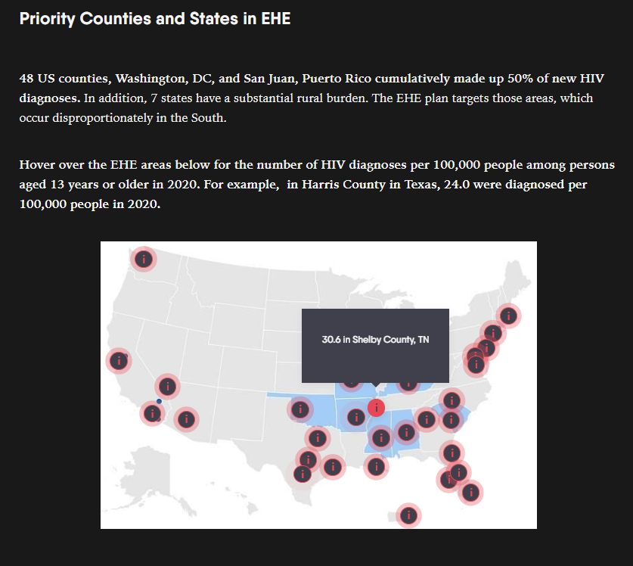

Module 2: Who and Why for PrEP
This module provides an overview of the 2021 CDC PrEP Guideline changes, PrEP screening process, CDC HIV testing recommendations, and PrEP navigation needs. Each module contains pre-test questions to help providers understand where they may have PrEP knowledge gaps. We also include a brief explanation on why the answer selection was correct or incorrect. The screenshot below is an example of a pre-test question with an explanation of a correct answer.
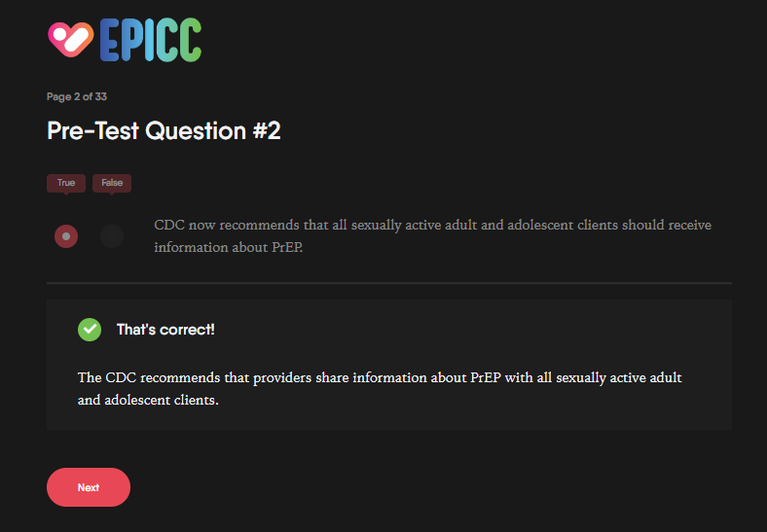
We also incorporate brief videos and hyperlinks to resources throughout the training on relevant topics. In module 2 we included a CDC created video on how to conduct a sexual health assessment and a hyperlink to the CDC’s A Guide to Taking a Sexual Health Assessment.
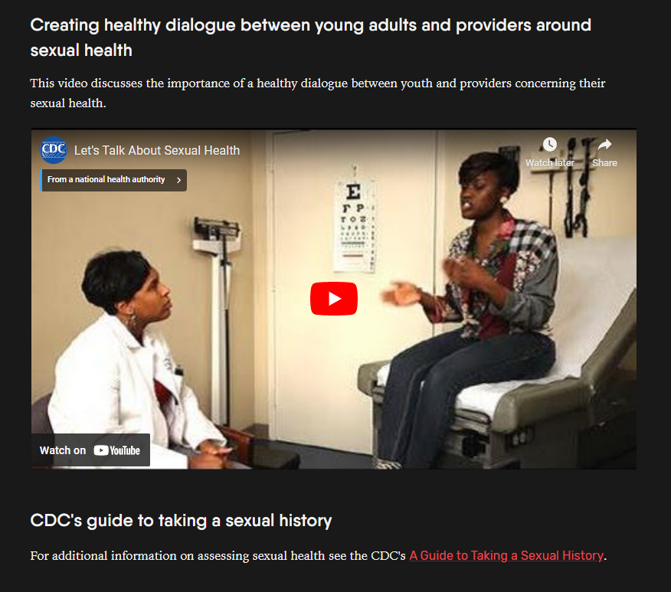
Module 3: Post-Exposure Prophylaxis
In this module, we provide an overview of Post-Exposure Prophylaxis (PEP) in contrast to PrEP and how to screen and prescribe PEP. In several sections, we include post-test questions to help providers understand what they learned in that module. Below we highlight an example of a check all that apply question.
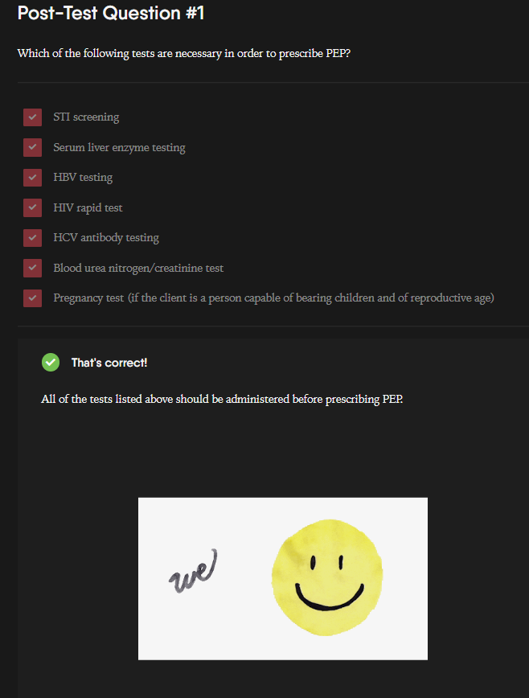
We also use flip cards throughout the modules as a way for providers to actively engage with the content rather than reading text on a screen. Providers are encouraged to click on the card to flip it for more information on that topic. The screenshots below show the front and back of a set of flip cards on PEP regimens.
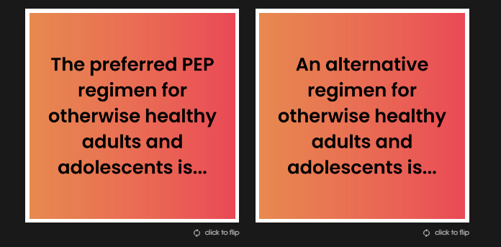
Above screenshot is the front of the cards and below screenshot is the back of the cards.
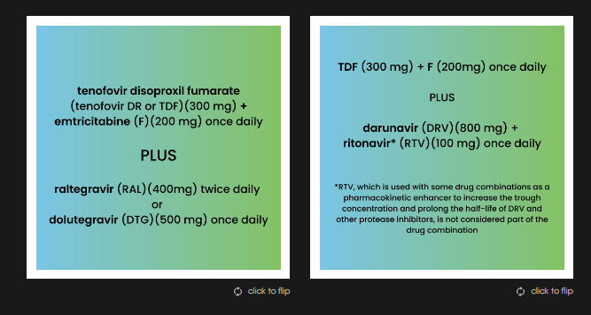
Module 4: Considerations in Choosing Among the Oral PrEP Options
This module provides an overview of the different oral PrEP regimens available and considerations for providers when prescribing these different regimens. An interactive element used in this module allows providers to click on a month to generate a to-do list for providers when seeing a client for that month.
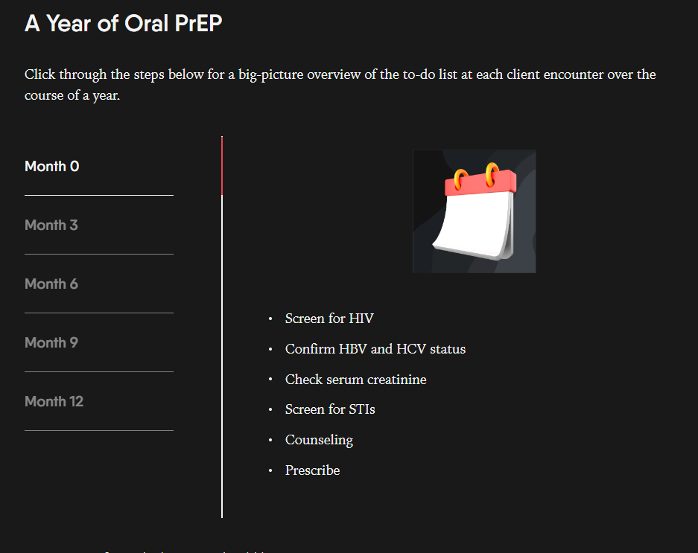

We also utilize the checklist interactive tool, particularly when discussing patient assessments to ensure eligibility criteria are met prior to prescribing PrEP. Providers can use these checklists as tools to ensure proper PrEP guidelines are being followed.

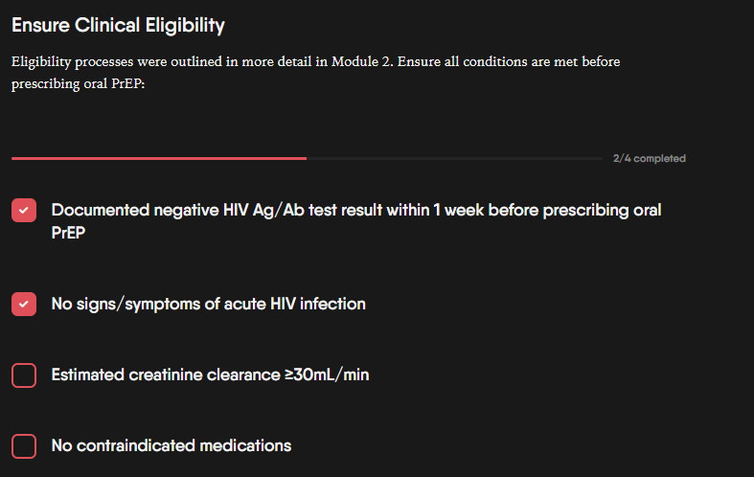
Module 5: Injectable PrEP
This module provides an overview of the process for initial injectable PrEP prescription and follow-ups. In most modules we use the Show More feature. If participants want to review more in-depth information on a topic, they can click on the plus sign to expand content on a particular topic as is demonstrated in the screenshot below for Dapivirine.
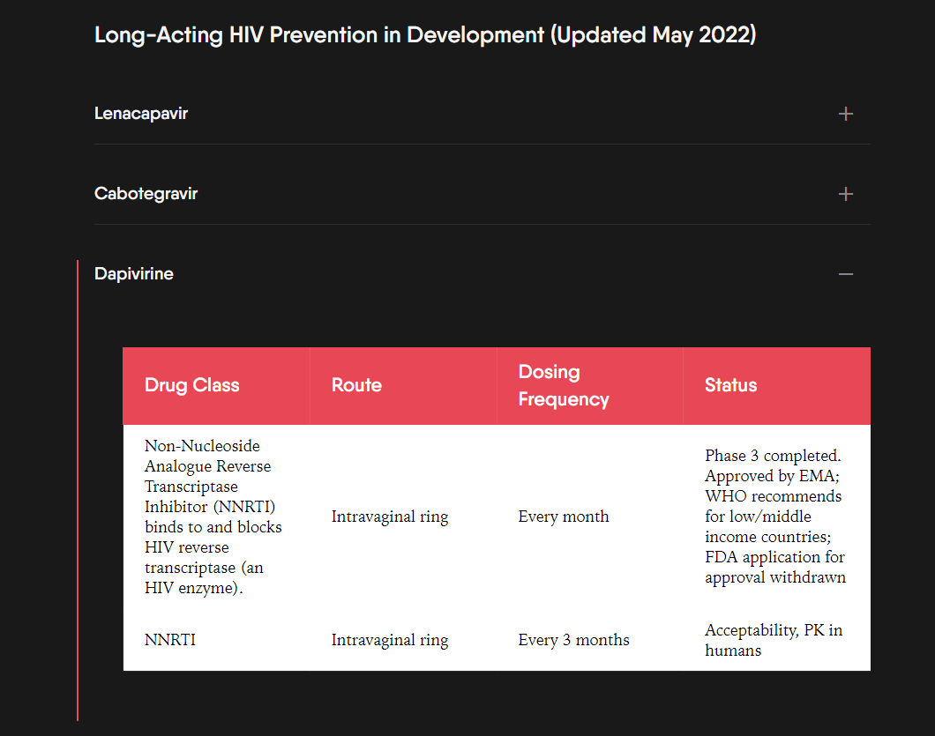
Module 6: Maximizing PrEP Adherence and Persistence
This module discusses strategies for increasing PrEP adherence and persistence. In most of the modules we include 1-2 case studies to help providers apply their new PrEP knowledge to real world cases they may encounter in clinic. In this module, we introduce providers to Kyle and ask a question based on the information provided in the case. In the screenshot below, we show an explanation for the correct answer.
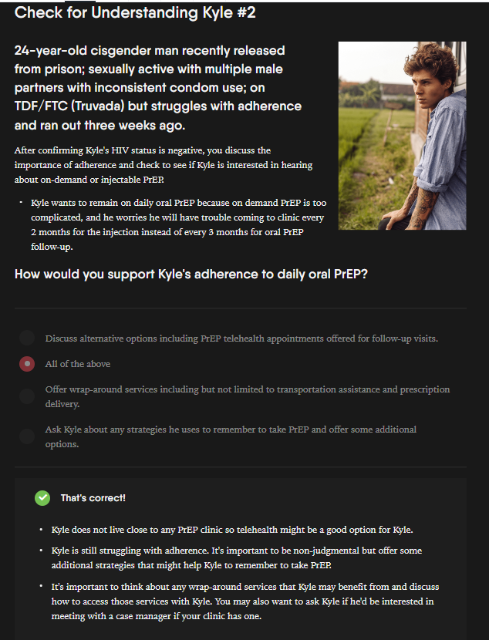

In addition to the EPICC+ PrEP knowledge training modules described above, mChoice provider participants will view a training video providing education in cultural competency and humility. This training is intended to improve provider communication with all clients.

