**Attachment A: Recruitment Materials**

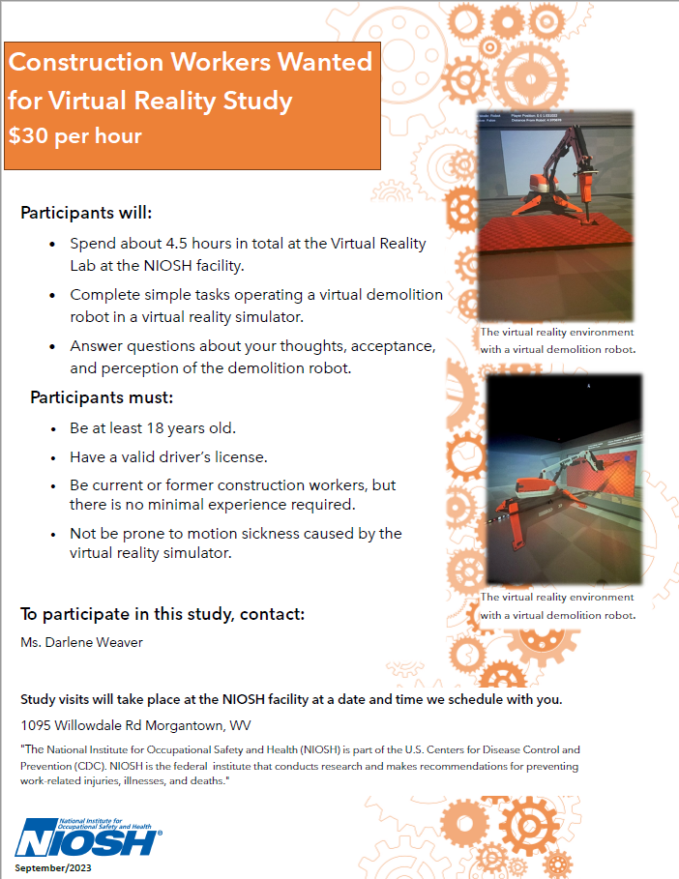

**Recruitment Call Script**

|  |
| --- |
| **Instructions:**  The blue circles with the numbers inside, represent questions the recruiter will ask the candidates to determine eligibility to participate in the study.  *Red italics* are instructions for the recruiter.  *[Red italics on brackets]* Are commands for the recruiter. |

|  |  |  |  |  |
| --- | --- | --- | --- | --- |
| **Recruiter:** Thank you for your interest in participating in this study. My name is Darlene Weaver, and I will give you an overview of the study and answer any questions you may have.  The purpose of the study is to explore the factors that may affect an operator when operating a demolition robot, and to explore the perception of operators on demolition robots. If you are not familiar with a demolition robot, it is a machine that resembles a small excavator, but it does not have an operator’s cab. Instead, an operator controls the demolition robot with a remote.  You will be standing in a 15’x15’x15’ room with projected images on the front wall, the side walls, and the floor; you may need to take a few steps in each direction; however, you will not be doing any heavy physical activity like running or lifting weights You will complete a series of tasks in this virtual reality (VR) simulator. You will operate a demolition robot to conduct demolition work from different locations using a remote control.  Please note that this demolition robot will be virtual, so there is not a physical demolition robot.  During the time you complete the tasks, you will be wearing virtual reality glasses and motion capture markers. You will have the motion capture markers strapped to different parts of your body to track your movements.  If you are eligible and decide to participate in the study, you will visit the Virtual Reality Laboratory located at NIOSH’s facilities in Morgantown, WV. The entire duration of your visit will be about 4.5 hours. You will receive compensation at a rate of $30 per hour for your time during the study. Compensation for partial hours is $10 per each 20 minutes, with periods less than 20 minutes rounded up.  The risks of participating in this study include simulator sickness or nausea, and psychological/emotional stress and/or economic damage due to the possibility of a breach of privacy. However, we will make every effort to protect your privacy. We will not share any identifying information recorded with your participation in this study.  Would you like to proceed with the eligibility requirement questions? | | | | |
| **Candidate:** | | | | |
| Yes | | No | | |
| **Recruiter:** Great. Are you at least 18 years old? | | **Recruiter:** I understand. I appreciate your call, and I would like to thank you for your time to find out more about this study.  Goodbye. *[End call]* | | |
| **Candidate:** | | | | |
| Yes | | No | | |
| **Recruiter:** Are you a current or former construction worker? | | **Recruiter:** In that case, you do not meet the age criteria for this study. However, we would like to thank you for your time and interest to participate.  Goodbye. *[End call]* | | |
| **Candidate:** | | | | |
| Yes | | No | | |
| **Recruiter:** Great. To be eligible to participate in this project, you must not be prone to simulator sickness. I will ask you two questions to determine if you are prone to simulator sickness or not. Please answer Yes or No. | | **Recruiter:** In that case, you do not meet the construction or demolition experience criteria for this study. However, we would like to thank you for your time and interest to participate.  Goodbye. *[End call]* | | |
| **Question** | | | **Answer** | |
| Have you ever used any game or system which involved virtual reality (VR)? If yes – have you ever had motion sickness or simulator sickness from using the VR equipment? | | |  | |
| Have you ever experienced motion sickness (for example from being in a motor vehicle or plane) severe enough that you have had to stop your activity because you were sick? | | |  | |
| *If the candidate answers “No” to the two questions above, then the candidate is* ***eligible*** *for the study* | | *If the candidate answers “Yes” to any of the above questions, then the candidate is* ***not eligible*** | | |
| **Recruiter:** Great. You meet all the eligibility criteria. In order to access this federal government facility, the required documentation of your identity that you provide depends on your citizenship status. If you are a U.S. citizen, you will need a valid driver’s license to access the facilities; if you are not a U.S. citizen, you will need a valid passport. Are you a U.S. citizen? | | **Recruiter:** Based on your answers to the Simulator Sickness Susceptibility questionnaire, it is likely you will develop motion sickness during this study. We would recommend that you do not participate. However, we would like to thank you for your time and interest to participate in this study.  Goodbye. *[End call]* | | |
| **Candidate:** | | | | |
| Yes | | No | | |
| Recruiter: Would you like to receive information about the study prior to your visit to NIOSH’s facilities? | | **Recruiter:** In that case, there is a process that we need to follow to request access for you to the facilities. To initiate this process, we require a copy of your current passport. Once we file the request, it can take between two to four weeks to get approved. Would you like to continue with this process? | | |
| **Candidate:** | |  |
| **Yes** | | **No** |
| **Recruiter:** Please email me a copy of your passport at [DWeaver@cdc.gov](mailto:DWeaver@cdc.gov) to initiate the process; and provide me with your contact information. Once the request is approved, I will get in touch with you.  *[Please write down the requested contact information before terminating the call]* | | **Recruiter:** I understand. Nevertheless**,** we would like to thank you for your time and interest to participate.  Goodbye. *[End call]* |
| **Candidate:** | | | | |
| Yes | | No | | |
| **Recruiter:** Would you please let me know the email address I can send the Inform Consent form? | | **Recruiter:** That is perfectly fine. When you come for the study, you will receive the Consent form and enough time to read it and to ask any questions before proceeding with the study. *[Proceed to schedule candidate’s visit]* | | |
| *Candidate* ***has*** *an email address* | *Candidate* ***does not have*** *an email address* | | | |
| *[Record email address:]* | **Recruiter:** We can send you a hard copy by regular mail. Could you please provide us with your home address, where we can send the form? | | | |
| *Recruiter proceeds to schedule the candidate’s visit. [Write down the date and time of the visit]* | | | | |
| **Recruiter:** Please bring your Driver’s License with you the day of the visit; the guard at the main entrance will ask you for this ID to allow you to enter our facilities.  We look forward to seeing you for the study. In the meantime, please give me a call at (304)285-6354 if you have any other questions. Goodbye. *[End call]* | | | | |