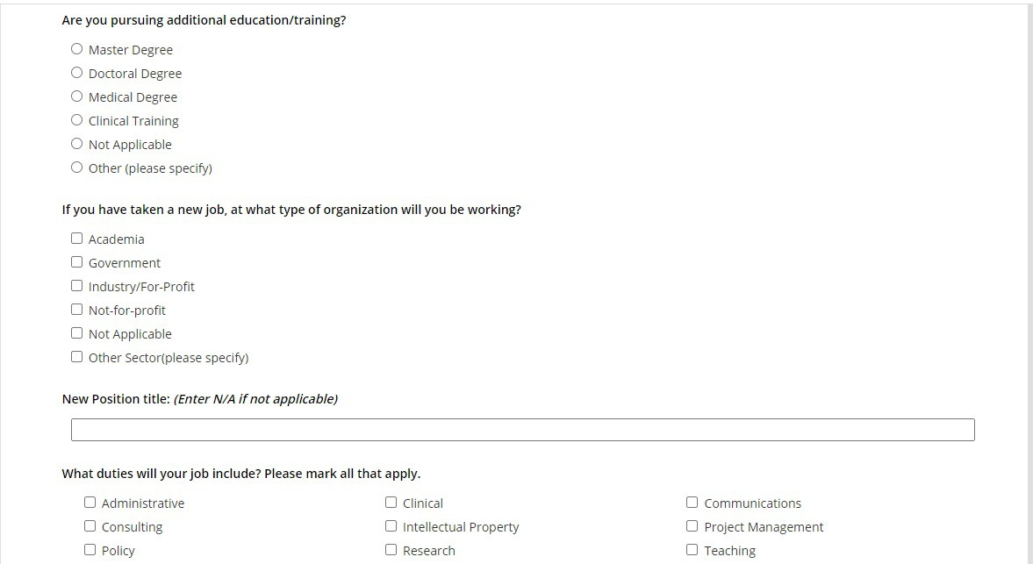Data Collection Tool: NEI Exit Survey for Trainees Part 1

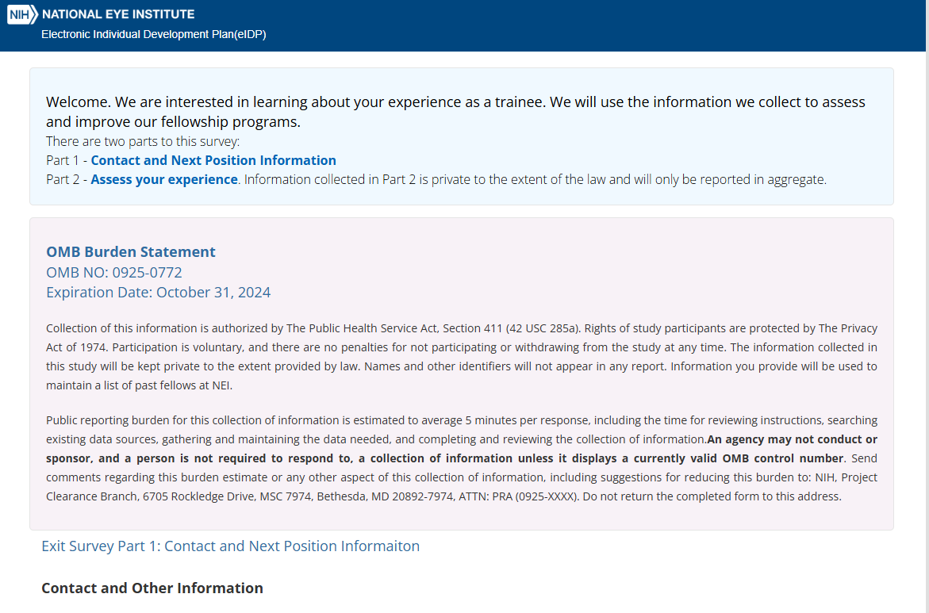

**If you have taken a new job. at what type of organization will you be working?**

**0 Academia**

**0 Government**

D Industry/For-Profit D Not-for-profit

0 Not Applicable

D other Sector(please specify)

**New Position title: *{Enter NIA if not applicable)***

What duties will your job include? Please mark all that apply.

**0 Administrative**

D Consulting D Policy

0 Not Applicable

D Clinical

D Intellectual Property D Research

D Other (please specify)

**0 Communications**

**0 Project Management**

D Teaching

**ls there anything that you would like to share with your training director about your experience at NEI?**



"

***max,mum charaaers 3000***

Ill

**Decline to Answer**