Email #1: Call for Data Submission
Data Submission Open for AHRQ Nursing Home Survey
Data Submission for AHRQ Surveys on Patient Safety Culture® Nursing Home Database
Voluntary data submission for AHRQ’s Surveys on Patient Safety Culture® (SOPS®) Nursing Home Database opened Oct. 1 for nursing homes that have administered AHRQ’s SOPS Nursing Home Survey. Nursing homes may submit survey data administered any time between Oct. 1, 2022 and Oct. 21, 2024. Participating nursing homes will receive feedback reports displaying their results compared to aggregated, de-identified results from all database participants.
Submissions will be accepted until Oct. 21.
The SOPS Nursing Home Database accepts data from the:
- SOPS Nursing Home Survey
- Workplace Safety Supplemental Items
Select to access survey and supporting materials and learn more about database submission.
To register and submit data, go to https://sopsdatabase.ahrq.gov/default.aspx?mode=nursinghome.
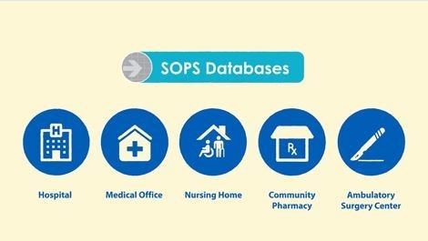 | Watch the brief animated video: Why Submit to the AHRQ SOPS Databases?
Email #2: Registration Approval: Username
Welcome to the Surveys on Patient Safety Culture (SOPS) Nursing Home Survey Data Submission System. Your account was set up with the following information:
Username: {replace:username}
Organization: {replace:orgname}
To activate your account please follow the link below:
<<Data Submission URL>>
For questions or comments please contact SOPS Database staff at DatabasesOnSafetyCulture@westat.com.

Email #3: Reminder email – Send one and two weeks after data submission
REMINDER: Data Submission for AHRQ Surveys on Patient Safety Culture® Nursing Home Database
Voluntary data submission for AHRQ’s Surveys on Patient Safety Culture® (SOPS®) Nursing Home Database opened Oct. 1 for nursing homes that have administered AHRQ’s SOPS Nursing Home Survey. Nursing homes may submit survey data administered any time between Oct. 1, 2022 and Oct. 21, 2024. Participating nursing homes will receive feedback reports displaying their results compared to aggregated, de-identified results from all database participants.
Submissions will be accepted until Oct. 21.
The SOPS Nursing Home Database accepts data from the:
- SOPS Nursing Home Survey
- Workplace Safety Supplemental Items
Select to access survey and supporting materials and learn more about database submission.
To register and submit data, go to https://sopsdatabase.ahrq.gov/default.aspx?mode=nursinghome.
Watch the brief animated video: Why Submit to the AHRQ SOPS Databases?
Email DatabasesOnSafetyCulture@westat.com with questions, or call 1-888-324-9790.

