Figure 1: Entering/Uploading Site Information
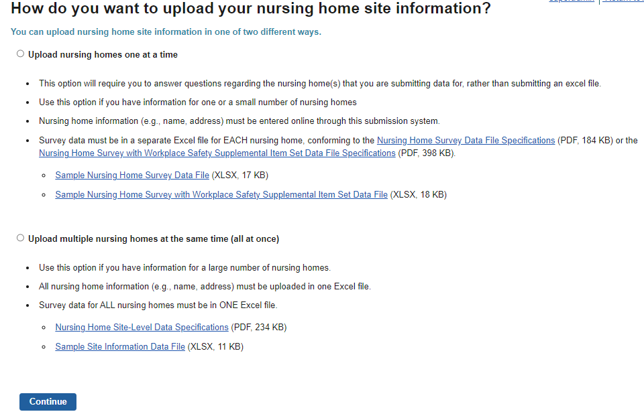
Figure 2: Upload Questionnaire
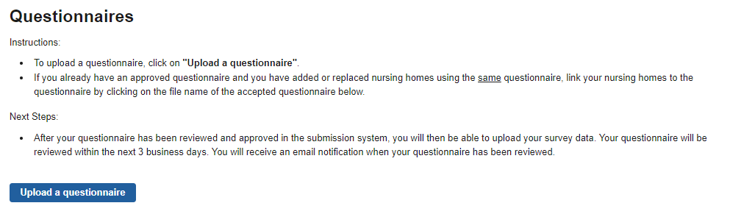

Figure 3: Submit Data Use Agreement
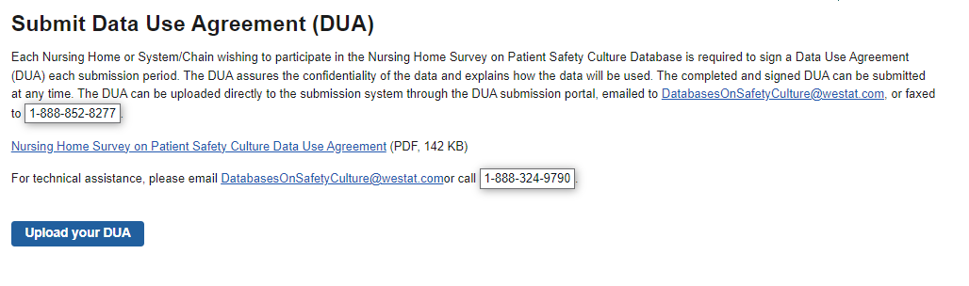
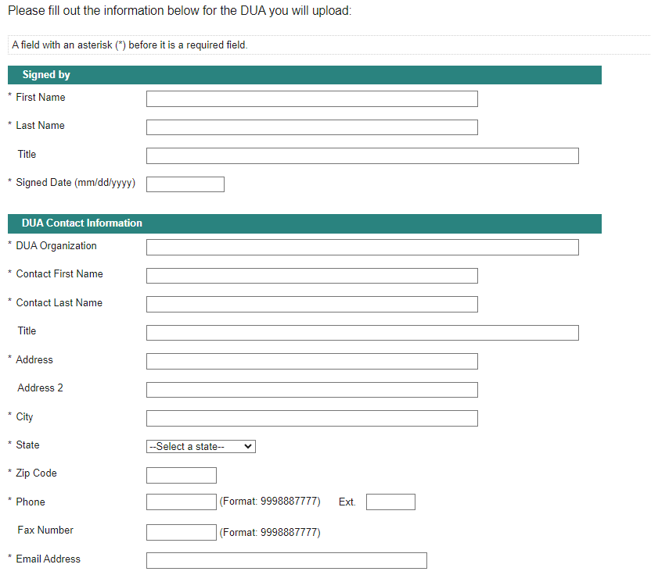

Figure 4: Submit Survey Data File
