Attachment D: Data Submission Emails
Email #1: Call for Data Submission
Data Submission Open for AHRQ Ambulatory Surgery Center Survey


June 2 to 20: AHRQ SOPS® Ambulatory Surgery Center Survey Data Submission
Voluntary data submission for AHRQ’s Surveys on Patient Safety Culture® (SOPS®) Ambulatory Surgery Center (ASC) Database will be open June 2-20 for ASCs that have administered AHRQ’s Ambulatory Surgery Center Survey on Patient Safety Culture. ASCs may submit their most recent survey data administered any time between July 2023 and June 2025. Participating ASCs will receive feedback reports displaying their results compared to aggregated, de-identified results from all database participants.
Select to access survey and supporting materials and learn more about database submission.
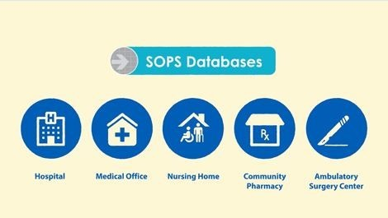 | Watch the brief animated video: Why Submit to the AHRQ SOPS Databases?

Email DatabasesOnSafetyCulture@westat.com with questions or call 1-888-324-9790.

Email #2: Registration Approval: Username
Email subject: Account Activation: Ambulatory Surgery Center Survey on Patient Safety Culture System
Welcome to the AHRQ Ambulatory Surgery Center Survey on Patient Safety Culture Data Submission System. Your account was set up with the following information:
Username: [User email address]
Organization: [User organization]
To activate your account please follow the link below:
<<Data Submission URL>>
For questions or comments please contact Database staff at DatabasesOnSafetyCulture@westat.com.

Email #3: Reminder email – Send one and two weeks after data submission
Now Open: Data Submission for AHRQ SOPS® Ambulatory Surgery Center (ASC) Database
Voluntary data submission for AHRQ’s Surveys on Patient Safety Culture® (SOPS®) Ambulatory Surgery Center (ASC) Database opened June 2 for ASCs that have administered AHRQ’s Ambulatory Surgery Center Survey on Patient Safety Culture. Participating ASCs will receive individual feedback reports displaying their results compared to aggregated, de-identified results from all database participants.
Submissions will be accepted until June 20.
Select to access survey and supporting materials and learn more about database submission.
To register and submit data, go to https://tinyurl.com/SOPS-ASC-Database.
Watch the brief animated video: Why Submit to the AHRQ SOPS Databases?
Email DatabasesOnSafetyCulture@westat.com with questions or call 1-888-324-9790.

