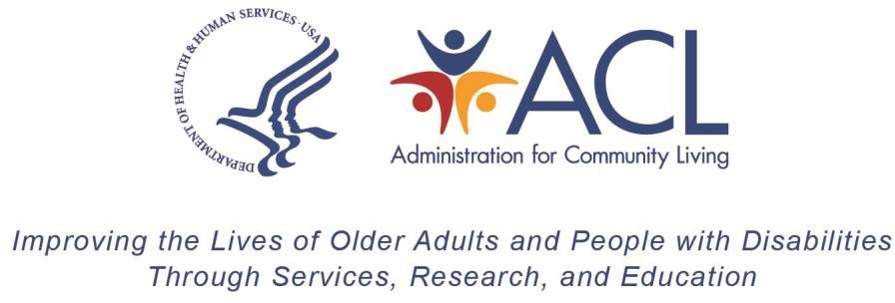

INSTRUCTIONS FOR REALLOTMENT OLDER AMERICANS ACT TITLE III AND TITLE VII

Due Date: Annually on the Second Friday in September

Inquires: ACL Fiscal Contact

Legal and Related References: Section 304(b) and Section 703(b) of the Older Americans Act of 1965, As Amended

The purpose of this Instruction is to notify grantees of the procedures for reporting reallotment of Older Americans Act (OAA) Title III and Title VII formula Grant Funds. Grantees must report to the Administration for Community Living (ACL) by the second Friday in September for each Federal Fiscal Year funding. To comply with reallotment reporting requirements, please complete the form by providing the following:

- a statement, signed by the authorized official, that all current Federal Fiscal Year (FFY) Title III and Title VII formula grant funds will be expended; or,
- the amount, if any, of the current FFY Title III and/or Title VII formula grant funds that will not be used by September 30 and will be released for reallotment; and,

- the request for additional current FFY Title III and/or Title VII formula grant funds, if any become available via the reallotment process, which would be expended by September 30 of the following year.

Statement of Fully Used Funds

Annual formula grant award allocations of OAA Title III and Title VII funds have a project period of two years, and all grant activities must occur within the project period. All financial obligations must be liquidated and a final financial report submitted no later than 120 days after the end date of the period of performance.

Release of Unused Funds

Grantees not intending to use the full amount of their Title III or Title VII formula allotments within the project period of the grant must submit a statement signed by the Authorized Official releasing Title III and/or Title VII formula grant funds for reallotment in the year in which funds are awarded. This statement must identify the amount and from which part of Title III (B - Supportive Services, C1 - Congregate Meals, C2 – Home Delivered Meals, D - Preventive Health, and E - Caregiver Support) or

Title VII (Ombudsman and Elder Abuse Prevention) the funds are being released. If funds are released for reallotment, ACL will issue a revised grant award(s) reflecting the decrease(s).

Request for Funds

If additional funds can be utilized, grantees should submit a brief statement justifying the need for additional funds. The statement must identify the Parts of Title III and/or VII for which funds are being requested.
Reallotted funds are one-time awards and there is no assurance additional reallotted funds will be received in future years. Reallotted funds do not impact allocation of funds in future years.

Paperwork Reduction Act Public Burden Statement:

According to the Paperwork Reduction Act of 1995 5 CFR § 1320.8(b)(3), no persons are required to respond to a collection of information unless such collection displays a valid OMB control number (OMB 0985-008X). Public reporting burden for this collection of information is estimated to average one (1) hour per response, including time for gathering, maintaining the data needed, completing, and reviewing the collection of information. The obligation to respond to this collection is required to retain or maintain benefits under the Older Americans Act (P.L. 116-131).
Information collected is planned for use by ACL to conduct federal oversight of Aging Programs. ACL uses information collected to monitor federal funds. Data will be kept private to the extent allowed by law. There are no assurances of confidentiality.

