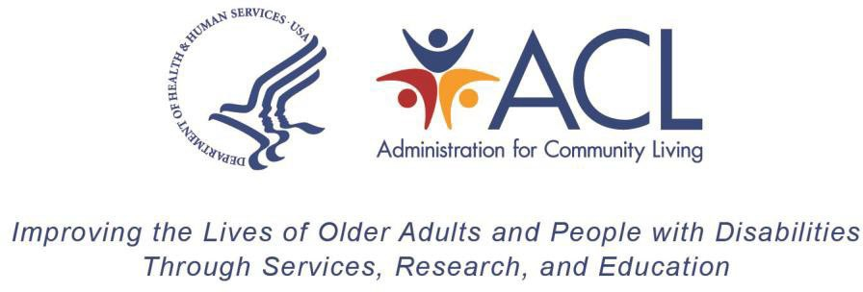

Instructions for Transfer of Title III Older Americans Act Formula Grant Funds
DUE DATE: On or before August 1, in the final year of the original two-year project period
INQUIRIES: ACL Fiscal Contact

CITATIONS: Older Americans Act, As Amended Sections 308 (b)(4)(A), 308 (b)(4)(B), 308 (b)(4)(C), 308 (b)(5)(A), and 316

Background

The Older Americans Act (OAA), as amended provides authority for States and Territories to transfer funds, within statutory limits, among their allotments for Home and Community Based Supportive Services (III-B), Congregate Nutrition Services (III-C1), and Home-Delivered Nutrition Services (III-C2). There is, however, no authority for States or Territories to transfer funds in or out of the allotments for Preventive Health Services Disease Prevention (III-D), and the National Family Caregiver Support Program (III-E). This instruction provides procedures for reporting to the Administration for Community Living (ACL) the transfer of funds among Title III allotments, as permitted in the OAA.

Transfers between Congregate Nutrition Services (Title III-C1) and Home-Delivered Nutrition Services (Title III-C2):

States and Territories may transfer a total of up to 40% of their allotment for Title III-C1 to Title III-C2, or vice versa. By statute, the election to transfer funds is a State or Territory decision that may be disapproved by the U.S. Assistant Secretary for Aging (ASA), only if the ASA determines that the transfer is not consistent with the objectives of the OAA, as amended.

The OAA, as amended provides that the ASA may grant a waiver to permit a State or Territory to transfer an additional 10%, i.e., up to a total of 50%, of funds between Titles III-C1 and III-C2. The approval of such a waiver by the ASA is contingent upon the State’s or Territory’s demonstration that the funds available under Titles III-C1 or III-C2, including transfers, are insufficient to satisfy needs. The content requirements of the waiver request are specified in section 308 (b)(4)(C).

Transfers between Home and Community Based Supportive Services (Title III-B) and the Nutrition Service Programs under Title III-C:

The OAA, as amended permits a State or Territory to transfer a total up to 30% of an allotment between Titles III-B and the Nutrition Programs under Title III-C (Title III- C1 and Title III-C2). Section 316 (b)(4) permits the ASA to grant a waiver of the 30% transfer limit. To receive a waiver, a State or Territory must comply with all the requirements in section 316. The section 316 waiver provision is more involved than the waiver provision in section 308 (relating to transfers between Titles III-C1 and III-C2).

Instructions for Reporting Transfers:

Each Federal fiscal year (FFY) Title III awards are issued with a unique grant number for each part/chapter; therefore, transfers need to be submitted and recorded timely for States and Territories to correctly report the Federal Funding Accountability Transparency Act (FFATA) sub-award activities and draw funds from Payment Management System (PMS) sub-accounts. Transfers are available in the original two-year project period in which funds are awarded. Funds may only be transferred between these Title III parts under grant awards issued in the same FFY. States and Territories are encouraged to submit requests, if possible, after the final FFY Title III allocations have been issued from ACL.

The transfer request must be submitted on the form and include the cumulative grant award (full allotment) for Title III Part-B, Title III-C1 and Title III-C2 before the requested transfer, the amount to be transferred from or to each part, total sum of the transfers (total net transfers), and the adjusted grant award amounts after the transfers (adjusted allotment). The State or Territory must also include the percentage requested to be transferred. If more than one transfer is needed, the subsequent transfers must reflect cumulative transfers to date. The transfer request must also provide, based on the state’s approach, a brief justification for the need and effects on provision of services and number of meals served (if applicable).

Once received, ACL will review and if approved issue an amended notice of award (NoA) reflecting the transfer request for each award impacted. Funds will not be available for drawdown from PMS until ACL issues the amended NoA(s). ACL strives to issue an amended NoA reflecting transfer requests within two weeks of receipt.

Transfer requests for amounts within the statutory limits must be submitted to AOA.Grants@acl.hhs.gov, on or before August 1 in the in the final year of the original two- year project period. Grantees may request extensions to transfer request timeframes with reasonable justifications.

Waiver Requests:
Contact the ACL Regional Administrator for further instructions on requesting a waiver. Waiver requests must be submitted to the ACL Regional Administrator as soon as possible and prior to the transfer request submission to ACL. States and Territories are cautioned not to wait until the transfer due date (August 1 of the final year of the original two-year project period) to request a waiver. The ASA reserves the right to approve or disapprove a State's or Territory’s request for a waiver of the limits on the amount of funds that a State or Territory may transfer. States and Territories will be notified in writing of the ASA's decision.

Paperwork Reduction Act Public Burden Statement

According to the Paperwork Reduction Act of 1995 5 CFR § 1320.8(b)(3), no persons are required to respond to a collection of information unless such collection displays a valid OMB control number (OMB 0985-008X). Public reporting burden for this collection of information is estimated to average one (1) hour per response, including time for gathering, maintaining the data needed, completing, and reviewing the collection of information. The obligation to respond to this collection is required to obtain or retain benefits under the Older Americans Act (P.L. 116-131). Information collected is planned for use by ACL to conduct federal oversight of Aging Programs. ACL uses information collected to monitor federal funds. Data will be kept private to the extent allowed by law. There are no assurances of confidentiality. Send comments regarding the burden estimate or any other aspect of this collection of information, including suggestions for reducing this burden, to the Administration for Community Living, U.S. Department of Health and Human Services, 330 C Street, SW, Washington, DC 20201-0008, Attention Adam Mosey adam.mosey@acl.hhs.gov and reference the OMB Control Number 0985-xxxx. Note: Please do not return the completed information collection to this address.

