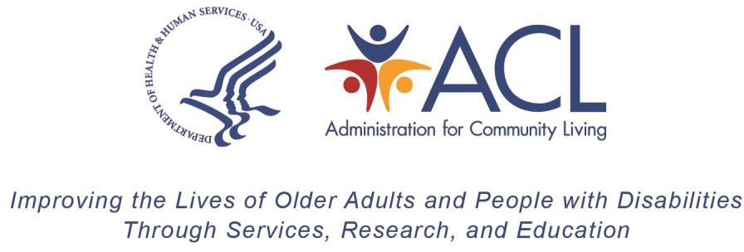

REALLOTMENT CERTIFICATION FOR OLDER AMERICANS ACT TITLE III AND VII

State/Territory:

Fiscal Year:

I certify, that for the Federal Fiscal Year for State/Territory (listed above) will (please check one):

Fully use all current year Title III and Title VII Older Americans Act grant funds during the project period of the grant award.
☐

Not fully use all current year Title III and Title VII Older Americans Act grant funds during the project period of the grant award and is releasing the below amounts for reallocation to other States/Territories:
☐

Grant Program | Amount Released for  Reallocation
Title III-B Supportive Services (OASS) | $
Title III-C1 Congregate Meal Program (OACM) | $
Title III-C2 Home Delivered Meal  Program (OAHD) | $
Title III-D Disease Prevention and  Health Promotion (OAPH) | $
Title III-E Family Caregiver  Supportive Services (OAFC) | $
Title VII - Chapter 2 Ombudsman  (OAOM) | $
Title VII - Chapter 3 Elder Abuse Prevention (OAEA) | $

If funds from other States or Territories become available through the Reallotment process, additional funds are requested below that will be used with within the current project period of the current year grant (please mark Y if additional funds are requested and N if no additional funds are requested):

Y/N | Grant Program
 | Title III-B Supportive Services (OASS)
 | Title III-C1 Congregate Meal Program (OACM)
Title III-C2 Home Delivered Meal Program
(OAHD)
Title III-D Disease Prevention and Health
Promotion (OAPH)
Title III-E Family Caregiver Supportive Services
(OAFC)
 | Title VII - Chapter 2 Ombudsman (OAOM)
Title VII - Chapter 3 Elder Abuse Prevention
(OAEA)

Please provide a brief justification for use of additional funds if they become available:

Signature of the Authorized State/Territory Official

Date

Paperwork Reduction Act Public Burden Statement
According to the Paperwork Reduction Act of 1995 5 CFR § 1320.8(b)(3), no persons are required to respond to a collection of information unless such collection displays a valid OMB control number (OMB 0985-008X). Public reporting burden for this collection of information is estimated to average one (1) hour per response, including time for gathering, maintaining the data needed, completing, and reviewing the collection of information. The obligation to respond to this collection is required to obtain or retain benefits under the Older Americans Act (P.L. 116-131). Information collected is planned for use by ACL to conduct federal oversight of Aging Programs. ACL uses information collected to monitor federal funds. Data will be kept private to the extent allowed by law. There are no assurances of confidentiality. Send comments regarding the burden estimate or any other aspect of this collection of information, including suggestions for reducing this burden, to the Administration for Community Living, U.S. Department of Health and Human Services, 330 C Street, SW, Washington, DC 20201-0008, Attention Adam Mosey adam.mosey@acl.hhs.gov and reference the OMB Control Number 0985-xxxx. Note: Please do not return the completed information collection to this address.

