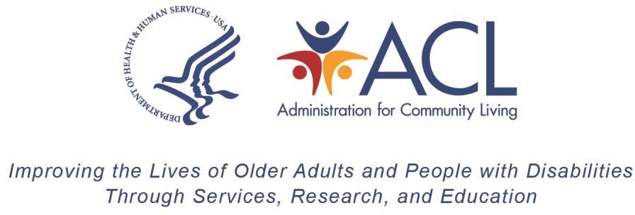

Transfer of Older Americans Act Title III Grant Formula Award Allocations
State/Territory:

Fiscal Year:

Grant Numbers:

Justification for transfer request, including the effect on provision of services and number of meals served (if applicable):

Attach Title III Allotment Worksheet to this transfer request.

Signature of the Authorized State/Territory Official

Date

Paperwork Reduction Act Public Burden Statement
According to the Paperwork Reduction Act of 1995 5 CFR § 1320.8(b)(3), no persons are required to respond to a collection of information unless such collection displays a valid OMB control number (OMB 0985-008X). Public reporting burden for this collection of information is estimated to average one (1) hour per response, including time for gathering, maintaining the data needed, completing, and reviewing the collection of information. The obligation to respond to this collection is required to obtain or retain benefits under the Older Americans Act (P.L. 116-131). Information collected is planned for use by ACL to conduct federal oversight of Aging Programs. ACL uses information collected to monitor federal funds. Data will be kept private to the extent allowed by law. There are no assurances of confidentiality. Send comments regarding the burden estimate or any other aspect of this collection of information, including suggestions for reducing this burden, to the Administration for Community Living, U.S. Department of Health and Human Services, 330 C Street, SW, Washington, DC 20201-0008, Attention Adam Mosey adam.mosey@acl.hhs.gov and reference the OMB Control Number 0985-xxxx. Note: Please do not return the completed information collection to this address.

