NATIONAL CENTER FOR EDUCATION STATISTICS NATIONAL ASSESSMENT OF EDUCATIONAL PROGRESS

National Assessment of Educational Progress (NAEP) 2026

Appendix J1
2024 Student Questionnaires Samples

OMB# 1850-0928 v.36



May 2025

NOTE: The 2026 student survey questionnaires were not available for this submission. The 2026 surveys will be included in either the Amendment #1 (Spring 2025), Amendment #2 (August/September 2025), or some combination of both Amendments. System login screens will be updated in upcoming Amendments to the Clearance Package.
Important changes in how we collect demographic information will be reflected in the 2026 instruments when they are ready for publication and review. In March 2024, the Office of Management and Budget (OMB) announced revisions to Statistical Policy Directive No. 15: Standards for Maintaining, Collecting, and Presenting Federal Data on Race and Ethnicity (SPD 15) and published the revised SPD15 standard in the Federal Register (89 FR 22182). See Part A.7 of this package to see how NCES plans to incorporate these revisions into NAEP 2026. Further, as we were preparing this package for 30D publication, the White House issued an Executive Orders “Defending Women from Gender Ideology Extremism and Restoring Biological Truth to the Federal Government,” (January 20, 2025) and “Ending Radical and Wasteful Government DEI Programs and Preferencing,” (January 20, 2025). In compliance with these Executive Orders, the materials in this package have been modified. In addition, a full review of all items is being conducted to ensure compliance with the Executive Orders. The revised questionnaires will be included in the next Amendments to this package. No collections of this information will take place before the submission and approval of Amendment #2.
Appendix J1 provides the student survey questionnaires that will be administered in 2024. Grades 4 and 8 Core, Math, and Reading questionnaires were previously approved in 2022 (OMB# 1850-0928 v.28), and any changes to the items from the 2022 administration are reflected in summary tables. Additionally, grade 8 Science and grade 12 Core, Math, and Reading were previously approved in 2019 (OMB# 1850-0928 v.15), and any changes to the items from the 2019 administration are reflected in summary tables. Learning Recovery SQs are available in this document.
Please note, some of the numbers of the items may be missing or out of order in these printed versions. This will be corrected in the platform view.

Table of Contents
Student Questionnaires
Student Login Screen 4
Appendix J1-1: Summary of Changes Operational Grade 4 (Core, Mathematics) 5
Appendix J1-2: Operational Grade 4 (Core, Mathematics) 8
Appendix J1-3: Summary of Changes Operational Grade 4 (Core, Reading) 13
Appendix J1-4: Operational Grade 4 (Core, Reading) 16
Appendix J1-5: Summary of Changes Operational Grade 8 (Core, Mathematics) 21
Appendix J1-6: Operational Grade 8 (Core, Mathematics) 24
Appendix J1-7: Summary of Changes Operational Grade 8 (Core, Reading) 31
Appendix J1-8: Operational Grade 8 (Core, Reading) 34
Appendix J1-9: Summary of Changes Operational Grade 12 (Core, Mathematics) 42
Appendix J1-10: Operational Grade 12 (Core, Mathematics) 45
Appendix J1-11: Summary of Changes Operational Grade 12 (Core, Reading) 54
Appendix J1-12: Operational Grade 12 (Core, Reading) 57
Appendix J1-13: Summary of Changes Operational Grade 4 (Mathematics) 65
Appendix J1-14: Operational Grade 4 (Mathematics) 66
Appendix J1-15: Summary of Changes Operational Grade 8 (Mathematics) 70
Appendix J1-16: Operational Grade 8 (Mathematics) 71
Appendix J1-17: Summary of Changes Operational Grade 12 (Mathematics) 76
Appendix J1-18: Operational Grade 12 (Mathematics) 79
Appendix J1-19: Summary of Changes Operational Grade 4 (Reading) 97
Appendix J1-20: Operational Grade 4 (Reading) 98
Appendix J1-21: Summary of Changes Operational Grade 8 (Reading) 102
Appendix J1-22: Operational Grade 8 (Reading) 103
Appendix J1-23: Summary of Changes Operational Grade 12 (Reading) 107
Appendix J1-24: Operational Grade 12 (Reading) 108
Appendix J1-25: Operational Grade 8 (Science) 117
Appendix J1-26: Operational Grade 4 (Debrief) 122
Appendix J1-27: Operational Grade 8 and 12 (Debrief) 123
Appendix J1-32: Pilot Grade 4 (Core) 124
Appendix J1-33: Pilot Grade 8 (Core) 126
Appendix J1-34: Pilot Grade 4 (Mathematics) 127
Appendix J1-35: Pilot Grade 8 (Mathematics) 131
Appendix J1-36: Pilot Grade 4 (Reading) 138
Appendix J1-37: Pilot Grade 8 (Reading) 144
Appendix J1-38: Operational Grade 8 (Core, Science) 151

Student Login Screen
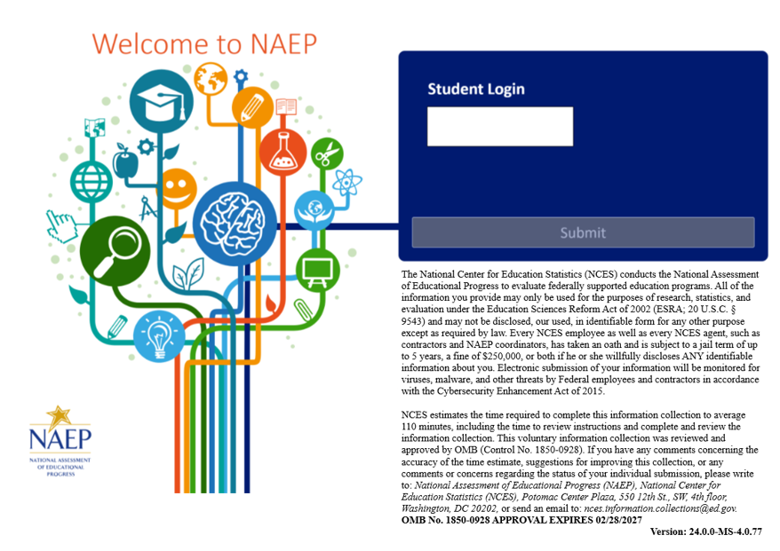

Appendix J1-1: Summary of Changes Operational Grade 4 (Core, Mathematics)

2024 Operational Grade 4 Core Mathematics Student
Previous Item | 2024 Item | D/A/ R+ | Rationale
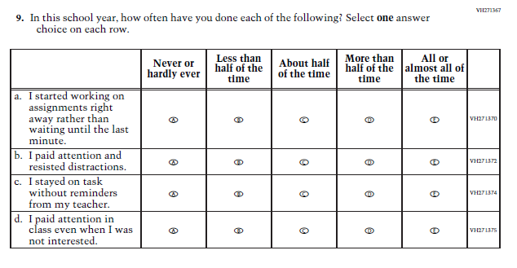  (2022 Grades 4 and 8, 2019 Grade 12) | N/A  Issue: Grit | D | This Item was selected to be dropped to reduce burden due to the addition of the Learning Recovery Items.
N/A | 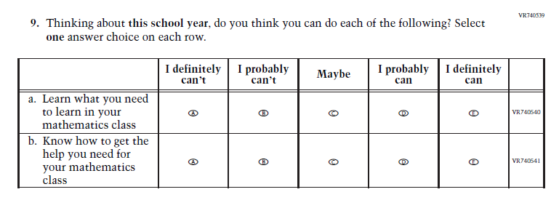  Issue: Learning Recovery | A | This Item was added to address gaps in learning that have developed due to the extended period of remote and hybrid learning that took place during the pandemic.
N/a | 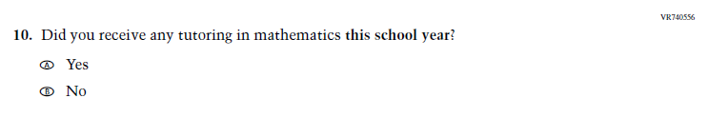  Issue: Learning Recovery | A | This Item was added to address gaps in learning that have developed due to the extended period of remote and hybrid learning that took place during the pandemic.
N/A | 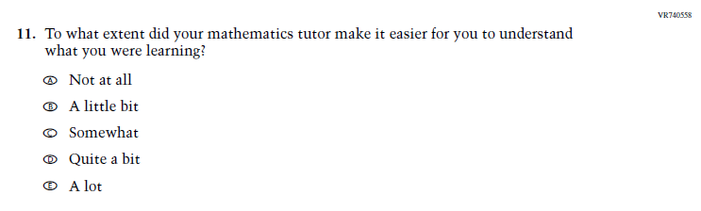  Issue: Learning Recovery | A | This Item was added to address gaps in learning that have developed due to the extended period of remote and hybrid learning that took place during the pandemic.

N/A | 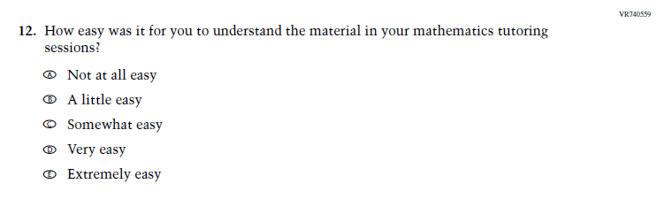  Issue: Learning Recovery | A | This Item was added to address gaps in learning that have developed due to the extended period of remote and hybrid learning that took place during the pandemic.
N/A | 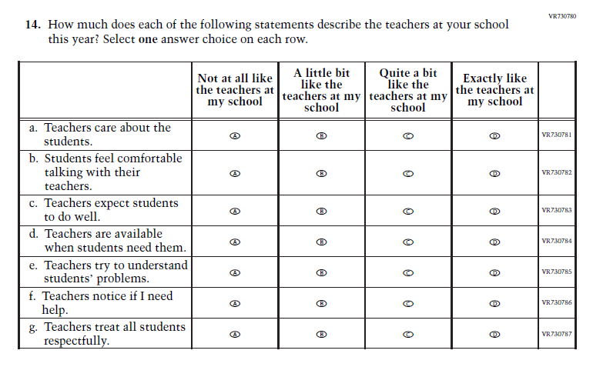  Issue: Learning Recovery | A | This Item was added to address gaps in learning that have developed due to the extended period of remote and hybrid learning that took place during the pandemic.

Appendix J1-2: Operational Grade 4 (Core, Mathematics)
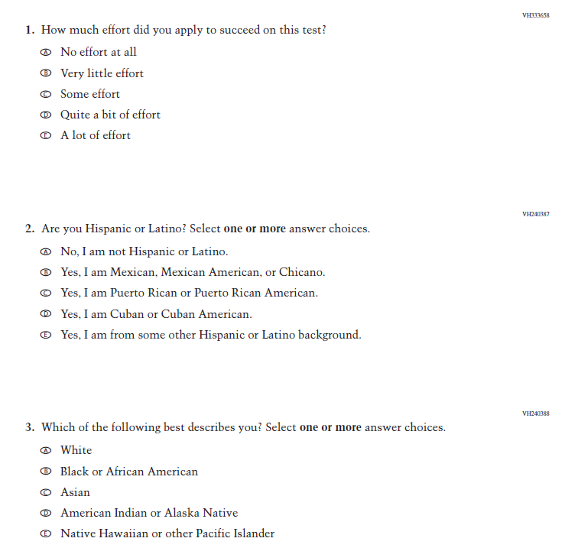
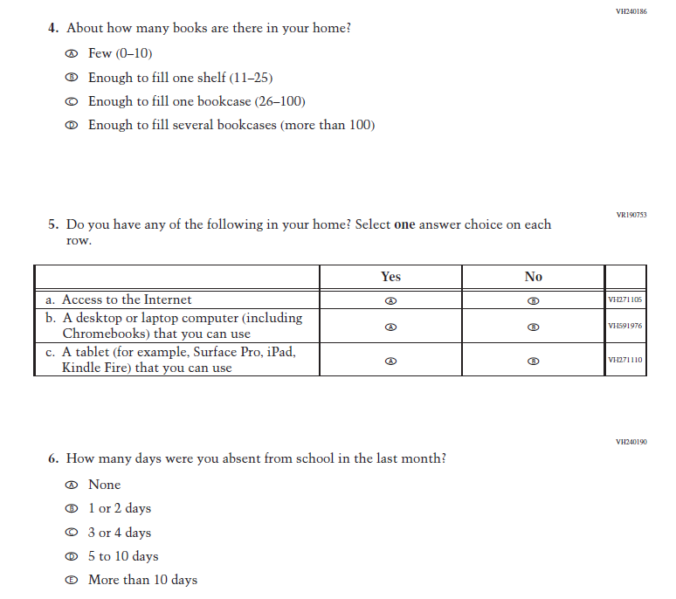
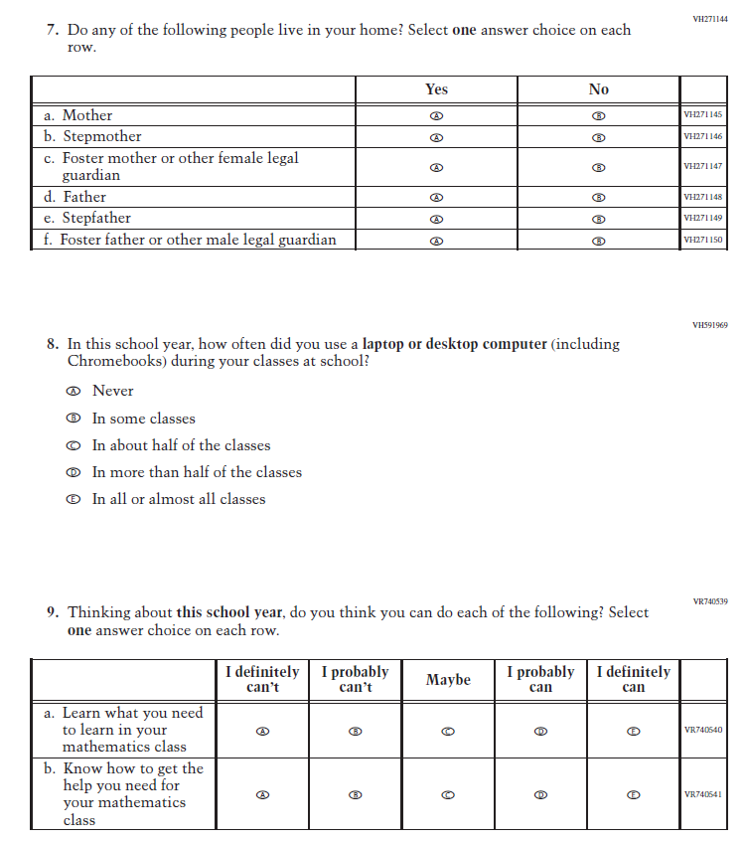
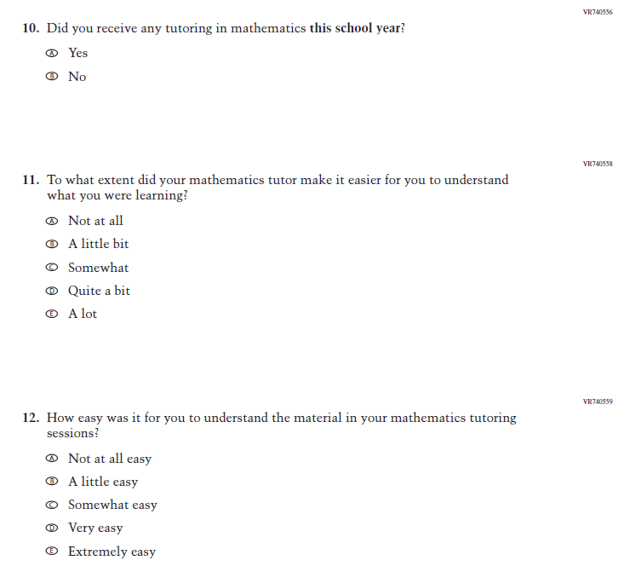
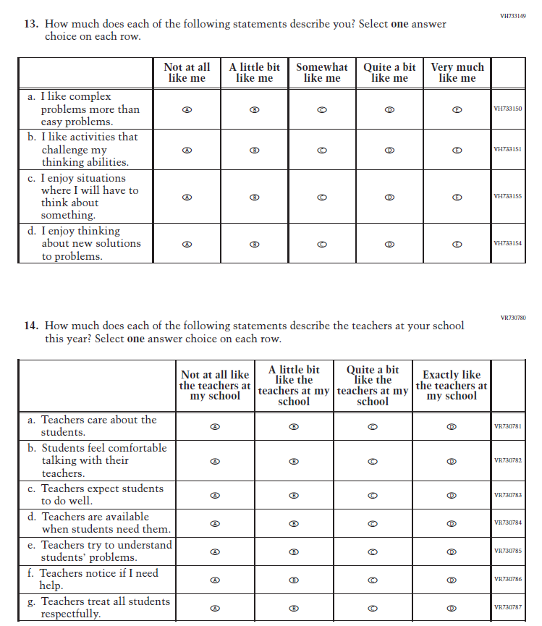

Appendix J1-3: Summary of Changes Operational Grade 4 (Core, Reading)

2024 Operational Grade 4 Core Reading Student
Previous Item | 2024 Item | D/A/ R+ | Rationale
(2022 Grades 4 and 8, 2019 Grade 12) | N/A  Issue: Grit | D | This Item was selected to be dropped to reduce burden due to the addition of the Learning Recovery Items.
N/A | 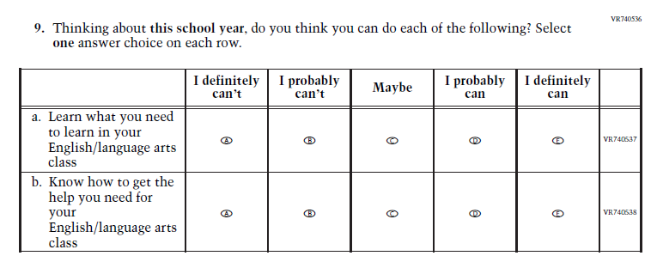  Issue: Learning Recovery | A | This Item was added to address gaps in learning that have developed due to the extended period of remote and hybrid learning that took place during the pandemic.

N/A | 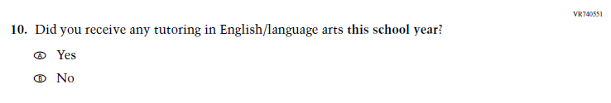  Issue: Learning Recovery | A | This Item was added to address gaps in learning that have developed due to the extended period of remote and hybrid learning that took place during the pandemic.
N/A | 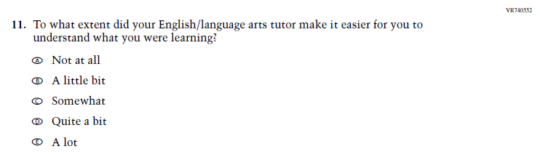  Issue: Learning Recovery | A | This Item was added to address gaps in learning that have developed due to the extended period of remote and hybrid learning that took place during the pandemic.

N/A | 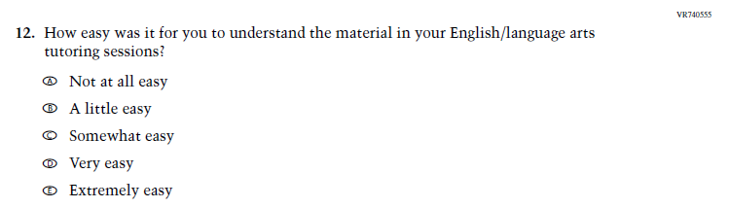  Issue: Learning Recovery | A | This Item was added to address gaps in learning that have developed due to the extended period of remote and hybrid learning that took place during the pandemic.
N/A | Issue: Learning Recovery | A | This Item was added to address gaps in learning that have developed due to the extended period of remote and hybrid learning that took place during the pandemic.

Appendix J1-4: Operational Grade 4 (Core, Reading)
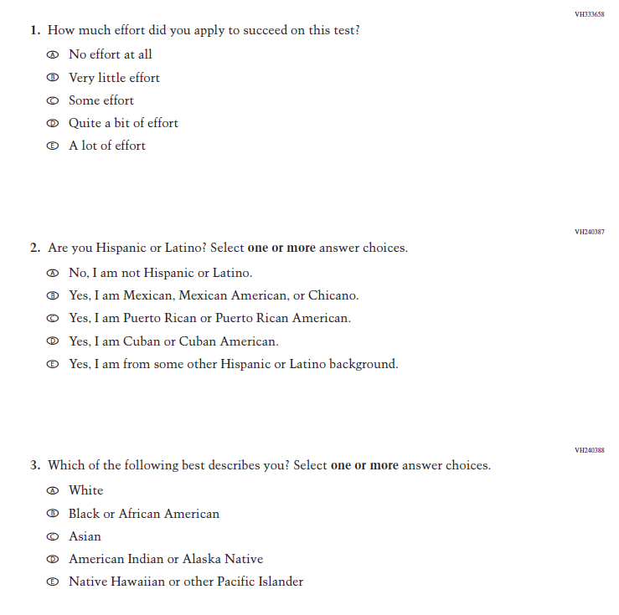
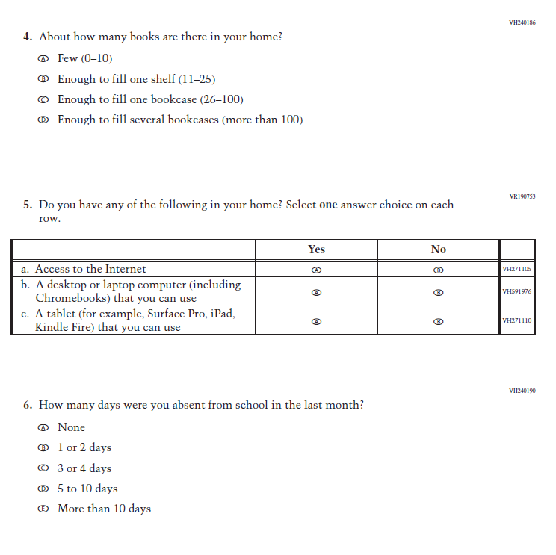
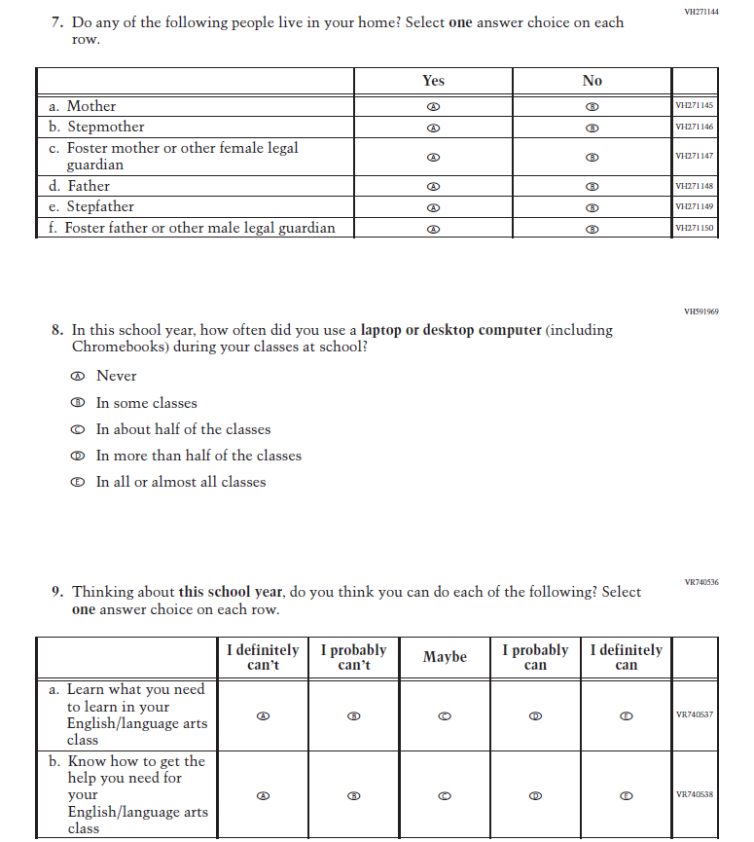
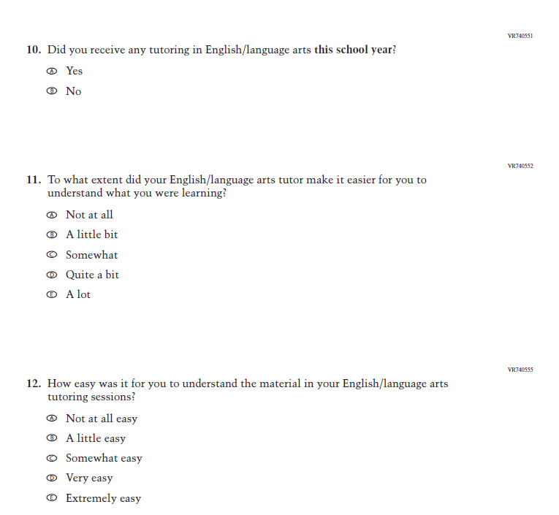
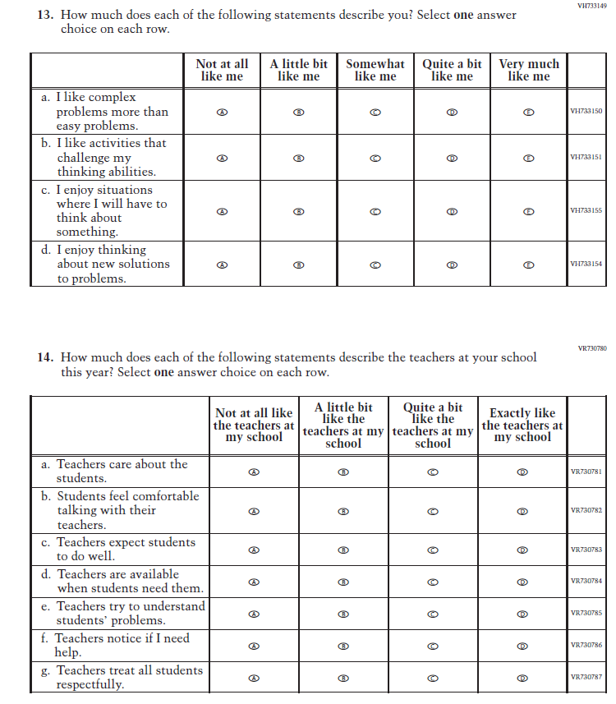

Appendix J1-5: Summary of Changes Operational Grade 8 (Core, Mathematics)
2024 Operational Grade 8 Core Mathematics Student
Previous Item | 2024 Item | D/A/ R+ | Rationale
(2022 Grades 4 and 8, 2019 Grade 12) | N/A  Issue: Grit | D | This Item was selected to be dropped to reduce burden due to the addition of the Learning Recovery Items.
N/A | Issue: Learning Recovery |  | This Item was added to address gaps in learning that have developed due to the extended period of remote and hybrid learning that took place during the pandemic.
N/a | Issue: Learning Recovery |  | This Item was added to address gaps in learning that have developed due to the extended period of remote and hybrid learning that took place during the pandemic.
N/A | Issue: Learning Recovery |  | This Item was added to address gaps in learning that have developed due to the extended period of remote and hybrid learning that took place during the pandemic.

N/A | Issue: Learning Recovery |  | This Item was added to address gaps in learning that have developed due to the extended period of remote and hybrid learning that took place during the pandemic.
N/A | Issue: Learning Recovery |  | This Item was added to address gaps in learning that have developed due to the extended period of remote and hybrid learning that took place during the pandemic.

Appendix J1-6: Operational Grade 8 (Core, Mathematics)
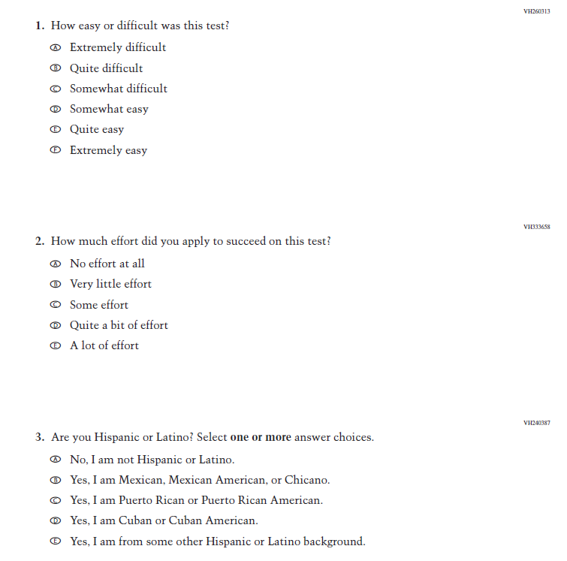
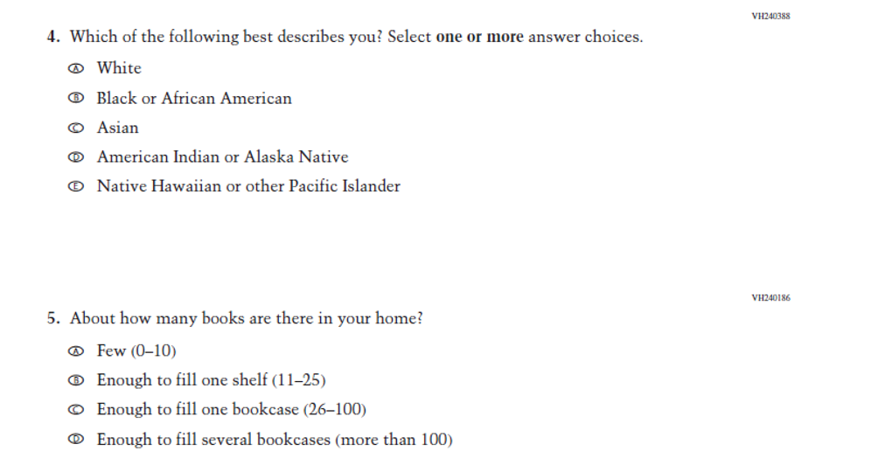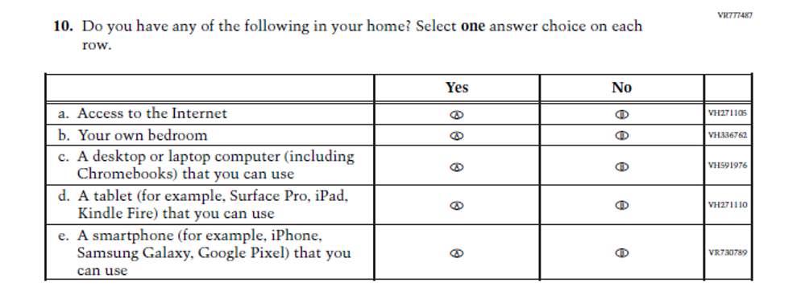
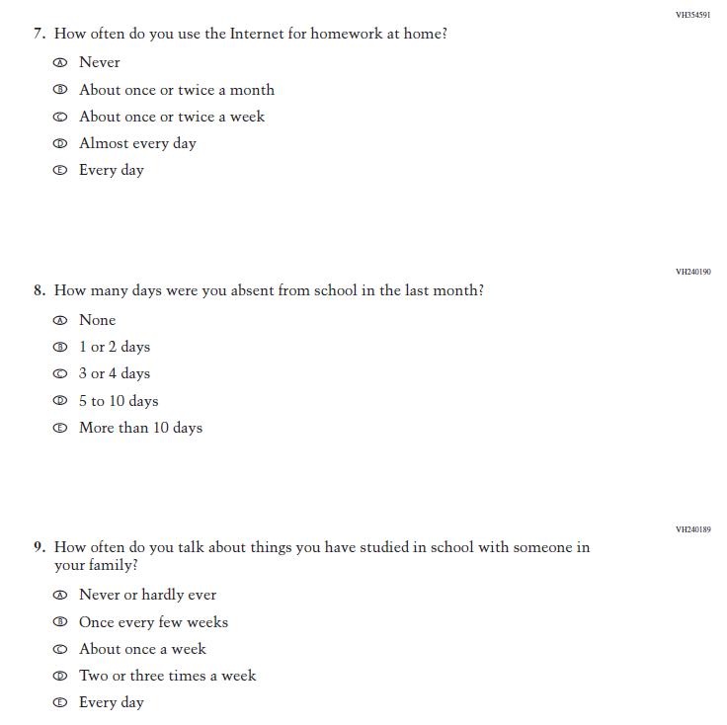
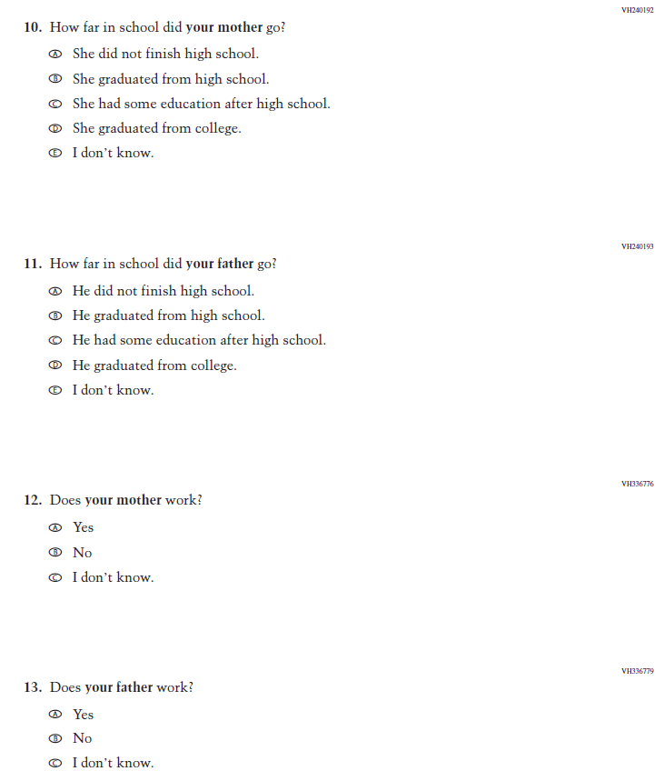
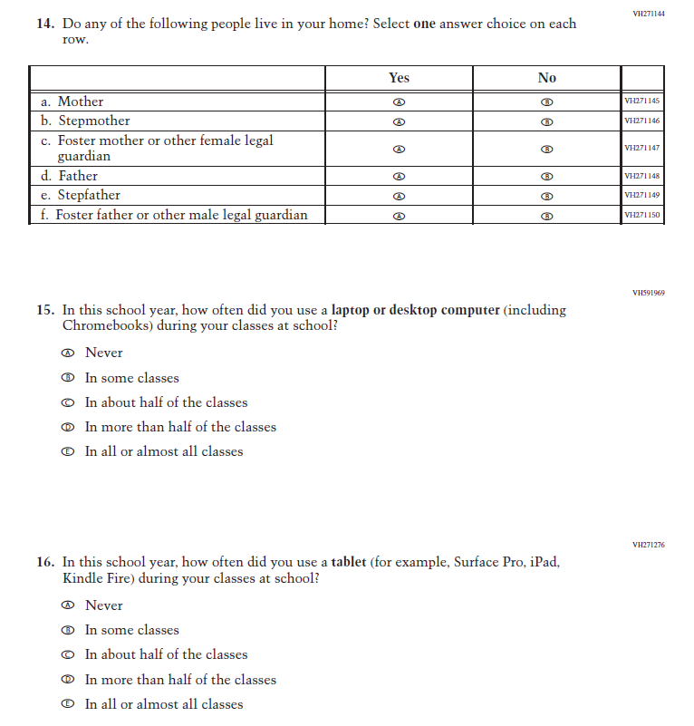
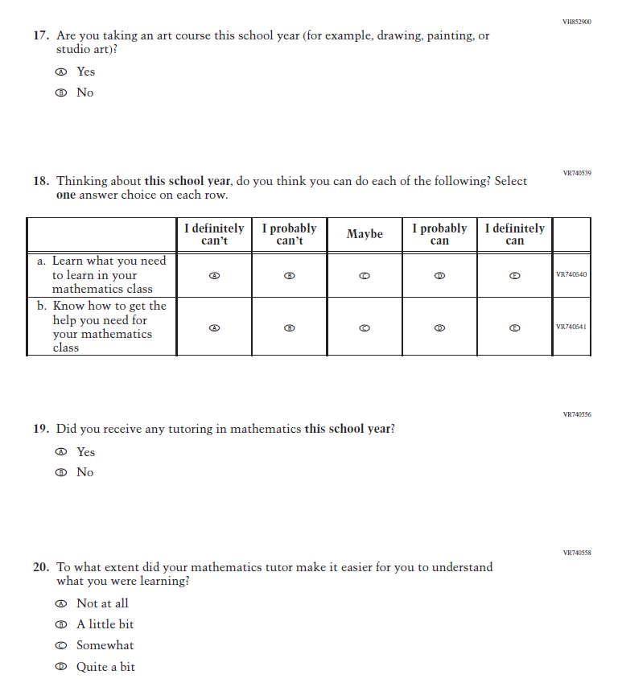
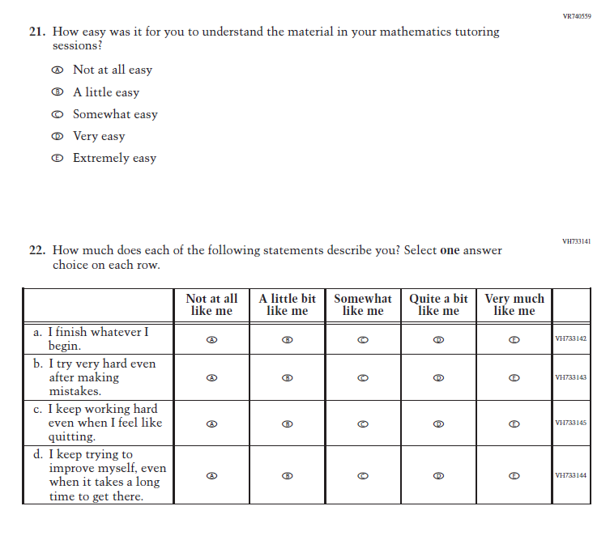
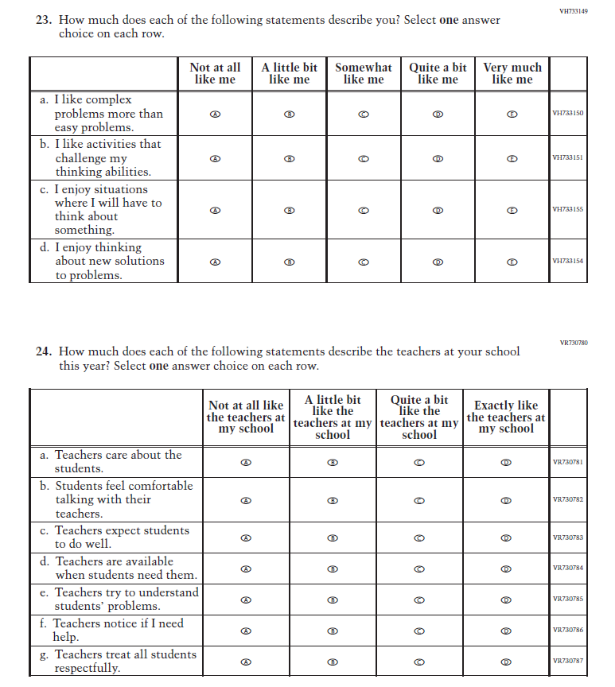

Appendix J1-7: Summary of Changes Operational Grade 8 (Core, Reading)
2024 Operational Grade 8 Core Reading Student
Previous Item | 2024 Item | D/A/ R+ | Rationale
(2022 Grades 4 and 8, 2019 Grade 12) | N/A  Issue: Grit | D | This Item was selected to be dropped to reduce burden due to the addition of the Learning Recovery Items.
N/A | Issue: Learning Recovery | A | This Item was added to address gaps in learning that have developed due to the extended period of remote and hybrid learning that took place during the pandemic.

N/A | Issue: Learning Recovery | A | This Item was added to address gaps in learning that have developed due to the extended period of remote and hybrid learning that took place during the pandemic.
N/A | Issue: Learning Recovery | A | This Item was added to address gaps in learning that have developed due to the extended period of remote and hybrid learning that took place during the pandemic.

N/A | Issue: Learning Recovery | A | This Item was added to address gaps in learning that have developed due to the extended period of remote and hybrid learning that took place during the pandemic.
N/A | Issue: Learning Recovery | A | This Item was added to address gaps in learning that have developed due to the extended period of remote and hybrid learning that took place during the pandemic.

Appendix J1-8: Operational Grade 8 (Core, Reading)
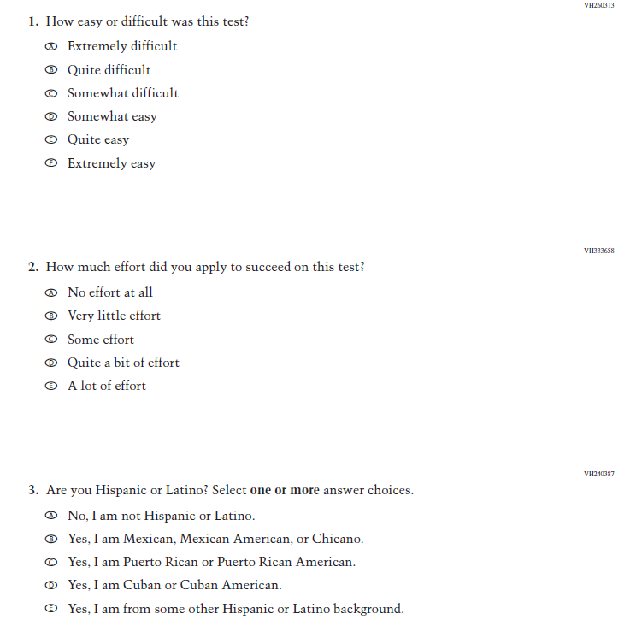
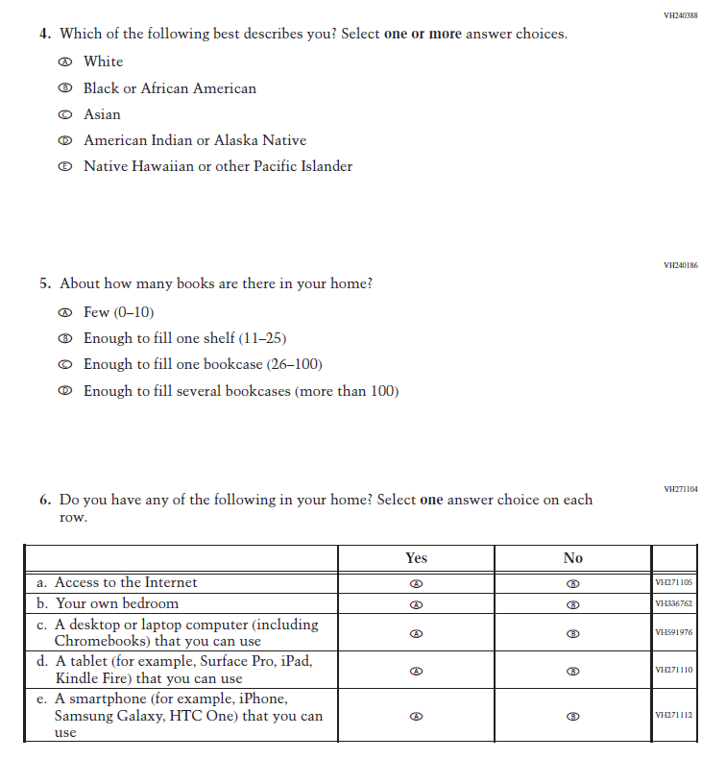
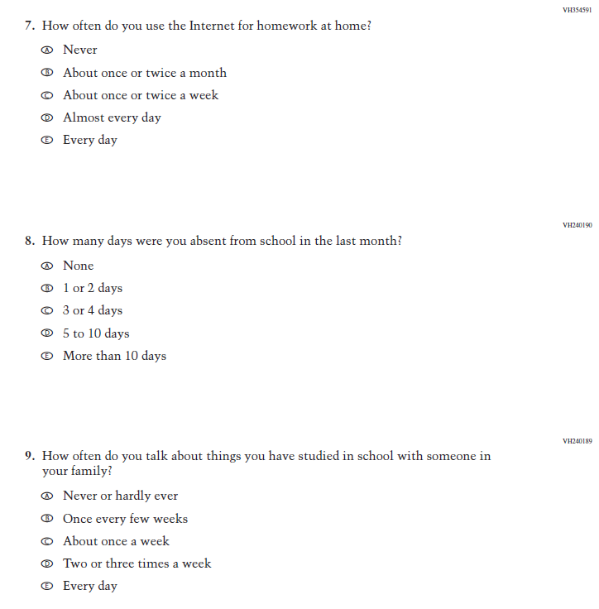
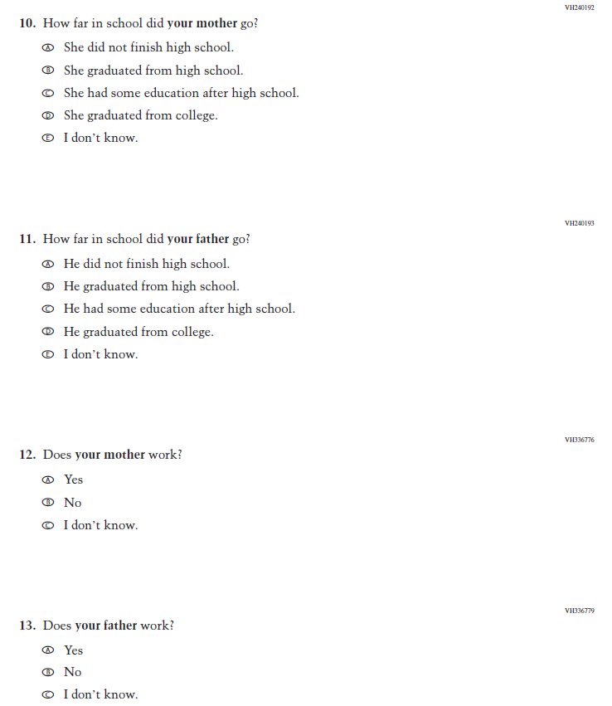
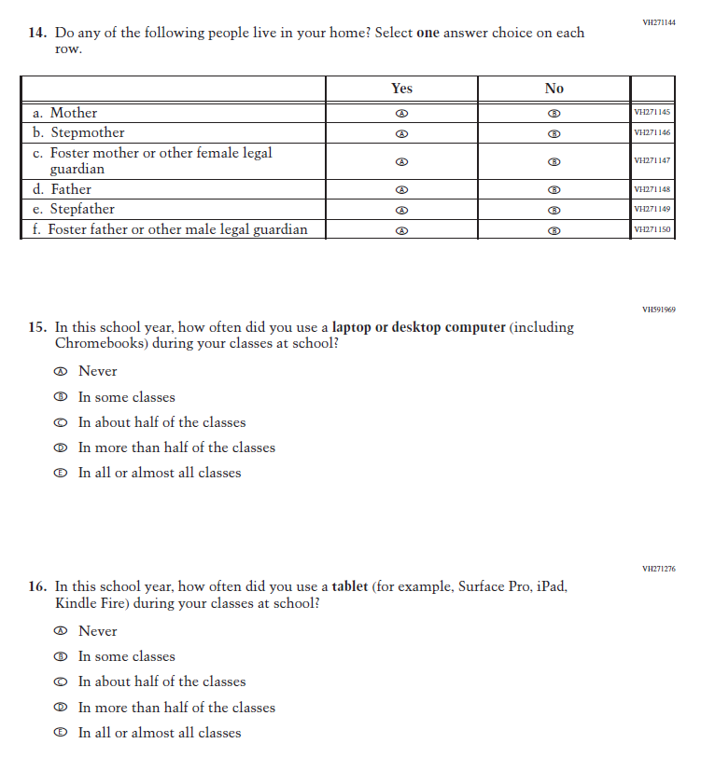
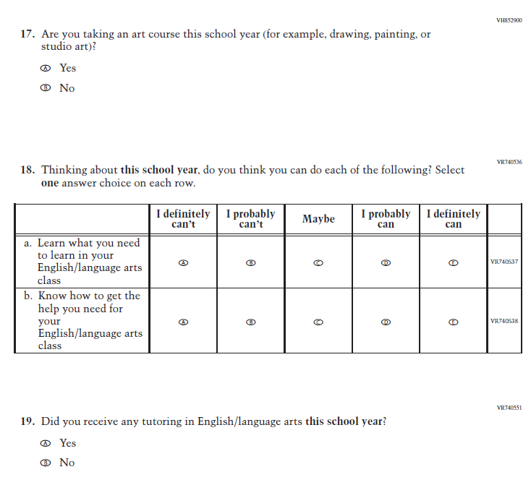
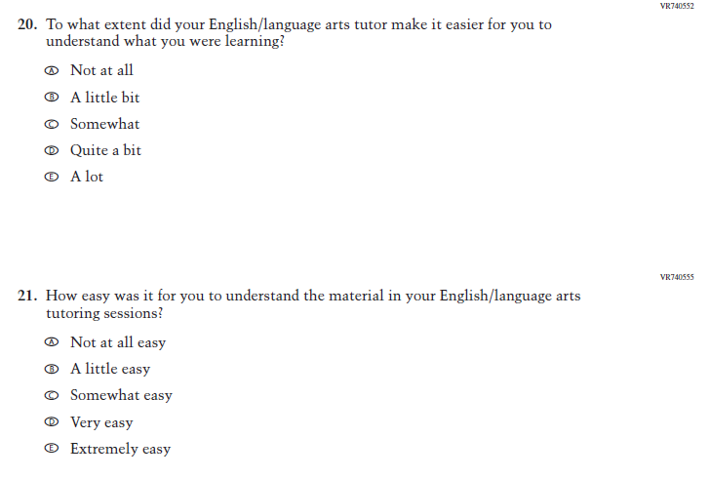
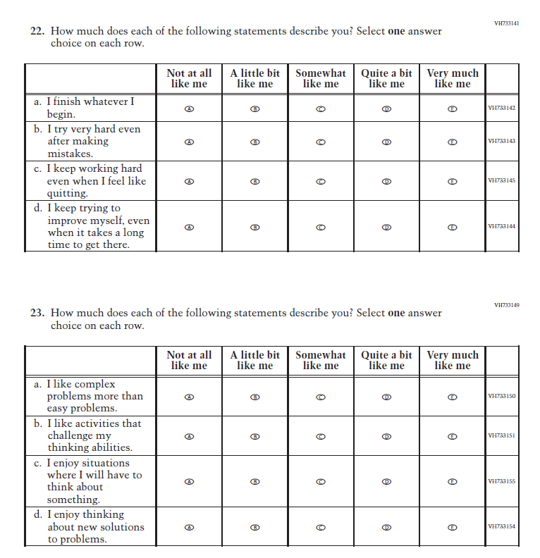
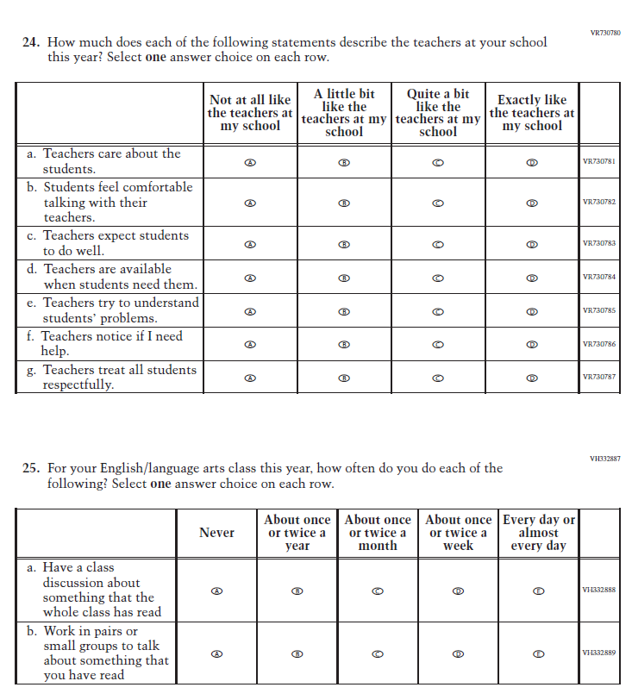
-

Appendix J1-9: Summary of Changes Operational Grade 12 (Core, Mathematics)
2024 Operational Grade 12 Core Mathematics Student
Previous Item | 2024 Item | D/A/ R+ | Rationale
(2022 Grades 4 and 8, 2019 Grade 12) | N/A  Issue: Grit | D | This Item was selected to be dropped to reduce burden due to the addition of the Learning Recovery Items.
N/A | Issue: Learning Recovery |  | This Item was added to address gaps in learning that have developed due to the extended period of remote and hybrid learning that took place during the pandemic.
N/a | Issue: Learning Recovery |  | This Item was added to address gaps in learning that have developed due to the extended period of remote and hybrid learning that took place during the pandemic.
N/A | Issue: Learning Recovery |  | This Item was added to address gaps in learning that have developed due to the extended period of remote and hybrid learning that took place during the pandemic.

N/A | Issue: Learning Recovery |  | This Item was added to address gaps in learning that have developed due to the extended period of remote and hybrid learning that took place during the pandemic.
N/A | Issue: Learning Recovery |  | This Item was added to address gaps in learning that have developed due to the extended period of remote and hybrid learning that took place during the pandemic.

Appendix J1-10: Operational Grade 12 (Core, Mathematics)
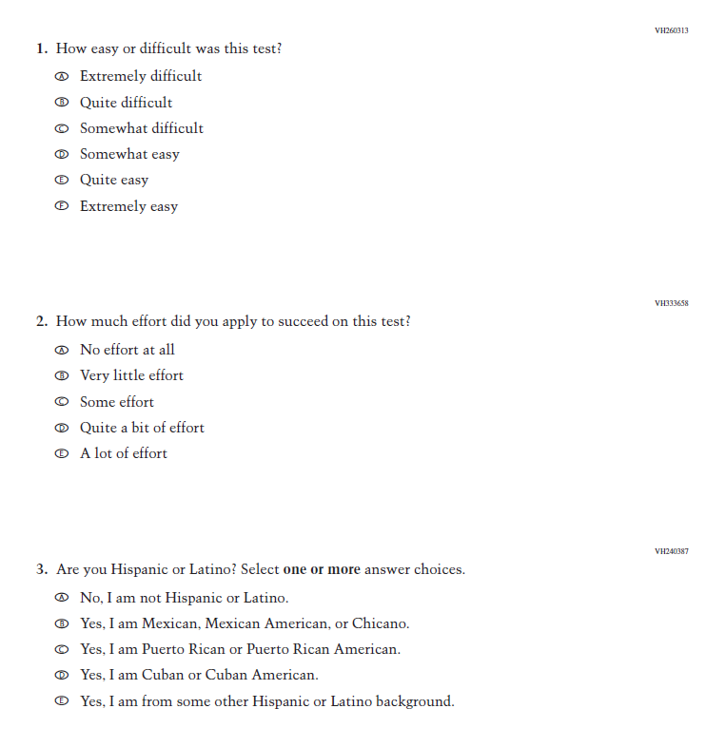
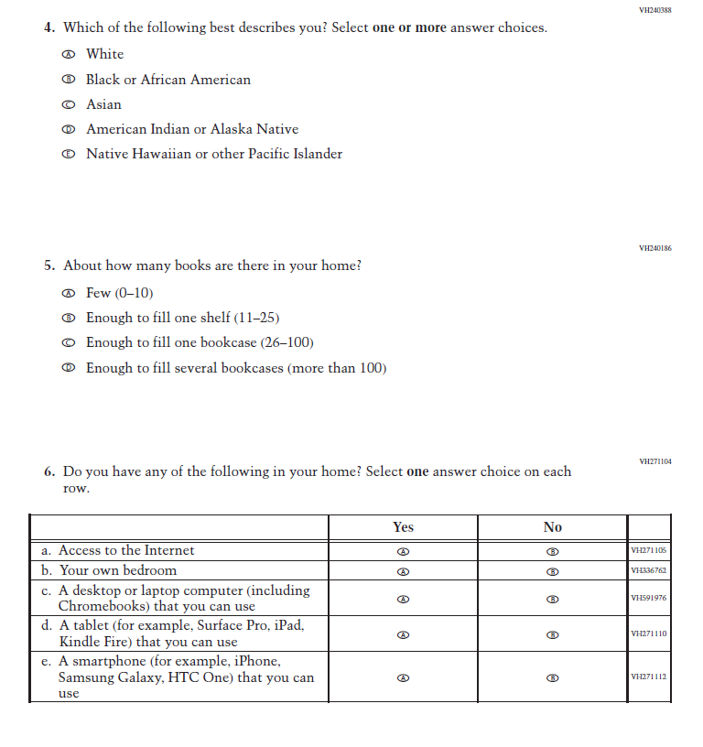
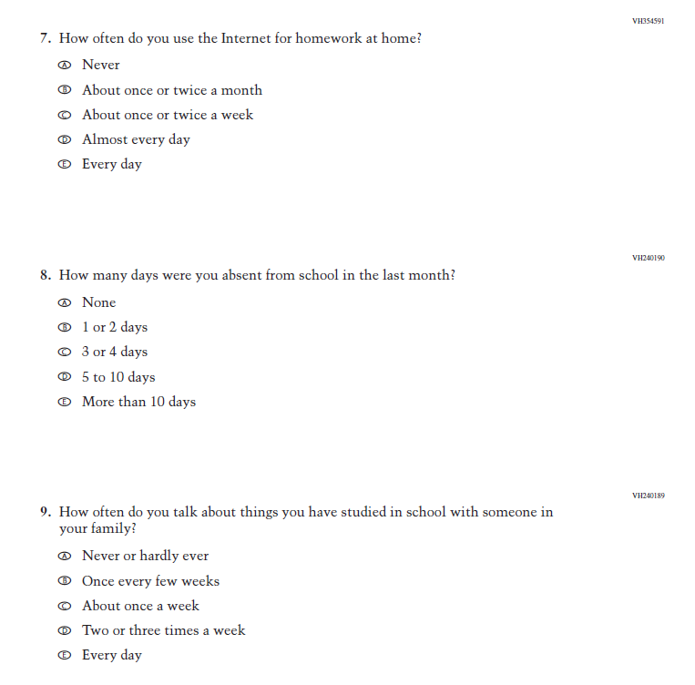
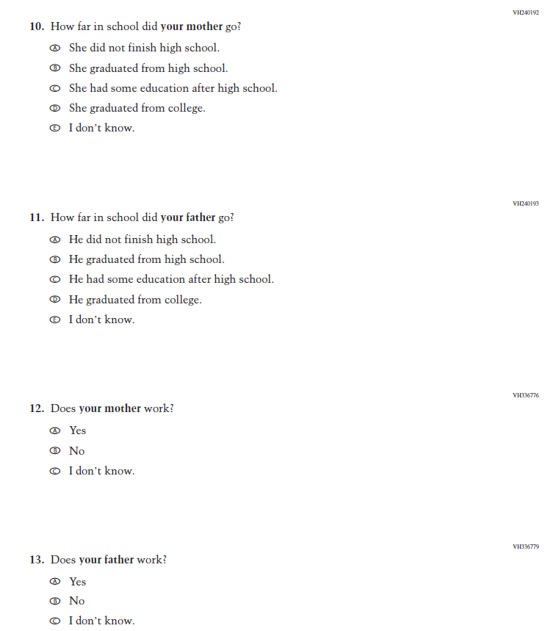
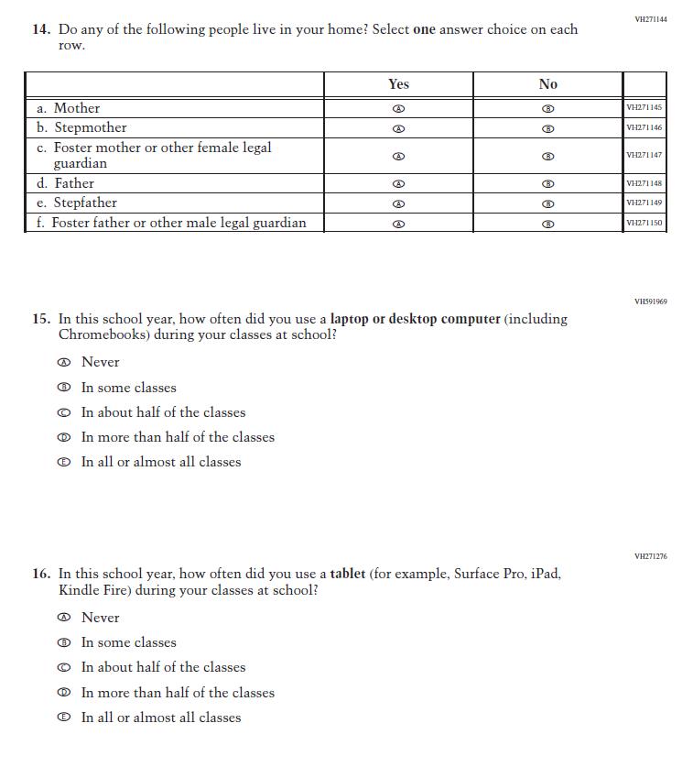
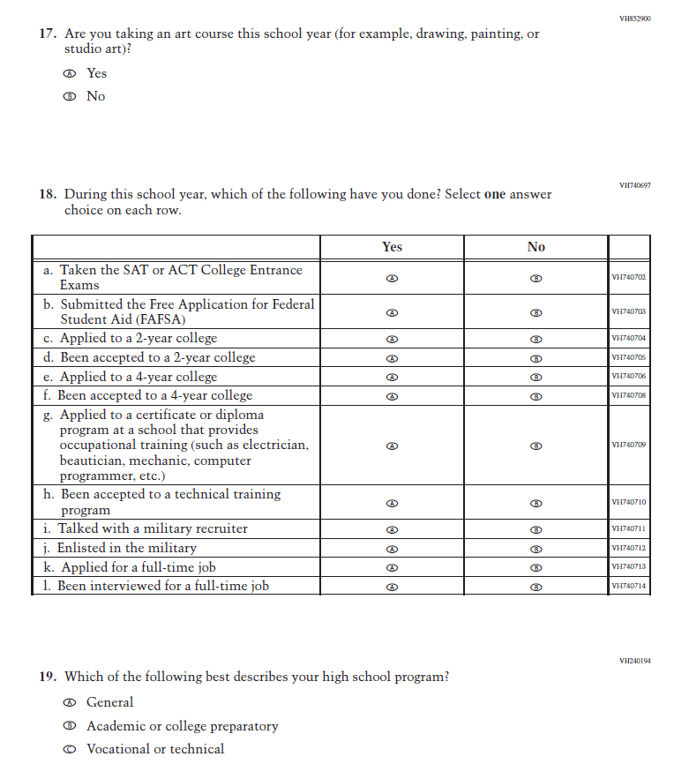
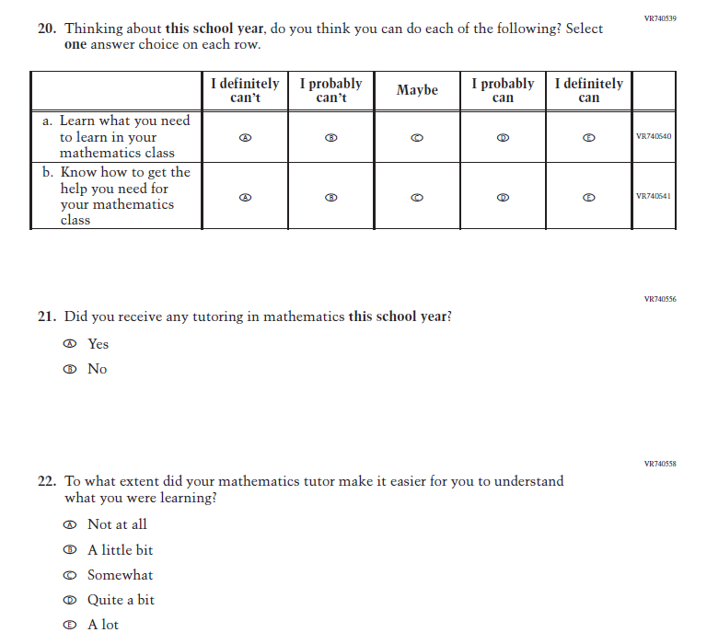
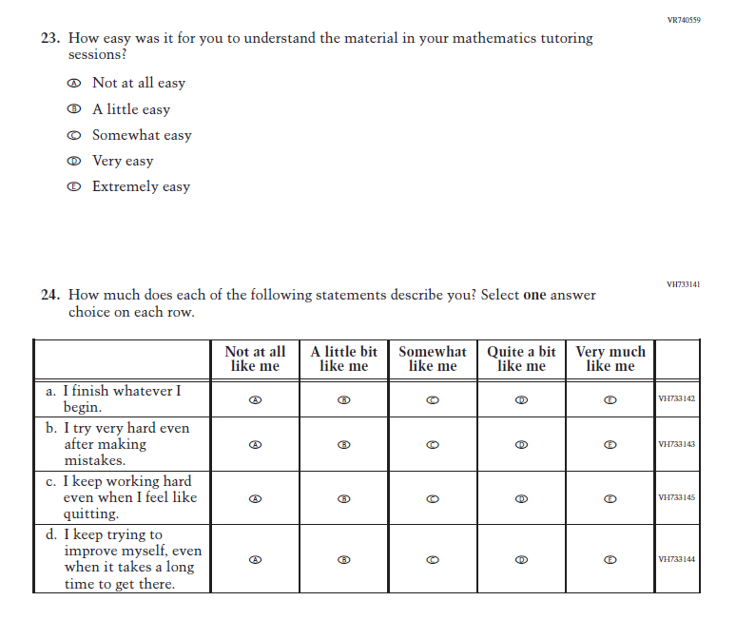
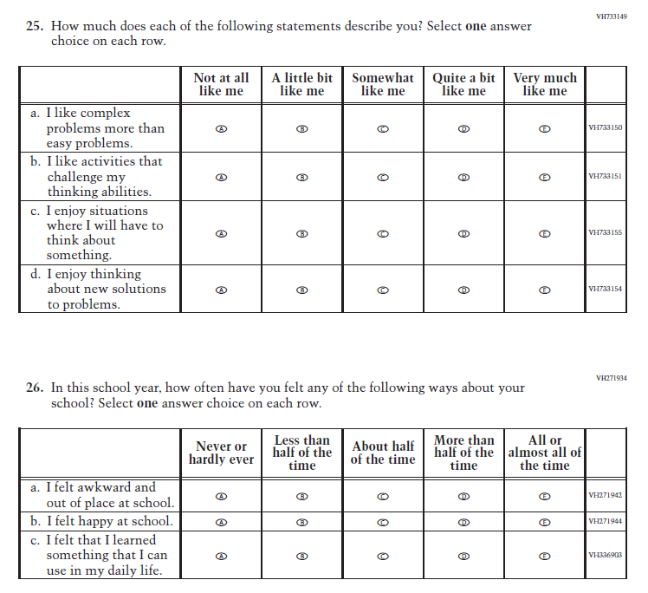
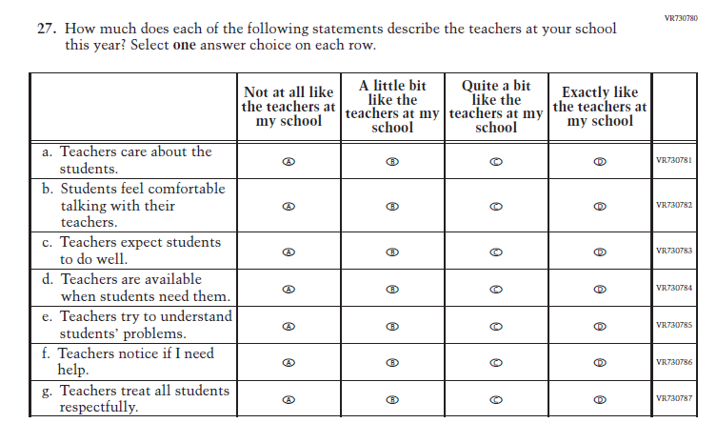

Appendix J1-11: Summary of Changes Operational Grade 12 (Core, Reading)

2024 Operational Grade 12 Core Reading Student
Previous Item | 2024 Item | D/A/ R+ | Rationale
(2022 Grades 4 and 8, 2019 Grade 12) | N/A  Issue: Grit | D | This Item was selected to be dropped to reduce burden due to the addition of the Learning Recovery Items.
N/A | Issue: Learning Recovery | A | This Item was added to address gaps in learning that have developed due to the extended period of remote and hybrid learning that took place during the pandemic.

N/A | Issue: Learning Recovery | A | This Item was added to address gaps in learning that have developed due to the extended period of remote and hybrid learning that took place during the pandemic.
N/A | Issue: Learning Recovery | A | This Item was added to address gaps in learning that have developed due to the extended period of remote and hybrid learning that took place during the pandemic.

N/A | Issue: Learning Recovery | A | This Item was added to address gaps in learning that have developed due to the extended period of remote and hybrid learning that took place during the pandemic.
N/A | Issue: Learning Recovery | A | This Item was added to address gaps in learning that have developed due to the extended period of remote and hybrid learning that took place during the pandemic.

Appendix J1-12: Operational Grade 12 (Core, Reading)
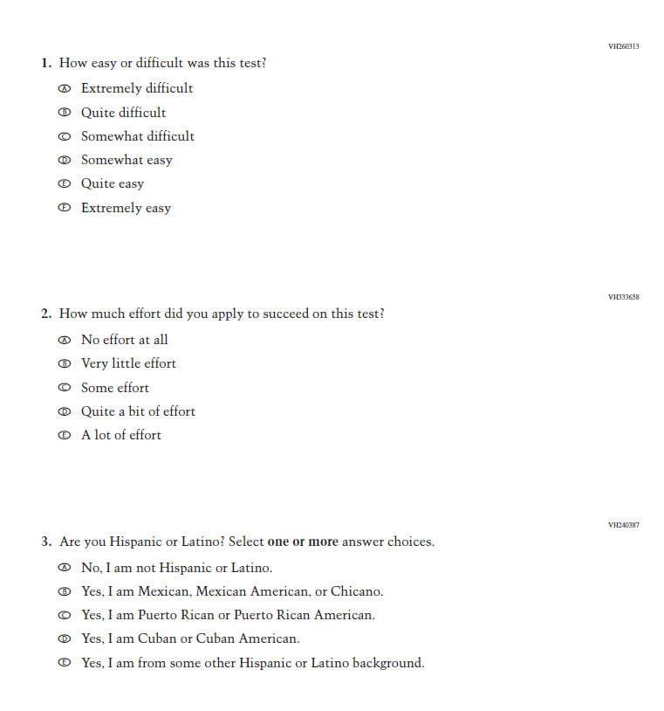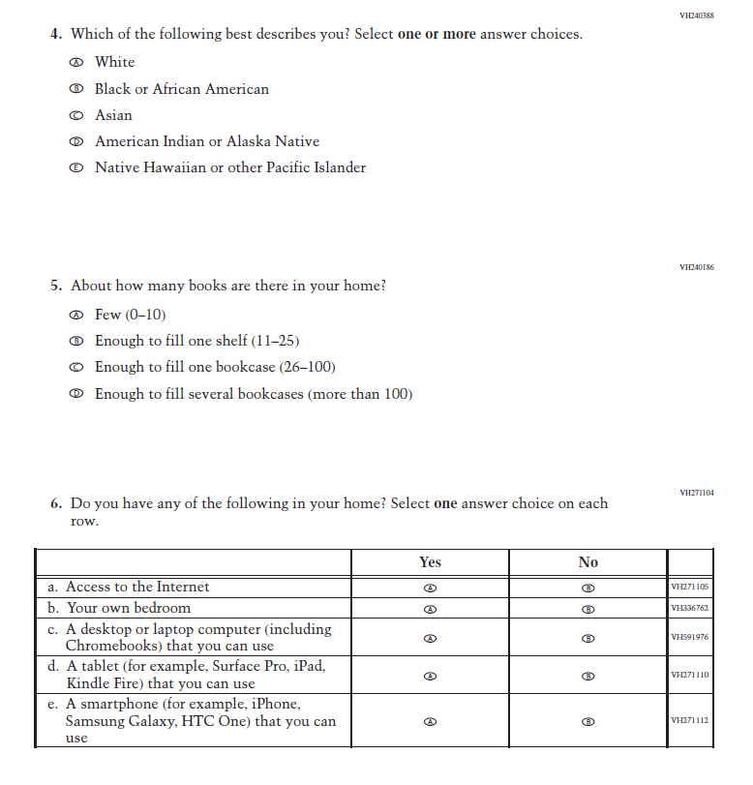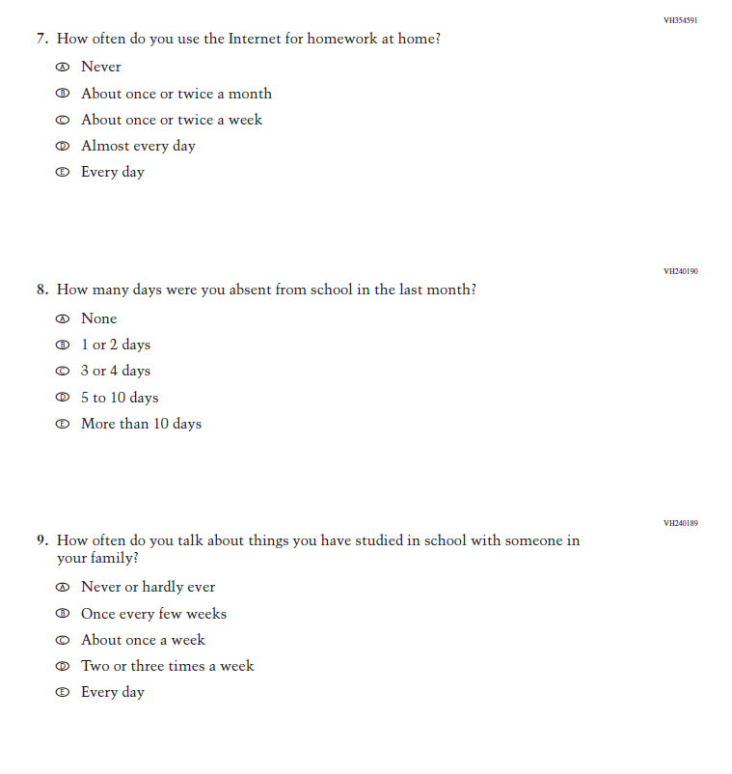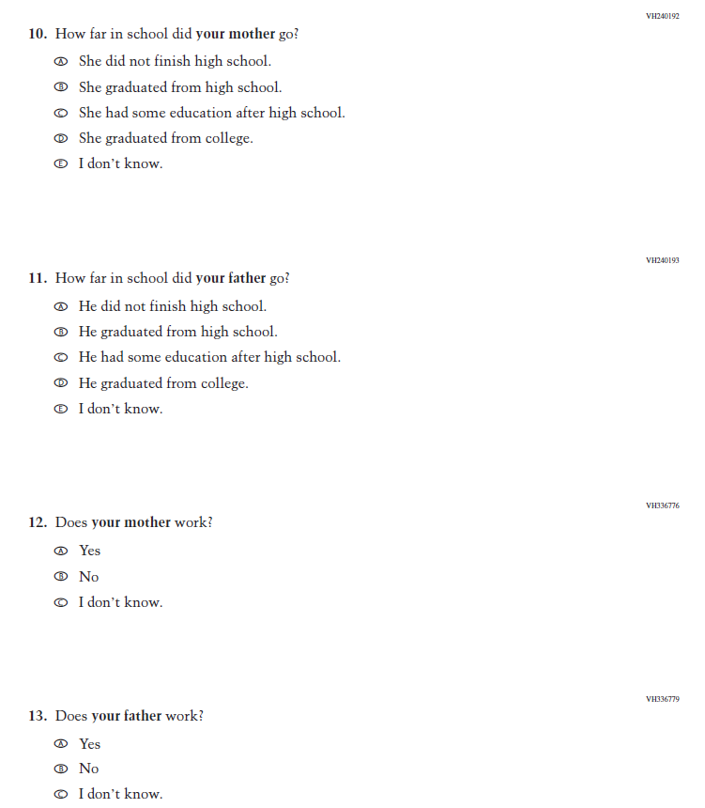
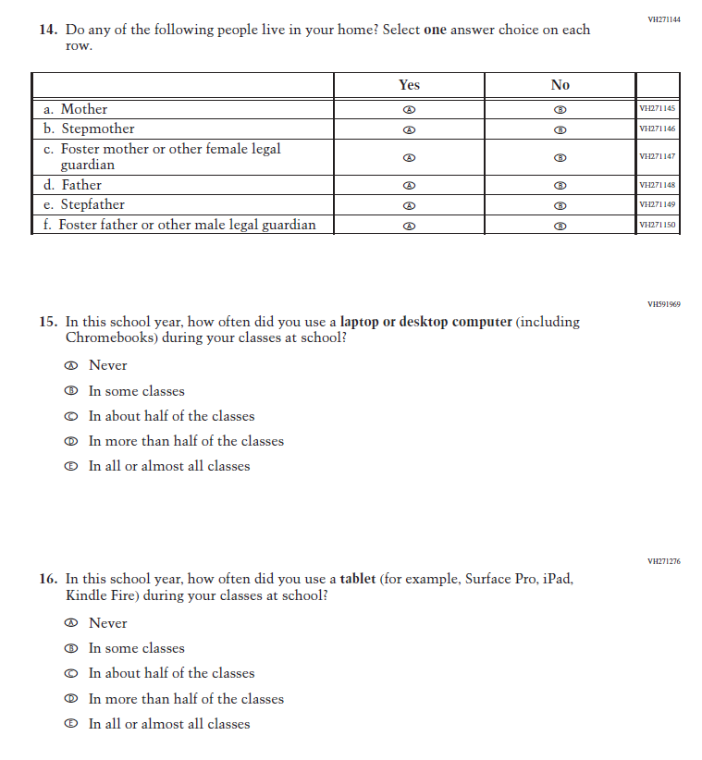
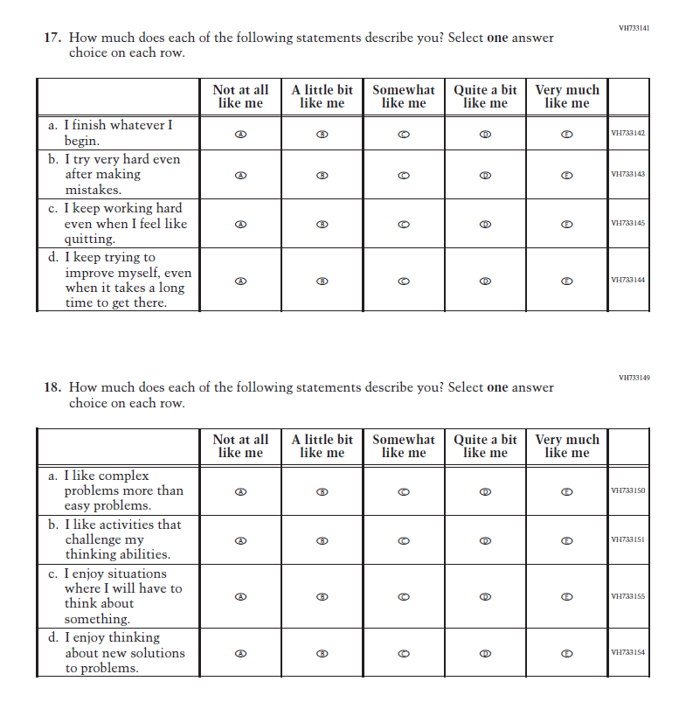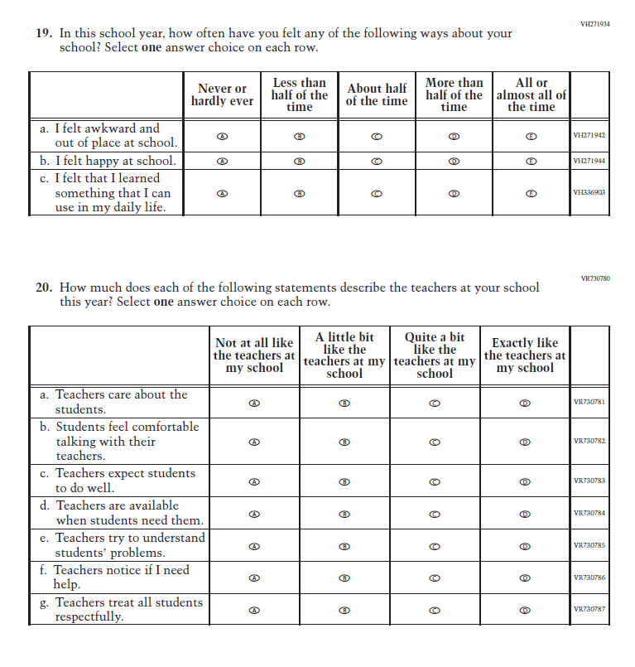
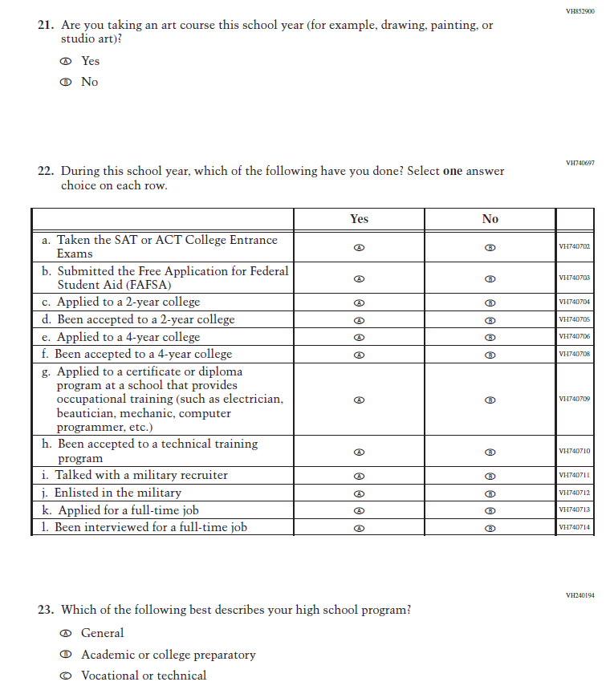
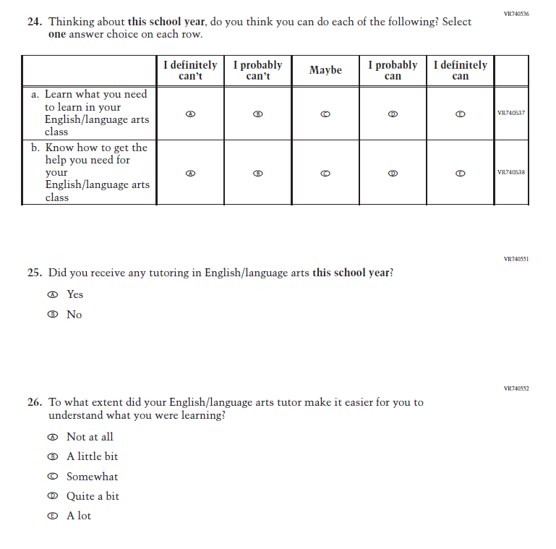
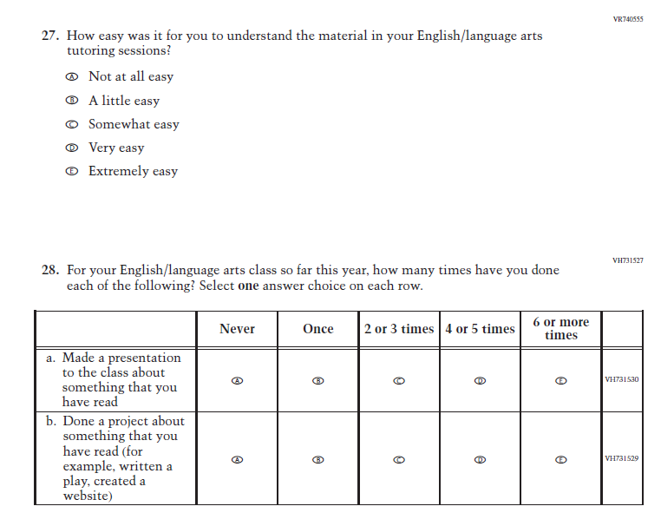

Appendix J1-13: Summary of Changes Operational Grade 4 (Mathematics)

2024 Operational Grade 4 Mathematics Student
Previous Item | 2024 Item | D/A/ R+ | Rationale
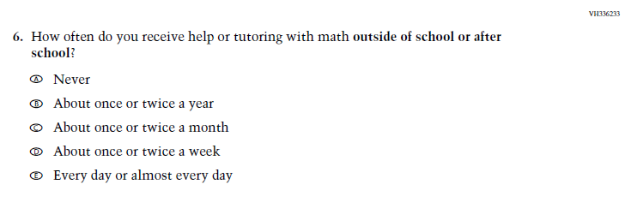  (2022 Grade 4) | N/A  Issue: Resources for Learning and Instruction | D | This Item was selected to be dropped to reduce burden due to the addition of the Learning Recovery Items.

Appendix J1-14: Operational Grade 4 (Mathematics)
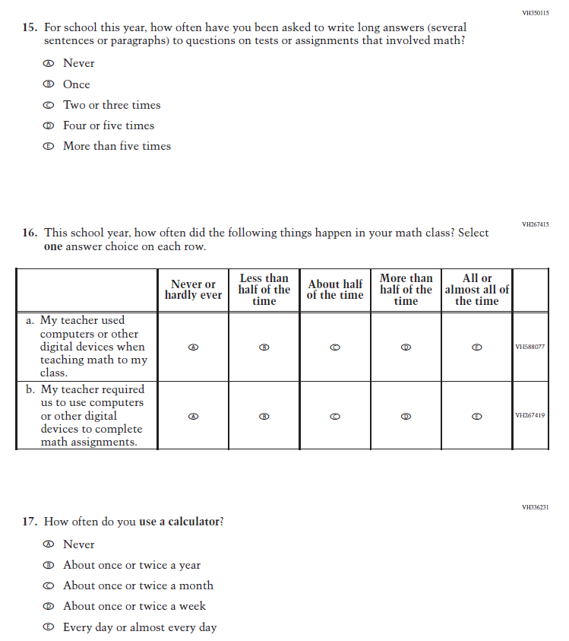
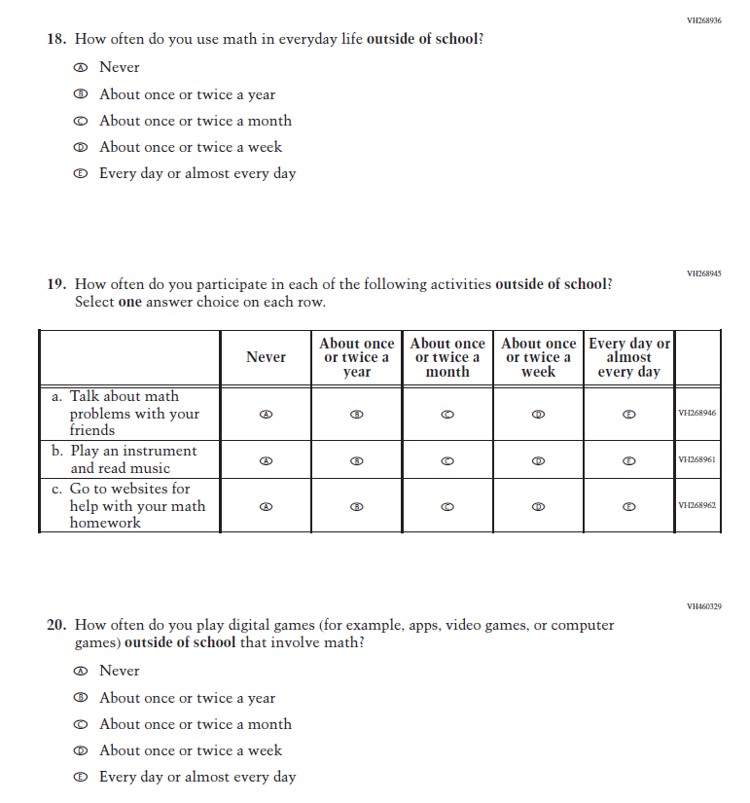
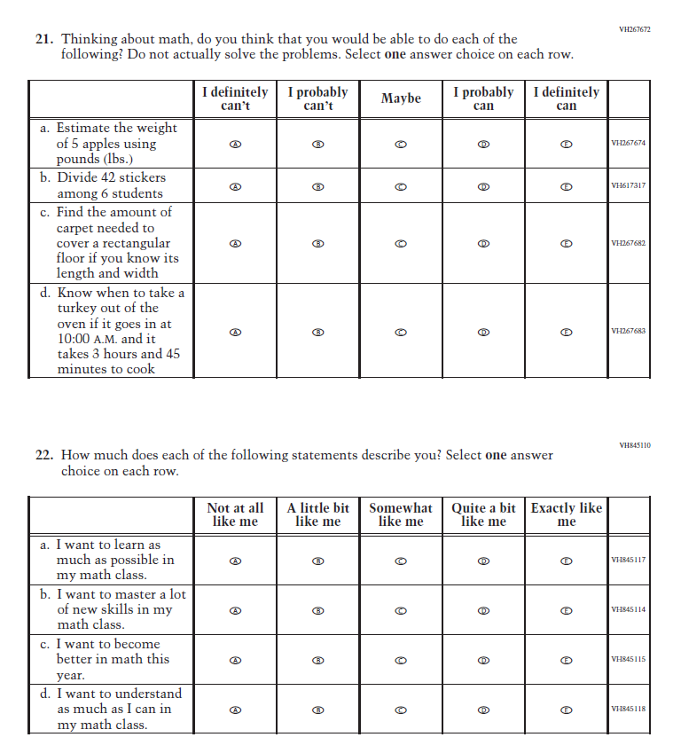
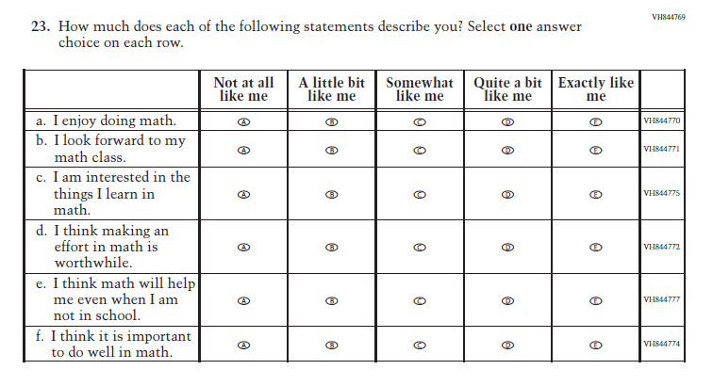

Appendix J1-15: Summary of Changes Operational Grade 8 (Mathematics)
2024 Operational Grade 8 Mathematics Student
Previous Item | 2024 Item | D/A/ R+ | Rationale
(2022 Grade 8) | N/A  Issue: Resources for Learning and Instruction | D | This Item was selected to be dropped to reduce burden due to the addition of the Learning Recovery Items.
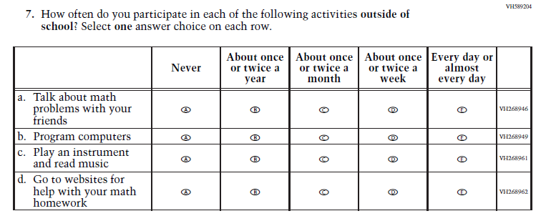  (2022 Grade 8) | 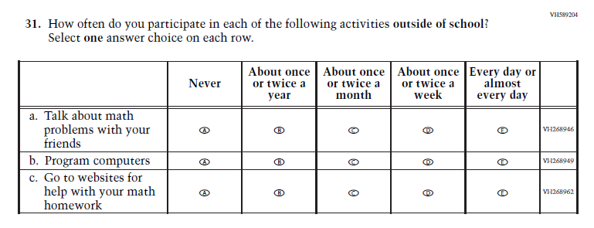  Issue: Resources for Learning and Instruction | R | This Item was selected to be revised to reduce burden due to the addition of the Learning Recovery Items.
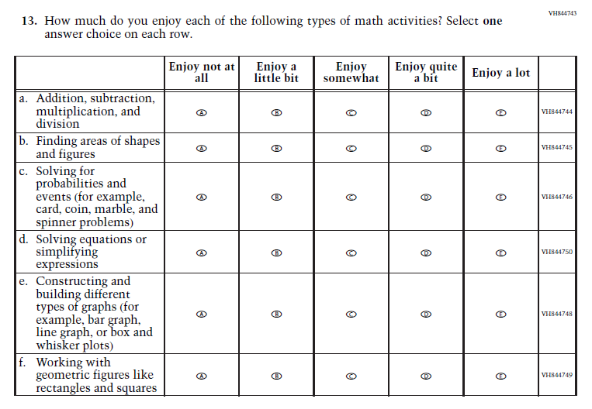  (2022 Grade 8) | N/A  Issue: Student Factors | D | This Item was selected to be dropped to reduce burden due to the addition of the Learning Recovery Items.

Appendix J1-16: Operational Grade 8 (Mathematics)

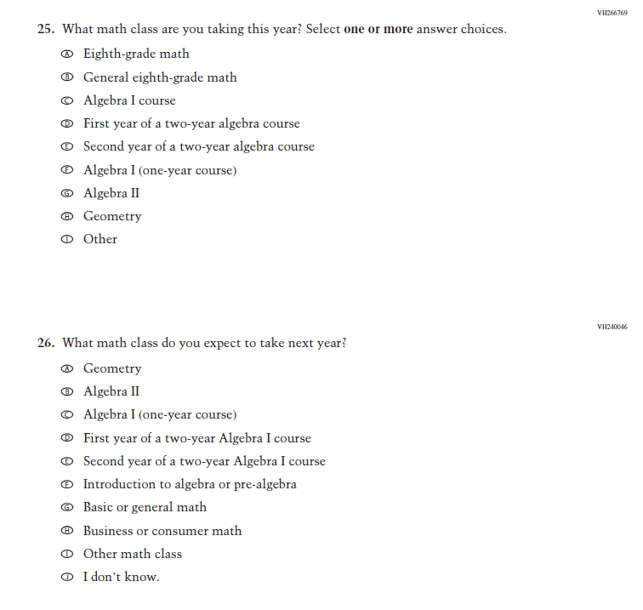
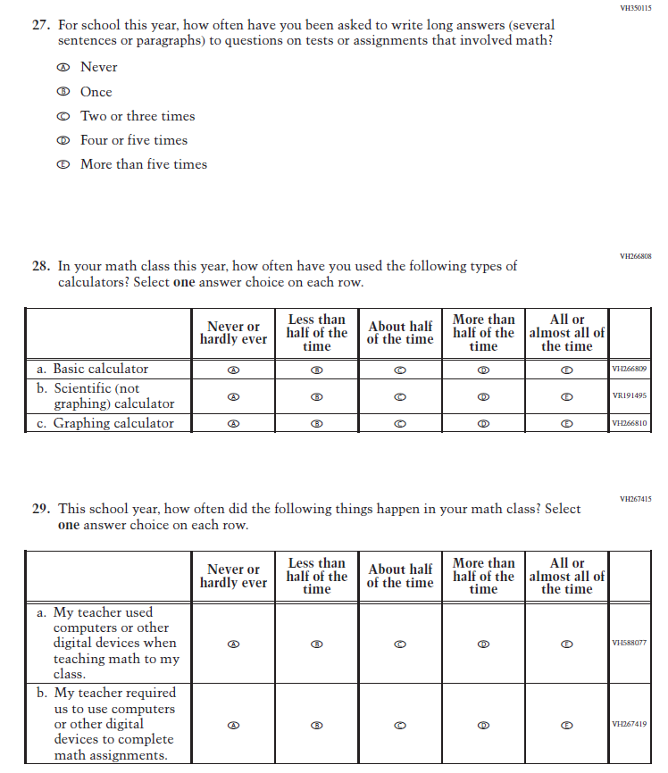
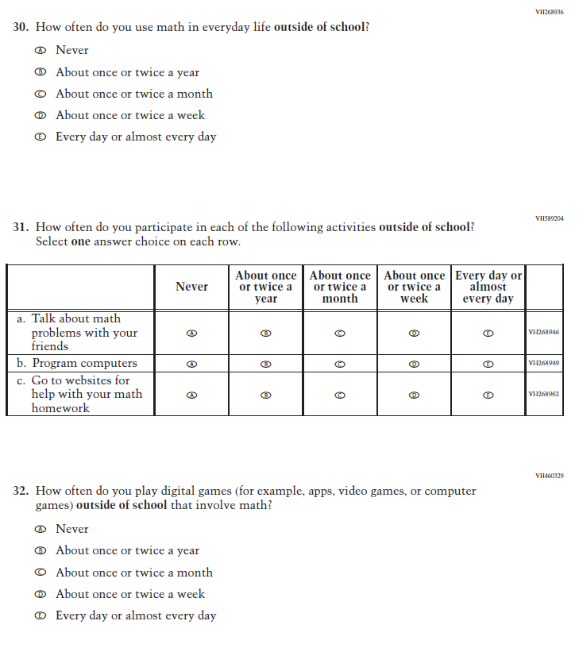
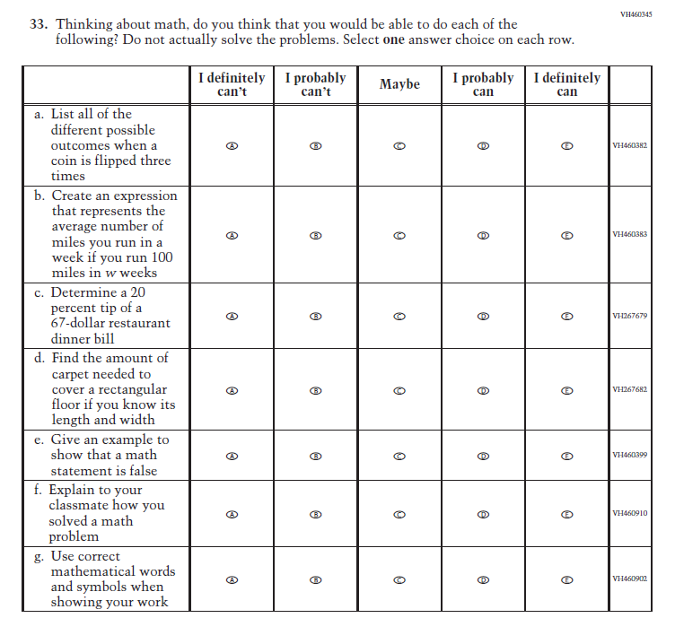
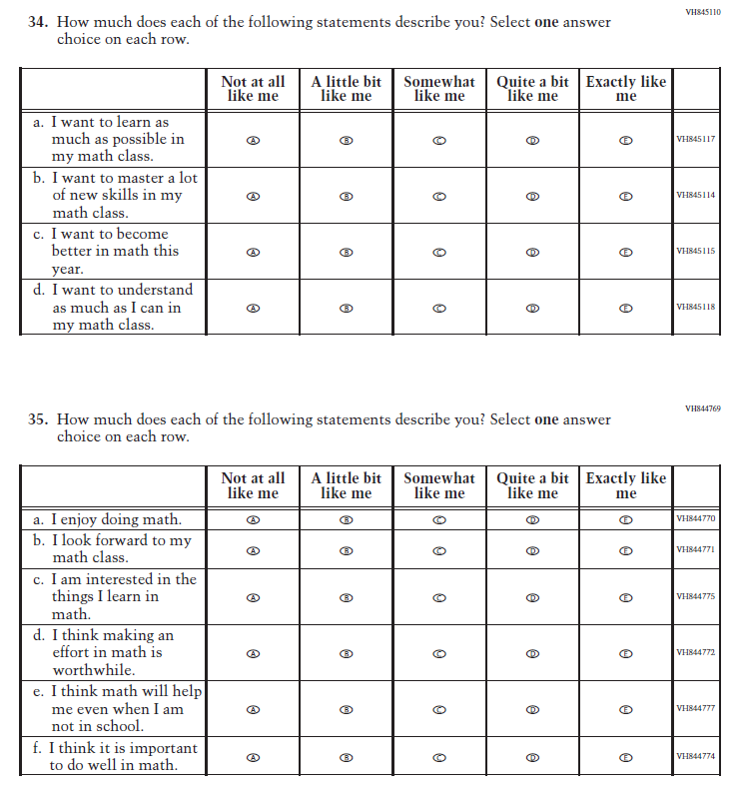

Appendix J1-17: Summary of Changes Operational Grade 12 (Mathematics)
2024 Operational Grade 12 Mathematics Student
Previous Item | 2024 Item | D/A/ R+ | Rationale
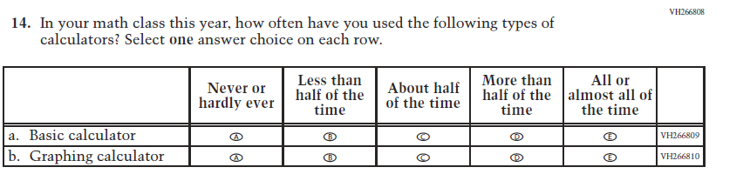  (2019 Grade 12) | 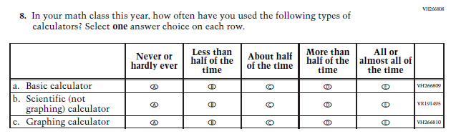  Issue: Resources for Learning and Instruction | R | SubItem “b.” added to match the Grade 8 Item that was administered in 2022.
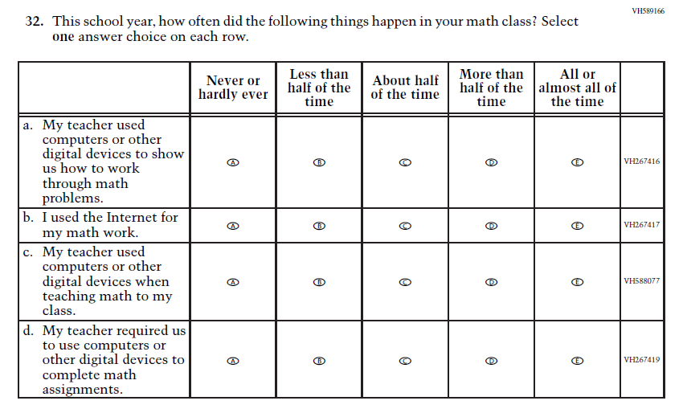  (2019 Grade 12) | N/A  Issue: Resources for Learning and Instruction | D | Due to the addition of the Learning Recovery Items, and to further reduce the expected response time at Grade 12, this Item was selected to be dropped.
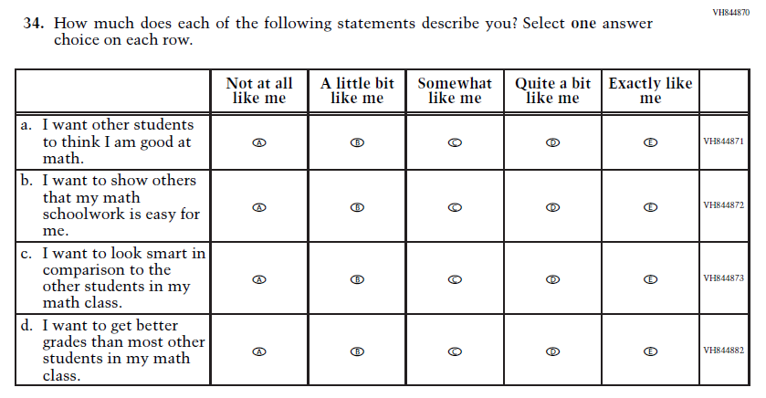  (2019 Grade 12) | N/A  Issue: Student Factors | D | Due to the addition of the Learning Recovery Items, and to further reduce the expected response time at Grade 12, this Item was selected to be dropped.
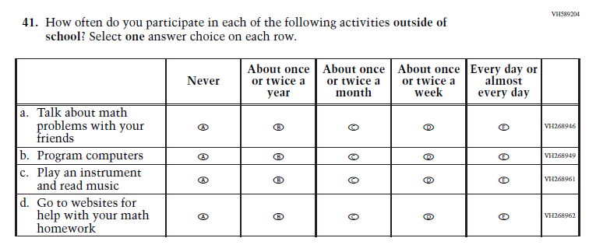  (2019 Grade 12) | 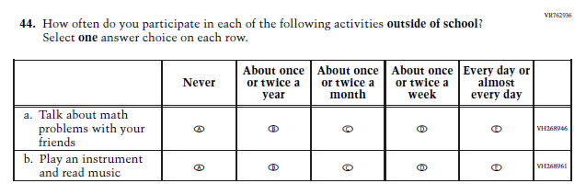  Issue: Resources for Learning and Instruction | R | Due to the addition of the Learning Recovery Items, and to further reduce the expected response time at Grade 12, this Item was revised.
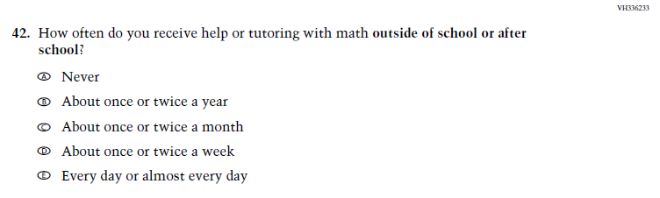  (2019 Grade 12) | N/A  Issue: Resources for Learning and Instruction | D | Due to the addition of the Learning Recovery Items, and to further reduce the expected response time at Grade 12, this Item was selected to be dropped.

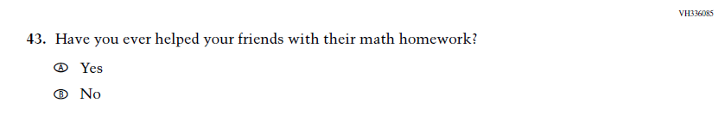  (2019 Grade 12) | N/A  Issue: Outside of School Learning | D | Due to the addition of the Learning Recovery Items, and to further reduce the expected response time at Grade 12, this Item was selected to be dropped.
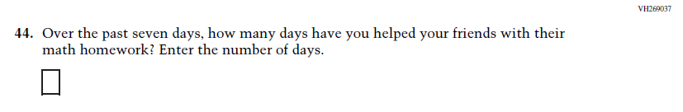  (2019 Grade 12) | N/A  Issue: Student Factors | D | Due to the addition of the Learning Recovery Items, and to further reduce the expected response time at Grade 12, this Item was selected to be dropped.

Appendix J1-18: Operational Grade 12 (Mathematics)
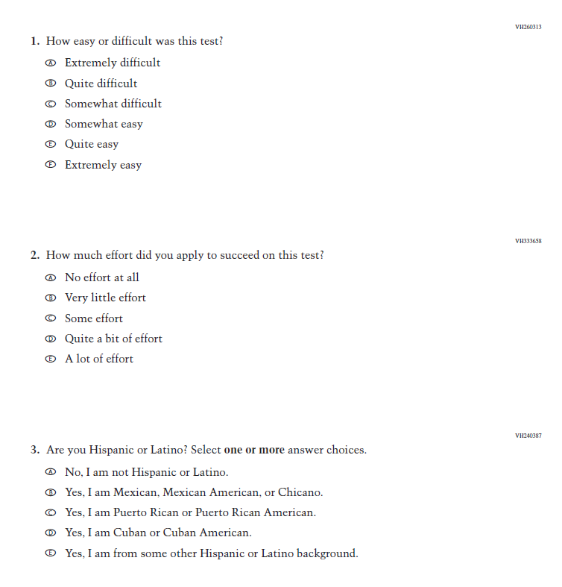
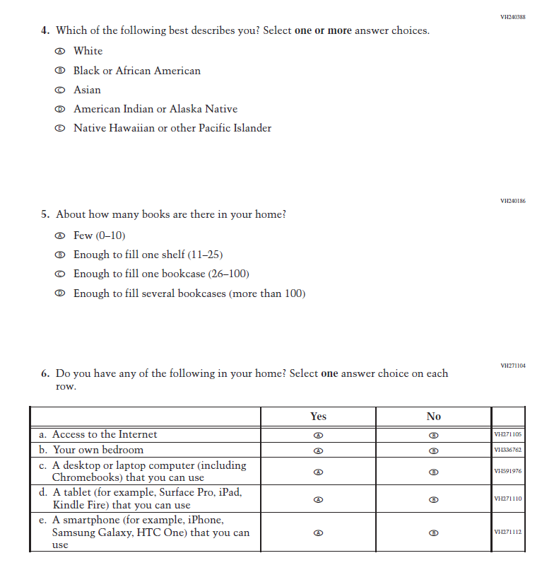
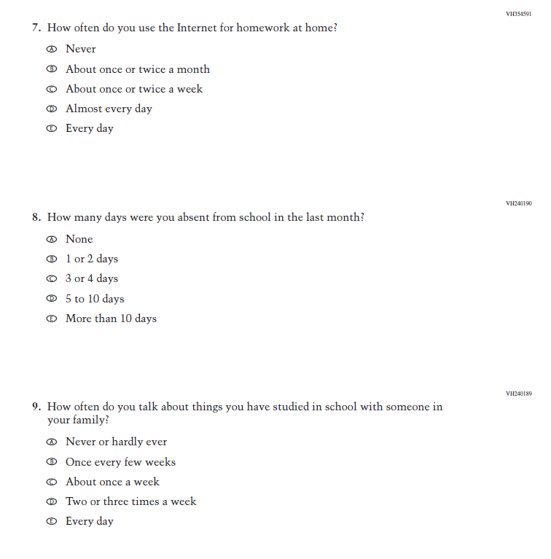
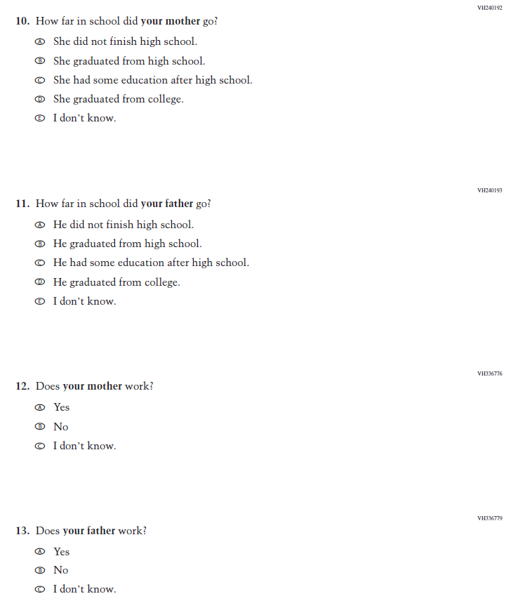
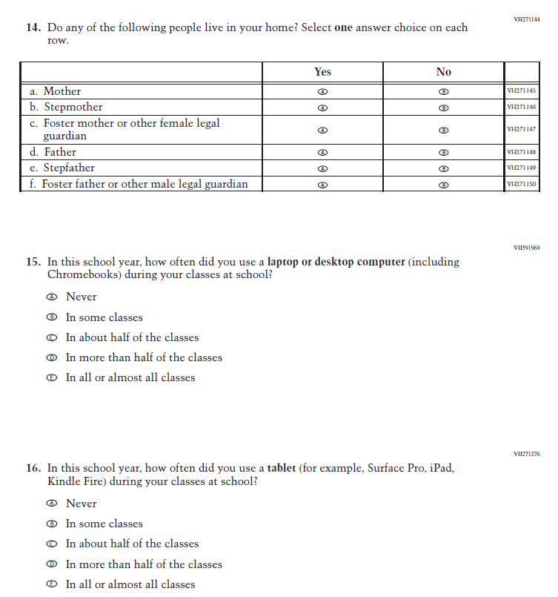
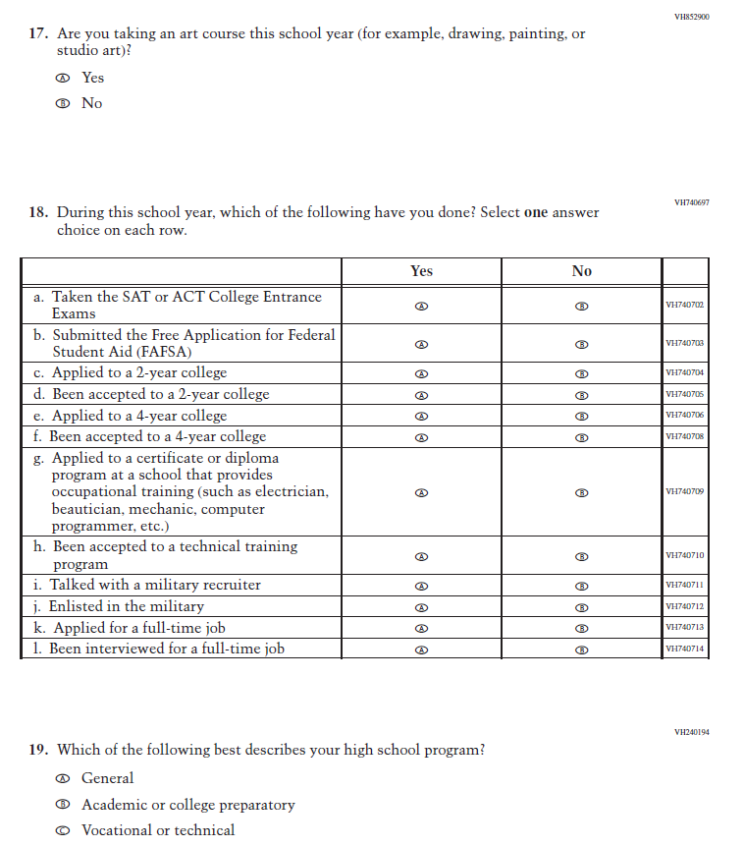
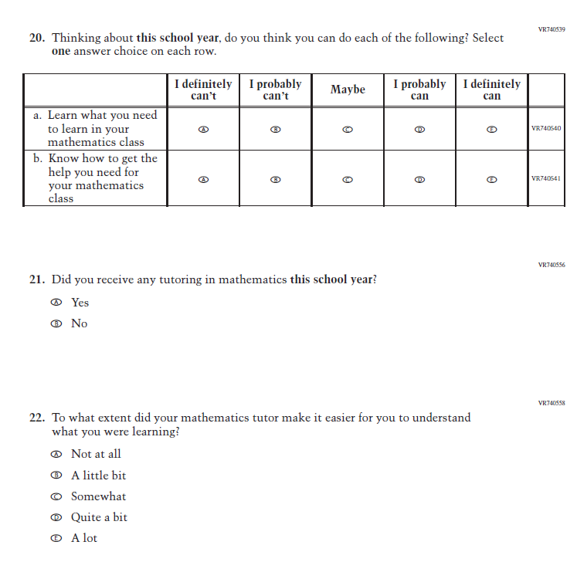
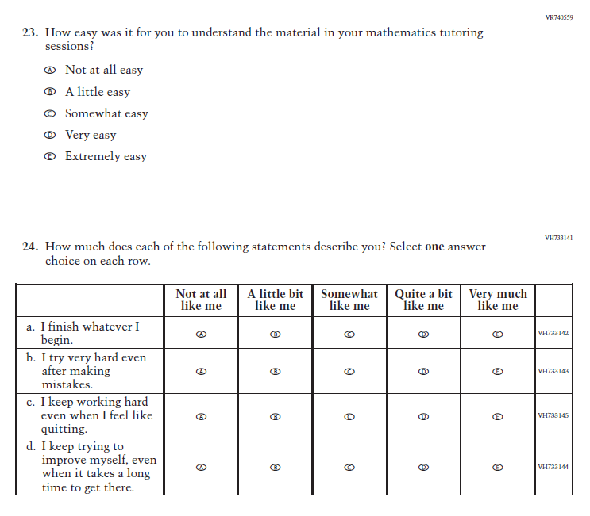
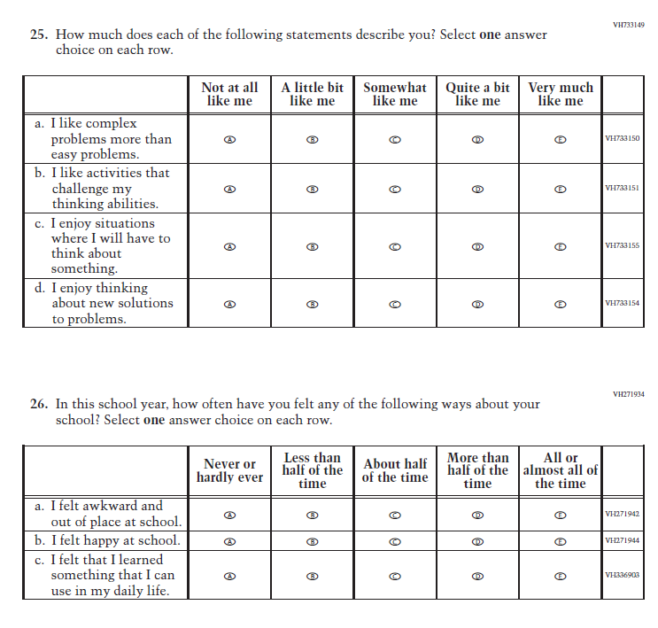
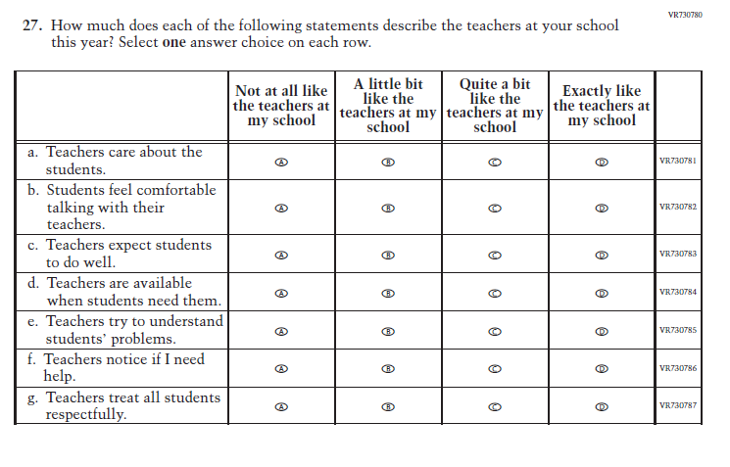
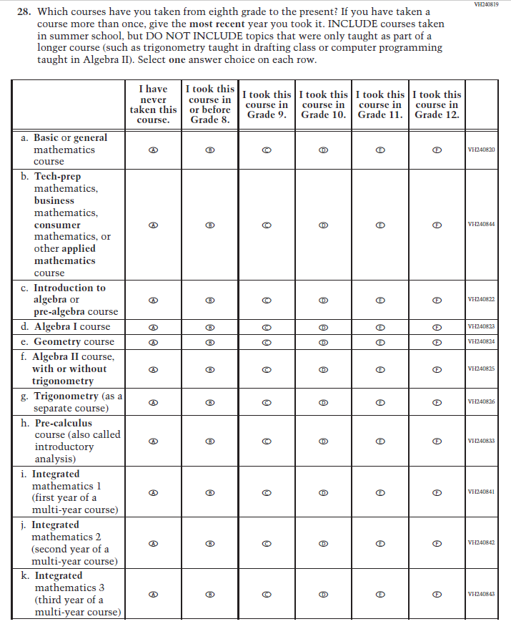
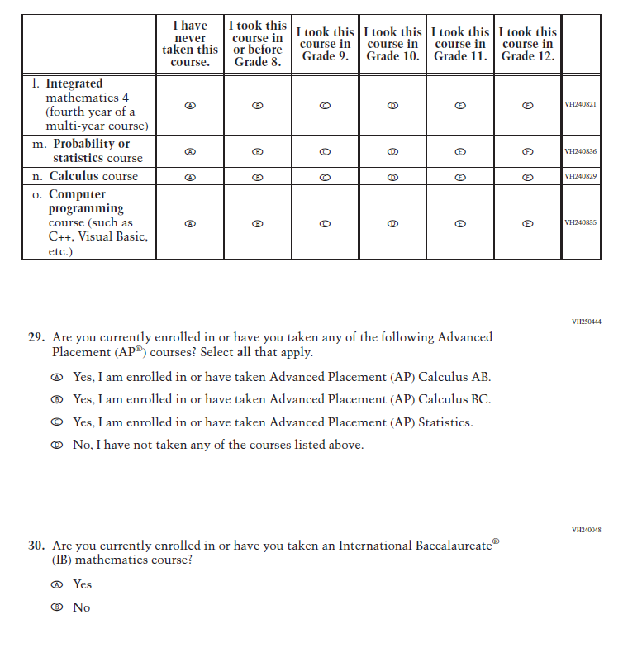
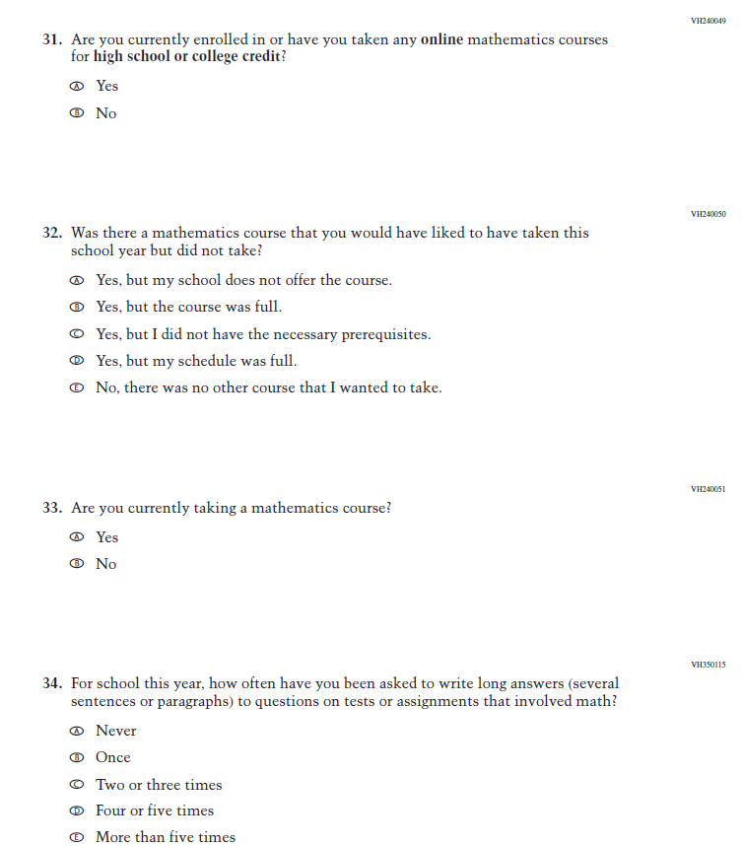
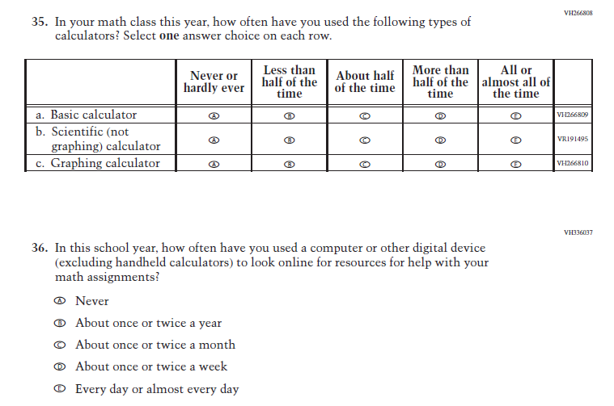
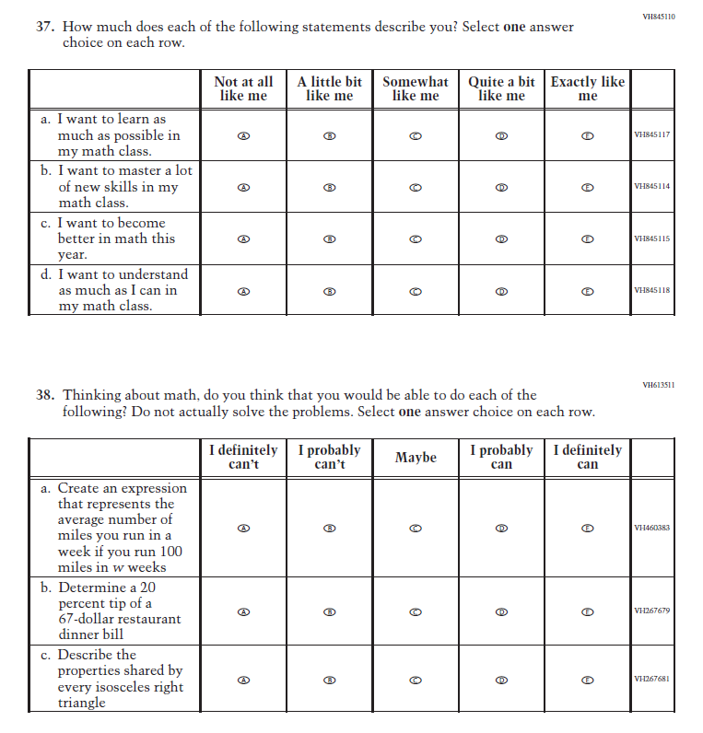
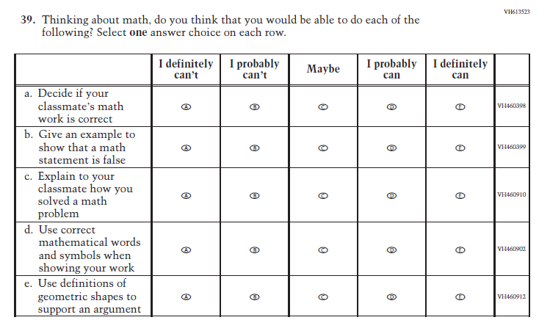
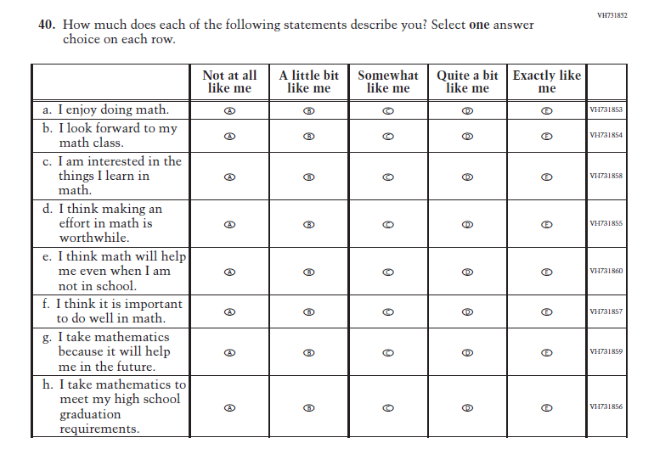
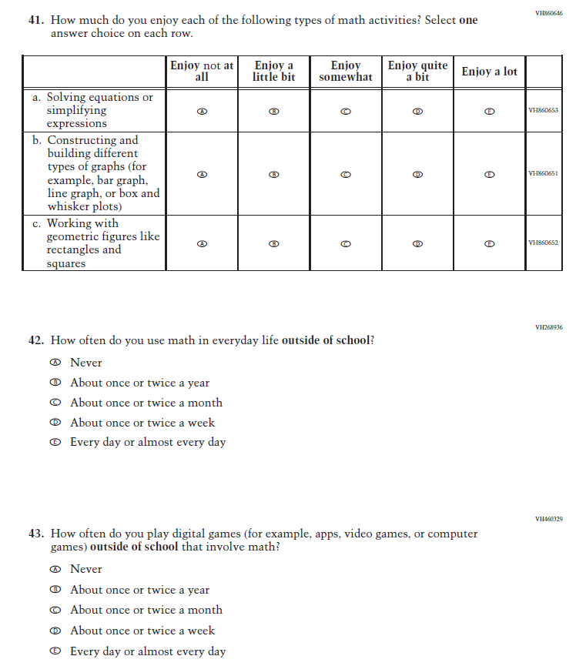
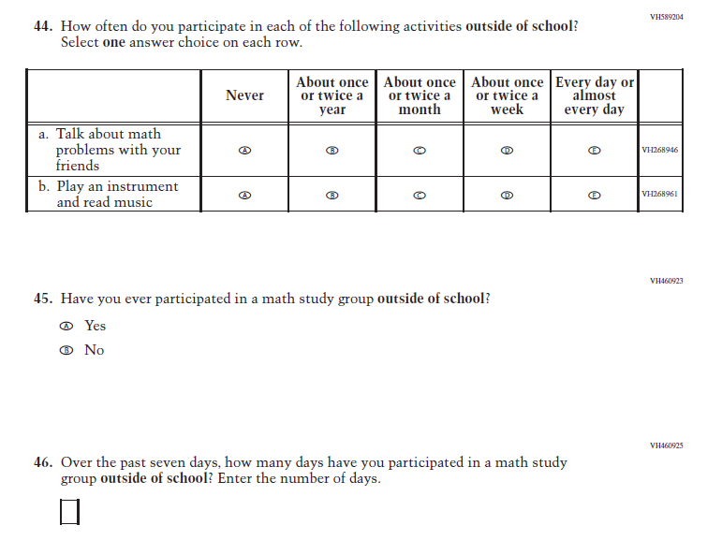

Appendix J1-19: Summary of Changes Operational Grade 4 (Reading)
2024 Operational Grade 4 Reading Student
Previous Item | 2024 Item | D/A/ R+ | Rationale
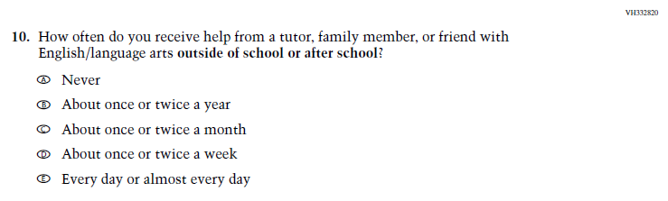  (2022 Grade 4) | N/A  Issue: Resources for Learning and Instruction | D | This Item was selected to be dropped to reduce burden due to the addition of the Learning Recovery Items.

Appendix J1-20: Operational Grade 4 (Reading)
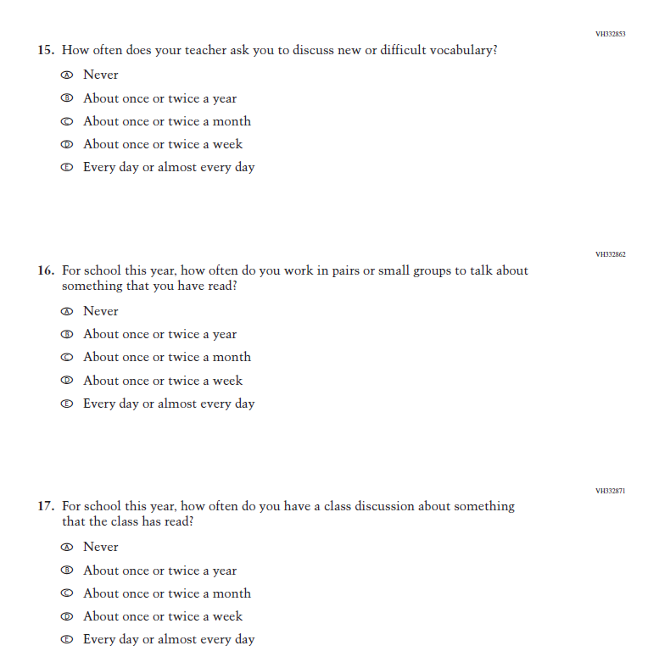
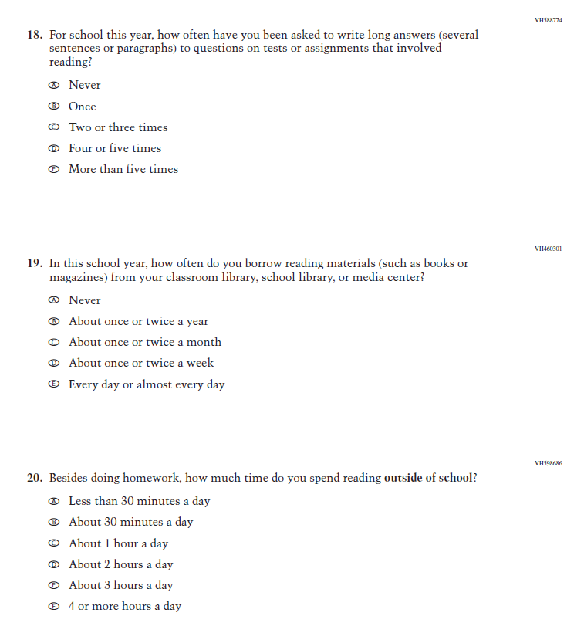
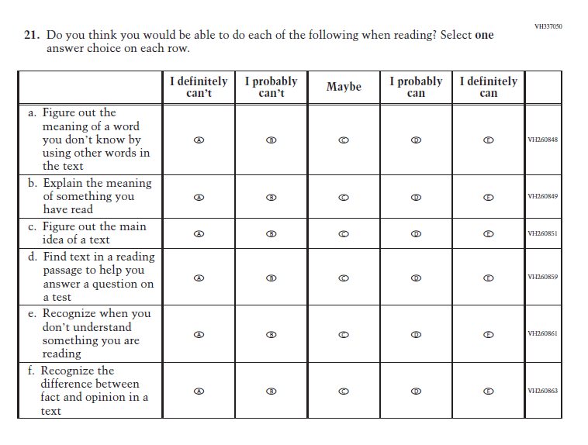
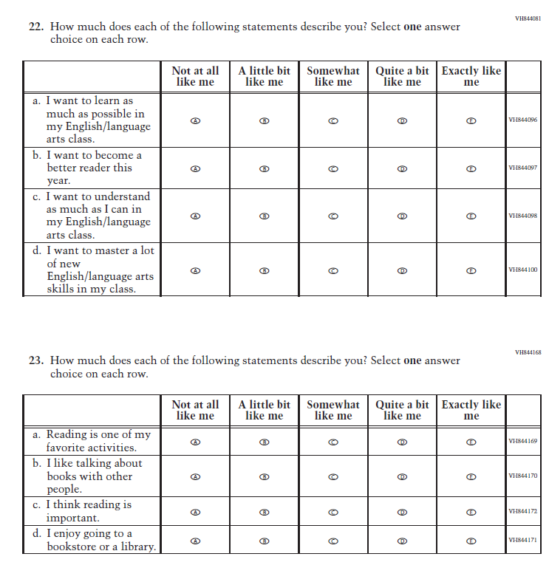
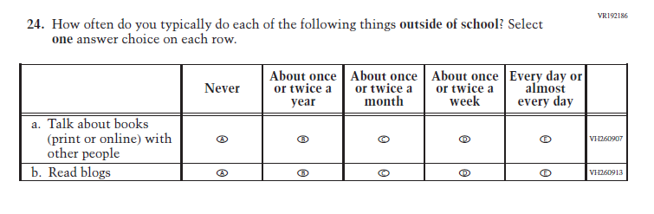

Appendix J1-21: Summary of Changes Operational Grade 8 (Reading)
2024 Operational Grade 8 Reading Student
Previous Item | 2024 Item | D/A/ R+ | Rationale
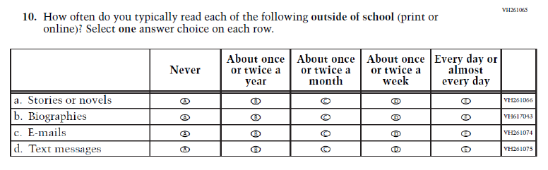  (2022 Grade 8) | N/A  Issue: Student Factors | D | This Item was selected to be dropped to reduce burden due to the addition of the Learning Recovery Items.
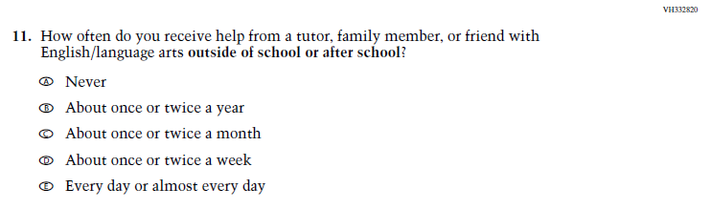  (2022 Grade 8) | N/A  Issue: Resources for Learning and Instruction | D | This Item was selected to be dropped to reduce burden due to the addition of the Learning Recovery Items.
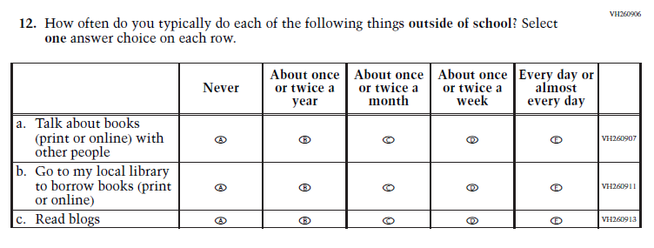  (2022 Grade 8) | N/A  Issue: Student Factors | D | This Item was selected to be dropped to reduce burden due to the addition of the Learning Recovery Items.

Appendix J1-22: Operational Grade 8 (Reading)
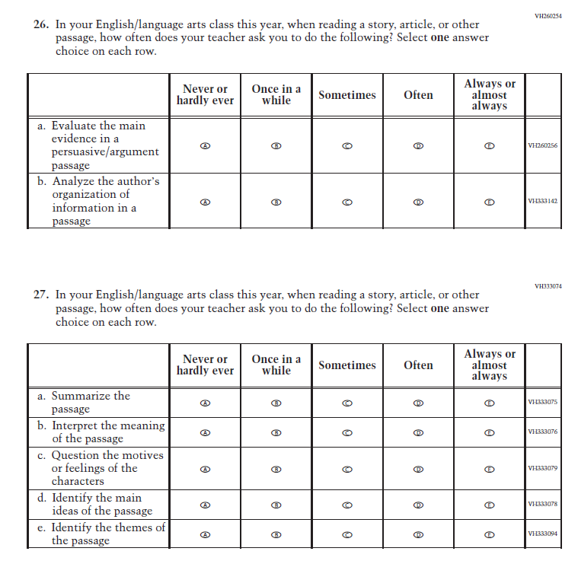
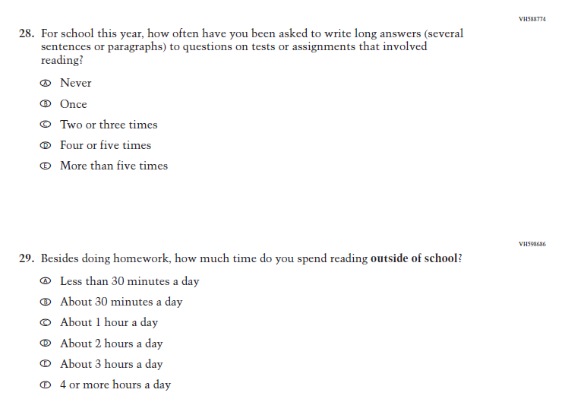
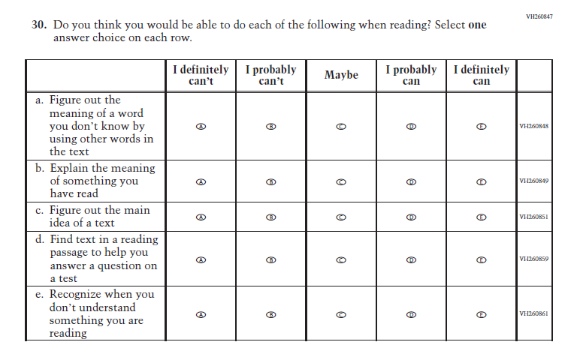
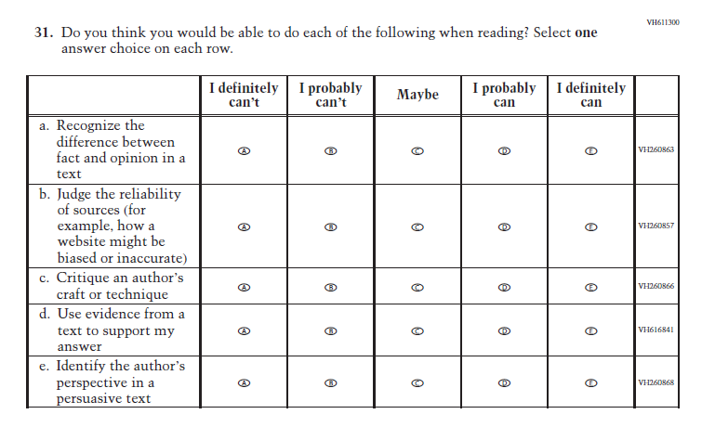
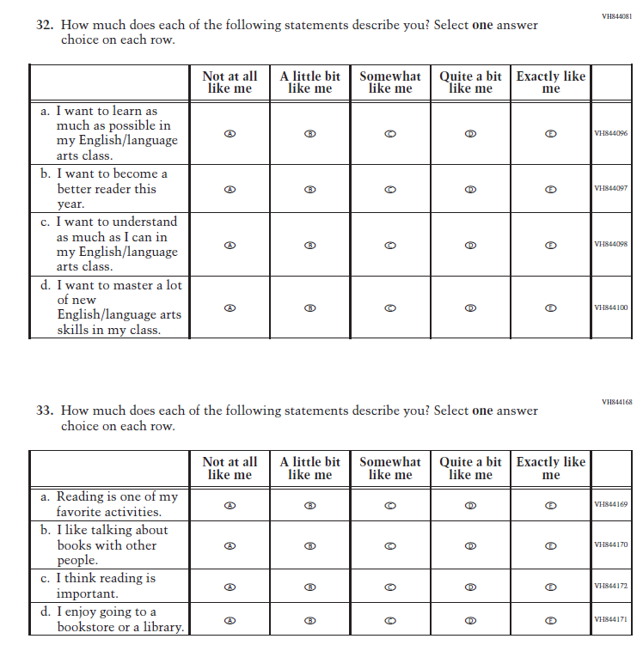

Appendix J1-23: Summary of Changes Operational Grade 12 (Reading)

2024 Operational Grade 12 Reading Student
Previous Item | 2024 Item | D/A/ R+ | Rationale
(2022 Grade 12) | N/A  Issue: Resources for Learning and Instruction | D | This Item was selected to be dropped to reduce burden due to the addition of the Learning Recovery Items.

Appendix J1-24: Operational Grade 12 (Reading)

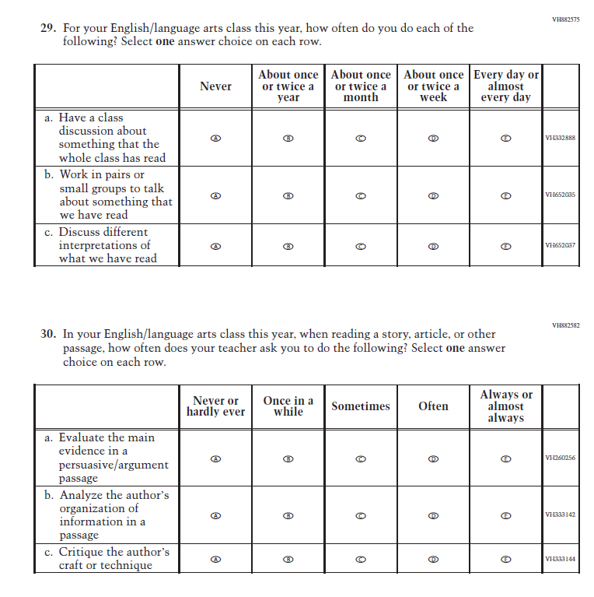
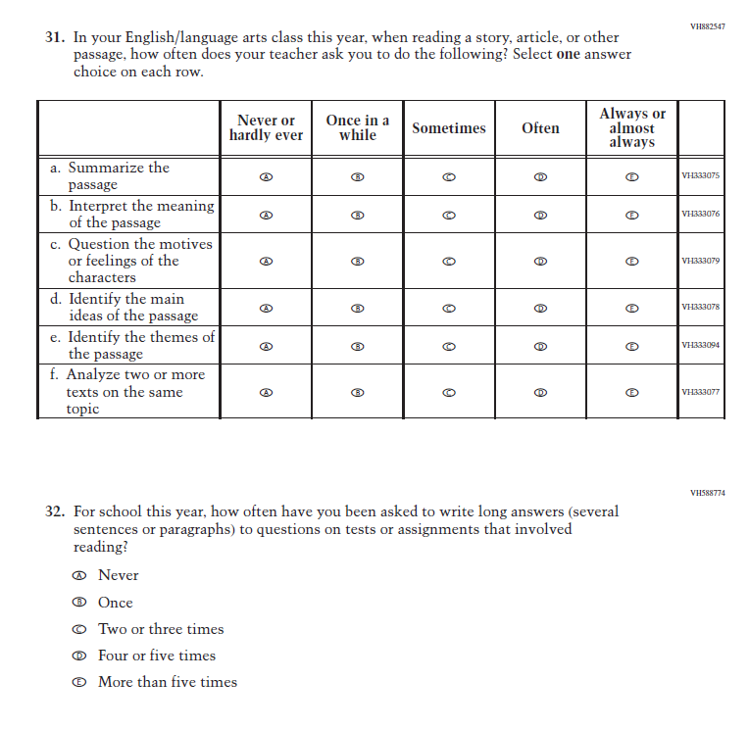
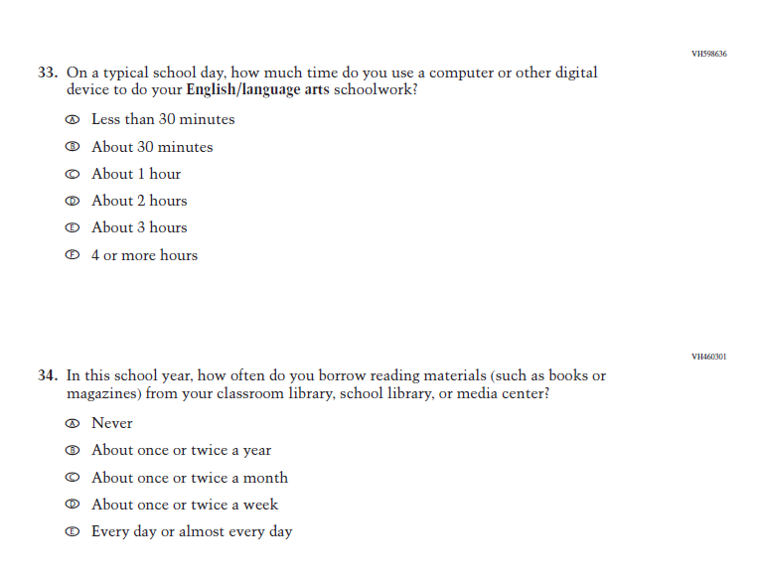
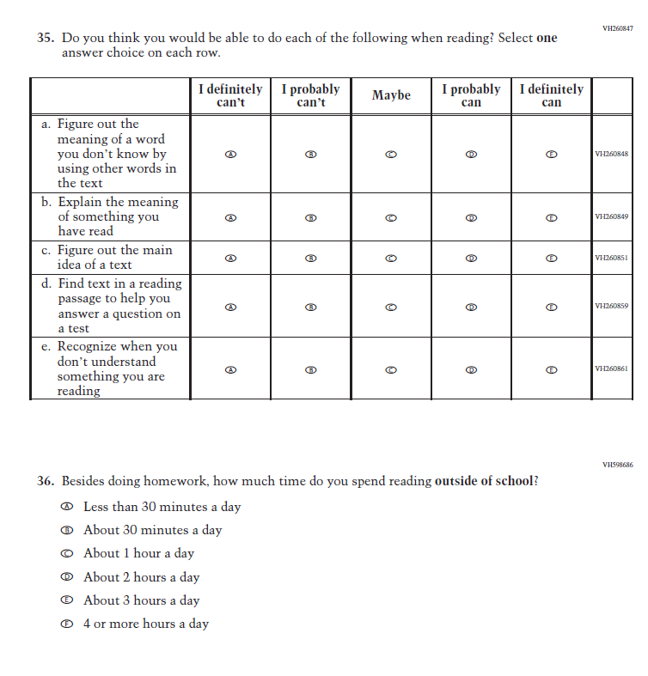
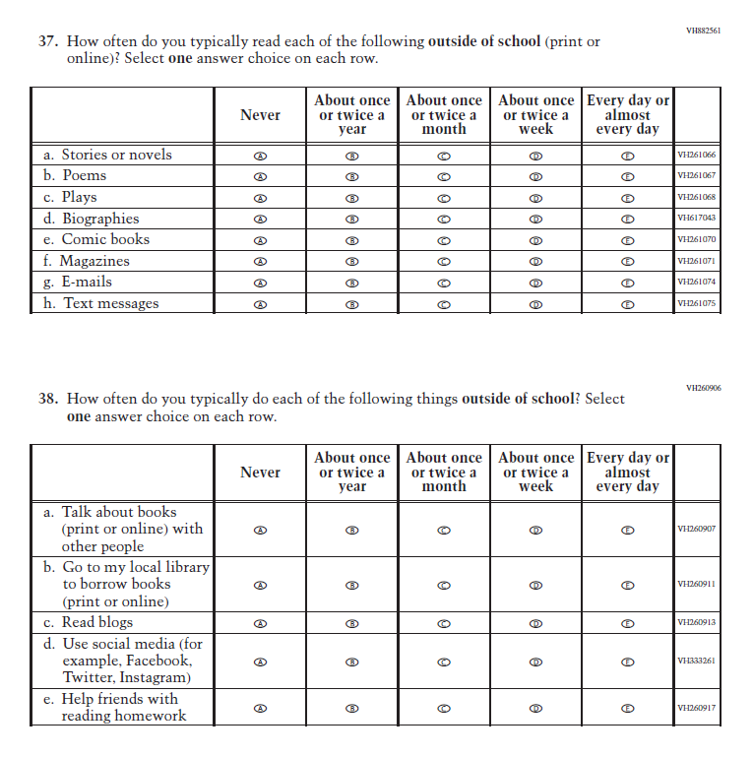
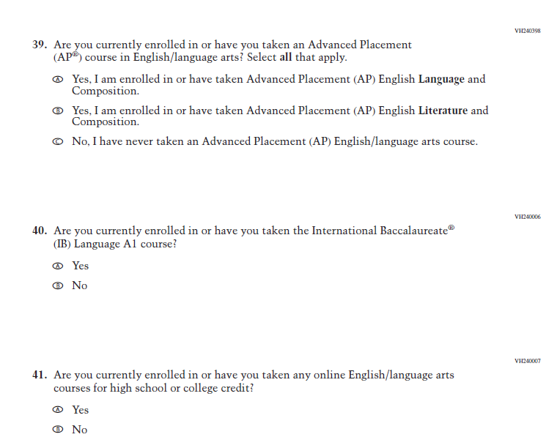
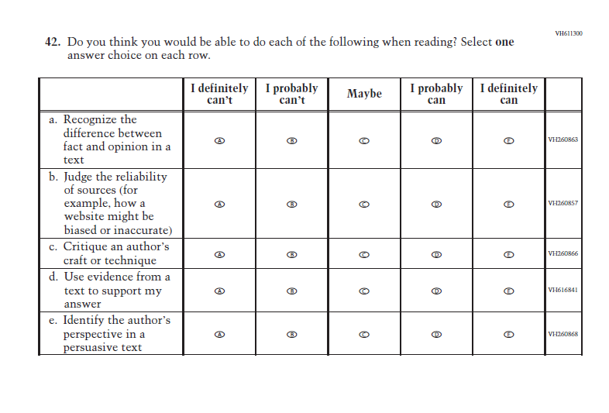
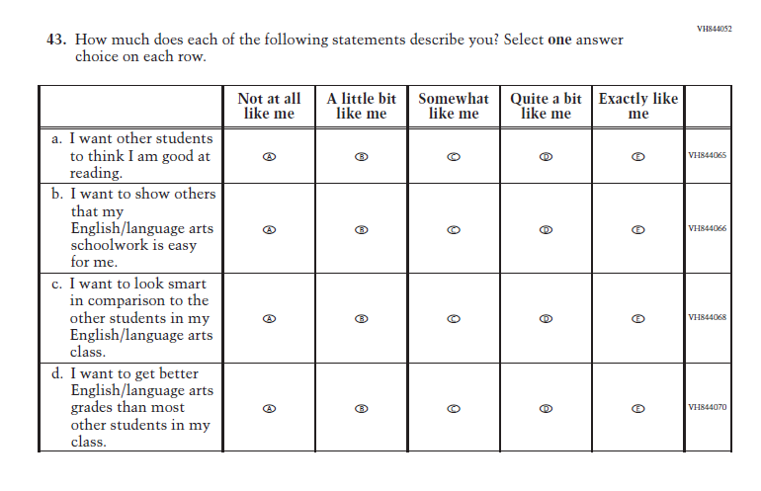
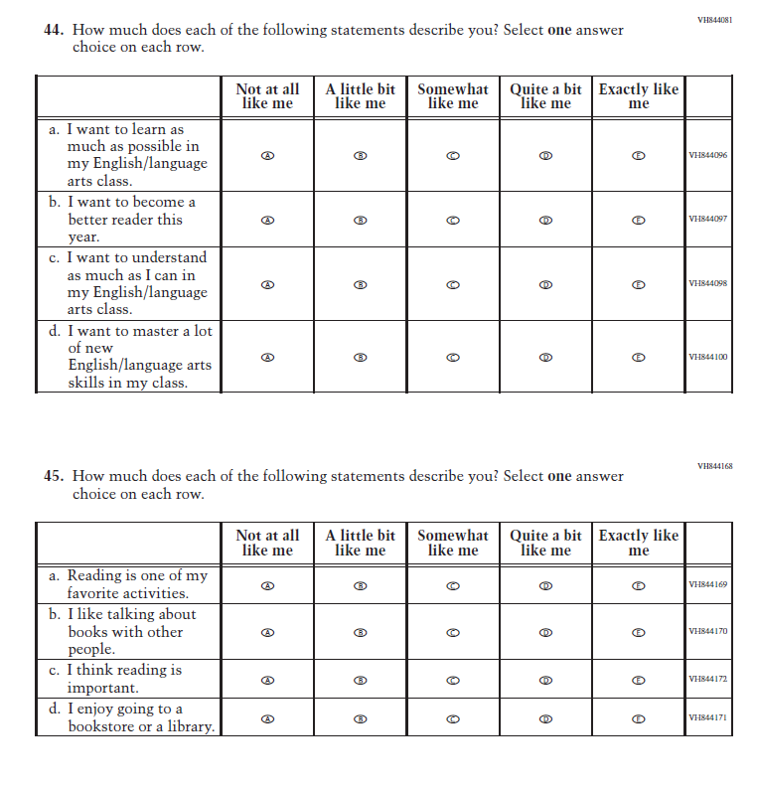

Appendix J1-25: Operational Grade 8 (Science)
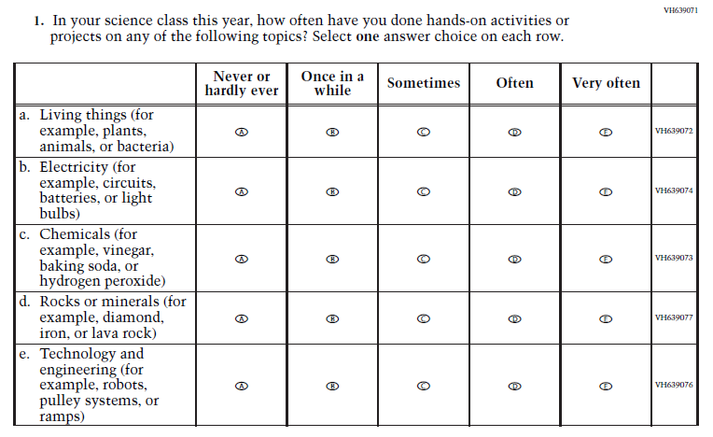
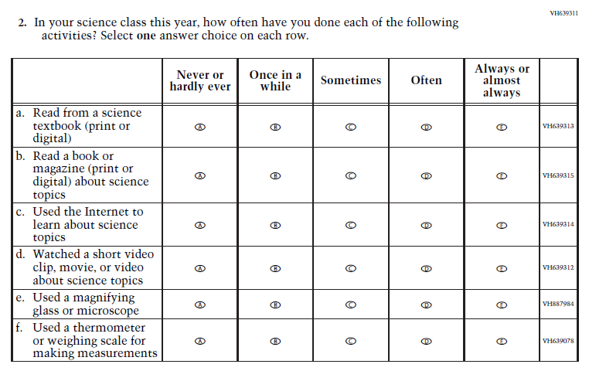

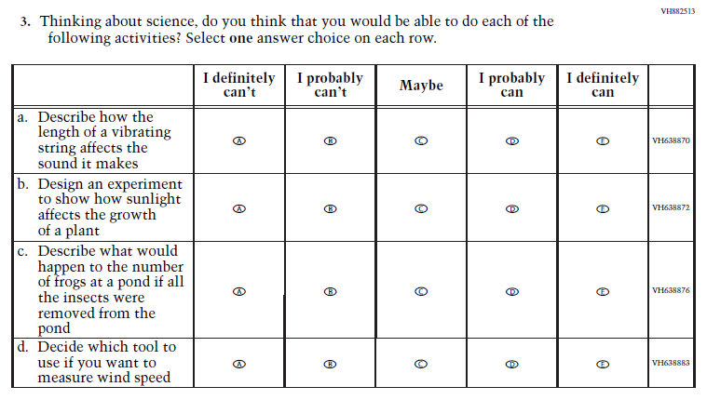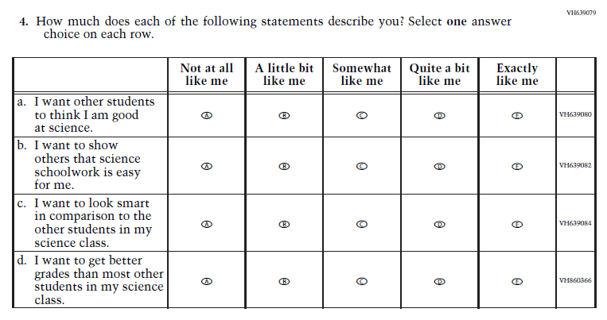

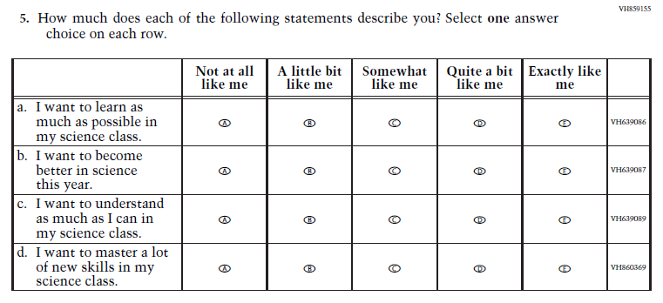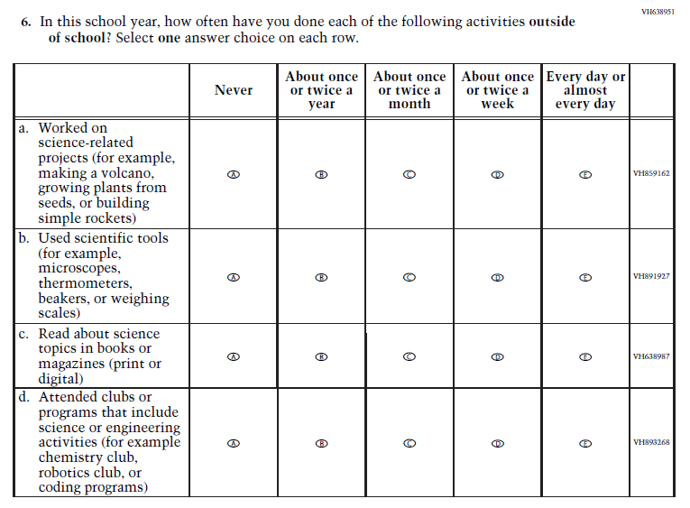

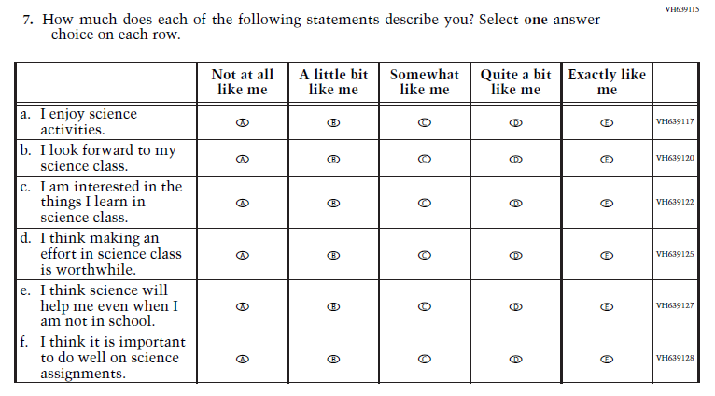
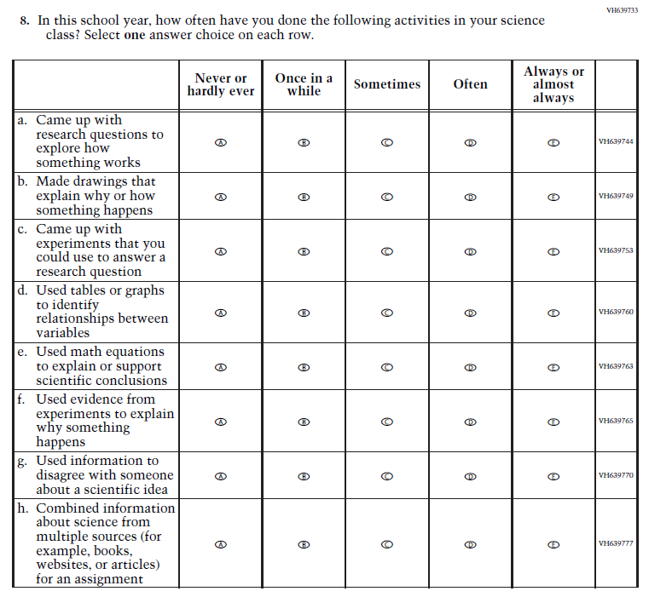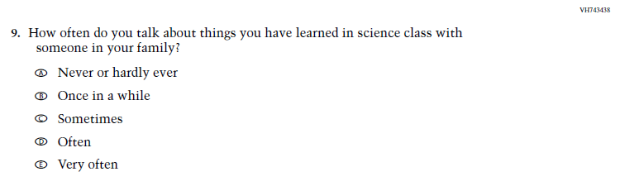

Appendix J1-26: Operational Grade 4 (Debrief)

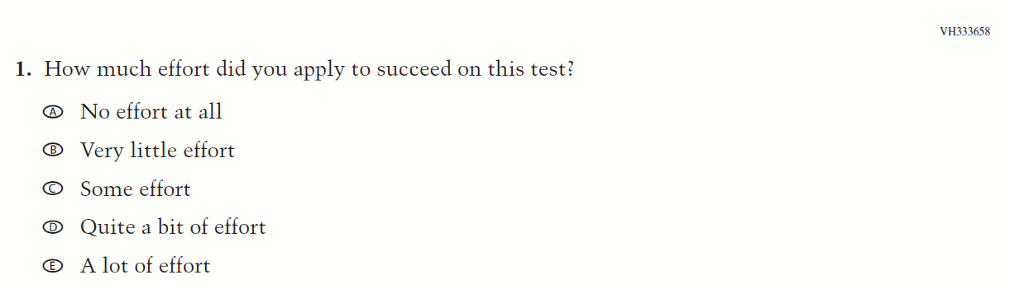

Appendix J1-27: Operational Grade 8 and 12 (Debrief)
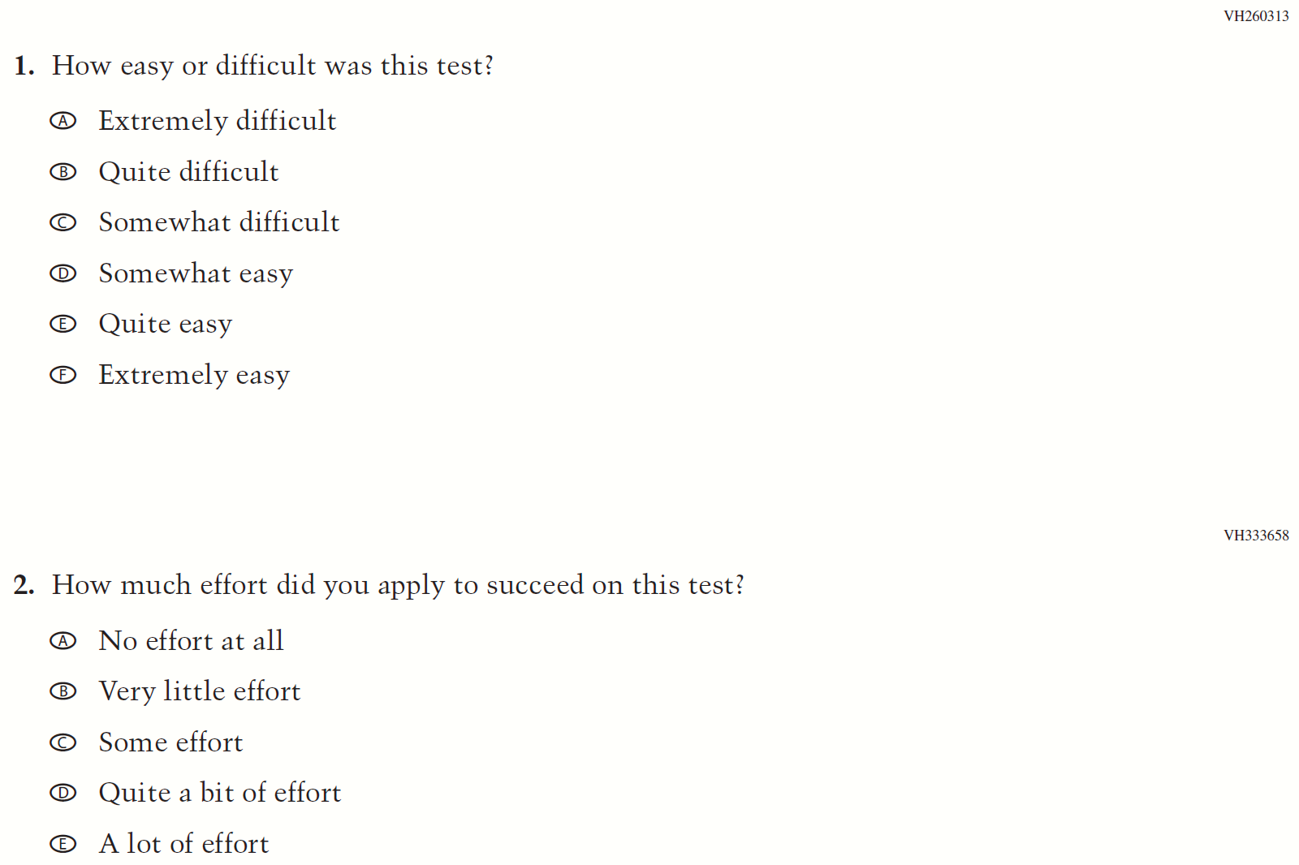

Appendix J1-32: Pilot Grade 4 (Core)
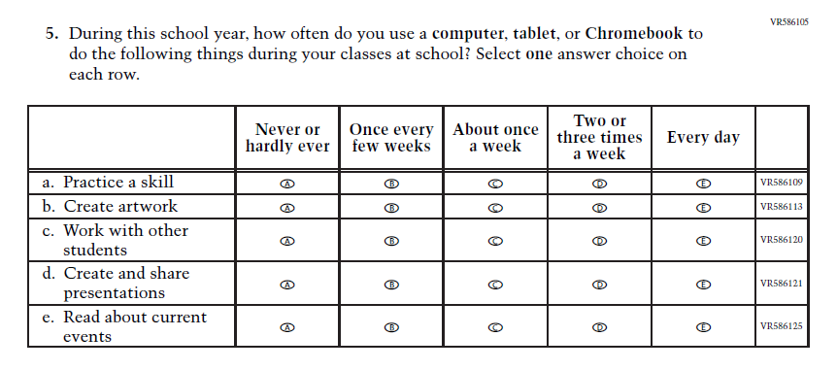
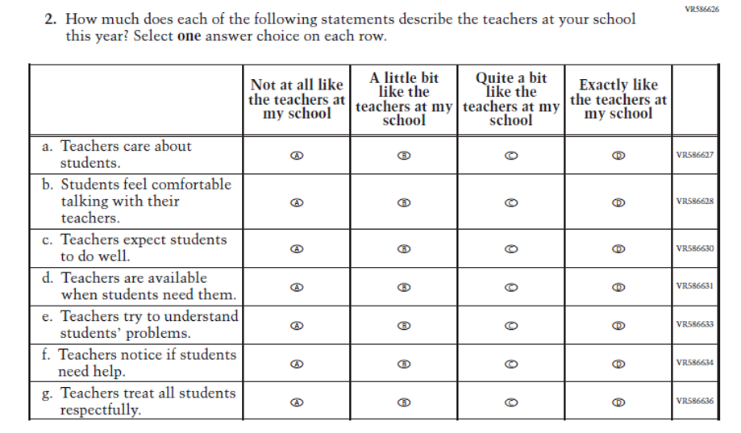
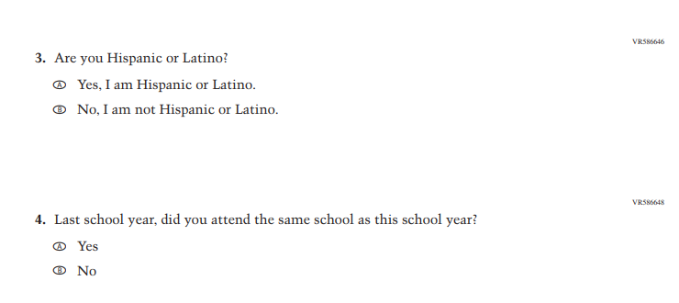

Appendix J1-33: Pilot Grade 8 (Core)
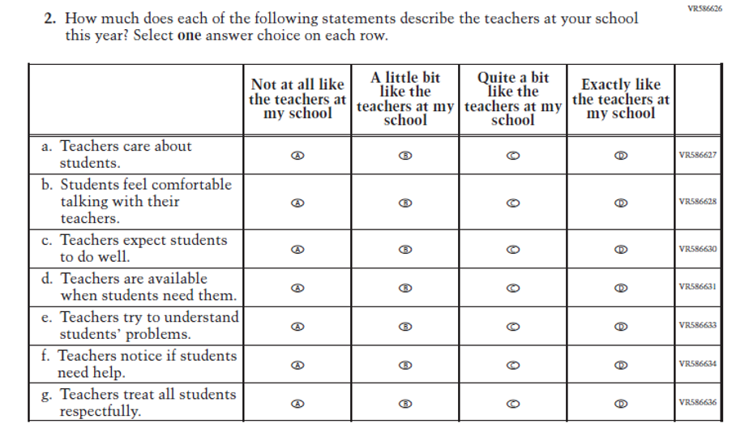
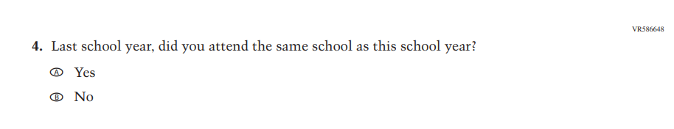

Appendix J1-34: Pilot Grade 4 (Mathematics)
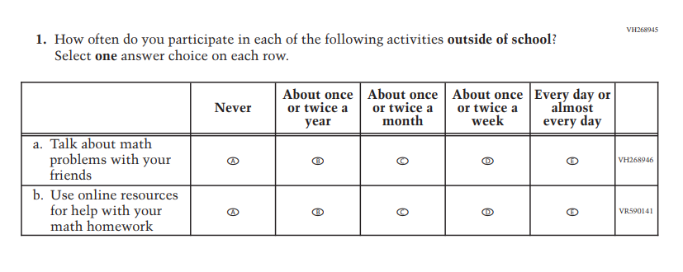
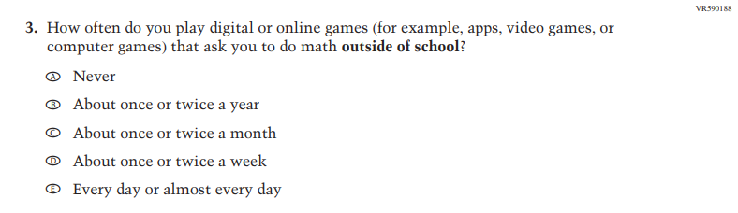
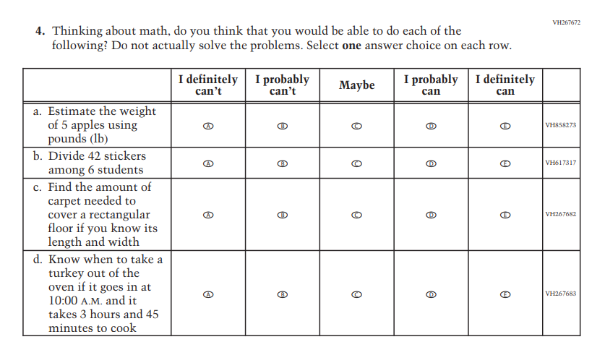
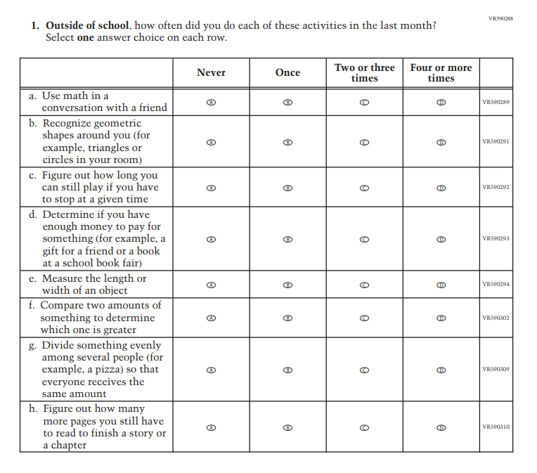
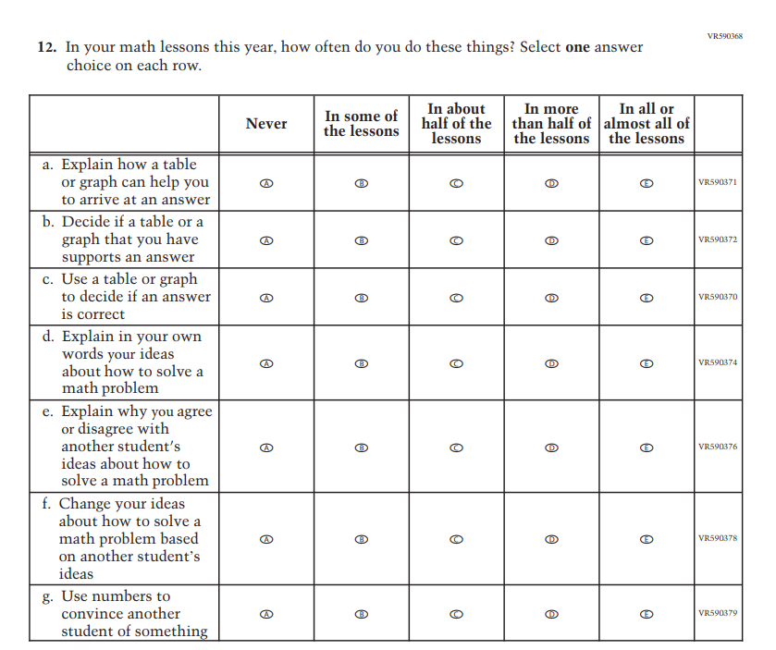
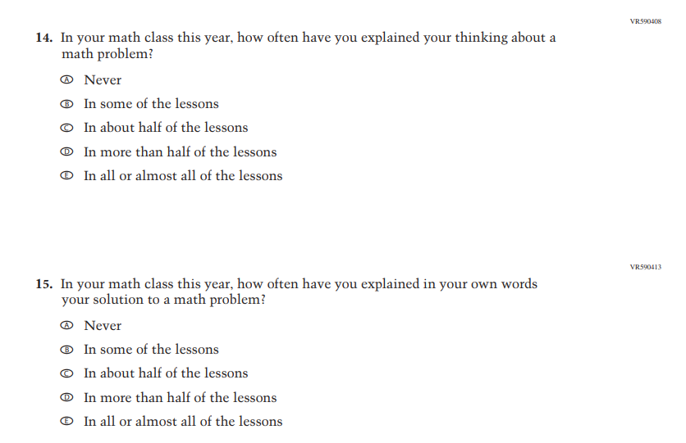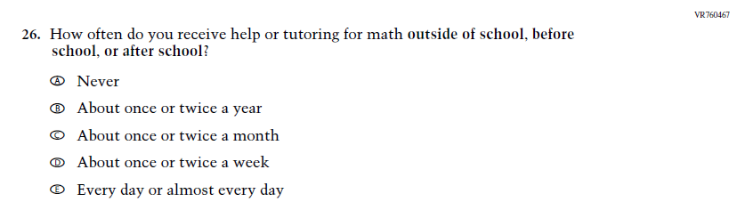

Appendix J1-35: Pilot Grade 8 (Mathematics)
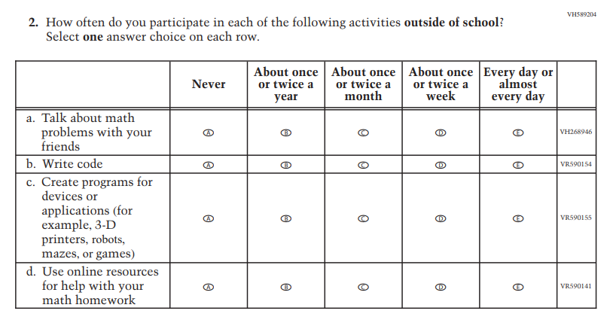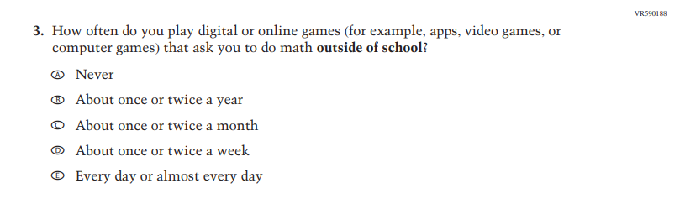
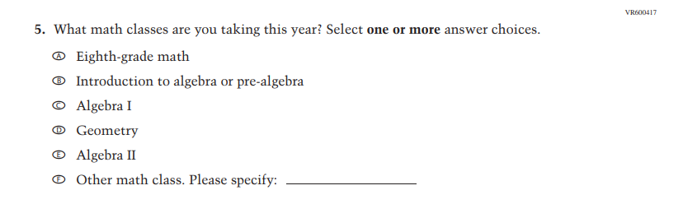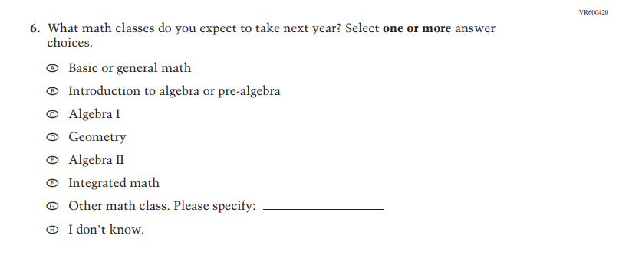
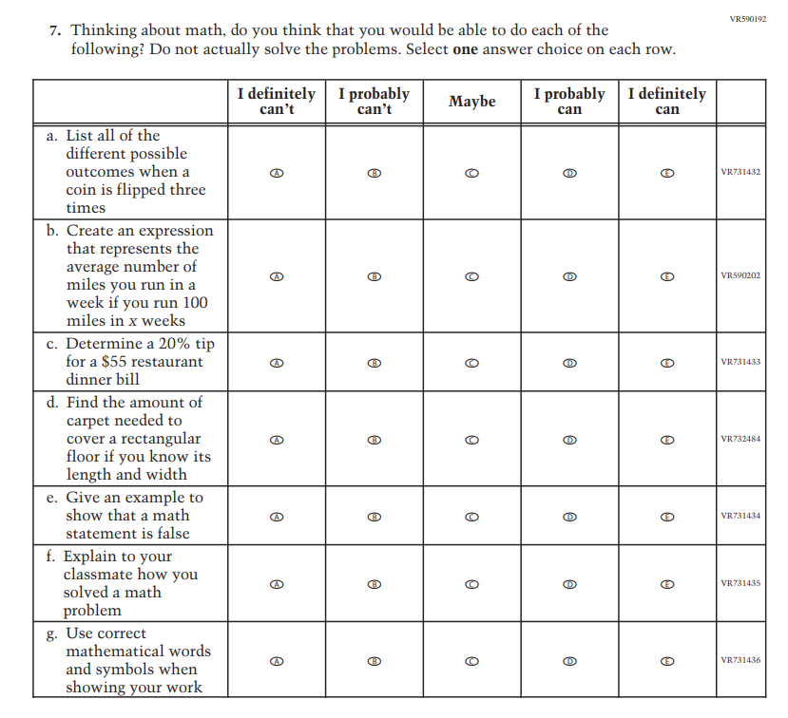
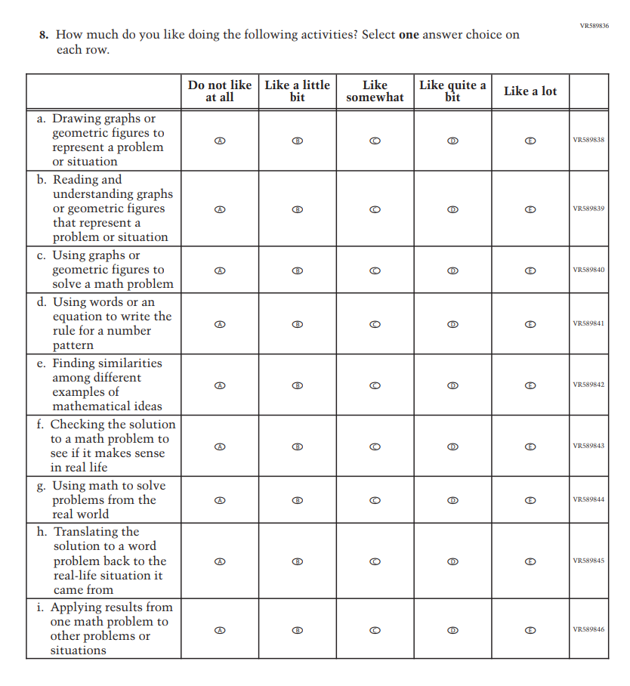
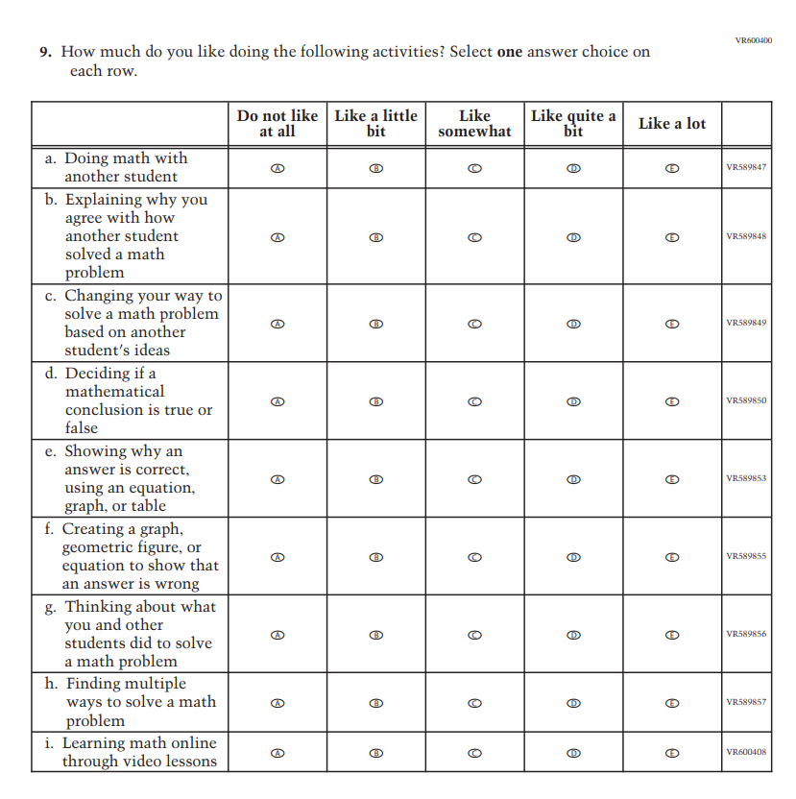
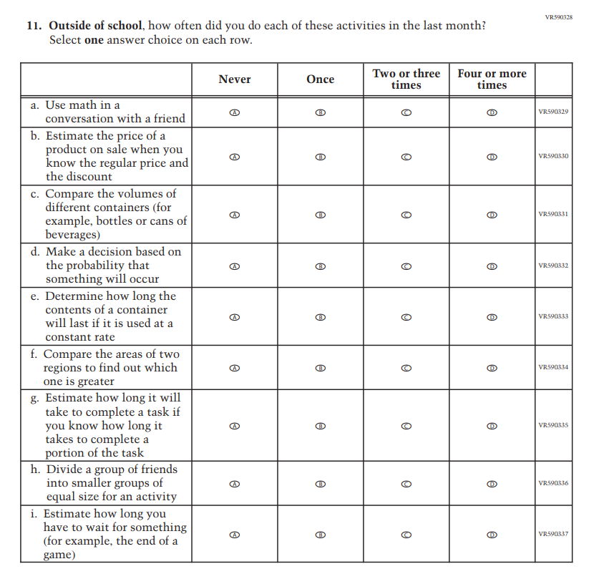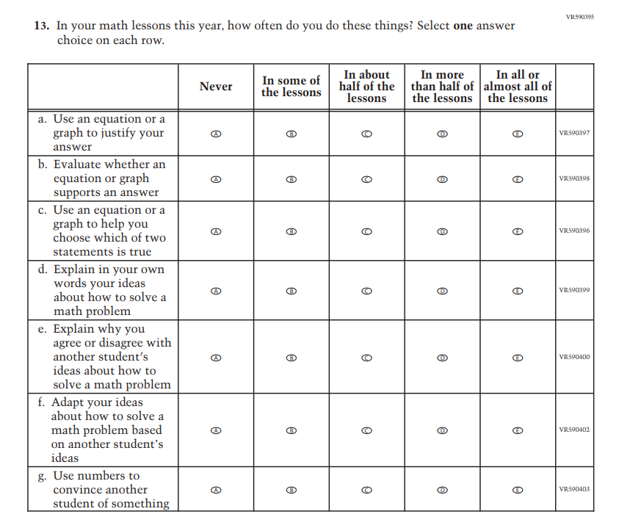
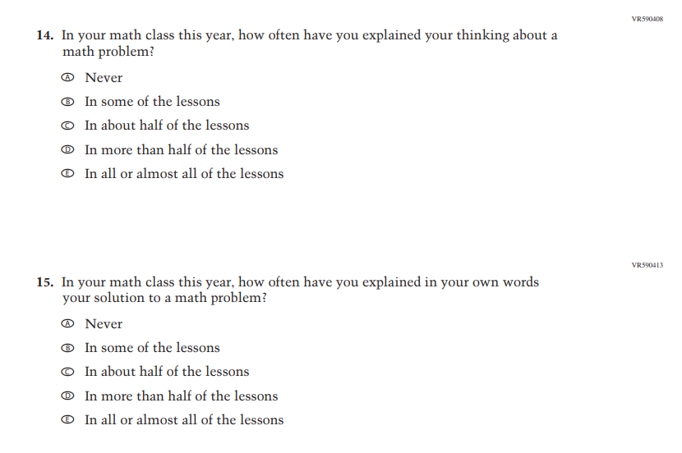

Appendix J1-36: Pilot Grade 4 (Reading)
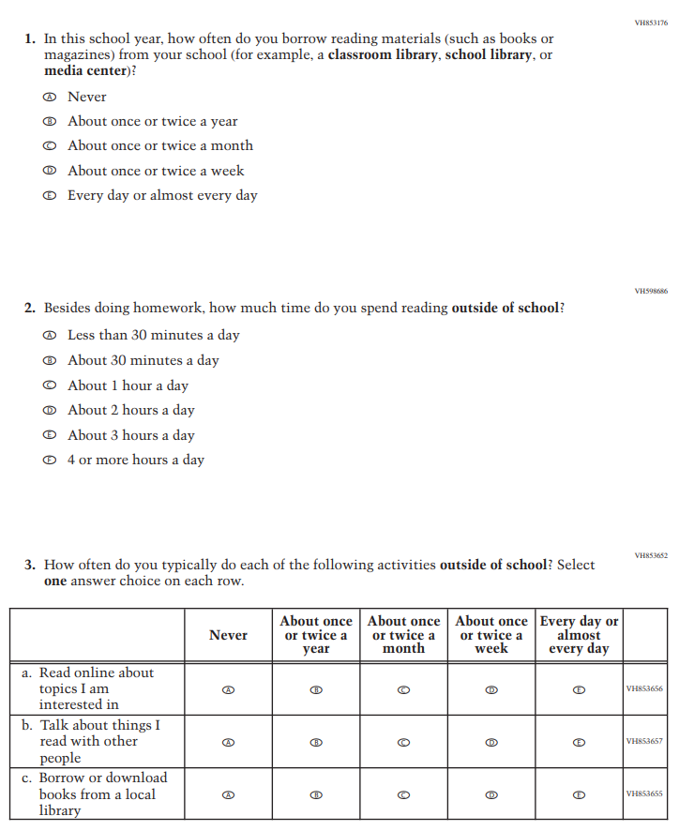
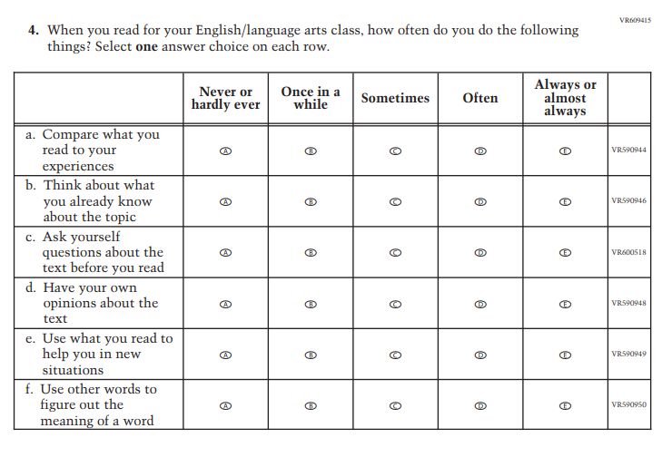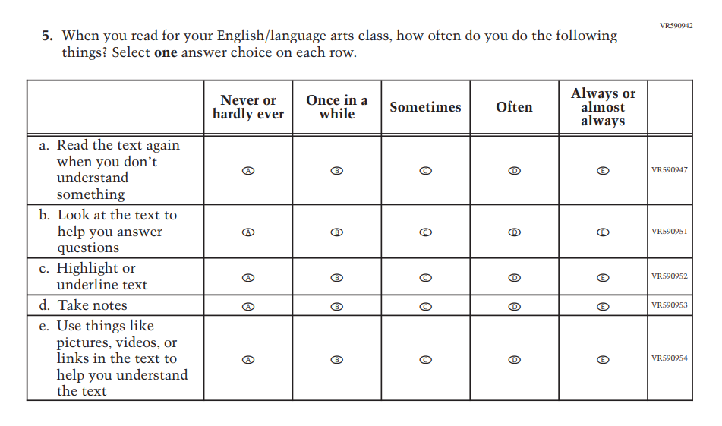
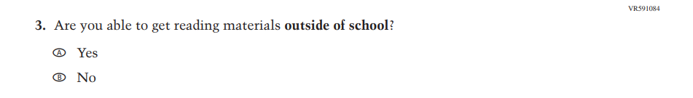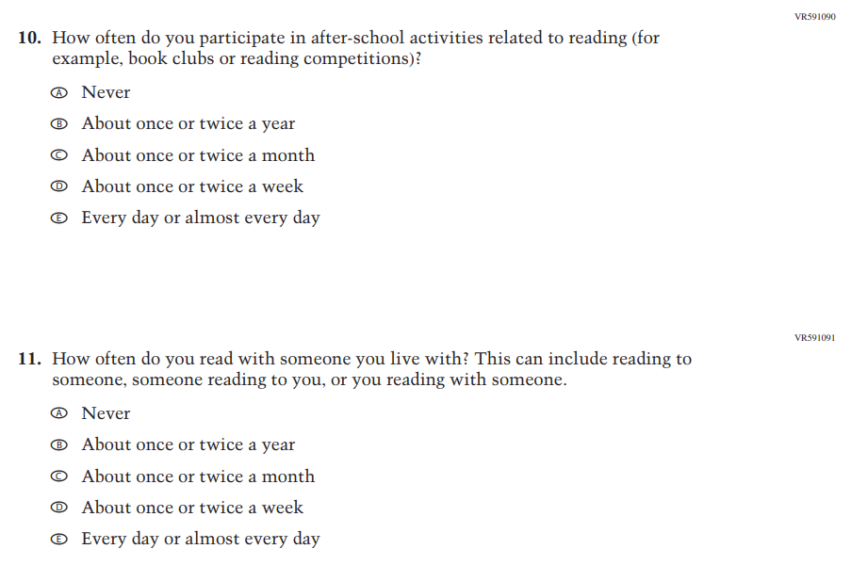

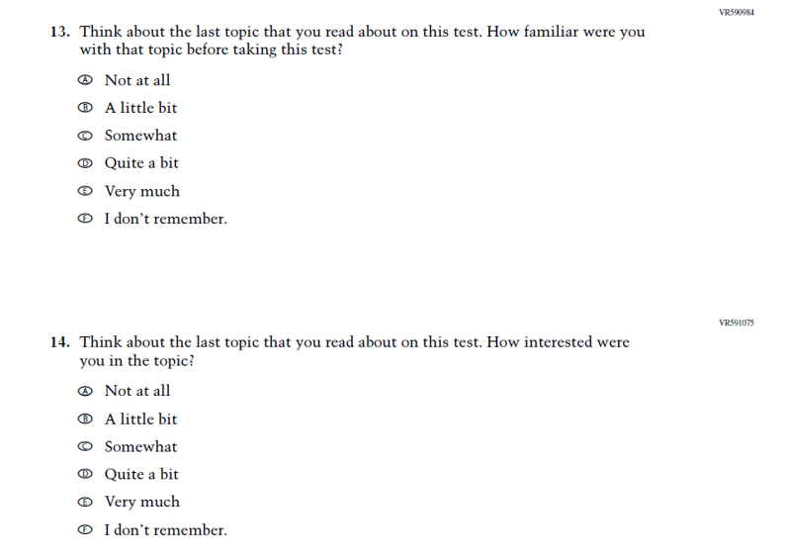
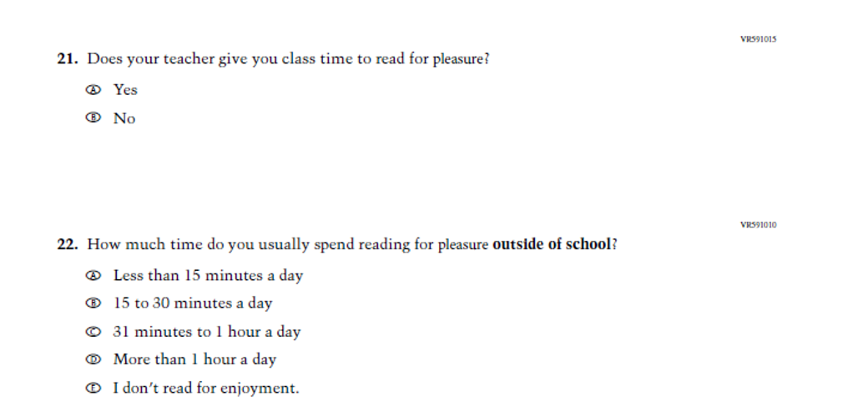
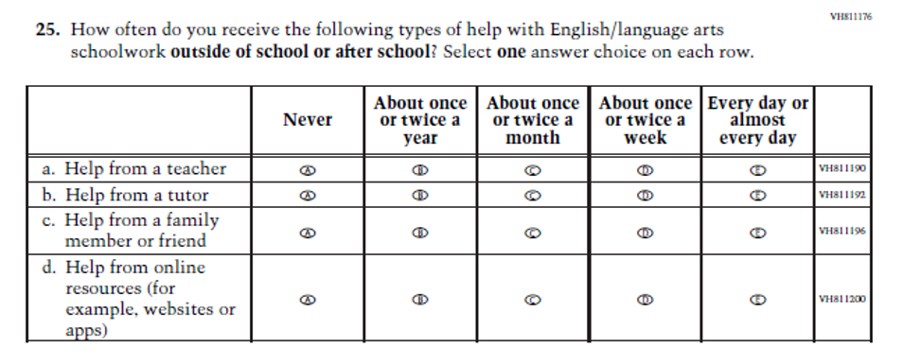

Appendix J1-37: Pilot Grade 8 (Reading) 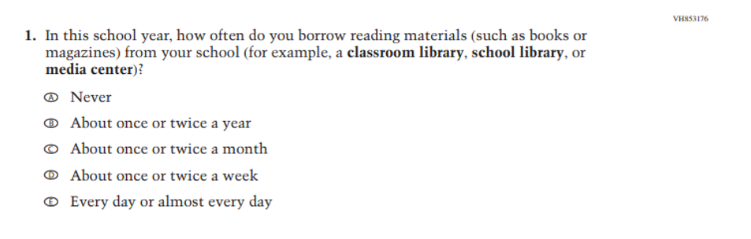
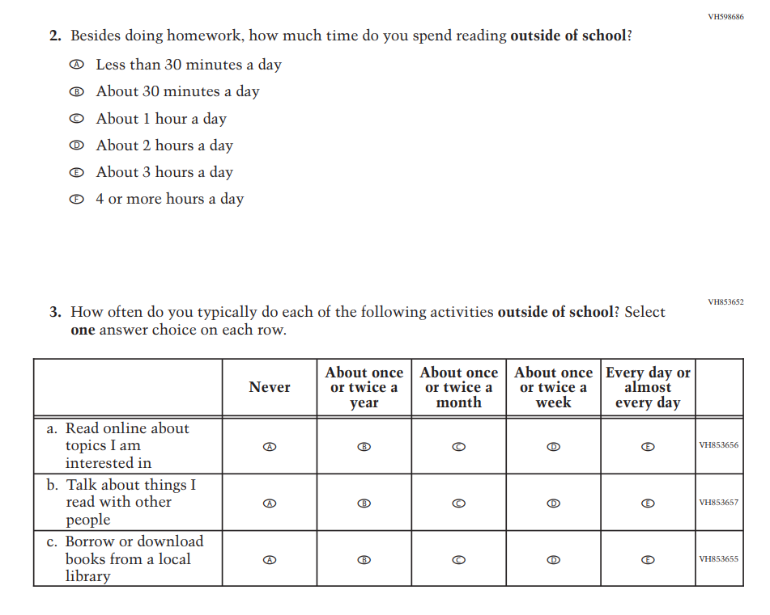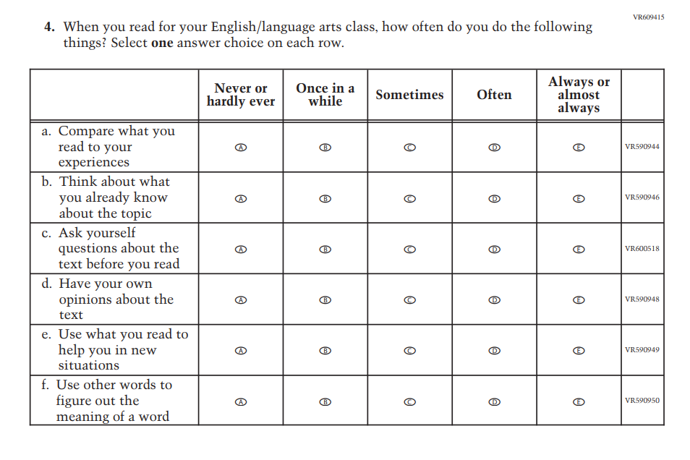
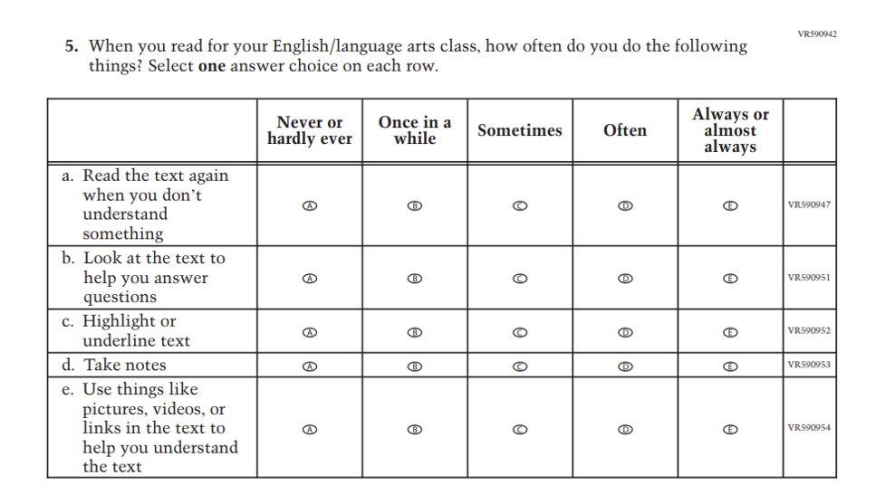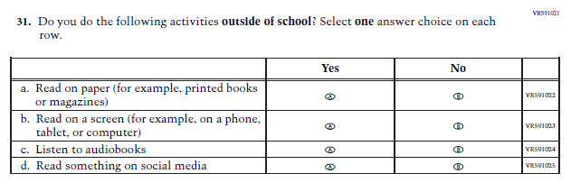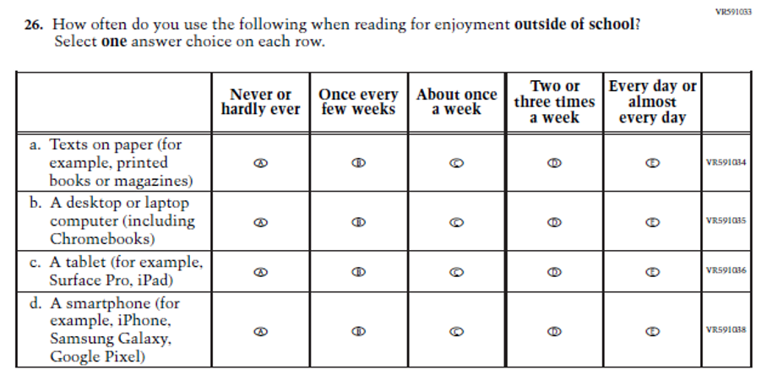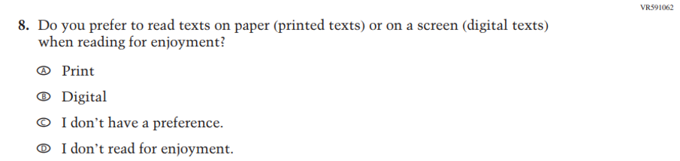
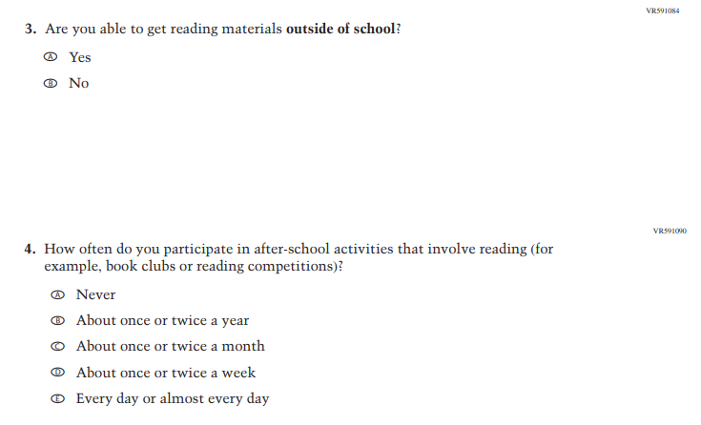
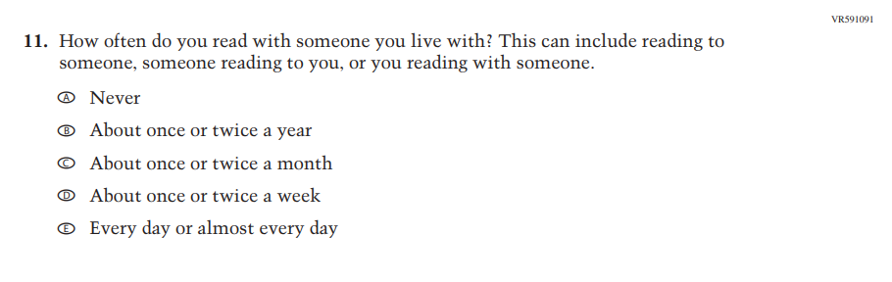

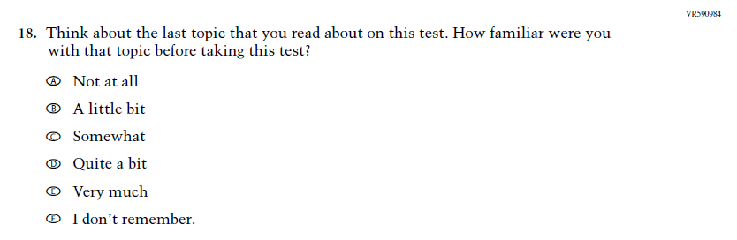
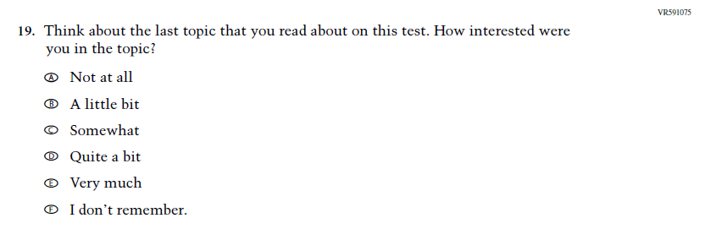
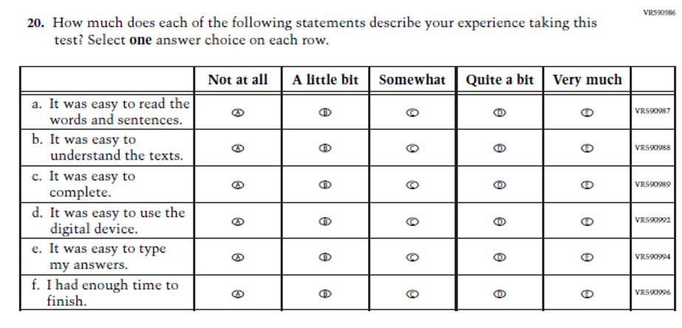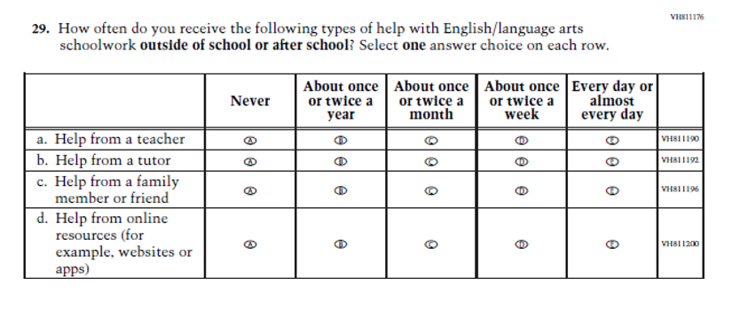
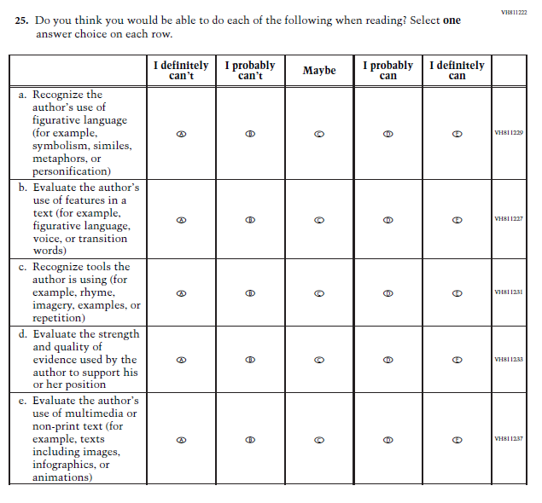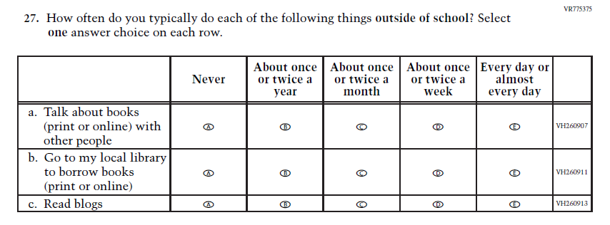

Appendix J1-38: Operational Grade 8 (Core, Science)
