NATIONAL CENTER FOR EDUCATION STATISTICS NATIONAL ASSESSMENT OF EDUCATIONAL PROGRESS

National Assessment of Educational Progress (NAEP)2026

Appendix J2
2024 Teacher Questionnaires Samples

OMB# 1850-0928 v.36



May 2025

NOTE: The 2026 teacher survey questionnaires were not available for this submission. The 2026 surveys will be included in either the Amendment #1 (Spring 2025), Amendment #2 (August/September 2025), or some combination of both Amendments. System login screens will be updated in upcoming Amendments to the Clearance Package.
Important changes in how we collect demographic information will be reflected in the 2026 instruments when they are ready for publication and review. In March 2024, the Office of Management and Budget (OMB) announced revisions to Statistical Policy Directive No. 15: Standards for Maintaining, Collecting, and Presenting Federal Data on Race and Ethnicity (SPD 15) and published the revised SPD15 standard in the Federal Register (89 FR 22182). See Part A.7 of this package to see how NCES plans to incorporate these revisions into NAEP 2026. Further, as we were preparing this package for 30D publication, the White House issued an Executive Orders “Defending Women from Gender Ideology Extremism and Restoring Biological Truth to the Federal Government,” (January 20, 2025) and “Ending Radical and Wasteful Government DEI Programs and Preferencing,” (January 20, 2025). In compliance with these Executive Orders, the materials in this package have been modified. In addition, a full review of all items is being conducted to ensure compliance with the Executive Orders. The revised questionnaires will be included in the next Amendment to this package. No collections of this information will take place before the submission and approval of Amendment #2.
Appendix J2 provides the teacher survey questionnaires that will be administered in 2024. Grades 4 and 8 Core, Math, and Reading questionnaires were previously approved in 2022 (OMB# 1850-0928 v.28), and any changes to the items from the 2022 administration are reflected in summary tables. Additionally, grade 8 Science was previously approved in 2019 (OMB# 1850-0928 v.15), and any changes to the items from the 2019 administration are reflected in summary tables. Learning Recovery SQs, are available in this document.
Please note, some of the numbers of the items may be missing or out of order in these printed versions. This will be corrected in the platform view.
Table of Contents
Teacher Questionnaires
Sample Teacher Questionnaire Login Screens 4
Appendix J2-1: Summary of Changes Operational Grade 4 (Core, Reading and Mathematics) 5
Appendix J2-2: Operational Grade 4 (Core, Reading and Mathematics) 8
Appendix J2-3: Summary of Changes Operational Grade 8 (Core, Reading, Mathematics, Science) 16
Appendix J2-4: Operational Grade 8 (Core, Reading, Mathematics, Science) 20
Appendix J2-5: Operational Grade 4 (Mathematics) 32
Appendix J2-6: Operational Grade 8 (Mathematics) 40
Appendix J2-7: Operational Grade 4 (Reading) 49
Appendix J2-8: Operational Grade 8 (Reading) 56
Appendix J2-9: Operational Grade 8 (Science) 63
Appendix J2-14: Pilot Reading and Mathematics Grade 4 (Core) 69
Appendix J2-15: Pilot Mathematics Grade 8 (Core) 79
Appendix J2-16: Pilot Reading Grade 8 (Core) 89
Appendix J2-17: Pilot Grade 4 (Mathematics) 99
Appendix J2-18: Pilot Grade 8 (Mathematics) 108
Appendix J2-19: Pilot Grade 4 (Reading) 120
Appendix J2-20: Pilot Grade 8 (Reading) 128

Sample Teacher Questionnaire Login Screens

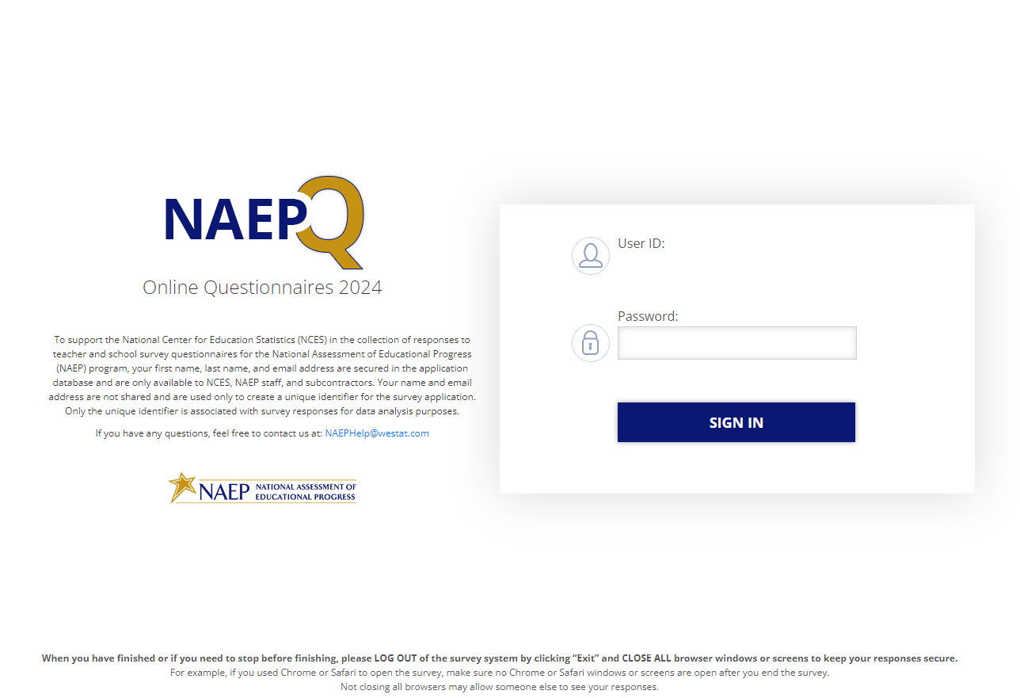
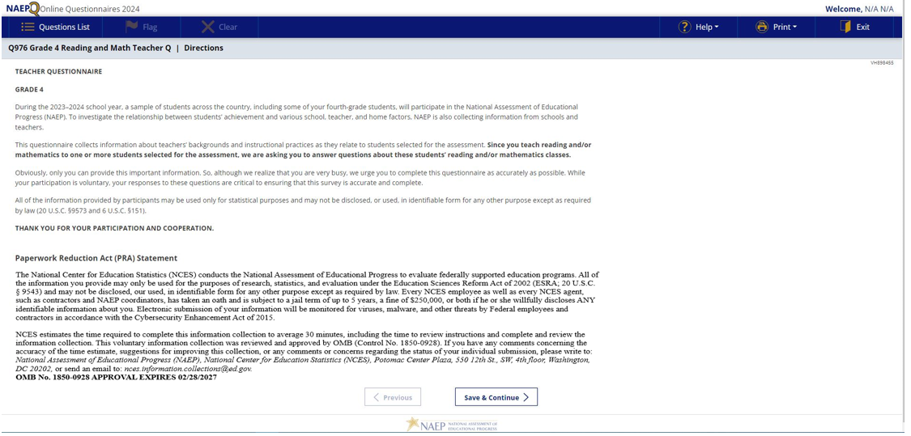

Appendix J2-1: Summary of Changes Operational Grade 4 (Core, Reading and Mathematics)
2024 Operational Grade 4 Core Teacher
Previous Item | 2024 Item | D/A/ R+ | Rationale
N/A | 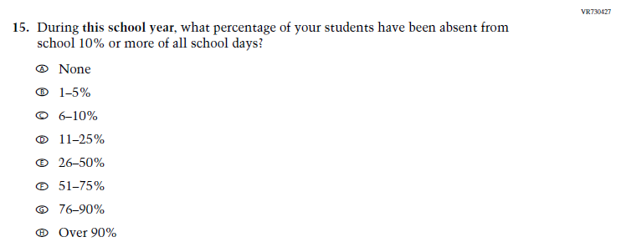  Issue: Learning Recovery | A | This Item was added to address gaps in learning that have developed due to the extended period of remote and hybrid learning that took place during the pandemic.
N/A | 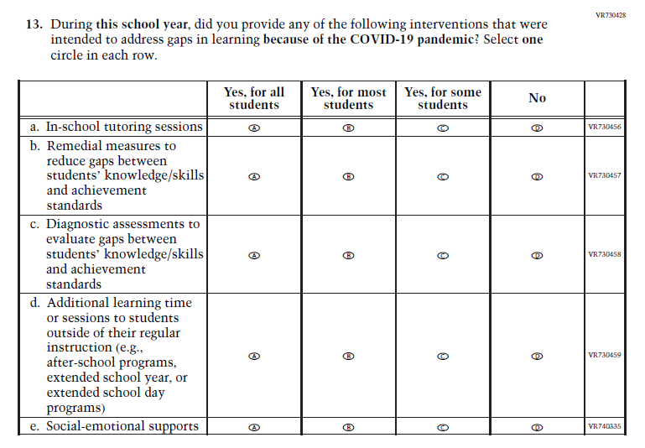  Issue: Learning Recovery | A | This Item was added to address gaps in learning that have developed due to the extended period of remote and hybrid learning that took place during the pandemic.
N/A | 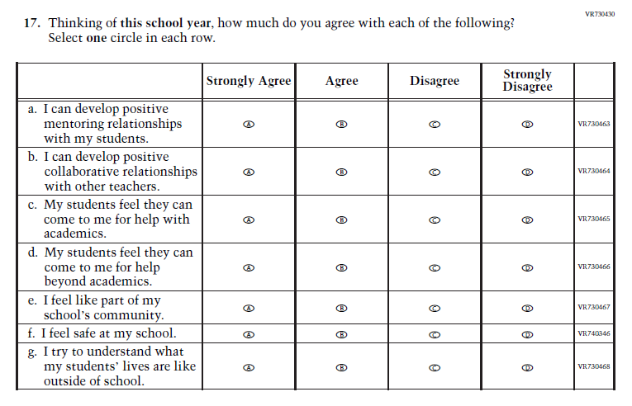  Issue: Learning Recovery | A | This Item was added to address gaps in learning that have developed due to the extended period of remote and hybrid learning that took place during the pandemic.

N/A | 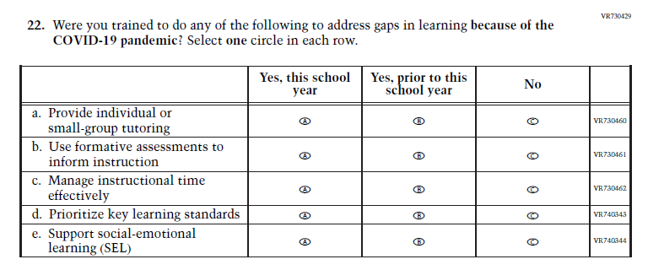  Issue: Learning Recovery | A | This Item was added to address gaps in learning that have developed due to the extended period of remote and hybrid learning that took place during the pandemic.

Appendix J2-2: Operational Grade 4 (Core, Reading and Mathematics)
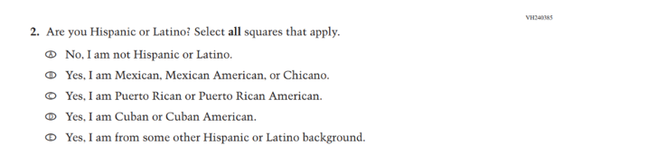
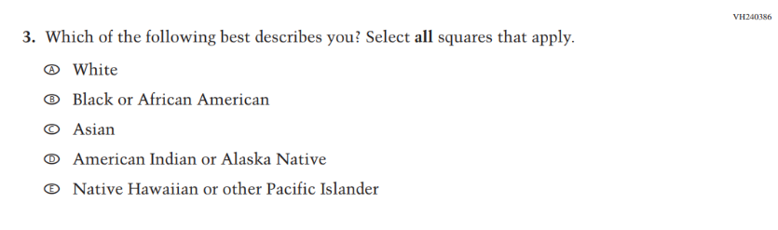
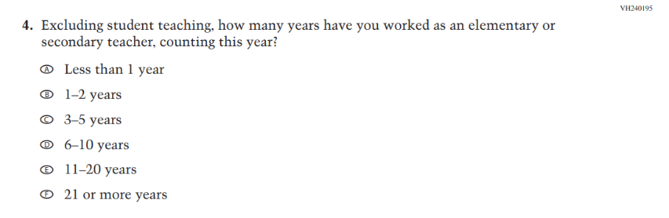

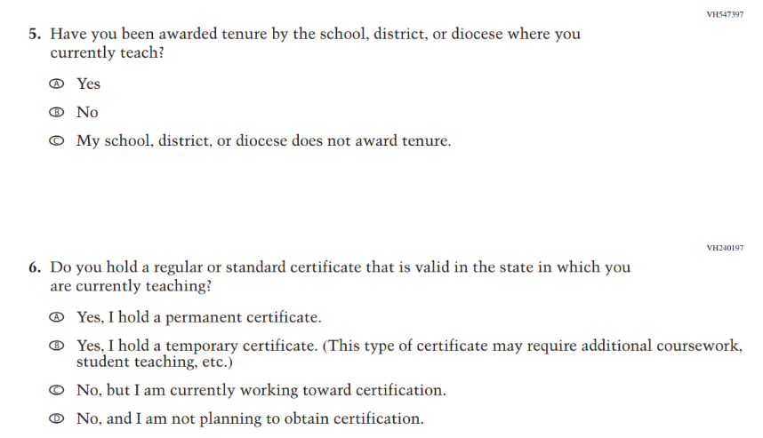
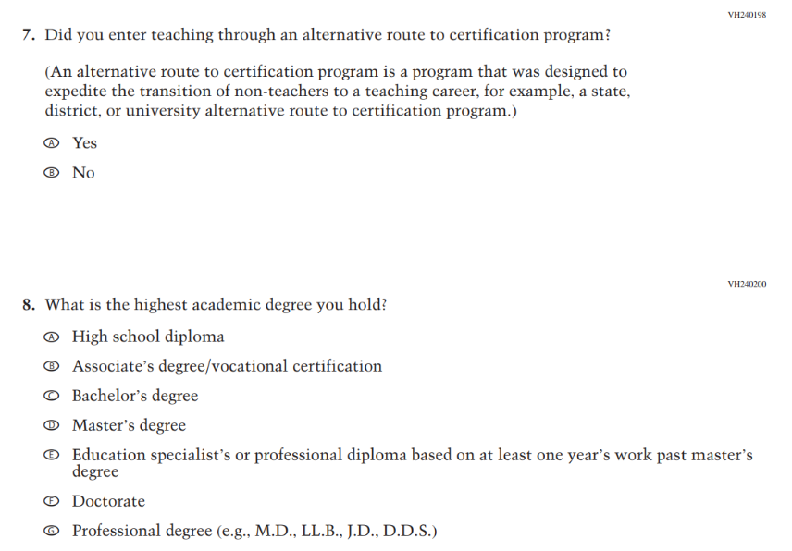

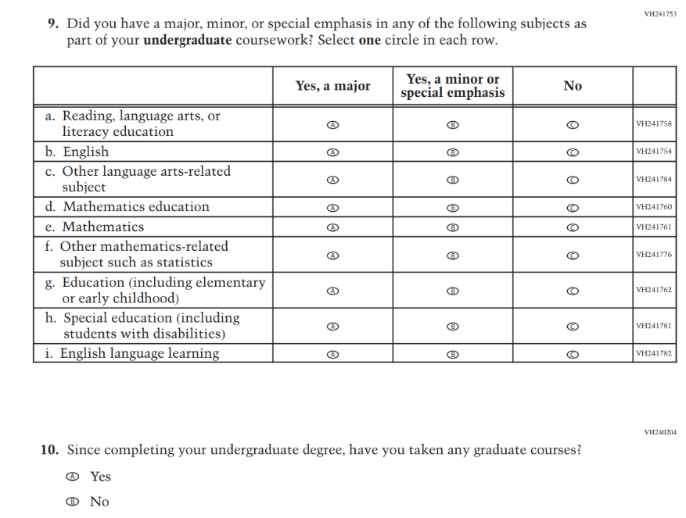

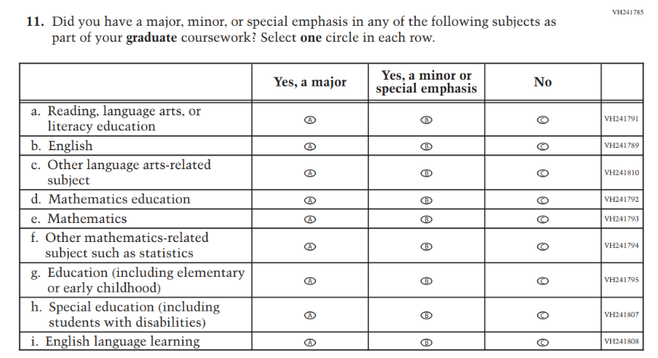
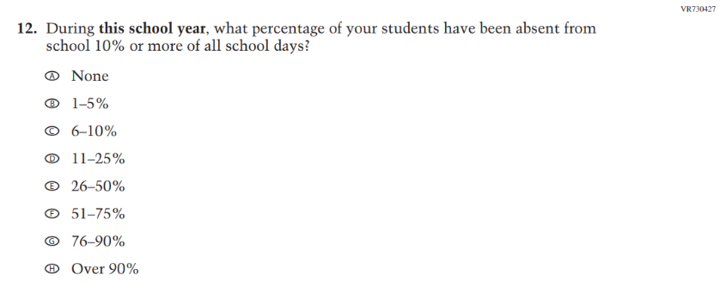
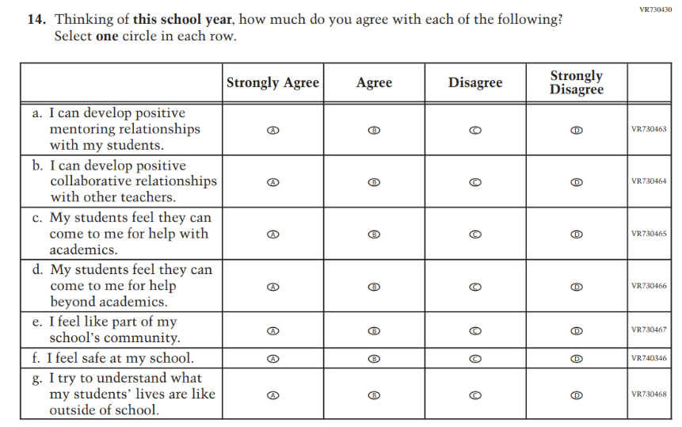
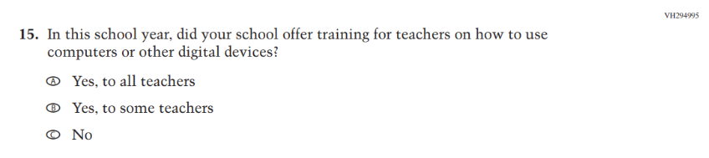
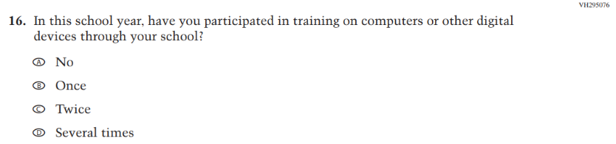
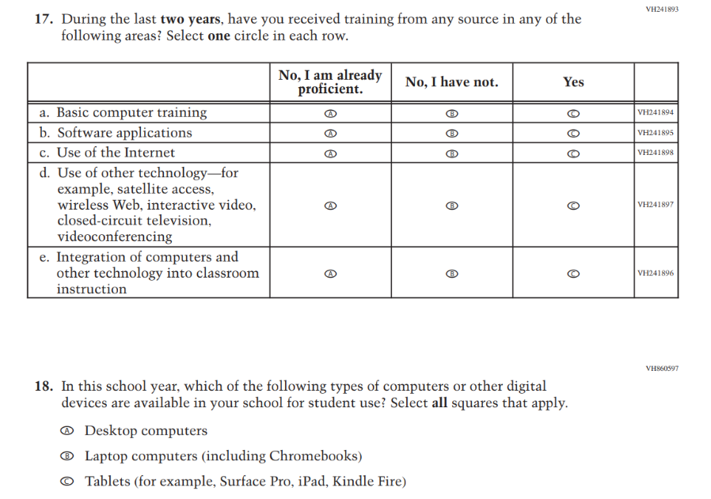
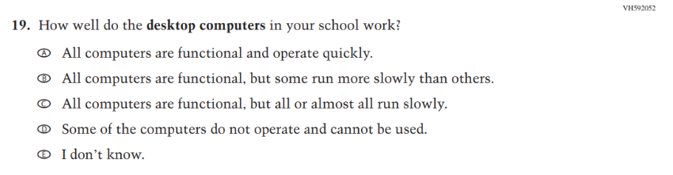
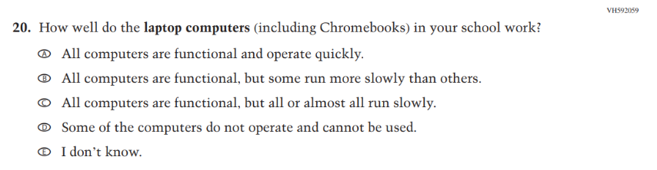
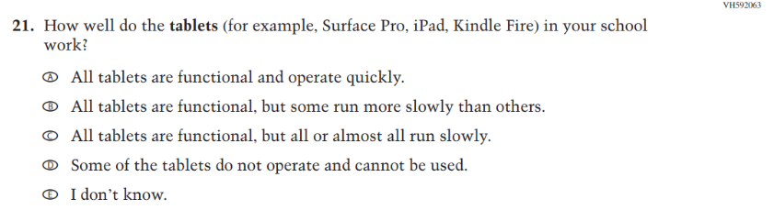
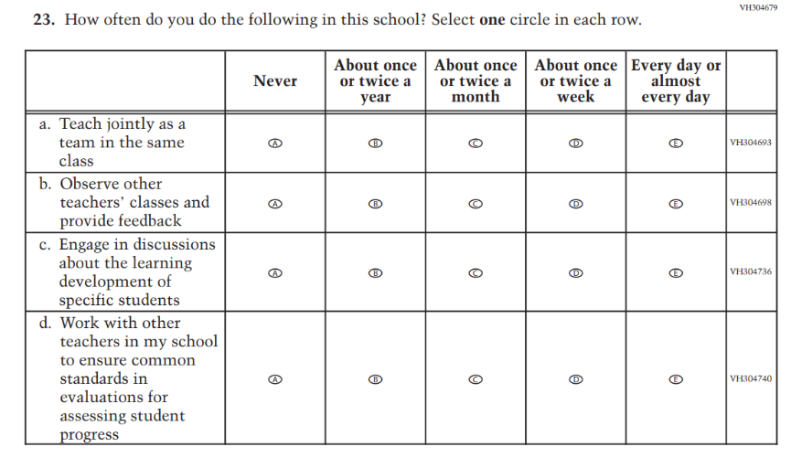
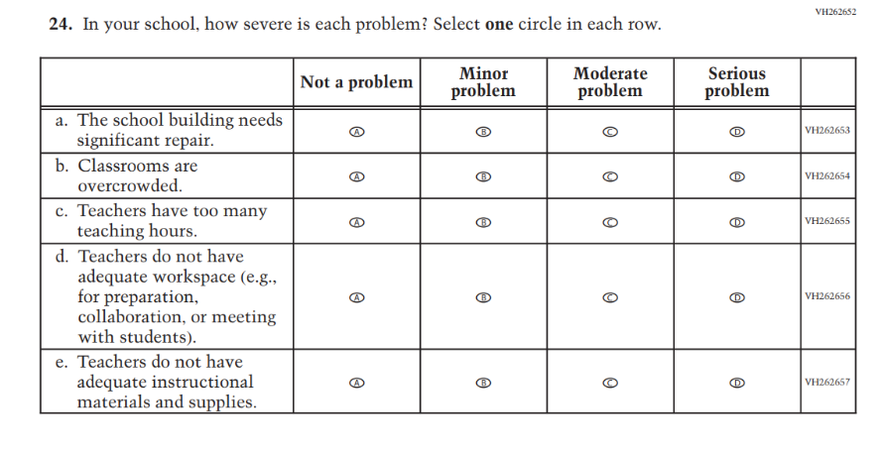
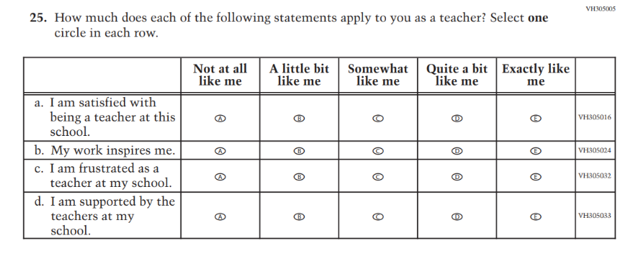
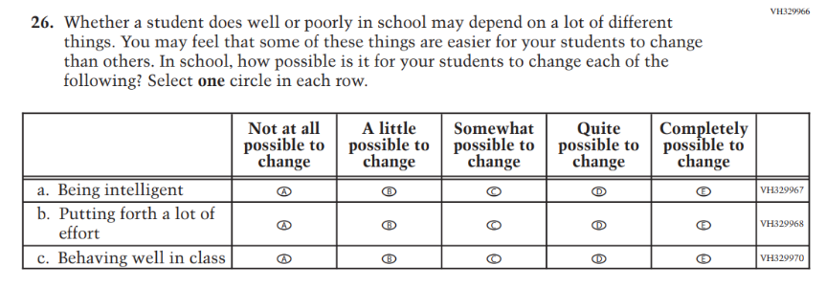

Appendix J2-3: Summary of Changes Operational Grade 8 (Core, Reading, Mathematics, Science)
2024 Operational Grade 8 Core Teacher
Previous Item | 2024 Item | D/A/ R+ | Rationale
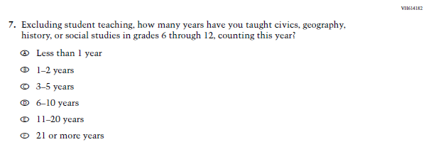  (2022 Grade 8) | 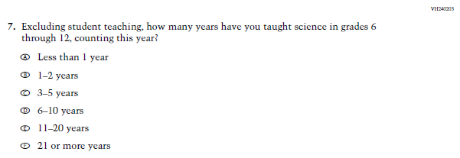  Issue: Teacher Preparation | R | The 2022 version of the Item, which references Social Studies, was replaced with the Item that references Science. Social Studies is not in the 2024 NAEP Assessment. Science is being administered at Grade 8.
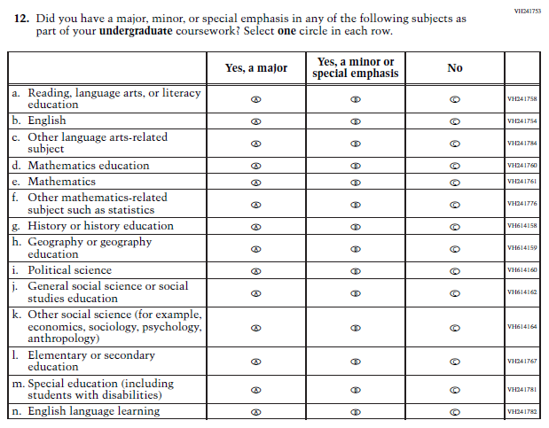  (2022 Grade 8) | 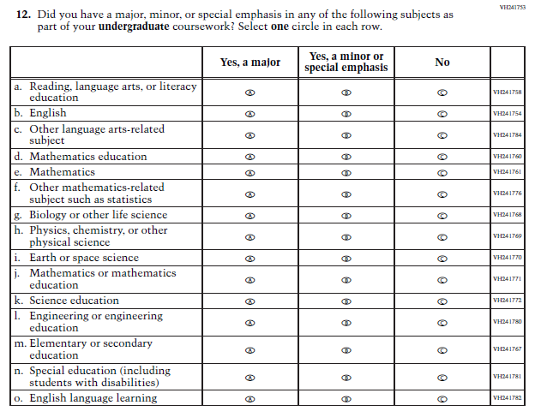  Issue: Teacher Preparation | R | SubItems “g.” through “k.” in the 2022 version of the Item, which reference Social Studies, have been replaced with SubItems that reference Science. SubItem “l.” also references Science. Social Studies is not in the 2024 NAEP Assessment. Science is being administered at Grade 8.
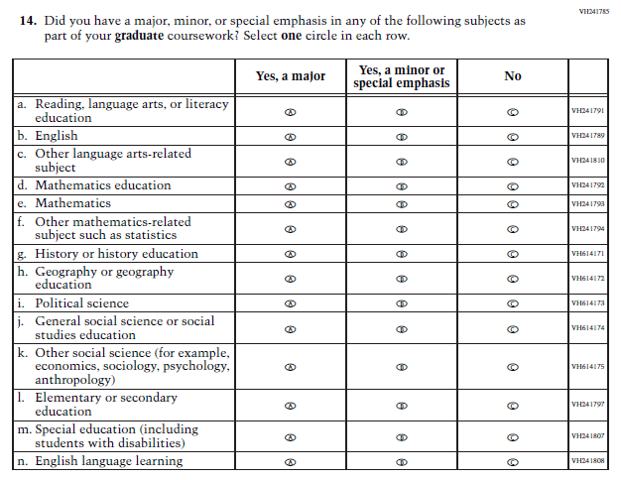  (2022 Grade 8) | 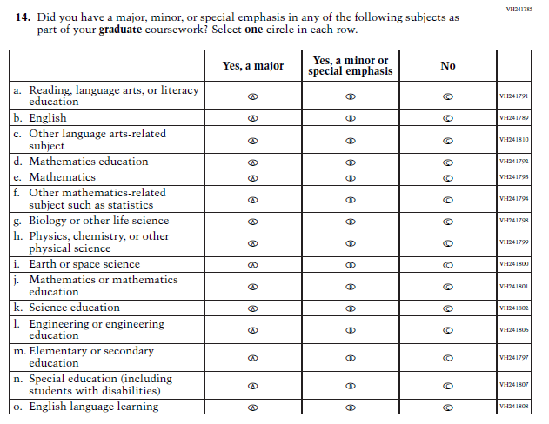  Issue: Teacher Preparation | R | SubItems “g.” through “k.” in the 2022 version of the Item, which reference Social Studies, have been replaced with SubItems that reference Science. SubItem “l.” also references Science. Social Studies is not in the 2024 NAEP Assessment. Science is being administered at Grade 8.
N/A | Issue: Learning Recovery | A | This Item was added to address gaps in learning that have developed due to the extended period of remote and hybrid learning that took place during the pandemic.
N/A | Issue: Learning Recovery | A | This Item was added to address gaps in learning that have developed due to the extended period of remote and hybrid learning that took place during the pandemic.
N/A | Issue: Learning Recovery | A | This Item was added to address gaps in learning that have developed due to the extended period of remote and hybrid learning that took place during the pandemic.

N/A | Issue: Learning Recovery | A | This Item was added to address gaps in learning that have developed due to the extended period of remote and hybrid learning that took place during the pandemic.

Appendix J2-4: Operational Grade 8 (Core, Reading, Mathematics, Science)
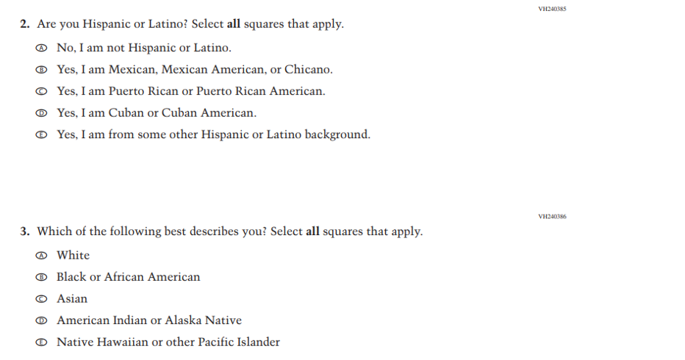
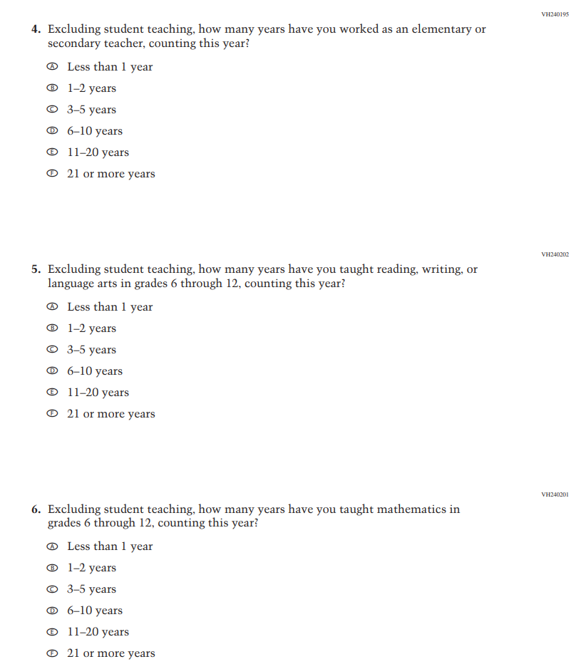
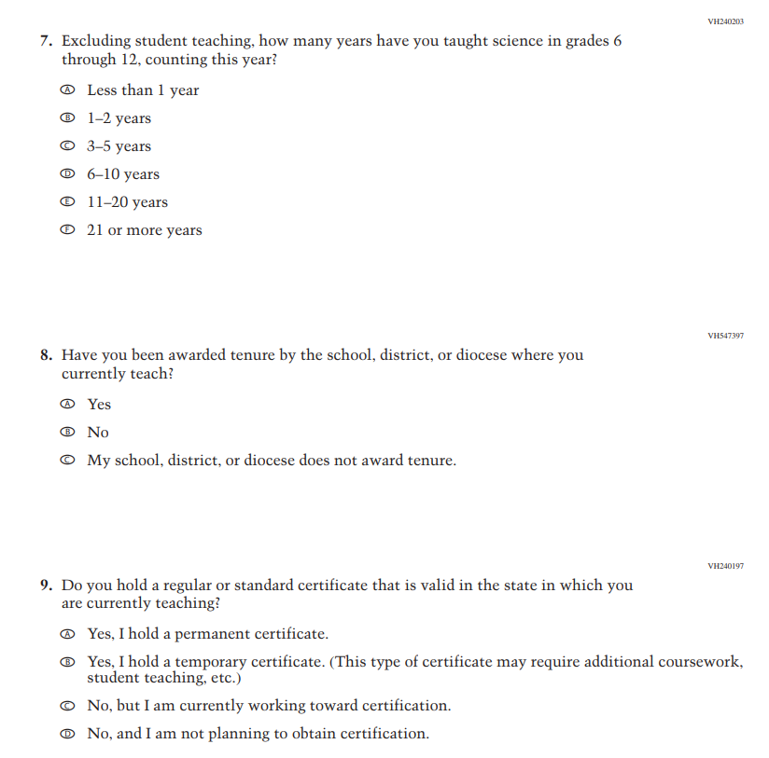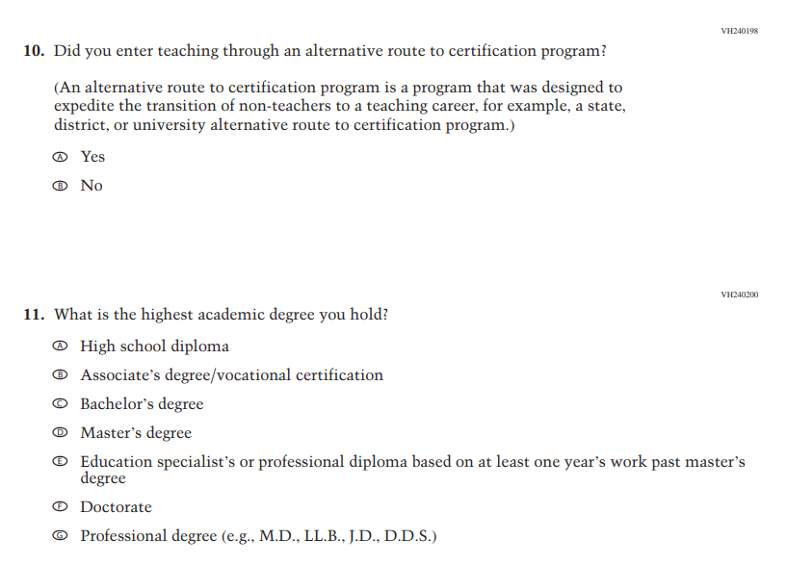
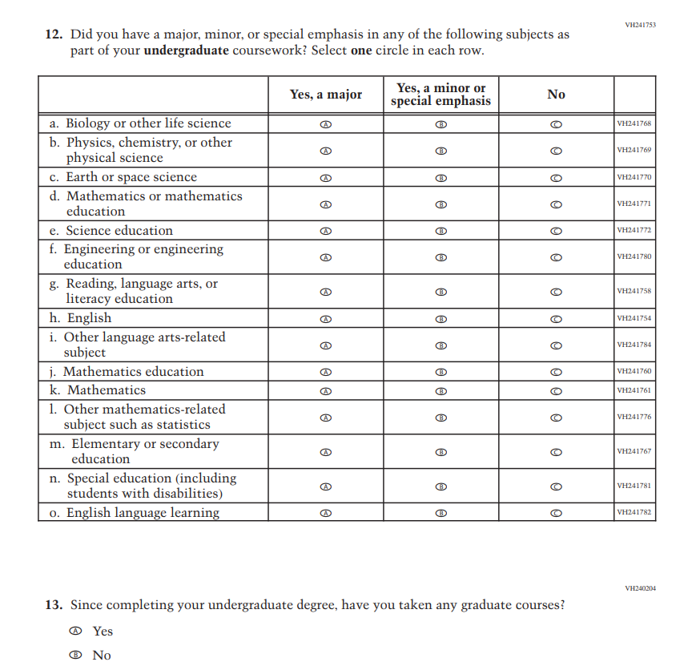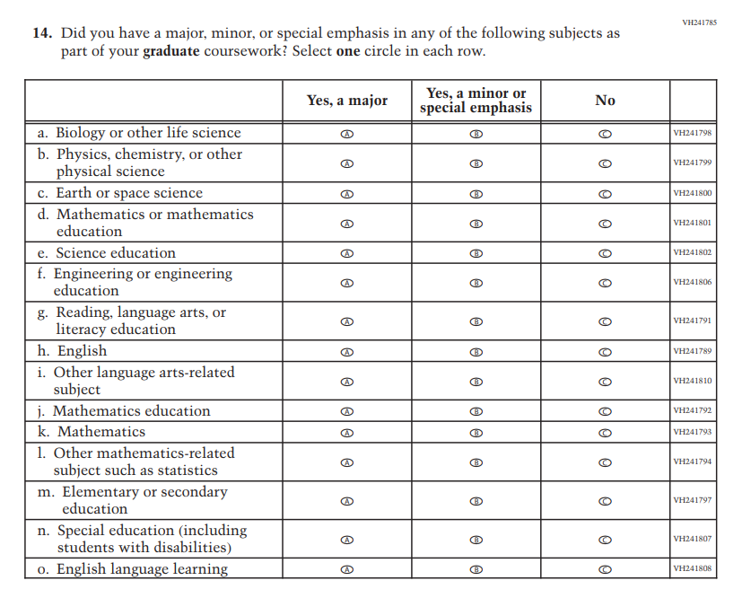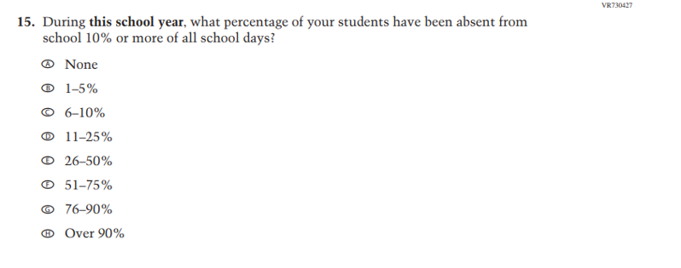
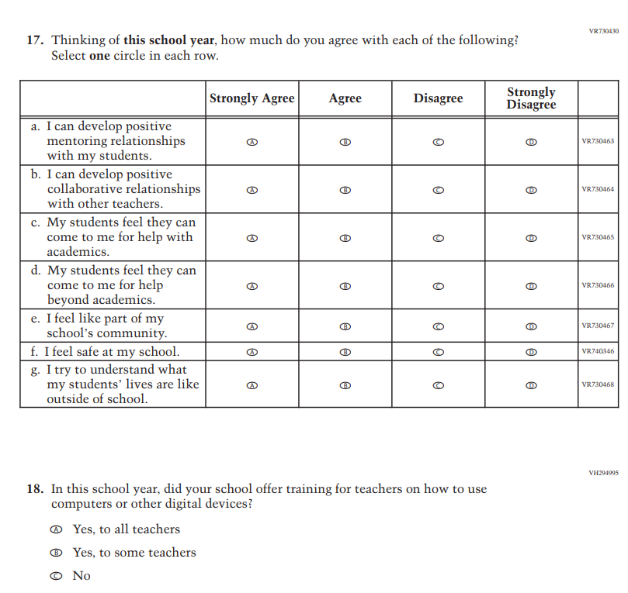
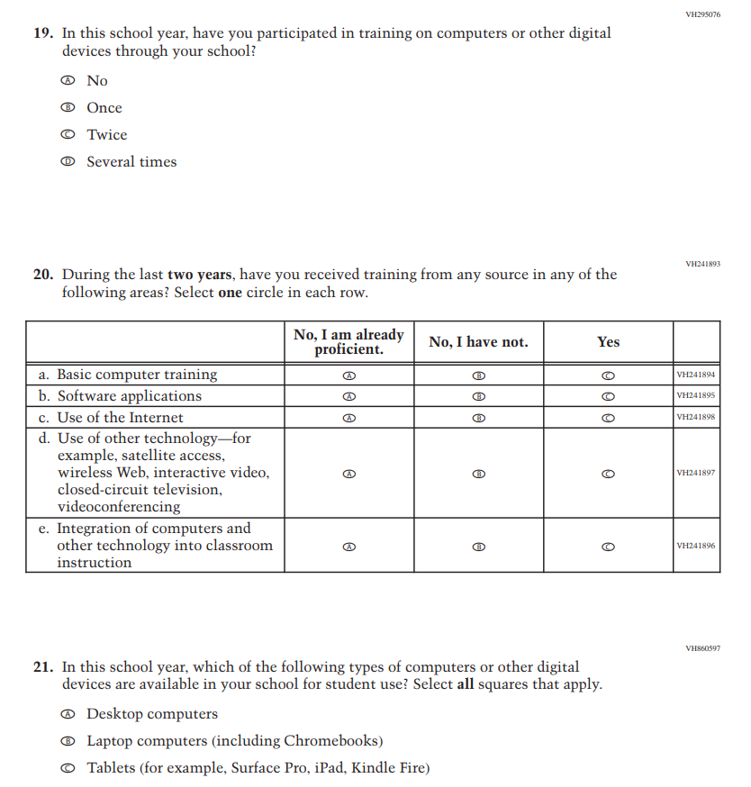
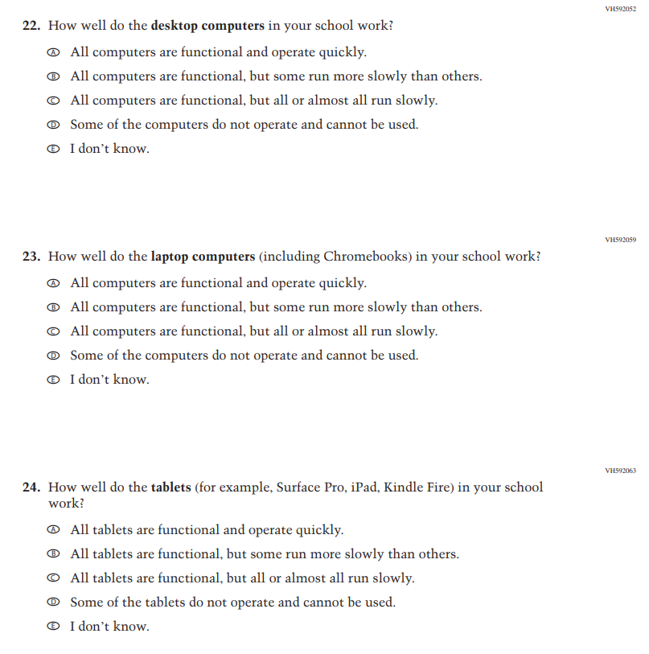
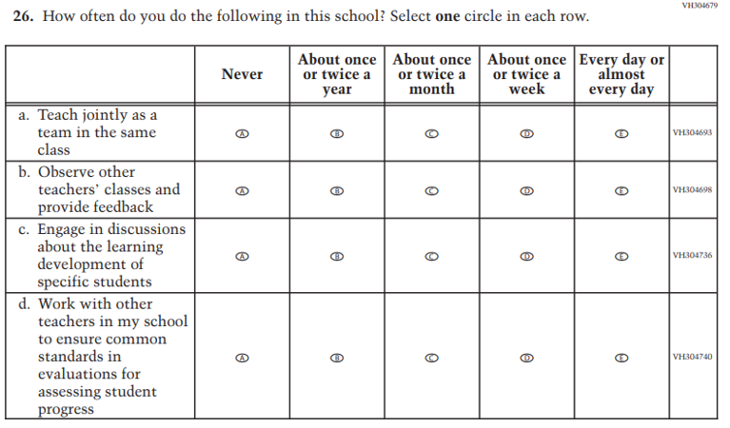
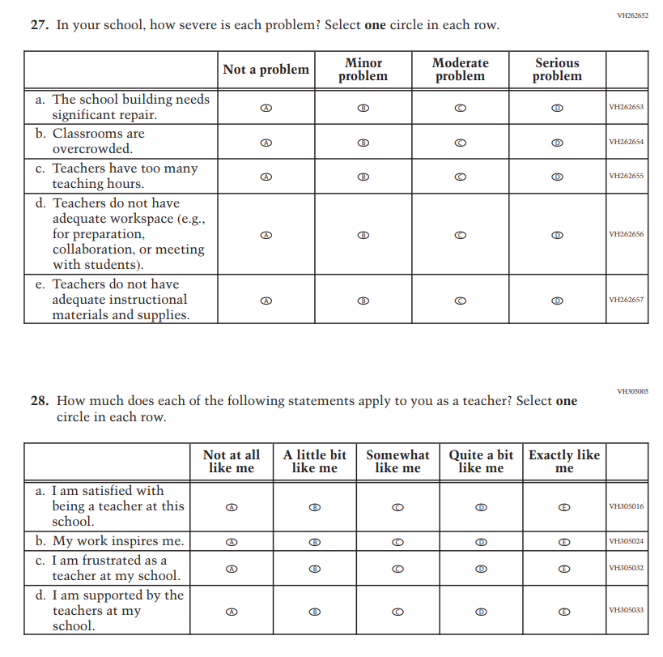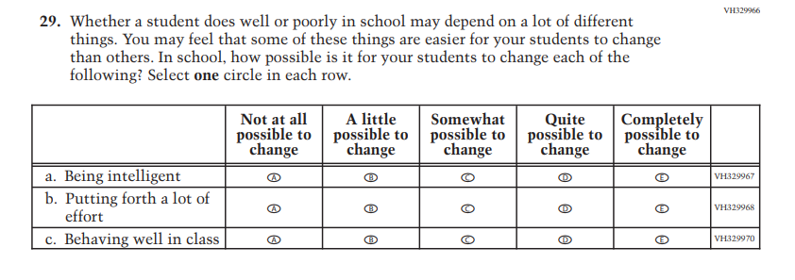

Appendix J2-5: Operational Grade 4 (Mathematics)
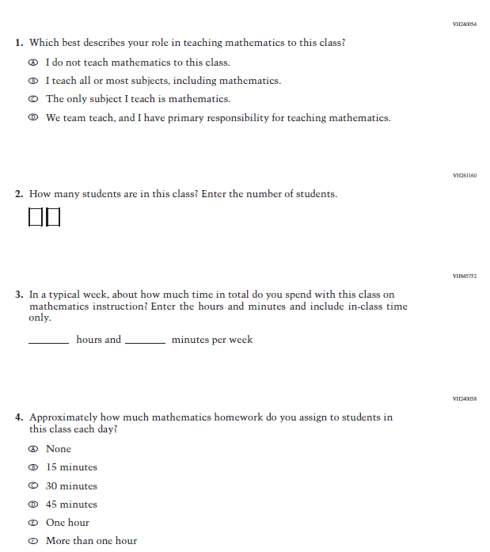

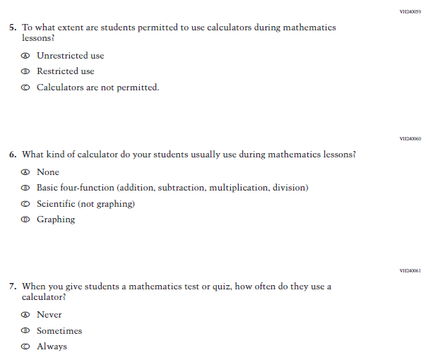

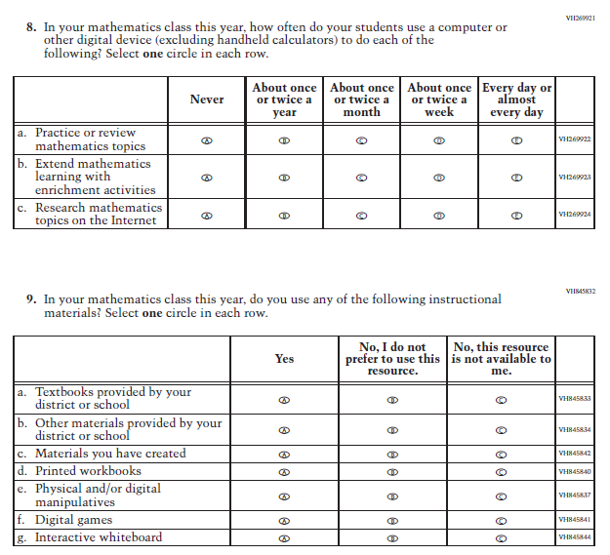

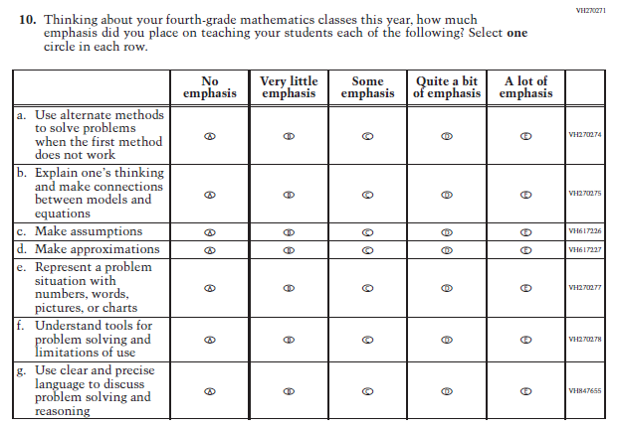

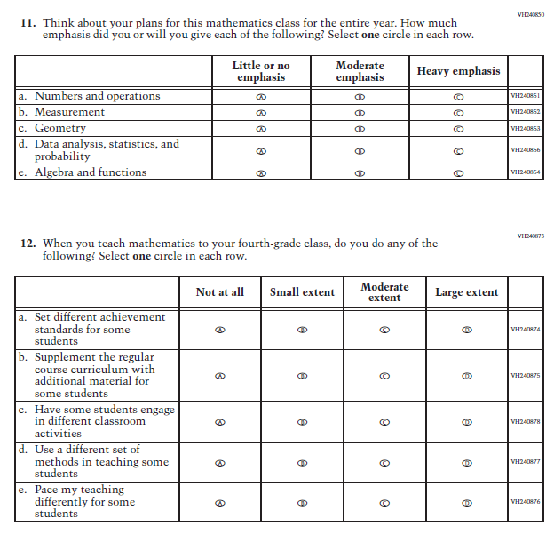

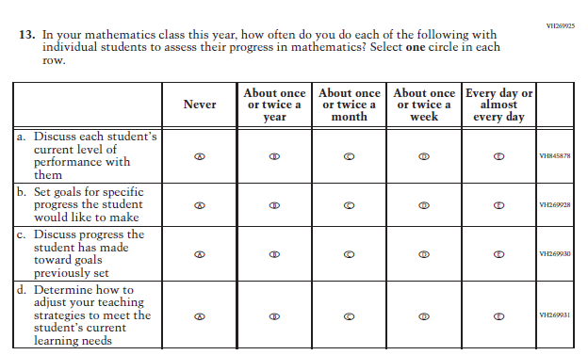

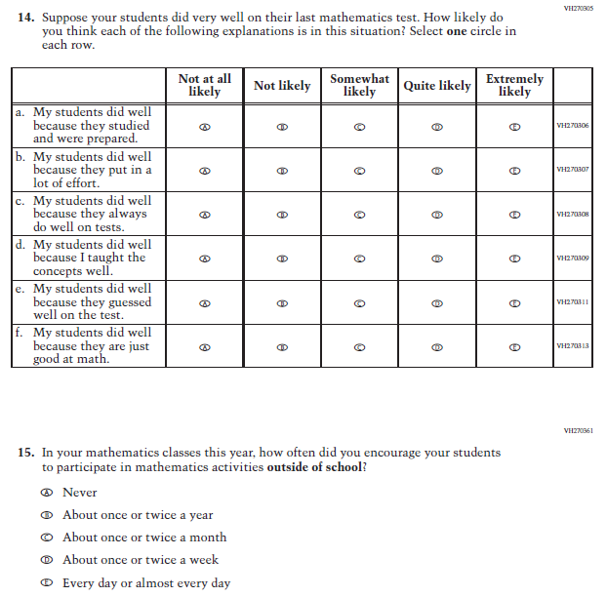

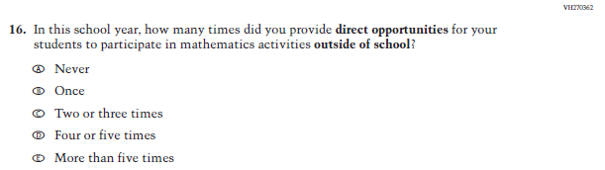

Appendix J2-6: Operational Grade 8 (Mathematics)
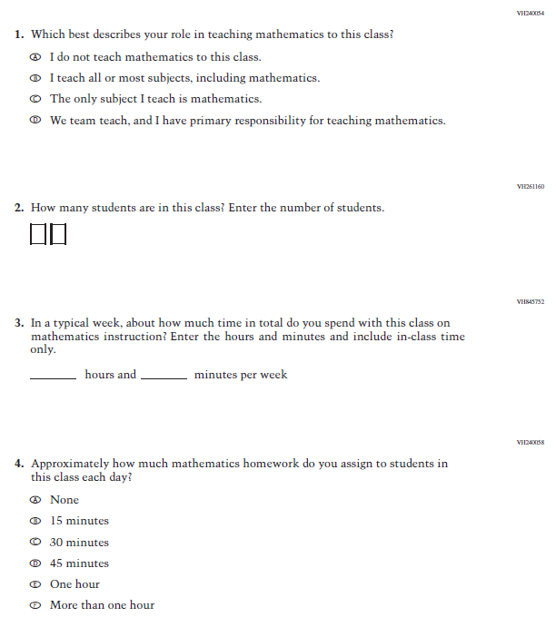

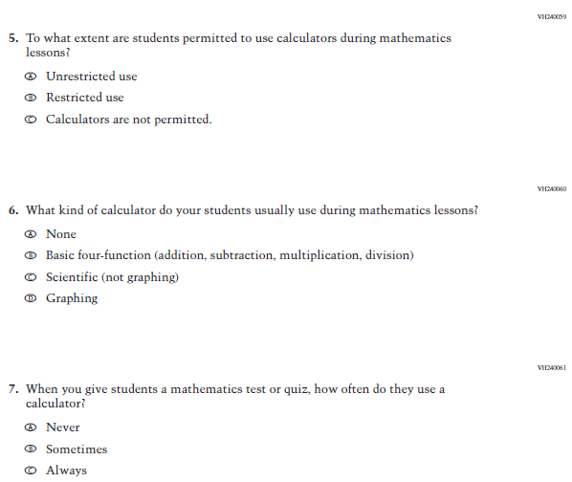

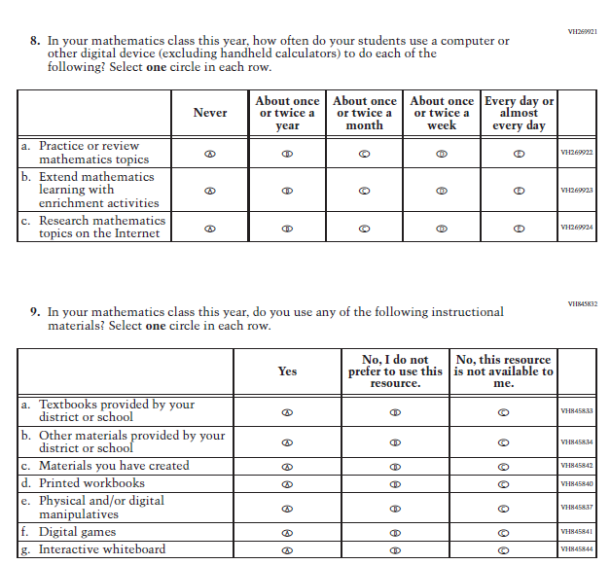

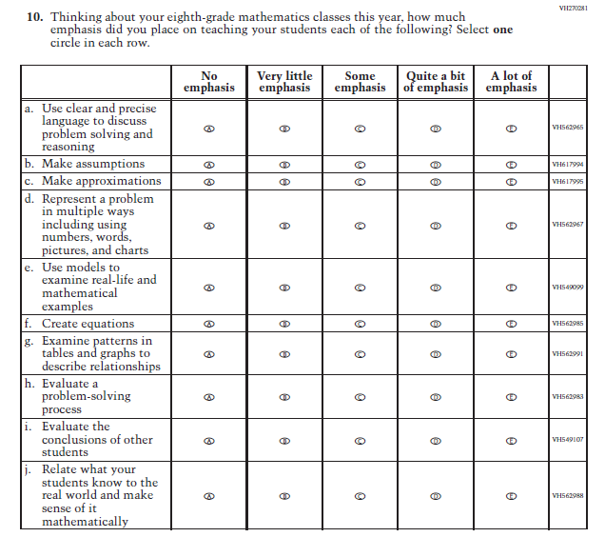

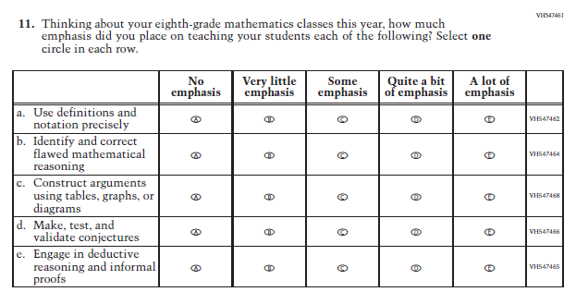

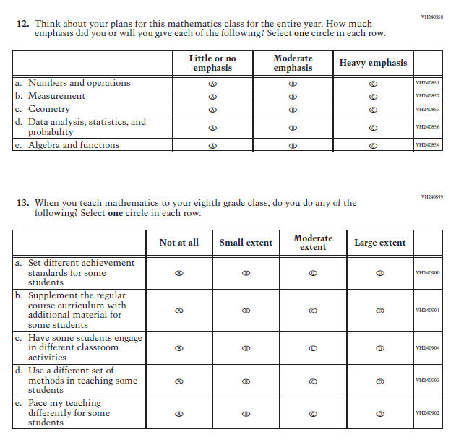

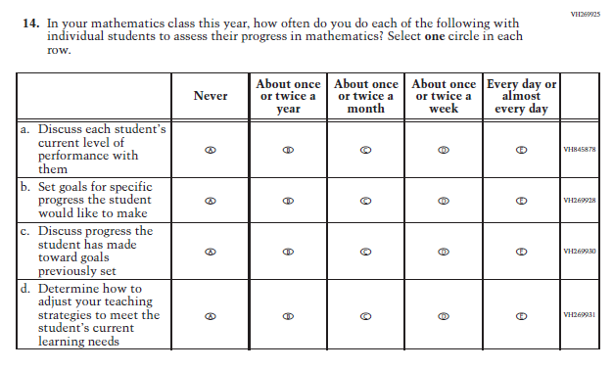

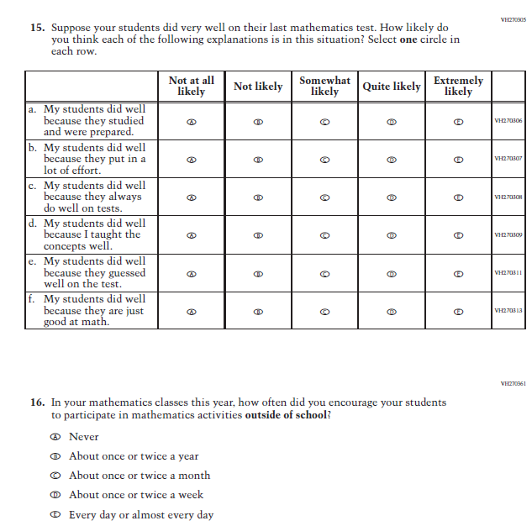

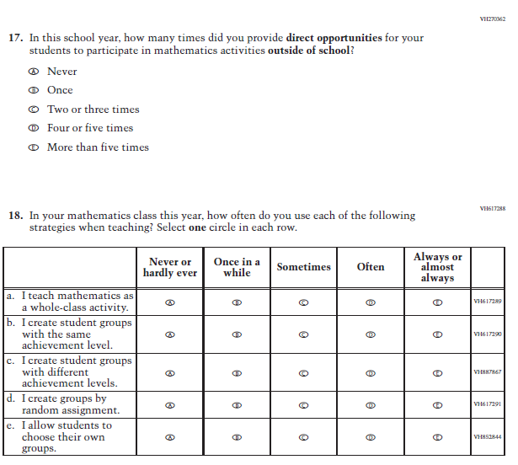

Appendix J2-7: Operational Grade 4 (Reading)
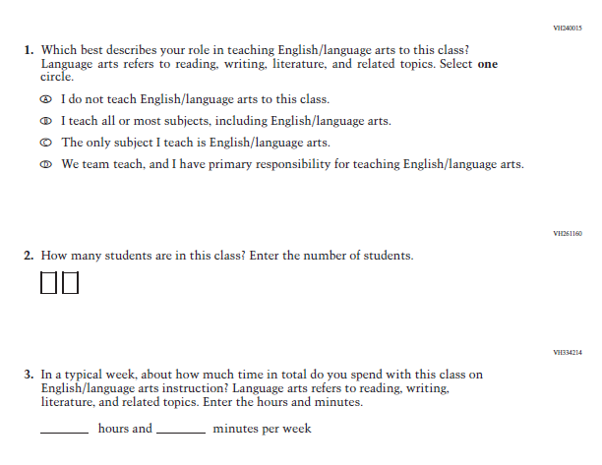

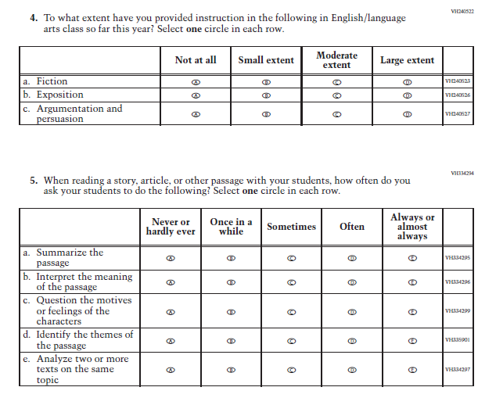

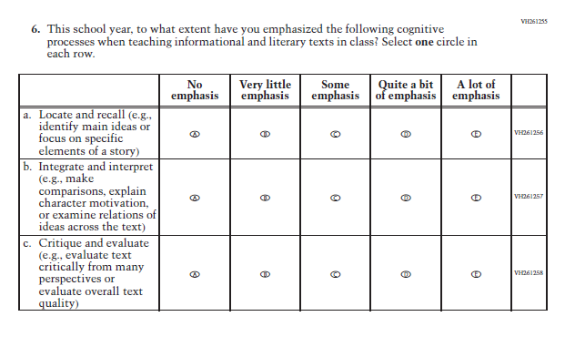

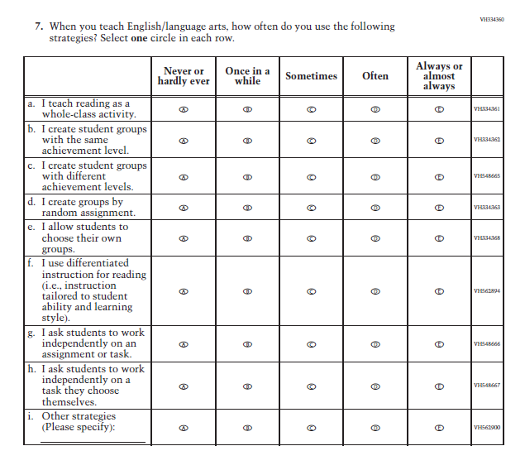

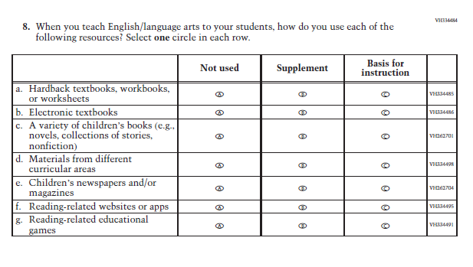

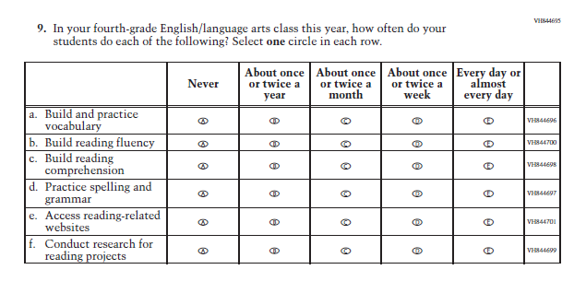

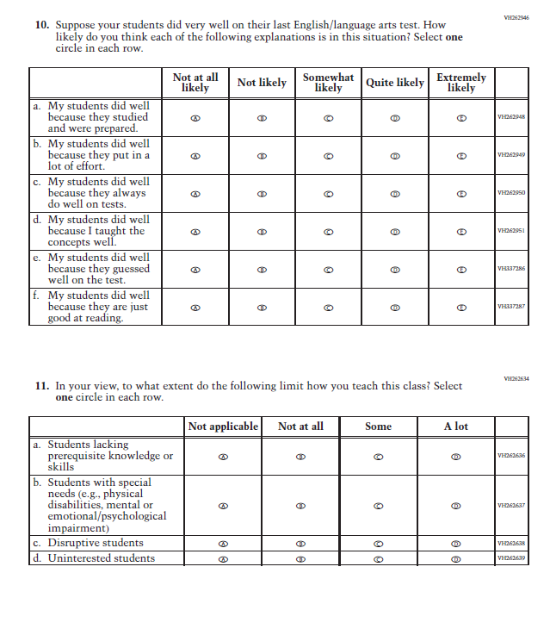

Appendix J2-8: Operational Grade 8 (Reading)
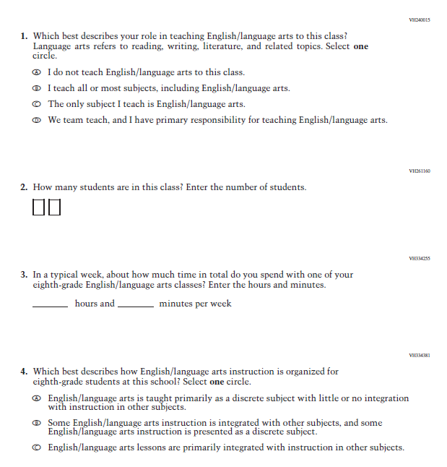

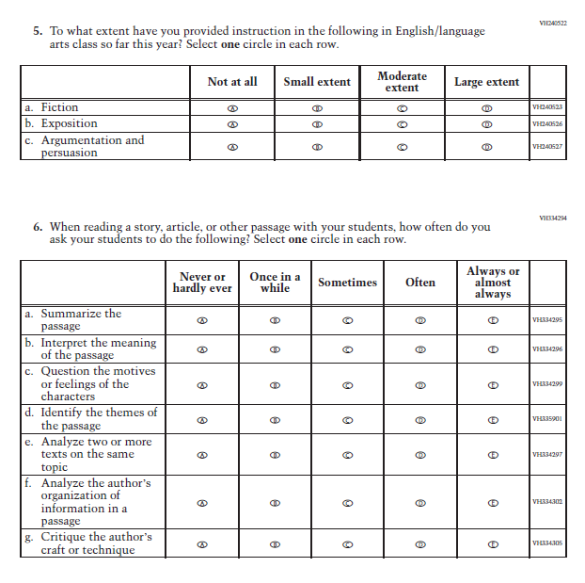

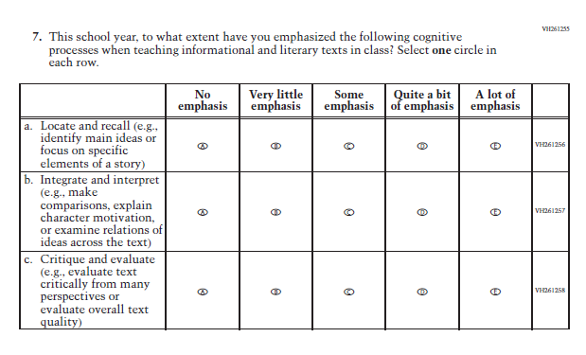

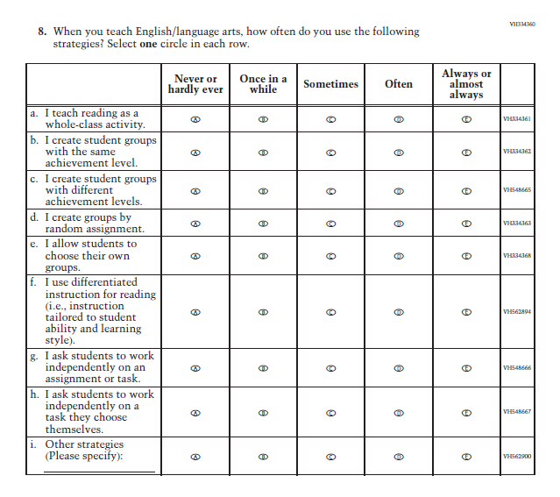

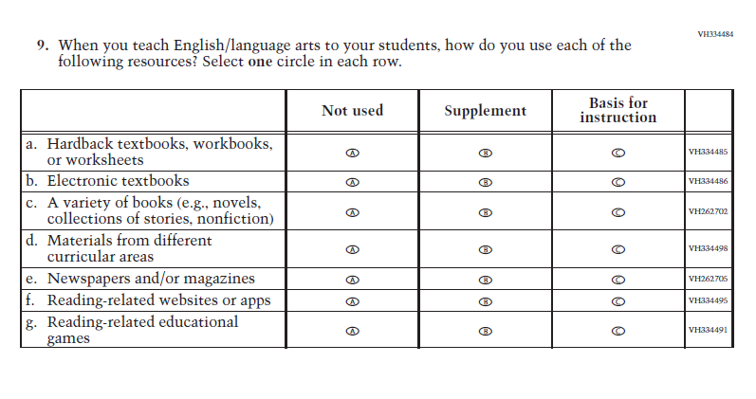

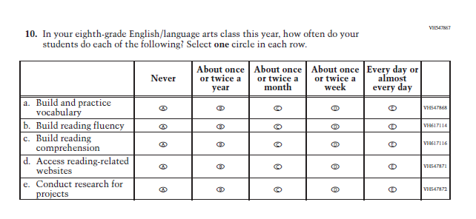

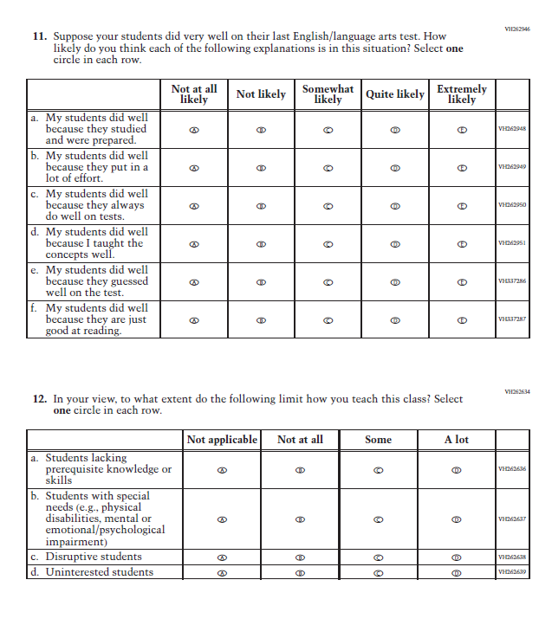

Appendix J2-9: Operational Grade 8 (Science)
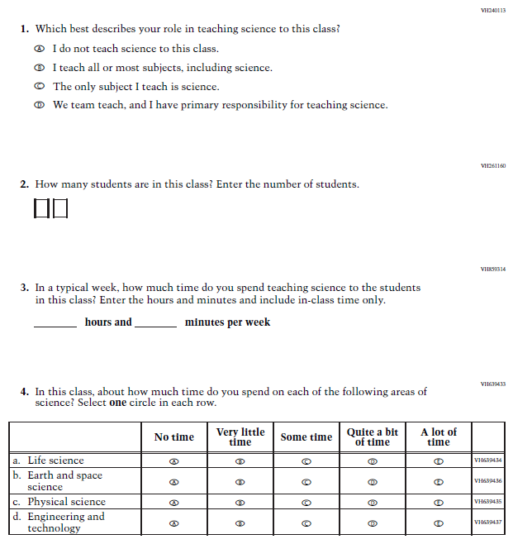

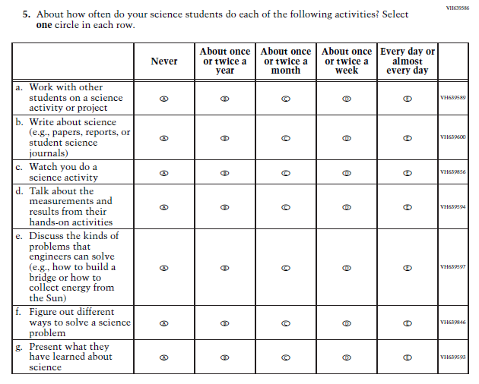

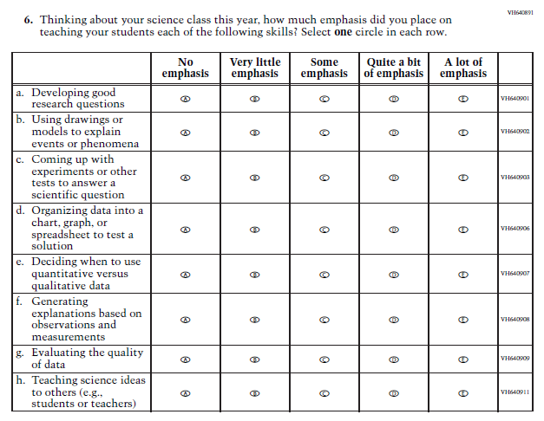
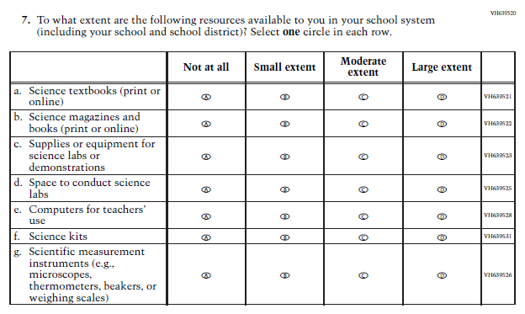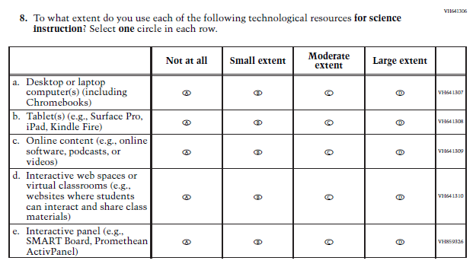

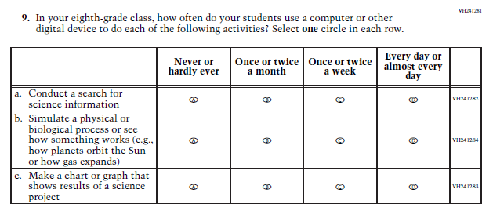
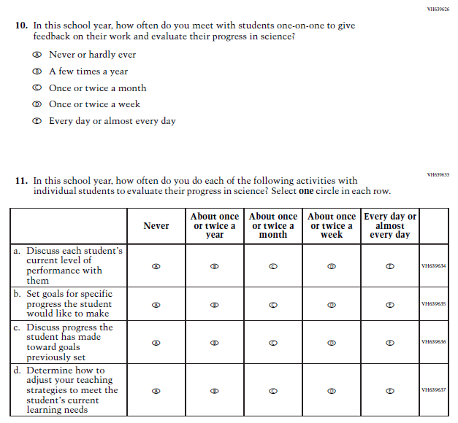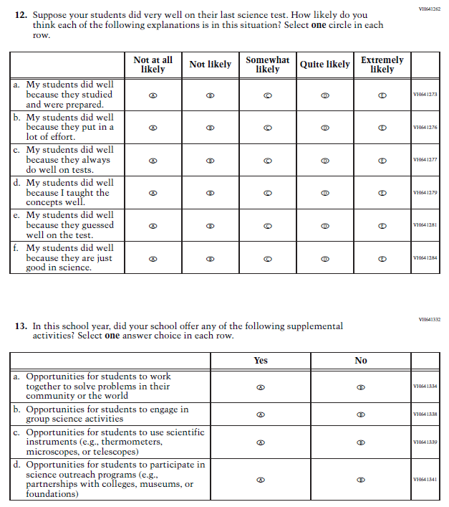

Appendix J2-14: Pilot Reading and Mathematics Grade 4 (Core)
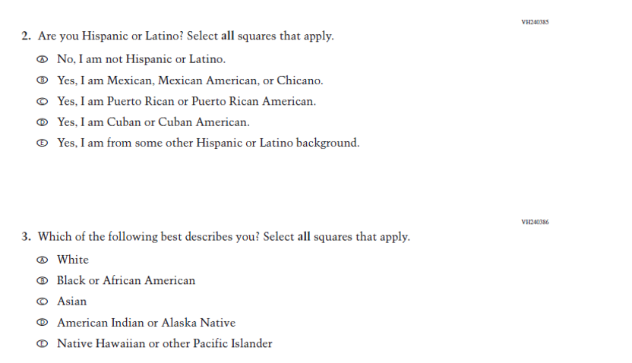
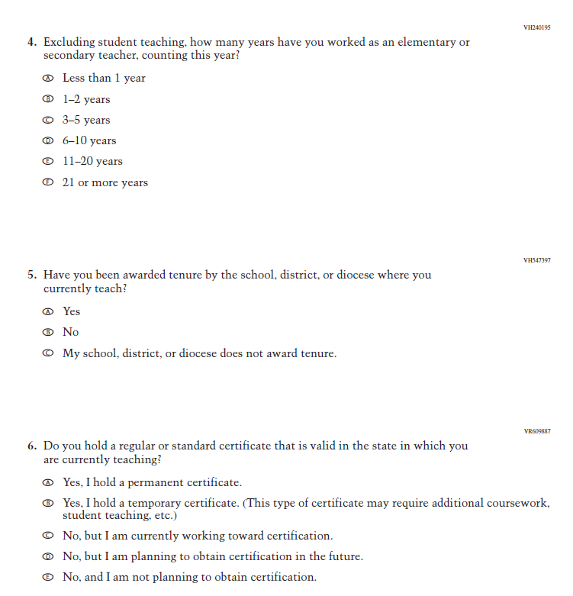
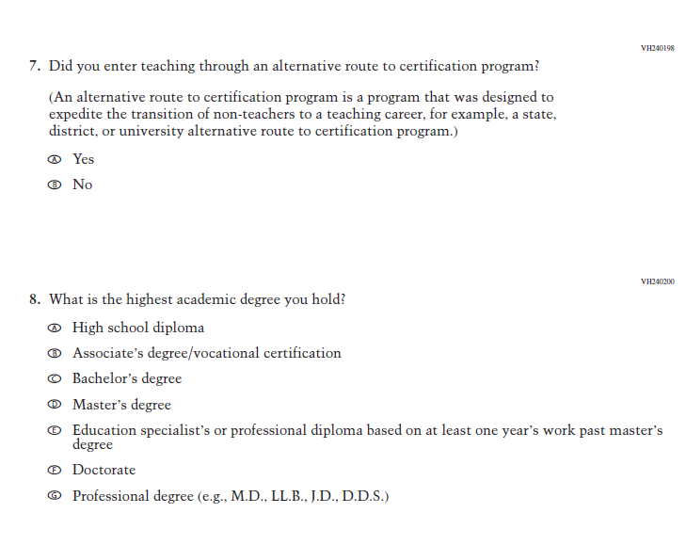
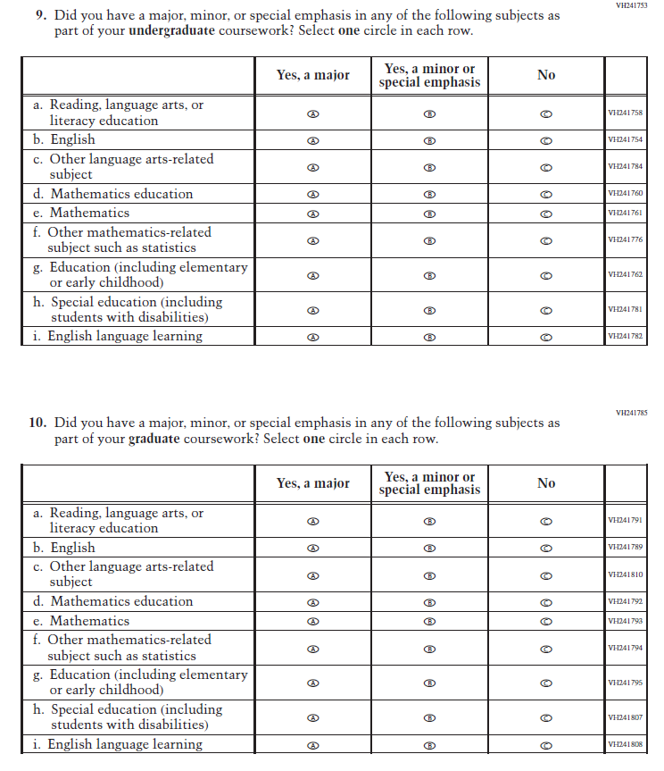
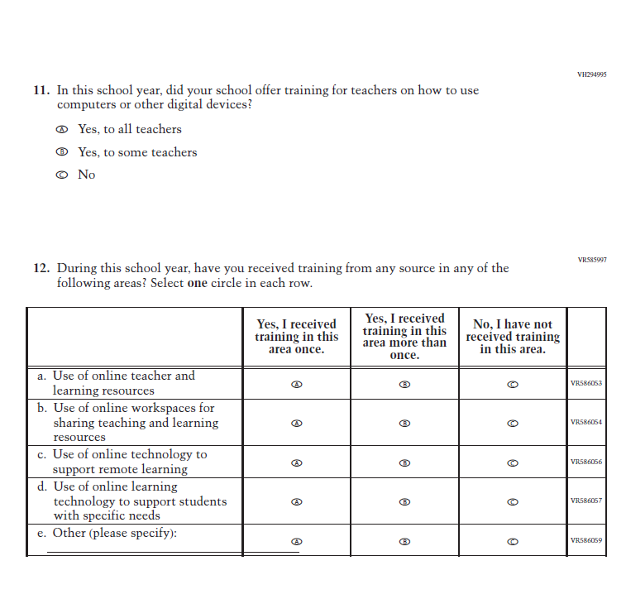
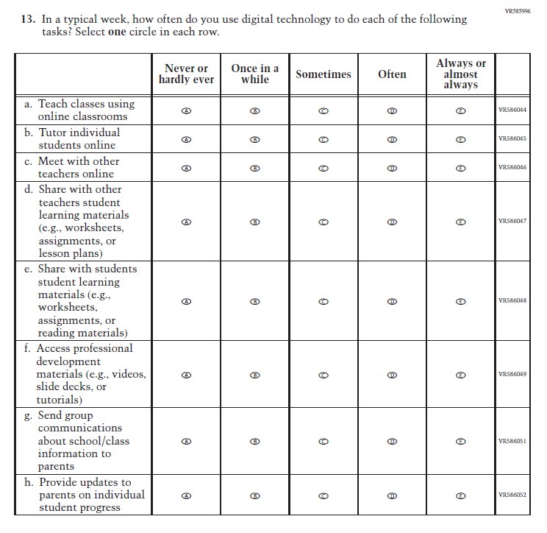
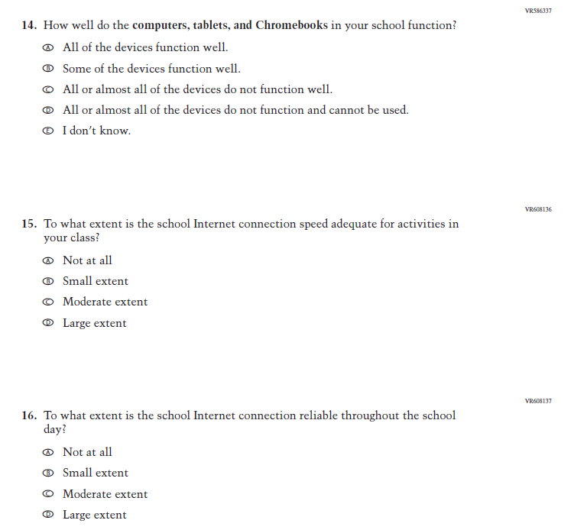
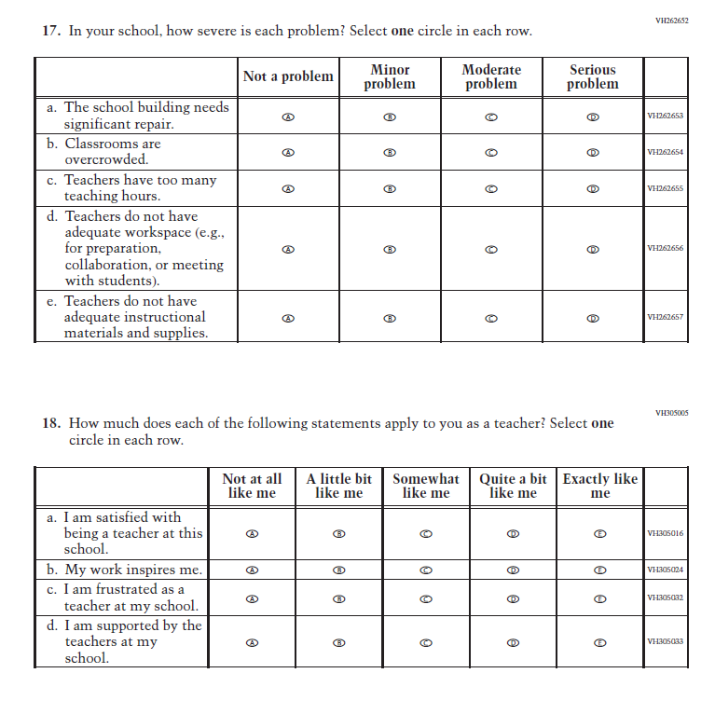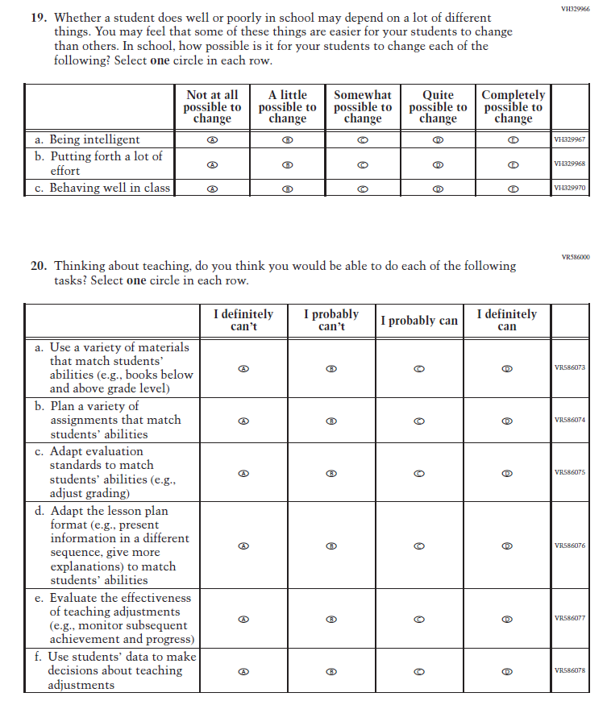
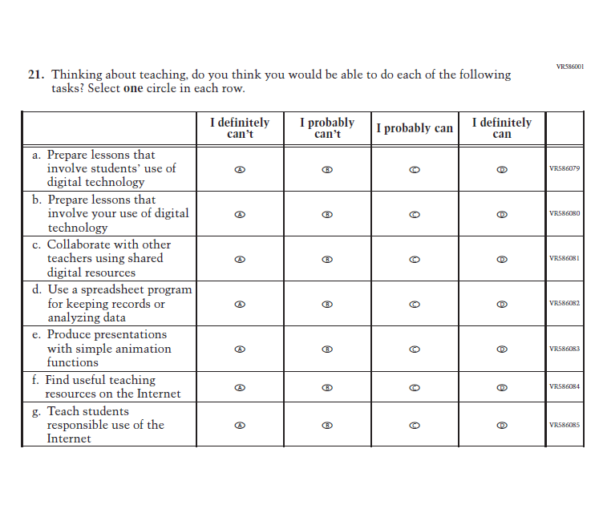

Appendix J2-15: Pilot Mathematics Grade 8 (Core)
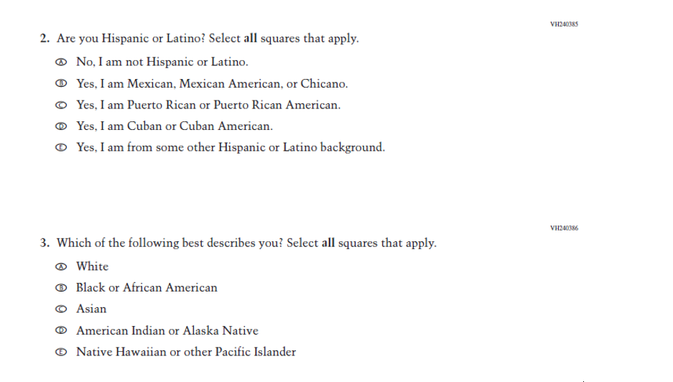
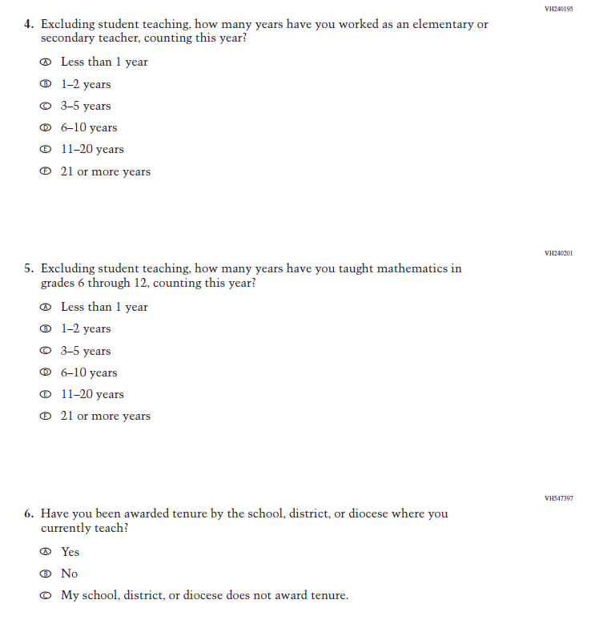
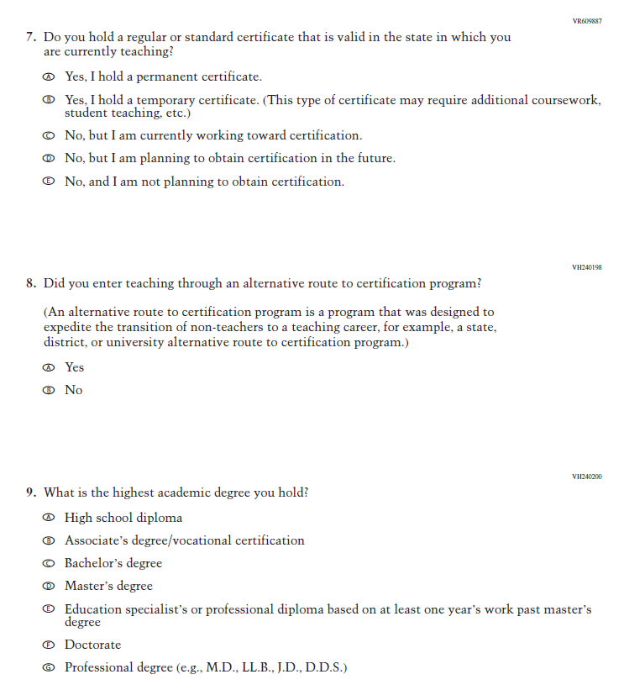
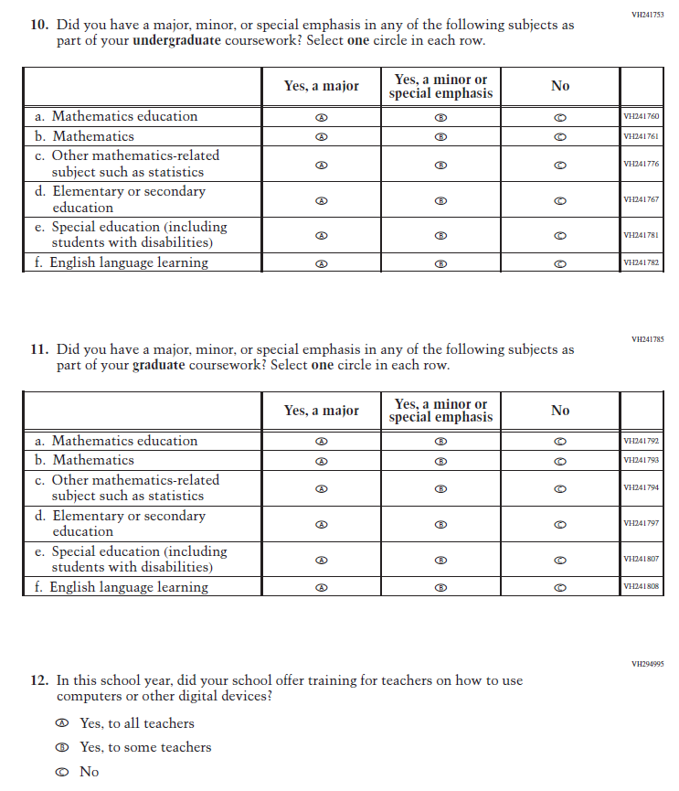
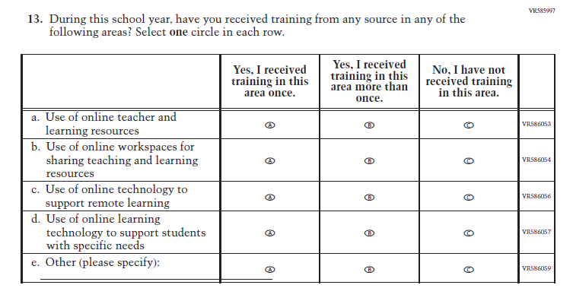
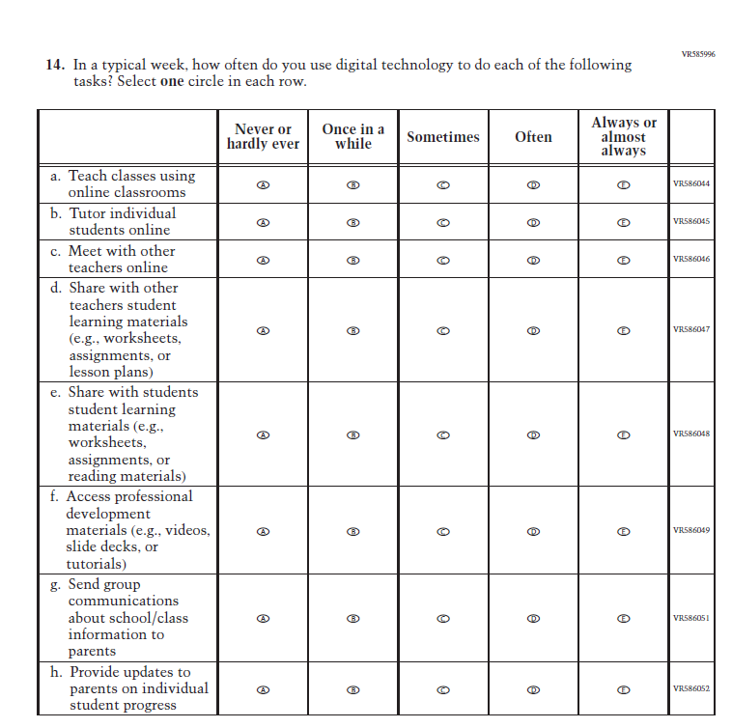
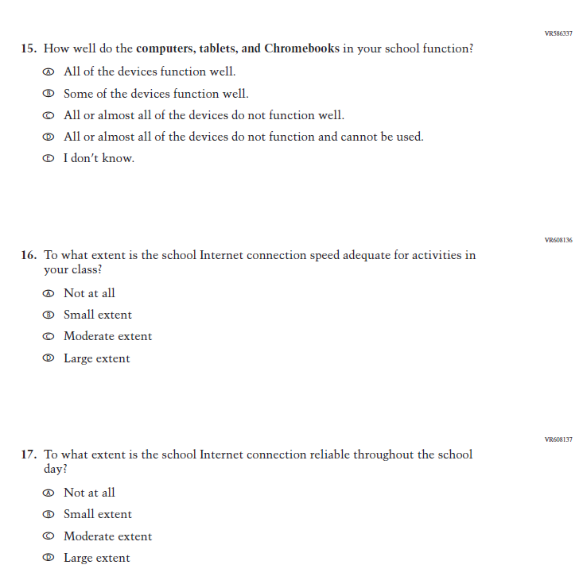
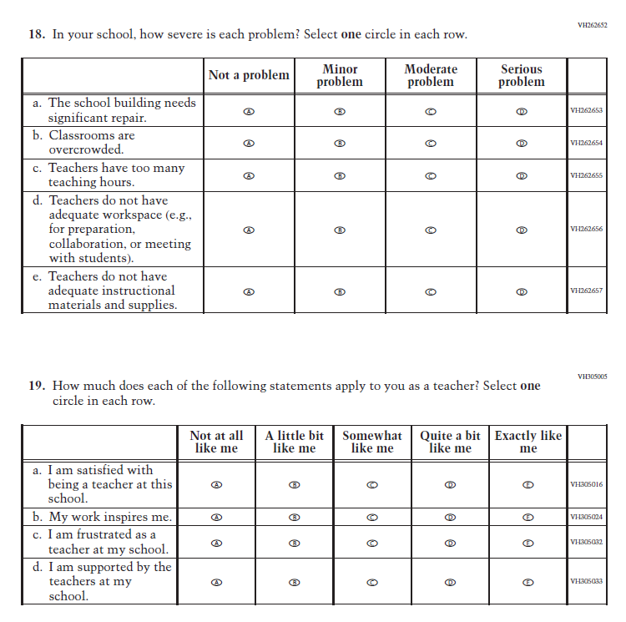
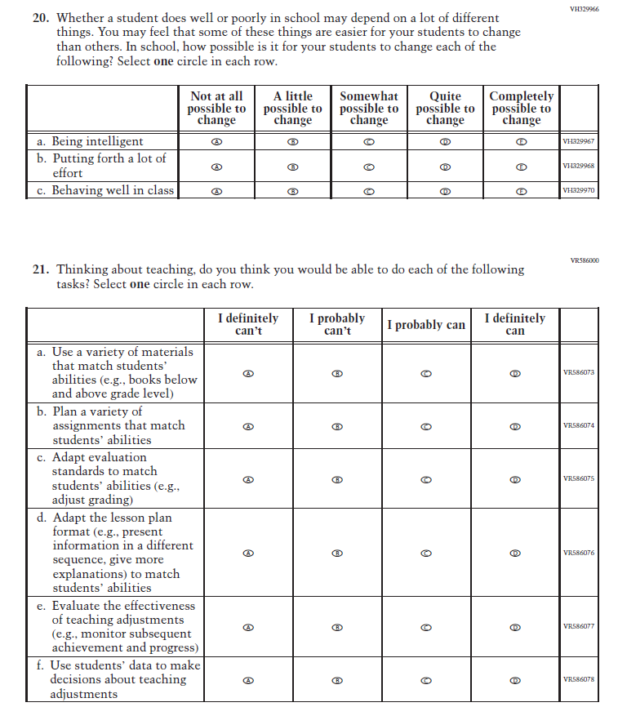
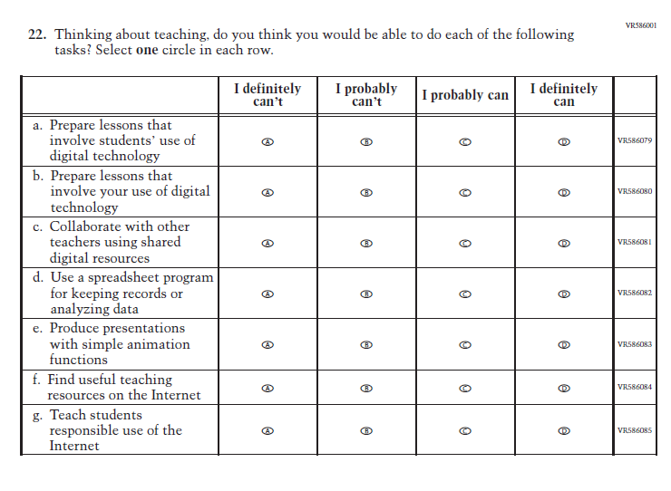

Appendix J2-16: Pilot Reading Grade 8 (Core)
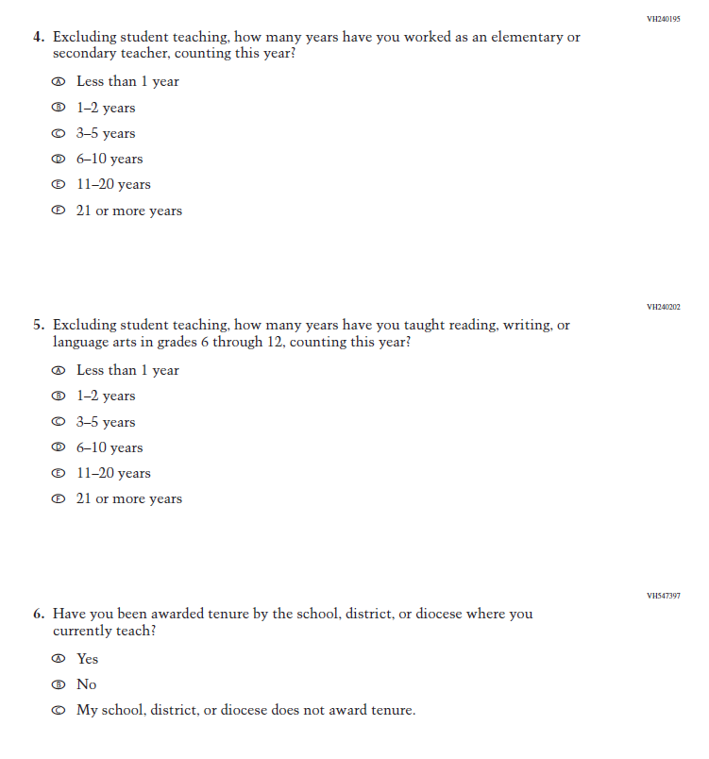
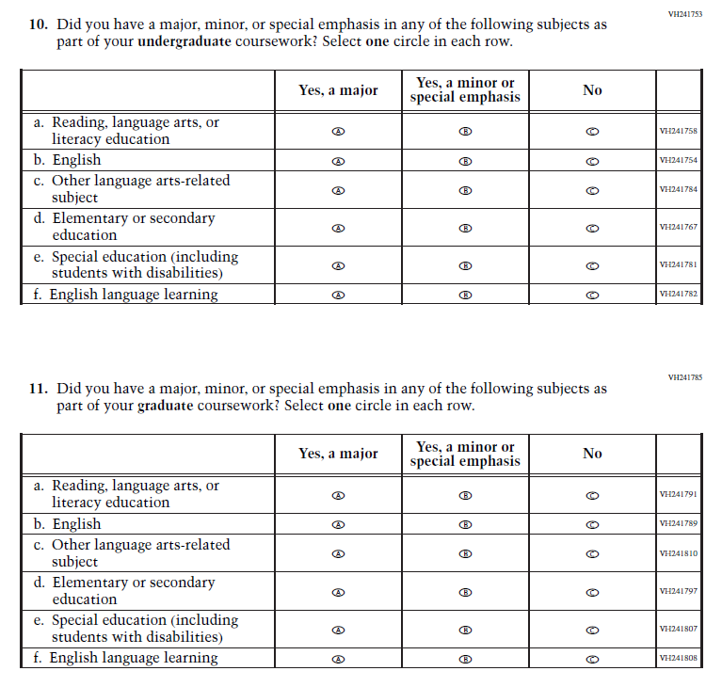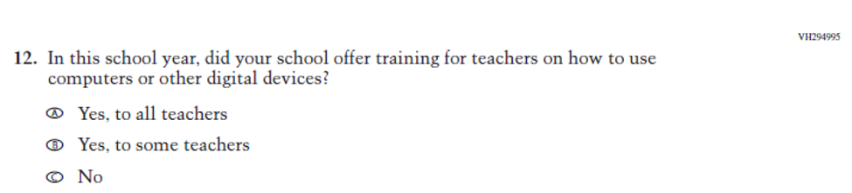

Appendix J2-17: Pilot Grade 4 (Mathematics)
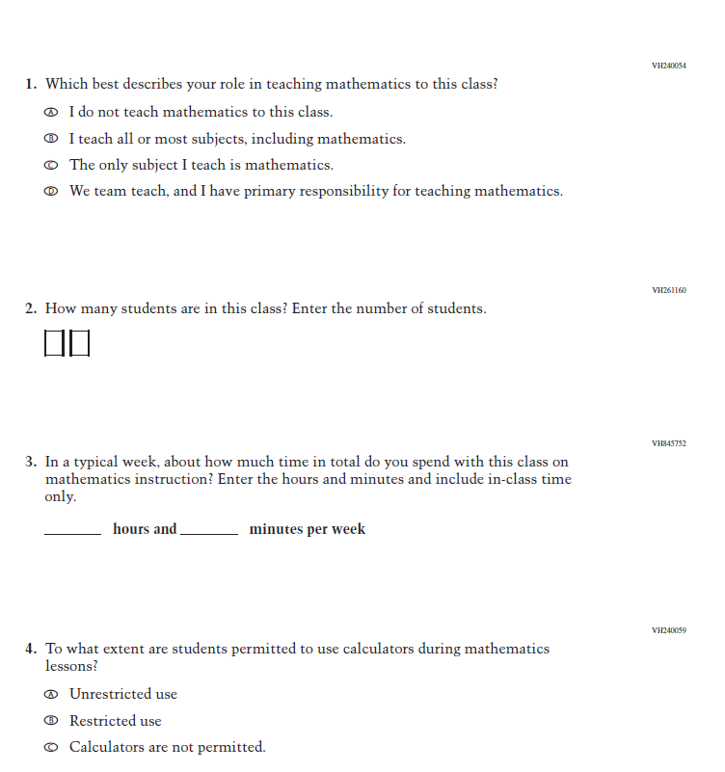
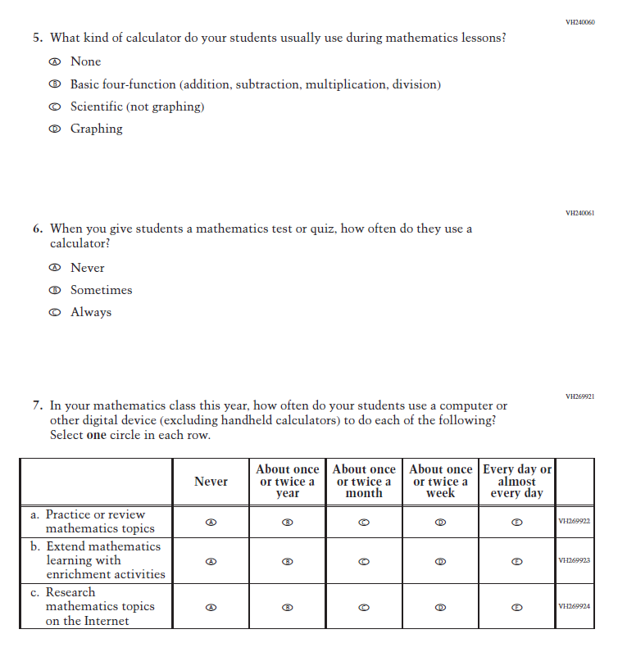
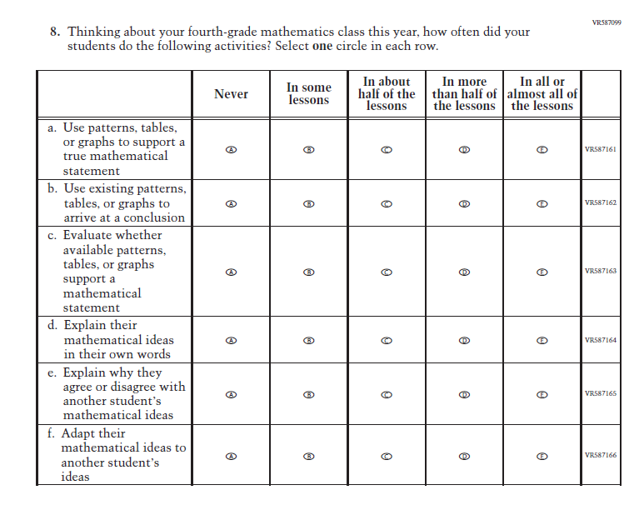
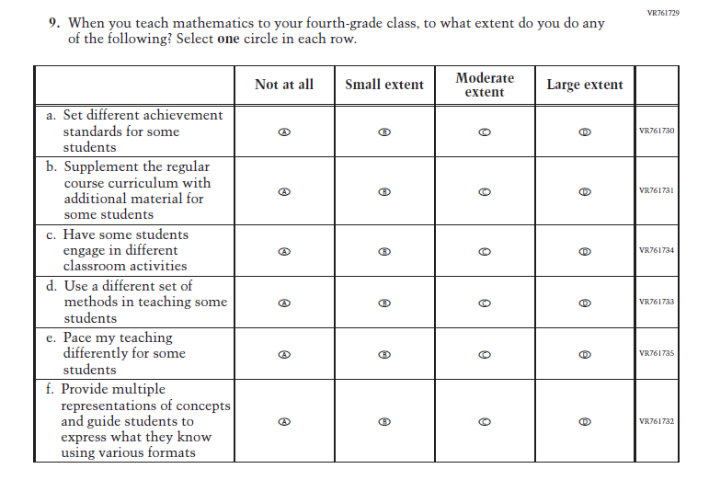
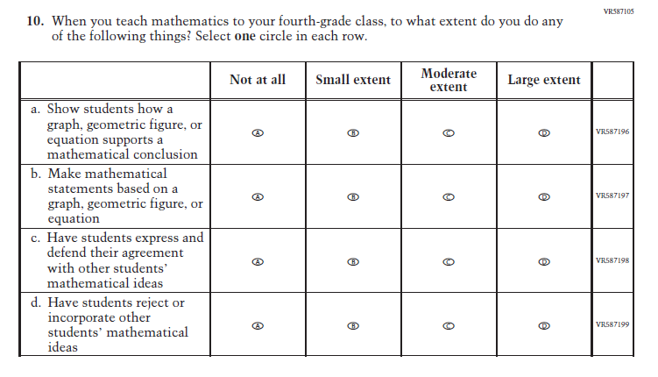
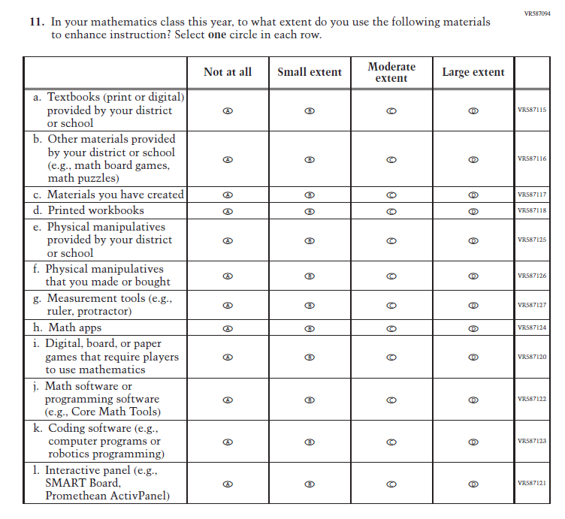
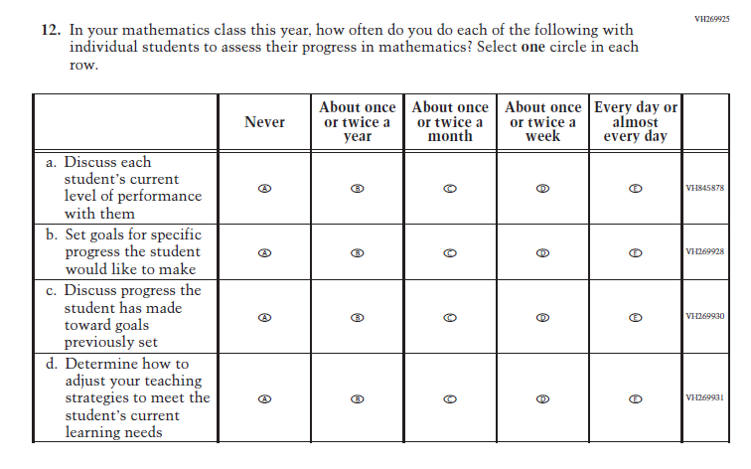
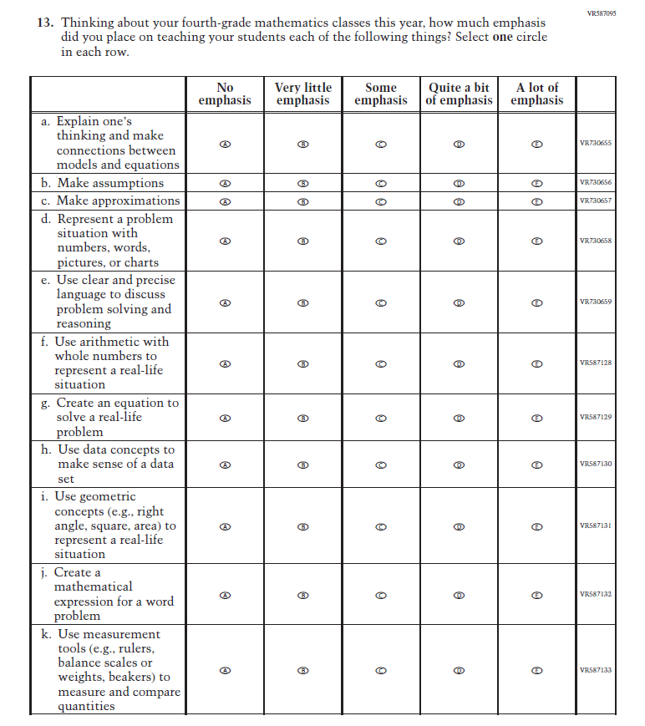
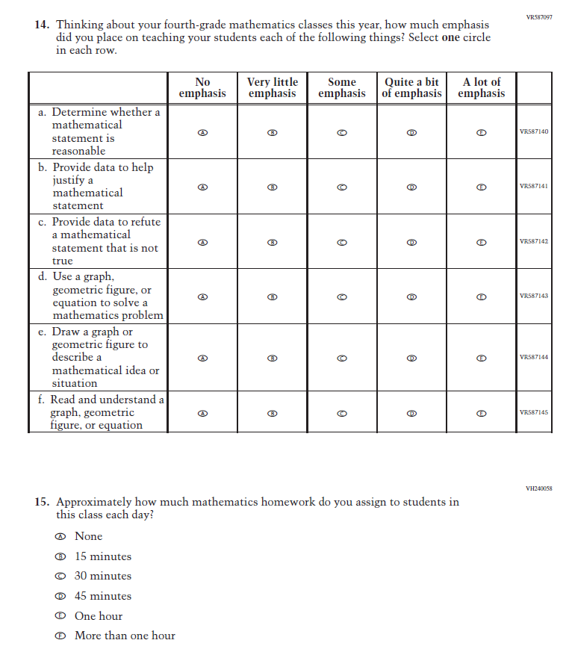
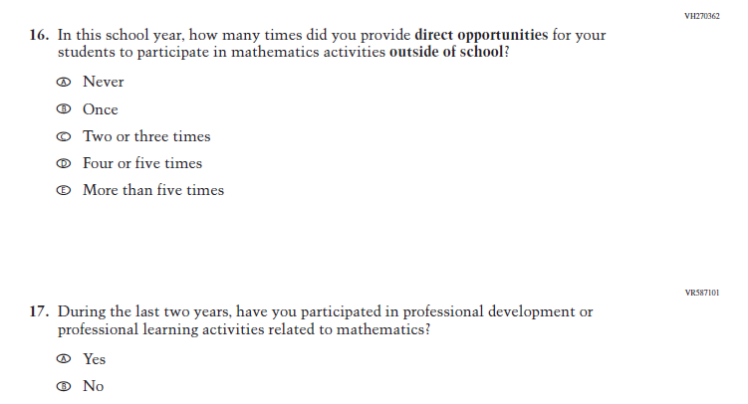
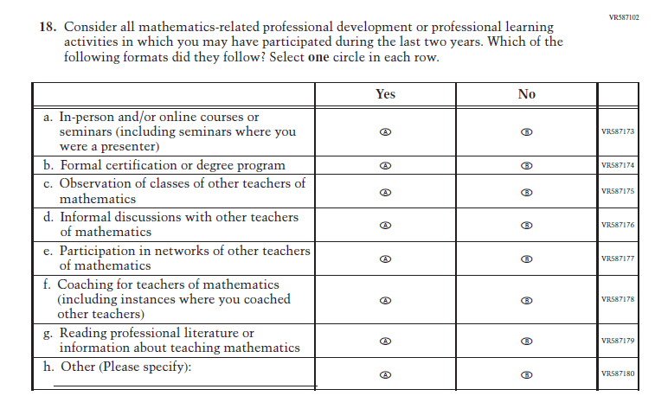
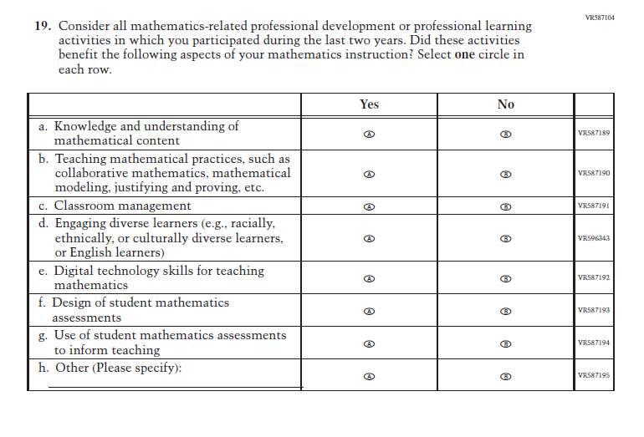

Appendix J2-18: Pilot Grade 8 (Mathematics)
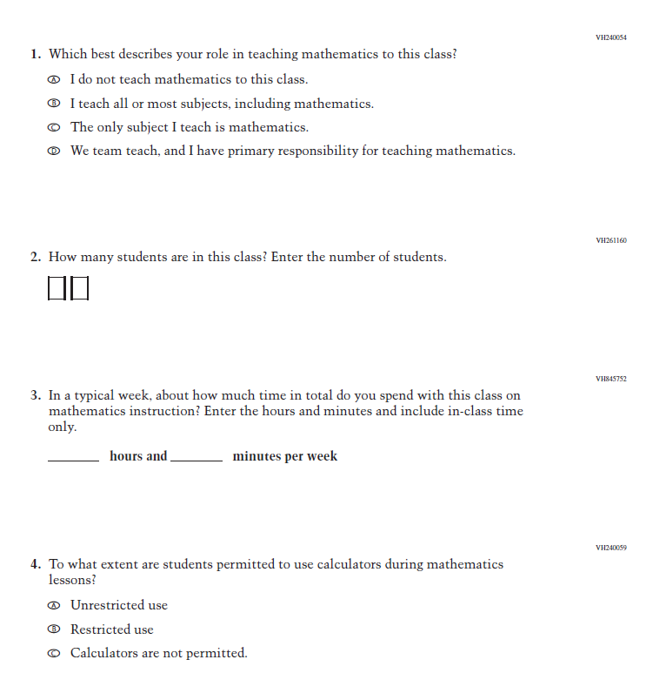
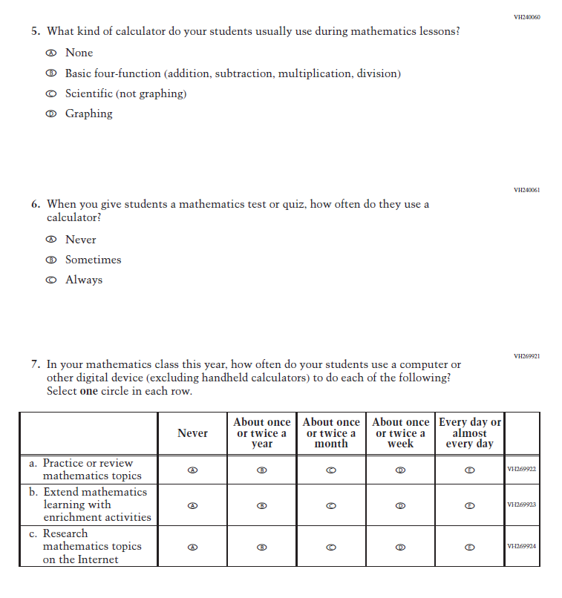
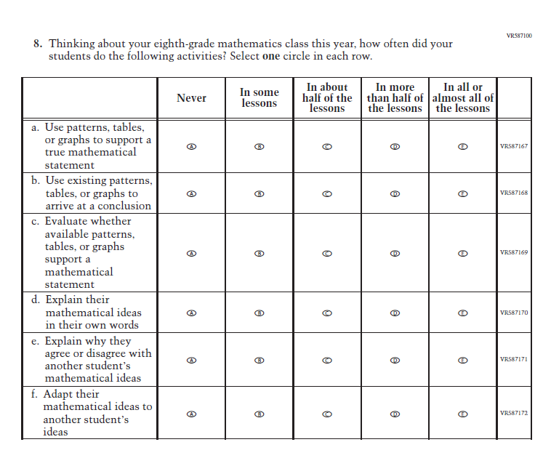
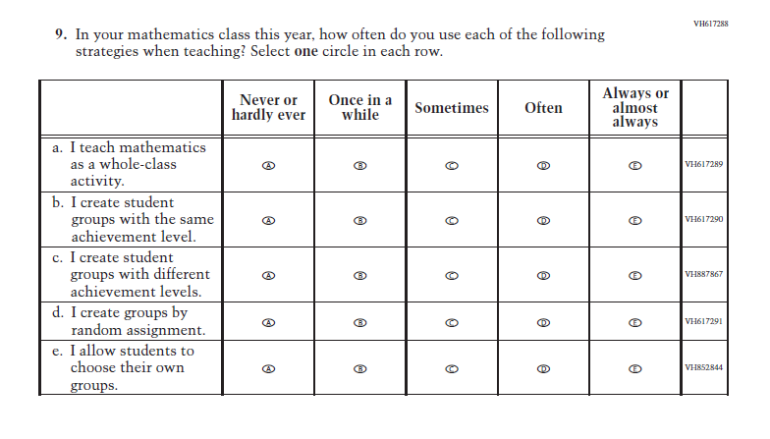
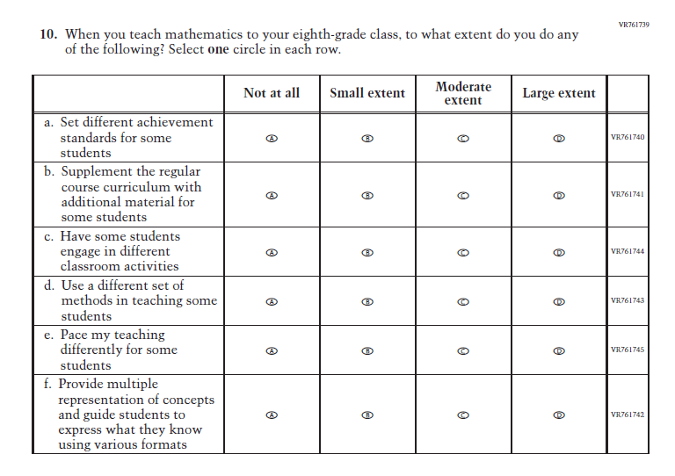
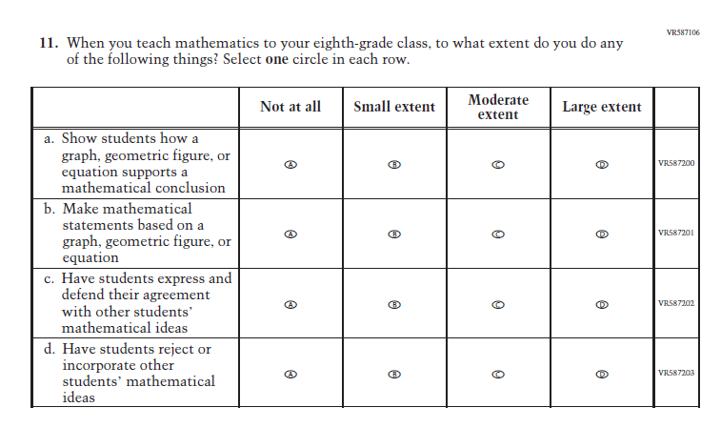
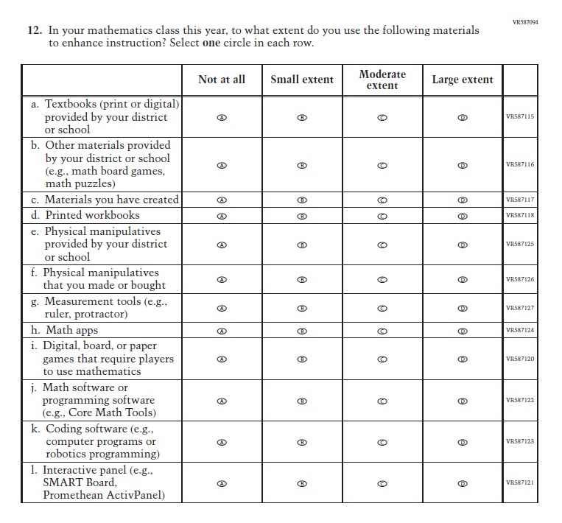
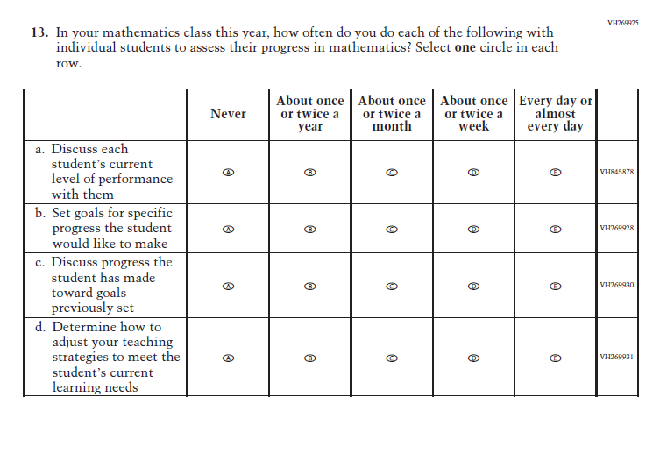
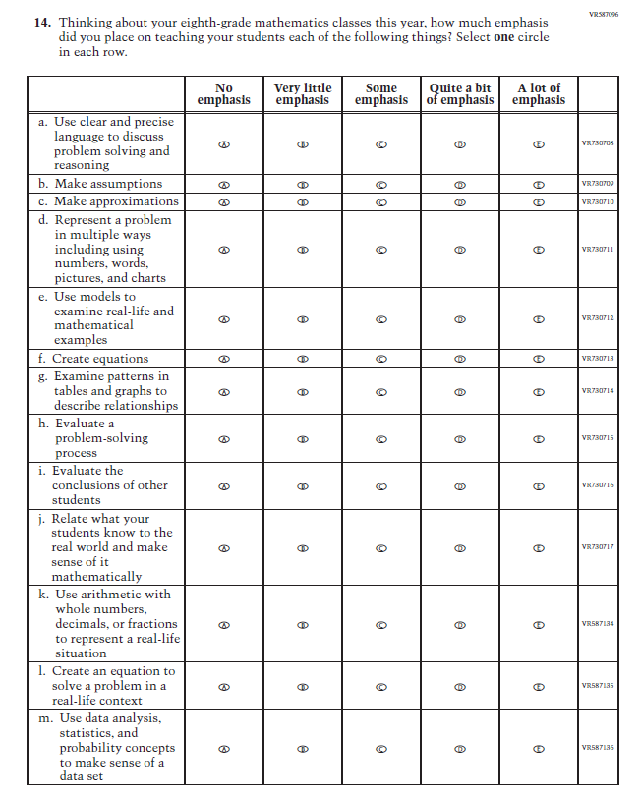
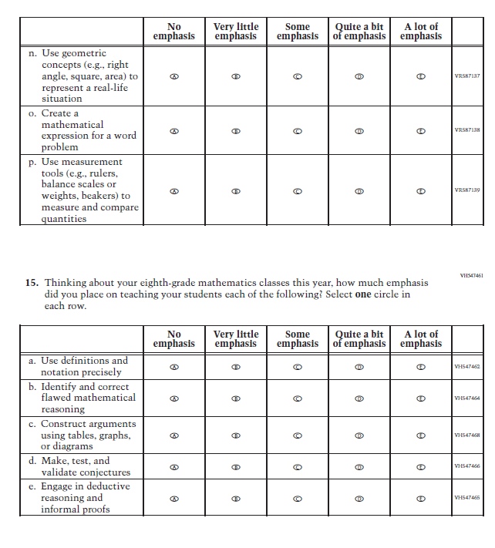
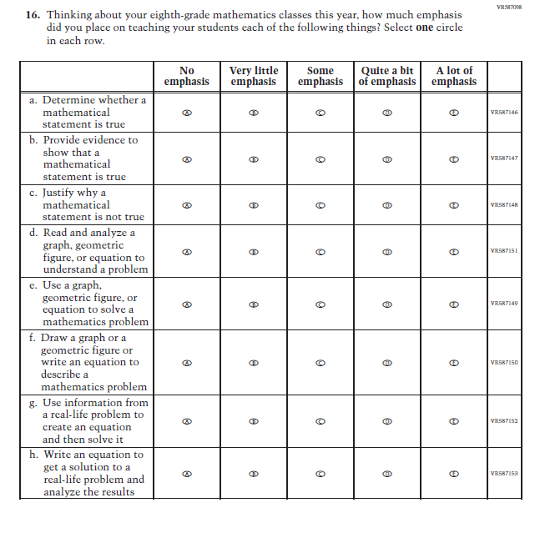
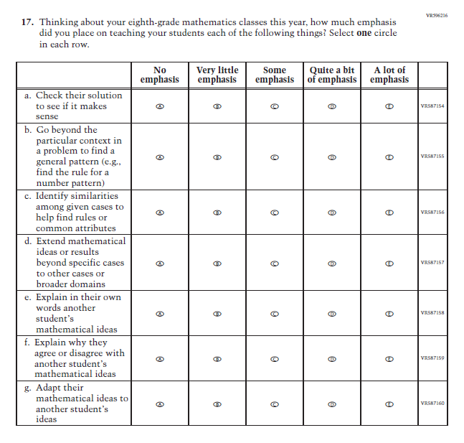
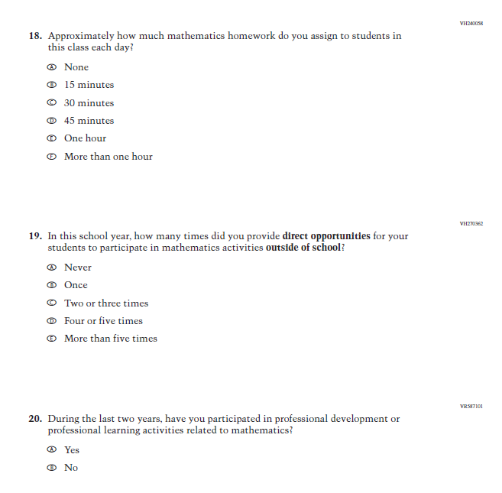
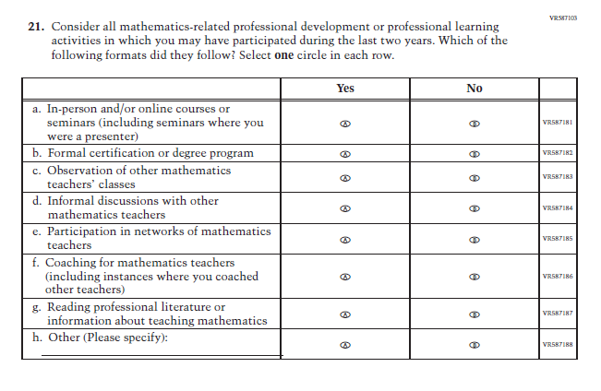
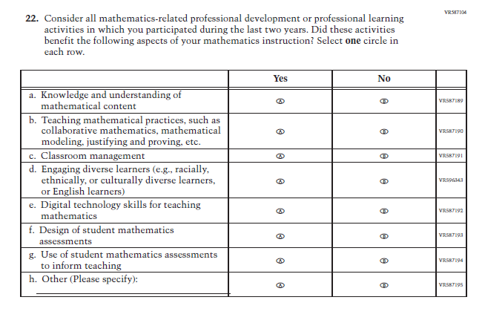

Appendix J2-19: Pilot Grade 4 (Reading)
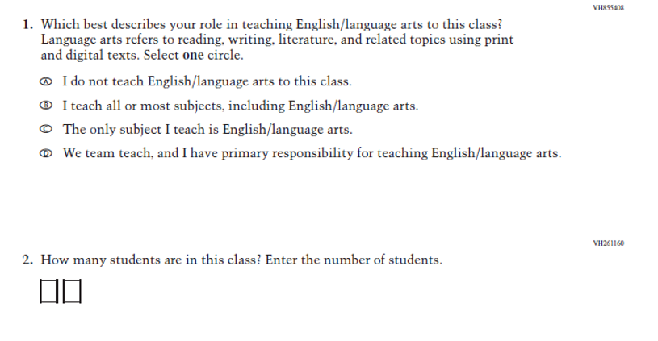
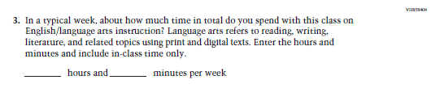
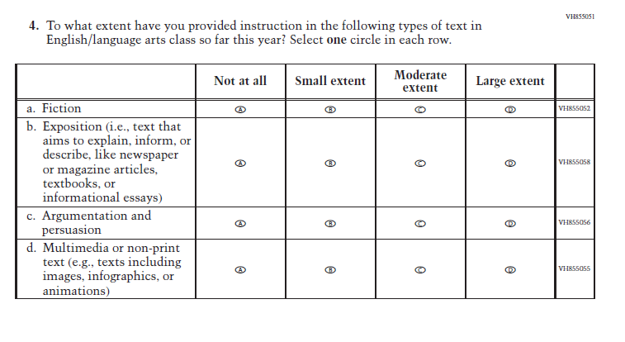
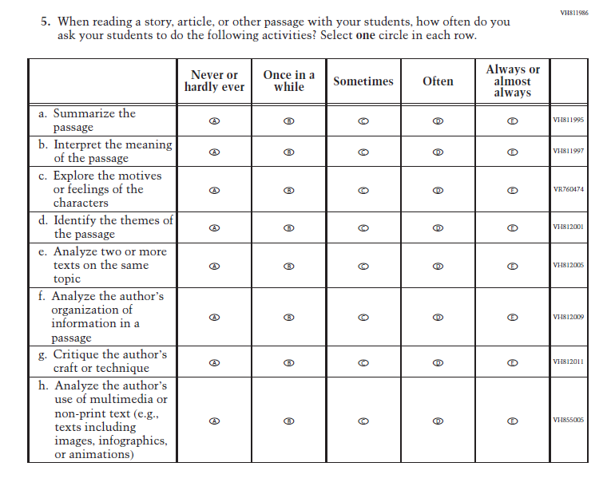
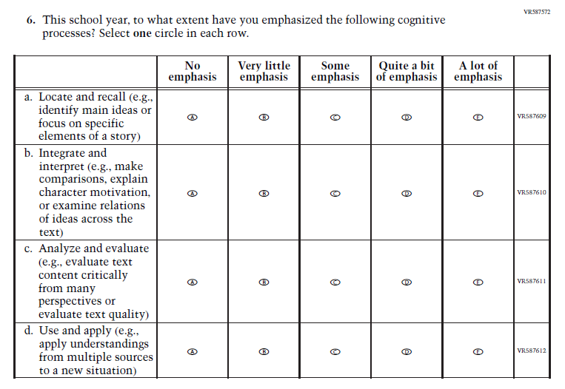
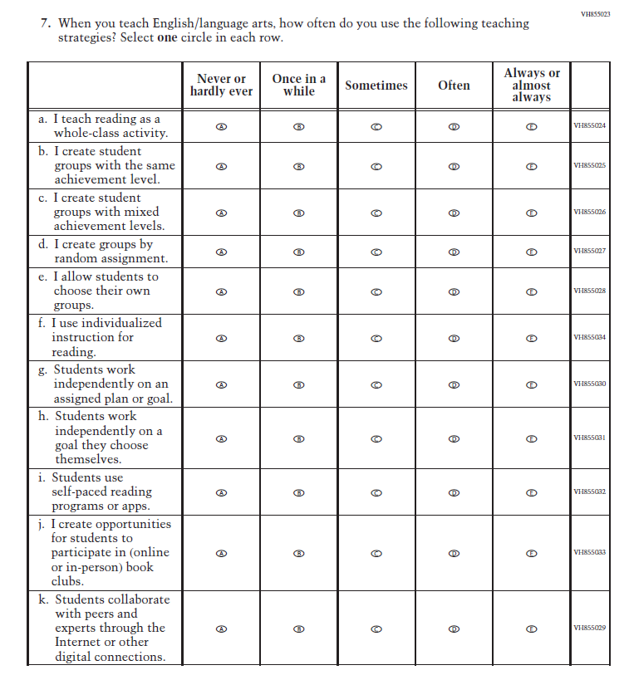
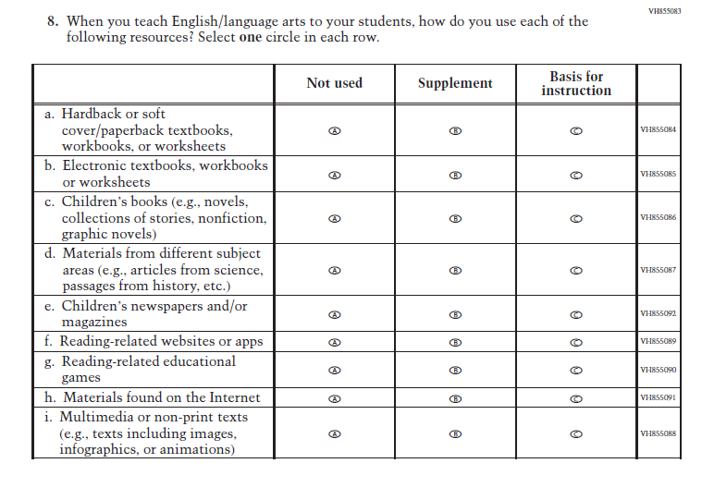
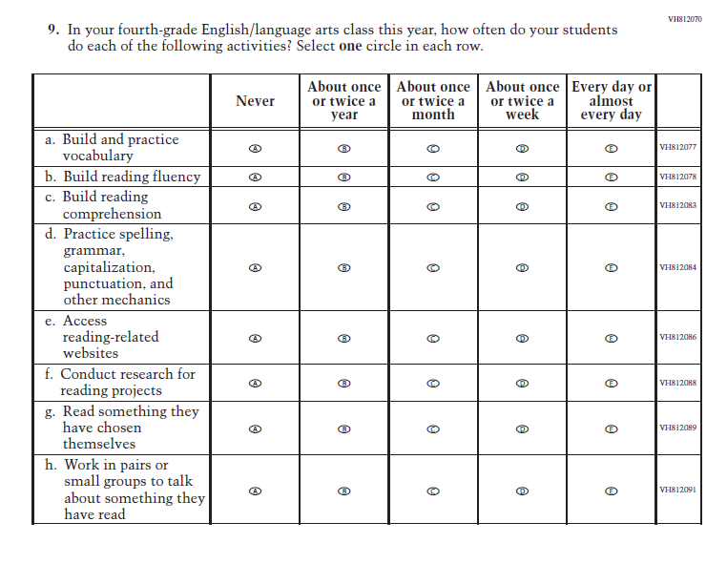
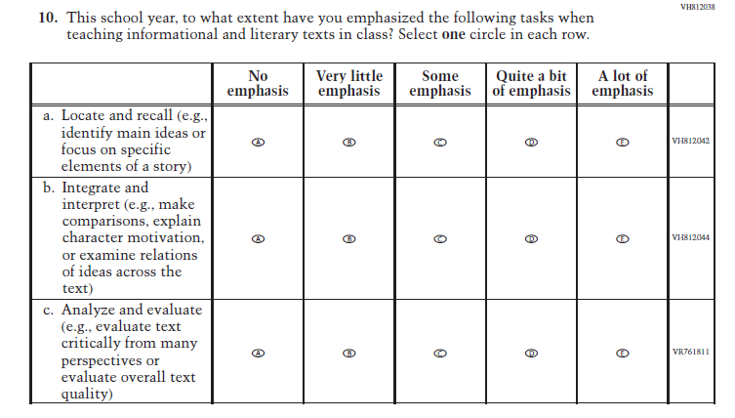
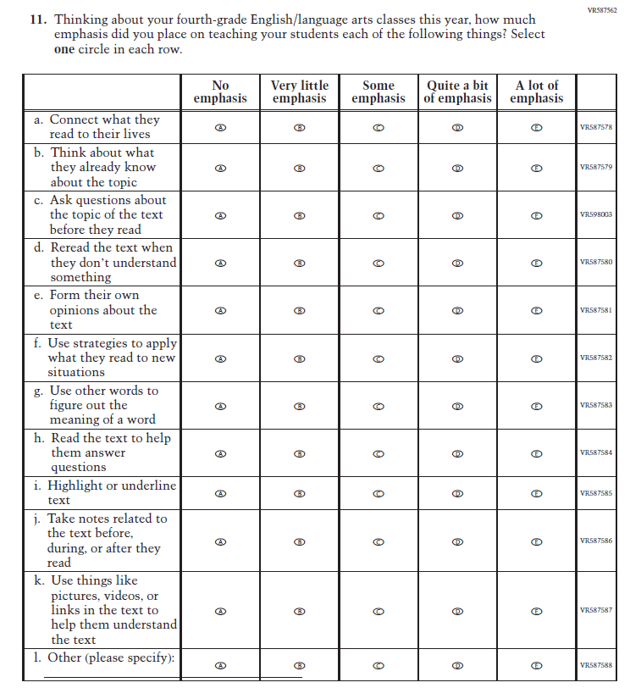
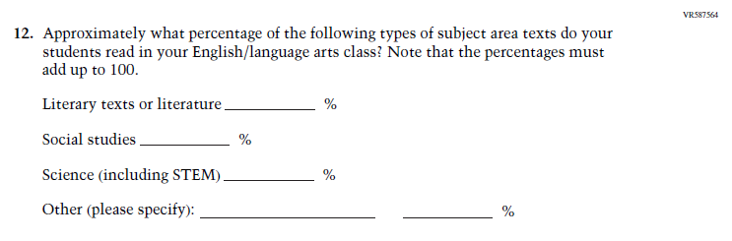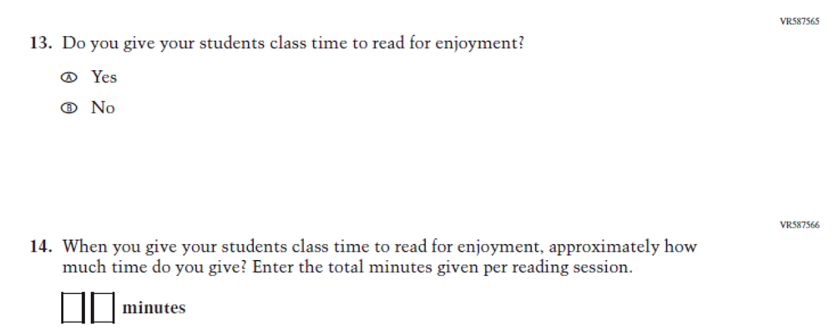

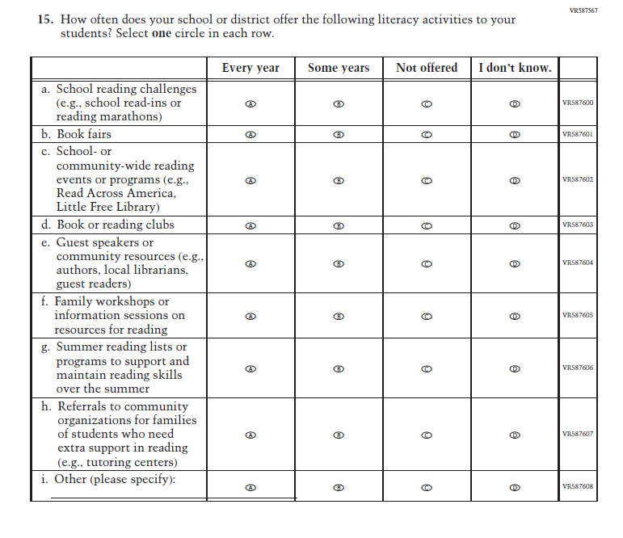
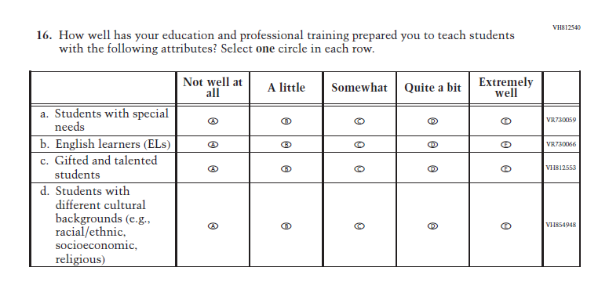

Appendix J2-20: Pilot Grade 8 (Reading)
