NATIONAL CENTER FOR EDUCATION STATISTICS NATIONAL ASSESSMENT OF EDUCATIONAL PROGRESS

National Assessment of Educational Progress (NAEP) 2026

Appendix J3
2024 School Questionnaires Samples

OMB# 1850-0928 v.36



May 2025

NOTE: The 2026 school survey questionnaires were not available for this submission. The 2026 surveys will be included in either the Amendment #1 (Spring 2025), Amendment #2 (August/September 2025), or some combination of both Amendments. System login screens will be updated in upcoming Amendments to the Clearance Package
Appendix J3 provides the school survey questionnaires that will be administered in 2024. Grades 4 and 8 Core, Math, Reading, and Charter School questionnaires were previously approved in 2022 (OMB# 1850-0928 v.28), and any changes to the items from the 2022 administration are reflected in summary tables. Additionally, grade 8 Science and grade 12 Core, Math, and Reading were previously approved in 2019 (OMB# 1850-0928 v.15), and any changes to the items from the 2019 administration are reflected in summary tables. Learning Recovery SQs, are available in this document.
Please note, some of the numbers of the items may be missing or out of order in these printed versions. This will be corrected in the platform view.

Table of Contents
School Questionnaires
School Administrator Questionnaire Login Screen 4
Appendix J3-1: Summary of Changes Operational Grade 4 and Grade 8 (Core) 5
Appendix J3-2: Operational Grade 4 (Core) 8
Appendix J3-3: Operational Grade 8 (Core) 19
Appendix J3-4: Summary of Changes Operational Grade 12 (Core) 31
Appendix J3-5: Operational Grade 12 (Core) 35
Appendix J3-6: Operational Grade 4 (Mathematics) 49
Appendix J3-7: Summary of Changes Operational Grade 8 (Mathematics) 53
Appendix J3-8: Operational Grade 8 (Mathematics) 54
Appendix J3-9: Operational Grade 12 (Mathematics) 57
Appendix J3-10: Summary of Changes Operational Grade 4, 8, and 12 (Reading) 63
Appendix J3-11: Operational Grade 4 (Reading) 64
Appendix J3-12: Operational Grade 8 (Reading) 68
Appendix J3-13: Operational Grade 12 (Reading) 71
Appendix J3-14: Operational Grade 8 (Science) 76
Appendix J3-15: Operational Grade 4, 8, and 12 Charter School 80
Appendix J3-16: Pilot Grade 4 Charter School (Reading and Mathematics) 83
Appendix J3-17: Pilot Grade 8 Charter School (Mathematics) 86
Appendix J3-18: Pilot Grade 8 Charter School (Reading) 89
Appendix J3-23: Pilot Grade 4 (Core) 92
Appendix J3-24: Pilot Grade 8 (Core) 103
Appendix J3-25: Pilot Grade 4 (Mathematics) 114
Appendix J3-26: Pilot Grade 8 (Mathematics) 119
Appendix J3-27: Pilot Grade 4 (Reading) 125
Appendix J3-28: Pilot Grade 8 (Reading) 130

School Administrator Questionnaire Login Screen
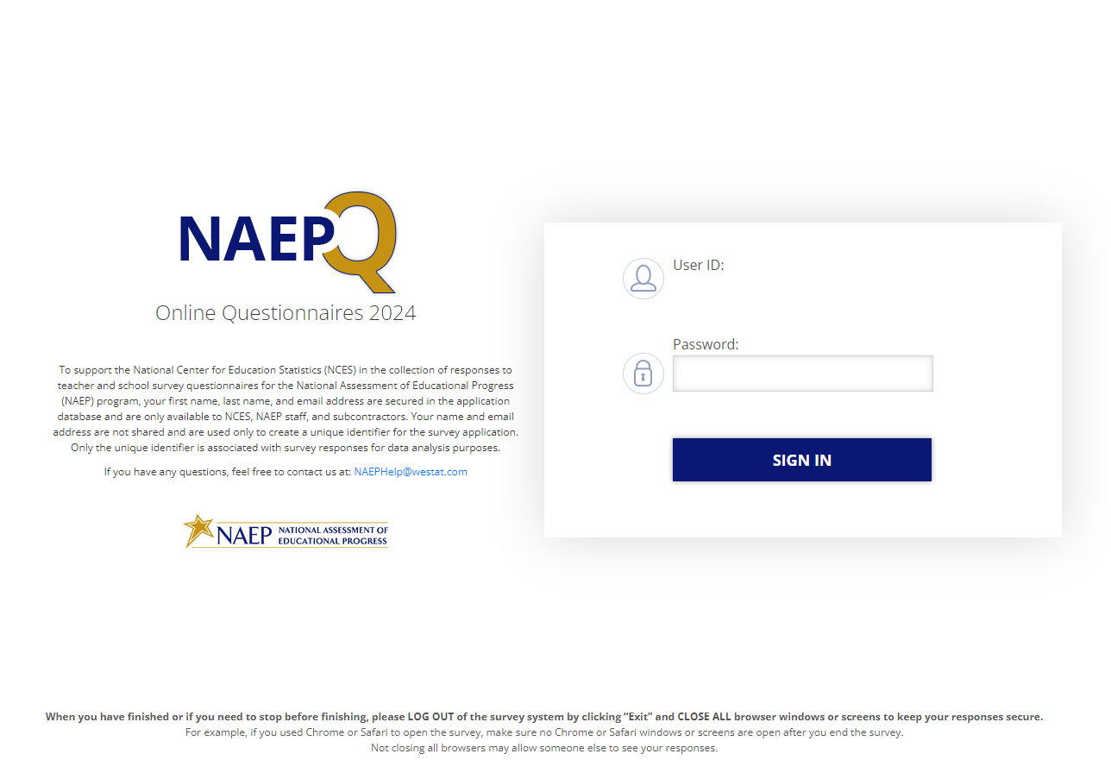
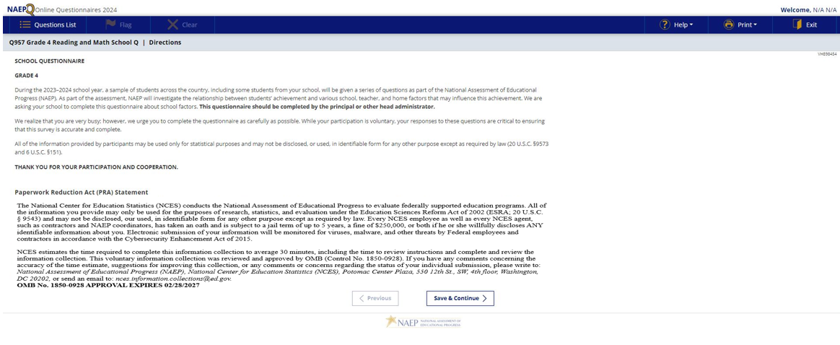

Appendix J3-1: Summary of Changes Operational Grade 4 and Grade 8 (Core)
2024 Operational Grade 4 and 8 Core School
Previous Item | 2024 Item | D/A/ R+ | Rationale
N/A | 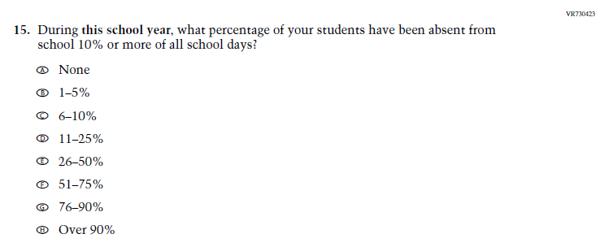  Issue: Learning Recovery | A | This Item was added to address gaps in learning that have developed due to the extended period of remote and hybrid learning that took place during the pandemic.
N/A | 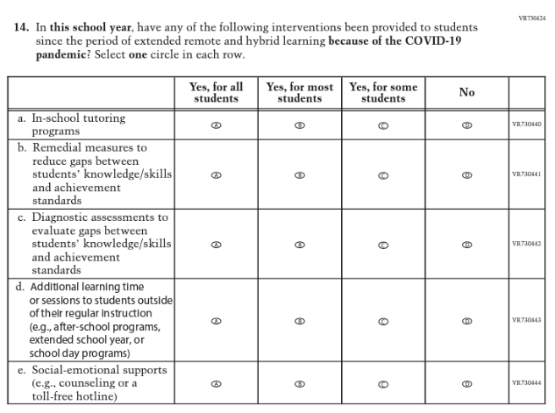  Issue: Learning Recovery | A | This Item was added to address gaps in learning that have developed due to the extended period of remote and hybrid learning that took place during the pandemic.
N/A | 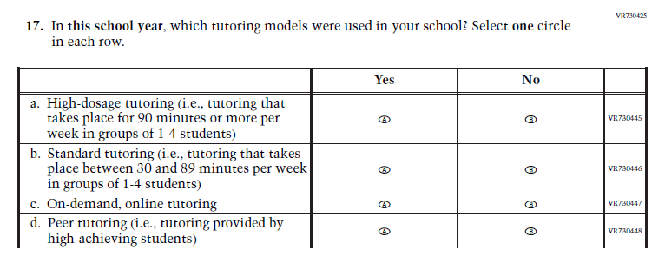  Issue: Learning Recovery | A | This Item was added to address gaps in learning that have developed due to the extended period of remote and hybrid learning that took place during the pandemic.
N/A | 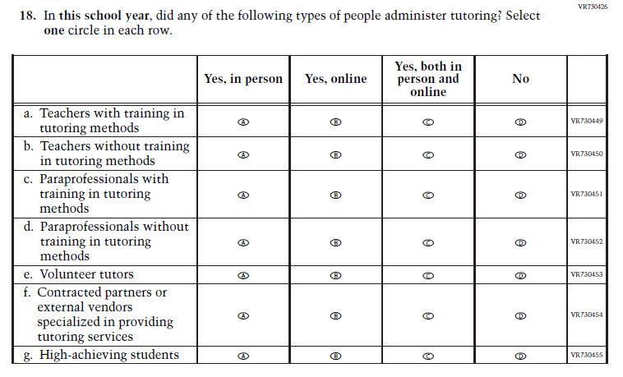  Issue: Learning Recovery | A | This Item was added to address gaps in learning that have developed due to the extended period of remote and hybrid learning that took place during the pandemic.
N/A | 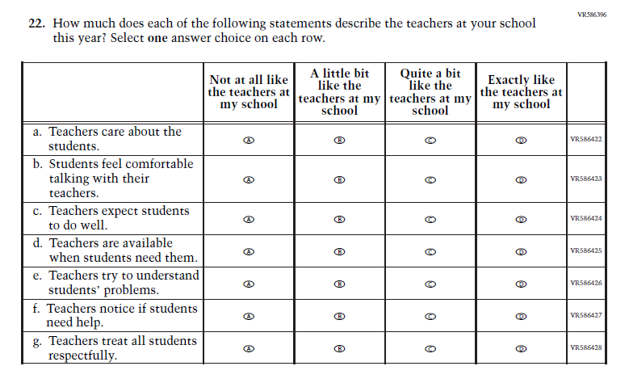  Issue: Learning Recovery | A | This Item was added to address gaps in learning that have developed due to the extended period of remote and hybrid learning that took place during the pandemic.
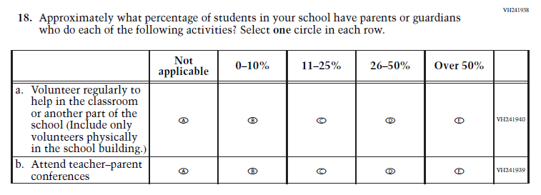  (2022 Grades 4 and 8) | N/A  Issue: School Climate | D | This Item was selected to be dropped to reduce burden due to the addition of the Learning Recovery Items.

Appendix J3-2: Operational Grade 4 (Core)

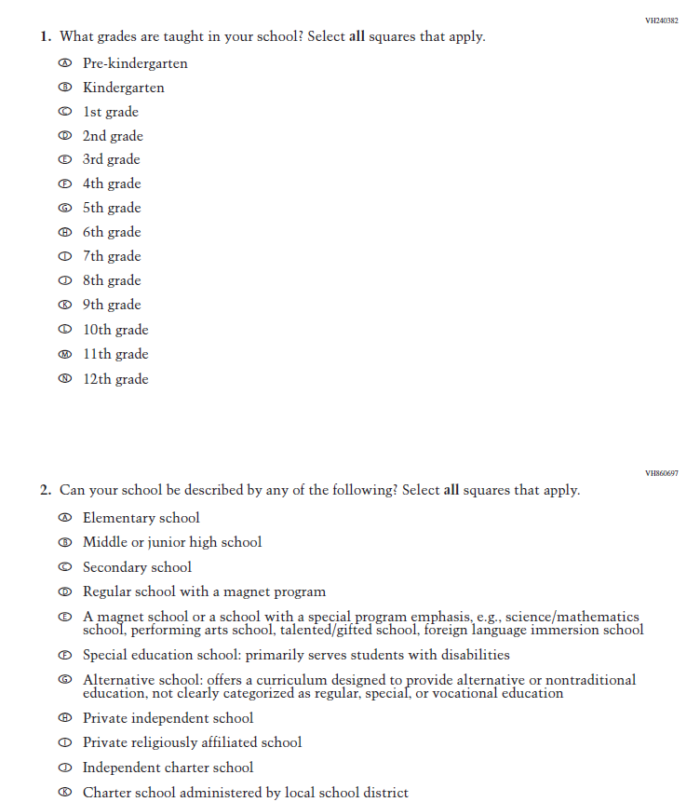
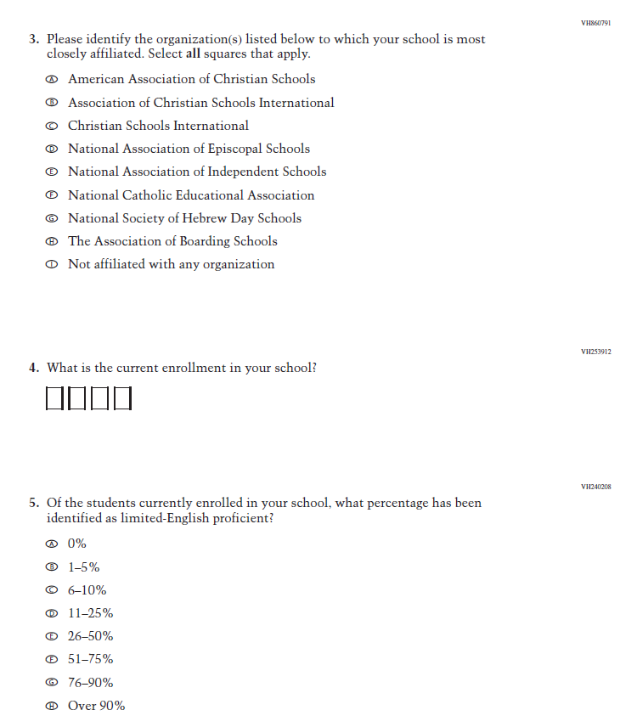
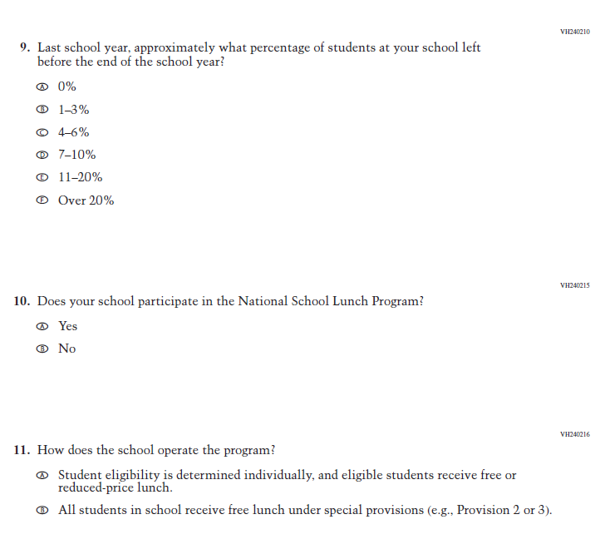
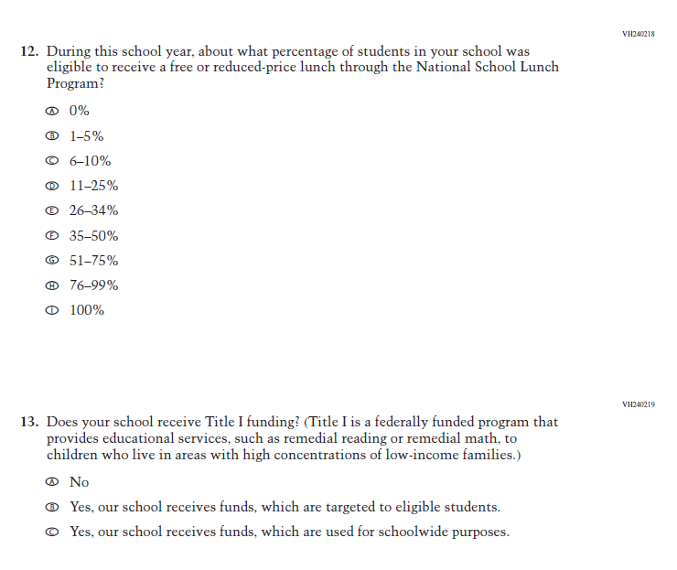
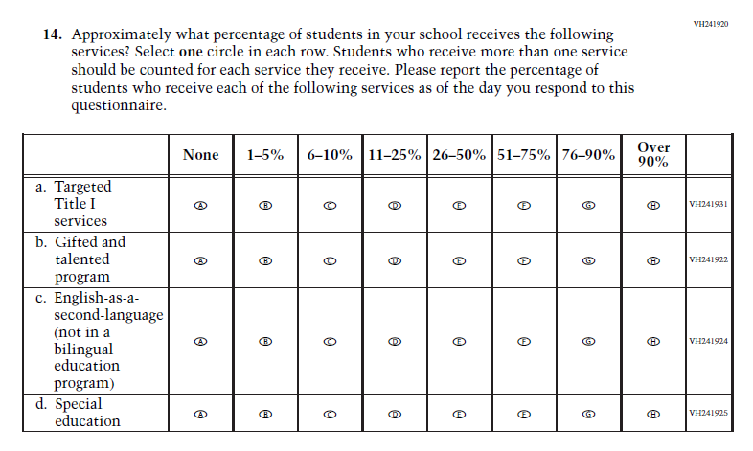
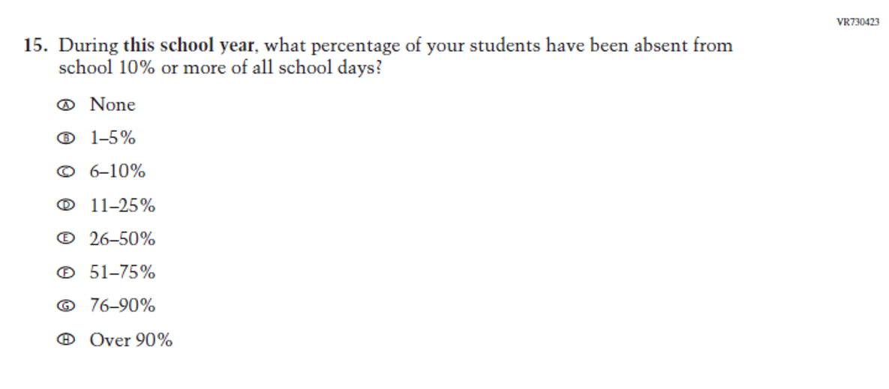
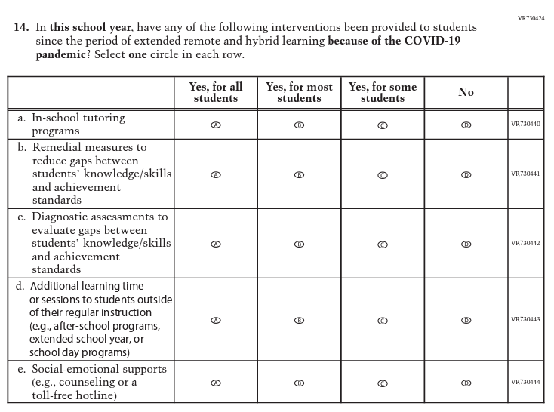
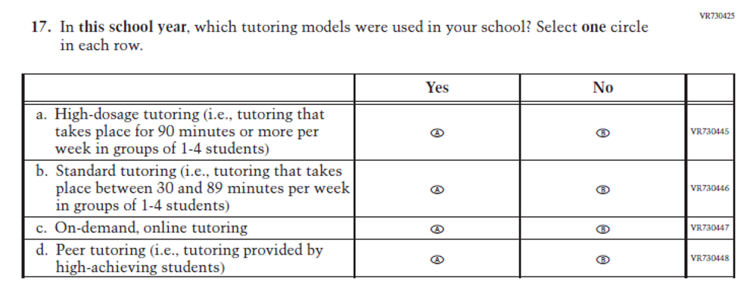
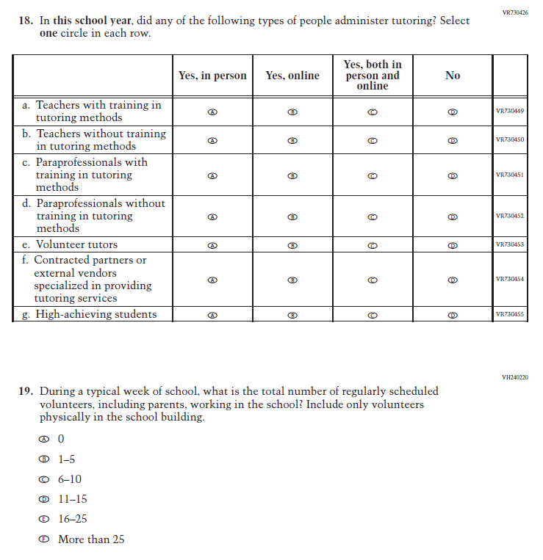
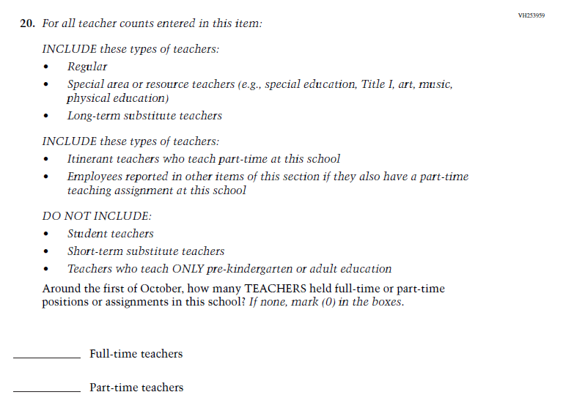
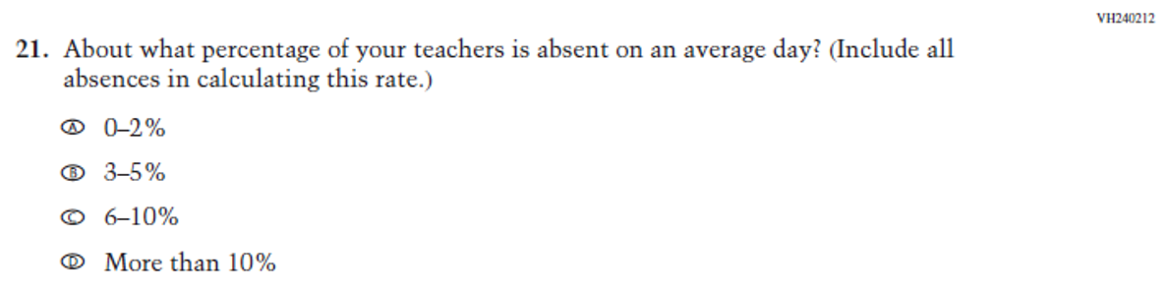
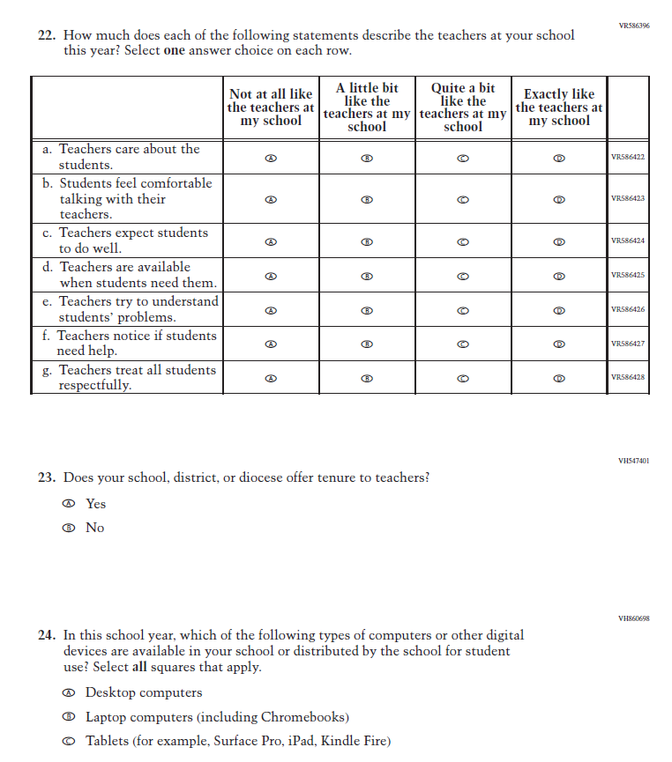
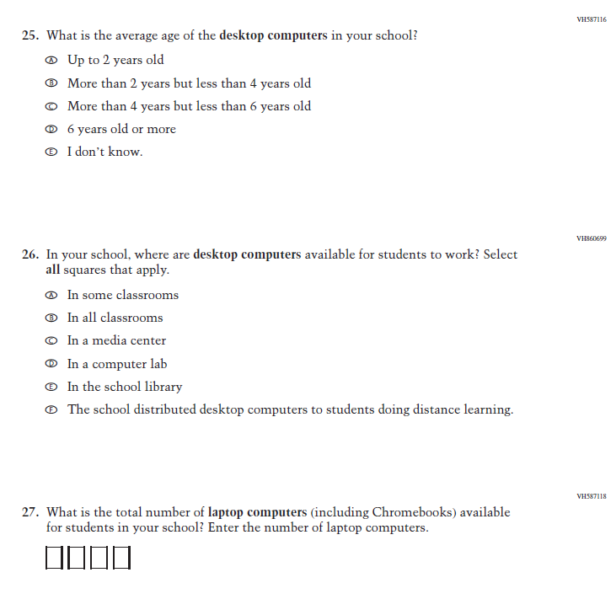
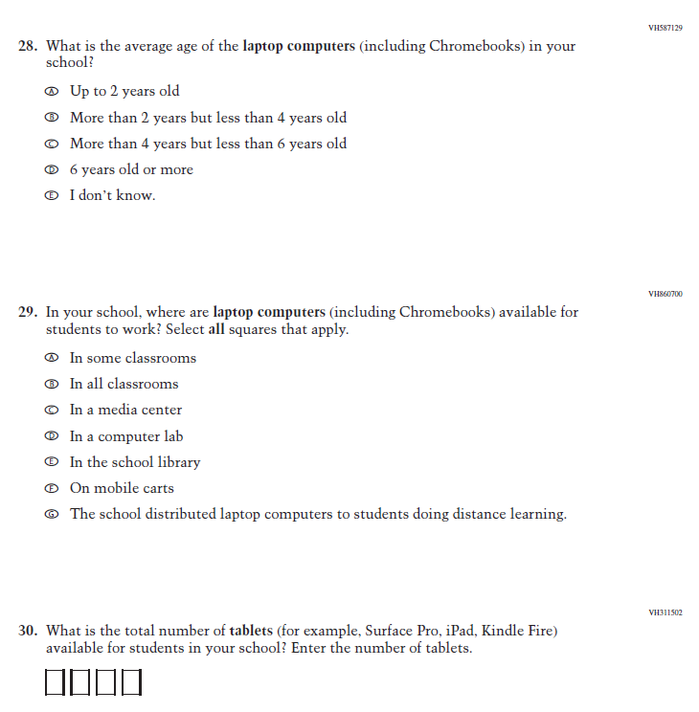
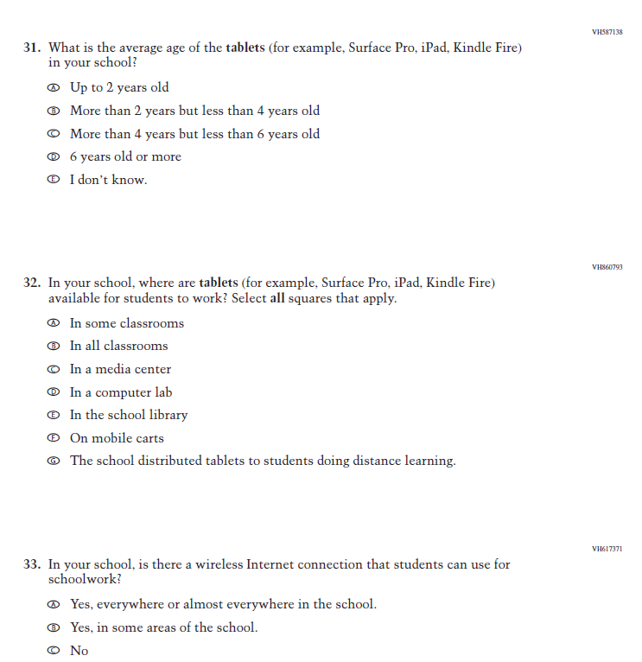

Appendix J3-3: Operational Grade 8 (Core)
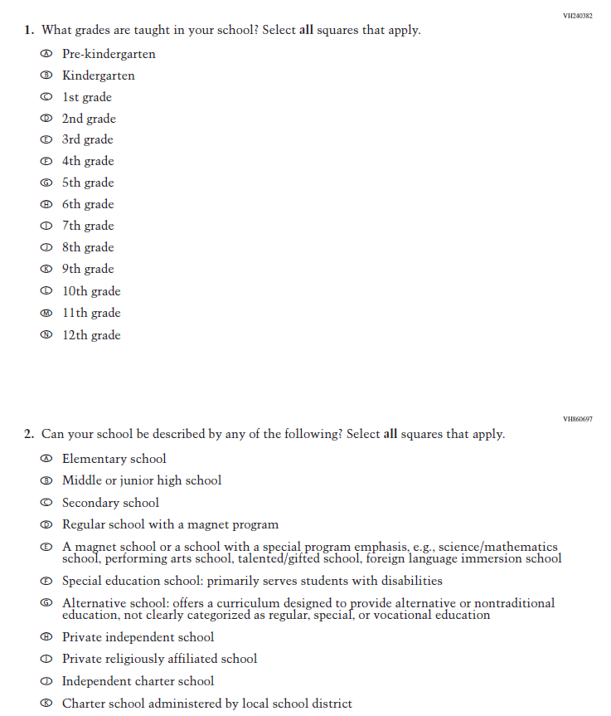
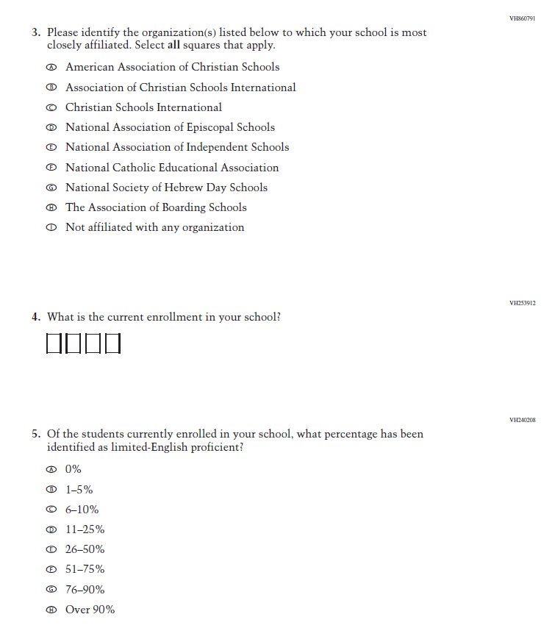
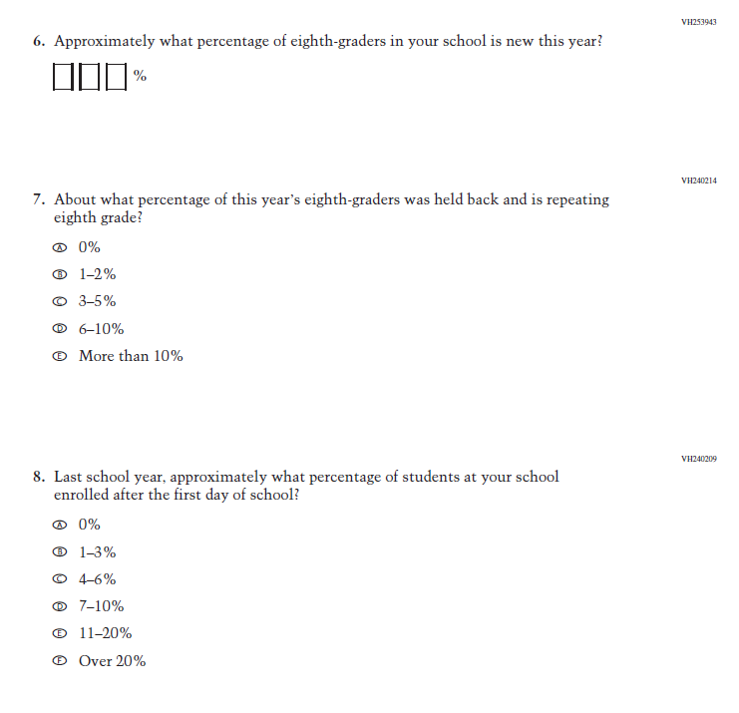
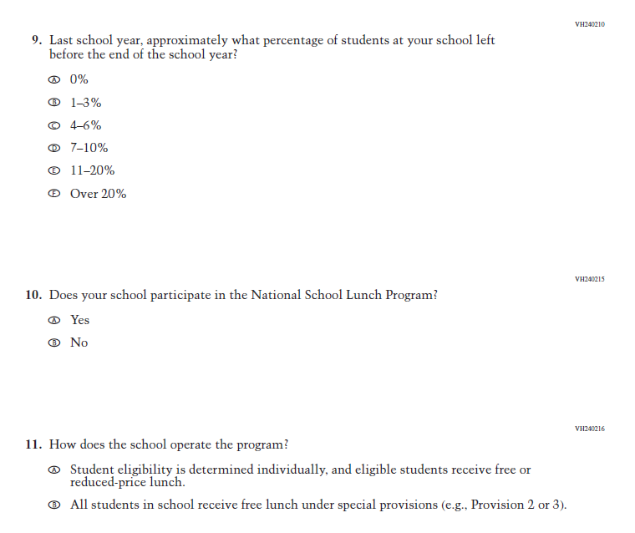
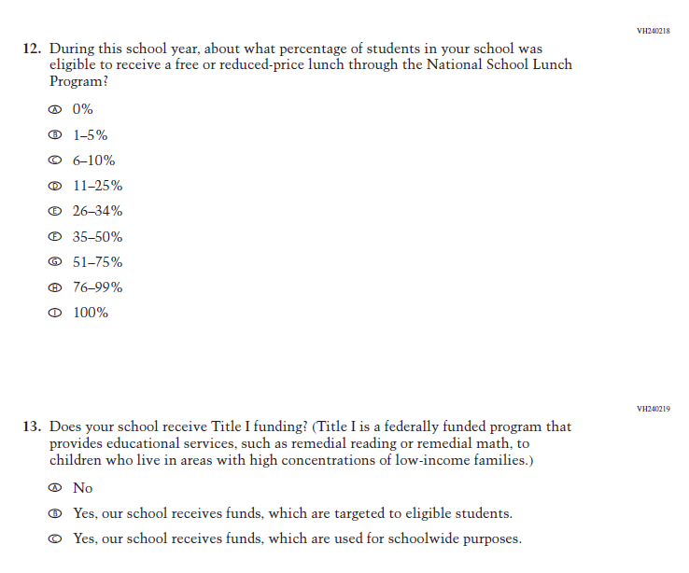
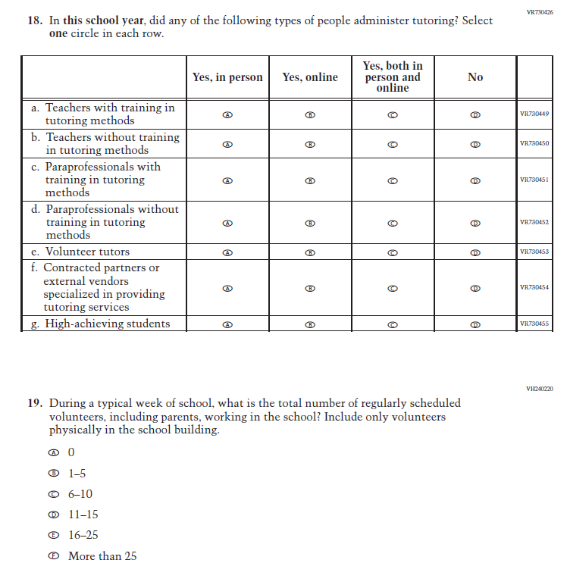
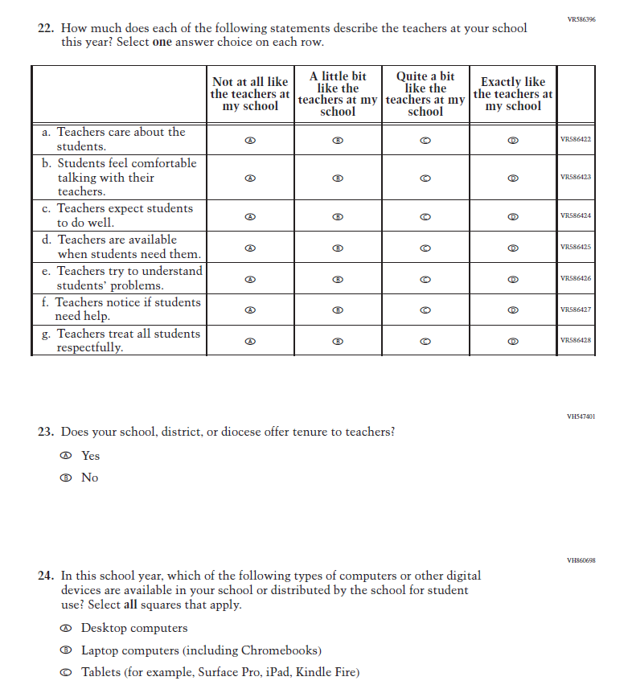
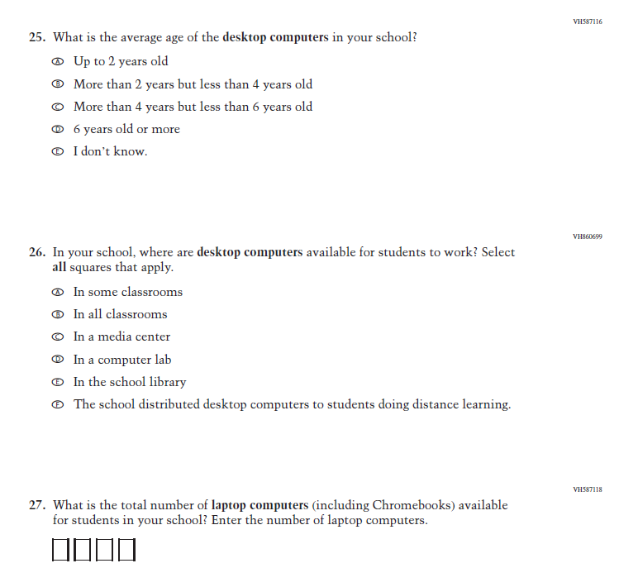
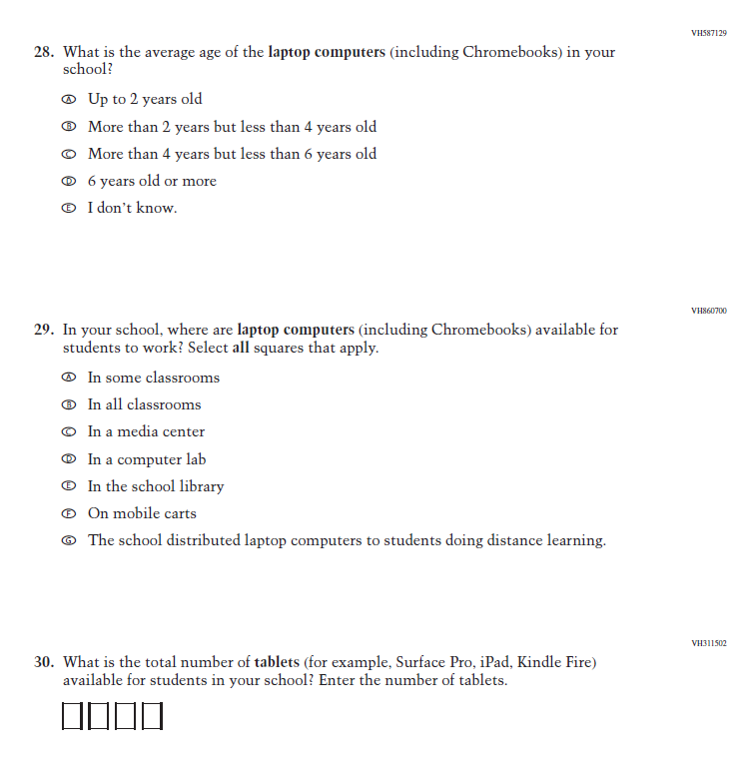
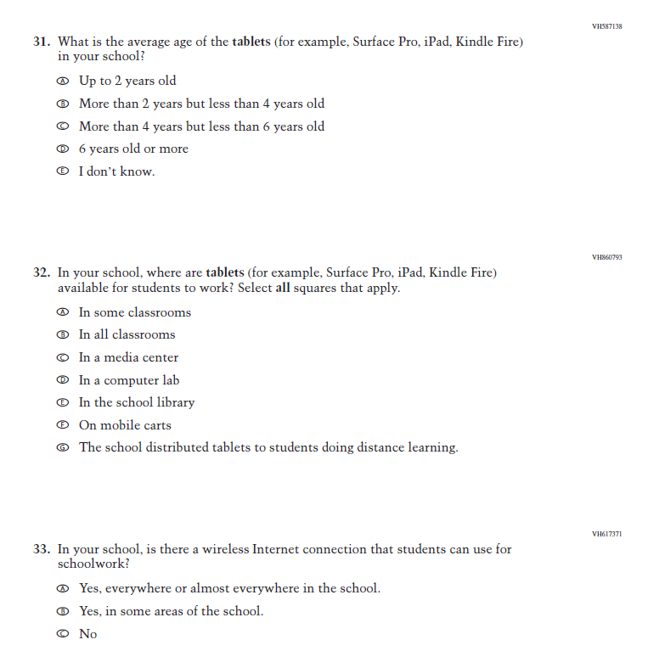
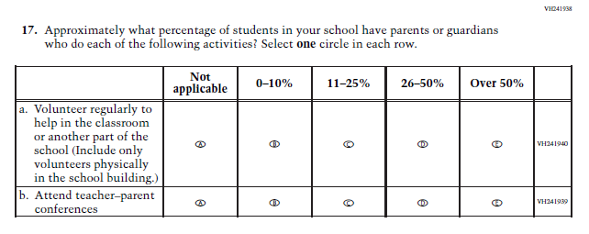

Appendix J3-4: Summary of Changes Operational Grade 12 (Core)
2024 Operational Grade 12 Core School
Previous Item | 2024 Item | D/A/ R+ | Rationale
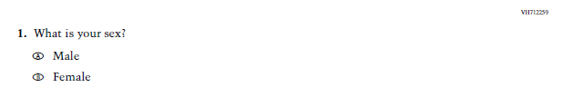  (2019 Grade 12) | N/A  Issue: Sex | D | This Item was dropped so Grade 12 matches Grades 4 and 8, which were administered in 2022.
N/A | Issue: Learning Recovery | A | This Item was added to address gaps in learning that have developed due to the extended period of remote and hybrid learning that took place during the pandemic.
N/A | Issue: Learning Recovery | A | This Item was added to address gaps in learning that have developed due to the extended period of remote and hybrid learning that took place during the pandemic.
N/A | Issue: Learning Recovery | A | This Item was added to address gaps in learning that have developed due to the extended period of remote and hybrid learning that took place during the pandemic.
N/A | Issue: Learning Recovery | A | This Item was added to address gaps in learning that have developed due to the extended period of remote and hybrid learning that took place during the pandemic.
N/A | Issue: Learning Recovery | A | This Item was added to address gaps in learning that have developed due to the extended period of remote and hybrid learning that took place during the pandemic.

N/A | Issue: Learning Recovery | A | This Item was added to address gaps in learning that have developed due to the extended period of remote and hybrid learning that took place during the pandemic.

Appendix J3-5: Operational Grade 12 (Core)
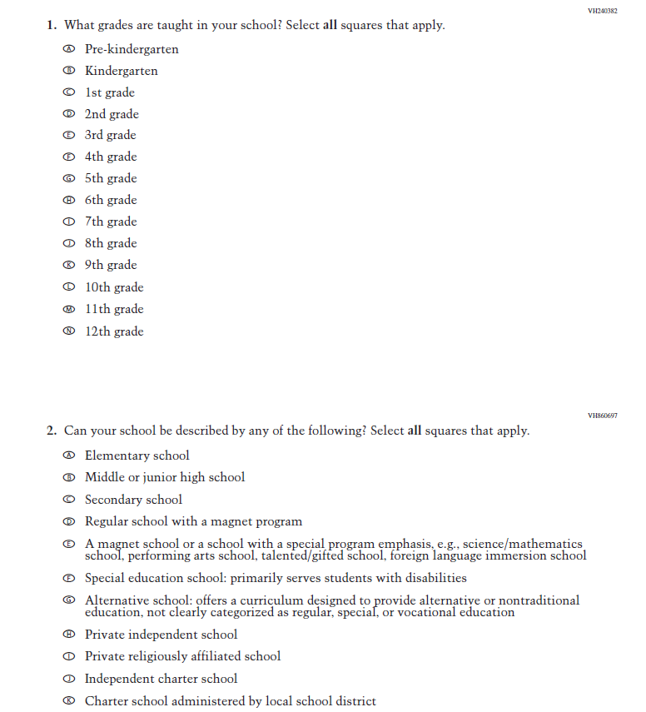
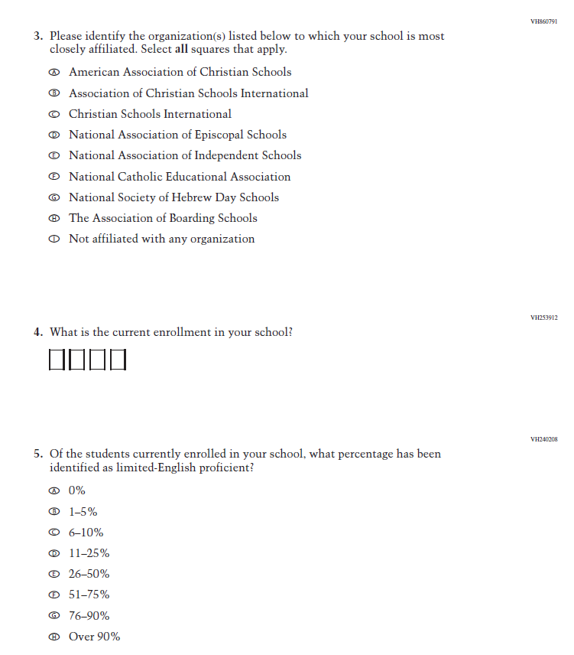
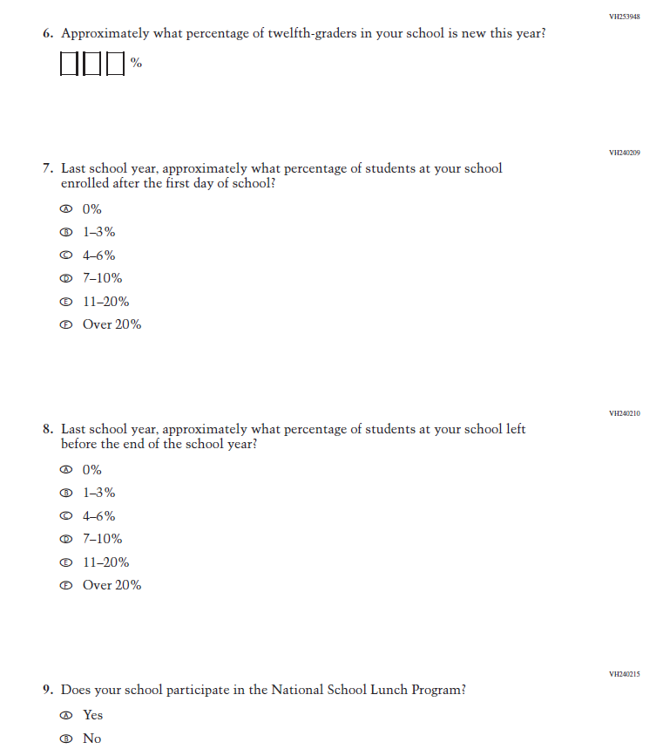
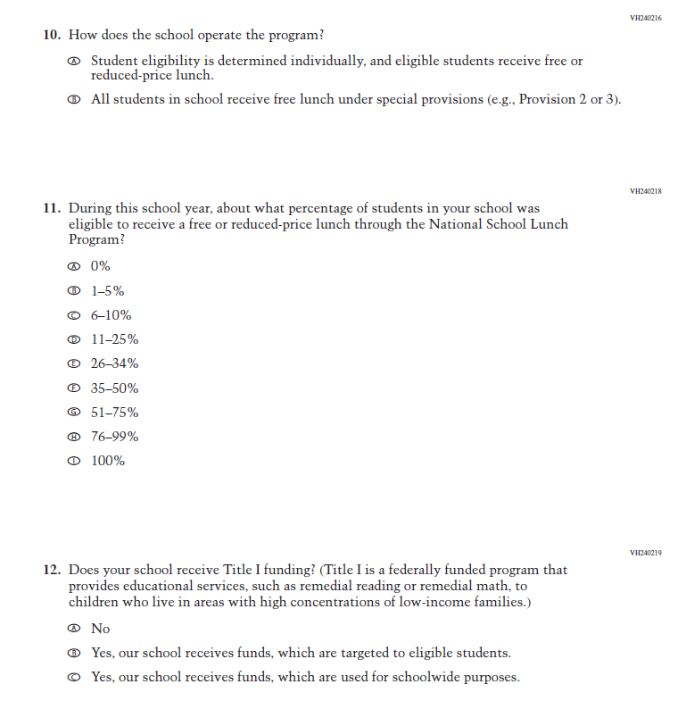
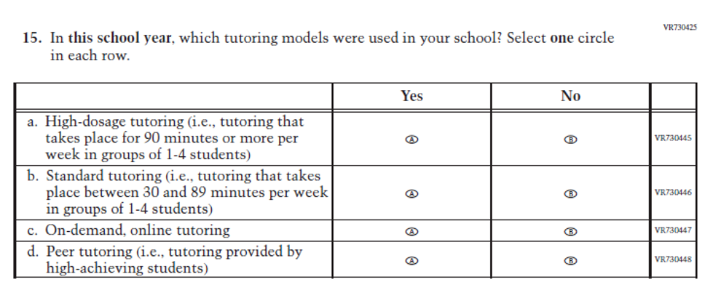
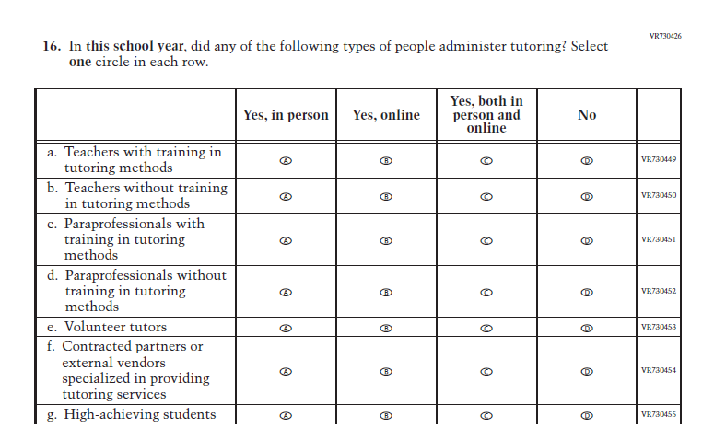
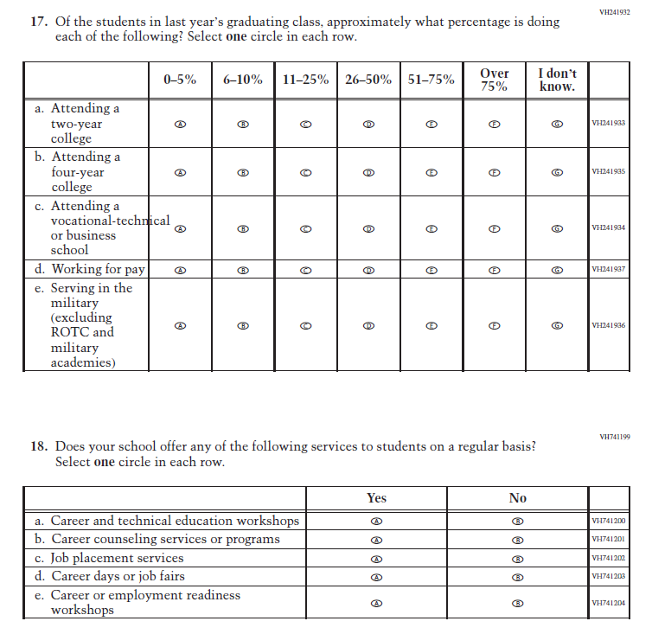
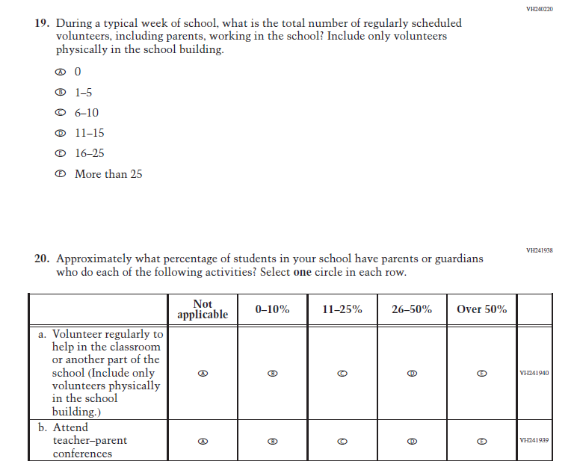
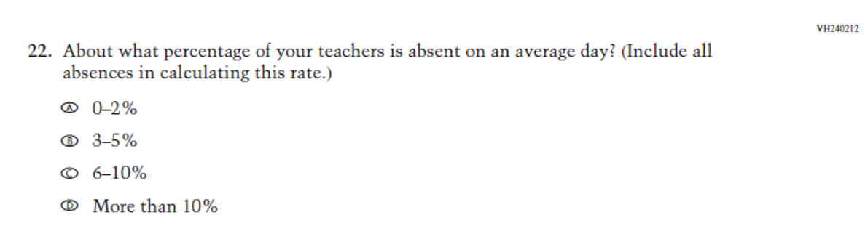
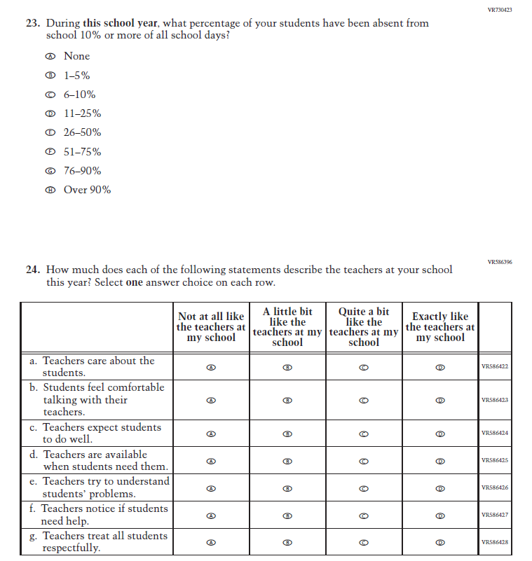
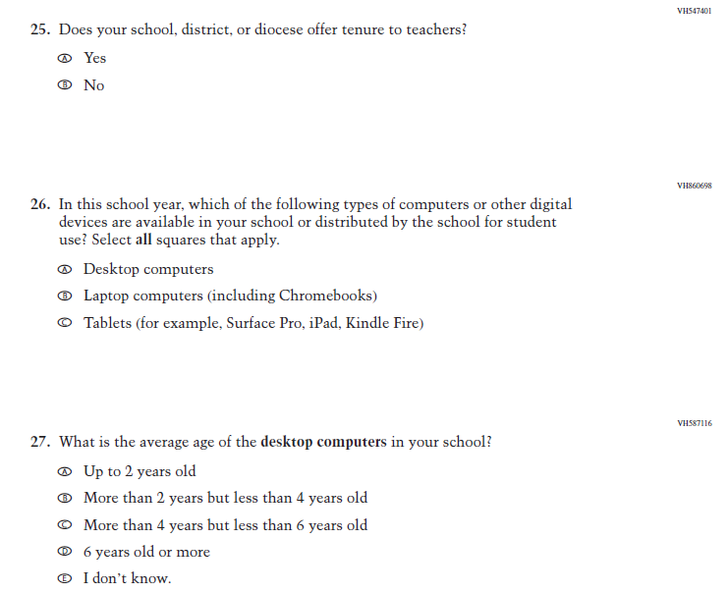
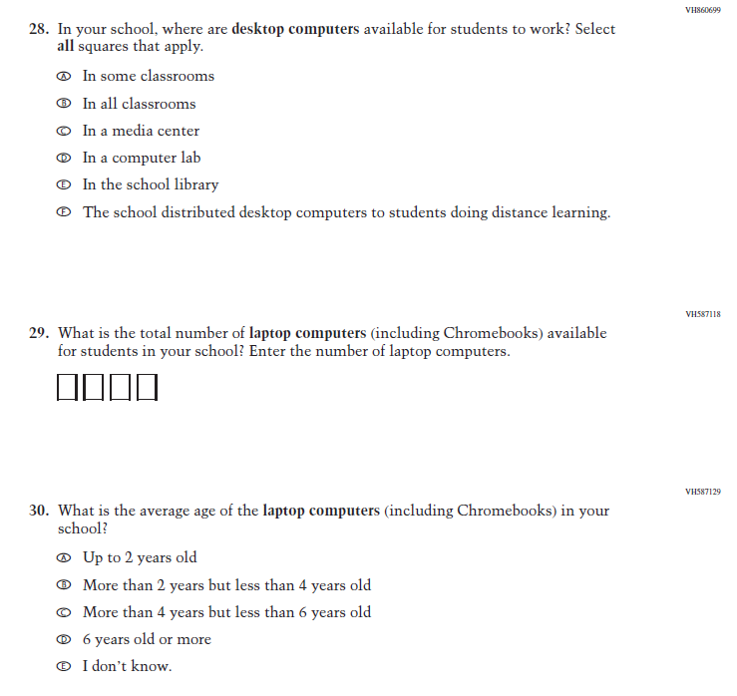
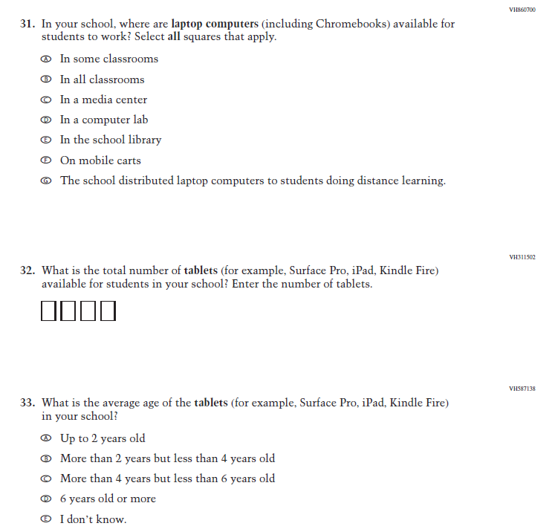
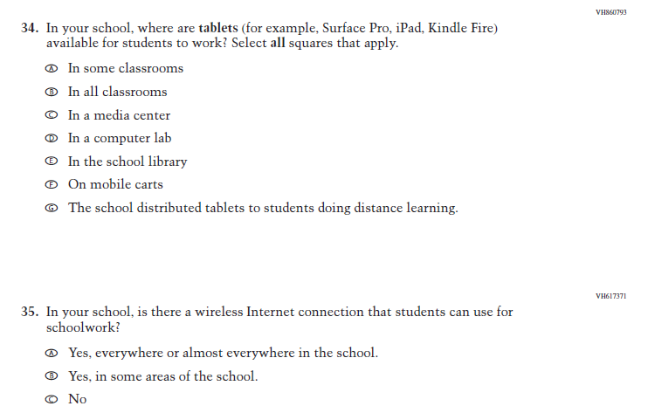

Appendix J3-6: Operational Grade 4 (Mathematics)
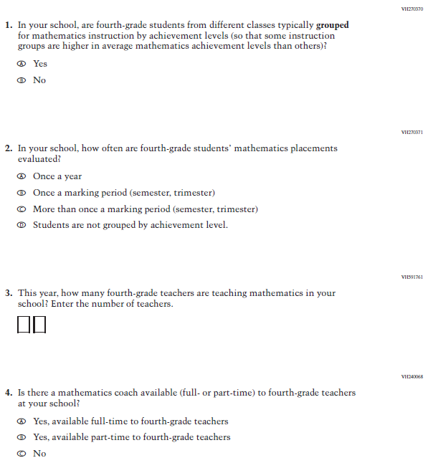

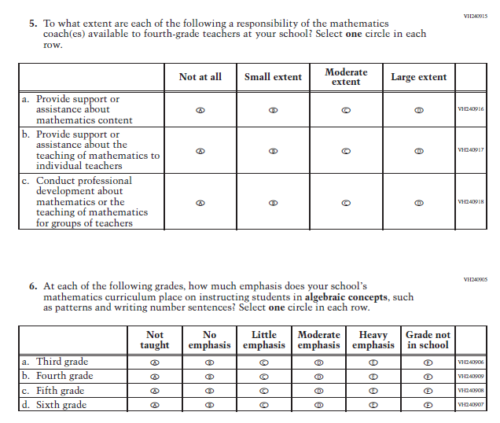

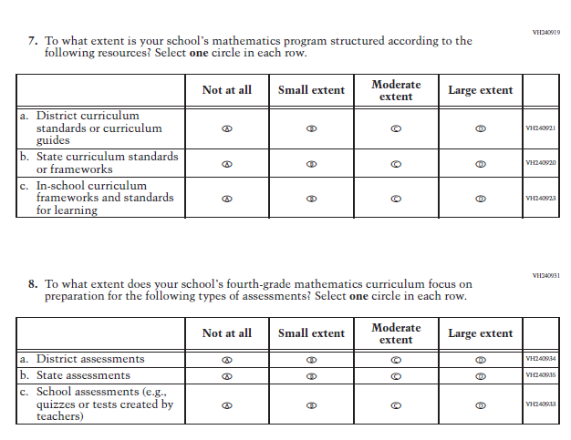

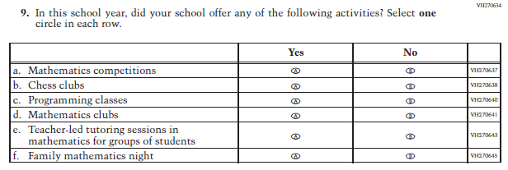

Appendix J3-7: Summary of Changes Operational Grade 8 (Mathematics)

2024 Operational Grade 8 Mathematics School
Previous Item | 2024 Item | D/A/ R+ | Rationale
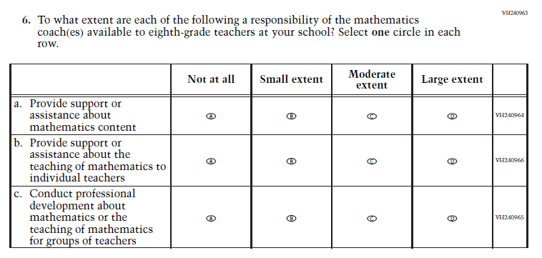  (2022 Grade 8) | N/A  Issue: Resources for Learning and Instruction | D | This Item was selected to be dropped to reduce burden due to the addition of the Learning Recovery Items.

Appendix J3-8: Operational Grade 8 (Mathematics)
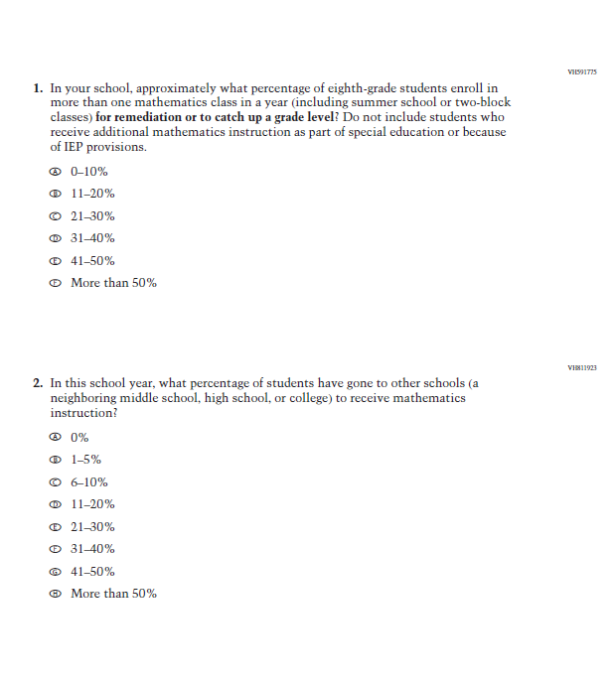
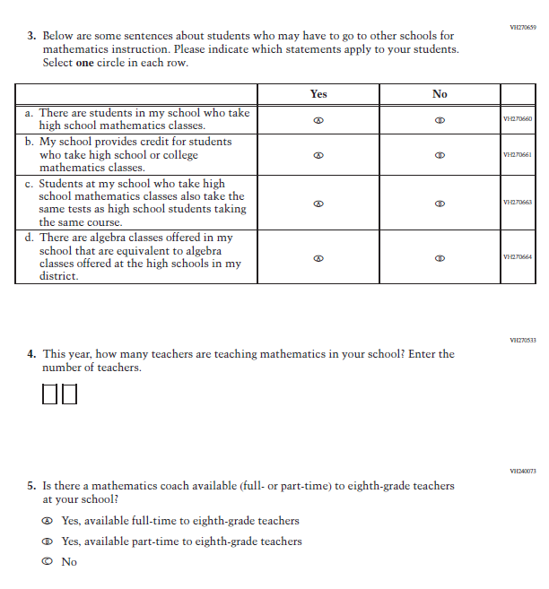
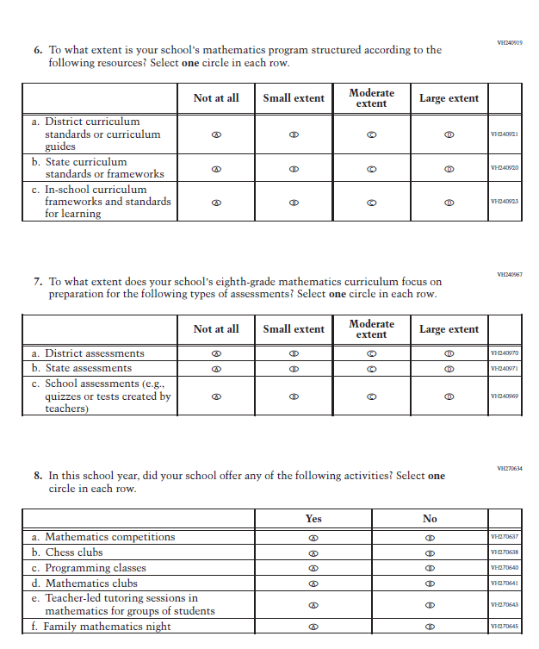

Appendix J3-9: Operational Grade 12 (Mathematics)
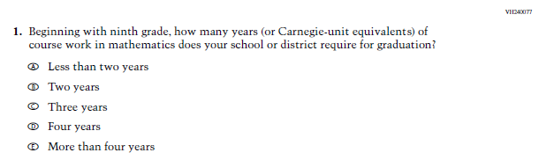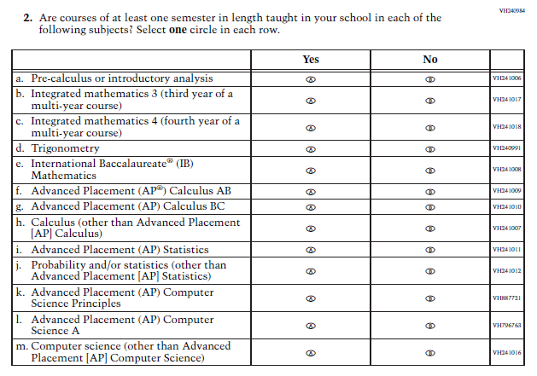

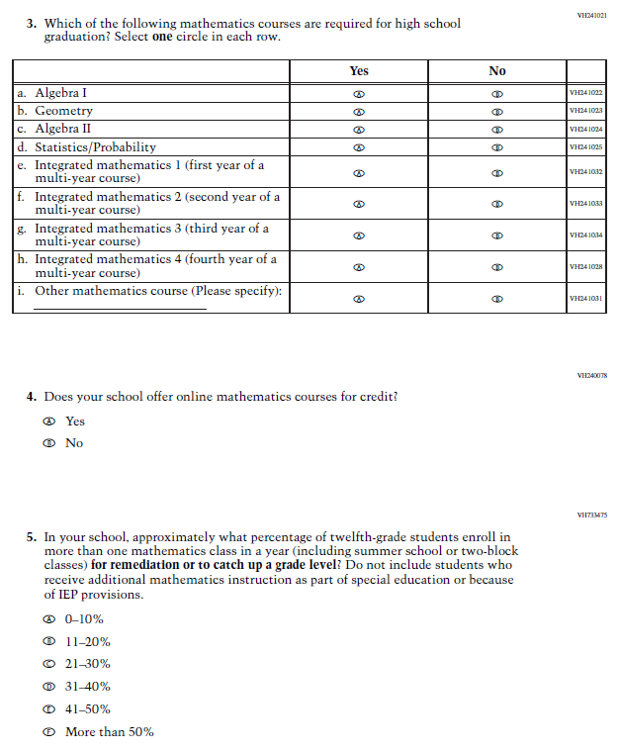

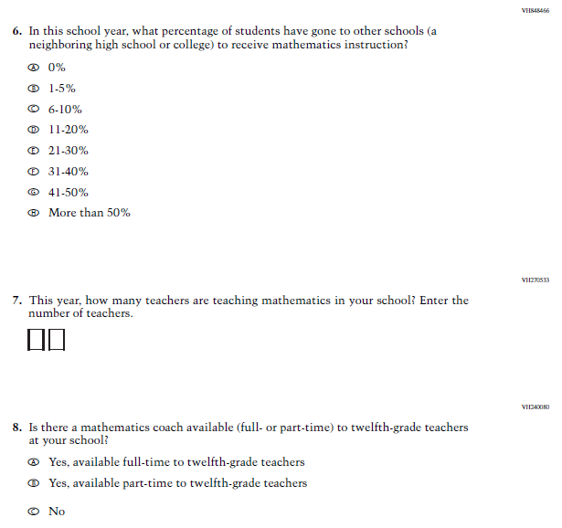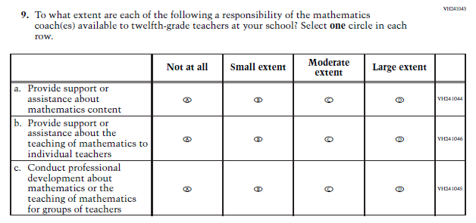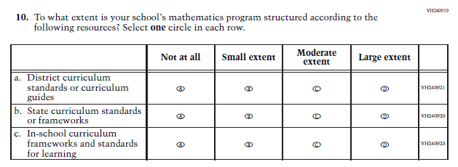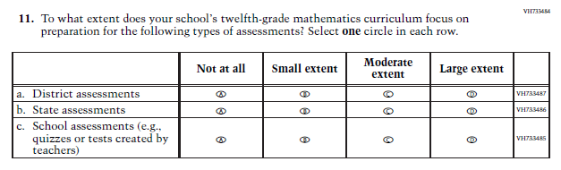

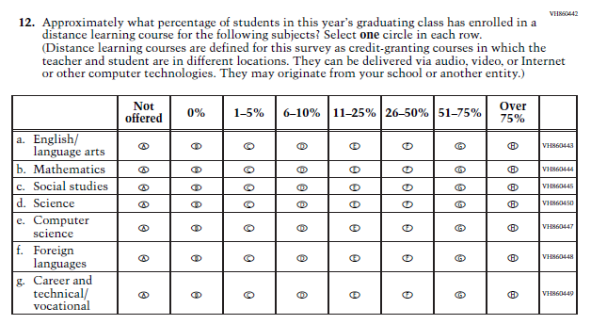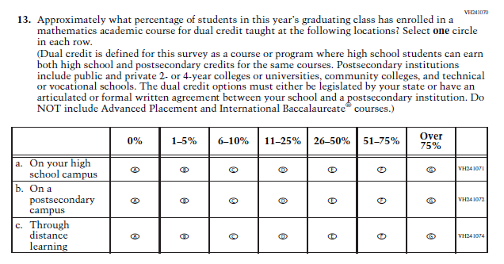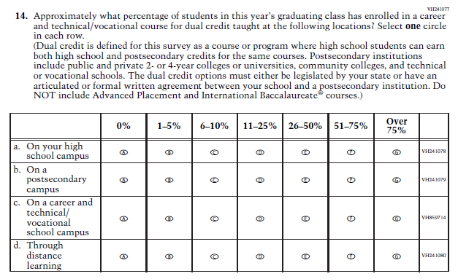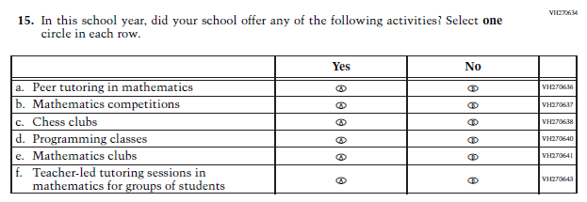

Appendix J3-10: Summary of Changes Operational Grade 4, 8, and 12 (Reading)

2024 Operational Grade 4, 8, and 12 Reading School
Previous Item | 2024 Item | D/A/ R+ | Rationale
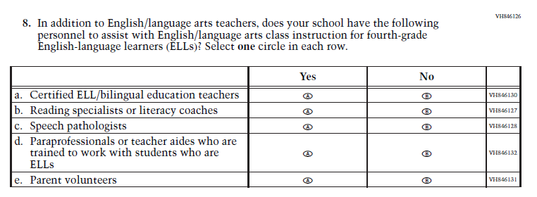  (2022 Grades 4 and 8, 2019 Grade 12) | 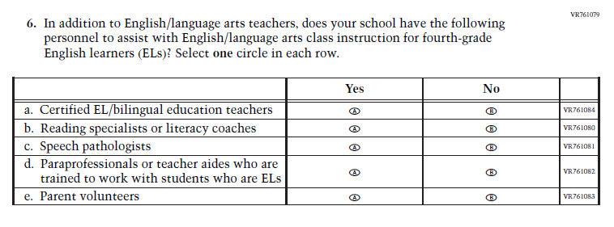  Issue: Resources for Learning and Instruction | R | This Item was revised to update applicable terminology: English-language learners (ELLs) updated to English learners (ELs).

Appendix J3-11: Operational Grade 4 (Reading)
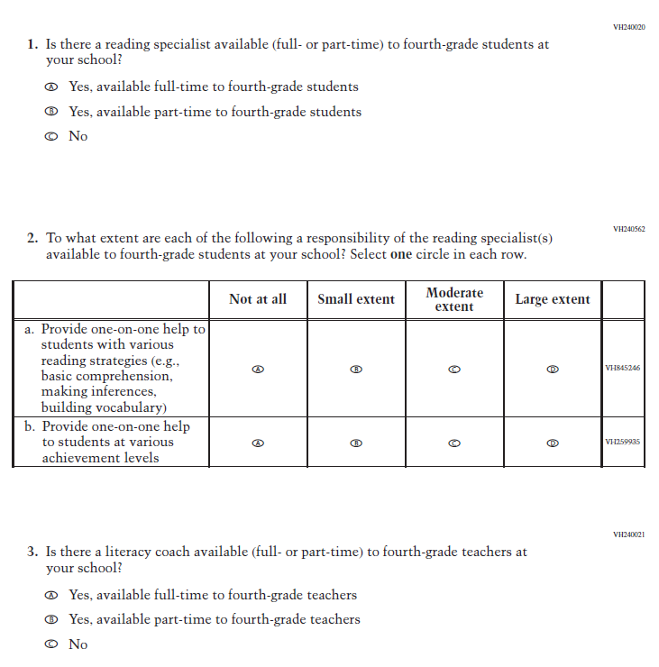
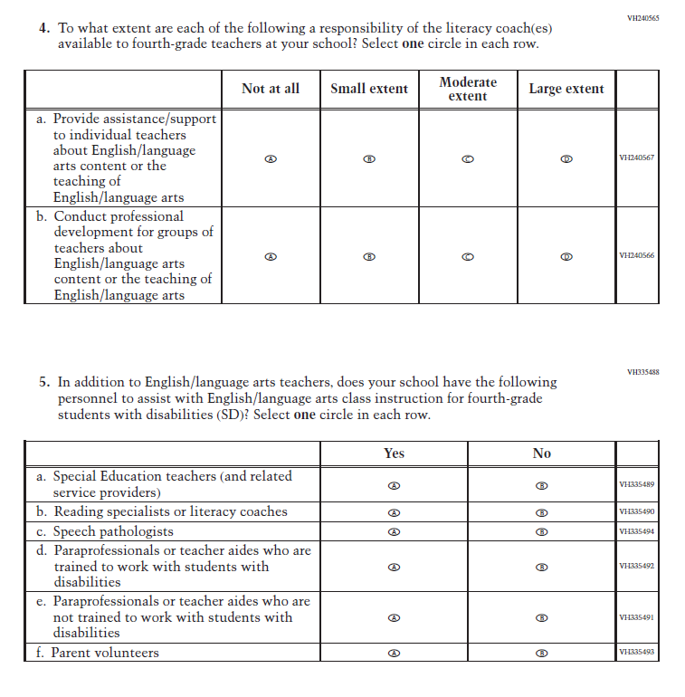
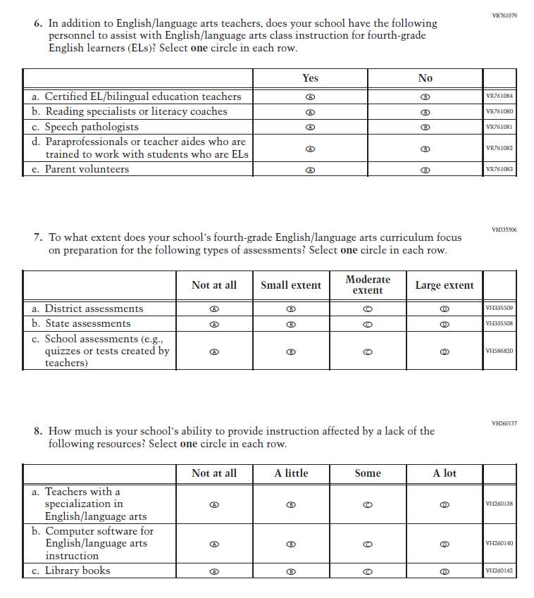
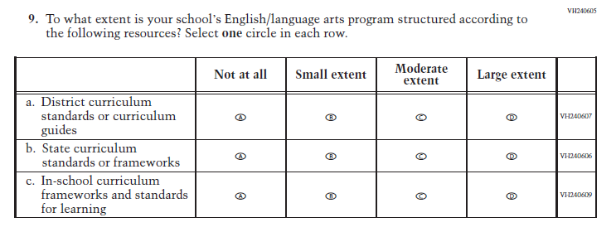

Appendix J3-12: Operational Grade 8 (Reading)
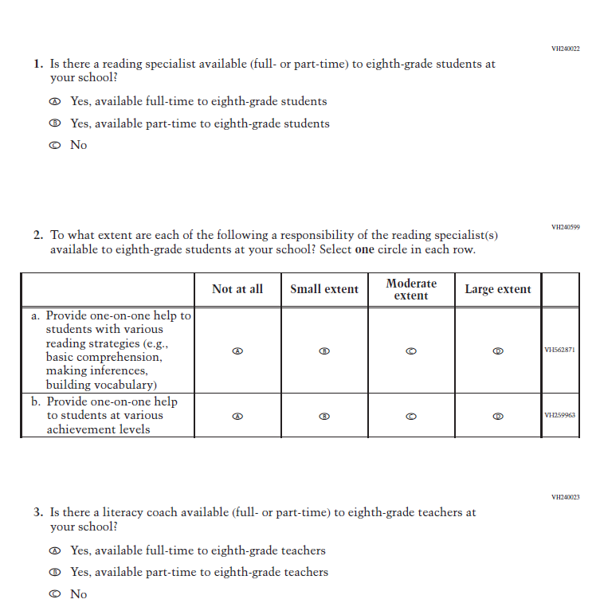
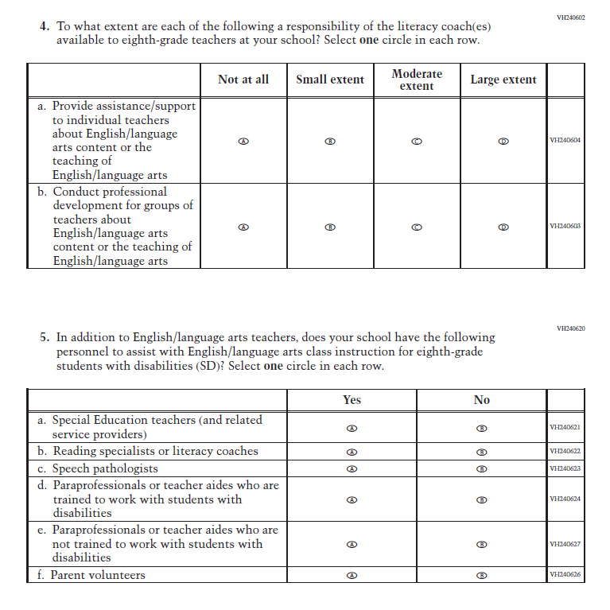
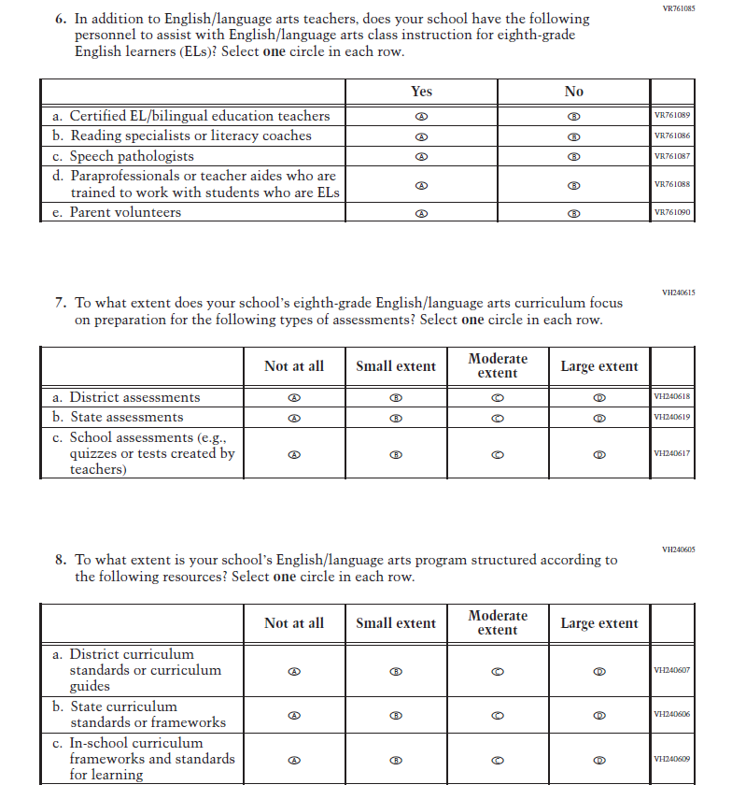
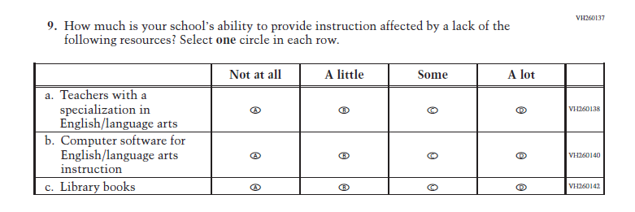

Appendix J3-13: Operational Grade 12 (Reading)

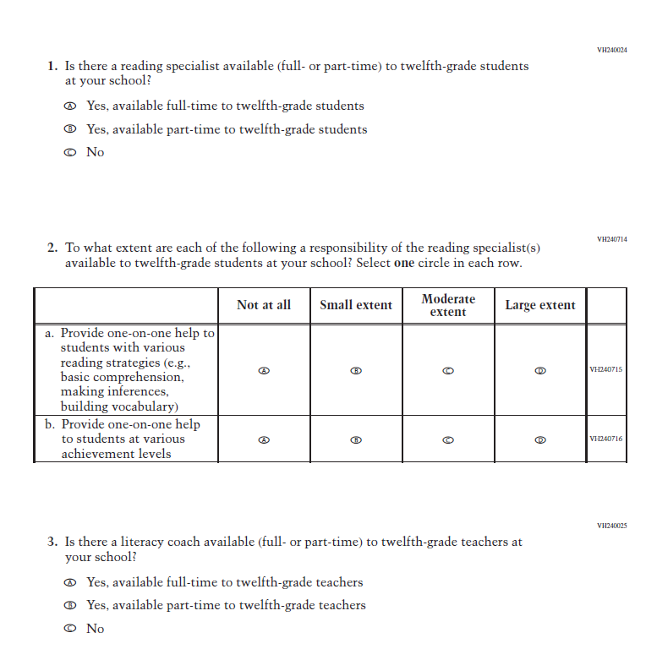
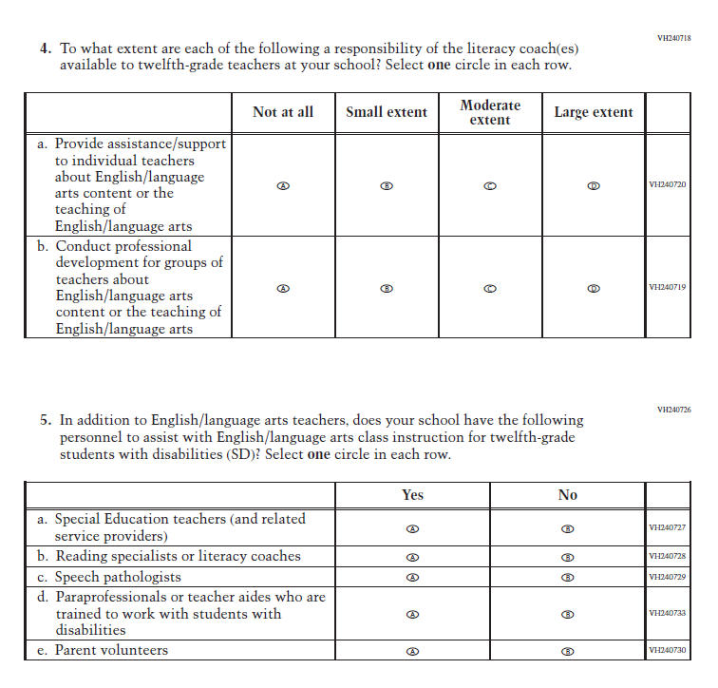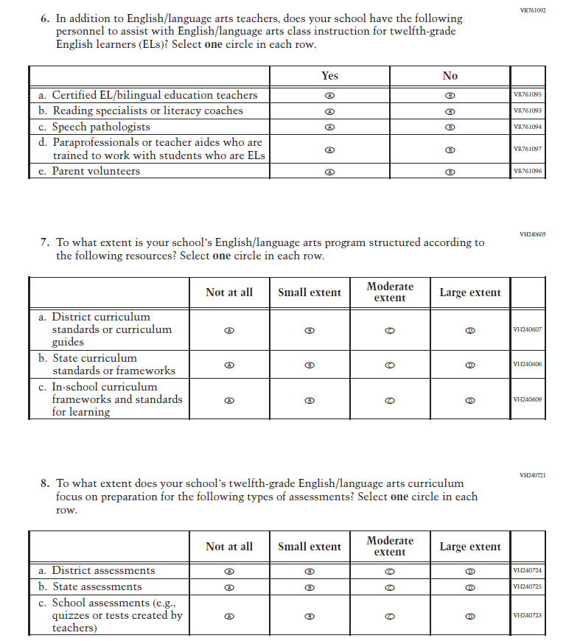
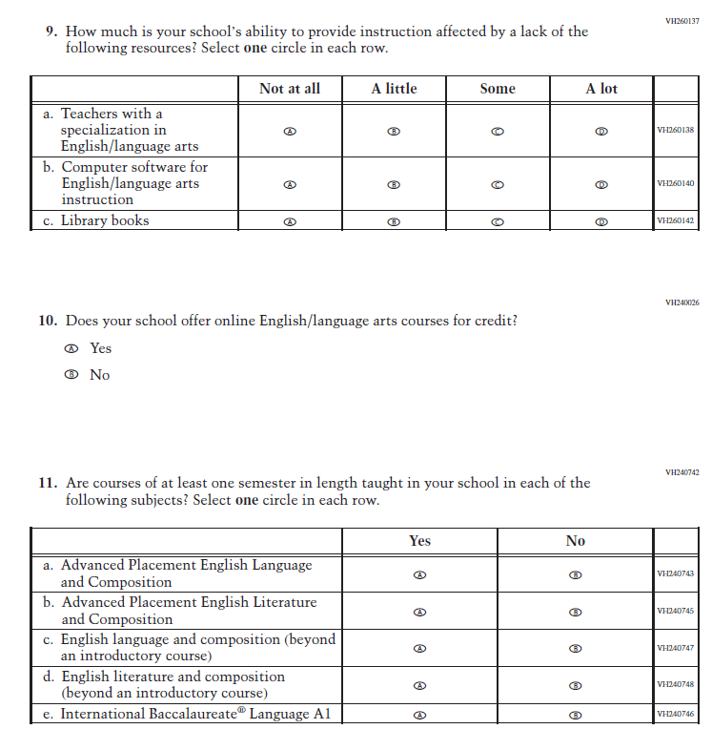
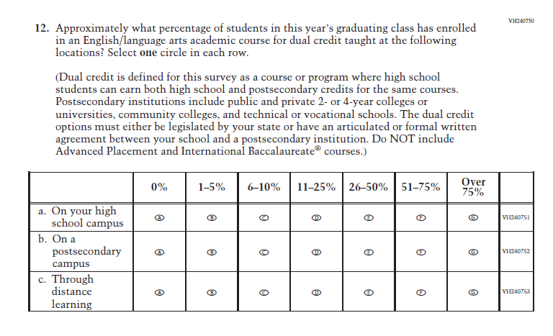

Appendix J3-14: Operational Grade 8 (Science)
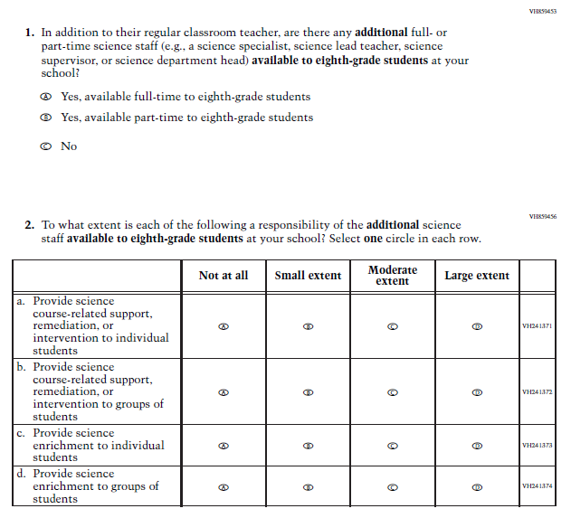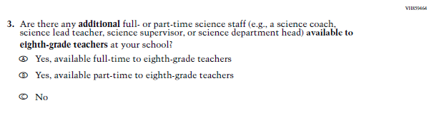

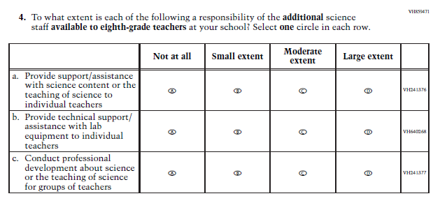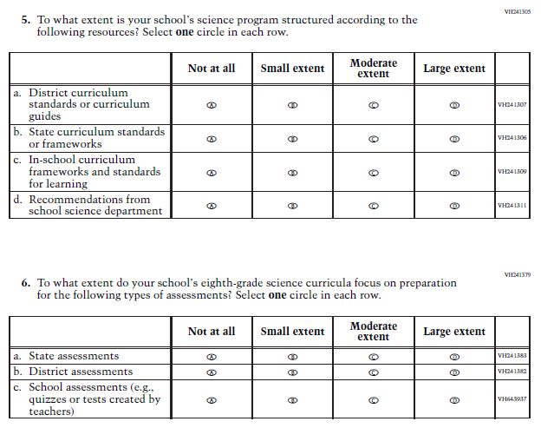

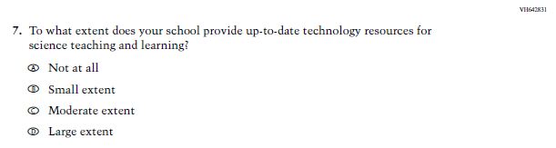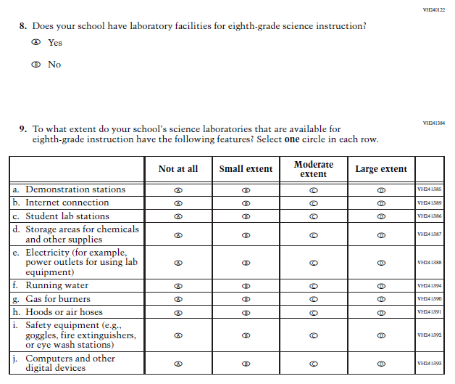

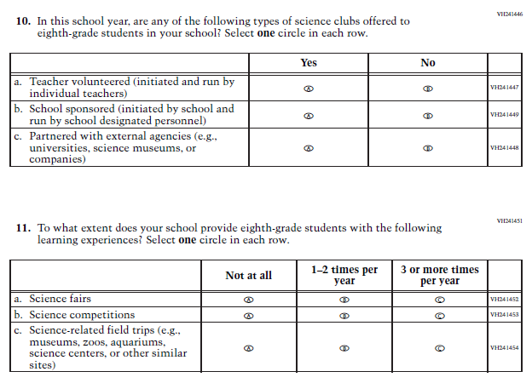

Appendix J3-15: Operational Grade 4, 8, and 12 Charter School
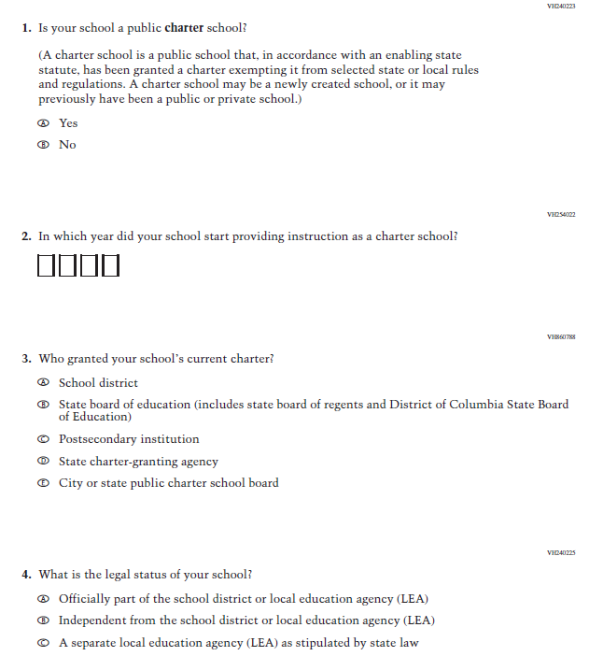

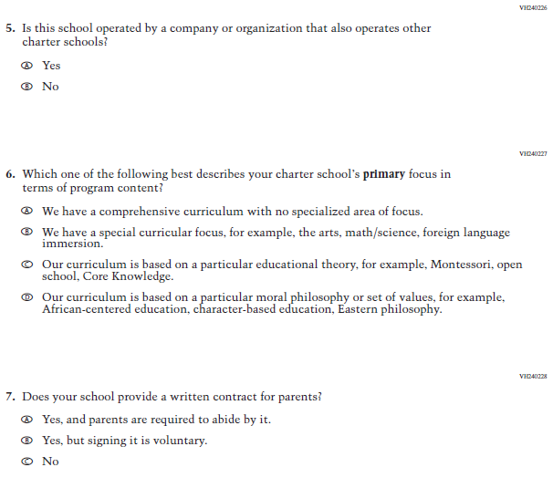

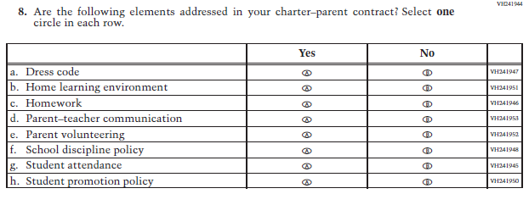

Appendix J3-16: Pilot Grade 4 Charter School (Reading and Mathematics)
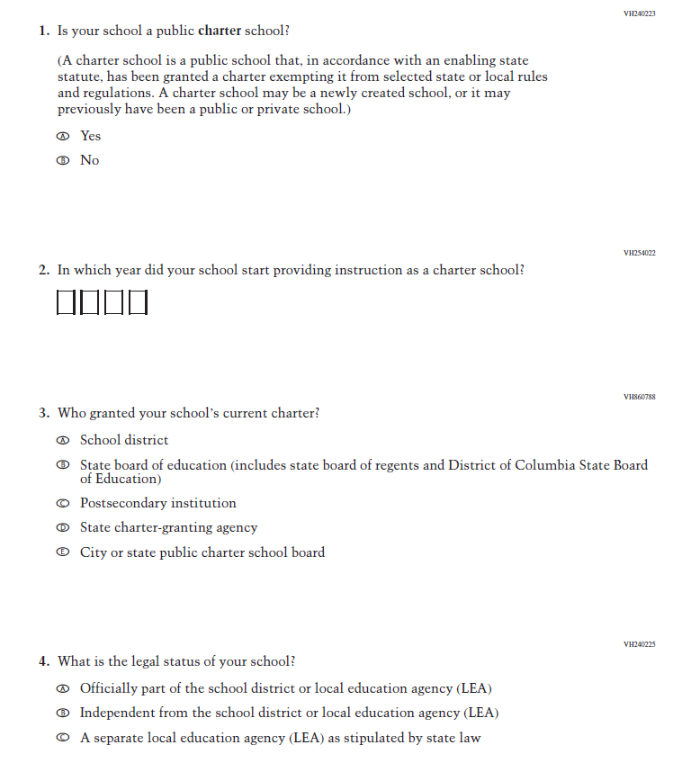
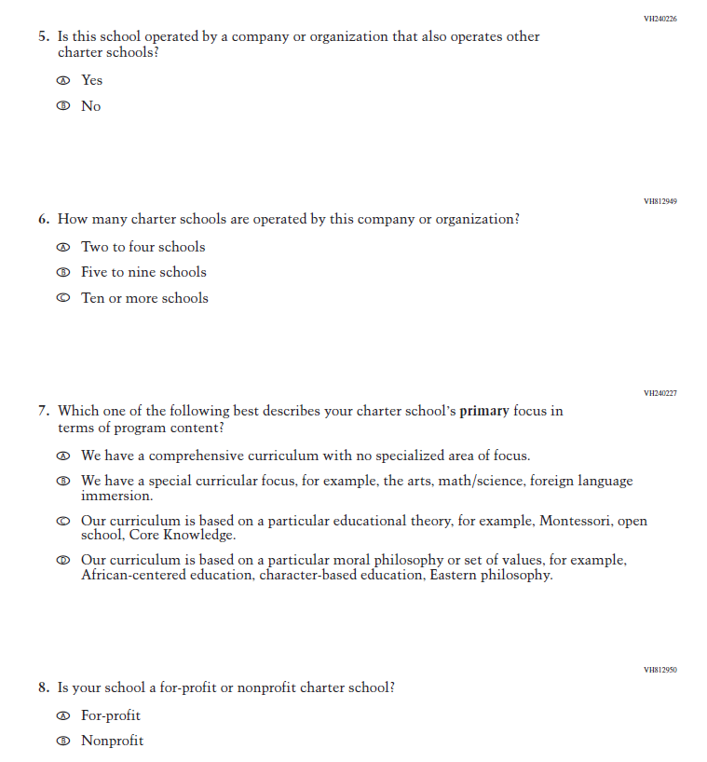
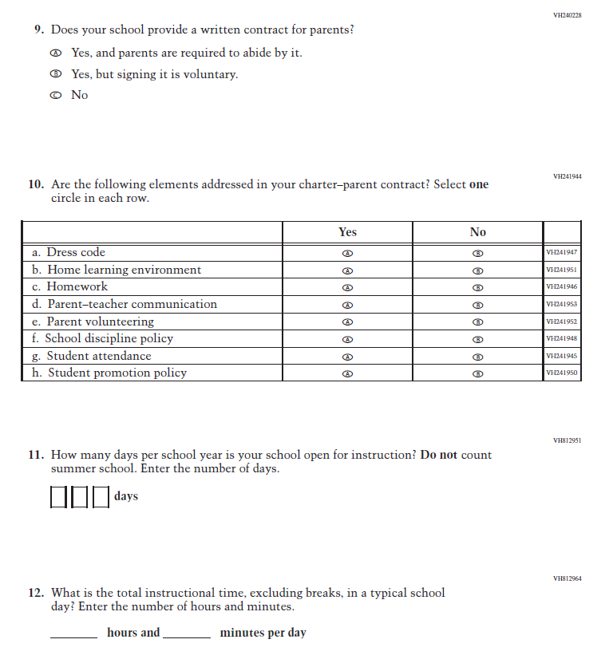

Appendix J3-17: Pilot Grade 8 Charter School (Mathematics)
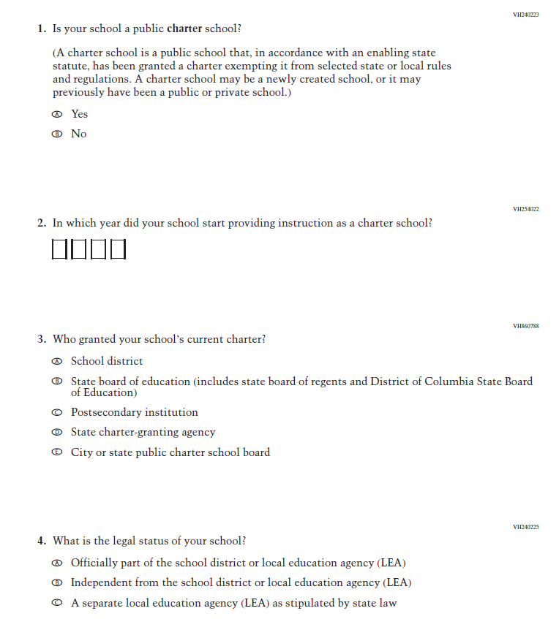
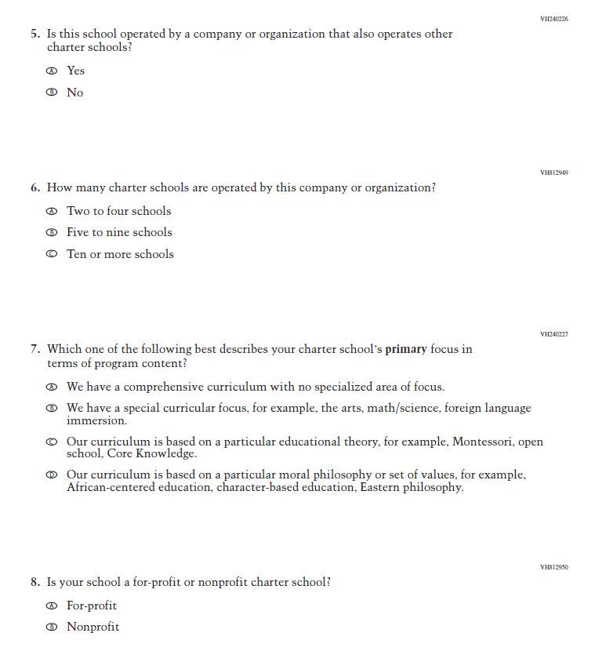
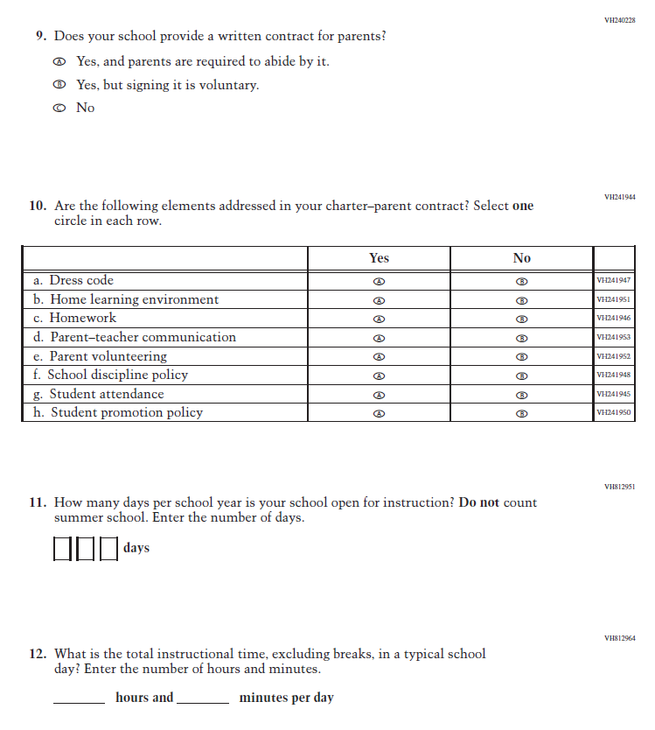

Appendix J3-18: Pilot Grade 8 Charter School (Reading)
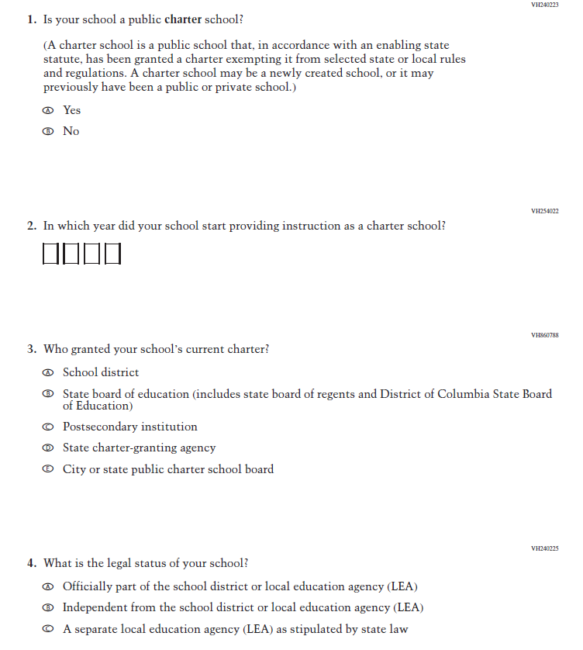
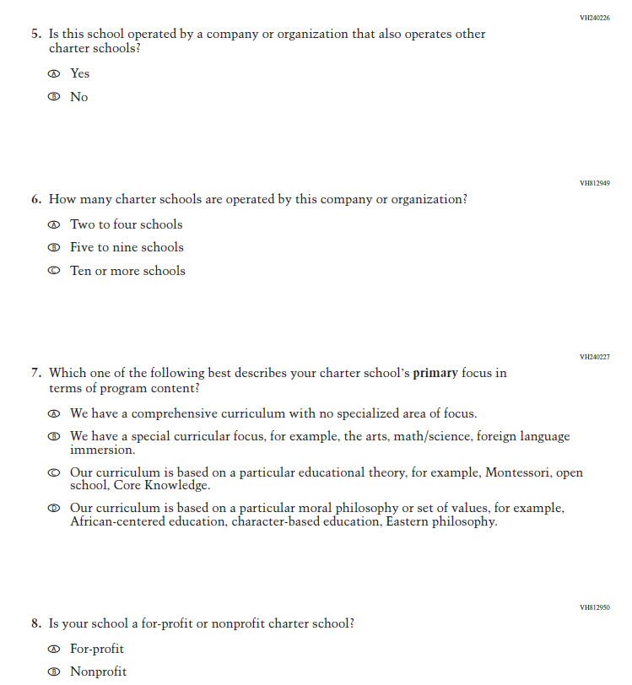
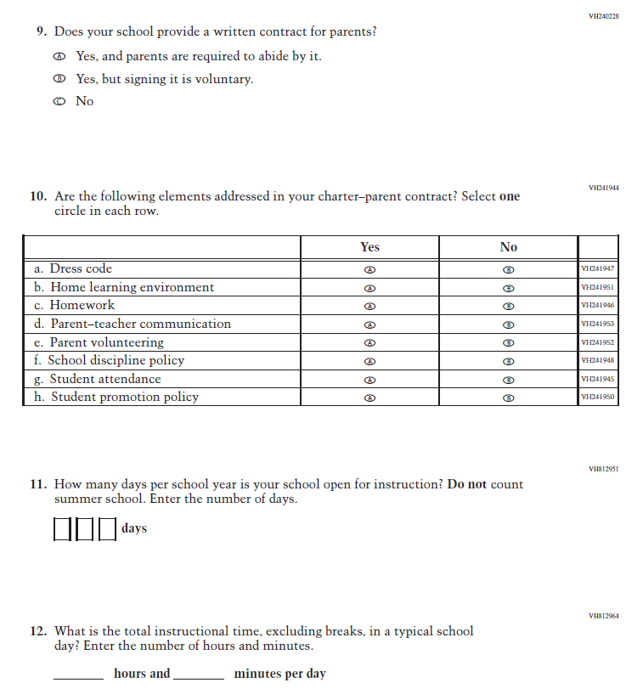

Appendix J3-23: Pilot Grade 4 (Core)
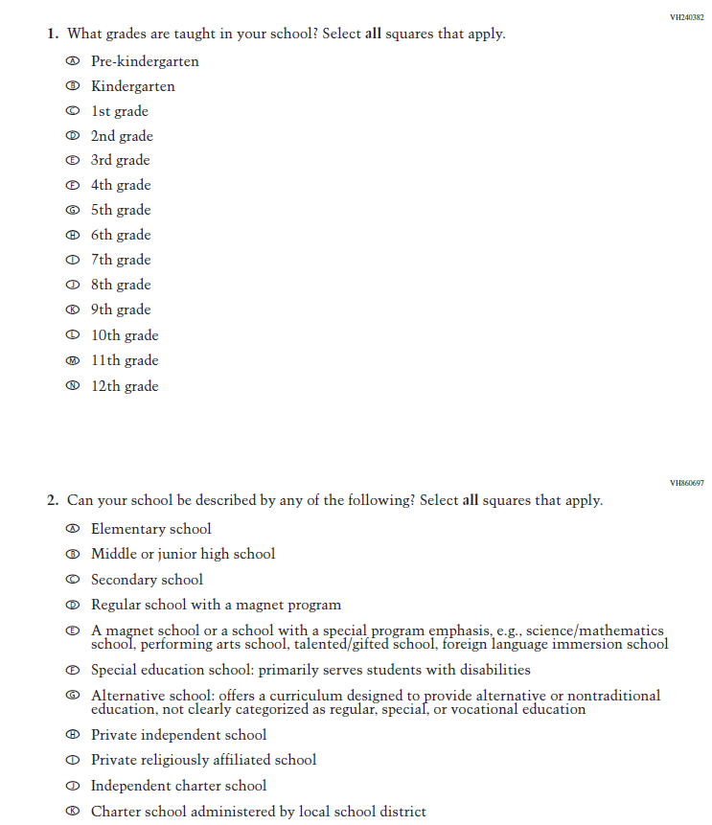
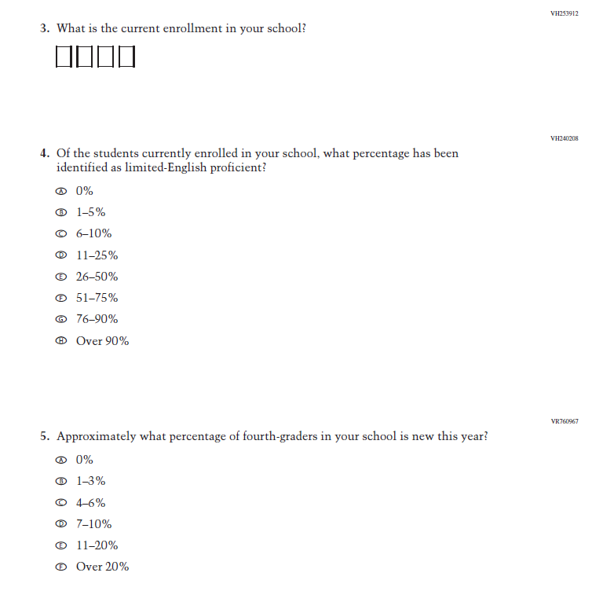
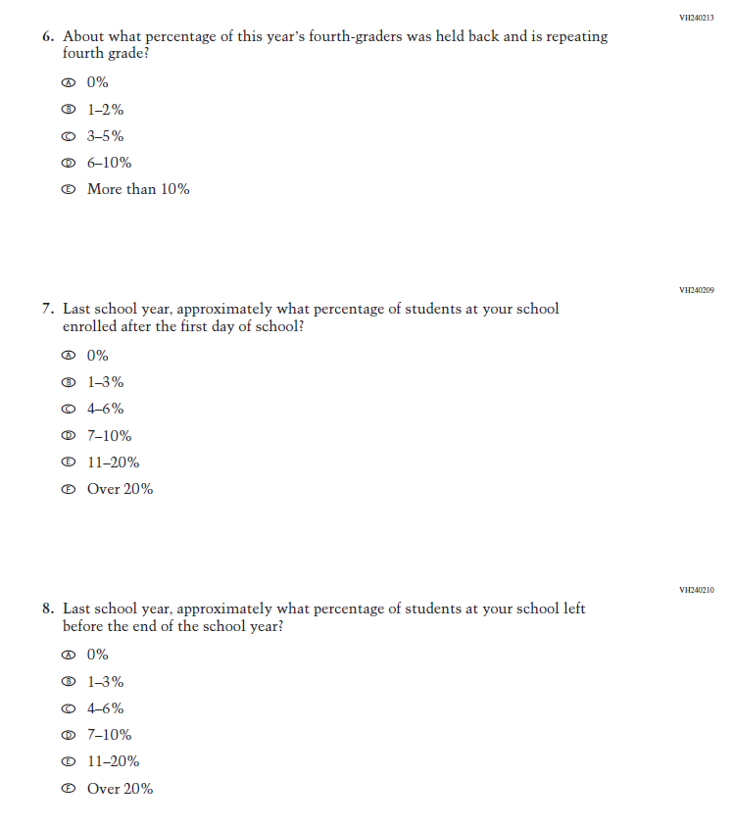
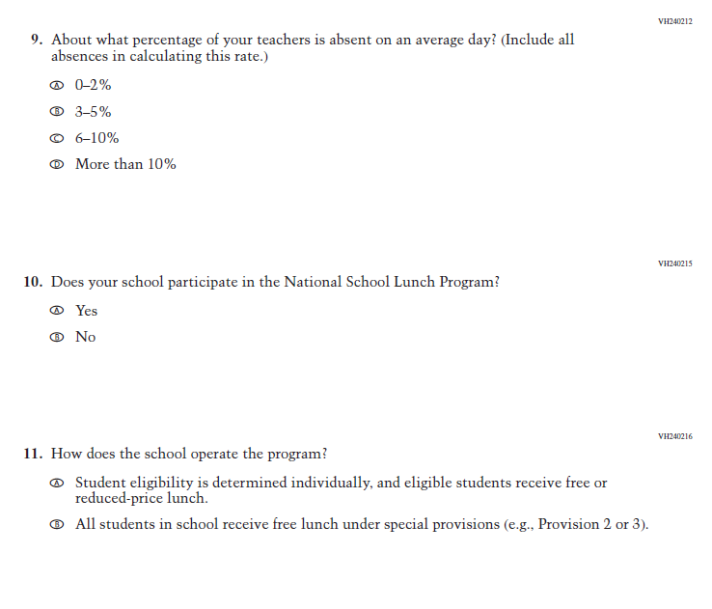
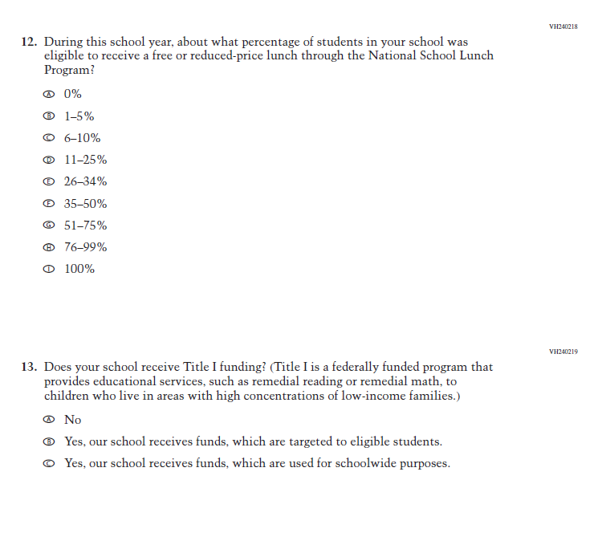
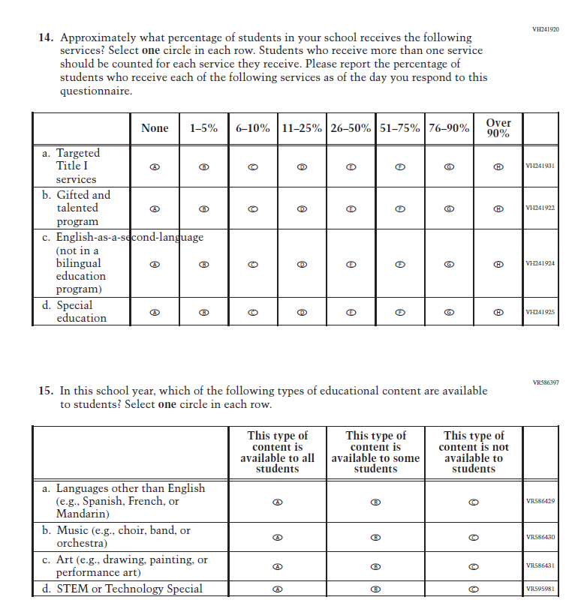
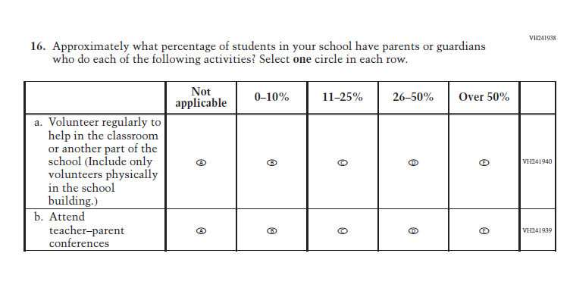
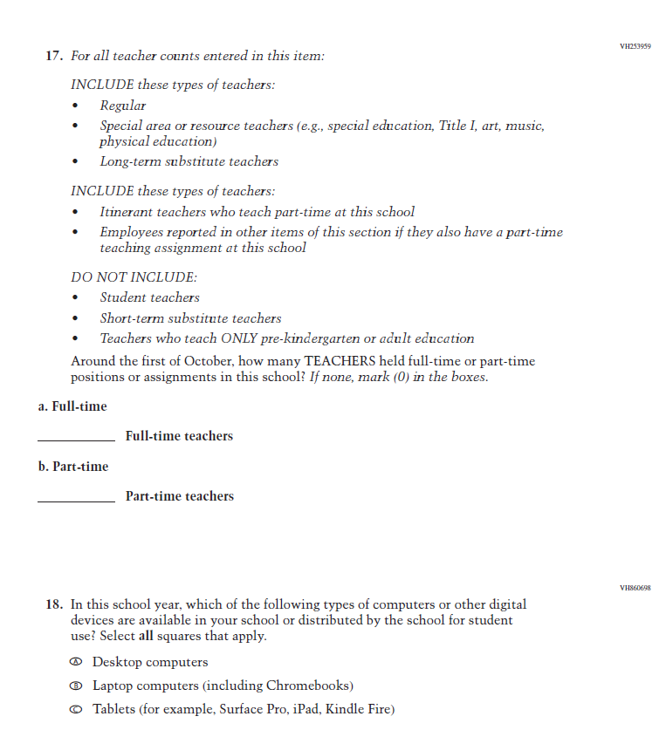
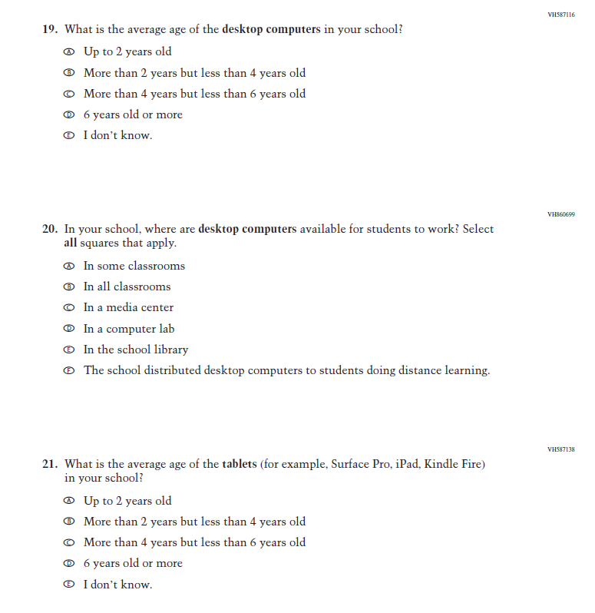
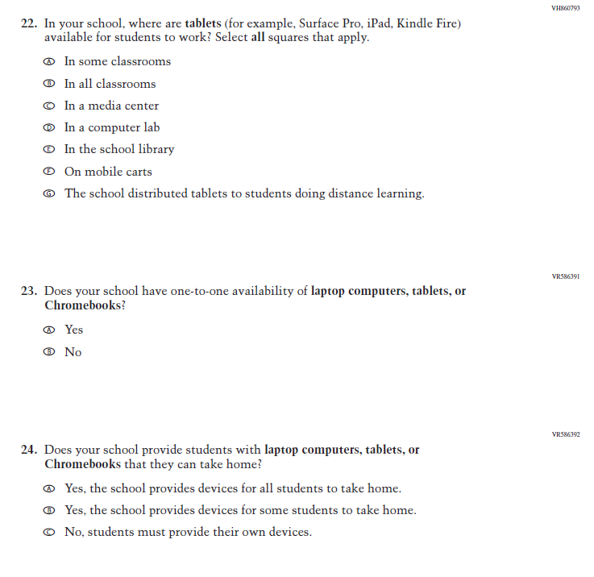
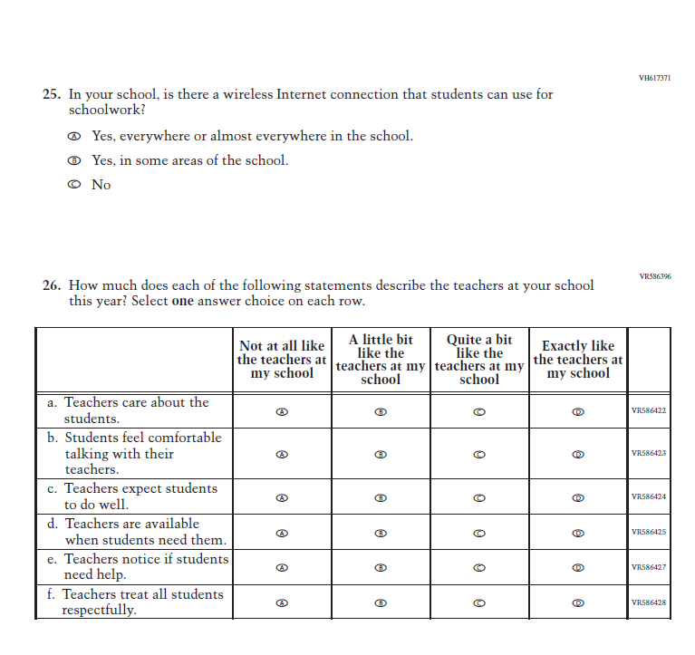

Appendix J3-24: Pilot Grade 8 (Core)
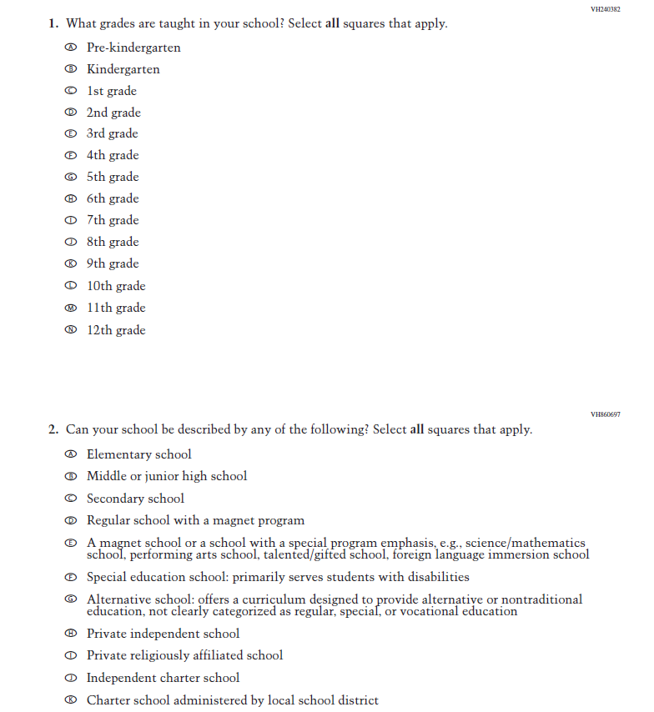
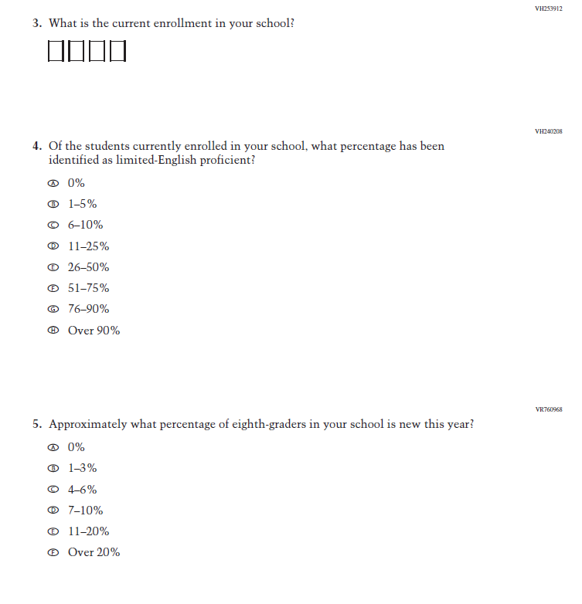
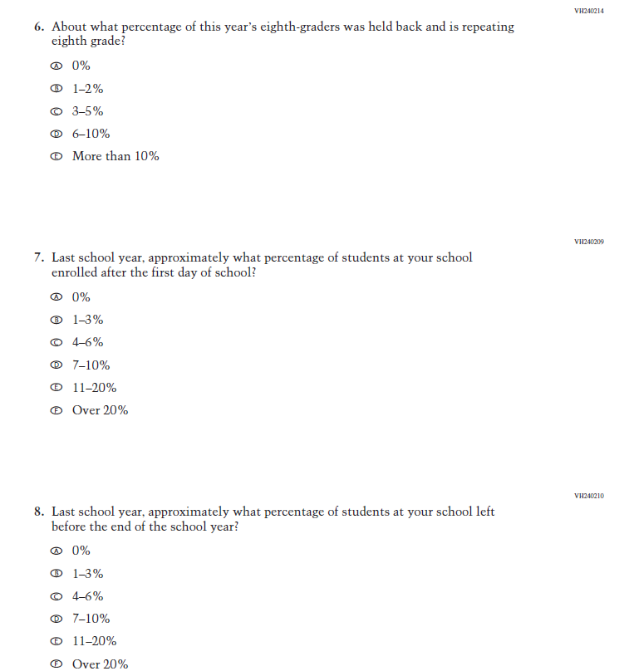
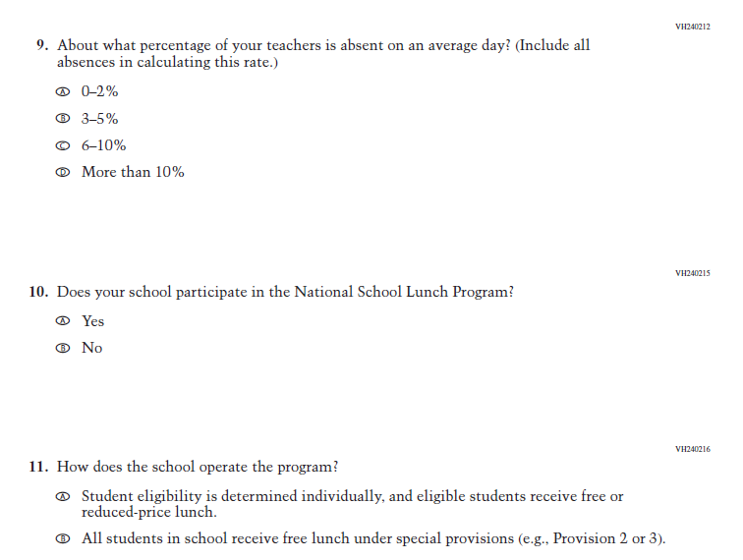
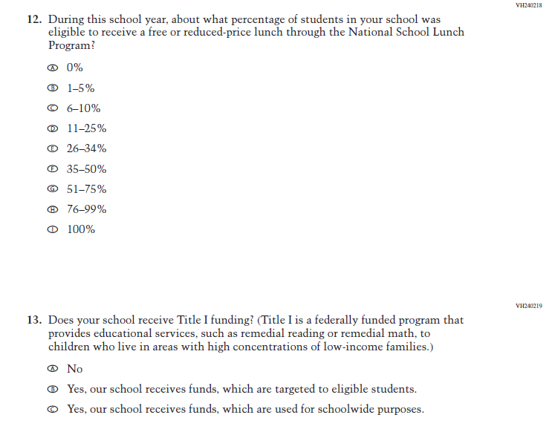
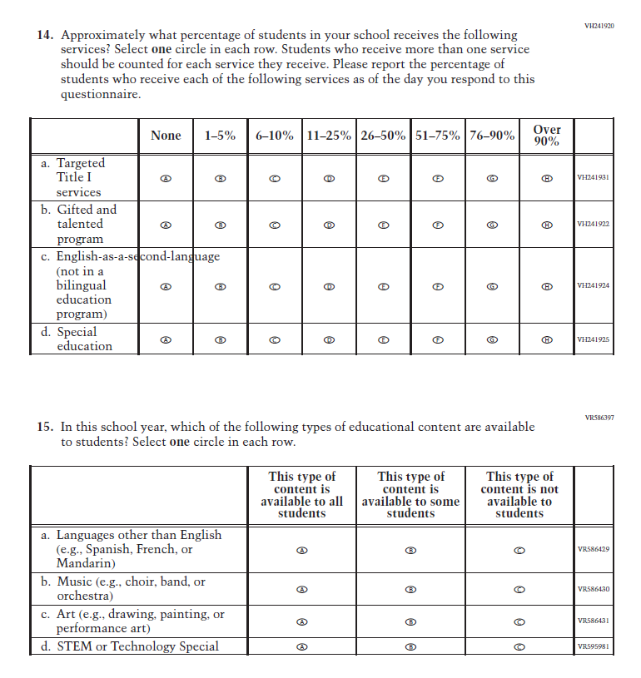
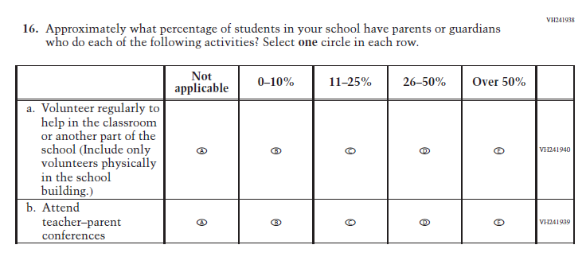
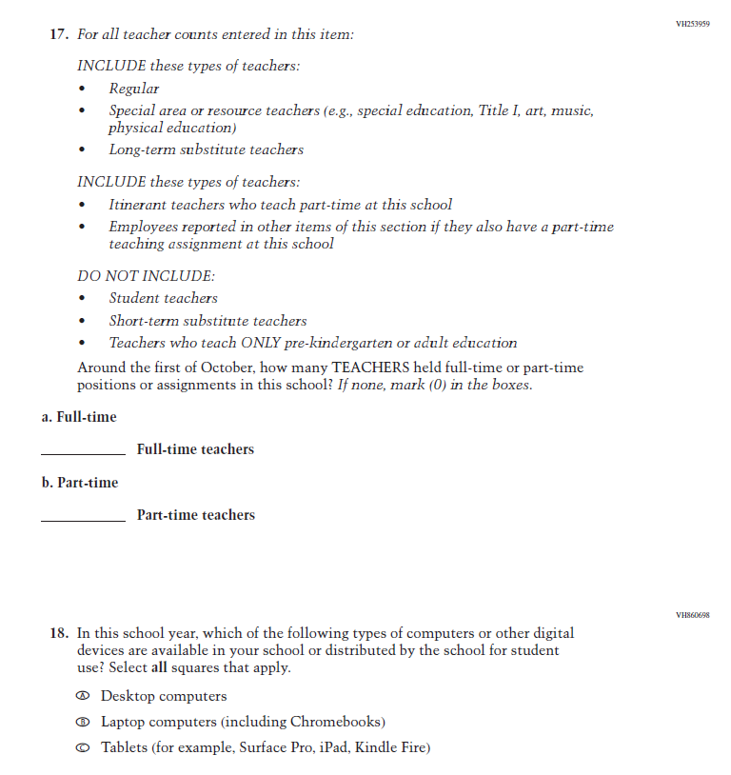
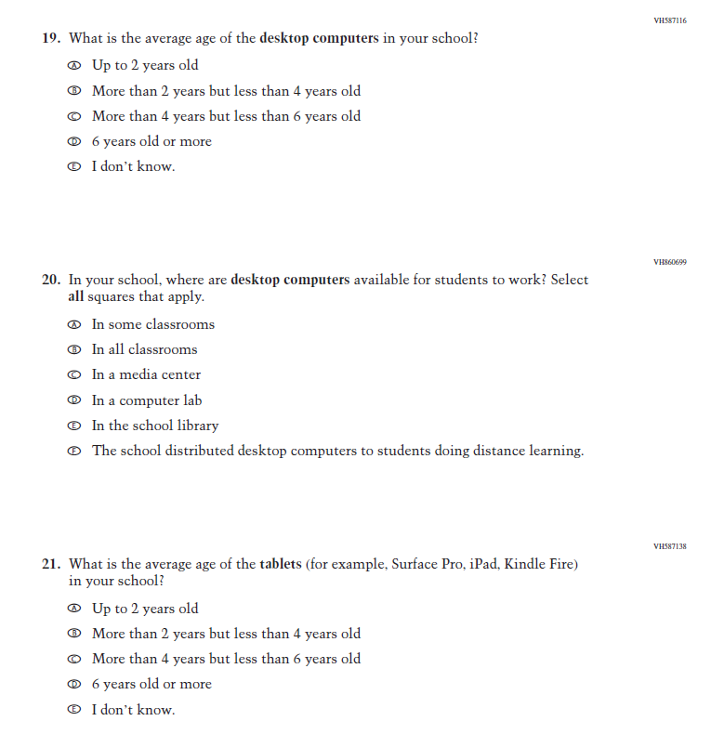
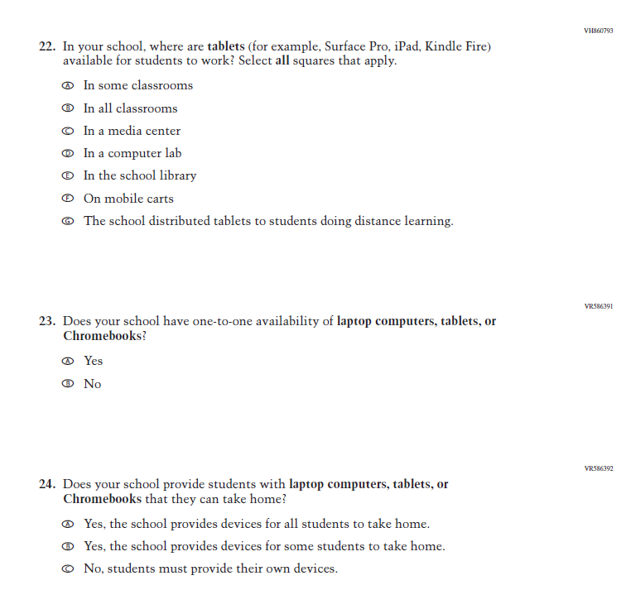
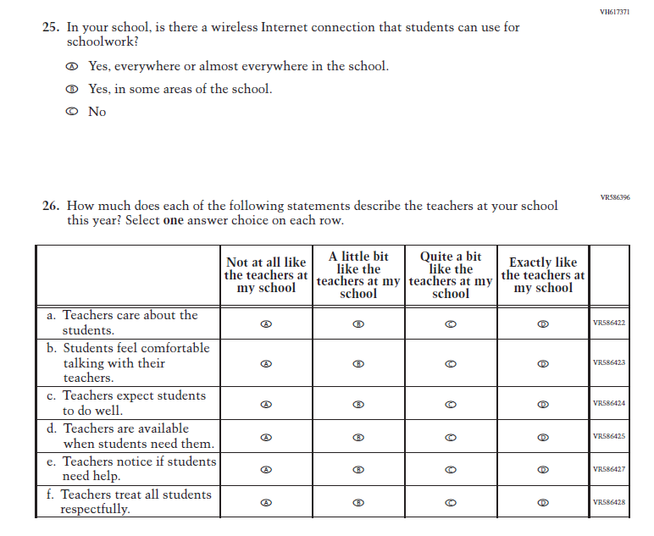

Appendix J3-25: Pilot Grade 4 (Mathematics)
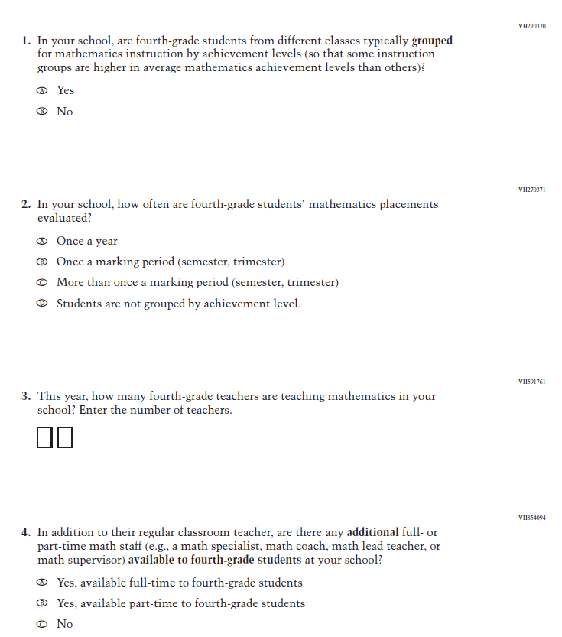
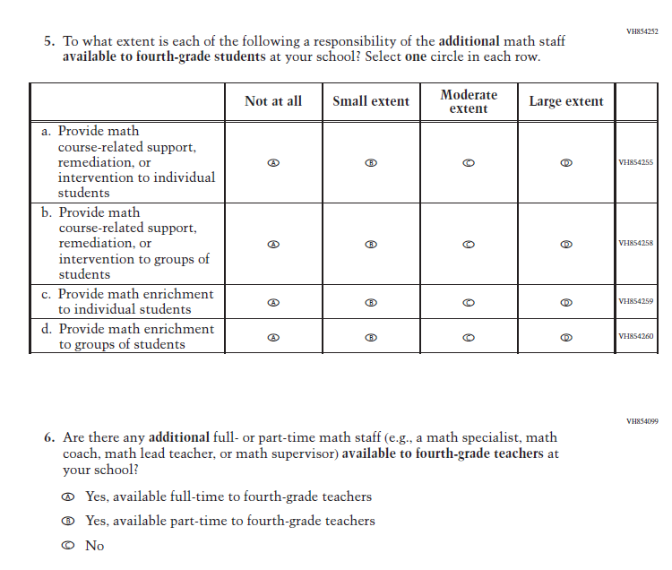
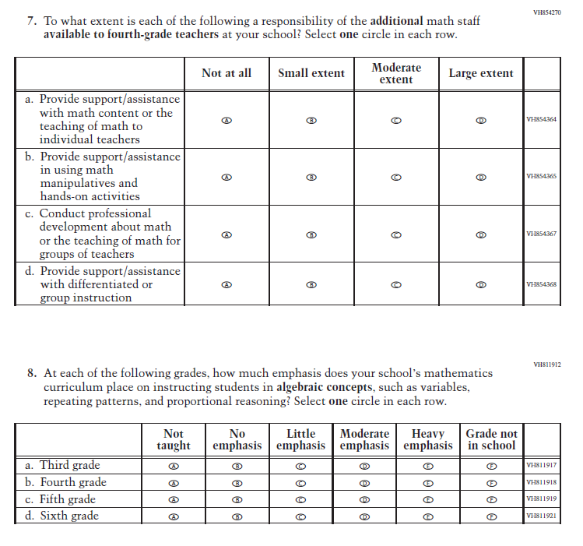
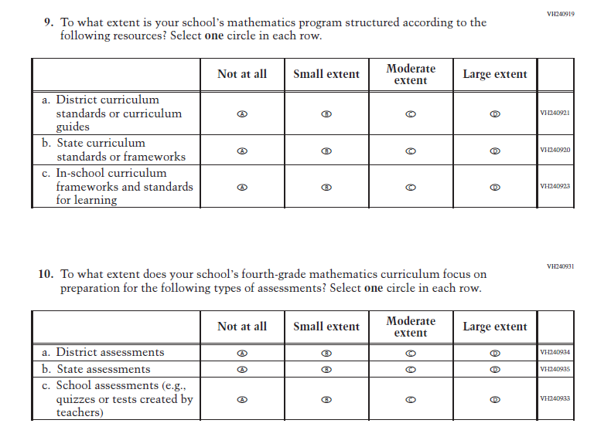
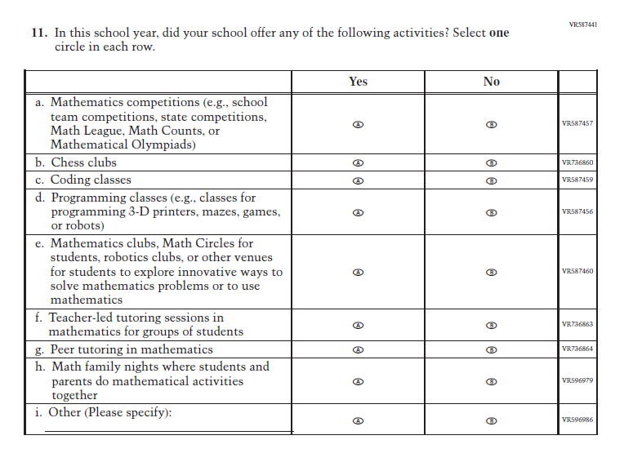

Appendix J3-26: Pilot Grade 8 (Mathematics)
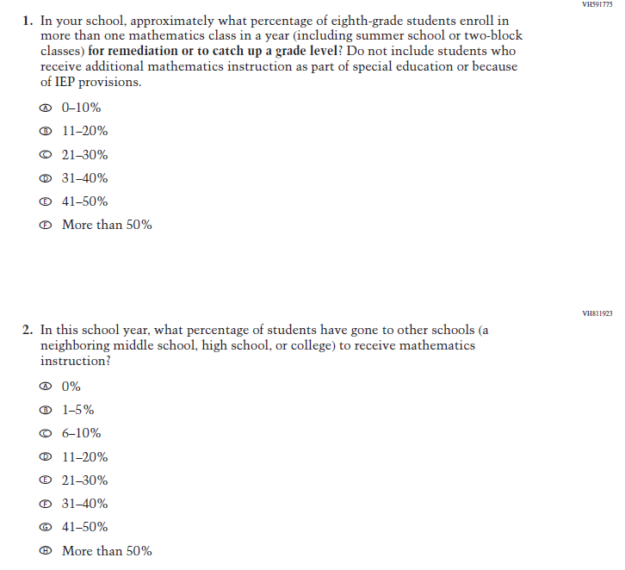
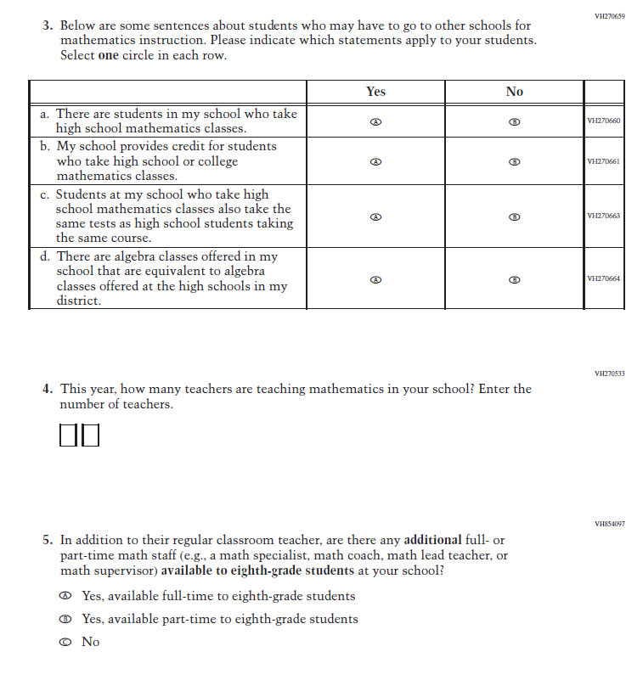
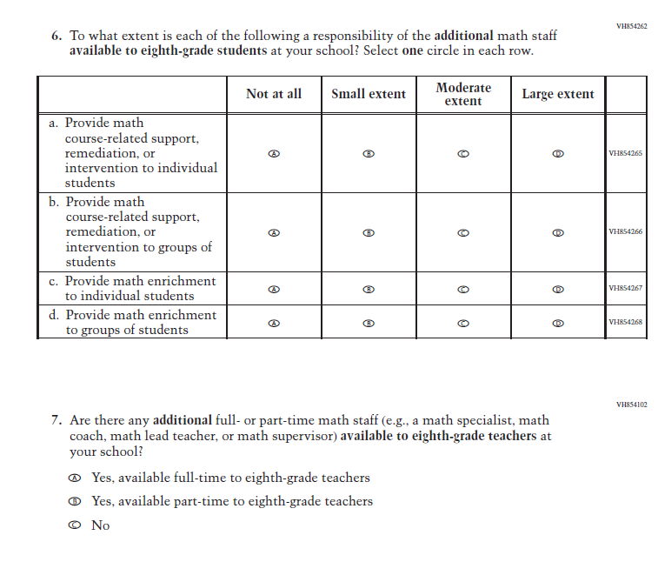
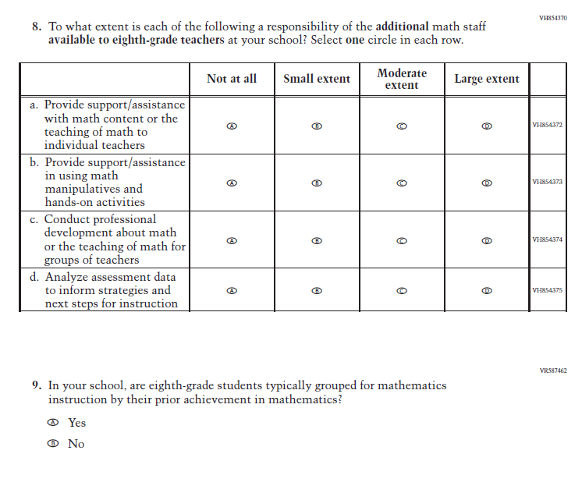
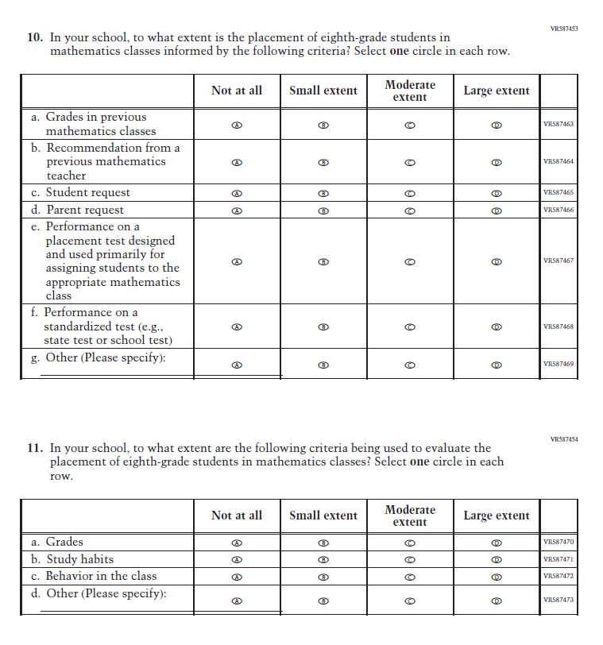
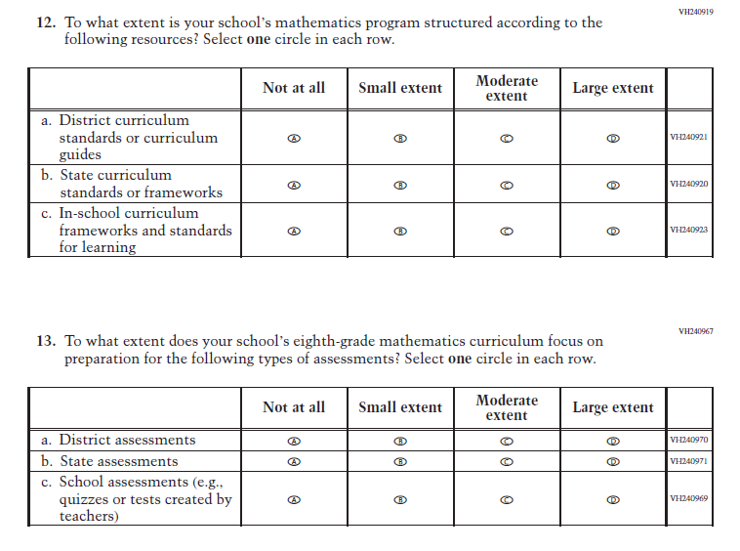
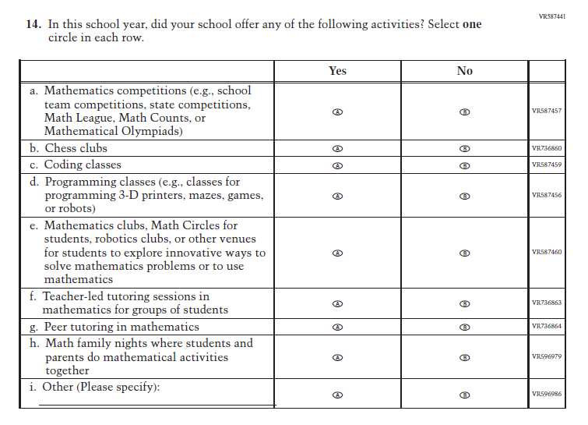

Appendix J3-27: Pilot Grade 4 (Reading)
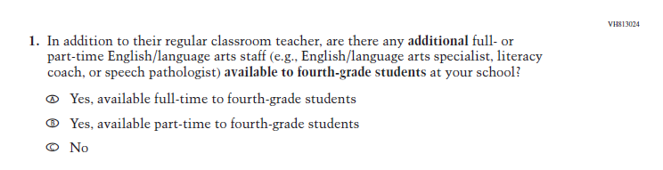
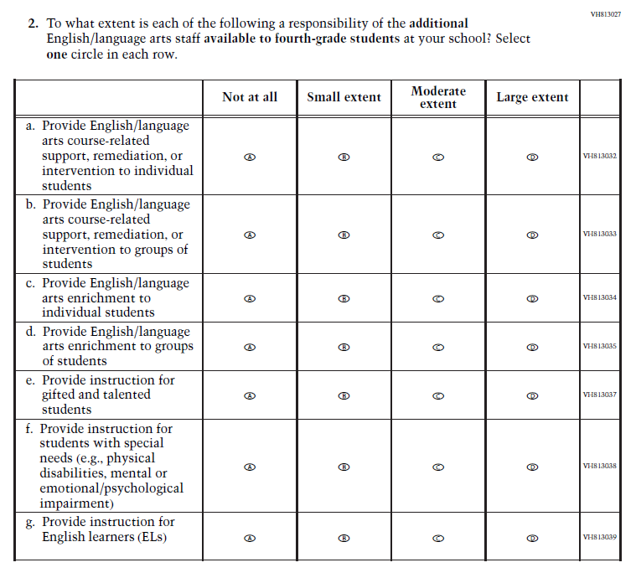
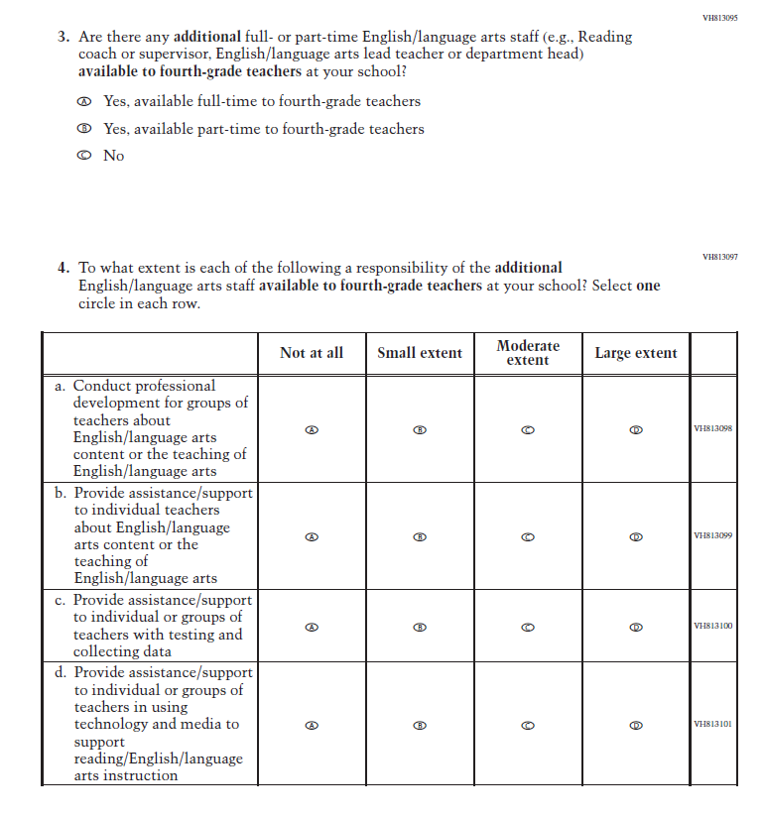
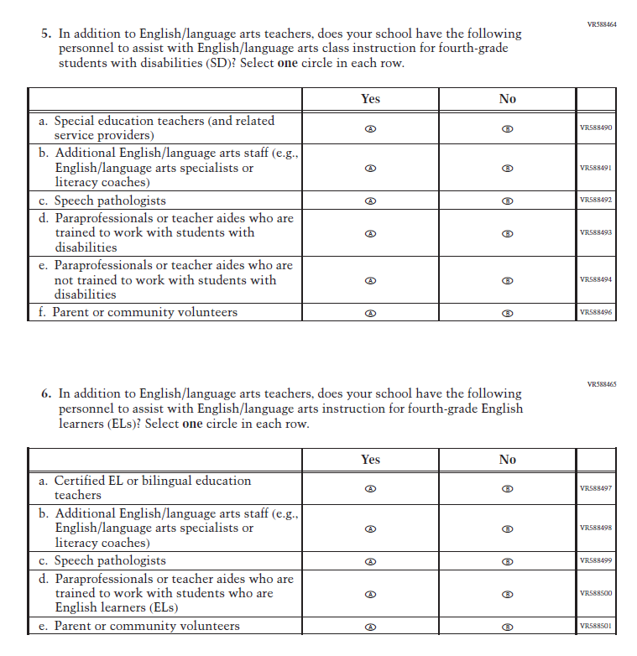
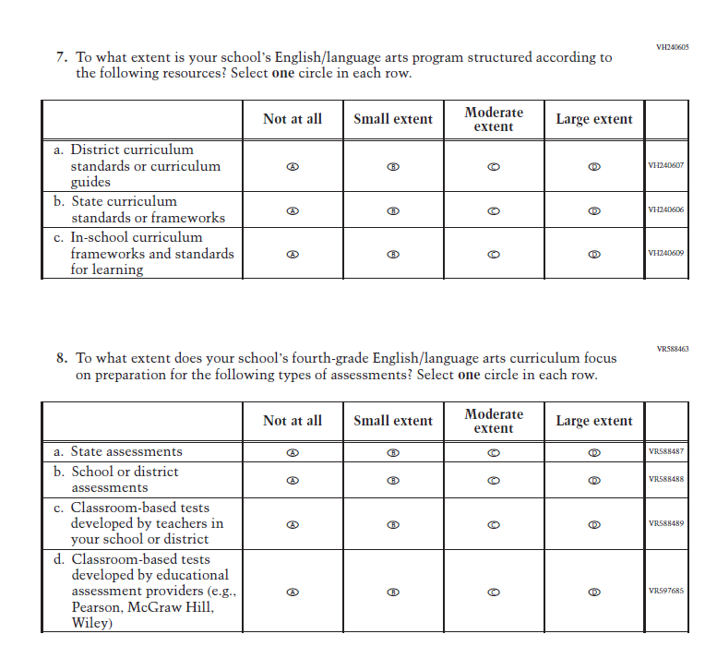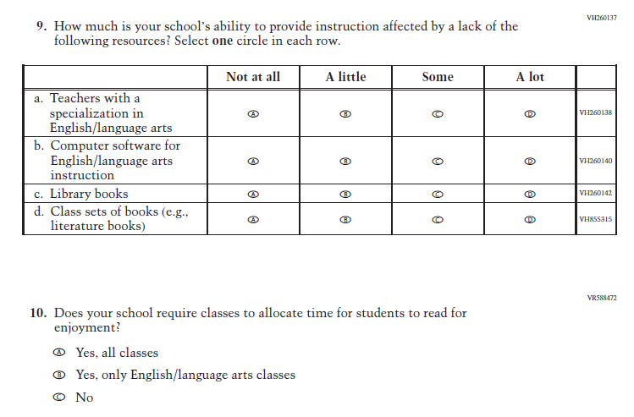

Appendix J3-28: Pilot Grade 8 (Reading)
