NATIONAL CENTER FOR EDUCATION STATISTICS
NATIONAL ASSESSMENT OF EDUCATIONAL PROGRESS

National Assessment of Education Progress (NAEP) 2026

Appendix D2

2025 Field Test Change Request #1 Communications and Recruitment Materials Samples

OMB# 1850-0928 v.36

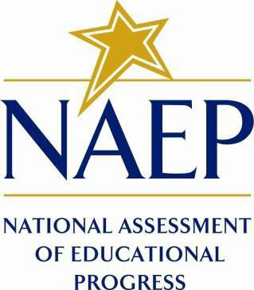

October 2024
Approved September 2024 (OMB#1850-0803 v.358)

Materials in this Appendix D2 are from 2025 Field Test Change Request #1, which is currently under OMB review and expected to receive approval at the end of September 2024. The 2026 materials were not ready for this submission, and they will reflect a combination of materials in Appendix D1 and Appendix D2 (Field Test Change Request #1, OMB# 1850-0803 v. 358). Amendment #1, scheduled for March 2025 submission, will include revisions to the 2026 materials needed in May in Appendix D3. Amendment #2, scheduled for June 2025 submission, will include all final materials needed for 2026 administrations in Appendix D3.
Table of Contents
Appendix D2-1: NAEP 2025 Field Test Overview Brochure (English and PR Spanish) 5
Appendix D2-2: NAEP 2025 Field Test Facts for Districts (English and PR Spanish) 7
Appendix D2-3: NAEP 2025 Field Test CSSO To District Superintendent Letter (English and PR Spanish) 12
Appendix D2-4: NAEP 2025 Field Test-Initial School Technology Survey Notification Letter (English and Spanish) 16
Appendix D2-5: NAEP 2025 Parent-Guardian Notification Letter 20
Appendix D2-6: NAEP 2025 Parent-Guardian Notification Letter, Private Schools 20
Appendix D2-7: NAEP 2025 Parent-Guardian Notification Letter, Puerto Rico 21
Appendix D2-8: NAEP 2025 Parent-Guardian Notification Letter, Bilingual Spanish Public Schools 22
Appendix D2-9: NAEP 2025 Parent-Guardian Notification Letter, Bilingual Spanish Private Schools 24
Appendix D2-10: NAEP 2025 Sampling Decision Notification, School(s) Selected 25
Appendix D2-11: NAEP 2025 Sampling Decision Notification, School(s) Not Selected 27
Appendix D2-12: NAEP 2025 Assessment Details Letter to Principal, School Device Model 28
Appendix D2-13: NAEP 2025 Assessment Details Letter to Principal, School Device Model, Puerto Rico 31
Appendix D2-14: NAEP 2025 Assessment Details Letter to Principal, NAEP Device Model 34
Appendix D2-15: NAEP 2025 Assessment Details Letter to Principal, NAEP Device Model, Puerto Rico 36
Appendix D2-16: NAEP 2025 Assessment Details Letter to School Coordinator School Device Model 39
Appendix D2-17: NAEP 2025 Assessment Details Letter to School Coordinator School Device Model, Puerto Rico 42
Appendix D2-18: NAEP 2025 Assessment Details Letter to School Coordinator NAEP Device Model 45
Appendix D2-19: NAEP 2025 Assessment Details Letter to School Coordinator NAEP Device Model, Puerto Rico 47
Appendix D2-20: NAEP 2025 NAEP in your School, School Device-Grades 4, 8, and 12 Mathematics and Reading 49
Appendix D2-21: NAEP 2025 NAEP in your School-School Device, School Device-Puerto Rico 53
Appendix D2-22: NAEP 2025 NAEP in your School-NAEP Device, Grades 4, 8, and 12 Mathematics and Reading 57
Appendix D2-23: NAEP 2025 NAEP in your School-NAEP Device, Puerto Rico 60
Appendix D2-24: NAEP 2025 NAEP in your School (Catholic Schools)-Grades 4, 8, and 12 Mathematics and Reading 64
Appendix D2-25: NAEP 2025 Facts for Teachers 68
Appendix D2-26: NAEP 2025 Facts for Teachers, Puerto Rico 72
Appendix D2-27: NAEP 2025 Preassessment Responsibilities Guide, School Device Model 78
Appendix D2-28: NAEP 2025 Preassessment Responsibilities Guide, School Device Model, Puerto Rico 82
Appendix D2-29: NAEP 2025 Preassessment Responsibilities Guide, NAEP Device Model 86
Appendix D2-30: NAEP 2025 Preassessment Responsibilities Guide, NAEP Device Model, Puerto Rico 89
Appendix D2-31: NAEP 2025 Assessment Date Notification and Preassessment Email, School Device Model 92
Appendix D2-32: NAEP 2025 Assessment Date Notification and Preassessment Email, School Device Model, Puerto Rico 94
Appendix D2-33: NAEP 2025 Assessment Date Notification and Preassessment Email, NAEP Device Model 96
Appendix D2-34: NAEP 2025 Assessment Date Notification and Preassessment Email, NAEP Device Model, Puerto Rico 97
Appendix D2-35: NAEP 2025 Application Installer Notification 98
Appendix D2-36: NAEP 2025 Application Installer Notification, Puerto Rico 99
Appendix D2-37: NAEP 2025 School Staff Assistance email template, Technology Support 100
Appendix D2-38: NAEP 2025 School Staff Assistance email template, Technology Support, Puerto Rico 101
Appendix D2-39: NAEP 2025 Email to school staff person identified to assist with Classroom Management 102
Appendix D2-40: NAEP 2025 Email to school staff person identified to assist with Classroom Management, Puerto Rico 103
Appendix D2-41: NAEP 2025 Email to school staff person identified to assist with Technology and Classroom Management 104
Appendix D2-42: NAEP 2025 Inclusion Guidelines for English Learners 106
Appendix D2-43: NAEP 2025 Inclusion Guidelines for English Learners, Puerto Rico 110
Appendix D2-44: NAEP 2025 Inclusion Guidelines for Students with Disabilities 115
Appendix D2-45: NAEP 2025 Inclusion Guidelines for Students with Disabilities, Puerto Rico 120
Appendix D2-46: NAEP 2025 Preassessment Responsibilities Guide, Private Schools School Device Model 124
Appendix D2-47: NAEP 2025 Instructions for preparing and importing a student excel file 127
Appendix D2-48: NAEP 2025 eNAEP Download Center 132
Appendix D2-49: NAEP 2025 eNAEP Download Center, Spanish 186
NAEP 2025 Best Practices Materials (New) 241
Appendix D2-50: NAEP 2025 Best Practices Introduction 242
Appendix D2-51: NAEP 2025 Best Practices Notification 244
Appendix D2-52: NAEP 2025 Best Practices Parent/Guardian Notification Letter 245
Appendix D2-53: NAEP 2025 Best Practices Storyboard for Introduction Video 247
Appendix D2-54: NAEP 2025 Best Practices 2019 Infographic Grade 12 Mathematics and Reading Results 248
Appendix D2-55: NAEP 2025 Best Practices PowerPoint Slide TV Monitor Announcement 252
Appendix D2-56: NAEP 2025 Best Practices PowerPoint Slides: Introducing NAEP to Parents 253
Appendix D2-57: NAEP 2025 Best Practices PowerPoint Slides: Introducing NAEP to Students 262
Appendix D2-58: NAEP 2025 Best Practices PowerPoint Slides: Introducing NAEP to Teachers 270
Appendix D2-59: NAEP 2025 Best Practices HTML Emails 278
Appendix D2-60: NAEP 2025 Best Practices Talking Points Principals and Teachers to Parents 281
Appendix D2-61: NAEP 2025 Best Practices Talking Points Principals and Teachers to Students 282
Appendix D2-62: NAEP 2025 Best Practices Talking Points Principals to Teachers 283
Appendix D2-63: NAEP 2025 Best Practices School Announcement Templates 284
Appendix D2-64: NAEP 2025 Best Practices High School Incentive Ideas 285
Appendix D2-65: NAEP 2025 Best Practices Social Media and Online Communication Sample Announcements 286
Appendix D2-66: NAEP 2025 Best Practices Certificate of Community Service 289
Appendix D2-67: NAEP 2025 Best Practices Certificate of Appreciation 290
Appendix D2-68: NAEP 2025 Best Practices NAEP Data, Tools, and Resources 292

Appendix D2-1: NAEP 2025 Field Test Overview Brochure (English and PR Spanish)
Title: Overview of NAEP 2025 Field Test
(Grades 4, 8, and 12; math and reading)

The National Assessment of Educational Progress (NAEP)—administered by the National Center for Education Statistics (NCES)—is the largest nationally representative and continuing assessment of what our nation’s students know and can do in various subjects. NAEP has been on a trajectory of modernization for years, leveraging digital technologies to improve the assessment processes and testing experience for students, while continuing to report vital data on student achievement.

Ultimately, NCES’s goals are to improve NAEP’s administration model to be more efficient and to be able to administer the assessment on devices (e.g., desktops, laptops, tablets with keyboards) students are most familiar with. In 2024, NCES administered the NAEP mathematics and reading assessments using school Internet and administered a proof-of-concept study at grades 4 and 8 using school devices. As the next step toward making the administration model more efficient, NCES will administer a field test as part of the NAEP 2025 program. This field test is part of NCES’s transition plan toward using devices and Internet managed by schools or districts to administer NAEP, which is intended to improve the assessment experience for schools and students. When assessed on devices that are most familiar to them, students will be able to participate in NAEP in a way that is more comfortable for them.

Call out box:
Assessment Details
- Dates: January 27–March 7, 2025
- Subjects: Mathematics and Reading
- Grades: 4, 8, and 12
- Sessions: Two groups of up to 25 students each, or one group of up to 50 students
- Student time: Approximately 2 hours (including transition time, directions, and completion of a survey questionnaire)

Each student will answer questions in one subject only. Students will also complete a survey questionnaire about their experience with the assessment and their educational experiences and opportunities to learn both in and outside of the classroom.

Achievement data from the study will not be publicly reported but will be used to inform future NAEP assessments.

Research and Development
NCES is a leader in research and innovation for large-scale assessments. NAEP’s modernizations are driven by research focused on education theory, policy, cognitive science, and classroom practice—consistent with the program’s reputation for high-quality, valid, and reliable assessments and data.

NCES will continue to explore how to best use evolving digital technologies to provide relevant data about student achievement.

Learn more about NAEP: https://nces.ed.gov/nationsreportcard/

National Center for Education Statistics (NCES) conducts the National Assessment of Educational Progress to evaluate federally supported education programs. All of the information you provide may be used only for statistical purposes and may not be disclosed, or used, in identifiable form for any other purpose except as required by law (20 U.S.C. §9573 and 6 U.S.C. §151). By law, every NCES employee as well as every NCES agent, such as contractors and NAEP coordinators, has taken an oath and is subject to a jail term of up to 5 years, a fine of $250,000, or both if he or she willfully discloses ANY identifiable information about you. Electronic submission of your information will be monitored for viruses, malware, and other threats by Federal employees and contractors in accordance with the Cybersecurity Enhancement Act of 2015.

Visión general de la prueba de campo de NAEP de 2025
(4.° y 8.° grado, Matemáticas)

La Evaluación Nacional del Progreso Educativo (NAEP, por sus siglas en inglés), administrada por el Centro Nacional para Estadísticas de la Educación (NCES), es la evaluación continua y nacionalmente representativa más grande que mide lo que los estudiantes de nuestro país saben y pueden hacer en diferentes materias. Durante varios años, NAEP ha seguido una trayectoria de innovación, aprovechando las tecnologías digitales para mejorar la experiencia de los estudiantes y los procesos de evaluación, al tiempo que continúa proporcionando datos esenciales sobre el rendimiento de los estudiantes.

En definitiva, los objetivos de NCES son mejorar el modelo de administración de NAEP para que sea más eficiente y poder administrar la evaluación en dispositivos (p. ej., computadoras de escritorio, computadoras portátiles, tabletas con teclado) con los que los estudiantes estén más familiarizados. En el 2024, NCES administró las evaluaciones de NAEP de Matemáticas utilizando el Internet de las escuelas y administró un estudio de prueba de concepto en los grados 4. °y 8.° utilizando los dispositivos de las escuelas. Como próximo paso para hacer más eficiente el modelo de administración, NCES administrará una prueba de campo como parte del programa de NAEP de 2025. Esta prueba de campo forma parte del plan de transición de NCES hacia el uso de dispositivos e Internet gestionados por las escuelas o los distritos para la administración de NAEP, con lo que se pretende mejorar la experiencia de evaluación para las escuelas y los estudiantes. Al ser evaluados en los dispositivos que les son más familiares, los estudiantes podrán participar en NAEP de una manera más cómoda para ellos.

<Call out box>
Información sobre la evaluación:
- Período: Del 27 de enero al 7 de marzo de 2025
- Materia: Matemáticas
- Grados: 4.° y 8.°
- Sesiones: Un grupo de 25 estudiantes máximo
- Tiempo del estudiante: Aproximadamente dos horas (incluido el tiempo de transición, las instrucciones y contestar un cuestionario de contexto).

Los estudiantes completarán un cuestionario de contexto sobre su experiencia con la evaluación y sus experiencias educativas y oportunidades de aprendizaje dentro y fuera del salón de clase.

Los datos de rendimiento del estudio no se darán a conocer públicamente, pero se utilizarán para orientar las futuras evaluaciones de NAEP.

Investigación y desarrollo
NCES es líder en investigación e innovación para las evaluaciones a gran escala. Las innovaciones de NAEP están impulsadas por la investigación centrada en la teoría de la educación, la política pública, la ciencia cognitiva y la práctica en el salón de clases, en concordancia con la reputación del programa de ofrecer evaluaciones y datos de alta calidad, válidos y fiables.

NCES continuará explorando la mejor manera de utilizar las tecnologías digitales en constante evolución para proporcionar datos relevantes sobre el rendimiento de los estudiantes.

Para más información sobre NAEP, visite: https://nces.ed.gov/nationsreportcard/puertorico/sp.aspx

El Centro Nacional para Estadísticas de la Educación (NCES, por sus siglas en inglés) administra la Evaluación Nacional del Progreso Educativo para evaluar programas de educación apoyados por el Gobierno federal. Toda la información que proporcione podrá usarse únicamente con fines estadísticos y no podrá darse a conocer o usarse ni para identificarlo ni para cualquier otro propósito salvo aquel requerido legalmente (20 U.S.C. §9573 y 6 U.S.C. §151). Por ley, todos los empleados de NCES al igual que todos los representantes del mismo, como contratistas y coordinadores de NAEP, han hecho un juramento y están sujetos a una pena de prisión de hasta 5 años, una multa de hasta $250,000 o ambas cosas, si dan a conocer intencionalmente CUALQUIER información que lo identifique. El envío de su información por vía electrónica será monitoreado por empleados y contratistas federales para detectar virus, programas maliciosos (malware) y otras amenazas conforme a la Ley de Mejoramiento de la Seguridad Cibernética de 2015.

Appendix D2-2: NAEP 2025 Field Test Facts for Districts (English and PR Spanish)
NOTE: Due to the timing of this English version of the letter and efforts to provide the most current information to school superintendents, there is a mention of a 2025 Long-term Trend Assessment in addition to the 2025 Field Test, and the English version of the letter was approved by OMB in April 2024 (OMB# 1850-0928 v.32).
NAEP 2024–2025
Facts for Districts
“NAEP is the only assessment providing half a century of performance data to measure what students know and can do. The state and national trends inform local, state, and national program and policy discussions that improve teaching and learning.”
—David Atherton, EdD, Principal, Clear Creek Middle School, Gresham, OR
What is NAEP?
The National Assessment of Educational Progress (NAEP) is an integral measure of academic progress across the nation and over time. It is the largest nationally representative and continuing assessment of what our nation’s students know and can do in various subjects such as civics, mathematics, reading, and U.S. history. The program also provides valuable insights into students’ educational experiences and opportunities to learn in and outside of the classroom.
NAEP is a congressionally mandated program administered by the National Center for Education Statistics (NCES), within the U.S. Department of Education and the Institute of Education Sciences.
How are NAEP results reported?
The results of NAEP are released as The Nation’s Report Card. Depending on the assessment, NAEP results are available for the nation, states, and select urban districts that participate in the Trial Urban District Assessment (TUDA). Results are also available for different student groups, based on factors such as race/ethnicity, gender, school location, and more. NAEP is not designed to collect or report results for individual students, classrooms, or schools.
Why should my district participate in NAEP?
Your district’s participation will help ensure that educators, policymakers, and elected officials have reliable data to better understand and improve student learning. Schools and students selected to participate in NAEP represent schools and students across the country. When students participate and give their best effort, NAEP results provide the most accurate and representative measure possible of student achievement and experience.
What NAEP assessments will be administered in the 2024–2025 school year?
The 2024–2025 program will include the long-term trend assessments for 9-, 13-, and 17-year-olds. The table below provides further information.

Age | Type of NAEP assessment | Subject | Format | Assessment Window
Age 13 | Long-term trend | Mathematics  Reading | Paper and Pencil | October 7–December 13, 2024
Age 9 | Long-term trend | Mathematics  Reading | Paper and Pencil | January 6–March 14, 2025
Age 17 | Long-term trend | Mathematics  Reading | Paper and Pencil | March 17–May 23, 2025

NAEP long-term trend assessments measure student performance in mathematics and reading and allow the performance of today’s students to be compared with students since the early 1970s. Students will also be asked to complete a survey questionnaire to provide a better understanding of factors that may be related to students’ learning. There will be no teacher questionnaire, but a school questionnaire will be administered via paper-and-pencil to gather information about school policies and characteristics. Results will be released for the nation.
NCES will also administer the NAEP 2025 field test which will assess students at grades 4, 8, and 12 in mathematics and reading as part of a transition to administering NAEP using school computers and Internet, which will allow students to have a more authentic assessment experience by using a device with which they are familiar. The assessment window for the field test will be [January 27–March 7, 2025]. Results from this field test will not be released but will inform future NAEP assessments.
What will students in my district do?
Participating students will complete subject-area questions in mathematics or reading. Each student will be assessed in one subject only. Students will also complete a survey questionnaire.
It takes participating students approximately 90 minutes to complete the long-term trend assessment and 2 hours to complete the field test assessment. This includes transition time, directions, and completion of a survey questionnaire. A broad range of accommodations are provided for students with disabilities and English learners.
Do teachers need to prepare students for the assessment?
Teachers do not need to prepare their students to take the assessment but should encourage them to do their best.
How can school administrators and teachers use NAEP data to help our students?
The Nation’s Report Card website (nationsreportcard.gov) allows you to examine the relationships between student performance and factors such as instructional practices, school resources, and more.
Questions from previous NAEP assessments can also be used as a helpful educational resource in the classroom. Teachers can use the NAEP Questions Tool (nces.ed.gov/nationsreportcard/nqt) to see how their students’ performance compares to peers in your state and across the nation. Released NAEP questions come with a scoring guide, sample student responses, and performance data.
Who will administer NAEP? What do schools need to provide on the day of the assessment?
NAEP representatives will administer the NAEP assessment and provide significant support to schools on assessment day.
For the long-term trend assessments, NAEP representatives will bring all necessary materials; schools will only need to provide space for students to take the assessment, including desks or tables. For the field test, NAEP representatives will reach out to schools closer to assessment day regarding usage of school computers and Internet.
How were schools in my district selected for NAEP?
Schools were selected as part of a carefully designed sampling process that ensures NAEP-selected schools and students are representative of your district, state, and the nation.
How is NAEP different from our state assessment?
NAEP serves a different role than state assessments. While states have their own unique assessments to measure student achievement against specific content standards, NAEP is designed to provide a common measure of student performance and progress across the country.
How long has NAEP been around?
NAEP was first administered in 1969 to measure student achievement nationally. In 1990, NAEP was administered at the state level for the first time. The NAEP TUDA program, which measures student achievement in some of the nation’s large urban districts, began in 2002. The program has come to be recognized as the gold standard of large-scale assessments due to its high technical quality and rigorous design and methodology.
How often is NAEP administered?
As part of main NAEP, students in grades 4 and 8 are scheduled to be assessed at the state and national levels in mathematics and reading every 2 years. Under the Elementary and Secondary Education Act, districts and states that receive Title I funds are required to participate in these biennial assessments. Other subjects are assessed periodically. Long-term trend assessments for 9-, 13-, and 17-year-olds are also assessed periodically.

Where can I find more information?
Learn more about the NAEP program at nces.ed.gov/nationsreportcard, and explore the latest NAEP results at nationsreportcard.gov.

You can also find NAEP on: <Facebook logo> <X logo> <YouTube logo> <LinkedIn logo> <Instagram logo>

National Center for Education Statistics (NCES) conducts the National Assessment of Educational Progress to evaluate federally supported education programs. All of the information you provide may be used only for statistical purposes and may not be disclosed, or used, in identifiable form for any other purpose except as required by law (20 U.S.C. §9573 and 6 U.S.C. §151). By law, every NCES employee as well as every NCES agent, such as contractors and NAEP coordinators, has taken an oath and is subject to a jail term of up to 5 years, a fine of $250,000, or both if he or she willfully discloses ANY identifiable information about you. Electronic submission of your information will be monitored for viruses, malware, and other threats by Federal employees and contractors in accordance with the Cybersecurity Enhancement Act of 2015.

This publication was prepared for the National Assessment of Educational Progress by Hager Sharp under contract GS-23F-0024M to the National Center for Education Statistics, U.S. Department of Education.

NAEP 2025 Información para los distritos

"NAEP es la única evaluación que proporciona medio siglo de datos de rendimiento para medir lo que los estudiantes saben y pueden hacer. Las tendencias estatales y nacionales orientan las discusiones de programas y políticas locales, estatales y nacionales que mejoran la enseñanza y el aprendizaje ".

- David Atherton, Doctor en educación, Clear Creek Middle School, Greshan, Oregón

¿Qué es NAEP?
La Evaluación Nacional del Progreso Educativo (NAEP, por sus siglas en inglés) es una medida integral del progreso educativo en toda la nación y a lo largo del tiempo. Es la evaluación continua y nacionalmente representativa más grande que mide lo que los estudiantes de nuestro país saben y pueden hacer en diferentes materias, tales como educación cívica, matemáticas, lectura e historia de Estados Unidos. El programa también proporciona información valiosa sobre las experiencias educativas de los estudiantes y las oportunidades de aprendizaje dentro y fuera del salón de clases.

NAEP es un proyecto autorizado por el Congreso y administrado por el Centro Nacional para Estadísticas de la Educación (NCES, por sus siglas en inglés), parte del Departamento de Educación de Estados Unidos y el Instituto de Ciencias de la Educación. NAEP requiere que Puerto Rico participe solo en la evaluación de matemáticas. El Departamento de Educación de Estados Unidos eximió a Puerto Rico de participar en la evaluación de lectura, ya que esta mide la capacidad de un estudiante para leer inglés, sin embargo, el español es el idioma de enseñanza en Puerto Rico.

¿Cómo se informan los resultados de NAEP?
Los resultados de NAEP se publican en un informe llamado la Libreta de Calificaciones de la Nación. Dependiendo de la evaluación, los resultados de NAEP están disponibles a nivel nacional, estatal y para determinados distritos urbanos que participan en la Evaluación Piloto de Distritos Urbanos (TUDA, por sus siglas en inglés). Además, los resultados están disponibles para diferentes grupos de estudiantes con base en factores como la raza/grupo étnico, el género y la ubicación de la escuela, entre otros. NAEP no está diseñada para recopilar o informar los resultados individuales de estudiantes, salones de clase o escuelas.

¿Por qué mi distrito debería participar en NAEP?
La participación de su distrito ayudará a asegurar que los educadores, los legisladores y los funcionarios electos tengan datos confiables para entender y mejorar la educación de los estudiantes. Las escuelas y los estudiantes seleccionados para participar en NAEP representan a las escuelas y a los estudiantes de todo el país. Cuando los estudiantes participan y dan su mejor esfuerzo, los resultados de NAEP proporcionan la medida más precisa y representativa posible sobre el rendimiento y las experiencias de los estudiantes.
¿Qué evaluaciones de NAEP se administrarán en Puerto Rico en el año académico de 2025?
El programa de 2025 incluirá la prueba de campo de NAEP 2025 para evaluar a los estudiantes de 4.° y 8.° grado en matemáticas como parte de una transición hacia la administración de NAEP en equipos de la escuela. Esto permitirá que los estudiantes tengan una experiencia de evaluación más auténtica al utilizar un dispositivo con el que están familiarizados. El período de evaluación para la prueba de campo será del 27 de enero al 7 de marzo de 2025. Los resultados de esta prueba de campo no se darán a conocer, pero servirán para orientar futuras evaluaciones de NAEP.

¿Qué harán los estudiantes en mi distrito?
Los estudiantes participantes completarán preguntas sobre matemáticas. Los estudiantes también completarán un cuestionario de contexto.

A los estudiantes participantes les toma aproximadamente 2 horas completar la evaluación de la prueba de campo, incluyendo el tiempo de transición, las instrucciones y el tiempo que toma contestar el cuestionario de contexto. Se ofrece una amplia gama de acomodos para los estudiantes con impedimentos y para aprendices del español.

¿Es necesario que los maestros preparen a los estudiantes para la evaluación?
Los maestros no tienen que preparar a sus estudiantes para la evaluación, pero sí deben motivarlos a que hagan su mejor esfuerzo.

¿Cómo pueden los administradores escolares y los maestros utilizar los datos de NAEP para ayudar a nuestros estudiantes?
La página web de La Libreta de Calificaciones de la Nación (nationsreportcard.gov) le permite examinar las relaciones entre el rendimiento de los estudiantes y factores tales como las prácticas de enseñanza y los recursos escolares, entre otros.

Las preguntas de evaluaciones de NAEP anteriores también pueden utilizarse como un recurso educativo útil en el salón de clases. Los maestros pueden utilizar la herramienta NAEP Questions Tool (http://nces.ed.gov/nationsreportcard/nqt) para ver cómo se compara el rendimiento de sus estudiantes con el de otros estudiantes en su estado y en todo el país. Las preguntas de NAEP publicadas incluyen una guía de puntuación, ejemplos de respuestas de los estudiantes y datos de rendimiento.

¿Quién administrará NAEP? ¿Qué deben proporcionar las escuelas el día de la evaluación?
El personal de NAEP administrará la evaluación y proporcionará un importante apoyo a su escuela el día de la evaluación.

Los representantes de NAEP se comunicarán con las escuelas antes del día de la evaluación para informarles sobre el uso de las computadoras y del Internet de la escuela.

¿Cómo se seleccionaron las escuelas de mi distrito para NAEP?
Las escuelas fueron seleccionadas como parte de un proceso de muestreo cuidadosamente diseñado que garantiza que las escuelas y los estudiantes seleccionados para NAEP representan a su distrito, al estado y a la nación.

¿En qué se diferencia NAEP de nuestras evaluaciones estatales?
NAEP cumple una función diferente a la de las evaluaciones estatales. Mientras que los estados tienen sus propias evaluaciones para medir el desempeño de los estudiantes en relación con estándares de contenido específicos, NAEP está diseñada para proporcionar una medida común del desempeño y progreso de los estudiantes en todo el país.

¿Desde cuándo existe NAEP?
NAEP se administró por primera vez en 1969 para medir los logros de los estudiantes a nivel nacional. En 1990, NAEP se administró por primera vez a nivel estatal.

¿Con qué frecuencia se administra NAEP?
Como parte del programa principal de NAEP, los estudiantes de 4.° y 8.° grado son evaluados a nivel estatal y nacional en matemáticas y lectura cada dos años. De conformidad con la Ley de Educación Primaria y Secundaria, los distritos y estados que reciben fondos del Título I están obligados a participar en estas evaluaciones bienales, con la excepción de Puerto Rico, que está exento de participar en la evaluación de lectura.

¿Dónde puedo encontrar más información?
Conozca más sobre el programa NAEP en nces.ed.gov/nationsreportcard/puertorico y explore los últimos resultados de NAEP en nationsreportcard.gov.

También puede encontrar a NAEP en: <Facebook logo> <X logo> <YouTube logo> <LinkedIn logo> <Instagram logo>
El Centro Nacional para Estadísticas de la Educación (NCES, por sus siglas en inglés) administra la Evaluación Nacional del Progreso Educativo para evaluar programas de educación apoyados por el Gobierno federal. Toda la información que proporcione podrá usarse únicamente con fines estadísticos y no podrá darse a conocer o usarse ni para identificarlo ni para cualquier otro propósito salvo aquel requerido legalmente (20 U.S.C. §9573 y 6 U.S.C. §151). Por ley, todos los empleados de NCES al igual que todos los representantes del mismo, como contratistas y coordinadores de NAEP, han hecho un juramento y están sujetos a una pena de prisión de hasta 5 años, una multa de hasta $250,000 o ambas cosas, si dan a conocer intencionalmente CUALQUIER información que lo identifique. El envío de su información por vía electrónica será monitoreado por empleados y contratistas federales para detectar virus, programas maliciosos (malware) y otras amenazas conforme a la Ley de Mejoramiento de la Seguridad Cibernética de 2015.

Appendix D2-3: NAEP 2025 Field Test CSSO To District Superintendent Letter (English and PR Spanish)
NOTE: Due to the timing of this English version of the letter and efforts to provide the most current information to district superintendents, there is a mention of a 2025 Long-term Trend Assessment in addition to the 2025 Field Test, and the English version of the letter was approved by OMB in April 2024 (OMB# 1850-0928 v.32).
NAEP 2024–2025 Notification Letter From
CHIEF STATE SCHOOL OFFICER TO DISTRICT SUPERINTENDENT
Red text should be customized before mail merge: highlighted text represents mail merge fields

Dear District Superintendent name,

Thank you for all you do to support education in state name. I am writing to notify you that number schools in your district have been selected to participate in the 2024–2025 administration of the National Assessment of Educational Progress (NAEP). NAEP is the largest nationally representative and continuing assessment of what students in the United States know and can do in various subjects. It is administered by the National Center for Education Statistics (NCES), within the U.S. Department of Education. Selected schools represent schools across the nation, and their participation provides an accurate picture of student performance. School District will play an important role by participating, and I hope that we can count on your full support to make this a positive experience for your schools and students.

Selected schools will be notified soon and will receive their assessment dates starting in month, so principals can include the scheduled assessment on their calendars and incorporate NAEP into the planned school program. Schools may work with the NAEP State Coordinator if there is a conflict with the scheduled assessment date.

Your selected schools may have been chosen for Long-Term Trend NAEP or the NAEP 2025 Field Test. For the long-term trend assessments, NAEP representatives will bring all necessary materials; schools will only need to provide space for students to take the assessment, including desks or tables. For the field test, NAEP representatives will reach out to schools closer to assessment day regarding usage of school computers and Internet.

NAEP 2024–2025 Long-Term Trend Assessment Overview

The NAEP 2024–2025 administration will be a paper-based assessment conducted in three windows. You may have schools selected for one, or more, or all of these windows. The attached list shows the assessment window for each selected school in School District.
- October 7–December 13, 2024
  - National long-term trend mathematics and reading assessments: Age 13
- January 6–March 14, 2025
  - National long-term trend mathematics and reading assessments: Age 9
- March 17–May 23, 2025
  - National long-term trend mathematics and reading assessments: Age 17

National results for Long-Term Trend assessments will be released as The Nation’s Report Card. The data collected from long-term trend assessments can be linked to NAEP assessments conducted since the early 1970s to measure progress over time.

NAEP 2025 Field Test Assessment Overview

The NAEP 2025 Field Test will assess grade 4, 8, and 12 students in mathematics and reading as part of a transition to administering NAEP using school computers and Internet, which will allow students to have a more comfortable assessment experience by using a device with which they are familiar.

If schools are selected for the NAEP 2025 Field Test, we will need the assistance of at least one district- or school-based technology coordinator and a school coordinator—it is possible for one person to serve in more than one role. If necessary, we will be in contact with the district’s assessment coordinator and technology director, and principals of selected schools, with specific details about the roles and responsibilities of each school- and district-level person who will assist with the planning.

The assessment window for the field test will be [January 27–March 7, 2025]. Results from this field test will not be released but will inform future NAEP assessments.

Next Steps

Please include the appropriate NAEP assessment windows (October 7 to December 13, 2024, for age 13; January 6 to March 14, 2025, for age 9; March 17 to May 23, 2025, for age 17; and [January 27 to March 7, 2025], for the field test) on your district test calendar. Information about NAEP can be found in the enclosures listed below and at http://nces.ed.gov/nationsreportcard. Name, our NAEP State Coordinator, will contact your staff with additional information.

Thank you for supporting this important assessment and for helping us accomplish our goal of 100 percent participation.

Sincerely,

Name of Chief State School Officer

Enclosures: List of district schools selected for NAEP
Facts for Districts

CC: State Testing Director
District Testing Director
NAEP State Coordinator

National Center for Education Statistics (NCES) conducts the National Assessment of Educational Progress to evaluate federally supported education programs. All of the information you provide may be used only for statistical purposes and may not be disclosed, or used, in identifiable form for any other purpose except as required by law (20 U.S.C. §9573 and 6 U.S.C. §151). By law, every NCES employee as well as every NCES agent, such as contractors and NAEP coordinators, has taken an oath and is subject to a jail term of up to 5 years, a fine of $250,000, or both if he or she willfully discloses ANY identifiable information about you. Electronic submission of your information will be monitored for viruses, malware, and other threats by Federal employees and contractors in accordance with the Cybersecurity Enhancement Act of 2015.

Carta de notificación sobre NAEP de 2025 en Puerto Rico del
SECRETARIO DE EDUCACIÓN AL SUPERINTENDENTE DISTRITAL
Se debe personalizar el texto en rojo antes de combinar la correspondencia: El texto resaltado representa los campos que se deben combinar

Estimado(a) nombre del superintendente distrital,

Gracias por todo lo que hace para apoyar la educación en Puerto Rico. Le escribo para informarle que cantidad escuelas en su distrito han sido seleccionadas para participar en la administración de la Evaluación Nacional del Progreso Educativo (NAEP, por sus siglas en inglés) de 2025. NAEP es la evaluación continua y nacionalmente representativa más grande acerca de lo que los estudiantes en Estados Unidos y Puerto Rico saben y pueden hacer en diferentes materias. NAEP es administrada por el Centro Nacional de Estadísticas de la Educación (NCES, por sus siglas en inglés) que forma parte del Departamento de Educación de Estados Unidos. Las escuelas seleccionadas representan a escuelas en el país y su participación proporciona una idea precisa del rendimiento de los estudiantes. Distrito escolar desempeñará un papel importante al participar y espero que podamos contar con todo su apoyo para hacer que esta sea una experiencia positiva para sus escuelas y estudiantes.

Las escuelas seleccionadas serán notificadas pronto y recibirán sus fechas para la evaluación a partir de mes, de manera que los directores puedan incluir la fecha programada para la evaluación en sus calendarios e incorporar a NAEP en el programa escolar planificado. Las escuelas pueden trabajar con el(la) coordinador(a) estatal de NAEP si hay algún conflicto con la fecha programada para la evaluación.

Sus escuelas seleccionadas participarán en la prueba de campo de NAEP de 2025. Como en años anteriores, los representantes de NAEP se comunicarán con las escuelas antes del día de la evaluación para informarles sobre el uso de las computadoras y del Internet de la escuela.

Visión general de la prueba de campo de NAEP de 2025

La prueba de campo de NAEP de 2025 evaluará a los estudiantes de 4.º y 8.º grados en matemáticas como parte de una transición hacia la administración de NAEP utilizando las computadoras y el Internet de la escuela, lo que permitirá que los estudiantes tengan una experiencia de evaluación más cómoda al utilizar un dispositivo con el que están familiarizados.

Para la prueba de campo de NAEP de 2025, necesitaremos la ayuda de al menos un(a) coordinador(a) de tecnología escolar o distrital y un(a) coordinador(a) escolar. Es posible que una persona desempeñe más de una función. De ser necesario, estaremos en contacto con el(la) coordinador(a) de evaluación y con el(la) director(a) de tecnología distrital, así como con los directores de las escuelas seleccionadas, con detalles específicos sobre las funciones y responsabilidades de cada persona a nivel escolar y distrital que colaborará con la planificación.

El período de evaluación para la prueba de campo será del [27 de enero al 7 de marzo de 2025]. Los resultados de esta prueba de campo no se darán a conocer, pero servirán para informar futuras evaluaciones de NAEP.

Próximos pasos

Incluya el período de la evaluación de NAEP [del 27 de enero al 7 de marzo de 2025] en el calendario de evaluaciones de su distrito. Puede encontrar información acerca de NAEP en https://nces.ed.gov/nationsreportcard/puertorico/sp.aspxl y en los adjuntos detallados a continuación. Nombre, nuestro(a) Coordinador(a) Estatal de NAEP, se comunicará con su personal para brindarles información adicional.

Gracias por apoyar esta importante evaluación y por ayudarnos a alcanzar nuestra meta de participación total.

Atentamente,

Nombre del secretario(a) de educación

Adjuntos: Lista distrital de escuelas seleccionadas para participar en NAEP
Información para los distritos

CC: Director(a) estatal de evaluaciones
Director(a) distrital de evaluaciones
Coordinador(a) estatal de NAEP

El Centro Nacional para Estadísticas de la Educación (NCES, por sus siglas en inglés) administra la Evaluación Nacional del Progreso Educativo para evaluar programas de educación apoyados por el Gobierno federal. Toda la información que proporcione podrá usarse únicamente con fines estadísticos y no podrá darse a conocer o usarse ni para identificarlo ni para cualquier otro propósito salvo aquel requerido legalmente (20 U.S.C. §9573 y 6 U.S.C. §151). Por ley, todos los empleados de NCES al igual que todos los representantes del mismo, como contratistas y coordinadores de NAEP, han hecho un juramento y están sujetos a una pena de prisión de hasta 5 años, una multa de hasta $250,000 o ambas cosas, si dan a conocer intencionalmente CUALQUIER información que lo identifique. El envío de su información por vía electrónica será monitoreado por empleados y contratistas federales para detectar virus, programas maliciosos (malware) y otras amenazas conforme a la Ley de Mejoramiento de la Seguridad Cibernética de 2015.

Appendix D2-4: NAEP 2025 Field Test-Initial School Technology Survey Notification Letter (English and Spanish)
NAEP 2025 Field Test – Initial School Technology Survey Notification Letter
NAEP STATE COORDINATOR TO SCHOOL TECHNOLOGY SURVEY RECIPIENT
Red text should be customized before mail merge, highlighted text represents mail merge fields.

::Do not distribute until notified that the AMS is ready for school and district user access::

Dear [District Technology Director / District Assessment Coordinator]:

Thank you for all you do to support education in state name. I am writing to notify you that one or more schools have been sampled for the National Assessment of Educational Progress (NAEP) 2025 Field Test. This field test will help inform assessments in future years as NAEP transitions to using school or district devices (e.g., desktops, laptops, tablets with keyboards).

At this time, we need to understand the technical specifications of the devices used for testing at [School Name]. / the following schools:
- School 1
- School 2
- School 3, etc.

Your role will be to
- register for the NAEP Assessment Management System using the link provided in the registration email from [AMS Email Domain]; and
- complete the School Technology Survey in the Assessment Management System for each school listed above by [date], which requires knowledge of
  - the operating system and hardware specifications of devices used by the school or district, and
  - how applications are added to a group of devices.

*Note, if you would like to designate a staff member to complete the survey on your behalf, please send the name and email address to [name] at [email address].

Additional technical details about taking NAEP assessments on school or district devices are posted on the eNAEP Download Center at [hyperlink for eNAEP Download Center].

We will evaluate your School Technology Survey responses and notify you of next steps in the fall.

What is NAEP?
NAEP is the largest nationally representative and continuing assessment of what our nation’s students know and can do in various subjects. NAEP is administered by the National Center for Education Statistics (NCES), within the U.S. Department of Education.

What will NAEP assess in 2025?
The NAEP 2025 Field Test will assess students in mathematics and reading at grades 4, 8, and 12 using school or district devices in most schools. Some schools may use Chromebooks provided by NAEP.

What if I have questions?
If you have questions about the School Technology Survey, please email the NAEP help desk at [help desk email]. If you have other questions about NAEP, please contact me at telephone number or email address.

Again, thank you for your assistance with this very important assessment.

Sincerely,

NAEP State Coordinator

Attachments:
Overview of 2025 Field Test Brochure

National Center for Education Statistics (NCES) conducts the National Assessment of Educational Progress to evaluate federally supported education programs. All of the information you provide may be used only for statistical purposes and may not be disclosed, or used, in identifiable form for any other purpose except as required by law (20 U.S.C. §9573 and 6 U.S.C. §151). By law, every NCES employee as well as every NCES agent, such as contractors and NAEP coordinators, has taken an oath and is subject to a jail term of up to 5 years, a fine of $250,000, or both if he or she willfully discloses ANY identifiable information about you. Electronic submission of your information will be monitored for viruses, malware, and other threats by Federal employees and contractors in accordance with the Cybersecurity Enhancement Act of 2015.

Prueba de campo de NAEP de 2025 - Carta de notificación inicial de la encuesta sobre la tecnología de la escuela
DEL(DE LA) COORDINADOR(A) ESTATAL DE NAEP AL(A LA) DESTINATARIO(A) DE LA ENCUESTA SOBRE LA TECNOLOGÍA DE LA ESCUELA
Se debe personalizar el texto en rojo antes de combinar la correspondencia: El texto resaltado representa los campos que se deben combinar.

::No distribuya hasta que se le notifique que el AMS está listo para que los usuarios de la escuela y del distrito puedan acceder al mismo::

Estimado(a) [director(a) de tecnología distrital / coordinador(a) distrital de evaluaciones]:

Gracias por todo lo que hace para apoyar la educación en Puerto Rico. Le escribo para notificarle que una o más escuelas han sido incluidas en la muestra para la prueba de campo de la Evaluación Nacional del Progreso Educativo (NAEP, por sus siglas en inglés) de 2025. Esta prueba de campo ayudará a orientar las evaluaciones en años futuros a medida que NAEP hace la transición al uso de dispositivos de la escuela o del distrito (p. ej., computadoras de escritorio, computadoras portátiles, tabletas con teclados).

En este momento, necesitamos conocer las especificaciones técnicas de los dispositivos utilizados para las pruebas en [Nombre de la escuela]. / las siguientes escuelas:
- Escuela 1
- Escuela 2
- Escuela 3, etc.

Su función consistirá en
- registrarse en el Sistema de Administración de la Evaluación de NAEP utilizando el enlace proporcionado en el correo electrónico de registro de [Dominio del correo electrónico del AMS]; y
- completar la Encuesta sobre la tecnología de la escuela en el Sistema de Administración de la Evaluación para cada escuela en la lista anterior antes del [fecha], lo que requiere saber sobre
  - el sistema operativo y las especificaciones de los equipos para los dispositivos utilizados por la escuela o el distrito, y
  - cómo se añaden aplicaciones a un grupo de dispositivos.

*Nota: si desea designar a un miembro del personal para que complete la encuesta en su nombre, envíe el nombre y la dirección de correo electrónico a [nombre] a [dirección de correo electrónico].

En el Centro de descargas de eNAEP [enlace al Centro de descargas de eNAEP] encontrará información técnica adicional sobre cómo completar las evaluaciones de NAEP en los dispositivos de la escuela o del distrito.

Evaluaremos las respuestas a la Encuesta sobre la tecnología de la escuela y le notificaremos los próximos pasos en otoño.

¿Qué es NAEP?
NAEP es la evaluación continua y nacionalmente representativa más grande acerca de lo que los estudiantes de nuestro país saben y pueden hacer en diferentes materias. NAEP es administrada por el Centro Nacional de Estadísticas de la Educación (NCES) que forma parte del Departamento de Educación de Estados Unidos.

¿Qué evaluará NAEP en 2025?
La prueba de campo de NAEP de 2025 evaluará a los estudiantes de 4.º y 8.º grados en matemáticas utilizando dispositivos de la escuela o del distrito en la mayoría de las escuelas. Es posible que algunas escuelas utilicen Chromebooks proporcionados por NAEP.

¿Y si tengo preguntas?
Si tiene preguntas respecto a la Encuesta sobre la tecnología de la escuela, comuníquese con el Centro de Ayuda de NAEP (Help Desk) escribiendo a [correo electrónico del Centro de Ayuda]. Si tiene otras preguntas sobre NAEP, comuníquese conmigo llamando al número de teléfono o escribiendo a dirección de correo electrónico.

Una vez más, gracias por su ayuda en esta importante evaluación.

Atentamente,

Coordinador(a) estatal de NAEP

Adjunto:
Visión general de la prueba de campo de NAEP de 2025

El Centro Nacional para Estadísticas de la Educación (NCES, por sus siglas en inglés) administra la Evaluación Nacional del Progreso Educativo para evaluar programas de educación apoyados por el Gobierno federal. Toda la información que proporcione podrá usarse únicamente con fines estadísticos y no podrá darse a conocer o usarse ni para identificarlo ni para cualquier otro propósito salvo aquel requerido legalmente (20 U.S.C. §9573 y 6 U.S.C. §151). Por ley, todos los empleados de NCES al igual que todos los representantes del mismo, como contratistas y coordinadores de NAEP, han hecho un juramento y están sujetos a una pena de prisión de hasta 5 años, una multa de hasta $250,000 o ambas cosas, si dan a conocer intencionalmente CUALQUIER información que lo identifique. El envío de su información por vía electrónica será monitoreado por empleados y contratistas federales para detectar virus, programas maliciosos (malware) y otras amenazas conforme a la Ley de Mejoramiento de la Seguridad Cibernética de 2015.

Appendix D2-5: NAEP 2025 Parent-Guardian Notification Letter
NAEP 2025 PARENT-GUARDIAN NOTIFICATION LETTER
Field Test: Grades 4, 8, and 12 Mathematics and Reading
(School Letterhead)
(Insert Date Here)
Dear Parent or Guardian:
(School name) will participate in the National Assessment of Educational Progress (NAEP) on (date). NAEP is the largest nationally representative and continuing assessment of what students know and can do in various subjects. NAEP is administered by the National Center for Education Statistics, within the U.S. Department of Education. NAEP is different from our state assessments because it is a common measure of achievement across the country. In 2025, our school will take part in the NAEP field test. Results from the field test will not be publicly released but will be used to inform future NAEP assessments. Your child (will/may) take a mathematics or reading assessment. In addition to subject-area questions, students voluntarily complete NAEP survey questions. These questions provide valuable information about participating students’ educational experiences and opportunities to learn both in and outside of the classroom. More information about NAEP survey questions is available at https://nces.ed.gov/nationsreportcard/parents under the section “What Questions Are on the Test?”

The assessment takes about 120 minutes for most students, which includes transition time, directions, and completion of survey questions.

The information collected is used for statistical purposes only.
- Your child’s grades will not be affected.
- Students may be excused for any reason, are not required to complete the assessment, and may skip any question.
- While the assessment is voluntary, NAEP depends on student participation to help policymakers improve education. However, if you do not want your child to participate, please notify me in writing by (date).

There is no need to study in preparation for NAEP, but please encourage your child to do their best. Contact (name) at (telephone number) or at (email address) if you have any questions.
We are excited that our school is participating in NAEP. We know that (school name)’s students will show what our nation’s students know and can do.
Sincerely,
(School Principal’s Name)

National Center for Education Statistics (NCES) conducts the National Assessment of Educational Progress to evaluate federally supported education programs. All of the information you provide may be used only for statistical purposes and may not be disclosed, or used, in identifiable form for any other purpose except as required by law (20 U.S.C. §9573 and 6 U.S.C. §151). By law, every NCES employee as well as every NCES agent, such as contractors and NAEP coordinators, has taken an oath and is subject to a jail term of up to 5 years, a fine of $250,000, or both if he or she willfully discloses ANY identifiable information about you. Electronic submission of your information will be monitored for viruses, malware, and other threats by Federal employees and contractors in accordance with the Cybersecurity Enhancement Act of 2015.
Appendix D2-6: NAEP 2025 Parent-Guardian Notification Letter, Private Schools
NAEP 2025 PARENT-GUARDIAN NOTIFICATION LETTER PRIVATE SCHOOL
Field Test: Grades 4, 8, and 12 Mathematics and Reading
(School Letterhead)
(Insert Date Here)
Dear Parent or Guardian:
We are pleased to notify you that (school name) has been selected to represent private schools across the nation by participating in the National Assessment of Educational Progress (NAEP) on (date). NAEP is the largest nationally representative and continuing assessment of what students in public and private schools know and can do in various subjects and is administered by the National Center for Education Statistics, within the U.S. Department of Education. NAEP is different from our state and school assessments because it is a common measure of achievement across the country. In 2025, our school will take part in the NAEP field test. Results from the field test will not be publicly released but will be used to inform future NAEP assessments. Your child (will/may) take a mathematics or reading assessment. In addition to subject-area questions, students voluntarily complete NAEP survey questions. These questions provide a wealth of information about students’ opportunities to learn in and outside the classroom. More information about NAEP survey questions is available at https://nces.ed.gov/nationsreportcard/parents under the section “What Questions Are on the Test?”

The assessment takes about 120 minutes for most students, which includes transition time, directions, and completion of survey questions.

The information collected is used for statistical purposes only.
- Your child’s grades will not be affected.
- Students are not required to complete the assessment. They may be excused for any reason, and they may skip any question.
- While the assessment is voluntary, NAEP depends on student participation to help policymakers improve education. However, if you do not want your child to participate, please notify me in writing by (date).

There is no need to study to prepare for NAEP, but please encourage your child to do their best. Contact (name) at (telephone number) or at (email address) if you have any questions. To learn more about private school participation in NAEP, visit https://nces.ed.gov/nationsreportcard/participating/private_nonpublic.aspx.
We are excited that our school is participating in NAEP. We know that (school name)’s students will show what our nation’s students know and can do.

Sincerely,
(School Principal’s Name)
National Center for Education Statistics (NCES) conducts the National Assessment of Educational Progress to evaluate federally supported education programs. All of the information you provide may be used only for statistical purposes and may not be disclosed, or used, in identifiable form for any other purpose except as required by law (20 U.S.C. §9573 and 6 U.S.C. §151). By law, every NCES employee as well as every NCES agent, such as contractors and NAEP coordinators, has taken an oath and is subject to a jail term of up to 5 years, a fine of $250,000, or both if he or she willfully discloses ANY identifiable information about you. Electronic submission of your information will be monitored for viruses, malware, and other threats by Federal employees and contractors in accordance with the Cybersecurity Enhancement Act of 2015.a

Appendix D2-7: NAEP 2025 Parent-Guardian Notification Letter, Puerto Rico
CARTA DE NOTIFICACIÓN A LOS PADRES O TUTORES SOBRE NAEP DE 2025
Puerto Rico – Prueba de campo
(Membrete de la escuela)
(Coloque la fecha aquí)
Estimado(a) padre, madre o tutor:

(Nombre de la escuela) participará en la Evaluación Nacional del Progreso Educativo (NAEP, por sus siglas en inglés) el (fecha). NAEP es la evaluación continua y nacionalmente representativa más grande acerca de lo que los estudiantes saben y pueden hacer en diferentes materias. NAEP es administrada por el Centro Nacional de Estadísticas de la Educación (NCES, por sus siglas en inglés), parte del Departamento de Educación de Estados Unidos. NAEP es diferente de nuestras evaluaciones estatales ya que ofrece una medida común de los logros en todo el país. En el 2025, nuestra escuela participará en la prueba de campo de NAEP. Los resultados de la prueba de campo no se publicarán, pero se utilizarán para orientar las evaluaciones futuras de NAEP.

Su hijo(a) (tomará/posiblemente tome) una evaluación de matemáticas. Además de las preguntas sobre matemáticas, los estudiantes contestan preguntas de contexto de NAEP de manera voluntaria. Las preguntas proporcionan información valiosa acerca de las experiencias y oportunidades de aprendizaje dentro y fuera del salón de clases de los estudiantes participantes. Puede encontrar más información acerca de las preguntas de NAEP en https://nces.ed.gov/nationsreportcard/parents/spanish.aspx en la sección “¿Qué se le preguntará a su hijo(a)?”

La evaluación toma unos 120 minutos para la mayoría de los estudiantes, incluyendo el tiempo de transición, instrucciones y el contestar las preguntas de contexto.

La información recolectada se utiliza únicamente con fines estadísticos.
- Las calificaciones de su hijo(a) no se verán afectadas.
- Los estudiantes pueden ser excusados por cualquier motivo, no están obligados a completar la evaluación y pueden dejar de responder cualquier pregunta.
- Aunque la evaluación es voluntaria, NAEP depende de la participación de los estudiantes para ayudarles a los legisladores a mejorar la educación. No obstante, si no desea que su hijo(a) participe, por favor, notifíqueme por escrito antes de (fecha).

No es necesario estudiar en preparación para NAEP, pero anime a su hijo(a) a que haga su mejor esfuerzo. Si tiene alguna pregunta, comuníquese con (nombre) llamando al (número de teléfono) o por correo electrónico escribiendo a (correo electrónico).

Nos entusiasma que nuestra escuela participe en NAEP. Sabemos que los estudiantes de (nombre de la escuela) mostrarán lo que los estudiantes de nuestro país saben y pueden hacer.

Atentamente,
(Nombre del director(a) de la escuela)

El Centro Nacional para Estadísticas de la Educación (NCES, por sus siglas en inglés) administra la Evaluación Nacional del Progreso Educativo para evaluar programas de educación apoyados por el Gobierno federal. Toda la información que proporcione podrá usarse únicamente con fines estadísticos y no podrá darse a conocer o usarse ni para identificarlo ni para cualquier otro propósito salvo aquel requerido legalmente (20 U.S.C. §9573 y 6 U.S.C. §151). Por ley, todos los empleados de NCES al igual que todos los representantes del mismo, como contratistas y coordinadores de NAEP, han hecho un juramento y están sujetos a una pena de prisión de hasta 5 años, una multa de hasta $250,000 o ambas cosas, si dan a conocer intencionalmente CUALQUIER información que lo identifique. El envío de su información por vía electrónica será monitoreado por empleados y contratistas federales para detectar virus, programas maliciosos (malware) y otras amenazas conforme a la Ley de Mejoramiento de la Seguridad Cibernética de 2015.

Appendix D2-8: NAEP 2025 Parent-Guardian Notification Letter, Bilingual Spanish Public Schools
CARTA DE NOTIFICACIÓN A LOS PADRES O TUTORES SOBRE NAEP DE 2025
Prueba de campo: Evaluaciones de Matemáticas y Lectura para 4.º, 8.º y 12.º grado
(Membrete de la escuela)
(Coloque la fecha aquí)
Estimado(a) padre, madre o tutor:

(Nombre de la escuela) participará en la Evaluación Nacional del Progreso Educativo (NAEP, por sus siglas en inglés) el (fecha). NAEP es la evaluación continua y nacionalmente representativa más grande acerca de lo que los estudiantes saben y pueden hacer en diferentes materias. NAEP es administrada por el Centro Nacional de Estadísticas de la Educación (NCES, por sus siglas en inglés), parte del Departamento de Educación de Estados Unidos. NAEP es diferente de nuestras evaluaciones estatales ya que ofrece una medida común de los logros en todo el país. En el 2025, nuestra escuela participará en la prueba de campo de NAEP. Los resultados de la prueba de campo no se publicarán, pero se utilizarán para orientar las evaluaciones futuras de NAEP.

Su hijo(a) (tomará/posiblemente tome) una evaluación de matemáticas o lectura. Además de las preguntas sobre la materia, los estudiantes contestan preguntas de contexto de NAEP de manera voluntaria. Las preguntas proporcionan información valiosa acerca de las experiencias y oportunidades de aprendizaje dentro y fuera del salón de clases de los estudiantes participantes. Puede encontrar más información acerca de las preguntas de NAEP en https://nces.ed.gov/nationsreportcard/parents/spanish.aspx en la sección “¿Qué se le preguntará a su hijo(a)?”

La evaluación toma unos 120 minutos para la mayoría de los estudiantes, incluyendo el tiempo de transición, instrucciones y el contestar las preguntas de contexto.

La información recolectada se utiliza únicamente con fines estadísticos.
- Las calificaciones de su hijo(a) no se verán afectadas.
- Los estudiantes pueden ser excusados por cualquier motivo, no están obligados a completar la evaluación y pueden dejar de responder cualquier pregunta.
- Aunque la evaluación es voluntaria, NAEP depende de la participación de los estudiantes para ayudarles a los legisladores a mejorar la educación. No obstante, si no desea que su hijo(a) participe, por favor, notifíqueme por escrito antes de (fecha).

No es necesario estudiar en preparación para NAEP, pero anime a su hijo(a) a que haga su mejor esfuerzo. Si tiene alguna pregunta, comuníquese con (nombre) llamando al (número de teléfono) o por correo electrónico escribiendo a (correo electrónico).

Nos entusiasma que nuestra escuela participe en NAEP. Sabemos que los estudiantes de (nombre de la escuela) mostrarán lo que los estudiantes de nuestro país saben y pueden hacer.

Atentamente,
(Nombre del director(a) de la escuela)

El Centro Nacional para Estadísticas de la Educación (NCES, por sus siglas en inglés) administra la Evaluación Nacional del Progreso Educativo para evaluar programas de educación apoyados por el Gobierno federal. Toda la información que proporcione podrá usarse únicamente con fines estadísticos y no podrá darse a conocer o usarse ni para identificarlo ni para cualquier otro propósito salvo aquel requerido legalmente (20 U.S.C. §9573 y 6 U.S.C. §151). Por ley, todos los empleados de NCES al igual que todos los representantes del mismo, como contratistas y coordinadores de NAEP, han hecho un juramento y están sujetos a una pena de prisión de hasta 5 años, una multa de hasta $250,000 o ambas cosas, si dan a conocer intencionalmente CUALQUIER información que lo identifique. El envío de su información por vía electrónica será monitoreado por empleados y contratistas federales para detectar virus, programas maliciosos (malware) y otras amenazas conforme a la Ley de Mejoramiento de la Seguridad Cibernética de 2015.

Appendix D2-9: NAEP 2025 Parent-Guardian Notification Letter, Bilingual Spanish Private Schools
CARTA DE NOTIFICACIÓN A LOS PADRES O TUTORES SOBRE NAEP DE 2025
ESCUELAS PRIVADAS
Prueba de campo: Evaluaciones de Matemáticas y Lectura para 4.º, 8.º y 12.º grado
(Membrete de la escuela)
(Coloque la fecha aquí)
Estimado(a) padre, madre o tutor:

Nos complace notificarle que (nombre de la escuela) ha sido seleccionada para representar a las escuelas privadas de todo el país en la Evaluación Nacional del Progreso Educativo (NAEP, por sus siglas en inglés) el (fecha). NAEP es la evaluación continua y nacionalmente representativa más grande acerca de lo que los estudiantes en las escuelas públicas y privadas saben y pueden hacer en diferentes materias y es administrada por el Centro Nacional de Estadísticas de la Educación (NCES, por sus siglas en inglés), parte del Departamento de Educación de Estados Unidos. NAEP es diferente de nuestras evaluaciones estatales ya que ofrece una medida común de los logros en todo el país. En el 2025, nuestra escuela participará en la prueba de campo de NAEP. Los resultados de la prueba de campo no se publicarán, pero se utilizarán para orientar las evaluaciones futuras de NAEP.

Su hijo(a) (tomará/posiblemente tome) una evaluación de matemáticas o lectura. Además de las preguntas sobre la materia, los estudiantes contestan preguntas de contexto de NAEP de manera voluntaria. Estas preguntas proporcionan una gran cantidad de información acerca de las oportunidades de aprendizaje dentro y fuera del salón de clases de los estudiantes. Puede encontrar más información acerca de las preguntas de NAEP en https://nces.ed.gov/nationsreportcard/parents/spanish.aspx en la sección “¿Qué se le preguntará a su hijo(a)?”

La evaluación toma unos 120 minutos para la mayoría de los estudiantes, incluyendo el tiempo de transición, instrucciones y el contestar las preguntas de contexto.

La información recolectada se utiliza únicamente con fines estadísticos.
- Las calificaciones de su hijo(a) no se verán afectadas.
- Los estudiantes, no están obligados a completar la evaluación. Ellos pueden ser excusados por cualquier motivo y pueden dejar de responder cualquier pregunta.
- Aunque la evaluación es voluntaria, NAEP depende de la participación de los estudiantes para ayudarles a los legisladores a mejorar la educación. No obstante, si no desea que su hijo(a) participe, por favor, notifíqueme por escrito antes de (fecha).

No es necesario estudiar en preparación para NAEP, pero anime a su hijo(a) a que haga su mejor esfuerzo. Si tiene alguna pregunta, comuníquese con (nombre) llamando al (número de teléfono) o por correo electrónico escribiendo a (correo electrónico). Para saber más sobre la participación de las escuelas privadas en NAEP, visite https://nces.ed.gov/nationsreportcard/participating/private_nonpublic.aspx (en inglés).

Nos entusiasma que nuestra escuela participe en NAEP. Sabemos que los estudiantes de (nombre de la escuela) mostrarán lo que los estudiantes de nuestro país saben y pueden hacer.

Atentamente,
(Nombre del director(a) de la escuela)

El Centro Nacional para Estadísticas de la Educación (NCES, por sus siglas en inglés) administra la Evaluación Nacional del Progreso Educativo para evaluar programas de educación apoyados por el Gobierno federal. Toda la información que proporcione podrá usarse únicamente con fines estadísticos y no podrá darse a conocer o usarse ni para identificarlo ni para cualquier otro propósito salvo aquel requerido legalmente (20 U.S.C. §9573 y 6 U.S.C. §151). Por ley, todos los empleados de NCES al igual que todos los representantes del mismo, como contratistas y coordinadores de NAEP, han hecho un juramento y están sujetos a una pena de prisión de hasta 5 años, una multa de hasta $250,000 o ambas cosas, si dan a conocer intencionalmente CUALQUIER información que lo identifique. El envío de su información por vía electrónica será monitoreado por empleados y contratistas federales para detectar virus, programas maliciosos (malware) y otras amenazas conforme a la Ley de Mejoramiento de la Seguridad Cibernética de 2015.

Appendix D2-10: NAEP 2025 Sampling Decision Notification, School(s) Selected
NAEP 2025 Field Test – Sampling Decision Notification – School(s) Selected
NAEP STATE COORDINATOR TO SCHOOL TECHNOLOGY SURVEY RESPONDENT
Red text should be customized before mail merge, highlighted text represents mail merge fields.

::Do not distribute until notified that the AMS is ready for school and district user access::

Dear School Technology Survey Respondent:

Thank you for completing the School Technology Survey for the National Assessment of Educational Progress (NAEP) 2025 Field Test. [School Name] was /The following schools were not selected for participation:
- School 1
- School 2
- School 3, etc.

Nothing further is required from the above listed schools with regards to the NAEP 2025 Field Test.

[School Name] was selected to participate under the [Administrative model]. / The following schools were selected to participate:
- School 1, Administrative model
- School 2, Administrative model
- School 3, Administrative model

As with previous years, the NAEP representatives will provide significant support to schools during the administration process and they will proctor the assessment. In addition, each school is assigned an administrative model—NAEP Device or School Device.
- NAEP Device Model: NAEP representatives will bring all necessary materials and equipment. The school will only have to provide a space for the assessment to be administered.
- School Device Model: NAEP will be administered on school devices (e.g., desktops, laptops, tablets with keyboards). The NAEP application will need to be installed on the school devices before the scheduled assessment date.

These schools selected for the School Device Model must designate a staff member who can oversee installation of the NAEP application on the student devices. This staff member may be at the district- or school-level. Please send me the name and email address of the designated person(s) by no later than [Friday, October 25, 2024]. I will send additional information to this identified person / these identified people in November on how to access, install, and validate the NAEP assessment application on the devices.

I will be contacting the principals of your selected school(s) to provide more details about the assessment in the near future. If you have other questions, please contact me at telephone number or email address.

Again, thank you for your assistance with this important assessment.

Sincerely,

NAEP State Coordinator

CC: District Assessment Coordinator

National Center for Education Statistics (NCES) conducts the National Assessment of Educational Progress to evaluate federally supported education programs. All of the information you provide may be used only for statistical purposes and may not be disclosed, or used, in identifiable form for any other purpose except as required by law (20 U.S.C. §9573 and 6 U.S.C. §151). By law, every NCES employee as well as every NCES agent, such as contractors and NAEP coordinators, has taken an oath and is subject to a jail term of up to 5 years, a fine of $250,000, or both if he or she willfully discloses ANY identifiable information about you. Electronic submission of your information will be monitored for viruses, malware, and other threats by Federal employees and contractors in accordance with the Cybersecurity Enhancement Act of 2015.

Appendix D2-11: NAEP 2025 Sampling Decision Notification, School(s) Not Selected
NAEP 2025 Field Test – Sampling Decision Notification – No Schools Selected
NAEP STATE COORDINATOR TO SCHOOL TECHNOLOGY SURVEY RESPONDENT
Red text should be customized before mail merge, highlighted text represents mail merge fields.

::Do not distribute until notified that the AMS is ready for school and district user access::

Dear School Technology Survey Respondent:

Thank you for completing the School Technology Survey for the National Assessment of Educational Progress (NAEP) 2025 Field Test. [School Name] was /The following schools were not selected for participation:
- School 1
- School 2
- School 3, etc.

Nothing further is required from you or your school(s) with regards to the NAEP 2025 Field Test. If you have questions about the decision, please contact me at telephone number or email address.

Again, thank you for your assistance with this important assessment.

Sincerely,

NAEP State Coordinator

CC: District Assessment Coordinator

National Center for Education Statistics (NCES) conducts the National Assessment of Educational Progress to evaluate federally supported education programs. All of the information you provide may be used only for statistical purposes and may not be disclosed, or used, in identifiable form for any other purpose except as required by law (20 U.S.C. §9573 and 6 U.S.C. §151). By law, every NCES employee as well as every NCES agent, such as contractors and NAEP coordinators, has taken an oath and is subject to a jail term of up to 5 years, a fine of $250,000, or both if he or she willfully discloses ANY identifiable information about you. Electronic submission of your information will be monitored for viruses, malware, and other threats by Federal employees and contractors in accordance with the Cybersecurity Enhancement Act of 2015.

Appendix D2-12: NAEP 2025 Assessment Details Letter to Principal, School Device Model
NAEP 2025 Assessment Details Notification Letter (School Device) From
NAEP STATE COORDINATOR TO SCHOOL PRINCIPAL: Grades 4, 8, and 12 Mathematics and Reading
Red text should be customized before mail merge; highlighted text represents mail merge fields

Dear Principal,

Thank you for all that you do to support education in state name. I am writing to inform you that school name has been selected to represent schools across the nation by participating in the 2025 field test being administered as part of the National Assessment of Educational Progress (NAEP). This field test is part of NCES’s transition plan to using school devices (e.g. desktops, laptops, tablets with keyboards) to administer NAEP, which is intended to improve the assessment experience for schools and students.

NAEP is the largest nationally representative and continuing assessment of what students in the United States know and can do in various subjects and is administered by the National Center for Education Statistics (NCES), within the U.S. Department of Education.

Assessment Overview for Your School
- Subjects: | Mathematics and reading
- Grade: | Grade (4 or 8 or 12)
- Assessment window: | January 27–March 7, 2025
- Administration model | School device
- Assessment sessions: | Two sequential sessions of up to 25 students each or all students at one time in one or two locations. School staff presence in the assessment location is encouraged to help support classroom management. Please note, if you select to assess all students at the same time in one or two locations, school staff presence is required at each location.
- Student time: | Approximately 2 hours (including transition time, directions, and completion of a survey questionnaire)
- Assessment administrators: | NAEP representatives

What do I need to know?

- Students will respond to questions in mathematics or reading. Each student will answer questions in only one subject. In addition to answering subject-area questions, students will complete NAEP survey questions that provide valuable information about students’ educational experiences and opportunities to learn in and outside the classroom.
- The NAEP assessment application must be installed on school devices by a district or school staff member by December 31, 2024, for students to take the assessment. The individual responsible for preparing the school devices will be contacted later this fall with more instruction.
- The installation of the NAEP assessment application on all the devices students will use to take the assessment must be confirmed within 10 days of the assessment.
- NAEP representatives will administer the assessment and provide significant support to your school.
- A school or district staff member will need to be available on assessment day at the beginning of the testing session to resolve any technical issues that may arise with launching the NAEP assessment on school devices.
- A school staff member’s presence throughout the assessment can have a positive impact on students’ motivation and performance. If assessing all students at the same time in one or two locations, the presence of a school staff member is required at each location to help support classroom management.
- Results from the field test will not be publicly reported but will be used to inform future NAEP assessments.
What are the next steps?
- Designate a NAEP school coordinator to serve as the main point of contact, provide a student list, and submit additional information.
- Review the school coordinator responsibilities and give the enclosed folder/attached documents to your designated NAEP school coordinator.
- Your school coordinator should
    - know how to access student information, such as birth date, demographic information, and enrollment status;
    - be comfortable using a computer, because all assessment preparation activities will be completed online;
    - be familiar with how students participate in statewide assessments; and
    - be familiar with the devices students will use to take the NAEP assessment to complete technical tasks before and during the administration, including confirming that the NAEP assessment application has been successfully installed on school devices before assessment day.
      - If necessary, an additional school or district staff member can be identified to assist with these tasks.

- To help ensure receipt of important email messages, work with school or district technology staff as necessary to add the domain westatstudies.com to the safe senders list.
- {Use this bullet if following Option 1: principal registers and invites school coordinator} Log in and set up your NAEP Assessment Management System (AMS) account using the link provided in the registration email from DoNotReply-NAEP@westatstudies.com.
- {Use this bullet if following Option 1: principal registers and invites school coordinator} Enter the school coordinator’s name and contact information in the AMS, select their role as School Coordinator, and select Send Invite.
- {Use this bullet if following Option 2: NSC invites the school coordinator, principal not expected to register} Send the designated school coordinator’s name and email address to me using the email address provided below.

In November, I will send your assessment date to your designated NAEP school coordinator. If the date presents a conflict for your school, we will work together to identify an alternate date.

Again, I would like to express my appreciation for your assistance with this very important assessment
of our nation’s students. Our chief state school officer, name, supports NAEP and encourages your students to participate.

Additional information about NAEP can be found in the enclosed documents/attachments and at http://nces.ed.gov/nationsreportcard.

If you have questions, please contact me at telephone number or via email at email address.

Sincerely,

NAEP State Coordinator

Enclosure/Attachment (or link for electronic mailing):
2025 Field Test Overview Brochure
NAEP in Your School
NAEP folder for your NAEP school coordinator, including the following:
Letter to your school coordinator
Student List Submission Instructions
Parent/Guardian Notification Letter

National Center for Education Statistics (NCES) conducts the National Assessment of Educational Progress to evaluate federally supported education programs. All of the information you provide may be used only for statistical purposes and may not be disclosed, or used, in identifiable form for any other purpose except as required by law (20 U.S.C. §9573 and 6 U.S.C. §151). By law, every NCES employee as well as every NCES agent, such as contractors and NAEP coordinators, has taken an oath and is subject to a jail term of up to 5 years, a fine of $250,000, or both if he or she willfully discloses ANY identifiable information about you. Electronic submission of your information will be monitored for viruses, malware, and other threats by Federal employees and contractors in accordance with the Cybersecurity Enhancement Act of 2015.

Appendix D2-13: NAEP 2025 Assessment Details Letter to Principal, School Device Model, Puerto Rico
Carta de notificación con detalles acerca de la evaluación NAEP de 2025 (Dispositivo de la escuela)
DE PARTE DEL(DE LA) COORDINADOR(A) ESTATAL DE NAEP PARA EL(LA) DIRECTOR(A) – PUERTO RICO
Se debe personalizar el texto en rojo antes de combinar la correspondencia, el texto resaltado representa los campos que se deben combinar.
Estimado(a) director(a),

Gracias por todo lo que hace para apoyar la educación en Puerto Rico. Le escribo para informarle que nombre de la escuela ha sido seleccionada para representar a las escuelas de Puerto Rico y el país al participar en la prueba de campo de 2025 que se administra como parte de la Evaluación Nacional del Progreso Educativo (NAEP, por sus siglas en inglés). Esta prueba de campo forma parte del plan de transición de NCES hacia el uso de dispositivos escolares (p. ej., computadoras de escritorio, computadoras portátiles, tabletas con teclados) para administrar NAEP, con lo que se pretende mejorar la experiencia de evaluación para las escuelas y los estudiantes.

NAEP es la evaluación continua y nacionalmente representativa más grande que mide lo que los estudiantes en Estados Unidos y Puerto Rico saben y pueden hacer en diferentes materias. NAEP es administrada por el Centro Nacional para Estadísticas de la Educación (NCES), que forma parte del Departamento de Educación de Estados Unidos.

Visión general de la evaluación en su escuela
- Materia: | Matemáticas
- Grado: | Grado (4.° u 8.°)
- Período de evaluación: | 27 de enero al 7 de marzo de 2025
- Modelo de administración: | Dispositivos de la escuela
- Sesiones de evaluación: | Una sesión de aproximadamente 25 estudiantes. Se recomienda la presencia de personal de la escuela en el lugar de la evaluación para ayudar a administrar el salón de clase.
- Tiempo del estudiante: | Aproximadamente 2 horas (incluyendo el tiempo de transición, las instrucciones y tiempo para contestar las preguntas del cuestionario de contexto).
- Administradores de la evaluación: | Representantes de NAEP

¿Qué debo saber?

- Los estudiantes responderán a preguntas sobre matemáticas. Además de responder a las preguntas sobre la materia, los estudiantes completarán un cuestionario de contexto de NAEP que proporciona información valiosa sobre las experiencias educativas de los estudiantes y las oportunidades de aprendizaje dentro y fuera del salón de clase.
- La aplicación de la evaluación de NAEP debe ser instalada en los dispositivos de la escuela por personal del distrito o de la escuela antes del 31 de diciembre de 2024, para que los estudiantes puedan tomar la evaluación. La persona responsable de preparar los dispositivos de la escuela será contactada a finales de este otoño con instrucciones adicionales.
- La instalación de la aplicación de la evaluación de NAEP en todos los dispositivos que los estudiantes utilizarán para tomar la evaluación debe confirmarse dentro de los 10 días previos a la evaluación.
- Los representantes de NAEP administrarán la evaluación y le proporcionarán bastante apoyo a su escuela.
- Un miembro del personal de la escuela o del distrito deberá estar disponible al comienzo de la sesión de la evaluación para resolver cualquier problema técnico que pueda surgir con la ejecución de la evaluación de NAEP en los dispositivos de la escuela.
- La presencia de un miembro del personal de la escuela puede tener un impacto positivo en la motivación y el desempeño de los estudiantes.
- Los resultados de la prueba de campo no se publicarán, pero se utilizarán para orientar las futuras evaluaciones de NAEP.
¿Cuáles son los próximos pasos?
- Designe a un(a) coordinador(a) escolar de NAEP para que sea la persona de contacto, y para que envíe información adicional.
- Revise las responsabilidades del(de la) coordinador(a) escolar y entréguele la carpeta adjunta/los documentos adjuntos a su coordinador(a) escolar designado(a) para NAEP.
- Su coordinador(a) escolar debe:
    - saber cómo acceder a la información de los estudiantes, tales como fecha de nacimiento, información demográfica y estado de matrícula;
    - saber usar una computadora, ya que todas las actividades en preparación para la evaluación se completarán en línea;
    - estar familiarizado(a) con la manera en que los estudiantes participan en evaluaciones a nivel estatal; y
    - estar familiarizado(a) con los dispositivos que los estudiantes utilizarán para tomar la evaluación de NAEP para completar las tareas técnicas antes y durante la administración, incluyendo la confirmación de que la aplicación de la evaluación de NAEP se ha instalado correctamente en los dispositivos de la escuela antes del día de la evaluación.
      - De ser necesario, se puede designar a otro miembro del personal de la escuela o del distrito para que colabore en estas tareas.

- Para garantizar que se reciban los mensajes de correo electrónico importantes, colabore con el personal de tecnología de su escuela o distrito según sea necesario para añadir el dominio westatstudies.com a la lista segura de remitentes.
- {Utilice este punto si eligió la opción 1: el(la) director(a) se registra e invita al(a la) coordinador(a) escolar} Ingrese y configure su cuenta del AMS de NAEP utilizando el enlace proporcionado en el correo electrónico de registro de [AMSRegistrationEmail].
- {Utilice este punto si eligió la opción 1: el(la) director(a) se registra e invita al(a la) coordinador(a) escolar} Ingrese el nombre y la información de contacto del(de la) coordinador(a) escolar en el AMS, seleccione coordinador(a) escolar como su función y seleccione Enviar invitación.
- {Utilice este punto si eligió la opción 2: el(la) NSC invita al(a la) coordinador(a) escolar, no se espera que el(la) directora(a) se registre} Envíeme el nombre y la dirección de correo electrónico del(de la) coordinador(a) escolar designado(a) utilizando la dirección de correo electrónico que se proporciona al final.

En noviembre, enviaré la fecha de la evaluación a su coordinador(a) escolar designado(a) para NAEP. Si la fecha presenta un conflicto para su escuela, trabajaremos juntos para identificar una fecha alterna.

Nuevamente, quisiera expresarle mi agradecimiento por su ayuda con esta evaluación tan importante de nuestros estudiantes. Nuestro(a) secretario(a) de educación, nombre, apoya NAEP y anima a sus estudiantes a participar.

Puede encontrar información adicional sobre NAEP en los documentos adjuntos y en https://nces.ed.gov/nationsreportcard/puertorico/.

Si tiene preguntas, por favor, comuníquese conmigo llamando al número de teléfono o por correo electrónico escribiendo a correo electrónico.

Atentamente,

Coordinador(a) estatal de NAEP

Adjuntos (o enlace para envío electrónico):
Información general de la prueba de campo de 2025
NAEP en su escuela
Carpeta de NAEP para el(la) coordinador(a) escolar de su escuela, incluyendo lo siguiente:
Carta a su coordinador(a) escolar
Carta de notificación para los padres, madres o tutores

El Centro Nacional para Estadísticas de la Educación (NCES, por sus siglas en inglés) administra la Evaluación Nacional del Progreso Educativo para evaluar programas de educación apoyados por el Gobierno federal. Toda la información que proporcione podrá usarse únicamente con fines estadísticos y no podrá darse a conocer o usarse ni para identificarlo ni para cualquier otro propósito salvo aquel requerido legalmente (20 U.S.C. §9573 y 6 U.S.C. §151). Por ley, todos los empleados de NCES al igual que todos los representantes del mismo, como contratistas y coordinadores de NAEP, han hecho un juramento y están sujetos a una pena de prisión de hasta 5 años, una multa de hasta $250,000 o ambas cosas, si dan a conocer intencionalmente CUALQUIER información que lo identifique. El envío de su información por vía electrónica será monitoreado por empleados y contratistas federales para detectar virus, programas maliciosos (malware) y otras amenazas conforme a la Ley de Mejoramiento de la Seguridad Cibernética de 2015.

Appendix D2-14: NAEP 2025 Assessment Details Letter to Principal, NAEP Device Model
NAEP 2025 Assessment Details Notification Letter (NAEP Device) From
NAEP STATE COORDINATOR TO SCHOOL PRINCIPAL: Grades 4, 8, and 12 Mathematics and Reading
Red text should be customized before mail merge; highlighted text represents mail merge fields

Dear Principal,

Thank you for all that you do to support education in state name. I am writing to inform you that school name has been selected to represent schools across the nation by participating in the 2025 field test being administered as part of the National Assessment of Educational Progress (NAEP). NAEP is the largest nationally representative and continuing assessment of what students in the United States know and can do in various subjects and is administered by the National Center for Education Statistics (NCES), within the U.S. Department of Education.

Assessment Overview for Your School
- Subjects: | Mathematics and reading
- Grade: | Grade (4 or 8 or 12)
- Assessment window: | January 27–March 7, 2025
- Administration model: | NAEP devices
- Assessment sessions: | Up to two sequential sessions of about 25 students each.
- Student time: | Approximately 2 hours (including transition time, directions, and completion of a survey questionnaire)
- Assessment administrators: | NAEP representatives

What do I need to know?

- Students will respond to questions in mathematics or reading. Each student will answer questions in only one subject. In addition to answering subject-area questions, students will complete NAEP survey questions that provide valuable information about students’ educational experiences and opportunities to learn in and outside the classroom.
- NAEP representatives will administer the assessment, bring all necessary materials and equipment, and provide significant support to your school.
- Students will complete the assessment on NAEP devices.
- A school staff member’s presence can have a positive impact on students’ motivation and performance. The presence of a school staff member as an observer during the assessment session(s) is appreciated.
- Results from the field test will not be publicly reported but will be used to inform future NAEP assessments.

What are the next steps?
- Designate a NAEP school coordinator to serve as the main point of contact, provide a student list, and submit additional information.
- Review the school coordinator responsibilities and give the enclosed folder/attached documents to your designated NAEP school coordinator.
- Your school coordinator should
    - know how to access student information, such as birth date, demographic information, and enrollment status;
    - be comfortable using a computer, because all assessment preparation activities will be completed online; and
    - be familiar with how students participate in statewide assessments.
- To help ensure receipt of important email messages, work with school or district technology staff as necessary to add the domain westatstudies.com to the safe senders list.
- {Use this bullet if following Option 1: principal registers and invites school coordinator} Log in and set up your NAEP Assessment Management System (AMS) account using the link provided in the registration email from DoNotReply-NAEP@westatstudies.com.
- {Use this bullet if following Option 1: principal registers and invites school coordinator} Enter the school coordinator’s name and contact information in the AMS, select their role as School Coordinator, and select Send Invite.
- {Use this bullet if following Option 2: NSC invites the school coordinator, principal not expected to register} Send the designated school coordinator’s name and email address to me using the email address provided below.

In November, I will send your assessment date to your designated NAEP school coordinator. If the date presents a conflict for your school, we will work together to identify an alternate date.

Again, I would like to express my appreciation for your assistance with this very important assessment
of our nation’s students. Our chief state school officer, name, supports NAEP and encourages your students to participate.

Additional information about NAEP can be found in the enclosed documents/attachment and at http://nces.ed.gov/nationsreportcard.

If you have questions, please contact me at telephone number or via email at email address.

Sincerely,

NAEP State Coordinator

Enclosure/Attachment (or link for electronic mailing):
2025 Field Test Overview Brochure
NAEP in Your School
NAEP folder for your NAEP school coordinator, including the following:
Letter to your school coordinator
Student List Submission Instructions
Parent/Guardian Notification Letter

National Center for Education Statistics (NCES) conducts the National Assessment of Educational Progress to evaluate federally supported education programs. All of the information you provide may be used only for statistical purposes and may not be disclosed, or used, in identifiable form for any other purpose except as required by law (20 U.S.C. §9573 and 6 U.S.C. §151). By law, every NCES employee as well as every NCES agent, such as contractors and NAEP coordinators, has taken an oath and is subject to a jail term of up to 5 years, a fine of $250,000, or both if he or she willfully discloses ANY identifiable information about you. Electronic submission of your information will be monitored for viruses, malware, and other threats by Federal employees and contractors in accordance with the Cybersecurity Enhancement Act of 2015.

Appendix D2-15: NAEP 2025 Assessment Details Letter to Principal, NAEP Device Model, Puerto Rico
Carta de notificación con detalles acerca de la evaluación NAEP de 2025 (Dispositivo de NAEP)
DE PARTE DEL(DE LA) COORDINADOR(A) ESTATAL DE NAEP PARA EL(LA) DIRECTOR(A) – PUERTO RICO
Se debe personalizar el texto en rojo antes de combinar la correspondencia, el texto resaltado representa los campos que se deben combinar.

Estimado(a) director(a),

Gracias por todo lo que hace para apoyar la educación en Puerto Rico. Le escribo para informarle que nombre de la escuela ha sido seleccionada para representar a las escuelas de Puerto Rico y el país al participar en la prueba de campo de 2025 que se administra como parte de la Evaluación Nacional del Progreso Educativo (NAEP, por sus siglas en inglés). NAEP es la evaluación continua y nacionalmente representativa más grande que mide lo que los estudiantes en Estados Unidos y Puerto Rico saben y pueden hacer en diferentes materias. NAEP es administrada por el Centro Nacional para Estadísticas de la Educación (NCES), que forma parte del Departamento de Educación de Estados Unidos.

Visión general de la evaluación en su escuela
- Materia: | Matemáticas
- Grado: | Grado (4.° u 8.°)
- Período de evaluación: | 27 de enero al 7 de marzo de 2025
- Modelo de administración: | Dispositivos de NAEP
- Sesiones de evaluación: | Una sesión de aproximadamente 25 estudiantes.
- Tiempo del estudiante: | Aproximadamente 2 horas (incluyendo el tiempo de transición, las instrucciones y tiempo para contestar las preguntas del cuestionario de contexto).
- Administradores de la evaluación: | Representantes de NAEP

¿Qué debo saber?

- Los estudiantes responderán a preguntas sobre matemáticas. Además de responder a las preguntas sobre la materia, los estudiantes completarán un cuestionario de contexto de NAEP que proporciona información valiosa sobre las experiencias educativas de los estudiantes y las oportunidades de aprendizaje dentro y fuera del salón de clase.
- Los representantes de NAEP administrarán la evaluación, llevarán todos los materiales y equipos necesarios y le proporcionarán bastante apoyo a su escuela.
- Los estudiantes completarán la evaluación en dispositivos proporcionados por NAEP.
- La presencia de un miembro del personal de la escuela puede tener un impacto positivo en la motivación y el desempeño de los estudiantes. Se agradece la presencia de un miembro del personal de la escuela como observador durante la sesión de evaluación.
- Los resultados de la prueba de campo no se publicarán, pero se utilizarán para orientar las futuras evaluaciones de NAEP.

¿Cuáles son los próximos pasos?
- Designe a un(a) coordinador(a) escolar de NAEP para que sea la persona de contacto, y para que envíe información adicional.
- Revise las responsabilidades del(de la) coordinador(a) escolar y entréguele la carpeta adjunta/los documentos adjuntos a su coordinador(a) escolar designado(a) para NAEP.
- Su coordinador(a) escolar debe:
    - saber cómo acceder a la información de los estudiantes, tales como fecha de nacimiento, información demográfica y estado de matrícula;
    - saber usar una computadora, ya que todas las actividades en preparación para la evaluación se completarán en línea; y
    - estar familiarizado(a) con la manera en que los estudiantes participan en evaluaciones a nivel estatal.
- Para garantizar que se reciban los mensajes de correo electrónico importantes, colabore con el personal de tecnología de su escuela o distrito según sea necesario para añadir el dominio westatstudies.com a la lista segura de remitentes.
- {Utilice este punto si eligió la opción 1: el(la) director(a) se registra e invita al(a la) coordinador(a) escolar} Ingrese y configure su cuenta del AMS de NAEP utilizando el enlace proporcionado en el correo electrónico de registro de [AMSRegistrationEmail].
- {Utilice este punto si eligió la opción 1: el(la) director(a) se registra e invita al(a la) coordinador(a) escolar} Ingrese el nombre y la información de contacto del(de la) coordinador(a) escolar en el AMS, seleccione coordinador(a) escolar como su función y seleccione Enviar invitación.
- {Utilice este punto si eligió la opción 2: el(la) NSC invita al(a la) coordinador(a) escolar, no se espera que el(la) directora(a) se registre} Envíeme el nombre y la dirección de correo electrónico del(de la) coordinador(a) escolar designado(a) utilizando la dirección de correo electrónico que se proporciona al final.

En noviembre, enviaré la fecha de la evaluación a su coordinador(a) escolar designado(a) para NAEP. Si la fecha presenta un conflicto para su escuela, trabajaremos juntos para identificar una fecha alterna.

Nuevamente, quisiera expresarle mi agradecimiento por su ayuda con esta evaluación tan importante de nuestros estudiantes. Nuestro(a) secretario(a) de educación, nombre, apoya NAEP y anima a sus estudiantes a participar.

Puede encontrar información adicional sobre NAEP en los documentos adjuntos y en https://nces.ed.gov/nationsreportcard/puertorico/.

Si tiene preguntas, por favor, comuníquese conmigo llamando al número de teléfono o por correo electrónico escribiendo a correo electrónico.

Atentamente,

Coordinador(a) estatal de NAEP

Adjuntos (o enlace para envío electrónico):
Información general de la prueba de campo de 2025
NAEP en su escuela
Carpeta de NAEP para el(la) coordinador(a) escolar de su escuela, incluyendo lo siguiente:
Carta a su coordinador(a) escolar
Carta de notificación para los padres, madres o tutores

El Centro Nacional para Estadísticas de la Educación (NCES, por sus siglas en inglés) administra la Evaluación Nacional del Progreso Educativo para evaluar programas de educación apoyados por el Gobierno federal. Toda la información que proporcione podrá usarse únicamente con fines estadísticos y no podrá darse a conocer o usarse ni para identificarlo ni para cualquier otro propósito salvo aquel requerido legalmente (20 U.S.C. §9573 y 6 U.S.C. §151). Por ley, todos los empleados de NCES al igual que todos los representantes del mismo, como contratistas y coordinadores de NAEP, han hecho un juramento y están sujetos a una pena de prisión de hasta 5 años, una multa de hasta $250,000 o ambas cosas, si dan a conocer intencionalmente CUALQUIER información que lo identifique. El envío de su información por vía electrónica será monitoreado por empleados y contratistas federales para detectar virus, programas maliciosos (malware) y otras amenazas conforme a la Ley de Mejoramiento de la Seguridad Cibernética de 2015.

Appendix D2-16: NAEP 2025 Assessment Details Letter to School Coordinator School Device Model
NAEP 2025 Assessment Details Notification Letter (School Device) From
NAEP STATE COORDINATOR TO SCHOOL COORDINATOR: Grades 4, 8, and 12 Mathematics and Reading
Red text should be customized before mail merge; highlighted text represents mail merge fields

Dear School Coordinator,

Welcome to the 2025 administration of the National Assessment of Educational Progress (NAEP). I look forward to working with you to coordinate NAEP in your school. NAEP is the largest nationally representative and continuing assessment of what students in the United States know and can do in various subjects and is administered by the National Center for Education Statistics (NCES), within the U.S. Department of Education.

Assessment Overview for Your School
- Subjects: | Mathematics and reading
- Grade: | Grade (4 or 8 or 12)
- Assessment window: | January 27–March 7, 2025
- Administration model:  - Assessment sessions: | School devices  Two sequential sessions of up to 25 students each or all students at one time in one or two locations. School staff presence in the assessment location is encouraged to help support classroom management. Please note, if you select to assess all students at the same time in one or two locations, school staff presence is required at each location.
- Student time: | Approximately 2 hours (including transition time, directions, and completion of a survey questionnaire)
- Assessment administrators: | NAEP representatives

As the school coordinator, you will have several responsibilities critical to making NAEP a success. The NAEP Assessment Management System (AMS) website is designed to assist you with these responsibilities. The timeline below indicates when you will need to complete specific assessment planning tasks in the NAEP AMS.
- October: Work with the school or district technology staff as necessary to add the domain westatstudies.com to the safe senders list to help ensure receipt of important email messages. Log in and set up your NAEP AMS account using the link provided in the registration email from DoNotReply-NAEP@westatstudies.com. Answer the questions in the School Information section by [date].
- October 7–November 22: Prepare and submit a list of all grade (4 or 8 or 12) students electronically by [date]. Please see the enclosed instructions.
- Early November: I will send you an assessment date and additional information on your tasks leading up to the assessment. If the date presents a conflict for your school, we will work together to identify an alternate date.
- Early December: An assigned NAEP representative responsible for administering the assessment will contact you to introduce themselves and coordinate the scheduling of an Assessment Planning Meeting. The NAEP representative can review how to complete the NAEP planning tasks upon request.
- One week before the assessment: Print student appointment cards and notify teachers in advance so they will know when to release students.
- During the assessment:
  - A school or district staff member will need to be available on assessment day at the beginning of the testing session to resolve any technical issues that may arise with launching the NAEP assessment on school devices.
  - A school staff member’s presence throughout the assessment can have a positive impact on students’ motivation and performance. If assessing all students at the same time in one or two locations, the presence of a school staff member is required at each location to help support classroom management.
- After the assessment: Destroy any hardcopy documents containing student names according to school protocol. Complete a short email survey on your experience with NAEP.

What do I need to know?

- Students will respond to questions in mathematics or reading. Each student will answer questions in only one subject. In addition to answering subject-area questions, students will complete NAEP survey questions that provide valuable information about students’ educational experiences and opportunities to learn in and outside the classroom.
- Students will complete the assessment on school devices.
- The NAEP application must be installed on school devices by a district or school staff member by December 31, 2024 for students to take the assessment. The individual responsible for preparing the school devices will be contacted later this fall with more instructions.
- The installation of the NAEP application on all the devices students will use to take the assessment must be confirmed within 10 days of the assessment.
- NAEP representatives will administer the assessment and provide significant support to your school.
- Results from the field test will not be publicly reported but will be used to inform future NAEP assessments.

Additional information about NAEP can be found at http://nces.ed.gov/nationsreportcard.

Thank you in advance for your cooperation and effort in helping to coordinate this important assessment. If you have any questions, please contact me at telephone number or email address.

Sincerely,

NAEP State Coordinator

Enclosure/Attachment: NAEP folder, including the following:
2025 Field Test Overview Brochure
NAEP in Your School
Student List Submission Instructions
Parent/Guardian Notification Letter

National Center for Education Statistics (NCES) conducts the National Assessment of Educational Progress to evaluate federally supported education programs. All of the information you provide may be used only for statistical purposes and may not be disclosed, or used, in identifiable form for any other purpose except as required by law (20 U.S.C. §9573 and 6 U.S.C. §151). By law, every NCES employee as well as every NCES agent, such as contractors and NAEP coordinators, has taken an oath and is subject to a jail term of up to 5 years, a fine of $250,000, or both if he or she willfully discloses ANY identifiable information about you. Electronic submission of your information will be monitored for viruses, malware, and other threats by Federal employees and contractors in accordance with the Cybersecurity Enhancement Act of 2015.

Appendix D2-17: NAEP 2025 Assessment Details Letter to School Coordinator School Device Model, Puerto Rico
Carta de notificación con detalles acerca de la evaluación NAEP de 2025 (Dispositivo de la escuela)
Carta de notificación con detalles acerca de la evaluación NAEP de 2025 (Dispositivo de la escuela)
DE PARTE DEL(DE LA) COORDINADOR(A) ESTATAL DE NAEP PARA EL(LA) COORDINADOR(A) ESCOLAR – PUERTO RICO
Se debe personalizar el texto en rojo antes de combinar la correspondencia, el texto resaltado representa los campos que se deben combinar.

Estimado(a) coordinador(a) escolar,

Bienvenido(a) a la administración de la Evaluación Nacional del Progreso Educativo (NAEP, por sus siglas en inglés) de 2025. Me alegrará trabajar con usted para coordinar NAEP en su escuela. NAEP es la evaluación continua y nacionalmente representativa más grande que mide lo que los estudiantes en Estados Unidos y Puerto Rico saben y pueden hacer en diferentes materias. NAEP es administrada por el Centro Nacional para Estadísticas de la Educación (NCES), que forma parte del Departamento de Educación de Estados Unidos.

Visión general de la evaluación en su escuela
- Materia: | Matemáticas
- Grado: | Grado (4.° u 8.°)
- Período de evaluación: | 27 de enero al 7 de marzo de 2025
- Sesiones de evaluación: | Una sesión de aproximadamente 25 estudiantes. Se recomienda la presencia de personal de la escuela en el lugar de la evaluación para ayudar a administrar el salón de clase.
- Tiempo del estudiante: | Aproximadamente 2 horas (incluyendo el tiempo de transición, las instrucciones y tiempo para contestar las preguntas del cuestionario de contexto).
- Administradores de la evaluación: | Representantes de NAEP

Como coordinador(a) escolar, usted tendrá varias responsabilidades esenciales para que NAEP sea un éxito. El sitio web del Sistema de Administración de la Evaluación de NAEP (AMS, por sus siglas en inglés) está diseñado para ayudarle con estas responsabilidades. El siguiente cronograma indica cuándo deberá completar las tareas específicas de planificación para la evaluación en el AMS de NAEP.
- Octubre: Para garantizar que se reciban los mensajes de correo electrónico importantes, colabore con el personal de tecnología de su escuela o distrito según sea necesario para añadir el dominio westatstudies.com a la lista segura de remitentes. Ingrese y configure su cuenta del AMS de NAEP utilizando el enlace proporcionado en el correo electrónico de registro de DoNotReply-NAEP@westatstudies.com. Responda a las preguntas de la sección Información de la escuela antes del [fecha].
- Principios de noviembre: Le enviaré una fecha para la evaluación e información adicional sobre las tareas previas a la evaluación. Si la fecha presenta un conflicto para su escuela, trabajaremos juntos para identificar una fecha alterna.
- Principios de diciembre: Un(a) representante de NAEP responsable de administrar la evaluación se comunicará con usted para presentarse y coordinar la programación de una reunión de planificación de la evaluación. Si lo solicita, el(la) representante de NAEP puede explicarle cómo completar las tareas de planificación de NAEP que se describen a continuación.
- Una semana antes de la evaluación: Imprima las tarjetas de recordatorio para los estudiantes y avise a los maestros con antelación para que sepan cuándo deben dejar salir a los estudiantes.
- Durante la evaluación:
  - Un miembro del personal de la escuela o del distrito deberá estar disponible al comienzo de la sesión de la evaluación para resolver cualquier problema técnico que pueda surgir con la ejecución de la evaluación de NAEP en los dispositivos de la escuela.
  - La presencia de un miembro del personal de la escuela durante la evaluación puede tener un impacto positivo en la motivación y el desempeño de los estudiantes.
- Después de la evaluación: Destruya cualquier documento impreso que contenga nombres de estudiantes de acuerdo con el protocolo de la escuela. Complete una breve encuesta sobre su experiencia con NAEP.

¿Qué debo saber?

- Los estudiantes responderán a preguntas sobre matemáticas. Además de responder a las preguntas sobre la materia, los estudiantes completarán un cuestionario de contexto de NAEP que proporciona información valiosa sobre las experiencias educativas de los estudiantes y las oportunidades de aprendizaje dentro y fuera del salón de clase.
- Los estudiantes completarán la evaluación en los dispositivos de la escuela.
- La aplicación de la evaluación de NAEP debe ser instalada en los dispositivos de la escuela por personal del distrito o de la escuela antes del 31 de diciembre de 2024, para que los estudiantes puedan tomar la evaluación. La persona responsable de preparar los dispositivos de la escuela será contactada a finales de este otoño con instrucciones adicionales.
- La instalación de la aplicación de evaluación de NAEP en todos los dispositivos que los estudiantes utilizarán para tomar la evaluación debe confirmarse dentro de los 10 días previos a la evaluación.
- Los representantes de NAEP administrarán la evaluación y le proporcionarán bastante apoyo a su escuela.
- Los resultados de la prueba de campo no se publicarán, pero se utilizarán para orientar las futuras evaluaciones de NAEP.

Puede encontrar información adicional sobre NAEP en https://nces.ed.gov/nationsreportcard/puertorico/.

Gracias de antemano por su cooperación y esfuerzo para ayudar a coordinar esta importante evaluación. Si tiene preguntas, por favor, comuníquese conmigo llamando al número de teléfono o por correo electrónico escribiendo a correo electrónico.

Atentamente,

Coordinador(a) estatal de NAEP

Adjuntos: Carpeta de NAEP, incluyendo lo siguiente:
Información general de la prueba de campo de 2025
NAEP en su escuela
Carta de notificación para los padres, madres o tutores

El Centro Nacional para Estadísticas de la Educación (NCES, por sus siglas en inglés) administra la Evaluación Nacional del Progreso Educativo para evaluar programas de educación apoyados por el Gobierno federal. Toda la información que proporcione podrá usarse únicamente con fines estadísticos y no podrá darse a conocer o usarse ni para identificarlo ni para cualquier otro propósito salvo aquel requerido legalmente (20 U.S.C. §9573 y 6 U.S.C. §151). Por ley, todos los empleados de NCES al igual que todos los representantes del mismo, como contratistas y coordinadores de NAEP, han hecho un juramento y están sujetos a una pena de prisión de hasta 5 años, una multa de hasta $250,000 o ambas cosas, si dan a conocer intencionalmente CUALQUIER información que lo identifique. El envío de su información por vía electrónica será monitoreado por empleados y contratistas federales para detectar virus, programas maliciosos (malware) y otras amenazas conforme a la Ley de Mejoramiento de la Seguridad Cibernética de 2015.

Appendix D2-18: NAEP 2025 Assessment Details Letter to School Coordinator NAEP Device Model
NAEP 2025 Assessment Details Notification Letter (NAEP Device) From
NAEP STATE COORDINATOR TO SCHOOL COORDINATOR: Grades 4, 8, and 12 Mathematics and Reading
Red text should be customized before mail merge; highlighted text represents mail merge fields

Dear School Coordinator,

Welcome to the 2025 administration of the National Assessment of Educational Progress (NAEP). I look forward to working with you to coordinate NAEP in your school. NAEP is the largest nationally representative and continuing assessment of what students in the United States know and can do in various subjects and is administered by the National Center for Education Statistics (NCES), within the U.S. Department of Education.

Assessment Overview for Your School
- Subjects: | Mathematics and reading
- Grade: | Grade (4 or 8 or 12)
- Assessment window: | January 27–March 7, 2025
- Assessment sessions: | Up to two sequential sessions of about 25 students each.
- Student time: | Approximately 2 hours (including transition time, directions, and completion of a survey questionnaire)
- Assessment administrators: | NAEP representatives

As the school coordinator, you will have several responsibilities critical to making NAEP a success. The NAEP Assessment Management System (AMS) website is designed to assist you with these responsibilities. The timeline below indicates when you will need to complete specific assessment planning tasks in the NAEP AMS.
- October: Work with the school or district technology staff as necessary to add the domain westatstudies.com to the safe senders list to help ensure receipt of important email messages. Log in and set up your NAEP AMS account using the link provided in the registration email from DoNotReply-NAEP@westatstudies.com. Answer the questions in the School Information section by [date].
- October 7–November 22: Prepare and submit a list of all grade (4 or 8 or 12) students electronically by [date]. Please see the enclosed instructions.
- Early November: I will send you an assessment date and additional information on your tasks leading up to the assessment. If the date presents a conflict for your school, we will work together to identify an alternate date.
- Early December: An assigned NAEP representative responsible for administering the assessment will contact you to introduce themselves and coordinate the scheduling of an Assessment Planning Meeting. The NAEP representative can review how to complete the NAEP planning tasks outlined below upon request.
- One week before the assessment: Print student appointment cards and notify teachers in advance so they will know when to release students.
- During the assessment: A staff member’s presence during each assessment can have a positive impact on students’ motivation and performance and is appreciated.
- After the assessment: Destroy any hardcopy documents containing student names according to school protocol. Complete a short survey on your experience with NAEP.

What do I need to know?

- Students will respond to questions in mathematics or reading. Each student will answer questions in only one subject. In addition to answering subject-area questions, students will complete NAEP survey questions that provide valuable information about students’ educational experiences and opportunities to learn in and outside the classroom.
- NAEP representatives will administer the assessment, bring all necessary materials and equipment, and provide significant support to your school.
- Students will complete the assessment on NAEP devices.
- Results from the field test will not be publicly reported but will be used to inform future NAEP assessments.

Additional information about NAEP can be found at http://nces.ed.gov/nationsreportcard.

Thank you in advance for your cooperation and effort in helping to coordinate this important assessment. If you have any questions, please contact me at telephone number or email address.

Sincerely,

NAEP State Coordinator

Enclosure/Attachment: NAEP folder, including the following:
2025 Field Test Overview Brochure
NAEP in Your School
Student List Submission Instructions
Parent/Guardian Notification Letter

National Center for Education Statistics (NCES) conducts the National Assessment of Educational Progress to evaluate federally supported education programs. All of the information you provide may be used only for statistical purposes and may not be disclosed, or used, in identifiable form for any other purpose except as required by law (20 U.S.C. §9573 and 6 U.S.C. §151). By law, every NCES employee as well as every NCES agent, such as contractors and NAEP coordinators, has taken an oath and is subject to a jail term of up to 5 years, a fine of $250,000, or both if he or she willfully discloses ANY identifiable information about you. Electronic submission of your information will be monitored for viruses, malware, and other threats by Federal employees and contractors in accordance with the Cybersecurity Enhancement Act of 2015.

Appendix D2-19: NAEP 2025 Assessment Details Letter to School Coordinator NAEP Device Model, Puerto Rico
Carta de notificación con detalles acerca de la evaluación NAEP de 2025 (Dispositivo de NAEP)
DE PARTE DEL(DE LA) COORDINADOR(A) ESTATAL DE NAEP PARA EL(LA) COORDINADOR(A) ESCOLAR – PUERTO RICO
Se debe personalizar el texto en rojo antes de combinar la correspondencia, el texto resaltado representa los campos que se deben combinar.

Estimado(a) coordinador(a) escolar,

Bienvenido(a) a la administración de la Evaluación Nacional del Progreso Educativo (NAEP, por sus siglas en inglés) de 2025. Me alegrará trabajar con usted para coordinar NAEP en su escuela. NAEP es la evaluación continua y nacionalmente representativa más grande que mide lo que los estudiantes en Estados Unidos y Puerto Rico saben y pueden hacer en diferentes materias. NAEP es administrada por el Centro Nacional para Estadísticas de la Educación (NCES), que forma parte del Departamento de Educación de Estados Unidos.

Visión general de la evaluación en su escuela
- Materia: | Matemáticas
- Grado: | Grado (4.° u 8.°)
- Período de evaluación: | 27 de enero al 7 de marzo de 2025
- Sesiones de evaluación: | Una sesión de aproximadamente 25 estudiantes.
- Tiempo del estudiante: | Aproximadamente 2 horas (incluyendo el tiempo de transición, las instrucciones y tiempo para contestar las preguntas del cuestionario de contexto).
- Administradores de la evaluación: | Representantes de NAEP

Como coordinador(a) escolar, usted tendrá varias responsabilidades esenciales para que NAEP sea un éxito. El sitio web del Sistema de Administración de la Evaluación de NAEP (AMS, por sus siglas en inglés) está diseñado para ayudarle con estas responsabilidades. El siguiente cronograma indica cuándo deberá completar las tareas específicas de planificación para la evaluación en el AMS de NAEP.
- Octubre: Para garantizar que se reciban los mensajes de correo electrónico importantes, colabore con el personal de tecnología de su escuela o distrito según sea necesario para añadir el dominio westatstudies.com a la lista segura de remitentes. Ingrese y configure su cuenta del AMS de NAEP utilizando el enlace proporcionado en el correo electrónico de registro de DoNotReply-NAEP@westatstudies.com. Responda a las preguntas de la sección Información de la escuela antes del [fecha].
- Principios de noviembre: Le enviaré una fecha para la evaluación e información adicional sobre las tareas previas a la evaluación. Si la fecha presenta un conflicto para su escuela, trabajaremos juntos para identificar una fecha alterna.
- Principios de diciembre: Un(a) representante de NAEP responsable de administrar la evaluación se comunicará con usted para presentarse y coordinar la programación de una reunión de planificación de la evaluación. Si lo solicita, el(la) representante de NAEP puede explicarle cómo completar las tareas de planificación de NAEP que se describen a continuación.
- Una semana antes de la evaluación: Imprima las tarjetas de recordatorio para los estudiantes y avise a los maestros con antelación para que sepan cuándo deben dejar salir a los estudiantes.
- Durante la evaluación: Se agradece la presencia de un miembro del personal durante cada evaluación, ya que puede tener un impacto positivo en la motivación y el desempeño de los estudiantes.
- Después de la evaluación: Destruya cualquier documento impreso que contenga nombres de estudiantes de acuerdo con el protocolo de la escuela. Complete una breve encuesta sobre su experiencia con NAEP.

¿Qué debo saber?

- Los estudiantes responderán a preguntas sobre matemáticas. Además de responder a las preguntas sobre la materia, los estudiantes completarán un cuestionario de contexto de NAEP que proporciona información valiosa sobre las experiencias educativas de los estudiantes y las oportunidades de aprendizaje dentro y fuera del salón de clase.
- Los representantes de NAEP le proporcionarán bastante apoyo a su escuela. Ellos administrarán la evaluación y llevarán todos los materiales y equipos necesarios.
- Los estudiantes completarán la evaluación en dispositivos proporcionados por NAEP.
- Los resultados de la prueba de campo no se publicarán, pero se utilizarán para orientar las futuras evaluaciones de NAEP.

Puede encontrar información adicional sobre NAEP en https://nces.ed.gov/nationsreportcard/puertorico/.

Gracias de antemano por su cooperación y esfuerzo para ayudar a coordinar esta importante evaluación. Si tiene preguntas, por favor, comuníquese conmigo llamando al número de teléfono o por correo electrónico escribiendo a correo electrónico.

Atentamente,

Coordinador(a) estatal de NAEP

Adjuntos: Carpeta de NAEP, incluyendo lo siguiente:
Información general de la prueba de campo de 2025
NAEP en su escuela
Carta de notificación para los padres, madres o tutores

El Centro Nacional para Estadísticas de la Educación (NCES, por sus siglas en inglés) administra la Evaluación Nacional del Progreso Educativo para evaluar programas de educación apoyados por el Gobierno federal. Toda la información que proporcione podrá usarse únicamente con fines estadísticos y no podrá darse a conocer o usarse ni para identificarlo ni para cualquier otro propósito salvo aquel requerido legalmente (20 U.S.C. §9573 y 6 U.S.C. §151). Por ley, todos los empleados de NCES al igual que todos los representantes del mismo, como contratistas y coordinadores de NAEP, han hecho un juramento y están sujetos a una pena de prisión de hasta 5 años, una multa de hasta $250,000 o ambas cosas, si dan a conocer intencionalmente CUALQUIER información que lo identifique. El envío de su información por vía electrónica será monitoreado por empleados y contratistas federales para detectar virus, programas maliciosos (malware) y otras amenazas conforme a la Ley de Mejoramiento de la Seguridad Cibernética de 2015.

Appendix D2-20: NAEP 2025 NAEP in your School, School Device-Grades 4, 8, and 12 Mathematics and Reading
NAEP 2025 in Your School (School Device) – Grades 4, 8, and 12 Mathematics and Reading

“NAEP is the only assessment providing half a century of performance data to measure what students know and can do. The state and national trends inform local, state, and national program and policy discussions that improve teaching and learning.”
– David Atherton, EdD, Principal, Clear Creek Middle School, Gresham, OR

What is NAEP?
The National Assessment of Educational Progress (NAEP) is the largest nationally representative and continuing assessment of what our nation’s students know and can do in various subjects such as civics, mathematics, reading, and U.S. history. The program also provides valuable insights into students’ educational experiences and opportunities to learn in and outside of the classroom.

NAEP is a congressionally mandated program administered by the National Center for Education Statistics (NCES), within the U.S. Department of Education and the Institute of Education Sciences.

What NAEP assessments will be administered in 2025?
As part of the NAEP 2025 program, NCES will administer a field test in mathematics and reading at grades 4, 8, and 12 between January 27 and March 7, 2025. NAEP representatives will administer the assessment in your school, using school-owned devices and Internet. This field test is part of NCES’s transition plan toward using devices and Internet managed by schools or districts to administer NAEP, which is intended to improve the assessment experience for schools and students.

Ultimately, NCES is working toward a flexible and authentic assessment administration. The goal is to make NAEP’s administration model more efficient and to be able to administer the assessment on devices (e.g., desktops, laptops, tablets with keyboards) that students are familiar with at school and at home.

Achievement data from the field test will not be publicly reported but will be used to inform future NAEP assessments.

What will my students do?
Participating fourth-, eighth-, and twelfth-graders will complete subject-area questions in mathematics or reading on school devices. Each student will be assessed in one subject only. Students will also complete a survey questionnaire about their experience with the assessment and their educational experiences and opportunities to learn both in and outside of the classroom.

It takes approximately 2 hours for students to complete the assessment, including transition time, directions, and completion of a survey questionnaire. A broad range of accommodations are provided for students with disabilities and English learners.

Who will administer NAEP in my school?
NAEP representatives will administer the NAEP assessment and provide significant support to your school on assessment day. A school or district staff member will need to be available on assessment day at the beginning of the testing session in case any technical issues arise while launching the NAEP assessment on the school’s devices.

Participating students may be assessed in two sequential sessions of up to 25 students each or simultaneously in one or two locations. If you select to assess all students at the same time in one or two locations, school staff presence is required at each location.

More information about roles and responsibilities for coordinating and administering NAEP in your school can be found on the last page of this fact sheet and in the accompanying Assessment Details Notification Letter.

Do teachers need to prepare students for the assessment?
Teachers do not need to prepare their students to take the assessment but should encourage them to do their best.

How was my school selected for NAEP?
Your school was selected as part of a carefully designed sampling process that ensures NAEP-selected schools and students are representative of their district, state, and the nation.

Why should my school participate in NAEP?
Your school’s participation will help ensure that you and your fellow educators—as well as policymakers and elected officials—have reliable data to better understand and improve student learning.

Your school and students represent schools and students across the country. When students participate and give their best effort, NAEP results provide the most accurate and representative measure possible of student achievement and experience.

How are NAEP results reported?
The results of NAEP are released as The Nation’s Report Card. Depending on the assessment, NAEP results are available for the nation, states, and select urban districts that participate in the Trial Urban District Assessment (TUDA). Results are also available for different student groups, based on factors such as race/ethnicity, gender, school location, and more. NAEP is not designed to collect or report results for individual students, classrooms, or schools. Results from the field test will not be publicly reported but will be used to inform future NAEP assessments.

How can my teachers and I use NAEP data to help our students?
The NAEP Data Explorer (https://www.nationsreportcard.gov/ndecore) is a powerful tool that allows you to examine the relationships between student performance and factors such as instructional practices, school resources, and more.

Questions from previous NAEP assessments can also be used as a helpful educational resource in the classroom. Teachers can use the NAEP Questions Tool (http://nces.ed.gov/nationsreportcard/nqt) to see how their students’ performance compares to peers in your state and across the nation. Released NAEP questions come with a scoring guide, sample student responses, and performance data.

How is NAEP different from our state assessment?
NAEP serves a different role than state assessments. While states have their own unique assessments to measure student achievement against specific content standards, NAEP is designed to provide a common measure of student performance and progress across the country.

How long has NAEP been around?
NAEP was first administered in 1969 to measure student achievement nationally. In 1990, NAEP was administered at the state level for the first time. The NAEP TUDA program, which measures student achievement in some of the nation’s large urban districts, began in 2002. NAEP has come to be recognized as the gold standard of large-scale assessments due to its high technical quality and rigorous design and methodology.

How often is NAEP administered?
Students in grades 4 and 8 are currently assessed at the state and national levels in mathematics and reading every 2 years. Under the Elementary and Secondary Education Act, districts and states that receive Title I funds are required to participate in these biennial assessments. Assessments for students in grade 12 and in other subjects are administered periodically.

Where can I find more information?
Learn more about the NAEP program at nces.ed.gov/nationsreportcard, and explore the latest NAEP results at nationsreportcard.gov.

You can also find NAEP on: <Facebook logo> <X logo> <YouTube logo> <LinkedIn logo> <Instagram logo>

Roles and Responsibilities for Coordinating and Administering NAEP

Who will be responsible for coordinating and administering NAEP?
Your NAEP State Coordinator, NAEP representatives, and school staff will work together to coordinate and administer the assessment. You will need to assign a staff member from your school to serve as the school coordinator and be the primary contact for the assessment.

Each principal will be responsible for
- assigning a school staff member to serve as the school coordinator;
- including the NAEP assessment date on the school calendar;
- empowering the designated school coordinator to work with NAEP representatives and the NAEP State Coordinator to prepare for the assessment; and
- informing school staff and students about NAEP and why student participation is critically important.

The school coordinator will be responsible for
- confirming the scheduled assessment date with the NAEP State Coordinator;
- registering for the Assessment Management System (AMS) website, which will serve as the primary resource and action center throughout the NAEP assessment process;
- providing information about the school;
- if requested, overseeing the submission of an electronic list of all students in the selected grade;
- being familiar with how students participate in statewide assessments;
- being familiar with the devices students will use to take the NAEP assessment to complete technical tasks before and during the administration, including confirming that the NAEP Assessment application has been successfully installed on school devices before assessment day;
- using the AMS website to collect and enter student information;
- notifying parents of the assessment (more information will be provided on how to complete this task);
- communicating with NAEP representatives and participating in a virtual Assessment Planning Meeting to finalize assessment preparations;
- reserving space for the assessment, including room(s), desks or tables, and an adequate number of electrical outlets in the assessment location;
- ensuring the availability of a school or district staff member on assessment day to address any technical issues; and
- collaborating with school staff to ensure a high rate of student participation.

If necessary, an additional school or district staff member can be identified to assist the school coordinator with technical tasks before and during the administration.

The NAEP State Coordinator works at your state department of education and will be responsible for
- working with schools to confirm the assessment date;
- communicating with principals about the importance of NAEP and student participation;
- providing schools with instructions for preparing a list of all students in the selected grade and information about notifying parents of participating students;
- providing guidance for the inclusion of students with disabilities and English learners; and
- responding to questions from the school community throughout the assessment period.

NAEP representatives, employed by a U.S. Department of Education contractor to work directly with schools, will be responsible for
- verifying information that the school coordinator has provided;
- working with the school coordinator to finalize assessment logistics;
- participating in a virtual Assessment Planning Meeting with the school coordinator; and
- administering the assessment.

Additional information about the school coordinator’s responsibilities will be sent prior to NAEP representatives contacting you.

National Center for Education Statistics (NCES) conducts the National Assessment of Educational Progress to evaluate federally supported education programs. All of the information you provide may be used only for statistical purposes and may not be disclosed, or used, in identifiable form for any other purpose except as required by law (20 U.S.C. §9573 and 6 U.S.C. §151). By law, every NCES employee as well as every NCES agent, such as contractors and NAEP coordinators, has taken an oath and is subject to a jail term of up to 5 years, a fine of $250,000, or both if he or she willfully discloses ANY identifiable information about you. Electronic submission of your information will be monitored for viruses, malware, and other threats by Federal employees and contractors in accordance with the Cybersecurity Enhancement Act of 2015.

Appendix D2-21: NAEP 2025 NAEP in your School-School Device, School Device-Puerto Rico
NAEP de 2025 en su escuela (Dispositivo de la escuela) – Matemáticas de 4.° y 8.° grado

"NAEP es la única evaluación que proporciona medio siglo de datos sobre el rendimiento para medir lo que los estudiantes saben y pueden hacer. Las tendencias estatales y nacionales orientan los diálogos sobre los programas y las políticas locales, estatales y nacionales que mejoran la enseñanza y el aprendizaje."
- David Atherton, EdD, Director, Clear Creek Middle School, Gresham, OR

¿Qué es NAEP?
La Evaluación Nacional del Progreso Educativo (NAEP, por sus siglas en inglés) es la evaluación continua más grande y representativa a nivel nacional de lo que los estudiantes de nuestra nación saben y pueden hacer en varias materias tales como educación cívica, matemáticas, lectura e historia de Estados Unidos. El programa también proporciona información valiosa sobre las experiencias educativas de los estudiantes y las oportunidades de aprendizaje dentro y fuera del salón de clase.

NAEP es un programa autorizado por el Congreso y administrado por el Centro Nacional para Estadísticas de la Educación (NCES), que forma parte del Departamento de Educación de Estados Unidos y del Instituto de Ciencias de la Educación.

¿Qué evaluaciones de NAEP se realizarán en 2025?
Como parte del programa de NAEP de 2025, NCES administrará una prueba de campo de matemáticas para los grados 4.° y 8.° en Puerto Rico entre el 27 de enero y el 7 de marzo de 2025. Los representantes de NAEP administrarán la evaluación en su escuela, utilizando dispositivos e Internet de propiedad de la escuela. Esta prueba de campo forma parte del plan de transición de NCES hacia el uso de dispositivos e Internet gestionados por las escuelas o los distritos para la administración de NAEP, con lo que se pretende mejorar la experiencia de evaluación para las escuelas y los estudiantes.

En definitiva, NCES está trabajando para lograr una administración flexible y auténtica de la evaluación. El objetivo es hacer que el modelo de administración de NAEP sea más eficiente y poder administrar la evaluación en dispositivos (p. ej., computadoras de escritorio, computadoras portátiles, tabletas con teclado) con los que los estudiantes estén más familiarizados en la escuela y en casa.

Los datos de rendimiento de la prueba de campo no se darán a conocer públicamente, pero se utilizarán para orientar las futuras evaluaciones de NAEP.

¿Qué harán mis estudiantes?
Los estudiantes de cuarto y octavo grados que participen responderán a preguntas de matemáticas en los dispositivos de NAEP. Los estudiantes además completarán un cuestionario de contexto sobre su experiencia con la evaluación y sus experiencias educativas y oportunidades de aprendizaje dentro y fuera del salón de clase.

A los estudiantes les toma aproximadamente 2 horas completar la evaluación, incluyendo el tiempo de transición, las instrucciones y el tiempo que toma contestar un cuestionario de contexto. Se ofrece una amplia gama de acomodos para los estudiantes con impedimentos y para aprendices del español.

¿Quién administrará NAEP en mi escuela?
Los representantes de NAEP administrarán la evaluación de NAEP y le proporcionarán bastante apoyo a su escuela el día de la evaluación. Un miembro del personal de la escuela o del distrito deberá estar disponible el día de la evaluación al comienzo de la sesión de la prueba en caso de que surja algún problema técnico al iniciar la evaluación de NAEP en los dispositivos de la escuela.

En la última página de esta hoja informativa encontrará más información sobre las funciones y responsabilidades para la coordinación y administración de NAEP en su escuela y en la Carta de notificación con detalles acerca de la evaluación que la acompaña.

¿Es necesario que los maestros preparen a los estudiantes para la evaluación?
No es necesario que los maestros preparen a los estudiantes para la prueba de campo, pero sí deben motivarlos a que hagan su mejor esfuerzo.

¿Cómo fue seleccionada mi escuela para NAEP?
Su escuela fue seleccionada como parte de un proceso de muestreo cuidadosamente diseñado que garantiza que las escuelas y los estudiantes seleccionados para NAEP representan a su distrito, al estado y a la nación.

¿Por qué mi escuela debería participar en NAEP?
La participación de su escuela ayudará a asegurar que usted y sus colegas educadores -así como los legisladores y los funcionarios electos- tengan datos confiables para entender y mejorar la educación de los estudiantes.

Su escuela y sus estudiantes representan a las escuelas y a los estudiantes de todo el país. Cuando los estudiantes participan y dan su mejor esfuerzo, los resultados de NAEP proporcionan la medida más precisa y representativa posible del rendimiento y las experiencias de los estudiantes.

¿Cómo se informan los resultados de NAEP?
Los resultados de NAEP se publican en un informe llamado la Libreta de Calificaciones de la Nación. Dependiendo de la evaluación, los resultados de NAEP están disponibles a nivel nacional, estatal y para determinados distritos urbanos que participan en la Evaluación Piloto de Distritos Urbanos (TUDA, por sus siglas en inglés). También hay resultados disponibles de diferentes grupos de estudiantes con base en factores como la raza/etnia, el género y la ubicación de la escuela, entre otros. NAEP no está diseñada para recopilar o informar los resultados individuales de estudiantes, salones de clase o escuelas. Los resultados de la prueba de campo no se harán públicos, pero se utilizarán para las futuras evaluaciones de NAEP.

¿Cómo podemos mis maestros y yo utilizar los datos de NAEP para ayudar a los estudiantes?
El explorador de datos, NAEP Data Explorer, (https://www.nationsreportcard.gov/ndecore) es una poderosa herramienta que les permite examinar las relaciones entre el rendimiento de los estudiantes y factores tales como las prácticas de enseñanza y los recursos escolares, entre otros.

Las preguntas de evaluaciones de NAEP anteriores también pueden utilizarse como un recurso educativo útil en el salón de clases. Los maestros pueden utilizar la herramienta NAEP Questions Tool (http://nces.ed.gov/nationsreportcard/nqt) para ver cómo se compara el rendimiento de sus estudiantes con el de otros estudiantes en su estado y en todo el país. Las preguntas de NAEP publicadas incluyen una guía de puntuación, ejemplos de respuestas de los estudiantes y datos de rendimiento.

¿En qué se diferencia NAEP de nuestra evaluación estatal?
NAEP cumple una función diferente a la de las evaluaciones estatales. Mientras que los estados tienen sus propias evaluaciones para medir el rendimiento de los estudiantes con respecto a estándares de contenido específicos, NAEP está diseñada para proporcionar una medida común del rendimiento y el progreso de los estudiantes en todo el país.

¿Desde cuándo existe NAEP?
NAEP se administró por primera vez en 1969 para medir el rendimiento de los estudiantes a nivel nacional. En 1990, NAEP se administró por primera vez a nivel estatal. El programa TUDA de NAEP, que mide el rendimiento de los estudiantes en algunos de los grandes distritos urbanos del país, comenzó en 2002. NAEP es reconocida como la estándar de oro de las evaluaciones a gran escala debido a su alta calidad técnica y a su riguroso diseño y metodología.

¿Con qué frecuencia se administra NAEP?
Actualmente, los estudiantes de 4.° y 8.° grado son evaluados a nivel estatal y nacional en matemáticas y lectura cada dos años. Según la Ley de Educación Primaria y Secundaria, los distritos y estados que reciben fondos del Título I están obligados a participar en estas evaluaciones bienales, con la excepción de Puerto Rico, que está exento de participar en la evaluación de lectura.

¿Dónde puedo encontrar más información?
Conozca más sobre el programa NAEP en nces.ed.gov/nationsreportcard/puertorico, y explore los últimos resultados de NAEP en nationsreportcard.gov.

También puede encontrar a NAEP en: <logo de Facebook> <logo de X> <logo de YouTube> <logo de LinkedIn> <logo de Instagram>.

Funciones y responsabilidades para coordinar y administrar NAEP

¿Quién se encargará de coordinar y administrar NAEP?
Su coordinador(a) estatal de NAEP, los representantes de NAEP y el personal de la escuela trabajarán en equipo para coordinar y administrar la evaluación. Usted deberá designar a un miembro del personal de su escuela para que se desempeñe como coordinador(a) escolar y para que sea el contacto principal para la evaluación.

Cada director(a) será responsable de:
- designar a un miembro del personal de la escuela para que se desempeñe como coordinador(a) escolar;
- incluir la fecha de la evaluación de NAEP en el calendario escolar;
- facultar al(a la) coordinador(a) escolar designado(a) para que trabaje con el(la) representante de NAEP y el(la) coordinador(a) estatal de NAEP en la preparación para la evaluación; e
- informar al personal de la escuela y a los estudiantes acerca de NAEP y el por qué la participación de los estudiantes es sumamente importante.

El(la) coordinador(a) escolar se encargará de:
- confirmar la fecha programada para la evaluación con el(la) coordinador(a) estatal de NAEP;
- registrarse en el sitio web del Sistema de Administración de la Evaluación (AMS), que servirá como principal recurso y centro de acción durante todo el proceso de evaluación de NAEP;
- proporcionar información sobre la escuela;
- estar familiarizado(a) con el modo en que los estudiantes participan en las evaluaciones estatales;
- estar familiarizado(a) con los dispositivos que los estudiantes utilizarán para tomar la evaluación de NAEP para completar las tareas técnicas antes y durante la administración, incluida la confirmación de que la aplicación de evaluación de NAEP se ha instalado correctamente en los dispositivos de la escuela antes del día de la evaluación;
- utilizar el sitio web del AMS para recopilar y proveer información sobre los estudiantes;
- notificar a los padres de familia acerca de la evaluación (se proporcionará más información acerca de cómo completar esta tarea);
- comunicarse con los representantes de NAEP y participación en una reunión virtual de planificación de la evaluación para finalizar los preparativos para la evaluación;
- reservar un espacio para la evaluación, incluyendo salón(es), pupitres o mesas y un número adecuado de tomas de corriente en el lugar de la evaluación;
- asegurarse de la disponibilidad de un miembro del personal de la escuela o del distrito el día de la evaluación para resolver cualquier problema técnico; y
- colaborar con el personal de la escuela para asegurar una tasa alta de participación estudiantil.

De ser necesario, se puede designar a otro miembro del personal de la escuela o del distrito para que ayude al(a la) coordinador(a) escolar con las tareas técnicas antes y durante la administración.

El(la) coordinador(a) estatal de NAEP trabaja en su Departamento de Educación estatal y se encargará de:
- trabajar con las escuelas para confirmar la fecha de la evaluación;
- comunicarse con los directores escolares acerca de la importancia de NAEP y de la participación de los estudiantes;
- proporcionarles a las escuelas la información para que notifiquen a los padres de los estudiantes participantes;
- orientar a las escuelas acerca de cómo incluir a estudiantes con impedimentos y a estudiantes aprendices del español; y
- responder a las preguntas de la comunidad escolar durante el periodo de evaluación.

Los representantes de NAEP, quienes son empleados por un contratista del Departamento de Educación de Estados Unidos para trabajar directamente con las escuelas, se encargarán de:
- verificar la información proporcionada por el(la) coordinador(a) escolar;
- trabajar con el(a) coordinador(a) escolar para finalizar la logística de la evaluación;
- participar en una reunión virtual de planificación de la evaluación con el(la) coordinador(a) escolar; y
- administrar la evaluación.

Antes de que los representantes de NAEP se comuniquen con usted, se le enviará información adicional sobre las responsabilidades del(de la) coordinador(a) escolar.

El Centro Nacional para Estadísticas de la Educación (NCES, por sus siglas en inglés) administra la Evaluación Nacional del Progreso Educativo para evaluar programas de educación apoyados por el Gobierno federal. Toda la información que proporcione podrá usarse únicamente con fines estadísticos y no podrá darse a conocer o usarse ni para identificarlo ni para cualquier otro propósito salvo aquel requerido legalmente (20 U.S.C. §9573 y 6 U.S.C. §151). Por ley, todos los empleados de NCES al igual que todos los representantes del mismo, como contratistas y coordinadores de NAEP, han hecho un juramento y están sujetos a una pena de prisión de hasta 5 años, una multa de hasta $250,000 o ambas cosas, si dan a conocer intencionalmente CUALQUIER información que lo identifique. El envío de su información por vía electrónica será monitoreado por empleados y contratistas federales para detectar virus, programas maliciosos (malware) y otras amenazas conforme a la Ley de Mejoramiento de la Seguridad Cibernética de 2015.

Appendix D2-22: NAEP 2025 NAEP in your School-NAEP Device, Grades 4, 8, and 12 Mathematics and Reading
NAEP 2025 in Your School (NAEP Device) – Grades 4, 8, and 12 Mathematics and Reading

“NAEP is the only assessment providing half a century of performance data to measure what students know and can do. The state and national trends inform local, state, and national program and policy discussions that improve teaching and learning.”
– David Atherton, EdD, Principal, Clear Creek Middle School, Gresham, OR

What is NAEP?
The National Assessment of Educational Progress (NAEP) is the largest nationally representative and continuing assessment of what our nation’s students know and can do in various subjects such as civics, mathematics, reading, and U.S. history. The program also provides valuable insights into students’ educational experiences and opportunities to learn in and outside of the classroom.

NAEP is a congressionally mandated program administered by the National Center for Education Statistics (NCES), within the U.S. Department of Education and the Institute of Education Sciences.

What NAEP assessments will be administered in 2025?
As part of the NAEP 2025 program, NCES will administer a field test in mathematics and reading at grades 4, 8, and 12 between January 27 and March 7, 2025. This field test is part of NCES’s transition plan toward using devices and Internet managed by schools or districts to administer NAEP, which is intended to improve the assessment experience for schools and students.

Ultimately, NCES is working toward a flexible and authentic assessment administration. The goal is to make NAEP’s administration model more efficient and to be able to administer the assessment on devices (e.g., desktops, laptops, tablets with keyboards) that students are familiar with at school and at home.

Achievement data from the field test will not be publicly reported but will be used to inform future NAEP assessments.

What will my students do?
Participating fourth-, eighth-, and twelfth-graders will complete subject-area questions in mathematics or reading on NAEP devices. Each student will be assessed in one subject only. Students will also complete a survey questionnaire about their experience with the assessment and their educational experiences and opportunities to learn both in and outside of the classroom.

It takes approximately 2 hours for students to complete the assessment, including transition time, directions, and completion of a survey questionnaire. A broad range of accommodations are provided for students with disabilities and English learners.

Who will administer NAEP in my school?
NAEP representatives will administer the NAEP assessment and provide significant support to your school on assessment day, including bringing all necessary materials and equipment to your school.

More information about roles and responsibilities for coordinating and administering NAEP in your school can be found on the last page of this fact sheet and in the accompanying Assessment Details Notification Letter.

Do teachers need to prepare students for the assessment?
Teachers do not need to prepare their students to take the assessment but should encourage them to do their best.

How was my school selected for NAEP?
Your school was selected as part of a carefully designed sampling process that ensures NAEP-selected schools and students are representative of their district, state, and the nation.

Why should my school participate in NAEP?
Your school’s participation will help ensure that you and your fellow educators—as well as policymakers and elected officials—have reliable data to better understand and improve student learning.

Your school and students represent schools and students across the country. When students participate and give their best effort, NAEP results provide the most accurate and representative measure possible of student achievement and experience.

How are NAEP results reported?
The results of NAEP are released as The Nation’s Report Card. Depending on the assessment, NAEP results are available for the nation, states, and select urban districts that participate in the Trial Urban District Assessment (TUDA). Results are also available for different student groups, based on factors such as race/ethnicity, gender, school location, and more. NAEP is not designed to collect or report results for individual students, classrooms, or schools. Results from the field test will not be publicly reported but will be used to inform future NAEP assessments.

How can my teachers and I use NAEP data to help our students?
The NAEP Data Explorer (https://www.nationsreportcard.gov/ndecore) is a powerful tool that allows you to examine the relationships between student performance and factors such as instructional practices, school resources, and more.

Questions from previous NAEP assessments can also be used as a helpful educational resource in the classroom. Teachers can use the NAEP Questions Tool (http://nces.ed.gov/nationsreportcard/nqt) to see how their students’ performance compares to peers in your state and across the nation. Released NAEP questions come with a scoring guide, sample student responses, and performance data.

How is NAEP different from our state assessment?
NAEP serves a different role than state assessments. While states have their own unique assessments to measure student achievement against specific content standards, NAEP is designed to provide a common measure of student performance and progress across the country.

How long has NAEP been around?
NAEP was first administered in 1969 to measure student achievement nationally. In 1990, NAEP was administered at the state level for the first time. The NAEP TUDA program, which measures student achievement in some of the nation’s large urban districts, began in 2002. NAEP has come to be recognized as the gold standard of large-scale assessments due to its high technical quality and rigorous design and methodology.

How often is NAEP administered?
Students in grades 4 and 8 are currently assessed at the state and national levels in mathematics and reading every 2 years. Under the Elementary and Secondary Education Act, districts and states that receive Title I funds are required to participate in these biennial assessments. Assessments for students in grade 12 and in other subjects are administered periodically.

Where can I find more information?
Learn more about the NAEP program at nces.ed.gov/nationsreportcard, and explore the latest NAEP results at nationsreportcard.gov.

You can also find NAEP on: <Facebook logo> <X logo> <YouTube logo> <LinkedIn logo> <Instagram logo>

Roles and Responsibilities for Coordinating and Administering NAEP

Who will be responsible for coordinating and administering NAEP?
Your NAEP State Coordinator, NAEP representatives, and school staff will work together to coordinate and administer the assessment. You will need to assign a staff member from your school to serve as the school coordinator and be the primary contact for the assessment.

Each principal will be responsible for
- assigning a school staff member to serve as the school coordinator;
- including the NAEP assessment date on the school calendar;
- empowering the designated school coordinator to work with NAEP representatives and the NAEP State Coordinator to prepare for the assessment; and
- informing school staff and students about NAEP and why student participation is critically important.

The school coordinator will be responsible for
- confirming the scheduled assessment date with the NAEP State Coordinator;
- registering for the Assessment Management System (AMS) website, which will serve as the primary resource and action center throughout the NAEP assessment process;
- providing information about the school;
- if requested, overseeing the submission of an electronic list of all students in the selected grade;
- being familiar with how students participate in statewide assessments;
- using the AMS website to collect and enter student information;
- notifying parents of the assessment (more information will be provided on how to complete this task);
- communicating with NAEP representatives and participating in a virtual Assessment Planning Meeting to finalize assessment planning tasks;
- reserving space for the assessment, including room(s), desks or tables, and an adequate number of electrical outlets in the assessment location; and
- collaborating with school staff to ensure a high rate of student participation.

The NAEP State Coordinator works at your state department of education and will be responsible for
- working with schools to confirm the assessment date;
- communicating with principals about the importance of NAEP and student participation;
- providing schools with instructions for preparing a list of students in the selected grade and information about notifying parents of participating students;
- providing guidance for the inclusion of students with disabilities and English learners; and
- responding to questions from the school community throughout the assessment period.

NAEP representatives, employed by a U.S. Department of Education contractor to work directly with schools, will be responsible for
- verifying information that the school coordinator has provided;
- working with the school coordinator to finalize assessment logistics;
- participating in a virtual Assessment Planning Meeting with the school coordinator; and
- administering the assessment.

Additional information about the school coordinator’s responsibilities will be sent prior to NAEP representatives contacting you.

National Center for Education Statistics (NCES) conducts the National Assessment of Educational Progress to evaluate federally supported education programs. All of the information you provide may be used only for statistical purposes and may not be disclosed, or used, in identifiable form for any other purpose except as required by law (20 U.S.C. §9573 and 6 U.S.C. §151). By law, every NCES employee as well as every NCES agent, such as contractors and NAEP coordinators, has taken an oath and is subject to a jail term of up to 5 years, a fine of $250,000, or both if he or she willfully discloses ANY identifiable information about you. Electronic submission of your information will be monitored for viruses, malware, and other threats by Federal employees and contractors in accordance with the Cybersecurity Enhancement Act of 2015.

Appendix D2-23: NAEP 2025 NAEP in your School-NAEP Device, Puerto Rico
NAEP de 2025 en su escuela (Dispositivo de NAEP) – Matemáticas de 4.° y 8.° grado

"NAEP es la única evaluación que proporciona medio siglo de datos sobre el rendimiento para medir lo que los estudiantes saben y pueden hacer. Las tendencias estatales y nacionales orientan los diálogos sobre los programas y las políticas locales, estatales y nacionales que mejoran la enseñanza y el aprendizaje."
- David Atherton, EdD, Director, Clear Creek Middle School, Gresham, OR

¿Qué es NAEP?
La Evaluación Nacional del Progreso Educativo (NAEP, por sus siglas en inglés) es la evaluación continua más grande y representativa a nivel nacional de lo que los estudiantes de nuestra nación saben y pueden hacer en varias materias tales como educación cívica, matemáticas, lectura e historia de Estados Unidos. El programa también proporciona información valiosa sobre las experiencias educativas de los estudiantes y las oportunidades de aprendizaje dentro y fuera del salón de clase.

NAEP es un programa autorizado por el Congreso y administrado por el Centro Nacional para Estadísticas de la Educación (NCES), que forma parte del Departamento de Educación de Estados Unidos y del Instituto de Ciencias de la Educación.

¿Qué evaluaciones de NAEP se realizarán en 2025?
Como parte del programa de NAEP de 2025, NCES administrará una prueba de campo de matemáticas para los grados 4.° y 8.° en Puerto Rico entre el 27 de enero y el 7 de marzo de 2025. Esta prueba de campo forma parte del plan de transición de NCES hacia el uso de dispositivos e Internet gestionados por las escuelas o los distritos para la administración de NAEP, con lo que se pretende mejorar la experiencia de evaluación para las escuelas y los estudiantes.

En definitiva, NCES está trabajando para lograr una administración flexible y auténtica de la evaluación. El objetivo es hacer que el modelo de administración de NAEP sea más eficiente y poder administrar la evaluación en dispositivos (p. ej., computadoras de escritorio, computadoras portátiles, tabletas con teclado) con los que los estudiantes estén más familiarizados en la escuela y en casa.

Los datos de rendimiento de la prueba de campo no se darán a conocer públicamente, pero se utilizarán para orientar las futuras evaluaciones de NAEP.

¿Qué harán mis estudiantes?
Los estudiantes de cuarto y octavo grados que participen responderán a preguntas de matemáticas en los dispositivos de NAEP. Los estudiantes además completarán un cuestionario de contexto sobre su experiencia con la evaluación y sus experiencias educativas y oportunidades de aprendizaje dentro y fuera del salón de clase.

A los estudiantes les toma aproximadamente 2 horas completar la evaluación, incluyendo el tiempo de transición, las instrucciones y el tiempo que toma contestar un cuestionario de contexto. Se ofrece una amplia gama de acomodos para los estudiantes con impedimentos y para aprendices del español.

¿Quién administrará NAEP en mi escuela?
Los representantes de NAEP administrarán la evaluación de NAEP y le proporcionarán bastante apoyo a su escuela el día de la evaluación, incluyendo llevar todos los materiales y equipos necesarios.

En la última página de esta hoja informativa encontrará más información sobre las funciones y responsabilidades para la coordinación y administración de NAEP en su escuela y en la Carta de notificación con detalles acerca de la evaluación que la acompaña.

¿Es necesario que los maestros preparen a los estudiantes para la evaluación?
No es necesario que los maestros preparen a los estudiantes para la prueba de campo, pero sí deben motivarlos a que hagan su mejor esfuerzo.

¿Cómo fue seleccionada mi escuela para NAEP?
Su escuela fue seleccionada como parte de un proceso de muestreo cuidadosamente diseñado que garantiza que las escuelas y los estudiantes seleccionados para NAEP representan a su distrito, al estado y a la nación.

¿Por qué mi escuela debería participar en NAEP?
La participación de su escuela ayudará a asegurar que usted y sus colegas educadores —así como los legisladores y los funcionarios electos— tengan datos confiables para entender y mejorar la educación de los estudiantes.

Su escuela y sus estudiantes representan a las escuelas y a los estudiantes de todo el país. Cuando los estudiantes participan y dan su mejor esfuerzo, los resultados de NAEP proporcionan la medida más precisa y representativa posible del rendimiento y las experiencias de los estudiantes.

¿Cómo se informan los resultados de NAEP?
Los resultados de NAEP se publican en un informe llamado la Libreta de Calificaciones de la Nación. Dependiendo de la evaluación, los resultados de NAEP están disponibles a nivel nacional, estatal y para determinados distritos urbanos que participan en la Evaluación Piloto de Distritos Urbanos (TUDA, por sus siglas en inglés). También hay resultados disponibles de diferentes grupos de estudiantes con base en factores como la raza/etnia, el género y la ubicación de la escuela, entre otros. NAEP no está diseñada para recopilar o informar los resultados individuales de estudiantes, salones de clase o escuelas. Los resultados de la prueba de campo no se harán públicos, pero se utilizarán para las futuras evaluaciones de NAEP.

¿Cómo podemos mis maestros y yo utilizar los datos de NAEP para ayudar a los estudiantes?
El explorador de datos, NAEP Data Explorer, (https://www.nationsreportcard.gov/ndecore) es una poderosa herramienta que les permite examinar las relaciones entre el rendimiento de los estudiantes y factores tales como las prácticas de enseñanza y los recursos escolares, entre otros.

Las preguntas de evaluaciones de NAEP anteriores también pueden utilizarse como un recurso educativo útil en el salón de clases. Los maestros pueden utilizar la herramienta NAEP Questions Tool (http://nces.ed.gov/nationsreportcard/nqt) para ver cómo se compara el rendimiento de sus estudiantes con el de otros estudiantes en su estado y en todo el país. Las preguntas de NAEP publicadas incluyen una guía de puntuación, ejemplos de respuestas de los estudiantes y datos de rendimiento.

¿En qué se diferencia NAEP de nuestra evaluación estatal?
NAEP cumple una función diferente a la de las evaluaciones estatales. Mientras que los estados tienen sus propias evaluaciones para medir el rendimiento de los estudiantes con respecto a estándares de contenido específicos, NAEP está diseñada para proporcionar una medida común del rendimiento y el progreso de los estudiantes en todo el país.

¿Desde cuándo existe NAEP?
NAEP se administró por primera vez en 1969 para medir el rendimiento de los estudiantes a nivel nacional. En 1990, NAEP se administró por primera vez a nivel estatal. El programa TUDA de NAEP, que mide el rendimiento de los estudiantes en algunos de los grandes distritos urbanos del país, comenzó en 2002. NAEP es reconocida como la estándar de oro de las evaluaciones a gran escala debido a su alta calidad técnica y a su riguroso diseño y metodología.

¿Con qué frecuencia se administra NAEP?
Actualmente, los estudiantes de 4.° y 8.° grado son evaluados a nivel estatal y nacional en matemáticas y en lectura cada dos años. Según la Ley de Educación Primaria y Secundaria, los distritos y estados que reciben fondos del Título I están obligados a participar en estas evaluaciones bienales, con la excepción de Puerto Rico, que está exento de participar en la evaluación de lectura.

¿Dónde puedo encontrar más información?
Conozca más sobre el programa NAEP en nces.ed.gov/nationsreportcard/puertorico, y explore los últimos resultados de NAEP en nationsreportcard.gov.

También puede encontrar a NAEP en: <logo de Facebook> <logo de X> <logo de YouTube> <logo de LinkedIn> <logo de Instagram>.

Funciones y responsabilidades para coordinar y administrar NAEP

¿Quién se encargará de coordinar y administrar NAEP?
Su coordinador(a) estatal de NAEP, los representantes de NAEP y el personal de la escuela trabajarán en equipo para coordinar y administrar la evaluación. Usted deberá designar a un miembro del personal de su escuela para que se desempeñe como coordinador(a) escolar y para que sea el contacto principal para la evaluación.

Cada director(a) será responsable de:
- designar a un miembro del personal de la escuela para que se desempeñe como coordinador(a) escolar;
- incluir la fecha de la evaluación de NAEP en el calendario escolar;
- facultar al(a la) coordinador(a) escolar designado(a) para que trabaje con el(la) representante de NAEP y el(la) coordinador(a) estatal de NAEP en la preparación para la evaluación; e
- informar al personal de la escuela y a los estudiantes acerca de NAEP y el por qué la participación de los estudiantes es sumamente importante.

El(la) coordinador(a) escolar se encargará de:
- confirmar la fecha programada para la evaluación con el(la) coordinador(a) estatal de NAEP;
- registrarse en el sitio web del Sistema de Administración de la Evaluación (AMS), que servirá como principal recurso y centro de acción durante todo el proceso de evaluación de NAEP;
- proporcionar información sobre la escuela;
- estar familiarizado(a) con el modo en que los estudiantes participan en las evaluaciones estatales;
- utilizar el sitio web del AMS para recopilar y proveer información sobre los estudiantes;
- notificar a los padres de familia acerca de la evaluación (se proporcionará más información acerca de cómo completar esta tarea);
- comunicarse con los representantes de NAEP y participación en una reunión virtual de planificación de la evaluación para finalizar las tareas de planificación para la evaluación;
- reservar un espacio para la evaluación, incluyendo salón(es), pupitres o mesas y un número adecuado de tomas de corriente en el lugar de la evaluación; y
- colaborar con el personal de la escuela para asegurar una tasa alta de participación estudiantil.

El(la) coordinador(a) estatal de NAEP trabaja en su Departamento de Educación estatal y se encargará de:
- trabajar con las escuelas para confirmar la fecha de la evaluación;
- comunicarse con los directores escolares acerca de la importancia de NAEP y de la participación de los estudiantes;
- proporcionarles a las escuelas la información para que notifiquen a los padres de los estudiantes participantes;
- orientar a las escuelas acerca de cómo incluir a estudiantes con impedimentos y a estudiantes aprendices del español; y
- responder a las preguntas de la comunidad escolar durante el periodo de evaluación.

Los representantes de NAEP, quienes son empleados por un contratista del Departamento de Educación de Estados Unidos para trabajar directamente con las escuelas, se encargarán de:
- verificar la información proporcionada por el(la) coordinador(a) escolar;
- trabajar con el(a) coordinador(a) escolar para finalizar la logística de la evaluación;
- participar en una reunión virtual de planificación de la evaluación con el(la) coordinador(a) escolar; y
- administrar la evaluación.

Antes de que los representantes de NAEP se comuniquen con usted, se le enviará información adicional sobre las responsabilidades del(de la) coordinador(a) escolar.

El Centro Nacional para Estadísticas de la Educación (NCES, por sus siglas en inglés) administra la Evaluación Nacional del Progreso Educativo para evaluar programas de educación apoyados por el Gobierno federal. Toda la información que proporcione podrá usarse únicamente con fines estadísticos y no podrá darse a conocer o usarse ni para identificarlo ni para cualquier otro propósito salvo aquel requerido legalmente (20 U.S.C. §9573 y 6 U.S.C. §151). Por ley, todos los empleados de NCES al igual que todos los representantes del mismo, como contratistas y coordinadores de NAEP, han hecho un juramento y están sujetos a una pena de prisión de hasta 5 años, una multa de hasta $250,000 o ambas cosas, si dan a conocer intencionalmente CUALQUIER información que lo identifique. El envío de su información por vía electrónica será monitoreado por empleados y contratistas federales para detectar virus, programas maliciosos (malware) y otras amenazas conforme a la Ley de Mejoramiento de la Seguridad Cibernética de 2015.

Appendix D2-24: NAEP 2025 NAEP in your School (Catholic Schools)-Grades 4, 8, and 12 Mathematics and Reading
“The Council for American Private Education (CAPE) strongly encourages private schools to participate in NAEP, an essential measure of student achievement in the United States.”
Michael Schuttloffel
Executive Director, CAPE

What is NAEP?
The National Assessment of Educational Progress (NAEP) is the largest nationally representative and continuing assessment of what our nation’s students know and can do in various subjects such as civics, mathematics, reading, and U.S. history. The program also provides valuable insights into students’ educational experiences and opportunities to learn in and outside of the classroom.

What NAEP assessments will be administered in 2025?
As part of the NAEP 2025 program, NCES will administer a field test in mathematics and reading at grades 4, 8, and 12 between January 27 and March 7, 2025. NAEP representatives will administer the assessment in your school, using school devices and Internet. This field test is part of NCES’s transition plan toward using devices and Internet managed by schools to administer NAEP, which is intended to improve the assessment experience for schools and students.

Ultimately, NCES is working toward a flexible and authentic assessment administration. The goal is to make NAEP’s administration model more efficient and to administer the assessment on devices (e.g., desktops, laptops, tablets with keyboards) that students are familiar with at school and at home.

Achievement data from the field test will not be publicly reported but will be used to inform future NAEP assessments.

What will my students do?
Participating fourth-, eighth-, and twelfth-graders will complete subject-area questions in mathematics or reading on school devices. Each student will be assessed in one subject only. Students will also complete a survey questionnaire that provides a wealth of information about their opportunities to learn in and outside the classroom. For more information, visit https://nces.ed.gov/nationsreportcard/experience/survey_questionnaires.aspx

It takes approximately 2 hours for students to complete the assessment, including transition time, directions, and completion of a survey questionnaire.

Who will administer NAEP in my school?
NAEP representatives will administer the NAEP assessment and provide significant support to your school on assessment day. A school staff member will need to be available on assessment day at the beginning of the testing session in case any technical issues arise while launching the NAEP assessment on the school’s devices.
Participating students may be assessed in two sequential sessions of up to 25 students each or simultaneously in one or two locations. If you select to assess all students at the same time in one or two locations, school staff presence is required at each location.

More information about roles and responsibilities for coordinating and administering NAEP in your school can be found on the last page of this fact sheet and in the accompanying Assessment Details Notification Letter.

Do teachers need to prepare students for the assessment?
Teachers do not need to prepare their students to take the assessment but should encourage them to do their best.

How was my school selected for NAEP?
Your school was selected as part of a carefully designed sampling process that ensures NAEP-selected schools and students are representative of the nation.

Why should my school participate in NAEP?
Participation in NAEP gives private schools a voice in the national conversation about education. Your school has been selected to represent other private schools across the nation.
Schools, students, and teachers who participate in NAEP enable The Nation’s Report Card to provide more inclusive representation of what our nation’s students know and can do in key subject areas. NAEP has historically demonstrated over time and across subjects that students in private schools on average outperform students in public schools. It is vital that all selected students participate to accurately capture private school student progress.
For more information, watch The Importance of Private School Participation in NAEP at https://www.youtube.com/watch?v=cQib9AjV9EI.

How are NAEP results reported?
Results from the field test will not be publicly reported but will be used to inform future NAEP assessments.

How can my teachers and I use NAEP data to help our students?
The NAEP Data Explorer (https://www.nationsreportcard.gov/ndecore) is a powerful tool that allows you to examine the relationships between student performance and factors such as instructional practices, school resources, and more.

Questions from previous NAEP assessments can also be used as a helpful educational resource in the classroom. Teachers can use the NAEP Questions Tool (http://nces.ed.gov/nationsreportcard/nqt) to see how their students’ performance compares to peers in your state and across the nation. Released NAEP questions come with a scoring guide, sample student responses, and performance data.

How long has NAEP been around?
NAEP was first administered in 1969 to measure student achievement nationally. In 1990, NAEP was administered at the state level for the first time. The NAEP Trial Urban District Assessment (TUDA) program, which measures student achievement in some of the nation’s large urban districts, began in 2002. NAEP has come to be recognized as the gold standard of large-scale assessments due to its high technical quality and rigorous design and methodology.

How often is NAEP administered?
Students in grades 4 and 8 are currently assessed at the state and national levels in mathematics and reading every 2 years. Other subjects and grades are assessed periodically.

Where can I find more information?
Learn more about the NAEP program at https://nces.ed.gov/nationsreportcard/participating/private_nonpublic.aspx and explore the latest NAEP results at nationsreportcard.gov.

You can also find NAEP on: <Facebook logo> <X logo> <YouTube logo> <LinkedIn logo> <Instagram logo>

Roles and Responsibilities for Coordinating and Administering NAEP

Who will be responsible for coordinating and administering NAEP?
Your NAEP representatives, and school staff will work together to coordinate and administer the assessment. You will need to assign a staff member from your school to serve as the school coordinator and be the primary contact for the assessment.

Each principal will be responsible for
- assigning a school staff member to serve as the school coordinator;
- including the NAEP assessment date on the school calendar;
- empowering the designated school coordinator to work with NAEP representatives to prepare for the assessment; and
- informing school staff and students about NAEP and why student participation is critically important.

The school coordinator will be responsible for
- confirming the suggested assessment date works with the school calendar ;
- registering for the Assessment Management System (AMS) website, which will serve as the primary resource and action center throughout the NAEP assessment process;
- providing a list of eligible students from which a random sample will be selected for participation in the assessment (student and school names will not be included in any reports);
- completing preassessment activities with guidance and support from NAEP representatives
- being familiar with the devices students will use to take the NAEP assessment (or identifying a school staff member who is familiar with the devices);
- notifying parents/guardians of the assessment ;
- communicating with NAEP representatives and participating in a virtual Assessment Planning Meeting to finalize assessment preparations;
- reserving space for the assessment, including room(s), desks or tables, and an adequate number of electrical outlets in the assessment location;
- ensuring the availability of a school staff member on assessment day to address any technical issues; and
- ensuring that students attend the session on the assessment date.

If necessary, an additional school staff member can be identified to assist the school coordinator with technical tasks before and during the administration, including confirming that the NAEP Assessment application is successfully installed on school devices before assessment day.

NAEP representatives will take care of everything else related to preparing for and conducting the assessment.
For more information about NAEP visit
- Program overview http://nces.ed.gov/nationsreportcard
- Private school participation https://nces.ed.gov/nationsreportcard/participating/private_nonpublic.aspx

NAEP – Giving Private Schools a Voice in the National Conversation

Find us on
[Facebook, Instagram, Twitter, LinkedIn and YouTube logos]
(Located across from “Find us on” section or as footer on Page 1)

National Center for Education Statistics (NCES) conducts the National Assessment of Educational Progress to evaluate federally supported education programs. All of the information you provide may be used only for statistical purposes and may not be disclosed, or used, in identifiable form for any other purpose except as required by law (20 U.S.C. §9573 and 6 U.S.C. §151). By law, every NCES employee as well as every NCES agent, such as contractors and NAEP coordinators, has taken an oath and is subject to a jail term of up to 5 years, a fine of $250,000, or both if he or she willfully discloses ANY identifiable information about you. Electronic submission of your information will be monitored for viruses, malware, and other threats by Federal employees and contractors in accordance with the Cybersecurity Enhancement Act of 2015.

Appendix D2-25: NAEP 2025 Facts for Teachers
NAEP 2025 Field Test
Facts for Teachers

What is NAEP?
The National Assessment of Educational Progress (NAEP) is an integral measure of academic progress over time. It is the largest nationally representative and continuing assessment of what our nation’s students know and can do in various subjects such as civics, mathematics, reading, science, U.S. history, and writing. The program also provides valuable insights into students’ educational experiences and opportunities to learn in and outside of the classroom. Elected officials, policymakers, and educators all use NAEP results to develop ways to improve education.

NAEP is a congressionally mandated program administered by the National Center for Education Statistics (NCES), within the U.S. Department of Education and the Institute of Education Sciences.

What NAEP assessments will be administered in 2025?
As part of the NAEP 2025 program, NCES will administer a field test in mathematics and reading at grades 4, 8, and 12 between January 27 and March 7, 2025. This field test is part of NCES’s transition plan toward using devices and Internet managed by schools or districts to administer NAEP, which is intended to improve the assessment experience for schools and students.

Ultimately, NCES is working toward a flexible and authentic assessment administration. The goal is to make NAEP’s administration model more efficient and to be able to administer the assessment on devices (e.g., desktops, laptops, tablets with keyboards) that students are familiar with at school and at home.

Achievement data from the field test will not be publicly reported but will be used to inform future NAEP assessments.

“As a teacher, my constant focus is to help students make progress in the classroom. NAEP helps with this mission by creating a common measure of student achievement across the country.” - Iris Garcia, Teacher, Biscayne Elementary Community School, Miami Beach, Florida

What can teachers and students expect?
Participating students will complete:
- Subject-area questions in mathematics or reading
- Survey questionnaires that provide valuable information about their educational experiences and opportunities to learn both in and outside of the classroom

It takes participating students approximately 2 hours to complete the assessment. This includes transition time, directions, and completion of survey questionnaires. A broad range of accommodations are provided for students with disabilities and English learners.

Teachers do not need to prepare their students to take the assessment, but they should encourage students to do their best.

Who will administer NAEP?
NAEP representatives will administer the NAEP assessment and provide significant support to schools on assessment day. NAEP representatives will contact your school with additional information.

How are schools and students selected for NAEP?
Schools are selected as part of a carefully designed sampling process that ensures NAEP-selected schools and students are representative of all schools and students across the United States.

How is NAEP different from our state assessment?
NAEP serves a different role than state assessments. While states have their own unique assessments with different content standards, the same NAEP assessment is administered in every state, providing a common measure of student achievement.

NAEP and Teachers

How are teachers essential partners in NAEP?
Schools and students selected to participate in NAEP represent schools and students across the country. Teachers make an important contribution by encouraging their students to participate and to give their best effort; this helps ensure that NAEP results provide the most accurate measure possible of student achievement across the country. To learn more about NAEP and view FAQs for teachers, visit https://nces.ed.gov/nationsreportcard/educators/.

Why are students asked to complete survey questionnaires?
In addition to subject-area questions, students participating in NAEP are asked to complete a survey questionnaire. Results from the questionnaire help put student achievement results into context, allow for meaningful comparison between student groups, and offer important insights for educators, policymakers, and researchers to better understand students’ educational experiences in the United States.

To learn more about NAEP survey questionnaires and view student, teacher, and school questionnaires from previous years, visit
https://nces.ed.gov/nationsreportcard/survey_questionnaires.aspx.

How can teachers use NAEP resources and data to help students?
You can use the NAEP Questions Tool (https://nces.ed.gov/nationsreportcard/nqt) to view released NAEP items and create customized assessments for your classroom. You can compare your students’ performance with their peers in your state and across the nation. Teachers, students, and parents can access information and also compare results for various demographic groups. Most released items include a scoring guide, sample student responses, and performance data.

The NAEP Data Explorer (https://www.nationsreportcard.gov/ndecore) is a powerful tool that allows you to examine the relationships between student performance and factors like instructional practices, school resources, and more.

How do the NAEP online dashboards help teachers explore NAEP results and more?
The Achievement Gaps Dashboard lets users explore achievement gaps that reveal significant differences in assessment scores between two groups of students (e.g., male and female students or White and Black students). You can also examine the latest national results in all the NAEP subjects and students’ educational experiences by school type with the new Public, Private, and Charter Schools Dashboard.

View the Achievement Gaps Dashboard at
https://www.nationsreportcard.gov/dashboards/achievement_gaps.aspx.

The Public, Private, and Charter Schools Dashboard is available at
https://www.nationsreportcard.gov/dashboards/schools_dashboard.aspx.

The School Pulse Panel (https://ies.ed.gov/schoolsurvey/spp/) is a study collecting information on the impact of the COVID-19 pandemic (i.e., learning mode, school staffing, or supply chain) from a national sample of elementary, middle, high, and combined public schools.

How long has NAEP been around?
NAEP was first administered in 1969 to measure student achievement nationally. In 1990, NAEP was administered at the state level for the first time. The NAEP Trial Urban District Assessment (TUDA) program, which measures student achievement in some of the nation’s large urban districts, began in 2002. The program has come to be recognized as the gold standard of large-scale assessments due to its high technical quality and rigorous design and methodology.

NAEP Results

The results of NAEP are released as The Nation’s Report Card. Depending on the assessment, NAEP results are available for the nation, states, and select urban districts that participate in TUDA. Results are also available for different student groups based on factors such as race/ethnicity, gender, school location, and more. NAEP is not designed to collect or report results for individual students, classrooms, or schools. Within a school, just some of the student population participates, and student responses are combined with those from other participating students to produce the results.

You can access data from previous assessments at
https://nces.ed.gov/nationsreportcard/naepdata and explore the most recent results at https://www.nationsreportcard.gov/.

As part of main NAEP, students in grades 4 and 8 are scheduled to be assessed at the national and state levels in mathematics and reading every 2 years. Under the Elementary and Secondary Education Act, districts and states that receive Title I funds are required to participate in these biennial assessments. Other subjects are assessed periodically. NAEP long-term trend assessments allow the performance of today’s students to be compared with students since the early 1970s and are administered periodically to 9-, 13-, and 17-year-olds.

Recent NAEP Results
Results from the NAEP assessments are released as they become available, following comprehensive scoring and analysis. Results from the 2022 Main NAEP results were released in October 2022. Below are highlights from this assessment, which is available at https://nces.ed.gov/nationsreportcard/.

2022 NAEP Reading and Math Assessment at Grades 4 and 8
In 2022, the average reading score at both fourth and eighth grade decreased by 3 points compared to 2019. In 2022, the average fourth-grade mathematics score decreased by 5 points and was lower than all previous assessment years going back to 2005; the average score was 1 point higher compared to 2003. The average eighth-grade mathematics score decreased by 8 points compared to 2019 and was lower than all previous assessment years going back to 2003.

FIGURE | Trend in fourth- and eighth-grade reading average scores
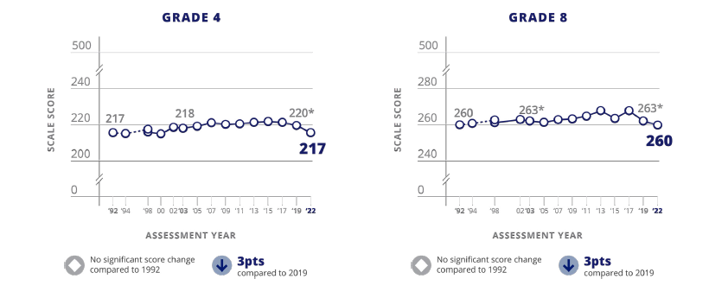

FIGURE | Trend in fourth- and eighth-grade mathematics average scores
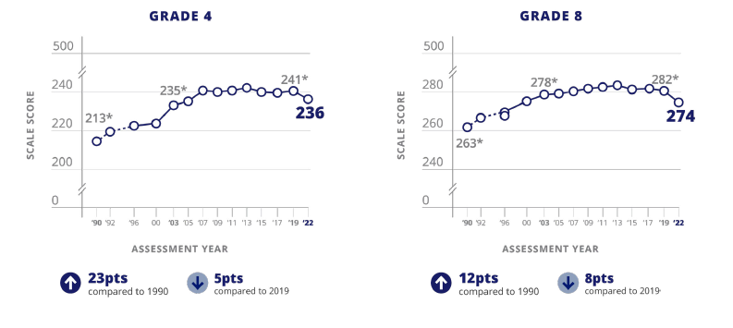

More About NAEP
To learn about upcoming NAEP assessments, download NAEP reports, and access sample questions, visit https://nces.ed.gov/nationsreportcard. Explore the latest NAEP results at https://nationsreportcard.gov.

Learn what NAEP means for schools that are selected to participate and get the latest NAEP news in Measure Up: NAEP News for the School Community, available online at https://nces.ed.gov/nationsreportcard/about/schools.aspx.

To hear teachers share their thoughts about why NAEP results are important, view the video Introducing NAEP to Teachers at https://nces.ed.gov/nationsreportcard/participating/schools.aspx.

To find your NAEP state coordinator’s contact information, visit https://nces.ed.gov/nationsreportcard/states and select your state or jurisdiction from the drop-down menu.

For additional assistance, call the NAEP help desk at 800-283-6237.

“The NAEP team that arrived at our school made the assessment process painless. Everyone on the team previously worked as an educator and interacted well with all of our students.”
—Kimberly Wilborn, Guidance Counselor, Sandburg Middle School, Fairfax County Public Schools, Alexandria, Virginia

National Center for Education Statistics (NCES) conducts the National Assessment of Educational Progress to evaluate federally supported education programs. All of the information you provide may be used only for statistical purposes and may not be disclosed, or used, in identifiable form for any other purpose except as required by law (20 U.S.C. §9573 and 6 U.S.C. §151). By law, every NCES employee as well as every NCES agent, such as contractors and NAEP coordinators, has taken an oath and is subject to a jail term of up to 5 years, a fine of $250,000, or both if he or she willfully discloses ANY identifiable information about you. Electronic submission of your information will be monitored for viruses, malware, and other threats by Federal employees and contractors in accordance with the Cybersecurity Enhancement Act of 2015.

This publication was prepared for the National Assessment of Educational Progress by Manhattan Strategy Group under contract 91990018C0001 to the National Center for Education Statistics,
U.S. Department of Education.

Find us on: <Facebook> <X> <YouTube> <LinkedIn> <Instagram>

Appendix D2-26: NAEP 2025 Facts for Teachers, Puerto Rico

Prueba de campo de NAEP de 2025
Información para maestros
¿Qué es NAEP?
La Evaluación Nacional del Progreso Educativo (NAEP, por sus siglas en inglés) es una medida integral del progreso educativo a lo largo del tiempo. Es la evaluación continua y nacionalmente representativa más grande que mide lo que los estudiantes de nuestro país saben y pueden hacer en diferentes materias, tales como educación cívica, matemáticas, lectura, ciencias, tecnología e ingeniería, historia de Estados Unidos y escritura. El programa también proporciona información valiosa sobre las experiencias educativas de los estudiantes y las oportunidades de aprendizaje dentro y fuera del salón de clases. Los funcionarios electos, los legisladores y los educadores usan los resultados de NAEP para desarrollar maneras de mejorar la educación.
NAEP es un programa autorizado por el Congreso y administrado por el Centro Nacional para Estadísticas de la Educación (NCES, por sus siglas en inglés), parte del Departamento de Educación de Estados Unidos y el Instituto de Ciencias de la Educación.
¿Qué evaluaciones de NAEP se administrarán en 2025?
Como parte del programa de NAEP de 2025, NCES administrará una prueba de campo de matemáticas para los grados 4 y 8 en Puerto Rico, entre el 27 de enero y el 7 de marzo de 2025. Esta prueba de campo forma parte del plan de transición de NCES hacia el uso de dispositivos e Internet gestionados por las escuelas o los distritos para la administración de NAEP, con lo que se pretende mejorar la experiencia de evaluación para las escuelas y los estudiantes.
En definitiva, NCES está trabajando para conseguir una administración de la evaluación flexible y auténtica. El objetivo es hacer que el modelo de administración de NAEP sea más eficiente y poder administrar la evaluación en dispositivos (p. ej., computadoras de escritorio, computadoras portátiles, tabletas con teclado) con los que los estudiantes estén más familiarizados en la escuela y en casa.
Los datos de rendimiento de la prueba de campo no se darán a conocer públicamente, pero se utilizarán para orientar las futuras evaluaciones de NAEP.
“Como maestra, mi objetivo constante es ayudar a los estudiantes a progresar en el salón de clase. NAEP ayuda con esta misión al crear una medida común del rendimiento de los estudiantes en todo el país." - Iris García, maestra, Biscayne Elementary Community School, Miami Beach, Florida
¿Qué pueden esperar los maestros y los estudiantes?
Los estudiantes participantes completarán:
- Preguntas de matemáticas
- Cuestionarios de contexto que proporcionan información valiosa sobre sus experiencias educativas y oportunidades de aprendizaje dentro y fuera del salón de clase

A los estudiantes les toma aproximadamente 2 horas completar la evaluación, incluyendo el tiempo de transición, las instrucciones y el tiempo que toma contestar un cuestionario de contexto. Se ofrece una amplia gama de acomodos para los estudiantes con impedimentos y para aprendices del español.
No es necesario que los maestros preparen a los estudiantes para la prueba de campo, pero sí deben motivarlos a que hagan su mejor esfuerzo.
¿Quién administrará NAEP?
El personal de NAEP administrará la evaluación y proporcionará un importante apoyo a las escuelas el día de la evaluación. Los representantes de NAEP se comunicarán con su escuela para proporcionarle información adicional.
¿Cómo se seleccionan las escuelas y los estudiantes para NAEP?
Las escuelas son seleccionadas como parte de un proceso de muestreo cuidadosamente diseñado que garantiza que las escuelas y los estudiantes seleccionados para NAEP representan a todas las escuelas y estudiantes en Puerto Rico y en Estados Unidos.
¿En qué se diferencia NAEP de nuestra evaluación estatal?
NAEP cumple una función diferente a la de las evaluaciones estatales. Si bien cada estado tiene su propia y única evaluación, con diferentes estándares de contenido, la misma evaluación NAEP se administra en todos los estados, proporcionando una medida común de los logros de los estudiantes.
NAEP y los maestros
¿De qué manera los maestros son aliados fundamentales para NAEP?
Las escuelas y los estudiantes seleccionados para participar en NAEP representan a las escuelas y a los estudiantes de todo el país. Los maestros contribuyen de manera importante al motivar a sus estudiantes a que participen y que hagan su mejor esfuerzo; esto contribuye a garantizar que los resultados de NAEP proporcionen la medida más exacta posible del rendimiento de los estudiantes de todo el país. Para más información acerca de NAEP y para ver las Preguntas Frecuentes para maestros (en inglés), visite la página https://nces.ed.gov/nationsreportcard/educators/.
¿Por qué se les pide a los estudiantes que completen los cuestionarios de contexto?
Además de las preguntas sobre la materia, a los estudiantes que participan en NAEP se les pide que completen un cuestionario de contexto. Los resultados del cuestionario ayudan a contextualizar los resultados del rendimiento de los estudiantes, permiten una comparación significativa entre grupos de estudiantes y ofrecen información importante para que los educadores, legisladores e investigadores comprendan mejor las experiencias educativas de los estudiantes en Estados Unidos.
Para más información sobre los cuestionarios de contexto de NAEP y para ver los cuestionarios de estudiantes, maestros y escuelas de años anteriores (en inglés), visite la página
https://nces.ed.gov/nationsreportcard/survey_questionnaires.aspx.

¿Cómo pueden los maestros usar los recursos y los datos de NAEP para ayudar a los estudiantes?
Puede usar la herramienta NAEP Questions Tool (https://nces.ed.gov/nationsreportcard/nqt) para ver las preguntas de NAEP publicadas y para crear evaluaciones personalizadas para su salón de clases. Puede comparar el rendimiento de sus estudiantes con el de otros estudiantes en su estado y en todo el país. Los maestros, estudiantes y padres de familia pueden acceder a la información y comparar los resultados de varios grupos demográficos. La mayoría de las preguntas publicadas incluyen una guía de puntuación, ejemplos de respuestas de los estudiantes e información sobre el rendimiento (en inglés).
El explorador de datos, NAEP Data Explorer, (https://www.nationsreportcard.gov/ndecore) es una poderosa herramienta que permite examinar las relaciones entre el rendimiento de los estudiantes y factores tales como las prácticas de enseñanza y los recursos escolares, entre otros (en inglés).
¿De qué manera los paneles de control en línea de NAEP ayudan a los maestros a explorar los resultados de la evaluación y más?
El Panel de Control de Disparidad en el Rendimiento les permite a los usuarios explorar disparidades en los logros que revelan diferencias significativas en las puntuaciones de las evaluaciones entre dos grupos de estudiantes (p. ej., entre estudiantes hombres y mujeres o entre estudiantes blancos y afroamericanos). Puede también revisar los resultados nacionales más recientes en todas las materias de NAEP y las experiencias educativas de los estudiantes según el tipo de escuela a través del nuevo Panel de Control de Escuelas Públicas, Privadas y Semiautónomas (Charter).
Vea el Panel de Control de Disparidad en el Rendimiento (en inglés) en la página
https://www.nationsreportcard.gov/dashboards/achievement_gaps.aspx.
El Panel de Control de escuelas públicas, privadas y Semiautónomas (Charter) (en inglés) está disponible en
https://www.nationsreportcard.gov/dashboards/schools_dashboard.aspx.
El Panel de Pulso Escolar (https://ies.ed.gov/schoolsurvey/spp/) es un estudio que recopila información sobre el impacto de la pandemia de COVID-19 (es decir, el modo de aprendizaje, el personal de la escuela o la cadena de suministros) de una muestra nacional de escuelas públicas de educación elemental, intermedia, superior y combinada.
¿Desde cuándo existe NAEP?
NAEP se administró por primera vez en 1969 para medir el rendimiento de los estudiantes a nivel nacional. En 1990, NAEP se administró por primera vez a nivel estatal. El programa TUDA de NAEP, que mide el rendimiento de los estudiantes en algunos de los grandes distritos urbanos del país, comenzó en 2002. NAEP es reconocida como el estándar de oro de las evaluaciones a gran escala debido a su alta calidad técnica y a su riguroso diseño y metodología.
Los resultados de NAEP
Los resultados de NAEP se publican en un informe llamado la Libreta de Calificaciones de la Nación. Dependiendo de la evaluación, los resultados de NAEP están disponibles para la nación, los estados y determinados distritos urbanos que participan en TUDA. También hay resultados disponibles para diferentes grupos de estudiantes con base en factores como la raza/grupo étnico, el género y la ubicación de la escuela, entre otros. NAEP no está diseñada para recopilar o informar los resultados individuales de estudiantes, salones de clase o escuelas. En una escuela, solamente algunos de los estudiantes participan y sus respuestas se combinan con las de otros estudiantes participantes para producir los resultados.
Puede acceder a datos de evaluaciones anteriores (en inglés) en la página
https://nces.ed.gov/nationsreportcard/naepdata y explorar los resultados más recientes https://www.nationsreportcard.gov/.
En Puerto Rico, los estudiantes de 4.° y 8.° grado están programados para ser evaluados en matemáticas cada dos años. Conforme a la Ley de Educación Primaria y Secundaria, los distritos y estados que reciben financiación del Título I deben participar en estas evaluaciones cada dos años.
Resultados recientes de NAEP
Los resultados de las evaluaciones de NAEP se dan a conocer a medida que están disponibles, tras una puntuación y un análisis exhaustivos. Los resultados principales de NAEP de 2022 se publicaron en octubre de 2022 y están disponibles en https://nces.ed.gov/nationsreportcard/.
Más información sobre NAEP
Para más información sobre las próximas evaluaciones de NAEP, descargar informes y acceder a ejemplos de preguntas, visite https://nces.ed.gov/nationsreportcard/puertorico/. Explore los resultados de NAEP en https://nationsreportcard.gov.
Conozca lo que NAEP significa para las escuelas que son seleccionadas para participar y entérese de las últimas novedades de NAEP en Medición: Novedades de NAEP para la Comunidad Escolar, disponible en línea en https://nces.ed.gov/nationsreportcard/about/schools.aspx.
Para escuchar lo que piensan los maestros sobre por qué son importantes los resultados de NAEP, vea el video Introducing NAEP to Teachers (en inglés) visitando la página https://nces.ed.gov/nationsreportcard/participating/schools.aspx.
Para encontrar información de contacto del Coordinador Estatal de NAEP (en inglés), visite https://nces.ed.gov/nationsreportcard/states y seleccione su estado o jurisdicción en el menú desplegable.
Si necesita ayuda adicional, llame al Centro de Ayuda de NAEP (Help Desk) al 800-283-6237.
“El equipo de NAEP que vino a nuestra escuela hizo que el proceso de evaluación fuera fácil. Todos los miembros del equipo habían sido educadores e interactuaron bien con todos nuestros estudiantes”.
—Kimberly Wilborn, Orientadora, Sandburg Middle School, Fairfax County Public Schools, Alexandria, Virginia
El Centro Nacional para Estadísticas de la Educación (NCES, por sus siglas en inglés) administra la Evaluación Nacional del Progreso Educativo para evaluar programas de educación apoyados por el Gobierno federal. Toda la información que proporcione podrá usarse únicamente con fines estadísticos y no podrá darse a conocer o usarse ni para identificarlo ni para cualquier otro propósito salvo aquel requerido legalmente (20 U.S.C. §9573 y 6 U.S.C. §151). Por ley, todos los empleados de NCES al igual que todos los representantes del mismo, como contratistas y coordinadores de NAEP, han hecho un juramento y están sujetos a una pena de prisión de hasta 5 años, una multa de hasta $250,000 o ambas cosas, si dan a conocer intencionalmente CUALQUIER información que lo identifique. El envío de su información por vía electrónica será monitoreado por empleados y contratistas federales para detectar virus, programas maliciosos (malware) y otras amenazas conforme a la Ley de Mejoramiento de la Seguridad Cibernética de 2015.
Esta publicación fue preparada para la Evaluación Nacional del Progreso Educativo por Manhattan Strategy Group bajo el contrato 91990018C0001 para el Centro Nacional de Estadísticas de la Educación, Departamento de Educación de Estados Unidos.
Encuéntrenos en: <Facebook> <X> <YouTube> <LinkedIn> <Instagram>

Appendix D2-27: NAEP 2025 Preassessment Responsibilities Guide, School Device Model
2025 Field Test Preassessment Responsibilities Guide (School Device)
Thank you for your support of the National Assessment of Educational Progress (NAEP). We look forward to working with you to make NAEP a positive experience at your school. The Assessment Management System (AMS) will be your primary resource for completing assessment planning tasks online for the upcoming assessment.
This guide outlines tasks you will complete along with available resources to make assessment day successful.
NAEP Activity Timeline
December–January:
- Complete Preassessment Activities
January–February:
- Add New Students
- Assessment Planning Meeting (APM) with NAEP representative
Within 10 school days before the assessment:
- Notify Parents and Guardians
- Support Assessment Activities
- Monitor Device Readiness Checks are Completed
January 27–March 7:
- NAEP 2025 Assessment Window
After the assessment:
- Wrap Up
You will need to complete the following activities:
- Complete Preassessment Activities
When the student sample is released in December, the following preassessment activities should be completed in the AMS.
  - Schedule Assessment Planning Meeting
    - An assigned NAEP representative, responsible for administering the assessment, will contact you in December to introduce themselves and monitor the scheduling of a virtual APM. School coordinators will select a date and time (1-hour block) to schedule their APM in the AMS. The NAEP representative can review how to complete the planning tasks outlined below upon request.
  - Provide Student Information
    - Review the student sample and identify any students who cannot take the assessment. Review demographic information and update any information that is missing or inaccurate.
    - Provide information about students with disabilities (SD) and English learners (EL) so that assessment administrators can plan appropriate testing accommodations.
      - You can invite your school’s SD and EL specialists to the AMS so that they can assist with this task.
      - Please note that school staff may need to assist with certain accommodations (e.g., cueing to stay on task, scribe). You will need to provide the contact information for the school staff that will assist with these accommodations.
  - Assessment Logistics
    - Schedule the assessment groups and reserve space at your school.
    - Students can either be assessed in two sequential sessions of up to 25 students each or all students at one time in one or two locations.
    - School staff presence in the assessment location is encouraged to help support classroom management.
    - If you select the option to assess all students at the same time in one or two locations, school staff presence is required at each location.
    - Assessment day details need to be entered via the Assessment Logistics section in the AMS, including
      - location(s) and start time(s) of the assessment, and
      - how students and teachers will be notified.
  - Technical Logistics
    - Provide details about assessing on school devices and run a network check to confirm your school Wi-Fi meets minimum requirements and required URLs have been safelisted.
    - Record how the school devices and assessment location will be set up for the NAEP assessment.
    - Identify a school staff member to provide technical support on assessment day.
  - Manage Questionnaires
    - Identify respondents and provide contact information for the school and teacher questionnaires.
    - Match students to the subject-specific teacher in the AMS.
    - Monitor the completion of the questionnaires by school staff.
    - Distribute information about NAEP to teachers.
- Add New Students
- To ensure all students have a chance to be selected for NAEP, you will be asked to update the student list in January (before the Assessment Planning Meeting) by adding any new students who have enrolled since the fall. A random sample will be drawn from this group of newly added students to be included in the assessment.
  - You can invite an additional staff member to register for the AMS as your school’s data specialist to assist.
- You will need to provide student information, manage questionnaires, and notify the parents/guardians of any newly added students after completing the Add New Students process.
- Attend Assessment Planning Meeting (APM)
- Participate in a 1-hour virtual planning meeting with your NAEP representative to review and confirm the information entered into the AMS.
  - An additional meeting can be scheduled with a technology coordinator to review and confirm technical logistics, if needed.
- Notify Parents and Guardians
- By law, parents/guardians of students selected to participate in NAEP must be notified in writing of their child’s selection prior to the administration of the assessment.
  - In the Notify Parents/Guardians section in the AMS, an electronic copy of the Parent/Guardian Notification Letter is available to download and distribute.
- Verify these notifications have been sent in the AMS.
- Support Assessment Day Activities
- Resources can be created and printed from the Support Assessment Day section in the AMS to remind teachers and students about the assessment.
  - Share the Teacher Notification Letter and List of Participating Students
  - Distribute the Student Appointment Cards
- Remind students to charge their devices and bring their headphones or earbuds on assessment day.
- Monitor Device Readiness Checks are Completed
- To ensure a smooth assessment experience in your school, it is important that each student device, including at least five spare devices, has the NAEP Assessment application installed and meets device requirements.
- A district or school staff member, who was identified and notified in November, will manage the installation of the NAEP Assessment application on identified devices for your school.
- In order, to complete the device readiness check, the NAEP Assessment application must be launched on each device and the verification code must be entered within 10 business days of the assessment date. The verification code and instructions for completing this check are available in the Technical Logistics section of the AMS.
  - School staff or students may complete this Device Readiness Check.
- Assessment Day Responsibilities
- A school or district staff member will need to be available on assessment day at the beginning of the assessment session in case any technical issues arise while launching the NAEP assessment on the school’s devices.
- A staff member’s presence throughout the assessment can have a positive impact on students’ motivation and performance. If assessing all students at the same time in one or two locations, the presence of a school staff member is required at each assessment location to help support classroom management.
- If less than 80 percent of the sampled students are assessed, a makeup session will be necessary, and the NAEP representative will schedule another date to administer the assessment to the absent students.
- If the assessment cannot take place due to technical issues, the NAEP representative will work with your school to reschedule the assessment.
- After the Assessment
- Destroy any hardcopy documents containing student names according to school protocol.
- Complete a short email survey on your experience with NAEP.
- Instructions for uninstalling the NAEP assessment application can be found at the eNAEP Download Center.
  - Please follow your school or district procedures for uninstalling applications on school devices.
If your AMS password has expired, you can request to reset your password by selecting “Forgot Password”. If you have any questions, please contact the NAEP help desk at 1-800-283-6237 or naephelp@westat.com.
Online Resources Information for selected schools
Information for Selected Schools | http://nces.ed.gov/nationsreportcard/participating/schools.aspx
Sample Questions Booklets | http://nces.ed.gov/nationsreportcard/about/booklets.aspx
NAEP Questions Tool | http://nces.ed.gov/nationsreportcard/nqt
Information for Parents and Guardians | http://nces.ed.gov/nationsreportcard/parents
Assessment Frameworks | https://www.nagb.gov/naep-frameworks/frameworks-overview.html
Digitally Based Assessments | https://nces.ed.gov/nationsreportcard/dba

For more information about NAEP, visit https://nces.ed.gov/nationsreportcard/.
Find us on: [Facebook, Twitter, and YouTube logos]
National Center for Education Statistics (NCES) conducts the National Assessment of Educational Progress to evaluate federally supported education programs. All of the information you provide may be used only for statistical purposes and may not be disclosed, or used, in identifiable form for any other purpose except as required by law (20 U.S.C. §9573 and 6 U.S.C. §151). By law, every NCES employee as well as every NCES agent, such as contractors and NAEP coordinators, has taken an oath and is subject to a jail term of up to 5 years, a fine of $250,000, or both if he or she willfully discloses ANY identifiable information about you. Electronic submission of your information will be monitored for viruses, malware, and other threats by Federal employees and contractors in accordance with the Cybersecurity Enhancement Act of 2015.

Appendix D2-28: NAEP 2025 Preassessment Responsibilities Guide, School Device Model, Puerto Rico
Guía de responsabilidades de preevaluación para la prueba de campo de NAEP 2025 (Dispositivo de la escuela)
Gracias por apoyar la Evaluación Nacional del Progreso Educativo (NAEP, por sus siglas en inglés). Esperamos trabajar con usted para hacer de NAEP una experiencia positiva en su escuela. El Sistema de Administración de la Evaluación (AMS) será su principal recurso para completar las tareas de planificación en línea para la próxima evaluación.
En esta guía se describen las tareas que deberá realizar y los recursos disponibles para que el día de la evaluación sea un éxito.
Calendario de actividades de NAEP
Diciembre - Enero:
- Completar las actividades de preevaluación
Enero - Febrero:
- Añadir estudiantes nuevos
- Reunión de planificación para la evaluación con el(la) representante de NAEP
En los 10 días lectivos antes de la evaluación:
- Notificar a los padres, madres o tutores
- Apoyar las actividades de la evaluación
- Supervisar que se han completado las verificaciones de disponibilidad del dispositivo
Del 27 de enero al 7 de marzo:
- Periodo de la evaluación de NAEP 2025
Después de la evaluación:
- Finalización
Deberá completar las siguientes actividades:
- Completar las actividades de preevaluación
Cuando se dé a conocer la muestra de estudiantes en diciembre, deberán completarse las siguientes actividades de preevaluación en el AMS:
  - Programar la reunión de planificación para la evaluación (APM)
    - Un representante asignado de NAEP, responsable de administrar la evaluación, se comunicará con usted para presentarse y supervisar la programación de una reunión de planificación para la evaluación (APM) de manera virtual. Los coordinadores escolares seleccionarán una fecha y hora (bloque de 1 hora) para programar su APM en el AMS. Si se solicita, el miembro del personal de campo de NAEP puede repasar cómo completar las tareas de planificación que se describen a continuación.
  - Proporcionar información sobre los estudiantes
    - Revise la muestra de estudiantes e identifique a aquellos que no pueden realizar la evaluación. Revise la información demográfica y actualice cualquier dato que falte o que no sea correcto.
    - Proporcione información sobre los estudiantes con impedimentos (EI) y los estudiantes aprendices del español (AE) para que los administradores de las evaluaciones puedan planificar los acomodos adecuados para las evaluaciones.
      - Puede invitar a los especialistas en EI y AE de su escuela al AMS para que le ayuden con esta tarea.
      - Tenga en cuenta que es posible que el personal de la escuela tenga que ayudar con determinados acomodos (p. ej., señas para que se mantengan enfocados, escribiente). Deberá facilitar la información de contacto del personal de la escuela que le ayudará con estos acomodos.
  - Logística de la evaluación
    - Programe los grupos para la evaluación y reserve espacio en su escuela.
    - Se recomienda la presencia del personal de la escuela en el lugar de la evaluación para ayudar a administrar el salón de clase.
    - Si selecciona la opción de evaluar a todos los estudiantes al mismo tiempo en uno o dos lugares, se requiere la presencia de personal de la escuela en cada lugar.
    - Los detalles del día de la evaluación deben ser compartidos a través de la sección Logística de la evaluación en el AMS, incluyendo:
      - el(los) lugar(es) y la(s) hora(s) de inicio de la evaluación, y
      - cómo se notificará a los estudiantes y maestros.
  - Logística técnica
    - Proporcione detalles sobre la evaluación con los dispositivos de la escuela y realice una verificación de la red para confirmar que el WiFi de su escuela cumple con los requisitos mínimos y que los URL requeridos están en la lista segura.
    - Registre cómo se configurarán los dispositivos de la escuela y el lugar de la evaluación para la evaluación de NAEP.
    - Identifique a un miembro del personal de la escuela que proporcionará asistencia técnica el día de la evaluación.
  - Administrar cuestionarios
    - Identifique a los encuestados y facilite información de contacto para los cuestionarios de las escuelas y los maestros.
    - Asigne a los estudiantes con el maestro de la asignatura específica en el AMS.
    - Supervise la cumplimentación de los cuestionarios por parte del personal escolar.
    - Distribuya información sobre NAEP entre los maestros.
- Añadir estudiantes nuevos
- Para garantizar que todos los estudiantes tengan la oportunidad de ser seleccionados para NAEP, se le pedirá que actualice la lista de estudiantes en enero (antes de la reunión de planificación para la evaluación) añadiendo a los estudiantes nuevos que se hayan matriculado desde el otoño. Se obtendrá una muestra aleatoria de este grupo de estudiantes recién añadidos para que participen en la evaluación.
  - Puede invitar a otro miembro del personal para que se registre en el AMS como especialista en datos de su escuela para que le ayude.
- Deberá proporcionar la información de los estudiantes, administrar los cuestionarios y notificar a los padres, madres o tutores de los estudiantes recién añadidos después de completar el proceso de Añadir estudiantes nuevos.
- Asistir a la reunión de planificación para la evaluación (APM)
- Participe en una reunión virtual de planificación de 1 hora con su representante de NAEP para revisar y confirmar la información de la evaluación compartida en el AMS.
- Notificar a los padres, madres y tutores
- Por ley, los padres/tutores de los estudiantes seleccionados para participar en NAEP deben ser notificados por escrito sobre la selección de su hijo(a) antes de la administración de la evaluación.
  - En la sección Notificar a los padres, madres o tutores del AMS, se puede descargar y distribuir una copia electrónica de la carta de notificación a los padres/tutores.
- Verifique en el AMS que estas notificaciones se han enviado.
- Apoyar las actividades del día de la evaluación
- Se pueden crear e imprimir recursos desde la sección Apoyar el día de la evaluación en el AMS para recordarle a los maestros y a los estudiantes sobre la evaluación.
  - Comparta la carta de notificación para maestros y la lista de estudiantes participantes
  - Distribuya las tarjetas de recordatorio para los estudiantes
- Recuérdeles a los estudiantes que carguen sus dispositivos y traigan sus audífonos el día de la evaluación.
- Supervisar que se completen las verificaciones de disponibilidad de los dispositivos
- Para asegurar una experiencia de evaluación sin problemas en su escuela, es importante que el dispositivo de cada estudiante, incluyendo al menos cinco dispositivos de repuesto, tenga instalada la aplicación de evaluación de NAEP y cumpla con los requisitos del dispositivo.
- Un miembro del personal del distrito o de la escuela, que fue identificado y notificado en noviembre, se encargará de gestionar la instalación de la aplicación de evaluación de NAEP en los dispositivos identificados para su escuela.
- Para completar la verificación de disponibilidad del dispositivo, la aplicación de evaluación de NAEP debe iniciarse en cada dispositivo y el código de verificación debe ingresarse dentro de los 10 días hábiles antes de la fecha de la evaluación. El código de verificación y las instrucciones para completar esta verificación están disponibles en la sección de Logística Técnica del AMS.
  - El personal de la escuela o los estudiantes pueden completar esta verificación de disponibilidad del dispositivo.
- Responsabilidades el día de la evaluación
- Un miembro del personal de la escuela o del distrito deberá estar disponible el día de la evaluación al comienzo de la sesión por si surge algún problema técnico al iniciar la evaluación NAEP en los dispositivos de la escuela.
- La presencia de un miembro del personal durante la evaluación puede tener un impacto positivo en la motivación y el desempeño de los estudiantes. Si se evalúan todos los estudiantes al mismo tiempo en uno o dos lugares, se requiere la presencia de un miembro del personal de la escuela en cada lugar de evaluación para ayudar a administrar el salón de clase.
- Si la asistencia de los estudiantes de la muestra es inferior al 80 %, será necesaria una sesión de reposición y el(la) representante de NAEP programará otra fecha para administrar la evaluación a los estudiantes ausentes.
- Si la evaluación no puede llevarse a cabo debido a problemas técnicos, el(la) representante de NAEP trabajará con su escuela para reprogramar la evaluación.
- Después de la evaluación
- Destruya cualquier documento impreso que contenga nombres de estudiantes de acuerdo con el protocolo de la escuela.
- Complete una breve encuesta por correo electrónico sobre su experiencia con NAEP.
- Las instrucciones para desinstalar la aplicación de evaluación de NAEP se encuentran en el Centro de descargas de eNAEP.
  - Siga los procedimientos de su escuela o distrito para desinstalar aplicaciones en los dispositivos de la escuela.

Si su contraseña para el AMS ha expirado, puede restablecerla seleccionando "Olvidé la contraseña". Si tiene alguna pregunta, comuníquese con la oficina de ayuda de NAEP (Help Desk) llamando al 1-800-283-6237 o escribiendo a naephelp@westat.com.
Recursos en línea Información para las escuelas seleccionadas
Información para las escuelas seleccionadas (en inglés) | http://nces.ed.gov/nationsreportcard/participating/schools.aspx
Vídeo introductorio de NAEP para los maestros (en inglés) | https://youtu.be/zR1_pUdSlFg
Cuadernos de ejemplos de preguntas | http://nces.ed.gov/nationsreportcard/about/booklets.aspx
Herramienta de preguntas de NAEP (en inglés) | http://nces.ed.gov/nationsreportcard/nqt
Información para los padres, madres y tutores | http://nces.ed.gov/nationsreportcard/parents
Marcos de la evaluación (en inglés) | https://www.nagb.gov/naep-frameworks/frameworks-overview.html
Evaluaciones digitales (en inglés) | https://nces.ed.gov/nationsreportcard/dba

Para más información sobre NAEP, visite https://nces.ed.gov/nationsreportcard/.
Encuéntrenos en: [Facebook logo, Twitter logo y YouTube logo].

El Centro Nacional para Estadísticas de la Educación (NCES, por sus siglas en inglés) administra la Evaluación Nacional del Progreso Educativo para evaluar programas de educación apoyados por el Gobierno federal. Toda la información que proporcione podrá usarse únicamente con fines estadísticos y no podrá darse a conocer o usarse ni para identificarlo ni para cualquier otro propósito salvo aquel requerido legalmente (20 U.S.C. §9573 y 6 U.S.C. §151). Por ley, todos los empleados de NCES al igual que todos los representantes del mismo, como contratistas y coordinadores de NAEP, han hecho un juramento y están sujetos a una pena de prisión de hasta 5 años, una multa de hasta $250,000 o ambas cosas, si dan a conocer intencionalmente CUALQUIER información que lo identifique. El envío de su información por vía electrónica será monitoreado por empleados y contratistas federales para detectar virus, programas maliciosos (malware) y otras amenazas conforme a la Ley de Mejoramiento de la Seguridad Cibernética de 2015.

Appendix D2-29: NAEP 2025 Preassessment Responsibilities Guide, NAEP Device Model
2025 Field Test Preassessment Responsibilities Guide (NAEP Device)
Thank you for your support of the National Assessment of Educational Progress (NAEP). We look forward to working with you to make NAEP a positive experience at your school. The Assessment Management System (AMS) will be your primary resource for completing assessment planning tasks online for the upcoming assessment.
This guide outlines tasks you will complete along with available resources to make assessment day successful.
NAEP Activity Timeline
December – January:
- Complete Preassessment Activities
January – February:
- Add New Students
- Assessment Planning Meeting with NAEP representative
Within 10 school days before the assessment:
- Notify Parents and Guardians
- Support Assessment Activities
January 27 – March 7:
- NAEP 2025 Assessment Window
After the assessment:
- Wrap Up
You will need to complete the following activities:
- Complete Preassessment Activities
When the student sample is released in December, the following preassessment activities should be completed in the AMS:
  - Schedule Assessment Planning Meeting (APM)
    - An assigned NAEP representative, responsible for administering the assessment, will contact you in December to introduce themselves and coordinate the scheduling of a virtual Assessment Planning Meeting (APM). School coordinators will select a date and time (1-hour block) to schedule their APM in the AMS. The NAEP representative can review how to complete their planning tasks outlined below upon request.
  - Provide Student Information
    - Review the student sample and identify any students who cannot take the assessment. Review demographic information and update any information that is missing or inaccurate.
    - Provide information about students with disabilities (SD) and English learners (EL) so that assessment administrators can plan appropriate testing accommodations.
      - You can invite your school’s SD and EL specialists to the AMS so that they can assist with this task.
      - Please note that school staff may need to assist with certain accommodations (e.g., cueing to stay on task, scribe). You will need to provide the contact information for the school staff that will assist with these accommodations.
  - Assessment Logistics
    - Schedule the assessment groups and reserve space at your school. (Please select a location on the first floor, or one that is accessible by elevator.)
    - Assessment day details, including the location(s) and start time(s) of the assessment, and how students and teachers will be notified, need to be entered via the Assessment Logistics section in the AMS.
  - Manage Questionnaires
    - Identify respondents and provide contact information for the school and teacher questionnaires.
    - Match students to the subject-specific teacher in the AMS.
    - Monitor the completion of the questionnaires by school staff.
    - Distribute information about NAEP to teachers.
- Add New Students (Before Assessment Planning Meeting)
- To ensure all students have a chance to be selected for NAEP, you will be asked to update the student list in January by adding any new students who have enrolled since the fall. NAEP will draw a random sample from this group of newly added students.
  - You can assign an additional staff member to serve as your school’s data specialist so that they can assist with this task.
- You will need to provide student information, manage questionnaires, and notify the parents/guardians of any newly added students after completing the Add New Students process.
- Attend Assessment Planning Meeting (APM)
- The school coordinator will participate in a 1-hour virtual planning meeting with their NAEP representative student information, as well as to review and confirm assessment details entered into the AMS.
- Notify Parents and Guardians
- By law, parents/guardians of students selected to participate in NAEP must be notified in writing of their child’s selection prior to the administration of the assessment.
  - In the Notify Parents/Guardians section in the AMS, an electronic copy of the Parent/Guardian Notification Letter is available to download and distribute.
- Verify these notifications have been sent in the AMS.
- Support Assessment Day Activities.
- Resources can be created and printed from the Support Assessment Day section in the AMS to remind teachers and students about the assessment.
  - Share the Teacher Notification Letter and List of Participating Students
  - Distribute the Student Appointment Cards
- Assessment Day Responsibilities
- The school coordinator and the teachers of selected students are encouraged to remain in the room during the assessment. A school staff member is appreciated and can positively impact students’ motivation and performance.
- If the attendance of sampled students is less than 80 percent, a makeup session will be necessary, and the NAEP representative will schedule another date to administer the assessment to the absent students.
- After the Assessment
- Destroy any hardcopy documents containing student names according to school protocol.
- Complete a short email survey on your experience with NAEP.

If your AMS password has expired, you can request to reset by clicking on “Learn more about how to log in.” If you have any questions, please contact the NAEP help desk at 1-888-499-6237 or naephelp@westat.com.
Online Resources Information for selected schools
Information for selected schools | http://nces.ed.gov/nationsreportcard/participating/schools.aspx
Introducing NAEP to Teachers video | https://youtu.be/zR1_pUdSlFg
Introducing NAEP to Students video | https://youtu.be/8drjkhe0iQU
Sample Questions booklets | http://nces.ed.gov/nationsreportcard/about/booklets.aspx
NAEP Questions Tool | http://nces.ed.gov/nationsreportcard/nqt
Information for parents | http://nces.ed.gov/nationsreportcard/parents
Assessment frameworks | https://www.nagb.gov/naep-frameworks/frameworks-overview.html
Digitally Based Assessments | https://nces.ed.gov/nationsreportcard/dba

For more information about NAEP, visit https://nces.ed.gov/nationsreportcard/.
Find us on: [Facebook, Twitter, and YouTube logos]

National Center for Education Statistics (NCES) conducts the National Assessment of Educational Progress to evaluate federally supported education programs. All of the information you provide may be used only for statistical purposes and may not be disclosed, or used, in identifiable form for any other purpose except as required by law (20 U.S.C. §9573 and 6 U.S.C. §151). By law, every NCES employee as well as every NCES agent, such as contractors and NAEP coordinators, has taken an oath and is subject to a jail term of up to 5 years, a fine of $250,000, or both if he or she willfully discloses ANY identifiable information about you. Electronic submission of your information will be monitored for viruses, malware, and other threats by Federal employees and contractors in accordance with the Cybersecurity Enhancement Act of 2015.

Appendix D2-30: NAEP 2025 Preassessment Responsibilities Guide, NAEP Device Model, Puerto Rico
Guía de responsabilidades de preevaluación para la prueba de campo de NAEP 2025 (Dispositivo de NAEP)
Gracias por apoyar la Evaluación Nacional del Progreso Educativo (NAEP, por sus siglas en inglés). Esperamos trabajar con usted para hacer de NAEP una experiencia positiva en su escuela. El Sistema de Administración de la Evaluación (AMS) será su principal recurso para completar las tareas de planificación en línea para la próxima evaluación.
En esta guía se describen las tareas que deberá realizar y los recursos disponibles para que el día de la evaluación sea un éxito.
Calendario de actividades de NAEP
Diciembre - Enero:
- Completar las actividades de preevaluación
Enero - Febrero:
- Añadir estudiantes nuevos
- Reunión de planificación para la evaluación con el(la) representante de NAEP
En los 10 días lectivos antes de la evaluación:
- Notificar a los padres, madres o tutores
- Apoyar las actividades de la evaluación
Del 27 de enero al 7 de marzo:
- Periodo de la evaluación de NAEP 2025
Después de la evaluación:
- Finalización
Deberá completar las siguientes actividades:
- Completar las actividades de preevaluación
Cuando se dé a conocer la muestra de estudiantes en diciembre, deberán completarse las siguientes actividades de preevaluación en el AMS:
  - Programar la reunión de planificación para la evaluación (APM)
    - Un representante asignado de NAEP, responsable de administrar la evaluación, se comunicará con usted para presentarse y verificar la programación de una reunión de planificación para la evaluación (APM) de manera virtual. Los coordinadores escolares seleccionarán una fecha y hora (bloque de 1 hora) para programar su APM en el AMS. Si se solicita, el miembro del personal de campo de NAEP puede repasar cómo completar las tareas de planificación que se describen a continuación.
  - Proporcionar información sobre los estudiantes
    - Revise la muestra de estudiantes e identifique a aquellos que no pueden realizar la evaluación. Revise la información demográfica y actualice cualquier dato que falte o que no sea correcto.
    - Proporcione información sobre los estudiantes con impedimentos (EI) y los estudiantes aprendices del español (AE) para que los administradores de las evaluaciones puedan planificar los acomodos adecuados para las evaluaciones.
      - Puede invitar a los especialistas en EI y AE de su escuela al AMS para que le ayuden con esta tarea.
      - Tenga en cuenta que es posible que el personal de la escuela tenga que ayudar con determinados acomodos (p. ej., señas para que se mantengan enfocados, escribiente). Deberá facilitar la información de contacto del personal de la escuela que le ayudará con estos acomodos.
  - Logística de la evaluación
    - Programe los grupos para la evaluación y reserve espacio en su escuela (seleccione un lugar en la primera planta o al que se pueda acceder en ascensor).
    - Los detalles del día de la evaluación, incluidos el(los) lugar(es) y la(s) hora(s) de inicio de la evaluación, y cómo se notificará a los estudiantes y maestros, deben ser compartidos a través de la sección Logística de la evaluación en el AMS.
  - Administrar cuestionarios
    - Identifique a los encuestados y facilite información de contacto para los cuestionarios de las escuelas y los maestros.
    - Asigne a los estudiantes con el maestro de la asignatura específica en el AMS.
    - Supervise la cumplimentación de los cuestionarios por parte del personal escolar.
    - Distribuya información sobre NAEP entre los maestros.
- Añadir estudiantes nuevos (antes de la reunión de planificación para la evaluación)
- Para garantizar que todos los estudiantes tengan la oportunidad de ser seleccionados para NAEP, se le pedirá que actualice la lista de estudiantes en enero añadiendo a los estudiantes nuevos que se hayan matriculado desde el otoño. NAEP obtendrá una muestra aleatoria de este grupo de estudiantes recién añadidos.
  - Puede designar a otro miembro del personal como especialista en datos de su escuela para que le ayude en esta tarea.
- Deberá proporcionar la información de los estudiantes, administrar los cuestionarios y notificar a los padres, madres o tutores de los estudiantes recién añadidos después de completar el proceso de Añadir estudiantes nuevos.
- Asistir a la reunión de planificación para la evaluación (APM)
- El(la) coordinador(a) escolar participará en una reunión virtual de planificación de 1 hora con su representante de NAEP para revisar la información de los estudiantes y también para revisar y confirmar los detalles de la evaluación compartidos en el AMS.
- Notificar a los padres, madres y tutores
- Por ley, los padres/tutores de los estudiantes seleccionados para participar en NAEP deben ser notificados por escrito sobre la selección de su hijo(a) antes de la administración de la evaluación.
  - En la sección Notificar a los padres, madres o tutores del AMS, se puede descargar y distribuir una copia electrónica de la carta de notificación a los padres/tutores.
- Verifique en el AMS que estas notificaciones se han enviado.
- Apoyar las actividades del día de la evaluación
- Se pueden crear e imprimir recursos desde la sección Apoyar el día de la evaluación en el AMS para recordarle a los maestros y a los estudiantes sobre la evaluación.
  - Comparta la carta de notificación para maestros y la lista de estudiantes participantes
  - Distribuya las tarjetas de recordatorio para los estudiantes
- Responsabilidades el día de la evaluación
- Se recomienda que el(la) coordinador(a) escolar y los maestros de los estudiantes seleccionados permanezcan en el salón durante la evaluación. Se agradece la presencia de un miembro del personal de la escuela, que pueda impactar positivamente en la motivación y el rendimiento de los estudiantes.
- Si la asistencia de los estudiantes de la muestra es inferior al 80 %, será necesaria una sesión de reposición y el(la) representante de NAEP programará otra fecha para administrar la evaluación a los estudiantes ausentes.
- Después de la evaluación
- Destruya cualquier documento impreso que contenga nombres de estudiantes de acuerdo con el protocolo de la escuela.
- Complete una breve encuesta por correo electrónico sobre su experiencia con NAEP.

Si su contraseña para el AMS ha expirado, puede restablecerla seleccionando "Olvidé la contraseña". Si tiene alguna pregunta, comuníquese con la oficina de ayuda de NAEP (Help Desk) llamando al 1-800-283-6237 o escribiendo a naephelp@westat.com.
Recursos en línea Información para las escuelas seleccionadas
Información para las escuelas seleccionadas (en inglés) | http://nces.ed.gov/nationsreportcard/participating/schools.aspx
Vídeo introductorio de NAEP para los maestros (en inglés) | https://youtu.be/zR1_pUdSlFg
Vídeo introductorio de NAEP para los estudiantes (en inglés) | https://youtu.be/8drjkhe0iQU
Cuadernos de ejemplos de preguntas | http://nces.ed.gov/nationsreportcard/about/booklets.aspx
Herramienta de preguntas de NAEP (en inglés) | http://nces.ed.gov/nationsreportcard/nqt
Información para los padres, madres y tutores | http://nces.ed.gov/nationsreportcard/parents
Marcos de la evaluación (en inglés) | https://www.nagb.gov/naep-frameworks/frameworks-overview.html
Evaluaciones digitales (en inglés) | https://nces.ed.gov/nationsreportcard/dba

Para más información sobre NAEP, visite https://nces.ed.gov/nationsreportcard/.
Encuéntrenos en: [Facebook logo, Twitter logo y YouTube logo].

El Centro Nacional para Estadísticas de la Educación (NCES, por sus siglas en inglés) administra la Evaluación Nacional del Progreso Educativo para evaluar programas de educación apoyados por el Gobierno federal. Toda la información que proporcione podrá usarse únicamente con fines estadísticos y no podrá darse a conocer o usarse ni para identificarlo ni para cualquier otro propósito salvo aquel requerido legalmente (20 U.S.C. §9573 y 6 U.S.C. §151). Por ley, todos los empleados de NCES al igual que todos los representantes del mismo, como contratistas y coordinadores de NAEP, han hecho un juramento y están sujetos a una pena de prisión de hasta 5 años, una multa de hasta $250,000 o ambas cosas, si dan a conocer intencionalmente CUALQUIER información que lo identifique. El envío de su información por vía electrónica será monitoreado por empleados y contratistas federales para detectar virus, programas maliciosos (malware) y otras amenazas conforme a la Ley de Mejoramiento de la Seguridad Cibernética de 2015.

Appendix D2-31: NAEP 2025 Assessment Date Notification and Preassessment Email, School Device Model
NAEP 2025 Assessment Date and Preassessment Notification (School Device)
NAEP STATE COORDINATOR TO
SCHOOL COORDINATOR
Red text should be customized before mail merge; [highlighted text] represents mail merge fields.
Save the date! NAEP is coming on [assessment date].

Dear [school coordinator name] and [technology coordinator name]:
Thank you for your support of NAEP. I look forward to working with you to coordinate NAEP in your school. The timeline below indicates when your school will need to complete specific assessment planning tasks.
- December–January:
    - Complete preassessment activities in the AMS
      - Review the list of selected students.
      - Provide student information and assessment logistics.
      - Provide details about assessing on school devices and run a network check to confirm your school Wi-Fi meets minimum requirements and required URLs have been safelisted.
      - If necessary, an additional school staff member can be identified as the technology coordinator to assist with these tasks.
- January–February:
  - Update the student list by adding any new students who have enrolled since the fall.
  - Attend a virtual Assessment Planning Meeting with NAEP representatives.
- Within 10 school days before the assessment:
- Notify parents and guardians of selected students,
- Print and share resources to support assessment activities,
- Monitor device readiness checks to confirm they are completed on the school devices that will be used for the assessment, and
- Remind students to charge their devices and bring their headphones or earbuds on assessment day.
- On Assessment Day: assessment date
    - A school or district staff member will need to be available on assessment day at the beginning of the assessment session in case any technical issues arise while launching the NAEP assessment on the school’s devices.
    - School staff presence in the assessment location is encouraged to help support classroom management. If you select the option to assess all students at the same time in one or two locations, school staff presence is required at each location.

I have provided more information about your responsibilities in the enclosed Preassessment Responsibilities Guide.

Thank you in advance for your cooperation and effort in helping to coordinate this important assessment.

If you have questions or a conflict with the scheduled assessment date, please contact me at telephone number or email address by date.

Sincerely,

NAEP State Coordinator

Enclosures/Attachments: Preassessment Responsibilities Guide

National Center for Education Statistics (NCES) conducts the National Assessment of Educational Progress to evaluate federally supported education programs. All of the information you provide may be used only for statistical purposes and may not be disclosed, or used, in identifiable form for any other purpose except as required by law (20 U.S.C. §9573 and 6 U.S.C. §151). By law, every NCES employee as well as every NCES agent, such as contractors and NAEP coordinators, has taken an oath and is subject to a jail term of up to 5 years, a fine of $250,000, or both if he or she willfully discloses ANY identifiable information about you. Electronic submission of your information will be monitored for viruses, malware, and other threats by Federal employees and contractors in accordance with the Cybersecurity Enhancement Act of 2015.
.

Appendix D2-32: NAEP 2025 Assessment Date Notification and Preassessment Email, School Device Model, Puerto Rico

Fecha de la evaluación de NAEP 2025 y notificación de preevaluación (Dispositivo de la escuela)
DEL(DE LA) COORDINADOR(A) ESTATAL DE NAEP AL (A LA) COORDINADOR(A) ESCOLAR
Se debe personalizar el texto en rojo antes de combinar la correspondencia, el texto resaltado representa los campos que se deben combinar.

¡Reserve la fecha! NAEP tendrá lugar el [fecha de la evaluación].

Estimado(a) [nombre del(de la) coordinador(a) escolar] y [nombre del(de la) coordinador(a) de tecnología]:
Gracias por apoyar a NAEP. Espero trabajar con usted para coordinar NAEP en su escuela. El programa que figura a continuación indica cuándo deberá completar las tareas específicas de planificación para la evaluación.
- Diciembre - Enero:
    - Completar las actividades de preevaluación en el AMS
      - Revisar la lista de estudiantes seleccionados.
      - Proporcionar información sobre los estudiantes y la logística de la evaluación.
      - Proporcionar detalles sobre la evaluación en los dispositivos de la escuela y realizar una verificación de la red para confirmar que el WiFi de su escuela cumple con los requisitos mínimos y que los URL requeridos están en la lista segura.
        - De ser necesario, se puede designar a otro miembro del personal de la escuela como coordinador(a) de tecnología para que ayude con estas tareas.
- Enero - Febrero:
    - Actualizar la lista de estudiantes añadiendo los estudiantes nuevos que se hayan matriculado desde el otoño.
    - Asistir a una reunión virtual de planificación para la evaluación con representantes de NAEP.
- En los 10 días lectivos anteriores a la evaluación:
    - Notificar a los padres, madres o tutores de los estudiantes seleccionados;
    - imprimir y compartir recursos para apoyar las actividades de la evaluación;
    - supervisar las verificaciones de preparación de los dispositivos para confirmar que se han completado en los dispositivos de la escuela que se utilizarán para la evaluación, y
    - recordarles a los estudiantes que carguen sus dispositivos y que traigan sus audífonos el día de la evaluación.
- El día de la evaluación: [fecha de la evaluación]
    - Un miembro del personal de la escuela o del distrito deberá estar disponible el día de la evaluación al comienzo de la sesión de evaluación en caso de que surja algún problema técnico al iniciar la evaluación de NAEP en los dispositivos de la escuela.
    - Se recomienda la presencia de personal de la escuela en el lugar de la evaluación para ayudar a administrar el salón de clase. Si selecciona la opción de evaluar a todos los estudiantes al mismo tiempo en uno o dos lugares, se requiere la presencia de personal de la escuela en cada lugar.

He proporcionado más información sobre sus responsabilidades en la Guía de responsabilidades de preevaluación adjunta.

Gracias de antemano por su cooperación y esfuerzo para ayudar a coordinar esta importante evaluación.

Si tiene preguntas o un conflicto con la fecha de evaluación prevista, comuníquese conmigo llamando al número de teléfono o escribiendo a dirección de correo electrónico antes del fecha.

Atentamente,

Coordinador(a) estatal de NAEP

Adjuntos/Anexos: Guía de responsabilidades de preevaluación

El Centro Nacional para Estadísticas de la Educación (NCES, por sus siglas en inglés) administra la Evaluación Nacional del Progreso Educativo para evaluar programas de educación apoyados por el Gobierno federal. Toda la información que proporcione podrá usarse únicamente con fines estadísticos y no podrá darse a conocer o usarse ni para identificarlo ni para cualquier otro propósito salvo aquel requerido legalmente (20 U.S.C. §9573 y 6 U.S.C. §151). Por ley, todos los empleados de NCES al igual que todos los representantes del mismo, como contratistas y coordinadores de NAEP, han hecho un juramento y están sujetos a una pena de prisión de hasta 5 años, una multa de hasta $250,000 o ambas cosas, si dan a conocer intencionalmente CUALQUIER información que lo identifique. El envío de su información por vía electrónica será monitoreado por empleados y contratistas federales para detectar virus, programas maliciosos (malware) y otras amenazas conforme a la Ley de Mejoramiento de la Seguridad Cibernética de 2015.

Appendix D2-33: NAEP 2025 Assessment Date Notification and Preassessment Email, NAEP Device Model
NAEP 2025 Assessment Date and Preassessment Notification (NAEP Device)
NAEP STATE COORDINATOR TO SCHOOL COORDINATOR
Red text should be customized before mail merge; [highlighted text] represents mail merge fields.
Save the date! NAEP is coming on [assessment date].

Dear [school coordinator name]:
Thank you for your support of NAEP. I look forward to working with you to coordinate NAEP in your school. The timeline below indicates when you will need to complete specific assessment planning tasks.
- December–January:
    - Provide preassessment information in the AMS.
    - Review the list of selected students.
    - Provide student information and assessment logistics.
- January–February:
    - Update the student list by adding any new students who have enrolled since the fall.
    - Attend a virtual Assessment Planning Meeting with NAEP representatives.
- Within 10 school days before the assessment:
    - Notify parents and guardians of selected students.
    - Print and share resources to support assessment activities.
- On Assessment Day: [assessment date]
    - School staff presence in the assessment location is encouraged to help support classroom management.
I have provided more information about your responsibilities in the enclosed Preassessment Responsibilities Guide.

Thank you in advance for your cooperation and effort in helping to coordinate this important assessment.

If you have questions or a conflict with the scheduled assessment date, please contact me at telephone number or email address by date.

Sincerely,

NAEP State Coordinator

Enclosures/Attachments: Preassessment Responsibilities Guide

National Center for Education Statistics (NCES) conducts the National Assessment of Educational Progress to evaluate federally supported education programs. All of the information you provide may be used only for statistical purposes and may not be disclosed, or used, in identifiable form for any other purpose except as required by law (20 U.S.C. §9573 and 6 U.S.C. §151). By law, every NCES employee as well as every NCES agent, such as contractors and NAEP coordinators, has taken an oath and is subject to a jail term of up to 5 years, a fine of $250,000, or both if he or she willfully discloses ANY identifiable information about you. Electronic submission of your information will be monitored for viruses, malware, and other threats by Federal employees and contractors in accordance with the Cybersecurity Enhancement Act of 2015.

Appendix D2-34: NAEP 2025 Assessment Date Notification and Preassessment Email, NAEP Device Model, Puerto Rico
Fecha de la evaluación NAEP de 2025 y notificación de preevaluación (Dispositivo de NAEP)
DEL(DE LA) COORDINADOR(A) ESTATAL DE NAEP AL(A LA) COORDINADOR(A) ESCOLAR
Se debe personalizar el texto en rojo antes de combinar la correspondencia, el texto resaltado representa los campos que se deben combinar.

¡Reserve la fecha! NAEP tendrá lugar el [fecha de la evaluación].

Estimado(a) [nombre del(de la) coordinador(a) escolar]:
Gracias apoyar a NAEP. Espero trabajar con usted para coordinar NAEP en su escuela. El programa que figura a continuación indica cuándo deberá completar las tareas específicas de planificación para la evaluación.
- Diciembre - Enero: Proporcionar información de preevaluación en el AMS
    - Revisará la lista de estudiantes seleccionados y proporcionará información sobre los estudiantes y la logística de la evaluación.
- Enero - Febrero:
    - Actualizará la lista de estudiantes añadiendo a los estudiantes nuevos que se hayan matriculado desde el otoño.
    - Asistirá a una reunión virtual de planificación para la evaluación con representantes de NAEP.
- En los 10 días lectivos anteriores a la evaluación:
    - Notificará a los padres, madres o tutores de los estudiantes seleccionados, e
    - imprimirá y compartirá recursos para apoyar las actividades de la evaluación.
- El día de la evaluación: [fecha de la evaluación]
    - La presencia de un miembro del personal a lo largo de la evaluación puede tener un impacto positivo en la motivación y el rendimiento de los estudiantes. Se agradece la presencia de un miembro del personal de la escuela.

He proporcionado más información sobre sus responsabilidades en la Guía de responsabilidades de preevaluación adjunta.

Gracias de antemano por su cooperación y esfuerzo para ayudar a coordinar esta importante evaluación.

Si tiene preguntas o un conflicto con la fecha de evaluación prevista, comuníquese conmigo llamando al número de teléfono o escribiendo a dirección de correo electrónico antes del fecha.

Atentamente,

Coordinador(a) estatal de NAEP

Adjuntos/Anexos: Guía de responsabilidades de preevaluación

El Centro Nacional para Estadísticas de la Educación (NCES, por sus siglas en inglés) administra la Evaluación Nacional del Progreso Educativo para evaluar programas de educación apoyados por el Gobierno federal. Toda la información que proporcione podrá usarse únicamente con fines estadísticos y no podrá darse a conocer o usarse ni para identificarlo ni para cualquier otro propósito salvo aquel requerido legalmente (20 U.S.C. §9573 y 6 U.S.C. §151). Por ley, todos los empleados de NCES al igual que todos los representantes del mismo, como contratistas y coordinadores de NAEP, han hecho un juramento y están sujetos a una pena de prisión de hasta 5 años, una multa de hasta $250,000 o ambas cosas, si dan a conocer intencionalmente CUALQUIER información que lo identifique. El envío de su información por vía electrónica será monitoreado por empleados y contratistas federales para detectar virus, programas maliciosos (malware) y otras amenazas conforme a la Ley de Mejoramiento de la Seguridad Cibernética de 2015.

Appendix D2-35: NAEP 2025 Application Installer Notification
2025 Application Installer Notification Letter From
NAEP STATE COORDINATOR TO SCHOOL DEVICE INSTALLER
Red text should be customized before mail merge; highlighted text represents mail merge fields

Dear [individual installing and validating devices]:

I am writing to notify you that you have been identified by [STS respondent] as the person best suited to oversee the preparation of school devices (e.g., desktops, laptops, tablets with keyboards) for the National Assessment of Educational Progress (NAEP) 2025 Field Test at [School Name]. / the following schools:
- School 1
- School 2
- School 3, etc.

What is needed from you for the NAEP 2025 Field Test?
In November, a link with more detailed instructions will be sent in an automated email from the email domain [domain name]. You will be responsible for ensuring the URLs needed for NAEP have been safelisted, the NAEP Assessment application is installed on school devices, and readiness checks are performed.

Approximately 25 to 50 students are typically sampled to take the NAEP assessment in each selected grade and school. If you wish to install the NAEP Assessment application only on school devices used by those students, you will need to register for our Assessment Management System to access a secure list of students. To register, please reach out to me using my contact information below. A list of sampled students will be available December 9. Additional students may be sampled in January 2025, after which the list would be updated.

What is NAEP?
NAEP is the largest nationally representative and continuing assessment of what our nation’s students know and can do in various subjects. NAEP is administered by the National Center for Education Statistics (NCES), within the U.S. Department of Education. Additional information about NAEP can be found at http://nces.ed.gov/nationsreportcard.

What will NAEP assess in 2025?
The NAEP 2025 Field Test will assess students in mathematics and reading at grades 4, 8, and 12 using school or district devices in most schools.

If you have questions about NAEP or your role, please contact me at telephone number or email address.

Thank you for your assistance with this very important assessment.

Sincerely,

NAEP State Coordinator

CC: School Coordinator
Technology Coordinator (if identified)

National Center for Education Statistics (NCES) conducts the National Assessment of Educational Progress to evaluate federally supported education programs. All of the information you provide may be used only for statistical purposes and may not be disclosed, or used, in identifiable form for any other purpose except as required by law (20 U.S.C. §9573 and 6 U.S.C. §151). By law, every NCES employee as well as every NCES agent, such as contractors and NAEP coordinators, has taken an oath and is subject to a jail term of up to 5 years, a fine of $250,000, or both if he or she willfully discloses ANY identifiable information about you. Electronic submission of your information will be monitored for viruses, malware, and other threats by Federal employees and contractors in accordance with the Cybersecurity Enhancement Act of 2015.

Appendix D2-36: NAEP 2025 Application Installer Notification, Puerto Rico
Carta de notificación al(a la) instalador(a) de la aplicación de 2025
DEL(DE LA) COORDINADOR(A) ESTATAL DE NAEP AL(A LA) INSTALADOR(A) EN EL DISPOSITIVO ESCOLAR
Se debe personalizar el texto en rojo antes de combinar la correspondencia, el texto resaltado representa los campos que se deben combinar.

Estimado(a) [persona que instalará y validará los dispositivos]:

Le escribo para notificarle que usted ha sido identificado(a) como la persona más adecuada para supervisar la preparación de los dispositivos de la escuela (p. ej., computadoras de escritorio, computadoras portátiles, tabletas con teclados) para la Prueba de campo de la Evaluación Nacional del Progreso Educativo (NAEP, por sus siglas en inglés) de 2025 en todas las escuelas de Puerto Rico.

¿Qué se necesita de usted para la Prueba de campo de NAEP de 2025?
En noviembre, se enviará un enlace con instrucciones más detalladas en un correo electrónico automatizado desde el dominio de correo electrónico [nombre de dominio]. Usted estará a cargo de asegurar que los URLs necesarios para NAEP hayan sido incluidos en una lista segura, que la aplicación de evaluación de NAEP esté instalada en los dispositivos de las escuelas y que se realicen las verificaciones de disponibilidad.

Aproximadamente se toma una muestra de 25 estudiantes para realizar la evaluación NAEP en cada grado y escuela seleccionados. Si desea instalar la aplicación de evaluación de NAEP solo en los dispositivos de la escuela utilizados por esos estudiantes, deberá registrarse en nuestro Sistema de Administración de la Evaluación para acceder a listas seguras de estudiantes. Para registrarse, comuníquese conmigo utilizando mi información de contacto que aparece más abajo. El 9 de diciembre estará disponible una lista de los estudiantes incluidos en la muestra de cada escuela. Es posible que se seleccione una muestra adicional de estudiantes en enero de 2025, después de lo cual se actualizarían las listas.

¿Qué es NAEP?
NAEP es la evaluación continua y nacionalmente representativa más grande que mide lo que los estudiantes en Estados Unidos y Puerto Rico saben y pueden hacer en diferentes materias. NAEP es administrada por el Centro Nacional para Estadísticas de la Educación (NCES), que forma parte del Departamento de Educación de Estados Unidos. Puede encontrar más información sobre NAEP en https://nces.ed.gov/nationsreportcard/puertorico/.

¿Qué evaluará NAEP en 2025?
La Prueba de campo de NAEP de 2025 evaluará a los estudiantes de 4.º grado y 8.º grado en matemáticas utilizando dispositivos de la escuela o del distrito en la mayoría de las escuelas.

Si tiene preguntas sobre NAEP o sobre su función, comuníquese conmigo llamando al número de teléfono o escribiendo a dirección de correo electrónico.

Gracias por su ayuda en esta evaluación tan importante.

Atentamente,

Coordinador(a) estatal de NAEP

El Centro Nacional para Estadísticas de la Educación (NCES, por sus siglas en inglés) administra la Evaluación Nacional del Progreso Educativo para evaluar programas de educación apoyados por el Gobierno federal. Toda la información que proporcione podrá usarse únicamente con fines estadísticos y no podrá darse a conocer o usarse ni para identificarlo ni para cualquier otro propósito salvo aquel requerido legalmente (20 U.S.C. §9573 y 6 U.S.C. §151). Por ley, todos los empleados de NCES al igual que todos los representantes del mismo, como contratistas y coordinadores de NAEP, han hecho un juramento y están sujetos a una pena de prisión de hasta 5 años, una multa de hasta $250,000 o ambas cosas, si dan a conocer intencionalmente CUALQUIER información que lo identifique. El envío de su información por vía electrónica será monitoreado por empleados y contratistas federales para detectar virus, programas maliciosos (malware) y otras amenazas conforme a la Ley de Mejoramiento de la Seguridad Cibernética de 2015.

Appendix D2-37: NAEP 2025 School Staff Assistance email template, Technology Support
[Technical Support Only]
Subject: NAEP Assessment School Staff Support (Technical Support)
To: School Staff Person identified to assist

Note for AC: Attach “NAEP 2025 School Staff Assistance Guidelines.pdf” and NAEP Non-Disclosure Agreement

Dear [SCHOOL STAFF PERSON FIRST NAME LAST NAME],
You have been identified as the person to support the NAEP assessment with school technology. I look forward to seeing you on [ASSESSMENT DAY OF WEEK], [ASSESSMENT DATE] to conduct the assessment in your school. Attached is a file detailing your role as a support person.

I will arrive at the school at [ARRIVAL TIME] and will need your assistance with the technology at your school at the start of the assessment. You are encouraged to remain in the assessment location for the duration of the NAEP assessment. Once students have been taking the assessment for 15 minutes, if you need to leave, please provide the NAEP representative with your contact information in case any technical support is needed.

Also attached to this email is the NAEP Non-Disclosure Agreement for your review. You will be asked to sign this document digitally on assessment day.
Please call or email me if you have any questions.
Thank you,
[NAEP Representative Name]
NAEP Representative
[NAEP Representative Email address]
[Phone]
Attachment: School Staff Assistance Guidelines and NAEP Non-Disclosure Agreement
National Center for Education Statistics (NCES) conducts the National Assessment of Educational Progress to evaluate federally supported education programs. All of the information you provide may be used only for statistical purposes and may not be disclosed, or used, in identifiable form for any other purpose except as required by law (20 U.S.C. §9573 and 6 U.S.C. §151). By law, every NCES employee as well as every NCES agent, such as contractors and NAEP coordinators, has taken an oath and is subject to a jail term of up to 5 years, a fine of $250,000, or both if he or she willfully discloses ANY identifiable information about you. Electronic submission of your information will be monitored for viruses, malware, and other threats by Federal employees and contractors in accordance with the Cybersecurity Enhancement Act of 2015.

Appendix D2-38: NAEP 2025 School Staff Assistance email template, Technology Support, Puerto Rico
[Apoyo técnico solamente]
Asunto: Miembro del personal de la escuela identificado para ayudar
Para: Miembro del personal de la escuela identificado para ayudar

Nota para el(la) CE: Adjunte las “Pautas para la asistencia del personal de la escuela.pdf" y el Acuerdo de confidencialidad de NAEP.

Estimado(a) [NOMBRE Y APELLIDO DEL MIEMBRO DEL PERSONAL DE LA ESCUELA],
Se le ha identificado como la persona que ayudará con la tecnología de la escuela para la evaluación de NAEP. Espero verle el [DÍA DE LA SEMANA DE LA EVALUACIÓN], [FECHA DE LA EVALUACIÓN] para realizar la evaluación en su escuela. Se adjunta un archivo en el que se detalla su función como la persona de apoyo.

Llegaré a la escuela a las [HORA DE LLEGADA] y necesitaré su ayuda con la tecnología de su escuela al comienzo de la evaluación. Le animo a permanecer en el lugar de la evaluación durante toda la evaluación de NAEP. Una vez transcurridos los primeros 15 minutos de la evaluación, si necesita irse, por favor proporcione su información de contacto al representante de NAEP en caso de necesitar apoyo técnico.

También se adjunta a este correo electrónico el Acuerdo de confidencialidad de NAEP para que lo pueda revisar. Se le pedirá que firme este documento digitalmente el día de la evaluación.
Por favor, llámeme o escríbame un correo electrónico si tiene alguna pregunta.
Atentamente,
[Nombre del(de la) representante de NAEP]
Representante de NAEP
[Dirección de correo electrónico del(de la) representante de NAEP]
[Teléfono]
Adjuntos: Pautas para la asistencia del personal de la escuela y Acuerdo de confidencialidad de NAEP

El Centro Nacional para Estadísticas de la Educación (NCES, por sus siglas en inglés) administra la Evaluación Nacional del Progreso Educativo para evaluar programas de educación apoyados por el Gobierno federal. Toda la información que proporcione podrá usarse únicamente con fines estadísticos y no podrá darse a conocer o usarse ni para identificarlo ni para cualquier otro propósito salvo aquel requerido legalmente (20 U.S.C. §9573 y 6 U.S.C. §151). Por ley, todos los empleados de NCES al igual que todos los representantes del mismo, como contratistas y coordinadores de NAEP, han hecho un juramento y están sujetos a una pena de prisión de hasta 5 años, una multa de hasta $250,000 o ambas cosas, si dan a conocer intencionalmente CUALQUIER información que lo identifique. El envío de su información por vía electrónica será monitoreado por empleados y contratistas federales para detectar virus, programas maliciosos (malware) y otras amenazas conforme a la Ley de Mejoramiento de la Seguridad Cibernética de 2015.

Appendix D2-39: NAEP 2025 Email to school staff person identified to assist with Classroom Management
[Classroom Management Support Only]
Subject: NAEP Assessment School Staff Support (Classroom Support)
To: School Staff Person identified to assist

Note for AC: Attach “NAEP 2025 School Staff Assistance Guidelines.pdf” and NAEP Non-Disclosure Agreement

Dear [SCHOOL STAFF PERSON FIRST NAME LAST NAME],
You have been identified as the classroom management support person for the NAEP assessment. I look forward to seeing you on [ASSESSMENT DAY OF WEEK], [ASSESSMENT DATE], when I arrive to conduct the assessment in your school. Attached is a file detailing your role as a support person.

[CHOOSE ONE OF THE FOLLOWING STATEMENTS BASED ON THE GROUPING OPTION SELECTED IN THE AMS. DELETE THE REMAINING STATEMENTS.]
Students at your school will be assessed in two groups at two different times
You are encouraged to remain in the assessment location for the duration of the NAEP assessment. Please arrive at the same time students are scheduled to arrive.

Students at your school will be assessed in two locations at the same time
You are required to remain in one of the assessment locations for the first 15 minutes of the assessment. Another school staff member will be in the other location. After the first 15 minutes, one of you can float between locations if needed. Please arrive at the same time the students are scheduled to arrive.

Students at your school will all be assessed in one location at the same time
You are required to remain in the assessment location for the duration of the NAEP assessment. Please arrive at the same time as the students.

Also attached to this email is the NAEP Non-Disclosure Agreement for your review. You will be asked to sign this document digitally on assessment day.
Please call or email me if you have any questions.
Thank you,
[NAEP Representative Name]
NAEP Representative
[NAEP Representative Email address]
[Phone]
Attachment: School Staff Assistance Guidelines and NAEP Non-Disclosure Agreement
National Center for Education Statistics (NCES) conducts the National Assessment of Educational Progress to evaluate federally supported education programs. All of the information you provide may be used only for statistical purposes and may not be disclosed, or used, in identifiable form for any other purpose except as required by law (20 U.S.C. §9573 and 6 U.S.C. §151). By law, every NCES employee as well as every NCES agent, such as contractors and NAEP coordinators, has taken an oath and is subject to a jail term of up to 5 years, a fine of $250,000, or both if he or she willfully discloses ANY identifiable information about you. Electronic submission of your information will be monitored for viruses, malware, and other threats by Federal employees and contractors in accordance with the Cybersecurity Enhancement Act of 2015.

Appendix D2-40: NAEP 2025 Email to school staff person identified to assist with Classroom Management, Puerto Rico

[Ayuda con el manejo del salón de clase solamente]
Asunto: Apoyo del personal escolar con la evaluación de NAEP
Para: Miembro del personal de la escuela identificado para ayudar

Nota para el(la) CE: Adjunte las “Pautas para la asistencia del personal de la escuela.pdf" y el Acuerdo de confidencialidad de NAEP.

Estimado(a) [NOMBRE Y APELLIDO DEL MIEMBRO DEL PERSONAL DE LA ESCUELA],
Se le ha identificado como la persona que ayudará con el manejo del salón de clase para la evaluación de NAEP. Espero verle el [DÍA DE LA SEMANA DE LA EVALUACIÓN], [FECHA DE LA EVALUACIÓN], cuando llegue a su escuela para realizar la evaluación. Se adjunta un archivo en el que se detalla su función como la persona de apoyo.

[SELECCIONE UNA DE LAS SIGUIENTES AFIRMACIONES EN FUNCIÓN DE LA OPCIÓN DE GRUPO SELECCIONADA EN EL AMS. ELIMINE LAS DEMÁS AFIRMACIONES].
Los estudiantes de su escuela serán evaluados en dos grupos en dos horarios diferentes
Le animamos a permanecer en el lugar de la evaluación durante toda la evaluación NAEP. Por favor, llegue a la misma hora que los estudiantes.

Los estudiantes de su escuela serán evaluados en dos lugares al mismo tiempo
Deberá permanecer en uno de los lugares de evaluación durante los primeros 15 minutos de la evaluación. Otro miembro del personal de la escuela estará en el otro lugar. Una vez transcurridos los primeros 15 minutos, uno de ustedes puede pasar de un lugar a otro si fuera necesario. Por favor, llegue a la misma hora que los estudiantes.

Todos los estudiantes de su escuela serán evaluados en un mismo lugar y al mismo tiempo
Deberá permanecer en el lugar de la evaluación durante toda la evaluación NAEP. Por favor, llegue a la misma hora que los estudiantes.

También se adjunta a este correo electrónico el Acuerdo de confidencialidad de NAEP para que lo pueda revisar. Se le pedirá que firme este documento digitalmente el día de la evaluación.
Por favor, llámeme o escríbame un correo electrónico si tiene alguna pregunta.
Atentamente,
[Nombre del(de la) representante de NAEP]
Representante de NAEP
[Dirección de correo electrónico del(de la) representante de NAEP]
[Teléfono]

Adjuntos: Pautas para la asistencia del personal de la escuela y Acuerdo de confidencialidad de NAEP
El Centro Nacional para Estadísticas de la Educación (NCES, por sus siglas en inglés) administra la Evaluación Nacional del Progreso Educativo para evaluar programas de educación apoyados por el Gobierno federal. Toda la información que proporcione podrá usarse únicamente con fines estadísticos y no podrá darse a conocer o usarse ni para identificarlo ni para cualquier otro propósito salvo aquel requerido legalmente (20 U.S.C. §9573 y 6 U.S.C. §151). Por ley, todos los empleados de NCES al igual que todos los representantes del mismo, como contratistas y coordinadores de NAEP, han hecho un juramento y están sujetos a una pena de prisión de hasta 5 años, una multa de hasta $250,000 o ambas cosas, si dan a conocer intencionalmente CUALQUIER información que lo identifique. El envío de su información por vía electrónica será monitoreado por empleados y contratistas federales para detectar virus, programas maliciosos (malware) y otras amenazas conforme a la Ley de Mejoramiento de la Seguridad Cibernética de 2015.

Appendix D2-41: NAEP 2025 Email to school staff person identified to assist with Technology and Classroom Management

[Technical Support and Classroom Management Support]
Subject: NAEP Assessment School Staff Support (Classroom and Technical Support)
To: School Staff Person identified to assist

Note for AC: Attach “NAEP 2025 School Staff Assistance Guidelines.pdf” and NAEP Non-Disclosure Agreement

Dear [SCHOOL STAFF PERSON FIRST NAME LAST NAME],
You have been identified as the school technology and classroom management support person for the NAEP assessment. I look forward to seeing you on [ASSESSMENT DAY OF WEEK], [ASSESSMENT DATE] when I arrive at [ARRIVAL TIME] to conduct the assessment in your school. Attached is a file detailing your role as a support person on the NAEP assessment.

[CHOOSE ONE OF THE FOLLOWING STATEMENTS BASED ON THE GROUPING OPTION SELECTED IN THE AMS. DELETE THE REMAINING STATEMENTS.]
Students at your school will be assessed in two groups at two different times
You will need to provide technical support at the start of the assessment. You are encouraged to remain in the assessment location for the duration of the NAEP assessment. Once students have been taking the assessment for 15 minutes, if you need to leave, please provide the NAEP representative with your contact information in case any technical support is needed.

Students at your school will be assessed in two locations at the same time
You will need to provide technical support at the start of the assessment. You are required to remain in one of the assessment locations for the first 15 minutes of the assessment. Another school staff member will be in the other location. After the first 15 minutes, one of you can float between locations as needed.
If technical support is required in that other location, you will need to switch places with the other school staff member to provide technical support.

Students at your school will all be assessed in one location at the same time
You will need to provide technical support at the start of the assessment. Once students are taking the assessment, you are required to remain in the assessment location for the duration of the NAEP assessment.

Also attached to this email is the NAEP Non-Disclosure Agreement for your review. You will be asked to sign this document digitally on assessment day.
Please call or email me if you have any questions.
Thank you,
[NAEP Representative Name]
NAEP Representative
[NAEP Representative Email address]
[Phone]
Attachment: School Staff Assistance Guidelines and NAEP Non-Disclosure Agreement
National Center for Education Statistics (NCES) conducts the National Assessment of Educational Progress to evaluate federally supported education programs. All of the information you provide may be used only for statistical purposes and may not be disclosed, or used, in identifiable form for any other purpose except as required by law (20 U.S.C. §9573 and 6 U.S.C. §151). By law, every NCES employee as well as every NCES agent, such as contractors and NAEP coordinators, has taken an oath and is subject to a jail term of up to 5 years, a fine of $250,000, or both if he or she willfully discloses ANY identifiable information about you. Electronic submission of your information will be monitored for viruses, malware, and other threats by Federal employees and contractors in accordance with the Cybersecurity Enhancement Act of 2015.

Appendix D2-42: NAEP 2025 Inclusion Guidelines for English Learners

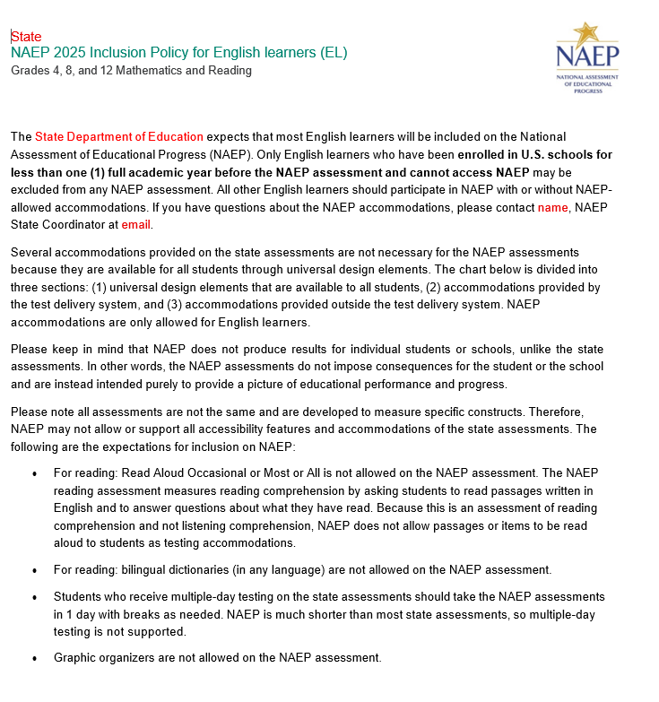

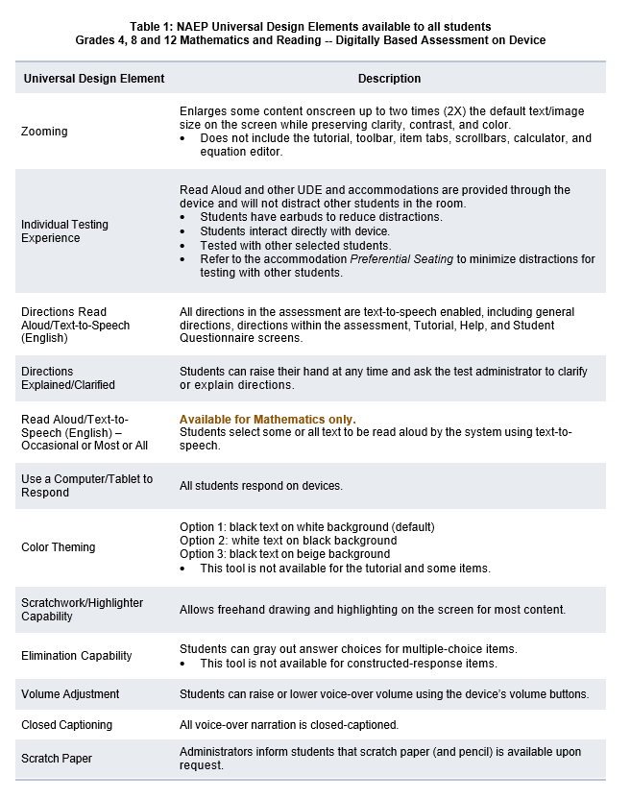

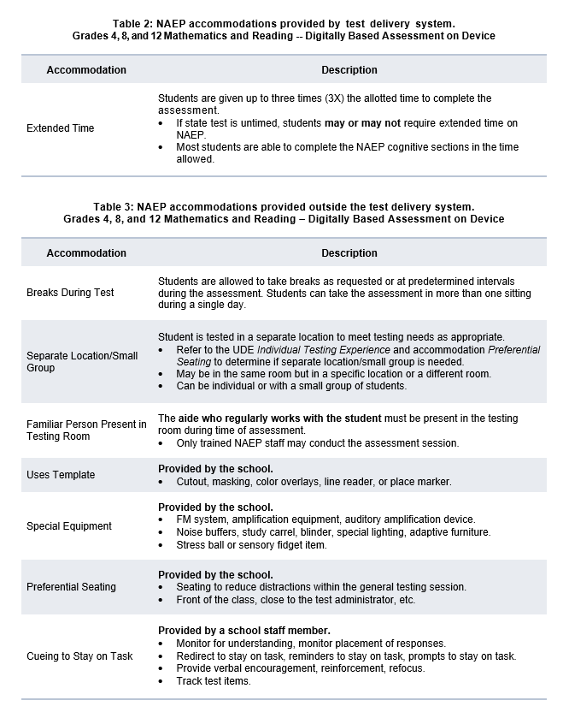

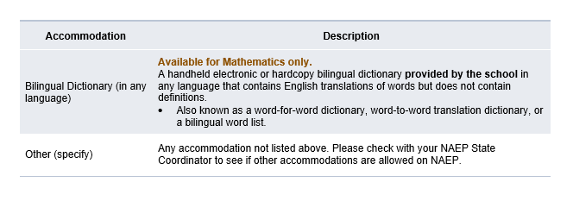

Appendix D2-43: NAEP 2025 Inclusion Guidelines for English Learners, Puerto Rico
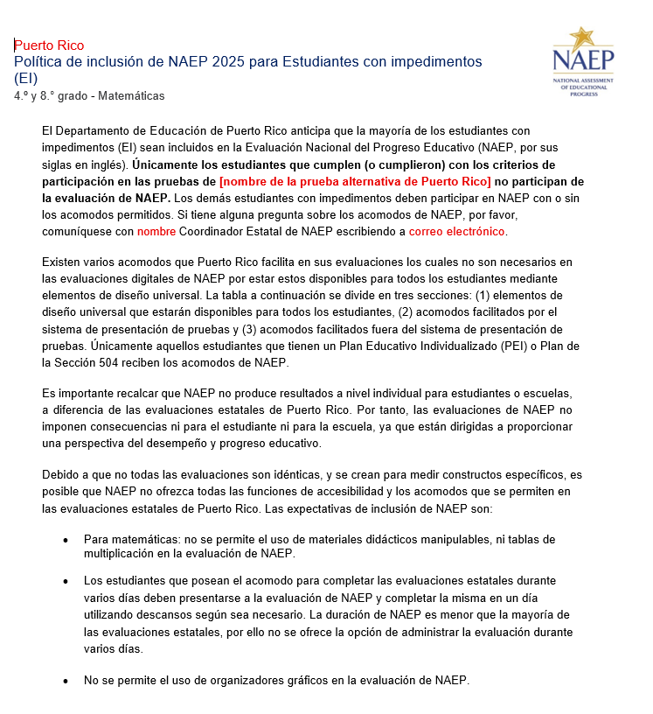

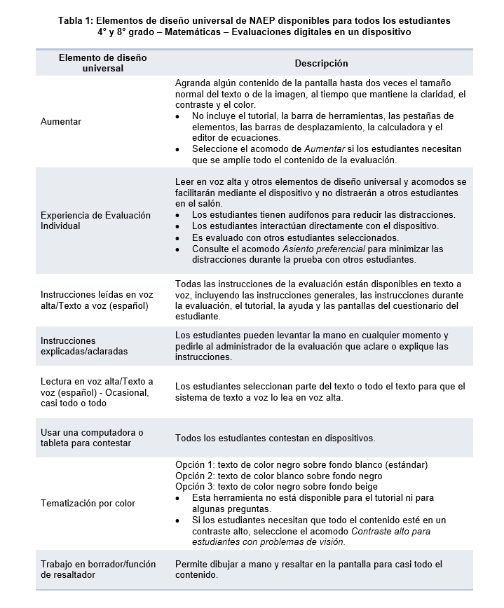

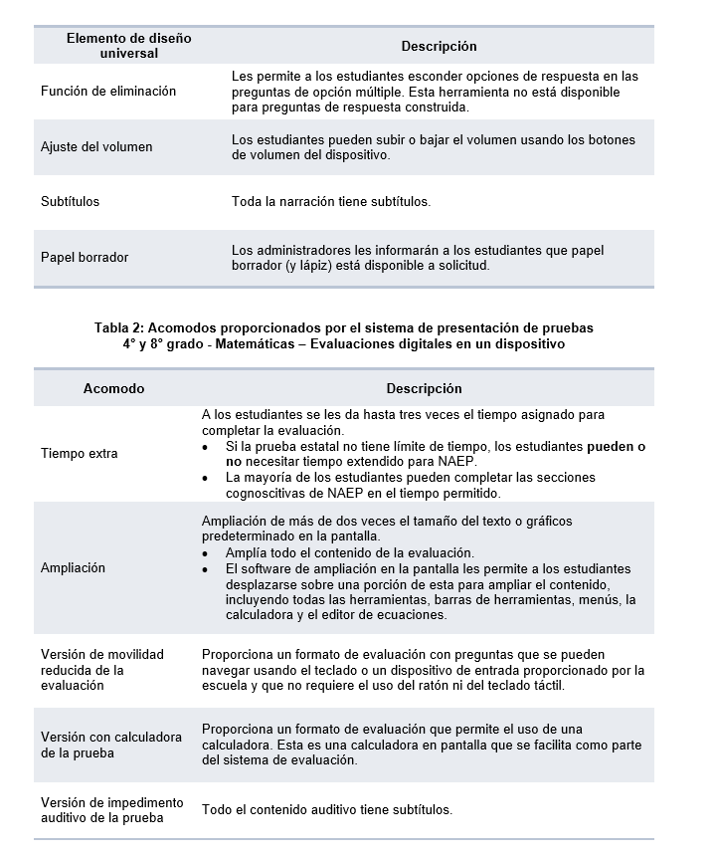

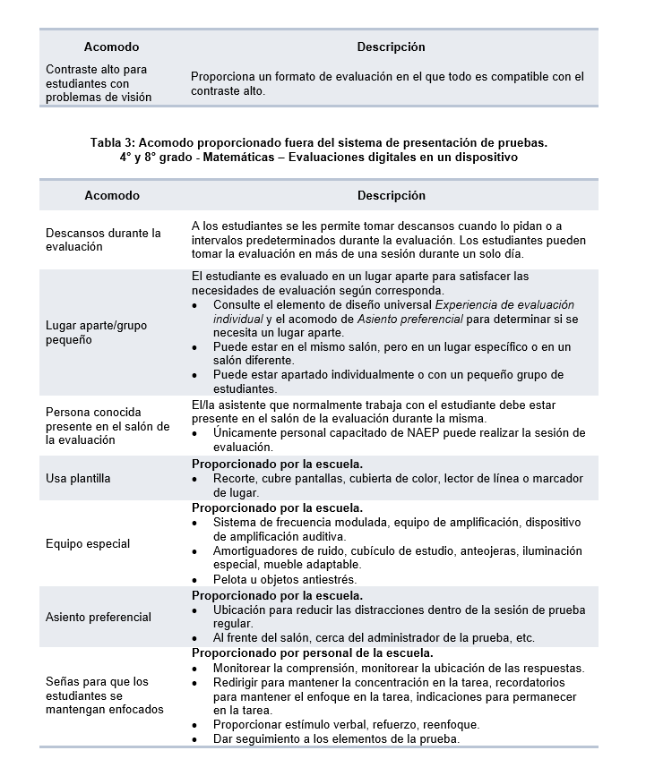

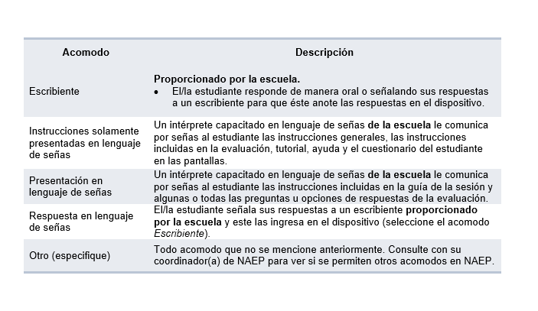

Appendix D2-44: NAEP 2025 Inclusion Guidelines for Students with Disabilities

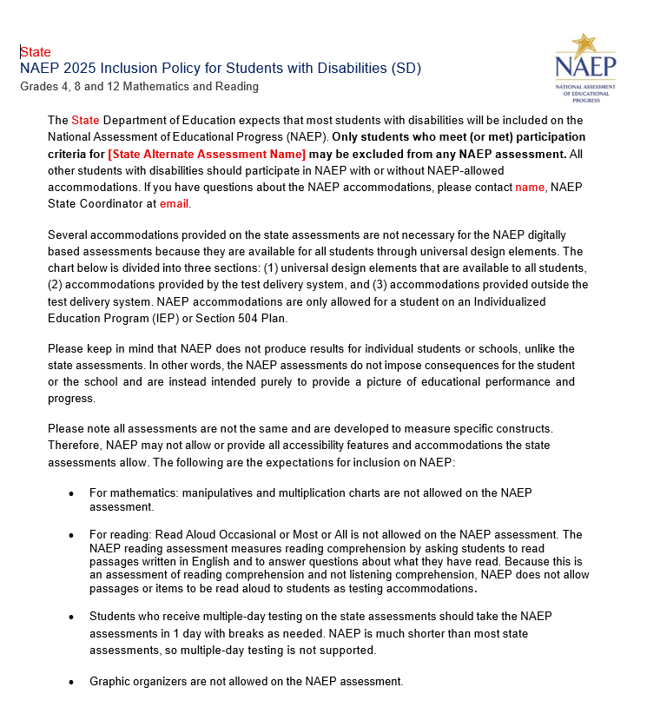

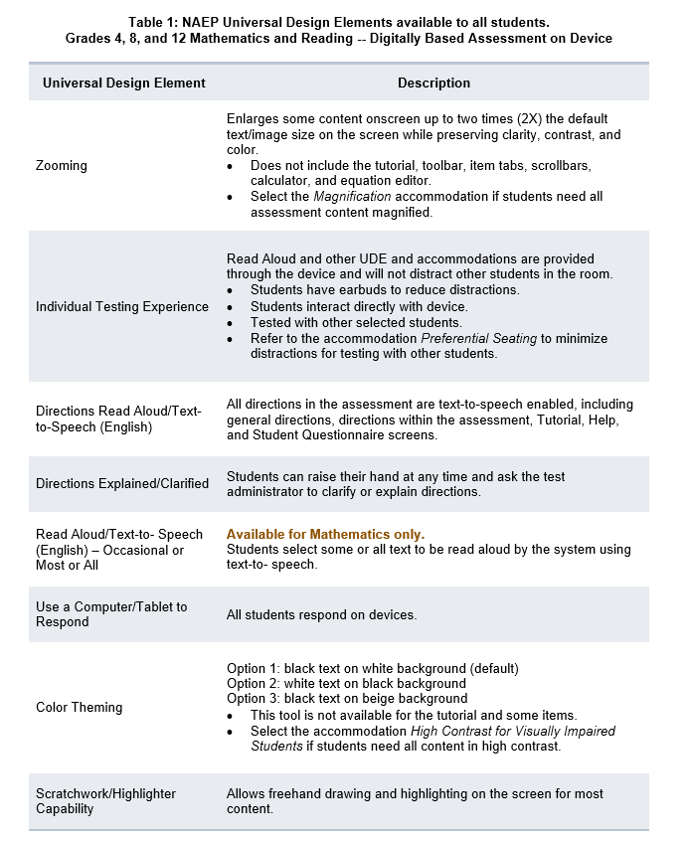

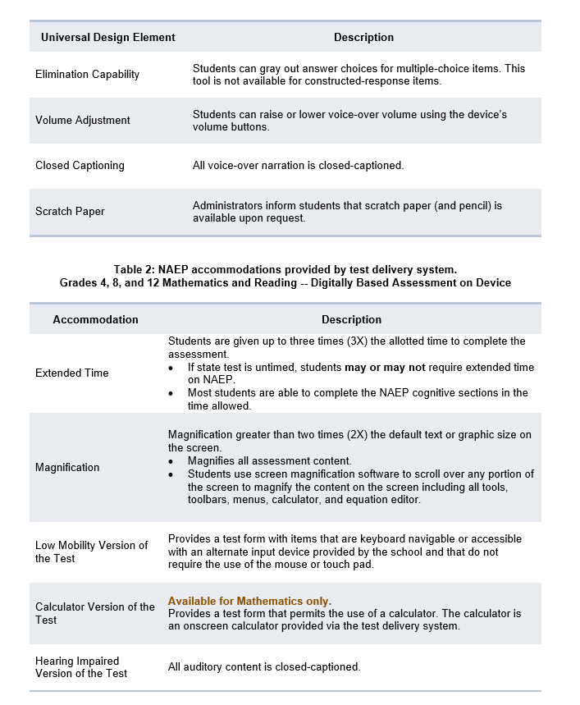

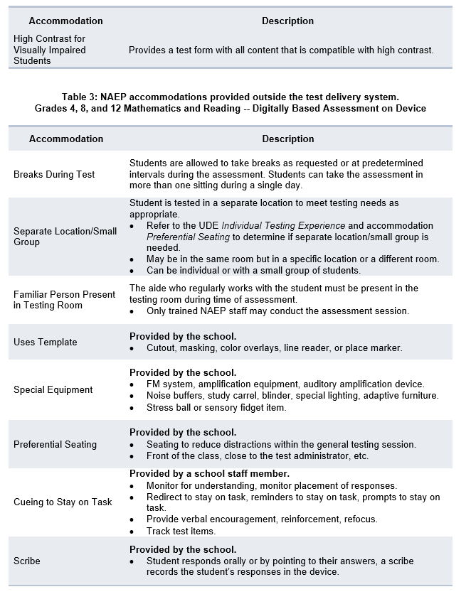

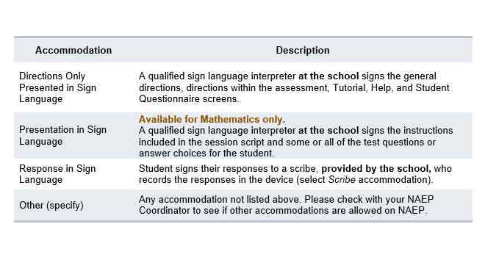

Appendix D2-45: NAEP 2025 Inclusion Guidelines for Students with Disabilities, Puerto Rico
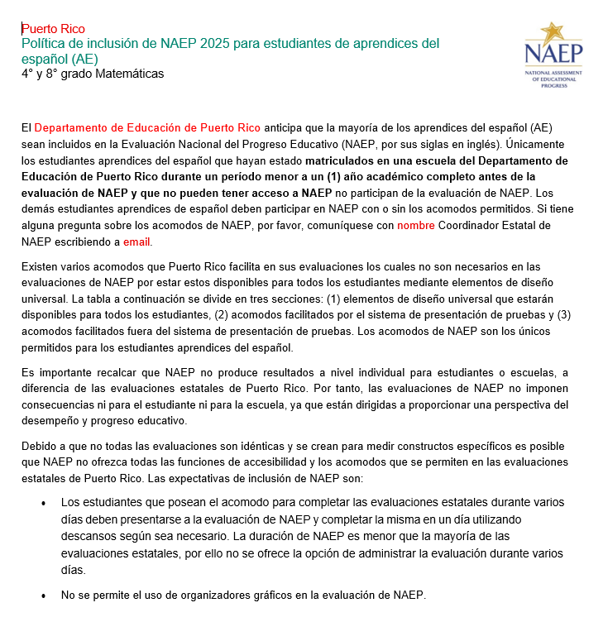

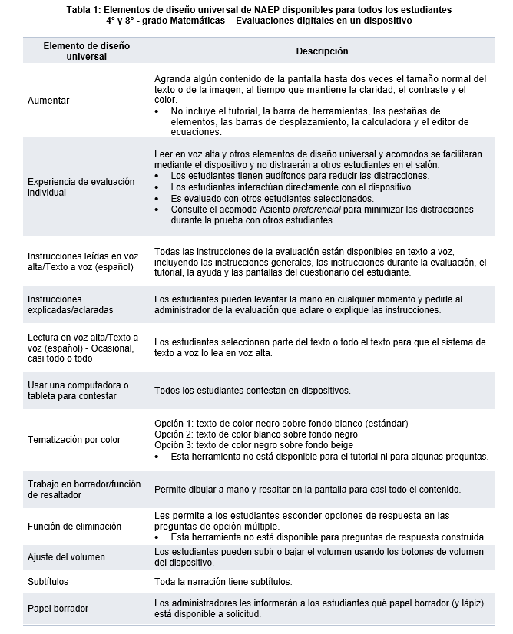

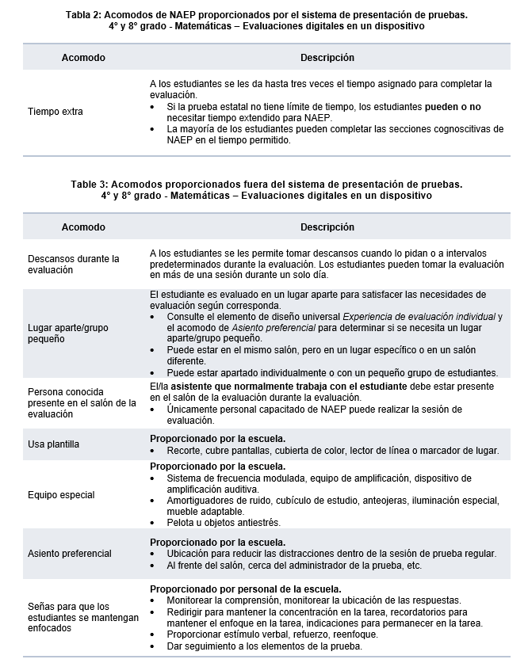

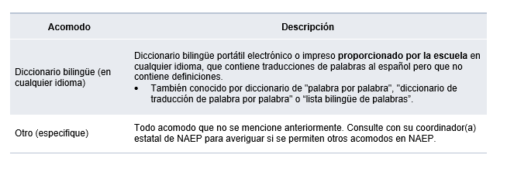

Appendix D2-46: NAEP 2025 Preassessment Responsibilities Guide, Private Schools School Device Model
2025 Field Test Private School Preassessment Responsibilities Guide
Thank you for supporting the National Assessment of Educational Progress (NAEP). We look forward to working with you to make NAEP a positive experience at your school. The Assessment Management System (AMS) will be your primary resource for completing assessment planning tasks online for the upcoming assessment.
This guide outlines tasks you will complete along with available resources to make assessment day successful.
NAEP Activity Timeline
December–January:
- Complete Preassessment Activities
January–February:
- Assessment Planning Meeting with NAEP representatives
Within 10 school days before the assessment:
- Notify Parents and Guardians,
- Support Assessment Activities
- Monitor/Confirm Device Readiness Checks are Completed
January 27–March 7:
- NAEP 2025 Assessment Window
After the assessment:
- Wrap Up
You will need to complete the following activities:
- Complete Preassessment Activities
When the student sample is released in December, the following preassessment activities should be completed in the AMS:
  - Schedule Assessment Planning Meeting (APM)
    - An assigned NAEP representative, responsible for administering the assessment, will contact you in December to introduce themselves and monitor the scheduling of an Assessment Planning Meeting. School coordinators will select a date and time (1-hour block) to schedule their APM in the AMS. The NAEP representative can review how to complete the planning tasks outlined below upon your request.
  - Provide Student Information
    - Review the student sample and identify any students who cannot take the assessment. Review demographic information and update any information that is missing or inaccurate.
    - Provide information about students with disabilities (SD) and English learners (EL) so that assessment administrators can plan appropriate assessment accommodations.
      - You can invite your school’s SD and EL specialists to the AMS to assist with this task.
      - Please note that school staff may need to assist with certain accommodations (e.g., cueing to stay on task, scribe). You will need to provide the contact information for the school staff who will assist with these accommodations.
  - Assessment Logistics
    - Schedule the assessment groups and reserve space at your school.
    - Students can either be assessed in two sequential sessions of up to 25 students each or all students at one time in one or two locations.
    - School staff presence in the assessment location is encouraged to help support classroom management.
    - If you select the option to assess all students at the same time in one or two locations, school staff presence is required at each assessment location.
    - Use the AMS to enter Assessment day details in the Assessment Logistics section.
      - location(s) and start time(s) of the assessment
      - how students and teachers will be notified
  - Technical Logistics
    - Review details about school devices and run a network check to confirm school Wi-Fi meets minimum requirements and required URLs are safelisted.
    - Record how the school devices and assessment location will be set up for the NAEP assessment.
    - Identify a school staff member to provide technical support on assessment day.
  - Manage Questionnaires
    - Identify respondents and provide contact information for the school and teacher questionnaires.
    - Match students to the subject-specific teacher in the AMS.
    - Monitor the completion of the questionnaires by school staff.
    - Distribute information about NAEP to teachers.
- Attend Assessment Planning Meeting (APM)
- Participate in a 1-hour virtual planning meeting with your NAEP representative to review and confirm information entered into the AMS.
  - An additional meeting can be scheduled with a technology coordinator to review and confirm technical logistics, if needed.
- Notify Parents and Guardians
- By law, parents/guardians of students selected to participate in NAEP must be notified in writing of their child’s selection prior to the administration of the assessment.
  - In the Notify Parents/Guardians section in the AMS, an electronic copy of the Parent/Guardian Notification Letter is available to download and distribute.
- Verify these notifications have been sent in the AMS.
- Support Assessment Day Activities.
- Resources can be created and printed from the Support Assessment Day section in the AMS to remind teachers and students about the assessment.
  - Share the Teacher Notification Letter and List of Participating Students
  - Distribute the Student Appointment Cards
- Monitor Device Readiness Checks are Completed
  - To ensure a smooth assessment experience in your school, it is important that each student device, including at least five spare devices, has the NAEP Assessment application installed and meets device requirements.
  - A school staff member, who was identified and notified in November, will manage the installation of the NAEP Assessment application on identified devices for your school.
  - In order, to complete the device readiness check, the NAEP Assessment application must be launched on each device and the verification code must be entered within 10 business days of the assessment date. The verification code and instructions for completing this check are available in the Technical Logistics section of the AMS.
  - School staff or students may complete this Device Readiness Check
- Assessment Day Responsibilities
- A school staff member will need to be available on assessment day at the beginning of the assessment session in case any technical issues arise while launching the NAEP assessment on the school’s devices.
- A staff member’s presence throughout the assessment can have a positive impact on students’ motivation and performance. If assessing all students at the same time in one or two locations, the presence of a school staff member is required at each assessment location to help support classroom management.
- If the attendance of sampled students is less than 80 percent, a makeup session will be necessary, and the NAEP representative will schedule another date to administer the assessment to the absent students.
- If the assessment cannot take place due to technical issues, the NAEP representative will work with your school to reschedule the assessment.
- After the Assessment
- Destroy any hardcopy documents containing student names according to school protocol.
- Complete a short email survey on your experience with NAEP.
- Instructions for uninstalling the NAEP assessment application can be found at the eNAEP Download Center.
  - Please follow your school procedures for uninstalling applications on school devices.
If your AMS password has expired, you can request to reset by selecting “Forgot Password”. If you have any questions, please contact the NAEP help desk at 1-800-283-6237 or naephelp@westat.com.
Online Resources Information for selected schools
Information for Selected Schools | https://nces.ed.gov/nationsreportcard/participating/private_nonpublic.aspx
Sample Questions Booklets | http://nces.ed.gov/nationsreportcard/about/booklets.aspx
NAEP Questions Tool | http://nces.ed.gov/nationsreportcard/nqt
Information for Parents | http://nces.ed.gov/nationsreportcard/parents
Assessment Frameworks | https://www.nagb.gov/naep-frameworks/frameworks-overview.html
Digitally Based Assessments | https://nces.ed.gov/nationsreportcard/dba

For more information about NAEP, visit https://nces.ed.gov/nationsreportcard/.
Find us on: [Facebook, Instagram, X, LinkedIn, and YouTube logos]
National Center for Education Statistics (NCES) conducts the National Assessment of Educational Progress to evaluate federally supported education programs. All of the information you provide may be used only for statistical purposes and may not be disclosed, or used, in identifiable form for any other purpose except as required by law (20 U.S.C. §9573 and 6 U.S.C. §151). By law, every NCES employee as well as every NCES agent, such as contractors and NAEP coordinators, has taken an oath and is subject to a jail term of up to 5 years, a fine of $250,000, or both if he or she willfully discloses ANY identifiable information about you. Electronic submission of your information will be monitored for viruses, malware, and other threats by Federal employees and contractors in accordance with the Cybersecurity Enhancement Act of 2015.

Appendix D2-47: NAEP 2025 Instructions for preparing and importing a student excel file
Instructions for Preparing and Importing a Student Excel file

Requirements
NAEP needs a complete Excel file of students enrolled during the 2024–2025 school year for the selected grade(s) at your school. Schools selected for multiple grades should create separate files for each grade. NAEP uses this student list to draw a random sample of students to participate in the assessment. Include all students in the selected grade, even students who are typically excluded from other testing programs, such as students with IEPs (SD) and English Learners (EL), and students participating in virtual/remote learning.
NAEP recommends using a Student List Template, which is available on the Assessment Management System website. If you create your own Excel file, use the same or similar header names. If you cannot submit your student data in an Excel file, contact the NAEP help desk at 1-800-283-6237 or naephelp@westat.com.
The Excel file must contain the following information for each student:
Excel Header Name | Format | Notes
State unique Student ID | Numeric | If available, do not use Social Security Numbers
First name | Text | Recommendation: If possible, include first and last names in separate columns. NAEP accepts names stored in a single column, which requires answering questions to determine how names are ordered/formatted.
Last name | Text
Middle name or initial optional | Text
Grade in School | 4, 8, 12 | Include all students in the selected grade
Homeroom/other locator optional | Text or Numeric | Optional, include if available
Month of Birth | Numeric | Recommendation: If possible, include month and year of birth in separate columns. NAEP accepts birthdates in a single column too. Expected birth years for NAEP: grade 4 2012–2016, grade 8 2008–2012, and grade 12 2004–2009.
Year of Birth | Numeric
Gender | School-defined code | Map school-defined codes to NAEP definitions. See pages 2-4.
Race/Ethnicity | School-defined code | Map school-defined codes to NAEP definitions. See pages 2-4.
Economically Disadvantaged | School-defined code | Map school-defined codes to NAEP definitions. See pages 2-4.
Students with Disabilities (SD) | School-defined code | Map school-defined codes to NAEP definitions. See pages 2-4.
English Learner (EL) | School-defined code | Map school-defined codes to NAEP definitions. See pages 2-4.
On-Break Indicator for all -year schools ONLY (schools without a summer break) | School-defined code | Only required for year-round schools
ZIP Code | Numeric | 5 or 9 digit format

NAEP Codes and Definitions
You will need to map your file’s school-defined codes to NAEP’s definitions for the following variables: Gender, Race/Ethnicity, Economically Disadvantaged, Students with Disabilities (SD), English Learner (EL). See NAEP definitions below.

Gender

Map your school’s codes to the following categories.
- Male
- Female
- Nonbinary: A student who does not identify exclusively as male or female.
- Information unavailable at this time: If you currently do not have this information for one or more students, blank cells or an indicator such as “N/A” (Not Available) in the cell(s) can be mapped to this code to notify your NAEP representative of the need to collect the data at a later date.

Race/Ethnicity
NAEP offers three student list templates to accommodate different race/ethnicity formats. Your NAEP State Coordinator has designated the preferred template for your state. See the Downloads section of Step 1 Import Students.
Race/ethnicity in one column – Use when all race/ethnicity information is included in a single column.
Race/ethnicity in two columns – Use when ethnicity (Hispanic, of any race) is included in a single column. Other race information is included in a separate column.
Race/ethnicity in six columns – Use when each of the six categories below have a dedicated column: Hispanic (of any race), White (not Hispanic), Black or African American (not Hispanic), Asian (not Hispanic), American Indian or Alaska Native (not Hispanic), and Native Hawaiian or Pacific Islander (not Hispanic). Responses from these six categories will determine the Two or More Races, not Hispanic category.
NAEP accepts race/ethnicity information in other formats. The formats above are the most common.

Map your school’s codes to the following categories.
- Hispanic, of any race: A person of Mexican, Puerto Rican, Cuban, Central or South American, or other Spanish (but not Portuguese) culture of origin, regardless of race
- White, not Hispanic: A person having origins in any of the original peoples of Europe (except Spain), North Africa, or the Middle East
- Black or African American, not Hispanic: A person having origins in any of the Black peoples of Africa
- Asian, not Hispanic: A person having origins in any of the original peoples of the Far East, Southeast Asia, the Indian Subcontinent, including, for example, Cambodia, China, Japan, India, Korea, Malaysia, Pakistan, the Philippine Islands, Thailand, and Vietnam
- American Indian or Alaska Native, not Hispanic: A person having origins in any of the original peoples of North and South America (including Central America), and who maintains tribal affiliation or community attachment
- Native Hawaiian or Pacific Islander, not Hispanic: A person having origins in any of the original people of Hawaii, Guam, Samoa, or other Pacific Islands
- Two or More Races, not Hispanic: A person who identifies with two or more of the non-Hispanic categories above.
- Information unavailable at this time: If you currently do not have this information for one or more students, blank cells or an indicator such as “N/A” (Not Available) in the cell(s) can be mapped to this code to notify your NAEP representative of the need to collect the data at a later date.
- School does not collect this information: Available to nonpublic schools only. When used, this code must be applied to all students.

Economically Disadvantaged
Map your school’s codes to the following categories.
- Yes, economically disadvantaged
- No, not economically disadvantaged
- Information unavailable at this time: If you currently do not have this information for one or more students, blank cells or an indicator such as “N/A” (Not Available) in the cell(s) can be mapped to this code to notify your NAEP representative of the need to collect the data at a later date.

English Learner (EL)
Map your school’s codes to the following categories.
- Yes, EL
- No, Not EL
- No, Formerly EL: If a student who has achieved full English proficiency, is monitored, and is included in EL subgroup for accountability reporting for 2 years (or 4 years depending on state policy) after exiting. Public schools, contact your NAEP State Coordinator if you have any questions about using this code.
- Information unavailable at this time: If you currently do not have this information for one or more students, blank cells or an indicator such as “N/A” (Not Available) in the cell(s) can be mapped to this code to notify your NAEP representative of the need to collect the data at a later date.

On-Break Indicator
For year-round schools only: Include students who will be on break/vacation on the scheduled assessment day along with all of the other students enrolled in the sampled grade. The Student List Template contains an “On Break” column for identifying students who will be on break/vacation by filling in “Yes.” If you are not using the template, create and provide data for an “On Break” column in your file.

Instructions for importing the student list
See the steps below for importing the student list.

Step 1: Prepare the Excel file and a legend
The legend should explain the file’s codes. The following NAEP variables involve school-defined codes:
- Gender
- Race/Ethnicity
- Economically Disadvantaged
- Students with Disabilities (SD)
- English Learner (EL)
In the example below, a school uses five different codes for the Students with Disabilities variable. The legend explains how to “map” school codes to NAEP definitions.
School codes for Students with Disabilities
IEP
IEP + 504
504
No
Blank (no data in cell)

NAEP Definitions
Legend
IEP =
IEP + 504 =
504 =
No =

Blank =
Yes, IEP
No, not SD
Information unavailable
Yes, IEP
Information unavailable
Yes, IEP
No, not SD
No, not SD

Step 2: Check your file, then upload
Prevent upload failures by resolving these common problems first.
- Student records should be in one worksheet. Delete all other worksheets.
- File should include all currently enrolled students in the selected grade. Delete any students that are not in the selected grade.
- Include all required NAEP variables (see page 1 for full list). The following cannot be blank for any students: first name, last name, birth month/year, grade, and gender. Blanks for other variables are acceptable, you will add missing information later.
- Check for duplicate students. Delete any duplicate student rows.
- Header row for each required variable must be in row 1.
- Blank rows should begin after the last student record. Delete blank rows between students.
- Remove password protection. NAEP cannot process protected files.
Go to the Import Student List section on your school’s AMS page. Select Upload file.

Step 3: Map file contents
Use the completed legend for this step. The legend explains how to map each variable.
- Map your file’s column headings to NAEP variables. This step is done automatically if you use NAEP’s Excel template or the same variable/header row names.
  - The field names used by your database system may not have the same names as the NAEP variable. In this case, match the names of your columns to the names of the NAEP variables.
- Map your school’s codes to NAEP definitions. In the repeated example below, the school code “IEP” is mapped to NAEP’s definition “Yes, IEP”, and so on.
School codes for Students with Disabilities
IEP
IEP + 504
504
No
Blank (no data in cell)

NAEP Definitions
Legend
IEP =
IEP + 504 =
504 =
No =

Blank =
Yes, IEP
No, not SD
Information unavailable
Yes, IEP
Information unavailable
Yes, IEP
No, not SD
No, not SD

Step 4: Check warnings
Information from the student list runs through a series of checks.
- Review warnings. NAEP compares the student list against two databases: previous NAEP assessments and Common of Core Data. Common Core of Data (CCD) is the Department of Education’s primary database on public elementary and secondary education in the United States. These comparisons generate warnings to ensure demographics in the student list are accurate. Warnings serve as prompts to review and confirm existing information, and do not always require changes to the student list. There are additional warnings that identify missing information and possible mapping problems.
- Resolve warnings. Some warnings are resolved by adding missing information or editing existing information. Others require a review of how file contents are mapped, and possible changes if the mapping is incorrect.

Step 5: Confirm file
Review student counts and percentages for each variable in your file. This summary serves as a final check before submitting the file. Make sure these counts and percentages are representative of students in the selected grade at your school.

Appendix D2-48: NAEP 2025 eNAEP Download Center

Getting Started > Preparing for Assessment > Preassessment Tools (Landing Page)
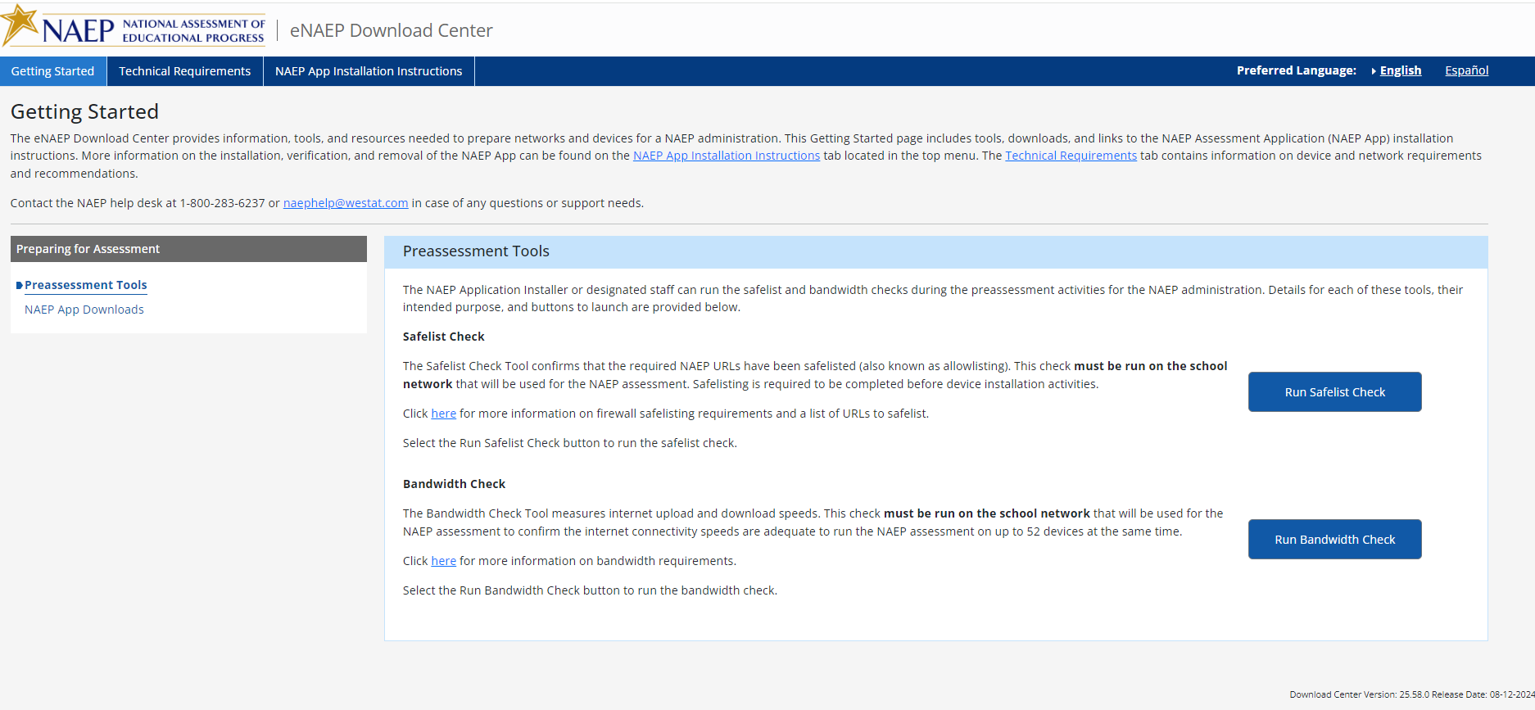

Getting Started > Preparing for Assessment > NAEP App Downloads
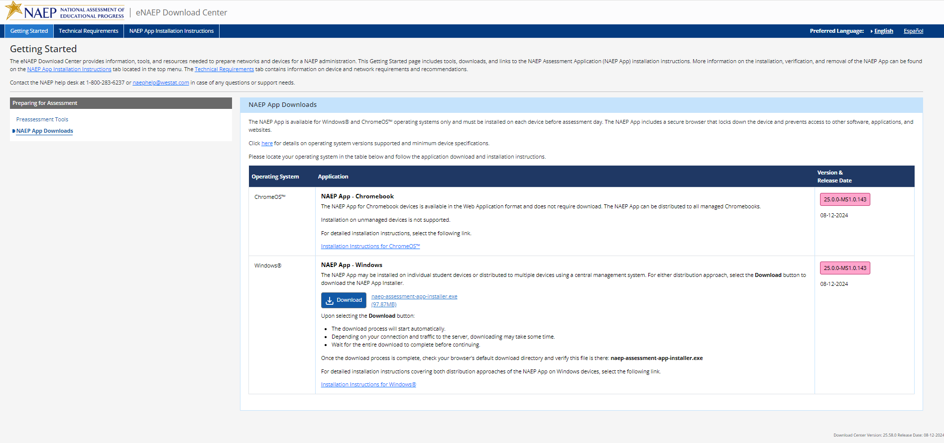

Technical Requirements > System Requirements > OS & Hardware Requirements
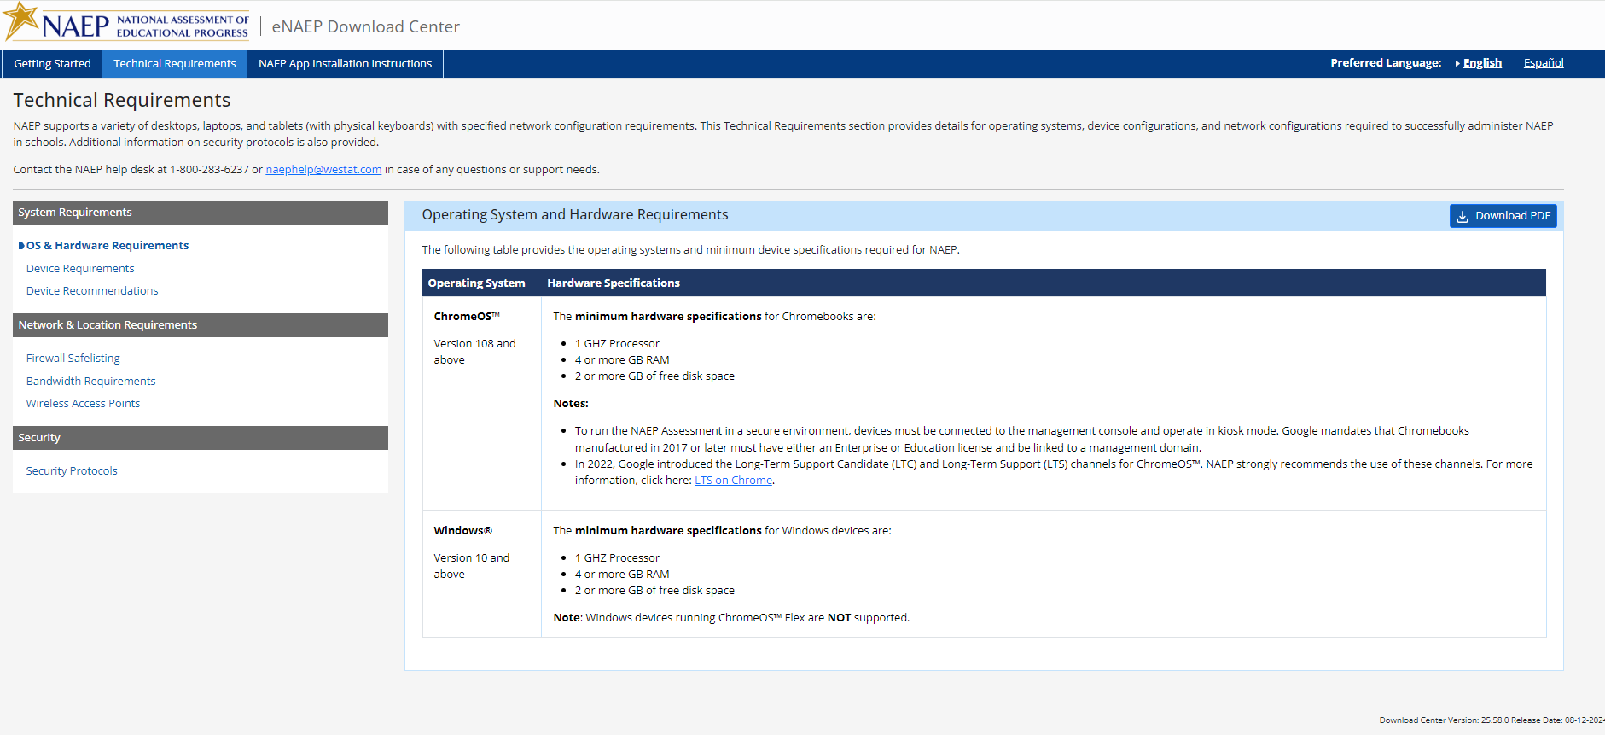

Technical Requirements > System Requirements > Device Requirements
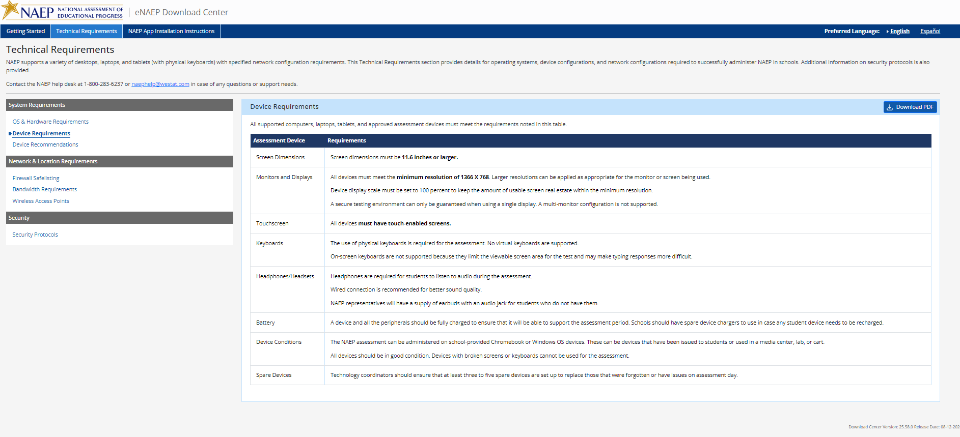
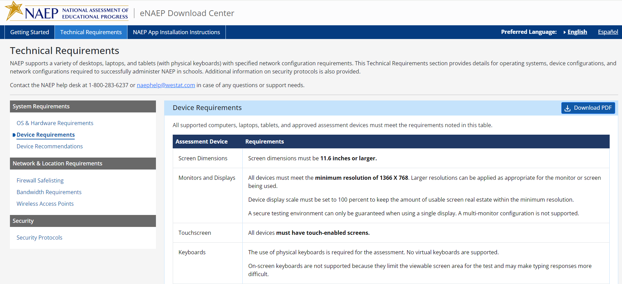
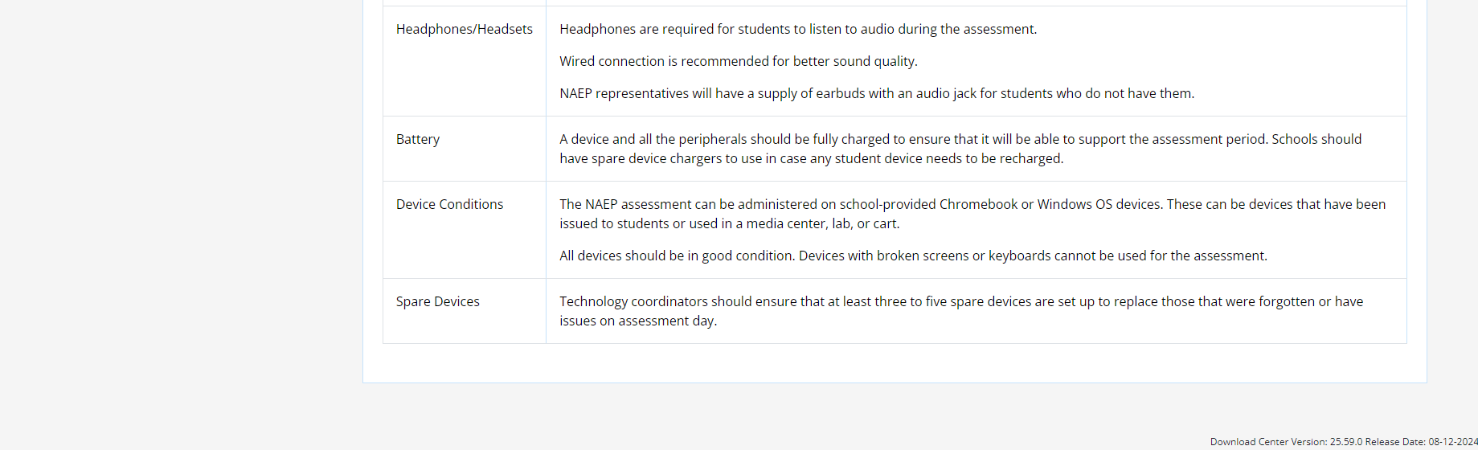

Technical Requirements > System Requirements > Device Recommendations
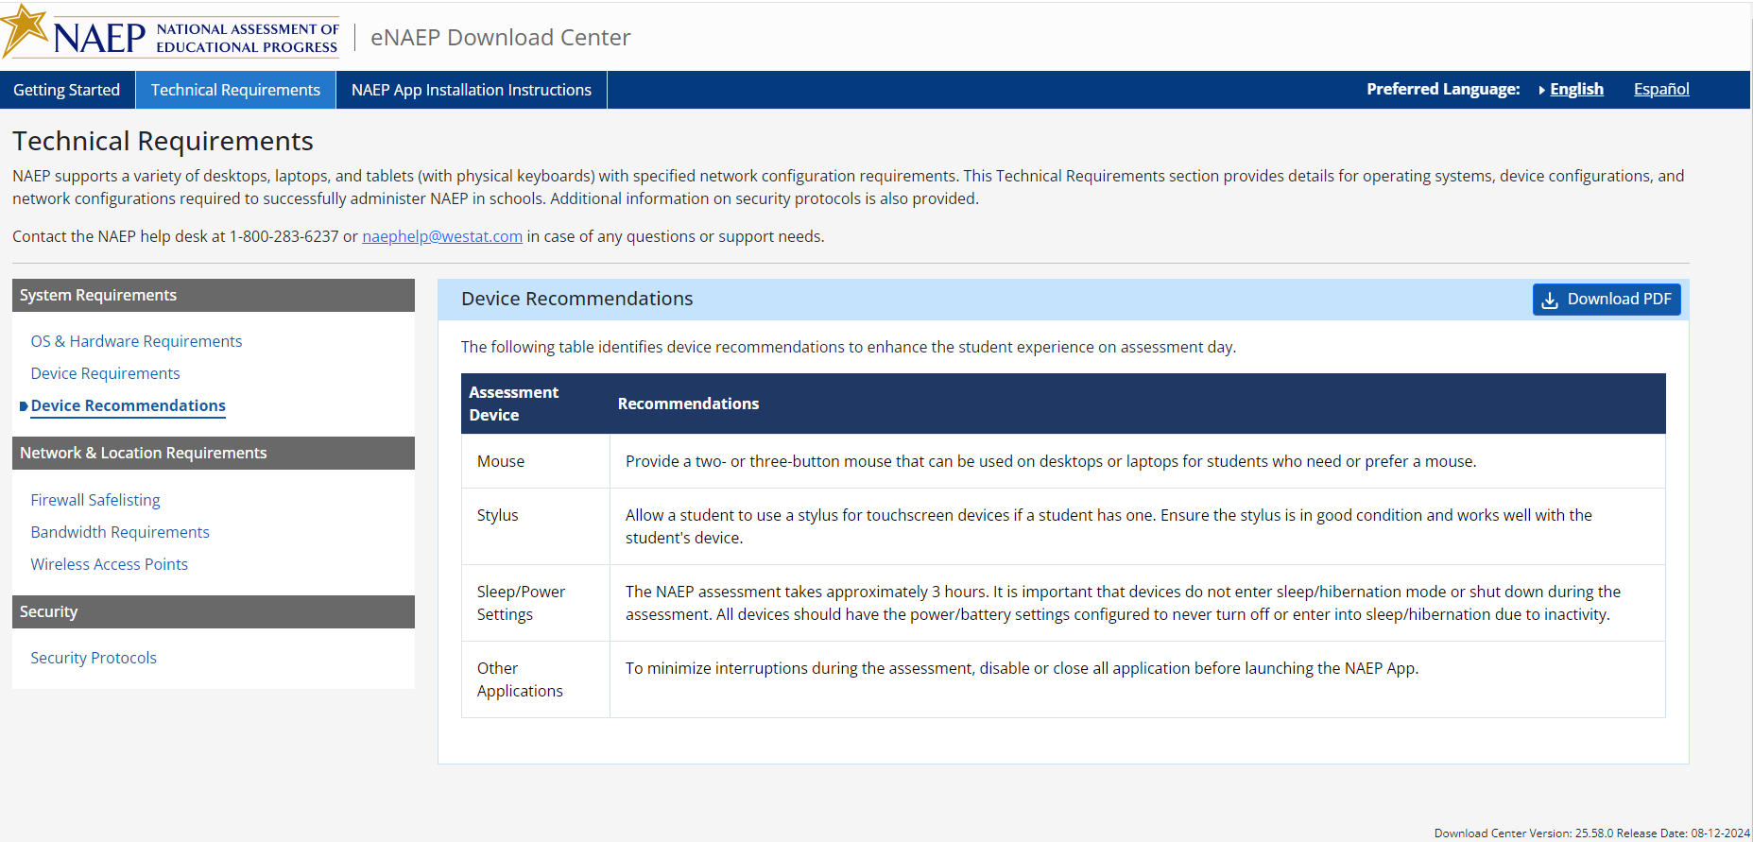

Technical Requirements > Network & Location Requirements > Firewall Safelisting
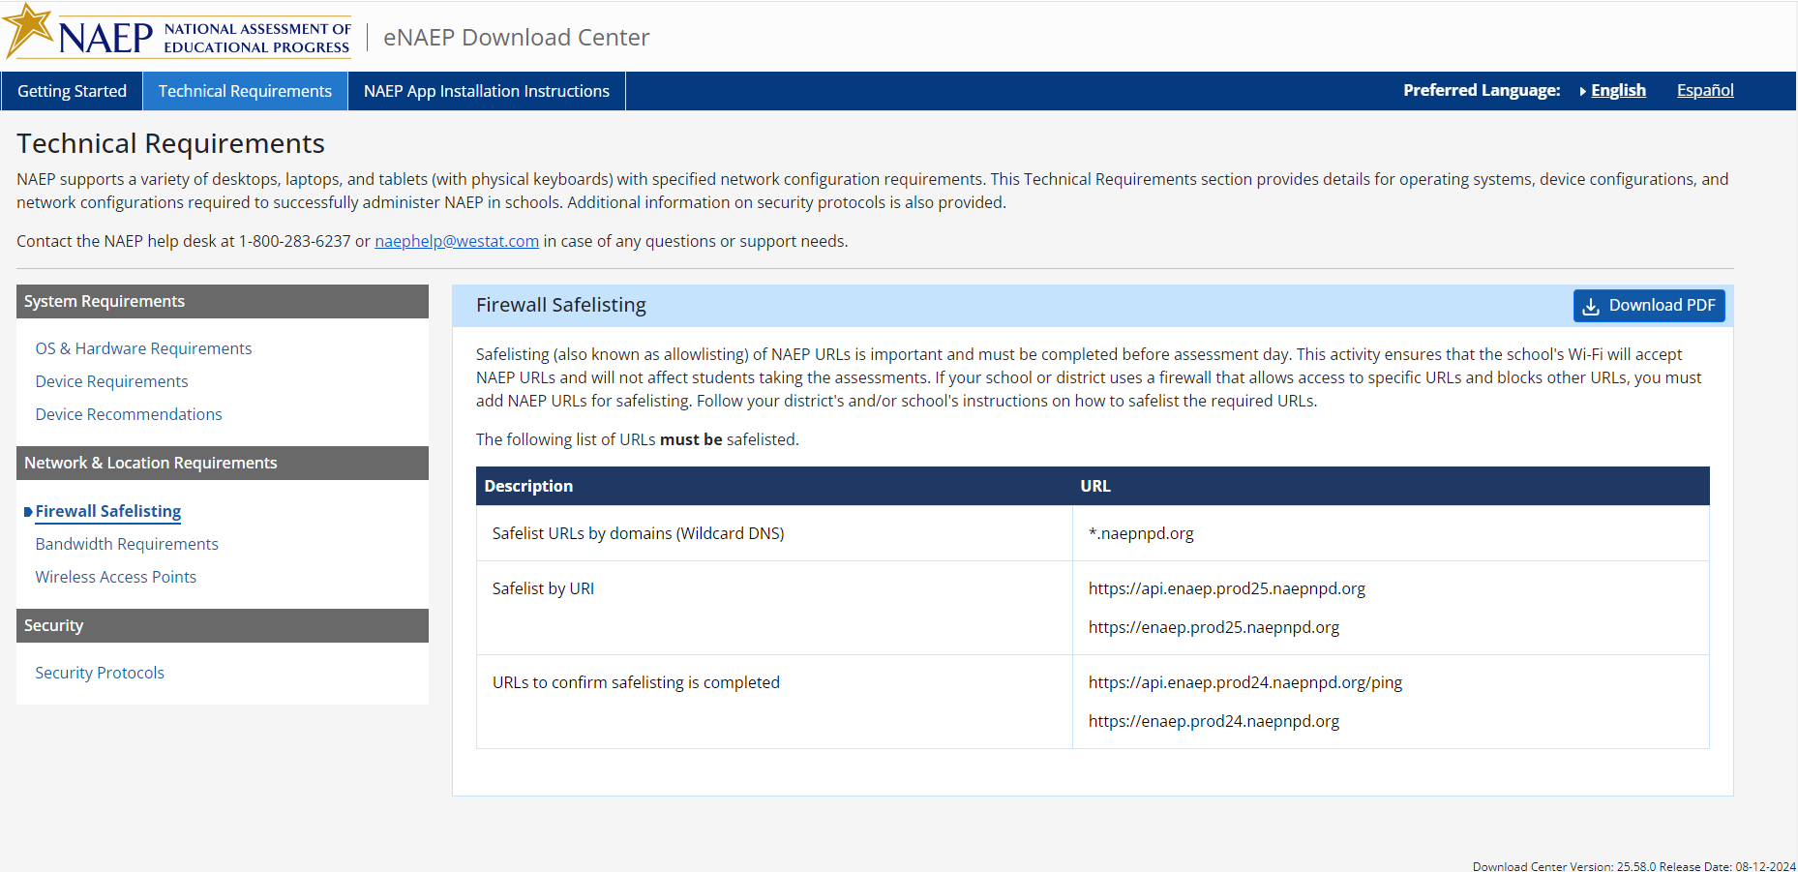

Technical Requirements > Network & Location Requirements > Bandwidth Requirements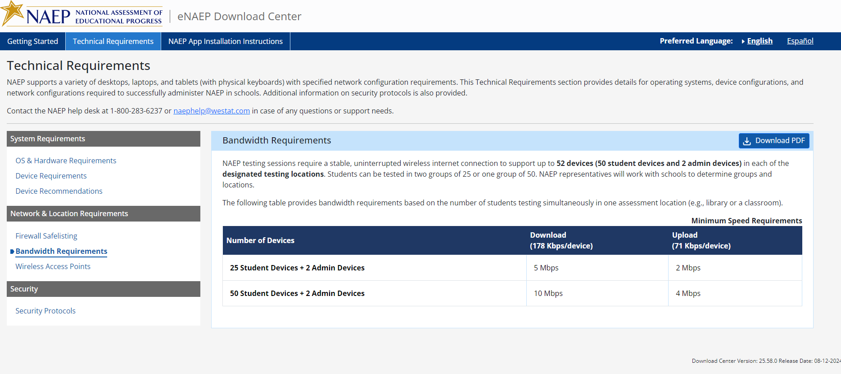

Technical Requirements > Network & Location Requirements > Wireless Access Point
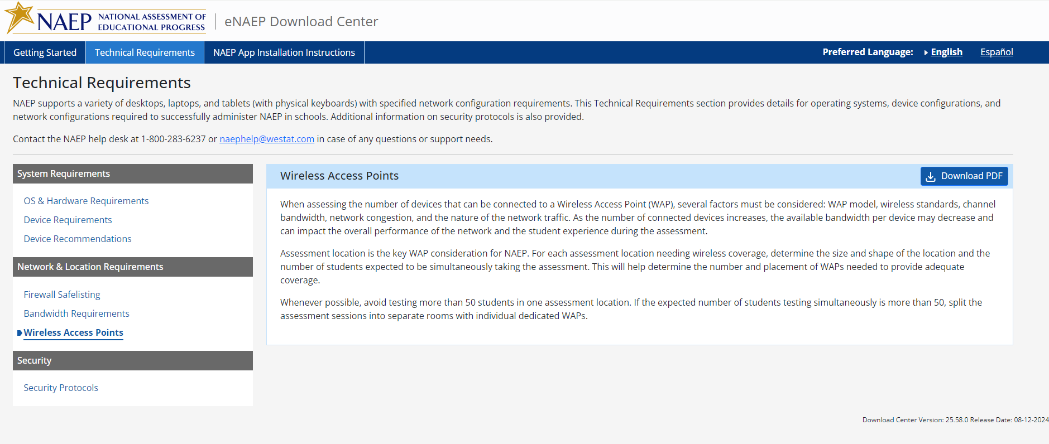

Technical Requirements > Security > Security Protocols
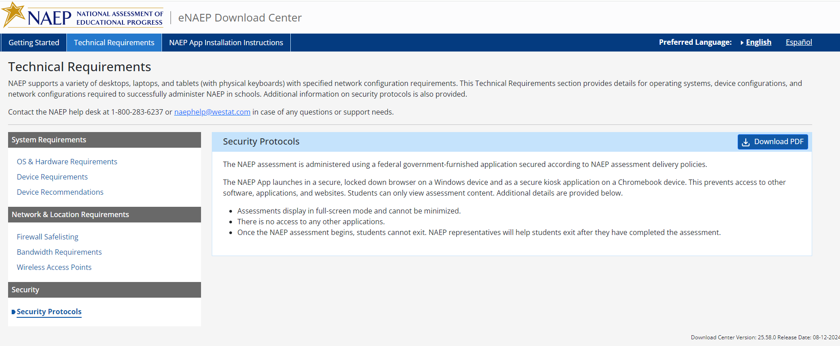

NAEP App Installation Instructions > ChromeOS > Installation Instructions
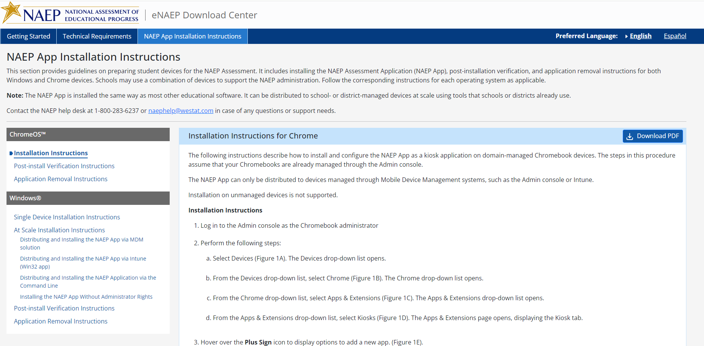
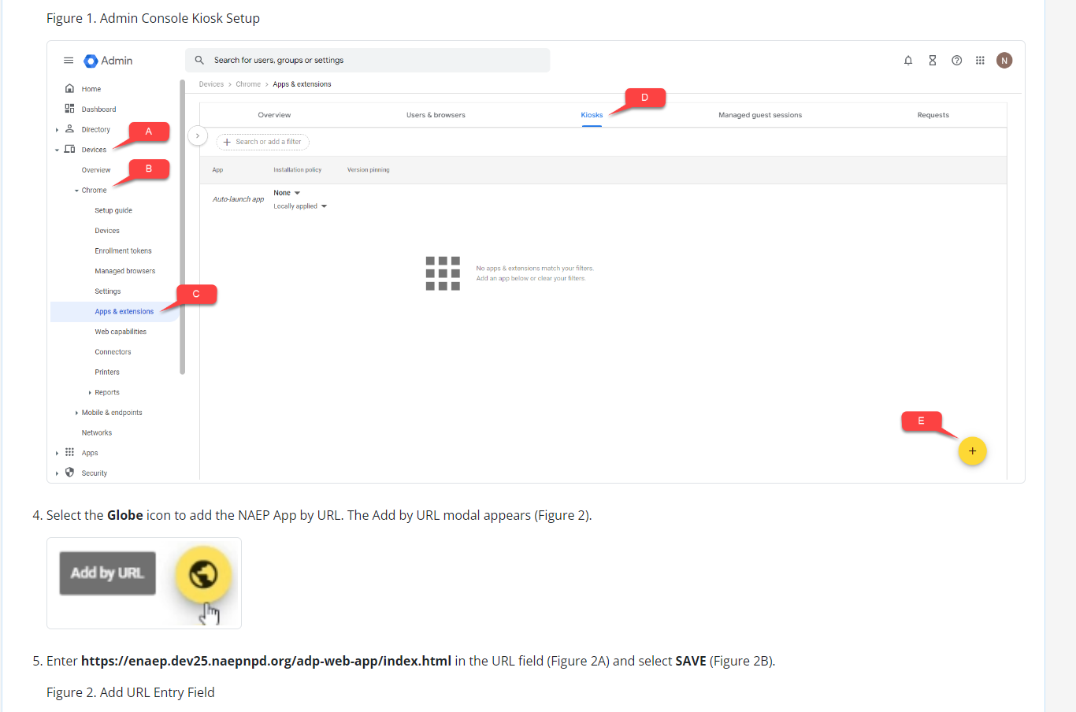
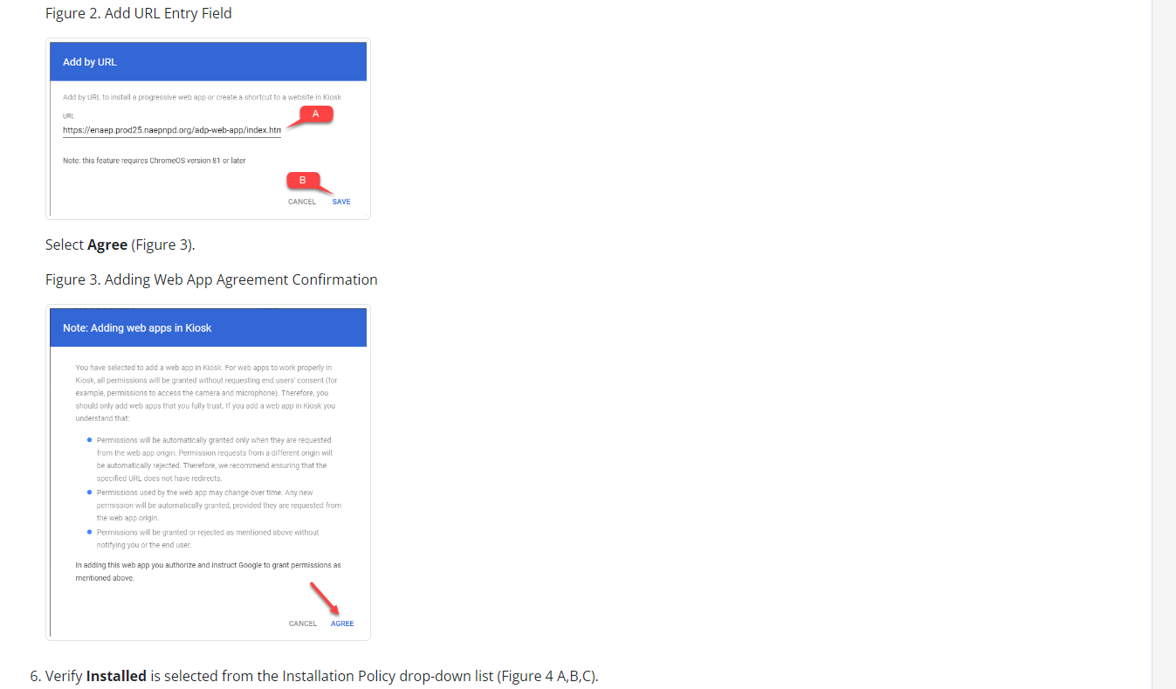
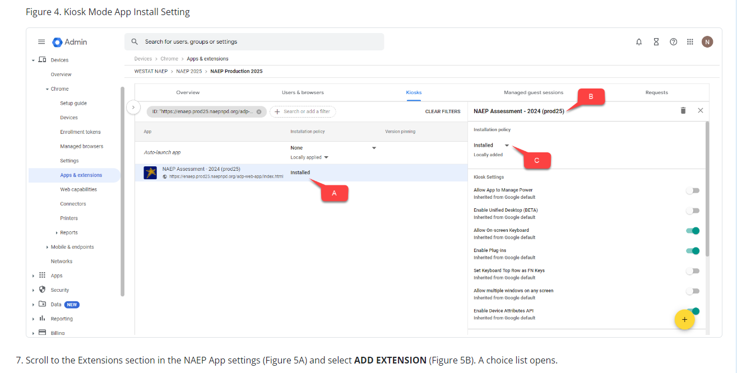
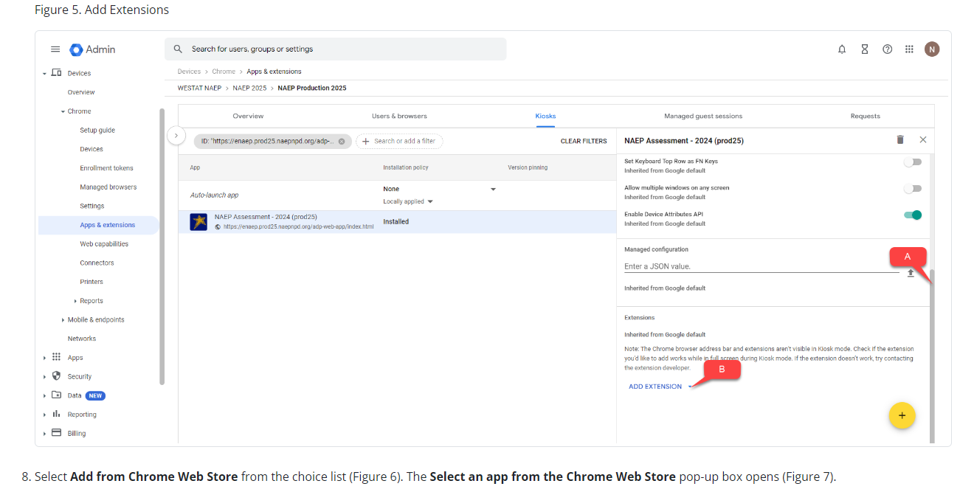
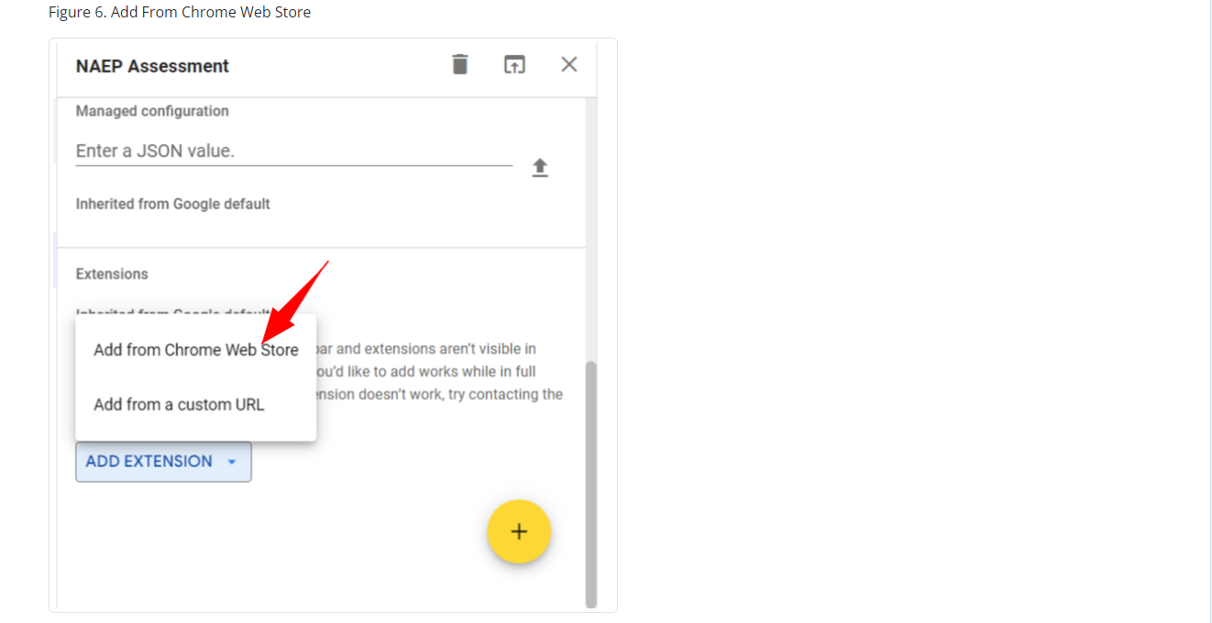
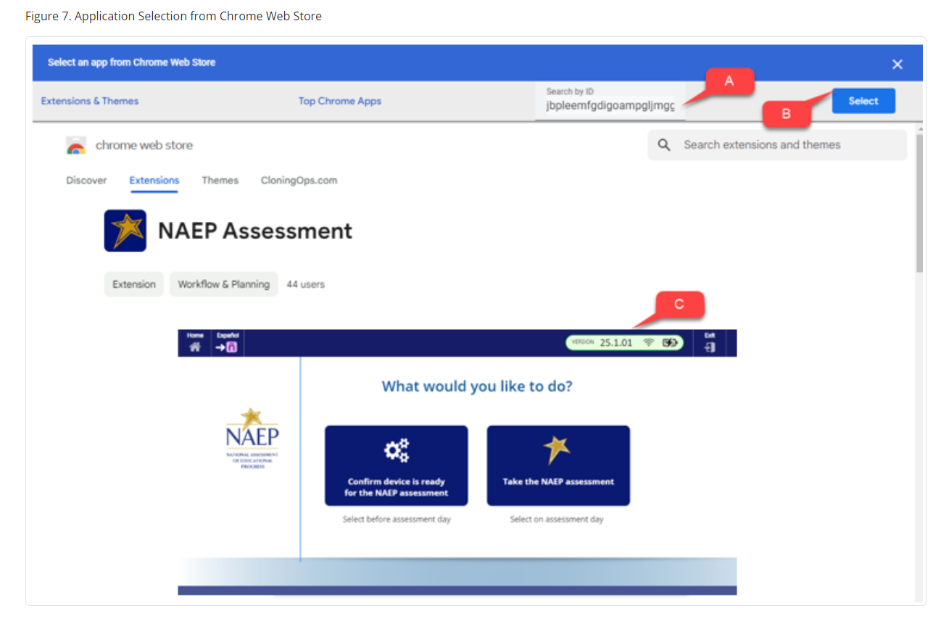
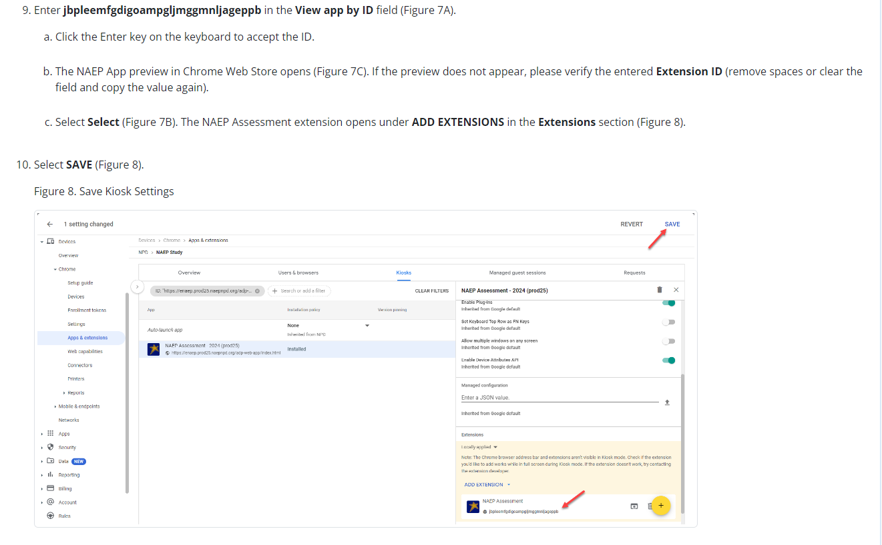
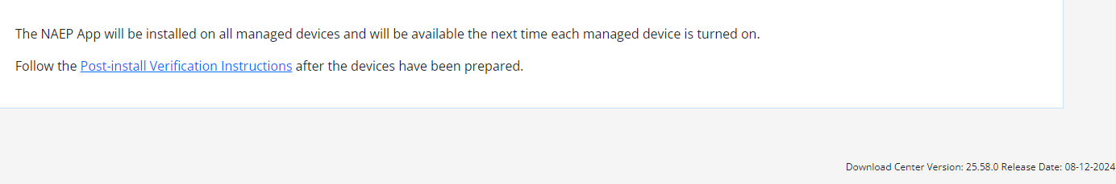

NAEP App Installation Instructions > ChromeOS > Post-install Verification Instructions
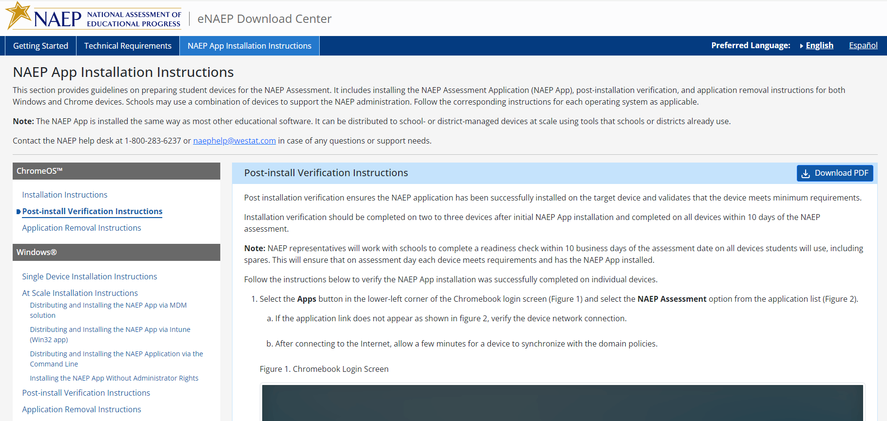
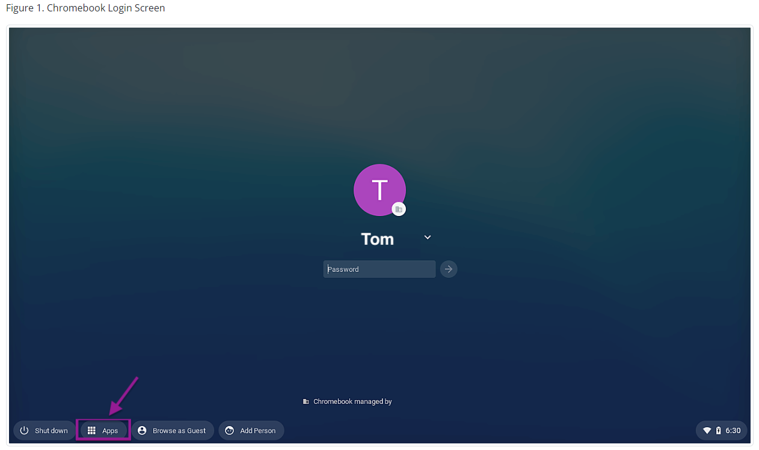
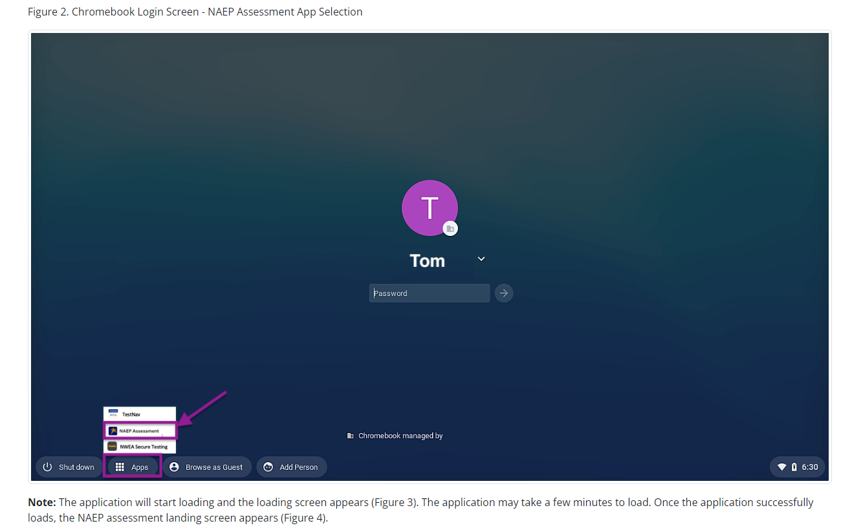
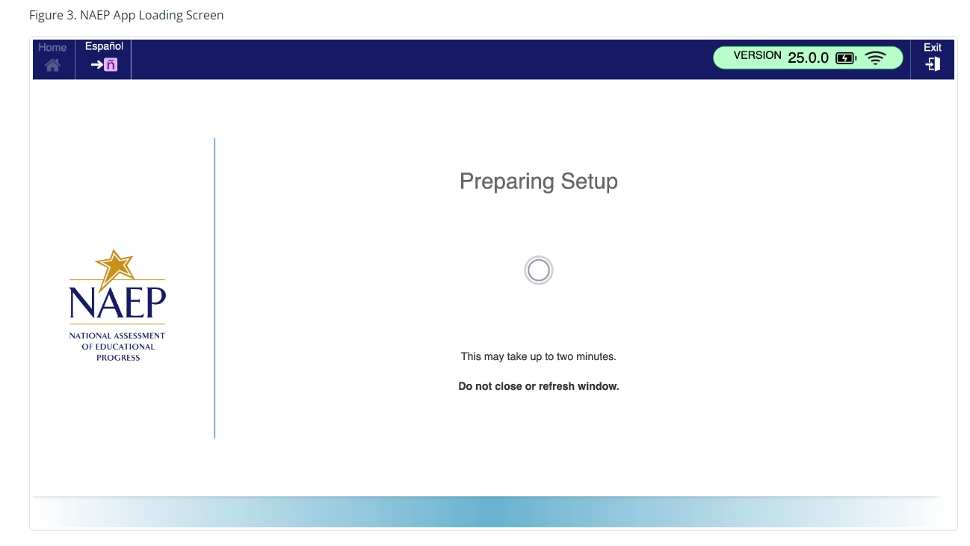
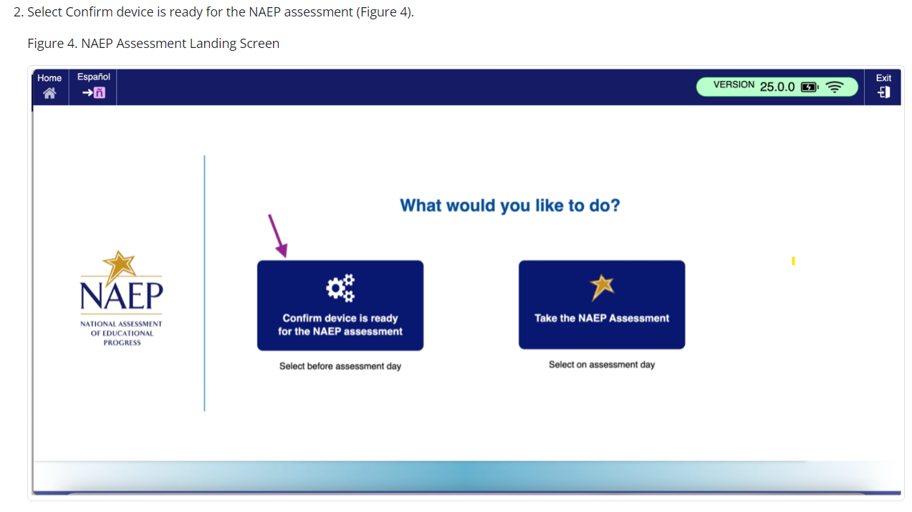

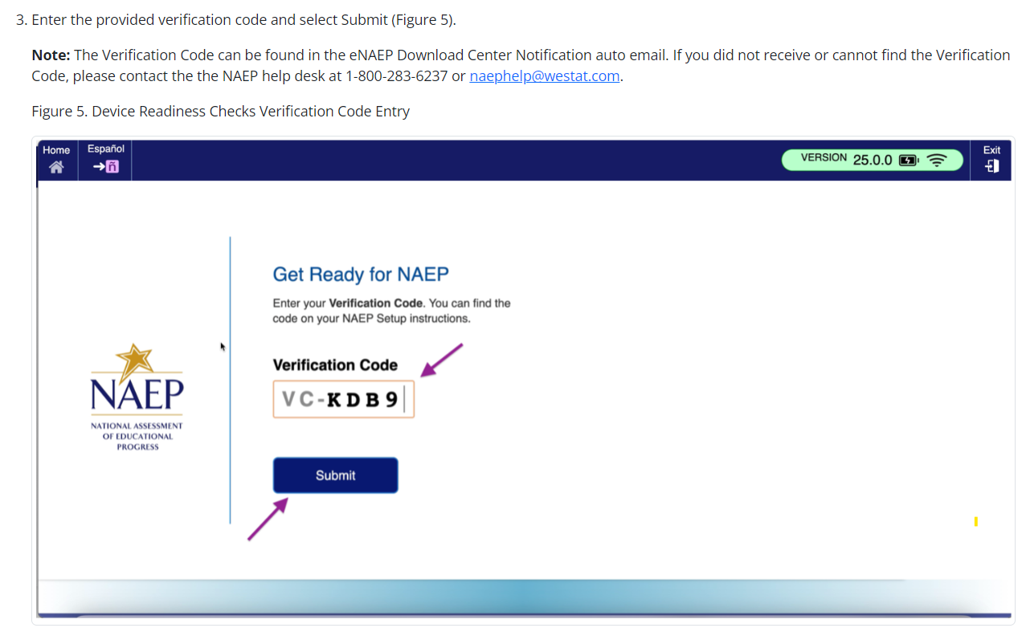
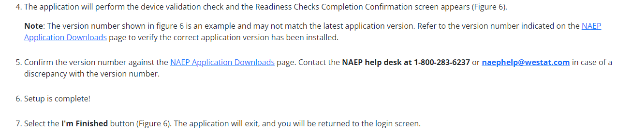
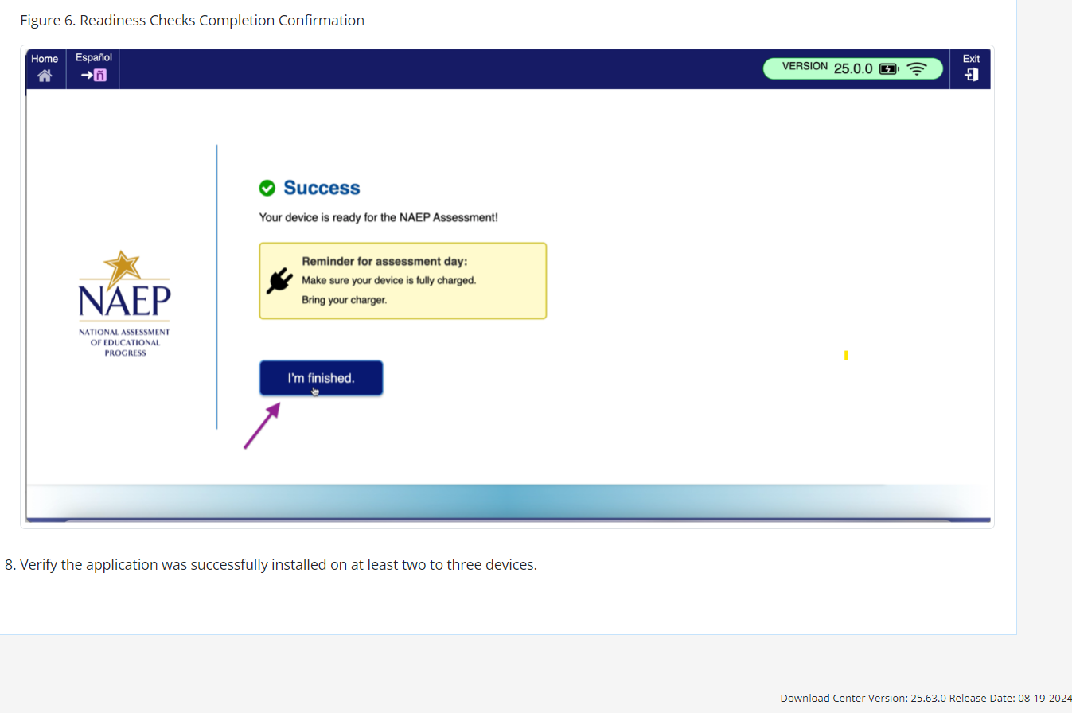

NAEP App Installation Instructions > ChromeOS > Application Removal Instructions
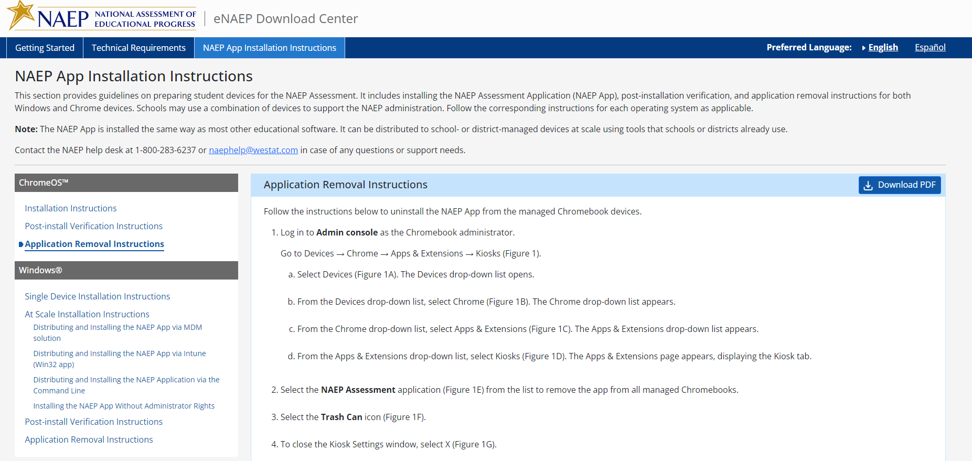
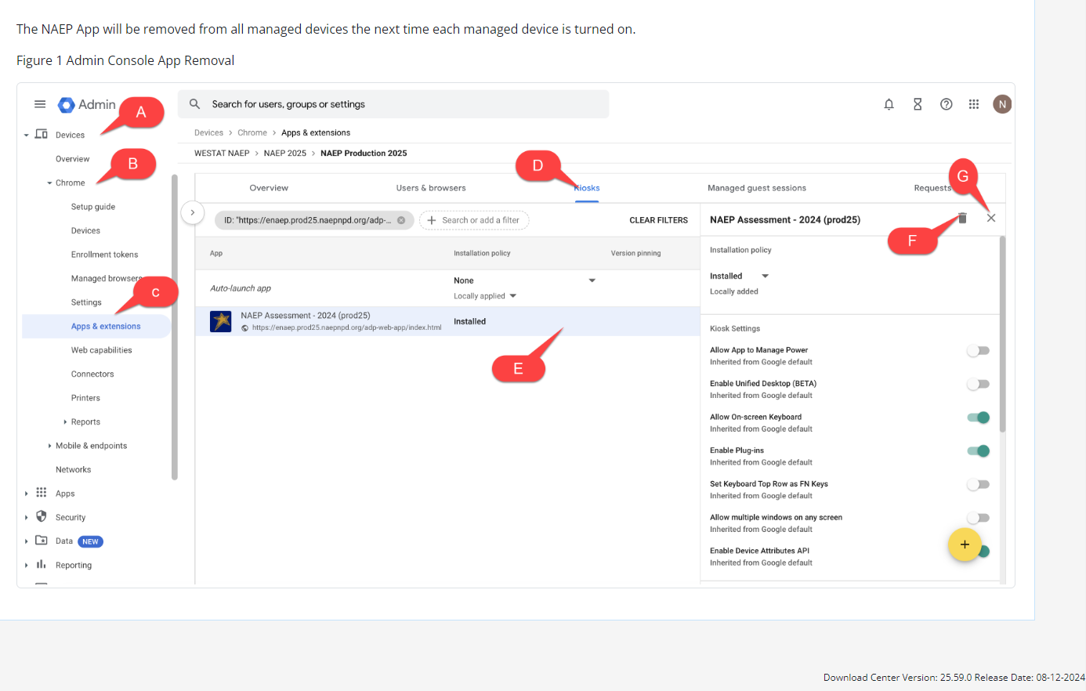

NAEP App Installation Instructions > Windows > Single Device Installation
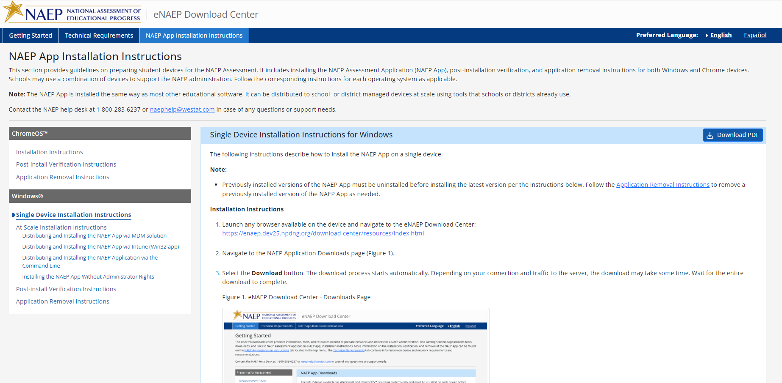
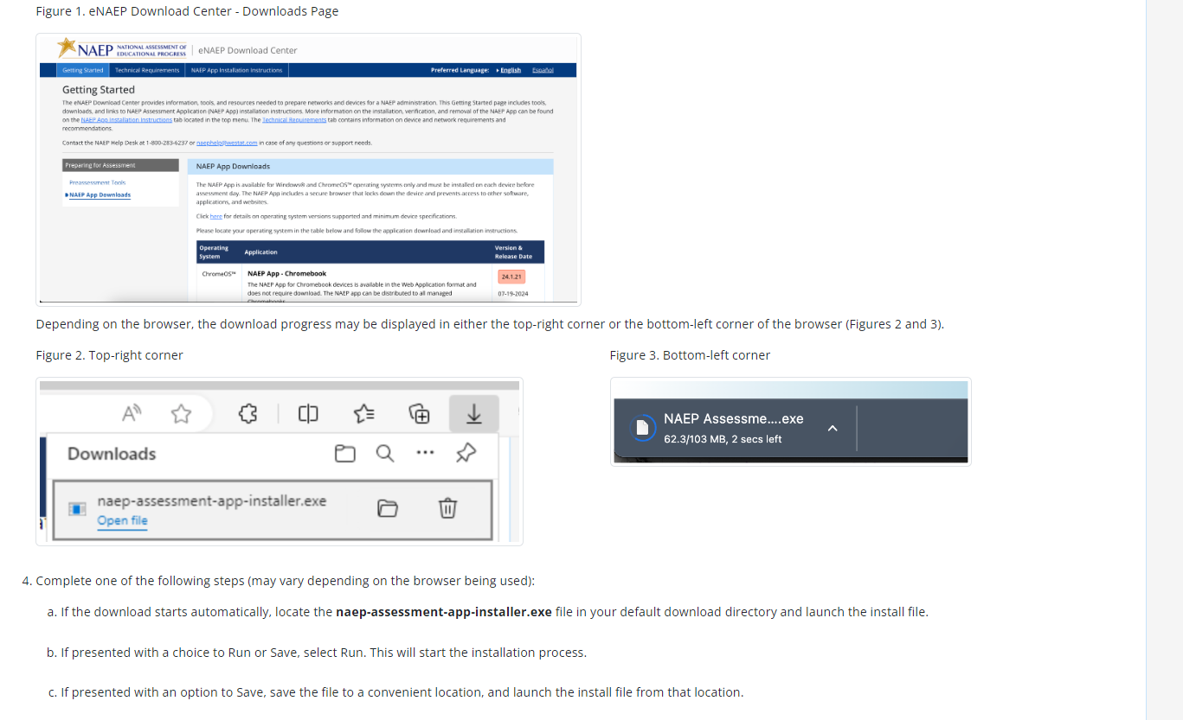
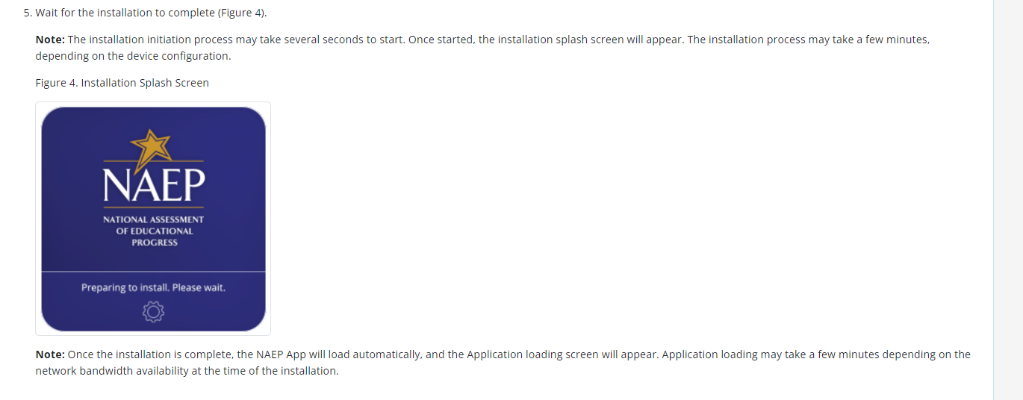
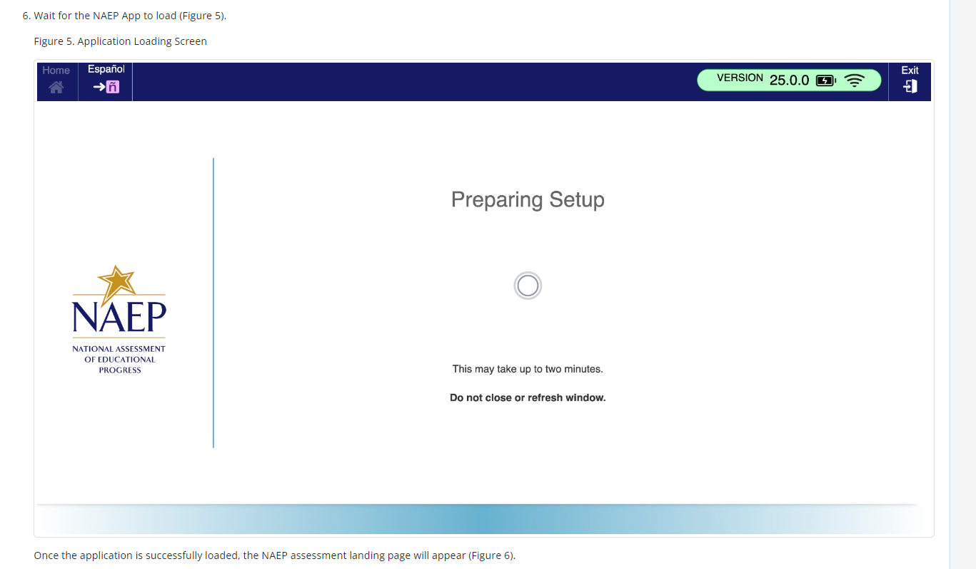
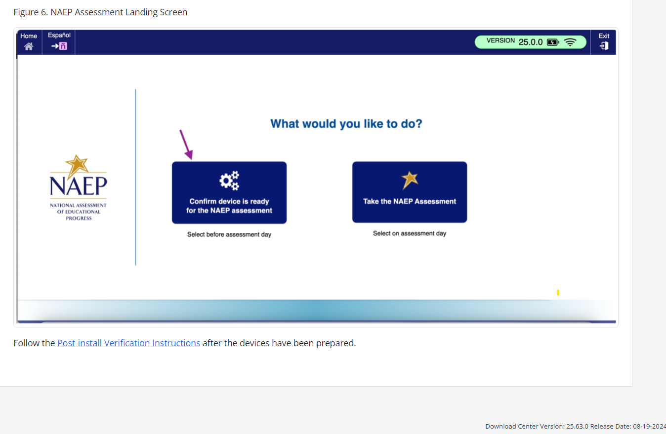

NAEP App Installation Instructions > Windows > At Scale Installation Instructions
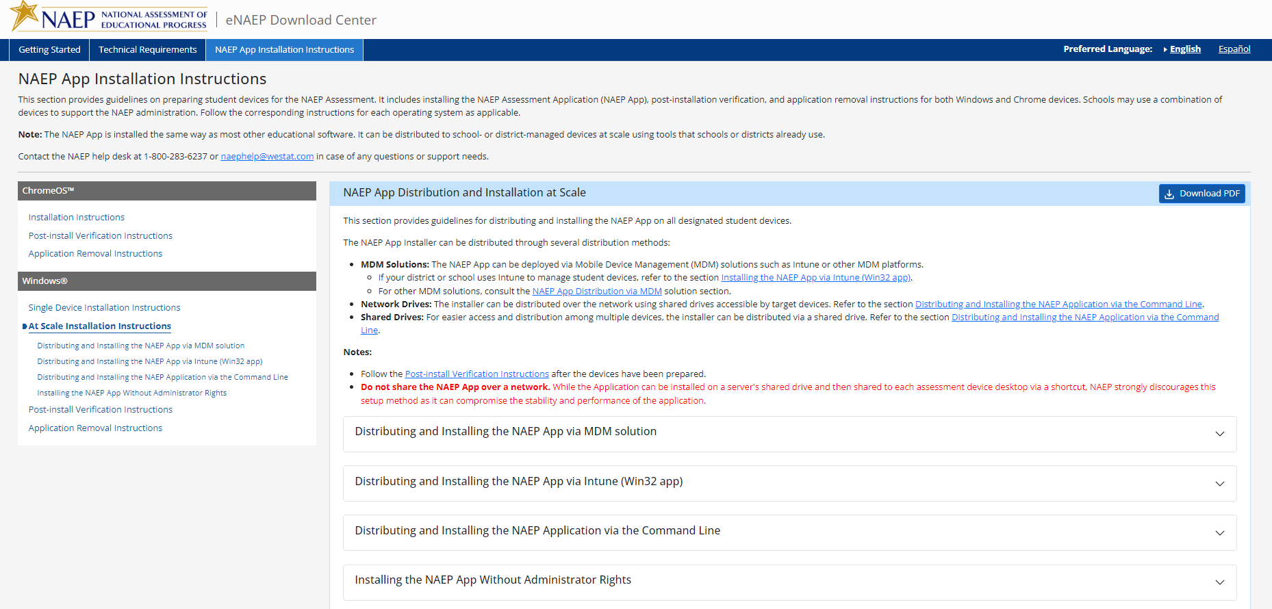

NAEP App Installation Instructions > Windows > At Scale Installation Instructions > Distributing and Installing the NAEP App via MDM Solution
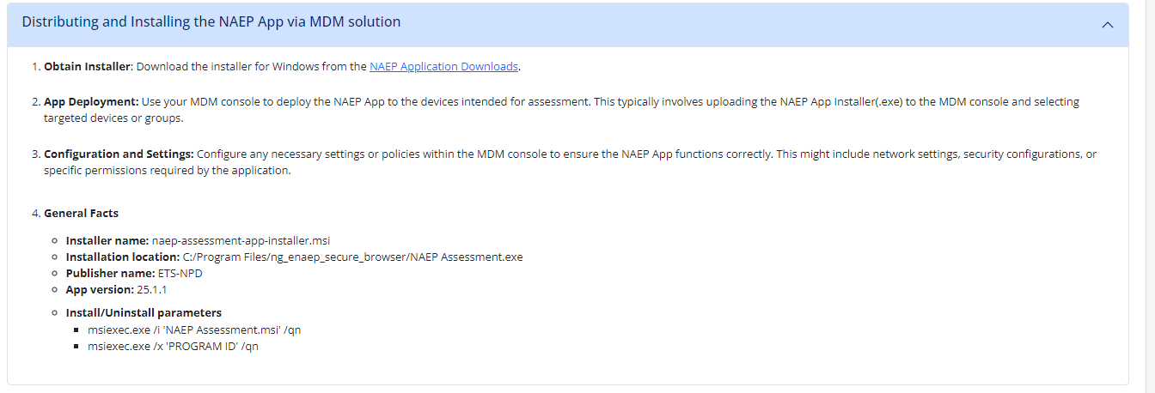

NAEP App Installation Instructions > Windows > At Scale Installation Instructions > Distributing and Installing the NAEP App via Intune (Win32 app)
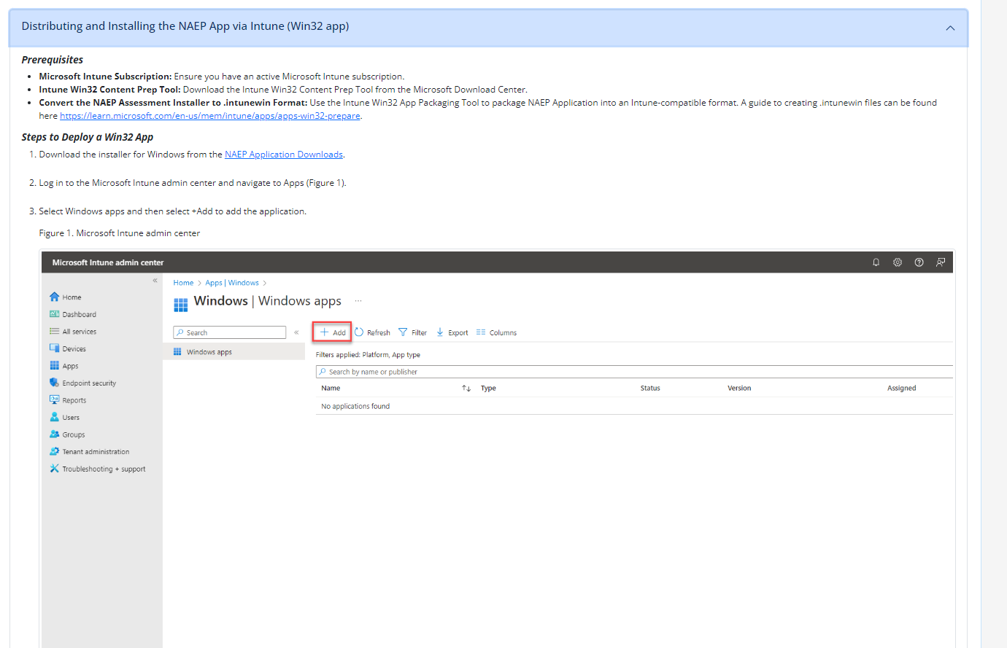
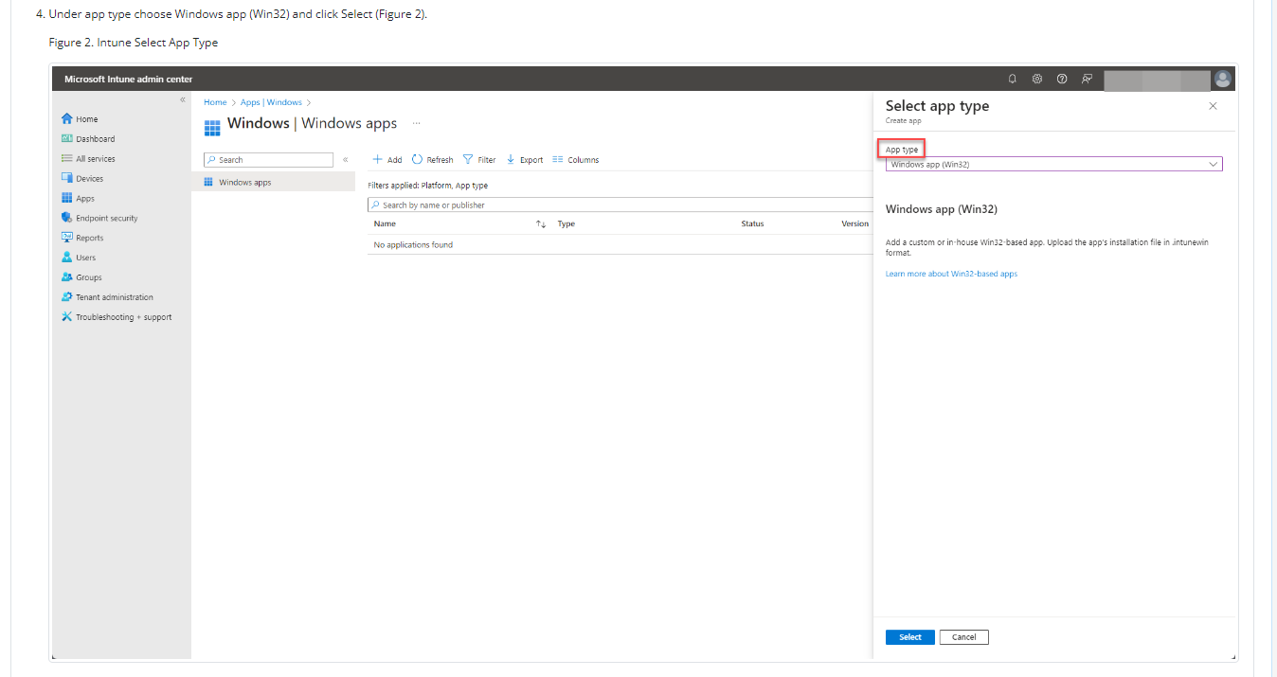
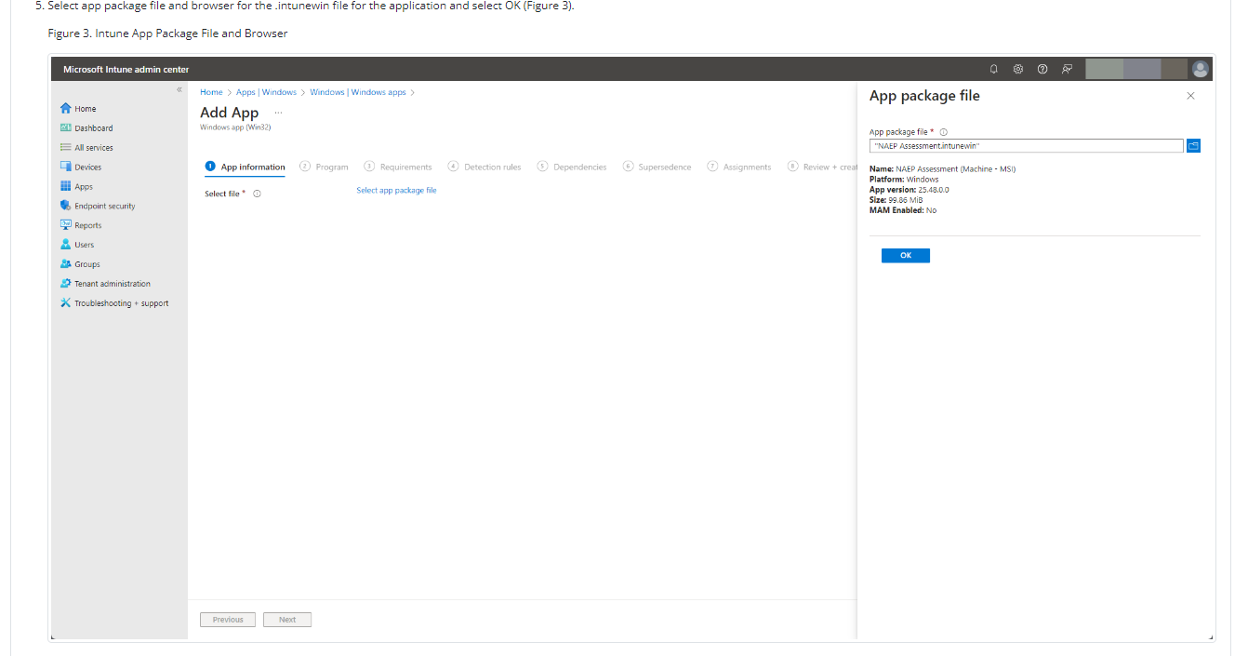
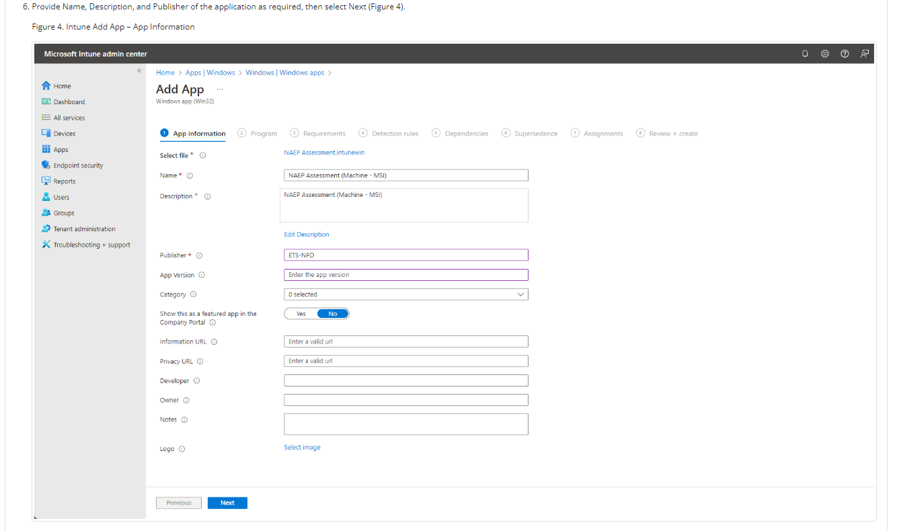
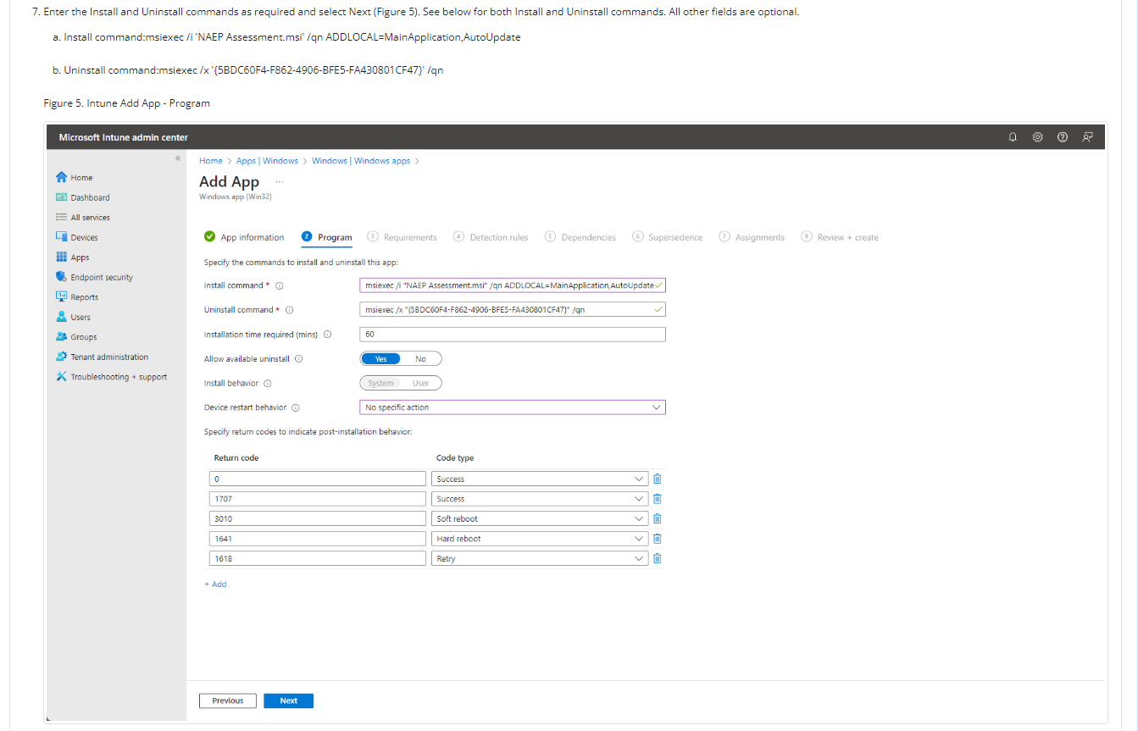
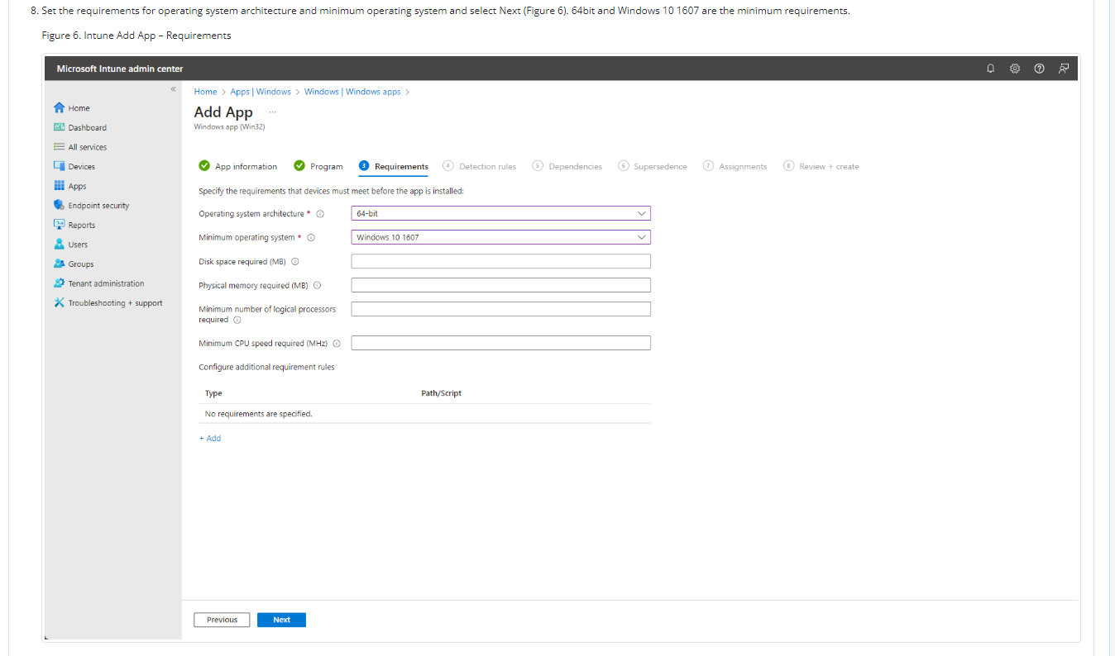
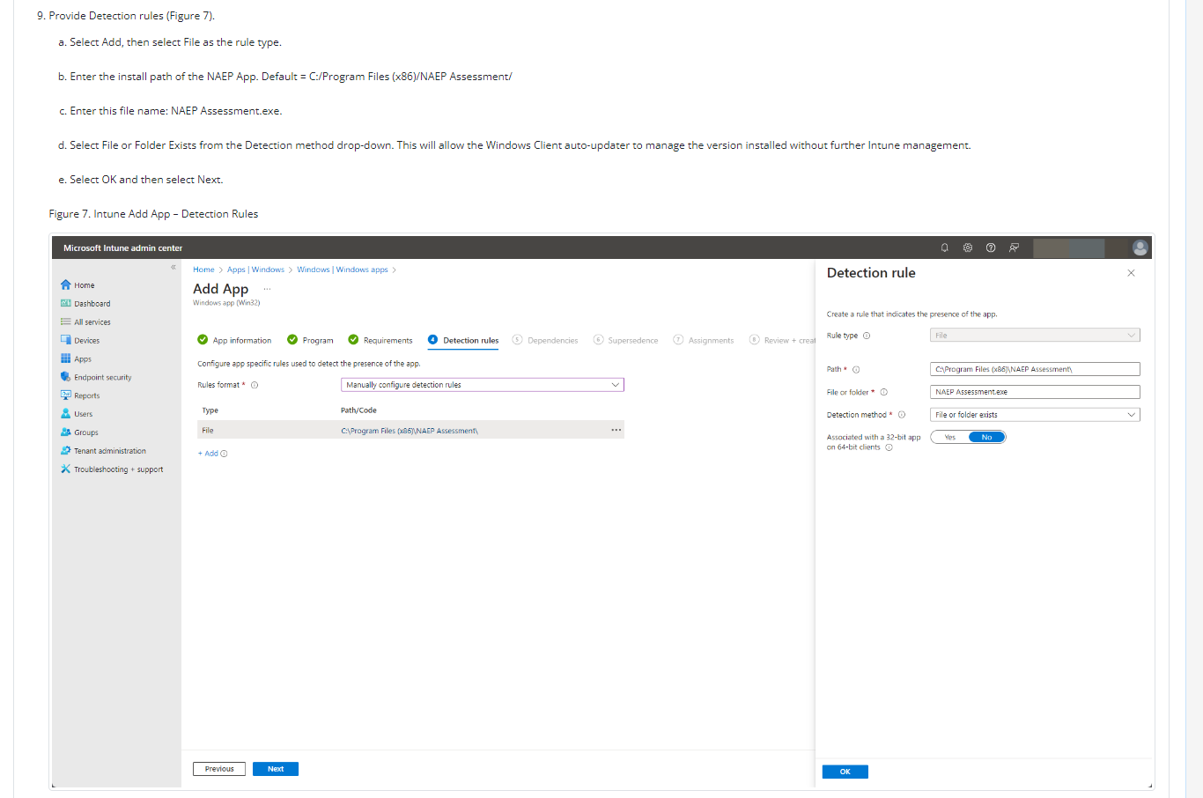
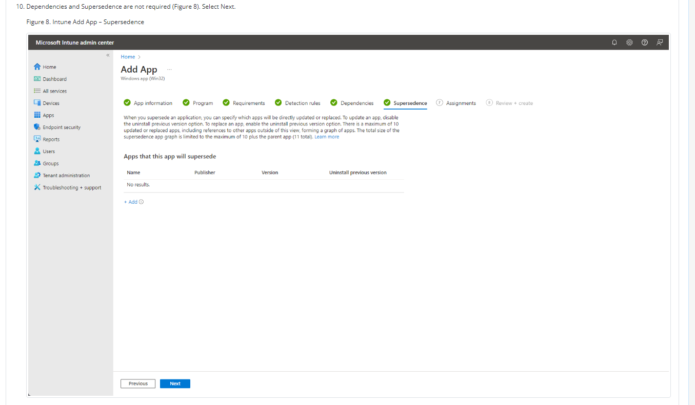
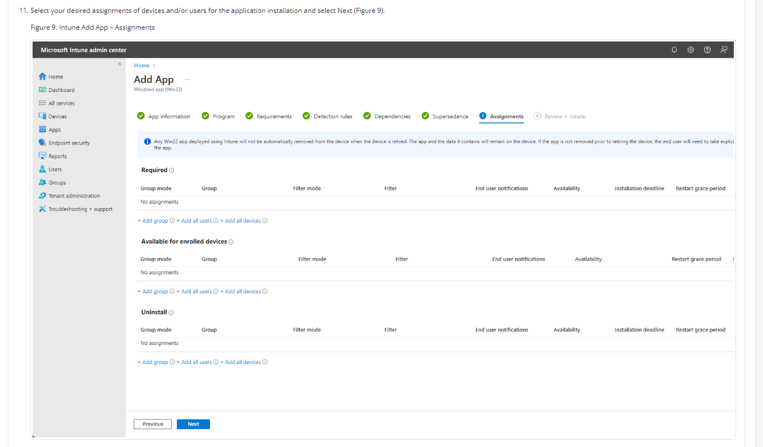
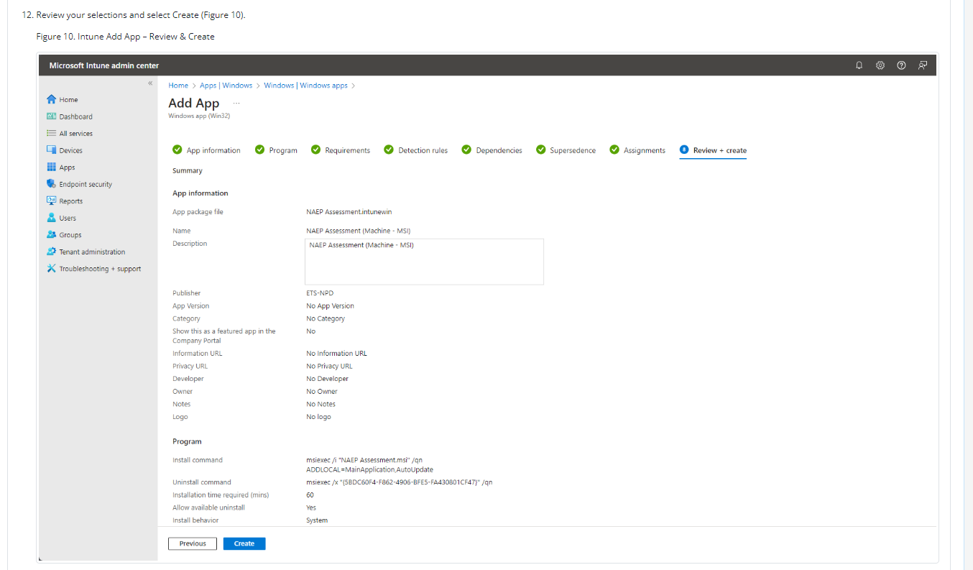
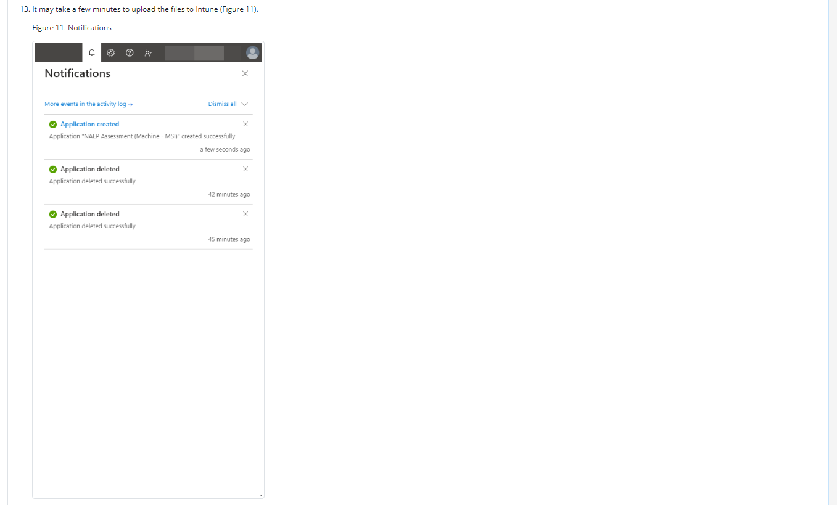
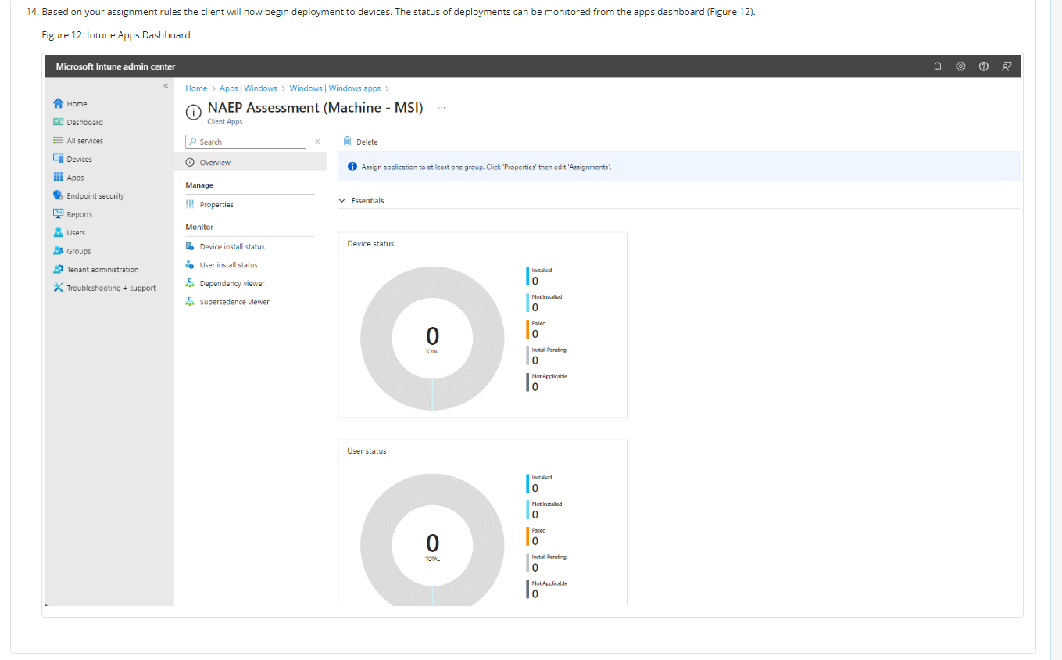

NAEP App Installation Instructions > Windows > At Scale Installation Instructions > Distributing and Installing the NAEP App via the Command Line
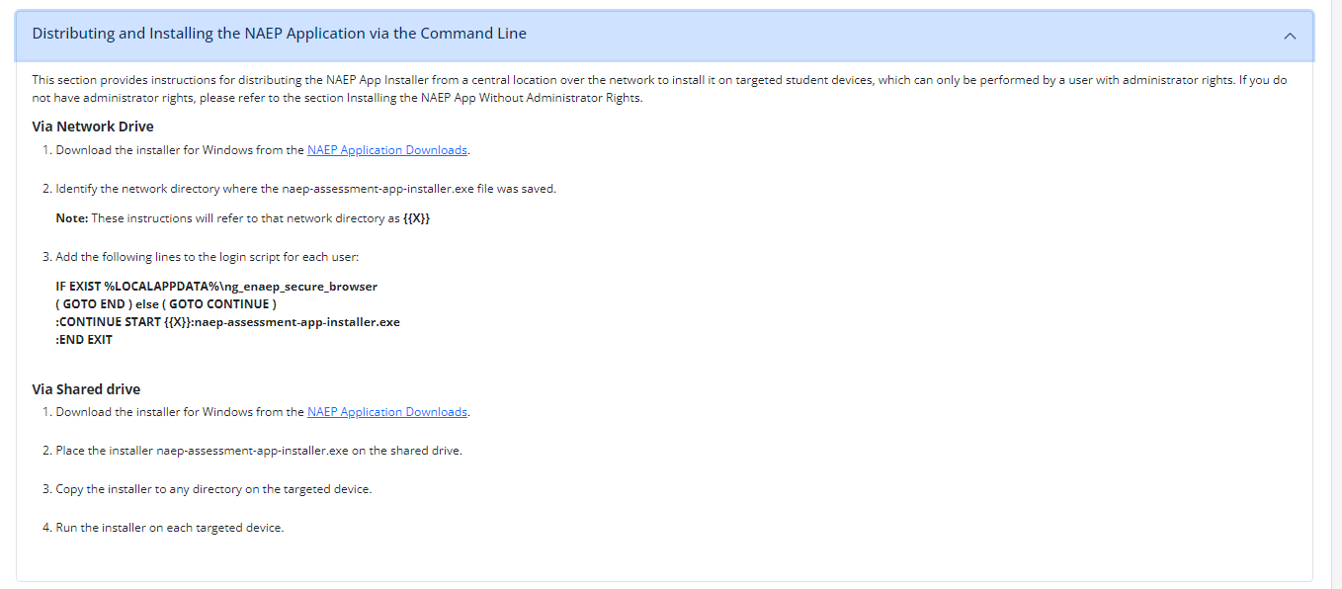

NAEP App Installation Instructions > Windows > At Scale Installation Instructions > Distributing and Installing the NAEP App Without Administrator Rights
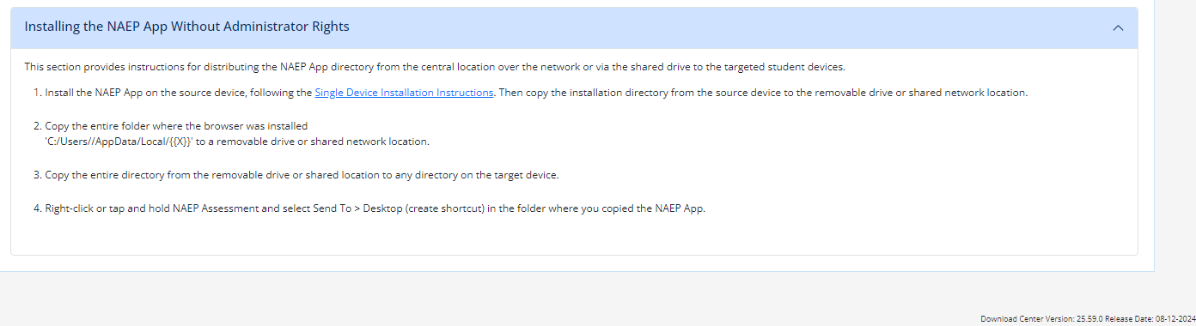

NAEP App Installation Instructions > Windows > Post-Install Verification Instructions
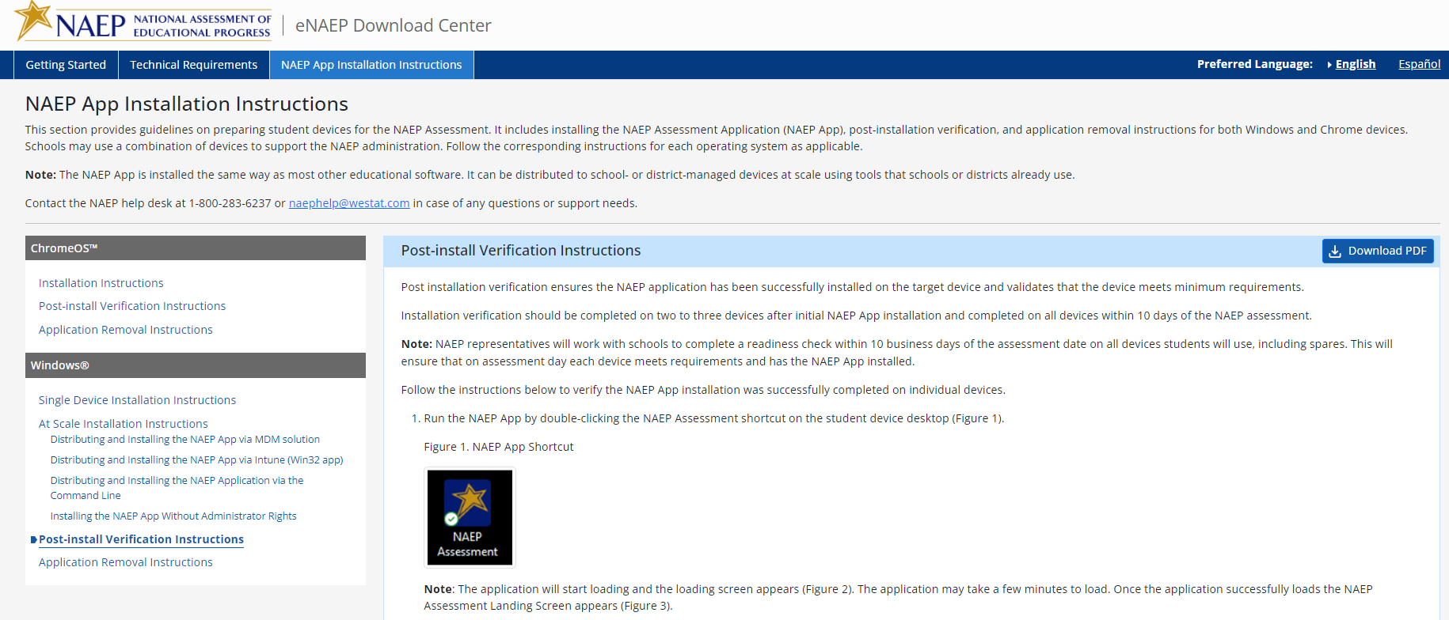
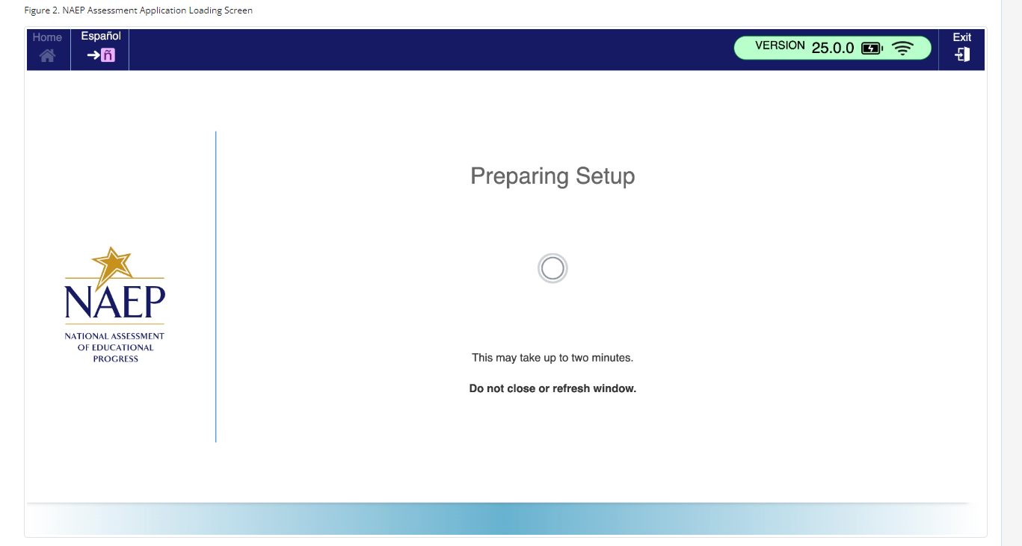
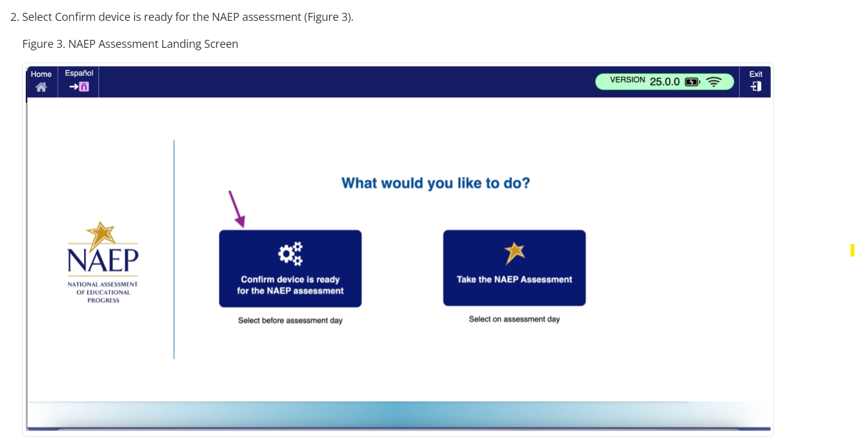
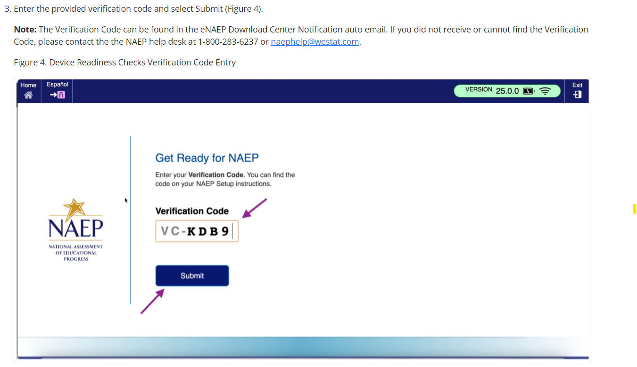
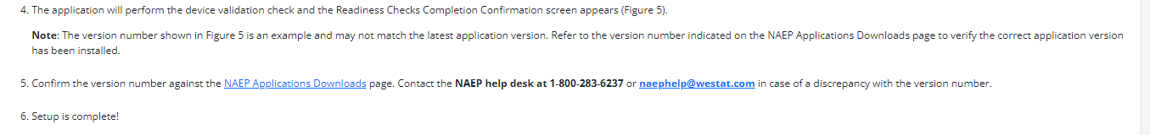
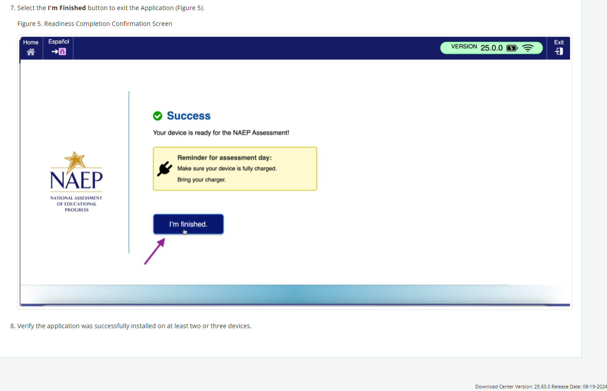

NAEP App Installation Instructions > Windows > Application Removal Instructions
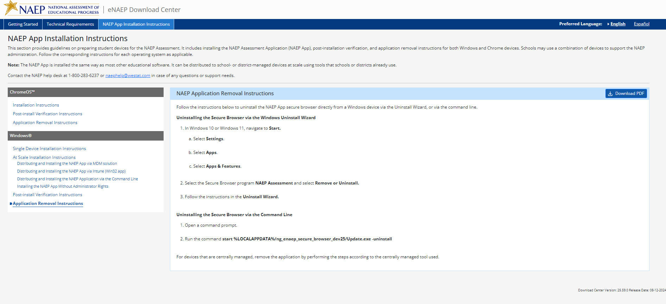

Appendix D2-49: NAEP 2025 eNAEP Download Center, Spanish

Inicio > Preparación para la evaluación > Herramientas de preevaluación
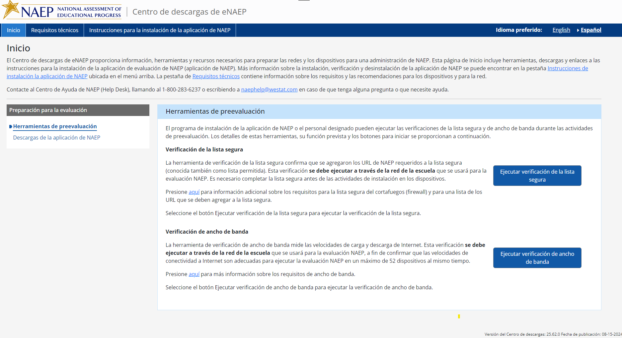

Inicio > Preparación para la evaluación > Descargas de la aplicación de NAEP

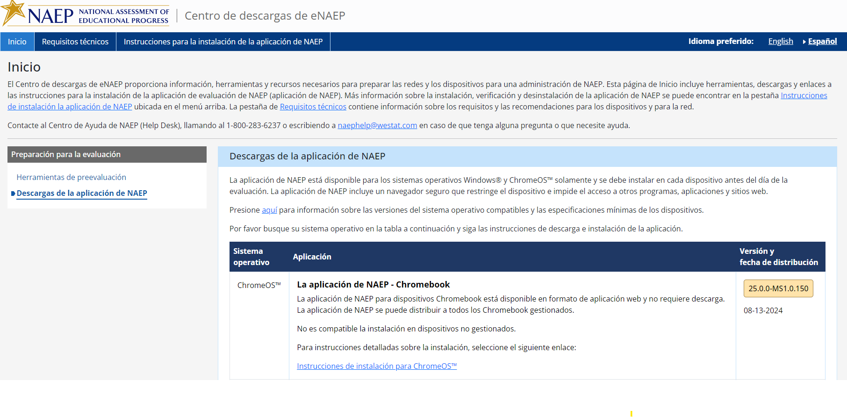
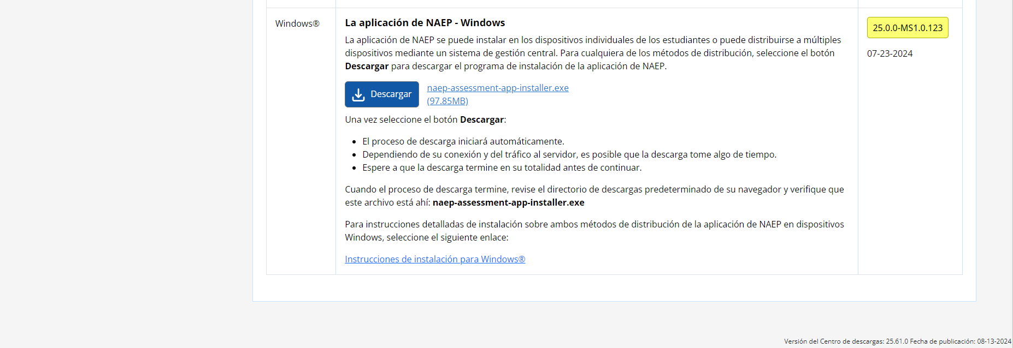

Requisitos técnicos > Requisitos del sistema > Requisitos de los sistemas operativos y del equipo

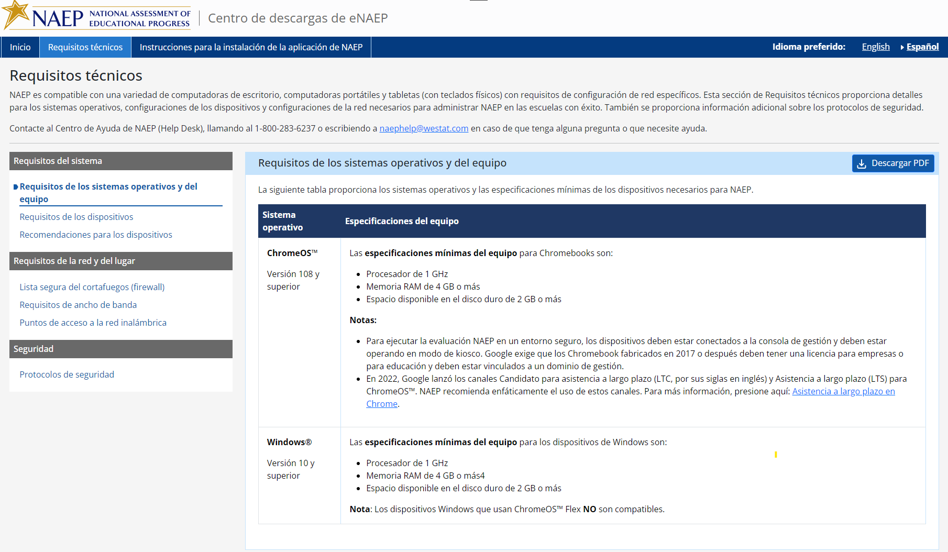

Requisitos técnicos > Requisitos del sistema >Requisitos de los dispositivos

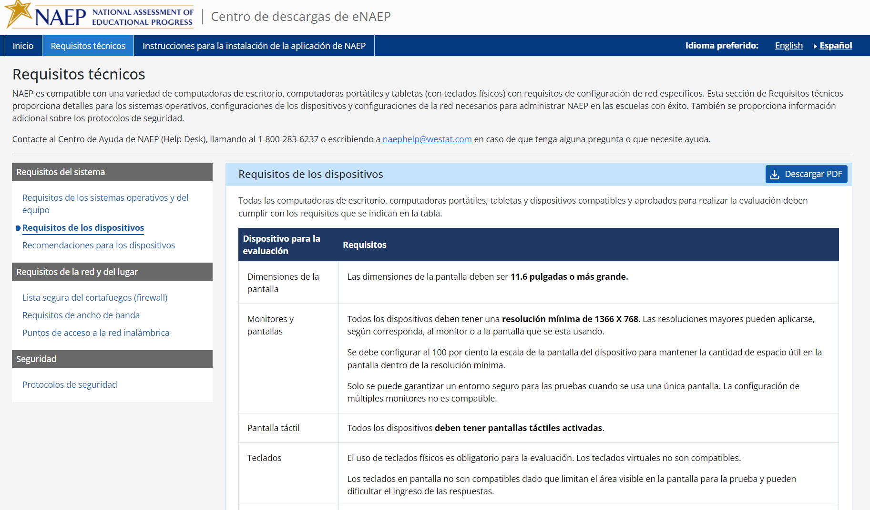
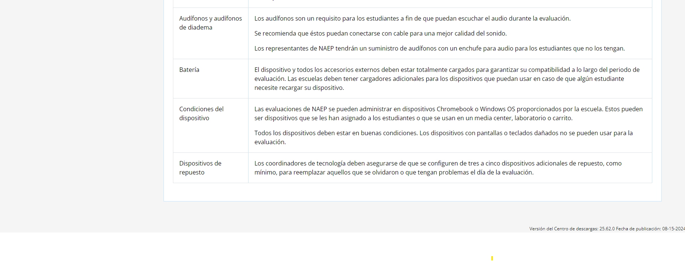

Requisitos técnicos > Requisitos del sistema > Recomendaciones para los dispositivos
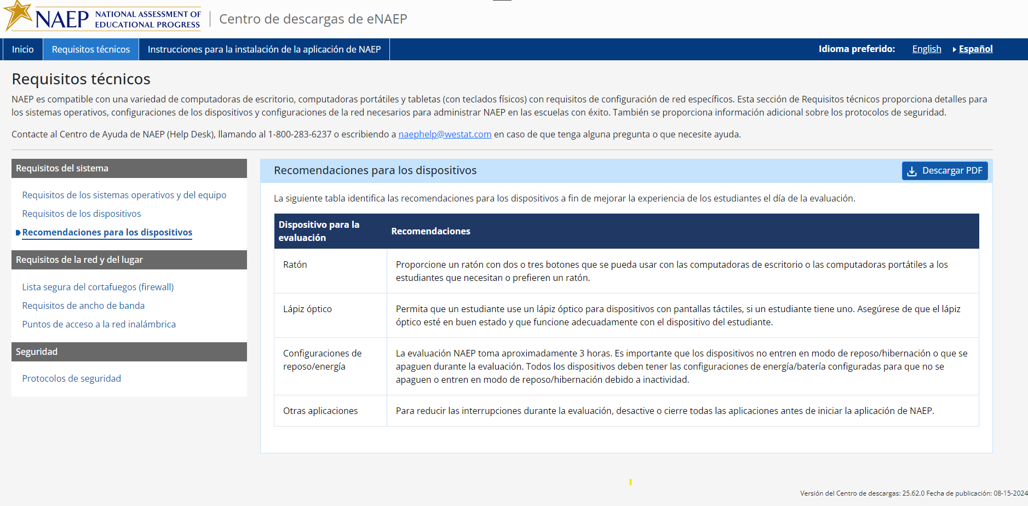

Requisitos técnicos > Requisitos de la red y del lugar >Lista segura del cortafuegos (firewall)

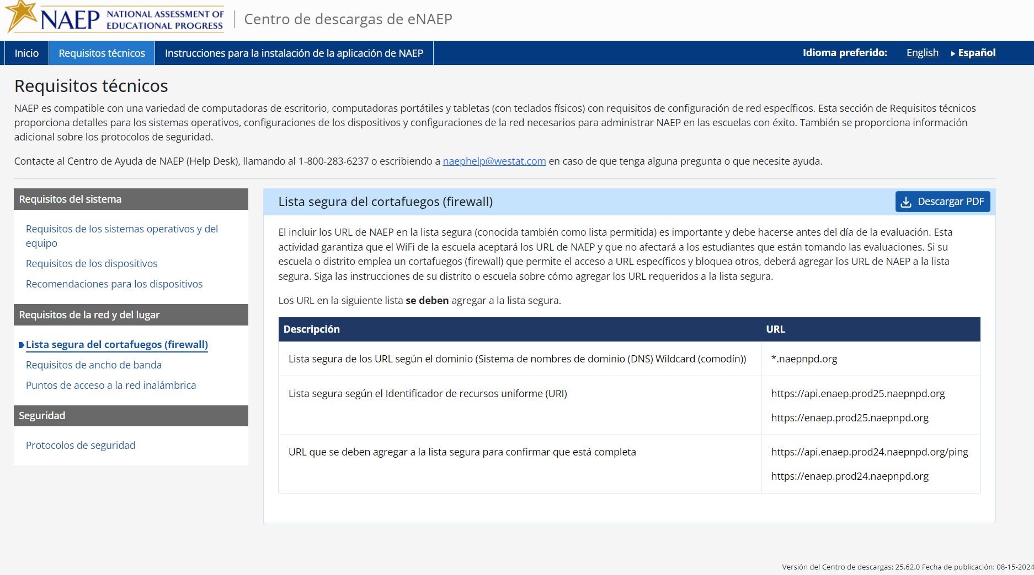

Requisitos técnicos > Requisitos de la red y del lugar >https://enaep.stage25.naepnpd.org/download-center/resources/index.html?development=true Requisitos de ancho de banda
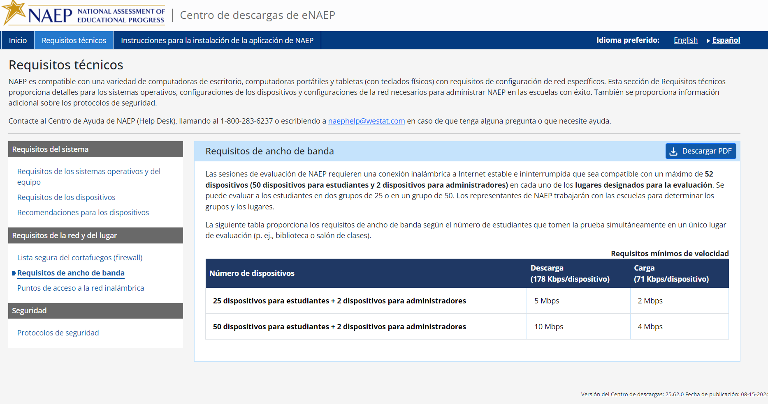

Requisitos técnicos > Requisitos de la red y del lugar >https://enaep.stage25.naepnpd.org/download-center/resources/index.html?development=true Puntos de acceso a la red inalámbrica
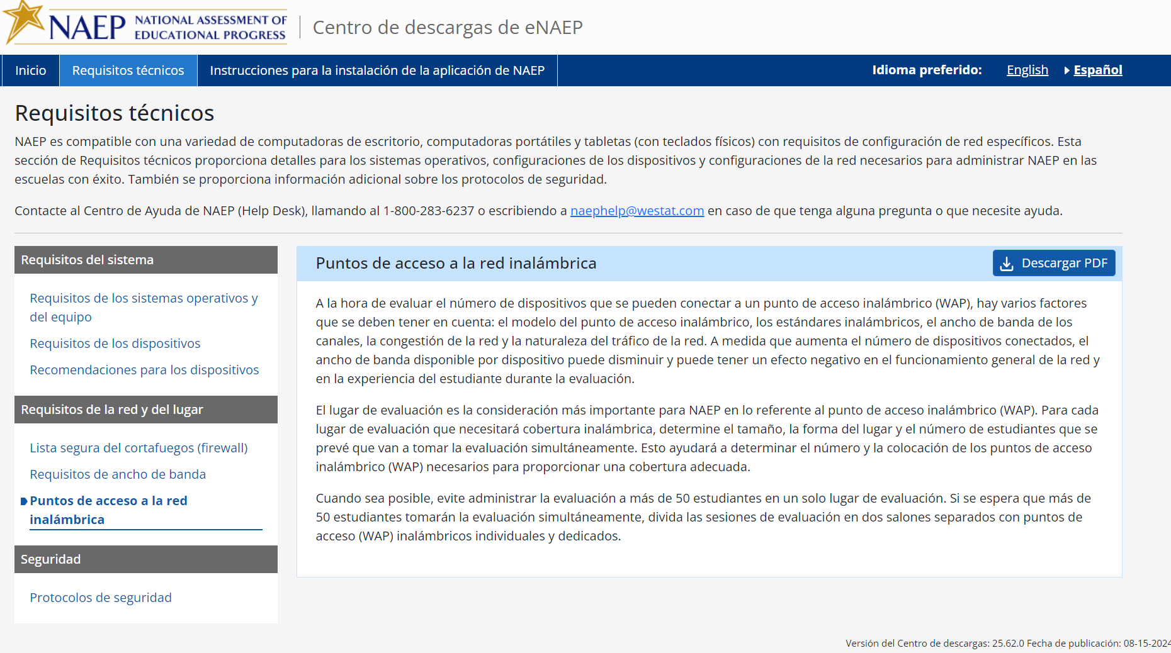

Requisitos técnicos > Seguridad >https://enaep.stage25.naepnpd.org/download-center/resources/index.html?development=true Protocolos de seguridad
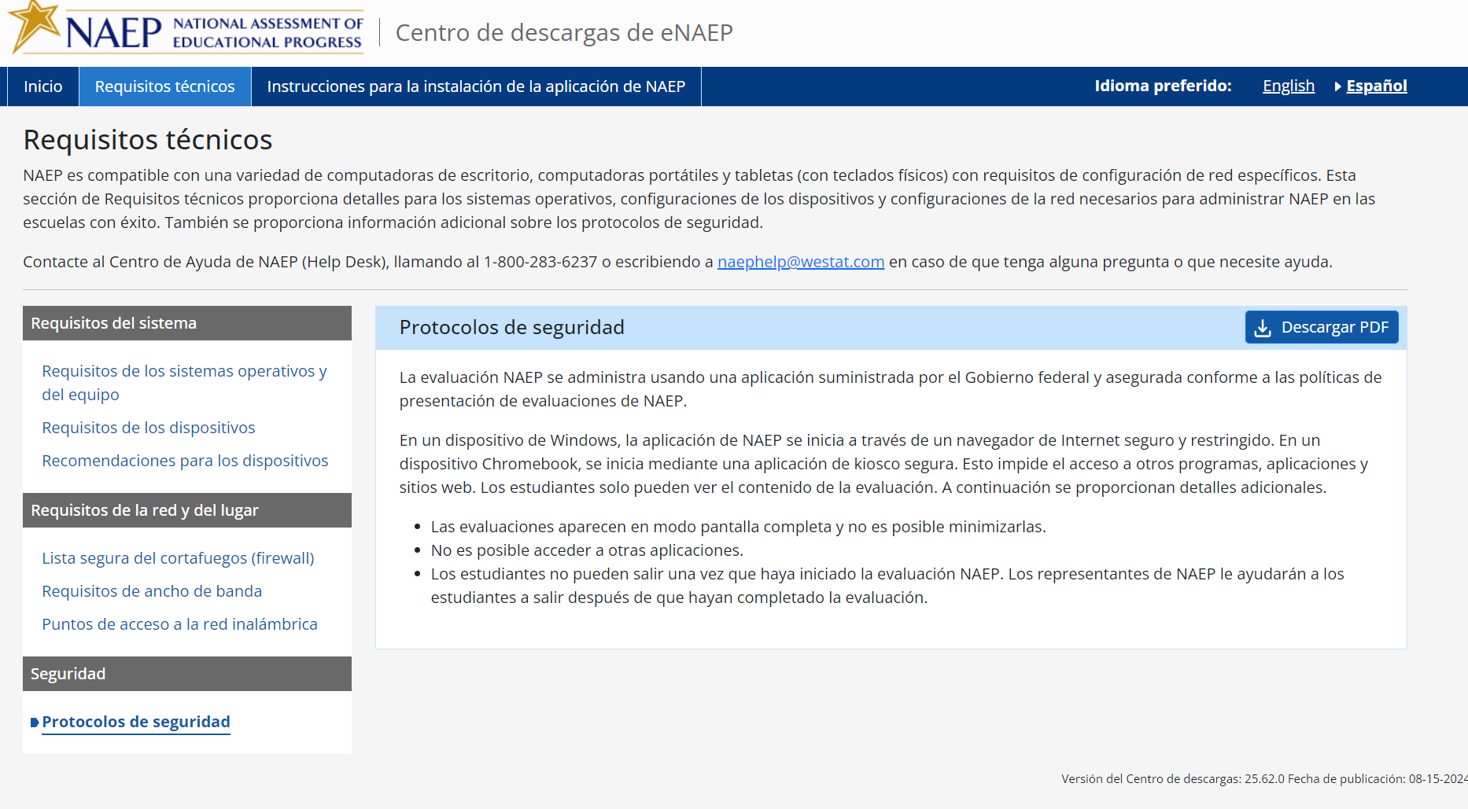

Instrucciones para la instalación de la aplicación de NAEP > ChromeOS > Instrucciones de instalación
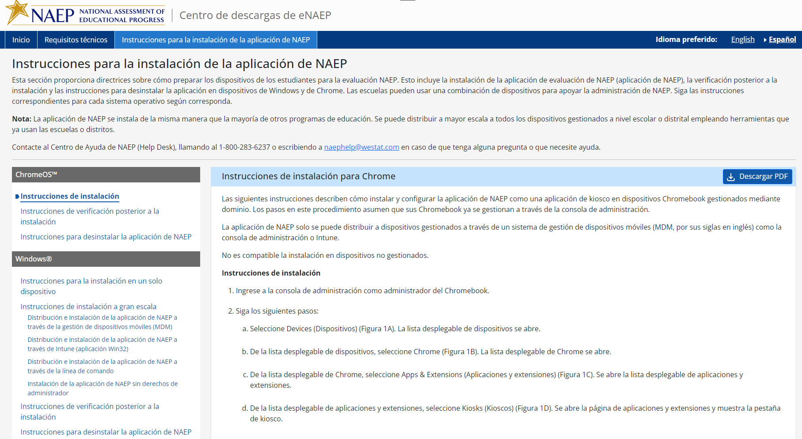
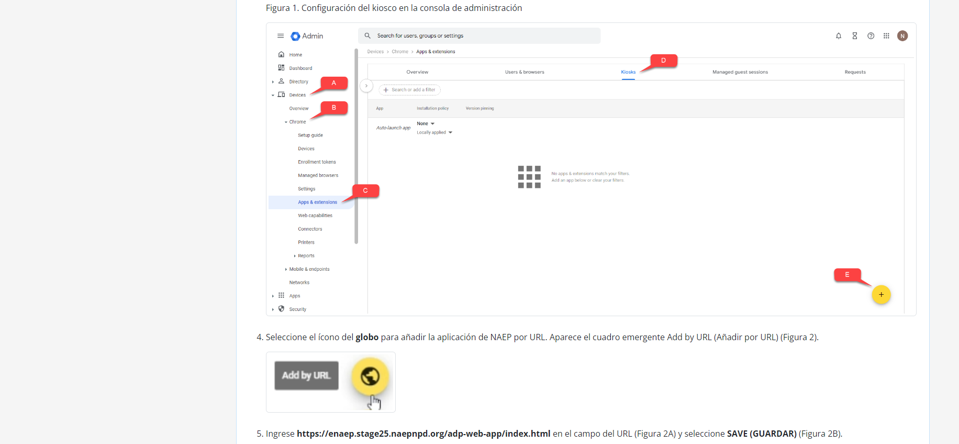
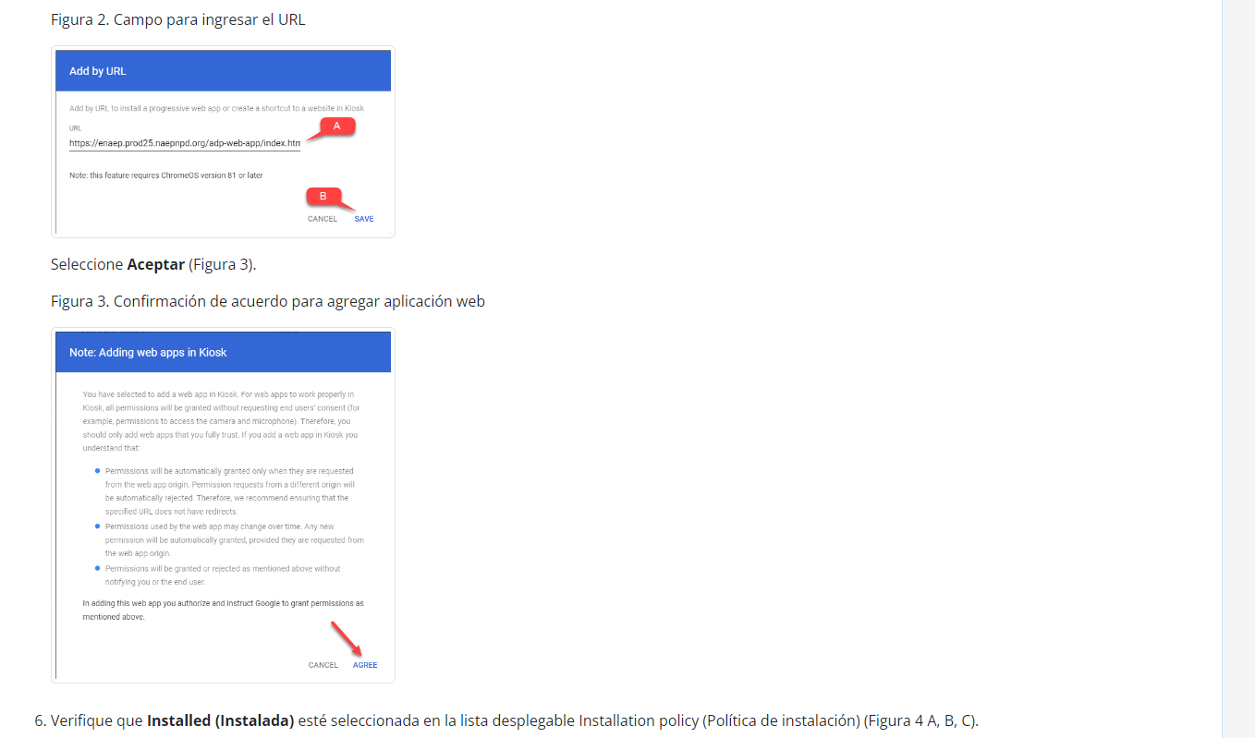
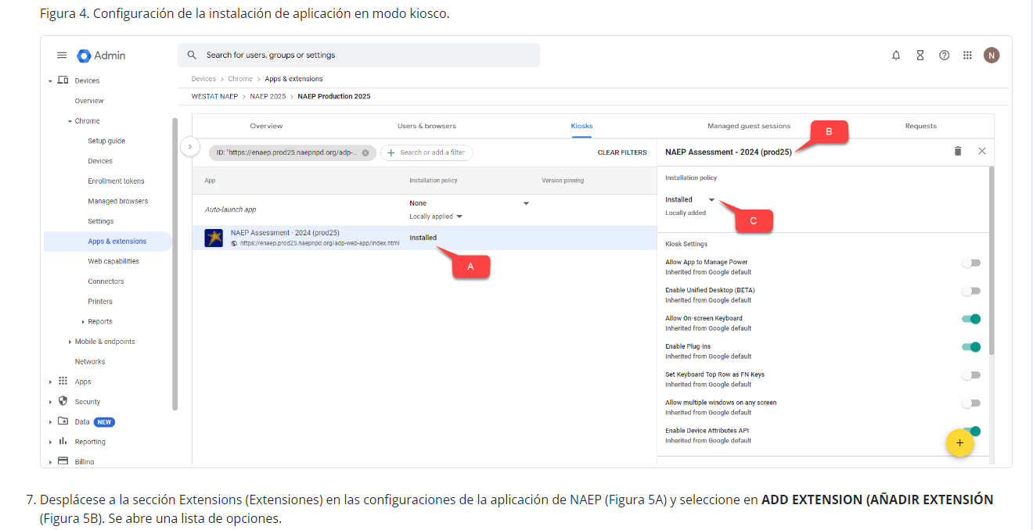
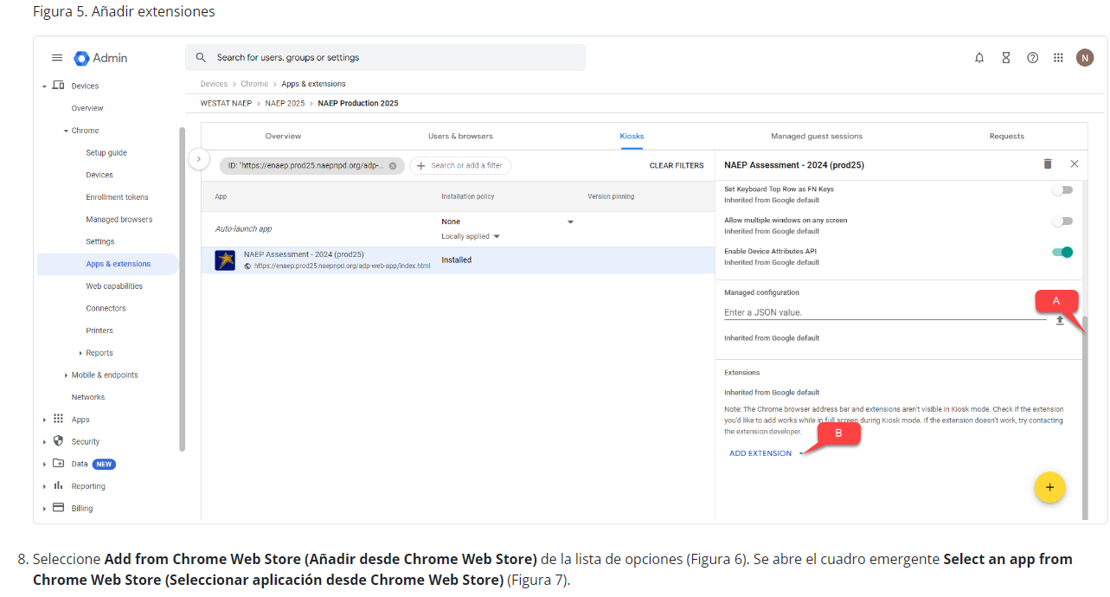
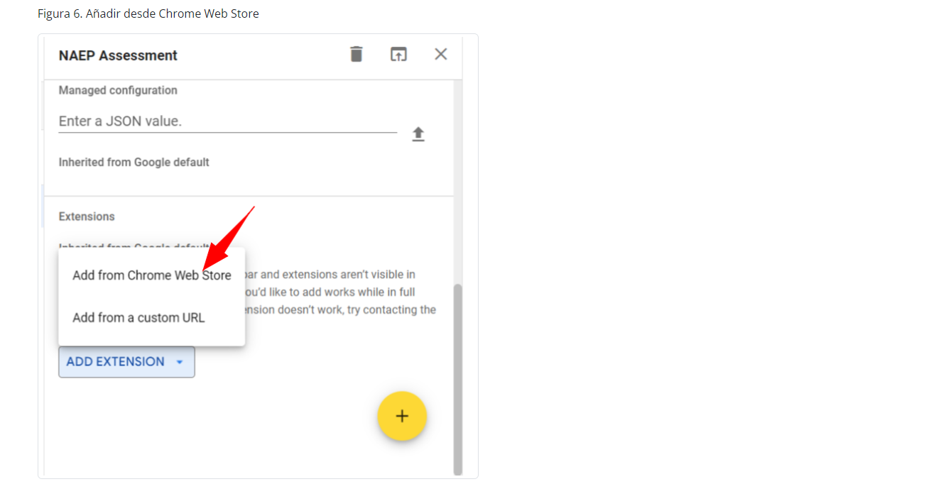
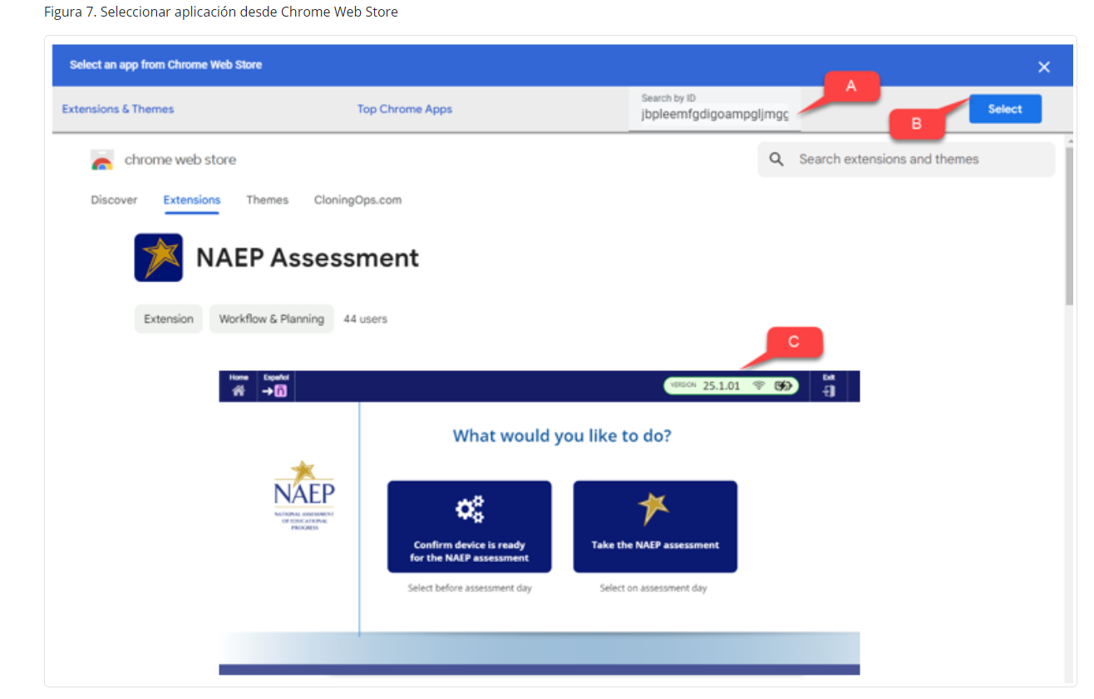
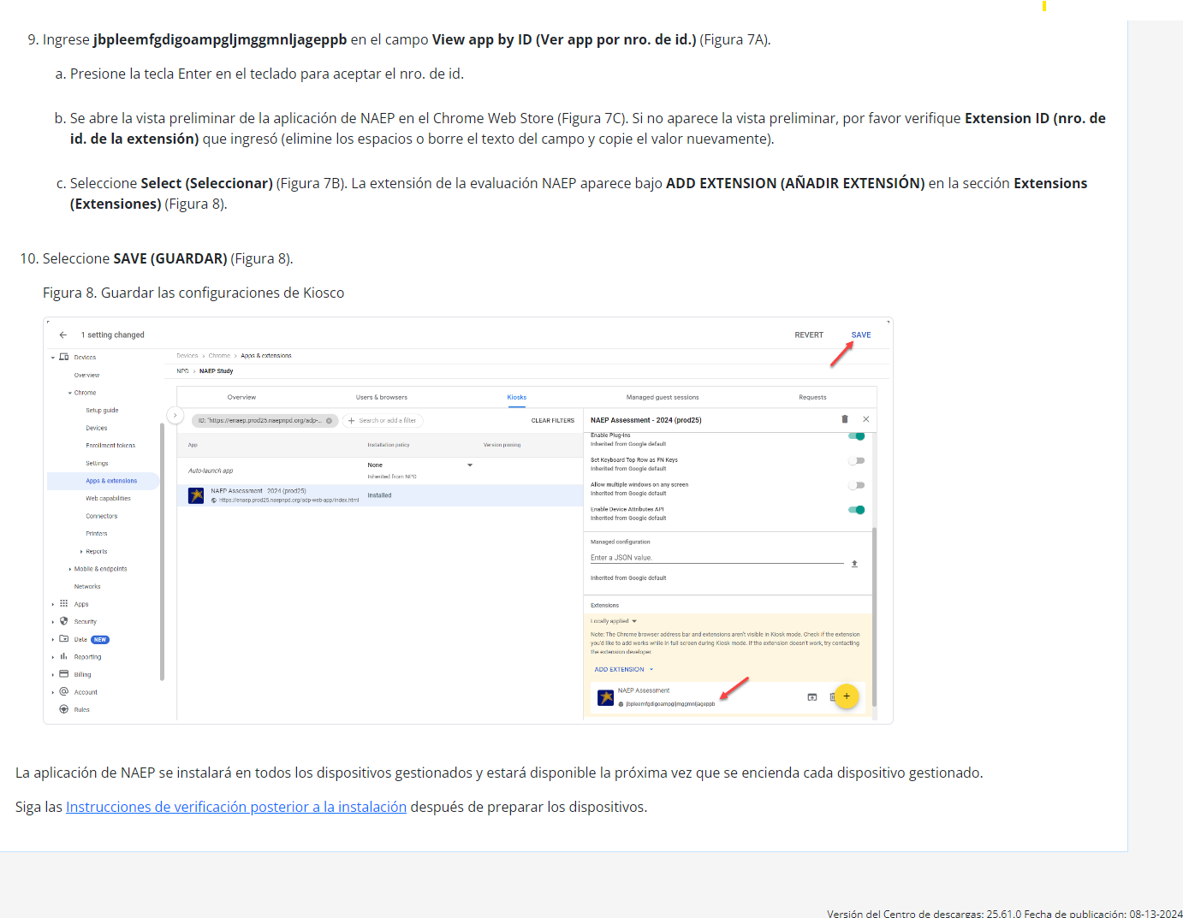

Instrucciones para la instalación de la aplicación de NAEP > ChromeOS > Instrucciones de verificación posterior a la instalación

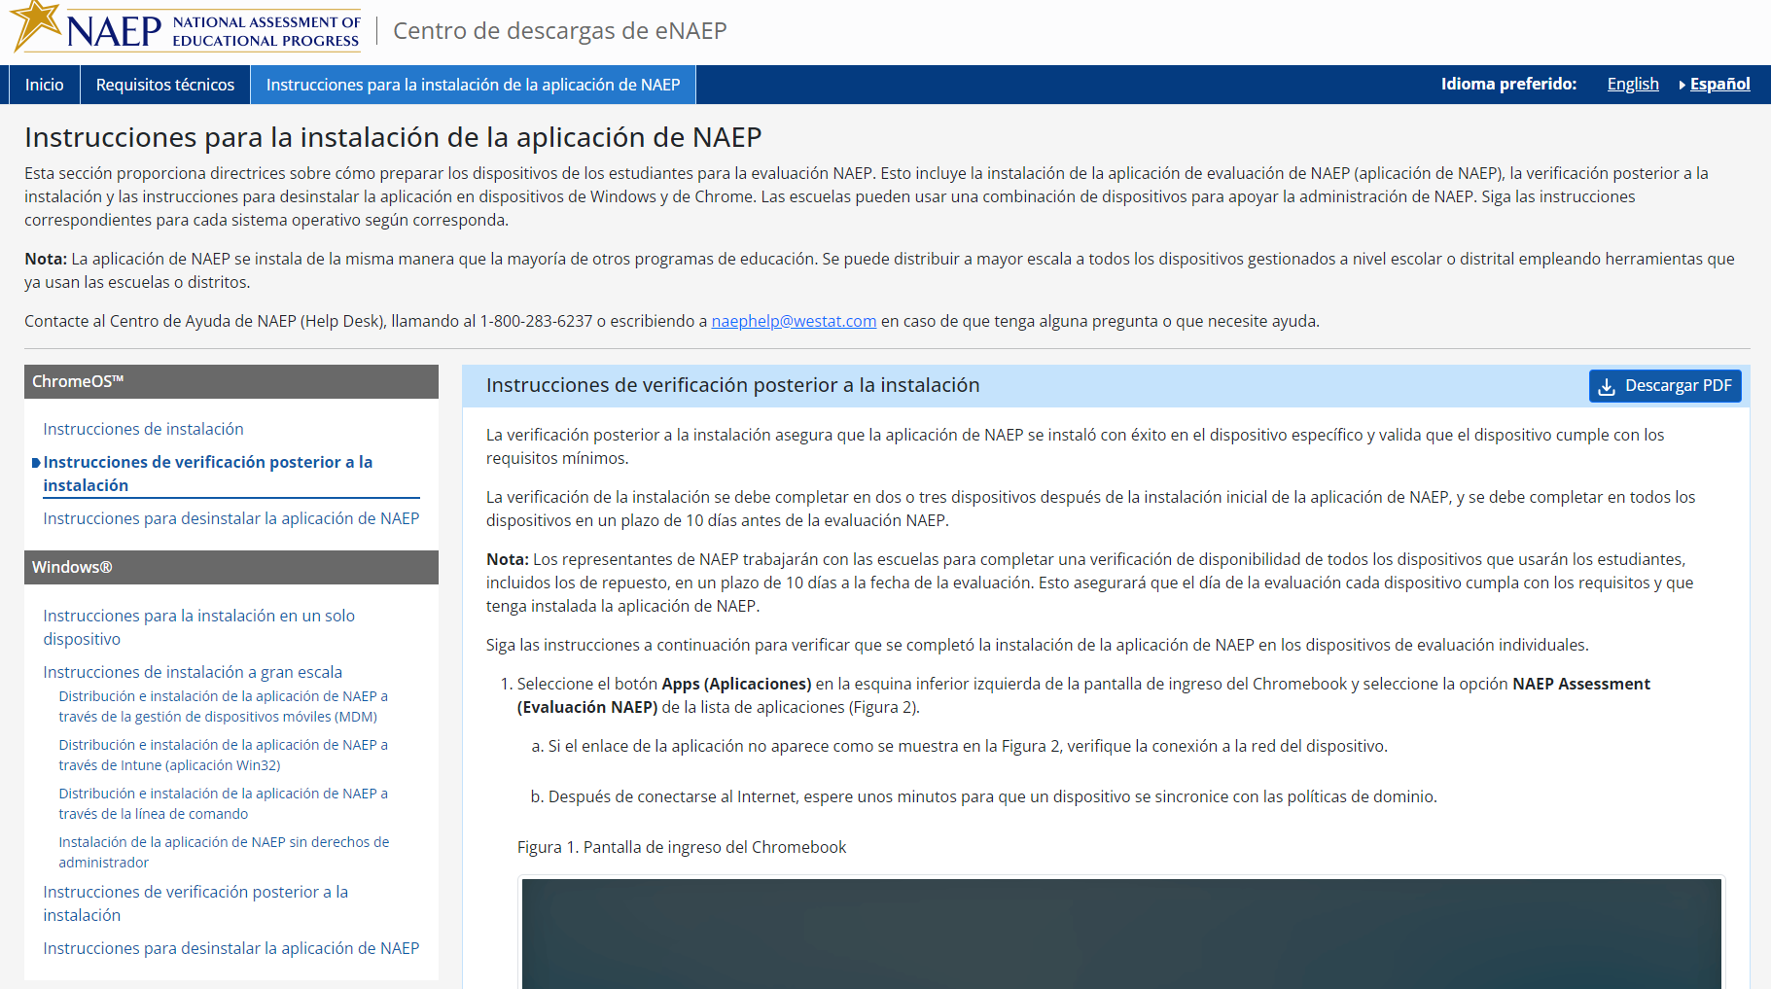

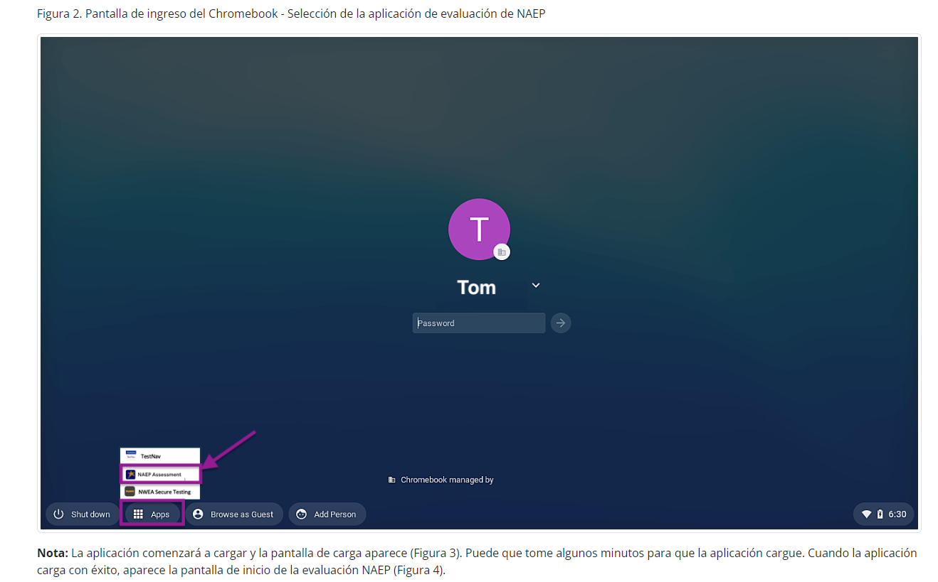
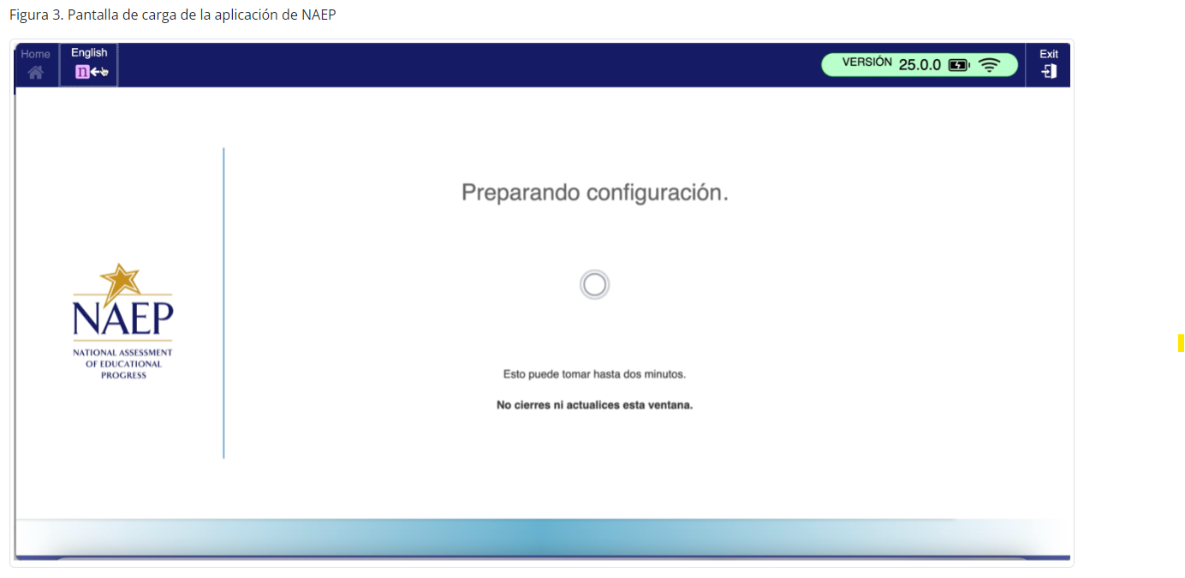
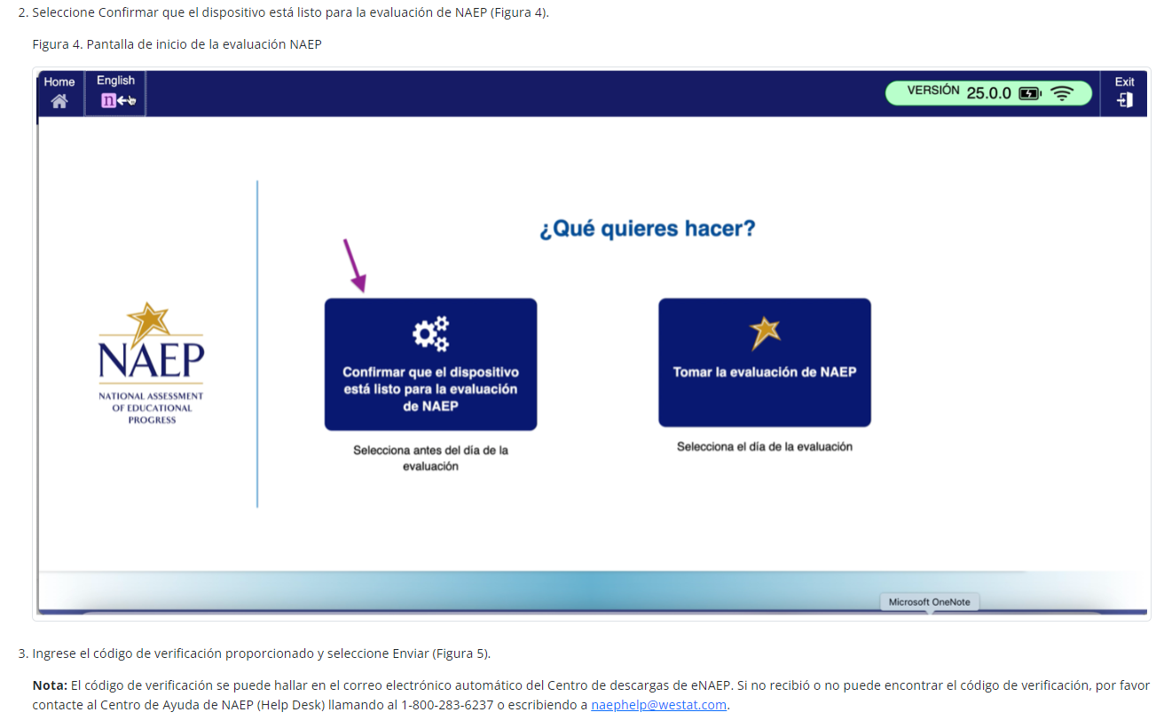

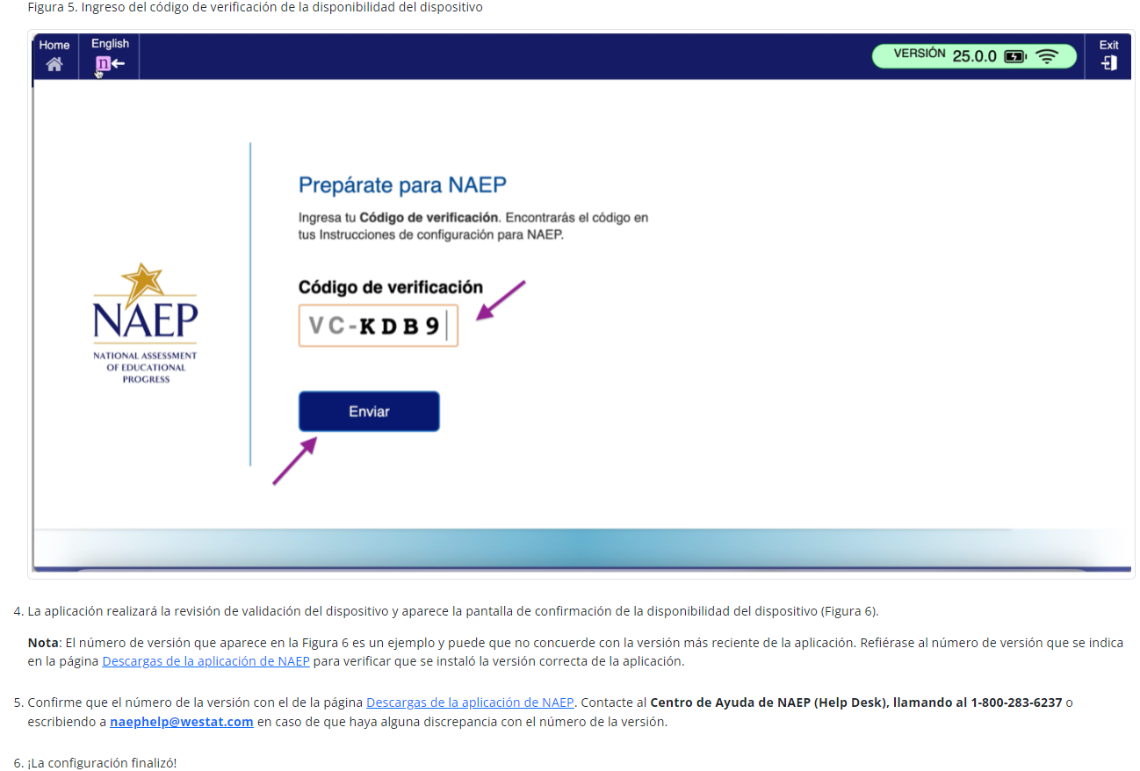
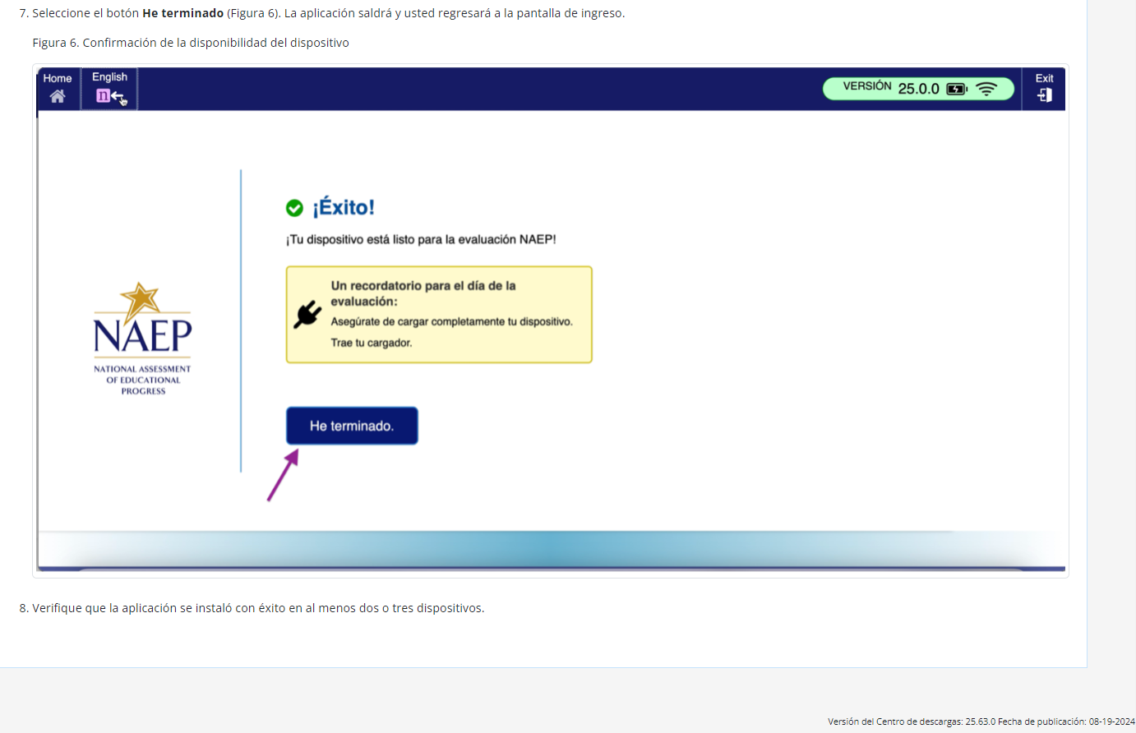

Instrucciones para la instalación de la aplicación de NAEP > ChromeOS > Instrucciones para desinstalar la aplicación de NAEP

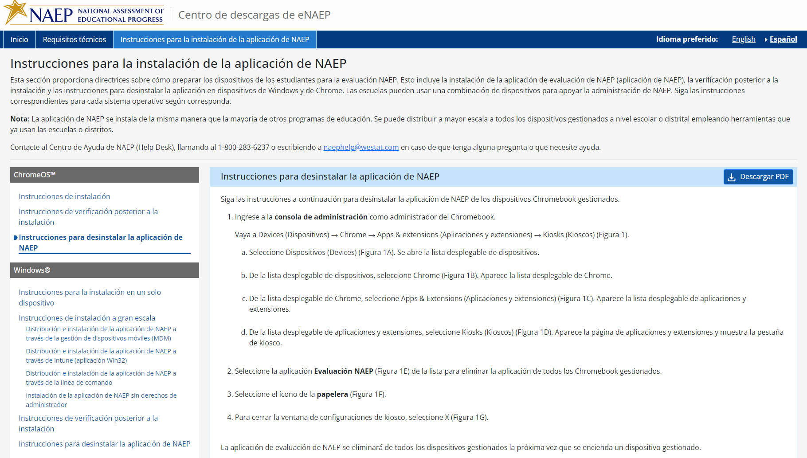
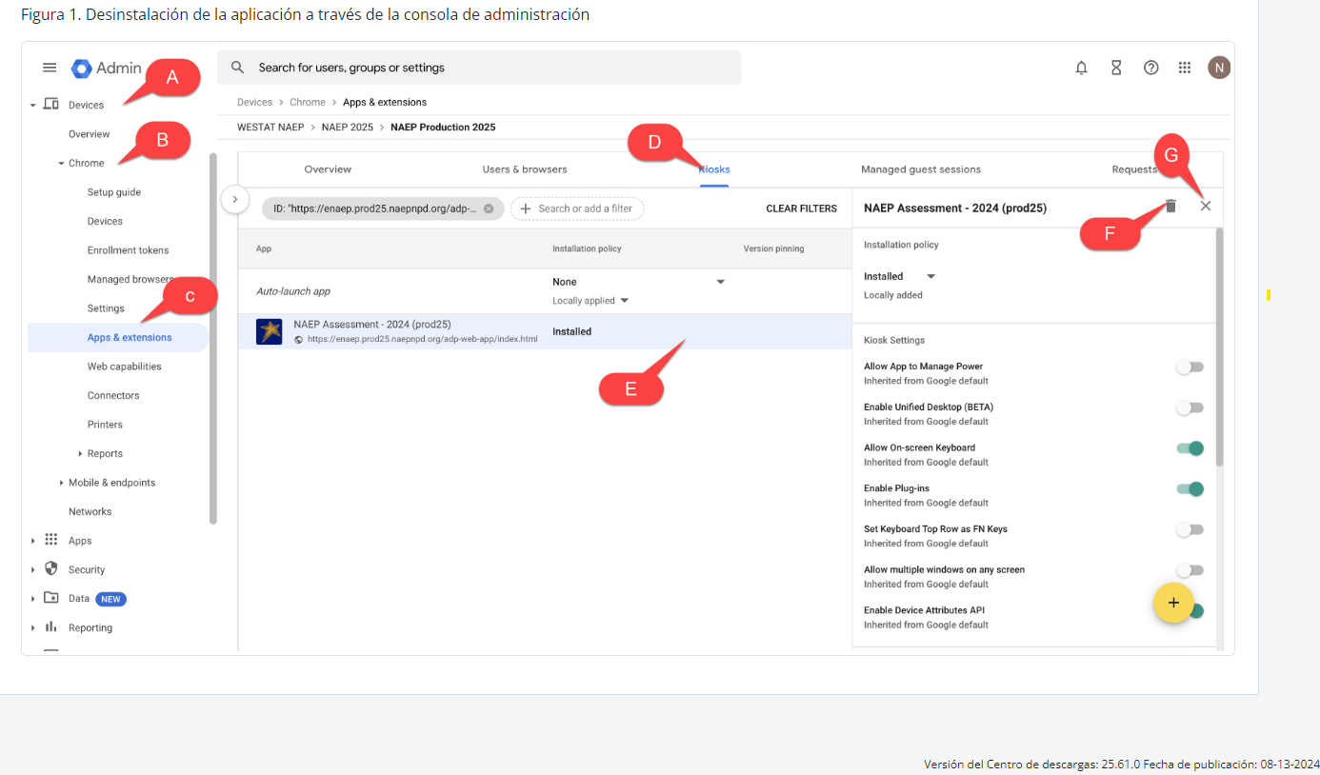

Instrucciones para la instalación de la aplicación de NAEP > Windows > Instrucciones para la instalación en un solo dispositivo
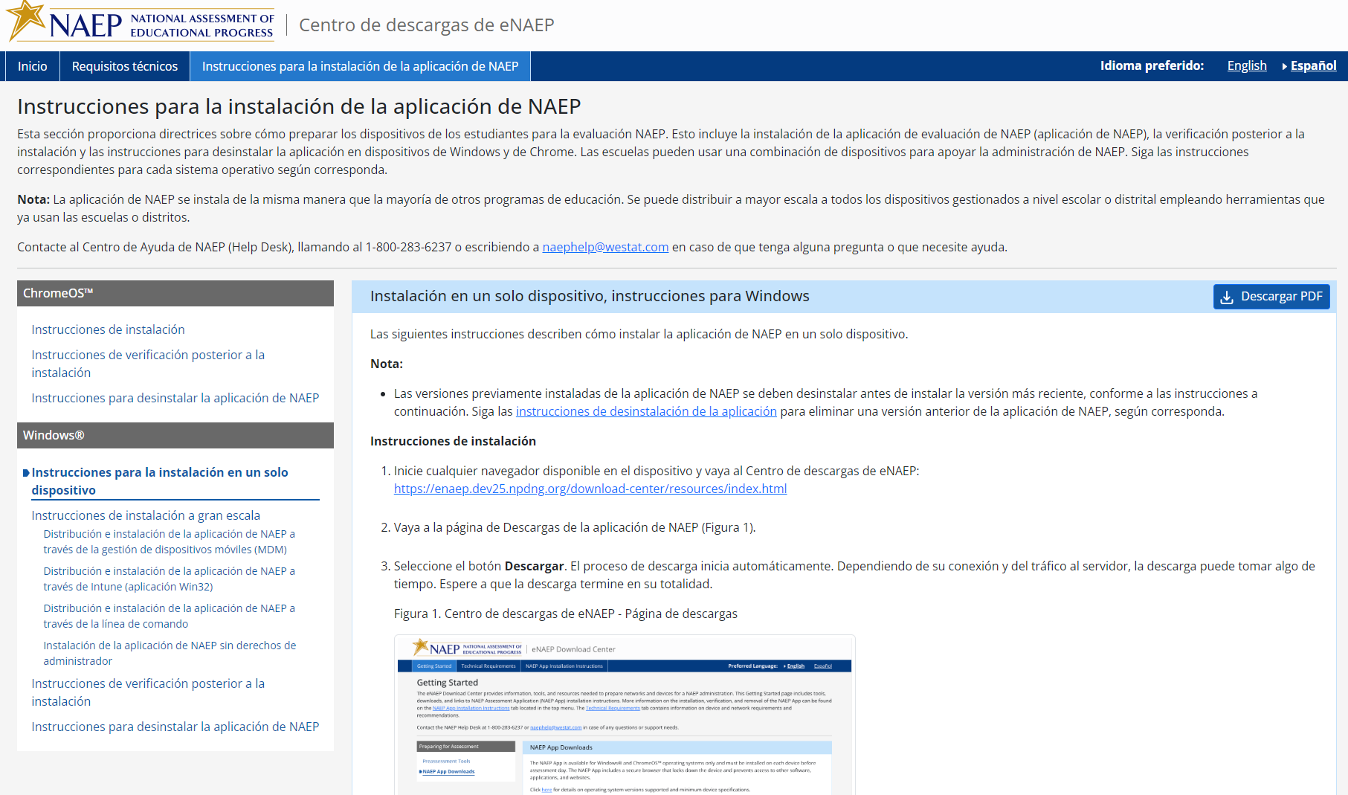
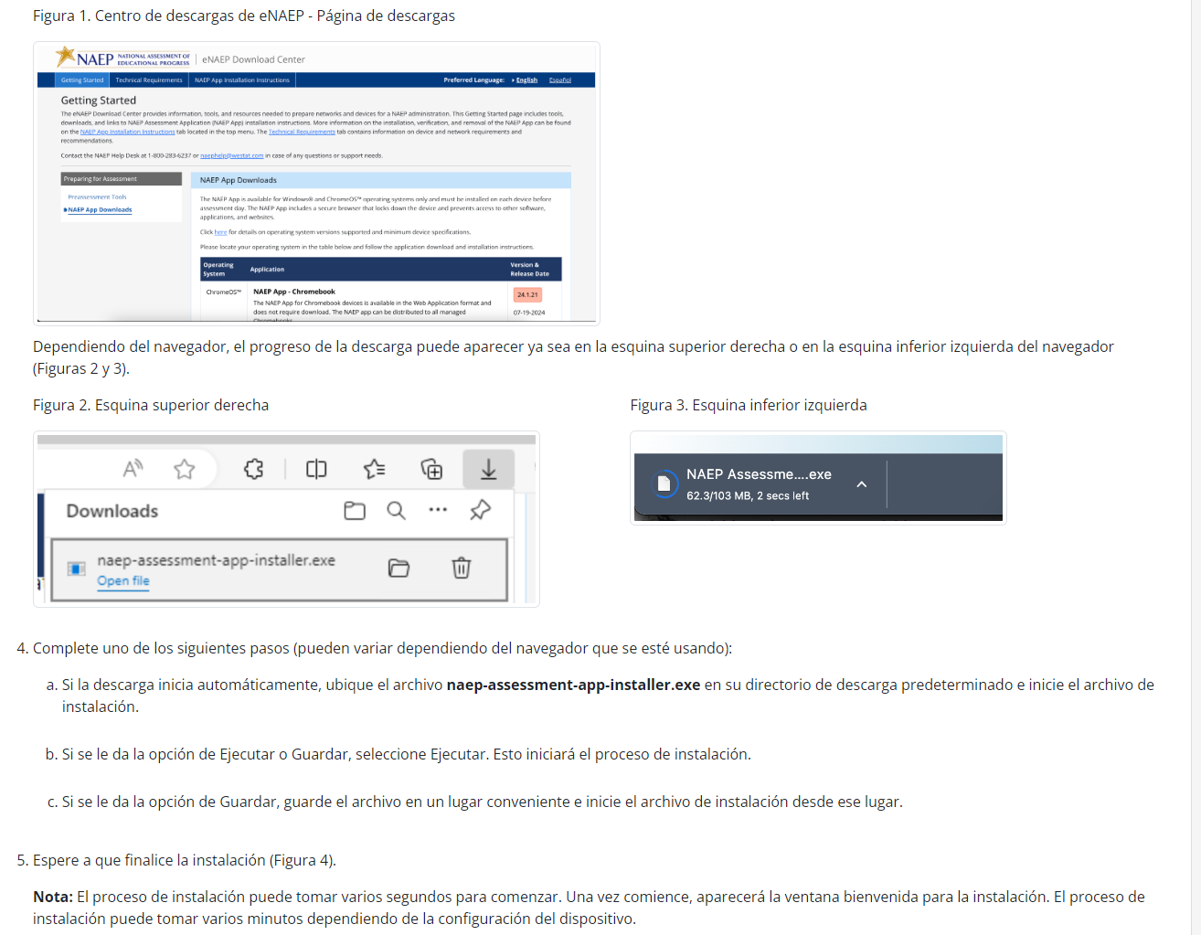
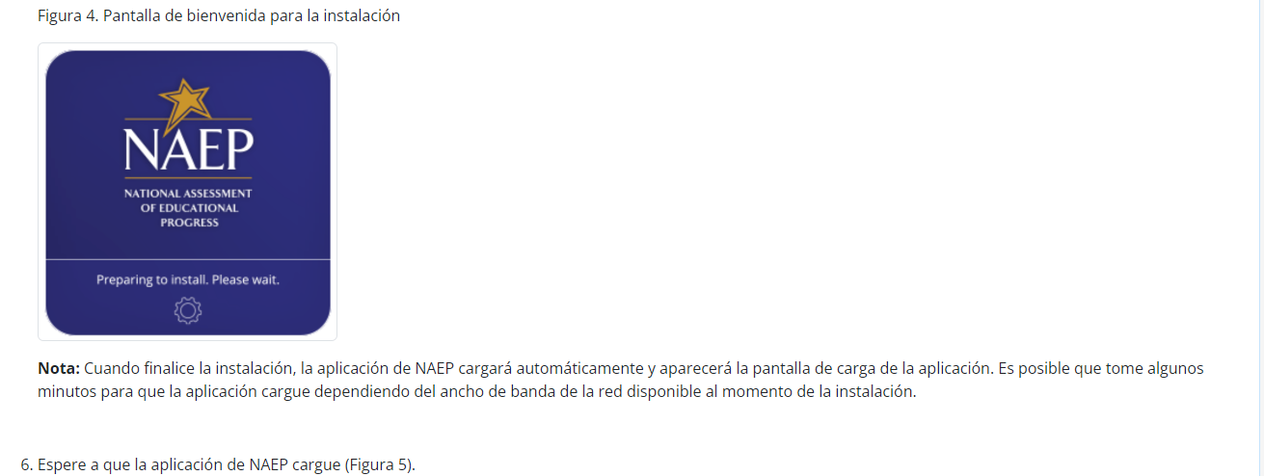
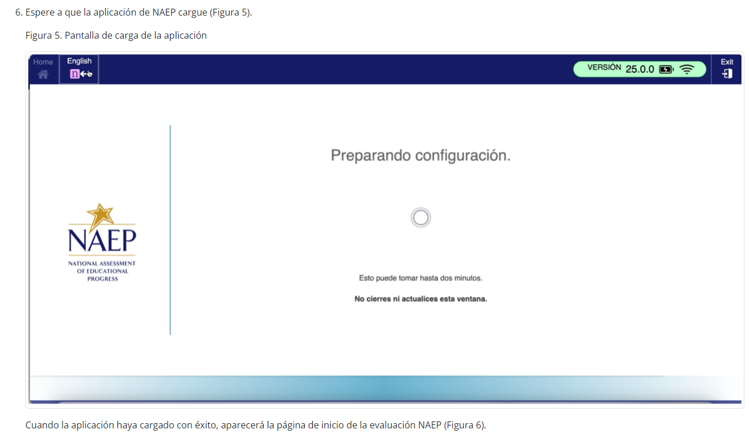
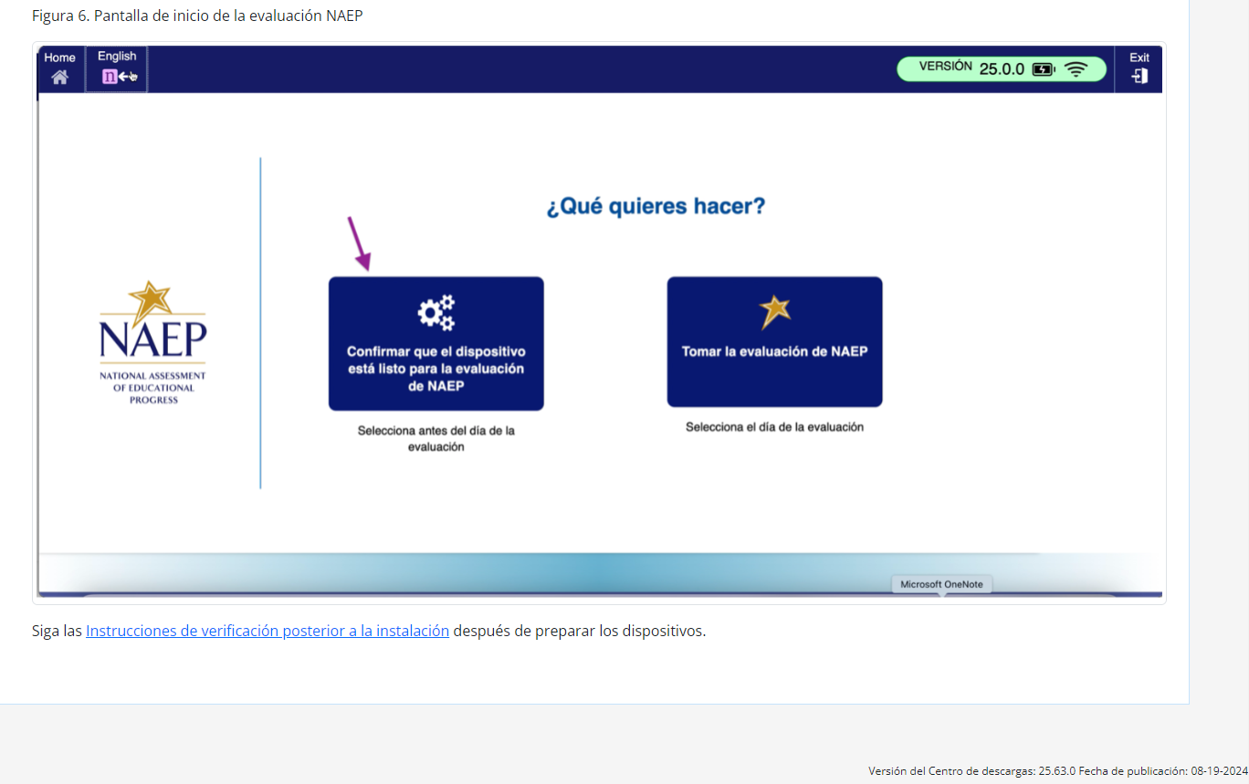

Instrucciones para la instalación de la aplicación de NAEP > Windows > Instrucciones de instalación a gran escala

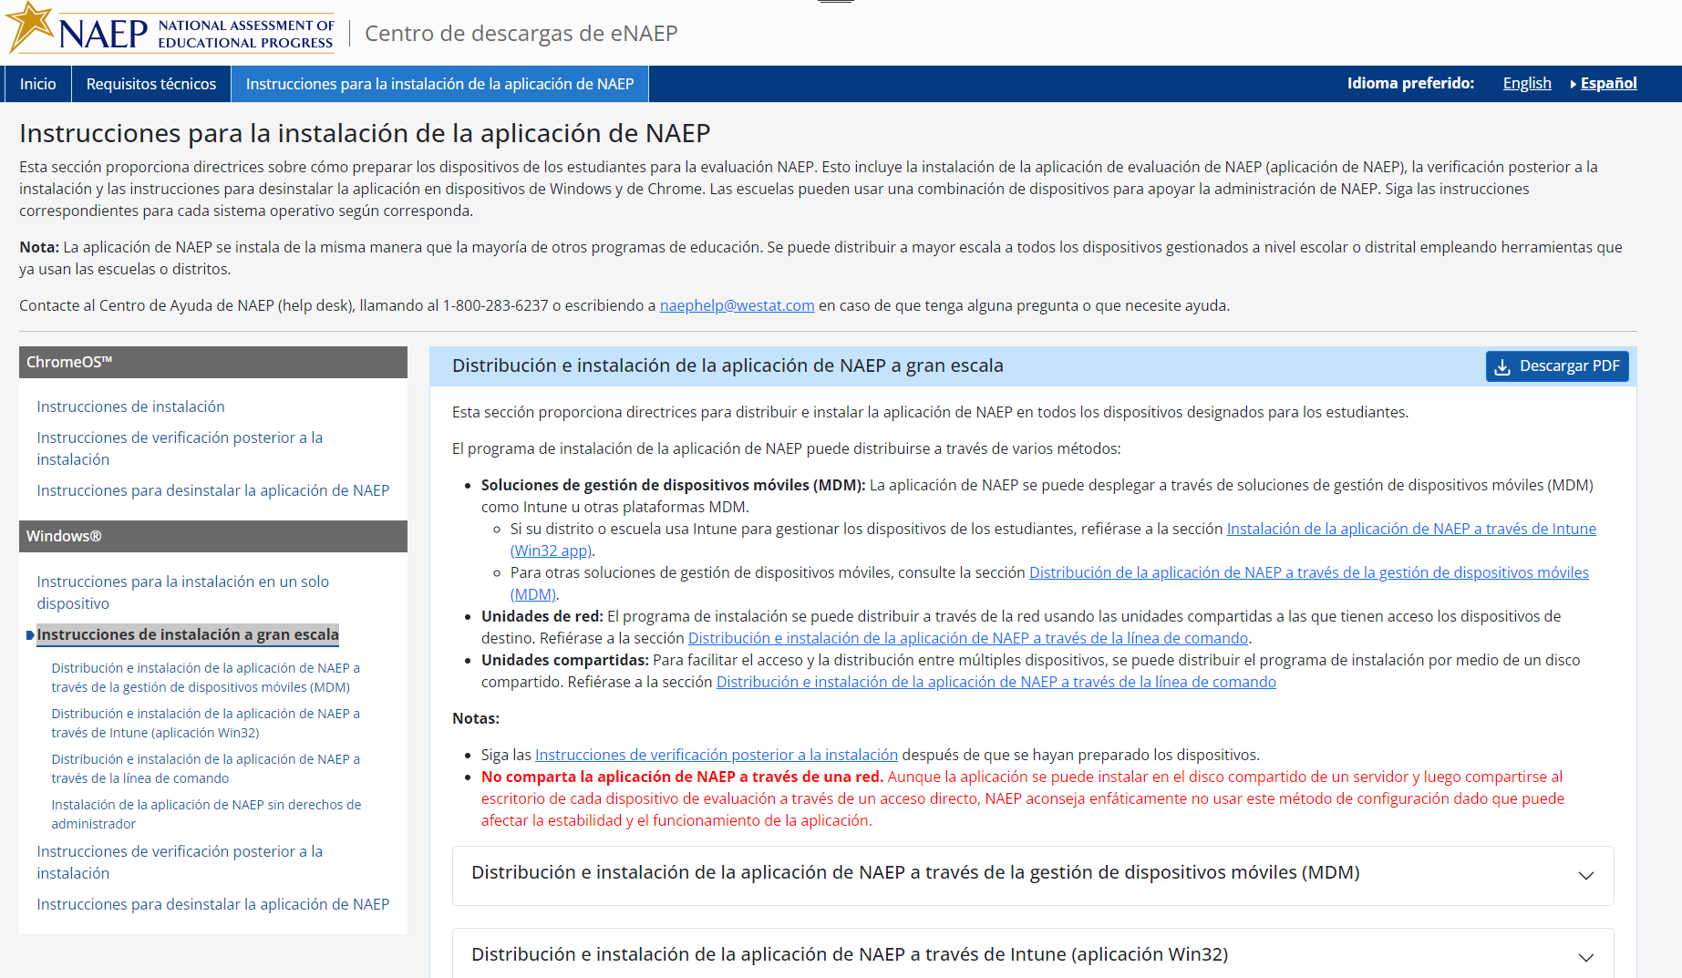

Instrucciones para la instalación de la aplicación de NAEP > Windows > Instrucciones de instalación a gran escala > Distribución e instalación de la aplicación de NAEP a través de la gestión de dispositivos móviles (MDM)

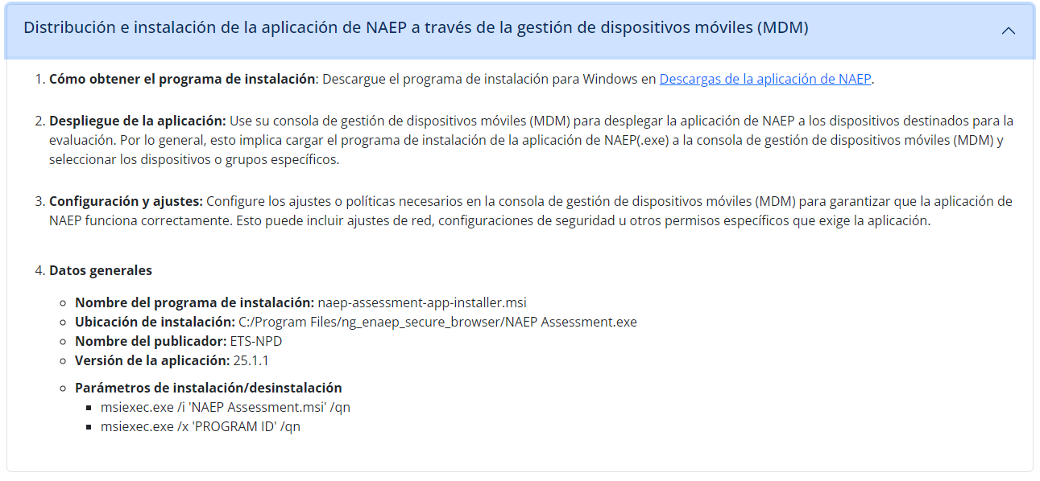

Instrucciones para la instalación de la aplicación de NAEP > Windows > Instrucciones de instalación a gran escala > Distribución e instalación de la aplicación de NAEP a través de Intune (aplicación Win32)
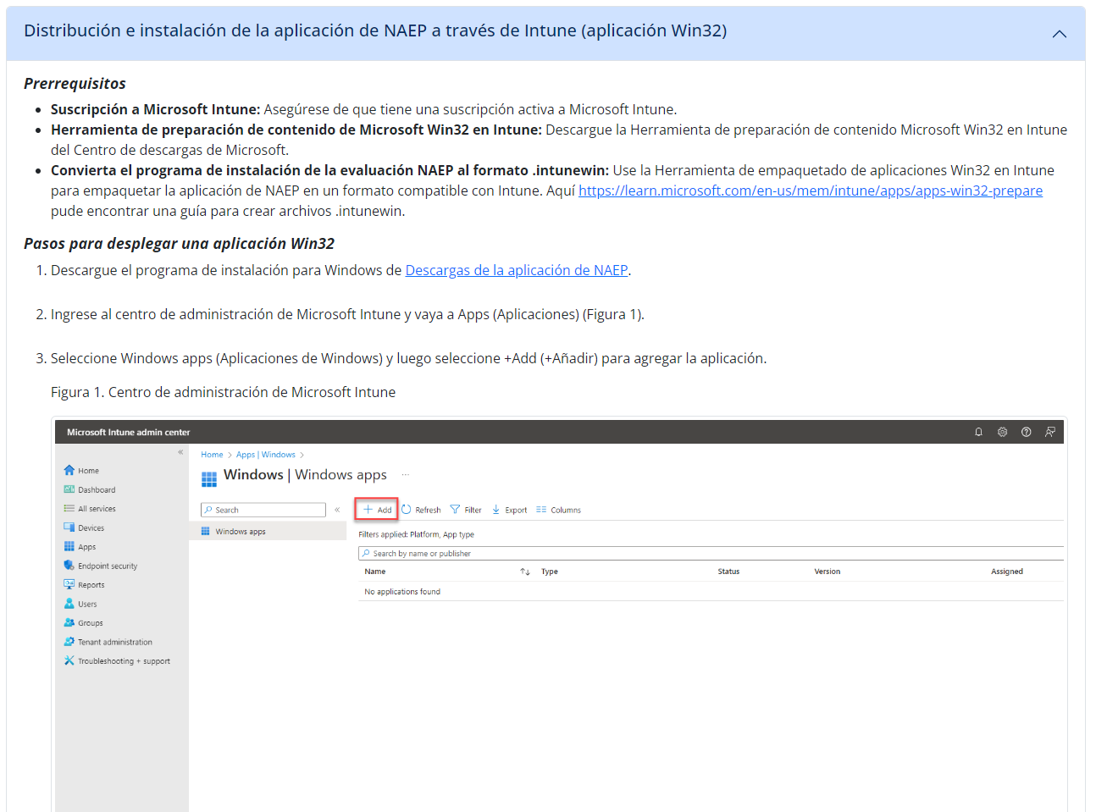
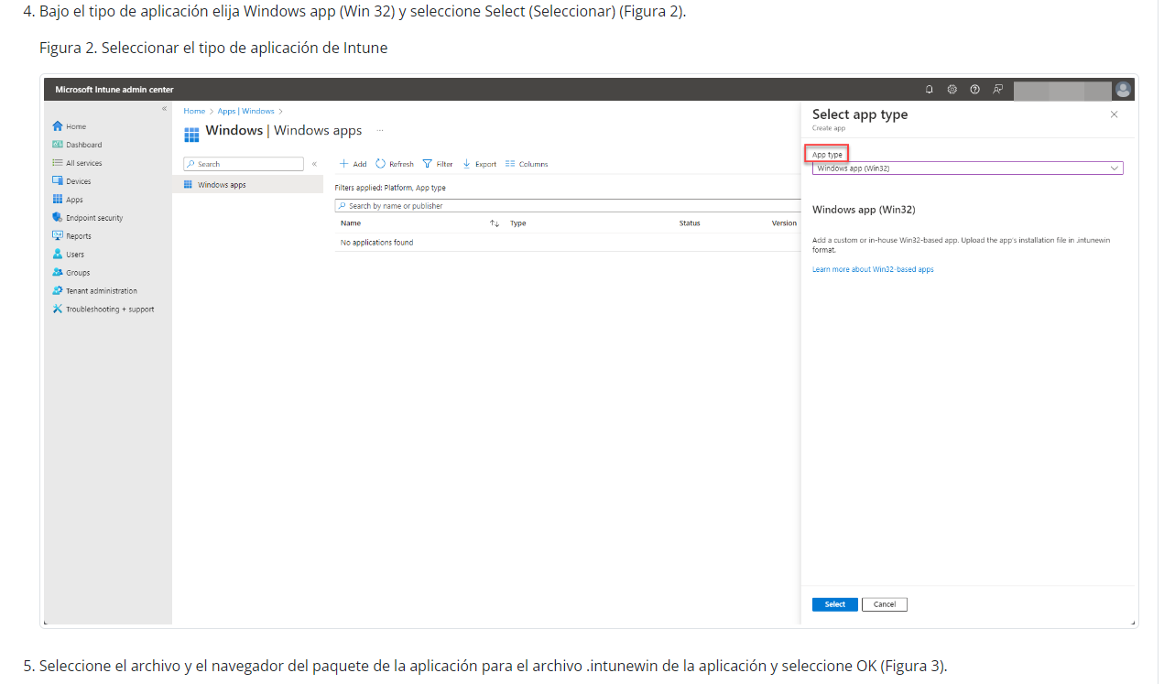
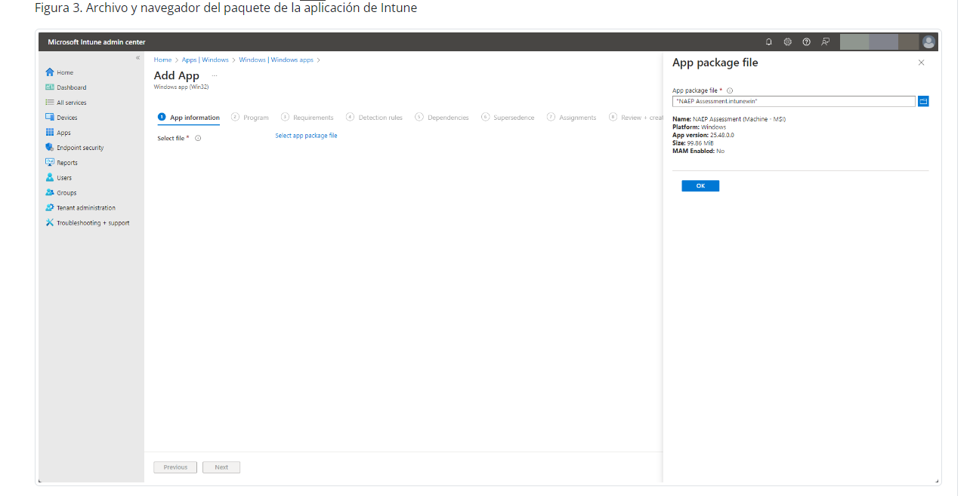
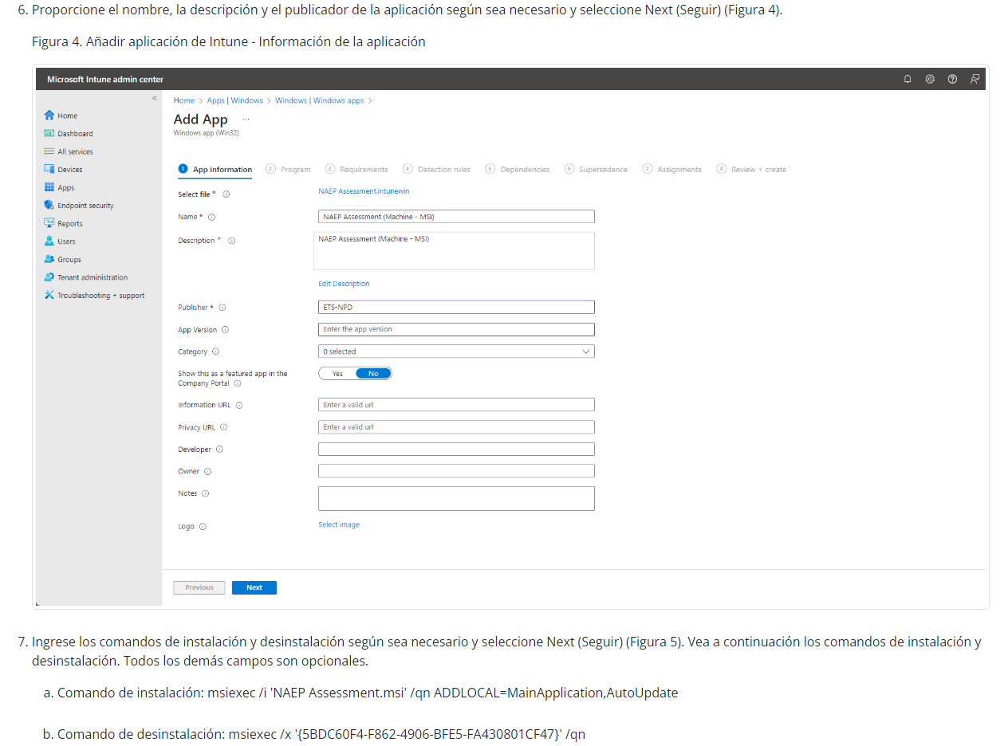
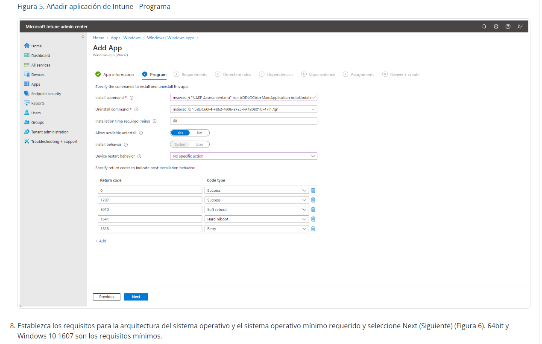
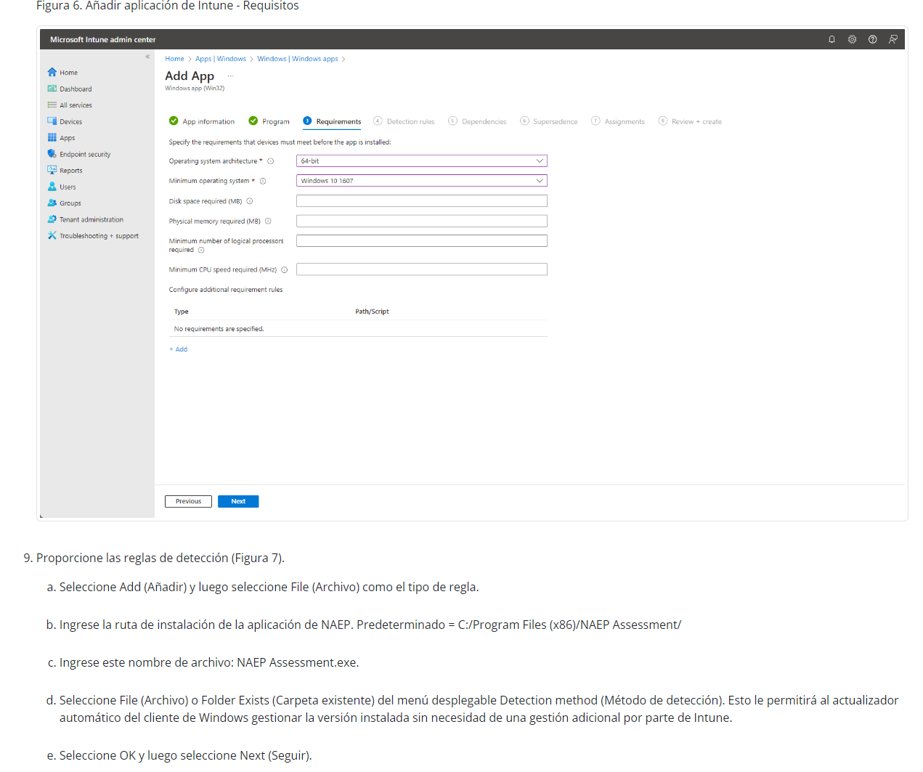
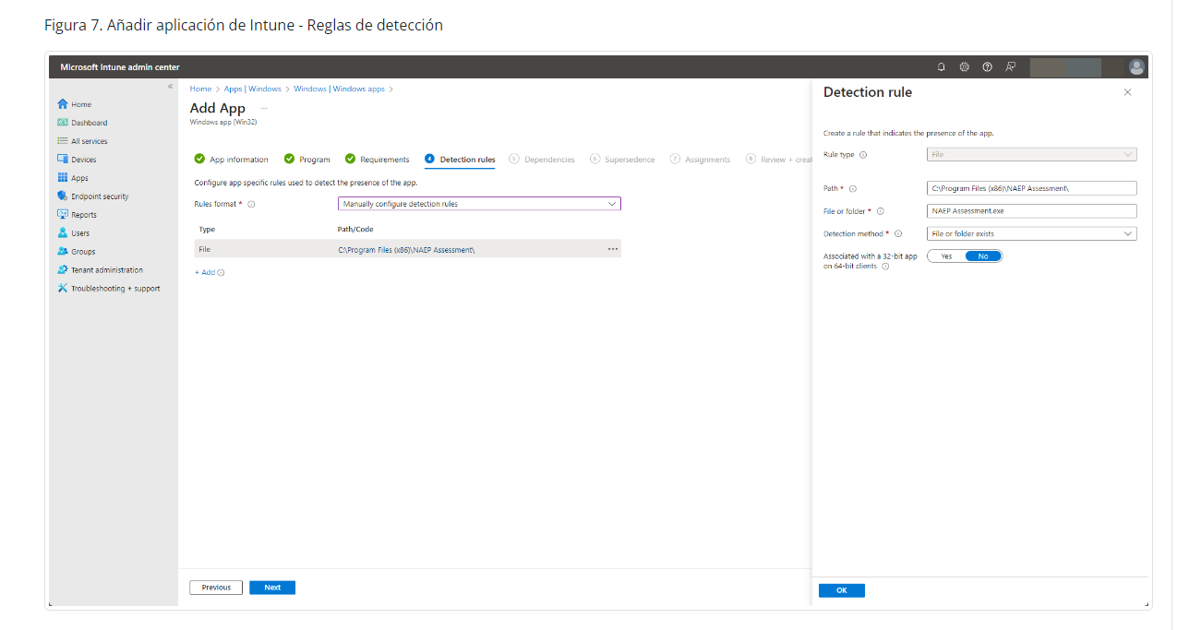
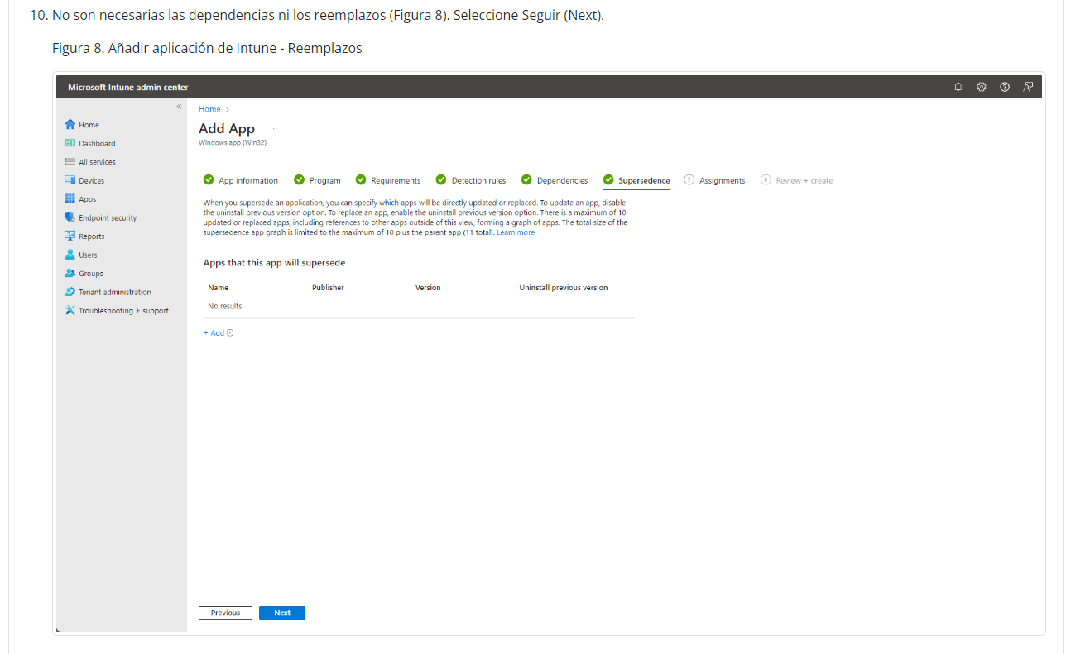
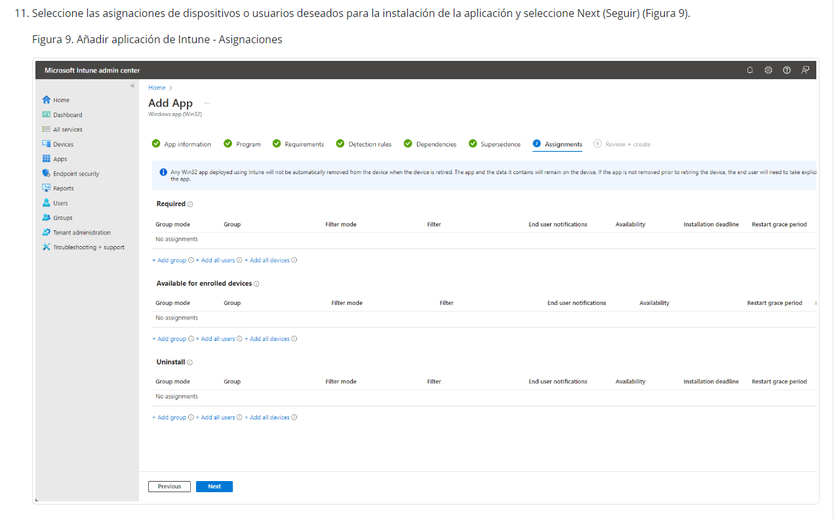
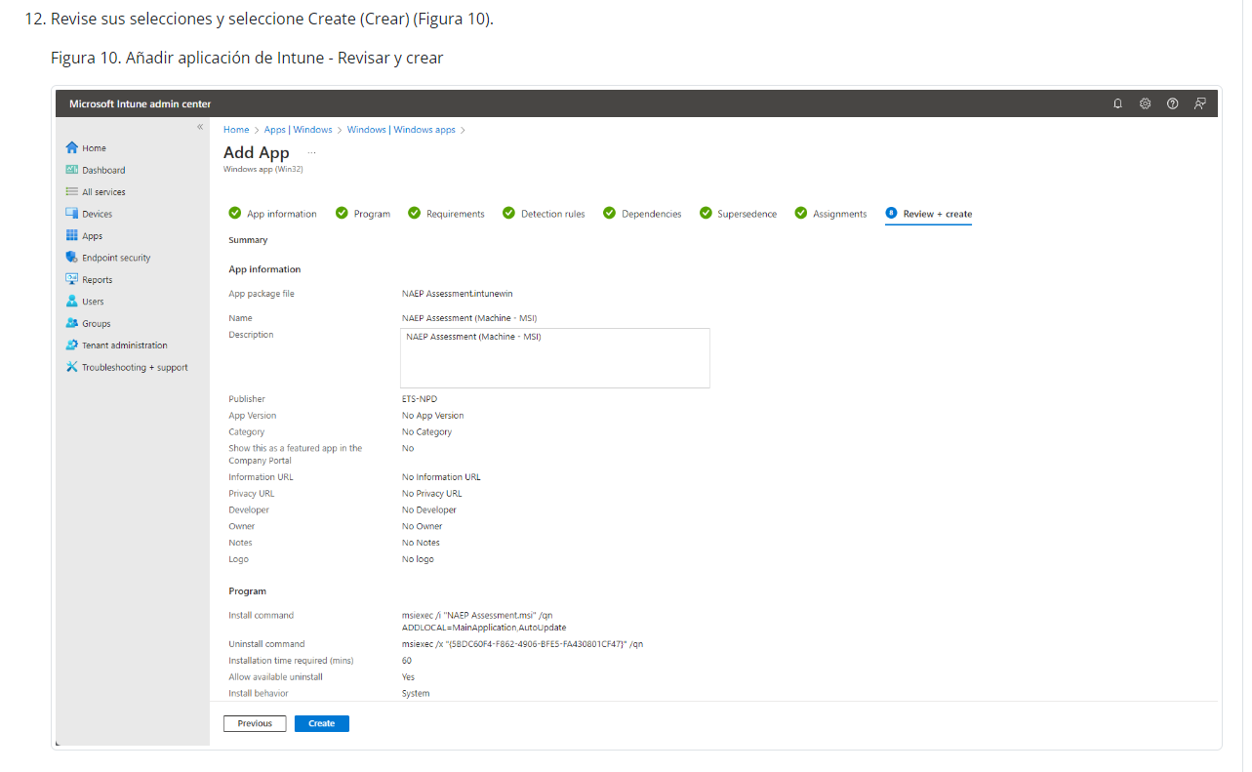
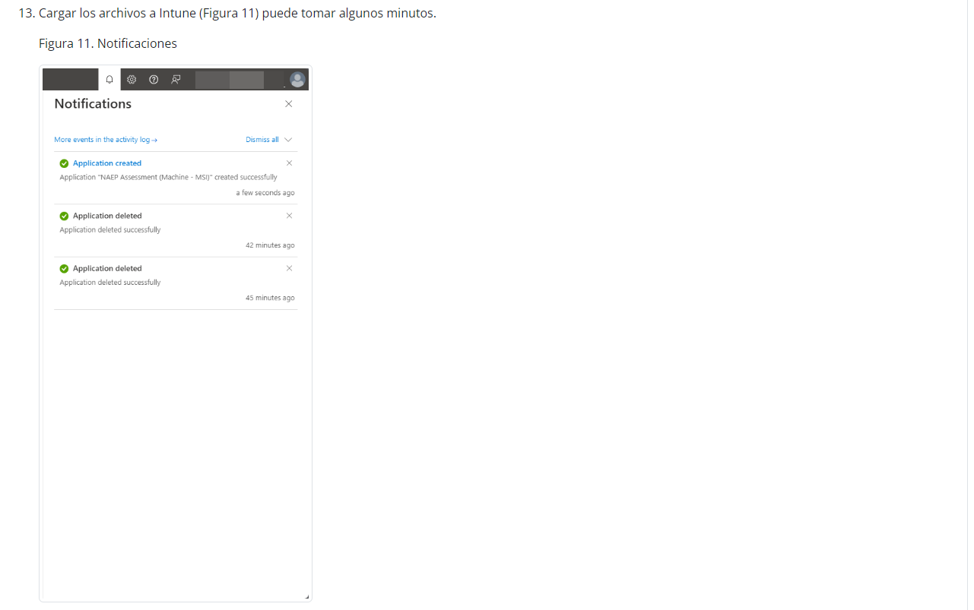
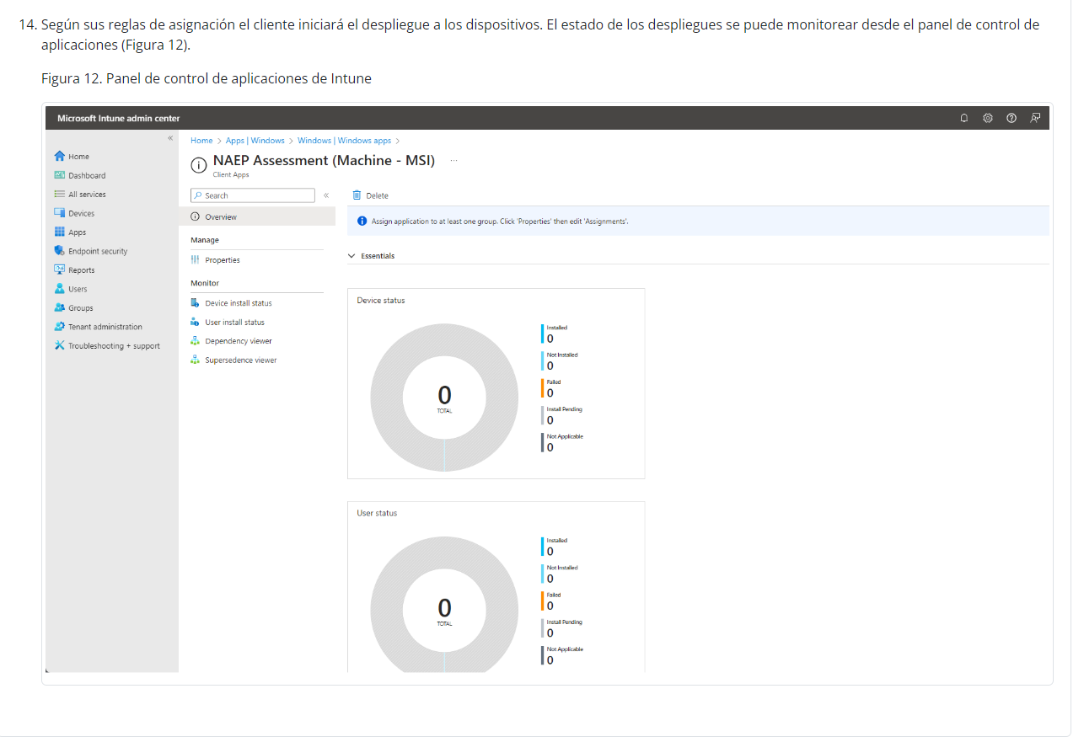

Instrucciones para la instalación de la aplicación de NAEP > Windows > Instrucciones de instalación a gran escala > Distribución e instalación de la aplicación de NAEP a través de la línea de commando

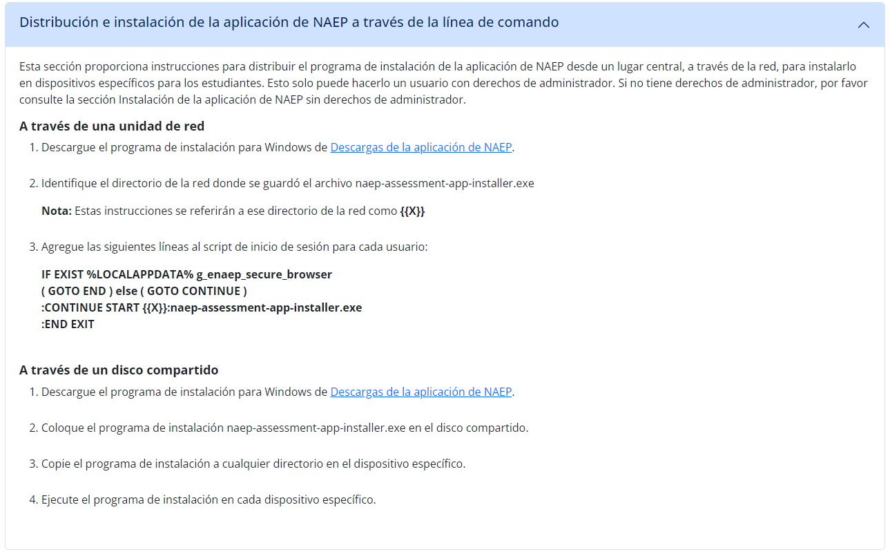

Instrucciones para la instalación de la aplicación de NAEP > Windows > Instrucciones de instalación a gran escala > Instalación de la aplicación de NAEP sin derechos de administrador
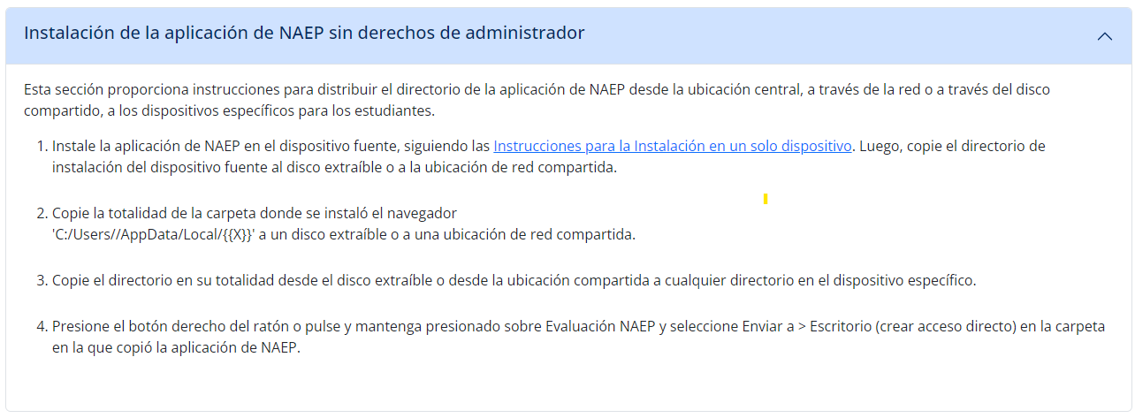

Instrucciones para la instalación de la aplicación de NAEP > Windows > Instrucciones de verificación posterior a la instalación
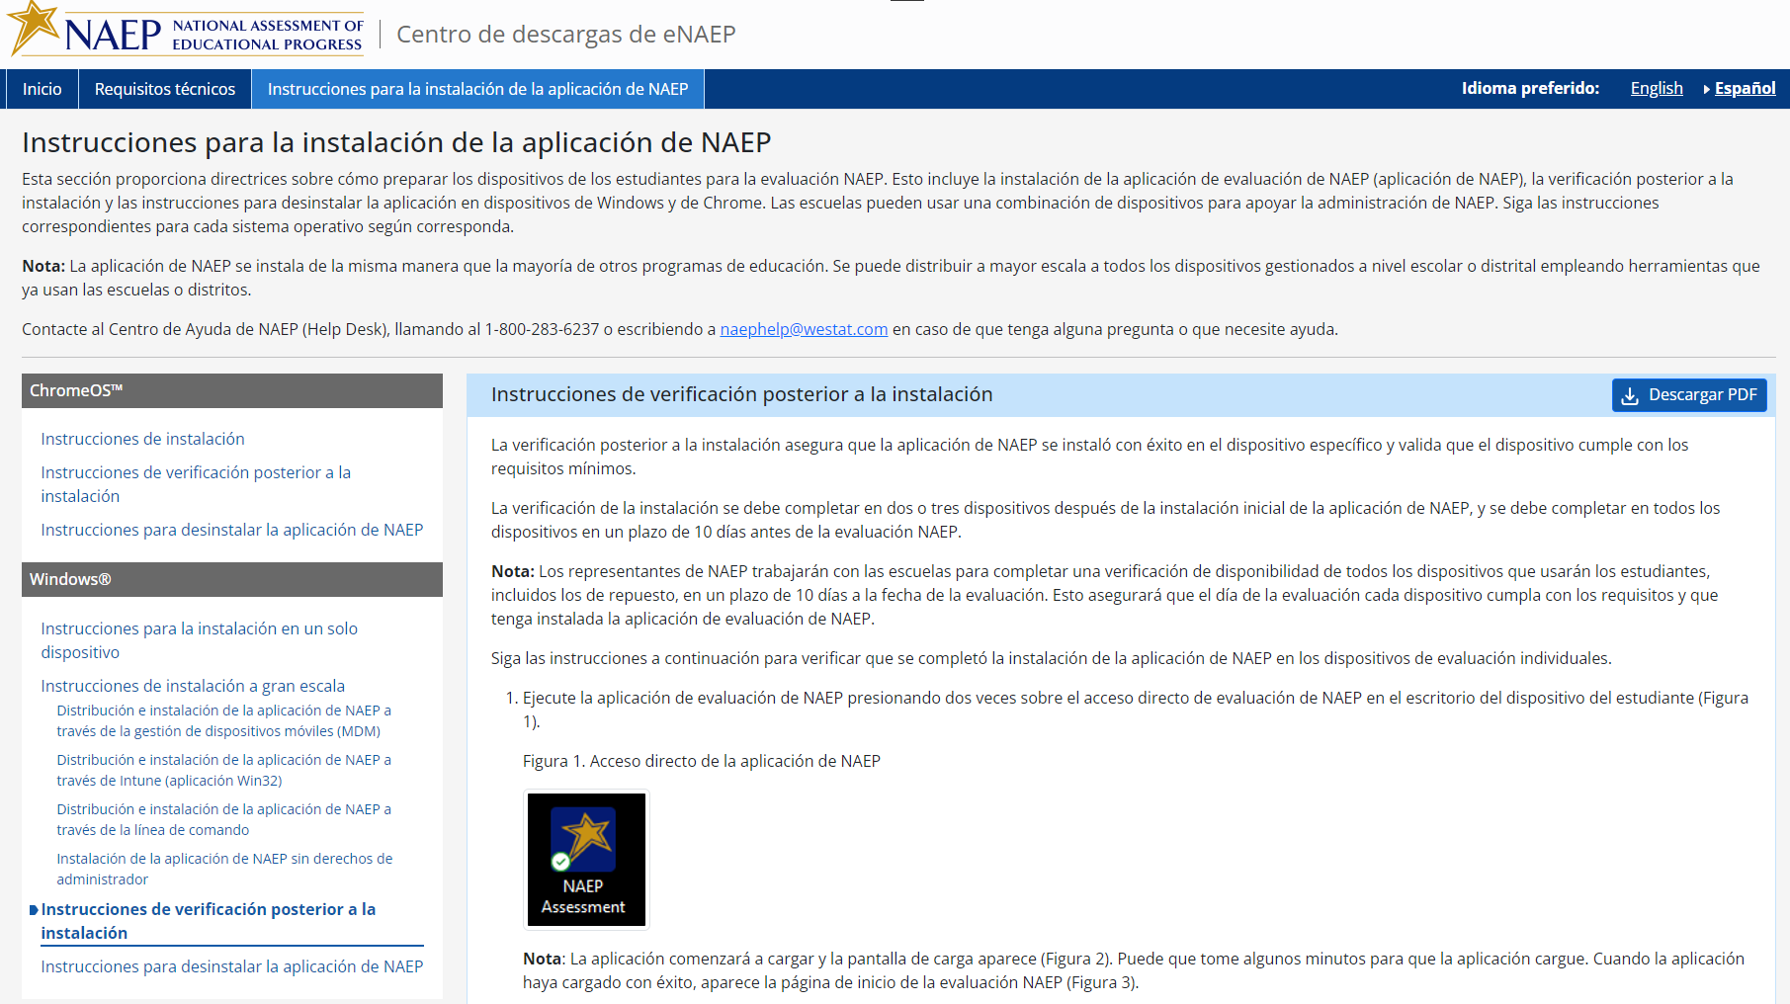
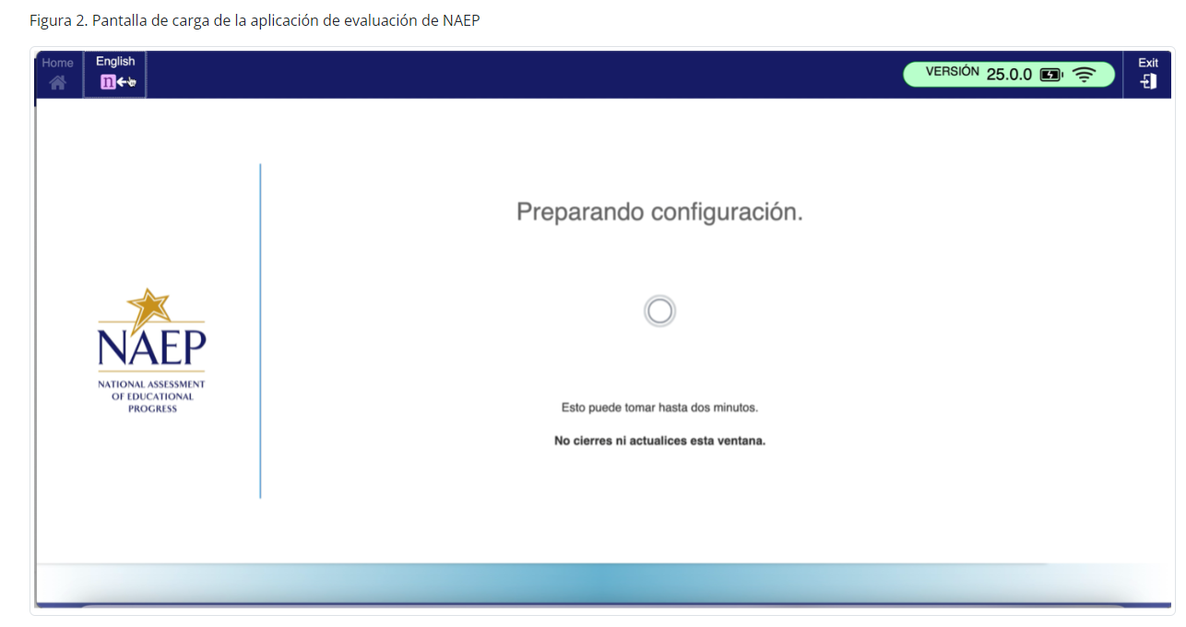
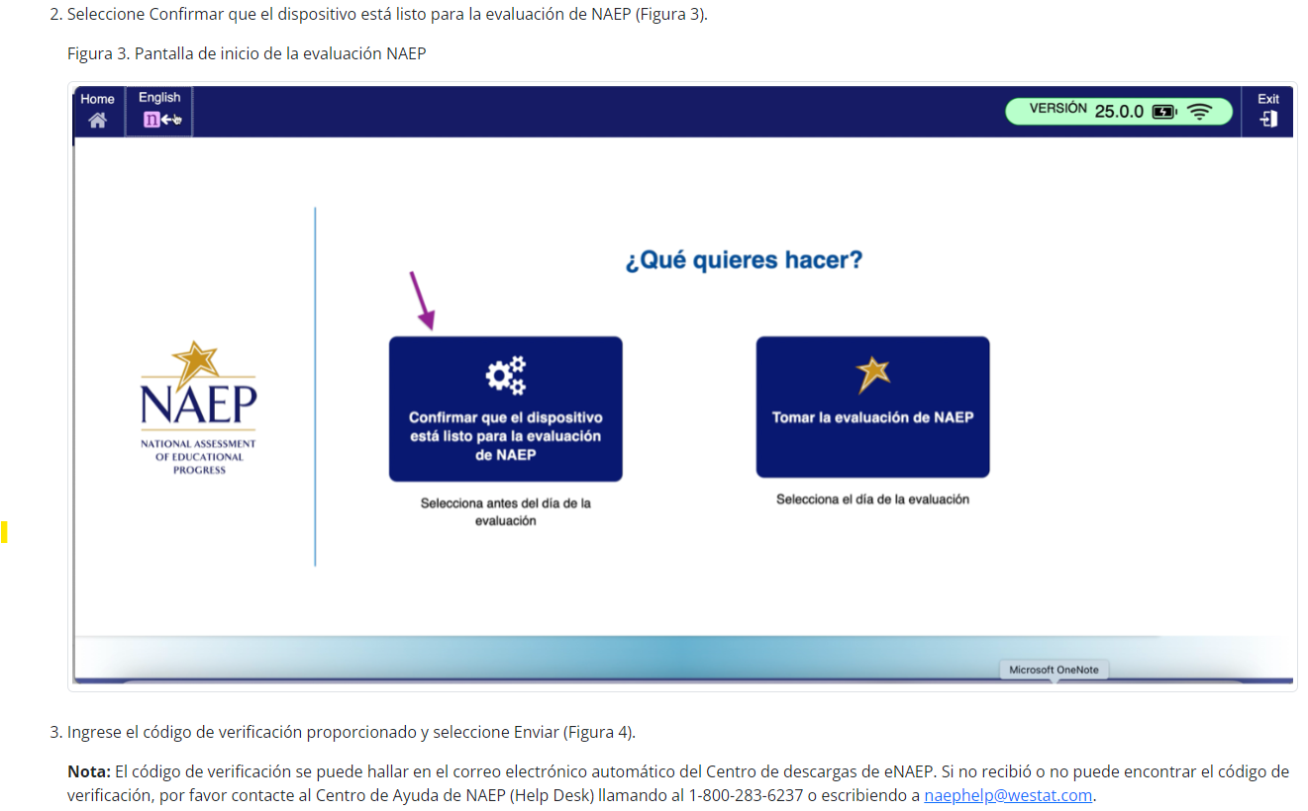
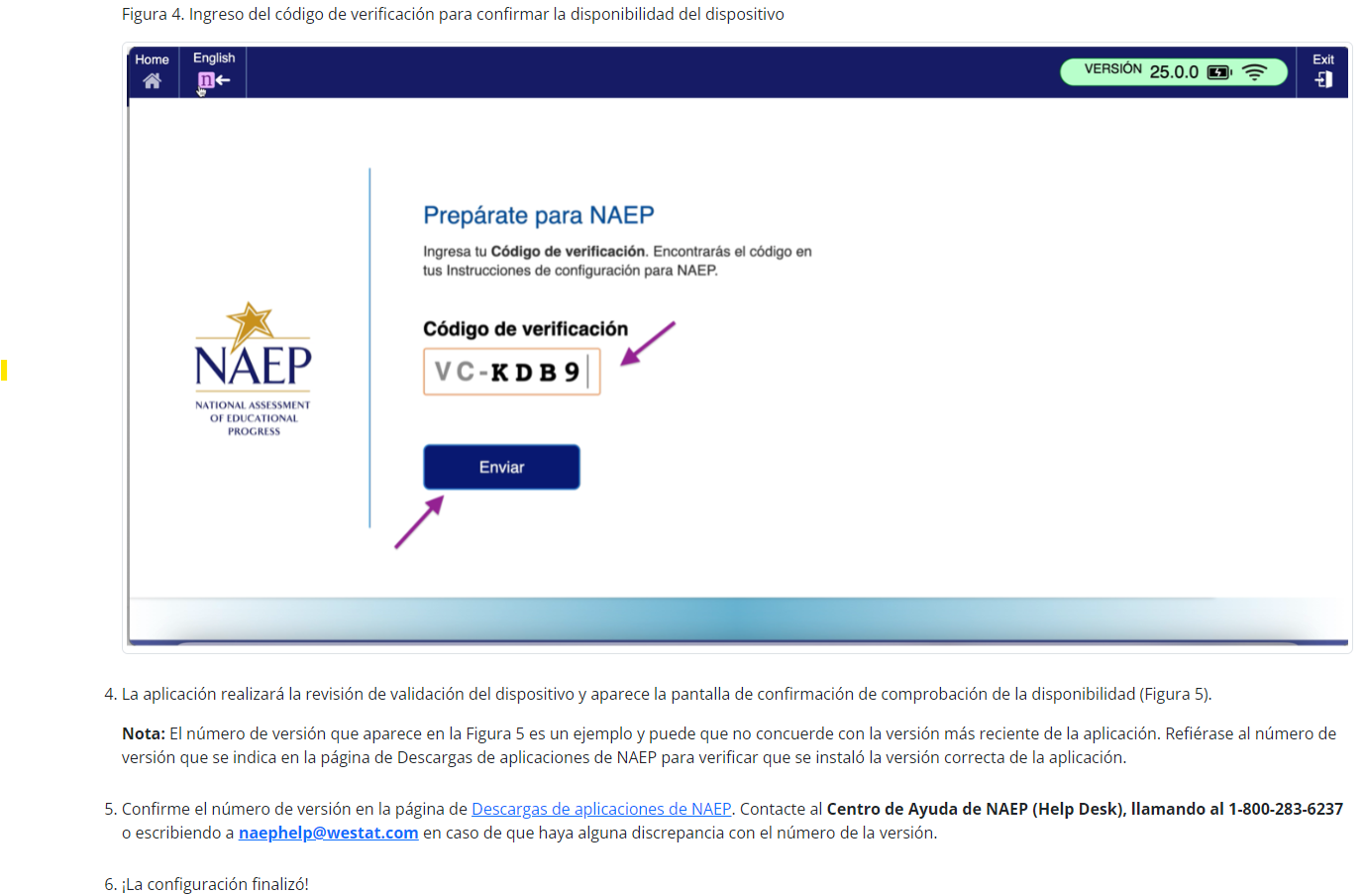
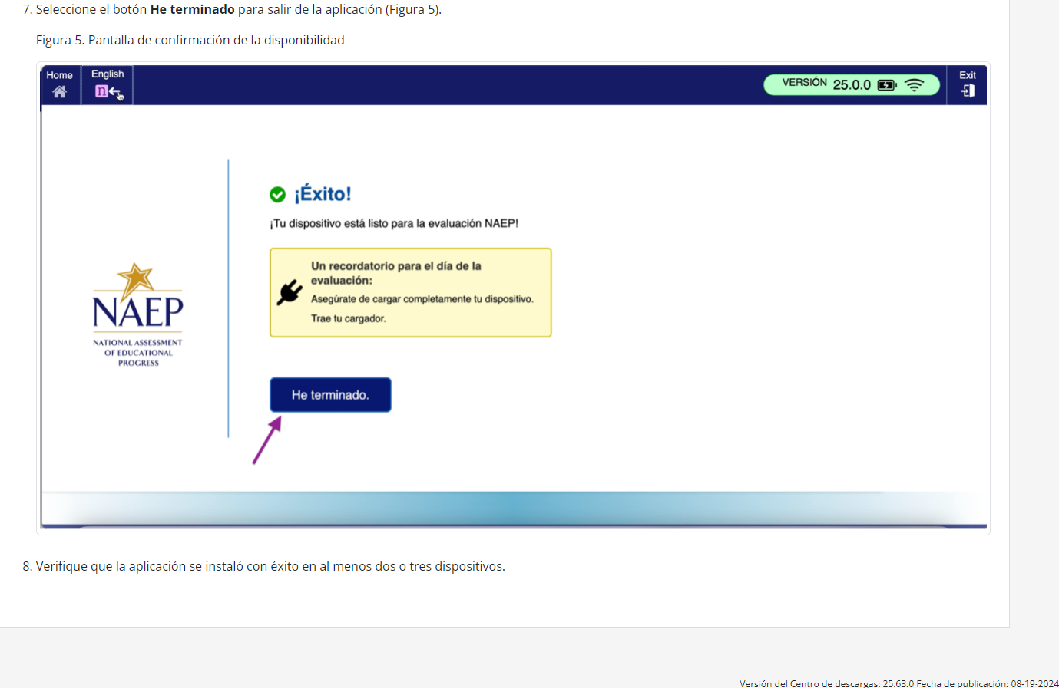

Instrucciones para la instalación de la aplicación de NAEP > Windows > Instrucciones para desinstalar la aplicación de NAEP
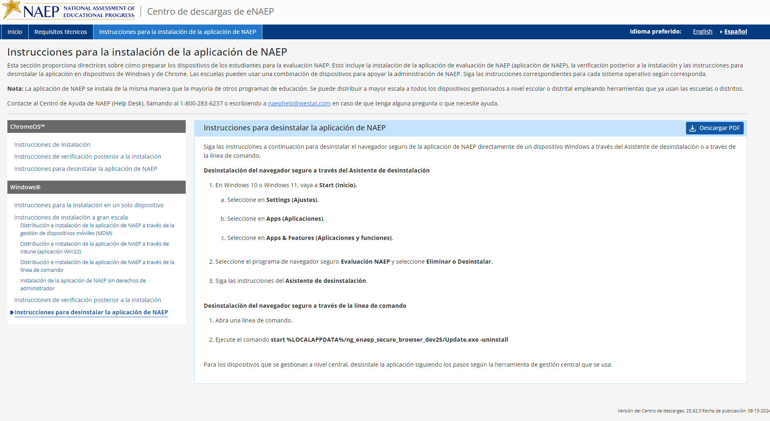

NAEP 2025 Best Practices Materials (New)

Appendix D2-50: NAEP 2025 Best Practices Introduction


This guide includes proven practices and strategies, from administrators like you, to make the National Assessment of Educational Progress (NAEP) a very positive and successful experience for our nation’s high schools.
NAEP results provide valuable feedback to educators, elected officials, and policymakers who work to maintain and improve the quality of our education system. Since NAEP is designed to assess a representative sample of our nation’s students, the accuracy of NAEP relies on the full participation of you, your teachers, and your students. One of the major purposes of NAEP is to show how education in the nation and our state is progressing. For that, we need a true picture of our students’ collective progress.

High school participation
Historically, high school student participation in NAEP has been a challenge. Both low participation and low motivation can undermine the validity and credibility of NAEP results for high school students. As the graph below demonstrates, NAEP participation increased with the implementation of the Best Practices Guide in 2007. However, the changing assessment landscape has led to declines in participation, and NAEP relies on principals like you more than ever.

NAEP School and Student Participation Rates for Public Schools: Grade 12

Recommendations from the Secondary School Principals’ Working Group
The Best Practices Guide was created after the National Center for Education Statistics convened a Secondary School Principals’ Working Group in 2005 to address high school participation rates. After discussing participation rates, student motivation, and student results, the working group concluded that the results did not reflect the true level of achievement of their students. The working group also concluded that high school principals and other school leaders could help improve participation rates by obtaining teacher buy-in and motivating students to take the assessment and do their best, and that best practices for achieving high participation should be shared with principals.
High school participation in NAEP improved after the implementation of these recommendations, but only because principals like you have used some or all the strategies included in the Best Practices Guide.

Preparing for NAEP 2025
This guide will provide the tools you need to communicate the importance of participating in NAEP to your students and teachers. Some of the resources available in the Best Practices Guide for Supporting High School NAEP Participation are as follows.
- Videos to introduce NAEP to students and teachers;
- PowerPoint presentations customized for the students, parents, and staff at your school;
- MS Word templates for student notification letters, morning announcements, and more;
- Talking points used by principals for communicating with teachers, students, and parents; and
- Social media posts announcing NAEP to various audiences.

In addition, you will receive three emails in the months leading up to the assessment. Each email will highlight effective strategies for encouraging participation and will link to the resources mentioned above.

Appendix D2-51: NAEP 2025 Best Practices Notification


Notification Letter

For Students

Dear Student:
Congratulations! You have been selected to participate in this year’s National Assessment of Educational Progress, also known as NAEP. Very few students are selected, but you have been chosen to represent thousands of your peers in this important assessment.
NAEP is the most important measure of what students from across the country know and can do in a variety of subject areas. It is different from our state assessments because it represents high school students across the country, not just those here in [state]. Your participation will provide a snapshot of what students from across the country have learned in school, which will inform major decisions about how to improve education in the United States. In short, it’s important that you take part and give it your best effort!
- You will take NAEP at [time, date, location] with other selected students.
- You will take a mathematics or reading assessment.
- NAEP takes up to 120 minutes, and you don’t need to study for it.
- Your answers will be anonymous and will NOT affect your grades or academic record in any way.
- Upon completion of the assessment, you will receive a Certificate of Community Service.
If you have any questions or would like to review sample questions, [insert name of school contact person] will be happy to help. You can also visit http://nces.ed.gov/nationsreportcard/students for more information.
We are fortunate that our school has been selected to participate in NAEP, and we are excited to have you take the assessment. We know you will do your best and help us show what our students are capable of.
Sincerely,
(School Principal)
What students are saying about NAEP participation…


Appendix D2-52: NAEP 2025 Best Practices Parent/Guardian Notification Letter
NAEP 2025 PARENT/GUARDIAN NOTIFICATION LETTER
(School Letterhead)
(Insert Date Here)

Dear Parent or Guardian:

(School name) will participate in the National Assessment of Educational Progress (NAEP) on (date). NAEP is the largest nationally representative and continuing assessment of what students know and can do in various subjects. NAEP is administered by the National Center for Education Statistics, within the U.S. Department of Education. NAEP is different from our state assessments because it is a common measure of achievement across the country. The results are released as The Nation’s Report Card, which provides information about student achievement to educators, parents/guardians, policymakers, and the public.
Your child (will/may) take a mathematics or reading assessment. In addition to subject-area questions, students voluntarily complete NAEP survey questions. These questions provide valuable information about participating students’ educational experiences and opportunities to learn both in and outside of the classroom. More information about NAEP survey questions is available at https://nces.ed.gov/nationsreportcard/parents under the section “What Questions Are on the Test?”

The assessment takes up to 120 minutes for most students, which includes transition time, directions, and completion of survey questions.

The information collected is used for statistical purposes only.
- Your child’s grades will not be affected.
- Students may be excused for any reason, are not required to complete the assessment, and may skip any question.
- While the assessment is voluntary, NAEP depends on student participation to help policymakers improve education. However, if you do not want your child to participate, please notify me in writing by (date).

There is no need to study in preparation for NAEP, but please encourage your child to do their best. Contact (name) at (telephone number) or at (email address) if you have any questions.
We are excited that our school is participating in NAEP. We know that (school name)’s students will show what our nation’s students know and can do.

Sincerely,
(School Principal’s Name)

National Center for Education Statistics (NCES) conducts the National Assessment of Educational Progress to evaluate federally supported education programs. All of the information you provide may be used only for statistical purposes and may not be disclosed, or used, in identifiable form for any other purpose except as required by law (20 U.S.C. §9573 and 6 U.S.C. §151). By law, every NCES employee as well as every NCES agent, such as contractors and NAEP coordinators, has taken an oath and is subject to a jail term of up to 5 years, a fine of $250,000, or both if he or she willfully discloses ANY identifiable information about you. Electronic submission of your information will be monitored for viruses, malware, and other threats by Federal employees and contractors in accordance with the Cybersecurity Enhancement Act of 2015.

Appendix D2-53: NAEP 2025 Best Practices Storyboard for Introduction Video
Storyboard for Introduction to Best Practices Video
Section | Narration | Description of Video
1 - Introduction | Thank you for your school’s participation in NAEP, the National Assessment for Educational Progress, for 2025, in mathematics and reading. | Title slide.
2 - What is NAEP | NAEP is the largest nationally representative assessment in mathematics and reading. Results from this assessment help inform educators, policymakers, and elected officials about the state of education in the nation. | Image of US map and results from NRC site.
3 - Importance of Student Participation | It’s important for NAEP to assess as many students selected to participate as possible. These students represent the nation's geographic, racial, ethnic, and socioeconomic diversity. Assessing representative samples of students, including students with disabilities and English learners, helps ensure that NAEP results accurately reflect the educational performance of all high school students, so NAEP can continue to serve as a meaningful measure of U.S. students’ academic achievement over time. | Images depicting nationally representative sample.
4 – The grade 12 participation challenge | High school student participation in NAEP is a challenge. In 2005, when only 67 percent of sampled high school students participated, the Best Practices Guide for Supporting High School NAEP Participation was developed based on suggestions from principals like you to help address the challenge. | Graph of student participation rate over time.
5 – The Best Practices Guide | We need your help in encouraging your students to participate in NAEP to ensure high school results can be reported for 2025. To help you support greater student participation, your NAEP State Coordinator will present you with a copy of this Best Practices Guide. | Image of the front cover of the guide.
6 – Resources | This guide provides the tools, resources, and strategies to communicate to students, teachers, and parents the importance of participating in NAEP and to encourage students to show up and do their best on the assessment. | Show table of contents and some resources.
7– Thank you | We encourage you to review this guide and implement these best practices in your school. If you have questions, please reach out to your NAEP State Coordinator. Thanks again for your school’s participation. | Thank you slide.

Appendix D2-54: NAEP 2025 Best Practices 2019 Infographic Grade 12 Mathematics and Reading Results
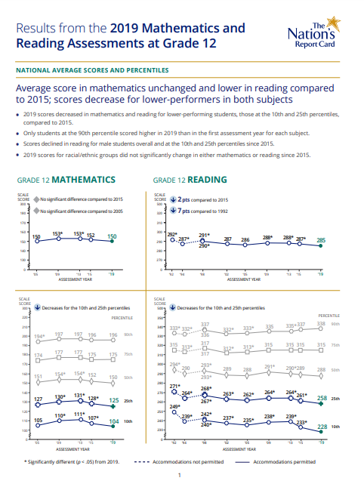
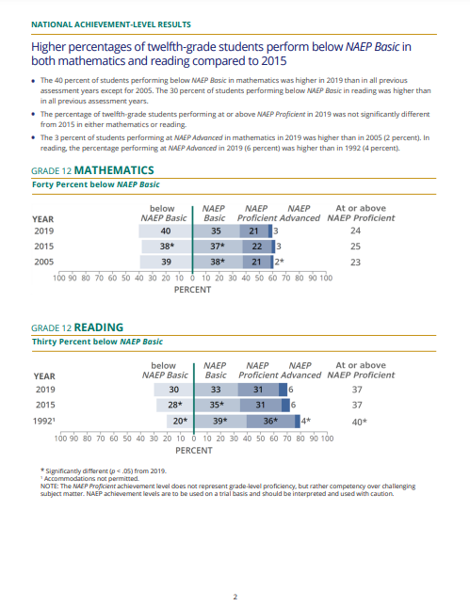
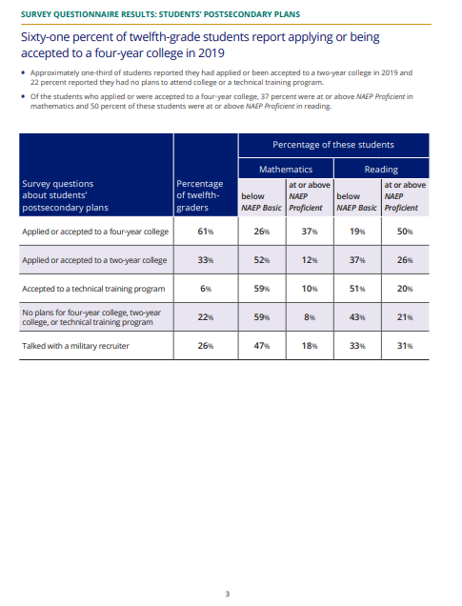

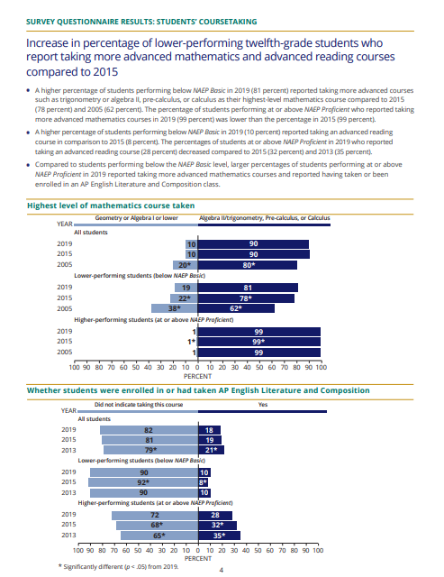

Appendix D2-55: NAEP 2025 Best Practices PowerPoint Slide TV Monitor Announcement
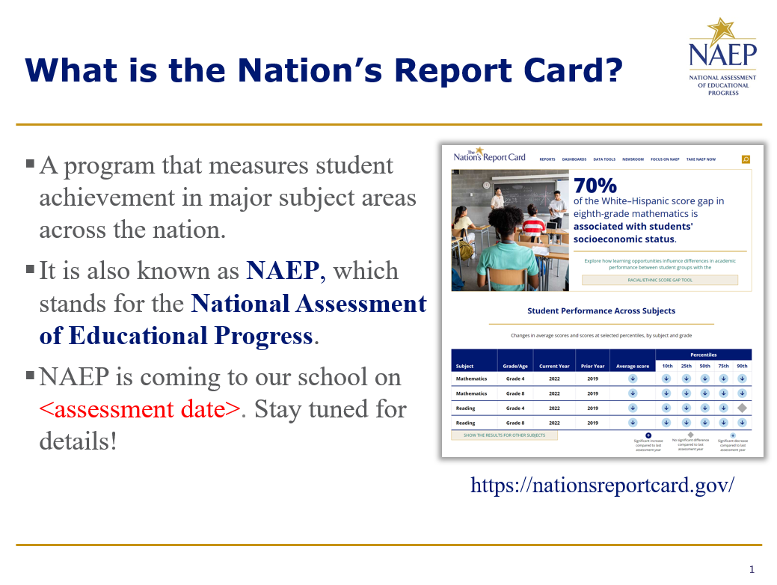

Appendix D2-56: NAEP 2025 Best Practices PowerPoint Slides: Introducing NAEP to Parents
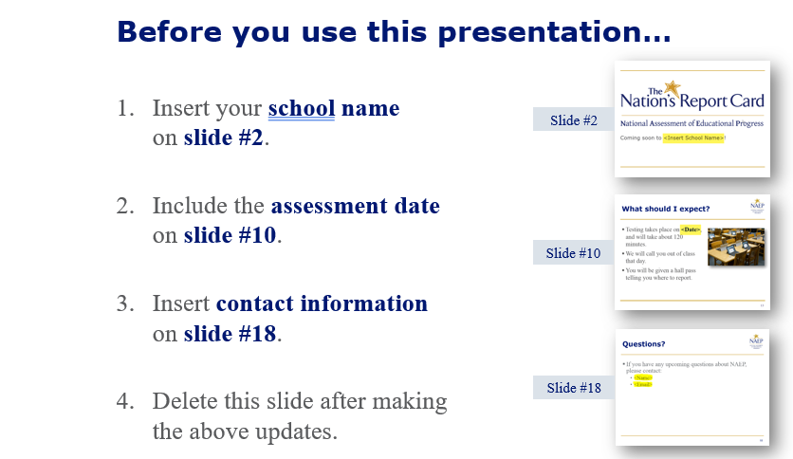

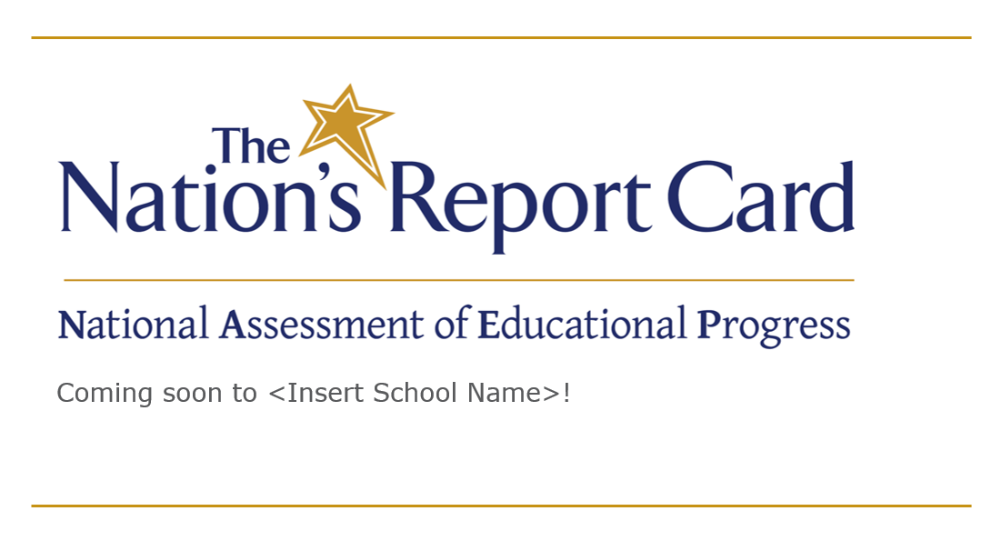

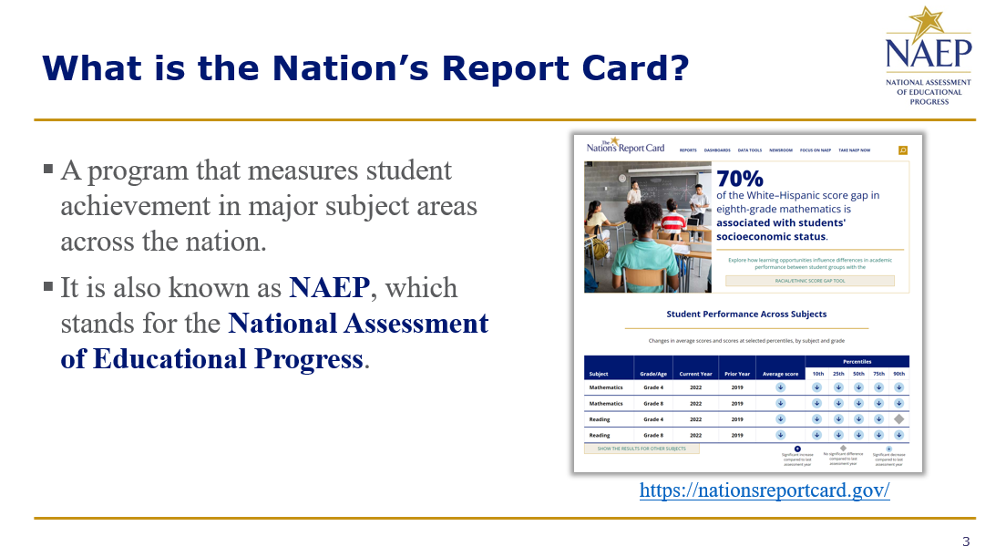

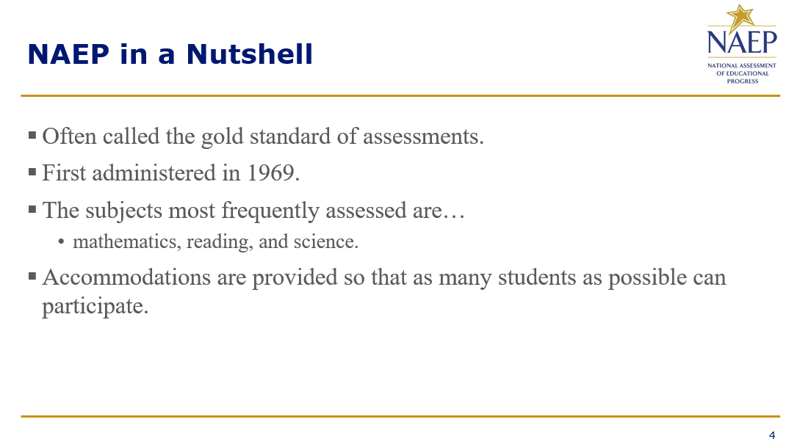

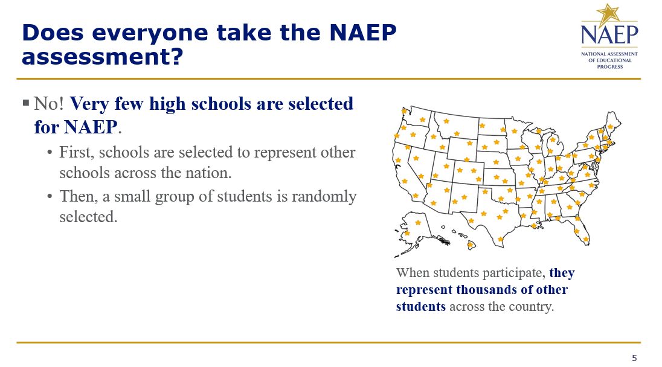
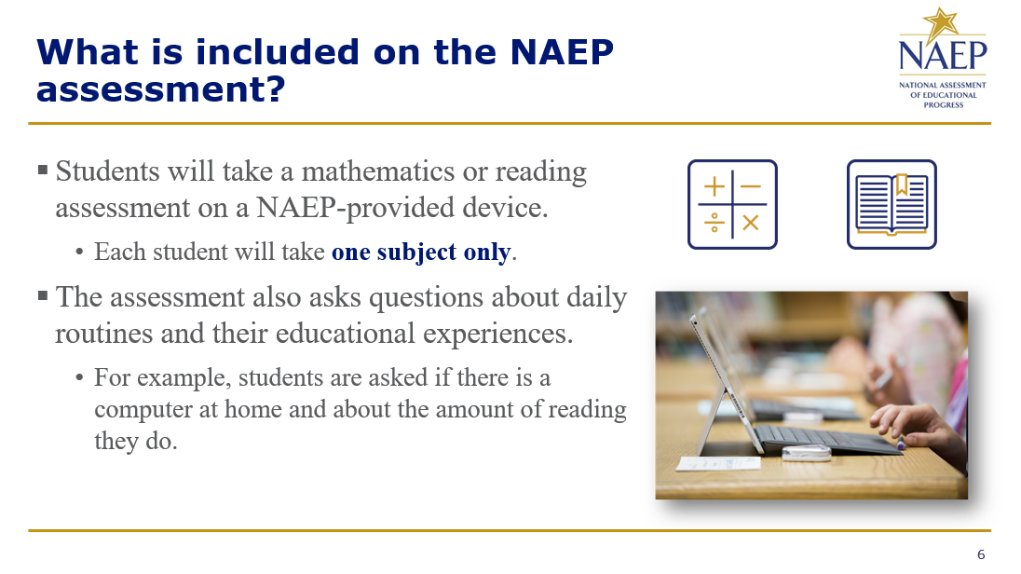

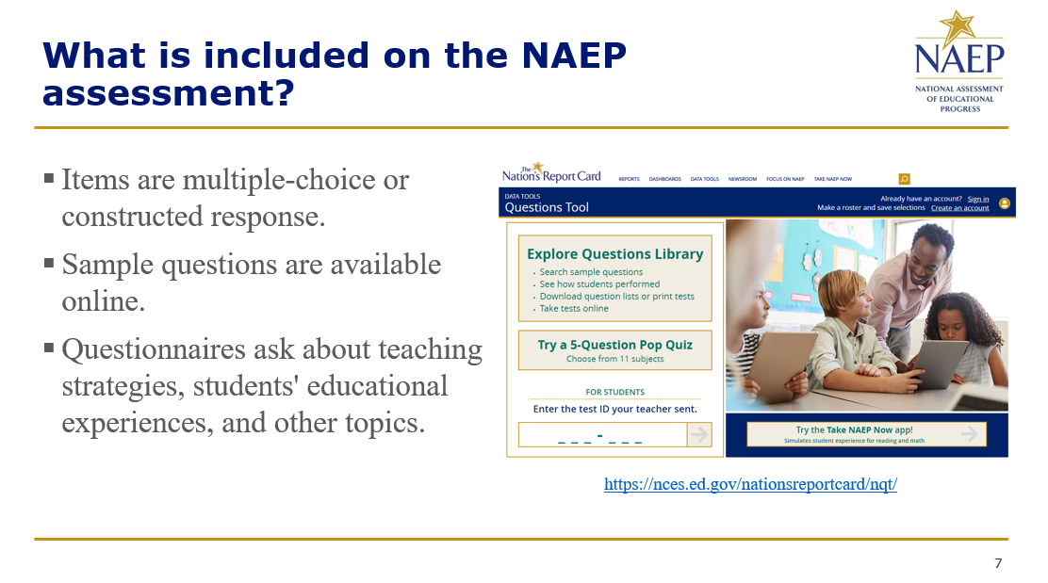
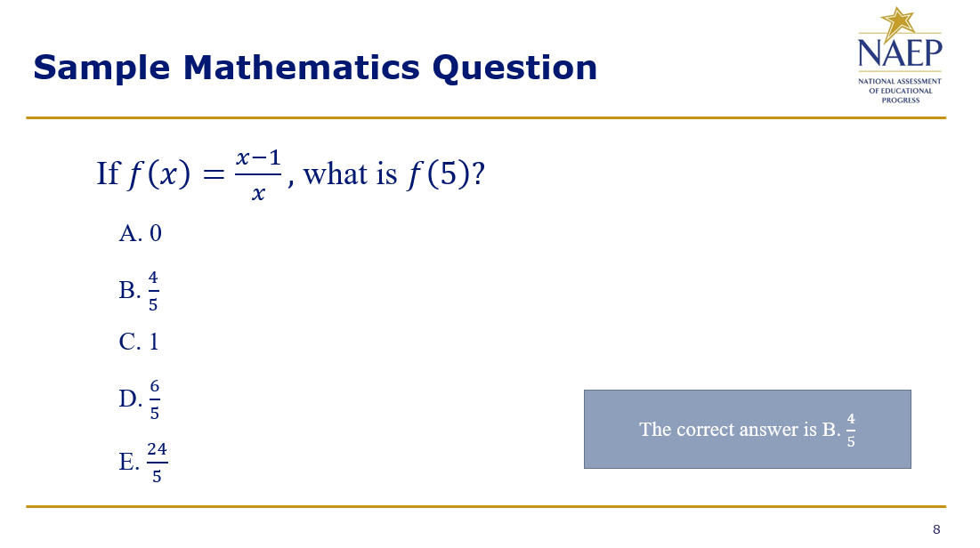

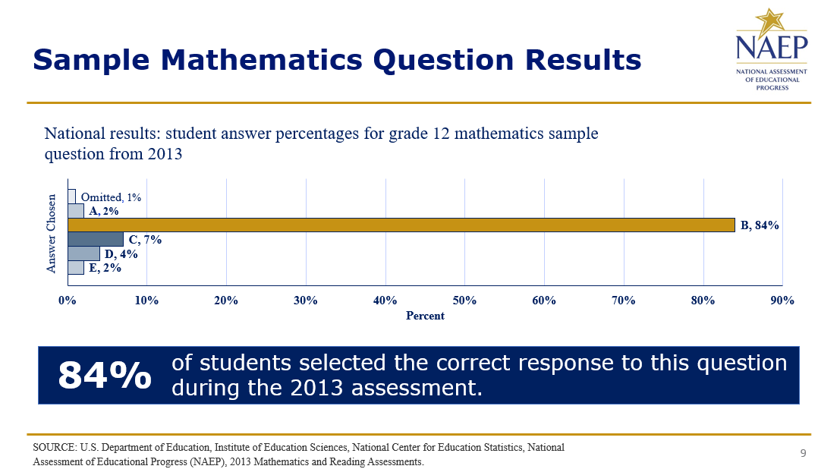
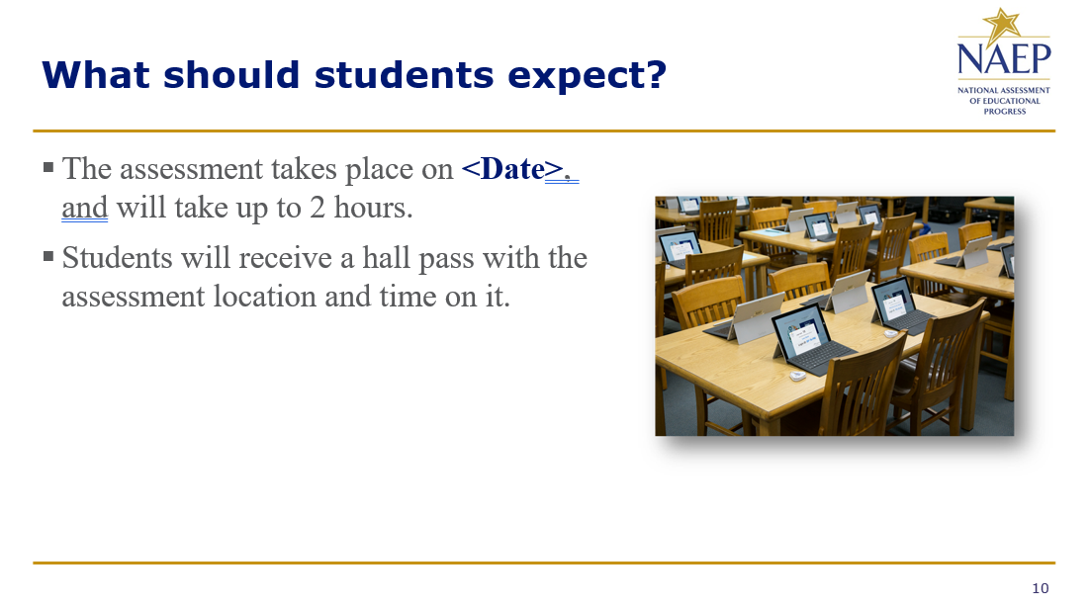

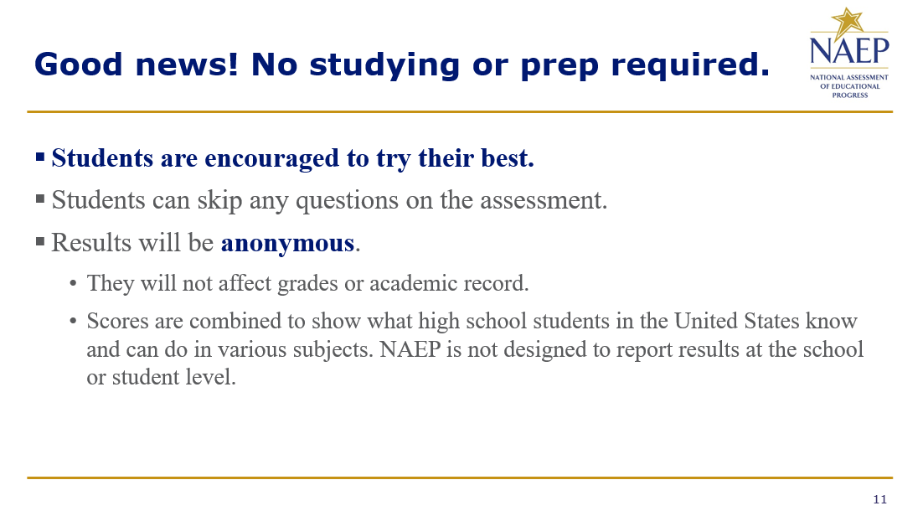

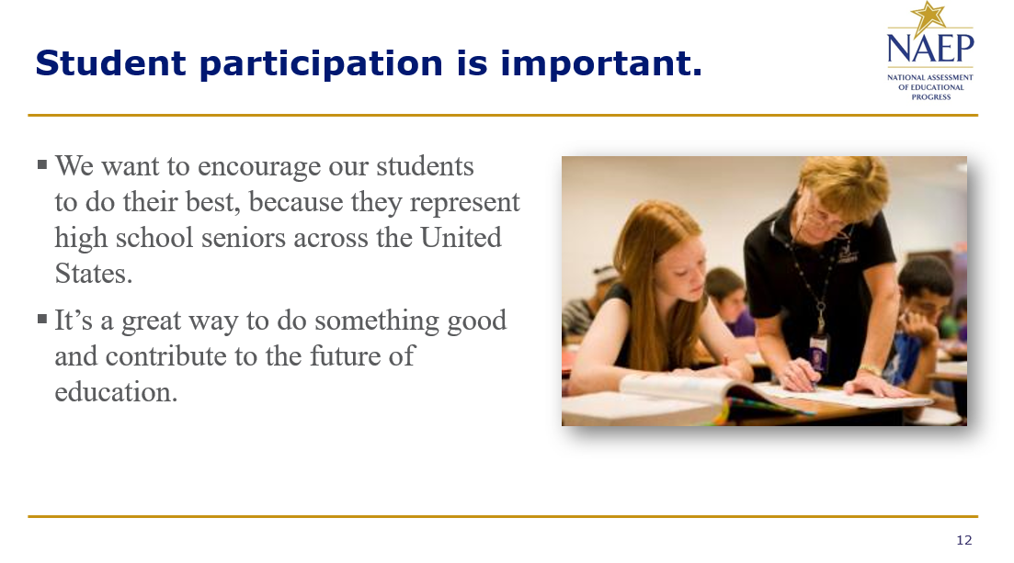

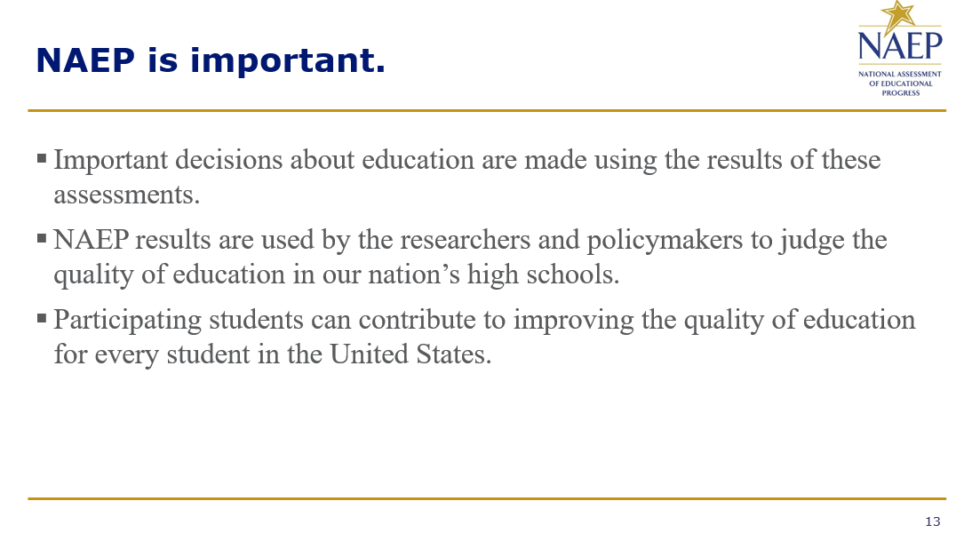
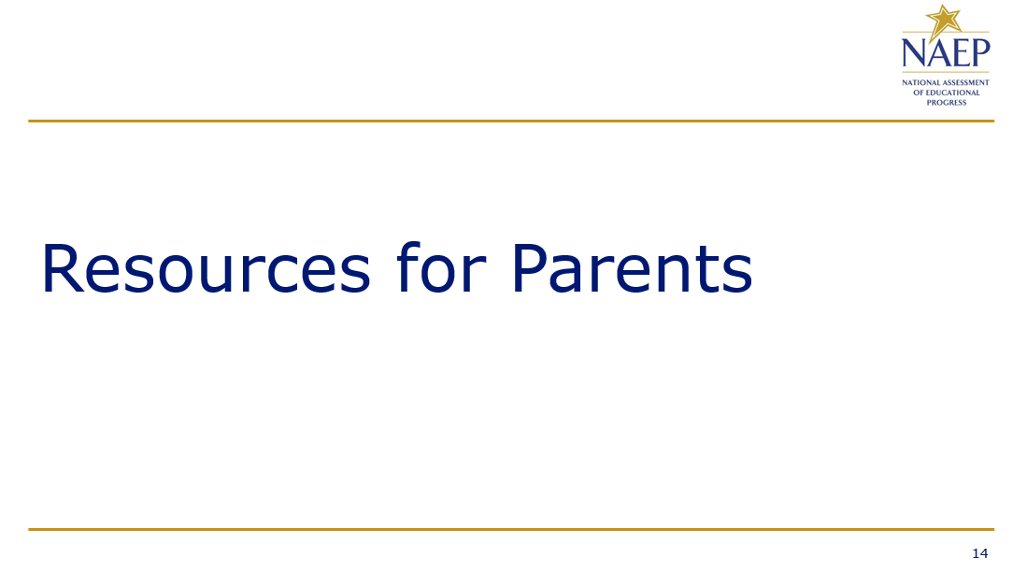

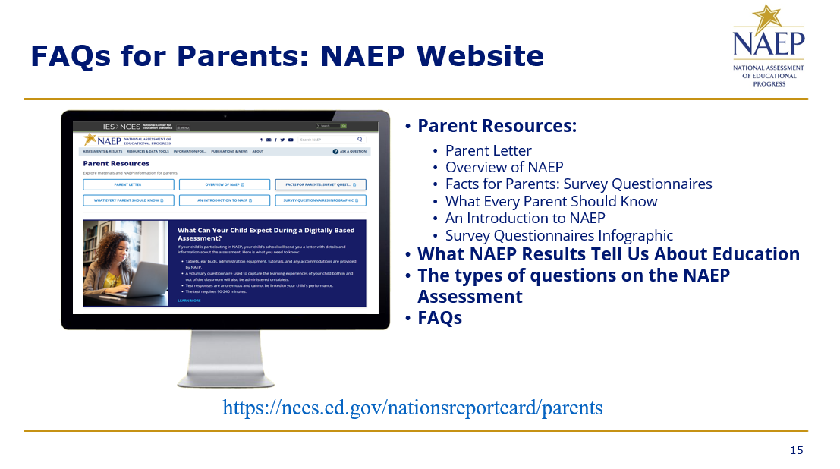
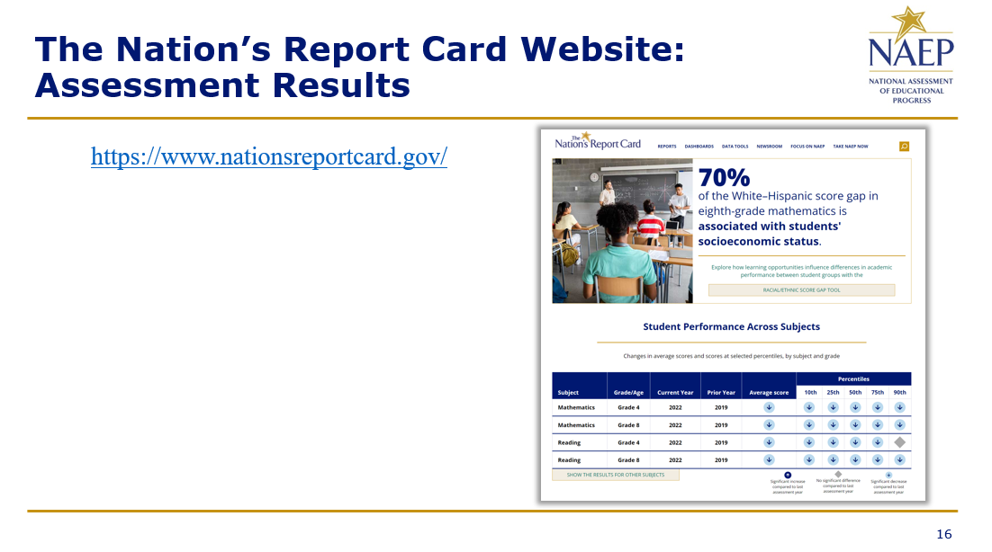

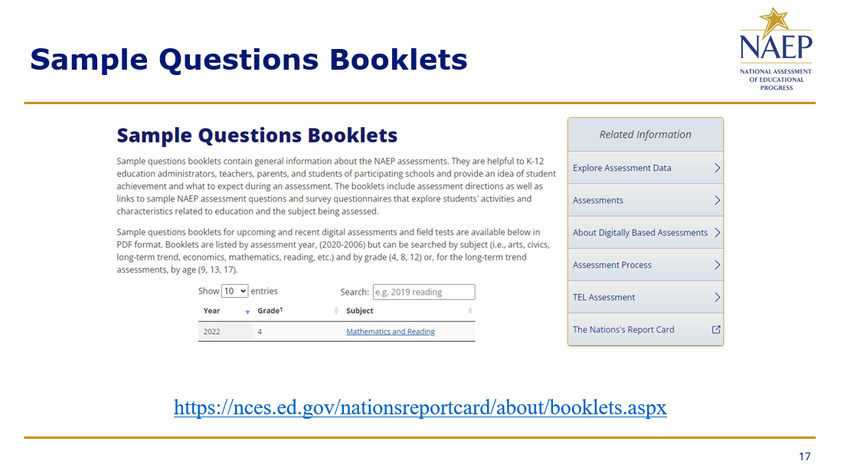
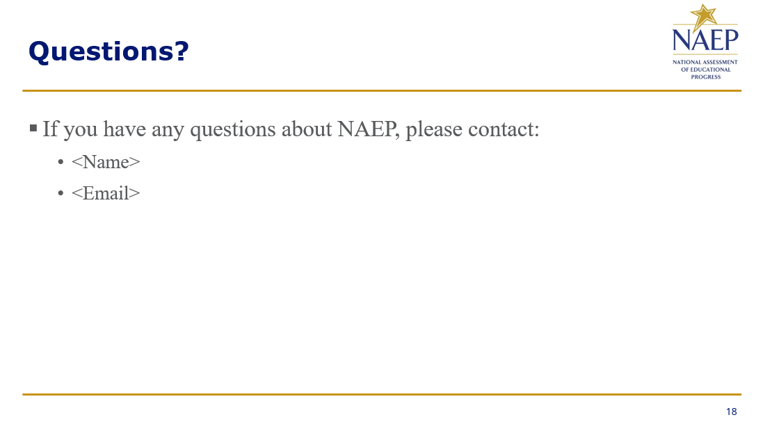

Appendix D2-57: NAEP 2025 Best Practices PowerPoint Slides: Introducing NAEP to Students
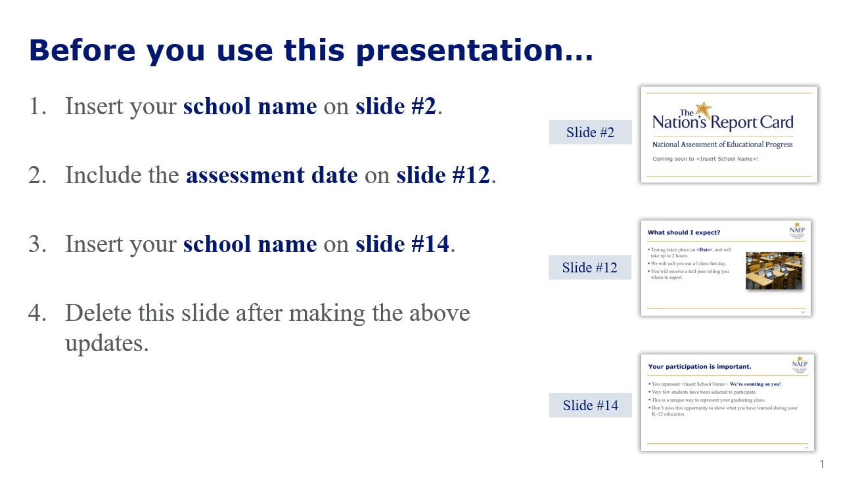
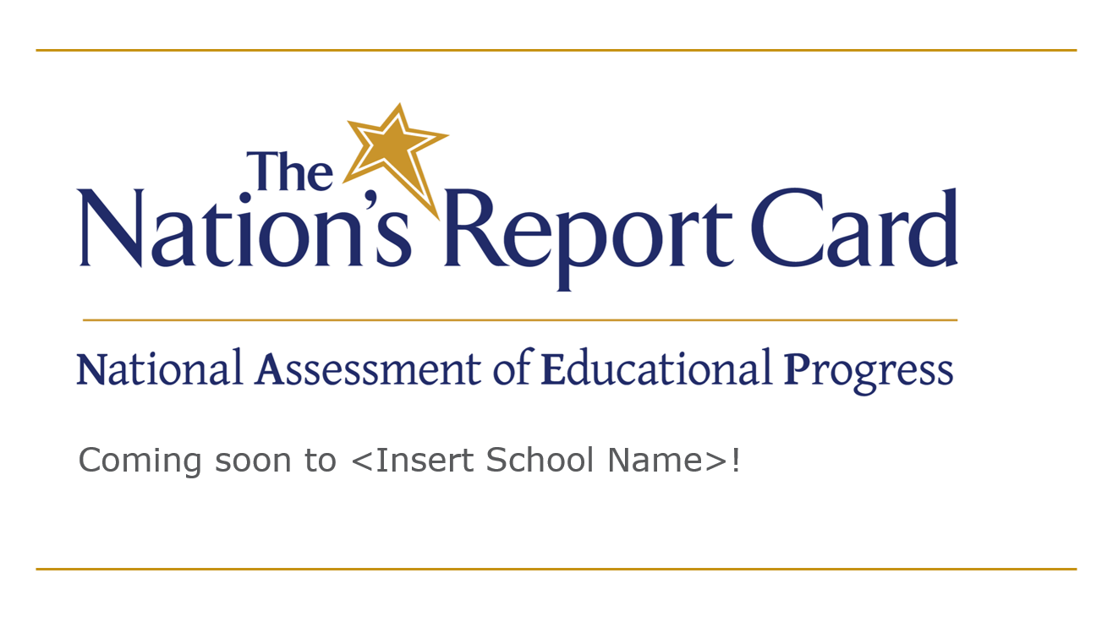

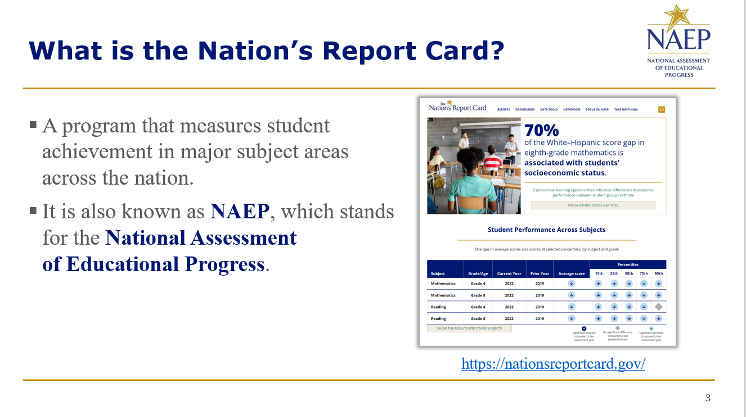
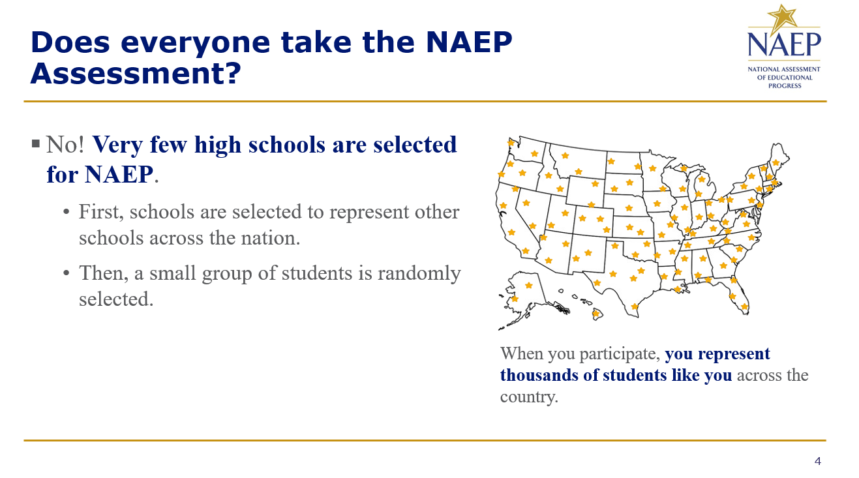

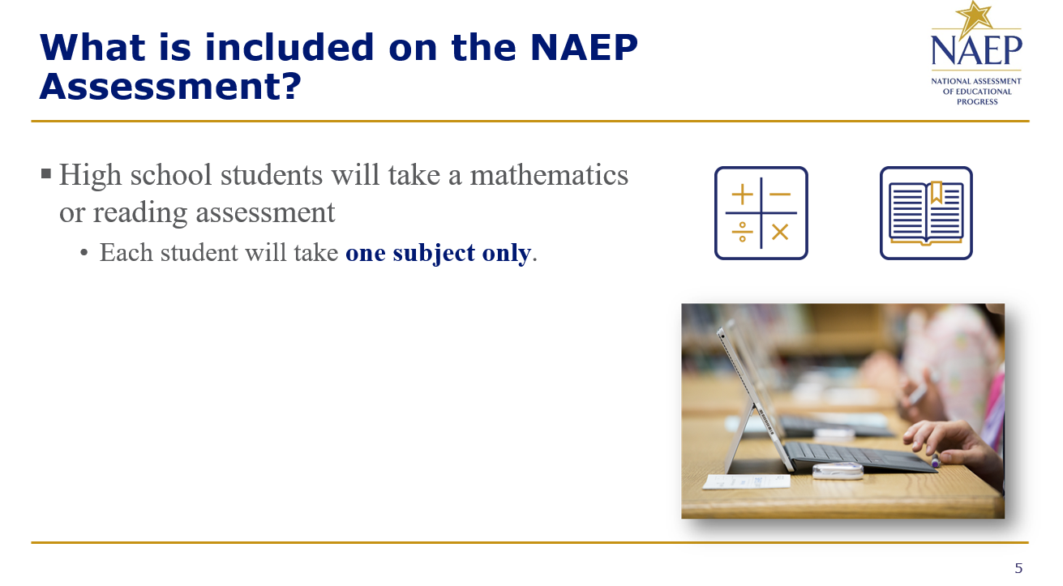
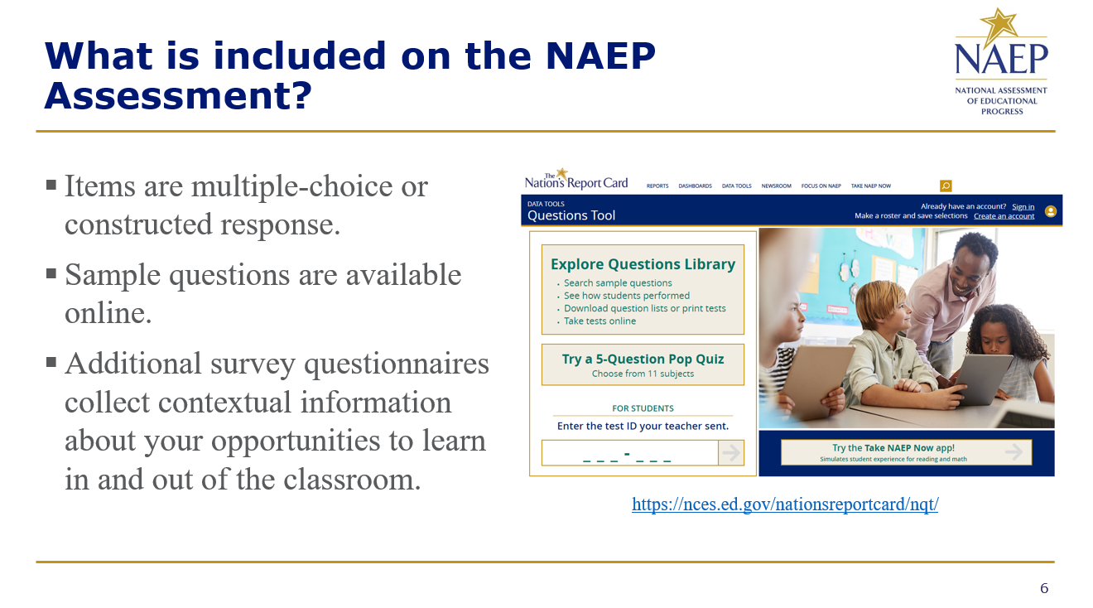

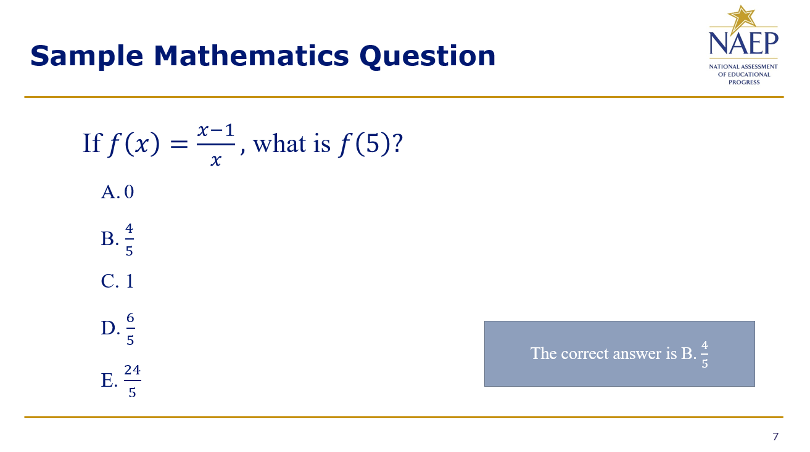
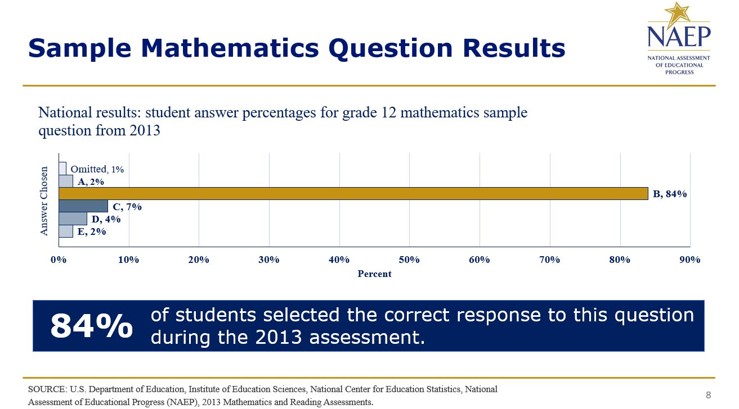

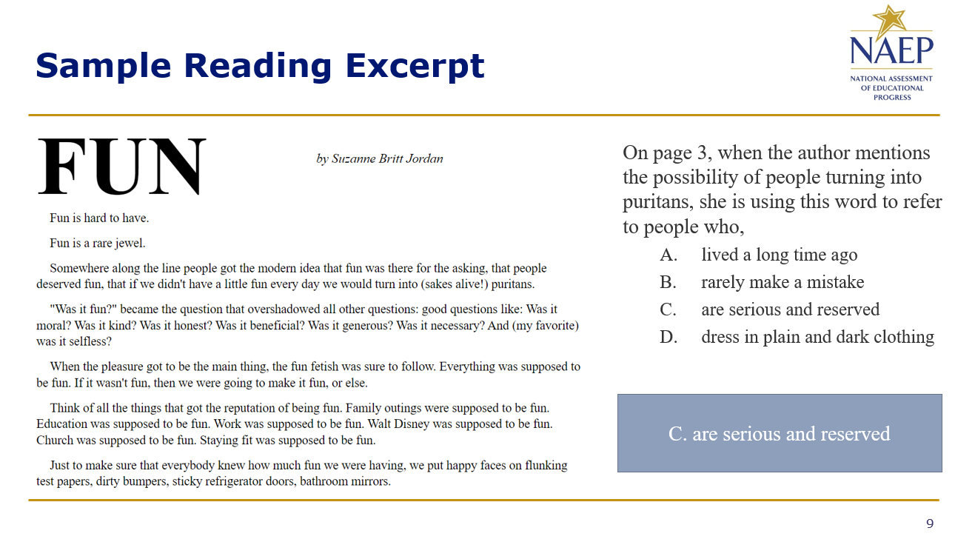
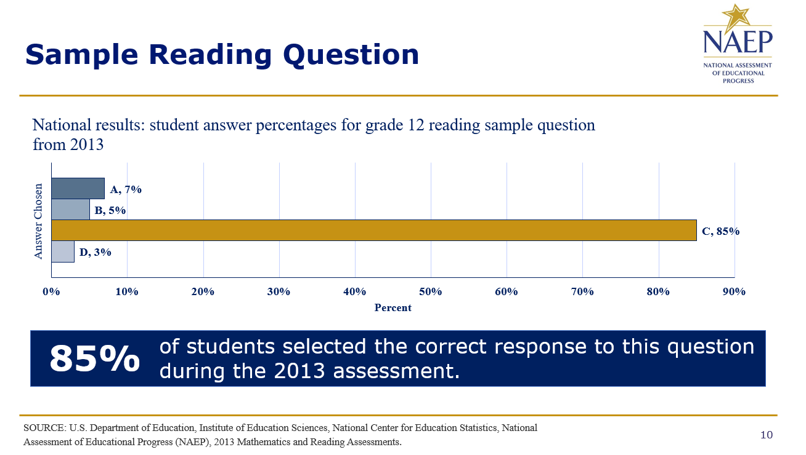

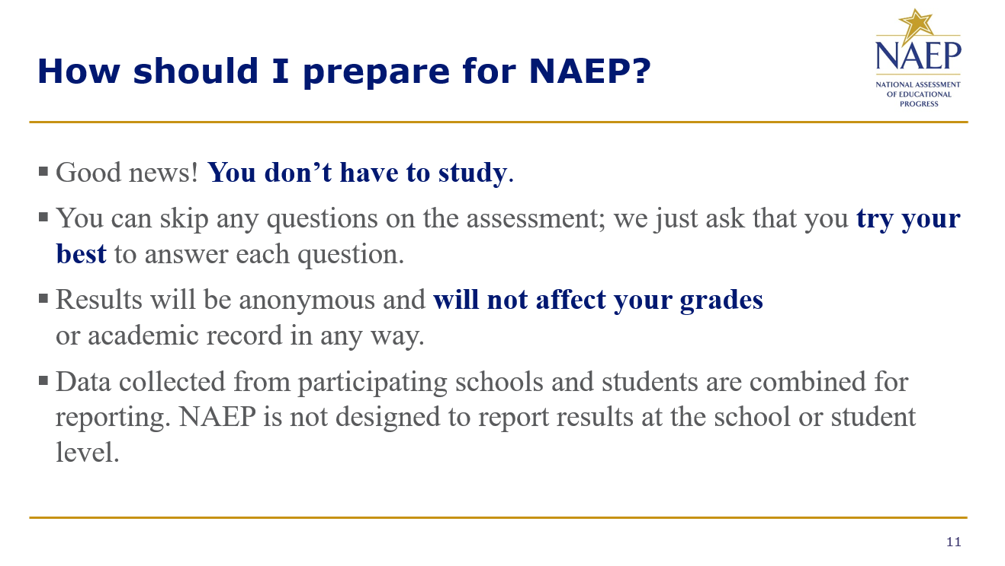
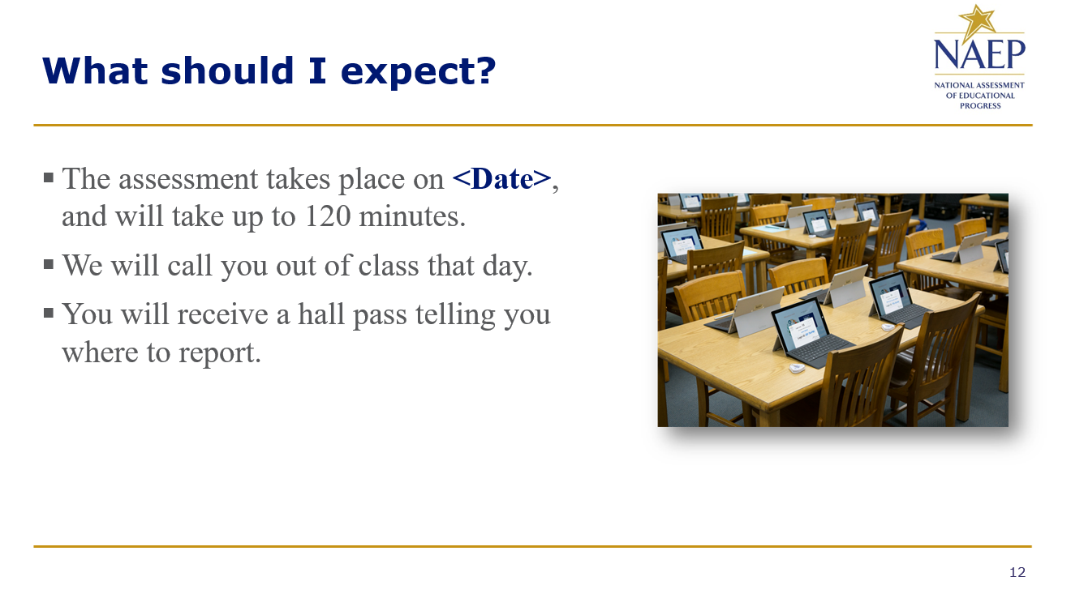

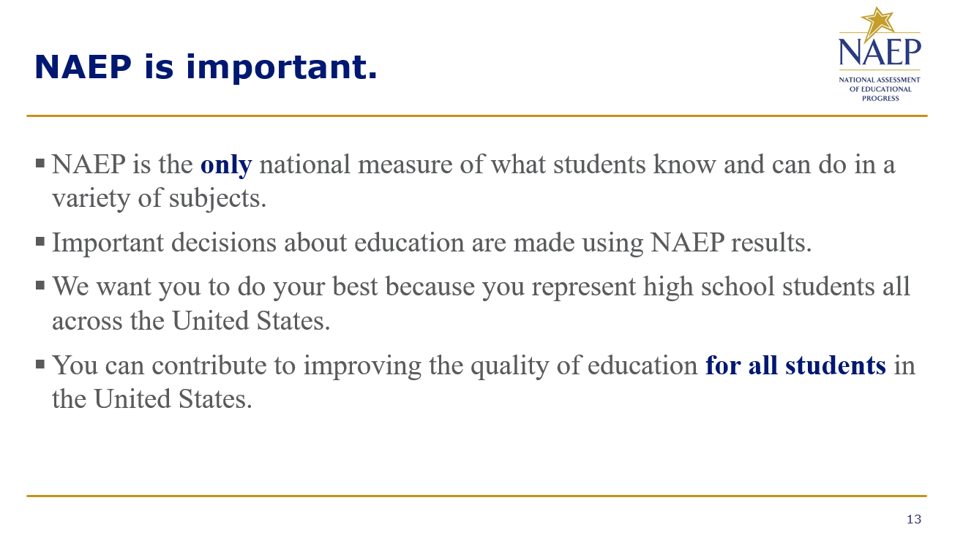
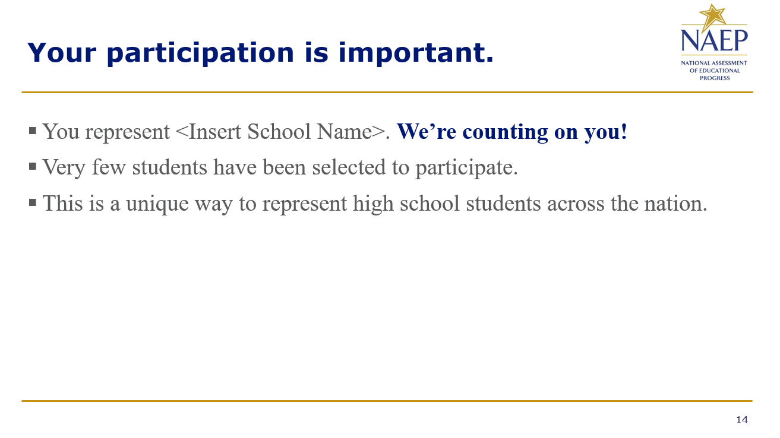

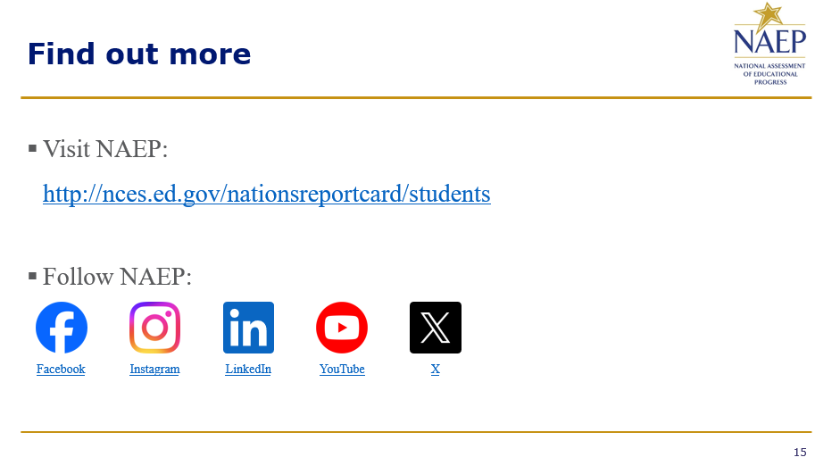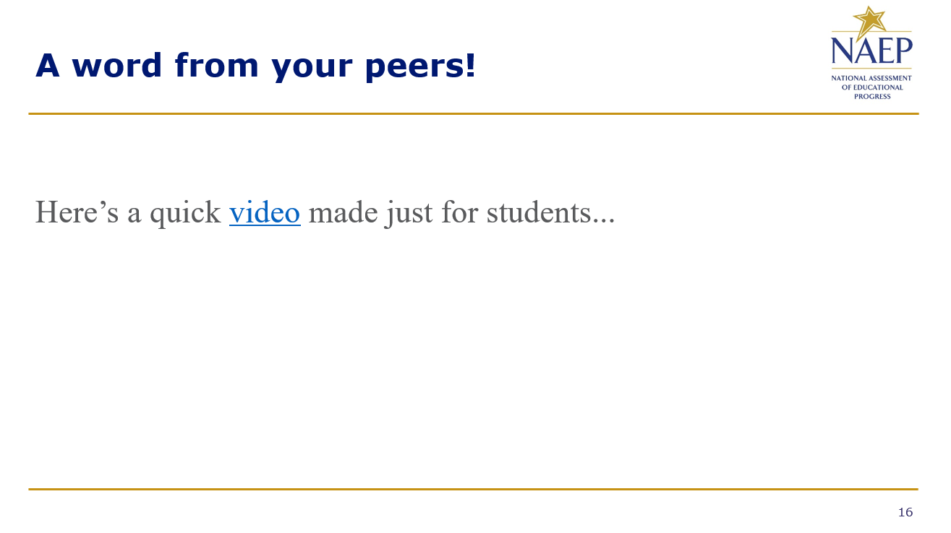

Appendix D2-58: NAEP 2025 Best Practices PowerPoint Slides: Introducing NAEP to Teachers
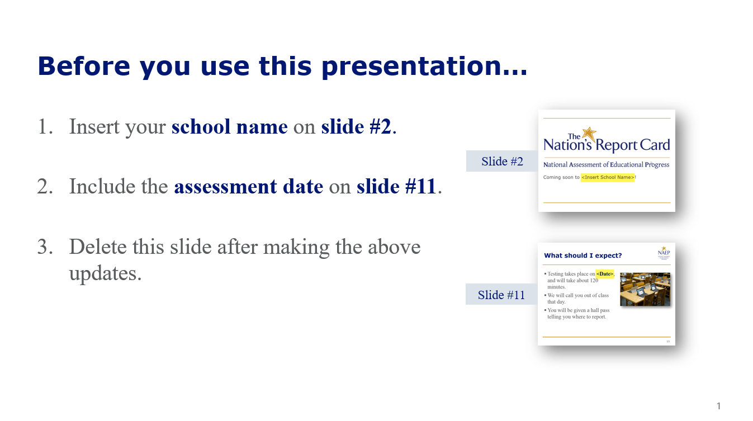
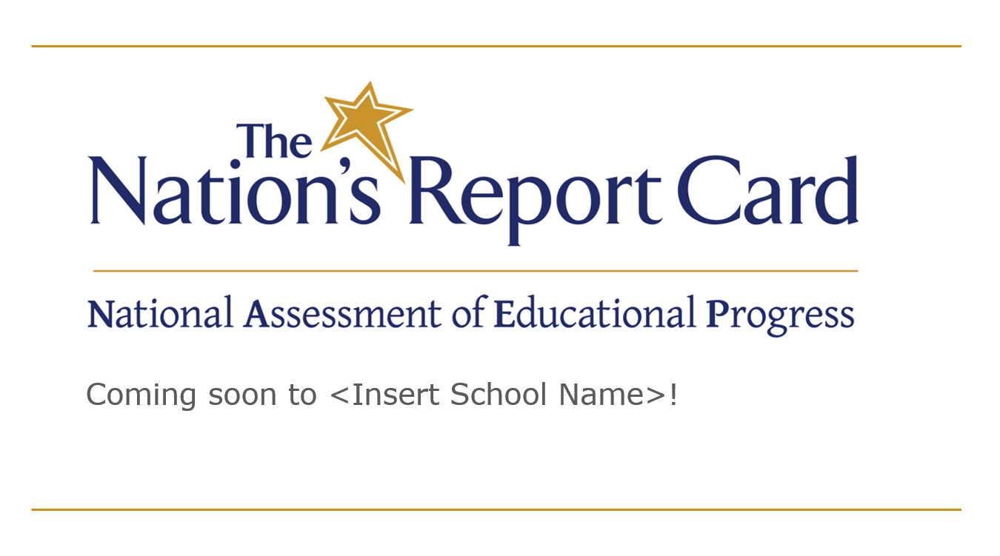

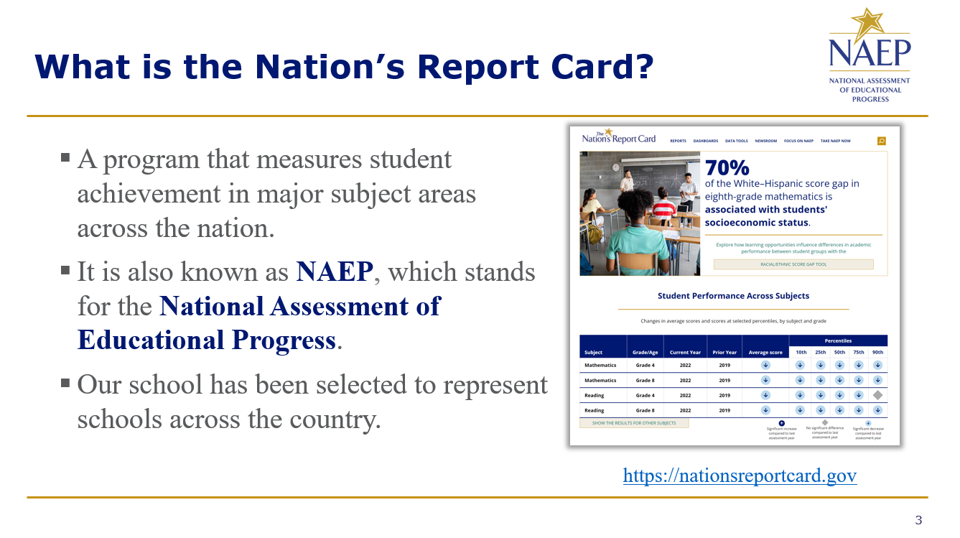
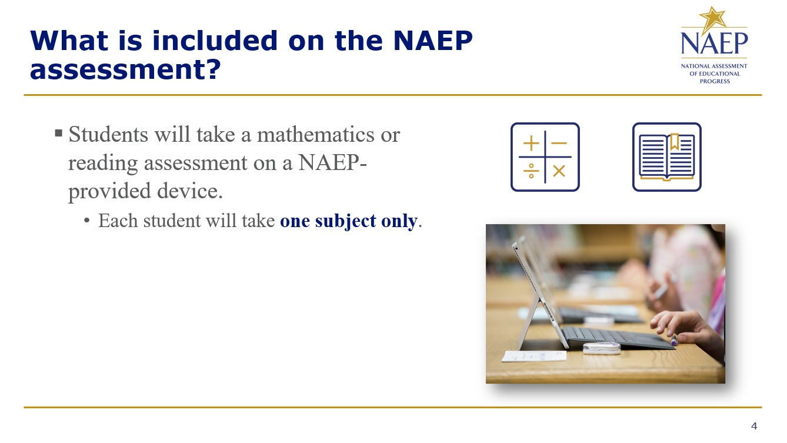

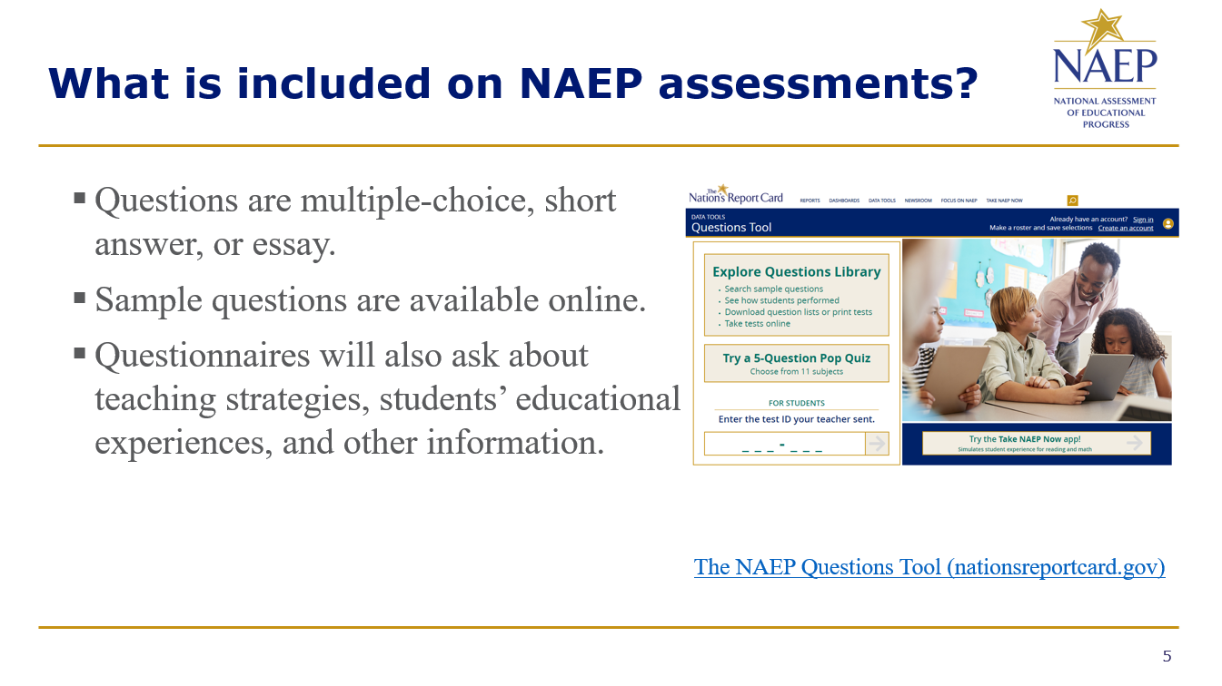
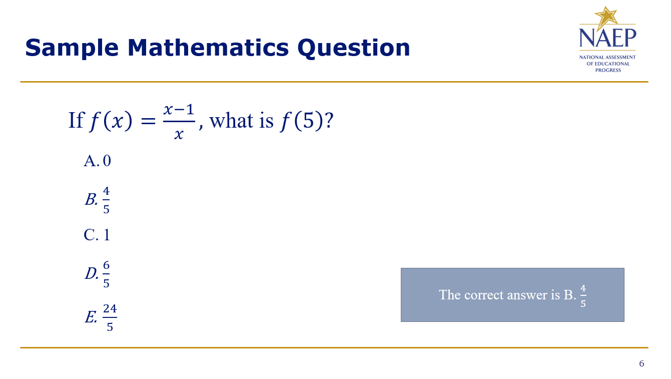

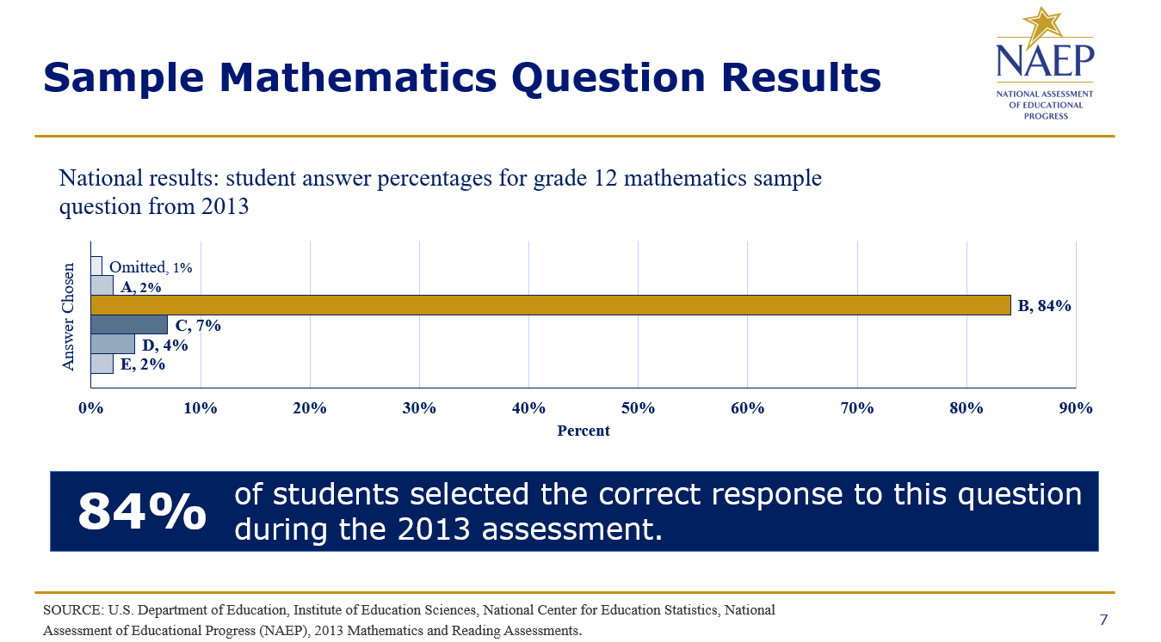
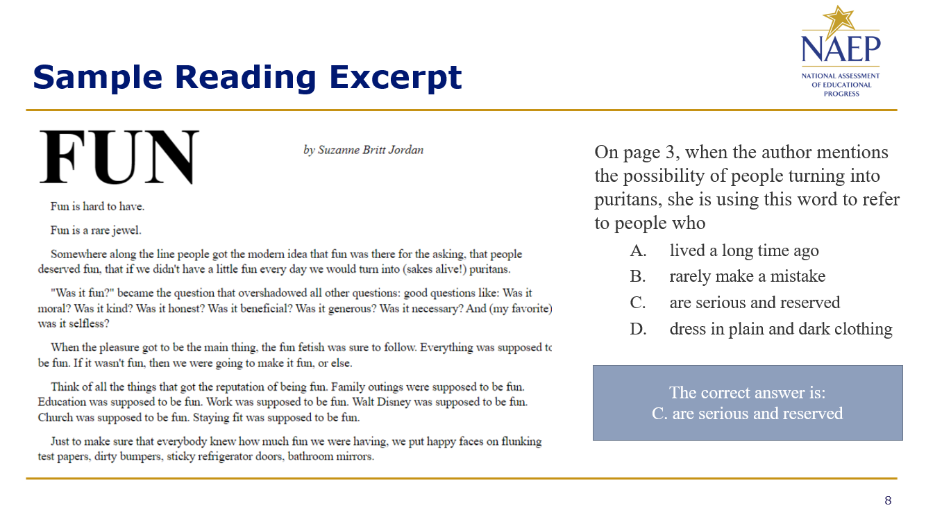

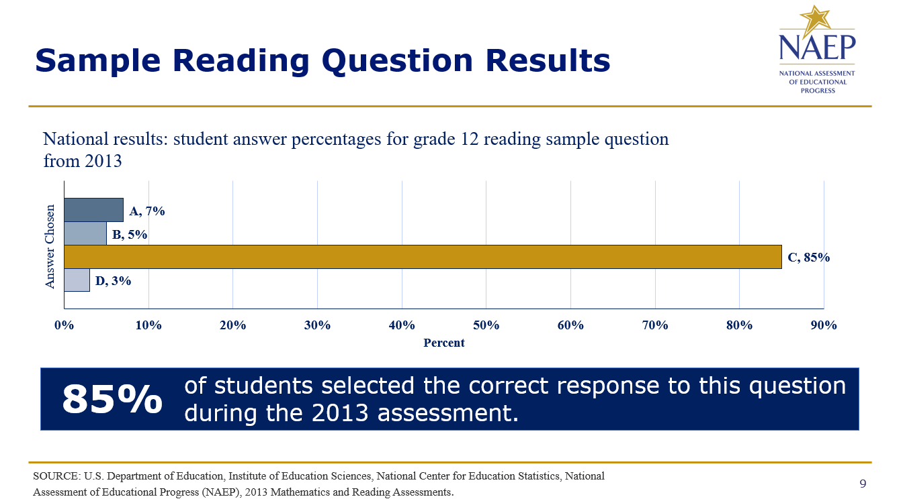
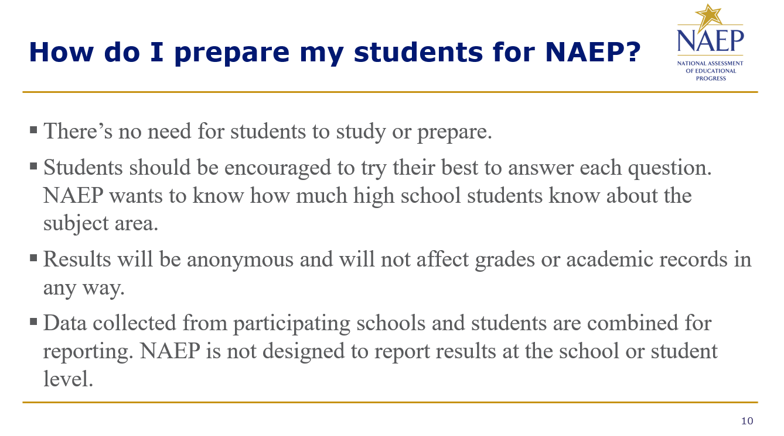

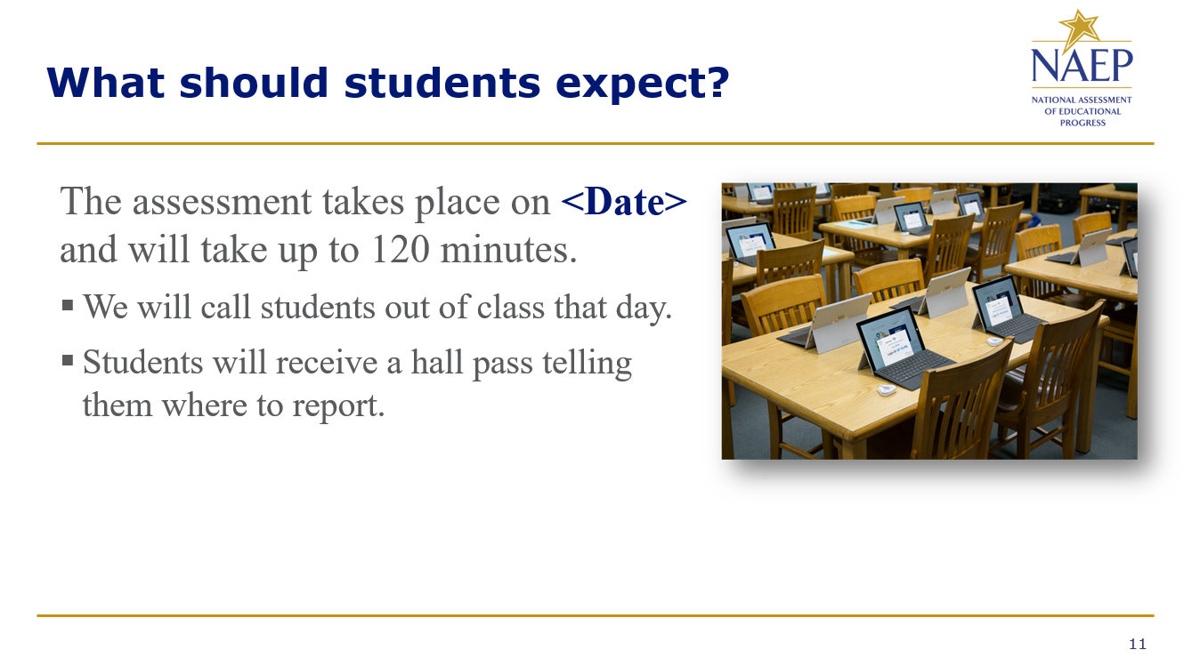
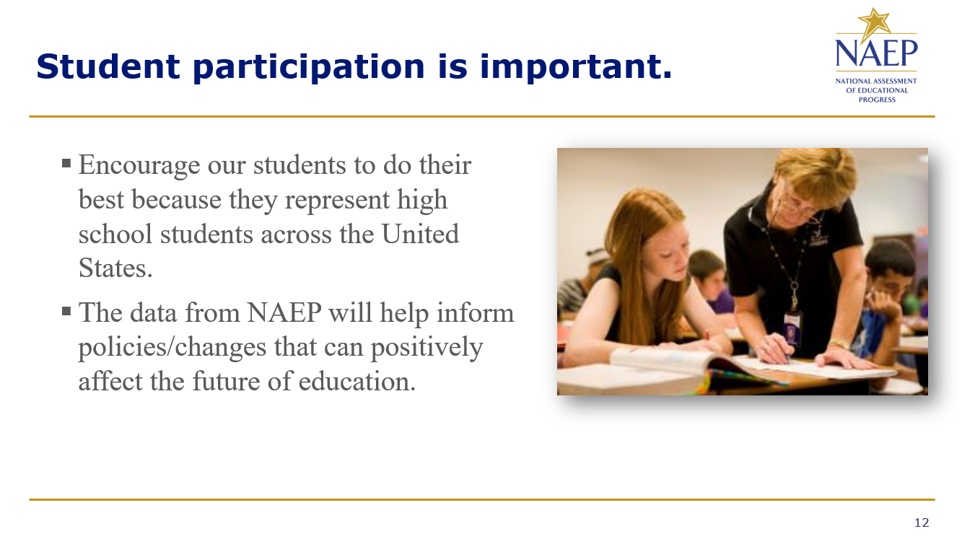

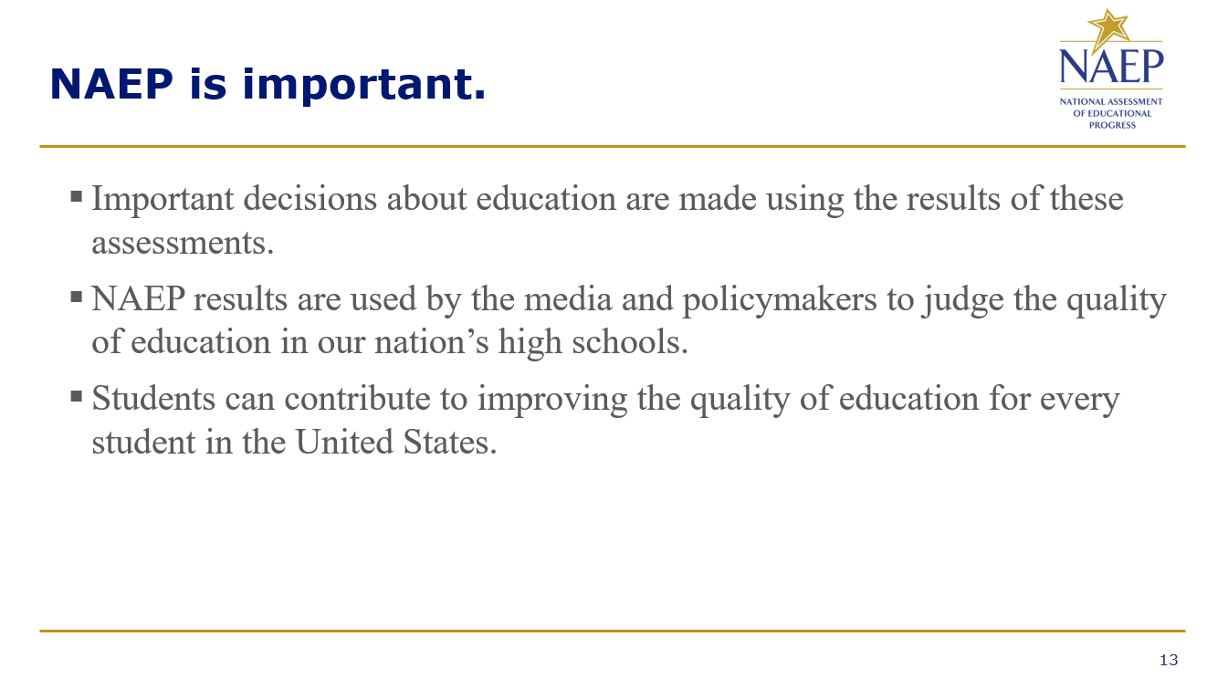
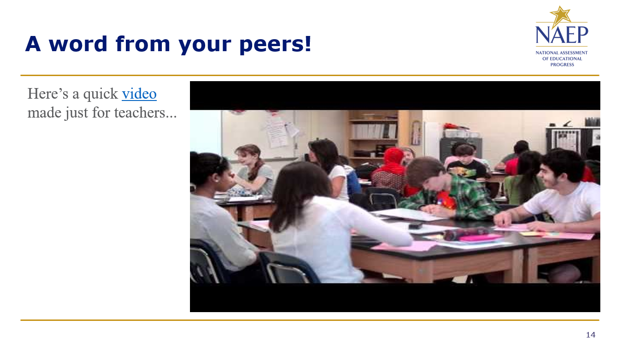

Appendix D2-59: NAEP 2025 Best Practices HTML Emails

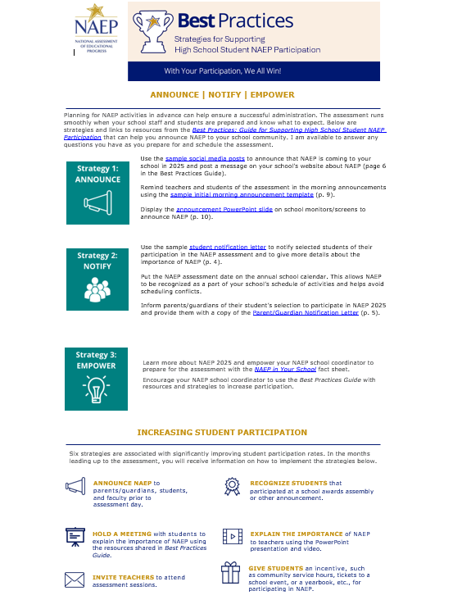
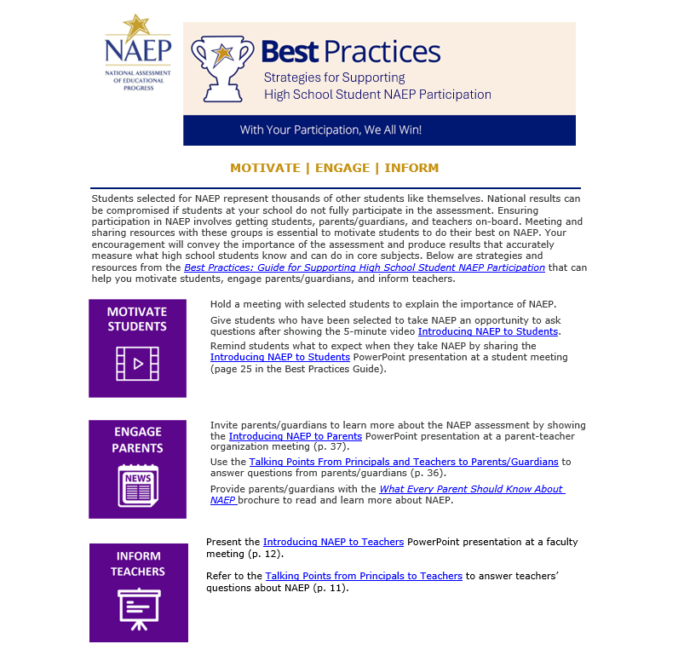

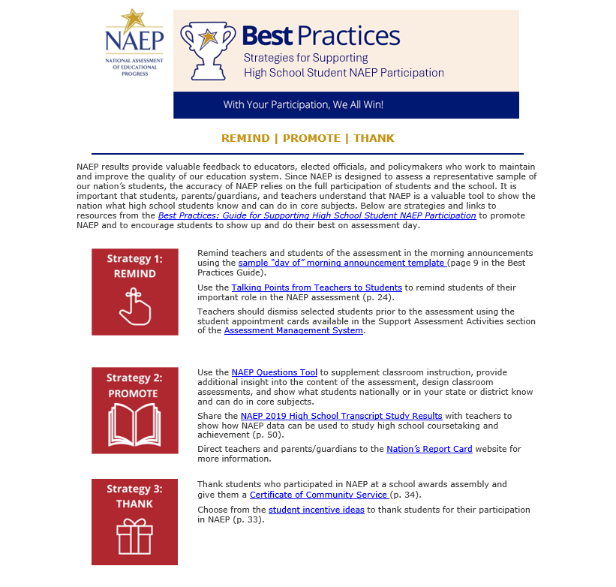

Appendix D2-60: NAEP 2025 Best Practices Talking Points Principals and Teachers to Parents

Talking Points

Principals and Teachers to Parents

What is NAEP?
The National Assessment of Educational Progress, or NAEP, is often called the gold standard of assessments and has been around since 1969. It’s called The Nation’s Report Card because it tells us how students across the country are doing. It is different from any of the other tests your child takes in school, including state assessments and even the SAT and ACT. All high school students in the United States are represented in NAEP, not just those in our state or those who plan to go on to college. As the largest national test, the results make the headlines of national and local news stories all over the country.

Why should I encourage my child to participate?
NAEP is a window into the state of our educational system and what students are learning. It opens the door for parents to understand how well children like theirs are doing compared to other students in participating large urban districts, other states, the nation, and the rest of the world. Your child has been selected to represent other students like them across the country. Not every student or every school takes the test, and your child can help to show the country just how much all our high school students know and can do in a variety of subjects. NAEP results help the President, Congress, and educators make informed decisions about how to improve our education system. Your child can make a difference by participating.

What does my child have to do?
If your child is selected to participate in the assessment, your child will need to be out of class for about 120 minutes. The results are anonymous, and your child’s grades won’t be affected. We encourage students to get a good amount of sleep the night before and to eat breakfast that morning. Please encourage your child to do their best.

Where can I find more information on NAEP?
Visit The Nation’s Report Card online at https://nces.ed.gov/nationsreportcard/ and dig deeper into topics such as
- How your child was selected
- NAEP accommodations
- NAEP scoring

Also, access the NAEP parent brochure at http://nces.ed.gov/pubsearch/pubsinfo.asp?pubid=2012469.

Appendix D2-61: NAEP 2025 Best Practices Talking Points Principals and Teachers to Students

Talking Points

Principals and Teachers to Students

What is NAEP?
NAEP stands for the National Assessment of Educational Progress. You may know it as The Nation’s Report Card. It’s the largest continuing and nationally representative assessment of what students across the country know and can do in various subjects. It is different from our state assessments and even the SAT and ACT because it represents all high school students across the country, not just those here in our state or those who plan to go on to college.

Why should I participate?
NAEP is important. The results of NAEP are released as The Nation’s Report Card and they help the President, Congress, and all our educators make decisions about how to improve our education system. By participating, you can influence those decisions and contribute to the quality of education for future students. Not all students take the assessment. You have been chosen to represent other high school students in our school, in our state, and across the country. It is important that you take part and put forth your best effort.

What do I have to do?
You will take the test with other selected students. The test takes only about 120 minutes. Students will be assessed in mathematics or reading. Each student will be assessed in only one subject. Your scores will be anonymous and will not affect your grades or academic record in anyway. Instead, they will be combined with the scores of other students to produce overall results. You should do your best because you were selected to represent students just like you across the country. When NAEP results are reported in the news, they influence the public’s opinion of what high school students across the United States know and can do in a variety of subjects.

Appendix D2-62: NAEP 2025 Best Practices Talking Points Principals to Teachers

Talking Points

Principals to Teachers

What is NAEP?
The National Assessment of Educational Progress (NAEP) is the largest continuing and nationally representative assessment that shows what students across the country know and can do in various subjects. It is different from our state assessments and even the SAT and ACT because it represents high school students across the country, not just those here in our state or those who plan to go on to college.

Why should I encourage my students to participate?
NAEP is an important and integral part of education in the United States. The results of NAEP are released as The Nation’s Report Card. Encouraging your students to participate and do their best gives them the opportunity to show how well our nation’s students perform.
- Elected officials, policymakers, and educators all use NAEP results to develop ways to improve education.
- NAEP provides a common measure of student achievement across the country.
- NAEP data can be used to compare and understand the performance of demographic groups within your state, the nation, and select urban districts.
- Teachers can use sample NAEP questions and scoring guides as a resource for understanding student performance.

What do I have to do?
Your students will need to be out of class for about 120 minutes for the assessment. You do not have to do anything to prepare for the assessment; you just need to release students from class and encourage them to do their best. Each student represents thousands of other high school students across the nation, so it is important that they participate and do their best.

Appendix D2-63: NAEP 2025 Best Practices School Announcement Templates

School Announcement

Templates

Initial morning announcement

Good morning, students and teachers. I am excited to announce that our school has been selected to participate in the 2025 National Assessment of Educational Progress, also known as NAEP. It is the largest continuing and nationally representative assessment of what students across the country know and can do in a variety of subjects. Some of our students have been selected to take assessments in mathematics and reading. To those who have been selected for this important test, you have all our support, and I have NO doubt that you will represent us well! More details to follow as we move closer to our school’s assessment day. Thank you in advance for your involvement.

Morning announcement used in the month leading up to NAEP assessment (possibly read once per week or biweekly)

Good morning, students and teachers. The countdown to the NAEP assessment is underway. We are only ___ days away from NAEP Day on [Date], when some of our students will take this important assessment to measure our nation’s educational progress. Students and teachers, if you have any questions, please reach out to ____, our School’s NAEP coordinator. Thank you.

Morning announcement used the day of the NAEP assessment
Good morning, students and teachers. NAEP Day is finally here! I would like to remind everyone that today some of our students will be participating in the National Assessment of Educational Progress. Teachers, please be sure to release those students 5 minutes before the assessment is scheduled to begin. For those students who are participating, please report to your designated locations on time. You are playing an important role in our nation’s ability to measure what students across the country are learning. What’s more, by taking the assessment, you are having an impact on the future of education for the students who follow you. Do your best and good luck. Thank you.

Appendix D2-64: NAEP 2025 Best Practices High School Incentive Ideas

Incentive Ideas

For students who participate in NAEP

Student incentives can help boost NAEP participation rates in your school. Here are some examples of strategies used by school principals over the past 10 years.

Raffle for prizes
Students who choose to participate can be entered into a raffle for a special prize. Some possible prizes are listed below.
- Free prom tickets
- Special parking space for a day or week
- Free yearbook
- Free yearbook space/page
- Gift card(s) from local businesses

Free food

Some schools offer a simple breakfast as a thank you to participating students—bagels, donuts, coffee, and orange juice. Another option is pizza for lunch or snacks for after the assessment.

Graduation pin

Create and distribute a pin or honor tag to be worn during graduation.

Appendix D2-65: NAEP 2025 Best Practices Social Media and Online Communication Sample Announcements

Social Media and Online Communication

Sample Announcements
If your school uses social media or other online communications to communicate with parents/guardians, students, and teachers, you can also use these methods to communicate the importance of the assessment to teachers and to encourage student participation. The messages on the following page are available for you to customize before posting to your school’s social media channels, school website, incorporated in school emails, or newsletters.
In addition, you can follow NAEP’s social media accounts as we regularly share resources, results, and tools for working with NAEP that states also share on their pages to prepare for participation in the assessments. Find our social media accounts below.

https://www.facebook.com/NationalAssessmentofEducationalProgress/


https://twitter.com/naep_nces?lang=en
https://www.youtube.com/user/TheNationsReportCard

Scheduling Information
Our school will have the chance to make a difference in education on [DATE]! Learn why our participation in NAEP is important at https://www.nationsreportcard.gov/.
A group of our students will represent thousands of others across the country on [DATE]! Known as The Nation’s Report Card, NAEP is the largest nationally representative and continuing assessment of what students in the United States know and can do in a variety of subjects. Learn more at https://www.nationsreportcard.gov/

We’re excited to announce our school will participate in #NAEP on [DATE]! Learn about this national assessment at https://www.nationsreportcard.gov/.

#NAEP will be administered to select students at our school on [DATE]. To learn more about the program, visit https://nces.ed.gov/nationsreportcard/students/

Something big is happening on [DATE]. A group of our students will participate in #NAEP that day! Learn more at https://nces.ed.gov/nationsreportcard/students/

Information for Teachers
Teachers, how much do you know about NAEP? What does NAEP mean for you and your students? Hear what other teachers are saying at https://nces.ed.gov/nationsreportcard/participating/schools.aspx
NAEP results help us better understand how our students are performing academically across the United States. Learn more about why participation is important at https://www.nationsreportcard.gov/focus_on_naep/participation/#/grade12
Some of our students have been selected to participate in #NAEP! Discover what other #teachers are saying at https://nces.ed.gov/nationsreportcard/participating/schools.aspx
#Teachers, do you know why our #student participation in #NAEP is important? Find out: https://www.nationsreportcard.gov/focus_on_naep/participation/#/grade12
#Teachers, find out the types of questions your #students will see on #NAEP with the NAEP Questions Tool: https://nces.ed.gov/nationsreportcard/nqt/

Information for Students
If you have been selected to take NAEP, your participation is essential for understanding what students across the country have learned in school. Curious about the types of questions you can expect to see on #NAEP? Check out the NAEP Test Yourself tool at https://www.nationsreportcard.gov/testyourself.aspx
What is NAEP? Learn the answer to this question and more at https://nces.ed.gov/nationsreportcard/students/
Curious about the types of questions you can expect to see on #NAEP? Check out the NAEP Test Yourself tool at https://www.nationsreportcard.gov/testyourself.aspx
You don’t have to study for #NAEP, but your participation is still important. Find out why: https://nces.ed.gov/nationsreportcard/students/
Information for Parents/Guardians
Parents, if your student has been selected to take NAEP, they will represent thousands of other students across the United States. Discover other reasons why participation is so important at https://nces.ed.gov/nationsreportcard/parents/
Do you have any questions about NAEP and your child’s involvement? Learn the answers to your questions and more by visiting https://nces.ed.gov/nationsreportcard/parents/
Mark your calendars, parents! Our school will participate in #NAEP on [DATE]. Learn more about the assessment at https://nces.ed.gov/nationsreportcard/parents/
If your child has been selected to participate in #NAEP, find more information about the assessment at https://nces.ed.gov/nationsreportcard/parents/
Why is your child’s participation in #NAEP important? Find out by visiting https://nces.ed.gov/nationsreportcard/parents/

Appendix D2-66: NAEP 2025 Best Practices Certificate of Community Service

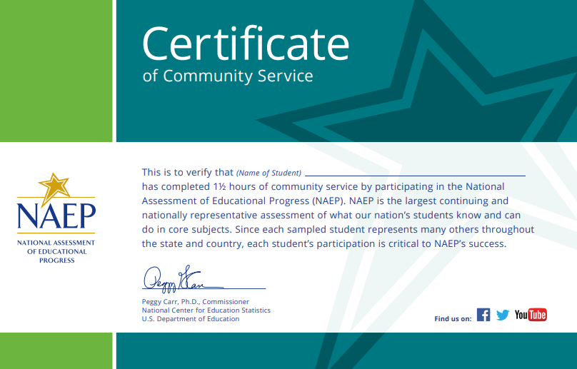

Appendix D2-67: NAEP 2025 Best Practices Certificate of Appreciation

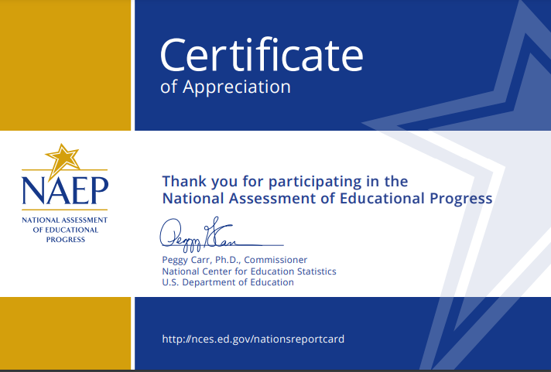
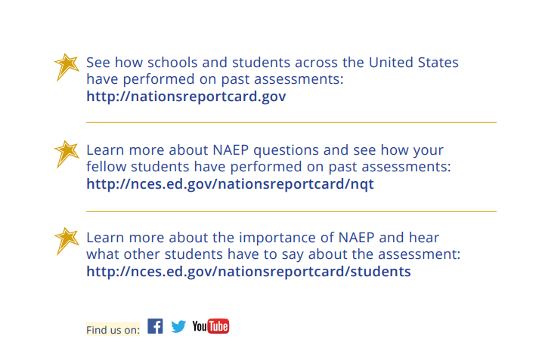

Appendix D2-68: NAEP 2025 Best Practices NAEP Data, Tools, and Resources



