NATIONAL CENTER FOR EDUCATION STATISTICS
NATIONAL ASSESSMENT OF EDUCATIONAL PROGRESS

National Assessment of Education Progress (NAEP) 2026

Appendix D

NAEP Communications and Recruitment Materials

OMB# 1850-0928 v.36

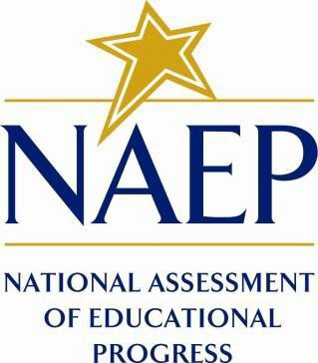

May 2025

Materials in this Appendix D include placeholders from 2024 NAEP (OMB# 1850-0928 v.31) and Appendix D2 (2025 Field Test Change Request #2, OMB# 1850-0803 v. 361). The initial 2026 communication materials are included in this submission; they are marked as (NEW). Amendment #1, scheduled for Summer 2025, will include materials that are needed for the public in August.
All communication and recruitment materials included in this Appendix will be used in both the Field Trial and 2026 Main NAEP Operational and Pilot Administration. Although the Field Trial and NAEP Administration differ in the size of the sample, dates of administration, and subjects, the content of the letters included in this document will not change among activities aside from the noted distinctions. Therefore, these recruitment materials will only be changed to account for these specific differences; to avoid duplication of documents, the materials included below refer to the “NAEP Administration” rather than also including the Field Trial. The table below shows differences in the admin windows and subjects between these activities; specific dates will be updated in Amendment #1.
Activity | Window | Grade | Subjects
Field Trial | Fall 2025 | 4, 8, 12 | Math, Reading
Main NAEP and Pilot Administration | January-March 2026 | 4, 8, 12 | Math, Reading, U.S. History/Civics

Important changes in how we collect demographic information will be reflected in the 2026 instruments when they are ready for publication and review. In March 2024, the Office of Management and Budget (OMB) announced revisions to Statistical Policy Directive No. 15: Standards for Maintaining, Collecting, and Presenting Federal Data on Race and Ethnicity (SPD 15) and published the revised SPD15 standard in the Federal Register (89 FR 22182). See Part A.7 of this package to see how NCES plans to incorporate these revisions into NAEP 2026. Further, as we were preparing this package for 30D publication, the White House issued Executive Orders “Defending
Government,” (January 20, 2025) and “Ending Radical and Wasteful Government DEI Programs and Preferencing,” (January 20, 2025). In compliance with these orders the 2024 materials below have been modified. Also, a full review of all materials is being conducted to ensure compliance with the Executive Orders. The revised materials will be included in the next Amendments to this package. No collections of this information will take place before the submission and approval of Amendment #2.

Table of Contents
Appendix D-1: NAEP 2024 Save-the-Date 8
Appendix D-2: NAEP 2024 Assessment Details Letters 10
Appendix D-3: NAEP 2024 in Your Private School 2024 19
Appendix D-4: NAEP 2024 in Your School 2024 29
Appendix D-5: NAEP 2024 Parent/Guardian English and Spanish Notification Letters, Private School 42
Appendix D-6: NAEP 2024 Parent/ Guardian English and Spanish Notification Letters, Public Schools 51
Appendix D-7: NAEP 2024 Preassessment Materials 62
Appendix D-8: NAEP 2024 Preassessment Email 63
Appendix D-9: NAEP 2024 Preassessment Responsibilities Guide 65
Appendix D-10: NAEP 2024 Before Assessment Day Checklist Email to Technical Coordinators 68
Appendix D-11: NAEP 2024 Internet Connectivity Survey Video Script English and Spanish 70
Appendix D-12: NAEP 2024 Assessment Day Feedback Email Template 76
Appendix D-13: NAEP 2024 Facts for Teachers, Public and Private Schools 78
Appendix D-14: NAEP 2024 Overview Brochure 90
Appendix D-15: NAEP 2024 Overview Brochure, Private School 95
Appendix D-16: NAEP 2024 Private School Factsheet 97
Appendix D-17: NAEP 2024 Sample Email from Catholic Diocese to Catholic School Administrator 100
Appendix D-18: NAEP 2024 Sample Letter from Catholic Diocese to Catholic School Administrator 102
Appendix D-19: NAEP 2024 State Coordinator to District Assessment Coordinator -Technology Notification 105
Appendix D-20: NAEP 2024 Technology Notification Letters 108
Appendix D-21: NAEP 2024 Technology Team Responsibilities Guide 117
Appendix D-22: NAEP 2024 Translation Notice 121
Appendix D-23: NAEP 2024 School Based Equipment (SBE) Staff Survey 123
Appendix D-24: NAEP 2024 Assessment Details Notification Principal to School Coordinator Letter 128
Appendix D-25: NAEP 2024 Public School Coordinator responsibilities 129
Appendix D-26: NAEP 2024 Private School Coordinator Responsibilities 130
Appendix D-27: NAEP 2024 Private School Video Script (Approved v.30) 131
Appendix D-28: NAEP 2024 Operational and Pilot Technical Fact Sheets 135
Appendix D-29: NAEP 2024 Best Practices Materials 148
Appendix D-30: NAEP 2024 Best Practices Initial Mailing 149
Appendix D-31: NAEP 2024 Best Practices Emails 152
Appendix D-32: NAEP 2024 Best Practices Notification Letter for Students 156
Appendix D-33: NAEP 2024 Best Practices Social Media and Online Communications 158
Appendix D-34: NAEP 2024 Storyboard for Introduction to Best Practices Video Script 162
Appendix D-35: NAEP 2024 Introducing NAEP to Students 164
Appendix D-36: NAEP 2024 Introducing NAEP to Teachers 173
Appendix D-37: NAEP 2024 Introducing NAEP to Parents 182
Appendix D-38: NAEP 2024 Introducing NAEP to Students Slides 192
Appendix D-39: NAEP 2024 Introducing NAEP to Parents Slides 202
Appendix D-40: NAEP 2024 Introducing NAEP to Teachers Slides 212
Appendix D-41-PR (Spanish version): NAEP 2024 Facts for Districts, Puerto Rico 221
Appendix D-42-S-PR (Spanish version): NAEP 2024 Facts for Principals, Puerto Rico 225
Appendix D-43-S-PR (Spanish version): NAEP 2024 Notification Letter from Chief State School Officer to District Superintendent, Puerto Rico 231
Appendix D-44-S-PR (Spanish version): NAEP 2024 and Pilot 2024 Initial Notification Letters from NAEP State Coordinator to School Principal, Puerto Rico 234
Appendix D-45-S-PR (Spanish version): NAEP 2024 Assessment Details Letter NAEP State Coordinator to School Coordinators, Puerto Rico 239
Appendix D-46-S-PR (Spanish version): NAEP 2024 and Pilot 2024 in Your School 242
Appendix D-47-S-PR (Spanish version): NAEP 2024 and Pilot 2024 Parent /Guardian Notification Letter, Public School–Puerto Rico 249
Appendix D-48-S-PR (Spanish version): NAEP 2024 Save the Date Letter 252
Appendix D-49-S-PR (Spanish version): NAEP 2024 Assessment Details NAEP State Coordinator to Principal, Puerto Rico 254
Appendix D-50-S-PR (Spanish version): NAEP 2024 District Coordinator Technology Notification–Puerto Rico 257
Appendix D-51-S-PR (Spanish version): NAEP 2024 Facts for Teachers–Puerto Rico 260
Appendix D-52-S-PR (Spanish version): NAEP 2024 and Pilot 2024 Parent /Guardian Notification Letter–Puerto Rico 266
Appendix D-53-S-PR (Spanish version): NAEP 2024 Technology Notification Letters–Puerto Rico 268
Appendix D-54-S-PR (Spanish version): NAEP 2024 Technology Team Responsibilities–Puerto Rico 277
Appendix D-55-S-PR (Spanish version): NAEP 2024 Operational and Pilot Technical Fact Sheet Puerto Rico 281
Appendix D-56: NAEP 2025 Field Test Overview Brochure (English and PR Spanish) 288
Appendix D-57: NAEP 2025 Field Test Facts for Districts (PR Spanish) 291
Appendix D-58: NAEP 2025 Field Test CSSO To District Superintendent Letter (PR Spanish) 295
Appendix D-59: NAEP 2026 Field Test-Initial School Technology Survey Notification Letter (English) (NEW) 298
Appendix D-60: NAEP 2025 Field Test-Initial School Technology Survey Notification Letter (Spanish) 301
Appendix D-61: NAEP 2025 Parent-Guardian Notification Letter 304
Appendix D-62: NAEP 2025 Parent-Guardian Notification Letter, Private Schools 306
Appendix D-63: NAEP 2025 Parent-Guardian Notification Letter, Puerto Rico 308
Appendix D-64: NAEP 2025 Parent-Guardian Notification Letter, Bilingual Spanish Public Schools 310
Appendix D-65: NAEP 2025 Parent-Guardian Notification Letter, Bilingual Spanish Private Schools 312
Appendix D-66: NAEP 2026 Administration Model Assignment (NEW) 314
Appendix D-67: NAEP 2025 Assessment Details Letter to Principal, School Device Model 316
Appendix D-68: NAEP 2025 Assessment Details Letter to Principal, School Device Model, Puerto Rico 320
Appendix D-69: NAEP 2025 Assessment Details Letter to Principal, NAEP Device Model 324
Appendix D-70: NAEP 2025 Assessment Details Letter to Principal, NAEP Device Model, Puerto Rico 327
Appendix D-71: NAEP 2025 Assessment Details Letter to School Coordinator School Device Model 331
Appendix D-72: NAEP 2025 Assessment Details Letter to School Coordinator School Device Model, Puerto Rico 335
Appendix D-73: NAEP 2025 Assessment Details Letter to School Coordinator NAEP Device Model 339
Appendix D-74: NAEP 2025 Assessment Details Letter to School Coordinator NAEP Device Model, Puerto Rico 342
Appendix D-75: NAEP 2025 NAEP in your School, School Device-Grades 4, 8, and 12 Mathematics and Reading 345
Appendix D-76: NAEP 2025 NAEP in your School-School Device, School Device-Puerto Rico 350
Appendix D-77: NAEP 2025 NAEP in your School-NAEP Device, Grades 4, 8, and 12 Mathematics and Reading 355
Appendix D-78: NAEP 2025 NAEP in your School-NAEP Device, Puerto Rico 359
Appendix D-79: NAEP 2025 NAEP in your School (Catholic Schools)-Grades 4, 8, and 12 Mathematics and Reading 364
Appendix D-80: NAEP 2025 Facts for Teachers 368
Appendix D-81: NAEP 2025 Facts for Teachers, Puerto Rico 374
Appendix D-82: NAEP 2025 Preassessment Responsibilities Guide, School Device Model 380
Appendix D-83: NAEP 2025 Preassessment Responsibilities Guide, School Device Model, Puerto Rico 385
Appendix D-84: NAEP 2025 Preassessment Responsibilities Guide, NAEP Device Model 390
Appendix D-85: NAEP 2025 Preassessment Responsibilities Guide, NAEP Device Model, Puerto Rico 394
Appendix D-86: NAEP 2025 Assessment Date Notification and Preassessment Email, School Device Model 398
Appendix D-87: NAEP 2025 Assessment Date Notification and Preassessment Email, School Device Model, Puerto Rico 401
Appendix D-88: NAEP 2025 Assessment Date Notification and Preassessment Email, NAEP Device Model 404
Appendix D-89: NAEP 2025 Assessment Date Notification and Preassessment Email, NAEP Device Model, Puerto Rico 406
Appendix D-90: NAEP 2026 eNAEP Download Center Notification (NEW) 408
Appendix D-91: NAEP 2025 Application Installer Notification, Puerto Rico 411
Appendix D-92: NAEP 2025 School Staff Assistance email template, Technology Support 412
Appendix D-93: NAEP 2025 School Staff Assistance email template, Technology Support, Puerto Rico 415
Appendix D-94: NAEP 2025 Email to school staff person identified to assist with Classroom Management 417
Appendix D-95: NAEP 2025 Email to school staff person identified to assist with Classroom Management, Puerto Rico 419
Appendix D-96: NAEP 2025 Email to school staff person identified to assist with Technology and Classroom Management 421
Appendix D-97: NAEP 2025 Inclusion Guidelines for English Learners 424
Appendix D-98: NAEP 2025 Inclusion Guidelines for English Learners, Puerto Rico 429
Appendix D-99: NAEP 2025 Inclusion Guidelines for Students with Disabilities 435
Appendix D-100: NAEP 2025 Inclusion Guidelines for Students with Disabilities, Puerto Rico 441
Appendix D-101: NAEP 2025 Preassessment Responsibilities Guide, Private School Device Model 446
Appendix D-102: NAEP 2025 Instructions for preparing and importing a student excel file 450
Appendix D-103: NAEP 2026 eNAEP Download Center (NEW) 456
Appendix D-104: NAEP 2026 eNAEP Download Center, Spanish (NEW) 511
Appendix D-105: NAEP 2026 eNAEP Download Center – Maintenance Page in English (NEW) 565
Appendix D-106: NAEP 2026 eNAEP Download Center – Maintenance Page in Spanish (NEW) 567
Appendix D-107: NAEP 2026 eNAEP Download Center – Page Not Found Error Page in English (NEW) 569
Appendix D-108: NAEP 2026 eNAEP Download Center – Page Not Found Error Page in Spanish (NEW) 570
Appendix D-109: NAEP 2025 Best Practices Materials 571
Appendix D-110: NAEP 2025 Best Practices Introduction 572
Appendix D-111: NAEP 2025 Best Practices Notification 575
Appendix D-112: NAEP 2025 Best Practices Parent/Guardian Notification Letter 577
Appendix D-113: NAEP 2025 Best Practices Storyboard for Introduction Video 579
Appendix D-114: NAEP 2025 Best Practices 2019 Infographic Grade 12 Mathematics and Reading Results 581
Appendix D-115: NAEP 2025 Best Practices PowerPoint Slide TV Monitor Announcement 585
Appendix D-116: NAEP 2025 Best Practices PowerPoint Slides: Introducing NAEP to Parents 587
Appendix D-117: NAEP 2025 Best Practices PowerPoint Slides: Introducing NAEP to Students 597
Appendix D-118: NAEP 2025 Best Practices PowerPoint Slides: Introducing NAEP to Teachers 606
Appendix D-119: NAEP 2025 Best Practices HTML Emails 615
Appendix D-120: NAEP 2025 Best Practices Talking Points Principals and Teachers to Parents 619
Appendix D-121: NAEP 2025 Best Practices Talking Points Principals and Teachers to Students 621
Appendix D-122: NAEP 2025 Best Practices Talking Points Principals to Teachers 623
Appendix D-123: NAEP 2025 Best Practices School Announcement Templates 625
Appendix D-124: NAEP 2025 Best Practices High School Incentive Ideas 627
Appendix D-125: NAEP 2025 Best Practices Social Media and Online Communication Sample Announcements 629
Appendix D-126: NAEP 2025 Best Practices Certificate of Community Service 633
Appendix D-127: NAEP 2025 Best Practices Certificate of Appreciation 635
Appendix D-128: NAEP 2025 Best Practices NAEP Data, Tools, and Resources 637
Appendix D-129: NAEP 2026 Facts for Districts (NEW) 640
Appendix D-130: NAEP 2026 Facts for Principals (NEW) 644
Appendix D-131: NAEP 2026 Notification Letter to Chief State Officer to District Superintendent (NEW) 654
Appendix D-132: NAEP 2026 Initial Notification Letters from NAEP State Coordinator to School Principal (NEW) 657
Appendix D-133: NAEP 2026 Initial Notification Letters from NAEP State Coordinator to School Principal, Pilots (NEW) 659
Appendix D-134: NAEP 2026 State Guide (NEW) 661
Appendix D-135: NAEP 2026 TUDA Guide to NAEP Participation (NEW) 666
Appendix D-136: NAEP 2026 Endorsement Letters to Private School Administrator (NEW) 671

Appendix D-1: NAEP 2024 Save-the-Date

NAEP 2024 Save-the-Date Letter From
NAEP STATE COORDINATOR TO SCHOOL PRINCIPAL – For All Sampled Schools
Red text should be customized before mail merge; highlighted text represents mail merge fields

Save the date! NAEP is coming on assessment date.

Dear Principal:

In May, I notified you that school name was selected to participate in the 2024 administration of the National Assessment of Educational Progress (NAEP). This letter includes the scheduled assessment date for your school.
Your school’s grade (4 or 8 or 12) students will take the assessment on (assessment date). Please place the NAEP assessment date on your 2023–2024 school calendar. Approximately (estimated student sample) students from your school will be selected to participate, but that number will vary depending on actual fall 2023 student enrollment numbers. The assessment will take about 120 minutes for most students, including transition time, directions, and completion of a survey questionnaire. NAEP representatives will provide significant support to your school. They will administer the assessment and bring all necessary materials and equipment.

If you have questions or a conflict with the scheduled assessment date, please contact me at telephone number or email address by date. I will send you more information about preparing for the assessment at the beginning of the school year.

NAEP is a common measure of student achievement across the country and is used to inform education policies and practices. Schools and students have an important role in ensuring that NAEP results are accurate. Our goal is 100 percent participation in this important assessment, and we know that we can count on you to help us reach it.

Sincerely,

NAEP State Coordinator

CC: District Test Coordinator

The National Center for Education Statistics (NCES) conducts the National Assessment of Educational Progress to evaluate federally supported education programs. All of the information you provide may only be used for the purposes of research, statistics, and evaluation under the Education Sciences Reform Act of 2002 (ESRA; 20 U.S.C. § 9543) and may not be disclosed, our used, in identifiable form for any other purpose except as required by law. Every NCES employee as well as every NCES agent, such as contractors and NAEP coordinators, has taken an oath and is subject to a jail term of up to 5 years, a fine of $250,000, or both if he or she willfully discloses ANY identifiable information about you. Electronic submission of your information will be monitored for viruses, malware, and other threats by Federal employees and contractors in accordance with the Cybersecurity Enhancement Act of 2015.

Appendix D-2: NAEP 2024 Assessment Details Letters

NAEP 2024 Assessment Details Notification
NAEP STATE COORDINATOR TO SCHOOL COORDINATOR: For Grades 4, 8, and 12 Mathematics and Reading
National, State and TUDA: Operational and Pilot Samples
Red text should be customized before mail merge; highlighted text represents mail merge fields.

Dear [school coordinator name]:
Welcome to the 2024 National Assessment of Educational Progress (NAEP). I look forward to working with you to coordinate NAEP in your school. A sample of your grade [4, 8, or 12] students will take mathematics and reading assessments on [assessment date]. Each student will answer questions in only one subject.

As the school coordinator, you will have a number of responsibilities critical to making NAEP a success. The NAEP Assessment Management System (AMS) website is designed to assist you with these responsibilities. The timeline below indicates when you will need to complete specific assessment planning tasks in the NAEP AMS.

- August–September: Work with school or district technology staff as necessary to add the domain westatstudies.com to the safe senders list to help ensure receipt of important email messages. Log in and set up your NAEP AMS account using the link provided in the registration email from DoNotReply-NAEP@westatstudies.com. Answer the questions in the School Information section by [date].
- October–November: Prepare and submit a list of all grade [4, 8, or 12] students electronically by [date]. Please see the enclosed instructions.
- December–January: An assigned NAEP representative, who is responsible for administering the assessment, will contact you in December to introduce themselves and monitor the scheduling of an Assessment Planning Meeting. The NAEP representative can review how to complete the NAEP planning tasks outlined below upon request. Be sure to complete all assessment preparation activities before the scheduled Assessment Planning Meeting.
    - Review the student sample and identify any students who cannot take the assessment. Also, review demographic information and update any information that is missing or inaccurate.
    - Provide information about students with disabilities (SD) and English learners (EL) so that assessment administrators can plan appropriate testing accommodations. You can request access for your school’s SD and EL specialists so that they can assist with this task. Please note that school staff may need to assist with certain accommodations (e.g., cueing to stay on task, scribing).
    - Notify parents/guardians that their children were selected for the assessment. A sample parent/guardian notification letter is enclosed and will be available on the NAEP AMS website for you to print on your school letterhead.
    - Update the student list by adding any new students who have enrolled since the fall. NAEP will draw a random sample from this group to ensure that all students have an opportunity to be selected for NAEP.
    - {Do not include the first sentence of this bullet for grade 12 schools} Identify and provide email addresses for the mathematics and reading teachers of sampled students so they can access and complete the teacher questionnaire. Manage the completion of questionnaires by school staff.
    - Schedule the assessment sessions and reserve space at your school. Because the NAEP team needs to transport heavy cases of devices and other materials into the school, please select a location on the first floor, or one that is accessible by elevator.
    - Work with the onsite technology coordinator to complete technical logistics in the AMS. This includes confirming network credentials are provided and available on test day; confirming responses entered in the Internet Connectivity Survey; and running the safelist check and Internet speed test in the designated testing location, while connected to the Wi-Fi network to be used for the NAEP administration. The safelist check and Internet speed test can be run at any time.
    - Participate in the Assessment Planning Meeting with your assigned NAEP representative.
During this virtual meeting, school coordinators will be asked to review and confirm assessment details and information entered into the NAEP AMS. The NAEP representative will also plan a virtual meeting with the onsite technology coordinator.
  - One week before the assessment: Print student appointment cards and notify teachers in advance so they will know when to release students.
  - After the assessment: Destroy any hardcopy documents containing student names according to school protocol. Complete a short email survey on your experience with NAEP.
The presence of a school staff person as an observer during each assessment session is appreciated.
A staff member’s presence can have a positive impact on students’ motivation and performance.

More details about each of the school coordinator responsibilities outlined above are provided in the NAEP AMS. Additional information about NAEP can be found at http://nces.ed.gov/nationsreportcard.

Thank you in advance for your cooperation and effort in helping to coordinate this important assessment. If you have any questions, please contact me at telephone number or email address.

Sincerely,

NAEP State Coordinator

Enclosures/Attachments: NAEP folder, including the following:
Student List Submission Instructions
Parent/Guardian Notification Letter

The National Center for Education Statistics (NCES) conducts the National Assessment of Educational Progress to evaluate federally supported education programs. All of the information you provide may only be used for the purposes of research, statistics, and evaluation under the Education Sciences Reform Act of 2002 (ESRA; 20 U.S.C. § 9543) and may not be disclosed, our used, in identifiable form for any other purpose except as required by law. Every NCES employee as well as every NCES agent, such as contractors and NAEP coordinators, has taken an oath and is subject to a jail term of up to 5 years, a fine of $250,000, or both if he or she willfully discloses ANY identifiable information about you. Electronic submission of your information will be monitored for viruses, malware, and other threats by Federal employees and contractors in accordance with the Cybersecurity Enhancement Act of 2015.

NAEP 2024 Assessment Details Notification
NAEP STATE COORDINATOR TO SCHOOL COORDINATOR: for Grade 8 Science
National Sample
Red text should be customized before mail merge; highlighted text represents mail merge fields.

Dear [school coordinator name]:
Welcome to the 2024 National Assessment of Educational Progress (NAEP). I look forward to working with you to coordinate NAEP in your school. A sample of your grade 8 students will take the science assessment on [assessment date].

As the school coordinator, you will have a number of responsibilities critical to making NAEP a success. The NAEP Assessment Management System (AMS) website is designed to assist you with these responsibilities. The timeline below indicates when you will need to complete specific assessment planning tasks in the NAEP AMS.

- August–September: Work with school or district technology staff as necessary to add the domain westatstudies.com to the safe senders list to help ensure receipt of important email messages. Log in and set up your NAEP AMS account using the link provided in the registration email from DoNotReply-NAEP@westatstudies.com. Answer the questions in the School Information section by [date].
- October–November: Prepare and submit a list of all grade 8 students electronically by [date]. Please see the enclosed instructions.
- December–January: An assigned NAEP representative, who is responsible for administering the assessment, will contact you in December to introduce themselves and monitor the scheduling of an Assessment Planning Meeting. The NAEP representative can review how to complete the NAEP planning tasks outlined below upon request. Be sure to complete all assessment preparation activities before the scheduled Assessment Planning Meeting.
    - Review the student sample and identify any students who cannot take the assessment. Also, review demographic information and update any information that is missing or inaccurate.
    - Provide information about students with disabilities (SD) and English learners (EL) so that assessment administrators can plan appropriate testing accommodations. You can request access for your school’s SD and EL specialists so they can assist with this task. Please note that school staff may need to assist with certain accommodations (e.g., cueing to stay on task, scribing).
    - Notify parents/guardians that their children were selected for the assessment. A sample parent/guardian notification letter is enclosed and will be available on the NAEP AMS website for you to print on your school letterhead.
    - Update the student list by adding any new students who have enrolled since the fall. NAEP will draw a random sample from this group to ensure that all students have an opportunity
to be selected for NAEP.
    - Identify and provide email addresses for the science teachers of sampled students so they can access and complete the teacher questionnaire. Manage the completion of questionnaires by school staff.
    - Schedule the assessment sessions and reserve space at your school. Because the NAEP team needs to transport heavy cases of devices and other materials into the school, please select
a location on the first floor, or one that is accessible by elevator.
    - Work with the onsite technology coordinator to complete technical logistics in the AMS. This includes confirming network credentials are provided and available on test day; confirming responses entered in Internet Connectivity Survey responses; and running the URL safelist and Internet speed test in the designated testing location, while connected to the Wi-Fi network to be used for the NAEP administration. The safelist check and Internet speed test can be run at any time.
    - Participate in the Assessment Planning Meeting with your assigned NAEP representative.
During this virtual meeting, school coordinators will be asked to review and confirm assessment details and information entered into the NAEP AMS. The NAEP representative will also plan a virtual meeting with the onsite technology coordinator.
  - One week before the assessment: Print student appointment cards and notify teachers in advance so they will know when to release students.
  - After the assessment: Destroy any hardcopy documents containing student names according to school protocol. Complete a short email survey on your experience with NAEP.
The presence of a school staff person as an observer during each assessment session is appreciated.
A staff member’s presence can have a positive impact on students’ motivation and performance.

More details about each of the school coordinator responsibilities outlined above are provided in the NAEP AMS. Additional information about NAEP can be found at http://nces.ed.gov/nationsreportcard.

Thank you in advance for your cooperation and effort in helping to coordinate this important assessment. If you have any questions, please contact me at telephone number or email address.

Sincerely,

NAEP State Coordinator

Enclosures/Attachments: NAEP folder, including the following:
Student List Submission Instructions
Parent/Guardian Notification Letter

The National Center for Education Statistics (NCES) conducts the National Assessment of Educational Progress to evaluate federally supported education programs. All of the information you provide may only be used for the purposes of research, statistics, and evaluation under the Education Sciences Reform Act of 2002 (ESRA; 20 U.S.C. § 9543) and may not be disclosed, our used, in identifiable form for any other purpose except as required by law. Every NCES employee as well as every NCES agent, such as contractors and NAEP coordinators, has taken an oath and is subject to a jail term of up to 5 years, a fine of $250,000, or both if he or she willfully discloses ANY identifiable information about you. Electronic submission of your information will be monitored for viruses, malware, and other threats by Federal employees and contractors in accordance with the Cybersecurity Enhancement Act of 2015.

NAEP 2024 Assessment Details Notification
NAEP STATE COORDINATOR TO PRINCIPAL
Grade 12 Mathematics and Reading
Red text should be customized before mail merge, highlighted text represents mail merge fields.

Dear [principal name]:

At the end of the school year, I notified [school name] of its selection to participate in the National Assessment of Educational Progress (NAEP). I am following up to provide additional information about preparing for the upcoming assessment, which begins with designating a school coordinator. I will also ask your district assessment coordinator to assign an onsite technology coordinator. While each coordinator role has different responsibilities, both roles may be filled by the same person. Assigning one person to both roles would require some collaboration with your district assessment coordinator. The responsibilities for the school coordinator and onsite technology coordinator are listed below.

To prepare for the assessment, please do the following:

- Place the NAEP assessment date, [assessment date], on your school calendar.
- Designate a NAEP school coordinator to serve as the liaison for all NAEP activities in your school.
  - Review the preassessment responsibilities in the enclosed school coordinator letter, and give the enclosed folder/attached documents to your designated NAEP school coordinator.
- To help ensure receipt of important email messages, work with school or district technology staff as necessary to add the domain westatstudies.com to the safe senders list.
- {Use this bullet if following Option 1: principal registers and invites school coordinator} Log in and set up your NAEP AMS account using the link provided in the registration email from DoNotReply-NAEP@westatstudies.com.
- {Use this bullet if following Option 1: principal registers and invites school coordinator} Enter the school coordinator’s name and contact information in the AMS, select their role as School Coordinator, and select Send Invite.
- {Use this bullet if following Option 2: NSC invites the school coordinator, principal not expected to register} Send the designated school coordinator’s name and email address to me using the email address provided below.
The school coordinator should
  - know how to access student information, such as birth date, demographic information, and enrollment status;
  - be comfortable using a computer, because all assessment preparation activities will be completed online;
  - work with the designated onsite technology coordinator to complete technical logistics for assessment day; and
  - be familiar with how students participate in statewide assessments.
The onsite technology coordinator should
  - register for the NAEP Assessment Management System;
  - schedule and participate in a 30-minute virtual meeting with the NAEP representative in January;
  - verify that the safelist check has passed;
  - run the Internet speed test in the assessment location;
  - communicate with the NAEP representative any network security policies and credentials for accessing the assigned Wi-Fi network; and
  - meet NAEP staff when they arrive on assessment day to provide credentials and help with accessing the Wi-Fi.

A NAEP representative responsible for administering the assessment will contact your NAEP school coordinator in December to begin collaboration on assessment planning.

Again, I would like to express my appreciation for your assistance with this very important assessment
of our nation’s students. Our chief state school officer, name, supports NAEP and encourages your students’ participation. The presence of a school staff member as an observer during each assessment session is appreciated. A staff member’s presence can have a positive impact on students’ motivation and performance.

I look forward to working with you and your school coordinator to ensure a successful NAEP administration. {Keep the following sentence if using Option 2 and inviting principals to register on an optional basis, otherwise delete} If you would like to access the NAEP Assessment Management System (AMS), please log in and set up your NAEP AMS account using the link provided in the registration email from DoNotReply-NAEP@westatstudies.com. If you have questions, please contact me at telephone number or email address.

Sincerely,

NAEP State Coordinator

Enclosures/Atachments: NAEP folder for your NAEP school coordinator, including the following:
Letter to your school coordinator
Student List Submission Instructions
Parent/Guardian Notification Letter
HSTS folder for your HSTS coordinator, including the following:
Letter to your HSTS coordinator

HSTS Coordinator Registration Instructions

CC: District Assessment Coordinator

The National Center for Education Statistics (NCES) conducts the National Assessment of Educational Progress to evaluate federally supported education programs. All of the information you provide may only be used for the purposes of research, statistics, and evaluation under the Education Sciences Reform Act of 2002 (ESRA; 20 U.S.C. § 9543) and may not be disclosed, our used, in identifiable form for any other purpose except as required by law. Every NCES employee as well as every NCES agent, such as contractors and NAEP coordinators, has taken an oath and is subject to a jail term of up to 5 years, a fine of $250,000, or both if he or she willfully discloses ANY identifiable information about you. Electronic submission of your information will be monitored for viruses, malware, and other threats by Federal employees and contractors in accordance with the Cybersecurity Enhancement Act of 2015.

NAEP 2024 Assessment Details Notification
NAEP STATE COORDINATOR TO PRINCIPAL
Grades 4 and 8, Mathematics and Reading; and Grade 8 Science
Red text should be customized before mail merge, highlighted text represents mail merge fields.

Dear [principal name]:

At the end of the school year, I notified [school name] of its selection to participate in the National Assessment of Educational Progress (NAEP). I am following up to provide additional information about preparing for the upcoming assessment, which begins with designating a school coordinator. I will also ask your district assessment coordinator to assign an onsite technology coordinator. While each coordinator role has different responsibilities, both roles may be filled by the same person. Assigning one person to both roles would require some collaboration with your district assessment coordinator. The responsibilities for the school coordinator and onsite technology coordinator are listed below.

To prepare for the assessment, please do the following:

- Place the NAEP assessment date, [assessment date], on your school calendar.
- Designate a NAEP school coordinator to serve as the liaison for all NAEP activities in your school.
  - Review the preassessment responsibilities in the enclosed school coordinator letter and give the enclosed folder/attached documents to your designated NAEP school coordinator.
- To help ensure receipt of important email messages, work with school or district technology staff as necessary to add the domain westatstudies.com to the safe senders list.
- {Use this bullet if following Option 1: principal registers and invites school coordinator} Log in and set up your NAEP AMS account using the link provided in the registration email from DoNotReply-NAEP@westatstudies.com.
- {Use this bullet if following Option 1: principal registers and invites school coordinator} Enter the school coordinator’s name and contact information in the AMS, select their role as School Coordinator, and select Send Invite.
- {Use this bullet if following Option 2: NSC invites the school coordinator, principal not expected to register} Send the designated school coordinator’s name and email address to me using the email address provided below.
The school coordinator should
  - know how to access student information such as birth date, demographic information, and enrollment status;
  - be comfortable using a computer, because all assessment preparation activities will be completed online;
  - work with the designated onsite technology coordinator to complete technical logistics for assessment day; and
  - be familiar with how students participate in statewide assessments.
The onsite technology coordinator should
  - register for the NAEP Assessment Management System;
  - schedule and participate in a 30-minute virtual meeting with the NAEP representative in January;
  - verify that the safelist check has passed;
  - run the Internet speed test in the assessment location;
  - inform the NAEP representative of any network security policies and credentials for accessing the assigned Wi-Fi network; and
  - meet NAEP staff when they arrive on assessment day to provide credentials and help with accessing the Wi-Fi.

A NAEP representative responsible for administering the assessment will contact your NAEP school coordinator and the onsite technology coordinator in December to begin collaboration on assessment planning.

Again, I would like to express my appreciation for your assistance with this very important assessment
of our nation’s students. Our chief state school officer, name, supports NAEP and encourages your students’ participation. The presence of a school staff member as an observer during each assessment session is appreciated. A staff member’s presence can have a positive impact on students’ motivation and performance.

I look forward to working with you and your school coordinator to ensure a successful NAEP administration. {Keep the following sentence if using Option 2 and inviting principals to register on an optional basis, otherwise delete} If you would like to access the NAEP Assessment Management System (AMS), please log in and set up your NAEP AMS account using the link provided in the registration email from DoNotReply-NAEP@westatstudies.com. If you have questions, please contact me at telephone number or email address.

Sincerely,

NAEP State Coordinator

Enclosures/Attachments: NAEP folder for your NAEP school coordinator, including the following:
Letter to your school coordinator
Student List Submission Instructions
Parent/Guardian Notification Letter

CC: District Assessment Coordinator

The National Center for Education Statistics (NCES) conducts the National Assessment of Educational Progress to evaluate federally supported education programs. All of the information you provide may only be used for the purposes of research, statistics, and evaluation under the Education Sciences Reform Act of 2002 (ESRA; 20 U.S.C. § 9543) and may not be disclosed, our used, in identifiable form for any other purpose except as required by law. Every NCES employee as well as every NCES agent, such as contractors and NAEP coordinators, has taken an oath and is subject to a jail term of up to 5 years, a fine of $250,000, or both if he or she willfully discloses ANY identifiable information about you. Electronic submission of your information will be monitored for viruses, malware, and other threats by Federal employees and contractors in accordance with the Cybersecurity Enhancement Act of 2015.

Appendix D-3: NAEP 2024 in Your Private School 2024

NAEP in Your Private School 2024
Grades 4 and 8 Mathematics and Reading

Page 1 Sidebar:
What is NAEP?
The National Assessment of Educational Progress (NAEP) is an essential measurement of student achievement in the United States.
- First administered in 1969, NAEP is the largest continuing and nationally representative assessment of what our nation’s public and private school students know and can do in various subjects.
- The schools and students participating in NAEP make an important contribution by representing other schools and students across the country.
- NAEP is a common measure of academic progress across the nation and over time. The results are released as The Nation’s Report Card.
Page 1 Text:
Why participate in NAEP?
Participation in NAEP gives private schools a voice in the national conversation about education. Your school has been selected to represent other private schools across the nation.
Schools, students, and teachers who participate in NAEP enable The Nation’s Report Card to provide more inclusive representation of what our nation’s students know and can do in key subject areas. NAEP has historically demonstrated over time and across subjects that students in private schools on average outperform students in public schools. It is vital that all selected students participate to accurately capture private school student progress.
For more information, watch The Importance of Private School Participation in NAEP at https://www.youtube.com/watch?v=cQib9AjV9EI.
How will NAEP 2024 be administered in your school?
From January 29 to March 8, 2024, NAEP will be administered in public and private schools across the country. Selected students in grades 4 and 8 will participate, and NAEP representatives will bring all necessary materials, including the devices on which the students take the assessment.
[The following three questions and answers each appear inside their own word-bubble graphic]

What subjects will students be assessed in?
One subject per student
Mathematics or reading

How will the assessment be conducted?
On Chromebooks or Surface Pros
Provided by NAEP

How long will the assessment take?
About 2 hours including
Transition, directions, and questionnaires

Students will also complete survey questionnaires that provide valuable information about their educational experiences and opportunities to learn both in and outside the classroom.
In addition to the student questionnaire, the school administrator and mathematics and reading teachers for grades 4 and 8 will also be asked to complete a questionnaire. These questionnaires cover topics such as classroom experience, teacher training, and school policies and provide valuable information for education stakeholders who need to gain a better perspective of student performance.
[Large quote at top of page 2]
“The Council for American Private Education (CAPE) strongly encourages private schools to participate in NAEP, an essential measure of student achievement in the United States.”

Michael Schuttloffel
Executive Director, CAPE

Page 2 Text:
What are the responsibilities of the principal and school coordinator?
The principal is responsible for
- Including the NAEP assessment date on the school calendar;
- Designating a school coordinator to work with NAEP representatives and prepare for the assessment;
- Informing school staff about NAEP and why participation is critically important; and
- Completing the school questionnaire.
The school coordinator is responsible for
- Confirming that the suggested assessment date works with the school calendar;
- Securing space for the assessment to take place;
- Providing a list of eligible students from which a random sample will be selected for participation in the assessment (student and school names will not be included in any reports)*;
- Informing parents/guardians about the assessment;
- Establishing an internet connectivity procedure for NAEP devices with guidance and support from NAEP representatives;
- Completing preassessment activities with guidance and support from NAEP representatives; and
- Ensuring that students attend the session on the assessment date.
NAEP representatives will take care of everything else related to preparing for and conducting the assessment.
For more information about NAEP visit
- Program overview http://nces.ed.gov/nationsreportcard
- Private school participation https://nces.ed.gov/nationsreportcard/participating/private_nonpublic.aspx

NAEP – Giving Private Schools a Voice in the National Conversation

Find us on
[Facebook, Twitter, and YouTube logos]
(Located across from “Find us on” section or as footer on Page 1)

* The National Center for Education Statistics (NCES) conducts the National Assessment of Educational Progress to evaluate federally supported education programs. All of the information you provide may only be used for the purposes of research, statistics, and evaluation under the Education Sciences Reform Act of 2002 (ESRA; 20 U.S.C. § 9543) and may not be disclosed, our used, in identifiable form for any other purpose except as required by law. Every NCES employee as well as every NCES agent, such as contractors and NAEP coordinators, has taken an oath and is subject to a jail term of up to 5 years, a fine of $250,000, or both if he or she willfully discloses ANY identifiable information about you. Electronic submission of your information will be monitored for viruses, malware, and other threats by Federal employees and contractors in accordance with the Cybersecurity Enhancement Act of 2015.

NAEP in Your Private School 2024
Grade 8 Science

Page 1 Sidebar:
What is NAEP?
The National Assessment of Educational Progress (NAEP) is an essential measurement of student achievement in the United States.
- First administered in 1969, NAEP is the largest continuing and nationally representative assessment of what our nation’s public and private school students know and can do in various subjects.
- The schools and students participating in NAEP make an important contribution by representing other schools and students across the country.
- NAEP is a common measure of academic progress across the nation and over time. The results are released as The Nation’s Report Card.
Page 1 Text:
Why participate in NAEP?
Participation in NAEP gives private schools a voice in the national conversation about education. Your school has been selected to represent other private schools across the nation.
Schools, students, and teachers who participate in NAEP enable The Nation’s Report Card to provide more inclusive representation of what our nation’s students know and can do in key subject areas. NAEP has historically demonstrated over time and across subjects that students in private schools on average outperform students in public schools. It is vital that all selected students participate to accurately capture private school student progress.
For more information, watch The Importance of Private School Participation in NAEP at https://www.youtube.com/watch?v=cQib9AjV9EI.
How will NAEP 2024 be administered in your school?
From January 29 to March 8, 2024, NAEP will be administered in public and private schools across the country. Selected students in grade 8 will participate, and NAEP representatives will bring all necessary materials, including the devices on which the students take the assessment.
[The following three questions and answers each appear inside their own word-bubble graphic]

What subject will students be assessed in?
Science

How will the assessment be conducted?
On Chromebooks or Surface Pros
Provided by NAEP

How long will the assessment take?
About 2 hours including
Transition, directions, and questionnaires

Students will also complete survey questionnaires that provide valuable information about their educational experiences and opportunities to learn both in and outside the classroom.
In addition to the student questionnaire, the school administrator and science teachers for grade 8 will also be asked to complete a questionnaire. These questionnaires cover topics such as classroom experience, teacher training, and school policies and provide valuable information for education stakeholders who need to gain a better perspective of student performance.

[Large quote at top of page 2]
“The Council for American Private Education (CAPE) strongly encourages private schools to participate in NAEP, an essential measure of student achievement in the United States.”

Michael Schuttloffel
Executive Director, CAPE

Page 2 Text:
What are the responsibilities of the principal and school coordinator?
The principal is responsible for
- Including the NAEP assessment date on the school calendar;
- Designating a school coordinator to work with NAEP representatives and prepare for the assessment;
- Informing school staff about NAEP and why participation is critically important; and
- Completing the school questionnaire.
The school coordinator is responsible for
- Confirming that the suggested assessment date works with the school calendar;
- Securing space for the assessment to take place;
- Providing a list of eligible students from which a random sample will be selected for participation in the assessment (student and school names will not be included in any reports)*;
- Informing parents/guardians about the assessment;
- Establishing an internet connectivity procedure for NAEP devices with guidance and support from NAEP representatives;
- Completing preassessment activities with guidance and support from NAEP representatives; and
- Ensuring that students attend the session on the assessment date.
NAEP representatives will take care of everything else related to preparing for and conducting the assessment.
For more information about NAEP visit
- Program overview http://nces.ed.gov/nationsreportcard
- Private school participation https://nces.ed.gov/nationsreportcard/participating/private_nonpublic.aspx

NAEP – Giving Private Schools a Voice in the National Conversation

Find us on
[Facebook, Twitter, and YouTube logos]
(Located across from “Find us on” section or as footer on Page 1)

* The National Center for Education Statistics (NCES) conducts the National Assessment of Educational Progress to evaluate federally supported education programs. All of the information you provide may only be used for the purposes of research, statistics, and evaluation under the Education Sciences Reform Act of 2002 (ESRA; 20 U.S.C. § 9543) and may not be disclosed, our used, in identifiable form for any other purpose except as required by law. Every NCES employee as well as every NCES agent, such as contractors and NAEP coordinators, has taken an oath and is subject to a jail term of up to 5 years, a fine of $250,000, or both if he or she willfully discloses ANY identifiable information about you. Electronic submission of your information will be monitored for viruses, malware, and other threats by Federal employees and contractors in accordance with the Cybersecurity Enhancement Act of 2015.

NAEP in Your Private School 2024
Grade 12 Mathematics and Reading

Page 1 Sidebar:
What is NAEP?
The National Assessment of Educational Progress (NAEP) is an essential measurement of student achievement in the United States.
- First administered in 1969, NAEP is the largest continuing and nationally representative assessment of what our nation’s public and private school students know and can do in various subjects.
- The schools and students participating in NAEP make an important contribution by representing other schools and students across the country.
- NAEP is a common measure of academic progress across the nation and over time. The results are released as The Nation’s Report Card.
Page 1 Text:
Why participate in NAEP?
Participation in NAEP gives private schools a voice in the national conversation about education. Your school has been selected to represent other private schools across the nation.
Schools, students, and teachers who participate in NAEP enable The Nation’s Report Card to provide more inclusive representation of what our nation’s students know and can do in key subject areas. NAEP has historically demonstrated over time and across subjects that students in private schools on average outperform students in public schools. It is vital that all selected students participate to accurately capture private school student progress.
For more information, watch The Importance of Private School Participation in NAEP at https://www.youtube.com/watch?v=cQib9AjV9EI.
How will NAEP 2024 be administered in your school?
From January 29 to March 8, 2024, NAEP will be administered in public and private schools across the country. Selected students in grade 12 will participate, and NAEP representatives will bring all necessary materials, including the devices on which the students take the assessment.
[The following three questions and answers each appear inside their own word-bubble graphic]

What subjects will students be assessed in?
One subject per student
Mathematics or reading

How will the assessment be conducted?
On Chromebooks or Surface Pros
Provided by NAEP

How long will the assessment take?
About 2 hours including
Transition, directions, and questionnaires

Students will also complete survey questionnaires that provide valuable information about their educational experiences and opportunities to learn both in and outside the classroom.
The principal will also be asked to complete a questionnaire. NAEP collects information from schools to provide a more complete understanding of assessment results. Topics such as classroom experience, staff development, and school policies can be valuable information for education stakeholders who need to gain a better picture of student performance.

[Large quote at top of page 2]
“The Council for American Private Education (CAPE) strongly encourages private schools to participate in NAEP, an essential measure of student achievement in the United States.”

Michael Schuttloffel
Executive Director, CAPE

Page 2 Text:
What are the responsibilities of the principal and school coordinator?
The principal is responsible for
- Including the NAEP assessment date on the school calendar;
- Designating a school coordinator to work with NAEP representatives and prepare for the assessment;
- Informing school staff about NAEP and why participation is critically important; and
- Completing the school questionnaire.
The school coordinator is responsible for
- Confirming that the suggested assessment date works with the school calendar;
- Securing space for the assessment to take place;
- Providing a list of eligible students from which a random sample will be selected for participation in the assessment (student and school names will not be included in any reports)*;
- Informing parents/guardians about the assessment;
- Establishing an internet connectivity procedure for NAEP devices with guidance and support from NAEP representatives;
- Completing preassessment activities with guidance and support from NAEP representatives; and
- Ensuring that students attend the session on the assessment date.
NAEP representatives will take care of everything else related to preparing for and conducting the assessment.
For more information about NAEP visit
- Program overview http://nces.ed.gov/nationsreportcard
- Private school participation https://nces.ed.gov/nationsreportcard/participating/private_nonpublic.aspx

NAEP – Giving Private Schools a Voice in the National Conversation

Find us on
[Facebook, Twitter, and YouTube logos]
(Located across from “Find us on” section or as footer on Page 1)

* The National Center for Education Statistics (NCES) conducts the National Assessment of Educational Progress to evaluate federally supported education programs. All of the information you provide may only be used for the purposes of research, statistics, and evaluation under the Education Sciences Reform Act of 2002 (ESRA; 20 U.S.C. § 9543) and may not be disclosed, our used, in identifiable form for any other purpose except as required by law. Every NCES employee as well as every NCES agent, such as contractors and NAEP coordinators, has taken an oath and is subject to a jail term of up to 5 years, a fine of $250,000, or both if he or she willfully discloses ANY identifiable information about you. Electronic submission of your information will be monitored for viruses, malware, and other threats by Federal employees and contractors in accordance with the Cybersecurity Enhancement Act of 2015.

Appendix D-4: NAEP 2024 in Your School 2024

NAEP 2024 in Your School
Grades 4 and 8 Mathematics and Reading

Sidebar Page One

What is NAEP?

The National Assessment of Educational Progress (NAEP) is an essential measurement of student achievement in the United States.

- First administered in 1969, NAEP is the largest continuing and nationally representative assessment of what our nation’s students know and can do in various subjects such as civics, mathematics, reading, science, and U.S. history.
- The schools and students participating in NAEP represent schools and students across the country.
- NAEP is considered the gold standard of assessments because of its high technical quality. From developing frameworks and questions to the reporting of results, NAEP represents the best thinking of assessment and content specialists, state education staff, and teachers from around the nation.
- NAEP is a common measure of academic progress across the nation and over time. The results are released as The Nation's Report Card.

Body Page One

Visit https://nces.ed.gov/nationsreportcard/about/covid19.aspx for more information about NAEP health and safety protocols.

NAEP will be administered on Surface Pros and Chromebooks to a sample of fourth- and eighth-grade students in mathematics and reading between January 29 and March 8, 2024. In 2024, NAEP will continue to examine transitions to online assessments and using devices that students are most familiar with. Such shifts will help to ensure the program can flexibly, meaningfully, and reliably measure trends in student achievement and experiences over time.

Under the Elementary and Secondary Education Act, districts and states receiving Title I funding are required to participate in the biennial NAEP mathematics and reading assessments in grades 4 and 8.

Results for the 2024 mathematics and reading assessments will be reported for the nation, states, and select urban districts. NAEP results are used by teachers, principals, parents, policymakers, and researchers to assess students’ progress in various subject areas and develop ways to improve education in the United States.

What is involved?

Each student will be assessed in one subject only. It takes approximately 2 hours for students to complete the assessment, including transition time, directions, and completion of survey questions. NAEP survey questionnaires aim to get a better understanding of students’ educational experiences and opportunities to learn both inside and outside of the classroom.

The school principal and grade 4 and 8 teachers of the subjects being assessed will also complete a questionnaire. These questionnaires are designed to provide contextual information for the assessment results, as well as information about factors that may be related to students’ learning.

Additional information will be collected about how students with disabilities and English learners will participate in the assessment and the accommodations they will receive.

For more information about NAEP, visit www.nces.ed.gov/nationsreportcard.

Body Page Two

It’s important to know...

Who will be responsible for coordinating and administering NAEP?
Your NAEP State Coordinator, NAEP representatives, and school staff will work together to coordinate and administer the assessment. You will need to assign a member of your school’s staff to serve as the school coordinator and be the primary contact for the assessment. This person should be
- familiar with how students participate in statewide assessments; and
- comfortable using a computer to collect and enter student information online.

The NAEP State Coordinator works at your state department of education and will be responsible for
- working with schools to confirm the assessment date;
- communicating with principals about the importance of NAEP and student participation;
- providing schools with instructions for preparing a list of fourth- and eighth-grade students and information about notifying parents of participating students;
- providing guidance for including students with disabilities and English learners; and
- responding to questions from the school community throughout the assessment period.

NAEP representatives employed by a U.S. Department of Education contractor to work directly with schools will be responsible for
- selecting a random sample of students from the school list of fourth- and eighth-graders;
- verifying information that the school coordinator has provided via the Assessment Management System (AMS) website, which will serve as the primary resource and action center throughout the NAEP assessment process;
- working with the school coordinator to finalize assessment logistics;
- bringing all assessment materials to the school on the scheduled day; and
- administering the assessment.

Each principal will be responsible for
- assigning a school staff member to serve as school coordinator;
- including the NAEP assessment date on the school calendar;
- empowering the designated school coordinator to work with the NAEP representative and NAEP State Coordinator to prepare for the assessment; and
- informing school staff and students about NAEP and why student participation is critically important.

The school coordinator will be responsible for
- confirming the scheduled assessment date with the NAEP State Coordinator;
- registering for the AMS website and providing information about the school;
- if requested, overseeing the submission of an electronic list of fourth- and/or eighth-grade students;
- using the AMS website to prepare for the assessment;
- notifying parents of the assessment (more information will be provided on how to complete this task);
- communicating with the NAEP representative and participating in an Assessment Planning Meeting via Zoom to finalize assessment preparations;
- reserving space for the assessment, including room(s), desks or tables, and an adequate number of electrical outlets in the assessment location; and
- collaborating with school staff to ensure a high rate of student participation.

Detailed information about the school coordinator’s responsibilities will be sent at the beginning of the school year.

The National Center for Education Statistics (NCES) conducts the National Assessment of Educational Progress to evaluate federally supported education programs. All of the information you provide may only be used for the purposes of research, statistics, and evaluation under the Education Sciences Reform Act of 2002 (ESRA; 20 U.S.C. § 9543) and may not be disclosed, our used, in identifiable form for any other purpose except as required by law. Every NCES employee as well as every NCES agent, such as contractors and NAEP coordinators, has taken an oath and is subject to a jail term of up to 5 years, a fine of $250,000, or both if he or she willfully discloses ANY identifiable information about you. Electronic submission of your information will be monitored for viruses, malware, and other threats by Federal employees and contractors in accordance with the Cybersecurity Enhancement Act of 2015.

Page Two Footer

Find us on: [insert social media icons]

This publication was prepared for the National Assessment of Educational Progress by Hager Sharp under contract GS-23F-0024M to the National Center for Education Statistics, U.S. Department of Education.

NAEP 2024 in Your School
Grade 8 Science

Sidebar Page One

What is NAEP?

The National Assessment of Educational Progress (NAEP) is an essential measurement of student achievement in the United States.

- First administered in 1969, NAEP is the largest continuing and nationally representative assessment of what our nation’s students know and can do in various subjects such as civics, mathematics, reading, science, and U.S. history.
- The schools and students participating in NAEP represent schools and students across the country.
- NAEP is considered the gold standard of assessments because of its high technical quality. From developing frameworks and questions to the reporting of results, NAEP represents the best thinking of assessment and content specialists, state education staff, and teachers from around the nation.
- NAEP is a common measure of academic progress across the nation and over time. The results are released as The Nation's Report Card.

Body Page One

Visit https://nces.ed.gov/nationsreportcard/about/covid19.aspx for more information about NAEP health and safety protocols.

NAEP will be administered on Surface Pros and Chromebooks to a sample of eighth-grade students in science between January 29 and March 8, 2024. In 2024, NAEP will continue to examine transitions to online assessments and using devices that students are most familiar with. Such shifts will help to ensure the program can flexibly, meaningfully, and reliably measure trends in student achievement and experiences over time.

Results for the 2024 science assessments will be reported for the nation. NAEP results are used by teachers, principals, parents, policymakers, and researchers to assess students’ progress in various subject areas and develop ways to improve education in the United States.

What is involved?

Each student will be assessed in one subject only. It takes approximately 2 hours for students to complete the assessment, including transition time, directions, and completion of survey questions. NAEP survey questionnaires aim to get a better understanding of students’ educational experiences and opportunities to learn both inside and outside of the classroom.

The school principal and grade 8 teachers of the subjects being assessed will also complete a questionnaire. These questionnaires are designed to provide contextual information for the assessment results, as well as information about factors that may be related to students’ learning.

Additional information will be collected about how students with disabilities and English learners will participate in the assessment and the accommodations they will receive.

For more information about NAEP, visit www.nces.ed.gov/nationsreportcard.

Body Page Two

It’s important to know...

Who will be responsible for coordinating and administering NAEP?
Your NAEP State Coordinator, NAEP representatives, and school staff will work together to coordinate and administer the assessment. You will need to assign a member of your school’s staff to serve as the school coordinator and be the primary contact for the assessment. This person should be
- familiar with how students participate in statewide assessments; and
- comfortable using a computer to collect and enter student information online.

The NAEP State Coordinator works at your state department of education and will be responsible for
- working with schools to confirm the assessment date;
- communicating with principals about the importance of NAEP and student participation;
- providing schools with instructions for preparing a list of eighth-grade students and information about notifying parents of participating students;
- providing guidance for including students with disabilities and English learners; and
- responding to questions from the school community throughout the assessment period.

NAEP representatives employed by a U.S. Department of Education contractor to work directly with schools will be responsible for
- selecting a random sample of students from the school list of eighth-graders;
- verifying information that the school coordinator has provided via the Assessment Management System (AMS) website, which will serve as the primary resource and action center throughout the NAEP assessment process;
- working with the school coordinator to finalize assessment logistics;
- bringing all assessment materials to the school on the scheduled day; and
- administering the assessment.

Each principal will be responsible for
- assigning a school staff member to serve as school coordinator;
- including the NAEP assessment date on the school calendar;
- empowering the designated school coordinator to work with the NAEP representative and NAEP State Coordinator to prepare for the assessment; and
- informing school staff and students about NAEP and why student participation is critically important.

The school coordinator will be responsible for
- confirming the scheduled assessment date with the NAEP State Coordinator;
- registering for the AMS website and providing information about the school;
- if requested, overseeing the submission of an electronic list of eighth-grade students;
- using the AMS website to prepare for the assessment;
- notifying parents of the assessment (more information will be provided on how to complete this task);
- communicating with the NAEP representative and participating in an Assessment Planning Meeting via Zoom to finalize assessment preparations;
- reserving space for the assessment, including room(s), desks or tables, and an adequate number of electrical outlets in the assessment location; and
- collaborating with school staff to ensure a high rate of student participation.

Detailed information about the school coordinator’s responsibilities will be sent at the beginning of the school year.

The National Center for Education Statistics (NCES) conducts the National Assessment of Educational Progress to evaluate federally supported education programs. All of the information you provide may only be used for the purposes of research, statistics, and evaluation under the Education Sciences Reform Act of 2002 (ESRA; 20 U.S.C. § 9543) and may not be disclosed, our used, in identifiable form for any other purpose except as required by law. Every NCES employee as well as every NCES agent, such as contractors and NAEP coordinators, has taken an oath and is subject to a jail term of up to 5 years, a fine of $250,000, or both if he or she willfully discloses ANY identifiable information about you. Electronic submission of your information will be monitored for viruses, malware, and other threats by Federal employees and contractors in accordance with the Cybersecurity Enhancement Act of 2015.

Page Two Footer

Find us on: [insert social media icons]

This publication was prepared for the National Assessment of Educational Progress by Hager Sharp under contract GS-23F-0024M to the National Center for Education Statistics, U.S. Department of Education.

NAEP 2024 in Your School
Grade 12 Mathematics and Reading

Sidebar Page One

What is NAEP?

The National Assessment of Educational Progress (NAEP) is an essential measurement of student achievement in the United States.

- First administered in 1969, NAEP is the largest continuing and nationally representative assessment of what our nation’s students know and can do in various subjects such as civics, mathematics, reading, science, and U.S. history.
- The schools and students participating in NAEP represent schools and students across the country.
- NAEP is considered the gold standard of assessments because of its high technical quality. From developing frameworks and questions to the reporting of results, NAEP represents the best thinking of assessment and content specialists, state education staff, and teachers from around the nation.
- NAEP is a common measure of academic progress across the nation and over time. The results are released as The Nation's Report Card.

Body Page One

Visit https://nces.ed.gov/nationsreportcard/about/covid19.aspx for more information about NAEP health and safety protocols.

NAEP will be administered on Surface Pros and Chromebooks to a sample of twelfth-grade students in mathematics and reading between January 29 and March 8, 2024. In 2024, NAEP will continue to examine transitions to online assessments and using devices that students are most familiar with. Such shifts will help to ensure the program can flexibly, meaningfully, and reliably measure trends in student achievement and experiences over time.

Results for the 2024 mathematics and reading assessments will be reported for the nation. NAEP results are used by teachers, principals, parents, policymakers, and researchers to assess students’ progress in various subject areas and develop ways to improve education in the United States.

What is involved?

Each student will be assessed in one subject only. It takes approximately 2 hours for students to complete the assessment, including transition time, directions, and completion of survey questions. NAEP survey questionnaires aim to get a better understanding of students’ educational experiences and opportunities to learn both inside and outside of the classroom.

The school principal will also complete a questionnaire. These questionnaires are designed to provide contextual information for the assessment results, as well as information about factors that may be related to students’ learning.

Additional information will be collected about how students with disabilities and English learners will participate in the assessment and the accommodations they will receive.

For more information about NAEP, visit www.nces.ed.gov/nationsreportcard.

Body Page Two

It’s important to know...

Who will be responsible for coordinating and administering NAEP?
Your NAEP State Coordinator, NAEP representatives, and school staff will work together to coordinate and administer the assessment. You will need to assign a member of your school’s staff to serve as the school coordinator and be the primary contact for the assessment. This person should be
- familiar with how students participate in statewide assessments; and
- comfortable using a computer to collect and enter student information online.

The NAEP State Coordinator works at your state department of education and will be responsible for
- working with schools to confirm the assessment date;
- communicating with principals about the importance of NAEP and student participation;
- providing schools with instructions for preparing a list of twelfth-grade students and information about notifying parents of participating students;
- providing guidance for including students with disabilities and English learners; and
- responding to questions from the school community throughout the assessment period.

NAEP representatives employed by a U.S. Department of Education contractor to work directly with schools will be responsible for
- selecting a random sample of students from the school list of twelfth-graders;
- verifying information that the school coordinator has provided via the Assessment Management System (AMS), which will serve as the primary resource and action center throughout the NAEP assessment process;
- working with the school coordinator to finalize assessment logistics;
- bringing all assessment materials to the school on the scheduled day; and
- administering the assessment.

Each principal will be responsible for
- assigning a school staff member to serve as school coordinator;
- including the NAEP assessment date on the school calendar;
- empowering the designated school coordinator to work with the NAEP representative and NAEP State Coordinator to prepare for the assessment; and
- informing school staff and students about NAEP and why student participation is critically important.

The school coordinator will be responsible for
- confirming the scheduled assessment date with the NAEP State Coordinator;
- registering for the AMS website and providing information about the school;
- if requested, overseeing the submission of an electronic list of twelfth-grade students;
- using the AMS website to prepare for the assessment;
- notifying parents of the assessment (more information will be provided on how to complete this task);
- communicating with the NAEP representative and participating in an Assessment Planning Meeting via Zoom to finalize assessment preparations;
- reserving space for the assessment, including room(s), desks or tables, and an adequate number of electrical outlets in the assessment location; and
- collaborating with school staff to ensure a high rate of student participation.

Detailed information about the school coordinator’s responsibilities will be sent at the beginning of the school year.

The National Center for Education Statistics (NCES) conducts the National Assessment of Educational Progress to evaluate federally supported education programs. All of the information you provide may only be used for the purposes of research, statistics, and evaluation under the Education Sciences Reform Act of 2002 (ESRA; 20 U.S.C. § 9543) and may not be disclosed, our used, in identifiable form for any other purpose except as required by law. Every NCES employee as well as every NCES agent, such as contractors and NAEP coordinators, has taken an oath and is subject to a jail term of up to 5 years, a fine of $250,000, or both if he or she willfully discloses ANY identifiable information about you. Electronic submission of your information will be monitored for viruses, malware, and other threats by Federal employees and contractors in accordance with the Cybersecurity Enhancement Act of 2015.

Page Two Footer

Find us on: [insert social media icons]

This publication was prepared for the National Assessment of Educational Progress by Hager Sharp under contract GS-23F-0024M to the National Center for Education Statistics, U.S. Department of Education.

NAEP 2024 in Your School
Grades 4 and 8 Mathematics and Reading Pilot

Sidebar Page One

What is NAEP?

The National Assessment of Educational Progress (NAEP) is an essential measurement of student achievement in the United States.

- First administered in 1969, NAEP is the largest continuing and nationally representative assessment of what our nation’s students know and can do in various subjects such as civics, mathematics, reading, science, and U.S. history.
- The schools and students participating in NAEP represent schools and students across the country.
- NAEP is considered the gold standard of assessments because of its high technical quality. From developing frameworks and questions to the reporting of results, NAEP represents the best thinking of assessment and content specialists, state education staff, and teachers from around the nation.
- NAEP is a common measure of academic progress across the nation and over time. The results are released as The Nation's Report Card.

Body Page One

Visit https://nces.ed.gov/nationsreportcard/about/covid19.aspx for more information about NAEP health and safety protocols.

The NAEP pilot assessments will be administered on Surface Pros and Chromebooks to a sample of fourth- and eighth-grade students in mathematics and reading between January 29 and March 8, 2024. In 2024, NAEP will continue to examine transitions to online assessments and using devices that students are most familiar with. Such shifts will help to ensure the program can flexibly, meaningfully, and reliably measure trends in student achievement and experiences over time.

Results from the pilot test will not be publicly released but will be used to inform future NAEP assessments.

What is involved?

Each student will be assessed in one subject only. It takes approximately 2 hours for students to complete the assessment, including transition time, directions, and completion of survey questions. NAEP survey questionnaires aim to get a better understanding of students’ educational experiences and opportunities to learn both inside and outside of the classroom.

The school principal and grade 4 and 8 teachers of the subjects being assessed will also complete a questionnaire. These questionnaires are designed to provide contextual information for the assessment results, as well as information about factors that may be related to students’ learning.

Additional information will be collected about how students with disabilities and English learners will participate in the assessment and the accommodations they will receive.

For more information about NAEP, visit www.nces.ed.gov/nationsreportcard.

Body Page Two

It’s important to know...

Who will be responsible for coordinating and administering NAEP?
Your NAEP State Coordinator, NAEP representatives, and school staff will work together to coordinate and administer the assessment. You will need to assign a member of your school’s staff to serve as the school coordinator and be the primary contact for the assessment. This person should be
- familiar with how students participate in statewide assessments; and
- comfortable using a computer to collect and enter student information online.

The NAEP State Coordinator works at your state department of education and will be responsible for
- working with schools to confirm the assessment date;
- communicating with principals about the importance of NAEP and student participation;
- providing schools with instructions for preparing a list of fourth- and eighth-grade students and information about notifying parents of participating students;
- providing guidance for including students with disabilities and English learners; and
- responding to questions from the school community throughout the assessment period.

NAEP representatives employed by a U.S. Department of Education contractor to work directly with schools will be responsible for
- selecting a random sample of students from the school list of fourth- and eighth-graders;
- verifying information that the school coordinator has provided via the Assessment Management System (AMS) website, which will serve as the primary resource and action center throughout the NAEP assessment process;
- working with the school coordinator to finalize assessment logistics;
- bringing all assessment materials to the school on the scheduled day; and
- administering the assessment.

Each principal will be responsible for
- assigning a school staff member to serve as school coordinator;
- including the NAEP assessment date on the school calendar;
- empowering the designated school coordinator to work with the NAEP representative and NAEP State Coordinator to prepare for the assessment; and
- informing school staff and students about NAEP and why student participation is critically important.

The school coordinator will be responsible for
- confirming the scheduled assessment date with the NAEP State Coordinator;
- registering for the AMS website and providing information about the school;
- if requested, overseeing the submission of an electronic list of fourth- and/or eighth-grade students;
- using the AMS website to prepare for the assessment;
- notifying parents of the assessment (more information will be provided on how to complete this task);
- communicating with the NAEP representative and participating in an Assessment Planning Meeting via Zoom to finalize assessment preparations;
- reserving space for the assessment, including room(s), desks or tables, and an adequate number of electrical outlets in the assessment location; and
- collaborating with school staff to ensure a high rate of student participation.

Detailed information about the school coordinator’s responsibilities will be sent at the beginning of the school year.

The National Center for Education Statistics (NCES) conducts the National Assessment of Educational Progress to evaluate federally supported education programs. All of the information you provide may only be used for the purposes of research, statistics, and evaluation under the Education Sciences Reform Act of 2002 (ESRA; 20 U.S.C. § 9543) and may not be disclosed, our used, in identifiable form for any other purpose except as required by law. Every NCES employee as well as every NCES agent, such as contractors and NAEP coordinators, has taken an oath and is subject to a jail term of up to 5 years, a fine of $250,000, or both if he or she willfully discloses ANY identifiable information about you. Electronic submission of your information will be monitored for viruses, malware, and other threats by Federal employees and contractors in accordance with the Cybersecurity Enhancement Act of 2015.

Page Two Footer

Find us on: [insert social media icons]

This publication was prepared for the National Assessment of Educational Progress by Hager Sharp under contract GS-23F-0024M to the National Center for Education Statistics, U.S. Department of Education.

Appendix D-5: NAEP 2024 Parent/Guardian English and Spanish Notification Letters, Private School

NAEP 2024 PARENT/GUARDIAN NOTIFICATION LETTER PRIVATE SCHOOL
Grades 4 and 8 – Mathematics and Reading
(School Letterhead)
(Insert Date Here)
Dear Parent or Guardian:
We are pleased to notify you that (school name) has been selected to represent private schools across the nation by participating in the National Assessment of Educational Progress (NAEP) on (date). NAEP is the largest nationally representative and continuing assessment of what students in public and private schools know and can do in various subjects. NAEP is different from state and school assessments because it provides a common measure of student achievement across the country. It is administered by the National Center for Education Statistics, within the U.S. Department of Education. The results are released as The Nation’s Report Card, which provides information about student achievement to educators, parents/guardians, policymakers, and the public.
Your child (will/may) take a mathematics or reading assessment. In addition to subject-area questions, students voluntarily complete a NAEP survey questionnaire. The questionnaire provides valuable information about participating students’ educational experiences and opportunities to learn both in and outside of the classroom. More information is available at https://nces.ed.gov/nationsreportcard/parents

The assessment takes about 120 minutes for most students, which includes transition time, directions, and completion of survey questions.

The information collected is used for statistical purposes only.
- Your child’s grades will not be affected.
- Students may be excused for any reason, are not required to complete the assessment, and may skip any question.
- While the assessment is voluntary, NAEP depends on student participation to help policymakers improve education. However, if you do not want your child to participate, please notify me in writing by (date).

There is no need to study in preparation for NAEP, but please encourage your child to do their best. Contact (name) at (telephone number) or at (email address) if you have any questions. To learn more about private school participation in NAEP, visit https://nces.ed.gov/nationsreportcard/participating/private_nonpublic.aspx.
We are excited that our school is participating in NAEP. We know that (school name)’s students will show what our nation’s students in private schools know and can do.
Sincerely,
(School Principal’s Name)

The National Center for Education Statistics (NCES) conducts the National Assessment of Educational Progress to evaluate federally supported education programs. All of the information you provide may only be used for the purposes of research, statistics, and evaluation under the Education Sciences Reform Act of 2002 (ESRA; 20 U.S.C. § 9543) and may not be disclosed, our used, in identifiable form for any other purpose except as required by law. Every NCES employee as well as every NCES agent, such as contractors and NAEP coordinators, has taken an oath and is subject to a jail term of up to 5 years, a fine of $250,000, or both if he or she willfully discloses ANY identifiable information about you. Electronic submission of your information will be monitored for viruses, malware, and other threats by Federal employees and contractors in accordance with the Cybersecurity Enhancement Act of 2015.

NAEP 2024 PARENT/GUARDIAN NOTIFICATION LETTER PRIVATE SCHOOL
National: Grades 8 and 12 mathematics, reading, and science
(School Letterhead)
(Insert Date Here)
Dear Parent or Guardian:
We are pleased to notify you that (school name) has been selected to represent private schools across the nation by participating in the National Assessment of Educational Progress (NAEP) on (date). NAEP is the largest nationally representative and continuing assessment of what students in public and private schools know and can do in various subjects. NAEP is different from state and school assessments because it provides a common measure of student achievement across the country. It is administered by the National Center for Education Statistics, within the U.S. Department of Education. The results are released as The Nation’s Report Card, which provides information about student achievement to educators, parents/guardians, policymakers, and the public.
Your child (will/may) take a mathematics, reading, or science assessment. In addition to subject-area questions, students voluntarily complete a NAEP survey questionnaire. The questionnaire provides valuable information about participating students’ educational experiences and opportunities to learn both in and outside of the classroom. More information is available at https://nces.ed.gov/nationsreportcard/parents.

The assessment takes about 120 minutes for most students, which includes transition time, directions, and completion of survey questions.

The information collected is used for statistical purposes only.
- Your child’s grades will not be affected.
- Students may be excused for any reason, are not required to complete the assessment, and may skip any question.
- While the assessment is voluntary, NAEP depends on student participation to help policymakers improve education. However, if you do not want your child to participate, please notify me in writing by (date).

There is no need to study in preparation for NAEP, but please encourage your child to do their best. Contact (name) at (telephone number) or at (email address) if you have any questions. To learn more about private school participation in NAEP, visit https://nces.ed.gov/nationsreportcard/participating/private_nonpublic.aspx.
We are excited that our school is participating in NAEP. We know that (school name)’s students will show what our nation’s students in private schools know and can do.
Sincerely,
(School Principal’s Name)

The National Center for Education Statistics (NCES) conducts the National Assessment of Educational Progress to evaluate federally supported education programs. All of the information you provide may only be used for the purposes of research, statistics, and evaluation under the Education Sciences Reform Act of 2002 (ESRA; 20 U.S.C. § 9543) and may not be disclosed, our used, in identifiable form for any other purpose except as required by law. Every NCES employee as well as every NCES agent, such as contractors and NAEP coordinators, has taken an oath and is subject to a jail term of up to 5 years, a fine of $250,000, or both if he or she willfully discloses ANY identifiable information about you. Electronic submission of your information will be monitored for viruses, malware, and other threats by Federal employees and contractors in accordance with the Cybersecurity Enhancement Act of 2015.

CARTA DE NOTIFICACIÓN A LOS PADRES O TUTORES SOBRE NAEP DE 2024
ESCUELAS PRIVADAS
Evaluaciones de Matemáticas y Lectura para 4.º y 8.º grado
(Membrete de la escuela)
(Coloque la fecha aquí)
Estimado(a) padre, madre o tutor:

Nos complace notificarle que (nombre de la escuela) ha sido seleccionada para representar a las escuelas privadas de todo el país al participar en la Evaluación Nacional del Progreso Educativo (NAEP, por sus siglas en inglés) el (fecha). NAEP es la evaluación continua y nacionalmente representativa más grande acerca de lo que los estudiantes en las escuelas públicas y privadas saben y pueden hacer en diferentes materias. NAEP es diferente de nuestras evaluaciones estatales y escolares ya que ofrece una medida común de los logros en todo el país. NAEP es administrada por el Centro Nacional de Estadísticas de la Educación (NCES, por sus siglas en inglés), parte del Departamento de Educación de Estados Unidos. Los resultados se publican en un informe llamado La Libreta de Calificaciones de la Nación, el cual les proporciona información a los educadores, padres o tutores, legisladores y al público acerca de los logros de los estudiantes.

Su hijo(a) (tomará/posiblemente tome) una evaluación de matemáticas o lectura. Además de las preguntas sobre la materia, los estudiantes contestan cuestionarios de contexto de NAEP de manera voluntaria. Los cuestionarios proporcionan información valiosa acerca de las experiencias y oportunidades de aprendizaje dentro y fuera del salón de clases de los estudiantes participantes. Además, los estudiantes indígenas americanos y nativos de Alaska (AI/AN) se incluirán en el Estudio Nacional de Educación Indígena (NIES, por sus siglas en inglés). NIES describe el estado de la educación de los estudiantes AI/AN en los Estados Unidos. Puede encontrar más información en https://nces.ed.gov/nationsreportcard/parents/spanish.aspx.

La evaluación toma unos 120 minutos para la mayoría de los estudiantes, incluyendo el tiempo de transición, instrucciones y el contestar las preguntas de contexto.

La información recolectada se utiliza únicamente con fines estadísticos.
- Las calificaciones de su hijo(a) no se verán afectadas.
- Los estudiantes pueden ser excusados por cualquier motivo, no están obligados a completar la evaluación y pueden dejar de responder cualquier pregunta.
- Aunque la evaluación es voluntaria, NAEP depende de la participación de los estudiantes para ayudarles a los legisladores a mejorar la educación. No obstante, si no desea que su hijo(a) participe, por favor, notifíqueme por escrito antes de (fecha).

No es necesario estudiar en preparación para NAEP, pero anime a su hijo(a) a que haga su mejor esfuerzo. Si tiene alguna pregunta, comuníquese con (nombre) llamando al (número de teléfono) o por correo electrónico escribiendo a (correo electrónico). Para saber más sobre la participación de las escuelas privadas en la NAEP, visite https://nces.ed.gov/nationsreportcard/participating/private_nonpublic.aspx (en inglés).

Nos entusiasma que nuestra escuela participe en NAEP. Sabemos que los estudiantes de (nombre de la escuela) mostrarán lo que los estudiantes en las escuelas privadas saben y pueden hacer.

Atentamente,

(Nombre del director(a) de la escuela)

The National Center for Education Statistics (NCES) conducts the National Assessment of Educational Progress to evaluate federally supported education programs. All of the information you provide may only be used for the purposes of research, statistics, and evaluation under the Education Sciences Reform Act of 2002 (ESRA; 20 U.S.C. § 9543) and may not be disclosed, our used, in identifiable form for any other purpose except as required by law. Every NCES employee as well as every NCES agent, such as contractors and NAEP coordinators, has taken an oath and is subject to a jail term of up to 5 years, a fine of $250,000, or both if he or she willfully discloses ANY identifiable information about you. Electronic submission of your information will be monitored for viruses, malware, and other threats by Federal employees and contractors in accordance with the Cybersecurity Enhancement Act of 2015.

CARTA DE NOTIFICACIÓN A LOS PADRES O TUTORES SOBRE NAEP DE 2024
ESCUELAS PRIVADAS
Nacional: Evaluaciones de Matemáticas, Lectura y Ciencias para 8.º y 12.º grado
(Membrete de la escuela)
(Coloque la fecha aquí)
Estimado(a) padre, madre o tutor:

Nos complace notificarle que (nombre de la escuela) ha sido seleccionada para representar a las escuelas privadas de todo el país al participar en la Evaluación Nacional del Progreso Educativo (NAEP, por sus siglas en inglés) el (fecha). NAEP es la evaluación continua y nacionalmente representativa más grande acerca de lo que los estudiantes en las escuelas públicas y privadas saben y pueden hacer en diferentes materias. NAEP es diferente de nuestras evaluaciones estatales y escolares ya que ofrece una medida común de los logros de los estudiantes en todo el país. NAEP es administrada por el Centro Nacional de Estadísticas de la Educación (NCES, por sus siglas en inglés), parte del Departamento de Educación de Estados Unidos. Los resultados se publican en un informe llamado La Libreta de Calificaciones de la Nación, el cual les proporciona información a los educadores, padres o tutores, legisladores y al público acerca de los logros de los estudiantes.

Su hijo(a) (tomará/posiblemente tome) una evaluación de matemáticas, lectura o ciencias. Además de las preguntas sobre la materia, los estudiantes contestan cuestionarios de contexto de NAEP de manera voluntaria. Los cuestionarios proporcionan información valiosa acerca de las experiencias y oportunidades de aprendizaje dentro y fuera del salón de clases de los estudiantes participantes. Puede encontrar más información en https://nces.ed.gov/nationsreportcard/parents/spanish.aspx.

La evaluación toma unos 120 minutos para la mayoría de los estudiantes, incluyendo el tiempo de transición, instrucciones y el contestar las preguntas de contexto.

La información recolectada se utiliza únicamente con fines estadísticos.
- Las calificaciones de su hijo(a) no se verán afectadas.
- Los estudiantes pueden ser excusados por cualquier motivo, no están obligados a completar la evaluación y pueden dejar de responder cualquier pregunta.
- Aunque la evaluación es voluntaria, NAEP depende de la participación de los estudiantes para ayudarles a los legisladores a mejorar la educación. No obstante, si no desea que su hijo(a) participe, por favor, notifíqueme por escrito antes de (fecha).

No es necesario estudiar en preparación para NAEP, pero anime a su hijo(a) a que haga su mejor esfuerzo. Si tiene alguna pregunta, comuníquese con (nombre) llamando al (número de teléfono) o por correo electrónico escribiendo a (correo electrónico). Para saber más sobre la participación de las escuelas privadas en la NAEP, visite https://nces.ed.gov/nationsreportcard/participating/private_nonpublic.aspx (en inglés).

Nos entusiasma que nuestra escuela participe en NAEP. Sabemos que los estudiantes de (nombre de la escuela) mostrarán lo que los estudiantes en las escuelas privadas saben y pueden hacer.

Atentamente,

(Nombre del director(a) de la escuela)

The National Center for Education Statistics (NCES) conducts the National Assessment of Educational Progress to evaluate federally supported education programs. All of the information you provide may only be used for the purposes of research, statistics, and evaluation under the Education Sciences Reform Act of 2002 (ESRA; 20 U.S.C. § 9543) and may not be disclosed, our used, in identifiable form for any other purpose except as required by law. Every NCES employee as well as every NCES agent, such as contractors and NAEP coordinators, has taken an oath and is subject to a jail term of up to 5 years, a fine of $250,000, or both if he or she willfully discloses ANY identifiable information about you. Electronic submission of your information will be monitored for viruses, malware, and other threats by Federal employees and contractors in accordance with the Cybersecurity Enhancement Act of 2015.

Appendix D-6: NAEP 2024 Parent/ Guardian English and Spanish Notification Letters, Public Schools

NAEP 2024 PARENT/GUARDIAN NOTIFICATION LETTER
Grades 4 and 8 Mathematics and Reading
(School Letterhead)
(Insert Date Here)

Dear Parent or Guardian:
(School name) will participate in the National Assessment of Educational Progress (NAEP) on (date). NAEP is the largest nationally representative and continuing assessment of what students know and can do in various subjects. NAEP is administered by the National Center for Education Statistics, within the U.S. Department of Education. NAEP is different from our state assessments because it is a common measure of achievement across the country. The results are released as The Nation’s Report Card, which provides information about student achievement to educators, parents/guardians, policymakers, and the public.
Your child (will/may) take a mathematics or reading assessment. In addition to subject-area questions, students voluntarily complete NAEP survey questions.These questions provide valuable information about participating students’ educational experiences and opportunities to learn both in and outside of the classroom.. More information about NAEP survey questions is available at https://nces.ed.gov/nationsreportcard/parents under the section “What Questions Are on the Test?”

The assessment takes about 120 minutes for most students, which includes transition time, directions, and completion of survey questions.

The information collected is used for statistical purposes only.
- Your child’s grades will not be affected.
- Students may be excused for any reason, are not required to complete the assessment, and may skip any question.
- While the assessment is voluntary, NAEP depends on student participation to help policymakers improve education. However, if you do not want your child to participate, please notify me in writing by (date).

There is no need to study in preparation for NAEP, but please encourage your child to do their best. Contact (name) at (telephone number) or at (email address) if you have any questions.

We are excited that our school is participating in NAEP. We know that (school name)’s students will show what our nation’s students know and can do.
Sincerely,
(School Principal’s Name)
The National Center for Education Statistics (NCES) conducts the National Assessment of Educational Progress to evaluate federally supported education programs. All of the information you provide may only be used for the purposes of research, statistics, and evaluation under the Education Sciences Reform Act of 2002 (ESRA; 20 U.S.C. § 9543) and may not be disclosed, our used, in identifiable form for any other purpose except as required by law. Every NCES employee as well as every NCES agent, such as contractors and NAEP coordinators, has taken an oath and is subject to a jail term of up to 5 years, a fine of $250,000, or both if he or she willfully discloses ANY identifiable information about you. Electronic submission of your information will be monitored for viruses, malware, and other threats by Federal employees and contractors in accordance with the Cybersecurity Enhancement Act of 2015.

NAEP 2024 PARENT/GUARDIAN NOTIFICATION LETTER
National: Grades 8 and 12 Mathematics, Reading, or Science
(School Letterhead)
(Insert Date Here)
Dear Parent or Guardian:
(School name) will participate in the National Assessment of Educational Progress (NAEP) on (date). NAEP is the largest nationally representative and continuing assessment of what students know and can do in various subjects. NAEP is administered by the National Center for Education Statistics, within the U.S. Department of Education. NAEP is different from our state assessments because it is a common measure of achievement across the country. The results are released as The Nation’s Report Card, which provides information about student achievement to educators, parents/guardians, policymakers, and the public.
Your child (will/may) take a mathematics, reading, or science assessment. In addition to subject-area questions, students voluntarily complete NAEP survey questions. These questions provide valuable information about participating students’ educational experiences and opportunities to learn both in and outside of the classroom. More information about NAEP survey questions is available at https://nces.ed.gov/nationsreportcard/parents under the section “What Questions Are on the Test?”

The assessment takes about 120 minutes for most students, which includes transition time, directions, and completion of survey questions.

The information collected is used for statistical purposes only.
- Your child’s grades will not be affected.
- Students may be excused for any reason, are not required to complete the assessment, and may skip any question.
- While the assessment is voluntary, NAEP depends on student participation to help policymakers improve education. However, if you do not want your child to participate, please notify me in writing by (date).

There is no need to study in preparation for NAEP, but please encourage your child to do their best. Contact (name) at (telephone number) or at (email address) if you have any questions.
We are excited that our school is participating in NAEP. We know that (school name)’s students will show what our nation’s students know and can do.
Sincerely,
(School Principal’s Name)

N The National Center for Education Statistics (NCES) conducts the National Assessment of Educational Progress to evaluate federally supported education programs. All of the information you provide may only be used for the purposes of research, statistics, and evaluation under the Education Sciences Reform Act of 2002 (ESRA; 20 U.S.C. § 9543) and may not be disclosed, our used, in identifiable form for any other purpose except as required by law. Every NCES employee as well as every NCES agent, such as contractors and NAEP coordinators, has taken an oath and is subject to a jail term of up to 5 years, a fine of $250,000, or both if he or she willfully discloses ANY identifiable information about you. Electronic submission of your information will be monitored for viruses, malware, and other threats by Federal employees and contractors in accordance with the Cybersecurity Enhancement Act of 2015.

NAEP 2024 PARENT/GUARDIAN NOTIFICATION LETTER
Pilot: Grades 4 and 8 Mathematics and Reading
(School Letterhead)
(Insert Date Here)
Dear Parent or Guardian:
(School name) will participate in the National Assessment of Educational Progress (NAEP) on (date). NAEP is the largest nationally representative and continuing assessment of what students know and can do in various subjects. NAEP is administered by the National Center for Education Statistics, within the U.S. Department of Education. NAEP is different from our state assessments because it is a common measure of achievement across the country. In 2024, our school will take part in the NAEP pilot test. Results from the pilot test will not be publicly released but will be used to inform future NAEP assessments.
Your child (will/may) take a mathematics or reading assessment. In addition to subject-area questions, students voluntarily complete NAEP survey questions. These questions provide valuable information about participating students’ educational experiences and opportunities to learn both in and outside of the classroom. More information about NAEP survey questions is available at https://nces.ed.gov/nationsreportcard/parents under the section “What Questions Are on the Test?”

The assessment takes about 120 minutes for most students, which includes transition time, directions, and completion of survey questions.

The information collected is used for statistical purposes only.
- Your child’s grades will not be affected.
- Students may be excused for any reason, are not required to complete the assessment, and may skip any question.
- While the assessment is voluntary, NAEP depends on student participation to help policymakers improve education. However, if you do not want your child to participate, please notify me in writing by (date).

There is no need to study in preparation for NAEP, but please encourage your child to do their best. Contact (name) at (telephone number) or at (email address) if you have any questions.
We are excited that our school is participating in NAEP. We know that (school name)’s students will show what our nation’s students know and can do.
Sincerely,
(School Principal’s Name)

The National Center for Education Statistics (NCES) conducts the National Assessment of Educational Progress to evaluate federally supported education programs. All of the information you provide may only be used for the purposes of research, statistics, and evaluation under the Education Sciences Reform Act of 2002 (ESRA; 20 U.S.C. § 9543) and may not be disclosed, our used, in identifiable form for any other purpose except as required by law. Every NCES employee as well as every NCES agent, such as contractors and NAEP coordinators, has taken an oath and is subject to a jail term of up to 5 years, a fine of $250,000, or both if he or she willfully discloses ANY identifiable information about you. Electronic submission of your information will be monitored for viruses, malware, and other threats by Federal employees and contractors in accordance with the Cybersecurity Enhancement Act of 2015.

CARTA DE NOTIFICACIÓN A LOS PADRES O TUTORES SOBRE NAEP DE 2024
Evaluaciones de Matemáticas y Lectura para 4.º y 8.º grado
(Membrete de la escuela)
(Coloque la fecha aquí)
Estimado(a) padre, madre o tutor:

(Nombre de la escuela) participará en la Evaluación Nacional del Progreso Educativo (NAEP, por sus siglas en inglés) el (fecha). NAEP es la evaluación continua y nacionalmente representativa más grande acerca de lo que los estudiantes saben y pueden hacer en diferentes materias. NAEP es administrada por el Centro Nacional de Estadísticas de la Educación (NCES, por sus siglas en inglés), parte del Departamento de Educación de Estados Unidos. NAEP es diferente de nuestras evaluaciones estatales ya que ofrece una medida común de los logros en todo el país. Los resultados se publican en un informe llamado La Libreta de Calificaciones de la Nación, el cual les proporciona información a los educadores, padres o tutores, legisladores y al público acerca de los logros de los estudiantes.

Su hijo(a) (tomará/posiblemente tome) una evaluación de matemáticas o lectura. Además de las preguntas sobre la materia, los estudiantes contestan preguntas de contexto de NAEP de manera voluntaria. Las preguntas proporcionan información valiosa acerca de las experiencias y oportunidades de aprendizaje dentro y fuera del salón de clases de los estudiantes participantes. Además, los estudiantes indígenas americanos y nativos de Alaska (AI/AN) se incluirán en el Estudio Nacional de Educación Indígena (NIES, por sus siglas en inglés). NIES describe el estado de la educación de los estudiantes AI/AN en los Estados Unidos. Puede encontrar más información acerca de las preguntas de NAEP en https://nces.ed.gov/nationsreportcard/parents/spanish.aspx en la sección “¿Qué se le preguntará a su hijo(a)?”

La evaluación toma unos 120 minutos para la mayoría de los estudiantes, incluyendo el tiempo de transición, instrucciones y el contestar las preguntas de contexto.

La información recolectada se utiliza únicamente con fines estadísticos.
- Las calificaciones de su hijo(a) no se verán afectadas.
- Los estudiantes pueden ser excusados por cualquier motivo, no están obligados a completar la evaluación y pueden dejar de responder cualquier pregunta.
- Aunque la evaluación es voluntaria, NAEP depende de la participación de los estudiantes para ayudarles a los legisladores a mejorar la educación. No obstante, si no desea que su hijo(a) participe, por favor, notifíqueme por escrito antes de (fecha).

No es necesario estudiar en preparación para NAEP, pero anime a su hijo(a) a que haga su mejor esfuerzo. Si tiene alguna pregunta, comuníquese con (nombre) llamando al (número de teléfono) o por correo electrónico escribiendo a (correo electrónico).

Nos entusiasma que nuestra escuela participe en NAEP. Sabemos que los estudiantes de (nombre de la escuela) mostrarán lo que los estudiantes de nuestro país saben y pueden hacer.

Atentamente,

(Nombre del director(a) de la escuela)

The National Center for Education Statistics (NCES) conducts the National Assessment of Educational Progress to evaluate federally supported education programs. All of the information you provide may only be used for the purposes of research, statistics, and evaluation under the Education Sciences Reform Act of 2002 (ESRA; 20 U.S.C. § 9543) and may not be disclosed, our used, in identifiable form for any other purpose except as required by law. Every NCES employee as well as every NCES agent, such as contractors and NAEP coordinators, has taken an oath and is subject to a jail term of up to 5 years, a fine of $250,000, or both if he or she willfully discloses ANY identifiable information about you. Electronic submission of your information will be monitored for viruses, malware, and other threats by Federal employees and contractors in accordance with the Cybersecurity Enhancement Act of 2015.

CARTA DE NOTIFICACIÓN A LOS PADRES O TUTORES SOBRE NAEP DE 2024
Nacional: Evaluaciones de Matemáticas, Lectura o Ciencias para 8.º y 12.º grado
(Membrete de la escuela)
(Coloque la fecha aquí)
Estimado(a) padre, madre o tutor:

(Nombre de la escuela) participará en la Evaluación Nacional del Progreso Educativo (NAEP, por sus siglas en inglés) el (fecha). NAEP es la evaluación continua y nacionalmente representativa más grande acerca de lo que los estudiantes saben y pueden hacer en diferentes materias. NAEP es administrada por el Centro Nacional de Estadísticas de la Educación (NCES, por sus siglas en inglés), parte del Departamento de Educación de Estados Unidos. NAEP es diferente de nuestras evaluaciones estatales ya que ofrece una medida común de los logros en todo el país. Los resultados se publican en un informe llamado La Libreta de Calificaciones de la Nación, el cual les proporciona información a los educadores, padres o tutores, legisladores y al público acerca de los logros de los estudiantes.

Su hijo(a) (tomará/posiblemente tome) una evaluación de matemáticas, lectura o ciencias. Además de las preguntas sobre la materia, los estudiantes contestan preguntas de contexto de NAEP de manera voluntaria. Las preguntas proporcionan información valiosa acerca de las experiencias y oportunidades de aprendizaje dentro y fuera del salón de clases de los estudiantes participantes. Puede encontrar más información acerca de las preguntas de NAEP en https://nces.ed.gov/nationsreportcard/parents/spanish.aspx en la sección “¿Qué se le preguntará a su hijo(a)?”

La evaluación toma unos 120 minutos para la mayoría de los estudiantes, incluyendo el tiempo de transición, instrucciones y el contestar las preguntas de contexto.

La información recolectada se utiliza únicamente con fines estadísticos.
- Las calificaciones de su hijo(a) no se verán afectadas.
- Los estudiantes pueden ser excusados por cualquier motivo, no están obligados a completar la evaluación y pueden dejar de responder cualquier pregunta.
- Aunque la evaluación es voluntaria, NAEP depende de la participación de los estudiantes para ayudarles a los legisladores a mejorar la educación. No obstante, si no desea que su hijo(a) participe, por favor, notifíqueme por escrito antes de (fecha).

No es necesario estudiar en preparación para NAEP, pero anime a su hijo(a) a que haga su mejor esfuerzo. Si tiene alguna pregunta, comuníquese con (nombre) llamando al (número de teléfono) o por correo electrónico escribiendo a (correo electrónico).

Nos entusiasma que nuestra escuela participe en NAEP. Sabemos que los estudiantes de (nombre de la escuela) mostrarán lo que los estudiantes de nuestro país saben y pueden hacer.

Atentamente,

(Nombre del director(a) de la escuela)

The National Center for Education Statistics (NCES) conducts the National Assessment of Educational Progress to evaluate federally supported education programs. All of the information you provide may only be used for the purposes of research, statistics, and evaluation under the Education Sciences Reform Act of 2002 (ESRA; 20 U.S.C. § 9543) and may not be disclosed, our used, in identifiable form for any other purpose except as required by law. Every NCES employee as well as every NCES agent, such as contractors and NAEP coordinators, has taken an oath and is subject to a jail term of up to 5 years, a fine of $250,000, or both if he or she willfully discloses ANY identifiable information about you. Electronic submission of your information will be monitored for viruses, malware, and other threats by Federal employees and contractors in accordance with the Cybersecurity Enhancement Act of 2015.
CARTA DE NOTIFICACIÓN A LOS PADRES O TUTORES SOBRE NAEP DE 2024
Prueba Piloto: Matemáticas y Lectura para 4.º y 8.º grado
(Membrete de la escuela)
(Coloque la fecha aquí)
Estimado(a) padre, madre o tutor:

(Nombre de la escuela) participará en la Evaluación Nacional del Progreso Educativo (NAEP, por sus siglas en inglés) el (fecha). NAEP es la evaluación continua y nacionalmente representativa más grande acerca de lo que los estudiantes saben y pueden hacer en diferentes materias. NAEP es administrada por el Centro Nacional de Estadísticas de la Educación (NCES, por sus siglas en inglés), parte del Departamento de Educación de Estados Unidos. NAEP es diferente de nuestras evaluaciones estatales ya que ofrece una medida común de los logros en todo el país. En el 2024, nuestra escuela participará en la prueba piloto de NAEP. Los resultados de la prueba piloto no se darán a conocer públicamente, pero se utilizarán para orientar las futuras evaluaciones de NAEP.

Su hijo(a) (tomará/posiblemente tome) una evaluación de matemáticas o lectura. Además de las preguntas sobre la materia, los estudiantes contestan preguntas de contexto de NAEP de manera voluntaria. Las preguntas proporcionan información valiosa acerca de las experiencias y oportunidades de aprendizaje dentro y fuera del salón de clases de los estudiantes participantes. Puede encontrar más información acerca de las preguntas de NAEP en https://nces.ed.gov/nationsreportcard/parents/spanish.aspx en la sección “¿Qué se le preguntará a su hijo(a)?”

La evaluación toma unos 120 minutos para la mayoría de los estudiantes, incluyendo el tiempo de transición, instrucciones y el contestar las preguntas de contexto.

La información recolectada se utiliza únicamente con fines estadísticos.
- Las calificaciones de su hijo(a) no se verán afectadas.
- Los estudiantes pueden ser excusados por cualquier motivo, no están obligados a completar la evaluación y pueden dejar de responder cualquier pregunta.
- Aunque la evaluación es voluntaria, NAEP depende de la participación de los estudiantes para ayudarles a los legisladores a mejorar la educación. No obstante, si no desea que su hijo(a) participe, por favor, notifíqueme por escrito antes de (fecha).

No es necesario estudiar en preparación para NAEP, pero anime a su hijo(a) a que haga su mejor esfuerzo. Si tiene alguna pregunta, comuníquese con (nombre) llamando al (número de teléfono) o por correo electrónico escribiendo a (correo electrónico).

Nos entusiasma que nuestra escuela participe en NAEP. Sabemos que los estudiantes de (nombre de la escuela) mostrarán lo que los estudiantes de nuestro país saben y pueden hacer.

Atentamente,

(Nombre del director(a) de la escuela)

The National Center for Education Statistics (NCES) conducts the National Assessment of Educational Progress to evaluate federally supported education programs. All of the information you provide may only be used for the purposes of research, statistics, and evaluation under the Education Sciences Reform Act of 2002 (ESRA; 20 U.S.C. § 9543) and may not be disclosed, our used, in identifiable form for any other purpose except as required by law. Every NCES employee as well as every NCES agent, such as contractors and NAEP coordinators, has taken an oath and is subject to a jail term of up to 5 years, a fine of $250,000, or both if he or she willfully discloses ANY identifiable information about you. Electronic submission of your information will be monitored for viruses, malware, and other threats by Federal employees and contractors in accordance with the Cybersecurity Enhancement Act of 2015.

Appendix D-7: NAEP 2024 Preassessment Materials

Appendix D-8: NAEP 2024 Preassessment Email

NAEP 2024 Preassessment Notification
NAEP STATE COORDINATOR TO
SCHOOL COORDINATOR AND ON-SITE TECHNOLOGY COORDINATOR
Red text should be customized before mail merge; highlighted text represents mail merge fields.

Dear [school coordinator name] and [on-site technology coordinator name]:
Thank you for your support of NAEP. I look forward to working with you to coordinate NAEP in your school. As the main points of contact at your school, you both will have responsibilities critical to making NAEP a success. The timeline below indicates when you will need to complete specific assessment planning tasks.
- December – January: Complete preassessment activities in the AMS
    - The school coordinator will review the list of selected students and provide student information and assessment logistics. The on-site technology coordinator will answer questions necessary to plan technical logistics and run the NAEP Network Diagnostic Tool to check safelisting and internet speed in the designated testing location on the assigned Wi-Fi network.
- January – February: Attend a virtual Assessment Planning Meeting with NAEP field staff
- One week before the assessment: Support assessment activities
    - School coordinators will notify parents and guardians of selected students and support assessment activities. The on-site technology coordinator will run the NAEP Network Diagnostic Tool to confirm safelisting and internet speed in the designated testing location on the assigned Wi-Fi network.
- January 29 – March 8: NAEP 2024 Assessment Window
    - On assessment day, the school coordinator and on-site technology coordinator will meet and help field staff with accessing school Wi-Fi on NAEP devices.

I have provided more information about your responsibilities in the enclosed Preassessment Responsibilities Guide.

Thank you in advance for your cooperation and effort in helping to coordinate this important assessment. If you have any questions, please contact me at telephone number or email address.

Sincerely,

NAEP State Coordinator

Enclosures/Attachments: Preassessment Responsibilities Guide

The National Center for Education Statistics (NCES) conducts the National Assessment of Educational Progress to evaluate federally supported education programs. All of the information you provide may only be used for the purposes of research, statistics, and evaluation under the Education Sciences Reform Act of 2002 (ESRA; 20 U.S.C. § 9543) and may not be disclosed, our used, in identifiable form for any other purpose except as required by law. Every NCES employee as well as every NCES agent, such as contractors and NAEP coordinators, has taken an oath and is subject to a jail term of up to 5 years, a fine of $250,000, or both if he or she willfully discloses ANY identifiable information about you. Electronic submission of your information will be monitored for viruses, malware, and other threats by Federal employees and contractors in accordance with the Cybersecurity Enhancement Act of 2015.

Appendix D-9: NAEP 2024 Preassessment Responsibilities Guide

Responsibilities will be denoted by different colors for the school coordinator (SC) and on-site technology coordinator (OTC) these abbreviations in parenthesis will not be printed in the final layout version.
2024 Preassessment Responsibilities Guide
NAEP School Coordinator and On-site Technology Coordinator
Thank you for your support of the National Assessment of Educational Progress (NAEP). We look forward to working with you to make NAEP a positive experience at your school. The Assessment Management System (AMS) will be your primary resource for completing assessment planning tasks online for the upcoming assessment.
This guide outlines tasks you will complete along with available resources to make assessment day successful.
NAEP Activity Timeline
- December – January: Preassessment Activities
- January – February: Assessment Planning Meeting
- One week before the assessment: Notify Parents and Guardians and Support Assessment Activities
  - January 29 – March 8: NAEP 2024 Assessment Window
  - After the assessment: Wrap Up
You will need to complete the following activities:
- Complete Preassessment Activities (December – January)
Now that the student sample is released, the following preassessment activities should be completed in the AMS:
  - (SC) Schedule Assessment Planning Meeting (APM)
    - An assigned NAEP field staff, who is responsible for administering the assessment, will contact you in December to introduce themselves and monitor the scheduling of an Assessment Planning Meeting. School coordinators will select a date and time (1-hour block) to schedule their APM in the AMS. The NAEP field staff can review how to complete their planning tasks outlined below upon request.
  - (OTC) Schedule Assessment Planning Meeting (APM)
    - An assigned NAEP field staff, who is responsible for administering the assessment, will contact you in December to introduce themselves and monitor the scheduling of an Assessment Planning Meeting. On-site technology coordinators will select a date and time (30-minute block) to schedule their APM in the AMS. The NAEP field staff can review how to complete their planning tasks outlined below upon request.
  - (SC) Provide Student Information
    - Review the student sample and identify any students who cannot take the assessment. Review demographic information and update any information that is missing or inaccurate.
    - Provide information about students with disabilities (SD) and English learners (EL) so that assessment administrators can plan appropriate testing accommodations.
      - You can request access for your school’s SD and EL specialists so that they can assist with this task.
      - Please note that school staff may need to assist with certain accommodations (e.g., cueing to stay on task, scribe). You will need to provide the contact information for the school staff that will assist with these accommodations.
  - (OTC) Technical Logistics
    - The onsite technology coordinator will confirm technical logistics to help ensure NAEP can connect to the school’s Wi-Fi on assessment day. This includes confirming network credentials are provided and available on test day; confirming responses entered in the Internet Connectivity Survey; and running the NAEP Network Diagnostic Tool to confirm safelisting and internet speed. This should be done in the designated testing location, while connected to the Wi-Fi network to be used for the NAEP administration.
  - (SC) Assessment Logistics
    - Schedule the assessment groups and reserve space at your school. (Please select a location on the first floor, or one that is accessible by elevator.)
    - Assessment day details, including the location(s) and start time(s) of the assessment, and how students and teachers will be notified, need to be entered via the Assessment Logistics section in the AMS.
  - (SC) Manage Questionnaires
    - Identify respondents and provide contact information for the school and teacher questionnaires.
    - Match students to the subject-specific teacher in the AMS.
    - Monitor the completion of the questionnaires by school staff.
    - Distribute information about NAEP to teachers.
  - (SC) Add Students - January
    - Update the student list by adding any new students who have enrolled since the fall. NAEP will draw a random sample from this group to ensure that all students have an opportunity to be selected for NAEP.
    - You can request access for your school’s data specialists so that they can assist with this task.
- Attend Assessment Planning Meeting (APM)
- (SC) The school coordinator will participate in a 1-hour virtual planning meeting with NAEP field staff to review and confirm assessment details and information entered into the AMS.
- (OTC) The on-site technology coordinator will participate in a 30-minute virtual planning meeting with NAEP field staff to confirm the school’s network meets the technical requirements and plan for technical logistics on assessment day. If necessary, the District Technology Director should also attend.
- Notify Parents and Guardians
- (SC) By law, parents/guardians of students selected to participate in NAEP must be notified in writing of their child’s selection prior to the administration of the assessment.
- In the Notify Parents/Guardians section in the AMS, an electronic copy of the Parent/Guardian Notification Letter is available to download and distribute.
- Verify these notifications have been sent in the AMS.
- Support Assessment Day Activities
- (SC) Prior to the assessment day, the school coordinator will need to remind teachers and students about the assessment and ensure that students will attend. Share the Teacher Notification Letter and attach the List of Participating Students. Distribute the Student Appointment Cards to help assessment day run smoothly. These resources can be created and printed from the Downloads section in the AMS.
- (OTC) One week prior to the assessment, run the NAEP Network Diagnostic Tool to confirm safelisting and internet speed in the designated testing location on the assigned Wi-Fi network.
- Assessment Day Responsibilities
- (SC) The school coordinator and the teachers of selected students are encouraged to remain in the room during the assessment. If attendance of sampled students is less than 90 percent, a makeup session will be necessary, and the NAEP representative will schedule another date to administer the assessment to the students who were absent.
- (OTC) On the day of the assessment, the on-site technology coordinator will meet NAEP field staff when they arrive to make sure they have the Wi-Fi login credentials and help with accessing Wi-Fi on NAEP devices.
- After the Assessment
- (SC) Destroy any hardcopy documents containing student names according to school protocol. Complete a debriefing interview and short email survey on your experience with NAEP.
- (OTC) Complete a short email survey on your experience with NAEP.

If your AMS password has expired, you can request to reset by clicking on “Learn more about how to log in.” If you have any questions, please contact the NAEP help desk at 1-800-283-6237 or naephelp@westat.com
Online Resources Information for selected schools
Information for selected schools | http://nces.ed.gov/nationsreportcard/participating/schools.aspx
Introducing NAEP to Teachers video | https://youtu.be/zR1_pUdSlFg
Introducing NAEP to Students video | https://youtu.be/8drjkhe0iQU
Sample Questions booklets | http://nces.ed.gov/nationsreportcard/about/booklets.aspx
NAEP Questions Tool | http://nces.ed.gov/nationsreportcard/nqt
Information for parents | http://nces.ed.gov/nationsreportcard/parents
Assessment frameworks | https://www.nagb.gov/naep-frameworks/frameworks-overview.html
Digitally Based Assessments | https://nces.ed.gov/nationsreportcard/dba

For more information about NAEP, visit https://nces.ed.gov/nationsreportcard/.
Find us on: [Facebook, Twitter, and YouTube logos]

The National Center for Education Statistics (NCES) conducts the National Assessment of Educational Progress to evaluate federally supported education programs. All of the information you provide may only be used for the purposes of research, statistics, and evaluation under the Education Sciences Reform Act of 2002 (ESRA; 20 U.S.C. § 9543) and may not be disclosed, our used, in identifiable form for any other purpose except as required by law. Every NCES employee as well as every NCES agent, such as contractors and NAEP coordinators, has taken an oath and is subject to a jail term of up to 5 years, a fine of $250,000, or both if he or she willfully discloses ANY identifiable information about you. Electronic submission of your information will be monitored for viruses, malware, and other threats by Federal employees and contractors in accordance with the Cybersecurity Enhancement Act of 2015.

Appendix D-10: NAEP 2024 Before Assessment Day Checklist Email to Technical Coordinators

Subject: Before Assessment Day Checklist
Sent: AMS
TO: On-Site Technology Coordinator
CC: School Coordinator

Dear [On-Site Technology Coordinator Name],

On assessment date, we will be using ## NAEP devices for administering the NAEP assessment using the school’s WiFi connections. You need to complete one last step before you plan for the NAEP team’s arrival.

Run the Network Diagnostic Tool
- Prior to the [assessment date], you will need to run the network diagnostic tool a second time in the [assessment location] on the following [Wi-Fi Network].

After you have run the network diagnostic tool, please use the checklist below to prepare for the NAEP’s team arrival on the morning of the assessment.

- There is missing information in the AMS. Please login to the AMS to provide the following missing information:
  - [Enter missing data from the AMS]
- Be prepared for the NAEP team’s arrival at [arrival time].
  - Have the [Wi-Fi name] network ready for their arrival.
  - The [Wi-Fi name] network requires login credentials that will also need to be ready.
  - The [Wi-Fi name] network requires additional login procedures to assist with setting up NAEP devices.
  - Be ready to provide a demonstration logging on to the school’s network on one NAEP device.

Please reach out to your NAEP representative with any questions so that can you can have a successful assessment day.

We look forward to administering NAEP in your school.

Appendix D-11: NAEP 2024 Internet Connectivity Survey Video Script English and Spanish

Screen # | Screen content | Audio script | Media/images
1 | Internet Connectivity Survey | The National Assessment of Educational Progress (NAEP) developed the Internet Connectivity Survey which is designed to gather information to help meet the goal of connecting NAEP devices to school Wi-Fi to conduct the assessments online. In 2024, NAEP will connect to the school’s Internet to administer the assessment and monitor the progress of the assessment remotely in real-time for greater quality control.  Your school's responses to the survey will help determine if this is feasible. | Show image of ICS
2 | Illustration of what the NAEP assessment looks like with devices connecting to school Wi-Fi | NAEP will bring and set up all the necessary equipment to conduct the assessment, including the devices students will use to take the assessment. | Show images/animation of staff bringing in pelican cases to the schools, unpacking pelicans, setting up devices, and having the students present
3 | We need your help! | Help us ensure NAEP in your school is a success by completing four key steps. | Show picture of school staff and NAEP staff interacting
4 | Complete the Internet Connectivity Survey | First, complete the Internet Connectivity Survey to determine if your school’s Wi-Fi can support NAEP. We’ll also need you to safelist the NAEP URLs to ensure unrestricted access to the school’s Wi-Fi and provide some additional information about the connection NAEP will use and security policies in order to access it. | Show ICS being completed  (can use animation)
5 | Work with the on-site school technology coordinator | Second, work with the on-site technology coordinator at the school.  The on-site technology coordinator will run the NAEP Diagnostic Tool in January and attend a 30-minute virtual meeting with NAEP to verify the Wireless Access Point can support the number of devices NAEP will connect, confirm there are no Wi-Fi interruptions anticipated the day of the assessment and determine how to obtain credentials.  It is encouraged that anyone involved with providing Wi-Fi work with the on-site technology coordinator attend this virtual meeting. | Show AMS screen of button with speed test and safelist checks completed
6 | On-site Technology Coordinator Run NAEP Diagnostic Tool in January | Third, 1 week before the scheduled assessment date, the on-site technology coordinator will be prompted to run the NAEP Diagnostic Tool in each testing location on the assigned Wi-Fi network to confirm the bandwidth requirements. | Show image of the NAEP Diagnostic Tool
7 | On-site technology coordinator meets NAEP team at the school on assessment day | Fourth, the on-site technology coordinator will need to meet NAEP staff when they arrive at the school on assessment day. This is typically 2 hours before the assessment is scheduled to start. This is to ensure the NAEP team has the credentials to access the network, demonstrate how to connect to the school Wi-Fi, and provide any additional support to ensure setup runs smoothly. | Show photo of person meeting the team
8 | Ensure NAEP is successful in your school | Helping us with these four key steps can ensure that assessment day activities go smoothly at your school and your students have the best testing experience on assessment day.  Thank you for your partnership in helping make NAEP a success in your school!
Screen # | Screen content | Audio script | Media/images
1 | Encuesta sobre la conectividad a Internet | La Evaluación Nacional del Progreso Educativo (NAEP, por sus siglas en inglés) desarrolló la encuesta sobre la conectividad a Internet, la cual está diseñada para recopilar información que ayude a cumplir el objetivo de conectar los dispositivos de NAEP al WiFi de la escuela para administrar las evaluaciones en línea. En el 2024, NAEP se conectará al Internet de la escuela para administrar la evaluación y supervisar el progreso de la evaluación a distancia en tiempo real para un mayor control de calidad.  Las respuestas de su escuela a la encuesta ayudarán a determinar si esto es posible. | Show image of ICS
2 | Ilustración sobre cómo se visualiza la evaluación de NAEP con los dispositivos conectados al WiFi de la escuela | NAEP llevará y configurará todo el equipo necesario para realizar la evaluación, incluidos los dispositivos que utilizarán los estudiantes para tomar la evaluación. | Show images/animation of staff bringing in pelican cases to the schools, unpacking pelicans, setting up devices, and having the students present
3 | ¡Necesitamos su ayuda! | Ayúdenos a garantizar el éxito de NAEP en su escuela completando cuatro pasos esenciales. | Show picture of school staff and NAEP staff interacting
4 | Complete la encuesta sobre la conectividad a Internet | Primero, complete la encuesta sobre la conectividad a Internet para determinar si el WiFi de su escuela es compatible con NAEP. También necesitaremos que incluya los URL de NAEP a la lista segura para garantizar el acceso sin restricciones al WiFi de la escuela y que proporcione información adicional sobre la conexión que utilizará NAEP y las políticas de seguridad para acceder a ella. | Show ICS being completed  (can use animation)
5 | Trabaje con el(la) coordinador(a) de tecnología interno(a) | Segundo, trabaje con el o la coordinadora de tecnología interna de la escuela.  El o la coordinadora de tecnología interna ejecutará la Herramienta de diagnóstico de la red de NAEP en enero y asistirá a una reunión virtual de 30 minutos con NAEP para verificar que el punto de acceso inalámbrico es compatible con la cantidad de dispositivos que NAEP conectará, confirmar que no se prevén interrupciones a la red WiFi el día de la evaluación y determinar cómo se obtendrán las credenciales.  Se recomienda que cualquier persona encargada de proporcionar el WiFi trabaje con el o la coordinadora de tecnología interna para asistir a esta reunión virtual. | Show AMS screen of button with speed test and safelist checks completed
6 | El(la) coordinador(a) de tecnología interno(a) ejecuta la Herramienta de diagnóstico de la red de NAEP en enero | Tercero, 1 semana antes de la fecha programada para la evaluación, se solicitará al o a la coordinadora de tecnología interna que ejecute la Herramienta de diagnóstico de NAEP en cada lugar de la prueba, usando la red WiFi asignada, para confirmar los requisitos de ancho de banda. | Show image of the NAEP Diagnostic Tool
7 | El(la) coordinador(a) de tecnología interno(a) se reúne con el equipo de NAEP en la escuela el día de la evaluación | Cuarto, el o la coordinadora de tecnología interna deberá reunirse con el personal de NAEP cuando lleguen a su escuela el día de la evaluación.  Esto suele ocurrir 2 horas antes de que comience la evaluación. Esto es para asegurar que el equipo de NAEP tiene las credenciales para acceder a la red, demostrar cómo conectarse al WiFi de la escuela, y proporcionar cualquier ayuda adicional para asegurar que la configuración se realice sin problemas. | Show photo of person meeting the team
8 | Asegúrese de que NAEP sea un éxito en su escuela | Su ayuda con estos cuatro pasos esenciales puede garantizar que las actividades el día de la evaluación se desarrollen sin inconvenientes en su escuela y que sus estudiantes tengan la mejor experiencia posible el día de la evaluación.  Gracias por colaborar para que  NAEP sea un éxito en su escuela.

Appendix D-12: NAEP 2024 Assessment Day Feedback Email Template

Assessment Day Feedback Email Template
Dear [SCHOOL COORDINATOR NAME}
Thank you for your participation in NAEP. Please take a few minutes to complete a short survey about your NAEP experience at [SCHOOL NAME]. This survey is in addition to the debriefing interview that the NAEP representative conducted with you at the end of the assessment sessions and will help us continue to improve our administration of NAEP.
Click the [SURVEY LINK] link to begin.
Thank you,
NAEP Operations

Appendix D-13: NAEP 2024 Facts for Teachers, Public and Private Schools
NAEP 2024 Facts for Teachers

What is NAEP?
The National Assessment of Educational Progress (NAEP) is an integral measure of academic progress over time. It is the largest nationally representative and continuing assessment of what our nation’s students know and can do in various subjects such as civics, mathematics, reading, science, technology and engineering literacy, U.S. history, and writing. The program also provides valuable insights into students’ educational experiences and opportunities to learn in and outside of the classroom. Elected officials, policymakers, and educators all use NAEP results to develop ways to improve education.

NAEP is a congressionally mandated program administered by the National Center for Education Statistics (NCES), within the U.S. Department of Education and the Institute of Education Sciences.

What NAEP assessments will be administered in 2024?
The 2024 program will include:
- Assessments in mathematics and reading at grades 4, 8, and 12 and science at grade 8
- Pilot testing in mathematics and reading at grades 4 and 8, to help improve future NAEP assessments and ensure that they continue to be a reliable measure of student achievement
- Survey questionnaires for participating students, teachers, and principals, to provide a better understanding of factors that may be related to students’ learning*

The assessments will be administered between January 29 and March 8, 2024.
Results will be released at the national, state, and select urban district levels for the mathematics and reading assessments at grades 4 and 8. National results will be released for the science assessment at grade 8 and mathematics and reading assessments at grade 12.

Additionally, some schools and students may be selected to participate in special studies.

Footnote text:
* There will be no teacher questionnaires at grade 12.
“As a teacher, my constant focus is to help students make progress in the classroom. NAEP helps with this mission by creating a common measure of student achievement across the country.”
— Iris Garcia, Teacher, Biscayne Elementary Community School, Miami Beach, Florida

What can teachers and students expect?
Participating students will complete:
- Subject-area questions in mathematics, reading, or science
- Survey questionnaires that provide valuable information about their educational experiences and opportunities to learn both in and outside of the classroom

It takes participating students approximately 2 hours to complete the assessments. This includes transition time, directions, and completion of survey questionnaires. A broad range of accommodations are provided for students with disabilities and English learners.

Some students will be assessed on NAEP-provided Surface Pros and some students will be assessed on NAEP-provided Chromebooks, in order to inform the program’s transition to using devices that are most familiar to students.

Teachers do not need to prepare their students to take the assessment, but they should encourage students to do their best.

Who will administer NAEP? What do schools need to provide on the day of the assessment?
NAEP representatives will administer the NAEP assessment and provide significant support to schools on assessment day. They will bring all necessary materials and equipment, including the Surface Pros and Chromebooks to assess the students.

Schools will only need to provide space for students to take the assessment, desks or tables, and an adequate number of electrical outlets in the assessment location.
- NAEP will also ask to utilize school-based Internet—when possible—as the program continues to examine a shift toward online assessments. NAEP representatives will contact your district in the coming months to learn more about your schools’ internet capabilities.
How are schools and students selected for NAEP?
Schools are selected as part of a carefully designed sampling process that ensures NAEP-selected schools and students are representative of all schools and students across the United States.

How is NAEP different from our state assessment?
NAEP serves a different role than state assessments. While states have their own unique assessments with different content standards, the same NAEP assessment is administered in every state, providing a common measure of student achievement.

NAEP and Teachers
How are teachers essential partners in NAEP?
Schools and students selected to participate in NAEP represent schools and students across the country. Teachers make an important contribution by encouraging their students to participate and to give their best effort; this helps ensure that NAEP results provide the most accurate measure possible of student achievement across the country. To learn more about NAEP and view FAQs for teachers, visit https://nces.ed.gov/nationsreportcard/educators/.

Why are students, teachers, and principals asked to complete survey questionnaires?
In addition to subject-area questions, students participating in NAEP are asked to complete a survey questionnaire. Results from the questionnaire help put student achievement results into context, allow for meaningful comparison between student groups, and offer important insights for educators, policymakers, and researchers to better understand students’ educational experiences in the United States.

Teachers of students participating in NAEP are also asked to complete a survey questionnaire. The NAEP teacher survey questionnaire gathers information on teacher training and instructional practices. The questionnaire will be delivered via an online format, but teachers can request a paper-and-pencil version. There is no teacher questionnaire for the grade 12 assessments.

Principals or school administrators of students participating in NAEP are asked to complete a survey questionnaire that provides information about school policies and characteristics. The questionnaire will also be delivered via an online format, but a paper-and-pencil version is available upon request.

To learn more about NAEP survey questionnaires and view student, teacher, and school questionnaires from previous years, visit https://nces.ed.gov/nationsreportcard/survey_questionnaires.aspx.

How can teachers use NAEP resources and data to help students?
You can use the NAEP Questions Tool (https://nces.ed. gov/nationsreportcard/nqt) to view released NAEP items and create customized assessments for your classroom. You can compare your students’ performance with their peers in your state and across the nation. Teachers, students, and parents can access information and compare results for various demographic groups. Most released items include a scoring guide, sample student responses, and performance data.

The NAEP Data Explorer (https://www.nationsreportcard.gov/ndecore) is a powerful tool that allows you to examine the relationships between student performance and factors like instructional practices, school resources, and more.

How do the NAEP online dashboards help teachers explore NAEP results and more?
The Achievement Gaps Dashboard lets users explore achievement gaps that reveal significant differences in assessment scores between two groups of students (e.g., male and female students or White and Black students). You can also examine the latest national results in all the NAEP subjects and students’ educational experiences by school type with the new Public, Private, and Charter Schools Dashboard.

View the Achievement Gaps Dashboard at https://www.nationsreportcard.gov/dashboards/achievement_gaps.aspx.

The Public, Private, and Charter Schools Dashboard is available at https://www.nationsreportcard.gov/dashboards/schools_dashboard.aspx.

The School Pulse Panel (https://ies.ed.gov/schoolsurvey/spp/) is a study collecting information on the impact of the COVID-19 pandemic (i.e., learning mode, school staffing, or supply chain) from a national sample of elementary, middle, high, and combined public schools.

How long has NAEP been around?
NAEP was first administered in 1969 to measure student achievement nationally. In 1990, NAEP was administered at the state level for the first time. The NAEP Trial Urban District Assessment (TUDA) program, which measures student achievement in some of the nation’s large urban districts, began in 2002. The program has come to be recognized as the gold standard of large-scale assessments due to its high technical quality and rigorous design and methodology.

NAEP Results
The results of NAEP are released as The Nation’s Report Card. Depending on the assessment, NAEP results are available for the nation, states, and select urban districts that participate in TUDA. Results are also available for different student groups based on factors such as race/ethnicity, sex, school location, and more. NAEP is not designed to collect or report results for individual students, classrooms, or schools. Within a school, just some of the student population participates, and student responses are combined with those from other participating students to produce the results.

You can access data from previous assessments at https://nces.ed.gov/nationsreportcard/naepdata and explore the most recent results at https://www.nationsreportcard.gov/.

As part of main NAEP, students in grades 4 and 8 are scheduled to be assessed at the national and state levels in mathematics and reading every 2 years. Under the Elementary and Secondary Education Act, districts and states that receive Title I funds are required to participate in these biennial assessments. Other subjects are assessed periodically. NAEP long-term trend assessments allow the performance of today’s students to be compared with students since the early 1970s and are administered periodically to 9-, 13-, and 17-year-olds.

Recent NAEP Results
Results from the NAEP assessments are released as they become available, following comprehensive scoring and analysis. Results from the 2022 Main NAEP results were released in October 2022. Below are highlights from this assessment, which is available at https://nces.ed.gov/nationsreportcard/.

2022 NAEP Reading and Math Assessment at Grades 4 and 8
In 2022, the average reading score at both fourth and eighth grade decreased by 3 points compared to 2019. In 2022, the average fourth-grade mathematics score decreased by 5 points and was lower than all previous assessment years going back to 2005; the average score was 1 point higher compared to 2003. The average eighth-grade mathematics score decreased by 8 points compared to 2019 and was lower than all previous assessment years going back to 2003.

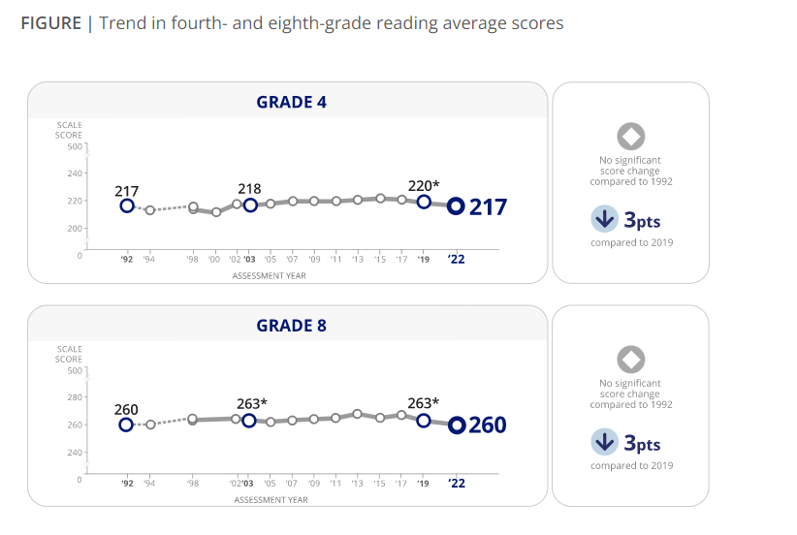
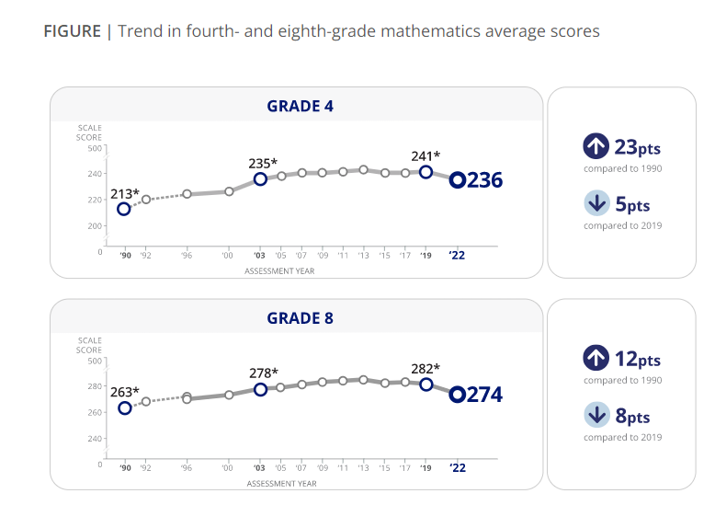

More About NAEP
To learn about upcoming NAEP assessments, download NAEP reports, and access sample questions, visit https://nces.ed.gov/nationsreportcard. Explore the latest NAEP results at https://nationsreportcard.gov.

Visit https://nces.ed.gov/nationsreportcard/about/covid19.aspx for more information about NAEP health and safety protocols.

Learn what NAEP means for schools that are selected to participate and get the latest NAEP news in Measure Up: NAEP News for the School Community, available online at https://nces.ed.gov/nationsreportcard/about/schools.aspx.

To hear teachers share their thoughts about why NAEP results are important, view the video Introducing NAEP to Teachers at https://nces.ed.gov/nationsreportcard/participating/schools.aspx.

To find your NAEP state coordinator’s contact information, visit https://nces.ed.gov/nationsreportcard/states and select your state or jurisdiction from the drop-down menu.
For additional assistance, call the NAEP help desk at 800-283-6237.

“The NAEP team that arrived at our school made the assessment process painless. Everyone on the team previously worked as an educator and interacted well with all of our students.”
—Kimberly Wilborn, Guidance Counselor, Sandburg Middle School, Fairfax County Public Schools, Alexandria, Virginia

The National Center for Education Statistics (NCES) conducts the National Assessment of Educational Progress to evaluate federally supported education programs. All of the information you provide may only be used for the purposes of research, statistics, and evaluation under the Education Sciences Reform Act of 2002 (ESRA; 20 U.S.C. § 9543) and may not be disclosed, our used, in identifiable form for any other purpose except as required by law. Every NCES employee as well as every NCES agent, such as contractors and NAEP coordinators, has taken an oath and is subject to a jail term of up to 5 years, a fine of $250,000, or both if he or she willfully discloses ANY identifiable information about you. Electronic submission of your information will be monitored for viruses, malware, and other threats by Federal employees and contractors in accordance with the Cybersecurity Enhancement Act of 2015.

This publication was prepared for the National Assessment of Educational Progress by Hager Sharp under contract GS-23F-0024M to the National Center for Education Statistics, U.S. Department of Education.

NAEP 2024 FACTS FOR TEACHERS IN PRIVATE SCHOOLS -TEXT ONLY REVIEW
I'm thankful for the opportunity for our school to participate in NAEP because I believe it leads to useful outcomes for individual schools, private schools specifically, and education generally in our country. I would strongly encourage all private schools to participate, if selected.
— Dr. James A. Thomas, President of Columbia Academy, Columbia, TN

The National Assessment of Educational Progress (NAEP) is the largest continuing and nationally representative assessment of what students in public and private schools know and can do in various subjects. First administered in 1969, NAEP collects and reports information on student trends and performance and compares the achievement of students in public schools with that of students in private schools. Private schools represent about 24 percent of the schools in the nation, educate approximately 9 percent of the nation’s students, and are a critical component of the NAEP program. Private school data are essential to providing a complete and accurate picture of education in the United States and to informing future policy decisions. The results of NAEP are released to the public as The Nation’s Report Card.

All About NAEP
As private school teachers, you are essential partners in NAEP. You make an important contribution by sharing your class time and encouraging your students to participate and do their best. When students take part in NAEP and give their best effort, we get the most accurate measure possible of student achievement across the country.

Teachers can use NAEP questions as a resource in the classroom. Teachers can use the NAEP Questions Tool at http://nces.ed.gov/nationsreportcard/nqt to create online self-scoring tests for students and see how the performance of students in private schools compares nationally with that of students in public school on specific items. Released items generally come with a scoring guide, sample student responses, and performance data. Students can try NAEP questions by visiting https://www.nationsreportcard.gov/sample_questions.aspx.

Teachers can watch the NAEP teacher video. The video provides an overview of the assessment as well as tips on how to support students selected to participate. Watch the video at https://www.youtube.com/watch?v=zR1_pUdSlFg.

Teachers can also view the private school video. Teachers and heads of school describe their experiences with the NAEP assessment and the value of NAEP to private schools in an online video, Private Schools and NAEP: A National Conversation. Watch the video at https://nces.ed.gov/nationsreportcard/participating/private_nonpublic.aspx.

Highlights of the NAEP 2024 Program
From January 29 to March 8, 2024, NAEP field staff will administer assessments in public and private schools across the country. The assessments will be administered at grades 4, 8, and 12 in mathematics and reading, and at grade 8 in science. Students will take only one subject.

NAEP representatives will bring all materials and equipment to the school on assessment day. The total time away from the classroom will be approximately 2 hours. This includes transition time, directions and tutorials, and completion of survey questions.

It’s important to know that…

No advance preparation is needed. No advance preparation for teachers or for students is necessary. Trained NAEP representatives, employed by a contractor to the National Center for Education Statistics, administer NAEP.

Participation is essential. To ensure that student achievement is accurately reported, students with disabilities (SD) and English learners (EL) are encouraged to participate in NAEP assessments. Many accommodations are allowed during the assessment, such as extended time, breaks during the test, and a separate setting. SD and EL teachers who work with the students selected for the assessment are asked to provide information to determine how these students will be assessed on NAEP.
NAEP data are used for statistical purposes only.* No one involved in administering NAEP keeps personal information on teachers or students after the assessments are completed. There are no results for individual students, classrooms, or schools.

How NAEP reports results

Since 1969, NAEP has produced many reports chronicling trends over time in student performance. Results for private schools are generally reported as overall private school results and for two groups of private schools, Catholic and other private schools.

NAEP also disseminates contextual information from data collected on student survey questionnaires. This information can be used to inform parents, the public, and education policymakers about our students’ educational experiences inside and outside the classroom. You can access data from previous assessments at https://www.nationsreportcard.gov/ndecore/xplore/nde, and explore the most recent results at http://nationsreportcard.gov. For a quick, but detailed, look at results for private schools, explore the NAEP Private School Quick Data tool at http://nces.ed.gov/nationsreportcard/about/private_school_quick_data.aspx.

Highlights of NAEP 2019 Mathematics and Reading

The NAEP 2022 mathematics and reading results include both achievement and survey questionnaire data for students in grades 4 and 8 across the country. The national results combine data from students assessed in public and private schools. Some highlights of these results are included.

In 2022, the average fourth-grade mathematics score decreased by 5 points and was lower than all previous assessment years going back to 2005; the average score was 1 point higher compared to 2003. The average eighth-grade mathematics score decreased by 8 points compared to 2019 and was lower than all previous assessment years going back to 2003. In 2022, fourth- and eighth-grade mathematics scores declined for most states/jurisdictions as well as for most participating urban districts compared to 2019. Average scores are reported on NAEP mathematics scales at grades 4 and 8 that range from 0 to 500.

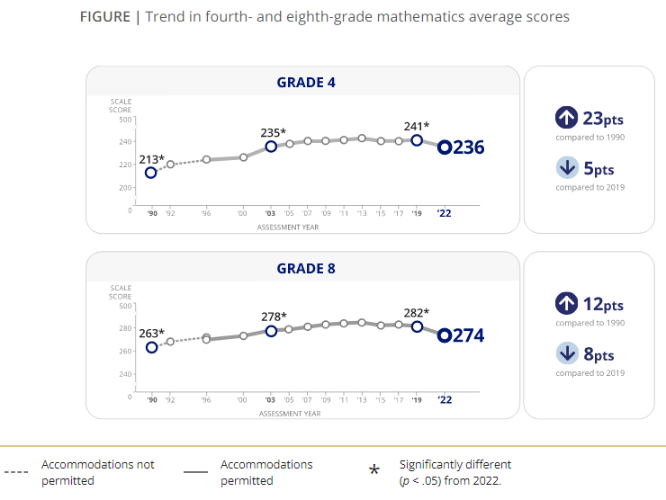
[GRAPH 1, data source: https://www.nationsreportcard.gov/highlights/mathematics/2022/ –must credit “Nation’s Report Card”]

In 2022, the average reading score at both fourth and eighth grade decreased by 3 points compared to 2019. At fourth grade, the average reading score was lower than all previous assessment years going back to 2005 and was not significantly different in comparison to 1992. At eighth grade, the average reading score was lower compared to all previous assessment years going back to 1998 and was not significantly different compared to 1992. In 2022, fourth- and eighth-grade reading scores declined for most states/jurisdictions compared to 2019. Average scores are reported on NAEP reading scales at grades 4 and 8 that range from 0 to 500.

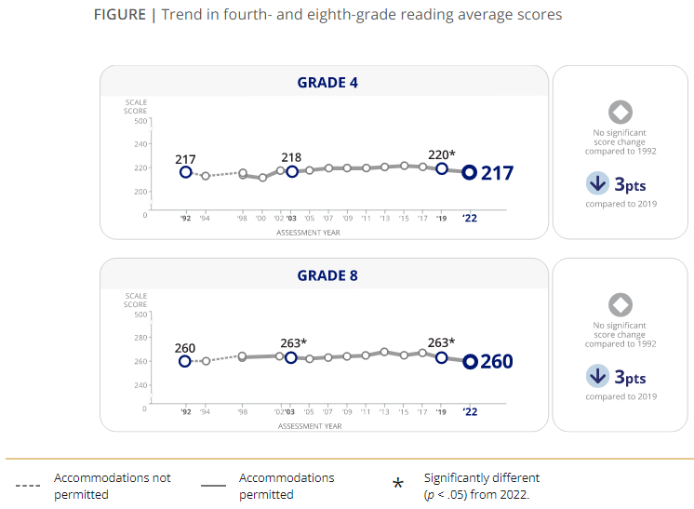

[GRAPH 1, data source: https://www.nationsreportcard.gov/highlights/reading/2022/ –must credit “Nation’s Report Card”]

All students who took the mathematics assessments in 2022 were asked if they ever attended school from home or somewhere else outside of school for any duration during the last school year (2020–21) because of the COVID-19 pandemic. Among eighth-grade students, 73 percent recalled learning remotely during the last school year, 18 percent reported they did not learn remotely, and 9 percent did not remember.

Of the eighth-grade students who reported learning remotely during the 2020–21 school year, higher performers (those at or above the 75th percentile) had more frequent access to a desktop computer, laptop, or tablet all the time; a quiet place to work available at least some of the time; and a teacher available to help them with mathematics schoolwork about once or twice a week or more compared to lower performers (those below the 25th percentile). Additionally, higher-performing eighth-grade students reported more participation in real-time video lessons with their teacher every day or almost every day compared to their lower-performing peers.

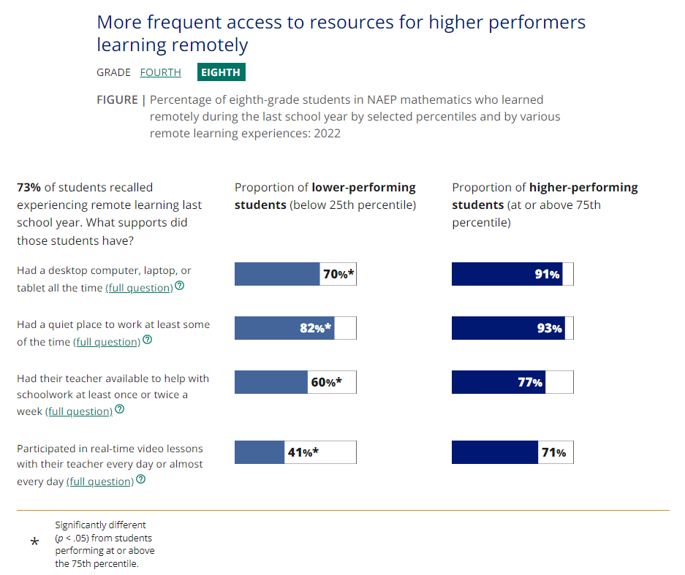
[GRAPH 3, data source: https://www.nationsreportcard.gov/highlights/mathematics/2022/#student-experiences –must credit “Nation’s Report Card”]

Results from the NAEP 2021 School Survey were reportable for Catholic, other private (non-Catholic), and public schools at grades 4 and 8. Between February and May 2021, a significantly higher percentage of Catholic and other private schools reported offering students in-person instruction compared to public schools.

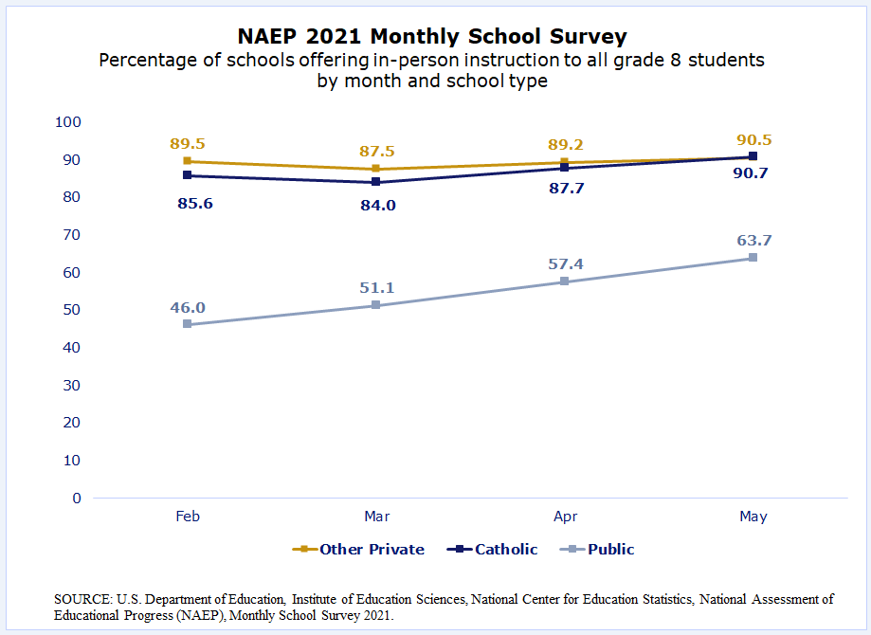
[GRAPH 4, SOURCE: U.S. Department of Education, Institute of Education Sciences, National Center for Education Statistics, National Assessment of Educational Progress (NAEP), Monthly School Survey 2021. https://nces.ed.gov/nationsreportcard/subject/participating/pdfs/measure_up_private_schools_summer_fall_2021.pdf ]

* The National Center for Education Statistics (NCES) conducts the National Assessment of Educational Progress to evaluate federally supported education programs. All of the information you provide may only be used for the purposes of research, statistics, and evaluation under the Education Sciences Reform Act of 2002 (ESRA; 20 U.S.C. § 9543) and may not be disclosed, our used, in identifiable form for any other purpose except as required by law. Every NCES employee as well as every NCES agent, such as contractors and NAEP coordinators, has taken an oath and is subject to a jail term of up to 5 years, a fine of $250,000, or both if he or she willfully discloses ANY identifiable information about you. Electronic submission of your information will be monitored for viruses, malware, and other threats by Federal employees and contractors in accordance with the Cybersecurity Enhancement Act of 2015.

Appendix D-14: NAEP 2024 Overview Brochure

Cover Page
[IES Logo] [NAEP Logo]
Title: An Overview of NAEP
Page 1
What is NAEP?
The National Assessment of Educational Progress (NAEP), often called The Nation’s Report Card, is the largest nationally representative and continuing assessment of what students in public and private schools in the United States know and are able to do in various subjects. Since 1969, NAEP has been a common measure of student achievement across the country in mathematics, reading, science, and many other subjects. Depending on the assessment, NAEP report cards provide national, state, and some district-level results, as well as results for different demographic groups.
NAEP is a congressionally mandated project of the National Center for Education Statistics (NCES), located within the U.S. Department of Education’s Institute of Education Sciences. NAEP data are also used in special studies conducted by NCES.
The National Assessment Governing Board, an independent, bipartisan organization made up of governors, state school superintendents, teachers, researchers, and representatives of the general public, sets policy for NAEP.
How is NAEP different from state assessments?
States have their own assessments, which are designed to provide individual student data about achievement based on different content standards, unique to each state. NCES administers the same NAEP assessment in every state, providing educators, policymakers, and parents with a common measure of student achievement that allows for direct comparisons among states and participating urban districts.
[Page 1 footer]
The NAEP website provides more extensive information about the assessment: http://nces.ed.gov/nationsreportcard
NAEP results are available on The Nation’s Report Card website: http://nationsreportcard.gov
The NAEP website features many tools and applications designed to provide quick and easy access to NAEP assessment data, examples of the types of questions students answer, performance comparisons, and more: https://nces.ed.gov/nationsreportcard/data/
Page 2
What subjects does NAEP assess?
NAEP includes a range of subjects at grades 4, 8, and 12 to provide a comprehensive look at the wide array of academic areas that are a part of a student’s education. Subjects include civics, mathematics, reading, science, technology and engineering literacy, U.S. history, and writing.
NAEP also measures student performance in mathematics and reading through the long-term trend assessment, which allows the performance of today’s students to be compared with students since the early 1970s. The assessment is administered periodically to 9-, 13-, and 17-year-olds.
How are NAEP results reported?
NAEP results are reported for the nation and, in most cases, for states, as well as for selected urban districts that participate in the Trial Urban District Assessment (TUDA). Results are reported as scores and as percentages of students reaching NAEP achievement levels—NAEP Basic, NAEP Proficient, and NAEP Advanced.
NAEP monitors overall educational progress for the nation, states, TUDA districts, and for different groups of students, including students with disabilities and English learners. NAEP is not designed to provide results for individual students or schools.
How is technology being used to measure and report student skills?
An increasing number of schools are making digital technologies an integral component of the learning environment. NAEP assessments have gradually transitioned various subjects from traditional paper-and-pencil to a digital format since 2017. Additionally, to assess students in more effective and engaging ways that mirror their classroom experiences, NAEP assessments are transitioning towards an online assessment model that will be compatible with the most common devices found in schools that are more familiar to students.
By transitioning to an online assessment that can be administered on various devices, NAEP will be more accessible than ever for students and will deepen our understanding of what students know and are able to do in various subjects.
How are NAEP results used?
Policymakers, researchers, and educators use NAEP results to inform educational improvements across the nation, within states and TUDA districts, and for various student groups. Parents, media, and the general public use NAEP results to monitor educational progress in their communities and compare performance with other regions of the country. NAEP also provides states with a benchmark to target important efforts that raise the bar for student achievement and ensure that students have equal opportunities to succeed.
NAEP also provides much-needed information about the academic achievement and continued recovery of students whose elementary or secondary school experiences have been shaped by online learning and the pandemic.
Learn how NAEP data are used to inform policy and practice in different states: https://nces.ed.gov/nationsreportcard/about/policy_practice.aspx
Page 3
Why is student participation important?
NAEP assesses a sample of students across the country to be representative of all students in the United States Each student’s participation is critical for providing an accurate and complete picture of student achievement and ensuring that policymakers, researchers, and educators have reliable data to inform educational improvements.
What is it like for students and schools to participate in NAEP?
- NAEP is administered to students during regular school hours. Each student is assessed in one subject area. Students spend between 90 and 120 minutes taking the assessment, including time to complete a survey questionnaire.
- NAEP representatives provide significant support to schools on assessment day.
- Allowable accommodations are provided as necessary for students with disabilities and/or English learners.
- Student responses on NAEP are private, and the privacy of each participating school and student is essential.

What other data are collected during a NAEP assessment?
NCES includes survey questionnaires as part of NAEP to collect information that helps put the results into context. There are three types of survey questionnaires:
- Students complete questionnaires that provide information on their opportunities to learn in and outside of the classroom, educational experiences, and a variety of other topics, including socioeconomic status and technology use. Students may skip any question by leaving a response blank.
- Teachers responsible for the subject of the administered assessment complete questionnaires that gather information on teacher trainings and instructional practices.
- School questionnaires, usually completed by the principal or assistant principal, gather information on school policies and characteristics.

Learn more about these questionnaires here: https://nces.ed.gov/nationsreportcard/experience/survey_questionnaires.aspx
[Page 3 footer]
All of the information provided by participants may be used only for statistical purposes and may not be disclosed, or used, in identifiable form for any other purpose except as required by law (20 U.S.C. §9573 and 6 U.S.C. §151). By law, every National Center for Education Statistics (NCES) employee as well as every NCES agent, such as contractors and NAEP coordinators, has taken an oath and is subject to a jail term of up to 5 years, a fine of $250,000, or both if he or she willfully discloses ANY identifiable information about participants. Electronic submission of participant’s information will be monitored for viruses, malware, and other threats by Federal employees and contractors in accordance with the Cybersecurity Enhancement Act of 2015. The collected information will be combined across respondents to produce statistical reports.
Page 4
The following are examples of the types of NAEP questions and features students may encounter when participating in digitally based assessments.*
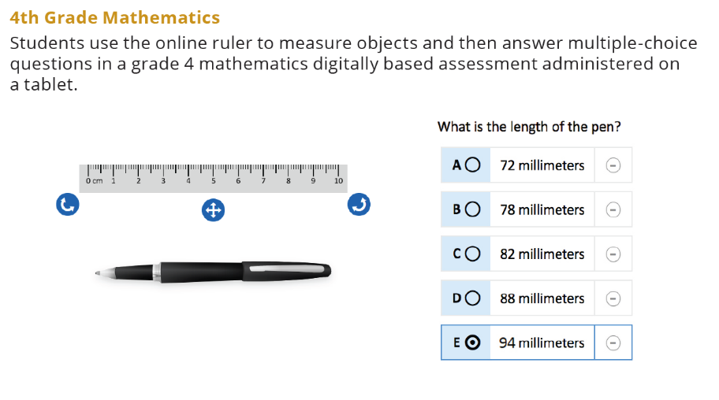
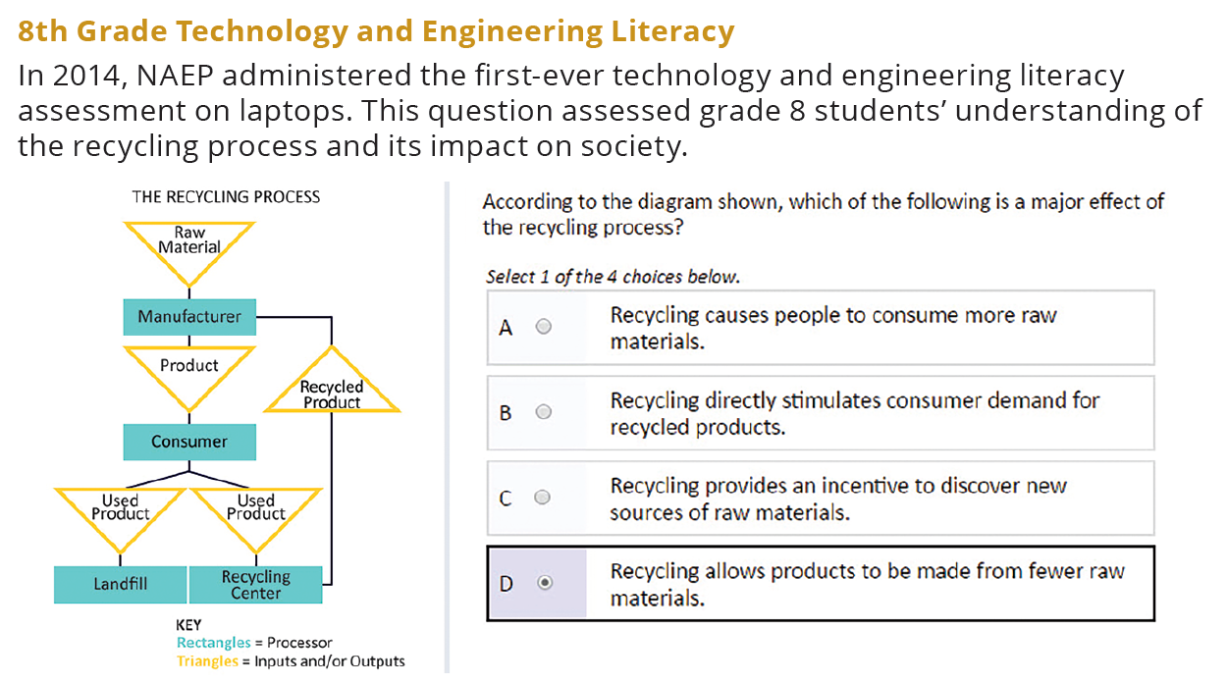
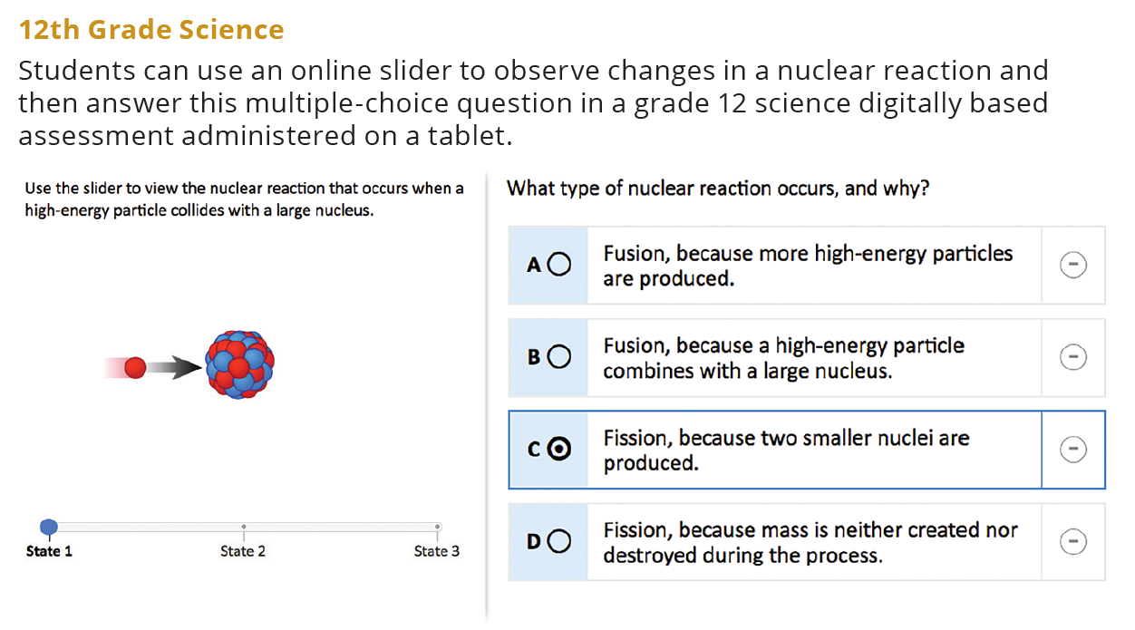
[Page 4 footer]
* The 4th grade and 12th grade questions are not released assessment questions but represent what students might be asked during a NAEP digitally based assessment. The 8th grade sample question was released from the 2014 NAEP technology and engineering literacy assessment.
Back Cover
www.ed.gov
[Department of Education Logo]
ies.ed.gov
Find us on: [Facebook] [Twitter] [YouTube]
This publication was prepared for the National Center for Education Statistics by Hager Sharp under contract ED-IES-13-C-0025.

Appendix D-15: NAEP 2024 Overview Brochure, Private School

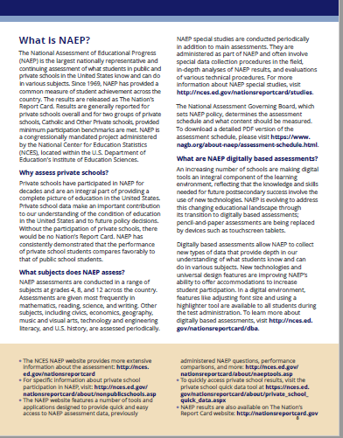
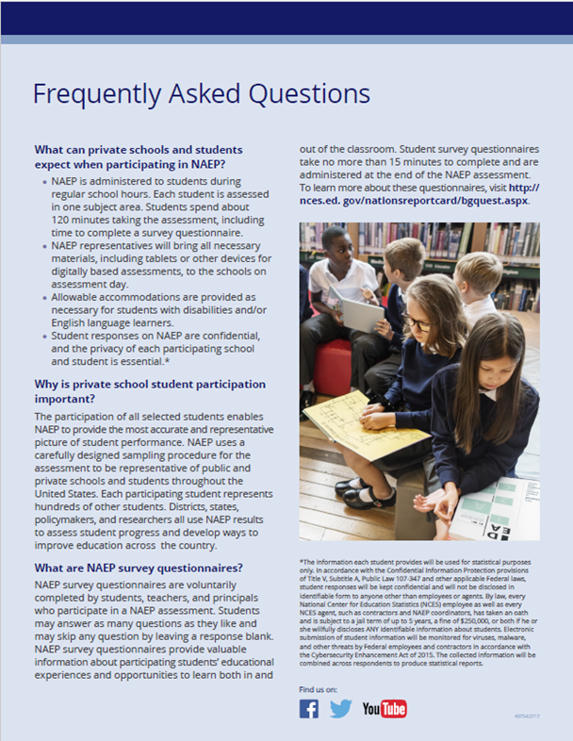
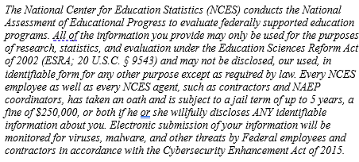
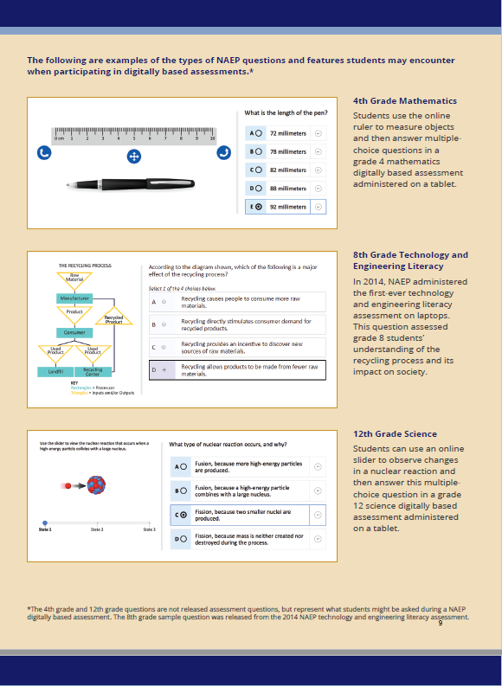

Appendix D-16: NAEP 2024 Private School Factsheet

NAEP National Assessment of Educational Progress 2024

Page 1 Banner at top of page
NAEP has received endorsement letters from CAPE, NCEA, NAIS, ACSI, and many others. Private school organizations will have the option to replace this with their own organization’s endorsement. For example, “NAEP is endorsed by the National Catholic Educational Association (NCEA).”
Page 1 Text
The National Assessment of Educational Progress (NAEP) is the largest nationally representative and continuing assessment of what our nation’s students in public and private schools know and can do. However, NAEP has been unable to provide a complete picture of private school achievement for the past few years because reporting requirements were not met due to low school participation.

Importance of Private School NAEP Participation
Private schools represent about 24 percent of schools in the nation and educate about 9 percent of students. Your school’s participation will help make it possible for private school data to be reported and contributes to the picture of education across the nation and to future policy decisions.
NAEP Administration:
- NAEP is administered at no cost to schools.
- NAEP representatives provide significant support to schools and will bring in all necessary materials and equipment to administer the assessment. Resources are also provided for administrators, teachers, and parents.
- Assessments are administered to students in grades 4, 8, and/or 12.
- The total assessment time for students is no more than 2 hours. This includes transition time, directions and tutorials, and completion of survey questions.
- NAEP offers accommodations to students with disabilities and English learners.

Page 2 Text
NAEP Results
- Data collected from participating schools and students are combined for reporting. NAEP is not designed to report results at the school or student level.
- NAEP provides valuable information about students’ educational experiences and opportunities to learn both in and outside the classroom.
- NAEP data have historically shown, across subjects and over time, that students in private schools on average score higher than students in public schools. With your support, private schools can achieve excellent participation, and private school results can be reported.

[Large Quote at bottom of page 2]
“The Council for American Private Education (CAPE) strongly encourages private schools to participate in NAEP, an essential measure of student achievement in the United States.” - Michael Schuttloffel, Executive Director, CAPE. Private school organizations will have the option to replace this with their own organization’s quote. For example, “The National Catholic Educational Association (NCEA) encourages member schools to participate in NAEP so that their results will be reported specifically and that we have some independent measure of the overall effectiveness of our schools and a benchmark against which to measure success as well as areas that need improvement.” – Sister Dale McDonald, Vice President of Public Policy

Page 2 Banner at bottom of page
NAEP — giving private schools a voice in the national education conversation.
Footer ON Page 2
It is vital that all selected students participate to accurately capture private school student progress. While the results from all participating schools and students are used in the national results, your participation can help make it possible to report NAEP results for private schools in 2024. For more information, please visit https://nces.ed.gov/nationsreportcard/participating/private_nonpublic.aspx

Appendix D-17: NAEP 2024 Sample Email from Catholic Diocese to Catholic School Administrator

NAEP 2024 Sample Email from Catholic Diocese to Catholic School Administrator
Red text should be customized
Dear Administrator,
Your school has been selected to participate in the 2024 National Assessment of Educational Progress (NAEP). I strongly urge you to participate so that we can continue to showcase the historically positive performance of our students and our schools. As recently as 2022, NAEP results consistently show that the performance of students in Catholic schools on average compares positively to students in public schools. We hope we can count on all selected Catholic schools continuing a long-standing tradition of achieving very high participation in this assessment, enabling NAEP to report results for students in Catholic schools.

To see the positive Catholic school student performance contrasted with students in public schools, visit https://www.nationsreportcard.gov/dashboards/schools_dashboard.aspx.

As in previous years, NAEP representatives provide significant support to schools and will bring in all necessary materials and equipment to administer the assessment at no cost to your school. A NAEP representative will contact you to discuss assessment details.
For information specifically for private schools, including a short 2-minute video about the value of NAEP for private schools, visit https://nces.ed.gov/nationsreportcard/participating/private_nonpublic.aspx.
For complete information about NAEP assessments, please visit the NAEP website at http://nces.ed.gov/nationsreportcard.
Thank you for your support of this important study, which allows us considerable no-cost opportunities to showcase the performance of our students and promote the value of our schools.
Sincerely,

Diocese Superintendent

The National Center for Education Statistics (NCES) conducts the National Assessment of Educational Progress to evaluate federally supported education programs. All of the information you provide may only be used for the purposes of research, statistics, and evaluation under the Education Sciences Reform Act of 2002 (ESRA; 20 U.S.C. § 9543) and may not be disclosed, our used, in identifiable form for any other purpose except as required by law. Every NCES employee as well as every NCES agent, such as contractors and NAEP coordinators, has taken an oath and is subject to a jail term of up to 5 years, a fine of $250,000, or both if he or she willfully discloses ANY identifiable information about you. Electronic submission of your information will be monitored for viruses, malware, and other threats by Federal employees and contractors in accordance with the Cybersecurity Enhancement Act of 2015.

Appendix D-18: NAEP 2024 Sample Letter from Catholic Diocese to Catholic School Administrator

NAEP 2024 Sample Letter from Catholic Diocese to Catholic School Administrator
Red text should be customized

(Date)
Dear Administrator:
I am pleased to inform you that (insert school name) has been selected to represent Catholic schools across our nation by participating in the 2024 administration of the National Assessment of Educational Progress (NAEP). Your school’s participation in NAEP 2024 is an opportunity to help make it possible for private and Catholic school data to be reported and compared with public school data.
First administered in 1969, NAEP is the largest continuing and nationally representative measure of private and public school student achievement across the country.

Catholic schools have a long-standing tradition of achieving very high participation in this assessment, enabling NAEP to report results for students in Catholic schools. NAEP results consistently show that the performance of students in Catholic schools, on average, compares positively to students in public schools. I strongly urge you to participate in the NAEP 2024 assessment so that we can continue to showcase the historically positive performance of our students and our schools. To see the positive Catholic school student performance contrasted with students in public schools, visit https://www.nationsreportcard.gov/dashboards/schools_dashboard.aspx.
Please keep the following in mind:
- NAEP is administered at no cost to your school.
- Parental notification is required for student participation and NAEP provides a notification template for your customization and use.
- NAEP data are used for statistical purposes only. School and student names are not associated with the results. All results are reported as “The Nation’s Report Card.”
- NAEP staff must pass an FBI background check and sign an oath of confidentiality. Many NAEP representatives are retired educators.
- NAEP representatives will provide significant support to participating schools. They will administer the assessment and bring all materials and equipment, including NAEP-provided Surface Pros and Chromebooks, on which students will take the assessment.
- You may appoint a school staff member to be your NAEP School Coordinator to work with NAEP to complete the logistical tasks for assessment planning.
Your leadership will most certainly have a strong impact on participation. By participating in NAEP, your students set a positive example for their peers by practicing good citizenship and contributing to data that serve to improve and strengthen the educational options for all our nation’s youth.
A NAEP representative will contact you to discuss assessment details. In the meantime, please visit the NAEP website at http://nces.ed.gov/nationsreportcard for complete information about the assessment, sample questions, previous results, and other NAEP publications and materials.
For information specifically for private schools, including a short video, visit https://nces.ed.gov/nationsreportcard/participating/private_nonpublic.aspx

The goal is 100 percent Catholic school participation, and I am counting on you to help us reach that goal!
Sincerely,

Diocese Superintendent

The National Center for Education Statistics (NCES) conducts the National Assessment of Educational Progress to evaluate federally supported education programs. All of the information you provide may only be used for the purposes of research, statistics, and evaluation under the Education Sciences Reform Act of 2002 (ESRA; 20 U.S.C. § 9543) and may not be disclosed, our used, in identifiable form for any other purpose except as required by law. Every NCES employee as well as every NCES agent, such as contractors and NAEP coordinators, has taken an oath and is subject to a jail term of up to 5 years, a fine of $250,000, or both if he or she willfully discloses ANY identifiable information about you. Electronic submission of your information will be monitored for viruses, malware, and other threats by Federal employees and contractors in accordance with the Cybersecurity Enhancement Act of 2015.
 NAEP – Giving Private Schools a Voice, since 1989

Appendix D-19: NAEP 2024 State Coordinator to District Assessment Coordinator -Technology Notification

Fall NAEP 2024 Identify Technology Coordinator
NAEP STATE COORDINATOR TO DISTRICT ASSESSMENT COORDINATOR
Red text should be customized before mail merge, highlighted text represents mail merge fields.

::Do not distribute until notified that the AMS is ready for school and district user access::

Dear District Assessment Coordinator:

At the end of the school year, I notified [selected school] / the schools below / the attached list of schools of their selection to participate in the National Assessment of Educational Progress (NAEP). I am following up with you to provide additional information about the upcoming assessment.

List of Selected Schools:
- School 1
- School 2
- Etc.

To prepare for the assessment, please review the enclosed Technology Coordinator Responsibilities Guide and designate a district or school technology coordinators. Each school should be assigned a technology coordinator, whether at the school or district level, and you may designate more than one if needed. The coordinator’s expertise will be important for completing a survey on technology and internet capabilities in the selected schools. Please give the enclosed guide to your designated technology coordinator/coordinators. The technology coordinator should
- be comfortable answering an internet connectivity survey; and
- know the internet capabilities in the schools, such as
  - Wi-Fi bandwidth;
  - how to connect devices to Wi-Fi with appropriate credentials; and
  - how to safelist URLs.

If you select a district technology coordinator to answer on behalf of multiple schools, a bulk editing feature is available when completing the checklist. To designate a technology coordinator, you will need to do the following:

- Work with school or district technology staff as necessary to add the domain westatstudies.com to the safe senders list.
- {Use this bullet if following Option 1, district assessment coordinator registers and invites Technology Coordinator} Log in and set up your NAEP AMS account using the link provided in the registration email from DoNotReply-NAEP@westatstudies.com.
- {Use this bullet if following Option 1, district assessment coordinator registers and invites Technology Coordinator} Enter each technology coordinator’s name and contact information in the AMS, select their role as Technology Coordinator, and select Send Invite.
- {Use this bullet if following Option 2, NSC invites the Technology Coordinator} Send the designated technology coordinator’s name and email address to me using the email address provided below.
Once you have identified a technology coordinator and passed along the Technology Coordinator Responsibilities Guide, they will have until [DATE] to complete the survey.

Thank you for your assistance with this very important assessment of our nation’s students. Our chief state school officer, name, supports NAEP and encourages your students’ participation. If you have questions, please contact me at telephone number or email address.

Sincerely,

NAEP State Coordinator

Enclosures:
Technology Coordinator Responsibilities Guide

The National Center for Education Statistics (NCES) conducts the National Assessment of Educational Progress to evaluate federally supported education programs. All of the information you provide may only be used for the purposes of research, statistics, and evaluation under the Education Sciences Reform Act of 2002 (ESRA; 20 U.S.C. § 9543) and may not be disclosed, our used, in identifiable form for any other purpose except as required by law. Every NCES employee as well as every NCES agent, such as contractors and NAEP coordinators, has taken an oath and is subject to a jail term of up to 5 years, a fine of $250,000, or both if he or she willfully discloses ANY identifiable information about you. Electronic submission of your information will be monitored for viruses, malware, and other threats by Federal employees and contractors in accordance with the Cybersecurity Enhancement Act of 2015.

Appendix D-20: NAEP 2024 Technology Notification Letters
Early Fall NAEP 2024 Technology Coordinator Notification
NAEP STATE COORDINATOR TO TECHNOLOGY COORDINATOR
Red text should be customized before mail merge, highlighted text represents mail merge fields.

::Do not distribute until notified that the AMS is ready for school and district user access::

Dear District/School Technology Coordinator:

Welcome to the 2024 National Assessment of Educational Progress (NAEP). You have been selected by your district to serve as the technology coordinator for all NAEP assessment activities at [School Name]./the following schools / the attached list of schools:
- School 1
- School 2
- Etc

Thank you in advance for helping to prepare for this important assessment!

NAEP is the largest nationally representative and continuing assessment of what students in the United States know and can do in various subjects. It is administered by the National Center for Education Statistics (NCES), within the U.S. Department of Education. The NAEP 2024 program will assess students in mathematics, reading, or science on an online platform using devices such as Chromebooks.

The goal of the NAEP team is to connect the NAEP-provided devices to the school’s Wi-Fi for the assessment. To prepare for the assessment’s technology requirements testing, each technology coordinator must

- Work with school or district technology staff as necessary to add the domain westatstudies.com to the safe senders list;
- Register for the NAEP Assessment Management System using the link provided in the registration email from DoNotReply-NAEP@westatstudies.com; and
- Complete the Internet Connectivity Survey, which requires knowledge of:
  - school’s Wi-Fi bandwidth;
  - how to connect devices to Wi-Fi with appropriate credentials; and
  - how to safelist URLs.

After you complete the survey, the school coordinator will verify everything by conducting bandwidth and safelist tests. I have provided more information about your responsibilities in the enclosed Technology Coordinator Responsibilities Guide.

Again, thank you for your assistance with this very important assessment of our nation’s students. If you have questions, please contact me at telephone number or email address.

Sincerely,

NAEP State Coordinator

Enclosures:
Technology Coordinator Responsibilities Guide

The National Center for Education Statistics (NCES) conducts the National Assessment of Educational Progress to evaluate federally supported education programs. All of the information you provide may only be used for the purposes of research, statistics, and evaluation under the Education Sciences Reform Act of 2002 (ESRA; 20 U.S.C. § 9543) and may not be disclosed, our used, in identifiable form for any other purpose except as required by law. Every NCES employee as well as every NCES agent, such as contractors and NAEP coordinators, has taken an oath and is subject to a jail term of up to 5 years, a fine of $250,000, or both if he or she willfully discloses ANY identifiable information about you. Electronic submission of your information will be monitored for viruses, malware, and other threats by Federal employees and contractors in accordance with the Cybersecurity Enhancement Act of 2015.

Fall NAEP 2024 Identify District Technology Director and On-Site Technology Coordinator
NAEP STATE COORDINATOR TO DISTRICT ASSESSMENT COORDINATOR
Red text should be customized before mail merge, highlighted text represents mail merge fields.

::Do not distribute until notified that the AMS is ready for school and district user access::

Dear District Assessment Coordinator:

At the end of the school year, I notified [selected school] / the schools below / the attached list of schools of their selection to participate in the National Assessment of Educational Progress (NAEP). I am following up with you to provide additional information about the upcoming assessment.

List of Selected Schools:
- School 1
- School 2
- Etc.

To prepare for the assessment, please review the enclosed Technology Team Responsibilities Guide and designate a district technology director and an on-site technology coordinator for each school. The district technology director and on-site technology coordinator(s) will work together to provide information on network technology and internet capabilities in the selected school(s). Each school principal has also designated a school coordinator, to serve as the main point of contact between the school and NAEP. Your chosen on-site technology coordinator(s) should collaborate with the school coordinator(s) to confirm technical logistics and ensure NAEP can connect to the school’s Wi-Fi on assessment day. If appropriate, the school and on-site technology coordinator may be the same person.

Please give the enclosed guide to your designated district technology director and on-site technology coordinator(s). These individuals should:
- know the internet capabilities in the schools, such as
  - Wi-Fi bandwidth;
  - how to connect external devices to Wi-Fi with appropriate credentials; and
  - how to safelist URLs;
- know how to set up a dedicated Wi-Fi network or identify an existing Wi-Fi network;
- collaborate with the designated School Coordinator to confirm technical logistics, if they are a different person; and
- ensure the NAEP field staff have the Wi-Fi log-in credentials before assessment day.

Best Practice: When possible, setting up a dedicated Wi-Fi network for NAEP use on assessment day will reduce the burden on the school(s), ensure the best student experience, and provide the ideal connection method for assessment administration. The dedicated Wi-Fi network should meet NAEP’s technical requirements. Your district technology director should be familiar with this process.

To designate both the district technology director and the on-site technology coordinator, you will need to do the following:

- Work with school or district technology staff as necessary to add the domain westatstudies.com to the safe senders list to ensure receipt of AMS emails.
- {Use this bullet if following Option 1, district assessment coordinator registers and invites District Technology Director and On-Site Technology Coordinator} Log in and set up your NAEP AMS account using the link provided in the registration email from DoNotReply-NAEP@westatstudies.com.
- {Use this bullet if following Option 1, district assessment coordinator registers and invites District Technology Director and On-Site Technology Coordinator} Enter each technology person’s name and contact information in the AMS, select their role as District Technology Director or On-Site Technology Coordinator, and select Send Invite.
- {Use this bullet if following Option 2, NSC invites the technology person} Send the designated technology director and the on-site technology coordinator’s name and email address to me using the email address provided below.

Please support your technology director and on-site technology coordinator(s) to ensure these important tasks are completed in a timely manner and that the administration of the assessment goes smoothly.

Once you have identified technology people and passed along the Technology Team Responsibilities Guide, they will have until [DATE] to complete the Internet Connectivity Survey for their designated school(s).

Thank you for your assistance with this very important assessment of our nation’s students. Our chief state school officer, name, supports NAEP and encourages your students’ participation. If you have questions or if there is anything I can do to further support you and your schools, please contact me at telephone number or email address.

Sincerely,

NAEP State Coordinator

Enclosures:
Technology Team Responsibilities Guide

The National Center for Education Statistics (NCES) conducts the National Assessment of Educational Progress to evaluate federally supported education programs. All of the information you provide may only be used for the purposes of research, statistics, and evaluation under the Education Sciences Reform Act of 2002 (ESRA; 20 U.S.C. § 9543) and may not be disclosed, our used, in identifiable form for any other purpose except as required by law. Every NCES employee as well as every NCES agent, such as contractors and NAEP coordinators, has taken an oath and is subject to a jail term of up to 5 years, a fine of $250,000, or both if he or she willfully discloses ANY identifiable information about you. Electronic submission of your information will be monitored for viruses, malware, and other threats by Federal employees and contractors in accordance with the Cybersecurity Enhancement Act of 2015.

Early Fall NAEP 2024 District Technology Director Notification
NAEP STATE COORDINATOR TO DISTRICT TECHNOLOGY DIRECTOR
Red text should be customized before mail merge, highlighted text represents mail merge fields.

::Do not distribute until notified that the AMS is ready for school and district user access::

Dear District Technology Director:

Welcome to the 2024 National Assessment of Educational Progress (NAEP). You have been selected by your district to serve as the district technology director for all NAEP assessment activities at [School Name]./the following schools: / the attached list of schools.
- School 1
- School 2
- School 3, etc.

Thank you in advance for helping to prepare for this important assessment!

NAEP is the largest nationally representative and continuing assessment of what students in the United States know and can do in various subjects. It is administered by the National Center for Education Statistics (NCES), within the U.S. Department of Education. The NAEP 2024 program will assess students in mathematics, reading, or science on an online platform using NAEP-provided devices (Chromebooks or Microsoft Surface Pros).

The goal of the NAEP team is to connect the NAEP-provided devices to the school’s Wi-Fi for the assessment. Your district has also appointed an on-site technology coordinator at each school who can support your role. In addition, each school principal has also designated a school coordinator, who serves as the main point of contact between the school and NAEP. You should collaborate with both the school coordinator and the on-site technology coordinator to confirm technical logistics and ensure NAEP can connect to the school’s Wi-Fi on assessment day.

To prepare for the assessment’s technology requirements, each district technology director must

- work with school or district technology staff as necessary to add the email domain westatstudies.com to the safe senders list;
- register for the NAEP Assessment Management System using the link provided in the registration email from DoNotReply-NAEP@westatstudies.com;
- complete the Internet Connectivity Survey with assistance from the on-site technology coordinator; you will need to know the following to complete the survey:
  - the school’s Wi-Fi bandwidth;
  - how to connect external NAEP-provided devices to Wi-Fi with appropriate credentials that can be given to the NAEP team; and
  - any required Wi-Fi network security procedures.
- know how to set up a dedicated Wi-Fi network or identify an existing Wi-Fi network;
- safelist NAEP URLs if your school or district uses a firewall; and
- attend a 30-minute assessment planning meeting prior to assessment day, if needed.

Best Practice: When possible, setting up a dedicated Wi-Fi network for NAEP use on assessment day will reduce the burden on the school(s), ensure the best student experience, and provide the ideal connection method for the assessment administration. The dedicated Wi-Fi network should meet NAEP’s technical requirements.

After you complete the survey, the on-site technology coordinator will verify the information you provide by conducting bandwidth and safelist tests in the assessment location. I have provided more information about your responsibilities in the enclosed Technology Team Responsibilities Guide.

Again, thank you for your assistance with this very important assessment of our nation’s students. If you have technical questions about the survey, please contact the NAEP help desk at naephelp@westat.com. If you have other questions about NAEP, please contact me at telephone number or email address.

Sincerely,

NAEP State Coordinator

Enclosures:
Technology Team Responsibilities Guide

The National Center for Education Statistics (NCES) conducts the National Assessment of Educational Progress to evaluate federally supported education programs. All of the information you provide may only be used for the purposes of research, statistics, and evaluation under the Education Sciences Reform Act of 2002 (ESRA; 20 U.S.C. § 9543) and may not be disclosed, our used, in identifiable form for any other purpose except as required by law. Every NCES employee as well as every NCES agent, such as contractors and NAEP coordinators, has taken an oath and is subject to a jail term of up to 5 years, a fine of $250,000, or both if he or she willfully discloses ANY identifiable information about you. Electronic submission of your information will be monitored for viruses, malware, and other threats by Federal employees and contractors in accordance with the Cybersecurity Enhancement Act of 2015.

Early Fall NAEP 2024 On-Site Technology Coordinator Notification
NAEP STATE COORDINATOR TO ON-SITE TECHNOLOGY COORDINATOR
Red text should be customized before mail merge, highlighted text represents mail merge fields.

::Do not distribute until notified that the AMS is ready for school and district user access::

Dear On-site Technology Coordinator:

Welcome to the 2024 National Assessment of Educational Progress (NAEP). You have been selected by your district to serve as the on-site technology coordinator for all NAEP assessment activities at [School Name].
Thank you in advance for helping to prepare for this important assessment!

NAEP is the largest nationally representative and continuing assessment of what students in the United States know and can do in various subjects. It is administered by the National Center for Education Statistics (NCES), within the U.S. Department of Education. The NAEP 2024 program will assess students in mathematics, reading, or science on an online platform using NAEP-provided devices (Chromebooks or Microsoft Surface Pros).

The goal of the NAEP team is to connect the NAEP-provided devices to the school’s Wi-Fi for the assessment. Each school principal has also designated a school coordinator, who serves as the main point of contact between the school and NAEP. In addition, your district has appointed a district technology director to assist at the district level. You should collaborate with the school coordinator to confirm technical logistics and ensure NAEP can connect to the school’s Wi-Fi on assessment day. Your district technology director can help with safelisting and collaborating on technology questions.

To prepare for the assessment’s technology requirements, each on-site technology coordinator must

- work with school or district technology staff as necessary to add the email domain westatstudies.com to the safe senders list;
- register for the NAEP Assessment Management System using the link provided in the registration email from DoNotReply-NAEP@westatstudies.com;
- assist the district technology director as necessary with completing the Internet Connectivity Survey; and safelisting URLs;
- [If completing ICS] complete the Internet Connectivity Survey which requires knowledge of the following:
  - the school’s Wi-Fi bandwidth;
  - how to connect external NAEP-provided devices to Wi-Fi with appropriate credentials that can be given to the NAEP team; and
  - any required Wi-Fi network security procedures.
- run the Network Diagnostic Tool to confirm safelist and bandwidth requirements are met;
- collaborate with the designated school coordinator to confirm technical logistics;
- attend a 30-minute assessment planning meeting prior to assessment day; and
- ensure the NAEP field staff have a single Wi-Fi log-in credential that can be used to connect all 28 NAEP-provided devices to the school/district’s Wi-Fi, in the designated testing location(s); the credentials must be available before assessment day

I have provided more information about your responsibilities in the enclosed Technology Team Responsibilities Guide.

Again, thank you for your assistance with this very important assessment of our nation’s students. If you have technical questions about the survey, please contact the NAEP help desk at naephelp@westat.com. If you have other questions about NAEP, please contact me at telephone number or email address.

Sincerely,

NAEP State Coordinator

Enclosures:
Technology Team Responsibilities Guide

The National Center for Education Statistics (NCES) conducts the National Assessment of Educational Progress to evaluate federally supported education programs. All of the information you provide may only be used for the purposes of research, statistics, and evaluation under the Education Sciences Reform Act of 2002 (ESRA; 20 U.S.C. § 9543) and may not be disclosed, our used, in identifiable form for any other purpose except as required by law. Every NCES employee as well as every NCES agent, such as contractors and NAEP coordinators, has taken an oath and is subject to a jail term of up to 5 years, a fine of $250,000, or both if he or she willfully discloses ANY identifiable information about you. Electronic submission of your information will be monitored for viruses, malware, and other threats by Federal employees and contractors in accordance with the Cybersecurity Enhancement Act of 2015.

Appendix D-21: NAEP 2024 Technology Team Responsibilities Guide

NAEP 2024 Technology Team Responsibilities Guide

Thank you for your support of the National Assessment of Educational Progress (NAEP). We look forward to working with you to make NAEP a positive experience at your school(s). Each school has a designated district technology director and on-site technology coordinator who are responsible for managing the technology requirements for the NAEP assessment. The NAEP team’s goal is to connect NAEP-provided devices to the school's Wi-Fi for the assessment. By working together with your school coordinator(s), you can ensure that everything goes smoothly on assessment day.

As district technology director, your main responsibilities are to
- Register for the Assessment Management System (AMS).
- Complete the Internet Connectivity Survey.
- Set up a dedicated Wi-Fi network or identify an existing Wi-Fi network for the assessment.
- Safelist the NAEP URLs and work with the on-site technology coordinator to confirm they are safelisted.
- Attend a 30-minute assessment planning meeting with NAEP field staff, if necessary.

As on-site technology coordinator, your main responsibilities are to
- Register for the Assessment Management System (AMS).
- Provide technical requirements to district technology director as needed for Internet Connectivity Survey.
- Run the Network Diagnostic Tool to confirm safelist and bandwidth requirements are met.
- Attend 30-minute assessment planning meeting with NAEP field staff.
- Ensure NAEP field staff have the Wi-Fi login credentials before assessment day.
- Meet the NAEP field staff when they arrive on assessment day to provide credentials and/or help with accessing Wi-Fi on NAEP devices.

Thank you in advance for helping to prepare for this important assessment!

Register for the Assessment Management System (AMS)
NAEP designed the AMS to assist you with providing the necessary information. Log in to the AMS to access and complete the Internet Connectivity Survey. Work with school or district technology staff as necessary to add the domain westatstudies.com to the safe senders list. You may register by using the link provided in the registration email from DoNotReply-NAEP@westatstudies.com.

Complete the Internet Connectivity Survey
After registering, the district technology director—with assistance as necessary from the on-site technology coordinator—will access the survey through the AMS. This survey collects preliminary information about using school Wi-Fi so students can successfully take the NAEP assessment using NAEP-provided devices. Final requirements will be discussed with the school coordinator during the Assessment Planning Meeting.

On the Internet Connectivity Survey, you will be asked
- if the school can provide a stable, uninterrupted wireless internet connection of 5 Mbps download speed and 2 Mbps upload speed for 28 devices in the designated testing location(s);
- if the school can provide the Wi-Fi network and log-in credentials the NAEP team will use to connect NAEP-provided devices on assessment day;
- if the Wi-Fi connection restricts which URLs can be accessed, and if there are restrictions, who from the school or district can safelist the URLs the NAEP team uses; and
- to provide any additional details about school information technology security procedures.

Multiple Schools Editing Feature
District technology directors answering the Internet Connectivity Survey for multiple schools can answer for several schools at once using the multiple schools editing feature in the AMS. If you only need to answer the survey for a single school, you will not see this feature.

- Each survey question contains a list of schools you must provide answers for.
- Before answering the question, you may select the box to check off any school or group of schools you would like to provide the same answer for.
  - If you want to answer the same way for every school, select the checkbox in the table header to select all schools.
  - Once you have selected the schools with the same answer, use the dropdown menu or text box to complete your answer.
  - If you would like to change the answer for a single school, you may focus on any individual school by selecting the three vertical dots to the left of the checkbox.
- Be sure to answer the question for every school.

If you have technical questions about the survey, please contact the NAEP Help Desk at 1-800-283-6237 or naephelp@westat.com.

Best Internet Connectivity Practices
When possible, setting up a dedicated Wi-Fi network for NAEP use on assessment day will reduce the burden on the school(s), ensure the best student experience, and provide the ideal connection method for the assessment administration. The dedicated Wi-Fi network should meet NAEP’s technical requirements and should not be throttled or deprioritized as it can impact the student testing experience.

Safelisting URLs

The safelisting (sometimes called “whitelist” or “allowlist”) of NAEP URLs, typically by the district technology director, is an important activity prior to assessment day to ensure the school’s Wi-Fi will accept NAEP URLs and does not impact students taking the assessments.

If someone indicated in the Internet Connectivity Survey that safelisting URLs will be required, please follow your district and/or school’s instructions on how to safelist these URLs. Safelisting NAEP URLs will be required by January, prior to the Assessment Planning Meeting with the NAEP representative. Also, based on your security policies, you may be asked to safelist multiple times.

Sites to Safelist for the NAEP Assessment
Data transfer API, time sensitive:  *.naepnpd.org  *.naep.ed.gov | Ookla/Internet Speed Test Tool:  *.speedtestcustom.com  *.ooklaserver.net | Wiris:  *.wiris.net/  *.wiris.com/

Safelist Check and Internet Speed Test
Once the survey and safelisting are completed, the on-site technology coordinator performs the safelist checks and internet speed tests. The internet speed tests must be run using the designated Wi-Fi network planned for the assessment while in the room where the assessment will take place. This will ensure everything goes smoothly on assessment day.

Assessment Planning Meeting
The on-site technology coordinator will attend a 30-minute planning meeting with NAEP field staff to confirm the school’s network meets the technical requirements and plan for technical logistics on assessment day. The NAEP field staff will also discuss Wi-Fi credentials and network security procedures to ensure a successful assessment. If necessary, the district technology director should also attend.

Assessment Day
On the day of the assessment, the on-site technology coordinator will meet NAEP field staff when they arrive to provide credentials and/or help with accessing Wi-Fi on NAEP devices.

The National Center for Education Statistics (NCES) conducts the National Assessment of Educational Progress to evaluate federally supported education programs. All of the information you provide may only be used for the purposes of research, statistics, and evaluation under the Education Sciences Reform Act of 2002 (ESRA; 20 U.S.C. § 9543) and may not be disclosed, our used, in identifiable form for any other purpose except as required by law. Every NCES employee as well as every NCES agent, such as contractors and NAEP coordinators, has taken an oath and is subject to a jail term of up to 5 years, a fine of $250,000, or both if he or she willfully discloses ANY identifiable information about you. Electronic submission of your information will be monitored for viruses, malware, and other threats by Federal employees and contractors in accordance with the Cybersecurity Enhancement Act of 2015.

Appendix D-22: NAEP 2024 Translation Notice

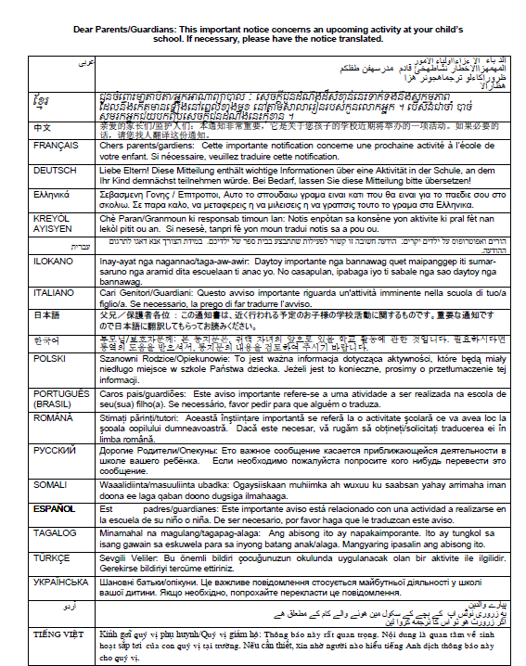

Appendix D-23: NAEP 2024 School Based Equipment (SBE) Staff Survey

School-Based Equipment-Staff Questions
Respondent: The district assessment coordinator designates a technology coordinator for each sampled school who will respond to this survey. The designated technology coordinator may be school based or district based.
Distribution: This survey will be distributed via AMS after schools complete the 2024 operational assessment; all technology coordinators in each grade will receive the survey.

Device Ownership
- Which of the following models is used in your school(s) to provide technology access (e.g., laptops, desktop computers, tablets) for your students (select all that apply)?

 | One to one | One to many | Media room or library | Bring your own device (BYOD) | Not applicable
Grade 4
Grade 8
Grade 12

Device Management
- Are all your student devices managed?
- Yes
  - School
  - District
  - State
- No
  - Approximate percentage of managed devices (fillable field):
  - Approximate percentage of unmanaged devices (fillable field):

- How does a school, district, or state manage student devices?
- School-owned devices:
  - Chromebooks
    - Google Admin console
    - Google Workspace for Education
    - Other, please specify (fillable field):
  - Microsoft Windows devices
    - Microsoft Intune for Education service:
    - Other, please specify (fillable field):
  - Other platforms (please specify):

- Bring your own devices (BYOD)
  - Does not manage centrally
  - Chromebooks
    - Google Admin console
    - Google Workspace for Education
    - Other, please specify (fillable field):
  - Microsoft Windows devices
    - Microsoft Intune for Education service
    - Other, please specify (fillable field):
  - Other platforms (please specify):

- How are applications distributed to devices?
- Chromebooks
  - All applications are managed via Google Admin console
  - Faculty or students can install apps as a part of a classroom curriculum
  - Applications are installed individually from the Chrome web store
  - Applications are installed individually from credible sources (e.g., websites from organizations such as Pearson, Cambium)
- Microsoft Windows devices
  - All applications are distributed remotely via a central management tool.
  - Preferred format (if known)
  - MSI
  - MSIX
  - Installed individually from Windows Store
  - Installed individually from credible sources (e.g., websites from organizations such as Pearson, Cambium)
  - Other, please specify (fillable field):
- Other platforms (please specify):

- How are major state assessment apps configured on school devices to provide a secure/lockdown testing/assessment environment?
- Chromebooks
  - via Google Admin console kiosk mode option
  - Other, please specify (fillable field):
- Windows
  - via Microsoft tool "Take a Test in kiosk mode"
  - Installed app controls the secure environment without additional configurations required.
  - Installed app controls the secure environment with additional manual configurations.
  - Other, please specify (fillable field):

- Who is responsible for installing applications on school equipment (select all that apply)?
- School technology coordinator
- District technology coordinator
- Other, please specify (fillable field):

Device and Security Policies
- What is the replace (refresh) device policy at your school/district/state?
- Every year
- Every two years
- Every three years
- Every four years
- Other, please specify (fillable field):

- What is the operating system (OS) upgrade policy at your school/district/state?
- Every major OS release
- On a set schedule (please specify):
- On a delayed schedule (please specify):

- Do your security policies allow an outside application to be downloaded on student devices?
- Yes
- No

- Do school/district/state policies enforce the creation of guest accounts for any state assessment/test applications?
- Yes
- No

- Do school/district/state policies allow any of the following activities?
 | Yes | Yes, with restrictions | No | Not applicable
a. Allowing installed applications to access the local user’s file system
b. Downloading applications from websites other than Microsoft and Chrome application stores
c. Downloading and installing executable files from credible sources if they are safelisted/whitelisted
d. Downloading and installing any executable files from credible sources regardless of safelist status

Device Specification
- What type of student devices and operating systems (OS) does your school support (check all that apply)?
 | Chromebook ChromeOs | Microsoft Windows  (Laptops, tablets, desktops) | MacOs (Laptops, desktops) | iPad  iOS | Android Tablet  Android Os | Other (fillable)
Grade 4
Grade 8
Grade 12

- What is the screen resolution on the type of devices students use in your school (select all that apply)?
- 1366x768
- 1920x1080
- 1920x1200
- 1224x768
- Other (fillable field):

- What is the screen size on the type of devices students use in your school (select all that apply)?
- 14.0”
- 12.2”
- 13.5”
- 15.6”
- Other (fillable field):

- If touch computers are used by students, is a stylus provided (select all that apply)?
- Touch computers are provided by the school with a stylus
- Touch computers are provided by the school without stylus
- Students purchase their own styluses
- Touch computers are not used by students

Appendix D-24: NAEP 2024 Assessment Details Notification Principal to School Coordinator Letter

Appendix D-25: NAEP 2024 Public School Coordinator responsibilities

Appendix D-26: NAEP 2024 Private School Coordinator Responsibilities

Appendix D-27: NAEP 2024 Private School Video Script (Approved v.30)

Video Title: NAEP is Supported by Many Private School Organizations
Screen # | Narrated Text | Description of Screen
1 | The National Assessment of Educational Progress, also known as NAEP, or The Nation’s Report Card, is supported by many private school organizations. | NAEP logo appears on screen.
2 | Several organizations have provided letters of support for the NAEP 2024 assessment, including the Council for American Private Education (CAPE), the National Catholic Educational Association (NCEA), the National Association of Independent Schools (NAIS), and the Association of Christian Schools International (ACSI) among many others. | Screen shots of endorsement letters from CAPE, NCEA, NAIS, and ACSI appear on screen.
3 | Here is the full list of private school organizations that have provided letters of support for NAEP 2024. | [Placeholder for full list of organizations that provide letters in 2024]
4 | By participating in NAEP 2024, your school will contribute to the picture of education across the nation and to future policy decisions. For more information about the importance of participation in NAEP, contact your private school organization leaders or your NAEP representative. | A map of the United States with education icons popping out of various locations in the map
5 | NAEP, giving private schools a voice in the national education conversation. | NAEP, giving private schools a voice in the national education conversation.

Video Title: NAEP Benefits for Students, Teachers, and Schools
Screen # | Narrated Text | Description of Screen
1 | Your school has been selected to represent private schools across our nation by participating in the 2024 administration of the National Assessment of Educational Progress, also known as NAEP or The Nation’s Report Card. | NAEP logo appears on screen.
2 | Students, teachers, and schools all benefit by participating in NAEP. | Icons representing students, teachers, and schools
3 | By participating in NAEP, students can receive a certificate of community service for their time spent on the NAEP assessment. | Screen shot of community service certificate
4 | Students experience an engaging digitally based assessment with rich content in a low stakes environment as NAEP results are not reported at the individual school or student level. | Images of students participating in the NAEP assessment
5 | Students that participate in NAEP contribute to improving the quality of education for all students in the United States. | A map of the United States with education icons popping out of various locations in the map
6 | Teachers also make an important contribution to improving education quality in the United States by encouraging their students to participate and give their best effort. This helps ensure that NAEP results provide the most accurate measure possible of student achievement across the country. | Image of teachers supporting students in the classroom
7 | Teachers can also access NAEP’s free data tools such as the NAEP Questions Tool to generate tests online using NAEP questions that could be used in their classroom. | Screen shot of the NAEP Questions Tool website
8 | Teachers also receive a certificate of appreciation for completing the teacher questionnaire. | Screen shot of the teacher certificate
9 | Schools that participate in NAEP receive a certificate of appreciation signed by the Commissioner of the National Center for Education Statistics. | Screen shot of the school certificate
10 | We look forward to working with you to make NAEP a success in your school. Please reach out to your NAEP representative to discuss any participation questions. NAEP, giving private schools a voice in the national education conversation. | Image of NAEP representatives.  NAEP, giving private schools a voice in the national education conversation.

Video Title: Participation in NAEP is Easy
Screen # | Narrated Text | Description of Screen
1 | Your school has been selected to represent private schools across our nation by participating in the 2024 administration of the National Assessment of Educational Progress, also known as NAEP or The Nation’s Report Card. | NAEP logo appears on screen.
2 | In order to have a complete picture of the academic achievement and progress of the nation's private school students, selected private schools must participate in NAEP. Your school’s participation in NAEP 2024 is an opportunity to help make it possible for private school data to be reported and compared with public school data. | Icons representing public and private schools  Your school’s participation is important!
3 | Participating in NAEP is easy and there is no cost to your school to participate. Your school has been assigned a NAEP representative who will support your school’s designated NAEP school coordinator to ensure smooth assessment day activities. NAEP representatives will work with the school coordinator to confirm that the assessment date works with the school calendar, to secure a space for the assessment to take place, and to confirm other assessment day logistics. | Participating in NAEP is easy!  Image of the NAEP representatives on the phone with a school coordinator
4 | NAEP representatives will bring in all the necessary equipment and materials and will administer the assessment to students. When the assessment is complete, NAEP representatives will pack up all the equipment and materials and return the testing location to its original condition. | Images of NAEP representatives bringing the equipment to the school and administering the assessment
5 | We look forward to working with you to make NAEP a success in your private school. Please reach out to your NAEP representative to discuss any participation questions. NAEP, giving private schools a voice in the national education conversation. | Image of NAEP representatives.  NAEP, giving private schools a voice in the national education conversation.

Appendix D-28: NAEP 2024 Operational and Pilot Technical Fact Sheets

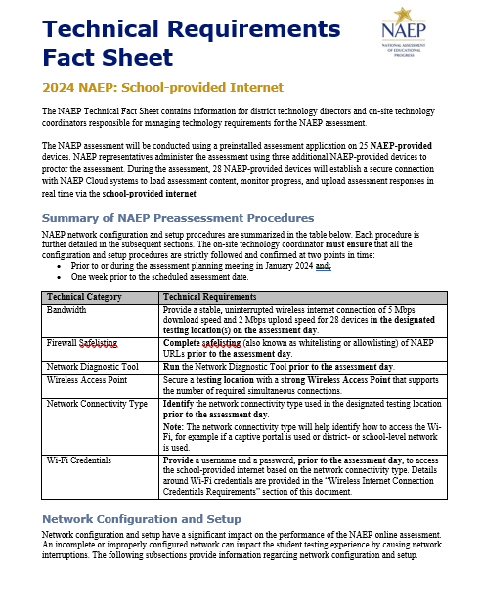

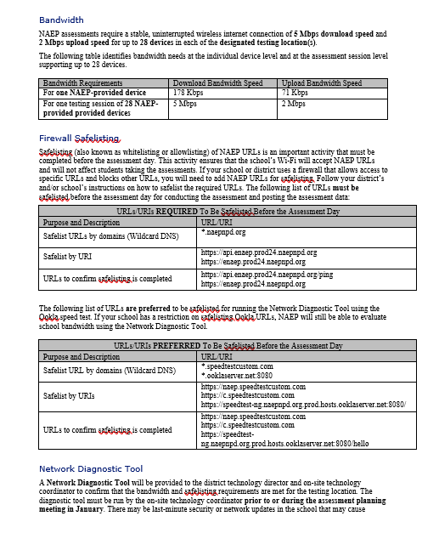
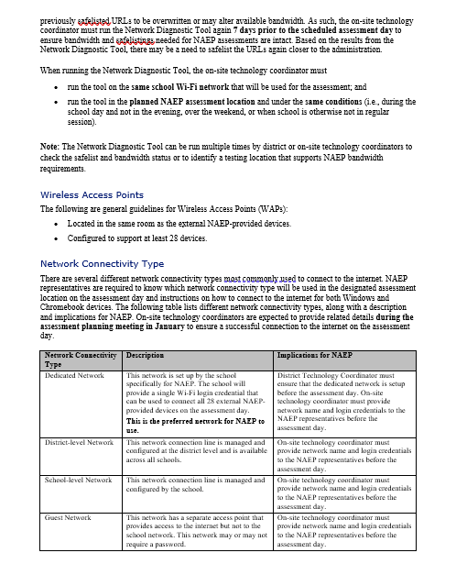

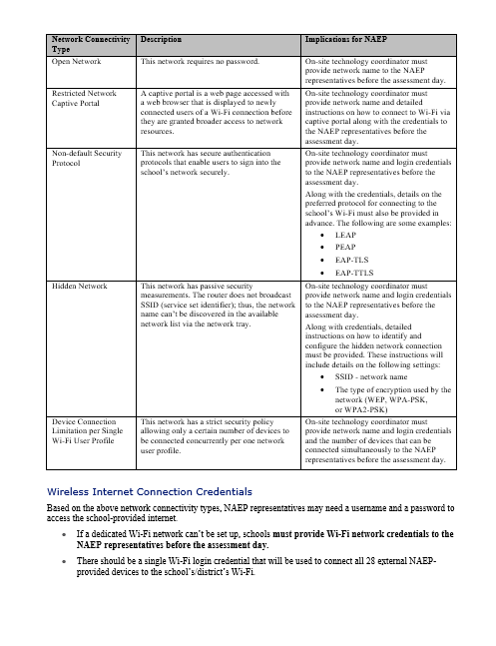

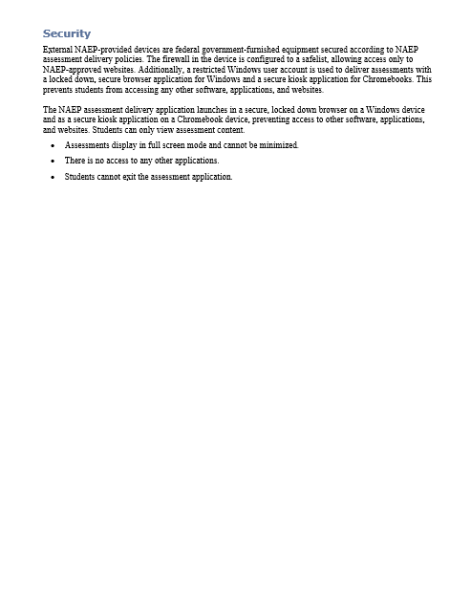
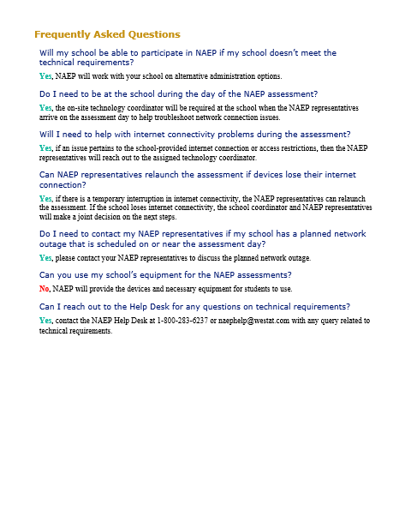

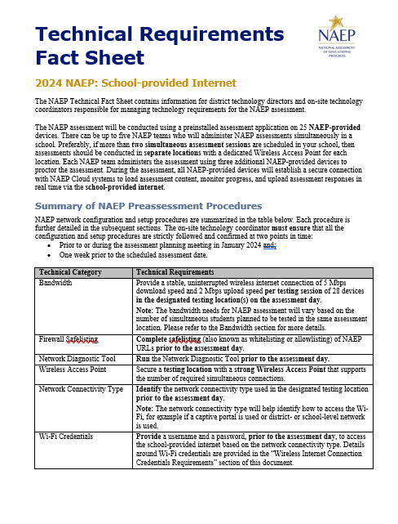
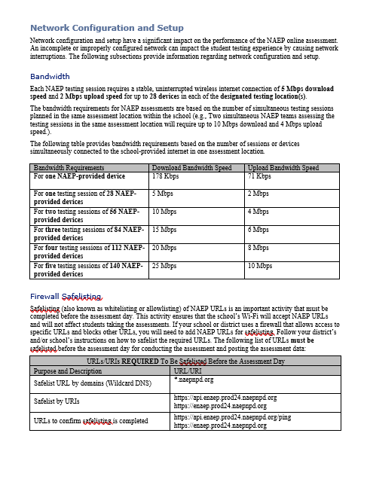
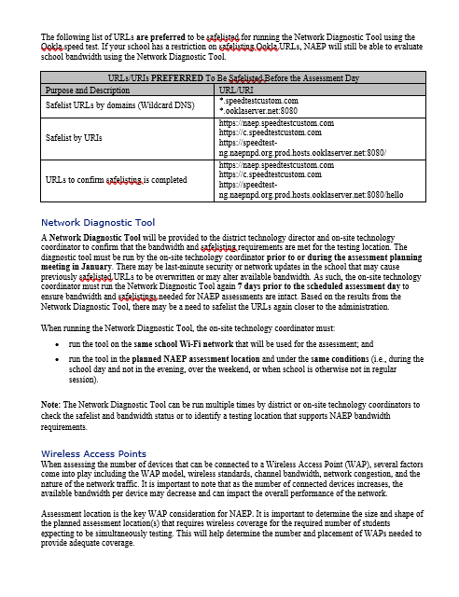

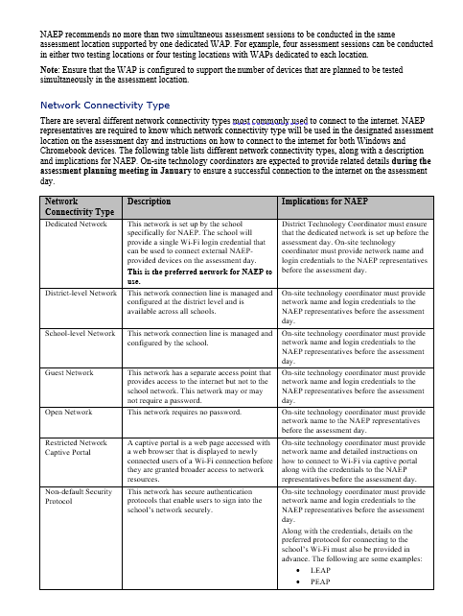

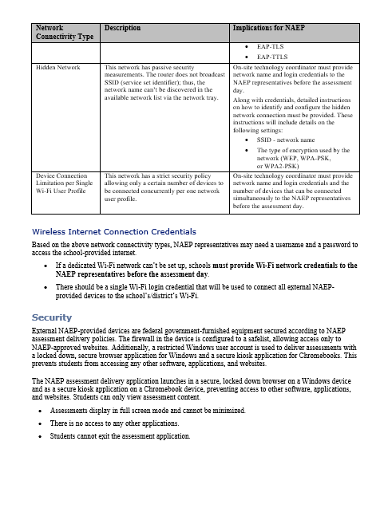

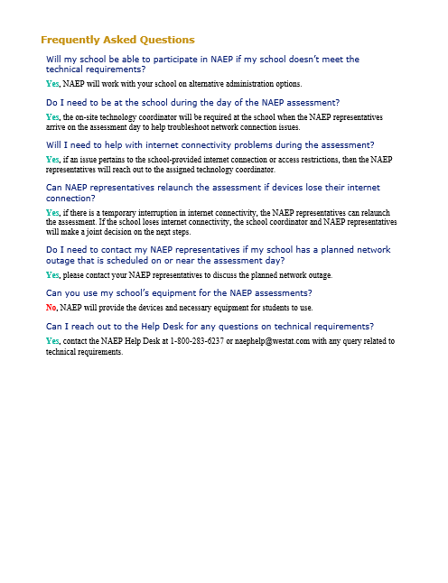

Appendix D-29: NAEP 2024 Best Practices Materials

Appendix D-30: NAEP 2024 Best Practices Initial Mailing

Dear School Principal,
Enclosed please find the Best Practices Guide for Supporting Twelfth-Grade NAEP Participation. The guide includes proven practices and strategies, from administrators like you, to make the National Assessment of Educational Progress (NAEP) a very positive and successful experience for our nation’s high schools.
NAEP results provide valuable feedback to educators, elected officials, and policymakers who work to maintain and improve the quality of our education system. Since NAEP is designed to assess a representative sample of our nation’s students, the accuracy of NAEP relies on the full participation of you, your teachers, and your students. One of the major purposes of NAEP is to show how education in the nation and our state is progressing. For that, we need a true picture of our students’ collective progress.

Twelfth-grade participation
Historically, twelfth-grade student participation in NAEP has been a challenge. Both low participation and low motivation can undermine the validity and credibility of NAEP results for high school students. As the graph below demonstrates, NAEP participation increased with the implementation of the Best Practices Guide in 2007. Participation is more important than ever since this is the first NAEP Grade 12 assessment since the COVID-19 pandemic began.

NAEP School and Student Participation Rates for Public Schools: Grade 12

Recommendations from the Secondary School Principals’ Working Group
The Best Practices Guide was created after NCES convened a Secondary School Principals’ Working Group in 2005 to address twelfth-grade participation rates. After discussing participation rates, student motivation, and student results, the working group concluded that the results did not reflect the true level of achievement of their students. The working group also concluded that high school principals and other school leaders could help improve participation rates by obtaining teacher buy-in and motivating students to take the assessment and do their best, and that best practices for achieving high participation should be shared with principals.
Twelfth-grade participation in NAEP improved after the implementation of these recommendations, but only because principals like you have used some or all the strategies included in the Best Practices Guide. With increased participation headwinds in assessments, NAEP relies on principals like you more than ever.

Preparing for NAEP 2024
The guide included in this package will provide the tools you need to communicate the importance of participating in NAEP to your students and teachers. Some of the resources available in the Best Practices Guide for Supporting Twelfth-Grade NAEP Participation are listed below:
- Videos to introduce NAEP to students and teachers;
- PowerPoint presentations customized for the students, parents, and staff at your school;
- MS Word templates for student notification letters, morning announcements, and more;
- Talking points used by principals for communicating with teachers, students, and parents; and
- Social media posts announcing NAEP to various audiences.
In addition, you will receive three emails in the months leading up to the assessment. Each email will highlight effective strategies for encouraging participation and will link to the resources mentioned above.

Meeting with your NAEP State Coordinator
I will be meeting with grade 12 schools to introduce the resources from the Best Practices Guide and effective strategies for encouraging participation on the NAEP assessment. <State Coordinators will include specific details on their meeting here.>
If you have any questions about the Best Practices Guide or the upcoming NAEP assessment, please contact me at NSC email or NSC phone number.

Sincerely,

NSC Name
Enclosures: NAEP 2024 Best Practices Guide for Supporting Twelfth-Grade NAEP Participation

The National Center for Education Statistics (NCES) conducts the National Assessment of Educational Progress to evaluate federally supported education programs. All of the information you provide may only be used for the purposes of research, statistics, and evaluation under the Education Sciences Reform Act of 2002 (ESRA; 20 U.S.C. § 9543) and may not be disclosed, our used, in identifiable form for any other purpose except as required by law. Every NCES employee as well as every NCES agent, such as contractors and NAEP coordinators, has taken an oath and is subject to a jail term of up to 5 years, a fine of $250,000, or both if he or she willfully discloses ANY identifiable information about you. Electronic submission of your information will be monitored for viruses, malware, and other threats by Federal employees and contractors in accordance with the Cybersecurity Enhancement Act of 2015.

Appendix D-31: NAEP 2024 Best Practices Emails

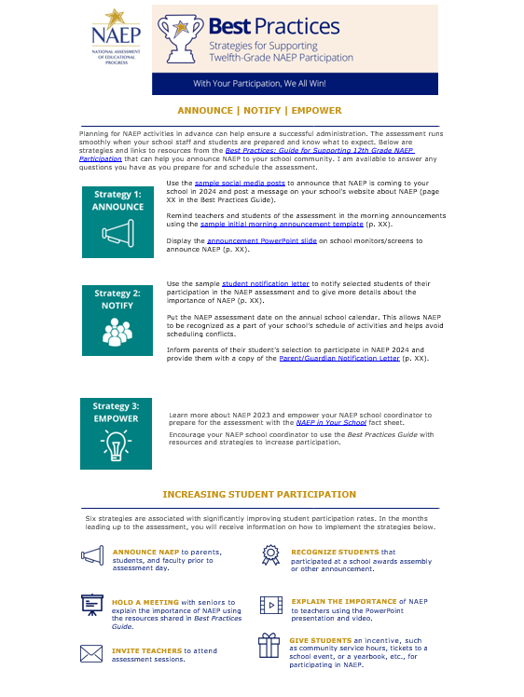

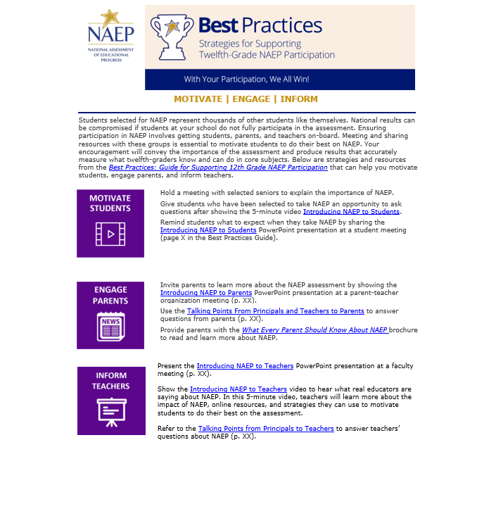
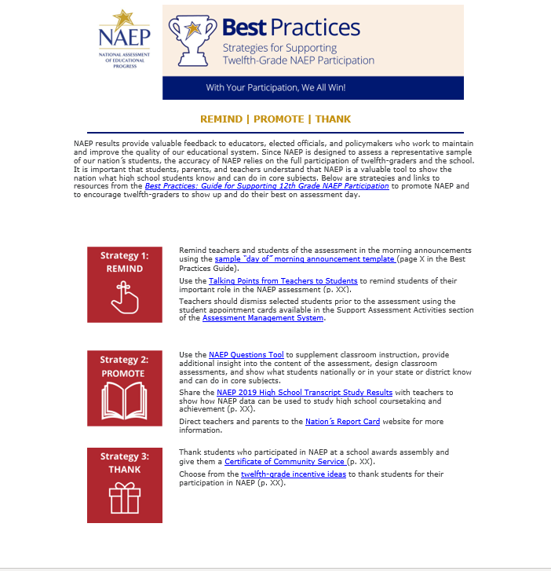

Appendix D-32: NAEP 2024 Best Practices Notification Letter for Students


Notification Letter
For Students

Dear Student:
Congratulations! You have been selected to participate in this year’s National Assessment of Educational Progress, also known as NAEP. Very few students are selected, but you have been chosen to represent thousands of your peers in this important assessment.
NAEP is the most important measure of what students from across the country know and can do in a variety of subject areas. It is different from our state assessments because it represents high school students across the country, not just those here in [state]. Your participation will provide a snapshot of what students from across the country have learned in school, which will inform major decisions about how to improve education in the United States. In short, it’s important that you take part and give it your best effort!
- You will take NAEP at [time, date, location] with other selected students.
- You will take a mathematics or reading assessment.
- NAEP takes about 2 hours, and you don’t need to study for it.
- Your answers will be anonymous and will NOT affect your grades or academic record in any way.
- Upon completion of the assessment, you will receive a Certificate of Community Service.
If you have any questions or would like to review sample questions, [insert name of school contact person] will be happy to help. You can also visit http://nces.ed.gov/nationsreportcard/students for more information.
We are fortunate that our school has been selected to participate in NAEP, and we are excited to have you take the assessment. We know you will do your best and help us show what our students are capable of.
Sincerely,
(School Principal)
What students are saying about NAEP participation…
[Insert QR code linking to Hager Sharp’s Introducing NAEP to Students video]

Appendix D-33: NAEP 2024 Best Practices Social Media and Online Communications

Social Media and Online Communication

Sample Announcements
If your school uses Twitter and/or Facebook to communicate with parents, students, and teachers, you can also use these platforms to communicate the importance of the assessment to teachers and to encourage student participation. The following messages below are formatted for Facebook and Twitter and are available for you to customize before posting to your school’s social media channels. These messages can also be posted on your school website, incorporated in school emails, newsletters, and/or your school’s preferred social media platform.
In addition, you can follow NAEP’s social media accounts as we regularly share resources, results, and tools for working with NAEP that states also share on their pages to prepare for participation in the assessments. Find our social media accounts below.

https://www.facebook.com/NationalAssessmentofEducationalProgress/


https://twitter.com/naep_nces?lang=en
https://www.youtube.com/user/TheNationsReportCard

Scheduling Information
Facebook | Twitter
Our school will have the chance to make a difference in education on [DATE]! Learn why our participation in NAEP is important at https://www.nationsreportcard.gov/. | We’re excited to announce our school will participate in #NAEP on [DATE]! Learn about this national assessment at https://www.nationsreportcard.gov/.
A group of our 12th-graders will represent thousands of others across the country on [DATE]! Known as The Nation’s Report Card, NAEP is the largest nationally representative and continuing assessment of what students in the United States know and can do in a variety of subjects. Learn more at https://www.nationsreportcard.gov/ | #NAEP will be administered to select 12th-graders at our school on [DATE]. To learn more about the program, visit https://nces.ed.gov/nationsreportcard/students/
 | Something big is happening on [DATE]. A group of our 12th-graders will participate in #NAEP that day! Learn more at https://nces.ed.gov/nationsreportcard/students/
Information for Teachers
Facebook | Twitter
Teachers, how much do you know about NAEP? What does NAEP mean for you and your students? Hear what other teachers are saying at https://nces.ed.gov/nationsreportcard/participating/schools.aspx | Some of our 12th-graders have been selected to participate in #NAEP! Discover what other #teachers are saying at https://nces.ed.gov/nationsreportcard/participating/schools.aspx
NAEP results help us better understand how our students are performing academically across the United States. Learn more about why participation is important at https://www.nationsreportcard.gov/focus_on_naep/participation/#/grade12 | #Teachers, do you know why our #student participation in #NAEP is important? Find out: https://www.nationsreportcard.gov/focus_on_naep/participation/#/grade12
 | #Teachers, find out the types of questions your #students will see on #NAEP with the NAEP Questions Tool: https://nces.ed.gov/nationsreportcard/nqt/

Information for Students
Facebook | Twitter
12th-graders, don’t forget! If you have been selected to take NAEP, your participation is essential for understanding what students across the country have learned in school. Curious about the types of questions you can expect to see on #NAEP? Check out the NAEP Test Yourself tool at https://www.nationsreportcard.gov/testyourself.aspx | Curious about the types of questions you can expect to see on #NAEP? Check out the NAEP Test Yourself tool at https://www.nationsreportcard.gov/testyourself.aspx
What is NAEP? Learn the answer to this question and more at https://nces.ed.gov/nationsreportcard/students/ | You don’t have to study for #NAEP, but your participation is still important. Find out why: https://nces.ed.gov/nationsreportcard/students/
Information for Parents
Facebook | Twitter
Parents, if your 12th-grader has been selected to take NAEP, they will represent thousands of other students across the United States. Discover other reasons why participation is so important at https://nces.ed.gov/nationsreportcard/parents/ | Mark your calendars, parents! Our school will participate in #NAEP on [DATE]. Learn more about the assessment at https://nces.ed.gov/nationsreportcard/parents/
Do you have any questions about NAEP and your child’s involvement? Learn the answers to your questions and more by visiting https://nces.ed.gov/nationsreportcard/parents/ | If your child has been selected to participate in #NAEP, find more information about the assessment at https://nces.ed.gov/nationsreportcard/parents/
 | Why is your child’s participation in #NAEP important? Find out by visiting https://nces.ed.gov/nationsreportcard/parents/

Appendix D-34: NAEP 2024 Storyboard for Introduction to Best Practices Video Script

Storyboard for Introduction to Best Practices Video
Section | Narration | Description of Video
1 - Introduction | Thank you for your school’s participation in NAEP, the National Assessment of Educational Progress, for 2024, in mathematics and reading at grade 12. | Title slide.
2 - What is NAEP | NAEP is the largest nationally representative assessment in mathematics and reading. Results from this assessment help inform educators, policymakers, and elected officials about the state of education in the nation. | Image of US map and results from NRC site.
3 - COVID-19 | NAEP was last administered at grade 12 in 2019, prior to the start of the COVID-19 pandemic. NAEP 2024 will provide valuable insight into how the pandemic may have affected this generation of learners. | Image of timeline of HSTS administrations with COVID affected years highlighted.
4 - Importance of Student Participation | It’s important for NAEP to assess as many students selected to participate as possible. Assessing representative samples of students, including students with disabilities and English learners, helps ensure that NAEP results accurately reflect the educational performance of all grade 12 students, so NAEP can continue to serve as a meaningful measure of U.S. students’ academic achievement over time. | Images depicting nationally representative sample.
5 – The grade 12 participation challenge | Grade 12 student participation in NAEP is a challenge. In 2005, when only 67 percent of sampled high school seniors participated, the Best Practices Guide for Supporting 12th Grade NAEP Participation was developed based on suggestions from principals like you to help address the challenge. | Graph of student participation rate over time.
6 – The Best Practices Guide | We need your help in encouraging your twelfth-graders to participate in NAEP to ensure grade 12 results can be reported for 2024. To help you support greater student participation, your NAEP State Coordinator will present you with a copy of this Best Practices Guide. | Image of the front cover of the guide.
7 – Resources | This guide provides the tools, resources, and strategies to communicate to students, teachers, and parents the importance of participating in NAEP and to encourage grade 12 students to show up and do their best on the assessment. | Show table of contents and some resources.
8 – Thank you | We encourage you to review this guide and implement these best practices in your schools. If you have questions, please reach out to your NAEP State Coordinator. Thanks again for your school’s participation. | Thank you slide.

Appendix D-35: NAEP 2024 Introducing NAEP to Students

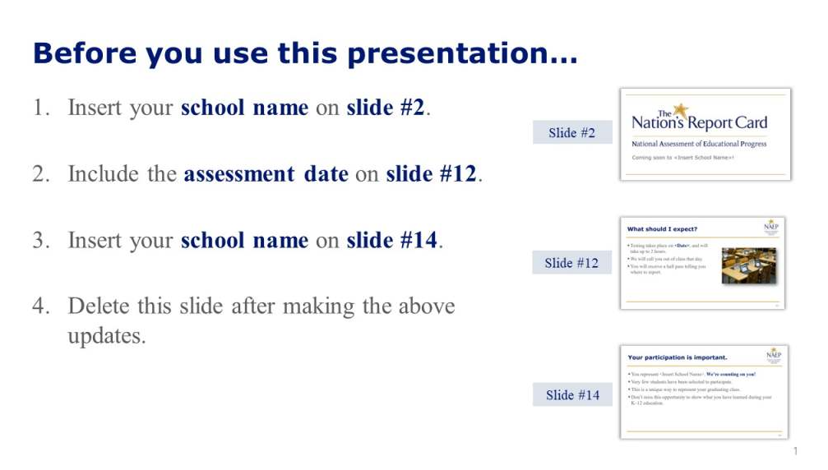
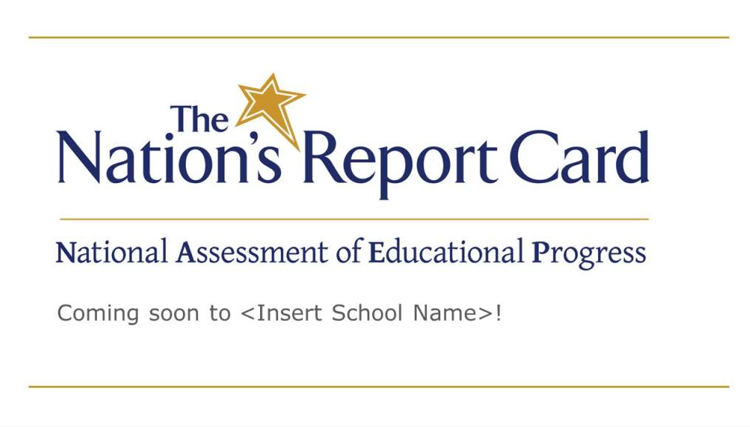

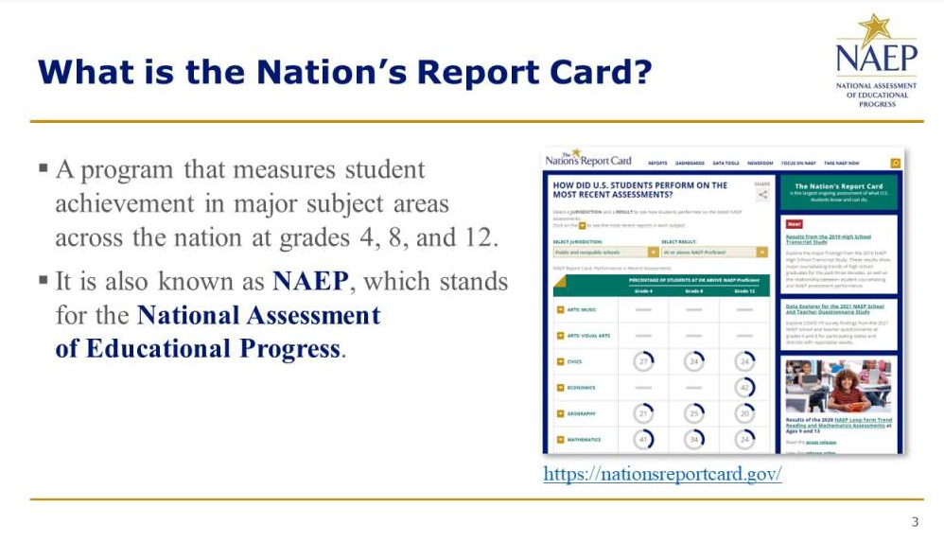

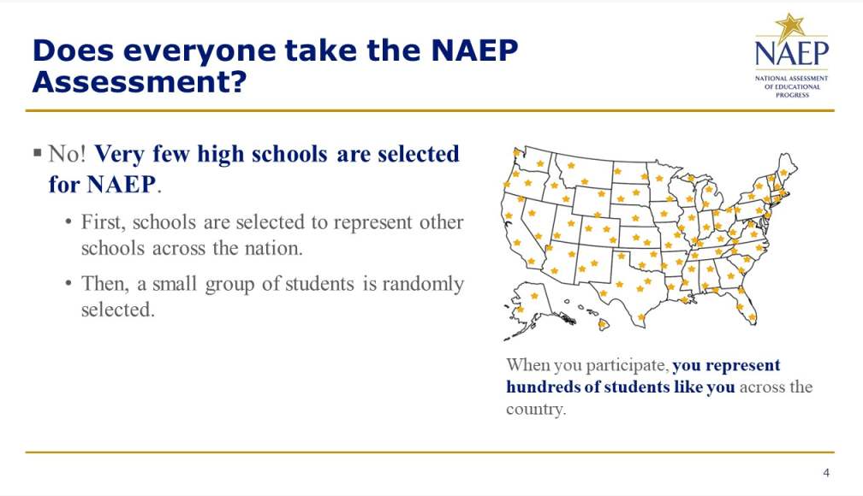

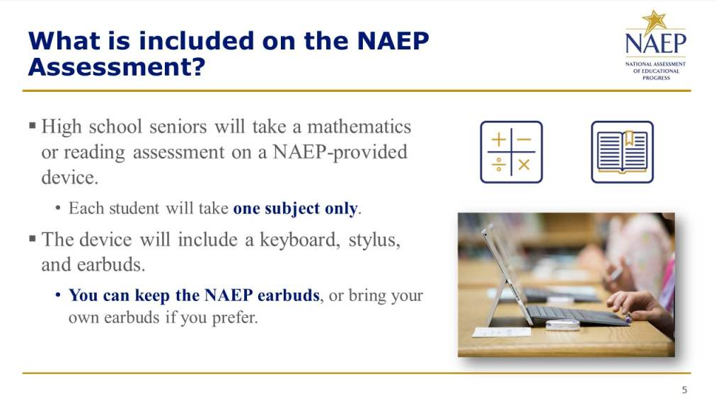
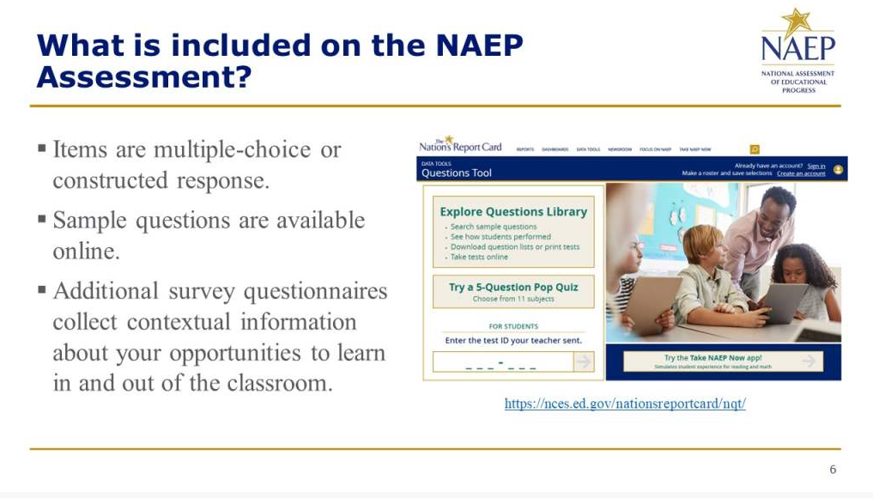
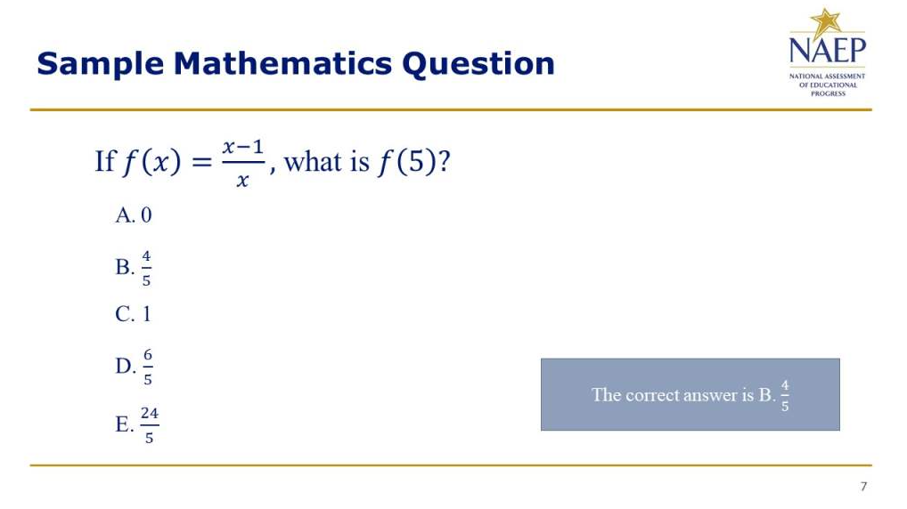
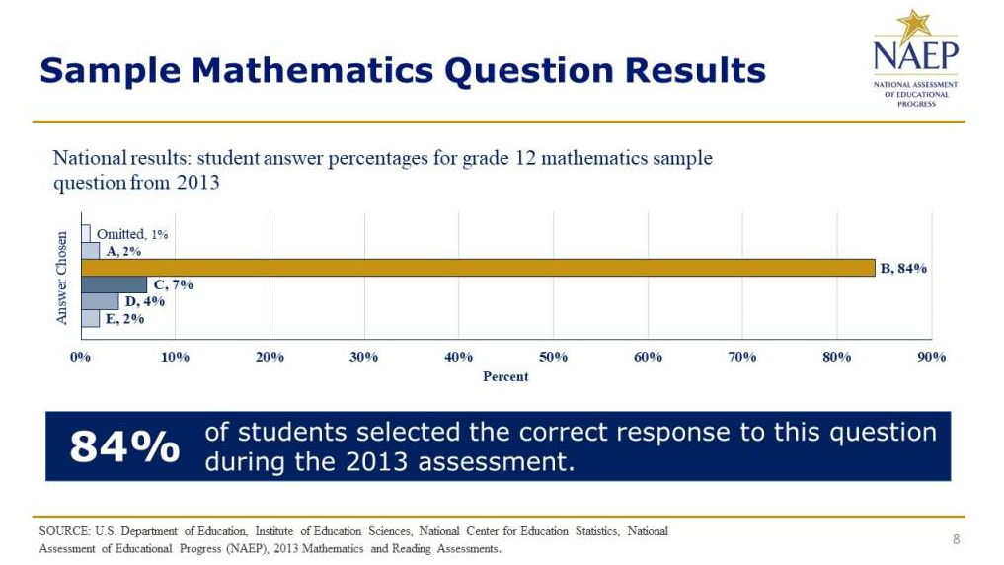

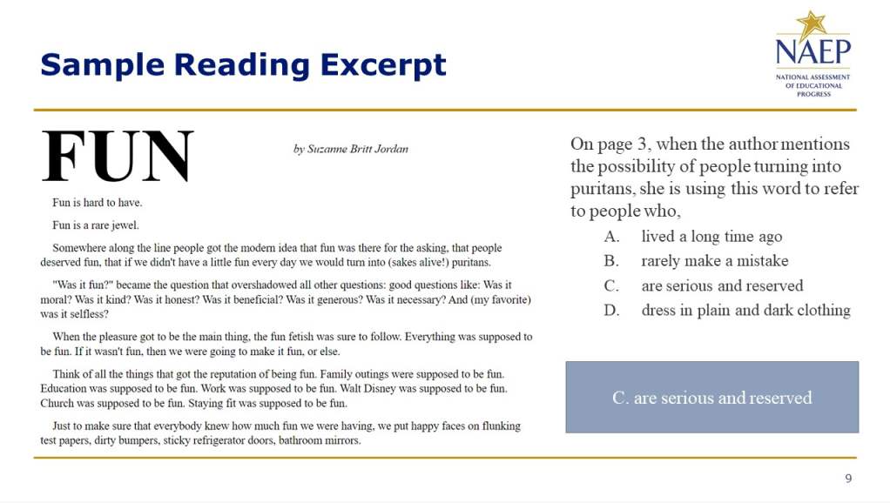
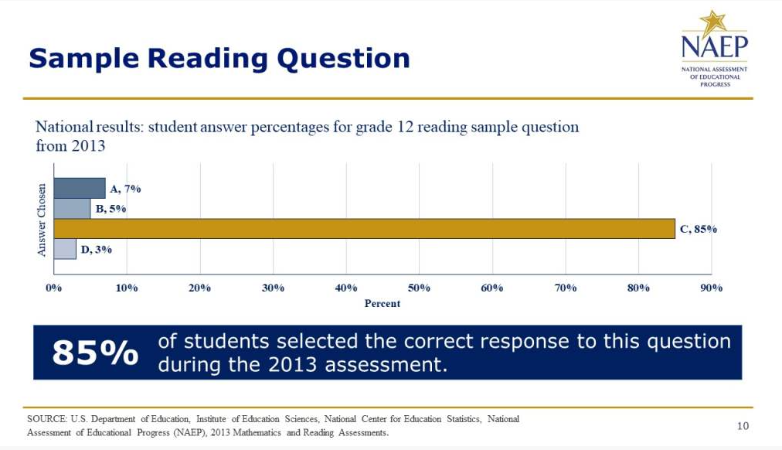

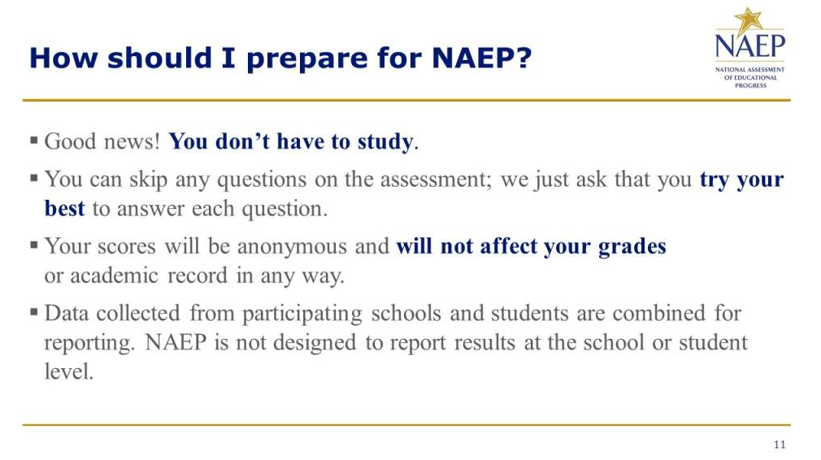
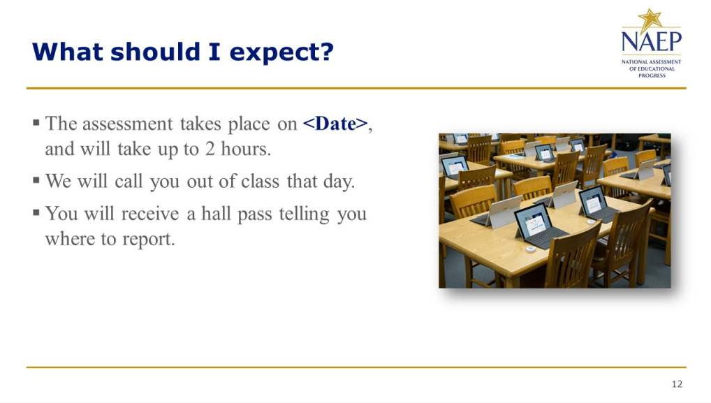

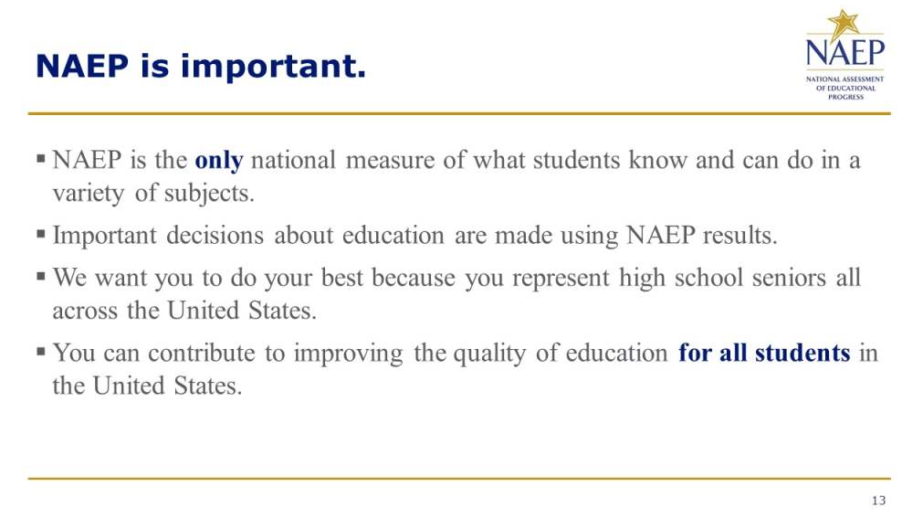
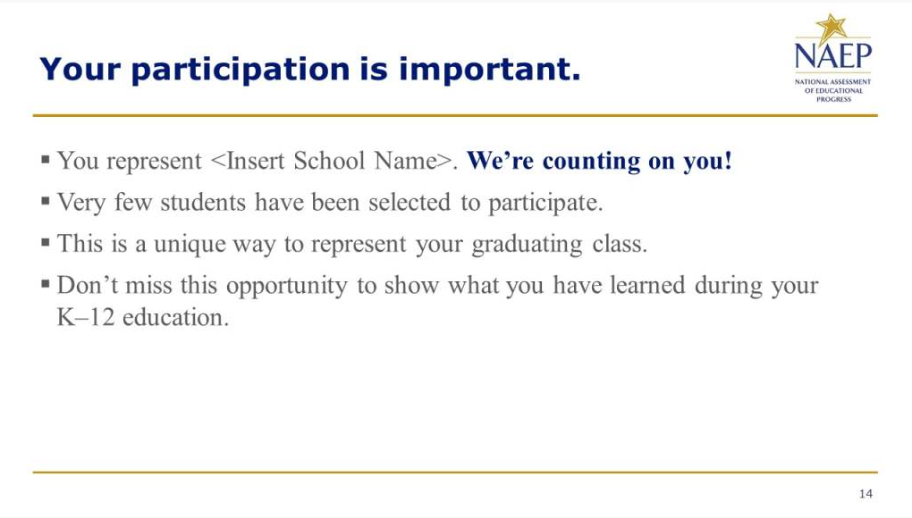

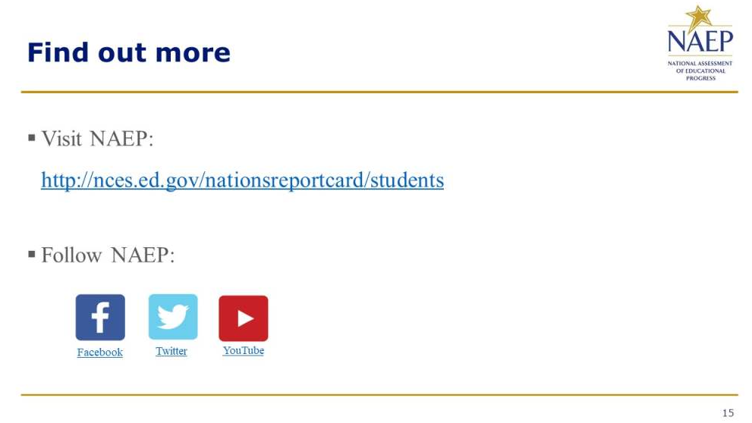

Appendix D-36: NAEP 2024 Introducing NAEP to Teachers

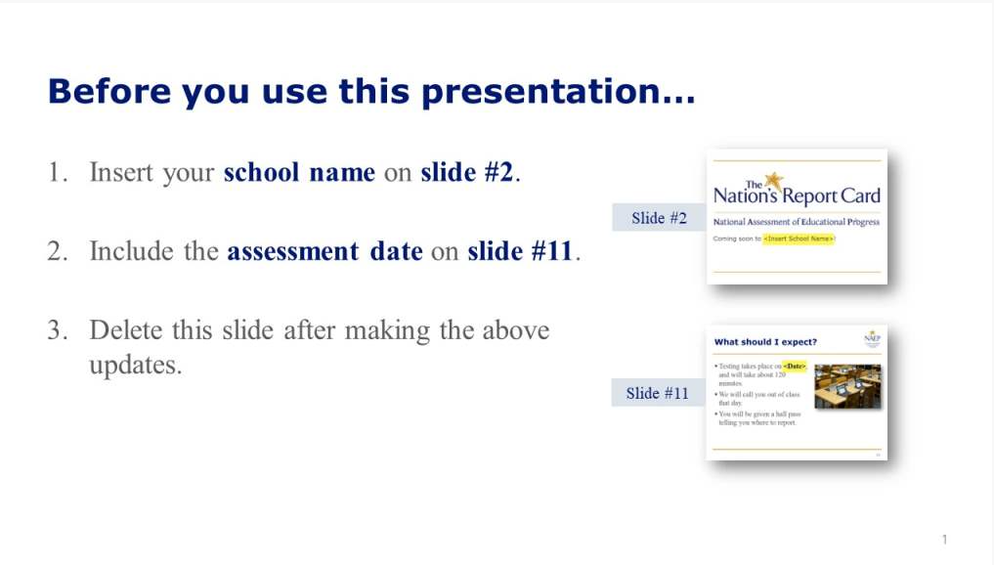
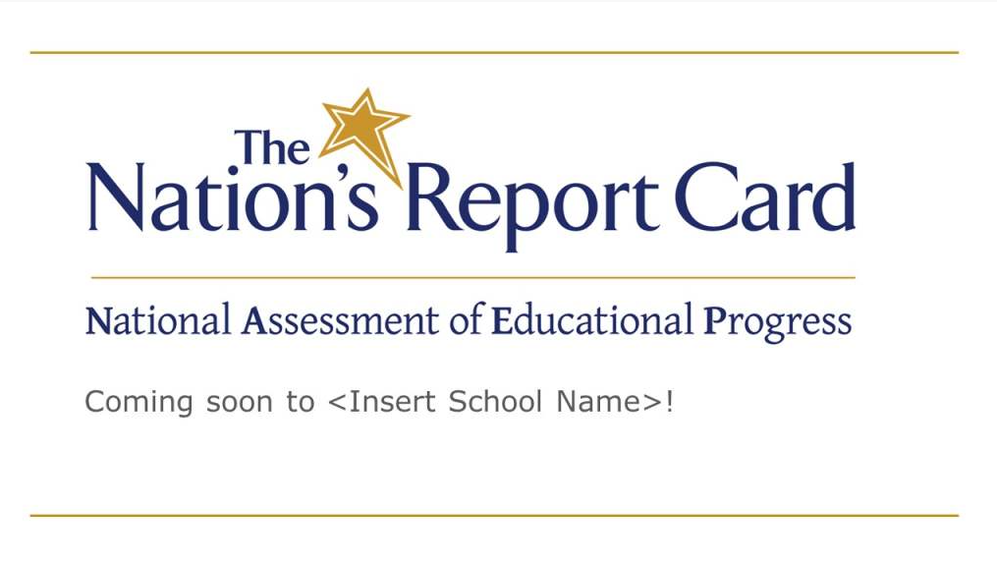

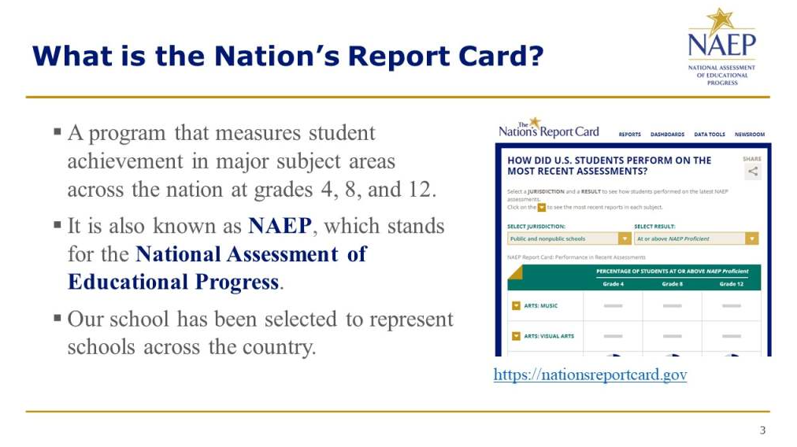
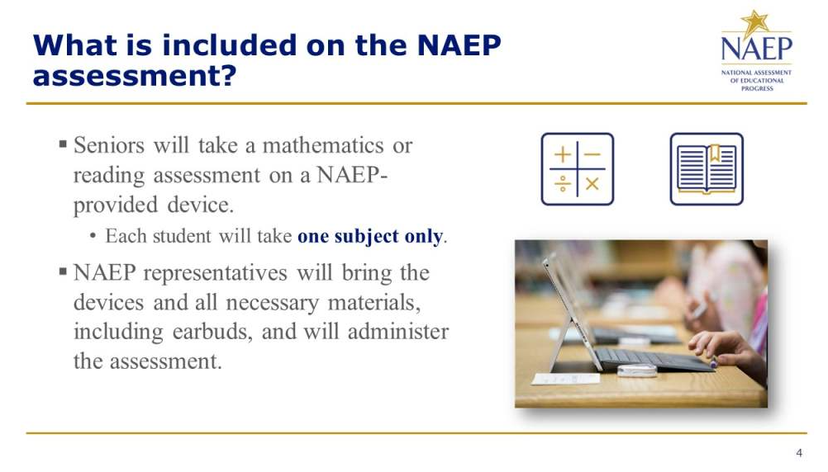

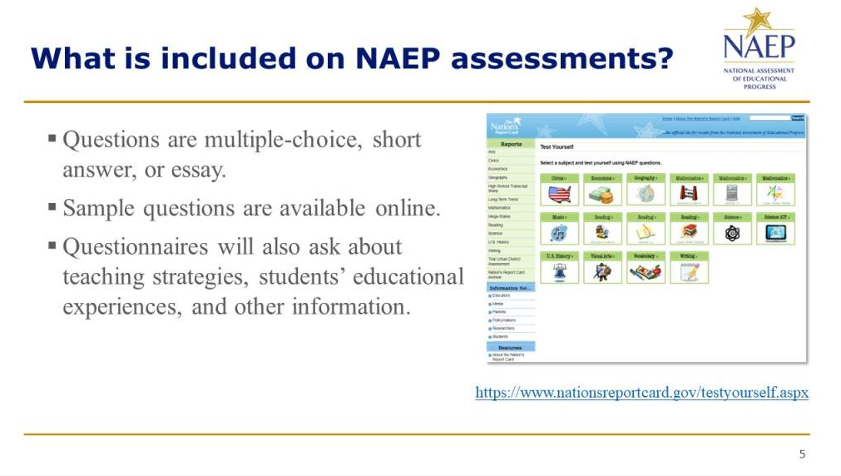
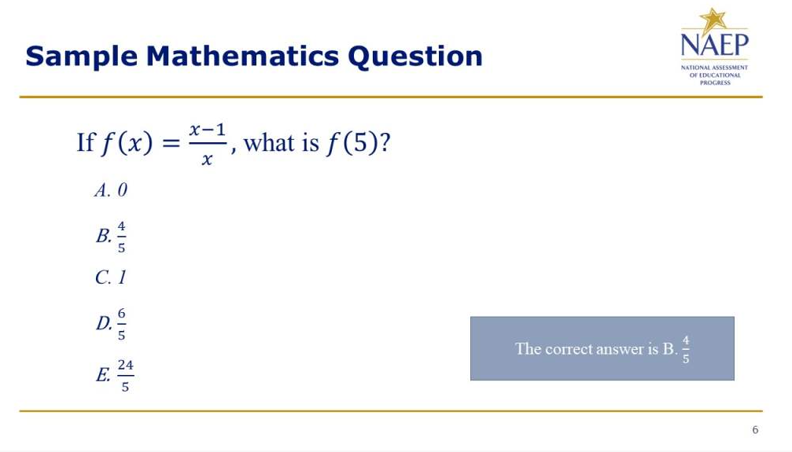

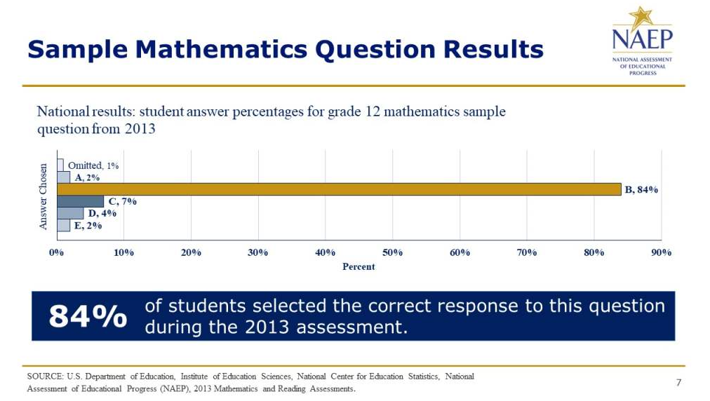
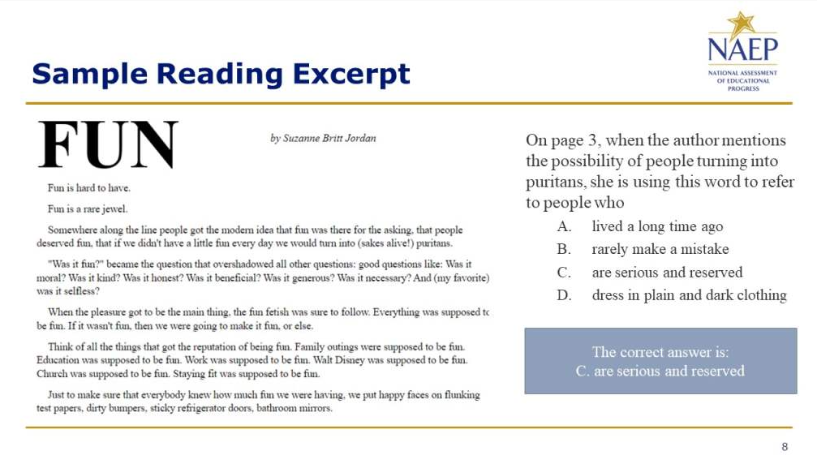

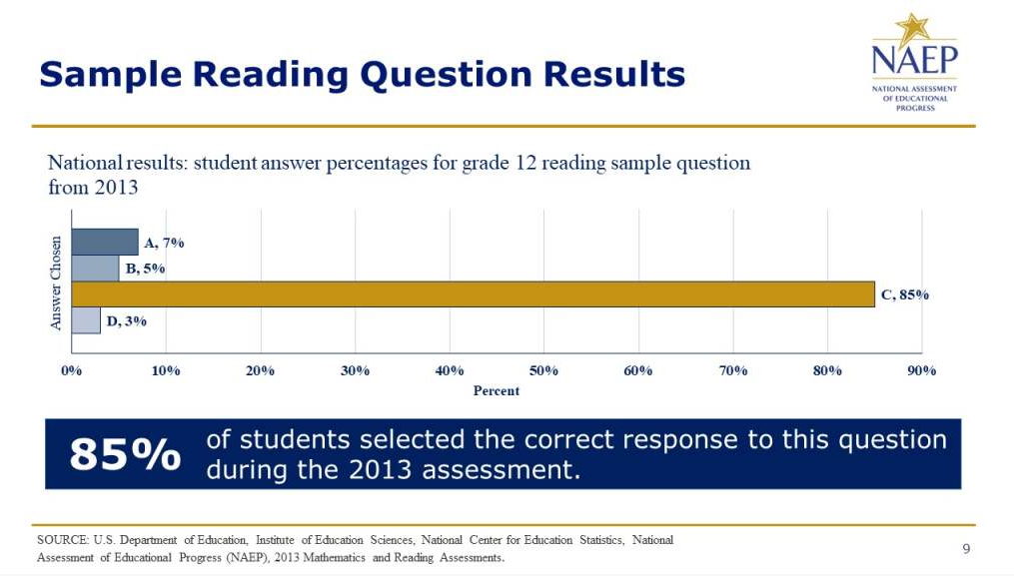
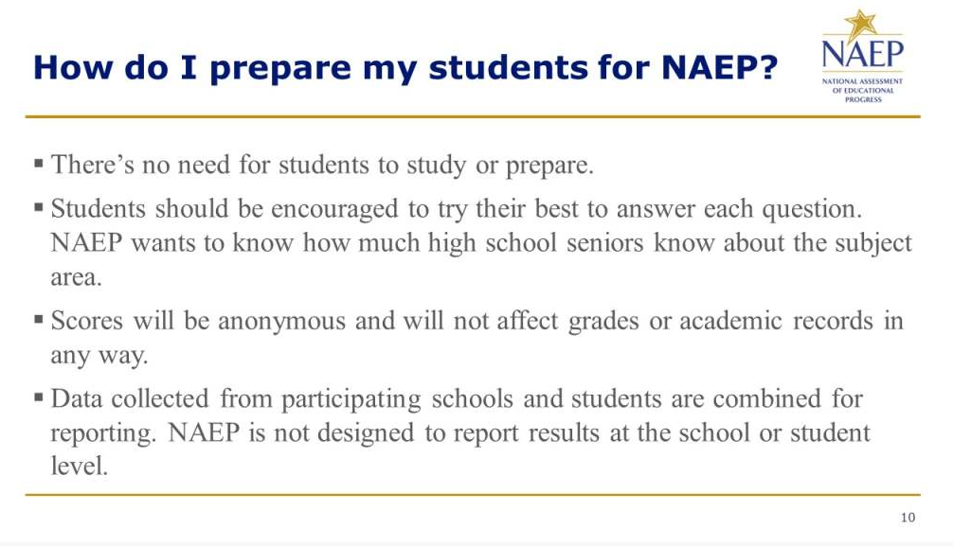

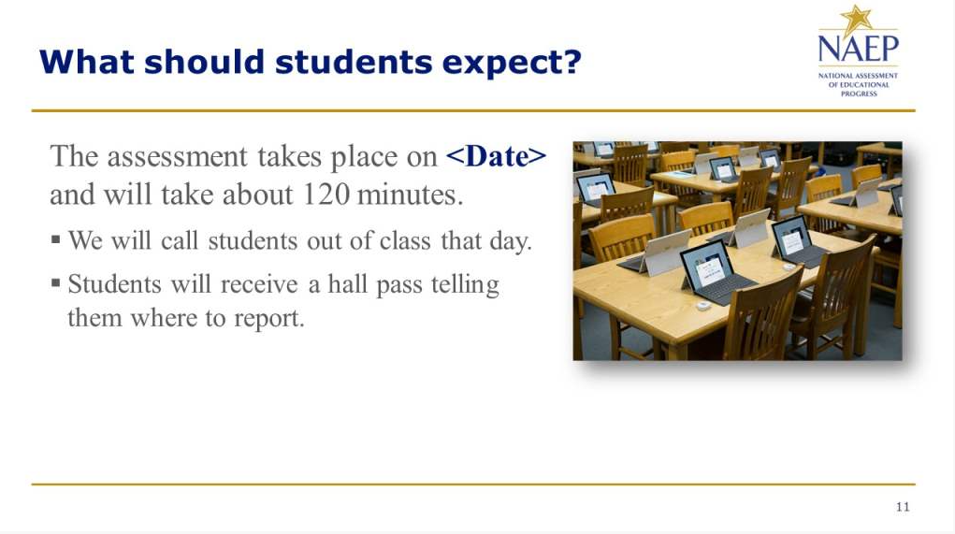
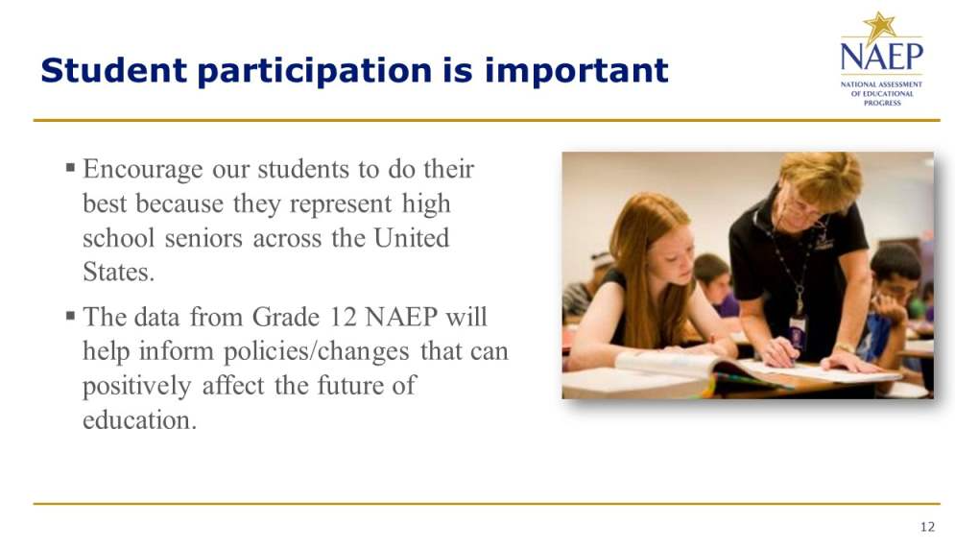

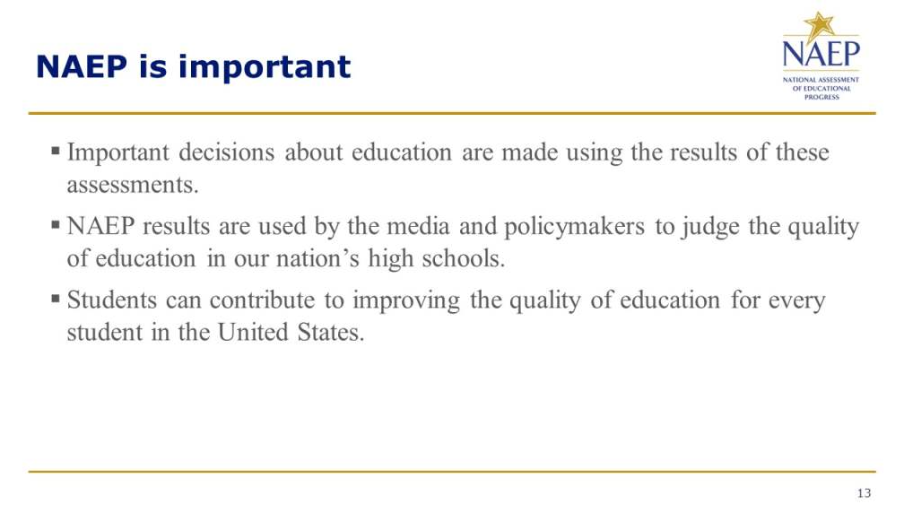
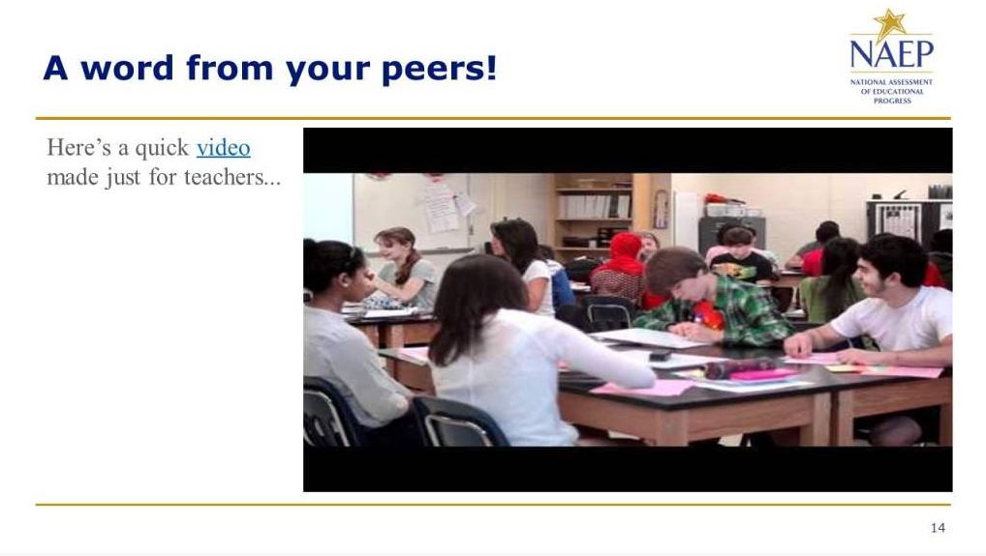

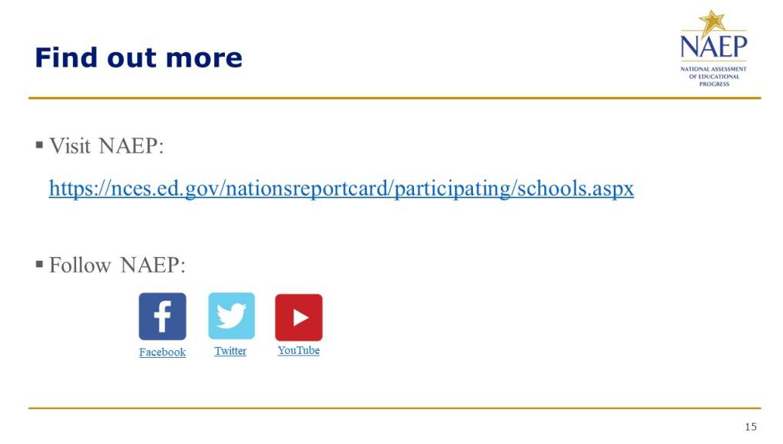

Appendix D-37: NAEP 2024 Introducing NAEP to Parents

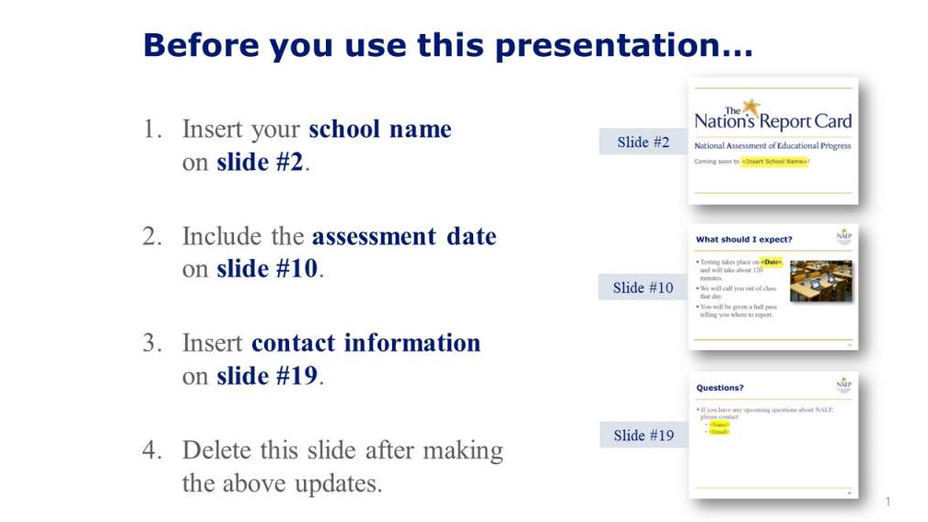
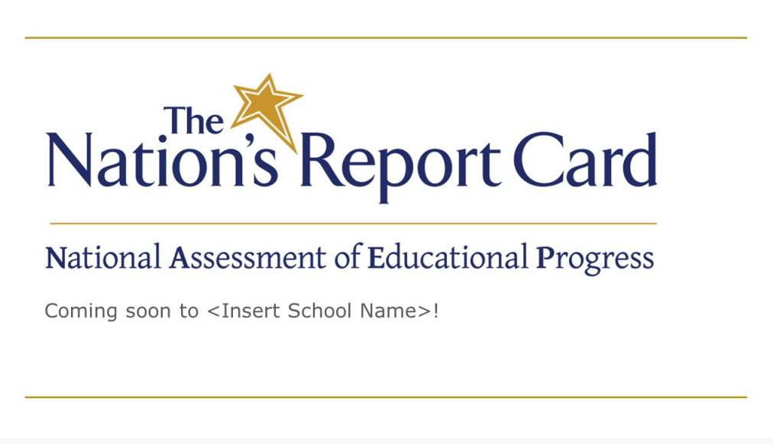

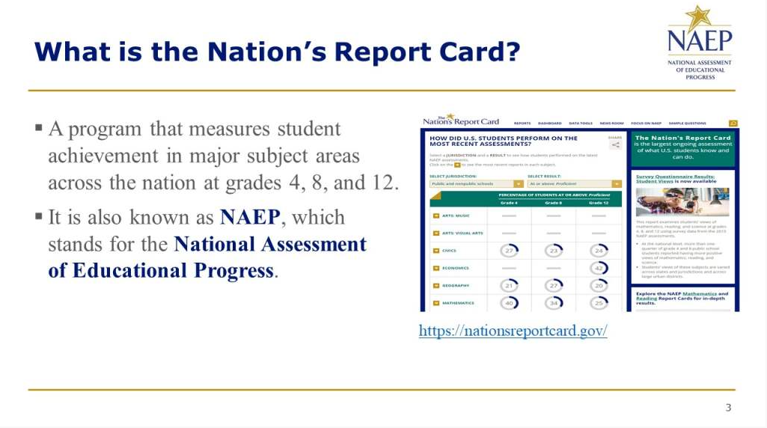
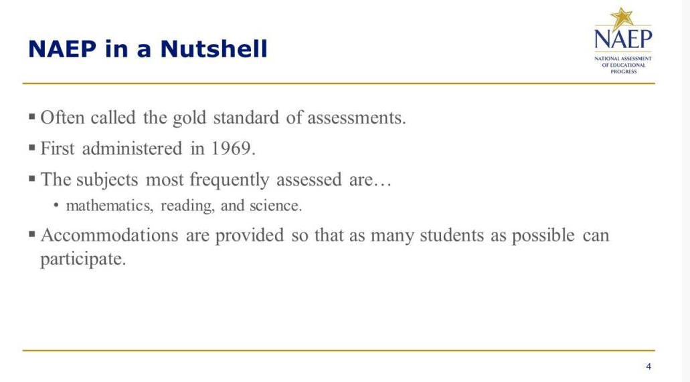

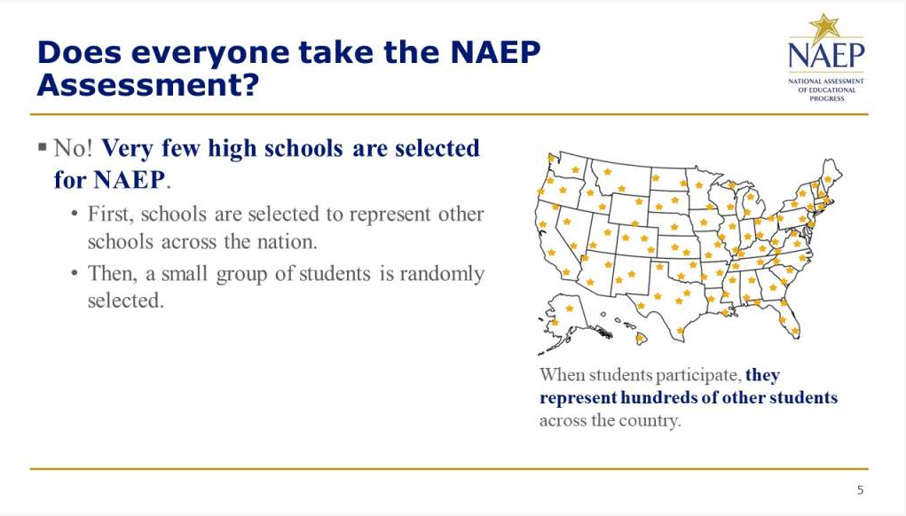
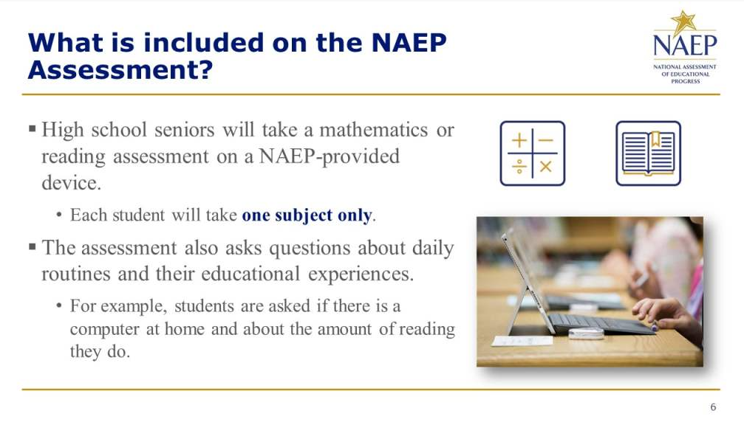

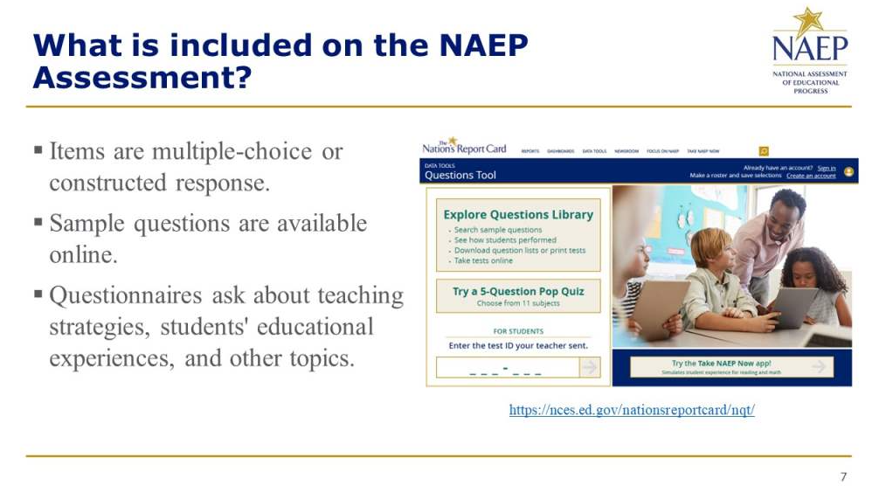
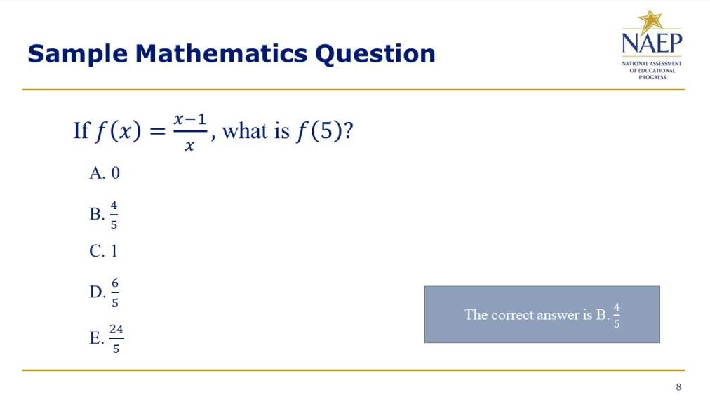

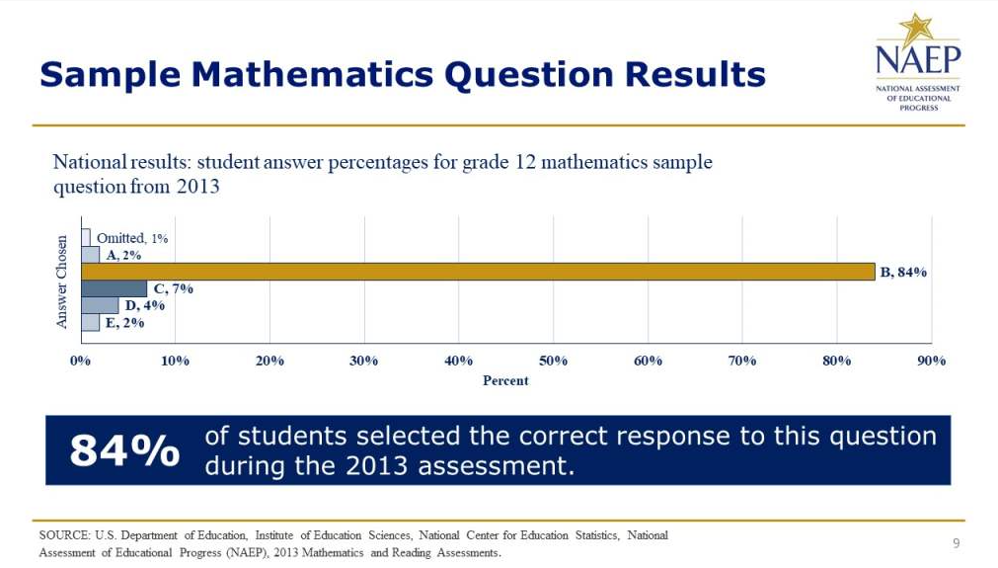
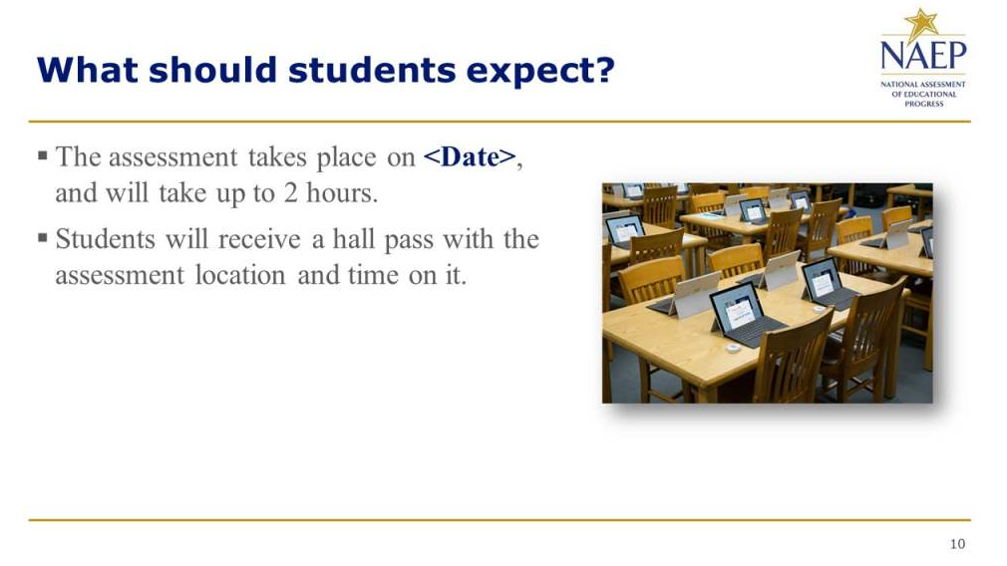

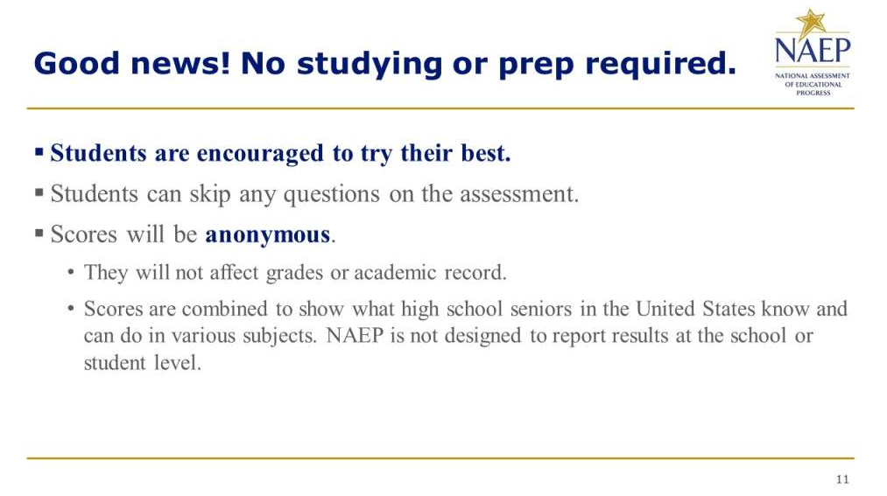
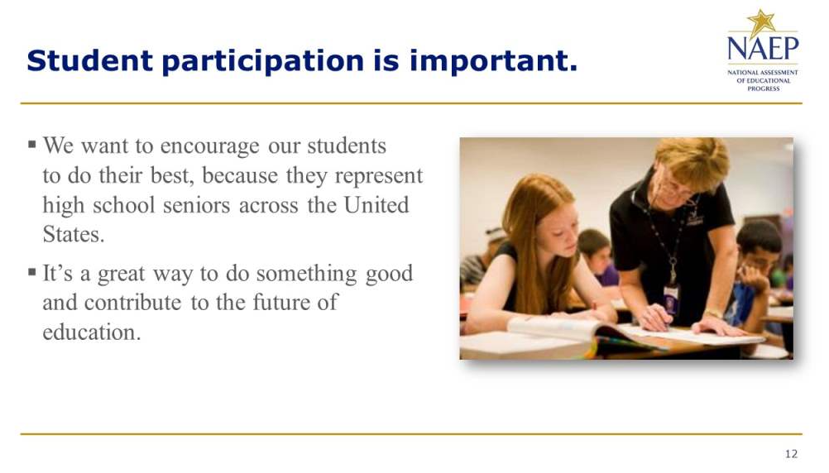

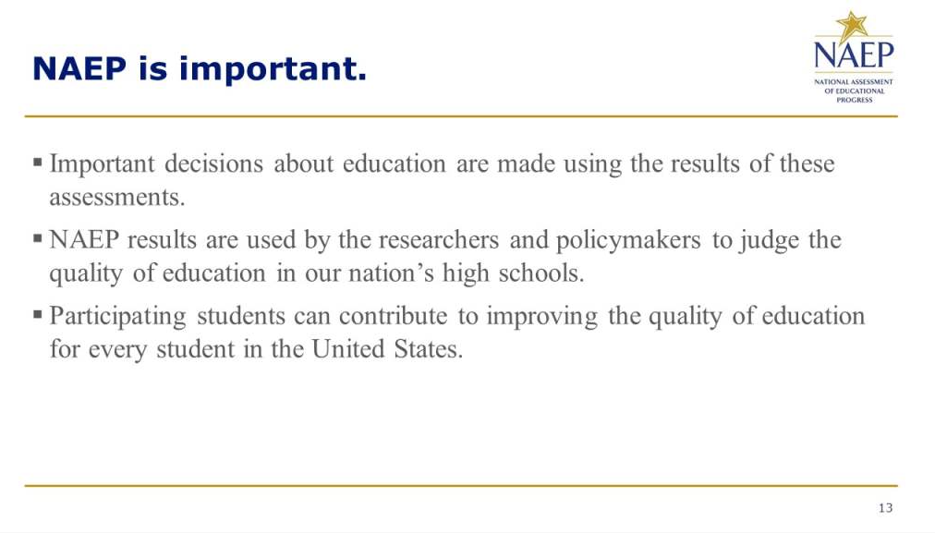
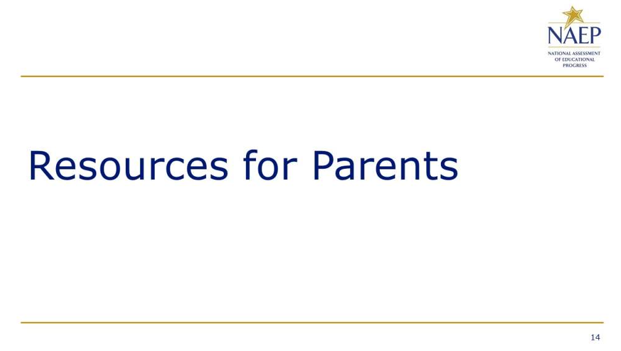

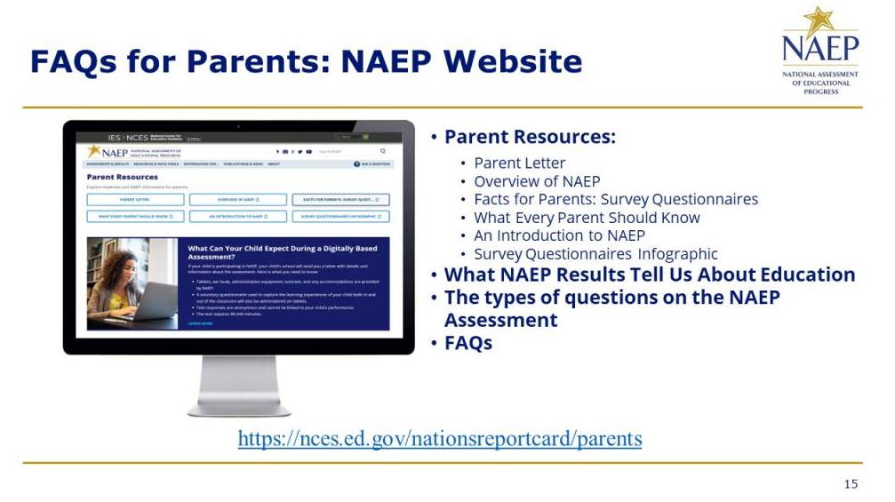
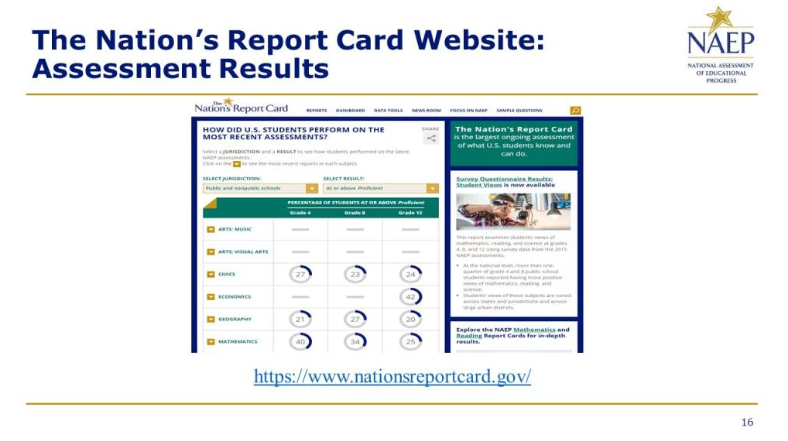

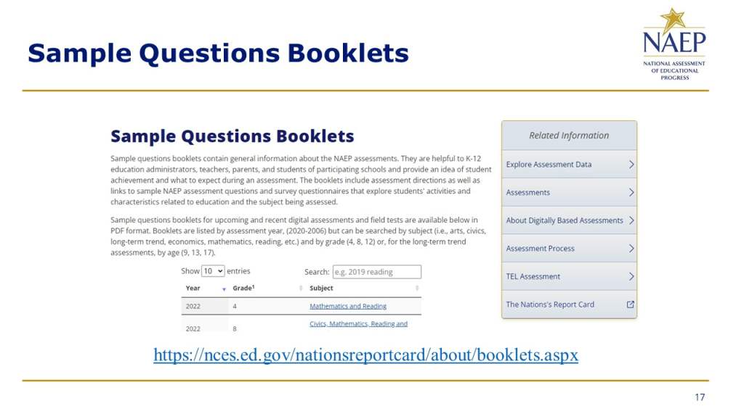
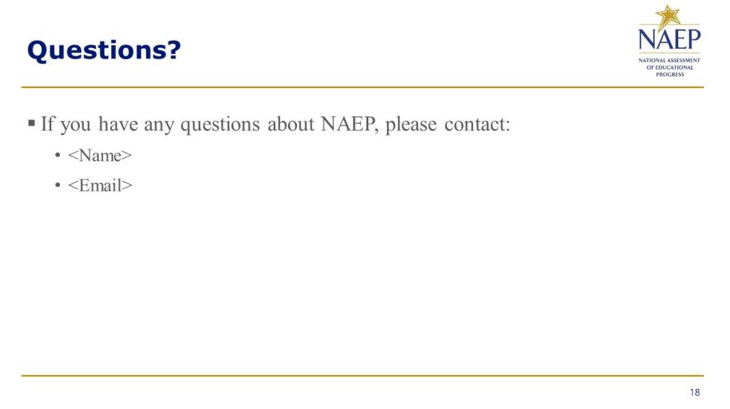

Appendix D-38: NAEP 2024 Introducing NAEP to Students Slides

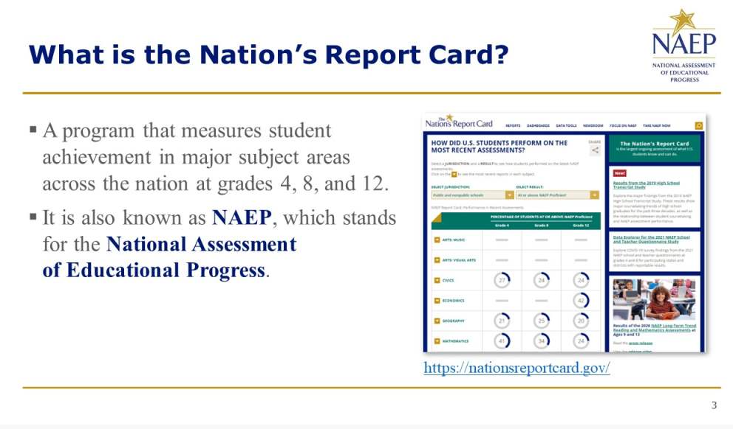

Appendix D-39: NAEP 2024 Introducing NAEP to Parents Slides

Appendix D-40: NAEP 2024 Introducing NAEP to Teachers Slides

Appendix D-41-PR (Spanish version): NAEP 2024 Facts for Districts, Puerto Rico

2024 Información para los distritos

"NAEP es la única evaluación que proporciona medio siglo de datos de rendimiento para medir lo que los estudiantes saben y pueden hacer. Las tendencias estatales y nacionales orientan las discusiones de programas y políticas locales, estatales y nacionales que mejoran la enseñanza y el aprendizaje ".

- David Atherton, Doctor en educación, Clear Creek Middle School, Greshan, Oregón

¿Qué es NAEP?
La Evaluación Nacional del Progreso Educativo (NAEP, por sus siglas en inglés) es una medida integral del progreso educativo en toda la nación y a lo largo del tiempo. Es la evaluación continua y nacionalmente representativa más grande que mide lo que los estudiantes de nuestro país saben y pueden hacer en diferentes materias, tales como educación cívica, matemáticas, lectura e historia de Estados Unidos. El programa también proporciona información valiosa sobre las experiencias educativas de los estudiantes y las oportunidades de aprendizaje dentro y fuera del salón de clases.

NAEP es un proyecto autorizado por el Congreso y administrado por el Centro Nacional para Estadísticas de la Educación (NCES, por sus siglas en inglés), parte del Departamento de Educación de Estados Unidos y el Instituto de Ciencias de la Educación. NAEP requiere que Puerto Rico participe solo en la evaluación de matemáticas. El Departamento de Educación de los Estados Unidos eximió a Puerto Rico de participar en la evaluación de lectura, ya que esta mide la capacidad de un estudiante para leer inglés, sin embargo, el español es el idioma de enseñanza en Puerto Rico.

¿Cómo se informan los resultados de NAEP?
Los resultados de NAEP se publican en un informe llamado la Libreta de Calificaciones de la Nación. Los resultados de NAEP están disponibles a nivel nacional. Los resultados para los estados y determinados distritos urbanos que participan en la Evaluación Piloto de Distritos Urbanos (TUDA, por sus siglas en inglés) también pueden estar disponibles, dependiendo de la evaluación. Además, los resultados están disponibles para diferentes grupos de estudiantes con base en factores como la raza/grupo étnico, el género y la ubicación de la escuela, entre otros. NAEP no está diseñada para informar los resultados individuales de estudiantes, salones de clase o escuelas.

¿Por qué mi distrito debería participar en NAEP?
La participación de su distrito es de vital importancia por varios motivos.
- Los resultados de las evaluaciones de 2024 proporcionarán información muy necesaria sobre los logros académicos y el sostenimiento de la recuperación de los estudiantes cuyas experiencias en la escuela elemental o intermedia se han visto marcadas por la pandemia de COVID-19.
- Las escuelas y los estudiantes seleccionados para participar en NAEP representan a las escuelas y a los estudiantes de todo el país. Cuando los estudiantes participan y dan su mejor esfuerzo, los resultados de NAEP proporcionan la medida más precisa y representativa posible sobre el rendimiento y las experiencias de los estudiantes.
- Las evaluaciones de 2024 ayudarán a NAEP a continuar examinando las transiciones a las evaluaciones en línea y el uso de dispositivos con los que los estudiantes estén más familiarizados. Estos cambios ayudarán a garantizar que el programa pueda medir de manera flexible, significativa y confiable las tendencias en los logros y experiencias de los estudiantes a lo largo del tiempo.

¿Qué evaluaciones de NAEP se administrarán en Puerto Rico en 2024?
El programa de 2024 incluirá:
- una evaluación de matemáticas en 4.° y 8.° grado;
- una prueba piloto de matemáticas en 4.° y 8.° grado, para ayudar a mejorar las futuras evaluaciones de NAEP y garantizar que sigan siendo una medida fiable de los logros de los estudiantes;
- cuestionarios de contexto para estudiantes, maestros y directores participantes, con el fin de comprender mejor los factores que pueden estar relacionados con el aprendizaje de los estudiantes.

La evaluación se administrará entre el 29 de enero y el 8 de marzo de 2024.

Los resultados se publicarán a nivel nacional, estatal y para determinados distritos urbanos para las evaluaciones de matemáticas de 4.° y 8.° grado.

¿Qué harán los estudiantes en mi distrito?
Los estudiantes participantes completarán:
- preguntas sobre matemáticas;
- cuestionarios de contexto que proporcionan información valiosa sobre sus experiencias educativas y sus oportunidades de aprendizaje tanto dentro como fuera del salón de clases.

A los estudiantes les toma aproximadamente 2 horas completar la evaluación, incluyendo el tiempo de transición, las instrucciones y el tiempo que toma contestar el cuestionario de contexto. Se ofrece una amplia gama de acomodos para los estudiantes con impedimentos y para aprendices del español.

Algunos estudiantes serán evaluados en Surface Pros proporcionadas por NAEP y algunos estudiantes serán evaluados en Chromebooks proporcionados por NAEP, con el fin de orientar la transición del programa hacia el uso de dispositivos que sean más familiares para los estudiantes.

¿Es necesario que los maestros preparen a los estudiantes para la evaluación?
Los maestros no tienen que preparar a sus estudiantes para la evaluación, pero sí deben motivarlos a que hagan su mejor esfuerzo.

¿Quién administrará NAEP? ¿Qué deben proporcionar las escuelas el día de la evaluación?
El personal de NAEP administrará la evaluación y proporcionará un importante apoyo a su escuela el día de la evaluación. Ellos llevarán todos los materiales y equipos necesarios, incluidos las Surface Pros y los Chromebooks para evaluar a los estudiantes.

Las escuelas solo tendrán que proporcionar espacio para que los estudiantes tomen la evaluación, incluídos los pupitres o mesas, y un número adecuado de enchufes eléctricos en el lugar de la evaluación.
- NAEP también solicitará usar el Internet de la escuela, siempre y cuando sea posible, ya que el programa continúa examinando la transición a las evaluaciones en línea. Los representantes de NAEP contactarán a su distrito en los próximos meses a fin de conocer más acerca de las capacidades de Internet en su escuela.

¿Cómo se seleccionaron las escuelas de mi distrito para NAEP?
Las escuelas fueron seleccionadas como parte de un proceso de muestreo cuidadosamente diseñado que garantiza que las escuelas y los estudiantes seleccionados para NAEP representan a su distrito, al estado y a la nación.

De conformidad con la Ley de Educación Primaria y Secundaria, los distritos y estados que reciben fondos del Título I están obligados a participar en estas evaluaciones bienales, con la excepción de Puerto Rico, que está exento de participar en la evaluación de lectura.

¿Cómo pueden los administradores escolares y los maestros utilizar los datos de NAEP para ayudar a nuestros estudiantes?
El explorador de datos, NAEP Data Explorer, (https://www.nationsreportcard.gov/ndecore) es una poderosa herramienta que le permite examinar las relaciones entre el rendimiento de los estudiantes y factores tales como las prácticas de enseñanza y los recursos escolares, entre otros.

Las preguntas de evaluaciones de NAEP anteriores también pueden utilizarse como un recurso educativo útil en el salón de clases. Los maestros pueden utilizar la herramienta NAEP Questions Tool (http://nces.ed.gov/nationsreportcard/nqt) para ver cómo se compara el rendimiento de sus estudiantes con el de otros estudiantes en su estado y en todo el país. Las preguntas de NAEP publicadas incluyen una guía de puntuación, ejemplos de respuestas de los estudiantes y datos de rendimiento.

¿Desde cuándo existe NAEP?
NAEP se administró por primera vez en 1969 para medir los logros de los estudiantes a nivel nacional. En 1990, NAEP se administró por primera vez a nivel estatal.

¿Dónde puedo encontrar más información?
Conozca más sobre el programa NAEP en nces.ed.gov/nationsreportcard/puertorico, y explore los últimos resultados de NAEP en nationsreportcard.gov.

Visite nces.ed.gov/nationsreportcard/about/covid19_spanish.aspx para obtener más información sobre los protocolos para el COVID-19 de NAEP.

También puede encontrar a NAEP en: <Facebook logo> <Twitter logo> <YouTube logo>

The National Center for Education Statistics (NCES) conducts the National Assessment of Educational Progress to evaluate federally supported education programs. All of the information you provide may only be used for the purposes of research, statistics, and evaluation under the Education Sciences Reform Act of 2002 (ESRA; 20 U.S.C. § 9543) and may not be disclosed, our used, in identifiable form for any other purpose except as required by law. Every NCES employee as well as every NCES agent, such as contractors and NAEP coordinators, has taken an oath and is subject to a jail term of up to 5 years, a fine of $250,000, or both if he or she willfully discloses ANY identifiable information about you. Electronic submission of your information will be monitored for viruses, malware, and other threats by Federal employees and contractors in accordance with the Cybersecurity Enhancement Act of 2015.

Appendix D-42-S-PR (Spanish version): NAEP 2024 Facts for Principals, Puerto Rico

NAEP 2024
Información general para los directores
4.° y 8.° grado Matemáticas

Page One Sidebar
NAEP es una parte esencial de la educación en Estados Unidos y Puerto Rico.
- Los funcionarios electos, los legisladores y los educadores usan los resultados de NAEP para desarrollar maneras de mejorar la educación.
- NAEP es un proyecto autorizado por el Congreso y administrado por el Centro Nacional para Estadísticas de la Educación (NCES, por sus siglas en inglés), parte del Departamento de Educación de Estados Unidos y el Instituto de Ciencias de la Educación.
- NAEP desempeña un papel diferente al de las evaluaciones estatales. Si bien cada estado tiene su propia y única evaluación, con diferentes estándares de contenido, la misma evaluación NAEP se administra en cada estado, proporcionando una medida común de los logros de los estudiantes.
- Dependiendo del tipo de evaluación NAEP que se administre, los datos se pueden usar para comparar y entender el rendimiento de grupos demográficos en su estado, en el país y en otros estados. NAEP no está diseñada para informar los resultados individuales de ningún estudiante, clase o escuela.
- A los estudiantes, maestros y directores que participan en NAEP se les pide que completen cuestionarios que proporcionan una mayor comprensión de las experiencias educativas y de los factores que podrían estar relacionados con el aprendizaje estudiantil.

Page One Body
“NAEP es la única evaluación que proporciona medio siglo de datos de rendimiento para medir lo que los estudiantes saben y pueden hacer. Las tendencias estatales y nacionales orientan las discusiones de programas y políticas locales, estatales y nacionales que mejoran la enseñanza y el aprendizaje ".
- David Atherton, Doctor en educación, Clear Creek Middle School, Greshan, Oregón

Visite https://nces.ed.gov/nationsreportcard/about/covid19.aspx para más información sobre los protocolos de NAEP relacionados con la salud y la seguridad.

¿Qué es NAEP?
La Evaluación Nacional del Progreso Educativo (NAEP, por sus siglas en inglés) es la evaluación continua y nacionalmente representativa más grande que mide lo que los estudiantes de nuestro país saben y pueden hacer en diferentes materias, tales como educación cívica, matemáticas, lectura, ciencias e historia de Estados Unidos. Los resultados de NAEP se publican en un informe llamado la Libreta de Calificaciones de la Nación. NAEP requiere que Puerto Rico participe solo en la evaluación de matemáticas. El Departamento de Educación de Estados Unidos eximió a Puerto Rico de participar en la evaluación de lectura, ya que esta mide la capacidad de un estudiante para leer inglés, sin embargo, el español es el idioma de instrucción en Puerto Rico.

¿Qué pueden esperar los directores y las escuelas?
Los representantes de NAEP le proporcionarán bastante apoyo a su escuela el día de la evaluación. Como directores, ustedes hacen una contribución importante al programa al seleccionar y facultar al coordinador escolar de NAEP, al reunirse con los maestros y estudiantes participantes y al animar a sus estudiantes a participar y a que hagan su mejor esfuerzo. Ustedes son aliados fundamentales para NAEP. Cuando los estudiantes participan en la evaluación y hacen su mejor esfuerzo, los resultados de NAEP proporcionan la medición más exacta posible del rendimiento estudiantil en todo el país.

En el 2024, la evaluación de matemáticas de NAEP se administrará en dispositivos a los estudiantes de 4.° y 8.° grado. Los resultados se publicarán a nivel nacional, estatal y distrital.

Además de responder a las preguntas sobre la materia, los estudiantes completarán un cuestionario de contexto de NAEP que proporciona información valiosa sobre las experiencias educativas de los estudiantes y las oportunidades de aprendizaje dentro y fuera del salón de clase.

El día de la evaluación, los representantes de NAEP llevarán a las escuelas todos los materiales y equipos necesarios, incluyendo las Surface Pros y los Chromebooks proporcionados por NAEP, desinfectados. Las escuelas únicamente tendrán que proporcionar espacio para que los estudiantes tomen la evaluación, pupitres o mesas, y una cantidad adecuada de enchufes eléctricos en el lugar de la evaluación.

En el 2024, NAEP continuará examinando las transiciones a las evaluaciones en línea y el uso de dispositivos con los que los estudiantes estén más familiarizados. Estos cambios ayudarán a garantizar que el programa pueda medir de manera flexible, significativa y confiable las tendencias en los logros y experiencias de los estudiantes a lo largo del tiempo.

Como parte de estos cambios, los representantes de NAEP utilizarán el Internet en la escuela, siempre y cuando sea posible, para realizar la evaluación. El programa trabajará con usted o su distrito para determinar si esto es posible en su escuela.

Para más información acerca de NAEP, visite www.nces.ed.gov/nationsreportcard/puertorico/.

Page Two Body
NAEP se administró por primera vez en 1969 para medir el rendimiento estudiantil a nivel nacional. En 1990, NAEP se administró a nivel estatal por primera vez. Actualmente se evalúa a los estudiantes de 4.° y 8.° grado a nivel nacional y estatal en matemáticas y lectura cada 2 años y en otras materias de manera periódica.

¿Por qué se le considera a NAEP el estándar de oro? Desde el desarrollo de los marcos teóricos y las preguntas de la evaluación hasta la publicación de los resultados, NAEP ofrece una alta calidad técnica y representa las mejores ideas de especialistas de evaluación y de contenido, del personal estatal de educación y de maestros de todo el país. NAEP es un recurso confiable que mide el progreso estudiantil y que contribuye a informar la toma de decisiones sobre políticas que mejoren la educación de Estados Unidos y Puerto Rico.

¿Cómo se informan los resultados de NAEP? NAEP informa los resultados de distintos grupos demográficos en vez de los resultados individuales de estudiantes o escuelas. En una escuela, solamente algunos de los estudiantes participan y las respuestas de los estudiantes se combinan con las de otros estudiantes participantes para producir los resultados.

¿Cómo se seleccionan las escuelas y los estudiantes para NAEP? Un proceso de muestreo cuidadosamente diseñado garantiza que las escuelas y los estudiantes seleccionados para NAEP representan a todas las escuelas y estudiantes en Estados Unidos y Puerto Rico. Para asegurar que la muestra represente a todos los estudiantes en las escuelas del país, NAEP permite una gran variedad de acomodos para estudiantes con impedimentos y estudiantes con limitaciones lingüísticas en español.

¿Qué pueden esperar los maestros y estudiantes? Incluyendo el tiempo de transición, las instrucciones y tutoriales y el contestar un cuestionario de contexto, a los estudiantes les toma aproximadamente 2 horas completar la evaluación. Los maestros no tienen que preparar a sus estudiantes para que tomen la evaluación, pero sí deben motivarlos a que hagan su mejor esfuerzo. Los representantes de NAEP le brindan un gran apoyo a su escuela al trabajar con el coordinador escolar designado para organizar las actividades de la evaluación.
Visite la página web de NAEP en http://nces.ed.gov/nationsreportcard/puertorico/ para ver esta y más información.

The National Center for Education Statistics (NCES) conducts the National Assessment of Educational Progress to evaluate federally supported education programs. All of the information you provide may only be used for the purposes of research, statistics, and evaluation under the Education Sciences Reform Act of 2002 (ESRA; 20 U.S.C. § 9543) and may not be disclosed, our used, in identifiable form for any other purpose except as required by law. Every NCES employee as well as every NCES agent, such as contractors and NAEP coordinators, has taken an oath and is subject to a jail term of up to 5 years, a fine of $250,000, or both if he or she willfully discloses ANY identifiable information about you. Electronic submission of your information will be monitored for viruses, malware, and other threats by Federal employees and contractors in accordance with the Cybersecurity Enhancement Act of 2015.

Page Two Footer
Encuéntrenos en: [insert social media icons]

Esta publicación fue preparada para la Evaluación Nacional del Progreso Educativo por Hager Sharp bajo el contrato GS-23F-0024M para el Centro Nacional de Estadísticas de la Educación, Departamento de Educación de Estados Unidos.

NAEP 2024
Información general para los directores
Prueba piloto: 4.° y 8.° grado Matemáticas

Page One Sidebar
NAEP es una parte esencial de la educación en Estados Unidos y Puerto Rico.
- Los funcionarios electos, los legisladores y los educadores usan los resultados de NAEP para desarrollar maneras de mejorar la educación.
- NAEP es un proyecto autorizado por el Congreso y administrado por el Centro Nacional para Estadísticas de la Educación (NCES, por sus siglas en inglés), parte del Departamento de Educación de Estados Unidos y el Instituto de Ciencias de la Educación.
- NAEP desempeña un papel diferente al de las evaluaciones estatales. Si bien cada estado tiene su propia y única evaluación, con diferentes estándares de contenido, la misma evaluación NAEP se administra en cada estado, proporcionando una medida común de los logros de los estudiantes.
- Dependiendo del tipo de evaluación NAEP que se administre, los datos se pueden usar para comparar y entender el rendimiento de grupos demográficos en su estado, en el país, y en otros estados. NAEP no está diseñada para informar los resultados individuales de ningún estudiante, clase o escuela.
- A los estudiantes, maestros y directores que participan en NAEP se les pide que completen cuestionarios que proporcionan una mayor comprensión de las experiencias educativas y de los factores que podrían estar relacionados con el aprendizaje estudiantil.

Page One Body
“NAEP es la única evaluación que proporciona medio siglo de datos de rendimiento para medir lo que los estudiantes saben y pueden hacer. Las tendencias estatales y nacionales orientan las discusiones de programas y políticas locales, estatales y nacionales que mejoran la enseñanza y el aprendizaje ".
- David Atherton, Doctor en educación, Clear Creek Middle School, Greshan, Oregón

Visite https://nces.ed.gov/nationsreportcard/about/covid19.aspx para más información sobre los protocolos de NAEP relacionados con la salud y la seguridad.

¿Qué es NAEP?
La Evaluación Nacional del Progreso Educativo (NAEP, por sus siglas en inglés) es la evaluación continua y nacionalmente representativa más grande que mide lo que los estudiantes de nuestro país saben y pueden hacer en diferentes materias, tales como educación cívica, matemáticas, lectura, ciencias e historia de Estados Unidos. Los resultados de NAEP se publican en un informe llamado la Libreta de Calificaciones de la Nación. NAEP requiere que Puerto Rico participe solo en la evaluación de matemáticas. El Departamento de Educación de Estados Unidos eximió a Puerto Rico de participar en la evaluación de lectura, ya que esta mide la capacidad de un estudiante para leer inglés, sin embargo, el español es el idioma de instrucción en Puerto Rico.

¿Qué pueden esperar los directores y las escuelas?
Los representantes de NAEP le proporcionarán bastante apoyo a su escuela el día de la evaluación. Como directores, ustedes hacen una contribución importante al programa al seleccionar y facultar al coordinador escolar de NAEP, al reunirse con los maestros y estudiantes participantes y al animar a sus estudiantes a participar y a que hagan su mejor esfuerzo. Ustedes son aliados fundamentales para NAEP. Cuando los estudiantes participan en la evaluación y hacen su mejor esfuerzo, los resultados de NAEP proporcionan la medición más exacta posible del rendimiento estudiantil en todo el país.

En el 2024, la evaluación de matemáticas de NAEP se administrará en dispositivos a los estudiantes de 4.° y 8.° grado. Los resultados de la prueba piloto no se darán a conocer públicamente, pero se utilizarán para orientar las futuras evaluaciones de NAEP.

Además de responder a las preguntas sobre la materia, los estudiantes completarán un cuestionario de contexto de NAEP que proporciona información valiosa sobre las experiencias educativas de los estudiantes y las oportunidades de aprendizaje dentro y fuera del salón de clase.

El día de la evaluación los representantes de NAEP llevarán a las escuelas todos los materiales y equipos necesarios, incluyendo las Surface Pros y los Chromebooks proporcionados por NAEP, desinfectados. Las escuelas únicamente tendrán que proporcionar espacio para que los estudiantes tomen la evaluación, pupitres o mesas, y una cantidad adecuada de enchufes eléctricos en el lugar de la evaluación.

En el 2024, NAEP continuará examinando las transiciones a las evaluaciones en línea y el uso de dispositivos con los que los estudiantes estén más familiarizados. Estos cambios ayudarán a garantizar que el programa pueda medir de manera flexible, significativa y confiable las tendencias en los logros y experiencias de los estudiantes a lo largo del tiempo.

Como parte de estos cambios, los representantes de NAEP utilizarán el Internet en la escuela, siempre y cuando sea posible, para realizar la evaluación. El programa trabajará con usted o su distrito para determinar si esto es posible en su escuela.

Para más información acerca de NAEP, visite www.nces.ed.gov/nationsreportcard/puertorico/.

Page Two Body
NAEP se administró por primera vez en 1969 para medir el rendimiento estudiantil a nivel nacional. En 1990, NAEP se administró a nivel estatal por primera vez. Actualmente se evalúa a los estudiantes de 4.° y 8.° grado a nivel nacional y estatal en matemáticas y lectura cada 2 años, y en otras materias de manera periódica.

¿Por qué se le considera a NAEP el estándar de oro? Desde el desarrollo de los marcos teóricos y las preguntas de la evaluación hasta la publicación de los resultados, NAEP ofrece una alta calidad técnica y representa las mejores ideas de especialistas de evaluación y de contenido, del personal estatal de educación y de maestros de todo el país. NAEP es un recurso confiable que mide el progreso estudiantil y que contribuye a informar la toma de decisiones sobre políticas que mejoren la educación de Estados Unidos y Puerto Rico.

¿Cómo se informan los resultados de NAEP? NAEP informa los resultados de distintos grupos demográficos en vez de los resultados individuales de estudiantes o escuelas. En una escuela, solamente algunos de los estudiantes participan y las respuestas de los estudiantes se combinan con las de otros estudiantes participantes para producir los resultados.

¿Cómo se seleccionan las escuelas y los estudiantes para NAEP? Un proceso de muestreo cuidadosamente diseñado garantiza que las escuelas y los estudiantes seleccionados para NAEP representan a todas las escuelas y estudiantes en Estados Unidos y Puerto Rico. Para asegurar que la muestra represente a todos los estudiantes en las escuelas del país, NAEP permite una gran variedad de acomodos para estudiantes con impedimentos y estudiantes con limitaciones lingüísticas en español.

¿Qué pueden esperar los maestros y estudiantes? Incluyendo el tiempo de transición, las instrucciones y tutoriales y el contestar un cuestionario de contexto, a los estudiantes les toma aproximadamente 2 horas completar la evaluación. Los maestros no tienen que preparar a sus estudiantes para que tomen la evaluación, pero sí deben motivarlos a que hagan su mejor esfuerzo. Los representantes de NAEP le brindan un gran apoyo a su escuela al trabajar con el coordinador escolar designado para organizar las actividades de la evaluación.
Visite la página web de NAEP en http://nces.ed.gov/nationsreportcard/puertorico/ para ver esta y más información.

The National Center for Education Statistics (NCES) conducts the National Assessment of Educational Progress to evaluate federally supported education programs. All of the information you provide may only be used for the purposes of research, statistics, and evaluation under the Education Sciences Reform Act of 2002 (ESRA; 20 U.S.C. § 9543) and may not be disclosed, our used, in identifiable form for any other purpose except as required by law. Every NCES employee as well as every NCES agent, such as contractors and NAEP coordinators, has taken an oath and is subject to a jail term of up to 5 years, a fine of $250,000, or both if he or she willfully discloses ANY identifiable information about you. Electronic submission of your information will be monitored for viruses, malware, and other threats by Federal employees and contractors in accordance with the Cybersecurity Enhancement Act of 2015.

Page Two Footer
Encuéntrenos en: [insert social media icons]

Esta publicación fue preparada para la Evaluación Nacional del Progreso Educativo por Hager Sharp bajo el contrato GS-23F-0024M para el Centro Nacional de Estadísticas de la Educación, Departamento de Educación de Estados Unidos.

Appendix D-43-S-PR (Spanish version): NAEP 2024 Notification Letter from Chief State School Officer to District Superintendent, Puerto Rico

Carta de notificación de mayo sobre NAEP de 2024 en Puerto Rico del
SECRETARIO DE EDUCACIÓN AL SUPERINTENDENTE DISTRITAL
Se debe personalizar el texto en rojo antes de combinar la correspondencia: El texto resaltado representa los campos que se deben combinar

Estimado(a) nombre del superintendente distrital,

Gracias por todo lo que hace para apoyar la educación en Puerto Rico. Le escribo para informarle que cantidad escuelas en su distrito han sido seleccionadas para participar en la administración de la Evaluación Nacional del Progreso Educativo (NAEP, por sus siglas en inglés) de 2023. NAEP es la evaluación continua y nacionalmente representativa más grande acerca de lo que los estudiantes en Estados Unidos y Puerto Rico saben y pueden hacer en diferentes materias. NAEP es administrada por el Centro Nacional de Estadísticas de la Educación (NCES, por sus siglas en inglés) que forma parte del Departamento de Educación de Estados Unidos. Las escuelas seleccionadas representan a escuelas en el país y su participación proporciona una idea precisa del rendimiento de los estudiantes. Distrito escolar desempeñará un papel importante al participar y espero que podamos contar con todo su apoyo para hacer que esta sea una experiencia positiva para sus escuelas y estudiantes.

Visión general del programa de NAEP de 2024

La administración de NAEP de 2024 evaluará a los estudiantes entre el 29 de enero y el 8 de marzo de 2024. La lista adjunta de escuelas de su distrito seleccionadas para NAEP muestra el programa de evaluación para cada escuela. Los estudiantes responderán a preguntas de matemáticas.
- Evaluaciones a nivel estatal
  - 4.º y 8.º grados: matemáticas

Evaluación piloto

NAEP también administrará una evaluación piloto de matemáticas para los grados 4.º y 8.º. Los resultados de las evaluaciones piloto no se publicarán, pero se utilizarán para orientar las futuras evaluaciones de NAEP.

Transiciones del Programa de NAEP de 2024

Las evaluaciones de 2024 ayudarán a NAEP a continuar examinando las transiciones hacia las evaluaciones en línea y el uso de dispositivos con los que los estudiantes estén más familiarizados. Estos cambios ayudarán a garantizar que el programa pueda medir de manera flexible, significativa y confiable las tendencias en los logros y experiencias de los estudiantes a lo largo del tiempo.

Los representantes de NAEP le proporcionan bastante apoyo a las escuelas participantes. Ellos administrarán la evaluación y llevarán todos los materiales y equipos necesarios, incluidos los dispositivos para evaluar a los estudiantes. NAEP también solicitará usar el Internet de la escuela, siempre y cuando sea posible, para llevar a cabo la evaluación. El equipo del programa trabajará con los distritos y escuelas para determinar si esto es posible para cada escuela.

¿Qué viene después?

El coordinador estatal de NAEP se pondrá en contacto con el/la coordinador(a) de evaluaciones de su distrito y con los directores para proporcionarles detalles adicionales sobre la evaluación. Se le pedirá al/a la coordinador(a) de evaluaciones de su distrito que elija a un coordinador de tecnología para que identifique las capacidades de Internet de cada escuela.

Incluya el período de la evaluación de NAEP (del 29 de enero al 8 de marzo de 2024) en el calendario de evaluaciones de su distrito. A partir de agosto, cada escuela recibirá su fecha de evaluación. Las escuelas pueden hablar con su coordinador(a) estatal de NAEP si hay un conflicto con la fecha programada. Es posible que se seleccionen algunas escuelas adicionales en Distrito escolar en una fecha posterior; si esto sucede, su coordinador(a) estatal de NAEP se comunicará con usted.

Puede encontrar información acerca de NAEP en los adjuntos detallados a continuación y en: https://nces.ed.gov/nationsreportcard/puertorico/sp.aspx. Nombre, su Coordinador(a) Estatal de NAEP, se comunicará con su personal para brindarles información adicional.

Gracias por apoyar esta importante evaluación y por ayudarnos a alcanzar nuestra meta de participación total.

Atentamente,

Nombre del secretario(a) de educación

Adjuntos: Lista distrital de escuelas seleccionadas para participar en NAEP
Información para los distritos

CC: Director(a) estatal de evaluaciones
Director(a) distrital de evaluaciones
Coordinador(a) estatal de NAEP

The National Center for Education Statistics (NCES) conducts the National Assessment of Educational Progress to evaluate federally supported education programs. All of the information you provide may only be used for the purposes of research, statistics, and evaluation under the Education Sciences Reform Act of 2002 (ESRA; 20 U.S.C. § 9543) and may not be disclosed, our used, in identifiable form for any other purpose except as required by law. Every NCES employee as well as every NCES agent, such as contractors and NAEP coordinators, has taken an oath and is subject to a jail term of up to 5 years, a fine of $250,000, or both if he or she willfully discloses ANY identifiable information about you. Electronic submission of your information will be monitored for viruses, malware, and other threats by Federal employees and contractors in accordance with the Cybersecurity Enhancement Act of 2015.

Appendix D-44-S-PR (Spanish version): NAEP 2024 and Pilot 2024 Initial Notification Letters from NAEP State Coordinator to School Principal, Puerto Rico

Carta de notificación de mayo sobre NAEP 2024 en Puerto Rico del
COORDINADOR ESTATAL DE NAEP PARA EL DIRECTOR DE LA ESCUELA
Para matemáticas de 4.º y 8.º grado
Se debe personalizar el texto en rojo antes de combinar la correspondencia; el texto resaltado representa los campos que se deben combinar

Estimado(a) director(a),

Gracias por todo lo que hace para apoyar la educación en Puerto Rico. Le escribo para informarle que nombre de la escuela ha sido seleccionada para representar a las escuelas de Puerto Rico y el país al participar en la administración de la Evaluación Nacional del Progreso Educativo (NAEP, por sus siglas en inglés) de 2024. NAEP es la evaluación continua y nacionalmente representativa más grande acerca de lo que los estudiantes en Estados Unidos y Puerto Rico saben y pueden hacer en diferentes materias. NAEP es administrada por el Centro Nacional de Estadísticas de la Educación (NCES, por sus siglas en inglés) que forma parte del Departamento de Educación de Estados Unidos.

Visión general de la evaluación en su escuela

- Materia: Matemáticas
- Grado: 4.° u 8.°
- Período de evaluación: 29 de enero al 8 de marzo de 2024
- Sesiones de evaluación: Una sesión de aproximadamente 25 estudiantes. La sesión durará
aproximadamente 120 minutos (incluyendo el tiempo de transición,
las instrucciones y el tiempo para contestar las preguntas del cuestionario de contexto).
- Administrador de la evaluación: Representantes de NAEP

¿Qué debo saber?

- Los estudiantes completarán la evaluación en dispositivos proporcionados por NAEP.
  - Los estudiantes responderán a preguntas sobre matemáticas. Además de responder a las preguntas sobre la materia, los estudiantes completarán un cuestionario de contexto de NAEP que proporciona información valiosa sobre las experiencias educativas de los estudiantes y las oportunidades de aprendizaje dentro y fuera del salón de clase.
- Los representantes de NAEP le proporcionarán bastante apoyo a su escuela. Ellos administrarán la evaluación y llevarán todos los materiales y equipos necesarios.
  - NAEP solicitará usar el Internet de la escuela, siempre y cuando sea posible, para llevar a cabo la evaluación. El equipo del programa trabajará con los distritos y escuelas para determinar si esto es posible para cada escuela.
- Los resultados se darán a conocer como La Libreta de Calificaciones de la Nación.

¿Cuáles son los siguientes pasos?

Por ahora, solo le escribo para notificarle sobre la evaluación. En agosto, le enviaré la fecha de la evaluación. Si la fecha resulta conflictiva para su escuela, trabajaremos juntos para encontrar una fecha alternativa. Nuestro objetivo es fijar la fecha de la evaluación lo antes posible para que pueda incluir la fecha en su calendario escolar 2023-2024.
Al principio del año escolar, le enviaré información detallada sobre la evaluación y le pediré que identifique a un(a) coordinador(a) escolar para que ejerza como principal punto de contacto y para que envíe información adicional.

Puede encontrar información adicional acerca de NAEP en el adjunto Información general para los directores y en https://nces.ed.gov/nationsreportcard/puertorico/sp.aspx. Si tiene alguna pregunta, comuníquese conmigo llamando al número de teléfono o por correo electrónico escribiendo a correo electrónico.

Nuestro(a) secretario(a) de educación, nombre, y el/la superintendente de su distrito, nombre, apoyan a NAEP y esperan que su escuela participe. Sabemos que podemos contar con usted para ayudar a alcanzar nuestra meta de participación total.

Atentamente,

Coordinador(a) estatal de NAEP

Adjunto (o enlace para envío electrónico): Información general para los directores

CC: Director(a) distrital de evaluaciones

The National Center for Education Statistics (NCES) conducts the National Assessment of Educational Progress to evaluate federally supported education programs. All of the information you provide may only be used for the purposes of research, statistics, and evaluation under the Education Sciences Reform Act of 2002 (ESRA; 20 U.S.C. § 9543) and may not be disclosed, our used, in identifiable form for any other purpose except as required by law. Every NCES employee as well as every NCES agent, such as contractors and NAEP coordinators, has taken an oath and is subject to a jail term of up to 5 years, a fine of $250,000, or both if he or she willfully discloses ANY identifiable information about you. Electronic submission of your information will be monitored for viruses, malware, and other threats by Federal employees and contractors in accordance with the Cybersecurity Enhancement Act of 2015.

Carta de notificación de mayo sobre la prueba piloto de NAEP 2024 en Puerto Rico del
COORDINADOR ESTATAL DE NAEP PARA EL DIRECTOR DE LA ESCUELA
Para matemáticas de 4.º y 8.º grado
Se debe personalizar el texto en rojo antes de combinar la correspondencia; el texto resaltado representa los campos que se deben combinar

Estimado(a) director(a),

Gracias por todo lo que hace para apoyar la educación en Puerto Rico. Le escribo para informarle que nombre de la escuela ha sido seleccionada para representar a las escuelas de Puerto Rico y el país al participar en la administración de la Evaluación Nacional del Progreso Educativo (NAEP, por sus siglas en inglés) de 2024. NAEP es la evaluación continua y nacionalmente representativa más grande acerca de lo que los estudiantes en Estados Unidos y Puerto Rico saben y pueden hacer en diferentes materias. NAEP es administrada por el Centro Nacional de Estadísticas de la Educación (NCES, por sus siglas en inglés) que forma parte del Departamento de Educación de Estados Unidos.

El programa de NAEP 2024 incluirá una prueba piloto para evaluar preguntas nuevas, continuar explorando una plataforma de evaluación en línea y estudiar más a fondo la transición a diferentes dispositivos con los que los estudiantes estén más familiarizados. Al participar, su escuela ayudará a garantizar que las evaluaciones de NAEP continúen siendo una medida confiable, válida y eficiente de los logros y las experiencias educativas de los estudiantes a lo largo del tiempo.

Visión general de la evaluación en su escuela

- Materia: Matemáticas
- Grado: 4.° u 8.°
- Período de evaluación: 29 de enero al 8 de marzo de 2024
- Sesiones de evaluación: Una sesión de aproximadamente 25 estudiantes. La sesión durará
aproximadamente 120 minutos (incluyendo el tiempo de transición,
las instrucciones y el tiempo para contestar las preguntas del cuestionario de contexto).
- Administrador de la evaluación: Representantes de NAEP

¿Qué debo saber?

- Los estudiantes completarán la evaluación en dispositivos proporcionados por NAEP.
  - Los estudiantes responderán a preguntas sobre matemáticas. Además de responder a las preguntas sobre la materia, los estudiantes completarán un cuestionario de contexto de NAEP que proporciona información valiosa sobre las experiencias educativas de los estudiantes y las oportunidades de aprendizaje dentro y fuera del salón de clase.
- Los representantes de NAEP le proporcionarán bastante apoyo a su escuela. Ellos administrarán la evaluación y llevarán todos los materiales y equipos necesarios.
  - NAEP solicitará usar el Internet de la escuela, siempre y cuando sea posible, para llevar a cabo la evaluación. El equipo del programa trabajará con los distritos y escuelas para determinar si esto es posible para cada escuela.
  - Los resultados de las evaluaciones piloto no se publicarán, pero se utilizarán para orientar las futuras evaluaciones de NAEP.

¿Cuáles son los siguientes pasos?

Por ahora, solo le escribo para notificarle sobre la evaluación. En agosto, le enviaré la fecha de la evaluación. Si la fecha resulta conflictiva para su escuela, trabajaremos juntos para encontrar una fecha alternativa. Nuestro objetivo es fijar la fecha de la evaluación lo antes posible para que pueda incluir la fecha en su calendario escolar 2023-2024.
Al principio del año escolar, le enviaré información detallada sobre la evaluación y le pediré que identifique a un(a) coordinador(a) escolar para que ejerza como principal punto de contacto y para que envíe información adicional.

Puede encontrar información adicional acerca de NAEP en el adjunto Información general para los directores y en https://nces.ed.gov/nationsreportcard/puertorico/sp.aspx. Si tiene alguna pregunta, comuníquese conmigo llamando al número de teléfono o por correo electrónico escribiendo a correo electrónico.

Nuestro(a) secretario(a) de educación, nombre, y el/la superintendente de su distrito, nombre, apoyan a NAEP y esperan que su escuela participe. Sabemos que podemos contar con usted para ayudar a alcanzar nuestra meta de participación total.

Atentamente,

Coordinador(a) estatal de NAEP

Adjunto (o enlace para envío electrónico): Información general para los directores

CC: Director(a) distrital de evaluaciones

The National Center for Education Statistics (NCES) conducts the National Assessment of Educational Progress to evaluate federally supported education programs. All of the information you provide may only be used for the purposes of research, statistics, and evaluation under the Education Sciences Reform Act of 2002 (ESRA; 20 U.S.C. § 9543) and may not be disclosed, our used, in identifiable form for any other purpose except as required by law. Every NCES employee as well as every NCES agent, such as contractors and NAEP coordinators, has taken an oath and is subject to a jail term of up to 5 years, a fine of $250,000, or both if he or she willfully discloses ANY identifiable information about you. Electronic submission of your information will be monitored for viruses, malware, and other threats by Federal employees and contractors in accordance with the Cybersecurity Enhancement Act of 2015.

Appendix D-45-S-PR (Spanish version): NAEP 2024 Assessment Details Letter NAEP State Coordinator to School Coordinators, Puerto Rico

Carta de notificación con detalles acerca de la evaluación NAEP de 2024
DE PARTE DEL COORDINADOR ESTATAL DE NAEP AL COORDINADOR ESCOLAR
PUERTO RICO
Muestras operacionales y piloto

Se debe personalizar el texto en rojo antes de combinar la correspondencia, el texto resaltado
representa los campos que se deben combinar.

Estimado(a) [nombre del/de la coordinador(a) escolar]:

Bienvenido(a) a la Evaluación Nacional del Progreso Educativo (NAEP, por sus siglas en inglés) de 2024. Espero trabajar con usted para coordinar la evaluación NAEP en su escuela. Una muestra de sus estudiantes de [4.°, 8.°] grado tomarán la evaluación de matemáticas en [fecha de la evaluación].

Como coordinador(a) escolar, usted tendrá varias responsabilidades que son fundamentales para hacer que NAEP sea un éxito. El Sistema de Administración de la Evaluación (AMS, por sus siglas en inglés) de NAEP está diseñado para ayudarle con estas responsabilidades. El programa de actividades a continuación indica cuándo tendrá que completar las secciones específicas del AMS de NAEP.

- Agosto–septiembre: Colaborar con el personal de tecnología de su escuela o distrito según sea necesario para añadir el dominio westatstudies.com a la lista segura de remitentes para garantizar que se reciban los mensajes de correo electrónico importantes. Ingresar y configurar su cuenta del AMS de NAEP utilizando el enlace que se proporciona en el correo electrónico de registro de DoNotReply-NAEP@westatstudies.com. Contestar las preguntas en la sección Información de la escuela antes de [fecha].
- Diciembre–enero: Un(a) representante asignado(a) de NAEP, encargado(a) de administrar la evaluación, se comunicará con usted en diciembre para presentarse y verificar la programación de una reunión de planificación para la evaluación. Si lo solicita, el/la representante de NAEP podrá explicarle cómo completar las tareas de planificación de NAEP que se describen a continuación. Asegúrese de completar todas las actividades de preparación para la evaluación antes de la reunión de planificación para la evaluación programada.
- Revisar la muestra de estudiantes e identificar a cualquier estudiante que no pueda tomar la evaluación. También revisar la información demográfica y actualizar cualquier información o si es inexacta.
  - Proporcionar información acerca de los estudiantes con impedimentos (EI) y estudiantes aprendices del español (AE) para que los administradores de la evaluación puedan planificar los acomodos apropiados. Puede solicitar acceso a los especialistas en EI y AE en su escuela para que ellos o ellas le colaboren con esta tarea. Tenga en cuenta que posiblemente el personal de la escuela tenga que ayudar con ciertos acomodos (p. ej. señas para que los estudiantes se mantengan enfocados, escribiente).
  - Notificar a los padres, madres o tutores que sus hijos han sido seleccionados para la evaluación. Se adjunta una muestra de la carta de notificación para los padres, madres o tutores y estará disponible en la página web del AMS de NAEP para que pueda imprimirla con el membrete de su escuela.
  - Programar las sesiones de evaluación y reservar el espacio en su escuela. Dado que el equipo de NAEP necesita transportar cajas pesadas con los dispositivos y otros materiales a la escuela. Por favor, seleccione un lugar en un primer piso o al que se pueda llegar en ascensor.
  - Actualizar la lista de estudiantes para agregar a estudiantes nuevos que se hayan matriculado desde el otoño. NAEP seleccionará una muestra al azar de este grupo para asegurar que todos los estudiantes tengan la oportunidad de ser seleccionados para NAEP.
  - Identificar y proporcionar las direcciones de correo electrónico de los maestros de matemáticas de los estudiantes incluidos en la muestra, para que puedan acceder al cuestionario para maestros y completarlo. Dirigir al personal de la escuela para que complete los cuestionarios.
  - Trabajar con el/la coordinador(a) de tecnología interno(a) para completar la logística técnica en el AMS. Esto incluye confirmar que las credenciales de la red se proporcionen y estén disponibles el día de la prueba; confirmar las respuestas ingresadas en la encuesta sobre la conectividad a Internet; y realizar la verificación de la lista segura y la prueba de velocidad de Internet en el lugar designado para la prueba, mientras se está conectado a la red WiFi que se utilizará para la administración de la prueba de NAEP. La verificación de la lista segura y la prueba de velocidad de Internet pueden realizarse en cualquier momento.
  - Participar en una reunión de planificación para la evaluación con su representante de NAEP asignado(a). Durante esta reunión virtual, se les pedirá a los coordinadores escolares que revisen y confirmen los detalles de la evaluación y la información ingresada en el AMS de NAEP. El/la representante de NAEP también organizará una reunión virtual con el/la coordinador(a) de tecnología interno(a).
- Una semana antes de la evaluación: Imprimir las tarjetas de invitación de los estudiantes participantes y notificar a los maestros con anticipación para que sepan cuándo deben dejar salir a los estudiantes.
- Después de la evaluación: De conformidad con el protocolo de la escuela, destruya cualquier documento impreso que contenga nombres de estudiantes. Complete una breve encuesta por correo electrónico sobre su experiencia con NAEP.
Durante la evaluación, se agradecería la presencia de un miembro de la escuela como observador en cada sesión. La presencia de un miembro del personal puede tener un impacto positivo en la motivación y el desempeño de los estudiantes.
Se proporcionan más detalles sobre cada una de las responsabilidades del coordinador escolar/de la coordinadora escolar descritas anteriormente en el AMS de NAEP. Puede encontrar información adicional acerca de NAEP en https://nces.ed.gov/nationsreportcard/puertorico/default_sp.aspx .

Le agradecemos de antemano su cooperación y esfuerzo para ayudar a coordinar esta importante evaluación. Si tiene alguna pregunta, por favor, comuníquese conmigo llamando al número de teléfono o por correo electrónico escribiendo a correo electrónico.

Atentamente,

Coordinador(a) estatal de NAEP

Adjuntos: Carpeta de NAEP que incluye lo siguiente:
Carta de notificación para los padres, madres o tutores

The National Center for Education Statistics (NCES) conducts the National Assessment of Educational Progress to evaluate federally supported education programs. All of the information you provide may only be used for the purposes of research, statistics, and evaluation under the Education Sciences Reform Act of 2002 (ESRA; 20 U.S.C. § 9543) and may not be disclosed, our used, in identifiable form for any other purpose except as required by law. Every NCES employee as well as every NCES agent, such as contractors and NAEP coordinators, has taken an oath and is subject to a jail term of up to 5 years, a fine of $250,000, or both if he or she willfully discloses ANY identifiable information about you. Electronic submission of your information will be monitored for viruses, malware, and other threats by Federal employees and contractors in accordance with the Cybersecurity Enhancement Act of 2015.

Appendix D-46-S-PR (Spanish version): NAEP 2024 and Pilot 2024 in Your School

NAEP de 2024 en su escuela
Matemáticas de 4.° y 8.° grado

Sidebar Page One

¿Qué es NAEP?

La Evaluación Nacional del Progreso Educativo (NAEP, por sus siglas en inglés) es una medida integral del progreso académico en Estados Unidos y Puerto Rico.

- NAEP se administró por primera vez en 1969 y es la evaluación continua más grande y representativa a nivel nacional de lo que los estudiantes de nuestra nación saben y pueden hacer en varias materias tales como educación cívica, matemáticas, lectura, ciencias e historia de Estados Unidos.
- Las escuelas y los estudiantes que participan en NAEP representan a las escuelas y a los estudiantes de todo el país.
- NAEP es considerada el estándar de oro de las evaluaciones debido a su alta calidad técnica. Desde el desarrollo de marcos y preguntas hasta la publicación de los resultados, NAEP representa lo mejor del pensamiento de especialistas en evaluaciones y contenido, personal educativo estatal y maestros de todo el país.
- NAEP es una medida común del progreso académico en todo el país y a lo largo del tiempo. Los resultados se dan a conocer en un informe llamado la Libreta de Calificaciones de la Nación.

Body Page One

Visite https://nces.ed.gov/nationsreportcard/about/covid19_spanish.aspx para obtener más información sobre los protocolos de salud y seguridad de NAEP.

La evaluación de matemáticas de NAEP se administrará en Surface Pros y Chromebooks a una muestra de estudiantes de cuarto y octavo grado entre el 29 de enero y el 8 de marzo de 2024. En 2024, NAEP continuará examinando las transiciones a las evaluaciones en línea y el uso de dispositivos con los que los estudiantes estén más familiarizados. Estos cambios ayudarán a garantizar que el programa pueda medir de manera flexible, significativa y confiable las tendencias en los logros y experiencias de los estudiantes a lo largo del tiempo.

De conformidad con la Ley de Educación Primaria y Secundaria, los distritos y estados que reciben fondos del Título I están obligados a participar en las evaluaciones bienales de NAEP de matemáticas y lectura en 4.° y 8.° grado. NAEP requiere que Puerto Rico participe solo en la evaluación de matemáticas. El Departamento de Educación de Estados Unidos eximió a Puerto Rico de participar en la evaluación de lectura, ya que esta mide la capacidad de un estudiante para leer inglés, sin embargo, el español es el idioma de instrucción en Puerto Rico.

Los resultados de la evaluación de 2024 se publicarán para la nación, los estados y determinados distritos urbanos. Los resultados de NAEP son utilizados por maestros, directores, padres, legisladores e investigadores para evaluar el progreso de los estudiantes en varias materias y para desarrollar formas para mejorar la educación en los Estados Unidos y Puerto Rico.

¿Qué se puede esperar?

Incluyendo el tiempo de transición, las instrucciones y tutoriales y el contestar un cuestionario de contexto, a los estudiantes les toma aproximadamente 2 horas completar la evaluación. El objetivo de los cuestionarios de contexto de NAEP es conocer mejor las experiencias educativas de los estudiantes y las oportunidades de aprendizaje dentro y fuera del salón de clase.

El/la director(a) de la escuela y los maestros de 4.° y 8.° grado de la materia que está siendo evaluada también completarán un cuestionario. Estos cuestionarios están diseñados para proporcionar información contextual sobre los resultados de la evaluación, así como información sobre los factores que pueden estar relacionados con el aprendizaje de los estudiantes.

Se recopilará información adicional sobre cómo los estudiantes con impedimentos y los estudiantes aprendices del español participarán en la evaluación y los acomodos que recibirán.

Para más información acerca de NAEP, visite www.nces.ed.gov/nationsreportcard/puertorico.

Body Page Two

Es importante saber...

¿Quién se encargará de coordinar y administrar NAEP?
Su coordinador(a) estatal de NAEP, los representantes de NAEP y el personal de la escuela trabajarán juntos para coordinar y administrar la evaluación. Usted deberá designar a un miembro del personal de su escuela para que se desempeñe como coordinador(a) escolar y sea el contacto principal para la evaluación. Esta persona deberá:
- estar familiarizada con la manera en como los estudiantes participan en las evaluaciones estatales; y
- estar cómoda usando una computadora para recopilar e ingresar en línea la información de los estudiantes.

El/la coordinador(a) estatal de NAEP trabaja en el departamento de educación de su estado y estará a cargo de:
- trabajar con las escuelas para confirmar la fecha de la evaluación;
- comunicar a los directores la importancia de NAEP y de la participación de los estudiantes;
- proporcionar a las escuelas información sobre cómo notificar a los padres de los estudiantes participantes;
- proporcionar pautas para incluir a los estudiantes con impedimentos y a los estudiantes aprendices del español; y
- responder a las preguntas de la comunidad escolar a lo largo del periodo de la evaluación.

Los representantes de NAEP empleados por un contratista del Departamento de Educación de EE. UU. para trabajar directamente con las escuelas estarán a cargo de:
- seleccionar una muestra aleatoria de estudiantes de la lista de estudiantes de cuarto y octavo grado de la escuela;
- verificar la información que el/la coordinador(a) escolar ha proporcionado a través del sitio web del Sistema de Administración de la Evaluación (AMS, por sus siglas en inglés), que servirá como principal recurso y centro de acción durante todo el proceso de evaluación de NAEP;
- trabajar con el/la coordinador(a) escolar para finalizar la logística de la evaluación;
- llevar todos los materiales de la evaluación a la escuela el día programado; y
- administrar la evaluación.

Cada director(a) estará a cargo de:
- asignar a un miembro del personal de la escuela para que se desempeñe como coordinador(a) escolar;
- incluir la fecha de la evaluación de NAEP en el calendario escolar;
- autorizar al/a la coordinador(a) escolar designado a que trabaje con el/la representante de NAEP y el/la coordinador(a) estatal de NAEP para preparar la evaluación; e
- informar al personal de la escuela y a los estudiantes sobre NAEP y sobre por qué es tan importante la participación de los estudiantes.

El/la coordinador(a) escolar estará a cargo de:
- confirmar la fecha programada para la evaluación con el/la coordinador(a) estatal de NAEP;
- registrarse en el sitio web del AMS y proporcionar información sobre la escuela;
- utilizar el sitio web del AMS para prepararse para la evaluación;
- notificar a los padres sobre la evaluación (se proporcionará más información sobre cómo completar esta tarea);
- comunicarse con el/la representante de NAEP y participar en una reunión de planificación para la evaluación a través de Zoom para finalizar los preparativos de la evaluación;
- reservar el espacio para la evaluación, incluyendo el/los salón(es), escritorios o mesas, y un número adecuado de tomas de corriente en el lugar de la evaluación; y
- colaborar con el personal de la escuela para garantizar un alto porcentaje de participación estudiantil.

A comienzos del año escolar se enviará información detallada sobre las responsabilidades del/de la coordinador(a) escolar.

The National Center for Education Statistics (NCES) conducts the National Assessment of Educational Progress to evaluate federally supported education programs. All of the information you provide may only be used for the purposes of research, statistics, and evaluation under the Education Sciences Reform Act of 2002 (ESRA; 20 U.S.C. § 9543) and may not be disclosed, our used, in identifiable form for any other purpose except as required by law. Every NCES employee as well as every NCES agent, such as contractors and NAEP coordinators, has taken an oath and is subject to a jail term of up to 5 years, a fine of $250,000, or both if he or she willfully discloses ANY identifiable information about you. Electronic submission of your information will be monitored for viruses, malware, and other threats by Federal employees and contractors in accordance with the Cybersecurity Enhancement Act of 2015.

Page Two Footer

Encuéntrenos en: [insert social media icons]

Esta publicación fue preparada para la Evaluación Nacional del Progreso Educativo por Hager Sharp bajo el contrato GS-23F-0024M para el Centro Nacional de Estadísticas de la Educación, Departamento de Educación de Estados Unidos.

NAEP de 2024 en su escuela
Prueba piloto de matemáticas de 4.° y 8.° grado

Sidebar Page One

¿Qué es NAEP?

La Evaluación Nacional del Progreso Educativo (NAEP, por sus siglas en inglés) es una medida integral del progreso académico en Estados Unidos y Puerto Rico.

- NAEP se administró por primera vez en 1969 y es la evaluación continua más grande y representativa a nivel nacional de lo que los estudiantes de nuestra nación saben y pueden hacer en varias materias tales como educación cívica, matemáticas, lectura, ciencias e historia de Estados Unidos.
- Las escuelas y los estudiantes que participan en NAEP representan a las escuelas y a los estudiantes de todo el país.
- NAEP es considerada el estándar de oro de las evaluaciones debido a su alta calidad técnica. Desde el desarrollo de marcos y preguntas hasta la publicación de los resultados, NAEP representa lo mejor del pensamiento de especialistas en evaluaciones y contenido, personal educativo estatal y maestros de todo el país.
- NAEP es una medida común del progreso académico en todo el país y a lo largo del tiempo. Los resultados se dan a conocer en un informe llamado la Libreta de Calificaciones de la Nación.

Body Page One

Visite https://nces.ed.gov/nationsreportcard/about/covid19_spanish.aspx para obtener más información sobre los protocolos de la salud y seguridad de NAEP.

La evaluación piloto de matemáticas de NAEP se administrará en Surface Pros y Chromebooks a una muestra de estudiantes de cuarto y octavo grado entre el 29 de enero y el 8 de marzo de 2024. En 2024, NAEP continuará examinando las transiciones a las evaluaciones en línea y el uso de dispositivos con los que los estudiantes estén más familiarizados. Estos cambios ayudarán a garantizar que el programa pueda medir de manera flexible, significativa y confiable las tendencias en los logros y experiencias de los estudiantes a lo largo del tiempo.

Los resultados de la prueba piloto no se darán a conocer públicamente, pero se utilizarán para orientar las futuras evaluaciones de NAEP.

¿Qué se puede esperar?

Incluyendo el tiempo de transición, las instrucciones y tutoriales y el contestar un cuestionario de contexto, a los estudiantes les toma aproximadamente 2 horas completar la evaluación. El objetivo de los cuestionarios de contexto de NAEP es conocer mejor las experiencias educativas de los estudiantes y las oportunidades de aprendizaje dentro y fuera del salón de clase.

El/la director(a) de la escuela y los maestros de 4.° y 8.° grado de la materia que está siendo evaluada también completarán un cuestionario. Estos cuestionarios están diseñados para proporcionar información contextual sobre los resultados de la evaluación, así como información sobre los factores que pueden estar relacionados con el aprendizaje de los estudiantes.

Se recopilará información adicional sobre cómo los estudiantes con impedimentos y los estudiantes aprendices del español participarán en la evaluación y los acomodos que recibirán.

Para más información acerca de NAEP, visite http://www.nces.ed.gov/nationsreportcard/puertorico.

Body Page Two

Es importante saber...

¿Quién se encargará de coordinar y administrar NAEP?
Su coordinador(a) estatal de NAEP, los representantes de NAEP y el personal de la escuela trabajarán juntos para coordinar y administrar la evaluación. Usted deberá designar a un miembro del personal de su escuela para que se desempeñe como coordinador(a) escolar y sea el contacto principal para la evaluación. Esta persona deberá:
- estar familiarizada con la manera en como los estudiantes participan en las evaluaciones estatales; y
- estar cómoda usando una computadora para recopilar e ingresar en línea la información de los estudiantes.

El/la coordinador(a) estatal de NAEP trabaja en el departamento de educación de su estado y estará a cargo de:
- trabajar con las escuelas para confirmar la fecha de la evaluación;
- comunicar a los directores la importancia de NAEP y de la participación de los estudiantes;
- proporcionar a las escuelas información sobre cómo notificar a los padres de los estudiantes participantes;
- proporcionar pautas para incluir a los estudiantes con impedimentos y a los estudiantes aprendices del español; y
- responder a las preguntas de la comunidad escolar a lo largo del periodo de la evaluación.

Los representantes de NAEP empleados por un contratista del Departamento de Educación de EE. UU. para trabajar directamente con las escuelas estarán a cargo de:
- seleccionar una muestra aleatoria de estudiantes de la lista de estudiantes de cuarto y octavo grado de la escuela;
- verificar la información que el/la coordinador(a) escolar ha proporcionado a través del sitio web del Sistema de Administración de la Evaluación (AMS, por sus siglas en inglés), que servirá como principal recurso y centro de acción durante todo el proceso de evaluación de NAEP;
- trabajar con el/la coordinador(a) escolar para finalizar la logística de la evaluación;
- llevar todos los materiales de la evaluación a la escuela el día programado; y
- administrar la evaluación.

Cada director(a) estará a cargo de:
- asignar a un miembro del personal de la escuela para que se desempeñe como coordinador(a) escolar;
- incluir la fecha de la evaluación de NAEP en el calendario escolar;
- autorizar al/a la coordinador(a) escolar designado a que trabaje con el/la representante de NAEP y el/la coordinador(a) estatal de NAEP para preparar la evaluación; e
- informar al personal de la escuela y a los estudiantes sobre NAEP y sobre por qué es tan importante la participación de los estudiantes.

El/la coordinador(a) escolar estará a cargo de:
- confirmar la fecha programada para la evaluación con el/la coordinador(a) estatal de NAEP;
- registrarse en el sitio web del AMS y proporcionar información sobre la escuela;
- utilizar el sitio web del AMS para prepararse para la evaluación;
- notificar a los padres sobre la evaluación (se proporcionará más información sobre cómo completar esta tarea);
- comunicarse con el/la representante de NAEP y participar en una reunión de planificación para la evaluación a través de Zoom para finalizar los preparativos de la evaluación;
- reservar el espacio para la evaluación, incluyendo el/los salón(es), escritorios o mesas, y un número adecuado de tomas de corriente en el lugar de la evaluación; y
- colaborar con el personal de la escuela para garantizar un alto porcentaje de participación estudiantil.

A comienzos del año escolar se enviará información detallada sobre las responsabilidades del/de la coordinador(a) escolar.

The National Center for Education Statistics (NCES) conducts the National Assessment of Educational Progress to evaluate federally supported education programs. All of the information you provide may only be used for the purposes of research, statistics, and evaluation under the Education Sciences Reform Act of 2002 (ESRA; 20 U.S.C. § 9543) and may not be disclosed, our used, in identifiable form for any other purpose except as required by law. Every NCES employee as well as every NCES agent, such as contractors and NAEP coordinators, has taken an oath and is subject to a jail term of up to 5 years, a fine of $250,000, or both if he or she willfully discloses ANY identifiable information about you. Electronic submission of your information will be monitored for viruses, malware, and other threats by Federal employees and contractors in accordance with the Cybersecurity Enhancement Act of 2015.

Page Two Footer

Encuéntrenos en: [insert social media icons]

Esta publicación fue preparada para la Evaluación Nacional del Progreso Educativo por Hager Sharp bajo el contrato GS-23F-0024M para el Centro Nacional de Estadísticas de la Educación, Departamento de Educación de Estados Unidos.

Appendix D-47-S-PR (Spanish version): NAEP 2024 and Pilot 2024 Parent /Guardian Notification Letter, Public School–Puerto Rico

CARTA DE NOTIFICACIÓN A LOS PADRES O TUTORES SOBRE NAEP DE 2024
Puerto Rico - Operacional
(Membrete de la escuela)
(Coloque la fecha aquí)
Estimado(a) padre, madre o tutor:

(Nombre de la escuela) participará en la Evaluación Nacional del Progreso Educativo (NAEP, por sus siglas en inglés) el (fecha). NAEP es la evaluación continua y nacionalmente representativa más grande acerca de lo que los estudiantes saben y pueden hacer en diferentes materias. NAEP es administrada por el Centro Nacional de Estadísticas de la Educación (NCES, por sus siglas en inglés), parte del Departamento de Educación de Estados Unidos. NAEP es diferente de nuestras evaluaciones estatales ya que ofrece una medida común de los logros en todo el país. Los resultados se publican en un informe llamado La Libreta de Calificaciones de la Nación, el cual les proporciona información a los educadores, padres, legisladores y al público acerca de los logros de los estudiantes.

Su hijo(a) (tomará/posiblemente tome) una evaluación de matemáticas. Además de las preguntas sobre matemáticas, los estudiantes contestan preguntas de contexto de NAEP de manera voluntaria. Las preguntas proporcionan información valiosa acerca de las experiencias y oportunidades de aprendizaje dentro y fuera del salón de clases de los estudiantes participantes. Puede encontrar más información acerca de las preguntas de NAEP en https://nces.ed.gov/nationsreportcard/parents/spanish.aspx en la sección “¿Qué se le preguntará a su hijo(a)?”

La evaluación toma unos 120 minutos para la mayoría de los estudiantes, incluyendo el tiempo de transición, instrucciones y el contestar las preguntas de contexto.

La información recolectada se utiliza únicamente con fines estadísticos.
- Las calificaciones de su hijo(a) no se verán afectadas.
- Los estudiantes pueden ser excusados por cualquier motivo, no están obligados a completar la evaluación y pueden dejar de responder cualquier pregunta.
- Aunque la evaluación es voluntaria, NAEP depende de la participación de los estudiantes para ayudarles a los legisladores a mejorar la educación. No obstante, si no desea que su hijo(a) participe, por favor, notifíqueme por escrito antes de (fecha).

No es necesario estudiar en preparación para NAEP, pero anime a su hijo(a) a que haga su mejor esfuerzo. Si tiene alguna pregunta, comuníquese con (nombre) llamando al (número de teléfono) o por correo electrónico escribiendo a (correo electrónico).

Nos entusiasma que nuestra escuela participe en NAEP. Sabemos que los estudiantes de (nombre de la escuela) mostrarán lo que los estudiantes de nuestro país saben y pueden hacer.

Atentamente,

(Nombre del director(a) de la escuela)

The National Center for Education Statistics (NCES) conducts the National Assessment of Educational Progress to evaluate federally supported education programs. All of the information you provide may only be used for the purposes of research, statistics, and evaluation under the Education Sciences Reform Act of 2002 (ESRA; 20 U.S.C. § 9543) and may not be disclosed, our used, in identifiable form for any other purpose except as required by law. Every NCES employee as well as every NCES agent, such as contractors and NAEP coordinators, has taken an oath and is subject to a jail term of up to 5 years, a fine of $250,000, or both if he or she willfully discloses ANY identifiable information about you. Electronic submission of your information will be monitored for viruses, malware, and other threats by Federal employees and contractors in accordance with the Cybersecurity Enhancement Act of 2015.

CARTA DE NOTIFICACIÓN A LOS PADRES O TUTORES SOBRE NAEP DE 2024
Puerto Rico – Prueba Piloto
(Membrete de la escuela)
(Coloque la fecha aquí)
Estimado(a) padre, madre o tutor:

(Nombre de la escuela) participará en la Evaluación Nacional del Progreso Educativo (NAEP, por sus siglas en inglés) el (fecha). NAEP es la evaluación continua y nacionalmente representativa más grande acerca de lo que los estudiantes saben y pueden hacer en diferentes materias. NAEP es administrada por el Centro Nacional de Estadísticas de la Educación (NCES, por sus siglas en inglés), parte del Departamento de Educación de Estados Unidos. NAEP es diferente de nuestras evaluaciones estatales ya que ofrece una medida común de los logros en todo el país. En el 2024, nuestra escuela participará en la prueba piloto de NAEP. Los resultados de la prueba piloto no se darán a conocer públicamente, pero se utilizarán para orientar las futuras evaluaciones de NAEP.

Su hijo(a) (tomará/posiblemente tome) una evaluación de matemáticas. Además de las preguntas sobre matemáticas, los estudiantes contestan preguntas de contexto de NAEP de manera voluntaria. Las preguntas proporcionan información valiosa acerca de las experiencias y oportunidades de aprendizaje dentro y fuera del salón de clases de los estudiantes participantes. Puede encontrar más información acerca de las preguntas de NAEP en https://nces.ed.gov/nationsreportcard/parents/spanish.aspx en la sección “¿Qué se le preguntará a su hijo(a)?”

La evaluación toma unos 120 minutos para la mayoría de los estudiantes, incluyendo el tiempo de transición, instrucciones y el contestar las preguntas de contexto.

La información recolectada se utiliza únicamente con fines estadísticos.
- Las calificaciones de su hijo(a) no se verán afectadas.
- Los estudiantes pueden ser excusados por cualquier motivo, no están obligados a completar la evaluación y pueden dejar de responder cualquier pregunta.
- Aunque la evaluación es voluntaria, NAEP depende de la participación de los estudiantes para ayudarles a los legisladores a mejorar la educación. No obstante, si no desea que su hijo(a) participe, por favor, notifíqueme por escrito antes de (fecha).

No es necesario estudiar en preparación para NAEP, pero anime a su hijo(a) a que haga su mejor esfuerzo. Si tiene alguna pregunta, comuníquese con (nombre) llamando al (número de teléfono) o por correo electrónico escribiendo a (correo electrónico).

Nos entusiasma que nuestra escuela participe en NAEP. Sabemos que los estudiantes de (nombre de la escuela) mostrarán lo que los estudiantes de nuestro país saben y pueden hacer.

Atentamente,

(Nombre del director(a) de la escuela)

The National Center for Education Statistics (NCES) conducts the National Assessment of Educational Progress to evaluate federally supported education programs. All of the information you provide may only be used for the purposes of research, statistics, and evaluation under the Education Sciences Reform Act of 2002 (ESRA; 20 U.S.C. § 9543) and may not be disclosed, our used, in identifiable form for any other purpose except as required by law. Every NCES employee as well as every NCES agent, such as contractors and NAEP coordinators, has taken an oath and is subject to a jail term of up to 5 years, a fine of $250,000, or both if he or she willfully discloses ANY identifiable information about you. Electronic submission of your information will be monitored for viruses, malware, and other threats by Federal employees and contractors in accordance with the Cybersecurity Enhancement Act of 2015.

Appendix D-48-S-PR (Spanish version): NAEP 2024 Save the Date Letter

Carta de recordatorio de la fecha de NAEP de 2024 del
COORDINADOR ESTATAL DE NAEP PARA EL DIRECTOR DE LA ESCUELA
Se debe personalizar el texto en rojo antes de combinar la correspondencia; el texto resaltado representa los campos que se deben combinar

¡Recordatorio de la fecha! NAEP se llevará a cabo el fecha de la evaluación.

Estimado(a) director(a):

En mayo le notifiqué que nombre de la escuela fue seleccionada para participar en la administración de la Evaluación Nacional del Progreso Educativo (NAEP, por sus siglas en inglés) de 2024. Esta carta incluye la fecha de la evaluación programada para su escuela.

Los estudiantes de 4.º u 8.º grado de su escuela completarán la evaluación el fecha de la evaluación. Agregue la fecha de la evaluación NAEP en su calendario escolar 2023-2024. Aproximadamente muestra aproximada de estudiantes estudiantes de su escuela serán seleccionados para participar, pero ese número puede variar en función del número real de estudiantes matriculados en otoño de 2023. La evaluación tomará aproximadamente 120 minutos para la mayoría de los estudiantes, incluyendo el tiempo de transición, instrucciones y completar el cuestionario de contexto. Los representantes de NAEP le proporcionarán bastante apoyo a su escuela, administrarán la evaluación y llevarán todos los materiales y el equipo necesarios.

Si tiene alguna pregunta, comuníquese conmigo llamando al número de teléfono o por correo electrónico escribiendo a correo electrónico antes del fecha. Le enviaré más información sobre los preparativos para la evaluación al comienzo del año escolar.

NAEP es una medida común del rendimiento de los estudiantes en todo el país y se utiliza para informar políticas y prácticas educativas. Las escuelas y los estudiantes desempeñan un papel importante para garantizar que los resultados de NAEP sean precisos. Nuestra meta es alcanzar el 100 por ciento de participación en esta importante evaluación y sabemos que podemos contar con usted para que nos ayude a alcanzarla.

Atentamente,

Coordinador(a) estatal de NAEP

CC: Coordinador(a) distrital de evaluaciones

The National Center for Education Statistics (NCES) conducts the National Assessment of Educational Progress to evaluate federally supported education programs. All of the information you provide may only be used for the purposes of research, statistics, and evaluation under the Education Sciences Reform Act of 2002 (ESRA; 20 U.S.C. § 9543) and may not be disclosed, our used, in identifiable form for any other purpose except as required by law. Every NCES employee as well as every NCES agent, such as contractors and NAEP coordinators, has taken an oath and is subject to a jail term of up to 5 years, a fine of $250,000, or both if he or she willfully discloses ANY identifiable information about you. Electronic submission of your information will be monitored for viruses, malware, and other threats by Federal employees and contractors in accordance with the Cybersecurity Enhancement Act of 2015.

Appendix D-49-S-PR (Spanish version): NAEP 2024 Assessment Details NAEP State Coordinator to Principal, Puerto Rico

Carta de notificación con detalles acerca de NAEP de 2024
DE PARTE DEL COORDINADOR ESTATAL DE NAEP PARA EL/LA DIRECTOR(A) – PUERTO RICO

Se debe personalizar el texto en rojo antes de combinar la correspondencia; el texto resaltado representa los campos que se deben combinar.

Estimado(a) [nombre del director/de la directora]:

Al final del año escolar, le notifiqué a [nombre de la escuela] que fue elegida para participar en la Evaluación Nacional del Progreso Educativo (NAEP, por sus siglas en inglés). Le escribo para proporcionarle información adicional sobre la preparación para la próxima evaluación, la cual comienza con la designación de un(a) coordinador(a) escolar. También le pediré al/a la coordinador(a) de evaluaciones de su distrito que designe a un(a) coordinador(a) de tecnología escolar interno(a). Aunque las funciones de cada coordinador tienen responsabilidades diferentes, ambas pueden ser desempeñadas por la misma persona. Designar a una persona para ambas funciones requiere cierta colaboración con el/la coordinador(a) de evaluaciones de su distrito. Las responsabilidades del/de la coordinador(a) de tecnología interno(a) se enumeran a continuación.

En preparación para la evaluación, haga lo siguiente:

- Coloque la fecha de la evaluación NAEP, [fecha de la evaluación] en el calendario de su escuela.
Designe a un(a) coordinador(a) escolar de NAEP para que se encargue de todas las actividades de NAEP en su escuela.
  - Revise las responsabilidades de preevaluación en la carta para el/la coordinador(a) escolar adjunta, y entréguele la carpeta adjunta/los documentos adjuntos al/a la coordinador(a) escolar designado(a) para NAEP.
- Para garantizar que se reciban los mensajes de correo electrónico importantes, colabore con el personal de tecnología de su escuela o distrito según sea necesario para añadir el dominio westatstudies.com a la lista segura de remitentes.
- {Utilice este punto si eligió la opción 1: el/la coordinador(a) distrital de evaluación se registra e invita al/a la coordinador(a) escolar} Ingrese y configure su cuenta del AMS de NAEP utilizando el enlace proporcionado en el correo electrónico de registro de DoNotReply-NAEP@westatstudies.com.
- {Utilice este punto si eligió la opción 1: el/la coordinador(a) distrital de evaluación se registra e invita al/a la coordinador(a) escolar} Ingrese el nombre y la información de contacto del/de la coordinador(a) escolar al AMS, seleccione coordinador(a) escolar como su función y seleccione Enviar invitación.
- {Utilice este punto si eligió la opción 2: el/la NSC invita al/a la coordinador(a) escolar, no se espera que el/la director(a) se registre} Envíeme el nombre y la dirección de correo electrónico del/de la coordinador(a) escolar designado(a) utilizando la dirección de correo electrónico que se proporciona al final.

El/la coordinador(a) escolar debe:

- saber cómo acceder a la información de los estudiantes, tales como fecha de nacimiento, información demográfica y estado de matrícula;

- saber usar una computadora, ya que todas las actividades en preparación para la evaluación se completarán por Internet;

- trabajar con el/la coordinador(a) de tecnología interno(a) designado(a) para completar la logística técnica del día de la evaluación y

- estar familiarizado(a) con la manera en que los estudiantes participan en evaluaciones a nivel estatal.

El/la coordinador(a) de tecnología interno(a) debe:

- registrarse en el Sistema de Administración de la Evaluación de NAEP;
- programar y participar en una reunión virtual de 30 minutos con el/la representante de NAEP en enero;
- comprobar que la verificación de la lista segura se haya realizado con éxito;
- realizar la prueba de velocidad de Internet en el lugar de la evaluación;
- informar al/a la representante de NAEP las políticas de seguridad de la red y las credenciales para acceder a la red WiFi asignada; y
- reunirse con el personal de NAEP cuando lleguen el día de la evaluación para proporcionar credenciales y ayuda con el acceso a la red WiFi.
Nota: si es apropiado, el/la coordinador(a) de tecnología interno(a) de NAEP también podría ejercer como coordinador(a) escolar de NAEP.

Un(a) representante de NAEP que se encarga de administrar la evaluación, se comunicará con el/la coordinador(a) escolar y el/la coordinador(a) de tecnología interno(a) en diciembre para comenzar a colaborar con la planificación de la evaluación.

Nuevamente, quisiera expresarle mi agradecimiento por su ayuda con esta evaluación tan importante de nuestros estudiantes. Nuestro(a) director(a) estatal de educación, nombre, apoya NAEP y fomenta la participación de sus estudiantes. Durante la evaluación, se agradecería la presencia de un miembro de la escuela como observador en cada sesión. La presencia de esta persona puede tener un impacto positivo en la motivación y el desempeño de los estudiantes.

Espero colaborar con usted y con el/la coordinador(a) escolar para asegurar una administración exitosa de NAEP. {Mantenga la siguiente oración si utiliza la opción 2 e invita a los directores a registrarse de manera opcional; de lo contrario, elimínela} Si desea acceder al Sistema de Administración de la Evaluación (AMS, por sus siglas en inglés) de NAEP, ingrese y configure su cuenta del AMS de NAEP utilizando el enlace provisto en el correo electrónico de registro de DoNotReply-NAEP@westatstudies.com. Si tiene preguntas, por favor, comuníquese conmigo llamando al número de teléfono o por correo electrónico escribiendo a correo electrónico.

Atentamente,
Coordinador(a) estatal de NAEP

Adjuntos: Carpeta de NAEP para el coordinador/la coordinadora escolar de NAEP, incluyendo lo siguiente:
Carta a su coordinador(a) escolar
Carta de notificación para los padres, madres o tutores

CC: Coordinador(a) de Evaluación Distrital

The National Center for Education Statistics (NCES) conducts the National Assessment of Educational Progress to evaluate federally supported education programs. All of the information you provide may only be used for the purposes of research, statistics, and evaluation under the Education Sciences Reform Act of 2002 (ESRA; 20 U.S.C. § 9543) and may not be disclosed, our used, in identifiable form for any other purpose except as required by law. Every NCES employee as well as every NCES agent, such as contractors and NAEP coordinators, has taken an oath and is subject to a jail term of up to 5 years, a fine of $250,000, or both if he or she willfully discloses ANY identifiable information about you. Electronic submission of your information will be monitored for viruses, malware, and other threats by Federal employees and contractors in accordance with the Cybersecurity Enhancement Act of 2015.

Appendix D-50-S-PR (Spanish version): NAEP 2024 District Coordinator Technology Notification–Puerto Rico

Carta de otoño de NAEP 2024 para identificar al/a la coordinador(a) de tecnología
DEL COORDINADOR ESTATAL DE NAEP AL/A LA COORDINADOR(A) DISTRITAL DE EVALUACIÓN
Se debe personalizar el texto en rojo antes de combinar la correspondencia; el texto resaltado representa los campos que se deben combinar.

::No distribuir hasta que se le notifique que el AMS está listo para que los usuarios de la escuela y del distrito puedan acceder al mismo::

Estimado(a) coordinador(a) distrital de evaluación:

Al final del año escolar, notifiqué a [escuela seleccionada] / las escuelas que figuran a continuación / la lista de escuelas adjunta su selección para participar en la Evaluación Nacional del Progreso Educativo (NAEP, por sus siglas en inglés). Me comunico con usted para proporcionarle información adicional sobre la próxima evaluación.

Lista de escuelas seleccionadas:
- Escuela 1
- Escuela 2
- Etc.

Para prepararse para la evaluación, revise la Guía de responsabilidades del/de la coordinador(a) de tecnología adjunta y designe un(a) coordinador(a) o coordinadores de tecnología distrital o escolar. Cada escuela debe tener designado un(a) coordinador(a) de tecnología, ya sea a nivel distrital o escolar, y puede designar a más de uno de ser necesario. La experiencia del/de la coordinador(a) será importante a la hora de completar una encuesta sobre la tecnología y las capacidades de Internet en las escuelas seleccionadas. Entregue la guía adjunta a su coordinador(a) o coordinadores de tecnología designados. El/la coordinador(a) de tecnología debe:
- ser capaz de responder a una encuesta sobre la conectividad a Internet; y
- conocer las capacidades de Internet en las escuelas tales como:
  - ancho de banda de WiFi;
  - cómo conectar los dispositivos al WiFi con las credenciales adecuadas; y
  - cómo agregar URLs a una lista de sitios seguros.

Si selecciona a un(a) coordinador(a) distrital de tecnología para que responda en nombre de varias escuelas, existe una función de edición masiva al completar la lista de verificación. Para designar a un(a) coordinador(a) de tecnología, deberá hacer lo siguiente:

- Colabore con el personal de tecnología de su escuela o distrito según sea necesario para añadir el dominio westatstudies.com a la lista segura de remitentes.
- {Utilice este punto si eligió la opción 1, el/la coordinador(a) distrital de la evaluación se registra e invita al/a la coordinador(a) de tecnología} Ingrese y configure su cuenta del AMS de NAEP utilizando el enlace proporcionado en el correo electrónico de registro de DoNotReply-NAEP@westatstudies.com.
- {Utilice este punto si eligió la opción 1, el/la coordinador(a) distrital de la evaluación se registra e invita al/a la coordinador(a) de tecnología} Ingrese el nombre y la información de contacto de cada coordinador(a) de tecnología al AMS, seleccione coordinador(a) de tecnología como su función y seleccione Enviar invitación.
- {Utilice este punto si eligió la opción 2, el/la NSC invita al/a la coordinador(a) de tecnología} Envíeme el nombre y la dirección de correo electrónico del/de la coordinador(a) de tecnología designado(a) utilizando la dirección de correo electrónico que se proporciona a continuación.

Una vez que haya identificado a un(a) coordinador(a) de tecnología y le haya entregado la Guía de responsabilidades del/de la coordinador(a) de tecnología, él o ella tendrá hasta el FECHA para completar la encuesta.

Gracias por su ayuda en esta importante evaluación de los estudiantes de nuestra nación. Nuestro secretario de educación, nombre, apoya NAEP y anima a la participación de sus estudiantes. Si tiene alguna pregunta, por favor, comuníquese conmigo llamando al número de teléfono o por correo electrónico escribiendo a correo electrónico.

Atentamente,

Coordinador(a) estatal de NAEP

Adjunto: Guía de responsabilidades del/de la coordinador(a) de tecnología

The National Center for Education Statistics (NCES) conducts the National Assessment of Educational Progress to evaluate federally supported education programs. All of the information you provide may only be used for the purposes of research, statistics, and evaluation under the Education Sciences Reform Act of 2002 (ESRA; 20 U.S.C. § 9543) and may not be disclosed, our used, in identifiable form for any other purpose except as required by law. Every NCES employee as well as every NCES agent, such as contractors and NAEP coordinators, has taken an oath and is subject to a jail term of up to 5 years, a fine of $250,000, or both if he or she willfully discloses ANY identifiable information about you. Electronic submission of your information will be monitored for viruses, malware, and other threats by Federal employees and contractors in accordance with the Cybersecurity Enhancement Act of 2015.

Appendix D-51-S-PR (Spanish version): NAEP 2024 Facts for Teachers–Puerto Rico

Información para maestros sobre NAEP de 2024
¿Qué es NAEP?
La Evaluación Nacional del Progreso Educativo (NAEP, por sus siglas en inglés) es una medida integral del progreso educativo a lo largo del tiempo. Es la evaluación continua y nacionalmente representativa más grande que mide lo que los estudiantes de nuestro país saben y pueden hacer en diferentes materias, tales como educación cívica, matemáticas, lectura, ciencias, tecnología e ingeniería, historia de Estados Unidos y escritura. El programa también proporciona información valiosa sobre las experiencias educativas de los estudiantes y las oportunidades de aprendizaje dentro y fuera del salón de clases. Los funcionarios electos, los legisladores y los educadores usan los resultados de NAEP para desarrollar maneras de mejorar la educación.
NAEP es un programa autorizado por el Congreso y administrado por el Centro Nacional para Estadísticas de la Educación (NCES, por sus siglas en inglés), parte del Departamento de Educación de Estados Unidos y el Instituto de Ciencias de la Educación.
¿Qué evaluaciones de NAEP se administrarán en Puerto Rico en 2024?
El programa de 2024 incluirá:
- una evaluación de matemáticas para 4.° y 8.° grado;
- una prueba piloto de matemáticas para 4.° y 8.° grado, para ayudar a mejorar las futuras evaluaciones de NAEP y garantizar que sigan siendo una medida fiable de los logros de los estudiantes;
- cuestionarios de contexto para estudiantes, maestros y directores participantes, con el fin de comprender mejor los factores que pueden estar relacionados con el aprendizaje de los estudiantes.

Las evaluaciones se administrarán entre el 29 de enero y el 8 de marzo de 2024.

Los resultados se publicarán a nivel nacional, estatal y para determinados distritos urbanos para las evaluaciones de matemáticas de 4.° y 8.° grado.

"Como docente, mi enfoque continuo es ayudar a los estudiantes a mejorar en el salón de clase. NAEP ayuda con esta misión al crear un indicador común de los logros de los estudiantes en todo el país”.
— Iris Garcia, Maestra, Biscayne Elementary Community School, Miami Beach, Florida
¿Qué pueden esperar los maestros y los estudiantes?
Los estudiantes participantes completarán:
- preguntas sobre matemáticas;
- cuestionarios de contexto que proporcionan información valiosa sobre sus experiencias educativas y sus oportunidades de aprendizaje tanto dentro como fuera del salón de clases.

A los estudiantes participantes les toma aproximadamente 2 horas completar la evaluación, incluyendo el tiempo de transición, las instrucciones y el tiempo que toma contestar el cuestionario de contexto. Se ofrece una amplia gama de acomodos para los estudiantes con impedimentos y para aprendices del español.

Algunos estudiantes serán evaluados en Surface Pros proporcionadas por NAEP y algunos estudiantes serán evaluados en Chromebooks proporcionados por NAEP, con el fin de orientar la transición del programa hacia el uso de dispositivos que sean más familiares para los estudiantes.
Los maestros no tienen que preparar a sus estudiantes para la evaluación, pero sí deben motivarlos a que hagan su mejor esfuerzo.
¿Quién administrará NAEP? ¿Qué deben proporcionar las escuelas el día de la evaluación?
Los representantes de NAEP administrarán la evaluación y proporcionarán un importante apoyo a su escuela el día de la evaluación. Ellos llevarán todos los materiales y equipos necesarios, incluidos las Surface Pros y los Chromebooks para evaluar a los estudiantes.

Las escuelas solo tendrán que proporcionar espacio para que los estudiantes tomen la evaluación, incluídos los pupitres o mesas, y un número adecuado de enchufes eléctricos en el lugar de la evaluación.
- NAEP también solicitará usar el Internet de la escuela, siempre y cuando sea posible, ya que el programa continúa examinando la transición a las evaluaciones en línea. Los representantes de NAEP contactarán a su distrito en los próximos meses a fin de conocer más acerca de las capacidades de Internet en su escuela.
¿Cómo se seleccionan las escuelas y los estudiantes para NAEP?
Las escuelas son seleccionadas como parte de un proceso de muestreo cuidadosamente diseñado que garantiza que las escuelas y los estudiantes seleccionados para NAEP representan a todas las escuelas y estudiantes en Puerto Rico y en Estados Unidos.
¿En qué se diferencia NAEP de nuestra evaluación estatal?
NAEP cumple una función diferente a la de las evaluaciones estatales. Si bien cada estado tiene su propia y única evaluación, con diferentes estándares de contenido, la misma evaluación NAEP se administra en todos los estados, proporcionando una medida común de los logros de los estudiantes.
NAEP y los maestros
¿De qué manera los maestros son aliados fundamentales para NAEP?
Las escuelas y los estudiantes seleccionados para participar en NAEP representan a las escuelas y a los estudiantes de todo el país. Los maestros contribuyen de manera importante al motivar a sus estudiantes a que participen y que hagan su mejor esfuerzo; esto ayuda a garantizar que los resultados de NAEP proporcionen la medida más precisa posible sobre el rendimiento de los estudiantes en todo el país. Para más información acerca de NAEP y para ver las Preguntas Frecuentes para maestros (en inglés), visite la página: https://nces.ed.gov/nationsreportcard/educators/.
¿Por qué se les pide a los estudiantes, maestros y directores que completen los cuestionarios de contexto? Además de las preguntas sobre la materia, a los estudiantes participantes en NAEP se les pide que completen un cuestionario de contexto. Los resultados del cuestionario ayudan a poner en contexto los resultados del rendimiento de los estudiantes, permiten una comparación significativa entre grupos de estudiantes y ofrecen información importante para que los educadores, legisladores e investigadores comprendan mejor las experiencias educativas de los estudiantes en Puerto Rico y Estados Unidos.
A los maestros de los estudiantes participantes en NAEP también se les pide que completen un cuestionario de contexto. El cuestionario de contexto para maestros de NAEP recopila información sobre la capacitación de los maestros y sus prácticas de enseñanza. El cuestionario se distribuirá en línea, pero los maestros pueden solicitar una versión impresa.
A los directores o administradores escolares de los estudiantes participantes en NAEP se les pide que completen un cuestionario de contexto que proporciona información sobre las políticas y características de la escuela. El cuestionario también se distribuirá en línea, pero se puede solicitar una versión impresa.
Para obtener más información sobre los cuestionarios de contexto de NAEP y para ver los cuestionarios de los estudiantes, maestros y escuelas de años anteriores (en inglés), visite https://nces.ed.gov/nationsreportcard/survey_questionnaires.aspx.
¿Cómo pueden los maestros usar los recursos y los datos de NAEP para ayudar a los estudiantes?
Puede usar la herramienta NAEP Questions Tool (https://nces.ed.gov/nationsreportcard/nqt) para ver las preguntas de NAEP publicadas y para crear evaluaciones personalizadas para su salón de clases. Puede comparar el rendimiento de sus estudiantes con el de otros estudiantes en su estado y en todo el país. Los maestros, estudiantes y padres de familia pueden acceder a la información y comparar los resultados de varios grupos demográficos. La mayoría de las preguntas publicadas incluyen una guía de puntuación, ejemplos de respuestas de los estudiantes e información sobre el rendimiento (en inglés).
El explorador de datos, NAEP Data Explorer, (https://www.nationsreportcard.gov/ndecore) es una poderosa herramienta que permite examinar las relaciones entre el rendimiento de los estudiantes y factores tales como las prácticas de enseñanza y los recursos escolares, entre otros (en inglés).
¿De qué manera los paneles de control en línea de NAEP ayudan a los maestros a explorar los resultados de la evaluación y más?
El Panel de Control de Disparidad en el Rendimiento les permite a los usuarios explorar disparidades en los logros que revelan diferencias significativas en las puntuaciones de las evaluaciones entre dos grupos de estudiantes (p. ej., entre estudiantes hombres y mujeres o entre estudiantes blancos y afroamericanos). Puede también revisar los resultados nacionales más recientes en todas las materias de NAEP y las experiencias educativas de los estudiantes según el tipo de escuela a través del nuevo Panel de Control de Escuelas Públicas, Privadas y Semiautónomas (Charter).
Vea el Panel de Control de Disparidad en el Rendimiento (en inglés) en la página https://www.nationsreportcard.gov/dashboards/achievement_gaps.aspx.
El Panel de Control de Escuelas Públicas, Privadas y Semiautónomas (Charter) (en inglés) está disponible en https://www.nationsreportcard.gov/ dashboards/schools_dashboard.aspx.
El Panel de Pulso en las Escuelas (en inglés) (https://ies.ed.gov/schoolsurvey/spp/) es un estudio que recopila información sobre el impacto de la pandemia del COVID-19 (p. ej., el modo de enseñanza, la composición del personal de la escuela o la cadena de suministro) de una muestra nacional de escuelas públicas de enseñanza elemental, intermedia, superior y combinada.
¿Desde cuándo existe NAEP?
NAEP se administró por primera vez en 1969 para medir el rendimiento de los estudiantes a nivel nacional. En 1990, NAEP se administró por primera vez a nivel estatal. El programa de la Evaluación Piloto de Distritos Urbanos (TUDA, por sus siglas en inglés), que mide los logros de los estudiantes en algunos de los distritos urbanos más grandes del país, comenzó en 2002. El programa es reconocido como el estándar de oro de las evaluaciones a gran escala debido a su alta calidad técnica y a su riguroso diseño y metodología.
Los resultados de NAEP
Los resultados de NAEP se publican en un informe llamado la Libreta de Calificaciones de la Nación. Dependiendo de la evaluación, los resultados de NAEP están disponibles para la nación, los estados y determinados distritos urbanos que participan en TUDA. También hay resultados disponibles para diferentes grupos de estudiantes con base en factores como la raza/grupo étnico, el género y la ubicación de la escuela, entre otros. NAEP no está diseñada para recopilar o informar los resultados individuales de estudiantes, salones de clase o escuelas. En una escuela, solamente algunos de los estudiantes participan y sus respuestas se combinan con las de otros estudiantes participantes para producir los resultados.
Puede acceder a datos de evaluaciones anteriores (en inglés) en la página https://nces.ed.gov/nationsreportcard/naepdata y explorar los resultados más recientes en https://www.nationsreportcard.gov.
En Puerto Rico, los estudiantes de 4.° y 8.° grado están programados para ser evaluados en matemáticas cada dos años. Conforme a la Ley de Educación Primaria y Secundaria, los distritos y estados que reciben financiación del Título I deben participar en estas evaluaciones cada dos años.
Resultados recientes de NAEP
Los resultados de las evaluaciones de NAEP se publican tan pronto están disponibles, tras un exhaustivo proceso de calificación y análisis. Los resultados de NAEP de 2022 se publicaron en octubre de 2022. A continuación se presentan los aspectos más destacados de esta evaluación, disponible en https://nces.ed.gov/nationsreportcard/puertorico/sp.aspx.

Evaluación de matemáticas de NAEP de 2022 para 4.° y 8.° grado
En 2022, la puntuación promedio a nivel nacional en matemáticas de cuarto grado disminuyó en 5 puntos y fue inferior a la de todos los años de evaluación anteriores que se remontan a 2005 (en inglés). La puntuación promedio a nivel nacional fue 1 punto más alta en comparación con 2003. La puntuación promedio a nivel nacional de matemáticas de octavo grado disminuyó en 8 puntos en comparación con 2019 y fue inferior a la de todos los años de evaluación anteriores que se remontan a 2003 (en inglés).
Más información sobre NAEP
Para más información sobre las próximas evaluaciones de NAEP, descargar informes y acceder a ejemplos de preguntas, visite https://nces.ed.gov/nationsreportcard/puertorico/sp.aspx. Explore los resultados de NAEP en nationsreportcard.gov.
Visite nces.ed.gov/nationsreportcard/about/covid19.aspx para más información sobre los protocolos de NAEP para la salud y la seguridad (en inglés).

Conozca lo que NAEP significa para las escuelas que son seleccionadas para participar y entérese de las últimas novedades de NAEP en Medición: Novedades de NAEP para la Comunidad Escolar, disponible en Internet (en inglés) en https://nces.ed.gov/nationsreportcard/about/schools.aspx.
Para escuchar lo que piensan los maestros sobre por qué son importantes los resultados de NAEP, vea el video Introducing NAEP to Teachers (en inglés) visitando la página: https://nces.ed.gov/nationsreportcard/participating/schools.aspx.
Para encontrar información de contacto del Coordinador Estatal de NAEP, visite https://www.nationsreportcard.gov/profiles/stateprofile/overview/PR.
Si necesita ayuda adicional, llame al Centro de Ayuda de NAEP (Help Desk) al 800-283-6237.
“El equipo de NAEP que vino a nuestra escuela hizo que el proceso de evaluación fuera fácil. Todos los miembros del equipo habían sido educadores e interactuaron bien con todos nuestros estudiantes”.
—Kimberly Wilborn, Orientadora, Sandburg Middle School, Fairfax County Public Schools, Alexandria, Virginia

The National Center for Education Statistics (NCES) conducts the National Assessment of Educational Progress to evaluate federally supported education programs. All of the information you provide may only be used for the purposes of research, statistics, and evaluation under the Education Sciences Reform Act of 2002 (ESRA; 20 U.S.C. § 9543) and may not be disclosed, our used, in identifiable form for any other purpose except as required by law. Every NCES employee as well as every NCES agent, such as contractors and NAEP coordinators, has taken an oath and is subject to a jail term of up to 5 years, a fine of $250,000, or both if he or she willfully discloses ANY identifiable information about you. Electronic submission of your information will be monitored for viruses, malware, and other threats by Federal employees and contractors in accordance with the Cybersecurity Enhancement Act of 2015.

Hager Sharp preparó esta publicación para la Evaluación Nacional del Progreso Educativo de acuerdo con el contrato GS-23F-0024M con el Centro Nacional de Estadísticas de la Educación, el cual forma parte del Departamento de Educación de Estados Unidos.

Appendix D-52-S-PR (Spanish version): NAEP 2024 and Pilot 2024 Parent /Guardian Notification Letter–Puerto Rico

CARTA DE NOTIFICACIÓN A LOS PADRES O TUTORES SOBRE NAEP DE 2024
Puerto Rico – Prueba Piloto
(Membrete de la escuela)
(Coloque la fecha aquí)
Estimado(a) padre, madre o tutor:

(Nombre de la escuela) participará en la Evaluación Nacional del Progreso Educativo (NAEP, por sus siglas en inglés) el (fecha). NAEP es la evaluación continua y nacionalmente representativa más grande acerca de lo que los estudiantes saben y pueden hacer en diferentes materias. NAEP es administrada por el Centro Nacional de Estadísticas de la Educación (NCES, por sus siglas en inglés), parte del Departamento de Educación de Estados Unidos. NAEP es diferente de nuestras evaluaciones estatales ya que ofrece una medida común de los logros en todo el país. En el 2024, nuestra escuela participará en la prueba piloto de NAEP. Los resultados de la prueba piloto no se darán a conocer públicamente, pero se utilizarán para orientar las futuras evaluaciones de NAEP.

Su hijo(a) (tomará/posiblemente tome) una evaluación de matemáticas. Además de las preguntas sobre matemáticas, los estudiantes contestan preguntas de contexto de NAEP de manera voluntaria. Las preguntas proporcionan información valiosa acerca de las experiencias y oportunidades de aprendizaje dentro y fuera del salón de clases de los estudiantes participantes. Puede encontrar más información acerca de las preguntas de NAEP en https://nces.ed.gov/nationsreportcard/parents/spanish.aspx en la sección “¿Qué se le preguntará a su hijo(a)?”

La evaluación toma unos 120 minutos para la mayoría de los estudiantes, incluyendo el tiempo de transición, instrucciones y el contestar las preguntas de contexto.

La información recolectada se utiliza únicamente con fines estadísticos.
- Las calificaciones de su hijo(a) no se verán afectadas.
- Los estudiantes pueden ser excusados por cualquier motivo, no están obligados a completar la evaluación y pueden dejar de responder cualquier pregunta.
- Aunque la evaluación es voluntaria, NAEP depende de la participación de los estudiantes para ayudarles a los legisladores a mejorar la educación. No obstante, si no desea que su hijo(a) participe, por favor, notifíqueme por escrito antes de (fecha).

No es necesario estudiar en preparación para NAEP, pero anime a su hijo(a) a que haga su mejor esfuerzo. Si tiene alguna pregunta, comuníquese con (nombre) llamando al (número de teléfono) o por correo electrónico escribiendo a (correo electrónico).

Nos entusiasma que nuestra escuela participe en NAEP. Sabemos que los estudiantes de (nombre de la escuela) mostrarán lo que los estudiantes de nuestro país saben y pueden hacer.

Atentamente,

(Nombre del director(a) de la escuela)

The National Center for Education Statistics (NCES) conducts the National Assessment of Educational Progress to evaluate federally supported education programs. All of the information you provide may only be used for the purposes of research, statistics, and evaluation under the Education Sciences Reform Act of 2002 (ESRA; 20 U.S.C. § 9543) and may not be disclosed, our used, in identifiable form for any other purpose except as required by law. Every NCES employee as well as every NCES agent, such as contractors and NAEP coordinators, has taken an oath and is subject to a jail term of up to 5 years, a fine of $250,000, or both if he or she willfully discloses ANY identifiable information about you. Electronic submission of your information will be monitored for viruses, malware, and other threats by Federal employees and contractors in accordance with the Cybersecurity Enhancement Act of 2015.

Appendix D-53-S-PR (Spanish version): NAEP 2024 Technology Notification Letters–Puerto Rico

Carta de notificación de principios de otoño para NAEP de 2024 al/a la coordinador(a) de tecnología
DEL COORDINADOR ESTATAL DE NAEP AL/A LA COORDINADOR(A) DE TECNOLOGÍA
Se debe personalizar el texto en rojo antes de combinar la correspondencia; el texto resaltado representa los campos que se deben combinar.

::No distribuir hasta que se le notifique que el AMS está listo para que los usuarios de la escuela y del distrito puedan acceder al mismo::

Estimado(a) coordinador(a) distrital/escolar de tecnología:

Bienvenido(a) a la Evaluación Nacional del Progreso Educativo (NAEP, por sus siglas en inglés) de 2024. Usted ha sido seleccionado(a) por su distrito para servir como coordinador(a) de tecnología para todas las actividades de evaluación de NAEP en [Nombre de la escuela]./las siguientes escuelas/la lista de escuelas adjunta:
- Escuela 1
- Escuela 2
- Etc

Gracias de antemano por ayudar a preparar esta importante evaluación.

NAEP es la evaluación continua y nacionalmente representativa más grande acerca de lo que los estudiantes en Estados Unidos y Puerto Rico saben y pueden hacer en diferentes materias. NAEP es administrada por el Centro Nacional para Estadísticas de la Educación (NCES, por sus siglas en inglés), parte del Departamento de Educación de Estados Unidos. El programa de NAEP de 2024 evaluará a los estudiantes en matemáticas en una plataforma en línea utilizando dispositivos como los Chromebooks.

El objetivo del equipo de NAEP es conectar los dispositivos proporcionados por NAEP al WiFi de la escuela para la evaluación. Para que el/la coordinador(a) escolar pueda verificar que se cumplen los requisitos tecnológicos de la evaluación, cada coordinador(a) de tecnología deberá primero:

- colaborar con el personal de tecnología de la escuela o del distrito según sea necesario para añadir el dominio westatstudies.com a la lista segura de remitentes;
- registrarse en el Sistema de Administración de la Evaluación de NAEP utilizando el enlace proporcionado en el correo electrónico de registro de DoNotReply-NAEP@westatstudies.com; y
- completar la encuesta sobre la conectividad a Internet, lo cual requiere saber:
  - el ancho de banda del WiFi de la escuela;
  - cómo conectar los dispositivos al WiFi con las credenciales adecuadas; y
  - cómo agregar URLs a una lista de sitios seguros.

Una vez que haya completado la encuesta, el/la coordinador(a) escolar verificará todo mediante pruebas de ancho de banda y de listas de sitios seguros. He proporcionado más información sobre sus responsabilidades en la Guía de responsabilidades del/de la coordinador(a) de tecnología adjunta.

Nuevamente, gracias por su ayuda en esta evaluación importante de los estudiantes de nuestra nación. Si tiene alguna pregunta, por favor, comuníquese conmigo llamando al número de teléfono o por correo electrónico escribiendo a correo electrónico.

Atentamente,

Coordinador(a) estatal de NAEP

Adjunto: Guía de responsabilidades del/de la coordinador(a) de tecnología

The National Center for Education Statistics (NCES) conducts the National Assessment of Educational Progress to evaluate federally supported education programs. All of the information you provide may only be used for the purposes of research, statistics, and evaluation under the Education Sciences Reform Act of 2002 (ESRA; 20 U.S.C. § 9543) and may not be disclosed, our used, in identifiable form for any other purpose except as required by law. Every NCES employee as well as every NCES agent, such as contractors and NAEP coordinators, has taken an oath and is subject to a jail term of up to 5 years, a fine of $250,000, or both if he or she willfully discloses ANY identifiable information about you. Electronic submission of your information will be monitored for viruses, malware, and other threats by Federal employees and contractors in accordance with the Cybersecurity Enhancement Act of 2015.

Carta de otoño de NAEP 2024 para identificar al/a la director(a) de tecnología distrital y al/a la coordinador(a) de tecnología interno(a)
DEL COORDINADOR ESTATAL DE NAEP AL/A LA COORDINADOR(A) DISTRITAL DE EVALUACIÓN
Se debe personalizar el texto en rojo antes de combinar la correspondencia; el texto resaltado representa los campos que se deben combinar.

::No distribuir hasta que se le notifique que el AMS está listo para que los usuarios de la escuela y del distrito puedan acceder al mismo::

Estimado(a) coordinador(a) distrital de evaluación:

Al final del año escolar, notifiqué a [escuela seleccionada] / las escuelas que figuran a continuación / la lista de escuelas adjunta su selección para participar en la Evaluación Nacional del Progreso Educativo (NAEP, por sus siglas en inglés). Me comunico con usted para proporcionarle información adicional sobre la próxima evaluación.

Lista de escuelas seleccionadas:
- Escuela 1
- Escuela 2
- Etc.

Para prepararse para la evaluación, revise la Guía de responsabilidades del equipo de tecnología adjunta y designe un(a) director(a) de tecnología distrital y a un(a) coordinador(a) de tecnología interno(a) para cada escuela. El(la) director(a) de tecnología distrital y el(los) coordinador(es) de tecnología interno(s) colaborarán para proporcionar información sobre la tecnología de la red y las capacidades de Internet en la(s) escuela(s) seleccionada(s). Cada director(a) escolar también ha designado a un(a) coordinador(a) escolar, para que se desempeñe como principal punto de contacto entre la escuela y NAEP. El(los) coordinador(es) de tecnología interno(s) seleccionado(s) deberá(n) colaborar con el(los) coordinador(es) escolar(es) para confirmar la logística técnica y garantizar que NAEP pueda conectarse al WiFi de la escuela el día de la evaluación. Si es adecuado, el(la) coordinador(a) escolar y el(la) coordinador(a) de tecnología interno(a) pueden ser la misma persona.

Entregue la guía adjunta a su director(a) de tecnología distrital y al coordinador(es) de tecnología interno(s) designado(s). Estas personas deben:
- conocer las capacidades de Internet en las escuelas tales como:
  - ancho de banda de WiFi;
  - cómo conectar dispositivos externos al WiFi con las credenciales adecuadas; y
  - cómo agregar los URL a una lista de sitios seguros.
- saber cómo configurar una red WiFi dedicada o identificar una red WiFi existente;
- colaborar con el(la) coordinador(a) escolar designado(a) para confirmar la logística técnica, si se trata de una persona diferente; y
- asegurarse de que el personal de campo de NAEP tenga las credenciales antes del día de la evaluación para conectarse al WiFi.

Prácticas recomendadas: Si es posible, configurar una red WiFi dedicada para el uso de NAEP el día de la evaluación reducirá la carga de trabajo de la(s) escuela(s), garantizará una mejor experiencia para los estudiantes y proporcionará el método de conexión ideal para la administración de la evaluación. La red WiFi dedicada debe cumplir con los requisitos técnicos de NAEP. Su director(a) de tecnología distrital debe estar familiarizado(a) con este proceso.

Para designar al director(a) de tecnología distrital y al coordinador(a) de tecnología interno(a), deberá hacer lo siguiente:

- Colabore con el personal de tecnología escolar o distrital según sea necesario para añadir el dominio westatstudies.com a la lista segura de remitentes para garantizar que se reciban los correos electrónicos del AMS.
- {Utilice este punto si eligió la opción 1, el(la) coordinador(a) distrital de la evaluación se registra e invita al/a la director(a) de tecnología distrital y al/a la coordinador(a) de tecnología interno(a)} Ingrese y configure su cuenta del AMS de NAEP utilizando el enlace proporcionado en el correo electrónico de registro de DoNotReply-NAEP@westatstudies.com.
- {Utilice este punto si eligió la opción 1, el(la) coordinador(a) distrital de la evaluación se registra e invita al/a la director(a) de tecnología distrital y al/a la coordinador(a) de tecnología interno(a)} Ingrese el nombre y la información de contacto de cada persona al AMS, seleccione director(a) de tecnología distrital o coordinador(a) de tecnología interno(a) como su función y seleccione Enviar invitación.
- {Utilice este punto si eligió la opción 2, el(la) NSC invita al/a la persona de tecnología} Envíeme el nombre y la dirección de correo electrónico del/de la director(a) de tecnología y del/de la coordinador(a) de tecnología interno(a) designados utilizando la dirección de correo electrónico que se proporciona a continuación.

Por favor, ayude a su director(a) de tecnología y a su(s) coordinador(es) de tecnología interno(s) para garantizar que estas tareas importantes se completen a tiempo y que la administración de la evaluación se desarrolle sin problemas.

Una vez que haya identificado al personal de tecnología y les haya entregado la Guía de responsabilidades del equipo de tecnología, ellos(as) tendrán hasta el FECHA para completar la Encuesta sobre la conectividad a Internet para su(s) escuela(s) designada(s).

Gracias por su ayuda en esta importante evaluación de los estudiantes de nuestra nación. Nuestro secretario de educación, nombre, apoya NAEP y anima a la participación de sus estudiantes. Si tiene alguna pregunta o si hay algo que pueda hacer para brindarle más ayuda a usted y a su escuela, por favor, comuníquese conmigo llamando al número de teléfono o por correo electrónico escribiendo a correo electrónico.

Atentamente,

Coordinador(a) estatal de NAEP

Adjunto: Guía de responsabilidades del/de la coordinador(a) de tecnología

The National Center for Education Statistics (NCES) conducts the National Assessment of Educational Progress to evaluate federally supported education programs. All of the information you provide may only be used for the purposes of research, statistics, and evaluation under the Education Sciences Reform Act of 2002 (ESRA; 20 U.S.C. § 9543) and may not be disclosed, our used, in identifiable form for any other purpose except as required by law. Every NCES employee as well as every NCES agent, such as contractors and NAEP coordinators, has taken an oath and is subject to a jail term of up to 5 years, a fine of $250,000, or both if he or she willfully discloses ANY identifiable information about you. Electronic submission of your information will be monitored for viruses, malware, and other threats by Federal employees and contractors in accordance with the Cybersecurity Enhancement Act of 2015.

Carta de notificación de principios de otoño para NAEP de 2024 al/a la director(a) de tecnología distrital
DEL COORDINADOR ESTATAL DE NAEP AL/A LA DIRECTOR(A) DE TECNOLOGÍA DISTRITAL
Se debe personalizar el texto en rojo antes de combinar la correspondencia; el texto resaltado representa los campos que se deben combinar.

::No distribuir hasta que se le notifique que el AMS está listo para que los usuarios de la escuela y del distrito puedan acceder al mismo::

Estimado(a) director(a) de tecnología distrital:

Bienvenido(a) a la Evaluación Nacional del Progreso Educativo (NAEP, por sus siglas en inglés) de 2024. Usted ha sido seleccionado(a) por su distrito para servir como director(a) de tecnología distrital para todas las actividades de evaluación de NAEP en [Nombre de la escuela]./las siguientes escuelas/la lista de escuelas adjunta:
- Escuela 1
- Escuela 2
- Escuela 3, etc

Gracias de antemano por ayudar a preparar esta importante evaluación.

NAEP es la evaluación continua y nacionalmente representativa más grande acerca de lo que los estudiantes en Estados Unidos y Puerto Rico saben y pueden hacer en diferentes materias. NAEP es administrada por el Centro Nacional para Estadísticas de la Educación (NCES, por sus siglas en inglés), parte del Departamento de Educación de Estados Unidos. El programa de NAEP de 2024 evaluará a los estudiantes en matemáticas en una plataforma en línea utilizando dispositivos proporcionados por NAEP (Chromebooks o Microsoft Surface Pros).

El objetivo del equipo de NAEP es conectar los dispositivos proporcionados por NAEP al WiFi de la escuela para la evaluación. Su distrito también ha designado a un(a) coordinador(a) de tecnología interno(a) en cada escuela que puede ayudarle en su función. Además, el(la) director(a) de cada escuela también ha designado a un(a) coordinador(a) escolar, que se desempeña como principal punto de contacto entre la escuela y NAEP. Usted deberá colaborar tanto con el(la) coordinador(a) escolar como con el(la) coordinador(a) de tecnología interno(a) para confirmar la logística técnica y garantizar que NAEP pueda conectarse al WiFi de la escuela el día de la evaluación.

Para prepararse para los requisitos tecnológicos de la evaluación, cada director(a) de tecnología distrital deberá:

- colaborar con el personal de tecnología de la escuela o del distrito según sea necesario para añadir el dominio de correo electrónico westatstudies.com a la lista segura de remitentes;
- registrarse en el Sistema de Administración de la Evaluación de NAEP utilizando el enlace proporcionado en el correo electrónico de registro de DoNotReply-NAEP@westatstudies.com;
- completar la encuesta sobre la conectividad a Internet con la ayuda del/de la coordinador(a) de tecnología interno(a). Para completar la encuesta deberá saber lo siguiente:
  - el ancho de banda del WiFi de la escuela;
  - cómo conectar los dispositivos externos proporcionados por NAEP al WiFi con las credenciales adecuadas que puedan proporcionarse al equipo de NAEP; y
  - cualquier procedimiento de seguridad de la red WiFi que sea requerido.
- saber cómo configurar una red WiFi dedicada o identificar una red WiFi existente;
- saber cómo agregar los URL a una lista de sitios seguros si su escuela o distrito utiliza un cortafuegos (firewall), y
- asistir a una reunión de planificación para la evaluación de 30 minutos antes del día de la evaluación, de ser necesario.

Prácticas recomendadas: Si es posible, configurar una red WiFi dedicada para el uso de NAEP el día de la evaluación reducirá la carga de trabajo de la(s) escuela(s), garantizará una mejor experiencia para los estudiantes y proporcionará el método de conexión ideal para la administración de la evaluación. La red WiFi dedicada debe cumplir con los requisitos técnicos de NAEP.

Una vez que haya completado la encuesta, el(la) coordinador(a) de tecnología escolar interno(a) verificará la información que proporcione mediante pruebas de ancho de banda y de listas de sitios seguros en el lugar de la evaluación. He proporcionado más información sobre sus responsabilidades en la Guía de responsabilidades del equipo de tecnología adjunta.

Nuevamente, gracias por su ayuda en esta evaluación importante de los estudiantes de nuestra nación. Si tiene preguntas técnicas sobre la encuesta, comuníquese con el servicio de ayuda de NAEP escribiendo a naephelp@westat.com. Si tiene otras preguntas sobre NAEP, por favor, comuníquese conmigo llamando al número de teléfono o por correo electrónico escribiendo a correo electrónico.

Atentamente,

Coordinador(a) estatal de NAEP

Adjunto: Guía de responsabilidades del equipo de tecnología

The National Center for Education Statistics (NCES) conducts the National Assessment of Educational Progress to evaluate federally supported education programs. All of the information you provide may only be used for the purposes of research, statistics, and evaluation under the Education Sciences Reform Act of 2002 (ESRA; 20 U.S.C. § 9543) and may not be disclosed, our used, in identifiable form for any other purpose except as required by law. Every NCES employee as well as every NCES agent, such as contractors and NAEP coordinators, has taken an oath and is subject to a jail term of up to 5 years, a fine of $250,000, or both if he or she willfully discloses ANY identifiable information about you. Electronic submission of your information will be monitored for viruses, malware, and other threats by Federal employees and contractors in accordance with the Cybersecurity Enhancement Act of 2015.

Carta de notificación de principios de otoño para NAEP de 2024 al/a la coordinador(a) de tecnología interno(a)
DEL COORDINADOR ESTATAL DE NAEP AL/A LA COORDINADOR(A) DE TECNOLOGÍA INTERNO(A)
Se debe personalizar el texto en rojo antes de combinar la correspondencia; el texto resaltado representa los campos que se deben combinar.

::No distribuir hasta que se le notifique que el AMS está listo para que los usuarios de la escuela y del distrito puedan acceder al mismo::

Estimado(a) coordinador(a) de tecnología interno(a):

Bienvenido(a) a la Evaluación Nacional del Progreso Educativo (NAEP, por sus siglas en inglés) de 2024. Usted ha sido seleccionado(a) por su distrito para servir como coordinador(a) de tecnología interno(a) para todas las actividades de evaluación de NAEP en [Nombre de la escuela].
Gracias de antemano por ayudar a preparar esta importante evaluación.

NAEP es la evaluación continua y nacionalmente representativa más grande acerca de lo que los estudiantes en Estados Unidos y Puerto Rico saben y pueden hacer en diferentes materias. NAEP es administrada por el Centro Nacional para Estadísticas de la Educación (NCES, por sus siglas en inglés), parte del Departamento de Educación de Estados Unidos. El programa de NAEP de 2024 evaluará a los estudiantes en matemáticas en una plataforma en línea utilizando dispositivos proporcionados por NAEP (Chromebooks o Microsoft Surface Pros).

El objetivo del equipo de NAEP es conectar los dispositivos proporcionados por NAEP al WiFi de la escuela para la evaluación. El(la) director(a) de cada escuela también ha designado a un(a) coordinador(a) escolar, que se desempeña como principal punto de contacto entre la escuela y NAEP. Además, su distrito ha nombrado a un(a) director(a) de tecnología distrital para que ayude a nivel de distrito. Usted deberá colaborar con el(la) coordinador(a) escolar para confirmar la logística técnica y garantizar que NAEP pueda conectarse al WiFi de la escuela el día de la evaluación. El(la) director(a) de tecnología distrital puede ayudar con la lista segura y colaborar con las preguntas sobre tecnología.

Para prepararse para los requisitos tecnológicos de la evaluación, cada coordinador(a) de tecnología interno(a) deberá:

- colaborar con el personal de tecnología de la escuela o del distrito según sea necesario para añadir el dominio de correo electrónico westatstudies.com a la lista segura de remitentes;
- registrarse en el Sistema de Administración de la Evaluación de NAEP utilizando el enlace proporcionado en el correo electrónico de registro de DoNotReply-NAEP@westatstudies.com;
- ayudar al/a la director(a) de tecnología distrital, según sea necesario, para completar la Encuesta sobre la conectividad a Internet; y crear la lista segura de los URL;
- [Si está completando el ICS] completar la Encuesta sobre la conectividad a Internet para la cual deberá saber lo siguiente:
  - el ancho de banda del WiFi de la escuela;
  - cómo conectar los dispositivos externos proporcionados por NAEP al WiFi con las credenciales adecuadas que puedan proporcionarse al equipo de NAEP; y
  - cualquier procedimiento de seguridad de la red WiFi que sea requerido.
- ejecutar la Herramienta de diagnóstico de la red para confirmar que se cumplen los requisitos de la lista segura y del ancho de banda;
- colaborar con el(la) coordinador(a) escolar designado(a) para confirmar la logística técnica;
- asistir a una reunión de planificación para la evaluación de 30 minutos antes del día de la evaluación, de ser necesario.
- asegurarse de que el personal de campo de NAEP cuente con una credencial única de WiFi que pueda utilizarse para conectar los 28 dispositivos proporcionados por NAEP en el lugar(es) designado(s) para la evaluación a la red WiFi de la escuela o del distrito; las credenciales deben estar disponibles antes del día de la evaluación.

He proporcionado más información sobre sus responsabilidades en la Guía de responsabilidades del equipo de tecnología adjunta.

Nuevamente, gracias por su ayuda en esta evaluación importante de los estudiantes de nuestra nación. Si tiene preguntas técnicas sobre la encuesta, comuníquese con el servicio de ayuda de NAEP escribiendo a naephelp@westat.com. Si tiene otras preguntas sobre NAEP, por favor, comuníquese conmigo llamando al número de teléfono o por correo electrónico escribiendo a correo electrónico.

Atentamente,

Coordinador(a) estatal de NAEP

Adjunto: Guía de responsabilidades del equipo de tecnología

The National Center for Education Statistics (NCES) conducts the National Assessment of Educational Progress to evaluate federally supported education programs. All of the information you provide may only be used for the purposes of research, statistics, and evaluation under the Education Sciences Reform Act of 2002 (ESRA; 20 U.S.C. § 9543) and may not be disclosed, our used, in identifiable form for any other purpose except as required by law. Every NCES employee as well as every NCES agent, such as contractors and NAEP coordinators, has taken an oath and is subject to a jail term of up to 5 years, a fine of $250,000, or both if he or she willfully discloses ANY identifiable information about you. Electronic submission of your information will be monitored for viruses, malware, and other threats by Federal employees and contractors in accordance with the Cybersecurity Enhancement Act of 2015.

Appendix D-54-S-PR (Spanish version): NAEP 2024 Technology Team Responsibilities–Puerto Rico

Guía de responsabilidades del equipo de tecnología de NAEP de 2024 – Puerto Rico

Gracias por su apoyo a la Evaluación Nacional del Progreso Educativo (NAEP, por sus siglas en inglés). Esperamos trabajar con usted para hacer de NAEP una experiencia positiva en su(s) escuela(s). Cada escuela tiene un(a) director(a) de tecnología distrital y un(a) coordinador(a) de tecnología interno(a) designados, quienes son responsables de gestionar los requisitos tecnológicos para la evaluación de NAEP. El objetivo del equipo de NAEP es conectar los dispositivos proporcionados por NAEP al WiFi de la escuela para la evaluación. Al trabajar en equipo con su(s) coordinador(es) escolar(es), usted puede asegurarse de que todo transcurra sin inconvenientes el día de la evaluación.

Como director(a) de tecnología distrital, sus responsabilidades principales son:
- Registrarse en el Sistema de Administración de la Evaluación (AMS).
- Completar la Encuesta sobre la conectividad a Internet.
- Configurar una red WiFi dedicada o identificar una red WiFi existente para la evaluación.
- Incluir los URLs de NAEP a la lista segura y trabajar con el(la) coordinador(a) de tecnología interno(a) para confirmar que están en la lista segura.
- Asistir a una reunión de planificación para la evaluación de 30 minutos con el personal de campo de NAEP, de ser necesario.

Como coordinador(a) de tecnología interno(a), sus responsabilidades principales son:
- Registrarse en el Sistema de Administración de la Evaluación (AMS).
- Proporcionar los requisitos técnicos al/a la director(a) de tecnología distrital según sea necesario para la Encuesta sobre la conectividad a Internet.
- Ejecutar la Herramienta de diagnóstico de la red para confirmar que se cumplen los requisitos de lista segura y ancho de banda;
- Asistir a la reunión de planificación para la evaluación de 30 minutos con el personal de campo de NAEP.
- Asegurarse de que el personal de campo de NAEP tenga las credenciales de acceso al WiFi antes del día de la evaluación.
- Reunirse con el personal de campo de NAEP a su llegada el día de la evaluación para proporcionarles las credenciales o ayudarlos a acceder a la conexión WiFi en los dispositivos de NAEP.

¡Gracias de antemano por ayudarnos a preparar esta importante evaluación!

Regístrese en el Sistema de Administración de la Evaluación (AMS)
NAEP ha diseñado el Sistema de Administración de la Evaluación (AMS) para ayudarle a proporcionar la información necesaria. Ingrese al AMS para acceder y completar la Encuesta sobre la conectividad a Internet. Colabore con el personal de tecnología de su escuela o distrito, según sea necesario, para añadir el dominio westatstudies.com a la lista segura de remitentes. Puede registrarse utilizando el enlace proporcionado en el correo electrónico de registro de DoNotReply-NAEP@westatstudies.com.

Complete la Encuesta sobre la conectividad a Internet
Después de registrarse, el(la) director(a) de tecnología distrital (con la ayuda necesaria del/de la coordinador(a) de tecnología interno(a)) accederá a la encuesta a través del AMS. Esta encuesta recopila información preliminar sobre el uso de WiFi en la escuela para que los estudiantes puedan tomar con éxito la evaluación de NAEP utilizando los dispositivos proporcionados por NAEP. Los requisitos finales se discutirán con el(la) coordinador(a) escolar durante la reunión de planificación para la evaluación.

En la Encuesta sobre la conectividad a Internet, se le preguntará:
- si la escuela puede proporcionar una conexión inalámbrica a internet estable e ininterrumpida de 5 Mbps de velocidad de descarga y 2 Mbps de velocidad de carga para 28 dispositivos en el lugar(es) designado(s) para la evaluación;
- si la escuela puede proporcionar la red de WiFi y las credenciales de acceso que el equipo de NAEP utilizará para conectar los dispositivos proporcionados por NAEP el día de la evaluación;
- si la conexión WiFi restringe los URL a los que se puede acceder, y de ser así, quién de la escuela o del distrito puede agregar los URL que utiliza el equipo de NAEP a la lista de sitios seguros;
- y proporcionar cualquier detalle adicional sobre los procedimientos de seguridad informática de la escuela.

Función de edición masiva de escuelas
Los directores de tecnología distritales que respondan a la Encuesta sobre la conectividad a Internet para varias escuelas tienen una herramienta para responder para varias escuelas a la vez. Si solo tiene que responder a la encuesta para una sola escuela, no verá esta función.

- Cada pregunta de la encuesta contiene una lista de escuelas para las cuales debe proporcionar respuestas.
- Antes de responder a la pregunta, puede seleccionar la casilla para marcar cualquier escuela o grupo de escuelas para las que desee proporcionar la misma respuesta.
  - Si desea responder de la misma manera para todas las escuelas, seleccione la casilla a la cabecera de la tabla para seleccionar todas las escuelas.
  - Una vez que haya seleccionado las escuelas con la misma respuesta, utilice el menú desplegable o el recuadro de texto para completar su respuesta.
  - Si desea cambiar la respuesta para una sola escuela, puede centrarse en cualquier escuela individual seleccionando los tres puntos verticales a la izquierda de la casilla de verificación.
- Asegúrese de responder para cada escuela.

Si tiene preguntas técnicas sobre la encuesta, comuníquese con el Centro de Ayuda de NAEP (Help Desk) llamando al 1-800-283-6237 o escribiendo a naephelp@westat.com.

Prácticas recomendadas para la conectividad a Internet

Cuando sea posible, la configuración de una red WiFi dedicada para el uso de NAEP el día de la evaluación reducirá la carga para la(s) escuela(s), garantizará una mejor experiencia para los estudiantes y proporcionará el método de conexión ideal para la administración de la evaluación. La red WiFi dedicada debe cumplir con los requisitos técnicos de NAEP y no se debe reducir su velocidad ni su prioridad, ya que puede afectar la experiencia de los estudiantes en la evaluación.

Lista segura de los URL

La creación de una lista segura (a veces llamada "lista blanca" o "lista de permisos") de los URL de NAEP, generalmente por parte del/de la director(a) de tecnología distrital, es una actividad importante antes del día de la evaluación para garantizar que el WiFi de la escuela acepte los URL de NAEP y que no afecte a los estudiantes que toman las evaluaciones.

Si alguien indicó en la Encuesta sobre la conectividad a Internet que será necesario crear una lista segura de los URL, por favor siga las instrucciones de su distrito o de su escuela sobre cómo crear una lista segura de los URL. Se requiere incluir los URL de NAEP a la lista segura antes de la reunión de planificación para la evaluación en enero con un representante de NAEP. Además, dependiendo de sus políticas de seguridad, es posible que se le solicite incluir estos URL en la lista segura varias veces.

Sitios que deben incluirse en la lista segura para la evaluación NAEP
API de transferencia de datos, sensible al tiempo:  *.naepnpd.org  *.naep.ed.gov | Herramienta de prueba de velocidad de Ookla/Internet:  *.speedtestcustom.com  *.ooklaserver.net | Wiris:  *.wiris.net/  *.wiris.com/

Verificación de la lista segura y prueba de velocidad de Internet
Una vez completadas la encuesta y la lista segura, el(la) coordinador(a) de tecnología interno(a) realizará las verificaciones de la lista segura y las pruebas de velocidad de Internet. Las pruebas de velocidad de Internet deben realizarse utilizando la red WiFi designada para la evaluación mientras se está en el lugar donde se llevará a cabo la evaluación. Esto garantizará que todo transcurra sin problemas el día de la evaluación.

Reunión de planificación para la evaluación
El(la) coordinador(a) de tecnología interno(a) asistirá a una reunión de planificación de 30 minutos con el personal de campo de NAEP para confirmar que la red de la escuela cumple con los requisitos técnicos y para planificar la logística técnica el día de la evaluación. El personal de campo de NAEP también hablará sobre las credenciales de WiFi y los procedimientos de seguridad de la red para garantizar el éxito de la evaluación. De ser necesario, también deberá asistir a la reunión el(la) director(a) de tecnología distrital.

Día de la evaluación
El día de la evaluación, el(la) coordinador(a) de tecnología interno(a) se reunirá con el personal de campo de NAEP a su llegada para proporcionar las credenciales o ayudar con la conexión al WiFi en los dispositivos de NAEP.

The National Center for Education Statistics (NCES) conducts the National Assessment of Educational Progress to evaluate federally supported education programs. All of the information you provide may only be used for the purposes of research, statistics, and evaluation under the Education Sciences Reform Act of 2002 (ESRA; 20 U.S.C. § 9543) and may not be disclosed, our used, in identifiable form for any other purpose except as required by law. Every NCES employee as well as every NCES agent, such as contractors and NAEP coordinators, has taken an oath and is subject to a jail term of up to 5 years, a fine of $250,000, or both if he or she willfully discloses ANY identifiable information about you. Electronic submission of your information will be monitored for viruses, malware, and other threats by Federal employees and contractors in accordance with the Cybersecurity Enhancement Act of 2015.

Appendix D-55-S-PR (Spanish version): NAEP 2024 Operational and Pilot Technical Fact Sheet Puerto Rico

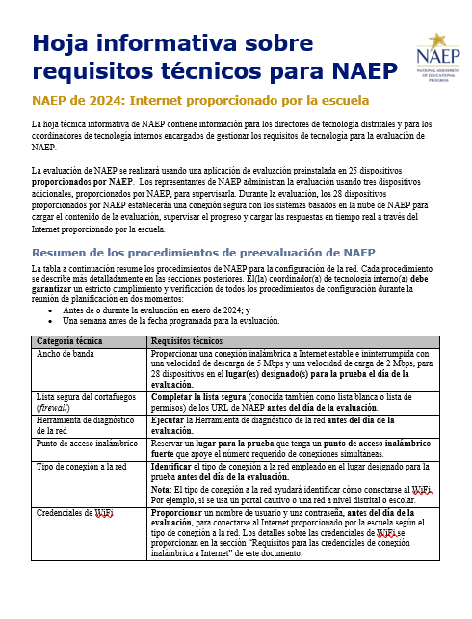

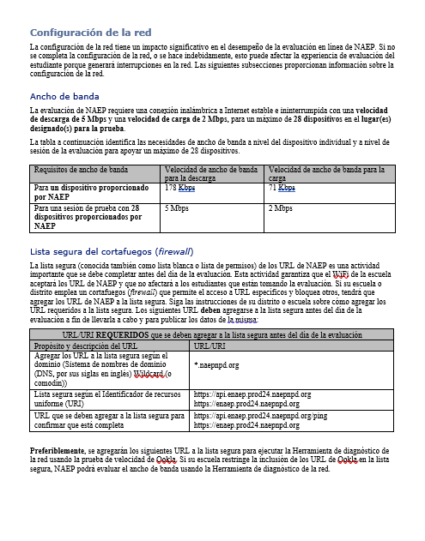
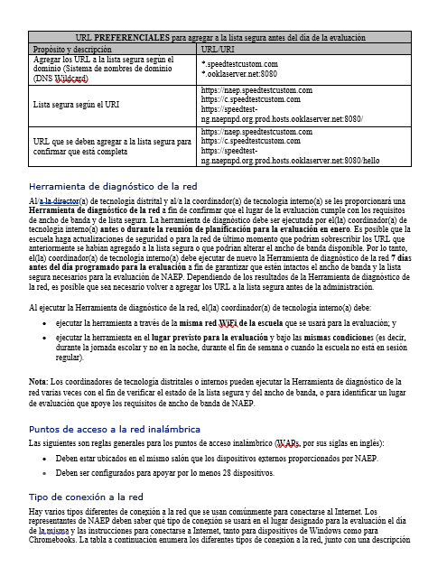

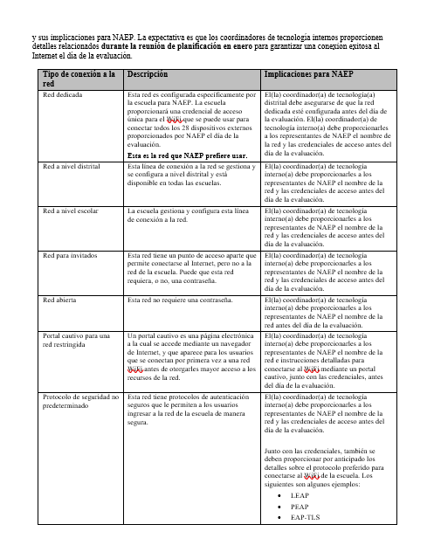

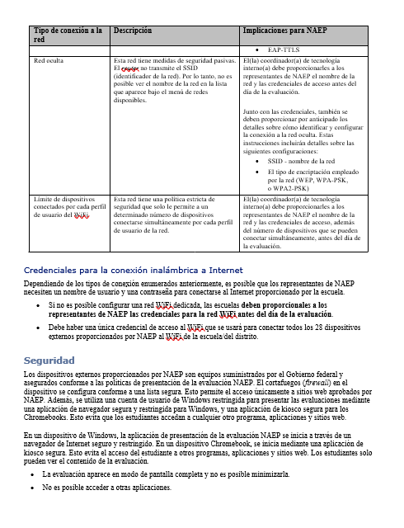
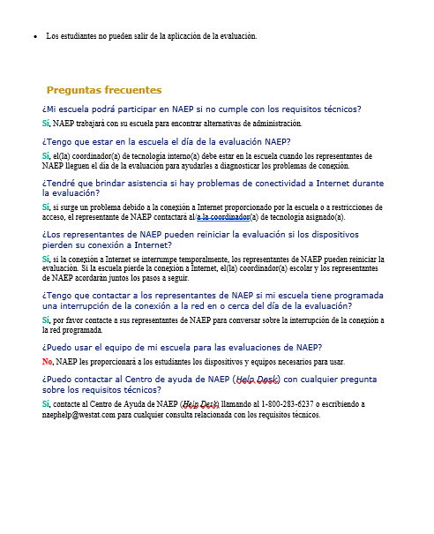

Appendix D-56: NAEP 2025 Field Test Overview Brochure (English and PR Spanish)

Title: Overview of NAEP 2025 Field Test
(Grades 4, 8, and 12; math and reading)

The National Assessment of Educational Progress (NAEP)—administered by the National Center for Education Statistics (NCES)—is the largest nationally representative and continuing assessment of what our nation’s students know and can do in various subjects. NAEP has been on a trajectory of modernization for years, leveraging digital technologies to improve the assessment processes and testing experience for students, while continuing to report vital data on student achievement.

Ultimately, NCES’s goals are to improve NAEP’s administration model to be more efficient and to be able to administer the assessment on devices (e.g., desktops, laptops, tablets with keyboards) students are most familiar with. In 2024, NCES administered the NAEP mathematics and reading assessments using school Internet and administered a proof-of-concept study at grades 4 and 8 using school devices. As the next step toward making the administration model more efficient, NCES will administer a field test as part of the NAEP 2025 program. This field test is part of NCES’s transition plan toward using devices and Internet managed by schools or districts to administer NAEP, which is intended to improve the assessment experience for schools and students. When assessed on devices that are most familiar to them, students will be able to participate in NAEP in a way that is more comfortable for them.

Call out box:
Assessment Details
- Dates: January 27–March 7, 2025
- Subjects: Mathematics and Reading
- Grades: 4, 8, and 12
- Sessions: Two groups of up to 25 students each, or one group of up to 50 students
- Student time: Approximately 2 hours (including transition time, directions, and completion of a survey questionnaire)

Each student will answer questions in one subject only. Students will also complete a survey questionnaire about their experience with the assessment and their educational experiences and opportunities to learn both in and outside of the classroom.

Achievement data from the study will not be publicly reported but will be used to inform future NAEP assessments.

Research and Development
NCES is a leader in research and innovation for large-scale assessments. NAEP’s modernizations are driven by research focused on education theory, policy, cognitive science, and classroom practice—consistent with the program’s reputation for high-quality, valid, and reliable assessments and data.

NCES will continue to explore how to best use evolving digital technologies to provide relevant data about student achievement.

Learn more about NAEP: https://nces.ed.gov/nationsreportcard/

The National Center for Education Statistics (NCES) conducts the National Assessment of Educational Progress to evaluate federally supported education programs. All of the information you provide may only be used for the purposes of research, statistics, and evaluation under the Education Sciences Reform Act of 2002 (ESRA; 20 U.S.C. § 9543) and may not be disclosed, our used, in identifiable form for any other purpose except as required by law. Every NCES employee as well as every NCES agent, such as contractors and NAEP coordinators, has taken an oath and is subject to a jail term of up to 5 years, a fine of $250,000, or both if he or she willfully discloses ANY identifiable information about you. Electronic submission of your information will be monitored for viruses, malware, and other threats by Federal employees and contractors in accordance with the Cybersecurity Enhancement Act of 2015.

Visión general de la prueba de campo de NAEP de 2025
(4.° y 8.° grado, Matemáticas)

La Evaluación Nacional del Progreso Educativo (NAEP, por sus siglas en inglés), administrada por el Centro Nacional para Estadísticas de la Educación (NCES), es la evaluación continua y nacionalmente representativa más grande que mide lo que los estudiantes de nuestro país saben y pueden hacer en diferentes materias. Durante varios años, NAEP ha seguido una trayectoria de innovación, aprovechando las tecnologías digitales para mejorar la experiencia de los estudiantes y los procesos de evaluación, al tiempo que continúa proporcionando datos esenciales sobre el rendimiento de los estudiantes.

En definitiva, los objetivos de NCES son mejorar el modelo de administración de NAEP para que sea más eficiente y poder administrar la evaluación en dispositivos (p. ej., computadoras de escritorio, computadoras portátiles, tabletas con teclado) con los que los estudiantes estén más familiarizados. En el 2024, NCES administró las evaluaciones de NAEP de Matemáticas utilizando el Internet de las escuelas y administró un estudio de prueba de concepto en los grados 4. °y 8.° utilizando los dispositivos de las escuelas. Como próximo paso para hacer más eficiente el modelo de administración, NCES administrará una prueba de campo como parte del programa de NAEP de 2025. Esta prueba de campo forma parte del plan de transición de NCES hacia el uso de dispositivos e Internet gestionados por las escuelas o los distritos para la administración de NAEP, con lo que se pretende mejorar la experiencia de evaluación para las escuelas y los estudiantes. Al ser evaluados en los dispositivos que les son más familiares, los estudiantes podrán participar en NAEP de una manera más cómoda para ellos.

<Call out box>
Información sobre la evaluación:
- Período: Del 27 de enero al 7 de marzo de 2025
- Materia: Matemáticas
- Grados: 4.° y 8.°
- Sesiones: Un grupo de 25 estudiantes máximo
- Tiempo del estudiante: Aproximadamente dos horas (incluido el tiempo de transición, las instrucciones y contestar un cuestionario de contexto).

Los estudiantes completarán un cuestionario de contexto sobre su experiencia con la evaluación y sus experiencias educativas y oportunidades de aprendizaje dentro y fuera del salón de clase.

Los datos de rendimiento del estudio no se darán a conocer públicamente, pero se utilizarán para orientar las futuras evaluaciones de NAEP.

Investigación y desarrollo
NCES es líder en investigación e innovación para las evaluaciones a gran escala. Las innovaciones de NAEP están impulsadas por la investigación centrada en la teoría de la educación, la política pública, la ciencia cognitiva y la práctica en el salón de clases, en concordancia con la reputación del programa de ofrecer evaluaciones y datos de alta calidad, válidos y fiables.

NCES continuará explorando la mejor manera de utilizar las tecnologías digitales en constante evolución para proporcionar datos relevantes sobre el rendimiento de los estudiantes.

Para más información sobre NAEP, visite: https://nces.ed.gov/nationsreportcard/puertorico/sp.aspx

The National Center for Education Statistics (NCES) conducts the National Assessment of Educational Progress to evaluate federally supported education programs. All of the information you provide may only be used for the purposes of research, statistics, and evaluation under the Education Sciences Reform Act of 2002 (ESRA; 20 U.S.C. § 9543) and may not be disclosed, our used, in identifiable form for any other purpose except as required by law. Every NCES employee as well as every NCES agent, such as contractors and NAEP coordinators, has taken an oath and is subject to a jail term of up to 5 years, a fine of $250,000, or both if he or she willfully discloses ANY identifiable information about you. Electronic submission of your information will be monitored for viruses, malware, and other threats by Federal employees and contractors in accordance with the Cybersecurity Enhancement Act of 2015.

Appendix D-57: NAEP 2025 Field Test Facts for Districts (PR Spanish)

NAEP 2025 Información para los distritos

"NAEP es la única evaluación que proporciona medio siglo de datos de rendimiento para medir lo que los estudiantes saben y pueden hacer. Las tendencias estatales y nacionales orientan las discusiones de programas y políticas locales, estatales y nacionales que mejoran la enseñanza y el aprendizaje ".

- David Atherton, Doctor en educación, Clear Creek Middle School, Greshan, Oregón

¿Qué es NAEP?
La Evaluación Nacional del Progreso Educativo (NAEP, por sus siglas en inglés) es una medida integral del progreso educativo en toda la nación y a lo largo del tiempo. Es la evaluación continua y nacionalmente representativa más grande que mide lo que los estudiantes de nuestro país saben y pueden hacer en diferentes materias, tales como educación cívica, matemáticas, lectura e historia de Estados Unidos. El programa también proporciona información valiosa sobre las experiencias educativas de los estudiantes y las oportunidades de aprendizaje dentro y fuera del salón de clases.

NAEP es un proyecto autorizado por el Congreso y administrado por el Centro Nacional para Estadísticas de la Educación (NCES, por sus siglas en inglés), parte del Departamento de Educación de Estados Unidos y el Instituto de Ciencias de la Educación. NAEP requiere que Puerto Rico participe solo en la evaluación de matemáticas. El Departamento de Educación de Estados Unidos eximió a Puerto Rico de participar en la evaluación de lectura, ya que esta mide la capacidad de un estudiante para leer inglés, sin embargo, el español es el idioma de enseñanza en Puerto Rico.

¿Cómo se informan los resultados de NAEP?
Los resultados de NAEP se publican en un informe llamado la Libreta de Calificaciones de la Nación. Dependiendo de la evaluación, los resultados de NAEP están disponibles a nivel nacional, estatal y para determinados distritos urbanos que participan en la Evaluación Piloto de Distritos Urbanos (TUDA, por sus siglas en inglés). Además, los resultados están disponibles para diferentes grupos de estudiantes con base en factores como la raza/grupo étnico, el género y la ubicación de la escuela, entre otros. NAEP no está diseñada para recopilar o informar los resultados individuales de estudiantes, salones de clase o escuelas.

¿Por qué mi distrito debería participar en NAEP?
La participación de su distrito ayudará a asegurar que los educadores, los legisladores y los funcionarios electos tengan datos confiables para entender y mejorar la educación de los estudiantes. Las escuelas y los estudiantes seleccionados para participar en NAEP representan a las escuelas y a los estudiantes de todo el país. Cuando los estudiantes participan y dan su mejor esfuerzo, los resultados de NAEP proporcionan la medida más precisa y representativa posible sobre el rendimiento y las experiencias de los estudiantes.
¿Qué evaluaciones de NAEP se administrarán en Puerto Rico en el año académico de 2025?
El programa de 2025 incluirá la prueba de campo de NAEP 2025 para evaluar a los estudiantes de 4.° y 8.° grado en matemáticas como parte de una transición hacia la administración de NAEP en equipos de la escuela. Esto permitirá que los estudiantes tengan una experiencia de evaluación más auténtica al utilizar un dispositivo con el que están familiarizados. El período de evaluación para la prueba de campo será del 27 de enero al 7 de marzo de 2025. Los resultados de esta prueba de campo no se darán a conocer, pero servirán para orientar futuras evaluaciones de NAEP.

¿Qué harán los estudiantes en mi distrito?
Los estudiantes participantes completarán preguntas sobre matemáticas. Los estudiantes también completarán un cuestionario de contexto.

A los estudiantes participantes les toma aproximadamente 2 horas completar la evaluación de la prueba de campo, incluyendo el tiempo de transición, las instrucciones y el tiempo que toma contestar el cuestionario de contexto. Se ofrece una amplia gama de acomodos para los estudiantes con impedimentos y para aprendices del español.

¿Es necesario que los maestros preparen a los estudiantes para la evaluación?
Los maestros no tienen que preparar a sus estudiantes para la evaluación, pero sí deben motivarlos a que hagan su mejor esfuerzo.

¿Cómo pueden los administradores escolares y los maestros utilizar los datos de NAEP para ayudar a nuestros estudiantes?
La página web de La Libreta de Calificaciones de la Nación (nationsreportcard.gov) le permite examinar las relaciones entre el rendimiento de los estudiantes y factores tales como las prácticas de enseñanza y los recursos escolares, entre otros.

Las preguntas de evaluaciones de NAEP anteriores también pueden utilizarse como un recurso educativo útil en el salón de clases. Los maestros pueden utilizar la herramienta NAEP Questions Tool (http://nces.ed.gov/nationsreportcard/nqt) para ver cómo se compara el rendimiento de sus estudiantes con el de otros estudiantes en su estado y en todo el país. Las preguntas de NAEP publicadas incluyen una guía de puntuación, ejemplos de respuestas de los estudiantes y datos de rendimiento.

¿Quién administrará NAEP? ¿Qué deben proporcionar las escuelas el día de la evaluación?
El personal de NAEP administrará la evaluación y proporcionará un importante apoyo a su escuela el día de la evaluación.

Los representantes de NAEP se comunicarán con las escuelas antes del día de la evaluación para informarles sobre el uso de las computadoras y del Internet de la escuela.

¿Cómo se seleccionaron las escuelas de mi distrito para NAEP?
Las escuelas fueron seleccionadas como parte de un proceso de muestreo cuidadosamente diseñado que garantiza que las escuelas y los estudiantes seleccionados para NAEP representan a su distrito, al estado y a la nación.

¿En qué se diferencia NAEP de nuestras evaluaciones estatales?
NAEP cumple una función diferente a la de las evaluaciones estatales. Mientras que los estados tienen sus propias evaluaciones para medir el desempeño de los estudiantes en relación con estándares de contenido específicos, NAEP está diseñada para proporcionar una medida común del desempeño y progreso de los estudiantes en todo el país.

¿Desde cuándo existe NAEP?
NAEP se administró por primera vez en 1969 para medir los logros de los estudiantes a nivel nacional. En 1990, NAEP se administró por primera vez a nivel estatal.

¿Con qué frecuencia se administra NAEP?
Como parte del programa principal de NAEP, los estudiantes de 4.° y 8.° grado son evaluados a nivel estatal y nacional en matemáticas y lectura cada dos años. De conformidad con la Ley de Educación Primaria y Secundaria, los distritos y estados que reciben fondos del Título I están obligados a participar en estas evaluaciones bienales, con la excepción de Puerto Rico, que está exento de participar en la evaluación de lectura.

¿Dónde puedo encontrar más información?
Conozca más sobre el programa NAEP en nces.ed.gov/nationsreportcard/puertorico y explore los últimos resultados de NAEP en nationsreportcard.gov.

También puede encontrar a NAEP en: <Facebook logo> <X logo> <YouTube logo> <LinkedIn logo> <Instagram logo>
The National Center for Education Statistics (NCES) conducts the National Assessment of Educational Progress to evaluate federally supported education programs. All of the information you provide may only be used for the purposes of research, statistics, and evaluation under the Education Sciences Reform Act of 2002 (ESRA; 20 U.S.C. § 9543) and may not be disclosed, our used, in identifiable form for any other purpose except as required by law. Every NCES employee as well as every NCES agent, such as contractors and NAEP coordinators, has taken an oath and is subject to a jail term of up to 5 years, a fine of $250,000, or both if he or she willfully discloses ANY identifiable information about you. Electronic submission of your information will be monitored for viruses, malware, and other threats by Federal employees and contractors in accordance with the Cybersecurity Enhancement Act of 2015.

Appendix D-58: NAEP 2025 Field Test CSSO To District Superintendent Letter (PR Spanish)

Carta de notificación sobre NAEP de 2025 en Puerto Rico del
SECRETARIO DE EDUCACIÓN AL SUPERINTENDENTE DISTRITAL
Se debe personalizar el texto en rojo antes de combinar la correspondencia: El texto resaltado representa los campos que se deben combinar

Estimado(a) nombre del superintendente distrital,

Gracias por todo lo que hace para apoyar la educación en Puerto Rico. Le escribo para informarle que cantidad escuelas en su distrito han sido seleccionadas para participar en la administración de la Evaluación Nacional del Progreso Educativo (NAEP, por sus siglas en inglés) de 2025. NAEP es la evaluación continua y nacionalmente representativa más grande acerca de lo que los estudiantes en Estados Unidos y Puerto Rico saben y pueden hacer en diferentes materias. NAEP es administrada por el Centro Nacional de Estadísticas de la Educación (NCES, por sus siglas en inglés) que forma parte del Departamento de Educación de Estados Unidos. Las escuelas seleccionadas representan a escuelas en el país y su participación proporciona una idea precisa del rendimiento de los estudiantes. Distrito escolar desempeñará un papel importante al participar y espero que podamos contar con todo su apoyo para hacer que esta sea una experiencia positiva para sus escuelas y estudiantes.

Las escuelas seleccionadas serán notificadas pronto y recibirán sus fechas para la evaluación a partir de mes, de manera que los directores puedan incluir la fecha programada para la evaluación en sus calendarios e incorporar a NAEP en el programa escolar planificado. Las escuelas pueden trabajar con el(la) coordinador(a) estatal de NAEP si hay algún conflicto con la fecha programada para la evaluación.

Sus escuelas seleccionadas participarán en la prueba de campo de NAEP de 2025. Como en años anteriores, los representantes de NAEP se comunicarán con las escuelas antes del día de la evaluación para informarles sobre el uso de las computadoras y del Internet de la escuela.

Visión general de la prueba de campo de NAEP de 2025

La prueba de campo de NAEP de 2025 evaluará a los estudiantes de 4.º y 8.º grados en matemáticas como parte de una transición hacia la administración de NAEP utilizando las computadoras y el Internet de la escuela, lo que permitirá que los estudiantes tengan una experiencia de evaluación más cómoda al utilizar un dispositivo con el que están familiarizados.

Para la prueba de campo de NAEP de 2025, necesitaremos la ayuda de al menos un(a) coordinador(a) de tecnología escolar o distrital y un(a) coordinador(a) escolar. Es posible que una persona desempeñe más de una función. De ser necesario, estaremos en contacto con el(la) coordinador(a) de evaluación y con el(la) director(a) de tecnología distrital, así como con los directores de las escuelas seleccionadas, con detalles específicos sobre las funciones y responsabilidades de cada persona a nivel escolar y distrital que colaborará con la planificación.

El período de evaluación para la prueba de campo será del [27 de enero al 7 de marzo de 2025]. Los resultados de esta prueba de campo no se darán a conocer, pero servirán para informar futuras evaluaciones de NAEP.

Próximos pasos

Incluya el período de la evaluación de NAEP [del 27 de enero al 7 de marzo de 2025] en el calendario de evaluaciones de su distrito. Puede encontrar información acerca de NAEP en https://nces.ed.gov/nationsreportcard/puertorico/sp.aspxl y en los adjuntos detallados a continuación. Nombre, nuestro(a) Coordinador(a) Estatal de NAEP, se comunicará con su personal para brindarles información adicional.

Gracias por apoyar esta importante evaluación y por ayudarnos a alcanzar nuestra meta de participación total.

Atentamente,

Nombre del secretario(a) de educación

Adjuntos: Lista distrital de escuelas seleccionadas para participar en NAEP
Información para los distritos

CC: Director(a) estatal de evaluaciones
Director(a) distrital de evaluaciones
Coordinador(a) estatal de NAEP

The National Center for Education Statistics (NCES) conducts the National Assessment of Educational Progress to evaluate federally supported education programs. All of the information you provide may only be used for the purposes of research, statistics, and evaluation under the Education Sciences Reform Act of 2002 (ESRA; 20 U.S.C. § 9543) and may not be disclosed, our used, in identifiable form for any other purpose except as required by law. Every NCES employee as well as every NCES agent, such as contractors and NAEP coordinators, has taken an oath and is subject to a jail term of up to 5 years, a fine of $250,000, or both if he or she willfully discloses ANY identifiable information about you. Electronic submission of your information will be monitored for viruses, malware, and other threats by Federal employees and contractors in accordance with the Cybersecurity Enhancement Act of 2015.

Appendix D-59: NAEP 2026 Field Test-Initial School Technology Survey Notification Letter (English) (NEW)

NAEP 2026 – Initial School Technology Survey Notification Letter
NAEP STATE COORDINATOR TO SCHOOL TECHNOLOGY SURVEY RECIPIENT
Red text should be customized before mail merge, highlighted text represents mail merge fields.

::Do not distribute until notified that the AMS is ready for school and district user access::

Dear [District Technology Director / District Assessment Coordinator/Principal]:

Thank you for all you do to support education in state name. I am writing to notify you that one or more schools in your district have been sampled for the 2026 administration of the National Assessment of Educational Progress (NAEP). NAEP will be administered on Chromebooks provided by NAEP or school devices.

To determine each school’s ability to support the administration of NAEP using school devices, we need to understand the technical specifications of the devices used for testing at [School Name]. / the following schools:
- School 1
- School 2
- School 3, etc.

Your role will be to do the following:
- Register for the NAEP Assessment Management System using the link provided in the registration email from [email domain]
- Complete the School Technology Survey in the Assessment Management System for each school listed above by [date], which requires knowledge of
  - the device operating system and available hardware for each sampled school,
  - district or school device management and security policies, and
  - any device sharing across schools.
- Identify an Application Installer for each sampled school assigned to administer NAEP on school devices after the completion of the School Technology Survey. This individual will be responsible for
  - deploying the NAEP Assessment Application to school devices, and
  - running a verification check on at least one of the devices that will be used to administer the NAEP assessment. .

*Note, if you would like to designate someone to complete the survey on your behalf, please send their name and email address to [NSC/NTC name] at [NSC/NTC email address].

The NAEP Assessment Application is COPPA and FERPA compliant and does not collect any student education records or personally identifiable information (PII) from students. The application and additional technical details about taking NAEP assessments on school or district devices are posted on the eNAEP Download Center at [eNAEP Download Center URL].

You will receive more details on how each school will be assessed and information on the next steps after completing the School Technology Survey.

What is NAEP?
NAEP is the largest nationally representative and continuing assessment of what our nation’s students know and can do in various subjects. NAEP is administered by the National Center for Education Statistics (NCES), within the U.S. Department of Education.

What will NAEP assess in 2026?
In 2026, NAEP will assess students in mathematics and reading at grades 4, 8, and 12, and in civics and U.S. history at grade 8. The mathematics and reading assessments will be administered on Chromebooks provided by NAEP or school devices. The civics and U.S. history assessments will be administered on Chromebooks provided by NAEP.

What if I have questions?
If you have questions about the School Technology Survey, please contact the NAEP help desk at [help desk phone number] or [help desk email]. If you have other questions about NAEP, please contact me at NSC/NTC telephone number or NSC/NTC email address.

Again, thank you for your assistance with this very important assessment.

Sincerely,

NAEP State/TUDA Coordinator

Attachments:
School Technology Survey questions PDF (optional)

The National Center for Education Statistics (NCES) conducts the National Assessment of Educational Progress to evaluate federally supported education programs. All of the information you provide may only be used for the purposes of research, statistics, and evaluation under the Education Sciences Reform Act of 2002 (ESRA; 20 U.S.C. § 9543) and may not be disclosed, our used, in identifiable form for any other purpose except as required by law. Every NCES employee as well as every NCES agent, such as contractors and NAEP coordinators, has taken an oath and is subject to a jail term of up to 5 years, a fine of $250,000, or both if he or she willfully discloses ANY identifiable information about you. Electronic submission of your information will be monitored for viruses, malware, and other threats by Federal employees and contractors in accordance with the Cybersecurity Enhancement Act of 2015.

Appendix D-60: NAEP 2025 Field Test-Initial School Technology Survey Notification Letter (Spanish)

Prueba de campo de NAEP de 2025 - Carta de notificación inicial de la encuesta sobre la tecnología de la escuela
DEL(DE LA) COORDINADOR(A) ESTATAL DE NAEP AL(A LA) DESTINATARIO(A) DE LA ENCUESTA SOBRE LA TECNOLOGÍA DE LA ESCUELA
Se debe personalizar el texto en rojo antes de combinar la correspondencia: El texto resaltado representa los campos que se deben combinar.

::No distribuya hasta que se le notifique que el AMS está listo para que los usuarios de la escuela y del distrito puedan acceder al mismo::

Estimado(a) [director(a) de tecnología distrital / coordinador(a) distrital de evaluaciones]:

Gracias por todo lo que hace para apoyar la educación en Puerto Rico. Le escribo para notificarle que una o más escuelas han sido incluidas en la muestra para la prueba de campo de la Evaluación Nacional del Progreso Educativo (NAEP, por sus siglas en inglés) de 2025. Esta prueba de campo ayudará a orientar las evaluaciones en años futuros a medida que NAEP hace la transición al uso de dispositivos de la escuela o del distrito (p. ej., computadoras de escritorio, computadoras portátiles, tabletas con teclados).

En este momento, necesitamos conocer las especificaciones técnicas de los dispositivos utilizados para las pruebas en [Nombre de la escuela]. / las siguientes escuelas:
- Escuela 1
- Escuela 2
- Escuela 3, etc.

Su función consistirá en
- registrarse en el Sistema de Administración de la Evaluación de NAEP utilizando el enlace proporcionado en el correo electrónico de registro de [Dominio del correo electrónico del AMS]; y
- completar la Encuesta sobre la tecnología de la escuela en el Sistema de Administración de la Evaluación para cada escuela en la lista anterior antes del [fecha], lo que requiere saber sobre
  - el sistema operativo y las especificaciones de los equipos para los dispositivos utilizados por la escuela o el distrito, y
  - cómo se añaden aplicaciones a un grupo de dispositivos.

*Nota: si desea designar a un miembro del personal para que complete la encuesta en su nombre, envíe el nombre y la dirección de correo electrónico a [nombre] a [dirección de correo electrónico].

En el Centro de descargas de eNAEP [enlace al Centro de descargas de eNAEP] encontrará información técnica adicional sobre cómo completar las evaluaciones de NAEP en los dispositivos de la escuela o del distrito.

Evaluaremos las respuestas a la Encuesta sobre la tecnología de la escuela y le notificaremos los próximos pasos en otoño.

¿Qué es NAEP?
NAEP es la evaluación continua y nacionalmente representativa más grande acerca de lo que los estudiantes de nuestro país saben y pueden hacer en diferentes materias. NAEP es administrada por el Centro Nacional de Estadísticas de la Educación (NCES) que forma parte del Departamento de Educación de Estados Unidos.

¿Qué evaluará NAEP en 2025?
La prueba de campo de NAEP de 2025 evaluará a los estudiantes de 4.º y 8.º grados en matemáticas utilizando dispositivos de la escuela o del distrito en la mayoría de las escuelas. Es posible que algunas escuelas utilicen Chromebooks proporcionados por NAEP.

¿Y si tengo preguntas?
Si tiene preguntas respecto a la Encuesta sobre la tecnología de la escuela, comuníquese con el Centro de Ayuda de NAEP (Help Desk) escribiendo a [correo electrónico del Centro de Ayuda]. Si tiene otras preguntas sobre NAEP, comuníquese conmigo llamando al número de teléfono o escribiendo a dirección de correo electrónico.

Una vez más, gracias por su ayuda en esta importante evaluación.

Atentamente,

Coordinador(a) estatal de NAEP

Adjunto:
Visión general de la prueba de campo de NAEP de 2025

The National Center for Education Statistics (NCES) conducts the National Assessment of Educational Progress to evaluate federally supported education programs. All of the information you provide may only be used for the purposes of research, statistics, and evaluation under the Education Sciences Reform Act of 2002 (ESRA; 20 U.S.C. § 9543) and may not be disclosed, our used, in identifiable form for any other purpose except as required by law. Every NCES employee as well as every NCES agent, such as contractors and NAEP coordinators, has taken an oath and is subject to a jail term of up to 5 years, a fine of $250,000, or both if he or she willfully discloses ANY identifiable information about you. Electronic submission of your information will be monitored for viruses, malware, and other threats by Federal employees and contractors in accordance with the Cybersecurity Enhancement Act of 2015.

Appendix D-61: NAEP 2025 Parent-Guardian Notification Letter

NAEP 2025 PARENT-GUARDIAN NOTIFICATION LETTER
Field Test: Grades 4, 8, and 12 Mathematics and Reading
(School Letterhead)
(Insert Date Here)
Dear Parent or Guardian:
(School name) will participate in the National Assessment of Educational Progress (NAEP) on (date). NAEP is the largest nationally representative and continuing assessment of what students know and can do in various subjects. NAEP is administered by the National Center for Education Statistics, within the U.S. Department of Education. NAEP is different from our state assessments because it is a common measure of achievement across the country. In 2025, our school will take part in the NAEP field test. Results from the field test will not be publicly released but will be used to inform future NAEP assessments. Your child (will/may) take a mathematics or reading assessment. In addition to subject-area questions, students voluntarily complete NAEP survey questions. These questions provide valuable information about participating students’ educational experiences and opportunities to learn both in and outside of the classroom. More information about NAEP survey questions is available at https://nces.ed.gov/nationsreportcard/parents under the section “What Questions Are on the Test?”

The assessment takes about 120 minutes for most students, which includes transition time, directions, and completion of survey questions.

The information collected is used for statistical purposes only.
- Your child’s grades will not be affected.
- Students may be excused for any reason, are not required to complete the assessment, and may skip any question.
- While the assessment is voluntary, NAEP depends on student participation to help policymakers improve education. However, if you do not want your child to participate, please notify me in writing by (date).

There is no need to study in preparation for NAEP, but please encourage your child to do their best. Contact (name) at (telephone number) or at (email address) if you have any questions.
We are excited that our school is participating in NAEP. We know that (school name)’s students will show what our nation’s students know and can do.
Sincerely,
(School Principal’s Name)
The National Center for Education Statistics (NCES) conducts the National Assessment of Educational Progress to evaluate federally supported education programs. All of the information you provide may only be used for the purposes of research, statistics, and evaluation under the Education Sciences Reform Act of 2002 (ESRA; 20 U.S.C. § 9543) and may not be disclosed, our used, in identifiable form for any other purpose except as required by law. Every NCES employee as well as every NCES agent, such as contractors and NAEP coordinators, has taken an oath and is subject to a jail term of up to 5 years, a fine of $250,000, or both if he or she willfully discloses ANY identifiable information about you. Electronic submission of your information will be monitored for viruses, malware, and other threats by Federal employees and contractors in accordance with the Cybersecurity Enhancement Act of 2015.

Appendix D-62: NAEP 2025 Parent-Guardian Notification Letter, Private Schools

NAEP 2025 PARENT-GUARDIAN NOTIFICATION LETTER PRIVATE SCHOOL
Field Test: Grades 4, 8, and 12 Mathematics and Reading
(School Letterhead)
(Insert Date Here)
Dear Parent or Guardian:
We are pleased to notify you that (school name) has been selected to represent private schools across the nation by participating in the National Assessment of Educational Progress (NAEP) on (date). NAEP is the largest nationally representative and continuing assessment of what students in public and private schools know and can do in various subjects and is administered by the National Center for Education Statistics, within the U.S. Department of Education. NAEP is different from our state and school assessments because it is a common measure of achievement across the country. In 2025, our school will take part in the NAEP field test. Results from the field test will not be publicly released but will be used to inform future NAEP assessments. Your child (will/may) take a mathematics or reading assessment. In addition to subject-area questions, students voluntarily complete NAEP survey questions. These questions provide a wealth of information about students’ opportunities to learn in and outside the classroom. More information about NAEP survey questions is available at https://nces.ed.gov/nationsreportcard/parents under the section “What Questions Are on the Test?”

The assessment takes about 120 minutes for most students, which includes transition time, directions, and completion of survey questions.

The information collected is used for statistical purposes only.
- Your child’s grades will not be affected.
- Students are not required to complete the assessment. They may be excused for any reason, and they may skip any question.
- While the assessment is voluntary, NAEP depends on student participation to help policymakers improve education. However, if you do not want your child to participate, please notify me in writing by (date).

There is no need to study to prepare for NAEP, but please encourage your child to do their best. Contact (name) at (telephone number) or at (email address) if you have any questions. To learn more about private school participation in NAEP, visit https://nces.ed.gov/nationsreportcard/participating/private_nonpublic.aspx.
We are excited that our school is participating in NAEP. We know that (school name)’s students will show what our nation’s students know and can do.

Sincerely,
(School Principal’s Name)
The National Center for Education Statistics (NCES) conducts the National Assessment of Educational Progress to evaluate federally supported education programs. All of the information you provide may only be used for the purposes of research, statistics, and evaluation under the Education Sciences Reform Act of 2002 (ESRA; 20 U.S.C. § 9543) and may not be disclosed, our used, in identifiable form for any other purpose except as required by law. Every NCES employee as well as every NCES agent, such as contractors and NAEP coordinators, has taken an oath and is subject to a jail term of up to 5 years, a fine of $250,000, or both if he or she willfully discloses ANY identifiable information about you. Electronic submission of your information will be monitored for viruses, malware, and other threats by Federal employees and contractors in accordance with the Cybersecurity Enhancement Act of 2015.

Appendix D-63: NAEP 2025 Parent-Guardian Notification Letter, Puerto Rico

CARTA DE NOTIFICACIÓN A LOS PADRES O TUTORES SOBRE NAEP DE 2025
Puerto Rico – Prueba de campo
(Membrete de la escuela)
(Coloque la fecha aquí)
Estimado(a) padre, madre o tutor:

(Nombre de la escuela) participará en la Evaluación Nacional del Progreso Educativo (NAEP, por sus siglas en inglés) el (fecha). NAEP es la evaluación continua y nacionalmente representativa más grande acerca de lo que los estudiantes saben y pueden hacer en diferentes materias. NAEP es administrada por el Centro Nacional de Estadísticas de la Educación (NCES, por sus siglas en inglés), parte del Departamento de Educación de Estados Unidos. NAEP es diferente de nuestras evaluaciones estatales ya que ofrece una medida común de los logros en todo el país. En el 2025, nuestra escuela participará en la prueba de campo de NAEP. Los resultados de la prueba de campo no se publicarán, pero se utilizarán para orientar las evaluaciones futuras de NAEP.

Su hijo(a) (tomará/posiblemente tome) una evaluación de matemáticas. Además de las preguntas sobre matemáticas, los estudiantes contestan preguntas de contexto de NAEP de manera voluntaria. Las preguntas proporcionan información valiosa acerca de las experiencias y oportunidades de aprendizaje dentro y fuera del salón de clases de los estudiantes participantes. Puede encontrar más información acerca de las preguntas de NAEP en https://nces.ed.gov/nationsreportcard/parents/spanish.aspx en la sección “¿Qué se le preguntará a su hijo(a)?”

La evaluación toma unos 120 minutos para la mayoría de los estudiantes, incluyendo el tiempo de transición, instrucciones y el contestar las preguntas de contexto.

La información recolectada se utiliza únicamente con fines estadísticos.
- Las calificaciones de su hijo(a) no se verán afectadas.
- Los estudiantes pueden ser excusados por cualquier motivo, no están obligados a completar la evaluación y pueden dejar de responder cualquier pregunta.
- Aunque la evaluación es voluntaria, NAEP depende de la participación de los estudiantes para ayudarles a los legisladores a mejorar la educación. No obstante, si no desea que su hijo(a) participe, por favor, notifíqueme por escrito antes de (fecha).

No es necesario estudiar en preparación para NAEP, pero anime a su hijo(a) a que haga su mejor esfuerzo. Si tiene alguna pregunta, comuníquese con (nombre) llamando al (número de teléfono) o por correo electrónico escribiendo a (correo electrónico).

Nos entusiasma que nuestra escuela participe en NAEP. Sabemos que los estudiantes de (nombre de la escuela) mostrarán lo que los estudiantes de nuestro país saben y pueden hacer.

Atentamente,
(Nombre del director(a) de la escuela)

The National Center for Education Statistics (NCES) conducts the National Assessment of Educational Progress to evaluate federally supported education programs. All of the information you provide may only be used for the purposes of research, statistics, and evaluation under the Education Sciences Reform Act of 2002 (ESRA; 20 U.S.C. § 9543) and may not be disclosed, our used, in identifiable form for any other purpose except as required by law. Every NCES employee as well as every NCES agent, such as contractors and NAEP coordinators, has taken an oath and is subject to a jail term of up to 5 years, a fine of $250,000, or both if he or she willfully discloses ANY identifiable information about you. Electronic submission of your information will be monitored for viruses, malware, and other threats by Federal employees and contractors in accordance with the Cybersecurity Enhancement Act of 2015.

Appendix D-64: NAEP 2025 Parent-Guardian Notification Letter, Bilingual Spanish Public Schools

CARTA DE NOTIFICACIÓN A LOS PADRES O TUTORES SOBRE NAEP DE 2025
Prueba de campo: Evaluaciones de Matemáticas y Lectura para 4.º, 8.º y 12.º grado
(Membrete de la escuela)
(Coloque la fecha aquí)
Estimado(a) padre, madre o tutor:

(Nombre de la escuela) participará en la Evaluación Nacional del Progreso Educativo (NAEP, por sus siglas en inglés) el (fecha). NAEP es la evaluación continua y nacionalmente representativa más grande acerca de lo que los estudiantes saben y pueden hacer en diferentes materias. NAEP es administrada por el Centro Nacional de Estadísticas de la Educación (NCES, por sus siglas en inglés), parte del Departamento de Educación de Estados Unidos. NAEP es diferente de nuestras evaluaciones estatales ya que ofrece una medida común de los logros en todo el país. En el 2025, nuestra escuela participará en la prueba de campo de NAEP. Los resultados de la prueba de campo no se publicarán, pero se utilizarán para orientar las evaluaciones futuras de NAEP.

Su hijo(a) (tomará/posiblemente tome) una evaluación de matemáticas o lectura. Además de las preguntas sobre la materia, los estudiantes contestan preguntas de contexto de NAEP de manera voluntaria. Las preguntas proporcionan información valiosa acerca de las experiencias y oportunidades de aprendizaje dentro y fuera del salón de clases de los estudiantes participantes. Puede encontrar más información acerca de las preguntas de NAEP en https://nces.ed.gov/nationsreportcard/parents/spanish.aspx en la sección “¿Qué se le preguntará a su hijo(a)?”

La evaluación toma unos 120 minutos para la mayoría de los estudiantes, incluyendo el tiempo de transición, instrucciones y el contestar las preguntas de contexto.

La información recolectada se utiliza únicamente con fines estadísticos.
- Las calificaciones de su hijo(a) no se verán afectadas.
- Los estudiantes pueden ser excusados por cualquier motivo, no están obligados a completar la evaluación y pueden dejar de responder cualquier pregunta.
- Aunque la evaluación es voluntaria, NAEP depende de la participación de los estudiantes para ayudarles a los legisladores a mejorar la educación. No obstante, si no desea que su hijo(a) participe, por favor, notifíqueme por escrito antes de (fecha).

No es necesario estudiar en preparación para NAEP, pero anime a su hijo(a) a que haga su mejor esfuerzo. Si tiene alguna pregunta, comuníquese con (nombre) llamando al (número de teléfono) o por correo electrónico escribiendo a (correo electrónico).

Nos entusiasma que nuestra escuela participe en NAEP. Sabemos que los estudiantes de (nombre de la escuela) mostrarán lo que los estudiantes de nuestro país saben y pueden hacer.

Atentamente,
(Nombre del director(a) de la escuela)

The National Center for Education Statistics (NCES) conducts the National Assessment of Educational Progress to evaluate federally supported education programs. All of the information you provide may only be used for the purposes of research, statistics, and evaluation under the Education Sciences Reform Act of 2002 (ESRA; 20 U.S.C. § 9543) and may not be disclosed, our used, in identifiable form for any other purpose except as required by law. Every NCES employee as well as every NCES agent, such as contractors and NAEP coordinators, has taken an oath and is subject to a jail term of up to 5 years, a fine of $250,000, or both if he or she willfully discloses ANY identifiable information about you. Electronic submission of your information will be monitored for viruses, malware, and other threats by Federal employees and contractors in accordance with the Cybersecurity Enhancement Act of 2015.

Appendix D-65: NAEP 2025 Parent-Guardian Notification Letter, Bilingual Spanish Private Schools

CARTA DE NOTIFICACIÓN A LOS PADRES O TUTORES SOBRE NAEP DE 2025
ESCUELAS PRIVADAS
Prueba de campo: Evaluaciones de Matemáticas y Lectura para 4.º, 8.º y 12.º grado
(Membrete de la escuela)
(Coloque la fecha aquí)
Estimado(a) padre, madre o tutor:

Nos complace notificarle que (nombre de la escuela) ha sido seleccionada para representar a las escuelas privadas de todo el país en la Evaluación Nacional del Progreso Educativo (NAEP, por sus siglas en inglés) el (fecha). NAEP es la evaluación continua y nacionalmente representativa más grande acerca de lo que los estudiantes en las escuelas públicas y privadas saben y pueden hacer en diferentes materias y es administrada por el Centro Nacional de Estadísticas de la Educación (NCES, por sus siglas en inglés), parte del Departamento de Educación de Estados Unidos. NAEP es diferente de nuestras evaluaciones estatales ya que ofrece una medida común de los logros en todo el país. En el 2025, nuestra escuela participará en la prueba de campo de NAEP. Los resultados de la prueba de campo no se publicarán, pero se utilizarán para orientar las evaluaciones futuras de NAEP.

Su hijo(a) (tomará/posiblemente tome) una evaluación de matemáticas o lectura. Además de las preguntas sobre la materia, los estudiantes contestan preguntas de contexto de NAEP de manera voluntaria. Estas preguntas proporcionan una gran cantidad de información acerca de las oportunidades de aprendizaje dentro y fuera del salón de clases de los estudiantes. Puede encontrar más información acerca de las preguntas de NAEP en https://nces.ed.gov/nationsreportcard/parents/spanish.aspx en la sección “¿Qué se le preguntará a su hijo(a)?”

La evaluación toma unos 120 minutos para la mayoría de los estudiantes, incluyendo el tiempo de transición, instrucciones y el contestar las preguntas de contexto.

La información recolectada se utiliza únicamente con fines estadísticos.
- Las calificaciones de su hijo(a) no se verán afectadas.
- Los estudiantes, no están obligados a completar la evaluación. Ellos pueden ser excusados por cualquier motivo y pueden dejar de responder cualquier pregunta.
- Aunque la evaluación es voluntaria, NAEP depende de la participación de los estudiantes para ayudarles a los legisladores a mejorar la educación. No obstante, si no desea que su hijo(a) participe, por favor, notifíqueme por escrito antes de (fecha).

No es necesario estudiar en preparación para NAEP, pero anime a su hijo(a) a que haga su mejor esfuerzo. Si tiene alguna pregunta, comuníquese con (nombre) llamando al (número de teléfono) o por correo electrónico escribiendo a (correo electrónico). Para saber más sobre la participación de las escuelas privadas en NAEP, visite https://nces.ed.gov/nationsreportcard/participating/private_nonpublic.aspx (en inglés).

Nos entusiasma que nuestra escuela participe en NAEP. Sabemos que los estudiantes de (nombre de la escuela) mostrarán lo que los estudiantes de nuestro país saben y pueden hacer.

Atentamente,
(Nombre del director(a) de la escuela)

The National Center for Education Statistics (NCES) conducts the National Assessment of Educational Progress to evaluate federally supported education programs. All of the information you provide may only be used for the purposes of research, statistics, and evaluation under the Education Sciences Reform Act of 2002 (ESRA; 20 U.S.C. § 9543) and may not be disclosed, our used, in identifiable form for any other purpose except as required by law. Every NCES employee as well as every NCES agent, such as contractors and NAEP coordinators, has taken an oath and is subject to a jail term of up to 5 years, a fine of $250,000, or both if he or she willfully discloses ANY identifiable information about you. Electronic submission of your information will be monitored for viruses, malware, and other threats by Federal employees and contractors in accordance with the Cybersecurity Enhancement Act of 2015.

Appendix D-66: NAEP 2026 Administration Model Assignment (NEW)

NAEP 2026 – Administration Model Assignment
AMS to School Technology Survey Respondent

From: AMS email address
To: School Technology Survey Respondent

Subject: NAEP 2026 School Technology Survey

Thank you for completing the School Technology Survey for the 2026 administration of the National Assessment of Educational Progress (NAEP).

NAEP will be administered for the following schools using school devices (e.g., desktops, laptops, tablets with keyboards). The NAEP Assessment Application will need to be deployed or installed on the school devices before December 31, 2025.
School Name | Sampled Grade | NAEP Application Installer
School 1 | 4 | Missing
School 2 | 8 | Missing
School 3 | 12 | John Doe

Schools assigned to take NAEP on school devices must have a staff member identified in the Assessment Management System (AMS) to oversee the installation of the NAEP Assessment Application on the devices. This staff member may be at the district or school level and will be identified in the AMS as the NAEP Application Installer. If you have not already identified a NAEP Application Installer, please do so via the AMS. The staff member identified in the AMS as the NAEP Application Installer will receive additional information on how to access, install, and validate the NAEP Assessment Application on the devices.
NAEP will be administered for the following schools using Chromebooks provided by NAEP. These schools will receive additional information on next steps in the fall.
School Name | Sampled Grade
School 1 | 4
School 2 | 8
School 3 | 12

The following schools did not meet the criteria to proceed with the 2026 administration of NAEP and no additional information is needed for these schools.
School Name | Sampled Grade
School 1 | 4
School 2 | 8

Appendix D-67: NAEP 2025 Assessment Details Letter to Principal, School Device Model

NAEP 2025 Assessment Details Notification Letter (School Device) From
NAEP STATE COORDINATOR TO SCHOOL PRINCIPAL: Grades 4, 8, and 12 Mathematics and Reading
Red text should be customized before mail merge; highlighted text represents mail merge fields

Dear Principal,

Thank you for all that you do to support education in state name. I am writing to inform you that school name has been selected to represent schools across the nation by participating in the 2025 field test being administered as part of the National Assessment of Educational Progress (NAEP). This field test is part of NCES’s transition plan to using school devices (e.g. desktops, laptops, tablets with keyboards) to administer NAEP, which is intended to improve the assessment experience for schools and students.

NAEP is the largest nationally representative and continuing assessment of what students in the United States know and can do in various subjects and is administered by the National Center for Education Statistics (NCES), within the U.S. Department of Education.

Assessment Overview for Your School
- Subjects: | Mathematics and reading
- Grade: | Grade (4 or 8 or 12)
- Assessment window: | January 27–March 7, 2025
- Administration model | School device
- Assessment sessions: | Two sequential sessions of up to 25 students each or all students at one time in one or two locations. School staff presence in the assessment location is encouraged to help support classroom management. Please note, if you select to assess all students at the same time in one or two locations, school staff presence is required at each location.
- Student time: | Approximately 2 hours (including transition time, directions, and completion of a survey questionnaire)
- Assessment administrators: | NAEP representatives

What do I need to know?

- Students will respond to questions in mathematics or reading. Each student will answer questions in only one subject. In addition to answering subject-area questions, students will complete NAEP survey questions that provide valuable information about students’ educational experiences and opportunities to learn in and outside the classroom.
- The NAEP assessment application must be installed on school devices by a district or school staff member by December 31, 2024, for students to take the assessment. The individual responsible for preparing the school devices will be contacted later this fall with more instruction.
- The installation of the NAEP assessment application on all the devices students will use to take the assessment must be confirmed within 10 days of the assessment.
- NAEP representatives will administer the assessment and provide significant support to your school.
- A school or district staff member will need to be available on assessment day at the beginning of the testing session to resolve any technical issues that may arise with launching the NAEP assessment on school devices.
- A school staff member’s presence throughout the assessment can have a positive impact on students’ motivation and performance. If assessing all students at the same time in one or two locations, the presence of a school staff member is required at each location to help support classroom management.
- Results from the field test will not be publicly reported but will be used to inform future NAEP assessments.
What are the next steps?
- Designate a NAEP school coordinator to serve as the main point of contact, provide a student list, and submit additional information.
- Review the school coordinator responsibilities and give the enclosed folder/attached documents to your designated NAEP school coordinator.
- Your school coordinator should
    - know how to access student information, such as birth date, demographic information, and enrollment status;
    - be comfortable using a computer, because all assessment preparation activities will be completed online;
    - be familiar with how students participate in statewide assessments; and
    - be familiar with the devices students will use to take the NAEP assessment to complete technical tasks before and during the administration, including confirming that the NAEP assessment application has been successfully installed on school devices before assessment day.
      - If necessary, an additional school or district staff member can be identified to assist with these tasks.

- To help ensure receipt of important email messages, work with school or district technology staff as necessary to add the domain westatstudies.com to the safe senders list.
- {Use this bullet if following Option 1: principal registers and invites school coordinator} Log in and set up your NAEP Assessment Management System (AMS) account using the link provided in the registration email from DoNotReply-NAEP@westatstudies.com.
- {Use this bullet if following Option 1: principal registers and invites school coordinator} Enter the school coordinator’s name and contact information in the AMS, select their role as School Coordinator, and select Send Invite.
- {Use this bullet if following Option 2: NSC invites the school coordinator, principal not expected to register} Send the designated school coordinator’s name and email address to me using the email address provided below.

In November, I will send your assessment date to your designated NAEP school coordinator. If the date presents a conflict for your school, we will work together to identify an alternate date.

Again, I would like to express my appreciation for your assistance with this very important assessment
of our nation’s students. Our chief state school officer, name, supports NAEP and encourages your students to participate.

Additional information about NAEP can be found in the enclosed documents/attachments and at http://nces.ed.gov/nationsreportcard.

If you have questions, please contact me at telephone number or via email at email address.

Sincerely,

NAEP State Coordinator

Enclosure/Attachment (or link for electronic mailing):
2025 Field Test Overview Brochure
NAEP in Your School
NAEP folder for your NAEP school coordinator, including the following:
Letter to your school coordinator
Student List Submission Instructions
Parent/Guardian Notification Letter

The National Center for Education Statistics (NCES) conducts the National Assessment of Educational Progress to evaluate federally supported education programs. All of the information you provide may only be used for the purposes of research, statistics, and evaluation under the Education Sciences Reform Act of 2002 (ESRA; 20 U.S.C. § 9543) and may not be disclosed, our used, in identifiable form for any other purpose except as required by law. Every NCES employee as well as every NCES agent, such as contractors and NAEP coordinators, has taken an oath and is subject to a jail term of up to 5 years, a fine of $250,000, or both if he or she willfully discloses ANY identifiable information about you. Electronic submission of your information will be monitored for viruses, malware, and other threats by Federal employees and contractors in accordance with the Cybersecurity Enhancement Act of 2015.

Appendix D-68: NAEP 2025 Assessment Details Letter to Principal, School Device Model, Puerto Rico

Carta de notificación con detalles acerca de la evaluación NAEP de 2025 (Dispositivo de la escuela)
DE PARTE DEL(DE LA) COORDINADOR(A) ESTATAL DE NAEP PARA EL(LA) DIRECTOR(A) – PUERTO RICO
Se debe personalizar el texto en rojo antes de combinar la correspondencia, el texto resaltado representa los campos que se deben combinar.
Estimado(a) director(a),

Gracias por todo lo que hace para apoyar la educación en Puerto Rico. Le escribo para informarle que nombre de la escuela ha sido seleccionada para representar a las escuelas de Puerto Rico y el país al participar en la prueba de campo de 2025 que se administra como parte de la Evaluación Nacional del Progreso Educativo (NAEP, por sus siglas en inglés). Esta prueba de campo forma parte del plan de transición de NCES hacia el uso de dispositivos escolares (p. ej., computadoras de escritorio, computadoras portátiles, tabletas con teclados) para administrar NAEP, con lo que se pretende mejorar la experiencia de evaluación para las escuelas y los estudiantes.

NAEP es la evaluación continua y nacionalmente representativa más grande que mide lo que los estudiantes en Estados Unidos y Puerto Rico saben y pueden hacer en diferentes materias. NAEP es administrada por el Centro Nacional para Estadísticas de la Educación (NCES), que forma parte del Departamento de Educación de Estados Unidos.

Visión general de la evaluación en su escuela
- Materia: | Matemáticas
- Grado: | Grado (4.° u 8.°)
- Período de evaluación: | 27 de enero al 7 de marzo de 2025
- Modelo de administración: | Dispositivos de la escuela
- Sesiones de evaluación: | Una sesión de aproximadamente 25 estudiantes. Se recomienda la presencia de personal de la escuela en el lugar de la evaluación para ayudar a administrar el salón de clase.
- Tiempo del estudiante: | Aproximadamente 2 horas (incluyendo el tiempo de transición, las instrucciones y tiempo para contestar las preguntas del cuestionario de contexto).
- Administradores de la evaluación: | Representantes de NAEP

¿Qué debo saber?

- Los estudiantes responderán a preguntas sobre matemáticas. Además de responder a las preguntas sobre la materia, los estudiantes completarán un cuestionario de contexto de NAEP que proporciona información valiosa sobre las experiencias educativas de los estudiantes y las oportunidades de aprendizaje dentro y fuera del salón de clase.
- La aplicación de la evaluación de NAEP debe ser instalada en los dispositivos de la escuela por personal del distrito o de la escuela antes del 31 de diciembre de 2024, para que los estudiantes puedan tomar la evaluación. La persona responsable de preparar los dispositivos de la escuela será contactada a finales de este otoño con instrucciones adicionales.
- La instalación de la aplicación de la evaluación de NAEP en todos los dispositivos que los estudiantes utilizarán para tomar la evaluación debe confirmarse dentro de los 10 días previos a la evaluación.
- Los representantes de NAEP administrarán la evaluación y le proporcionarán bastante apoyo a su escuela.
- Un miembro del personal de la escuela o del distrito deberá estar disponible al comienzo de la sesión de la evaluación para resolver cualquier problema técnico que pueda surgir con la ejecución de la evaluación de NAEP en los dispositivos de la escuela.
- La presencia de un miembro del personal de la escuela puede tener un impacto positivo en la motivación y el desempeño de los estudiantes.
- Los resultados de la prueba de campo no se publicarán, pero se utilizarán para orientar las futuras evaluaciones de NAEP.
¿Cuáles son los próximos pasos?
- Designe a un(a) coordinador(a) escolar de NAEP para que sea la persona de contacto, y para que envíe información adicional.
- Revise las responsabilidades del(de la) coordinador(a) escolar y entréguele la carpeta adjunta/los documentos adjuntos a su coordinador(a) escolar designado(a) para NAEP.
- Su coordinador(a) escolar debe:
    - saber cómo acceder a la información de los estudiantes, tales como fecha de nacimiento, información demográfica y estado de matrícula;
    - saber usar una computadora, ya que todas las actividades en preparación para la evaluación se completarán en línea;
    - estar familiarizado(a) con la manera en que los estudiantes participan en evaluaciones a nivel estatal; y
    - estar familiarizado(a) con los dispositivos que los estudiantes utilizarán para tomar la evaluación de NAEP para completar las tareas técnicas antes y durante la administración, incluyendo la confirmación de que la aplicación de la evaluación de NAEP se ha instalado correctamente en los dispositivos de la escuela antes del día de la evaluación.
      - De ser necesario, se puede designar a otro miembro del personal de la escuela o del distrito para que colabore en estas tareas.

- Para garantizar que se reciban los mensajes de correo electrónico importantes, colabore con el personal de tecnología de su escuela o distrito según sea necesario para añadir el dominio westatstudies.com a la lista segura de remitentes.
- {Utilice este punto si eligió la opción 1: el(la) director(a) se registra e invita al(a la) coordinador(a) escolar} Ingrese y configure su cuenta del AMS de NAEP utilizando el enlace proporcionado en el correo electrónico de registro de [AMSRegistrationEmail].
- {Utilice este punto si eligió la opción 1: el(la) director(a) se registra e invita al(a la) coordinador(a) escolar} Ingrese el nombre y la información de contacto del(de la) coordinador(a) escolar en el AMS, seleccione coordinador(a) escolar como su función y seleccione Enviar invitación.
- {Utilice este punto si eligió la opción 2: el(la) NSC invita al(a la) coordinador(a) escolar, no se espera que el(la) directora(a) se registre} Envíeme el nombre y la dirección de correo electrónico del(de la) coordinador(a) escolar designado(a) utilizando la dirección de correo electrónico que se proporciona al final.

En noviembre, enviaré la fecha de la evaluación a su coordinador(a) escolar designado(a) para NAEP. Si la fecha presenta un conflicto para su escuela, trabajaremos juntos para identificar una fecha alterna.

Nuevamente, quisiera expresarle mi agradecimiento por su ayuda con esta evaluación tan importante de nuestros estudiantes. Nuestro(a) secretario(a) de educación, nombre, apoya NAEP y anima a sus estudiantes a participar.

Puede encontrar información adicional sobre NAEP en los documentos adjuntos y en https://nces.ed.gov/nationsreportcard/puertorico/.

Si tiene preguntas, por favor, comuníquese conmigo llamando al número de teléfono o por correo electrónico escribiendo a correo electrónico.

Atentamente,

Coordinador(a) estatal de NAEP

Adjuntos (o enlace para envío electrónico):
Información general de la prueba de campo de 2025
NAEP en su escuela
Carpeta de NAEP para el(la) coordinador(a) escolar de su escuela, incluyendo lo siguiente:
Carta a su coordinador(a) escolar
Carta de notificación para los padres, madres o tutores

The National Center for Education Statistics (NCES) conducts the National Assessment of Educational Progress to evaluate federally supported education programs. All of the information you provide may only be used for the purposes of research, statistics, and evaluation under the Education Sciences Reform Act of 2002 (ESRA; 20 U.S.C. § 9543) and may not be disclosed, our used, in identifiable form for any other purpose except as required by law. Every NCES employee as well as every NCES agent, such as contractors and NAEP coordinators, has taken an oath and is subject to a jail term of up to 5 years, a fine of $250,000, or both if he or she willfully discloses ANY identifiable information about you. Electronic submission of your information will be monitored for viruses, malware, and other threats by Federal employees and contractors in accordance with the Cybersecurity Enhancement Act of 2015.

Appendix D-69: NAEP 2025 Assessment Details Letter to Principal, NAEP Device Model

NAEP 2025 Assessment Details Notification Letter (NAEP Device) From
NAEP STATE COORDINATOR TO SCHOOL PRINCIPAL: Grades 4, 8, and 12 Mathematics and Reading
Red text should be customized before mail merge; highlighted text represents mail merge fields

Dear Principal,

Thank you for all that you do to support education in state name. I am writing to inform you that school name has been selected to represent schools across the nation by participating in the 2025 field test being administered as part of the National Assessment of Educational Progress (NAEP). NAEP is the largest nationally representative and continuing assessment of what students in the United States know and can do in various subjects and is administered by the National Center for Education Statistics (NCES), within the U.S. Department of Education.

Assessment Overview for Your School
- Subjects: | Mathematics and reading
- Grade: | Grade (4 or 8 or 12)
- Assessment window: | January 27–March 7, 2025
- Administration model: | NAEP devices
- Assessment sessions: | Up to two sequential sessions of about 25 students each.
- Student time: | Approximately 2 hours (including transition time, directions, and completion of a survey questionnaire)
- Assessment administrators: | NAEP representatives

What do I need to know?

- Students will respond to questions in mathematics or reading. Each student will answer questions in only one subject. In addition to answering subject-area questions, students will complete NAEP survey questions that provide valuable information about students’ educational experiences and opportunities to learn in and outside the classroom.
- NAEP representatives will administer the assessment, bring all necessary materials and equipment, and provide significant support to your school.
- Students will complete the assessment on NAEP devices.
- A school staff member’s presence can have a positive impact on students’ motivation and performance. The presence of a school staff member as an observer during the assessment session(s) is appreciated.
- Results from the field test will not be publicly reported but will be used to inform future NAEP assessments.

What are the next steps?
- Designate a NAEP school coordinator to serve as the main point of contact, provide a student list, and submit additional information.
- Review the school coordinator responsibilities and give the enclosed folder/attached documents to your designated NAEP school coordinator.
- Your school coordinator should
    - know how to access student information, such as birth date, demographic information, and enrollment status;
    - be comfortable using a computer, because all assessment preparation activities will be completed online; and
    - be familiar with how students participate in statewide assessments.
- To help ensure receipt of important email messages, work with school or district technology staff as necessary to add the domain westatstudies.com to the safe senders list.
- {Use this bullet if following Option 1: principal registers and invites school coordinator} Log in and set up your NAEP Assessment Management System (AMS) account using the link provided in the registration email from DoNotReply-NAEP@westatstudies.com.
- {Use this bullet if following Option 1: principal registers and invites school coordinator} Enter the school coordinator’s name and contact information in the AMS, select their role as School Coordinator, and select Send Invite.
- {Use this bullet if following Option 2: NSC invites the school coordinator, principal not expected to register} Send the designated school coordinator’s name and email address to me using the email address provided below.

In November, I will send your assessment date to your designated NAEP school coordinator. If the date presents a conflict for your school, we will work together to identify an alternate date.

Again, I would like to express my appreciation for your assistance with this very important assessment
of our nation’s students. Our chief state school officer, name, supports NAEP and encourages your students to participate.

Additional information about NAEP can be found in the enclosed documents/attachment and at http://nces.ed.gov/nationsreportcard.

If you have questions, please contact me at telephone number or via email at email address.

Sincerely,

NAEP State Coordinator

Enclosure/Attachment (or link for electronic mailing):
2025 Field Test Overview Brochure
NAEP in Your School
NAEP folder for your NAEP school coordinator, including the following:
Letter to your school coordinator
Student List Submission Instructions
Parent/Guardian Notification Letter

The National Center for Education Statistics (NCES) conducts the National Assessment of Educational Progress to evaluate federally supported education programs. All of the information you provide may only be used for the purposes of research, statistics, and evaluation under the Education Sciences Reform Act of 2002 (ESRA; 20 U.S.C. § 9543) and may not be disclosed, our used, in identifiable form for any other purpose except as required by law. Every NCES employee as well as every NCES agent, such as contractors and NAEP coordinators, has taken an oath and is subject to a jail term of up to 5 years, a fine of $250,000, or both if he or she willfully discloses ANY identifiable information about you. Electronic submission of your information will be monitored for viruses, malware, and other threats by Federal employees and contractors in accordance with the Cybersecurity Enhancement Act of 2015.

Appendix D-70: NAEP 2025 Assessment Details Letter to Principal, NAEP Device Model, Puerto Rico

Carta de notificación con detalles acerca de la evaluación NAEP de 2025 (Dispositivo de NAEP)
DE PARTE DEL(DE LA) COORDINADOR(A) ESTATAL DE NAEP PARA EL(LA) DIRECTOR(A) – PUERTO RICO
Se debe personalizar el texto en rojo antes de combinar la correspondencia, el texto resaltado representa los campos que se deben combinar.

Estimado(a) director(a),

Gracias por todo lo que hace para apoyar la educación en Puerto Rico. Le escribo para informarle que nombre de la escuela ha sido seleccionada para representar a las escuelas de Puerto Rico y el país al participar en la prueba de campo de 2025 que se administra como parte de la Evaluación Nacional del Progreso Educativo (NAEP, por sus siglas en inglés). NAEP es la evaluación continua y nacionalmente representativa más grande que mide lo que los estudiantes en Estados Unidos y Puerto Rico saben y pueden hacer en diferentes materias. NAEP es administrada por el Centro Nacional para Estadísticas de la Educación (NCES), que forma parte del Departamento de Educación de Estados Unidos.

Visión general de la evaluación en su escuela
- Materia: | Matemáticas
- Grado: | Grado (4.° u 8.°)
- Período de evaluación: | 27 de enero al 7 de marzo de 2025
- Modelo de administración: | Dispositivos de NAEP
- Sesiones de evaluación: | Una sesión de aproximadamente 25 estudiantes.
- Tiempo del estudiante: | Aproximadamente 2 horas (incluyendo el tiempo de transición, las instrucciones y tiempo para contestar las preguntas del cuestionario de contexto).
- Administradores de la evaluación: | Representantes de NAEP

¿Qué debo saber?

- Los estudiantes responderán a preguntas sobre matemáticas. Además de responder a las preguntas sobre la materia, los estudiantes completarán un cuestionario de contexto de NAEP que proporciona información valiosa sobre las experiencias educativas de los estudiantes y las oportunidades de aprendizaje dentro y fuera del salón de clase.
- Los representantes de NAEP administrarán la evaluación, llevarán todos los materiales y equipos necesarios y le proporcionarán bastante apoyo a su escuela.
- Los estudiantes completarán la evaluación en dispositivos proporcionados por NAEP.
- La presencia de un miembro del personal de la escuela puede tener un impacto positivo en la motivación y el desempeño de los estudiantes. Se agradece la presencia de un miembro del personal de la escuela como observador durante la sesión de evaluación.
- Los resultados de la prueba de campo no se publicarán, pero se utilizarán para orientar las futuras evaluaciones de NAEP.

¿Cuáles son los próximos pasos?
- Designe a un(a) coordinador(a) escolar de NAEP para que sea la persona de contacto, y para que envíe información adicional.
- Revise las responsabilidades del(de la) coordinador(a) escolar y entréguele la carpeta adjunta/los documentos adjuntos a su coordinador(a) escolar designado(a) para NAEP.
- Su coordinador(a) escolar debe:
    - saber cómo acceder a la información de los estudiantes, tales como fecha de nacimiento, información demográfica y estado de matrícula;
    - saber usar una computadora, ya que todas las actividades en preparación para la evaluación se completarán en línea; y
    - estar familiarizado(a) con la manera en que los estudiantes participan en evaluaciones a nivel estatal.
- Para garantizar que se reciban los mensajes de correo electrónico importantes, colabore con el personal de tecnología de su escuela o distrito según sea necesario para añadir el dominio westatstudies.com a la lista segura de remitentes.
- {Utilice este punto si eligió la opción 1: el(la) director(a) se registra e invita al(a la) coordinador(a) escolar} Ingrese y configure su cuenta del AMS de NAEP utilizando el enlace proporcionado en el correo electrónico de registro de [AMSRegistrationEmail].
- {Utilice este punto si eligió la opción 1: el(la) director(a) se registra e invita al(a la) coordinador(a) escolar} Ingrese el nombre y la información de contacto del(de la) coordinador(a) escolar en el AMS, seleccione coordinador(a) escolar como su función y seleccione Enviar invitación.
- {Utilice este punto si eligió la opción 2: el(la) NSC invita al(a la) coordinador(a) escolar, no se espera que el(la) directora(a) se registre} Envíeme el nombre y la dirección de correo electrónico del(de la) coordinador(a) escolar designado(a) utilizando la dirección de correo electrónico que se proporciona al final.

En noviembre, enviaré la fecha de la evaluación a su coordinador(a) escolar designado(a) para NAEP. Si la fecha presenta un conflicto para su escuela, trabajaremos juntos para identificar una fecha alterna.

Nuevamente, quisiera expresarle mi agradecimiento por su ayuda con esta evaluación tan importante de nuestros estudiantes. Nuestro(a) secretario(a) de educación, nombre, apoya NAEP y anima a sus estudiantes a participar.

Puede encontrar información adicional sobre NAEP en los documentos adjuntos y en https://nces.ed.gov/nationsreportcard/puertorico/.

Si tiene preguntas, por favor, comuníquese conmigo llamando al número de teléfono o por correo electrónico escribiendo a correo electrónico.

Atentamente,

Coordinador(a) estatal de NAEP

Adjuntos (o enlace para envío electrónico):
Información general de la prueba de campo de 2025
NAEP en su escuela
Carpeta de NAEP para el(la) coordinador(a) escolar de su escuela, incluyendo lo siguiente:
Carta a su coordinador(a) escolar
Carta de notificación para los padres, madres o tutores

The National Center for Education Statistics (NCES) conducts the National Assessment of Educational Progress to evaluate federally supported education programs. All of the information you provide may only be used for the purposes of research, statistics, and evaluation under the Education Sciences Reform Act of 2002 (ESRA; 20 U.S.C. § 9543) and may not be disclosed, our used, in identifiable form for any other purpose except as required by law. Every NCES employee as well as every NCES agent, such as contractors and NAEP coordinators, has taken an oath and is subject to a jail term of up to 5 years, a fine of $250,000, or both if he or she willfully discloses ANY identifiable information about you. Electronic submission of your information will be monitored for viruses, malware, and other threats by Federal employees and contractors in accordance with the Cybersecurity Enhancement Act of 2015.

Appendix D-71: NAEP 2025 Assessment Details Letter to School Coordinator School Device Model

NAEP 2025 Assessment Details Notification Letter (School Device) From
NAEP STATE COORDINATOR TO SCHOOL COORDINATOR: Grades 4, 8, and 12 Mathematics and Reading
Red text should be customized before mail merge; highlighted text represents mail merge fields

Dear School Coordinator,

Welcome to the 2025 administration of the National Assessment of Educational Progress (NAEP). I look forward to working with you to coordinate NAEP in your school. NAEP is the largest nationally representative and continuing assessment of what students in the United States know and can do in various subjects and is administered by the National Center for Education Statistics (NCES), within the U.S. Department of Education.

Assessment Overview for Your School
- Subjects: | Mathematics and reading
- Grade: | Grade (4 or 8 or 12)
- Assessment window: | January 27–March 7, 2025
- Administration model:  - Assessment sessions: | School devices  Two sequential sessions of up to 25 students each or all students at one time in one or two locations. School staff presence in the assessment location is encouraged to help support classroom management. Please note, if you select to assess all students at the same time in one or two locations, school staff presence is required at each location.
- Student time: | Approximately 2 hours (including transition time, directions, and completion of a survey questionnaire)
- Assessment administrators: | NAEP representatives

As the school coordinator, you will have several responsibilities critical to making NAEP a success. The NAEP Assessment Management System (AMS) website is designed to assist you with these responsibilities. The timeline below indicates when you will need to complete specific assessment planning tasks in the NAEP AMS.
- October: Work with the school or district technology staff as necessary to add the domain westatstudies.com to the safe senders list to help ensure receipt of important email messages. Log in and set up your NAEP AMS account using the link provided in the registration email from DoNotReply-NAEP@westatstudies.com. Answer the questions in the School Information section by [date].
- October 7–November 22: Prepare and submit a list of all grade (4 or 8 or 12) students electronically by [date]. Please see the enclosed instructions.
- Early November: I will send you an assessment date and additional information on your tasks leading up to the assessment. If the date presents a conflict for your school, we will work together to identify an alternate date.
- Early December: An assigned NAEP representative responsible for administering the assessment will contact you to introduce themselves and coordinate the scheduling of an Assessment Planning Meeting. The NAEP representative can review how to complete the NAEP planning tasks upon request.
- One week before the assessment: Print student appointment cards and notify teachers in advance so they will know when to release students.
- During the assessment:
  - A school or district staff member will need to be available on assessment day at the beginning of the testing session to resolve any technical issues that may arise with launching the NAEP assessment on school devices.
  - A school staff member’s presence throughout the assessment can have a positive impact on students’ motivation and performance. If assessing all students at the same time in one or two locations, the presence of a school staff member is required at each location to help support classroom management.
- After the assessment: Destroy any hardcopy documents containing student names according to school protocol. Complete a short email survey on your experience with NAEP.

What do I need to know?

- Students will respond to questions in mathematics or reading. Each student will answer questions in only one subject. In addition to answering subject-area questions, students will complete NAEP survey questions that provide valuable information about students’ educational experiences and opportunities to learn in and outside the classroom.
- Students will complete the assessment on school devices.
- The NAEP application must be installed on school devices by a district or school staff member by December 31, 2024 for students to take the assessment. The individual responsible for preparing the school devices will be contacted later this fall with more instructions.
- The installation of the NAEP application on all the devices students will use to take the assessment must be confirmed within 10 days of the assessment.
- NAEP representatives will administer the assessment and provide significant support to your school.
- Results from the field test will not be publicly reported but will be used to inform future NAEP assessments.

Additional information about NAEP can be found at http://nces.ed.gov/nationsreportcard.

Thank you in advance for your cooperation and effort in helping to coordinate this important assessment. If you have any questions, please contact me at telephone number or email address.

Sincerely,

NAEP State Coordinator

Enclosure/Attachment: NAEP folder, including the following:
2025 Field Test Overview Brochure
NAEP in Your School
Student List Submission Instructions
Parent/Guardian Notification Letter

The National Center for Education Statistics (NCES) conducts the National Assessment of Educational Progress to evaluate federally supported education programs. All of the information you provide may only be used for the purposes of research, statistics, and evaluation under the Education Sciences Reform Act of 2002 (ESRA; 20 U.S.C. § 9543) and may not be disclosed, our used, in identifiable form for any other purpose except as required by law. Every NCES employee as well as every NCES agent, such as contractors and NAEP coordinators, has taken an oath and is subject to a jail term of up to 5 years, a fine of $250,000, or both if he or she willfully discloses ANY identifiable information about you. Electronic submission of your information will be monitored for viruses, malware, and other threats by Federal employees and contractors in accordance with the Cybersecurity Enhancement Act of 2015.

Appendix D-72: NAEP 2025 Assessment Details Letter to School Coordinator School Device Model, Puerto Rico

Carta de notificación con detalles acerca de la evaluación NAEP de 2025 (Dispositivo de la escuela)
Carta de notificación con detalles acerca de la evaluación NAEP de 2025 (Dispositivo de la escuela)
DE PARTE DEL(DE LA) COORDINADOR(A) ESTATAL DE NAEP PARA EL(LA) COORDINADOR(A) ESCOLAR – PUERTO RICO
Se debe personalizar el texto en rojo antes de combinar la correspondencia, el texto resaltado representa los campos que se deben combinar.

Estimado(a) coordinador(a) escolar,

Bienvenido(a) a la administración de la Evaluación Nacional del Progreso Educativo (NAEP, por sus siglas en inglés) de 2025. Me alegrará trabajar con usted para coordinar NAEP en su escuela. NAEP es la evaluación continua y nacionalmente representativa más grande que mide lo que los estudiantes en Estados Unidos y Puerto Rico saben y pueden hacer en diferentes materias. NAEP es administrada por el Centro Nacional para Estadísticas de la Educación (NCES), que forma parte del Departamento de Educación de Estados Unidos.

Visión general de la evaluación en su escuela
- Materia: | Matemáticas
- Grado: | Grado (4.° u 8.°)
- Período de evaluación: | 27 de enero al 7 de marzo de 2025
- Sesiones de evaluación: | Una sesión de aproximadamente 25 estudiantes. Se recomienda la presencia de personal de la escuela en el lugar de la evaluación para ayudar a administrar el salón de clase.
- Tiempo del estudiante: | Aproximadamente 2 horas (incluyendo el tiempo de transición, las instrucciones y tiempo para contestar las preguntas del cuestionario de contexto).
- Administradores de la evaluación: | Representantes de NAEP

Como coordinador(a) escolar, usted tendrá varias responsabilidades esenciales para que NAEP sea un éxito. El sitio web del Sistema de Administración de la Evaluación de NAEP (AMS, por sus siglas en inglés) está diseñado para ayudarle con estas responsabilidades. El siguiente cronograma indica cuándo deberá completar las tareas específicas de planificación para la evaluación en el AMS de NAEP.
- Octubre: Para garantizar que se reciban los mensajes de correo electrónico importantes, colabore con el personal de tecnología de su escuela o distrito según sea necesario para añadir el dominio westatstudies.com a la lista segura de remitentes. Ingrese y configure su cuenta del AMS de NAEP utilizando el enlace proporcionado en el correo electrónico de registro de DoNotReply-NAEP@westatstudies.com. Responda a las preguntas de la sección Información de la escuela antes del [fecha].
- Principios de noviembre: Le enviaré una fecha para la evaluación e información adicional sobre las tareas previas a la evaluación. Si la fecha presenta un conflicto para su escuela, trabajaremos juntos para identificar una fecha alterna.
- Principios de diciembre: Un(a) representante de NAEP responsable de administrar la evaluación se comunicará con usted para presentarse y coordinar la programación de una reunión de planificación de la evaluación. Si lo solicita, el(la) representante de NAEP puede explicarle cómo completar las tareas de planificación de NAEP que se describen a continuación.
- Una semana antes de la evaluación: Imprima las tarjetas de recordatorio para los estudiantes y avise a los maestros con antelación para que sepan cuándo deben dejar salir a los estudiantes.
- Durante la evaluación:
  - Un miembro del personal de la escuela o del distrito deberá estar disponible al comienzo de la sesión de la evaluación para resolver cualquier problema técnico que pueda surgir con la ejecución de la evaluación de NAEP en los dispositivos de la escuela.
  - La presencia de un miembro del personal de la escuela durante la evaluación puede tener un impacto positivo en la motivación y el desempeño de los estudiantes.
- Después de la evaluación: Destruya cualquier documento impreso que contenga nombres de estudiantes de acuerdo con el protocolo de la escuela. Complete una breve encuesta sobre su experiencia con NAEP.

¿Qué debo saber?

- Los estudiantes responderán a preguntas sobre matemáticas. Además de responder a las preguntas sobre la materia, los estudiantes completarán un cuestionario de contexto de NAEP que proporciona información valiosa sobre las experiencias educativas de los estudiantes y las oportunidades de aprendizaje dentro y fuera del salón de clase.
- Los estudiantes completarán la evaluación en los dispositivos de la escuela.
- La aplicación de la evaluación de NAEP debe ser instalada en los dispositivos de la escuela por personal del distrito o de la escuela antes del 31 de diciembre de 2024, para que los estudiantes puedan tomar la evaluación. La persona responsable de preparar los dispositivos de la escuela será contactada a finales de este otoño con instrucciones adicionales.
- La instalación de la aplicación de evaluación de NAEP en todos los dispositivos que los estudiantes utilizarán para tomar la evaluación debe confirmarse dentro de los 10 días previos a la evaluación.
- Los representantes de NAEP administrarán la evaluación y le proporcionarán bastante apoyo a su escuela.
- Los resultados de la prueba de campo no se publicarán, pero se utilizarán para orientar las futuras evaluaciones de NAEP.

Puede encontrar información adicional sobre NAEP en https://nces.ed.gov/nationsreportcard/puertorico/.

Gracias de antemano por su cooperación y esfuerzo para ayudar a coordinar esta importante evaluación. Si tiene preguntas, por favor, comuníquese conmigo llamando al número de teléfono o por correo electrónico escribiendo a correo electrónico.

Atentamente,

Coordinador(a) estatal de NAEP

Adjuntos: Carpeta de NAEP, incluyendo lo siguiente:
Información general de la prueba de campo de 2025
NAEP en su escuela
Carta de notificación para los padres, madres o tutores

The National Center for Education Statistics (NCES) conducts the National Assessment of Educational Progress to evaluate federally supported education programs. All of the information you provide may only be used for the purposes of research, statistics, and evaluation under the Education Sciences Reform Act of 2002 (ESRA; 20 U.S.C. § 9543) and may not be disclosed, our used, in identifiable form for any other purpose except as required by law. Every NCES employee as well as every NCES agent, such as contractors and NAEP coordinators, has taken an oath and is subject to a jail term of up to 5 years, a fine of $250,000, or both if he or she willfully discloses ANY identifiable information about you. Electronic submission of your information will be monitored for viruses, malware, and other threats by Federal employees and contractors in accordance with the Cybersecurity Enhancement Act of 2015.

Appendix D-73: NAEP 2025 Assessment Details Letter to School Coordinator NAEP Device Model

NAEP 2025 Assessment Details Notification Letter (NAEP Device) From
NAEP STATE COORDINATOR TO SCHOOL COORDINATOR: Grades 4, 8, and 12 Mathematics and Reading
Red text should be customized before mail merge; highlighted text represents mail merge fields

Dear School Coordinator,

Welcome to the 2025 administration of the National Assessment of Educational Progress (NAEP). I look forward to working with you to coordinate NAEP in your school. NAEP is the largest nationally representative and continuing assessment of what students in the United States know and can do in various subjects and is administered by the National Center for Education Statistics (NCES), within the U.S. Department of Education.

Assessment Overview for Your School
- Subjects: | Mathematics and reading
- Grade: | Grade (4 or 8 or 12)
- Assessment window: | January 27–March 7, 2025
- Assessment sessions: | Up to two sequential sessions of about 25 students each.
- Student time: | Approximately 2 hours (including transition time, directions, and completion of a survey questionnaire)
- Assessment administrators: | NAEP representatives

As the school coordinator, you will have several responsibilities critical to making NAEP a success. The NAEP Assessment Management System (AMS) website is designed to assist you with these responsibilities. The timeline below indicates when you will need to complete specific assessment planning tasks in the NAEP AMS.
- October: Work with the school or district technology staff as necessary to add the domain westatstudies.com to the safe senders list to help ensure receipt of important email messages. Log in and set up your NAEP AMS account using the link provided in the registration email from DoNotReply-NAEP@westatstudies.com. Answer the questions in the School Information section by [date].
- October 7–November 22: Prepare and submit a list of all grade (4 or 8 or 12) students electronically by [date]. Please see the enclosed instructions.
- Early November: I will send you an assessment date and additional information on your tasks leading up to the assessment. If the date presents a conflict for your school, we will work together to identify an alternate date.
- Early December: An assigned NAEP representative responsible for administering the assessment will contact you to introduce themselves and coordinate the scheduling of an Assessment Planning Meeting. The NAEP representative can review how to complete the NAEP planning tasks outlined below upon request.
- One week before the assessment: Print student appointment cards and notify teachers in advance so they will know when to release students.
- During the assessment: A staff member’s presence during each assessment can have a positive impact on students’ motivation and performance and is appreciated.
- After the assessment: Destroy any hardcopy documents containing student names according to school protocol. Complete a short survey on your experience with NAEP.

What do I need to know?

- Students will respond to questions in mathematics or reading. Each student will answer questions in only one subject. In addition to answering subject-area questions, students will complete NAEP survey questions that provide valuable information about students’ educational experiences and opportunities to learn in and outside the classroom.
- NAEP representatives will administer the assessment, bring all necessary materials and equipment, and provide significant support to your school.
- Students will complete the assessment on NAEP devices.
- Results from the field test will not be publicly reported but will be used to inform future NAEP assessments.

Additional information about NAEP can be found at http://nces.ed.gov/nationsreportcard.

Thank you in advance for your cooperation and effort in helping to coordinate this important assessment. If you have any questions, please contact me at telephone number or email address.

Sincerely,

NAEP State Coordinator

Enclosure/Attachment: NAEP folder, including the following:
2025 Field Test Overview Brochure
NAEP in Your School
Student List Submission Instructions
Parent/Guardian Notification Letter

The National Center for Education Statistics (NCES) conducts the National Assessment of Educational Progress to evaluate federally supported education programs. All of the information you provide may only be used for the purposes of research, statistics, and evaluation under the Education Sciences Reform Act of 2002 (ESRA; 20 U.S.C. § 9543) and may not be disclosed, our used, in identifiable form for any other purpose except as required by law. Every NCES employee as well as every NCES agent, such as contractors and NAEP coordinators, has taken an oath and is subject to a jail term of up to 5 years, a fine of $250,000, or both if he or she willfully discloses ANY identifiable information about you. Electronic submission of your information will be monitored for viruses, malware, and other threats by Federal employees and contractors in accordance with the Cybersecurity Enhancement Act of 2015.

Appendix D-74: NAEP 2025 Assessment Details Letter to School Coordinator NAEP Device Model, Puerto Rico

Carta de notificación con detalles acerca de la evaluación NAEP de 2025 (Dispositivo de NAEP)
DE PARTE DEL(DE LA) COORDINADOR(A) ESTATAL DE NAEP PARA EL(LA) COORDINADOR(A) ESCOLAR – PUERTO RICO
Se debe personalizar el texto en rojo antes de combinar la correspondencia, el texto resaltado representa los campos que se deben combinar.

Estimado(a) coordinador(a) escolar,

Bienvenido(a) a la administración de la Evaluación Nacional del Progreso Educativo (NAEP, por sus siglas en inglés) de 2025. Me alegrará trabajar con usted para coordinar NAEP en su escuela. NAEP es la evaluación continua y nacionalmente representativa más grande que mide lo que los estudiantes en Estados Unidos y Puerto Rico saben y pueden hacer en diferentes materias. NAEP es administrada por el Centro Nacional para Estadísticas de la Educación (NCES), que forma parte del Departamento de Educación de Estados Unidos.

Visión general de la evaluación en su escuela
- Materia: | Matemáticas
- Grado: | Grado (4.° u 8.°)
- Período de evaluación: | 27 de enero al 7 de marzo de 2025
- Sesiones de evaluación: | Una sesión de aproximadamente 25 estudiantes.
- Tiempo del estudiante: | Aproximadamente 2 horas (incluyendo el tiempo de transición, las instrucciones y tiempo para contestar las preguntas del cuestionario de contexto).
- Administradores de la evaluación: | Representantes de NAEP

Como coordinador(a) escolar, usted tendrá varias responsabilidades esenciales para que NAEP sea un éxito. El sitio web del Sistema de Administración de la Evaluación de NAEP (AMS, por sus siglas en inglés) está diseñado para ayudarle con estas responsabilidades. El siguiente cronograma indica cuándo deberá completar las tareas específicas de planificación para la evaluación en el AMS de NAEP.
- Octubre: Para garantizar que se reciban los mensajes de correo electrónico importantes, colabore con el personal de tecnología de su escuela o distrito según sea necesario para añadir el dominio westatstudies.com a la lista segura de remitentes. Ingrese y configure su cuenta del AMS de NAEP utilizando el enlace proporcionado en el correo electrónico de registro de DoNotReply-NAEP@westatstudies.com. Responda a las preguntas de la sección Información de la escuela antes del [fecha].
- Principios de noviembre: Le enviaré una fecha para la evaluación e información adicional sobre las tareas previas a la evaluación. Si la fecha presenta un conflicto para su escuela, trabajaremos juntos para identificar una fecha alterna.
- Principios de diciembre: Un(a) representante de NAEP responsable de administrar la evaluación se comunicará con usted para presentarse y coordinar la programación de una reunión de planificación de la evaluación. Si lo solicita, el(la) representante de NAEP puede explicarle cómo completar las tareas de planificación de NAEP que se describen a continuación.
- Una semana antes de la evaluación: Imprima las tarjetas de recordatorio para los estudiantes y avise a los maestros con antelación para que sepan cuándo deben dejar salir a los estudiantes.
- Durante la evaluación: Se agradece la presencia de un miembro del personal durante cada evaluación, ya que puede tener un impacto positivo en la motivación y el desempeño de los estudiantes.
- Después de la evaluación: Destruya cualquier documento impreso que contenga nombres de estudiantes de acuerdo con el protocolo de la escuela. Complete una breve encuesta sobre su experiencia con NAEP.

¿Qué debo saber?

- Los estudiantes responderán a preguntas sobre matemáticas. Además de responder a las preguntas sobre la materia, los estudiantes completarán un cuestionario de contexto de NAEP que proporciona información valiosa sobre las experiencias educativas de los estudiantes y las oportunidades de aprendizaje dentro y fuera del salón de clase.
- Los representantes de NAEP le proporcionarán bastante apoyo a su escuela. Ellos administrarán la evaluación y llevarán todos los materiales y equipos necesarios.
- Los estudiantes completarán la evaluación en dispositivos proporcionados por NAEP.
- Los resultados de la prueba de campo no se publicarán, pero se utilizarán para orientar las futuras evaluaciones de NAEP.

Puede encontrar información adicional sobre NAEP en https://nces.ed.gov/nationsreportcard/puertorico/.

Gracias de antemano por su cooperación y esfuerzo para ayudar a coordinar esta importante evaluación. Si tiene preguntas, por favor, comuníquese conmigo llamando al número de teléfono o por correo electrónico escribiendo a correo electrónico.

Atentamente,

Coordinador(a) estatal de NAEP

Adjuntos: Carpeta de NAEP, incluyendo lo siguiente:
Información general de la prueba de campo de 2025
NAEP en su escuela
Carta de notificación para los padres, madres o tutores

The National Center for Education Statistics (NCES) conducts the National Assessment of Educational Progress to evaluate federally supported education programs. All of the information you provide may only be used for the purposes of research, statistics, and evaluation under the Education Sciences Reform Act of 2002 (ESRA; 20 U.S.C. § 9543) and may not be disclosed, our used, in identifiable form for any other purpose except as required by law. Every NCES employee as well as every NCES agent, such as contractors and NAEP coordinators, has taken an oath and is subject to a jail term of up to 5 years, a fine of $250,000, or both if he or she willfully discloses ANY identifiable information about you. Electronic submission of your information will be monitored for viruses, malware, and other threats by Federal employees and contractors in accordance with the Cybersecurity Enhancement Act of 2015.

Appendix D-75: NAEP 2025 NAEP in your School, School Device-Grades 4, 8, and 12 Mathematics and Reading

NAEP 2025 in Your School (School Device) – Grades 4, 8, and 12 Mathematics and Reading

“NAEP is the only assessment providing half a century of performance data to measure what students know and can do. The state and national trends inform local, state, and national program and policy discussions that improve teaching and learning.”
– David Atherton, EdD, Principal, Clear Creek Middle School, Gresham, OR

What is NAEP?
The National Assessment of Educational Progress (NAEP) is the largest nationally representative and continuing assessment of what our nation’s students know and can do in various subjects such as civics, mathematics, reading, and U.S. history. The program also provides valuable insights into students’ educational experiences and opportunities to learn in and outside of the classroom.

NAEP is a congressionally mandated program administered by the National Center for Education Statistics (NCES), within the U.S. Department of Education and the Institute of Education Sciences.

What NAEP assessments will be administered in 2025?
As part of the NAEP 2025 program, NCES will administer a field test in mathematics and reading at grades 4, 8, and 12 between January 27 and March 7, 2025. NAEP representatives will administer the assessment in your school, using school-owned devices and Internet. This field test is part of NCES’s transition plan toward using devices and Internet managed by schools or districts to administer NAEP, which is intended to improve the assessment experience for schools and students.

Ultimately, NCES is working toward a flexible and authentic assessment administration. The goal is to make NAEP’s administration model more efficient and to be able to administer the assessment on devices (e.g., desktops, laptops, tablets with keyboards) that students are familiar with at school and at home.

Achievement data from the field test will not be publicly reported but will be used to inform future NAEP assessments.

What will my students do?
Participating fourth-, eighth-, and twelfth-graders will complete subject-area questions in mathematics or reading on school devices. Each student will be assessed in one subject only. Students will also complete a survey questionnaire about their experience with the assessment and their educational experiences and opportunities to learn both in and outside of the classroom.

It takes approximately 2 hours for students to complete the assessment, including transition time, directions, and completion of a survey questionnaire. A broad range of accommodations are provided for students with disabilities and English learners.

Who will administer NAEP in my school?
NAEP representatives will administer the NAEP assessment and provide significant support to your school on assessment day. A school or district staff member will need to be available on assessment day at the beginning of the testing session in case any technical issues arise while launching the NAEP assessment on the school’s devices.

Participating students may be assessed in two sequential sessions of up to 25 students each or simultaneously in one or two locations. If you select to assess all students at the same time in one or two locations, school staff presence is required at each location.

More information about roles and responsibilities for coordinating and administering NAEP in your school can be found on the last page of this fact sheet and in the accompanying Assessment Details Notification Letter.

Do teachers need to prepare students for the assessment?
Teachers do not need to prepare their students to take the assessment but should encourage them to do their best.

How was my school selected for NAEP?
Your school was selected as part of a carefully designed sampling process that ensures NAEP-selected schools and students are representative of their district, state, and the nation.

Why should my school participate in NAEP?
Your school’s participation will help ensure that you and your fellow educators—as well as policymakers and elected officials—have reliable data to better understand and improve student learning.

Your school and students represent schools and students across the country. When students participate and give their best effort, NAEP results provide the most accurate and representative measure possible of student achievement and experience.

How are NAEP results reported?
The results of NAEP are released as The Nation’s Report Card. Depending on the assessment, NAEP results are available for the nation, states, and select urban districts that participate in the Trial Urban District Assessment (TUDA). Results are also available for different student groups, based on factors such as race/ethnicity, sex, school location, and more. NAEP is not designed to collect or report results for individual students, classrooms, or schools. Results from the field test will not be publicly reported but will be used to inform future NAEP assessments.

How can my teachers and I use NAEP data to help our students?
The NAEP Data Explorer (https://www.nationsreportcard.gov/ndecore) is a powerful tool that allows you to examine the relationships between student performance and factors such as instructional practices, school resources, and more.

Questions from previous NAEP assessments can also be used as a helpful educational resource in the classroom. Teachers can use the NAEP Questions Tool (http://nces.ed.gov/nationsreportcard/nqt) to see how their students’ performance compares to peers in your state and across the nation. Released NAEP questions come with a scoring guide, sample student responses, and performance data.

How is NAEP different from our state assessment?
NAEP serves a different role than state assessments. While states have their own unique assessments to measure student achievement against specific content standards, NAEP is designed to provide a common measure of student performance and progress across the country.

How long has NAEP been around?
NAEP was first administered in 1969 to measure student achievement nationally. In 1990, NAEP was administered at the state level for the first time. The NAEP TUDA program, which measures student achievement in some of the nation’s large urban districts, began in 2002. NAEP has come to be recognized as the gold standard of large-scale assessments due to its high technical quality and rigorous design and methodology.

How often is NAEP administered?
Students in grades 4 and 8 are currently assessed at the state and national levels in mathematics and reading every 2 years. Under the Elementary and Secondary Education Act, districts and states that receive Title I funds are required to participate in these biennial assessments. Assessments for students in grade 12 and in other subjects are administered periodically.

Where can I find more information?
Learn more about the NAEP program at nces.ed.gov/nationsreportcard, and explore the latest NAEP results at nationsreportcard.gov.

You can also find NAEP on: <Facebook logo> <X logo> <YouTube logo> <LinkedIn logo> <Instagram logo>

Roles and Responsibilities for Coordinating and Administering NAEP

Who will be responsible for coordinating and administering NAEP?
Your NAEP State Coordinator, NAEP representatives, and school staff will work together to coordinate and administer the assessment. You will need to assign a staff member from your school to serve as the school coordinator and be the primary contact for the assessment.

Each principal will be responsible for
- assigning a school staff member to serve as the school coordinator;
- including the NAEP assessment date on the school calendar;
- empowering the designated school coordinator to work with NAEP representatives and the NAEP State Coordinator to prepare for the assessment; and
- informing school staff and students about NAEP and why student participation is critically important.

The school coordinator will be responsible for
- confirming the scheduled assessment date with the NAEP State Coordinator;
- registering for the Assessment Management System (AMS) website, which will serve as the primary resource and action center throughout the NAEP assessment process;
- providing information about the school;
- if requested, overseeing the submission of an electronic list of all students in the selected grade;
- being familiar with how students participate in statewide assessments;
- being familiar with the devices students will use to take the NAEP assessment to complete technical tasks before and during the administration, including confirming that the NAEP Assessment application has been successfully installed on school devices before assessment day;
- using the AMS website to collect and enter student information;
- notifying parents of the assessment (more information will be provided on how to complete this task);
- communicating with NAEP representatives and participating in a virtual Assessment Planning Meeting to finalize assessment preparations;
- reserving space for the assessment, including room(s), desks or tables, and an adequate number of electrical outlets in the assessment location;
- ensuring the availability of a school or district staff member on assessment day to address any technical issues; and
- collaborating with school staff to ensure a high rate of student participation.

If necessary, an additional school or district staff member can be identified to assist the school coordinator with technical tasks before and during the administration.

The NAEP State Coordinator works at your state department of education and will be responsible for
- working with schools to confirm the assessment date;
- communicating with principals about the importance of NAEP and student participation;
- providing schools with instructions for preparing a list of all students in the selected grade and information about notifying parents of participating students;
- providing guidance for the inclusion of students with disabilities and English learners; and
- responding to questions from the school community throughout the assessment period.

NAEP representatives, employed by a U.S. Department of Education contractor to work directly with schools, will be responsible for
- verifying information that the school coordinator has provided;
- working with the school coordinator to finalize assessment logistics;
- participating in a virtual Assessment Planning Meeting with the school coordinator; and
- administering the assessment.

Additional information about the school coordinator’s responsibilities will be sent prior to NAEP representatives contacting you.

The National Center for Education Statistics (NCES) conducts the National Assessment of Educational Progress to evaluate federally supported education programs. All of the information you provide may only be used for the purposes of research, statistics, and evaluation under the Education Sciences Reform Act of 2002 (ESRA; 20 U.S.C. § 9543) and may not be disclosed, our used, in identifiable form for any other purpose except as required by law. Every NCES employee as well as every NCES agent, such as contractors and NAEP coordinators, has taken an oath and is subject to a jail term of up to 5 years, a fine of $250,000, or both if he or she willfully discloses ANY identifiable information about you. Electronic submission of your information will be monitored for viruses, malware, and other threats by Federal employees and contractors in accordance with the Cybersecurity Enhancement Act of 2015.

Appendix D-76: NAEP 2025 NAEP in your School-School Device, School Device-Puerto Rico

NAEP de 2025 en su escuela (Dispositivo de la escuela) – Matemáticas de 4.° y 8.° grado

"NAEP es la única evaluación que proporciona medio siglo de datos sobre el rendimiento para medir lo que los estudiantes saben y pueden hacer. Las tendencias estatales y nacionales orientan los diálogos sobre los programas y las políticas locales, estatales y nacionales que mejoran la enseñanza y el aprendizaje."
- David Atherton, EdD, Director, Clear Creek Middle School, Gresham, OR

¿Qué es NAEP?
La Evaluación Nacional del Progreso Educativo (NAEP, por sus siglas en inglés) es la evaluación continua más grande y representativa a nivel nacional de lo que los estudiantes de nuestra nación saben y pueden hacer en varias materias tales como educación cívica, matemáticas, lectura e historia de Estados Unidos. El programa también proporciona información valiosa sobre las experiencias educativas de los estudiantes y las oportunidades de aprendizaje dentro y fuera del salón de clase.

NAEP es un programa autorizado por el Congreso y administrado por el Centro Nacional para Estadísticas de la Educación (NCES), que forma parte del Departamento de Educación de Estados Unidos y del Instituto de Ciencias de la Educación.

¿Qué evaluaciones de NAEP se realizarán en 2025?
Como parte del programa de NAEP de 2025, NCES administrará una prueba de campo de matemáticas para los grados 4.° y 8.° en Puerto Rico entre el 27 de enero y el 7 de marzo de 2025. Los representantes de NAEP administrarán la evaluación en su escuela, utilizando dispositivos e Internet de propiedad de la escuela. Esta prueba de campo forma parte del plan de transición de NCES hacia el uso de dispositivos e Internet gestionados por las escuelas o los distritos para la administración de NAEP, con lo que se pretende mejorar la experiencia de evaluación para las escuelas y los estudiantes.

En definitiva, NCES está trabajando para lograr una administración flexible y auténtica de la evaluación. El objetivo es hacer que el modelo de administración de NAEP sea más eficiente y poder administrar la evaluación en dispositivos (p. ej., computadoras de escritorio, computadoras portátiles, tabletas con teclado) con los que los estudiantes estén más familiarizados en la escuela y en casa.

Los datos de rendimiento de la prueba de campo no se darán a conocer públicamente, pero se utilizarán para orientar las futuras evaluaciones de NAEP.

¿Qué harán mis estudiantes?
Los estudiantes de cuarto y octavo grados que participen responderán a preguntas de matemáticas en los dispositivos de NAEP. Los estudiantes además completarán un cuestionario de contexto sobre su experiencia con la evaluación y sus experiencias educativas y oportunidades de aprendizaje dentro y fuera del salón de clase.

A los estudiantes les toma aproximadamente 2 horas completar la evaluación, incluyendo el tiempo de transición, las instrucciones y el tiempo que toma contestar un cuestionario de contexto. Se ofrece una amplia gama de acomodos para los estudiantes con impedimentos y para aprendices del español.

¿Quién administrará NAEP en mi escuela?
Los representantes de NAEP administrarán la evaluación de NAEP y le proporcionarán bastante apoyo a su escuela el día de la evaluación. Un miembro del personal de la escuela o del distrito deberá estar disponible el día de la evaluación al comienzo de la sesión de la prueba en caso de que surja algún problema técnico al iniciar la evaluación de NAEP en los dispositivos de la escuela.

En la última página de esta hoja informativa encontrará más información sobre las funciones y responsabilidades para la coordinación y administración de NAEP en su escuela y en la Carta de notificación con detalles acerca de la evaluación que la acompaña.

¿Es necesario que los maestros preparen a los estudiantes para la evaluación?
No es necesario que los maestros preparen a los estudiantes para la prueba de campo, pero sí deben motivarlos a que hagan su mejor esfuerzo.

¿Cómo fue seleccionada mi escuela para NAEP?
Su escuela fue seleccionada como parte de un proceso de muestreo cuidadosamente diseñado que garantiza que las escuelas y los estudiantes seleccionados para NAEP representan a su distrito, al estado y a la nación.

¿Por qué mi escuela debería participar en NAEP?
La participación de su escuela ayudará a asegurar que usted y sus colegas educadores -así como los legisladores y los funcionarios electos- tengan datos confiables para entender y mejorar la educación de los estudiantes.

Su escuela y sus estudiantes representan a las escuelas y a los estudiantes de todo el país. Cuando los estudiantes participan y dan su mejor esfuerzo, los resultados de NAEP proporcionan la medida más precisa y representativa posible del rendimiento y las experiencias de los estudiantes.

¿Cómo se informan los resultados de NAEP?
Los resultados de NAEP se publican en un informe llamado la Libreta de Calificaciones de la Nación. Dependiendo de la evaluación, los resultados de NAEP están disponibles a nivel nacional, estatal y para determinados distritos urbanos que participan en la Evaluación Piloto de Distritos Urbanos (TUDA, por sus siglas en inglés). También hay resultados disponibles de diferentes grupos de estudiantes con base en factores como la raza/etnia, el género y la ubicación de la escuela, entre otros. NAEP no está diseñada para recopilar o informar los resultados individuales de estudiantes, salones de clase o escuelas. Los resultados de la prueba de campo no se harán públicos, pero se utilizarán para las futuras evaluaciones de NAEP.

¿Cómo podemos mis maestros y yo utilizar los datos de NAEP para ayudar a los estudiantes?
El explorador de datos, NAEP Data Explorer, (https://www.nationsreportcard.gov/ndecore) es una poderosa herramienta que les permite examinar las relaciones entre el rendimiento de los estudiantes y factores tales como las prácticas de enseñanza y los recursos escolares, entre otros.

Las preguntas de evaluaciones de NAEP anteriores también pueden utilizarse como un recurso educativo útil en el salón de clases. Los maestros pueden utilizar la herramienta NAEP Questions Tool (http://nces.ed.gov/nationsreportcard/nqt) para ver cómo se compara el rendimiento de sus estudiantes con el de otros estudiantes en su estado y en todo el país. Las preguntas de NAEP publicadas incluyen una guía de puntuación, ejemplos de respuestas de los estudiantes y datos de rendimiento.

¿En qué se diferencia NAEP de nuestra evaluación estatal?
NAEP cumple una función diferente a la de las evaluaciones estatales. Mientras que los estados tienen sus propias evaluaciones para medir el rendimiento de los estudiantes con respecto a estándares de contenido específicos, NAEP está diseñada para proporcionar una medida común del rendimiento y el progreso de los estudiantes en todo el país.

¿Desde cuándo existe NAEP?
NAEP se administró por primera vez en 1969 para medir el rendimiento de los estudiantes a nivel nacional. En 1990, NAEP se administró por primera vez a nivel estatal. El programa TUDA de NAEP, que mide el rendimiento de los estudiantes en algunos de los grandes distritos urbanos del país, comenzó en 2002. NAEP es reconocida como la estándar de oro de las evaluaciones a gran escala debido a su alta calidad técnica y a su riguroso diseño y metodología.

¿Con qué frecuencia se administra NAEP?
Actualmente, los estudiantes de 4.° y 8.° grado son evaluados a nivel estatal y nacional en matemáticas y lectura cada dos años. Según la Ley de Educación Primaria y Secundaria, los distritos y estados que reciben fondos del Título I están obligados a participar en estas evaluaciones bienales, con la excepción de Puerto Rico, que está exento de participar en la evaluación de lectura.

¿Dónde puedo encontrar más información?
Conozca más sobre el programa NAEP en nces.ed.gov/nationsreportcard/puertorico, y explore los últimos resultados de NAEP en nationsreportcard.gov.

También puede encontrar a NAEP en: <logo de Facebook> <logo de X> <logo de YouTube> <logo de LinkedIn> <logo de Instagram>.

Funciones y responsabilidades para coordinar y administrar NAEP

¿Quién se encargará de coordinar y administrar NAEP?
Su coordinador(a) estatal de NAEP, los representantes de NAEP y el personal de la escuela trabajarán en equipo para coordinar y administrar la evaluación. Usted deberá designar a un miembro del personal de su escuela para que se desempeñe como coordinador(a) escolar y para que sea el contacto principal para la evaluación.

Cada director(a) será responsable de:
- designar a un miembro del personal de la escuela para que se desempeñe como coordinador(a) escolar;
- incluir la fecha de la evaluación de NAEP en el calendario escolar;
- facultar al(a la) coordinador(a) escolar designado(a) para que trabaje con el(la) representante de NAEP y el(la) coordinador(a) estatal de NAEP en la preparación para la evaluación; e
- informar al personal de la escuela y a los estudiantes acerca de NAEP y el por qué la participación de los estudiantes es sumamente importante.

El(la) coordinador(a) escolar se encargará de:
- confirmar la fecha programada para la evaluación con el(la) coordinador(a) estatal de NAEP;
- registrarse en el sitio web del Sistema de Administración de la Evaluación (AMS), que servirá como principal recurso y centro de acción durante todo el proceso de evaluación de NAEP;
- proporcionar información sobre la escuela;
- estar familiarizado(a) con el modo en que los estudiantes participan en las evaluaciones estatales;
- estar familiarizado(a) con los dispositivos que los estudiantes utilizarán para tomar la evaluación de NAEP para completar las tareas técnicas antes y durante la administración, incluida la confirmación de que la aplicación de evaluación de NAEP se ha instalado correctamente en los dispositivos de la escuela antes del día de la evaluación;
- utilizar el sitio web del AMS para recopilar y proveer información sobre los estudiantes;
- notificar a los padres de familia acerca de la evaluación (se proporcionará más información acerca de cómo completar esta tarea);
- comunicarse con los representantes de NAEP y participación en una reunión virtual de planificación de la evaluación para finalizar los preparativos para la evaluación;
- reservar un espacio para la evaluación, incluyendo salón(es), pupitres o mesas y un número adecuado de tomas de corriente en el lugar de la evaluación;
- asegurarse de la disponibilidad de un miembro del personal de la escuela o del distrito el día de la evaluación para resolver cualquier problema técnico; y
- colaborar con el personal de la escuela para asegurar una tasa alta de participación estudiantil.

De ser necesario, se puede designar a otro miembro del personal de la escuela o del distrito para que ayude al(a la) coordinador(a) escolar con las tareas técnicas antes y durante la administración.

El(la) coordinador(a) estatal de NAEP trabaja en su Departamento de Educación estatal y se encargará de:
- trabajar con las escuelas para confirmar la fecha de la evaluación;
- comunicarse con los directores escolares acerca de la importancia de NAEP y de la participación de los estudiantes;
- proporcionarles a las escuelas la información para que notifiquen a los padres de los estudiantes participantes;
- orientar a las escuelas acerca de cómo incluir a estudiantes con impedimentos y a estudiantes aprendices del español; y
- responder a las preguntas de la comunidad escolar durante el periodo de evaluación.

Los representantes de NAEP, quienes son empleados por un contratista del Departamento de Educación de Estados Unidos para trabajar directamente con las escuelas, se encargarán de:
- verificar la información proporcionada por el(la) coordinador(a) escolar;
- trabajar con el(a) coordinador(a) escolar para finalizar la logística de la evaluación;
- participar en una reunión virtual de planificación de la evaluación con el(la) coordinador(a) escolar; y
- administrar la evaluación.

Antes de que los representantes de NAEP se comuniquen con usted, se le enviará información adicional sobre las responsabilidades del(de la) coordinador(a) escolar.

The National Center for Education Statistics (NCES) conducts the National Assessment of Educational Progress to evaluate federally supported education programs. All of the information you provide may only be used for the purposes of research, statistics, and evaluation under the Education Sciences Reform Act of 2002 (ESRA; 20 U.S.C. § 9543) and may not be disclosed, our used, in identifiable form for any other purpose except as required by law. Every NCES employee as well as every NCES agent, such as contractors and NAEP coordinators, has taken an oath and is subject to a jail term of up to 5 years, a fine of $250,000, or both if he or she willfully discloses ANY identifiable information about you. Electronic submission of your information will be monitored for viruses, malware, and other threats by Federal employees and contractors in accordance with the Cybersecurity Enhancement Act of 2015.

Appendix D-77: NAEP 2025 NAEP in your School-NAEP Device, Grades 4, 8, and 12 Mathematics and Reading

NAEP 2025 in Your School (NAEP Device) – Grades 4, 8, and 12 Mathematics and Reading

“NAEP is the only assessment providing half a century of performance data to measure what students know and can do. The state and national trends inform local, state, and national program and policy discussions that improve teaching and learning.”
– David Atherton, EdD, Principal, Clear Creek Middle School, Gresham, OR

What is NAEP?
The National Assessment of Educational Progress (NAEP) is the largest nationally representative and continuing assessment of what our nation’s students know and can do in various subjects such as civics, mathematics, reading, and U.S. history. The program also provides valuable insights into students’ educational experiences and opportunities to learn in and outside of the classroom.

NAEP is a congressionally mandated program administered by the National Center for Education Statistics (NCES), within the U.S. Department of Education and the Institute of Education Sciences.

What NAEP assessments will be administered in 2025?
As part of the NAEP 2025 program, NCES will administer a field test in mathematics and reading at grades 4, 8, and 12 between January 27 and March 7, 2025. This field test is part of NCES’s transition plan toward using devices and Internet managed by schools or districts to administer NAEP, which is intended to improve the assessment experience for schools and students.

Ultimately, NCES is working toward a flexible and authentic assessment administration. The goal is to make NAEP’s administration model more efficient and to be able to administer the assessment on devices (e.g., desktops, laptops, tablets with keyboards) that students are familiar with at school and at home.

Achievement data from the field test will not be publicly reported but will be used to inform future NAEP assessments.

What will my students do?
Participating fourth-, eighth-, and twelfth-graders will complete subject-area questions in mathematics or reading on NAEP devices. Each student will be assessed in one subject only. Students will also complete a survey questionnaire about their experience with the assessment and their educational experiences and opportunities to learn both in and outside of the classroom.

It takes approximately 2 hours for students to complete the assessment, including transition time, directions, and completion of a survey questionnaire. A broad range of accommodations are provided for students with disabilities and English learners.

Who will administer NAEP in my school?
NAEP representatives will administer the NAEP assessment and provide significant support to your school on assessment day, including bringing all necessary materials and equipment to your school.

More information about roles and responsibilities for coordinating and administering NAEP in your school can be found on the last page of this fact sheet and in the accompanying Assessment Details Notification Letter.

Do teachers need to prepare students for the assessment?
Teachers do not need to prepare their students to take the assessment but should encourage them to do their best.

How was my school selected for NAEP?
Your school was selected as part of a carefully designed sampling process that ensures NAEP-selected schools and students are representative of their district, state, and the nation.

Why should my school participate in NAEP?
Your school’s participation will help ensure that you and your fellow educators—as well as policymakers and elected officials—have reliable data to better understand and improve student learning.

Your school and students represent schools and students across the country. When students participate and give their best effort, NAEP results provide the most accurate and representative measure possible of student achievement and experience.

How are NAEP results reported?
The results of NAEP are released as The Nation’s Report Card. Depending on the assessment, NAEP results are available for the nation, states, and select urban districts that participate in the Trial Urban District Assessment (TUDA). Results are also available for different student groups, based on factors such as race/ethnicity, sex, school location, and more. NAEP is not designed to collect or report results for individual students, classrooms, or schools. Results from the field test will not be publicly reported but will be used to inform future NAEP assessments.

How can my teachers and I use NAEP data to help our students?
The NAEP Data Explorer (https://www.nationsreportcard.gov/ndecore) is a powerful tool that allows you to examine the relationships between student performance and factors such as instructional practices, school resources, and more.

Questions from previous NAEP assessments can also be used as a helpful educational resource in the classroom. Teachers can use the NAEP Questions Tool (http://nces.ed.gov/nationsreportcard/nqt) to see how their students’ performance compares to peers in your state and across the nation. Released NAEP questions come with a scoring guide, sample student responses, and performance data.

How is NAEP different from our state assessment?
NAEP serves a different role than state assessments. While states have their own unique assessments to measure student achievement against specific content standards, NAEP is designed to provide a common measure of student performance and progress across the country.

How long has NAEP been around?
NAEP was first administered in 1969 to measure student achievement nationally. In 1990, NAEP was administered at the state level for the first time. The NAEP TUDA program, which measures student achievement in some of the nation’s large urban districts, began in 2002. NAEP has come to be recognized as the gold standard of large-scale assessments due to its high technical quality and rigorous design and methodology.

How often is NAEP administered?
Students in grades 4 and 8 are currently assessed at the state and national levels in mathematics and reading every 2 years. Under the Elementary and Secondary Education Act, districts and states that receive Title I funds are required to participate in these biennial assessments. Assessments for students in grade 12 and in other subjects are administered periodically.

Where can I find more information?
Learn more about the NAEP program at nces.ed.gov/nationsreportcard, and explore the latest NAEP results at nationsreportcard.gov.

You can also find NAEP on: <Facebook logo> <X logo> <YouTube logo> <LinkedIn logo> <Instagram logo>

Roles and Responsibilities for Coordinating and Administering NAEP

Who will be responsible for coordinating and administering NAEP?
Your NAEP State Coordinator, NAEP representatives, and school staff will work together to coordinate and administer the assessment. You will need to assign a staff member from your school to serve as the school coordinator and be the primary contact for the assessment.

Each principal will be responsible for
- assigning a school staff member to serve as the school coordinator;
- including the NAEP assessment date on the school calendar;
- empowering the designated school coordinator to work with NAEP representatives and the NAEP State Coordinator to prepare for the assessment; and
- informing school staff and students about NAEP and why student participation is critically important.

The school coordinator will be responsible for
- confirming the scheduled assessment date with the NAEP State Coordinator;
- registering for the Assessment Management System (AMS) website, which will serve as the primary resource and action center throughout the NAEP assessment process;
- providing information about the school;
- if requested, overseeing the submission of an electronic list of all students in the selected grade;
- being familiar with how students participate in statewide assessments;
- using the AMS website to collect and enter student information;
- notifying parents of the assessment (more information will be provided on how to complete this task);
- communicating with NAEP representatives and participating in a virtual Assessment Planning Meeting to finalize assessment planning tasks;
- reserving space for the assessment, including room(s), desks or tables, and an adequate number of electrical outlets in the assessment location; and
- collaborating with school staff to ensure a high rate of student participation.

The NAEP State Coordinator works at your state department of education and will be responsible for
- working with schools to confirm the assessment date;
- communicating with principals about the importance of NAEP and student participation;
- providing schools with instructions for preparing a list of students in the selected grade and information about notifying parents of participating students;
- providing guidance for the inclusion of students with disabilities and English learners; and
- responding to questions from the school community throughout the assessment period.

NAEP representatives, employed by a U.S. Department of Education contractor to work directly with schools, will be responsible for
- verifying information that the school coordinator has provided;
- working with the school coordinator to finalize assessment logistics;
- participating in a virtual Assessment Planning Meeting with the school coordinator; and
- administering the assessment.

Additional information about the school coordinator’s responsibilities will be sent prior to NAEP representatives contacting you.

The National Center for Education Statistics (NCES) conducts the National Assessment of Educational Progress to evaluate federally supported education programs. All of the information you provide may only be used for the purposes of research, statistics, and evaluation under the Education Sciences Reform Act of 2002 (ESRA; 20 U.S.C. § 9543) and may not be disclosed, our used, in identifiable form for any other purpose except as required by law. Every NCES employee as well as every NCES agent, such as contractors and NAEP coordinators, has taken an oath and is subject to a jail term of up to 5 years, a fine of $250,000, or both if he or she willfully discloses ANY identifiable information about you. Electronic submission of your information will be monitored for viruses, malware, and other threats by Federal employees and contractors in accordance with the Cybersecurity Enhancement Act of 2015.

Appendix D-78: NAEP 2025 NAEP in your School-NAEP Device, Puerto Rico

NAEP de 2025 en su escuela (Dispositivo de NAEP) – Matemáticas de 4.° y 8.° grado

"NAEP es la única evaluación que proporciona medio siglo de datos sobre el rendimiento para medir lo que los estudiantes saben y pueden hacer. Las tendencias estatales y nacionales orientan los diálogos sobre los programas y las políticas locales, estatales y nacionales que mejoran la enseñanza y el aprendizaje."
- David Atherton, EdD, Director, Clear Creek Middle School, Gresham, OR

¿Qué es NAEP?
La Evaluación Nacional del Progreso Educativo (NAEP, por sus siglas en inglés) es la evaluación continua más grande y representativa a nivel nacional de lo que los estudiantes de nuestra nación saben y pueden hacer en varias materias tales como educación cívica, matemáticas, lectura e historia de Estados Unidos. El programa también proporciona información valiosa sobre las experiencias educativas de los estudiantes y las oportunidades de aprendizaje dentro y fuera del salón de clase.

NAEP es un programa autorizado por el Congreso y administrado por el Centro Nacional para Estadísticas de la Educación (NCES), que forma parte del Departamento de Educación de Estados Unidos y del Instituto de Ciencias de la Educación.

¿Qué evaluaciones de NAEP se realizarán en 2025?
Como parte del programa de NAEP de 2025, NCES administrará una prueba de campo de matemáticas para los grados 4.° y 8.° en Puerto Rico entre el 27 de enero y el 7 de marzo de 2025. Esta prueba de campo forma parte del plan de transición de NCES hacia el uso de dispositivos e Internet gestionados por las escuelas o los distritos para la administración de NAEP, con lo que se pretende mejorar la experiencia de evaluación para las escuelas y los estudiantes.

En definitiva, NCES está trabajando para lograr una administración flexible y auténtica de la evaluación. El objetivo es hacer que el modelo de administración de NAEP sea más eficiente y poder administrar la evaluación en dispositivos (p. ej., computadoras de escritorio, computadoras portátiles, tabletas con teclado) con los que los estudiantes estén más familiarizados en la escuela y en casa.

Los datos de rendimiento de la prueba de campo no se darán a conocer públicamente, pero se utilizarán para orientar las futuras evaluaciones de NAEP.

¿Qué harán mis estudiantes?
Los estudiantes de cuarto y octavo grados que participen responderán a preguntas de matemáticas en los dispositivos de NAEP. Los estudiantes además completarán un cuestionario de contexto sobre su experiencia con la evaluación y sus experiencias educativas y oportunidades de aprendizaje dentro y fuera del salón de clase.

A los estudiantes les toma aproximadamente 2 horas completar la evaluación, incluyendo el tiempo de transición, las instrucciones y el tiempo que toma contestar un cuestionario de contexto. Se ofrece una amplia gama de acomodos para los estudiantes con impedimentos y para aprendices del español.

¿Quién administrará NAEP en mi escuela?
Los representantes de NAEP administrarán la evaluación de NAEP y le proporcionarán bastante apoyo a su escuela el día de la evaluación, incluyendo llevar todos los materiales y equipos necesarios.

En la última página de esta hoja informativa encontrará más información sobre las funciones y responsabilidades para la coordinación y administración de NAEP en su escuela y en la Carta de notificación con detalles acerca de la evaluación que la acompaña.

¿Es necesario que los maestros preparen a los estudiantes para la evaluación?
No es necesario que los maestros preparen a los estudiantes para la prueba de campo, pero sí deben motivarlos a que hagan su mejor esfuerzo.

¿Cómo fue seleccionada mi escuela para NAEP?
Su escuela fue seleccionada como parte de un proceso de muestreo cuidadosamente diseñado que garantiza que las escuelas y los estudiantes seleccionados para NAEP representan a su distrito, al estado y a la nación.

¿Por qué mi escuela debería participar en NAEP?
La participación de su escuela ayudará a asegurar que usted y sus colegas educadores —así como los legisladores y los funcionarios electos— tengan datos confiables para entender y mejorar la educación de los estudiantes.

Su escuela y sus estudiantes representan a las escuelas y a los estudiantes de todo el país. Cuando los estudiantes participan y dan su mejor esfuerzo, los resultados de NAEP proporcionan la medida más precisa y representativa posible del rendimiento y las experiencias de los estudiantes.

¿Cómo se informan los resultados de NAEP?
Los resultados de NAEP se publican en un informe llamado la Libreta de Calificaciones de la Nación. Dependiendo de la evaluación, los resultados de NAEP están disponibles a nivel nacional, estatal y para determinados distritos urbanos que participan en la Evaluación Piloto de Distritos Urbanos (TUDA, por sus siglas en inglés). También hay resultados disponibles de diferentes grupos de estudiantes con base en factores como la raza/etnia, el género y la ubicación de la escuela, entre otros. NAEP no está diseñada para recopilar o informar los resultados individuales de estudiantes, salones de clase o escuelas. Los resultados de la prueba de campo no se harán públicos, pero se utilizarán para las futuras evaluaciones de NAEP.

¿Cómo podemos mis maestros y yo utilizar los datos de NAEP para ayudar a los estudiantes?
El explorador de datos, NAEP Data Explorer, (https://www.nationsreportcard.gov/ndecore) es una poderosa herramienta que les permite examinar las relaciones entre el rendimiento de los estudiantes y factores tales como las prácticas de enseñanza y los recursos escolares, entre otros.

Las preguntas de evaluaciones de NAEP anteriores también pueden utilizarse como un recurso educativo útil en el salón de clases. Los maestros pueden utilizar la herramienta NAEP Questions Tool (http://nces.ed.gov/nationsreportcard/nqt) para ver cómo se compara el rendimiento de sus estudiantes con el de otros estudiantes en su estado y en todo el país. Las preguntas de NAEP publicadas incluyen una guía de puntuación, ejemplos de respuestas de los estudiantes y datos de rendimiento.

¿En qué se diferencia NAEP de nuestra evaluación estatal?
NAEP cumple una función diferente a la de las evaluaciones estatales. Mientras que los estados tienen sus propias evaluaciones para medir el rendimiento de los estudiantes con respecto a estándares de contenido específicos, NAEP está diseñada para proporcionar una medida común del rendimiento y el progreso de los estudiantes en todo el país.

¿Desde cuándo existe NAEP?
NAEP se administró por primera vez en 1969 para medir el rendimiento de los estudiantes a nivel nacional. En 1990, NAEP se administró por primera vez a nivel estatal. El programa TUDA de NAEP, que mide el rendimiento de los estudiantes en algunos de los grandes distritos urbanos del país, comenzó en 2002. NAEP es reconocida como la estándar de oro de las evaluaciones a gran escala debido a su alta calidad técnica y a su riguroso diseño y metodología.

¿Con qué frecuencia se administra NAEP?
Actualmente, los estudiantes de 4.° y 8.° grado son evaluados a nivel estatal y nacional en matemáticas y en lectura cada dos años. Según la Ley de Educación Primaria y Secundaria, los distritos y estados que reciben fondos del Título I están obligados a participar en estas evaluaciones bienales, con la excepción de Puerto Rico, que está exento de participar en la evaluación de lectura.

¿Dónde puedo encontrar más información?
Conozca más sobre el programa NAEP en nces.ed.gov/nationsreportcard/puertorico, y explore los últimos resultados de NAEP en nationsreportcard.gov.

También puede encontrar a NAEP en: <logo de Facebook> <logo de X> <logo de YouTube> <logo de LinkedIn> <logo de Instagram>.

Funciones y responsabilidades para coordinar y administrar NAEP

¿Quién se encargará de coordinar y administrar NAEP?
Su coordinador(a) estatal de NAEP, los representantes de NAEP y el personal de la escuela trabajarán en equipo para coordinar y administrar la evaluación. Usted deberá designar a un miembro del personal de su escuela para que se desempeñe como coordinador(a) escolar y para que sea el contacto principal para la evaluación.

Cada director(a) será responsable de:
- designar a un miembro del personal de la escuela para que se desempeñe como coordinador(a) escolar;
- incluir la fecha de la evaluación de NAEP en el calendario escolar;
- facultar al(a la) coordinador(a) escolar designado(a) para que trabaje con el(la) representante de NAEP y el(la) coordinador(a) estatal de NAEP en la preparación para la evaluación; e
- informar al personal de la escuela y a los estudiantes acerca de NAEP y el por qué la participación de los estudiantes es sumamente importante.

El(la) coordinador(a) escolar se encargará de:
- confirmar la fecha programada para la evaluación con el(la) coordinador(a) estatal de NAEP;
- registrarse en el sitio web del Sistema de Administración de la Evaluación (AMS), que servirá como principal recurso y centro de acción durante todo el proceso de evaluación de NAEP;
- proporcionar información sobre la escuela;
- estar familiarizado(a) con el modo en que los estudiantes participan en las evaluaciones estatales;
- utilizar el sitio web del AMS para recopilar y proveer información sobre los estudiantes;
- notificar a los padres de familia acerca de la evaluación (se proporcionará más información acerca de cómo completar esta tarea);
- comunicarse con los representantes de NAEP y participación en una reunión virtual de planificación de la evaluación para finalizar las tareas de planificación para la evaluación;
- reservar un espacio para la evaluación, incluyendo salón(es), pupitres o mesas y un número adecuado de tomas de corriente en el lugar de la evaluación; y
- colaborar con el personal de la escuela para asegurar una tasa alta de participación estudiantil.

El(la) coordinador(a) estatal de NAEP trabaja en su Departamento de Educación estatal y se encargará de:
- trabajar con las escuelas para confirmar la fecha de la evaluación;
- comunicarse con los directores escolares acerca de la importancia de NAEP y de la participación de los estudiantes;
- proporcionarles a las escuelas la información para que notifiquen a los padres de los estudiantes participantes;
- orientar a las escuelas acerca de cómo incluir a estudiantes con impedimentos y a estudiantes aprendices del español; y
- responder a las preguntas de la comunidad escolar durante el periodo de evaluación.

Los representantes de NAEP, quienes son empleados por un contratista del Departamento de Educación de Estados Unidos para trabajar directamente con las escuelas, se encargarán de:
- verificar la información proporcionada por el(la) coordinador(a) escolar;
- trabajar con el(a) coordinador(a) escolar para finalizar la logística de la evaluación;
- participar en una reunión virtual de planificación de la evaluación con el(la) coordinador(a) escolar; y
- administrar la evaluación.

Antes de que los representantes de NAEP se comuniquen con usted, se le enviará información adicional sobre las responsabilidades del(de la) coordinador(a) escolar.

The National Center for Education Statistics (NCES) conducts the National Assessment of Educational Progress to evaluate federally supported education programs. All of the information you provide may only be used for the purposes of research, statistics, and evaluation under the Education Sciences Reform Act of 2002 (ESRA; 20 U.S.C. § 9543) and may not be disclosed, our used, in identifiable form for any other purpose except as required by law. Every NCES employee as well as every NCES agent, such as contractors and NAEP coordinators, has taken an oath and is subject to a jail term of up to 5 years, a fine of $250,000, or both if he or she willfully discloses ANY identifiable information about you. Electronic submission of your information will be monitored for viruses, malware, and other threats by Federal employees and contractors in accordance with the Cybersecurity Enhancement Act of 2015.

Appendix D-79: NAEP 2025 NAEP in your School (Catholic Schools)-Grades 4, 8, and 12 Mathematics and Reading

“The Council for American Private Education (CAPE) strongly encourages private schools to participate in NAEP, an essential measure of student achievement in the United States.”
Michael Schuttloffel
Executive Director, CAPE

What is NAEP?
The National Assessment of Educational Progress (NAEP) is the largest nationally representative and continuing assessment of what our nation’s students know and can do in various subjects such as civics, mathematics, reading, and U.S. history. The program also provides valuable insights into students’ educational experiences and opportunities to learn in and outside of the classroom.

What NAEP assessments will be administered in 2025?
As part of the NAEP 2025 program, NCES will administer a field test in mathematics and reading at grades 4, 8, and 12 between January 27 and March 7, 2025. NAEP representatives will administer the assessment in your school, using school devices and Internet. This field test is part of NCES’s transition plan toward using devices and Internet managed by schools to administer NAEP, which is intended to improve the assessment experience for schools and students.

Ultimately, NCES is working toward a flexible and authentic assessment administration. The goal is to make NAEP’s administration model more efficient and to administer the assessment on devices (e.g., desktops, laptops, tablets with keyboards) that students are familiar with at school and at home.

Achievement data from the field test will not be publicly reported but will be used to inform future NAEP assessments.

What will my students do?
Participating fourth-, eighth-, and twelfth-graders will complete subject-area questions in mathematics or reading on school devices. Each student will be assessed in one subject only. Students will also complete a survey questionnaire that provides a wealth of information about their opportunities to learn in and outside the classroom. For more information, visit https://nces.ed.gov/nationsreportcard/experience/survey_questionnaires.aspx

It takes approximately 2 hours for students to complete the assessment, including transition time, directions, and completion of a survey questionnaire.

Who will administer NAEP in my school?
NAEP representatives will administer the NAEP assessment and provide significant support to your school on assessment day. A school staff member will need to be available on assessment day at the beginning of the testing session in case any technical issues arise while launching the NAEP assessment on the school’s devices.
Participating students may be assessed in two sequential sessions of up to 25 students each or simultaneously in one or two locations. If you select to assess all students at the same time in one or two locations, school staff presence is required at each location.

More information about roles and responsibilities for coordinating and administering NAEP in your school can be found on the last page of this fact sheet and in the accompanying Assessment Details Notification Letter.

Do teachers need to prepare students for the assessment?
Teachers do not need to prepare their students to take the assessment but should encourage them to do their best.

How was my school selected for NAEP?
Your school was selected as part of a carefully designed sampling process that ensures NAEP-selected schools and students are representative of the nation.

Why should my school participate in NAEP?
Participation in NAEP gives private schools a voice in the national conversation about education. Your school has been selected to represent other private schools across the nation.
Schools, students, and teachers who participate in NAEP enable The Nation’s Report Card to provide more inclusive representation of what our nation’s students know and can do in key subject areas. NAEP has historically demonstrated over time and across subjects that students in private schools on average outperform students in public schools. It is vital that all selected students participate to accurately capture private school student progress.
For more information, watch The Importance of Private School Participation in NAEP at https://www.youtube.com/watch?v=cQib9AjV9EI.

How are NAEP results reported?
Results from the field test will not be publicly reported but will be used to inform future NAEP assessments.

How can my teachers and I use NAEP data to help our students?
The NAEP Data Explorer (https://www.nationsreportcard.gov/ndecore) is a powerful tool that allows you to examine the relationships between student performance and factors such as instructional practices, school resources, and more.

Questions from previous NAEP assessments can also be used as a helpful educational resource in the classroom. Teachers can use the NAEP Questions Tool (http://nces.ed.gov/nationsreportcard/nqt) to see how their students’ performance compares to peers in your state and across the nation. Released NAEP questions come with a scoring guide, sample student responses, and performance data.

How long has NAEP been around?
NAEP was first administered in 1969 to measure student achievement nationally. In 1990, NAEP was administered at the state level for the first time. The NAEP Trial Urban District Assessment (TUDA) program, which measures student achievement in some of the nation’s large urban districts, began in 2002. NAEP has come to be recognized as the gold standard of large-scale assessments due to its high technical quality and rigorous design and methodology.

How often is NAEP administered?
Students in grades 4 and 8 are currently assessed at the state and national levels in mathematics and reading every 2 years. Other subjects and grades are assessed periodically.

Where can I find more information?
Learn more about the NAEP program at https://nces.ed.gov/nationsreportcard/participating/private_nonpublic.aspx and explore the latest NAEP results at nationsreportcard.gov.

You can also find NAEP on: <Facebook logo> <X logo> <YouTube logo> <LinkedIn logo> <Instagram logo>

Roles and Responsibilities for Coordinating and Administering NAEP

Who will be responsible for coordinating and administering NAEP?
Your NAEP representatives, and school staff will work together to coordinate and administer the assessment. You will need to assign a staff member from your school to serve as the school coordinator and be the primary contact for the assessment.

Each principal will be responsible for
- assigning a school staff member to serve as the school coordinator;
- including the NAEP assessment date on the school calendar;
- empowering the designated school coordinator to work with NAEP representatives to prepare for the assessment; and
- informing school staff and students about NAEP and why student participation is critically important.

The school coordinator will be responsible for
- confirming the suggested assessment date works with the school calendar ;
- registering for the Assessment Management System (AMS) website, which will serve as the primary resource and action center throughout the NAEP assessment process;
- providing a list of eligible students from which a random sample will be selected for participation in the assessment (student and school names will not be included in any reports);
- completing preassessment activities with guidance and support from NAEP representatives
- being familiar with the devices students will use to take the NAEP assessment (or identifying a school staff member who is familiar with the devices);
- notifying parents/guardians of the assessment ;
- communicating with NAEP representatives and participating in a virtual Assessment Planning Meeting to finalize assessment preparations;
- reserving space for the assessment, including room(s), desks or tables, and an adequate number of electrical outlets in the assessment location;
- ensuring the availability of a school staff member on assessment day to address any technical issues; and
- ensuring that students attend the session on the assessment date.

If necessary, an additional school staff member can be identified to assist the school coordinator with technical tasks before and during the administration, including confirming that the NAEP Assessment application is successfully installed on school devices before assessment day.

NAEP representatives will take care of everything else related to preparing for and conducting the assessment.
For more information about NAEP visit
- Program overview http://nces.ed.gov/nationsreportcard
- Private school participation https://nces.ed.gov/nationsreportcard/participating/private_nonpublic.aspx

NAEP – Giving Private Schools a Voice in the National Conversation

Find us on
[Facebook, Instagram, Twitter, LinkedIn and YouTube logos]
(Located across from “Find us on” section or as footer on Page 1)
The National Center for Education Statistics (NCES) conducts the National Assessment of Educational Progress to evaluate federally supported education programs. All of the information you provide may only be used for the purposes of research, statistics, and evaluation under the Education Sciences Reform Act of 2002 (ESRA; 20 U.S.C. § 9543) and may not be disclosed, our used, in identifiable form for any other purpose except as required by law. Every NCES employee as well as every NCES agent, such as contractors and NAEP coordinators, has taken an oath and is subject to a jail term of up to 5 years, a fine of $250,000, or both if he or she willfully discloses ANY identifiable information about you. Electronic submission of your information will be monitored for viruses, malware, and other threats by Federal employees and contractors in accordance with the Cybersecurity Enhancement Act of 2015.

Appendix D-80: NAEP 2025 Facts for Teachers

NAEP 2025 Field Test
Facts for Teachers

What is NAEP?
The National Assessment of Educational Progress (NAEP) is an integral measure of academic progress over time. It is the largest nationally representative and continuing assessment of what our nation’s students know and can do in various subjects such as civics, mathematics, reading, science, U.S. history, and writing. The program also provides valuable insights into students’ educational experiences and opportunities to learn in and outside of the classroom. Elected officials, policymakers, and educators all use NAEP results to develop ways to improve education.

NAEP is a congressionally mandated program administered by the National Center for Education Statistics (NCES), within the U.S. Department of Education and the Institute of Education Sciences.

What NAEP assessments will be administered in 2025?
As part of the NAEP 2025 program, NCES will administer a field test in mathematics and reading at grades 4, 8, and 12 between January 27 and March 7, 2025. This field test is part of NCES’s transition plan toward using devices and Internet managed by schools or districts to administer NAEP, which is intended to improve the assessment experience for schools and students.

Ultimately, NCES is working toward a flexible and authentic assessment administration. The goal is to make NAEP’s administration model more efficient and to be able to administer the assessment on devices (e.g., desktops, laptops, tablets with keyboards) that students are familiar with at school and at home.

Achievement data from the field test will not be publicly reported but will be used to inform future NAEP assessments.

“As a teacher, my constant focus is to help students make progress in the classroom. NAEP helps with this mission by creating a common measure of student achievement across the country.” - Iris Garcia, Teacher, Biscayne Elementary Community School, Miami Beach, Florida

What can teachers and students expect?
Participating students will complete:
- Subject-area questions in mathematics or reading
- Survey questionnaires that provide valuable information about their educational experiences and opportunities to learn both in and outside of the classroom

It takes participating students approximately 2 hours to complete the assessment. This includes transition time, directions, and completion of survey questionnaires. A broad range of accommodations are provided for students with disabilities and English learners.

Teachers do not need to prepare their students to take the assessment, but they should encourage students to do their best.

Who will administer NAEP?
NAEP representatives will administer the NAEP assessment and provide significant support to schools on assessment day. NAEP representatives will contact your school with additional information.

How are schools and students selected for NAEP?
Schools are selected as part of a carefully designed sampling process that ensures NAEP-selected schools and students are representative of all schools and students across the United States.

How is NAEP different from our state assessment?
NAEP serves a different role than state assessments. While states have their own unique assessments with different content standards, the same NAEP assessment is administered in every state, providing a common measure of student achievement.

NAEP and Teachers

How are teachers essential partners in NAEP?
Schools and students selected to participate in NAEP represent schools and students across the country. Teachers make an important contribution by encouraging their students to participate and to give their best effort; this helps ensure that NAEP results provide the most accurate measure possible of student achievement across the country. To learn more about NAEP and view FAQs for teachers, visit https://nces.ed.gov/nationsreportcard/educators/.

Why are students asked to complete survey questionnaires?
In addition to subject-area questions, students participating in NAEP are asked to complete a survey questionnaire. Results from the questionnaire help put student achievement results into context, allow for meaningful comparison between student groups, and offer important insights for educators, policymakers, and researchers to better understand students’ educational experiences in the United States.

To learn more about NAEP survey questionnaires and view student, teacher, and school questionnaires from previous years, visit
https://nces.ed.gov/nationsreportcard/survey_questionnaires.aspx.

How can teachers use NAEP resources and data to help students?
You can use the NAEP Questions Tool (https://nces.ed.gov/nationsreportcard/nqt) to view released NAEP items and create customized assessments for your classroom. You can compare your students’ performance with their peers in your state and across the nation. Teachers, students, and parents can access information and also compare results for various demographic groups. Most released items include a scoring guide, sample student responses, and performance data.

The NAEP Data Explorer (https://www.nationsreportcard.gov/ndecore) is a powerful tool that allows you to examine the relationships between student performance and factors like instructional practices, school resources, and more.

How do the NAEP online dashboards help teachers explore NAEP results and more?
The Achievement Gaps Dashboard lets users explore achievement gaps that reveal significant differences in assessment scores between two groups of students (e.g., male and female students or White and Black students). You can also examine the latest national results in all the NAEP subjects and students’ educational experiences by school type with the new Public, Private, and Charter Schools Dashboard.

View the Achievement Gaps Dashboard at
https://www.nationsreportcard.gov/dashboards/achievement_gaps.aspx.

The Public, Private, and Charter Schools Dashboard is available at
https://www.nationsreportcard.gov/dashboards/schools_dashboard.aspx.

The School Pulse Panel (https://ies.ed.gov/schoolsurvey/spp/) is a study collecting information on the impact of the COVID-19 pandemic (i.e., learning mode, school staffing, or supply chain) from a national sample of elementary, middle, high, and combined public schools.

How long has NAEP been around?
NAEP was first administered in 1969 to measure student achievement nationally. In 1990, NAEP was administered at the state level for the first time. The NAEP Trial Urban District Assessment (TUDA) program, which measures student achievement in some of the nation’s large urban districts, began in 2002. The program has come to be recognized as the gold standard of large-scale assessments due to its high technical quality and rigorous design and methodology.

NAEP Results

The results of NAEP are released as The Nation’s Report Card. Depending on the assessment, NAEP results are available for the nation, states, and select urban districts that participate in TUDA. Results are also available for different student groups based on factors such as race/ethnicity, sex, school location, and more. NAEP is not designed to collect or report results for individual students, classrooms, or schools. Within a school, just some of the student population participates, and student responses are combined with those from other participating students to produce the results.

You can access data from previous assessments at
https://nces.ed.gov/nationsreportcard/naepdata and explore the most recent results at https://www.nationsreportcard.gov/.

As part of main NAEP, students in grades 4 and 8 are scheduled to be assessed at the national and state levels in mathematics and reading every 2 years. Under the Elementary and Secondary Education Act, districts and states that receive Title I funds are required to participate in these biennial assessments. Other subjects are assessed periodically. NAEP long-term trend assessments allow the performance of today’s students to be compared with students since the early 1970s and are administered periodically to 9-, 13-, and 17-year-olds.

Recent NAEP Results
Results from the NAEP assessments are released as they become available, following comprehensive scoring and analysis. Results from the 2022 Main NAEP results were released in October 2022. Below are highlights from this assessment, which is available at https://nces.ed.gov/nationsreportcard/.

2022 NAEP Reading and Math Assessment at Grades 4 and 8
In 2022, the average reading score at both fourth and eighth grade decreased by 3 points compared to 2019. In 2022, the average fourth-grade mathematics score decreased by 5 points and was lower than all previous assessment years going back to 2005; the average score was 1 point higher compared to 2003. The average eighth-grade mathematics score decreased by 8 points compared to 2019 and was lower than all previous assessment years going back to 2003.

FIGURE | Trend in fourth- and eighth-grade reading average scores
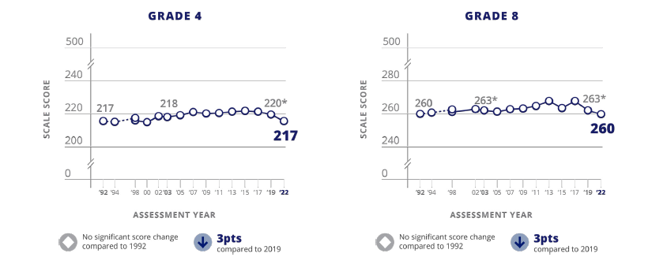

FIGURE | Trend in fourth- and eighth-grade mathematics average scores
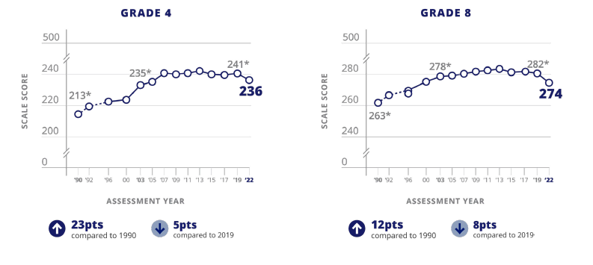

More About NAEP
To learn about upcoming NAEP assessments, download NAEP reports, and access sample questions, visit https://nces.ed.gov/nationsreportcard. Explore the latest NAEP results at https://nationsreportcard.gov.

Learn what NAEP means for schools that are selected to participate and get the latest NAEP news in Measure Up: NAEP News for the School Community, available online at https://nces.ed.gov/nationsreportcard/about/schools.aspx.

To hear teachers share their thoughts about why NAEP results are important, view the video Introducing NAEP to Teachers at https://nces.ed.gov/nationsreportcard/participating/schools.aspx.

To find your NAEP state coordinator’s contact information, visit https://nces.ed.gov/nationsreportcard/states and select your state or jurisdiction from the drop-down menu.

For additional assistance, call the NAEP help desk at 800-283-6237.

“The NAEP team that arrived at our school made the assessment process painless. Everyone on the team previously worked as an educator and interacted well with all of our students.”
—Kimberly Wilborn, Guidance Counselor, Sandburg Middle School, Fairfax County Public Schools, Alexandria, Virginia

The National Center for Education Statistics (NCES) conducts the National Assessment of Educational Progress to evaluate federally supported education programs. All of the information you provide may only be used for the purposes of research, statistics, and evaluation under the Education Sciences Reform Act of 2002 (ESRA; 20 U.S.C. § 9543) and may not be disclosed, our used, in identifiable form for any other purpose except as required by law. Every NCES employee as well as every NCES agent, such as contractors and NAEP coordinators, has taken an oath and is subject to a jail term of up to 5 years, a fine of $250,000, or both if he or she willfully discloses ANY identifiable information about you. Electronic submission of your information will be monitored for viruses, malware, and other threats by Federal employees and contractors in accordance with the Cybersecurity Enhancement Act of 2015.

This publication was prepared for the National Assessment of Educational Progress by Manhattan Strategy Group under contract 91990018C0001 to the National Center for Education Statistics,
U.S. Department of Education.

Find us on: <Facebook> <X> <YouTube> <LinkedIn> <Instagram>

Appendix D-81: NAEP 2025 Facts for Teachers, Puerto Rico

Prueba de campo de NAEP de 2025
Información para maestros
¿Qué es NAEP?
La Evaluación Nacional del Progreso Educativo (NAEP, por sus siglas en inglés) es una medida integral del progreso educativo a lo largo del tiempo. Es la evaluación continua y nacionalmente representativa más grande que mide lo que los estudiantes de nuestro país saben y pueden hacer en diferentes materias, tales como educación cívica, matemáticas, lectura, ciencias, tecnología e ingeniería, historia de Estados Unidos y escritura. El programa también proporciona información valiosa sobre las experiencias educativas de los estudiantes y las oportunidades de aprendizaje dentro y fuera del salón de clases. Los funcionarios electos, los legisladores y los educadores usan los resultados de NAEP para desarrollar maneras de mejorar la educación.
NAEP es un programa autorizado por el Congreso y administrado por el Centro Nacional para Estadísticas de la Educación (NCES, por sus siglas en inglés), parte del Departamento de Educación de Estados Unidos y el Instituto de Ciencias de la Educación.
¿Qué evaluaciones de NAEP se administrarán en 2025?
Como parte del programa de NAEP de 2025, NCES administrará una prueba de campo de matemáticas para los grados 4 y 8 en Puerto Rico, entre el 27 de enero y el 7 de marzo de 2025. Esta prueba de campo forma parte del plan de transición de NCES hacia el uso de dispositivos e Internet gestionados por las escuelas o los distritos para la administración de NAEP, con lo que se pretende mejorar la experiencia de evaluación para las escuelas y los estudiantes.
En definitiva, NCES está trabajando para conseguir una administración de la evaluación flexible y auténtica. El objetivo es hacer que el modelo de administración de NAEP sea más eficiente y poder administrar la evaluación en dispositivos (p. ej., computadoras de escritorio, computadoras portátiles, tabletas con teclado) con los que los estudiantes estén más familiarizados en la escuela y en casa.
Los datos de rendimiento de la prueba de campo no se darán a conocer públicamente, pero se utilizarán para orientar las futuras evaluaciones de NAEP.
“Como maestra, mi objetivo constante es ayudar a los estudiantes a progresar en el salón de clase. NAEP ayuda con esta misión al crear una medida común del rendimiento de los estudiantes en todo el país." - Iris García, maestra, Biscayne Elementary Community School, Miami Beach, Florida
¿Qué pueden esperar los maestros y los estudiantes?
Los estudiantes participantes completarán:
- Preguntas de matemáticas
- Cuestionarios de contexto que proporcionan información valiosa sobre sus experiencias educativas y oportunidades de aprendizaje dentro y fuera del salón de clase

A los estudiantes les toma aproximadamente 2 horas completar la evaluación, incluyendo el tiempo de transición, las instrucciones y el tiempo que toma contestar un cuestionario de contexto. Se ofrece una amplia gama de acomodos para los estudiantes con impedimentos y para aprendices del español.
No es necesario que los maestros preparen a los estudiantes para la prueba de campo, pero sí deben motivarlos a que hagan su mejor esfuerzo.
¿Quién administrará NAEP?
El personal de NAEP administrará la evaluación y proporcionará un importante apoyo a las escuelas el día de la evaluación. Los representantes de NAEP se comunicarán con su escuela para proporcionarle información adicional.
¿Cómo se seleccionan las escuelas y los estudiantes para NAEP?
Las escuelas son seleccionadas como parte de un proceso de muestreo cuidadosamente diseñado que garantiza que las escuelas y los estudiantes seleccionados para NAEP representan a todas las escuelas y estudiantes en Puerto Rico y en Estados Unidos.
¿En qué se diferencia NAEP de nuestra evaluación estatal?
NAEP cumple una función diferente a la de las evaluaciones estatales. Si bien cada estado tiene su propia y única evaluación, con diferentes estándares de contenido, la misma evaluación NAEP se administra en todos los estados, proporcionando una medida común de los logros de los estudiantes.
NAEP y los maestros
¿De qué manera los maestros son aliados fundamentales para NAEP?
Las escuelas y los estudiantes seleccionados para participar en NAEP representan a las escuelas y a los estudiantes de todo el país. Los maestros contribuyen de manera importante al motivar a sus estudiantes a que participen y que hagan su mejor esfuerzo; esto contribuye a garantizar que los resultados de NAEP proporcionen la medida más exacta posible del rendimiento de los estudiantes de todo el país. Para más información acerca de NAEP y para ver las Preguntas Frecuentes para maestros (en inglés), visite la página https://nces.ed.gov/nationsreportcard/educators/.
¿Por qué se les pide a los estudiantes que completen los cuestionarios de contexto?
Además de las preguntas sobre la materia, a los estudiantes que participan en NAEP se les pide que completen un cuestionario de contexto. Los resultados del cuestionario ayudan a contextualizar los resultados del rendimiento de los estudiantes, permiten una comparación significativa entre grupos de estudiantes y ofrecen información importante para que los educadores, legisladores e investigadores comprendan mejor las experiencias educativas de los estudiantes en Estados Unidos.
Para más información sobre los cuestionarios de contexto de NAEP y para ver los cuestionarios de estudiantes, maestros y escuelas de años anteriores (en inglés), visite la página
https://nces.ed.gov/nationsreportcard/survey_questionnaires.aspx.

¿Cómo pueden los maestros usar los recursos y los datos de NAEP para ayudar a los estudiantes?
Puede usar la herramienta NAEP Questions Tool (https://nces.ed.gov/nationsreportcard/nqt) para ver las preguntas de NAEP publicadas y para crear evaluaciones personalizadas para su salón de clases. Puede comparar el rendimiento de sus estudiantes con el de otros estudiantes en su estado y en todo el país. Los maestros, estudiantes y padres de familia pueden acceder a la información y comparar los resultados de varios grupos demográficos. La mayoría de las preguntas publicadas incluyen una guía de puntuación, ejemplos de respuestas de los estudiantes e información sobre el rendimiento (en inglés).
El explorador de datos, NAEP Data Explorer, (https://www.nationsreportcard.gov/ndecore) es una poderosa herramienta que permite examinar las relaciones entre el rendimiento de los estudiantes y factores tales como las prácticas de enseñanza y los recursos escolares, entre otros (en inglés).
¿De qué manera los paneles de control en línea de NAEP ayudan a los maestros a explorar los resultados de la evaluación y más?
El Panel de Control de Disparidad en el Rendimiento les permite a los usuarios explorar disparidades en los logros que revelan diferencias significativas en las puntuaciones de las evaluaciones entre dos grupos de estudiantes (p. ej., entre estudiantes hombres y mujeres o entre estudiantes blancos y afroamericanos). Puede también revisar los resultados nacionales más recientes en todas las materias de NAEP y las experiencias educativas de los estudiantes según el tipo de escuela a través del nuevo Panel de Control de Escuelas Públicas, Privadas y Semiautónomas (Charter).
Vea el Panel de Control de Disparidad en el Rendimiento (en inglés) en la página
https://www.nationsreportcard.gov/dashboards/achievement_gaps.aspx.
El Panel de Control de escuelas públicas, privadas y Semiautónomas (Charter) (en inglés) está disponible en
https://www.nationsreportcard.gov/dashboards/schools_dashboard.aspx.
El Panel de Pulso Escolar (https://ies.ed.gov/schoolsurvey/spp/) es un estudio que recopila información sobre el impacto de la pandemia de COVID-19 (es decir, el modo de aprendizaje, el personal de la escuela o la cadena de suministros) de una muestra nacional de escuelas públicas de educación elemental, intermedia, superior y combinada.
¿Desde cuándo existe NAEP?
NAEP se administró por primera vez en 1969 para medir el rendimiento de los estudiantes a nivel nacional. En 1990, NAEP se administró por primera vez a nivel estatal. El programa TUDA de NAEP, que mide el rendimiento de los estudiantes en algunos de los grandes distritos urbanos del país, comenzó en 2002. NAEP es reconocida como el estándar de oro de las evaluaciones a gran escala debido a su alta calidad técnica y a su riguroso diseño y metodología.
Los resultados de NAEP
Los resultados de NAEP se publican en un informe llamado la Libreta de Calificaciones de la Nación. Dependiendo de la evaluación, los resultados de NAEP están disponibles para la nación, los estados y determinados distritos urbanos que participan en TUDA. También hay resultados disponibles para diferentes grupos de estudiantes con base en factores como la raza/grupo étnico, el género y la ubicación de la escuela, entre otros. NAEP no está diseñada para recopilar o informar los resultados individuales de estudiantes, salones de clase o escuelas. En una escuela, solamente algunos de los estudiantes participan y sus respuestas se combinan con las de otros estudiantes participantes para producir los resultados.
Puede acceder a datos de evaluaciones anteriores (en inglés) en la página
https://nces.ed.gov/nationsreportcard/naepdata y explorar los resultados más recientes https://www.nationsreportcard.gov/.
En Puerto Rico, los estudiantes de 4.° y 8.° grado están programados para ser evaluados en matemáticas cada dos años. Conforme a la Ley de Educación Primaria y Secundaria, los distritos y estados que reciben financiación del Título I deben participar en estas evaluaciones cada dos años.
Resultados recientes de NAEP
Los resultados de las evaluaciones de NAEP se dan a conocer a medida que están disponibles, tras una puntuación y un análisis exhaustivos. Los resultados principales de NAEP de 2022 se publicaron en octubre de 2022 y están disponibles en https://nces.ed.gov/nationsreportcard/.
Más información sobre NAEP
Para más información sobre las próximas evaluaciones de NAEP, descargar informes y acceder a ejemplos de preguntas, visite https://nces.ed.gov/nationsreportcard/puertorico/. Explore los resultados de NAEP en https://nationsreportcard.gov.
Conozca lo que NAEP significa para las escuelas que son seleccionadas para participar y entérese de las últimas novedades de NAEP en Medición: Novedades de NAEP para la Comunidad Escolar, disponible en línea en https://nces.ed.gov/nationsreportcard/about/schools.aspx.
Para escuchar lo que piensan los maestros sobre por qué son importantes los resultados de NAEP, vea el video Introducing NAEP to Teachers (en inglés) visitando la página https://nces.ed.gov/nationsreportcard/participating/schools.aspx.
Para encontrar información de contacto del Coordinador Estatal de NAEP (en inglés), visite https://nces.ed.gov/nationsreportcard/states y seleccione su estado o jurisdicción en el menú desplegable.
Si necesita ayuda adicional, llame al Centro de Ayuda de NAEP (Help Desk) al 800-283-6237.
“El equipo de NAEP que vino a nuestra escuela hizo que el proceso de evaluación fuera fácil. Todos los miembros del equipo habían sido educadores e interactuaron bien con todos nuestros estudiantes”.
—Kimberly Wilborn, Orientadora, Sandburg Middle School, Fairfax County Public Schools, Alexandria, Virginia
The National Center for Education Statistics (NCES) conducts the National Assessment of Educational Progress to evaluate federally supported education programs. All of the information you provide may only be used for the purposes of research, statistics, and evaluation under the Education Sciences Reform Act of 2002 (ESRA; 20 U.S.C. § 9543) and may not be disclosed, our used, in identifiable form for any other purpose except as required by law. Every NCES employee as well as every NCES agent, such as contractors and NAEP coordinators, has taken an oath and is subject to a jail term of up to 5 years, a fine of $250,000, or both if he or she willfully discloses ANY identifiable information about you. Electronic submission of your information will be monitored for viruses, malware, and other threats by Federal employees and contractors in accordance with the Cybersecurity Enhancement Act of 2015.
Esta publicación fue preparada para la Evaluación Nacional del Progreso Educativo por Manhattan Strategy Group bajo el contrato 91990018C0001 para el Centro Nacional de Estadísticas de la Educación, Departamento de Educación de Estados Unidos.
Encuéntrenos en: <Facebook> <X> <YouTube> <LinkedIn> <Instagram>

Appendix D-82: NAEP 2025 Preassessment Responsibilities Guide, School Device Model

2025 Field Test Preassessment Responsibilities Guide (School Device)
Thank you for your support of the National Assessment of Educational Progress (NAEP). We look forward to working with you to make NAEP a positive experience at your school. The Assessment Management System (AMS) will be your primary resource for completing assessment planning tasks online for the upcoming assessment.
This guide outlines tasks you will complete along with available resources to make assessment day successful.
NAEP Activity Timeline
December–January:
- Complete Preassessment Activities
January–February:
- Add New Students
- Assessment Planning Meeting (APM) with NAEP representative
Within 10 school days before the assessment:
- Notify Parents and Guardians
- Support Assessment Activities
- Monitor Device Readiness Checks are Completed
January 27–March 7:
- NAEP 2025 Assessment Window
After the assessment:
- Wrap Up
You will need to complete the following activities:
- Complete Preassessment Activities
When the student sample is released in December, the following preassessment activities should be completed in the AMS.
  - Schedule Assessment Planning Meeting
    - An assigned NAEP representative, responsible for administering the assessment, will contact you in December to introduce themselves and monitor the scheduling of a virtual APM. School coordinators will select a date and time (1-hour block) to schedule their APM in the AMS. The NAEP representative can review how to complete the planning tasks outlined below upon request.
  - Provide Student Information
    - Review the student sample and identify any students who cannot take the assessment. Review demographic information and update any information that is missing or inaccurate.
    - Provide information about students with disabilities (SD) and English learners (EL) so that assessment administrators can plan appropriate testing accommodations.
      - You can invite your school’s SD and EL specialists to the AMS so that they can assist with this task.
      - Please note that school staff may need to assist with certain accommodations (e.g., cueing to stay on task, scribe). You will need to provide the contact information for the school staff that will assist with these accommodations.
  - Assessment Logistics
    - Schedule the assessment groups and reserve space at your school.
    - Students can either be assessed in two sequential sessions of up to 25 students each or all students at one time in one or two locations.
    - School staff presence in the assessment location is encouraged to help support classroom management.
    - If you select the option to assess all students at the same time in one or two locations, school staff presence is required at each location.
    - Assessment day details need to be entered via the Assessment Logistics section in the AMS, including
      - location(s) and start time(s) of the assessment, and
      - how students and teachers will be notified.
  - Technical Logistics
    - Provide details about assessing on school devices and run a network check to confirm your school Wi-Fi meets minimum requirements and required URLs have been safelisted.
    - Record how the school devices and assessment location will be set up for the NAEP assessment.
    - Identify a school staff member to provide technical support on assessment day.
  - Manage Questionnaires
    - Identify respondents and provide contact information for the school and teacher questionnaires.
    - Match students to the subject-specific teacher in the AMS.
    - Monitor the completion of the questionnaires by school staff.
    - Distribute information about NAEP to teachers.
- Add New Students
- To ensure all students have a chance to be selected for NAEP, you will be asked to update the student list in January (before the Assessment Planning Meeting) by adding any new students who have enrolled since the fall. A random sample will be drawn from this group of newly added students to be included in the assessment.
  - You can invite an additional staff member to register for the AMS as your school’s data specialist to assist.
- You will need to provide student information, manage questionnaires, and notify the parents/guardians of any newly added students after completing the Add New Students process.
- Attend Assessment Planning Meeting (APM)
- Participate in a 1-hour virtual planning meeting with your NAEP representative to review and confirm the information entered into the AMS.
  - An additional meeting can be scheduled with a technology coordinator to review and confirm technical logistics, if needed.
- Notify Parents and Guardians
- By law, parents/guardians of students selected to participate in NAEP must be notified in writing of their child’s selection prior to the administration of the assessment.
  - In the Notify Parents/Guardians section in the AMS, an electronic copy of the Parent/Guardian Notification Letter is available to download and distribute.
- Verify these notifications have been sent in the AMS.
- Support Assessment Day Activities
- Resources can be created and printed from the Support Assessment Day section in the AMS to remind teachers and students about the assessment.
  - Share the Teacher Notification Letter and List of Participating Students
  - Distribute the Student Appointment Cards
- Remind students to charge their devices and bring their headphones or earbuds on assessment day.
- Monitor Device Readiness Checks are Completed
- To ensure a smooth assessment experience in your school, it is important that each student device, including at least five spare devices, has the NAEP Assessment application installed and meets device requirements.
- A district or school staff member, who was identified and notified in November, will manage the installation of the NAEP Assessment application on identified devices for your school.
- In order, to complete the device readiness check, the NAEP Assessment application must be launched on each device and the verification code must be entered within 10 business days of the assessment date. The verification code and instructions for completing this check are available in the Technical Logistics section of the AMS.
  - School staff or students may complete this Device Readiness Check.
- Assessment Day Responsibilities
- A school or district staff member will need to be available on assessment day at the beginning of the assessment session in case any technical issues arise while launching the NAEP assessment on the school’s devices.
- A staff member’s presence throughout the assessment can have a positive impact on students’ motivation and performance. If assessing all students at the same time in one or two locations, the presence of a school staff member is required at each assessment location to help support classroom management.
- If less than 80 percent of the sampled students are assessed, a makeup session will be necessary, and the NAEP representative will schedule another date to administer the assessment to the absent students.
- If the assessment cannot take place due to technical issues, the NAEP representative will work with your school to reschedule the assessment.
- After the Assessment
- Destroy any hardcopy documents containing student names according to school protocol.
- Complete a short email survey on your experience with NAEP.
- Instructions for uninstalling the NAEP assessment application can be found at the eNAEP Download Center.
  - Please follow your school or district procedures for uninstalling applications on school devices.
If your AMS password has expired, you can request to reset your password by selecting “Forgot Password”. If you have any questions, please contact the NAEP help desk at 1-800-283-6237 or naephelp@westat.com.
Online Resources Information for selected schools
Information for Selected Schools | http://nces.ed.gov/nationsreportcard/participating/schools.aspx
Sample Questions Booklets | http://nces.ed.gov/nationsreportcard/about/booklets.aspx
NAEP Questions Tool | http://nces.ed.gov/nationsreportcard/nqt
Information for Parents and Guardians | http://nces.ed.gov/nationsreportcard/parents
Assessment Frameworks | https://www.nagb.gov/naep-frameworks/frameworks-overview.html
Digitally Based Assessments | https://nces.ed.gov/nationsreportcard/dba

For more information about NAEP, visit https://nces.ed.gov/nationsreportcard/.
Find us on: [Facebook, Twitter, and YouTube logos]
The National Center for Education Statistics (NCES) conducts the National Assessment of Educational Progress to evaluate federally supported education programs. All of the information you provide may only be used for the purposes of research, statistics, and evaluation under the Education Sciences Reform Act of 2002 (ESRA; 20 U.S.C. § 9543) and may not be disclosed, our used, in identifiable form for any other purpose except as required by law. Every NCES employee as well as every NCES agent, such as contractors and NAEP coordinators, has taken an oath and is subject to a jail term of up to 5 years, a fine of $250,000, or both if he or she willfully discloses ANY identifiable information about you. Electronic submission of your information will be monitored for viruses, malware, and other threats by Federal employees and contractors in accordance with the Cybersecurity Enhancement Act of 2015.

Appendix D-83: NAEP 2025 Preassessment Responsibilities Guide, School Device Model, Puerto Rico

Guía de responsabilidades de preevaluación para la prueba de campo de NAEP 2025 (Dispositivo de la escuela)
Gracias por apoyar la Evaluación Nacional del Progreso Educativo (NAEP, por sus siglas en inglés). Esperamos trabajar con usted para hacer de NAEP una experiencia positiva en su escuela. El Sistema de Administración de la Evaluación (AMS) será su principal recurso para completar las tareas de planificación en línea para la próxima evaluación.
En esta guía se describen las tareas que deberá realizar y los recursos disponibles para que el día de la evaluación sea un éxito.
Calendario de actividades de NAEP
Diciembre - Enero:
- Completar las actividades de preevaluación
Enero - Febrero:
- Añadir estudiantes nuevos
- Reunión de planificación para la evaluación con el(la) representante de NAEP
En los 10 días lectivos antes de la evaluación:
- Notificar a los padres, madres o tutores
- Apoyar las actividades de la evaluación
- Supervisar que se han completado las verificaciones de disponibilidad del dispositivo
Del 27 de enero al 7 de marzo:
- Periodo de la evaluación de NAEP 2025
Después de la evaluación:
- Finalización
Deberá completar las siguientes actividades:
- Completar las actividades de preevaluación
Cuando se dé a conocer la muestra de estudiantes en diciembre, deberán completarse las siguientes actividades de preevaluación en el AMS:
  - Programar la reunión de planificación para la evaluación (APM)
    - Un representante asignado de NAEP, responsable de administrar la evaluación, se comunicará con usted para presentarse y supervisar la programación de una reunión de planificación para la evaluación (APM) de manera virtual. Los coordinadores escolares seleccionarán una fecha y hora (bloque de 1 hora) para programar su APM en el AMS. Si se solicita, el miembro del personal de campo de NAEP puede repasar cómo completar las tareas de planificación que se describen a continuación.
  - Proporcionar información sobre los estudiantes
    - Revise la muestra de estudiantes e identifique a aquellos que no pueden realizar la evaluación. Revise la información demográfica y actualice cualquier dato que falte o que no sea correcto.
    - Proporcione información sobre los estudiantes con impedimentos (EI) y los estudiantes aprendices del español (AE) para que los administradores de las evaluaciones puedan planificar los acomodos adecuados para las evaluaciones.
      - Puede invitar a los especialistas en EI y AE de su escuela al AMS para que le ayuden con esta tarea.
      - Tenga en cuenta que es posible que el personal de la escuela tenga que ayudar con determinados acomodos (p. ej., señas para que se mantengan enfocados, escribiente). Deberá facilitar la información de contacto del personal de la escuela que le ayudará con estos acomodos.
  - Logística de la evaluación
    - Programe los grupos para la evaluación y reserve espacio en su escuela.
    - Se recomienda la presencia del personal de la escuela en el lugar de la evaluación para ayudar a administrar el salón de clase.
    - Si selecciona la opción de evaluar a todos los estudiantes al mismo tiempo en uno o dos lugares, se requiere la presencia de personal de la escuela en cada lugar.
    - Los detalles del día de la evaluación deben ser compartidos a través de la sección Logística de la evaluación en el AMS, incluyendo:
      - el(los) lugar(es) y la(s) hora(s) de inicio de la evaluación, y
      - cómo se notificará a los estudiantes y maestros.
  - Logística técnica
    - Proporcione detalles sobre la evaluación con los dispositivos de la escuela y realice una verificación de la red para confirmar que el WiFi de su escuela cumple con los requisitos mínimos y que los URL requeridos están en la lista segura.
    - Registre cómo se configurarán los dispositivos de la escuela y el lugar de la evaluación para la evaluación de NAEP.
    - Identifique a un miembro del personal de la escuela que proporcionará asistencia técnica el día de la evaluación.
  - Administrar cuestionarios
    - Identifique a los encuestados y facilite información de contacto para los cuestionarios de las escuelas y los maestros.
    - Asigne a los estudiantes con el maestro de la asignatura específica en el AMS.
    - Supervise la cumplimentación de los cuestionarios por parte del personal escolar.
    - Distribuya información sobre NAEP entre los maestros.
- Añadir estudiantes nuevos
- Para garantizar que todos los estudiantes tengan la oportunidad de ser seleccionados para NAEP, se le pedirá que actualice la lista de estudiantes en enero (antes de la reunión de planificación para la evaluación) añadiendo a los estudiantes nuevos que se hayan matriculado desde el otoño. Se obtendrá una muestra aleatoria de este grupo de estudiantes recién añadidos para que participen en la evaluación.
  - Puede invitar a otro miembro del personal para que se registre en el AMS como especialista en datos de su escuela para que le ayude.
- Deberá proporcionar la información de los estudiantes, administrar los cuestionarios y notificar a los padres, madres o tutores de los estudiantes recién añadidos después de completar el proceso de Añadir estudiantes nuevos.
- Asistir a la reunión de planificación para la evaluación (APM)
- Participe en una reunión virtual de planificación de 1 hora con su representante de NAEP para revisar y confirmar la información de la evaluación compartida en el AMS.
- Notificar a los padres, madres y tutores
- Por ley, los padres/tutores de los estudiantes seleccionados para participar en NAEP deben ser notificados por escrito sobre la selección de su hijo(a) antes de la administración de la evaluación.
  - En la sección Notificar a los padres, madres o tutores del AMS, se puede descargar y distribuir una copia electrónica de la carta de notificación a los padres/tutores.
- Verifique en el AMS que estas notificaciones se han enviado.
- Apoyar las actividades del día de la evaluación
- Se pueden crear e imprimir recursos desde la sección Apoyar el día de la evaluación en el AMS para recordarle a los maestros y a los estudiantes sobre la evaluación.
  - Comparta la carta de notificación para maestros y la lista de estudiantes participantes
  - Distribuya las tarjetas de recordatorio para los estudiantes
- Recuérdeles a los estudiantes que carguen sus dispositivos y traigan sus audífonos el día de la evaluación.
- Supervisar que se completen las verificaciones de disponibilidad de los dispositivos
- Para asegurar una experiencia de evaluación sin problemas en su escuela, es importante que el dispositivo de cada estudiante, incluyendo al menos cinco dispositivos de repuesto, tenga instalada la aplicación de evaluación de NAEP y cumpla con los requisitos del dispositivo.
- Un miembro del personal del distrito o de la escuela, que fue identificado y notificado en noviembre, se encargará de gestionar la instalación de la aplicación de evaluación de NAEP en los dispositivos identificados para su escuela.
- Para completar la verificación de disponibilidad del dispositivo, la aplicación de evaluación de NAEP debe iniciarse en cada dispositivo y el código de verificación debe ingresarse dentro de los 10 días hábiles antes de la fecha de la evaluación. El código de verificación y las instrucciones para completar esta verificación están disponibles en la sección de Logística Técnica del AMS.
  - El personal de la escuela o los estudiantes pueden completar esta verificación de disponibilidad del dispositivo.
- Responsabilidades el día de la evaluación
- Un miembro del personal de la escuela o del distrito deberá estar disponible el día de la evaluación al comienzo de la sesión por si surge algún problema técnico al iniciar la evaluación NAEP en los dispositivos de la escuela.
- La presencia de un miembro del personal durante la evaluación puede tener un impacto positivo en la motivación y el desempeño de los estudiantes. Si se evalúan todos los estudiantes al mismo tiempo en uno o dos lugares, se requiere la presencia de un miembro del personal de la escuela en cada lugar de evaluación para ayudar a administrar el salón de clase.
- Si la asistencia de los estudiantes de la muestra es inferior al 80 %, será necesaria una sesión de reposición y el(la) representante de NAEP programará otra fecha para administrar la evaluación a los estudiantes ausentes.
- Si la evaluación no puede llevarse a cabo debido a problemas técnicos, el(la) representante de NAEP trabajará con su escuela para reprogramar la evaluación.
- Después de la evaluación
- Destruya cualquier documento impreso que contenga nombres de estudiantes de acuerdo con el protocolo de la escuela.
- Complete una breve encuesta por correo electrónico sobre su experiencia con NAEP.
- Las instrucciones para desinstalar la aplicación de evaluación de NAEP se encuentran en el Centro de descargas de eNAEP.
  - Siga los procedimientos de su escuela o distrito para desinstalar aplicaciones en los dispositivos de la escuela.

Si su contraseña para el AMS ha expirado, puede restablecerla seleccionando "Olvidé la contraseña". Si tiene alguna pregunta, comuníquese con la oficina de ayuda de NAEP (Help Desk) llamando al 1-800-283-6237 o escribiendo a naephelp@westat.com.
Recursos en línea Información para las escuelas seleccionadas
Información para las escuelas seleccionadas (en inglés) | http://nces.ed.gov/nationsreportcard/participating/schools.aspx
Vídeo introductorio de NAEP para los maestros (en inglés) | https://youtu.be/zR1_pUdSlFg
Cuadernos de ejemplos de preguntas | http://nces.ed.gov/nationsreportcard/about/booklets.aspx
Herramienta de preguntas de NAEP (en inglés) | http://nces.ed.gov/nationsreportcard/nqt
Información para los padres, madres y tutores | http://nces.ed.gov/nationsreportcard/parents
Marcos de la evaluación (en inglés) | https://www.nagb.gov/naep-frameworks/frameworks-overview.html
Evaluaciones digitales (en inglés) | https://nces.ed.gov/nationsreportcard/dba

Para más información sobre NAEP, visite https://nces.ed.gov/nationsreportcard/.
Encuéntrenos en: [Facebook logo, Twitter logo y YouTube logo].

The National Center for Education Statistics (NCES) conducts the National Assessment of Educational Progress to evaluate federally supported education programs. All of the information you provide may only be used for the purposes of research, statistics, and evaluation under the Education Sciences Reform Act of 2002 (ESRA; 20 U.S.C. § 9543) and may not be disclosed, our used, in identifiable form for any other purpose except as required by law. Every NCES employee as well as every NCES agent, such as contractors and NAEP coordinators, has taken an oath and is subject to a jail term of up to 5 years, a fine of $250,000, or both if he or she willfully discloses ANY identifiable information about you. Electronic submission of your information will be monitored for viruses, malware, and other threats by Federal employees and contractors in accordance with the Cybersecurity Enhancement Act of 2015.

Appendix D-84: NAEP 2025 Preassessment Responsibilities Guide, NAEP Device Model

2025 Field Test Preassessment Responsibilities Guide (NAEP Device)
Thank you for your support of the National Assessment of Educational Progress (NAEP). We look forward to working with you to make NAEP a positive experience at your school. The Assessment Management System (AMS) will be your primary resource for completing assessment planning tasks online for the upcoming assessment.
This guide outlines tasks you will complete along with available resources to make assessment day successful.
NAEP Activity Timeline
December – January:
- Complete Preassessment Activities
January – February:
- Add New Students
- Assessment Planning Meeting with NAEP representative
Within 10 school days before the assessment:
- Notify Parents and Guardians
- Support Assessment Activities
January 27 – March 7:
- NAEP 2025 Assessment Window
After the assessment:
- Wrap Up
You will need to complete the following activities:
- Complete Preassessment Activities
When the student sample is released in December, the following preassessment activities should be completed in the AMS:
  - Schedule Assessment Planning Meeting (APM)
    - An assigned NAEP representative, responsible for administering the assessment, will contact you in December to introduce themselves and coordinate the scheduling of a virtual Assessment Planning Meeting (APM). School coordinators will select a date and time (1-hour block) to schedule their APM in the AMS. The NAEP representative can review how to complete their planning tasks outlined below upon request.
  - Provide Student Information
    - Review the student sample and identify any students who cannot take the assessment. Review demographic information and update any information that is missing or inaccurate.
    - Provide information about students with disabilities (SD) and English learners (EL) so that assessment administrators can plan appropriate testing accommodations.
      - You can invite your school’s SD and EL specialists to the AMS so that they can assist with this task.
      - Please note that school staff may need to assist with certain accommodations (e.g., cueing to stay on task, scribe). You will need to provide the contact information for the school staff that will assist with these accommodations.
  - Assessment Logistics
    - Schedule the assessment groups and reserve space at your school. (Please select a location on the first floor, or one that is accessible by elevator.)
    - Assessment day details, including the location(s) and start time(s) of the assessment, and how students and teachers will be notified, need to be entered via the Assessment Logistics section in the AMS.
  - Manage Questionnaires
    - Identify respondents and provide contact information for the school and teacher questionnaires.
    - Match students to the subject-specific teacher in the AMS.
    - Monitor the completion of the questionnaires by school staff.
    - Distribute information about NAEP to teachers.
- Add New Students (Before Assessment Planning Meeting)
- To ensure all students have a chance to be selected for NAEP, you will be asked to update the student list in January by adding any new students who have enrolled since the fall. NAEP will draw a random sample from this group of newly added students.
  - You can assign an additional staff member to serve as your school’s data specialist so that they can assist with this task.
- You will need to provide student information, manage questionnaires, and notify the parents/guardians of any newly added students after completing the Add New Students process.
- Attend Assessment Planning Meeting (APM)
- The school coordinator will participate in a 1-hour virtual planning meeting with their NAEP representative student information, as well as to review and confirm assessment details entered into the AMS.
- Notify Parents and Guardians
- By law, parents/guardians of students selected to participate in NAEP must be notified in writing of their child’s selection prior to the administration of the assessment.
  - In the Notify Parents/Guardians section in the AMS, an electronic copy of the Parent/Guardian Notification Letter is available to download and distribute.
- Verify these notifications have been sent in the AMS.
- Support Assessment Day Activities.
- Resources can be created and printed from the Support Assessment Day section in the AMS to remind teachers and students about the assessment.
  - Share the Teacher Notification Letter and List of Participating Students
  - Distribute the Student Appointment Cards
- Assessment Day Responsibilities
- The school coordinator and the teachers of selected students are encouraged to remain in the room during the assessment. A school staff member is appreciated and can positively impact students’ motivation and performance.
- If the attendance of sampled students is less than 80 percent, a makeup session will be necessary, and the NAEP representative will schedule another date to administer the assessment to the absent students.
- After the Assessment
- Destroy any hardcopy documents containing student names according to school protocol.
- Complete a short email survey on your experience with NAEP.

If your AMS password has expired, you can request to reset by clicking on “Learn more about how to log in.” If you have any questions, please contact the NAEP help desk at 1-888-499-6237 or naephelp@westat.com.
Online Resources Information for selected schools
Information for selected schools | http://nces.ed.gov/nationsreportcard/participating/schools.aspx
Introducing NAEP to Teachers video | https://youtu.be/zR1_pUdSlFg
Introducing NAEP to Students video | https://youtu.be/8drjkhe0iQU
Sample Questions booklets | http://nces.ed.gov/nationsreportcard/about/booklets.aspx
NAEP Questions Tool | http://nces.ed.gov/nationsreportcard/nqt
Information for parents | http://nces.ed.gov/nationsreportcard/parents
Assessment frameworks | https://www.nagb.gov/naep-frameworks/frameworks-overview.html
Digitally Based Assessments | https://nces.ed.gov/nationsreportcard/dba

For more information about NAEP, visit https://nces.ed.gov/nationsreportcard/.
Find us on: [Facebook, Twitter, and YouTube logos]

The National Center for Education Statistics (NCES) conducts the National Assessment of Educational Progress to evaluate federally supported education programs. All of the information you provide may only be used for the purposes of research, statistics, and evaluation under the Education Sciences Reform Act of 2002 (ESRA; 20 U.S.C. § 9543) and may not be disclosed, our used, in identifiable form for any other purpose except as required by law. Every NCES employee as well as every NCES agent, such as contractors and NAEP coordinators, has taken an oath and is subject to a jail term of up to 5 years, a fine of $250,000, or both if he or she willfully discloses ANY identifiable information about you. Electronic submission of your information will be monitored for viruses, malware, and other threats by Federal employees and contractors in accordance with the Cybersecurity Enhancement Act of 2015.

Appendix D-85: NAEP 2025 Preassessment Responsibilities Guide, NAEP Device Model, Puerto Rico

Guía de responsabilidades de preevaluación para la prueba de campo de NAEP 2025 (Dispositivo de NAEP)
Gracias por apoyar la Evaluación Nacional del Progreso Educativo (NAEP, por sus siglas en inglés). Esperamos trabajar con usted para hacer de NAEP una experiencia positiva en su escuela. El Sistema de Administración de la Evaluación (AMS) será su principal recurso para completar las tareas de planificación en línea para la próxima evaluación.
En esta guía se describen las tareas que deberá realizar y los recursos disponibles para que el día de la evaluación sea un éxito.
Calendario de actividades de NAEP
Diciembre - Enero:
- Completar las actividades de preevaluación
Enero - Febrero:
- Añadir estudiantes nuevos
- Reunión de planificación para la evaluación con el(la) representante de NAEP
En los 10 días lectivos antes de la evaluación:
- Notificar a los padres, madres o tutores
- Apoyar las actividades de la evaluación
Del 27 de enero al 7 de marzo:
- Periodo de la evaluación de NAEP 2025
Después de la evaluación:
- Finalización
Deberá completar las siguientes actividades:
- Completar las actividades de preevaluación
Cuando se dé a conocer la muestra de estudiantes en diciembre, deberán completarse las siguientes actividades de preevaluación en el AMS:
  - Programar la reunión de planificación para la evaluación (APM)
    - Un representante asignado de NAEP, responsable de administrar la evaluación, se comunicará con usted para presentarse y verificar la programación de una reunión de planificación para la evaluación (APM) de manera virtual. Los coordinadores escolares seleccionarán una fecha y hora (bloque de 1 hora) para programar su APM en el AMS. Si se solicita, el miembro del personal de campo de NAEP puede repasar cómo completar las tareas de planificación que se describen a continuación.
  - Proporcionar información sobre los estudiantes
    - Revise la muestra de estudiantes e identifique a aquellos que no pueden realizar la evaluación. Revise la información demográfica y actualice cualquier dato que falte o que no sea correcto.
    - Proporcione información sobre los estudiantes con impedimentos (EI) y los estudiantes aprendices del español (AE) para que los administradores de las evaluaciones puedan planificar los acomodos adecuados para las evaluaciones.
      - Puede invitar a los especialistas en EI y AE de su escuela al AMS para que le ayuden con esta tarea.
      - Tenga en cuenta que es posible que el personal de la escuela tenga que ayudar con determinados acomodos (p. ej., señas para que se mantengan enfocados, escribiente). Deberá facilitar la información de contacto del personal de la escuela que le ayudará con estos acomodos.
  - Logística de la evaluación
    - Programe los grupos para la evaluación y reserve espacio en su escuela (seleccione un lugar en la primera planta o al que se pueda acceder en ascensor).
    - Los detalles del día de la evaluación, incluidos el(los) lugar(es) y la(s) hora(s) de inicio de la evaluación, y cómo se notificará a los estudiantes y maestros, deben ser compartidos a través de la sección Logística de la evaluación en el AMS.
  - Administrar cuestionarios
    - Identifique a los encuestados y facilite información de contacto para los cuestionarios de las escuelas y los maestros.
    - Asigne a los estudiantes con el maestro de la asignatura específica en el AMS.
    - Supervise la cumplimentación de los cuestionarios por parte del personal escolar.
    - Distribuya información sobre NAEP entre los maestros.
- Añadir estudiantes nuevos (antes de la reunión de planificación para la evaluación)
- Para garantizar que todos los estudiantes tengan la oportunidad de ser seleccionados para NAEP, se le pedirá que actualice la lista de estudiantes en enero añadiendo a los estudiantes nuevos que se hayan matriculado desde el otoño. NAEP obtendrá una muestra aleatoria de este grupo de estudiantes recién añadidos.
  - Puede designar a otro miembro del personal como especialista en datos de su escuela para que le ayude en esta tarea.
- Deberá proporcionar la información de los estudiantes, administrar los cuestionarios y notificar a los padres, madres o tutores de los estudiantes recién añadidos después de completar el proceso de Añadir estudiantes nuevos.
- Asistir a la reunión de planificación para la evaluación (APM)
- El(la) coordinador(a) escolar participará en una reunión virtual de planificación de 1 hora con su representante de NAEP para revisar la información de los estudiantes y también para revisar y confirmar los detalles de la evaluación compartidos en el AMS.
- Notificar a los padres, madres y tutores
- Por ley, los padres/tutores de los estudiantes seleccionados para participar en NAEP deben ser notificados por escrito sobre la selección de su hijo(a) antes de la administración de la evaluación.
  - En la sección Notificar a los padres, madres o tutores del AMS, se puede descargar y distribuir una copia electrónica de la carta de notificación a los padres/tutores.
- Verifique en el AMS que estas notificaciones se han enviado.
- Apoyar las actividades del día de la evaluación
- Se pueden crear e imprimir recursos desde la sección Apoyar el día de la evaluación en el AMS para recordarle a los maestros y a los estudiantes sobre la evaluación.
  - Comparta la carta de notificación para maestros y la lista de estudiantes participantes
  - Distribuya las tarjetas de recordatorio para los estudiantes
- Responsabilidades el día de la evaluación
- Se recomienda que el(la) coordinador(a) escolar y los maestros de los estudiantes seleccionados permanezcan en el salón durante la evaluación. Se agradece la presencia de un miembro del personal de la escuela, que pueda impactar positivamente en la motivación y el rendimiento de los estudiantes.
- Si la asistencia de los estudiantes de la muestra es inferior al 80 %, será necesaria una sesión de reposición y el(la) representante de NAEP programará otra fecha para administrar la evaluación a los estudiantes ausentes.
- Después de la evaluación
- Destruya cualquier documento impreso que contenga nombres de estudiantes de acuerdo con el protocolo de la escuela.
- Complete una breve encuesta por correo electrónico sobre su experiencia con NAEP.

Si su contraseña para el AMS ha expirado, puede restablecerla seleccionando "Olvidé la contraseña". Si tiene alguna pregunta, comuníquese con la oficina de ayuda de NAEP (Help Desk) llamando al 1-800-283-6237 o escribiendo a naephelp@westat.com.
Recursos en línea Información para las escuelas seleccionadas
Información para las escuelas seleccionadas (en inglés) | http://nces.ed.gov/nationsreportcard/participating/schools.aspx
Vídeo introductorio de NAEP para los maestros (en inglés) | https://youtu.be/zR1_pUdSlFg
Vídeo introductorio de NAEP para los estudiantes (en inglés) | https://youtu.be/8drjkhe0iQU
Cuadernos de ejemplos de preguntas | http://nces.ed.gov/nationsreportcard/about/booklets.aspx
Herramienta de preguntas de NAEP (en inglés) | http://nces.ed.gov/nationsreportcard/nqt
Información para los padres, madres y tutores | http://nces.ed.gov/nationsreportcard/parents
Marcos de la evaluación (en inglés) | https://www.nagb.gov/naep-frameworks/frameworks-overview.html
Evaluaciones digitales (en inglés) | https://nces.ed.gov/nationsreportcard/dba

Para más información sobre NAEP, visite https://nces.ed.gov/nationsreportcard/.
Encuéntrenos en: [Facebook logo, Twitter logo y YouTube logo].

The National Center for Education Statistics (NCES) conducts the National Assessment of Educational Progress to evaluate federally supported education programs. All of the information you provide may only be used for the purposes of research, statistics, and evaluation under the Education Sciences Reform Act of 2002 (ESRA; 20 U.S.C. § 9543) and may not be disclosed, our used, in identifiable form for any other purpose except as required by law. Every NCES employee as well as every NCES agent, such as contractors and NAEP coordinators, has taken an oath and is subject to a jail term of up to 5 years, a fine of $250,000, or both if he or she willfully discloses ANY identifiable information about you. Electronic submission of your information will be monitored for viruses, malware, and other threats by Federal employees and contractors in accordance with the Cybersecurity Enhancement Act of 2015.

Appendix D-86: NAEP 2025 Assessment Date Notification and Preassessment Email, School Device Model

NAEP 2025 Assessment Date and Preassessment Notification (School Device)
NAEP STATE COORDINATOR TO
SCHOOL COORDINATOR
Red text should be customized before mail merge; [highlighted text] represents mail merge fields.
Save the date! NAEP is coming on [assessment date].

Dear [school coordinator name] and [technology coordinator name]:
Thank you for your support of NAEP. I look forward to working with you to coordinate NAEP in your school. The timeline below indicates when your school will need to complete specific assessment planning tasks.
- December–January:
    - Complete preassessment activities in the AMS
      - Review the list of selected students.
      - Provide student information and assessment logistics.
      - Provide details about assessing on school devices and run a network check to confirm your school Wi-Fi meets minimum requirements and required URLs have been safelisted.
      - If necessary, an additional school staff member can be identified as the technology coordinator to assist with these tasks.
- January–February:
  - Update the student list by adding any new students who have enrolled since the fall.
  - Attend a virtual Assessment Planning Meeting with NAEP representatives.
- Within 10 school days before the assessment:
- Notify parents and guardians of selected students,
- Print and share resources to support assessment activities,
- Monitor device readiness checks to confirm they are completed on the school devices that will be used for the assessment, and
- Remind students to charge their devices and bring their headphones or earbuds on assessment day.
- On Assessment Day: assessment date
    - A school or district staff member will need to be available on assessment day at the beginning of the assessment session in case any technical issues arise while launching the NAEP assessment on the school’s devices.
    - School staff presence in the assessment location is encouraged to help support classroom management. If you select the option to assess all students at the same time in one or two locations, school staff presence is required at each location.

I have provided more information about your responsibilities in the enclosed Preassessment Responsibilities Guide.

Thank you in advance for your cooperation and effort in helping to coordinate this important assessment.

If you have questions or a conflict with the scheduled assessment date, please contact me at telephone number or email address by date.

Sincerely,

NAEP State Coordinator

Enclosures/Attachments: Preassessment Responsibilities Guide

The National Center for Education Statistics (NCES) conducts the National Assessment of Educational Progress to evaluate federally supported education programs. All of the information you provide may only be used for the purposes of research, statistics, and evaluation under the Education Sciences Reform Act of 2002 (ESRA; 20 U.S.C. § 9543) and may not be disclosed, our used, in identifiable form for any other purpose except as required by law. Every NCES employee as well as every NCES agent, such as contractors and NAEP coordinators, has taken an oath and is subject to a jail term of up to 5 years, a fine of $250,000, or both if he or she willfully discloses ANY identifiable information about you. Electronic submission of your information will be monitored for viruses, malware, and other threats by Federal employees and contractors in accordance with the Cybersecurity Enhancement Act of 2015.
.

Appendix D-87: NAEP 2025 Assessment Date Notification and Preassessment Email, School Device Model, Puerto Rico

Fecha de la evaluación de NAEP 2025 y notificación de preevaluación (Dispositivo de la escuela)
DEL(DE LA) COORDINADOR(A) ESTATAL DE NAEP AL (A LA) COORDINADOR(A) ESCOLAR
Se debe personalizar el texto en rojo antes de combinar la correspondencia, el texto resaltado representa los campos que se deben combinar.

¡Reserve la fecha! NAEP tendrá lugar el [fecha de la evaluación].

Estimado(a) [nombre del(de la) coordinador(a) escolar] y [nombre del(de la) coordinador(a) de tecnología]:
Gracias por apoyar a NAEP. Espero trabajar con usted para coordinar NAEP en su escuela. El programa que figura a continuación indica cuándo deberá completar las tareas específicas de planificación para la evaluación.
- Diciembre - Enero:
    - Completar las actividades de preevaluación en el AMS
      - Revisar la lista de estudiantes seleccionados.
      - Proporcionar información sobre los estudiantes y la logística de la evaluación.
      - Proporcionar detalles sobre la evaluación en los dispositivos de la escuela y realizar una verificación de la red para confirmar que el WiFi de su escuela cumple con los requisitos mínimos y que los URL requeridos están en la lista segura.
        - De ser necesario, se puede designar a otro miembro del personal de la escuela como coordinador(a) de tecnología para que ayude con estas tareas.
- Enero - Febrero:
    - Actualizar la lista de estudiantes añadiendo los estudiantes nuevos que se hayan matriculado desde el otoño.
    - Asistir a una reunión virtual de planificación para la evaluación con representantes de NAEP.
- En los 10 días lectivos anteriores a la evaluación:
    - Notificar a los padres, madres o tutores de los estudiantes seleccionados;
    - imprimir y compartir recursos para apoyar las actividades de la evaluación;
    - supervisar las verificaciones de preparación de los dispositivos para confirmar que se han completado en los dispositivos de la escuela que se utilizarán para la evaluación, y
    - recordarles a los estudiantes que carguen sus dispositivos y que traigan sus audífonos el día de la evaluación.
- El día de la evaluación: [fecha de la evaluación]
    - Un miembro del personal de la escuela o del distrito deberá estar disponible el día de la evaluación al comienzo de la sesión de evaluación en caso de que surja algún problema técnico al iniciar la evaluación de NAEP en los dispositivos de la escuela.
    - Se recomienda la presencia de personal de la escuela en el lugar de la evaluación para ayudar a administrar el salón de clase. Si selecciona la opción de evaluar a todos los estudiantes al mismo tiempo en uno o dos lugares, se requiere la presencia de personal de la escuela en cada lugar.

He proporcionado más información sobre sus responsabilidades en la Guía de responsabilidades de preevaluación adjunta.

Gracias de antemano por su cooperación y esfuerzo para ayudar a coordinar esta importante evaluación.

Si tiene preguntas o un conflicto con la fecha de evaluación prevista, comuníquese conmigo llamando al número de teléfono o escribiendo a dirección de correo electrónico antes del fecha.

Atentamente,

Coordinador(a) estatal de NAEP

Adjuntos/Anexos: Guía de responsabilidades de preevaluación

The National Center for Education Statistics (NCES) conducts the National Assessment of Educational Progress to evaluate federally supported education programs. All of the information you provide may only be used for the purposes of research, statistics, and evaluation under the Education Sciences Reform Act of 2002 (ESRA; 20 U.S.C. § 9543) and may not be disclosed, our used, in identifiable form for any other purpose except as required by law. Every NCES employee as well as every NCES agent, such as contractors and NAEP coordinators, has taken an oath and is subject to a jail term of up to 5 years, a fine of $250,000, or both if he or she willfully discloses ANY identifiable information about you. Electronic submission of your information will be monitored for viruses, malware, and other threats by Federal employees and contractors in accordance with the Cybersecurity Enhancement Act of 2015.

Appendix D-88: NAEP 2025 Assessment Date Notification and Preassessment Email, NAEP Device Model

NAEP 2025 Assessment Date and Preassessment Notification (NAEP Device)
NAEP STATE COORDINATOR TO SCHOOL COORDINATOR
Red text should be customized before mail merge; [highlighted text] represents mail merge fields.
Save the date! NAEP is coming on [assessment date].

Dear [school coordinator name]:
Thank you for your support of NAEP. I look forward to working with you to coordinate NAEP in your school. The timeline below indicates when you will need to complete specific assessment planning tasks.
- December–January:
    - Provide preassessment information in the AMS.
    - Review the list of selected students.
    - Provide student information and assessment logistics.
- January–February:
    - Update the student list by adding any new students who have enrolled since the fall.
    - Attend a virtual Assessment Planning Meeting with NAEP representatives.
- Within 10 school days before the assessment:
    - Notify parents and guardians of selected students.
    - Print and share resources to support assessment activities.
- On Assessment Day: [assessment date]
    - School staff presence in the assessment location is encouraged to help support classroom management.
I have provided more information about your responsibilities in the enclosed Preassessment Responsibilities Guide.

Thank you in advance for your cooperation and effort in helping to coordinate this important assessment.

If you have questions or a conflict with the scheduled assessment date, please contact me at telephone number or email address by date.

Sincerely,

NAEP State Coordinator

Enclosures/Attachments: Preassessment Responsibilities Guide

The National Center for Education Statistics (NCES) conducts the National Assessment of Educational Progress to evaluate federally supported education programs. All of the information you provide may only be used for the purposes of research, statistics, and evaluation under the Education Sciences Reform Act of 2002 (ESRA; 20 U.S.C. § 9543) and may not be disclosed, our used, in identifiable form for any other purpose except as required by law. Every NCES employee as well as every NCES agent, such as contractors and NAEP coordinators, has taken an oath and is subject to a jail term of up to 5 years, a fine of $250,000, or both if he or she willfully discloses ANY identifiable information about you. Electronic submission of your information will be monitored for viruses, malware, and other threats by Federal employees and contractors in accordance with the Cybersecurity Enhancement Act of 2015.

Appendix D-89: NAEP 2025 Assessment Date Notification and Preassessment Email, NAEP Device Model, Puerto Rico

Fecha de la evaluación NAEP de 2025 y notificación de preevaluación (Dispositivo de NAEP)
DEL(DE LA) COORDINADOR(A) ESTATAL DE NAEP AL(A LA) COORDINADOR(A) ESCOLAR
Se debe personalizar el texto en rojo antes de combinar la correspondencia, el texto resaltado representa los campos que se deben combinar.

¡Reserve la fecha! NAEP tendrá lugar el [fecha de la evaluación].

Estimado(a) [nombre del(de la) coordinador(a) escolar]:
Gracias apoyar a NAEP. Espero trabajar con usted para coordinar NAEP en su escuela. El programa que figura a continuación indica cuándo deberá completar las tareas específicas de planificación para la evaluación.
- Diciembre - Enero: Proporcionar información de preevaluación en el AMS
    - Revisará la lista de estudiantes seleccionados y proporcionará información sobre los estudiantes y la logística de la evaluación.
- Enero - Febrero:
    - Actualizará la lista de estudiantes añadiendo a los estudiantes nuevos que se hayan matriculado desde el otoño.
    - Asistirá a una reunión virtual de planificación para la evaluación con representantes de NAEP.
- En los 10 días lectivos anteriores a la evaluación:
    - Notificará a los padres, madres o tutores de los estudiantes seleccionados, e
    - imprimirá y compartirá recursos para apoyar las actividades de la evaluación.
- El día de la evaluación: [fecha de la evaluación]
    - La presencia de un miembro del personal a lo largo de la evaluación puede tener un impacto positivo en la motivación y el rendimiento de los estudiantes. Se agradece la presencia de un miembro del personal de la escuela.

He proporcionado más información sobre sus responsabilidades en la Guía de responsabilidades de preevaluación adjunta.

Gracias de antemano por su cooperación y esfuerzo para ayudar a coordinar esta importante evaluación.

Si tiene preguntas o un conflicto con la fecha de evaluación prevista, comuníquese conmigo llamando al número de teléfono o escribiendo a dirección de correo electrónico antes del fecha.

Atentamente,

Coordinador(a) estatal de NAEP

Adjuntos/Anexos: Guía de responsabilidades de preevaluación

The National Center for Education Statistics (NCES) conducts the National Assessment of Educational Progress to evaluate federally supported education programs. All of the information you provide may only be used for the purposes of research, statistics, and evaluation under the Education Sciences Reform Act of 2002 (ESRA; 20 U.S.C. § 9543) and may not be disclosed, our used, in identifiable form for any other purpose except as required by law. Every NCES employee as well as every NCES agent, such as contractors and NAEP coordinators, has taken an oath and is subject to a jail term of up to 5 years, a fine of $250,000, or both if he or she willfully discloses ANY identifiable information about you. Electronic submission of your information will be monitored for viruses, malware, and other threats by Federal employees and contractors in accordance with the Cybersecurity Enhancement Act of 2015.

Appendix D-90: NAEP 2026 eNAEP Download Center Notification (NEW)

NAEP 2026 – eNAEP Download Center Notification
AUTO EMAIL TO SCHOOL OR DISTRICT APPLICATION INSTALLER
Highlighted text represents merge fields.

Subject: Instructions for School or District NAEP Assessment Application Installer
To: [Application Installer Email]

Dear [Application Installer Firstname] [Application Installer Lastname]:

Your school or district has been selected for the 2026 National Assessment of Educational Progress (NAEP). You have been identified as the person best suited to prepare the school devices (e.g., desktops, laptops, tablets with keyboards).

You can find important information at the eNAEP Download Center, including the following:
- detailed instructions on how to install and uninstall the NAEP Assessment application on one device or multiple devices operating on Windows or ChromeOS;
- specifications on what types of devices can be used for the NAEP assessment and other technical requirements; and
- tools that can be used to confirm the safe listing of provided NAEP assessment URLs or to conduct bandwidth checks.

In the fall, a school staff member will be identified as the school coordinator and will contact you regarding preparing school devices for the NAEP assessment.

Please complete the following activities by December 31, 2025.

- Prepare for NAEP Assessment Application Installation
Review the Getting Started and Technical Requirements tabs at the eNAEP Download Center for more detailed instructions.
  - Confirm whether safelisting is completed using the Safelist Check tool. The check must be run on the school network.
    - Safelist the NAEP URLs provided under the Getting Started tab if they are not already safelisted.
    - (Optional) Confirm the school can support the required bandwidth on the network that will be used for the NAEP assessment using the Bandwidth Check tool. School coordinators will also conduct a bandwidth check closer to the assessment, so you may skip this step if you do not anticipate problems with upload and download speeds.
  - Identify devices that will be used for the NAEP assessment. System requirements for these devices are available at the eNAEP Download Center under the Technical Requirements tab.
    - If you plan to install the application only on devices used by students who will take NAEP, please contact your NAEP State or TUDA Coordinator at their email, below, to register for the Assessment Management System so you can access a secure list of sampled students in December.

- Install and Verify the NAEP Assessment Application
The table below lists the schools that need the NAEP Assessment Application installed on school devices for the sampled grade level. Review the NAEP App Installation Instructions tab at the eNAEP Download Center for detailed instructions.
  - Deploy the NAEP Assessment Application to all school devices to be used on assessment day, and
  - Run a verification check by entering the eNAEP Verification Code from the table below on at least one of the devices to be used for the NAEP assessment.
    - Schools sharing devices are given the same eNAEP verification code, requiring just one verification check.
District Name | School name and grade  Grade | Shared Devices | eNAEP Verification Code
[District 1] | [School 1] , [Grade 1]  [School 2] , [Grade 2] | Y | [eNAEP Verification Code 1]
[District 2] | [School 3] , [Grade 3] | N | [eNAEP Verification Code 2]

- (Optional) Uninstall the NAEP Assessment Application
Once the NAEP assessment concludes, you may uninstall the NAEP Assessment application as directed by the detailed instructions found on the NAEP App Installation Instructions tab.

NAEP representatives will work with schools to complete a device readiness check on all devices students will use, including spares. This will ensure that on assessment day each device meets requirements and has the NAEP Assessment application installed.

What if I have questions?
If you have questions about these tasks, please contact the NAEP help desk at [help desk phone number] or [help desk email]. If you have other questions about NAEP, please contact your NAEP State or TUDA Coordinator at [NSC or NTC email].

Thank you again for your assistance with this very important assessment.

Appendix D-91: NAEP 2025 Application Installer Notification, Puerto Rico

Carta de notificación al(a la) instalador(a) de la aplicación de 2025
DEL(DE LA) COORDINADOR(A) ESTATAL DE NAEP AL(A LA) INSTALADOR(A) EN EL DISPOSITIVO ESCOLAR
Se debe personalizar el texto en rojo antes de combinar la correspondencia, el texto resaltado representa los campos que se deben combinar.

Estimado(a) [persona que instalará y validará los dispositivos]:

Le escribo para notificarle que usted ha sido identificado(a) como la persona más adecuada para supervisar la preparación de los dispositivos de la escuela (p. ej., computadoras de escritorio, computadoras portátiles, tabletas con teclados) para la Prueba de campo de la Evaluación Nacional del Progreso Educativo (NAEP, por sus siglas en inglés) de 2025 en todas las escuelas de Puerto Rico.

¿Qué se necesita de usted para la Prueba de campo de NAEP de 2025?
En noviembre, se enviará un enlace con instrucciones más detalladas en un correo electrónico automatizado desde el dominio de correo electrónico [nombre de dominio]. Usted estará a cargo de asegurar que los URLs necesarios para NAEP hayan sido incluidos en una lista segura, que la aplicación de evaluación de NAEP esté instalada en los dispositivos de las escuelas y que se realicen las verificaciones de disponibilidad.

Aproximadamente se toma una muestra de 25 estudiantes para realizar la evaluación NAEP en cada grado y escuela seleccionados. Si desea instalar la aplicación de evaluación de NAEP solo en los dispositivos de la escuela utilizados por esos estudiantes, deberá registrarse en nuestro Sistema de Administración de la Evaluación para acceder a listas seguras de estudiantes. Para registrarse, comuníquese conmigo utilizando mi información de contacto que aparece más abajo. El 9 de diciembre estará disponible una lista de los estudiantes incluidos en la muestra de cada escuela. Es posible que se seleccione una muestra adicional de estudiantes en enero de 2025, después de lo cual se actualizarían las listas.

¿Qué es NAEP?
NAEP es la evaluación continua y nacionalmente representativa más grande que mide lo que los estudiantes en Estados Unidos y Puerto Rico saben y pueden hacer en diferentes materias. NAEP es administrada por el Centro Nacional para Estadísticas de la Educación (NCES), que forma parte del Departamento de Educación de Estados Unidos. Puede encontrar más información sobre NAEP en https://nces.ed.gov/nationsreportcard/puertorico/.

¿Qué evaluará NAEP en 2025?
La Prueba de campo de NAEP de 2025 evaluará a los estudiantes de 4.º grado y 8.º grado en matemáticas utilizando dispositivos de la escuela o del distrito en la mayoría de las escuelas.

Si tiene preguntas sobre NAEP o sobre su función, comuníquese conmigo llamando al número de teléfono o escribiendo a dirección de correo electrónico.

Gracias por su ayuda en esta evaluación tan importante.

Atentamente,

Coordinador(a) estatal de NAEP

The National Center for Education Statistics (NCES) conducts the National Assessment of Educational Progress to evaluate federally supported education programs. All of the information you provide may only be used for the purposes of research, statistics, and evaluation under the Education Sciences Reform Act of 2002 (ESRA; 20 U.S.C. § 9543) and may not be disclosed, our used, in identifiable form for any other purpose except as required by law. Every NCES employee as well as every NCES agent, such as contractors and NAEP coordinators, has taken an oath and is subject to a jail term of up to 5 years, a fine of $250,000, or both if he or she willfully discloses ANY identifiable information about you. Electronic submission of your information will be monitored for viruses, malware, and other threats by Federal employees and contractors in accordance with the Cybersecurity Enhancement Act of 2015.

Appendix D-92: NAEP 2025 School Staff Assistance email template, Technology Support

[Technical Support Only]
Subject: NAEP Assessment School Staff Support (Technical Support)
To: School Staff Person identified to assist

Note for AC: Attach “NAEP 2025 School Staff Assistance Guidelines.pdf” and NAEP Non-Disclosure Agreement

Dear [SCHOOL STAFF PERSON FIRST NAME LAST NAME],
You have been identified as the person to support the NAEP assessment with school technology. I look forward to seeing you on [ASSESSMENT DAY OF WEEK], [ASSESSMENT DATE] to conduct the assessment in your school. Attached is a file detailing your role as a support person.

I will arrive at the school at [ARRIVAL TIME] and will need your assistance with the technology at your school at the start of the assessment. You are encouraged to remain in the assessment location for the duration of the NAEP assessment. Once students have been taking the assessment for 15 minutes, if you need to leave, please provide the NAEP representative with your contact information in case any technical support is needed.

Also attached to this email is the NAEP Non-Disclosure Agreement for your review. You will be asked to sign this document digitally on assessment day.
Please call or email me if you have any questions.
Thank you,
[NAEP Representative Name]
NAEP Representative
[NAEP Representative Email address]
[Phone]
Attachment: School Staff Assistance Guidelines and NAEP Non-Disclosure Agreement
The National Center for Education Statistics (NCES) conducts the National Assessment of Educational Progress to evaluate federally supported education programs. All of the information you provide may only be used for the purposes of research, statistics, and evaluation under the Education Sciences Reform Act of 2002 (ESRA; 20 U.S.C. § 9543) and may not be disclosed, our used, in identifiable form for any other purpose except as required by law. Every NCES employee as well as every NCES agent, such as contractors and NAEP coordinators, has taken an oath and is subject to a jail term of up to 5 years, a fine of $250,000, or both if he or she willfully discloses ANY identifiable information about you. Electronic submission of your information will be monitored for viruses, malware, and other threats by Federal employees and contractors in accordance with the Cybersecurity Enhancement Act of 2015.

Appendix D-93: NAEP 2025 School Staff Assistance email template, Technology Support, Puerto Rico

[Apoyo técnico solamente]
Asunto: Miembro del personal de la escuela identificado para ayudar
Para: Miembro del personal de la escuela identificado para ayudar

Nota para el(la) CE: Adjunte las “Pautas para la asistencia del personal de la escuela.pdf" y el Acuerdo de confidencialidad de NAEP.

Estimado(a) [NOMBRE Y APELLIDO DEL MIEMBRO DEL PERSONAL DE LA ESCUELA],
Se le ha identificado como la persona que ayudará con la tecnología de la escuela para la evaluación de NAEP. Espero verle el [DÍA DE LA SEMANA DE LA EVALUACIÓN], [FECHA DE LA EVALUACIÓN] para realizar la evaluación en su escuela. Se adjunta un archivo en el que se detalla su función como la persona de apoyo.

Llegaré a la escuela a las [HORA DE LLEGADA] y necesitaré su ayuda con la tecnología de su escuela al comienzo de la evaluación. Le animo a permanecer en el lugar de la evaluación durante toda la evaluación de NAEP. Una vez transcurridos los primeros 15 minutos de la evaluación, si necesita irse, por favor proporcione su información de contacto al representante de NAEP en caso de necesitar apoyo técnico.

También se adjunta a este correo electrónico el Acuerdo de confidencialidad de NAEP para que lo pueda revisar. Se le pedirá que firme este documento digitalmente el día de la evaluación.
Por favor, llámeme o escríbame un correo electrónico si tiene alguna pregunta.
Atentamente,
[Nombre del(de la) representante de NAEP]
Representante de NAEP
[Dirección de correo electrónico del(de la) representante de NAEP]
[Teléfono]
Adjuntos: Pautas para la asistencia del personal de la escuela y Acuerdo de confidencialidad de NAEP

The National Center for Education Statistics (NCES) conducts the National Assessment of Educational Progress to evaluate federally supported education programs. All of the information you provide may only be used for the purposes of research, statistics, and evaluation under the Education Sciences Reform Act of 2002 (ESRA; 20 U.S.C. § 9543) and may not be disclosed, our used, in identifiable form for any other purpose except as required by law. Every NCES employee as well as every NCES agent, such as contractors and NAEP coordinators, has taken an oath and is subject to a jail term of up to 5 years, a fine of $250,000, or both if he or she willfully discloses ANY identifiable information about you. Electronic submission of your information will be monitored for viruses, malware, and other threats by Federal employees and contractors in accordance with the Cybersecurity Enhancement Act of 2015.

Appendix D-94: NAEP 2025 Email to school staff person identified to assist with Classroom Management

[Classroom Management Support Only]
Subject: NAEP Assessment School Staff Support (Classroom Support)
To: School Staff Person identified to assist

Note for AC: Attach “NAEP 2025 School Staff Assistance Guidelines.pdf” and NAEP Non-Disclosure Agreement

Dear [SCHOOL STAFF PERSON FIRST NAME LAST NAME],
You have been identified as the classroom management support person for the NAEP assessment. I look forward to seeing you on [ASSESSMENT DAY OF WEEK], [ASSESSMENT DATE], when I arrive to conduct the assessment in your school. Attached is a file detailing your role as a support person.

[CHOOSE ONE OF THE FOLLOWING STATEMENTS BASED ON THE GROUPING OPTION SELECTED IN THE AMS. DELETE THE REMAINING STATEMENTS.]
Students at your school will be assessed in two groups at two different times
You are encouraged to remain in the assessment location for the duration of the NAEP assessment. Please arrive at the same time students are scheduled to arrive.

Students at your school will be assessed in two locations at the same time
You are required to remain in one of the assessment locations for the first 15 minutes of the assessment. Another school staff member will be in the other location. After the first 15 minutes, one of you can float between locations if needed. Please arrive at the same time the students are scheduled to arrive.

Students at your school will all be assessed in one location at the same time
You are required to remain in the assessment location for the duration of the NAEP assessment. Please arrive at the same time as the students.

Also attached to this email is the NAEP Non-Disclosure Agreement for your review. You will be asked to sign this document digitally on assessment day.
Please call or email me if you have any questions.
Thank you,
[NAEP Representative Name]
NAEP Representative
[NAEP Representative Email address]
[Phone]
Attachment: School Staff Assistance Guidelines and NAEP Non-Disclosure Agreement
The National Center for Education Statistics (NCES) conducts the National Assessment of Educational Progress to evaluate federally supported education programs. All of the information you provide may only be used for the purposes of research, statistics, and evaluation under the Education Sciences Reform Act of 2002 (ESRA; 20 U.S.C. § 9543) and may not be disclosed, our used, in identifiable form for any other purpose except as required by law. Every NCES employee as well as every NCES agent, such as contractors and NAEP coordinators, has taken an oath and is subject to a jail term of up to 5 years, a fine of $250,000, or both if he or she willfully discloses ANY identifiable information about you. Electronic submission of your information will be monitored for viruses, malware, and other threats by Federal employees and contractors in accordance with the Cybersecurity Enhancement Act of 2015.

Appendix D-95: NAEP 2025 Email to school staff person identified to assist with Classroom Management, Puerto Rico

[Ayuda con el manejo del salón de clase solamente]
Asunto: Apoyo del personal escolar con la evaluación de NAEP
Para: Miembro del personal de la escuela identificado para ayudar
Nota para el(la) CE: Adjunte las “Pautas para la asistencia del personal de la escuela.pdf" y el Acuerdo de confidencialidad de NAEP.

Estimado(a) [NOMBRE Y APELLIDO DEL MIEMBRO DEL PERSONAL DE LA ESCUELA],
Se le ha identificado como la persona que ayudará con el manejo del salón de clase para la evaluación de NAEP. Espero verle el [DÍA DE LA SEMANA DE LA EVALUACIÓN], [FECHA DE LA EVALUACIÓN], cuando llegue a su escuela para realizar la evaluación. Se adjunta un archivo en el que se detalla su función como la persona de apoyo.

[SELECCIONE UNA DE LAS SIGUIENTES AFIRMACIONES EN FUNCIÓN DE LA OPCIÓN DE GRUPO SELECCIONADA EN EL AMS. ELIMINE LAS DEMÁS AFIRMACIONES].
Los estudiantes de su escuela serán evaluados en dos grupos en dos horarios diferentes
Le animamos a permanecer en el lugar de la evaluación durante toda la evaluación NAEP. Por favor, llegue a la misma hora que los estudiantes.

Los estudiantes de su escuela serán evaluados en dos lugares al mismo tiempo
Deberá permanecer en uno de los lugares de evaluación durante los primeros 15 minutos de la evaluación. Otro miembro del personal de la escuela estará en el otro lugar. Una vez transcurridos los primeros 15 minutos, uno de ustedes puede pasar de un lugar a otro si fuera necesario. Por favor, llegue a la misma hora que los estudiantes.

Todos los estudiantes de su escuela serán evaluados en un mismo lugar y al mismo tiempo
Deberá permanecer en el lugar de la evaluación durante toda la evaluación NAEP. Por favor, llegue a la misma hora que los estudiantes.

También se adjunta a este correo electrónico el Acuerdo de confidencialidad de NAEP para que lo pueda revisar. Se le pedirá que firme este documento digitalmente el día de la evaluación.
Por favor, llámeme o escríbame un correo electrónico si tiene alguna pregunta.
Atentamente,
[Nombre del(de la) representante de NAEP]
Representante de NAEP
[Dirección de correo electrónico del(de la) representante de NAEP]
[Teléfono]
Adjuntos: Pautas para la asistencia del personal de la escuela y Acuerdo de confidencialidad de NAEP
The National Center for Education Statistics (NCES) conducts the National Assessment of Educational Progress to evaluate federally supported education programs. All of the information you provide may only be used for the purposes of research, statistics, and evaluation under the Education Sciences Reform Act of 2002 (ESRA; 20 U.S.C. § 9543) and may not be disclosed, our used, in identifiable form for any other purpose except as required by law. Every NCES employee as well as every NCES agent, such as contractors and NAEP coordinators, has taken an oath and is subject to a jail term of up to 5 years, a fine of $250,000, or both if he or she willfully discloses ANY identifiable information about you. Electronic submission of your information will be monitored for viruses, malware, and other threats by Federal employees and contractors in accordance with the Cybersecurity Enhancement Act of 2015.

Appendix D-96: NAEP 2025 Email to school staff person identified to assist with Technology and Classroom Management

[Technical Support and Classroom Management Support]
Subject: NAEP Assessment School Staff Support (Classroom and Technical Support)
To: School Staff Person identified to assist

Note for AC: Attach “NAEP 2025 School Staff Assistance Guidelines.pdf” and NAEP Non-Disclosure Agreement

Dear [SCHOOL STAFF PERSON FIRST NAME LAST NAME],
You have been identified as the school technology and classroom management support person for the NAEP assessment. I look forward to seeing you on [ASSESSMENT DAY OF WEEK], [ASSESSMENT DATE] when I arrive at [ARRIVAL TIME] to conduct the assessment in your school. Attached is a file detailing your role as a support person on the NAEP assessment.

[CHOOSE ONE OF THE FOLLOWING STATEMENTS BASED ON THE GROUPING OPTION SELECTED IN THE AMS. DELETE THE REMAINING STATEMENTS.]
Students at your school will be assessed in two groups at two different times
You will need to provide technical support at the start of the assessment. You are encouraged to remain in the assessment location for the duration of the NAEP assessment. Once students have been taking the assessment for 15 minutes, if you need to leave, please provide the NAEP representative with your contact information in case any technical support is needed.

Students at your school will be assessed in two locations at the same time
You will need to provide technical support at the start of the assessment. You are required to remain in one of the assessment locations for the first 15 minutes of the assessment. Another school staff member will be in the other location. After the first 15 minutes, one of you can float between locations as needed.
If technical support is required in that other location, you will need to switch places with the other school staff member to provide technical support.

Students at your school will all be assessed in one location at the same time
You will need to provide technical support at the start of the assessment. Once students are taking the assessment, you are required to remain in the assessment location for the duration of the NAEP assessment.

Also attached to this email is the NAEP Non-Disclosure Agreement for your review. You will be asked to sign this document digitally on assessment day.
Please call or email me if you have any questions.
Thank you,
[NAEP Representative Name]
NAEP Representative
[NAEP Representative Email address]
[Phone]
Attachment: School Staff Assistance Guidelines and NAEP Non-Disclosure Agreement
The National Center for Education Statistics (NCES) conducts the National Assessment of Educational Progress to evaluate federally supported education programs. All of the information you provide may only be used for the purposes of research, statistics, and evaluation under the Education Sciences Reform Act of 2002 (ESRA; 20 U.S.C. § 9543) and may not be disclosed, our used, in identifiable form for any other purpose except as required by law. Every NCES employee as well as every NCES agent, such as contractors and NAEP coordinators, has taken an oath and is subject to a jail term of up to 5 years, a fine of $250,000, or both if he or she willfully discloses ANY identifiable information about you. Electronic submission of your information will be monitored for viruses, malware, and other threats by Federal employees and contractors in accordance with the Cybersecurity Enhancement Act of 2015.

Appendix D-97: NAEP 2025 Inclusion Guidelines for English Learners

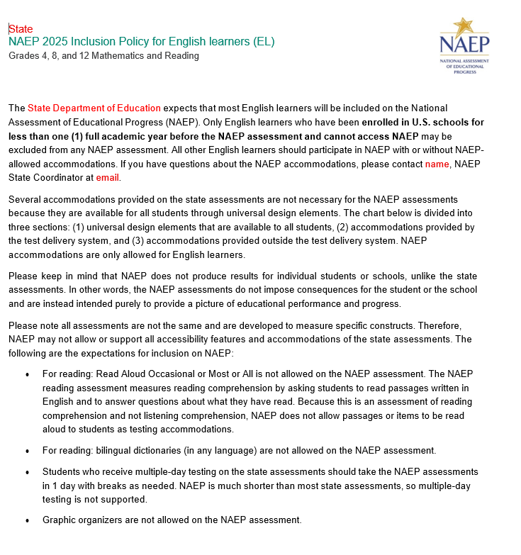

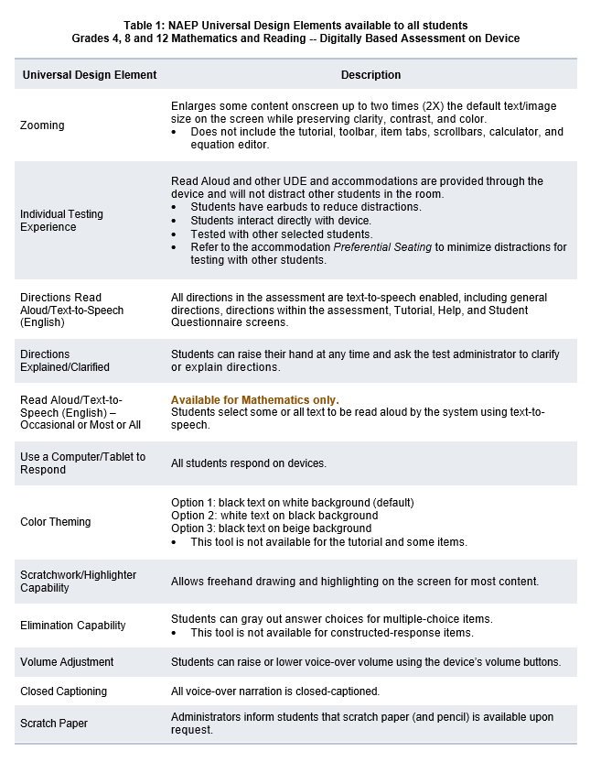

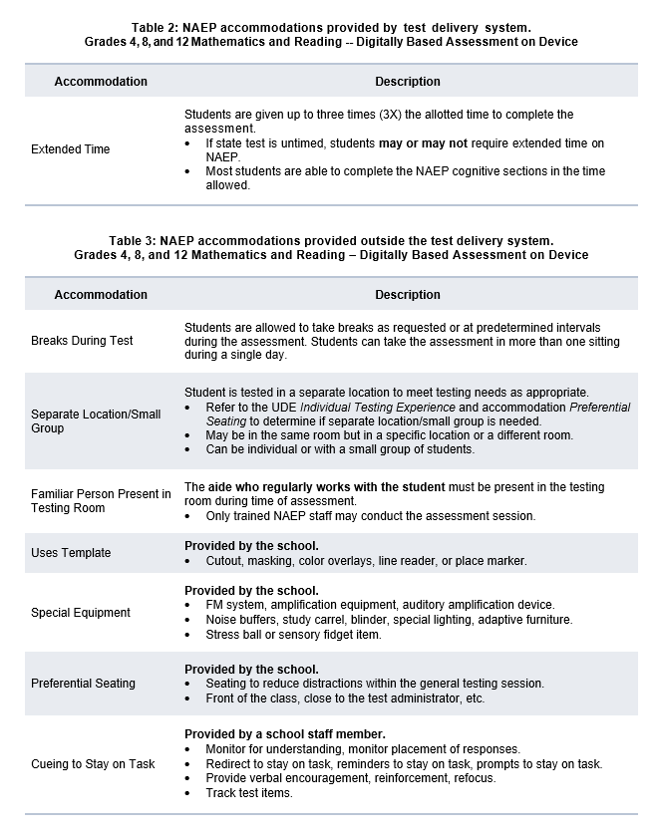

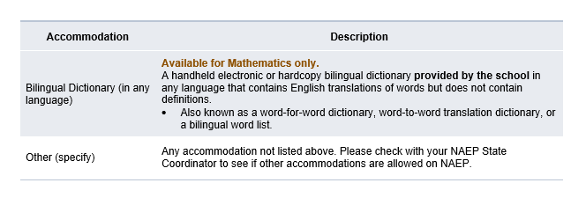

Appendix D-98: NAEP 2025 Inclusion Guidelines for English Learners, Puerto Rico

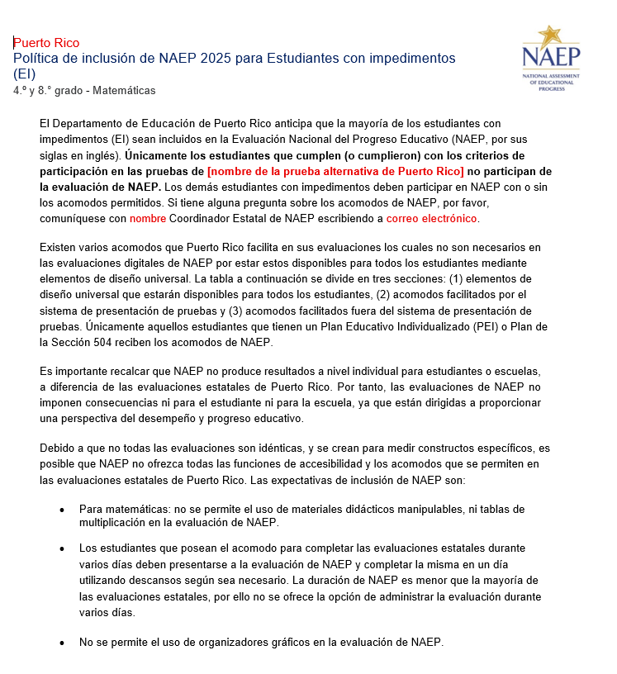

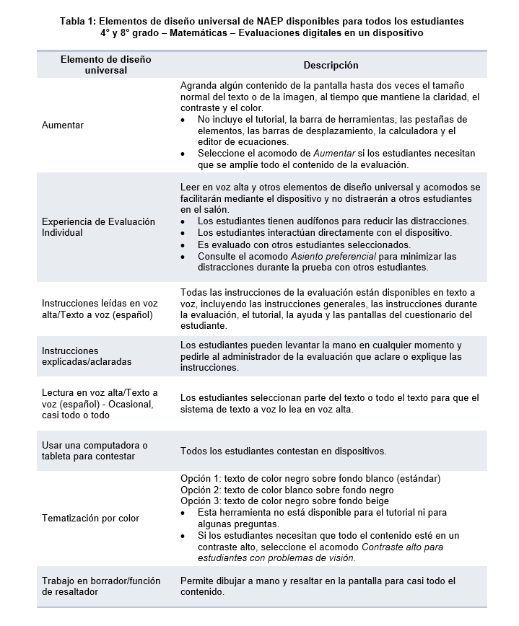

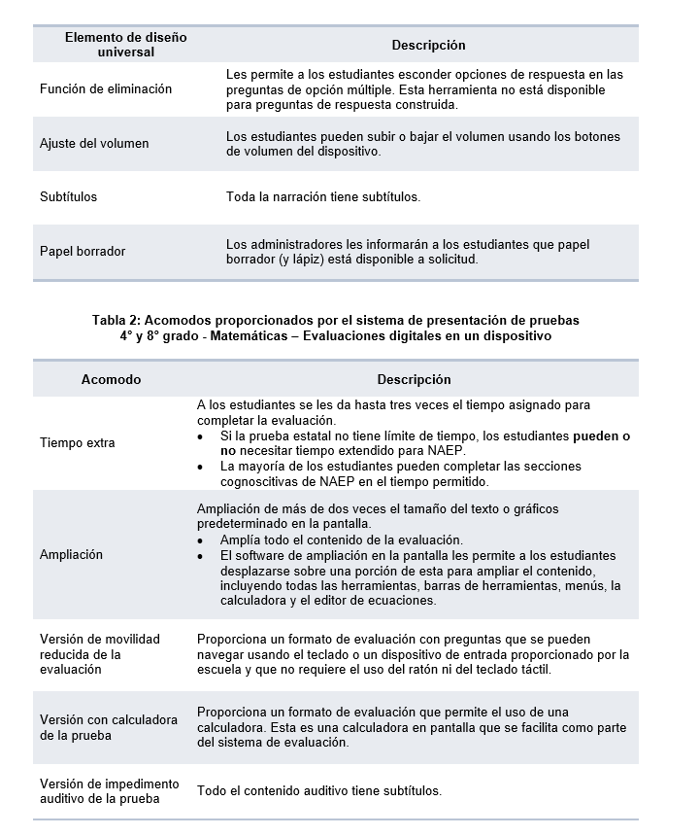

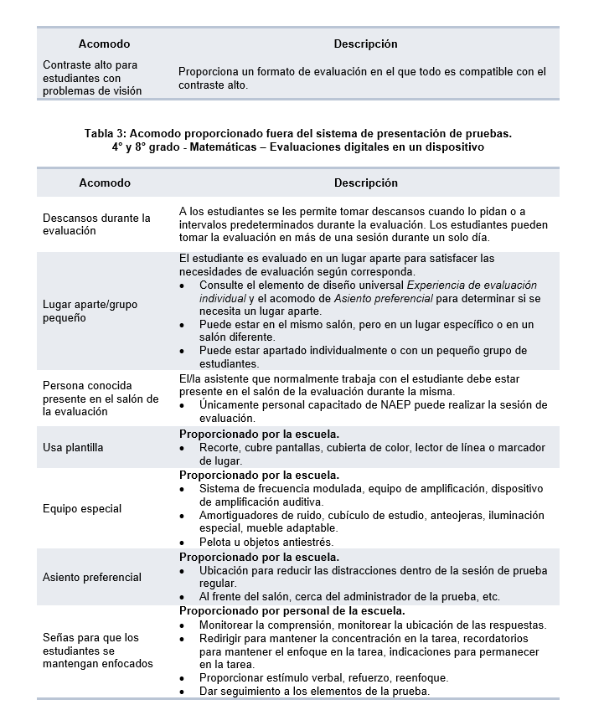

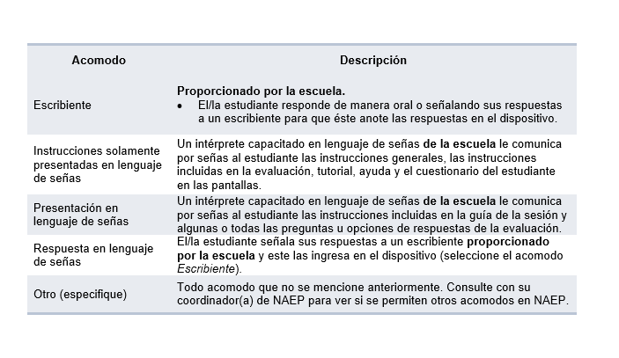

Appendix D-99: NAEP 2025 Inclusion Guidelines for Students with Disabilities

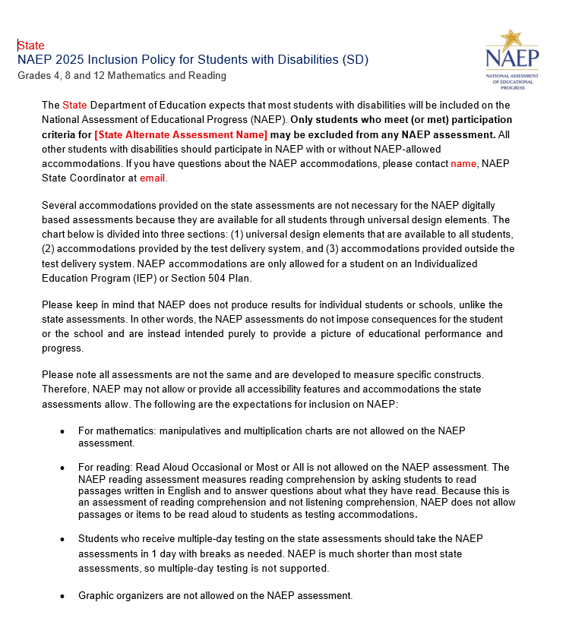

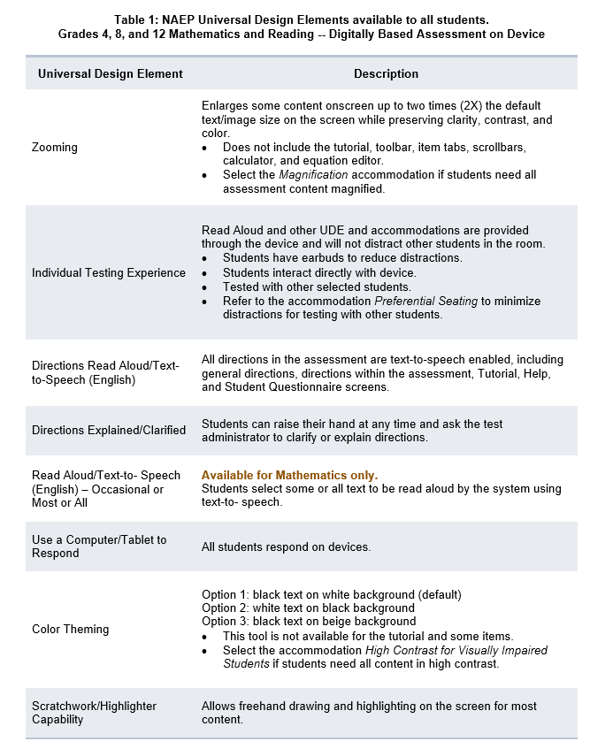

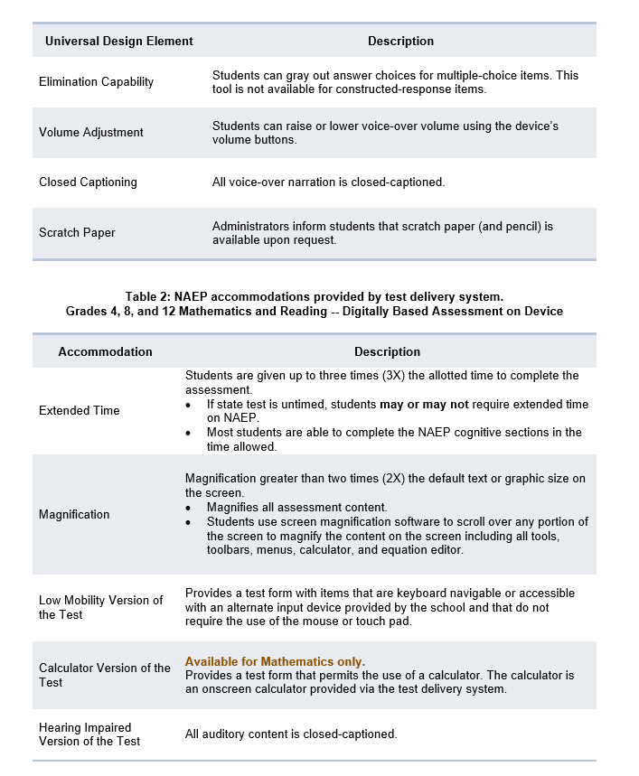

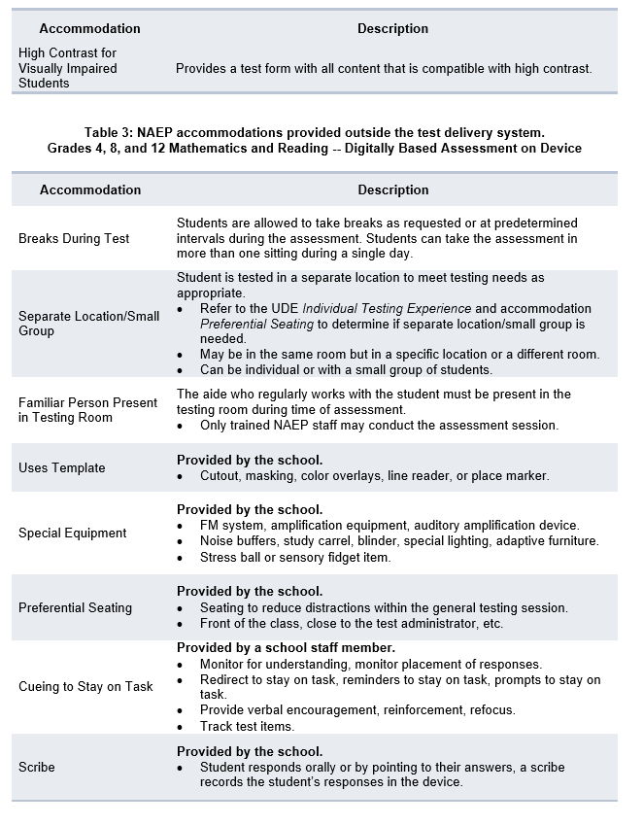

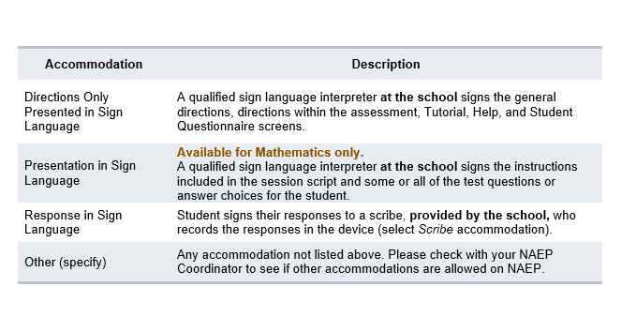

Appendix D-100: NAEP 2025 Inclusion Guidelines for Students with Disabilities, Puerto Rico

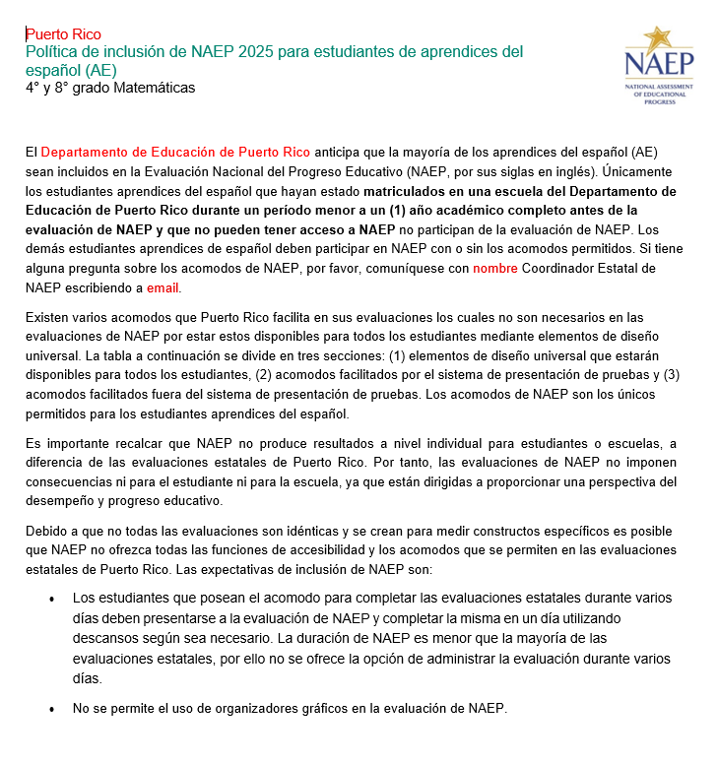

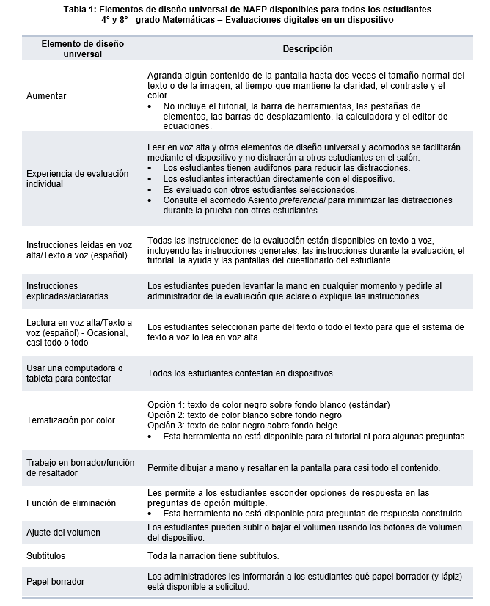

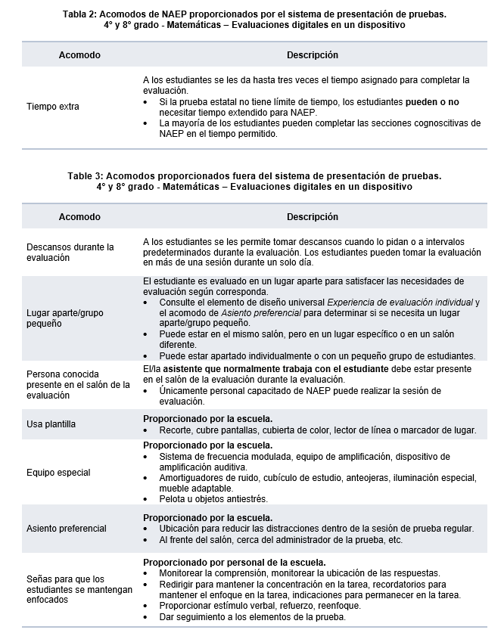

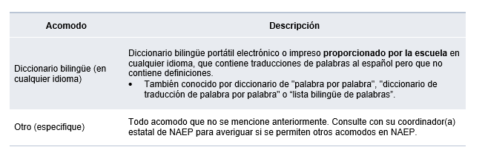

Appendix D-101: NAEP 2025 Preassessment Responsibilities Guide, Private School Device Model

2025 Field Test Private School Preassessment Responsibilities Guide
Thank you for supporting the National Assessment of Educational Progress (NAEP). We look forward to working with you to make NAEP a positive experience at your school. The Assessment Management System (AMS) will be your primary resource for completing assessment planning tasks online for the upcoming assessment.
This guide outlines tasks you will complete along with available resources to make assessment day successful.
NAEP Activity Timeline
December–January:
- Complete Preassessment Activities
January–February:
- Assessment Planning Meeting with NAEP representatives
Within 10 school days before the assessment:
- Notify Parents and Guardians,
- Support Assessment Activities
- Monitor/Confirm Device Readiness Checks are Completed
January 27–March 7:
- NAEP 2025 Assessment Window
After the assessment:
- Wrap Up
You will need to complete the following activities:
- Complete Preassessment Activities
When the student sample is released in December, the following preassessment activities should be completed in the AMS:
  - Schedule Assessment Planning Meeting (APM)
    - An assigned NAEP representative, responsible for administering the assessment, will contact you in December to introduce themselves and monitor the scheduling of an Assessment Planning Meeting. School coordinators will select a date and time (1-hour block) to schedule their APM in the AMS. The NAEP representative can review how to complete the planning tasks outlined below upon your request.
  - Provide Student Information
    - Review the student sample and identify any students who cannot take the assessment. Review demographic information and update any information that is missing or inaccurate.
    - Provide information about students with disabilities (SD) and English learners (EL) so that assessment administrators can plan appropriate assessment accommodations.
      - You can invite your school’s SD and EL specialists to the AMS to assist with this task.
      - Please note that school staff may need to assist with certain accommodations (e.g., cueing to stay on task, scribe). You will need to provide the contact information for the school staff who will assist with these accommodations.
  - Assessment Logistics
    - Schedule the assessment groups and reserve space at your school.
    - Students can either be assessed in two sequential sessions of up to 25 students each or all students at one time in one or two locations.
    - School staff presence in the assessment location is encouraged to help support classroom management.
    - If you select the option to assess all students at the same time in one or two locations, school staff presence is required at each assessment location.
    - Use the AMS to enter Assessment day details in the Assessment Logistics section.
      - location(s) and start time(s) of the assessment
      - how students and teachers will be notified
  - Technical Logistics
    - Review details about school devices and run a network check to confirm school Wi-Fi meets minimum requirements and required URLs are safelisted.
    - Record how the school devices and assessment location will be set up for the NAEP assessment.
    - Identify a school staff member to provide technical support on assessment day.
  - Manage Questionnaires
    - Identify respondents and provide contact information for the school and teacher questionnaires.
    - Match students to the subject-specific teacher in the AMS.
    - Monitor the completion of the questionnaires by school staff.
    - Distribute information about NAEP to teachers.
- Attend Assessment Planning Meeting (APM)
- Participate in a 1-hour virtual planning meeting with your NAEP representative to review and confirm information entered into the AMS.
  - An additional meeting can be scheduled with a technology coordinator to review and confirm technical logistics, if needed.
- Notify Parents and Guardians
- By law, parents/guardians of students selected to participate in NAEP must be notified in writing of their child’s selection prior to the administration of the assessment.
  - In the Notify Parents/Guardians section in the AMS, an electronic copy of the Parent/Guardian Notification Letter is available to download and distribute.
- Verify these notifications have been sent in the AMS.
- Support Assessment Day Activities.
- Resources can be created and printed from the Support Assessment Day section in the AMS to remind teachers and students about the assessment.
  - Share the Teacher Notification Letter and List of Participating Students
  - Distribute the Student Appointment Cards
- Monitor Device Readiness Checks are Completed
  - To ensure a smooth assessment experience in your school, it is important that each student device, including at least five spare devices, has the NAEP Assessment application installed and meets device requirements.
  - A school staff member, who was identified and notified in November, will manage the installation of the NAEP Assessment application on identified devices for your school.
  - In order, to complete the device readiness check, the NAEP Assessment application must be launched on each device and the verification code must be entered within 10 business days of the assessment date. The verification code and instructions for completing this check are available in the Technical Logistics section of the AMS.
  - School staff or students may complete this Device Readiness Check
- Assessment Day Responsibilities
- A school staff member will need to be available on assessment day at the beginning of the assessment session in case any technical issues arise while launching the NAEP assessment on the school’s devices.
- A staff member’s presence throughout the assessment can have a positive impact on students’ motivation and performance. If assessing all students at the same time in one or two locations, the presence of a school staff member is required at each assessment location to help support classroom management.
- If the attendance of sampled students is less than 80 percent, a makeup session will be necessary, and the NAEP representative will schedule another date to administer the assessment to the absent students.
- If the assessment cannot take place due to technical issues, the NAEP representative will work with your school to reschedule the assessment.
- After the Assessment
- Destroy any hardcopy documents containing student names according to school protocol.
- Complete a short email survey on your experience with NAEP.
- Instructions for uninstalling the NAEP assessment application can be found at the eNAEP Download Center.
  - Please follow your school procedures for uninstalling applications on school devices.
If your AMS password has expired, you can request to reset by selecting “Forgot Password”. If you have any questions, please contact the NAEP help desk at 1-800-283-6237 or naephelp@westat.com.
Online Resources Information for selected schools
Information for Selected Schools | https://nces.ed.gov/nationsreportcard/participating/private_nonpublic.aspx
Sample Questions Booklets | http://nces.ed.gov/nationsreportcard/about/booklets.aspx
NAEP Questions Tool | http://nces.ed.gov/nationsreportcard/nqt
Information for Parents | http://nces.ed.gov/nationsreportcard/parents
Assessment Frameworks | https://www.nagb.gov/naep-frameworks/frameworks-overview.html
Digitally Based Assessments | https://nces.ed.gov/nationsreportcard/dba

For more information about NAEP, visit https://nces.ed.gov/nationsreportcard/.
Find us on: [Facebook, Instagram, X, LinkedIn, and YouTube logos]
The National Center for Education Statistics (NCES) conducts the National Assessment of Educational Progress to evaluate federally supported education programs. All of the information you provide may only be used for the purposes of research, statistics, and evaluation under the Education Sciences Reform Act of 2002 (ESRA; 20 U.S.C. § 9543) and may not be disclosed, our used, in identifiable form for any other purpose except as required by law. Every NCES employee as well as every NCES agent, such as contractors and NAEP coordinators, has taken an oath and is subject to a jail term of up to 5 years, a fine of $250,000, or both if he or she willfully discloses ANY identifiable information about you. Electronic submission of your information will be monitored for viruses, malware, and other threats by Federal employees and contractors in accordance with the Cybersecurity Enhancement Act of 2015.

Appendix D-102: NAEP 2025 Instructions for preparing and importing a student excel file

Instructions for Preparing and Importing a Student Excel file

Requirements
NAEP needs a complete Excel file of students enrolled during the 2024–2025 school year for the selected grade(s) at your school. Schools selected for multiple grades should create separate files for each grade. NAEP uses this student list to draw a random sample of students to participate in the assessment. Include all students in the selected grade, even students who are typically excluded from other testing programs, such as students with IEPs (SD) and English Learners (EL), and students participating in virtual/remote learning.
NAEP recommends using a Student List Template, which is available on the Assessment Management System website. If you create your own Excel file, use the same or similar header names. If you cannot submit your student data in an Excel file, contact the NAEP help desk at 1-800-283-6237 or naephelp@westat.com.
The Excel file must contain the following information for each student:
Excel Header Name | Format | Notes
State unique Student ID | Numeric | If available, do not use Social Security Numbers
First name | Text | Recommendation: If possible, include first and last names in separate columns. NAEP accepts names stored in a single column, which requires answering questions to determine how names are ordered/formatted.
Last name | Text
Middle name or initial optional | Text
Grade in School | 4, 8, 12 | Include all students in the selected grade
Homeroom/other locator optional | Text or Numeric | Optional, include if available
Month of Birth | Numeric | Recommendation: If possible, include month and year of birth in separate columns. NAEP accepts birthdates in a single column too. Expected birth years for NAEP: grade 4 2012–2016, grade 8 2008–2012, and grade 12 2004–2009.
Year of Birth | Numeric
Sex | School-defined code | Map school-defined codes to NAEP definitions. See pages 2-4.
Race/Ethnicity | School-defined code | Map school-defined codes to NAEP definitions. See pages 2-4.
Economically Disadvantaged | School-defined code | Map school-defined codes to NAEP definitions. See pages 2-4.
Students with Disabilities (SD) | School-defined code | Map school-defined codes to NAEP definitions. See pages 2-4.
English Learner (EL) | School-defined code | Map school-defined codes to NAEP definitions. See pages 2-4.
On-Break Indicator for all -year schools ONLY (schools without a summer break) | School-defined code | Only required for year-round schools
ZIP Code | Numeric | 5 or 9 digit format

NAEP Codes and Definitions
You will need to map your file’s school-defined codes to NAEP’s definitions for the following variables: Sex, Race/Ethnicity, Economically Disadvantaged, Students with Disabilities (SD), English Learner (EL). See NAEP definitions below.

Sex

Map your school’s codes to the following categories.
- Male
- Female
- Information unavailable at this time: If you currently do not have this information for one or more students, blank cells or an indicator such as “N/A” (Not Available) in the cell(s) can be mapped to this code to notify your NAEP representative of the need to collect the data at a later date.

Race/Ethnicity
NAEP offers three student list templates to accommodate different race/ethnicity formats. Your NAEP State Coordinator has designated the preferred template for your state. See the Downloads section of Step 1 Import Students.
Race/ethnicity in one column – Use when all race/ethnicity information is included in a single column.
Race/ethnicity in two columns – Use when ethnicity (Hispanic, of any race) is included in a single column. Other race information is included in a separate column.
Race/ethnicity in six columns – Use when each of the six categories below have a dedicated column: Hispanic (of any race), White (not Hispanic), Black or African American (not Hispanic), Asian (not Hispanic), American Indian or Alaska Native (not Hispanic), and Native Hawaiian or Pacific Islander (not Hispanic). Responses from these six categories will determine the Two or More Races, not Hispanic category.
NAEP accepts race/ethnicity information in other formats. The formats above are the most common.

Map your school’s codes to the following categories.
- Hispanic, of any race: A person of Mexican, Puerto Rican, Cuban, Central or South American, or other Spanish (but not Portuguese) culture of origin, regardless of race
- White, not Hispanic: A person having origins in any of the original peoples of Europe (except Spain), North Africa, or the Middle East
- Black or African American, not Hispanic: A person having origins in any of the Black peoples of Africa
- Asian, not Hispanic: A person having origins in any of the original peoples of the Far East, Southeast Asia, the Indian Subcontinent, including, for example, Cambodia, China, Japan, India, Korea, Malaysia, Pakistan, the Philippine Islands, Thailand, and Vietnam
- American Indian or Alaska Native, not Hispanic: A person having origins in any of the original peoples of North and South America (including Central America), and who maintains tribal affiliation or community attachment
- Native Hawaiian or Pacific Islander, not Hispanic: A person having origins in any of the original people of Hawaii, Guam, Samoa, or other Pacific Islands
- Two or More Races, not Hispanic: A person who identifies with two or more of the non-Hispanic categories above.
- Information unavailable at this time: If you currently do not have this information for one or more students, blank cells or an indicator such as “N/A” (Not Available) in the cell(s) can be mapped to this code to notify your NAEP representative of the need to collect the data at a later date.
- School does not collect this information: Available to nonpublic schools only. When used, this code must be applied to all students.

Economically Disadvantaged
Map your school’s codes to the following categories.
- Yes, economically disadvantaged
- No, not economically disadvantaged
- Information unavailable at this time: If you currently do not have this information for one or more students, blank cells or an indicator such as “N/A” (Not Available) in the cell(s) can be mapped to this code to notify your NAEP representative of the need to collect the data at a later date.

English Learner (EL)
Map your school’s codes to the following categories.
- Yes, EL
- No, Not EL
- No, Formerly EL: If a student who has achieved full English proficiency, is monitored, and is included in EL subgroup for accountability reporting for 2 years (or 4 years depending on state policy) after exiting. Public schools, contact your NAEP State Coordinator if you have any questions about using this code.
- Information unavailable at this time: If you currently do not have this information for one or more students, blank cells or an indicator such as “N/A” (Not Available) in the cell(s) can be mapped to this code to notify your NAEP representative of the need to collect the data at a later date.

On-Break Indicator
For year-round schools only: Include students who will be on break/vacation on the scheduled assessment day along with all of the other students enrolled in the sampled grade. The Student List Template contains an “On Break” column for identifying students who will be on break/vacation by filling in “Yes.” If you are not using the template, create and provide data for an “On Break” column in your file.

Instructions for importing the student list
See the steps below for importing the student list.

Step 1: Prepare the Excel file and a legend
The legend should explain the file’s codes. The following NAEP variables involve school-defined codes:
- Sex
- Race/Ethnicity
- Economically Disadvantaged
- Students with Disabilities (SD)
- English Learner (EL)
In the example below, a school uses five different codes for the Students with Disabilities variable. The legend explains how to “map” school codes to NAEP definitions.
School codes for Students with Disabilities
IEP
IEP + 504
504
No
Blank (no data in cell)

NAEP Definitions
Legend
IEP =
IEP + 504 =
504 =
No =

Blank =
Yes, IEP
No, not SD
Information unavailable
Yes, IEP
Information unavailable
Yes, IEP
No, not SD
No, not SD

Step 2: Check your file, then upload
Prevent upload failures by resolving these common problems first.
- Student records should be in one worksheet. Delete all other worksheets.
- File should include all currently enrolled students in the selected grade. Delete any students that are not in the selected grade.
- Include all required NAEP variables (see page 1 for full list). The following cannot be blank for any students: first name, last name, birth month/year, grade, and sex. Blanks for other variables are acceptable, you will add missing information later.
- Check for duplicate students. Delete any duplicate student rows.
- Header row for each required variable must be in row 1.
- Blank rows should begin after the last student record. Delete blank rows between students.
- Remove password protection. NAEP cannot process protected files.
Go to the Import Student List section on your school’s AMS page. Select Upload file.

Step 3: Map file contents
Use the completed legend for this step. The legend explains how to map each variable.
- Map your file’s column headings to NAEP variables. This step is done automatically if you use NAEP’s Excel template or the same variable/header row names.
  - The field names used by your database system may not have the same names as the NAEP variable. In this case, match the names of your columns to the names of the NAEP variables.
- Map your school’s codes to NAEP definitions. In the repeated example below, the school code “IEP” is mapped to NAEP’s definition “Yes, IEP”, and so on.
School codes for Students with Disabilities
IEP
IEP + 504
504
No
Blank (no data in cell)

NAEP Definitions
Legend
IEP =
IEP + 504 =
504 =
No =

Blank =
Yes, IEP
No, not SD
Information unavailable
Yes, IEP
Information unavailable
Yes, IEP
No, not SD
No, not SD

Step 4: Check warnings
Information from the student list runs through a series of checks.
- Review warnings. NAEP compares the student list against two databases: previous NAEP assessments and Common of Core Data. Common Core of Data (CCD) is the Department of Education’s primary database on public elementary and secondary education in the United States. These comparisons generate warnings to ensure demographics in the student list are accurate. Warnings serve as prompts to review and confirm existing information, and do not always require changes to the student list. There are additional warnings that identify missing information and possible mapping problems.
- Resolve warnings. Some warnings are resolved by adding missing information or editing existing information. Others require a review of how file contents are mapped, and possible changes if the mapping is incorrect.

Step 5: Confirm file
Review student counts and percentages for each variable in your file. This summary serves as a final check before submitting the file. Make sure these counts and percentages are representative of students in the selected grade at your school.

Appendix D-103: NAEP 2026 eNAEP Download Center (NEW)

Getting Started > Preparing for Assessment > Preassessment Tools (Landing Page)
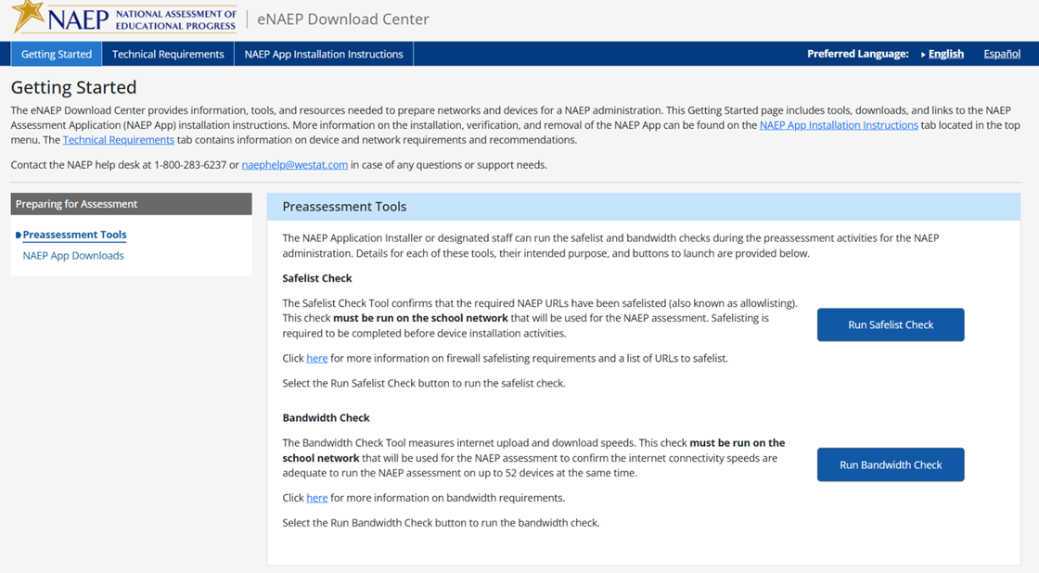

Getting Started > Preparing for Assessment > NAEP App Downloads

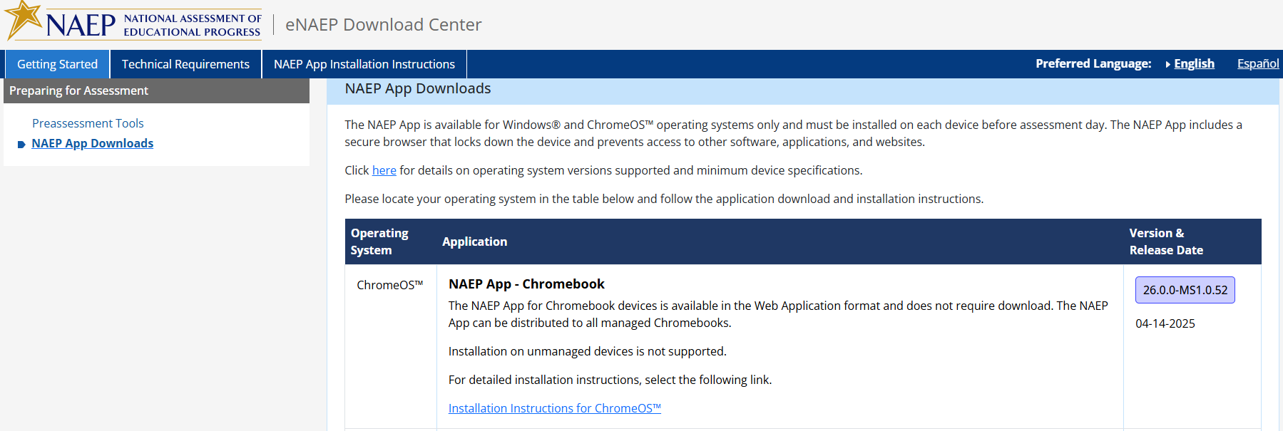

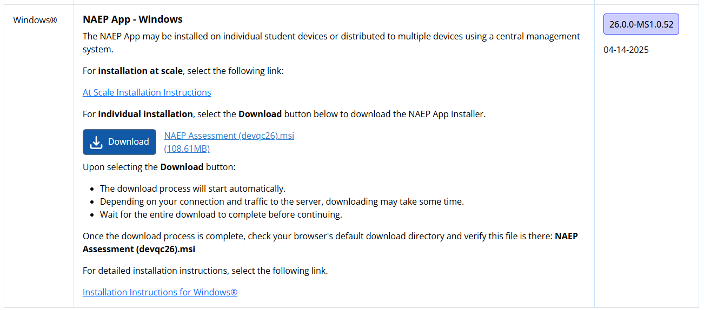

Technical Requirements > System Requirements > OS & Hardware Requirements
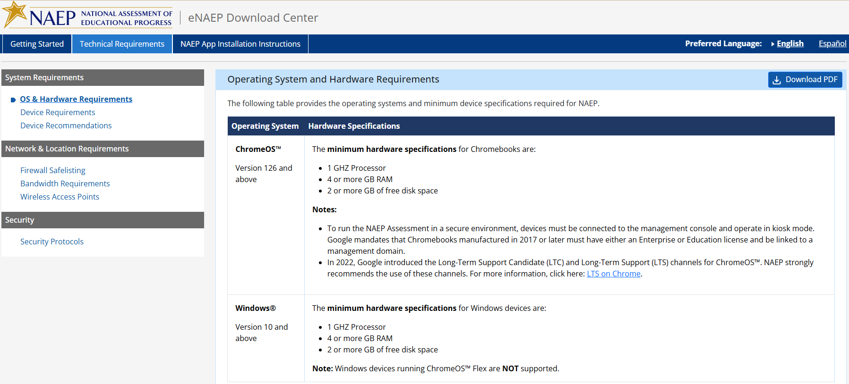

Technical Requirements > System Requirements > Device Requirements

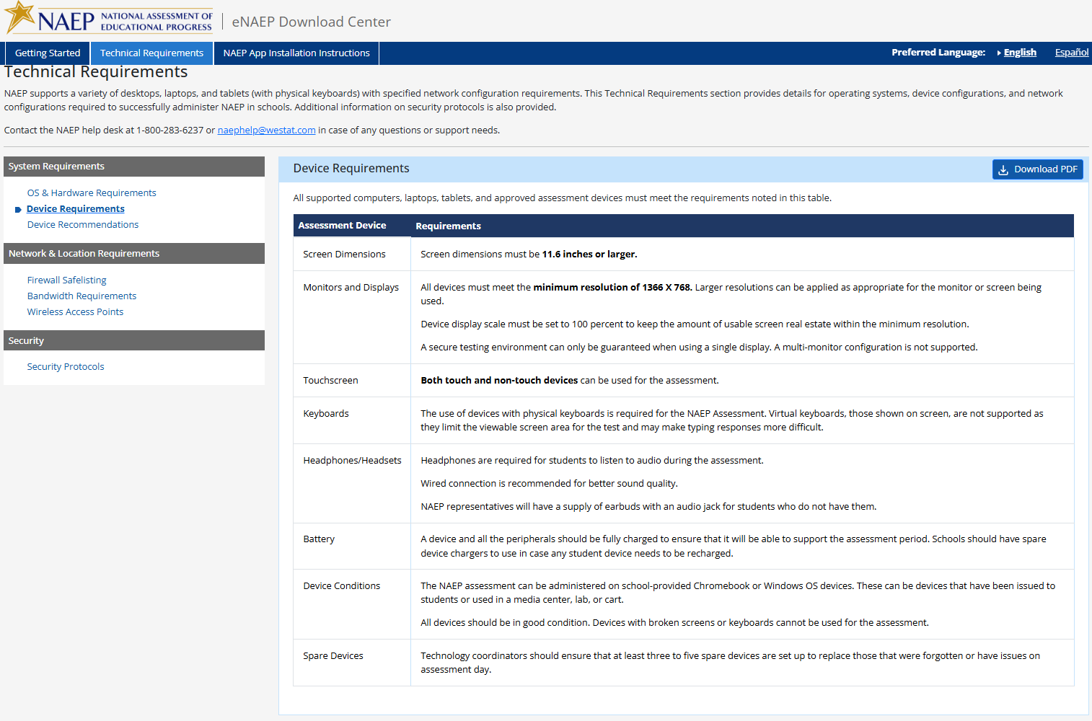

Technical Requirements > System Requirements > Device Recommendations

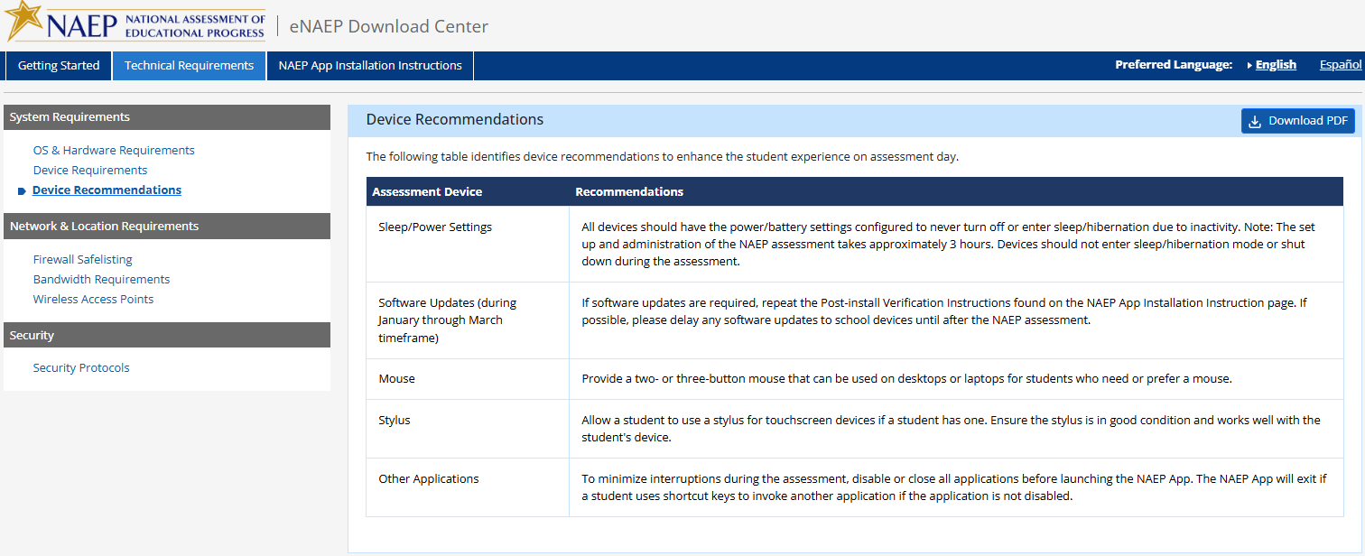

Technical Requirements > Network & Location Requirements > Firewall Safelisting

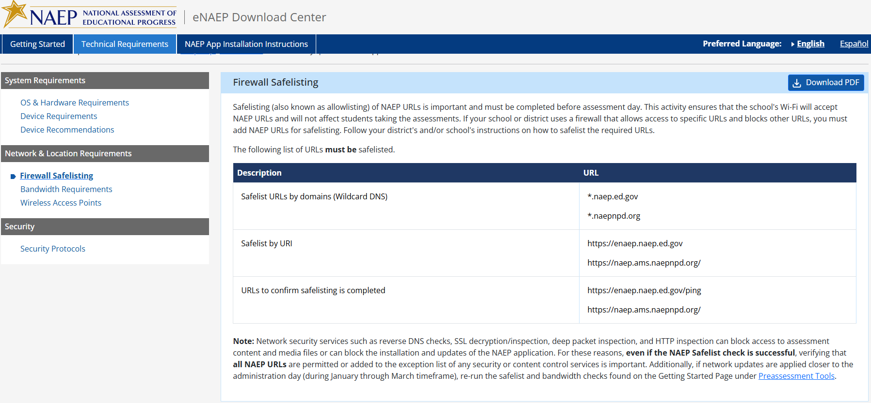

Technical Requirements > Network & Location Requirements > Bandwidth Requirements 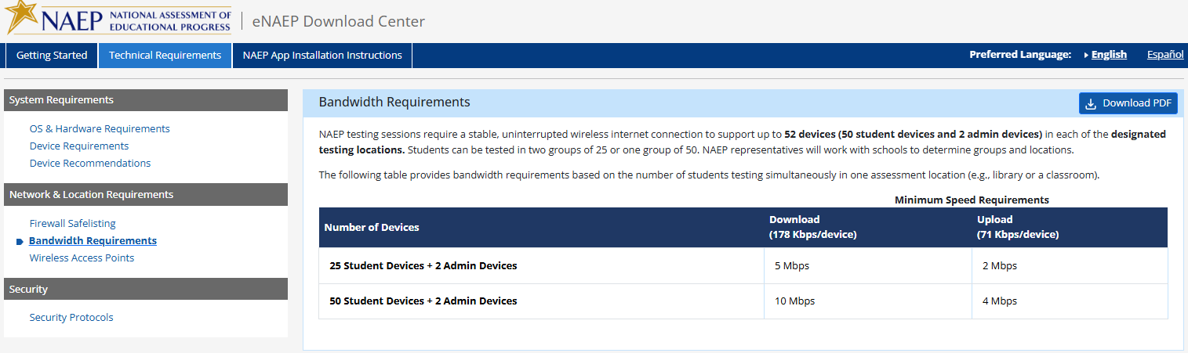

Technical Requirements > Network & Location Requirements > Wireless Access Point
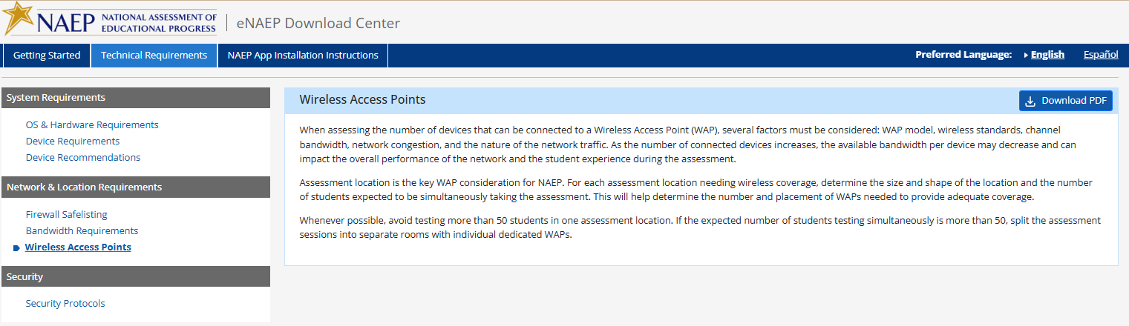

Technical Requirements > Security > Security Protocols

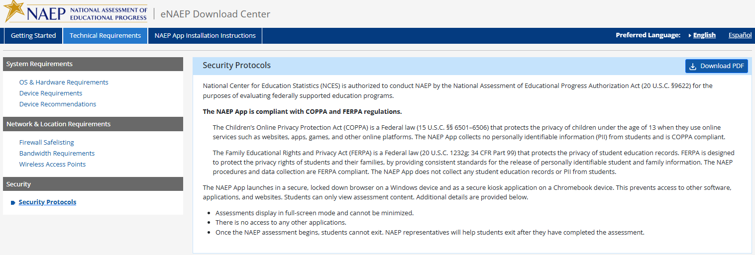

NAEP App Installation Instructions > ChromeOS > Installation Instructions
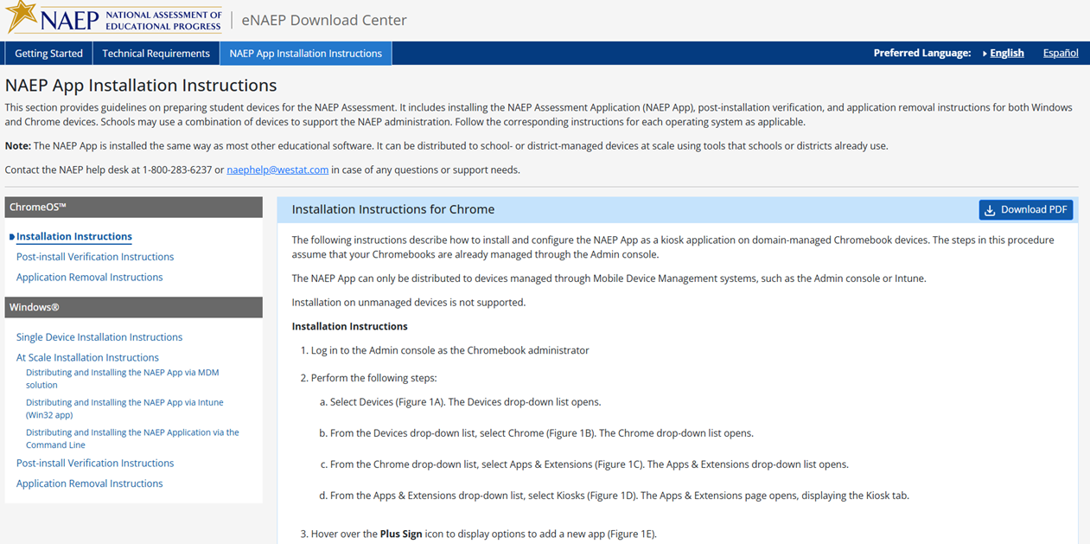
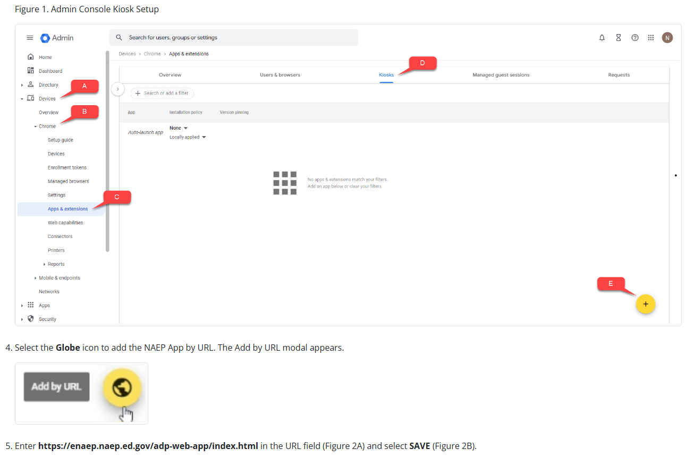

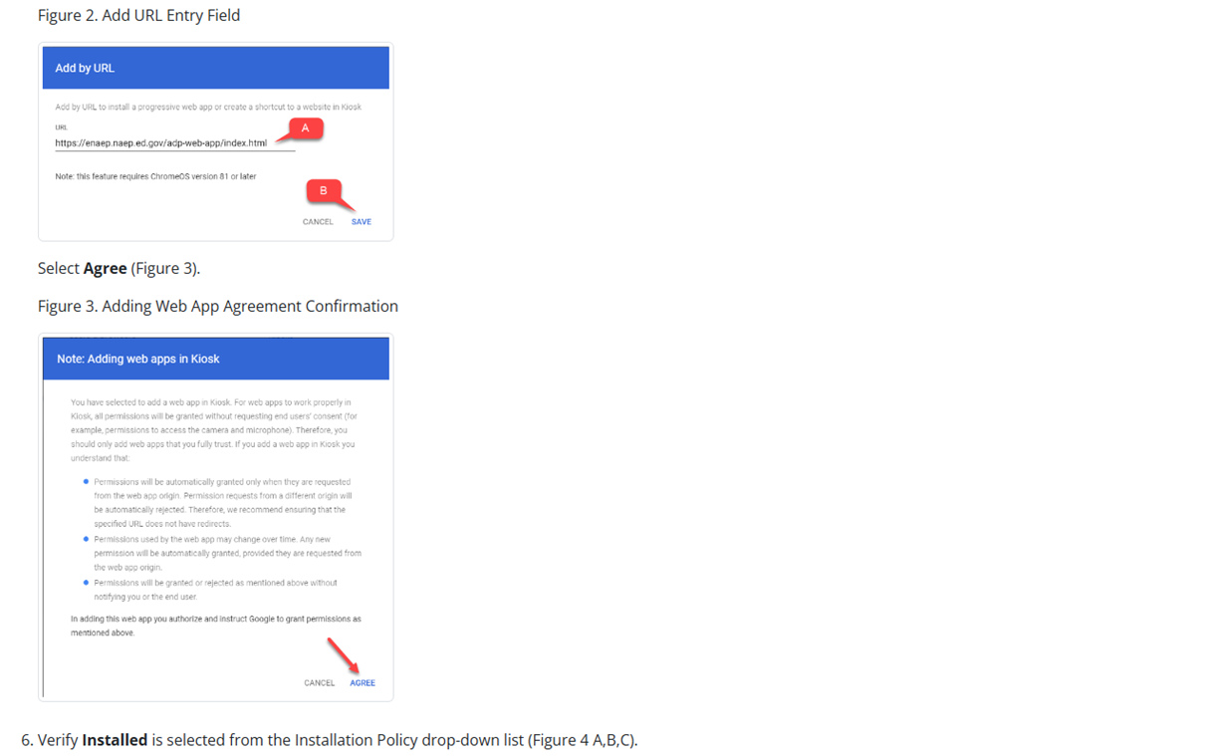
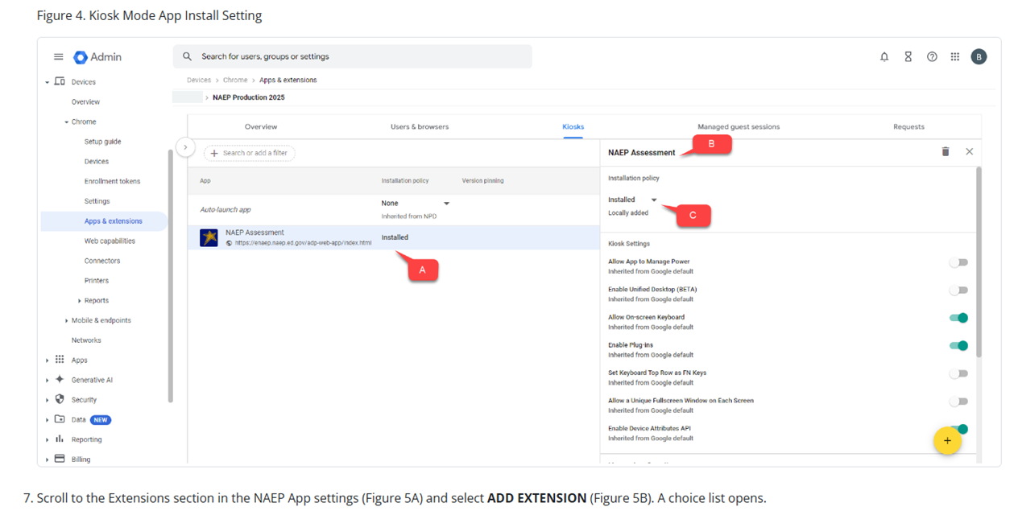
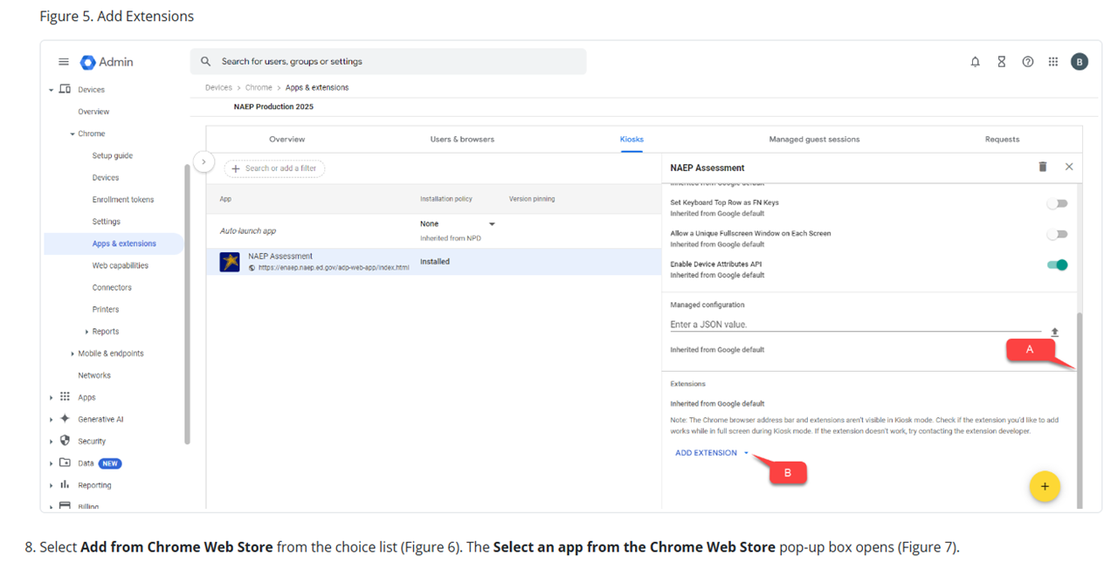
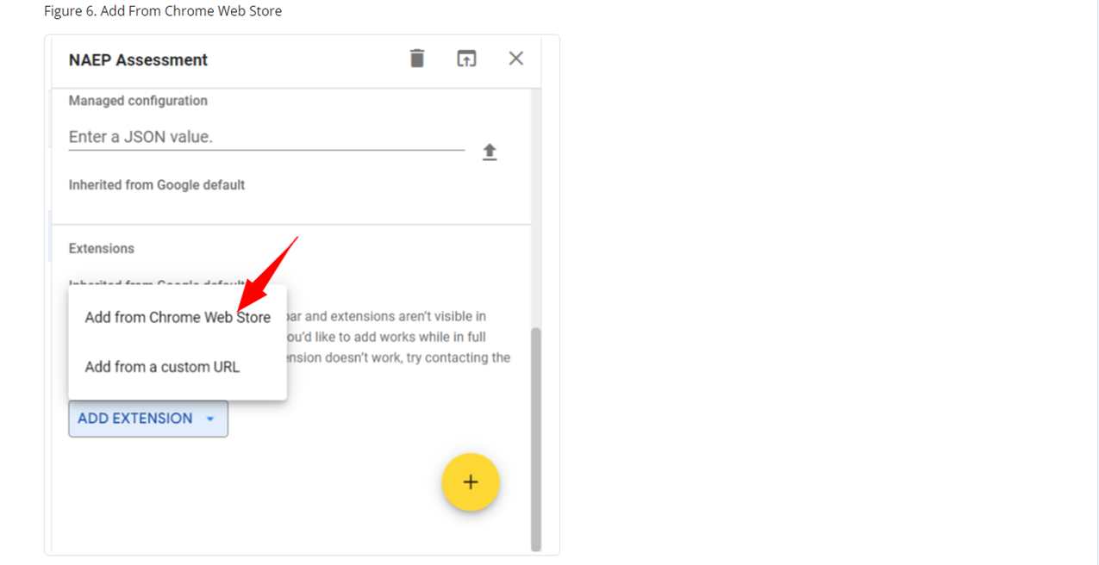
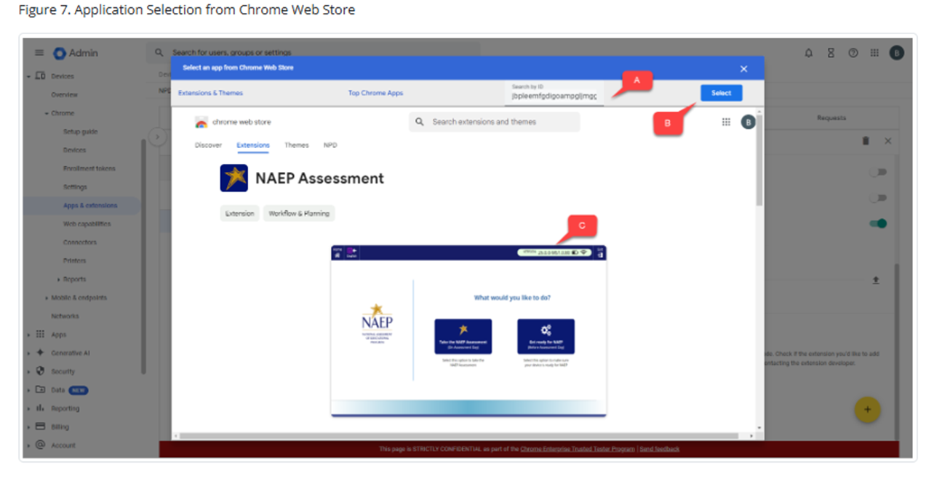
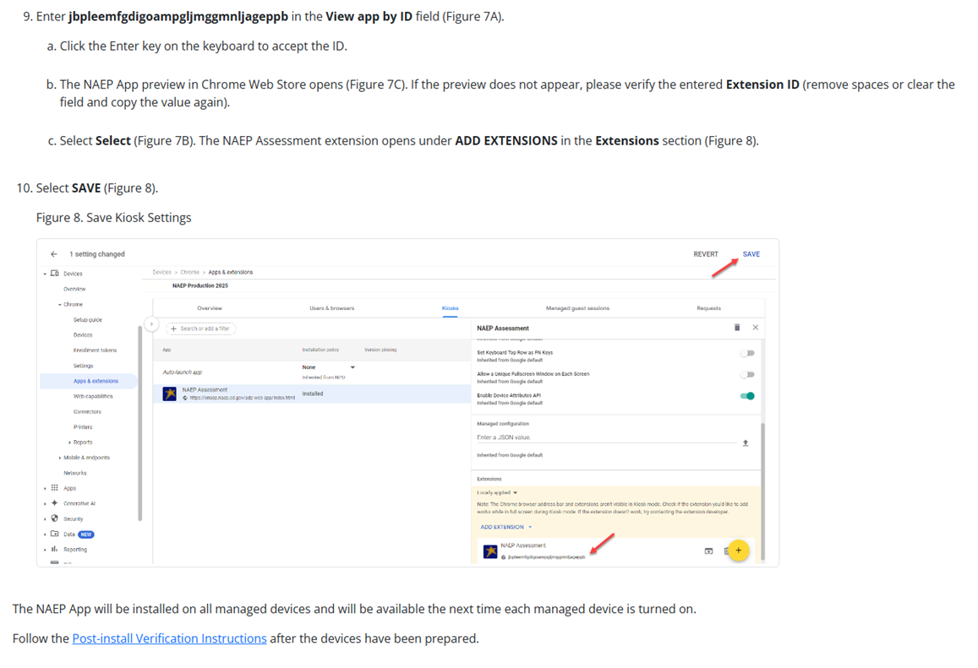

NAEP App Installation Instructions > ChromeOS > Post-install Verification Instructions
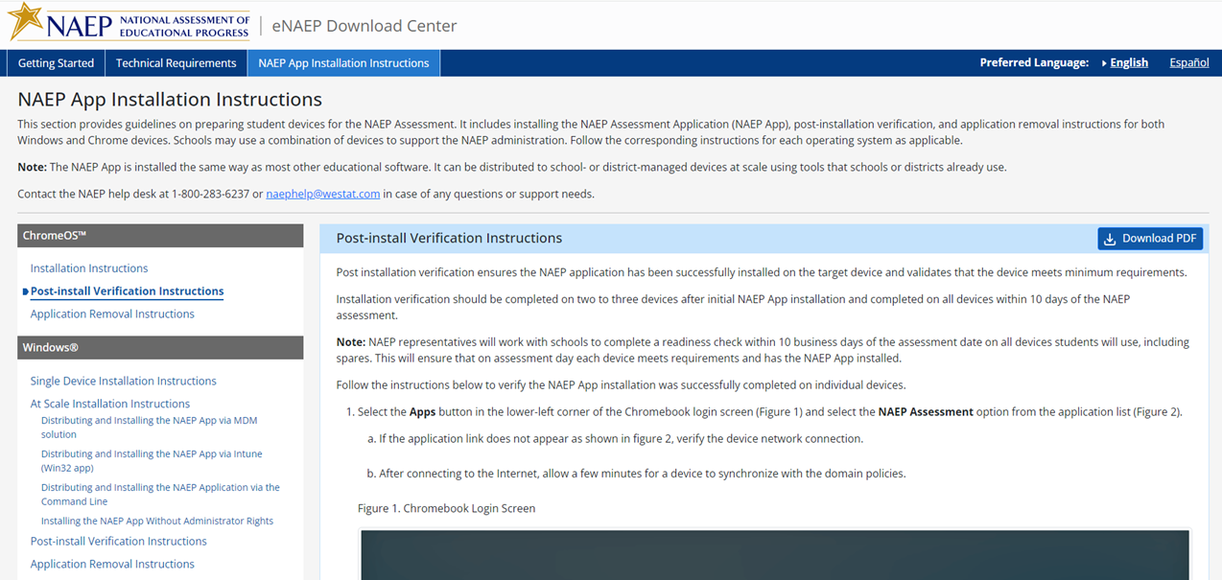
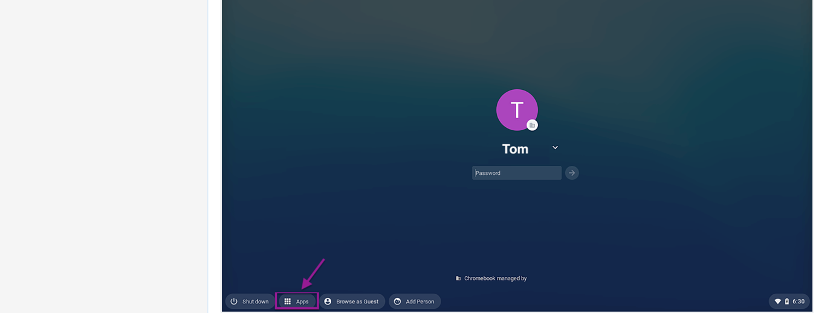
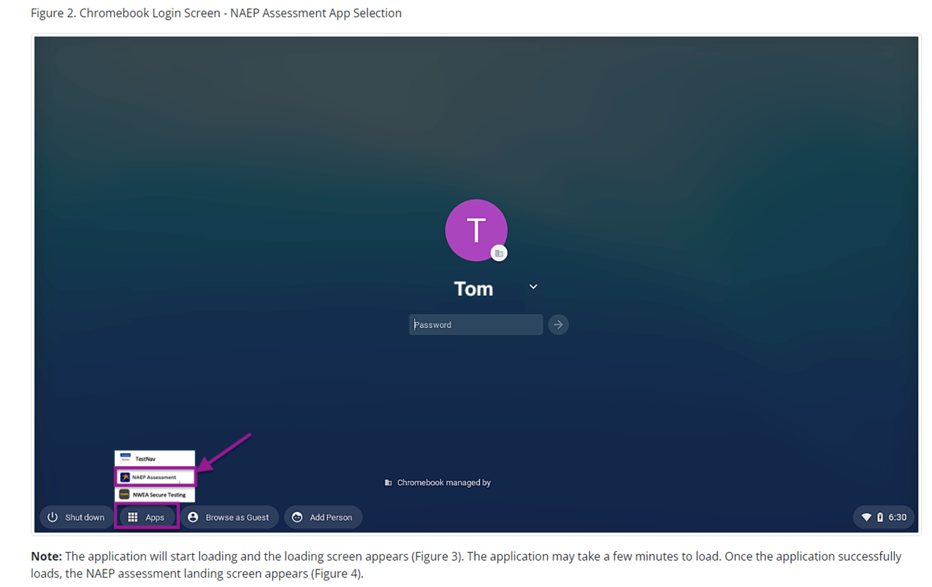
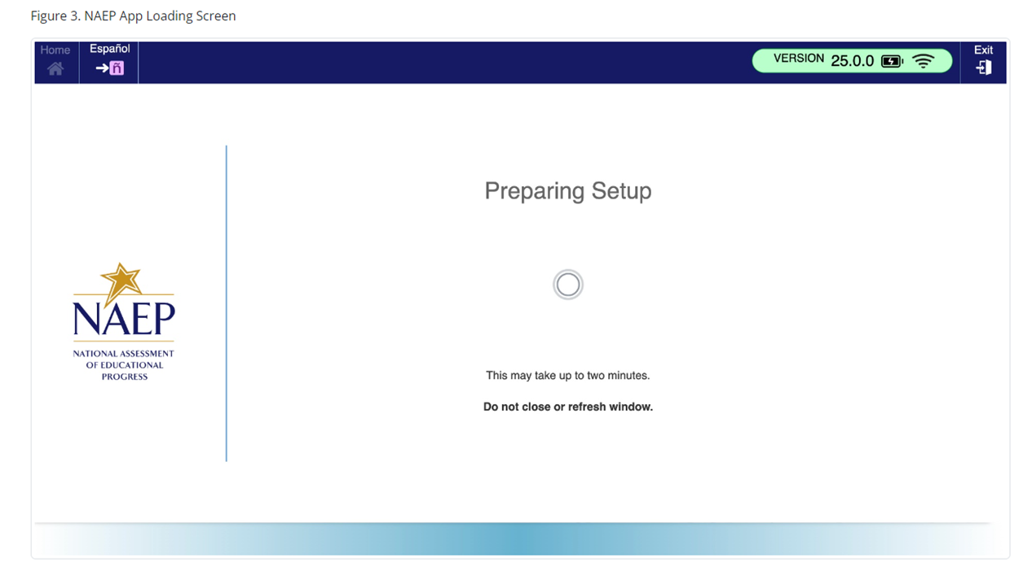
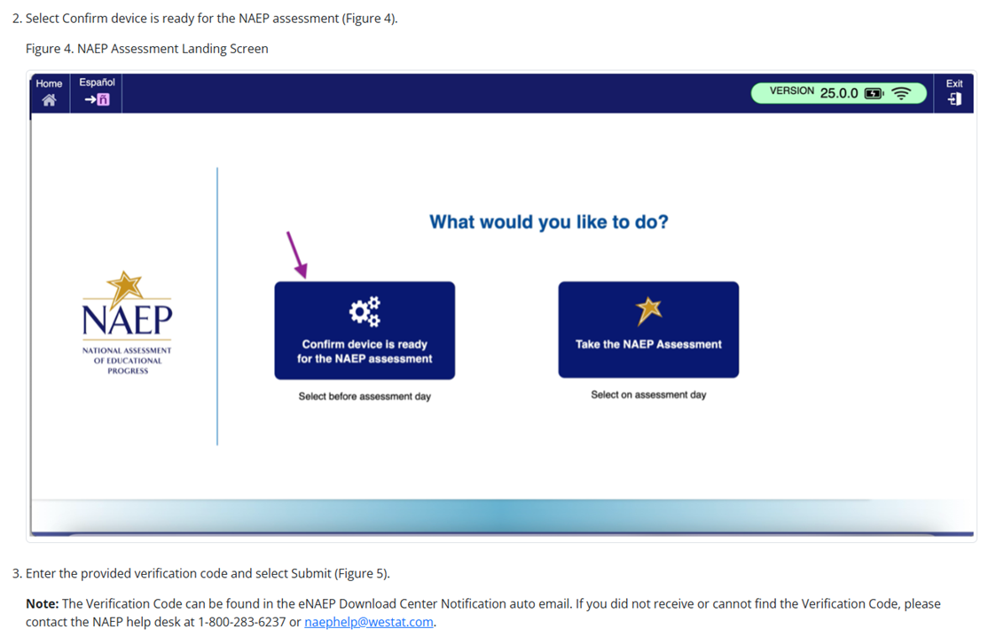

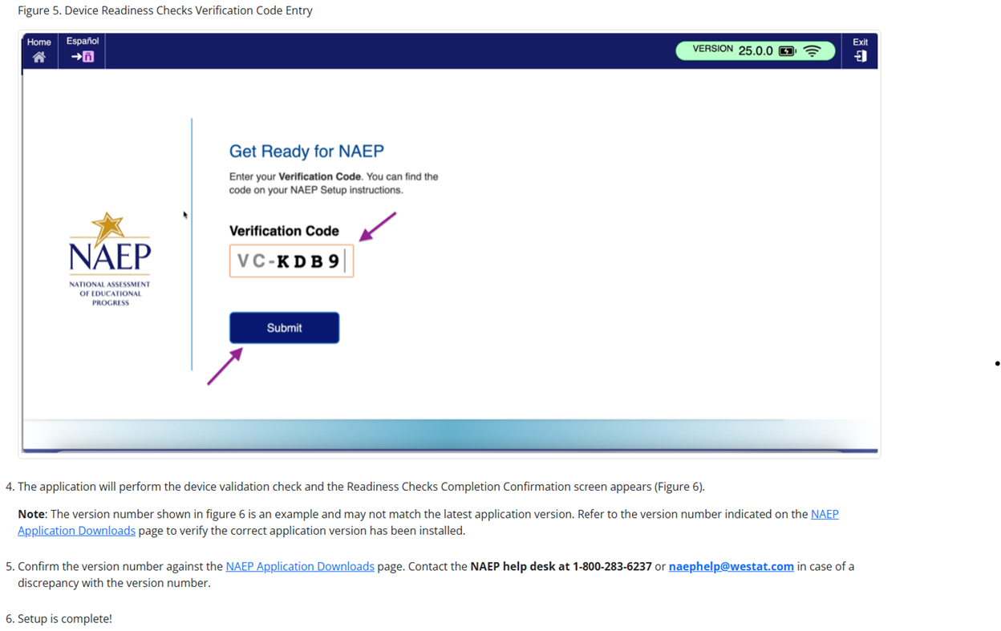

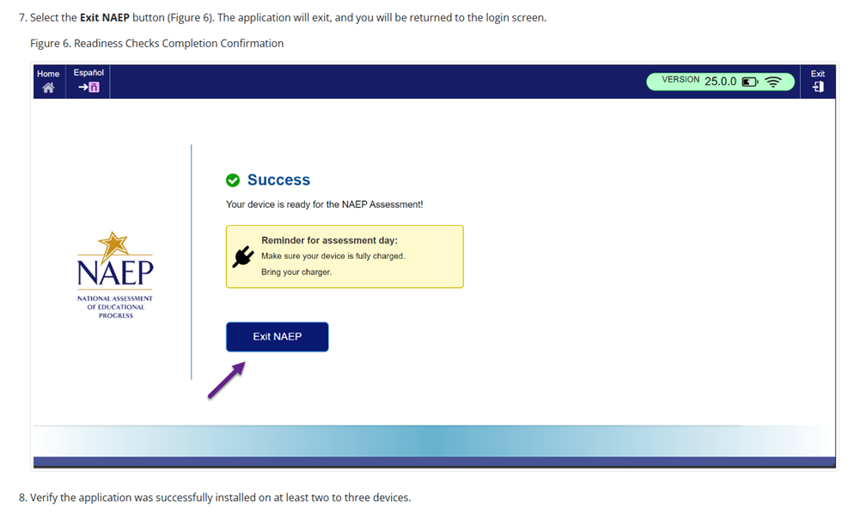

NAEP App Installation Instructions > ChromeOS > Application Removal Instructions
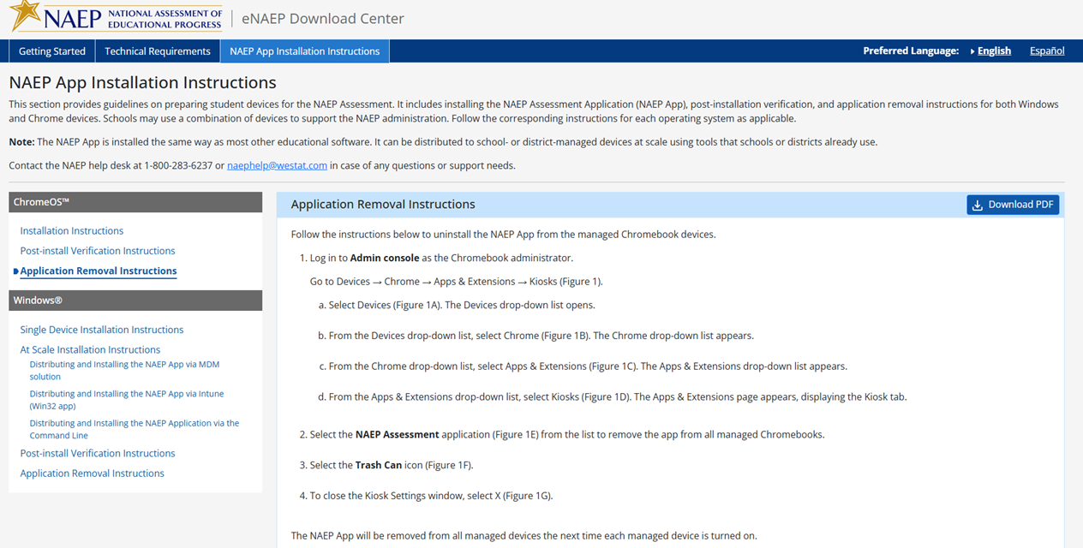
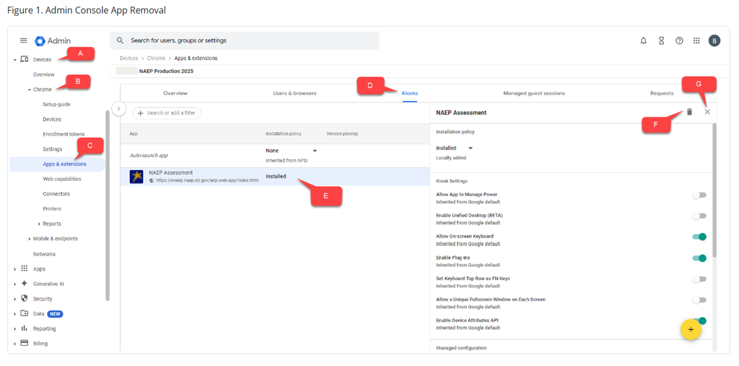

NAEP App Installation Instructions > Windows > Single Device Installation
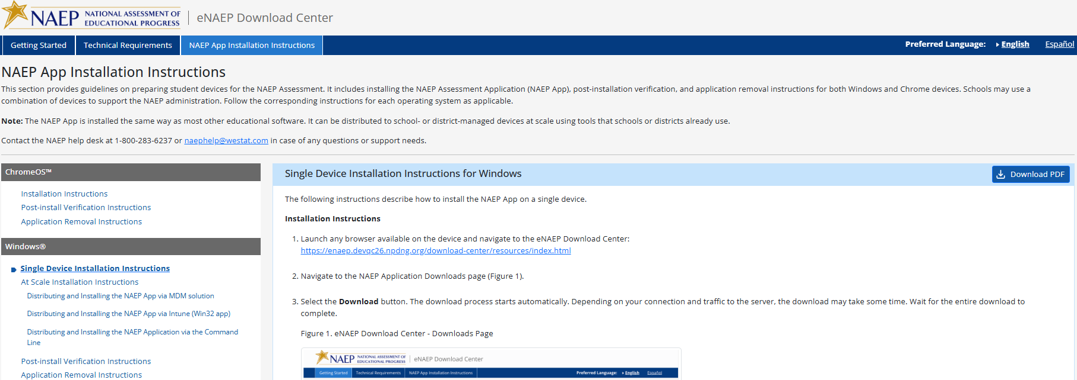
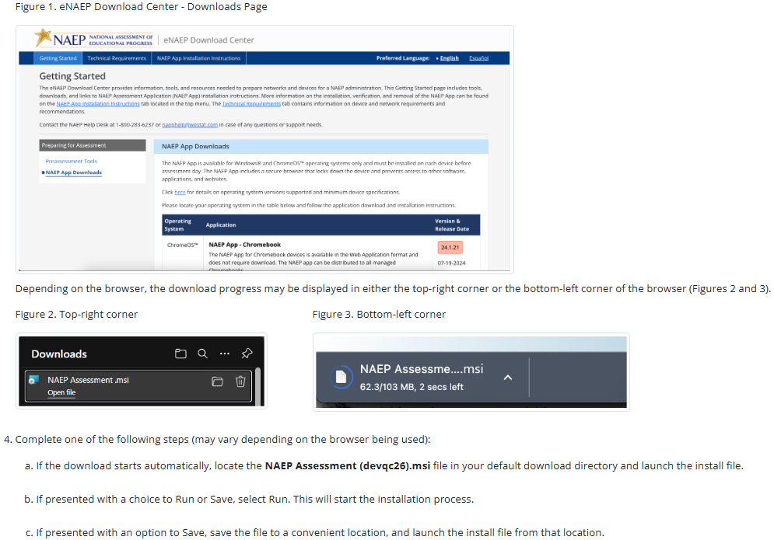
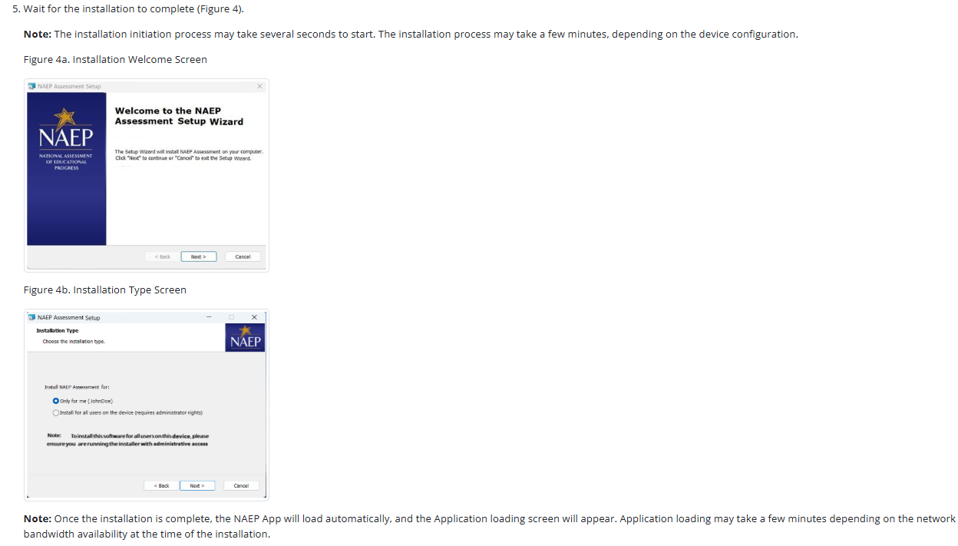
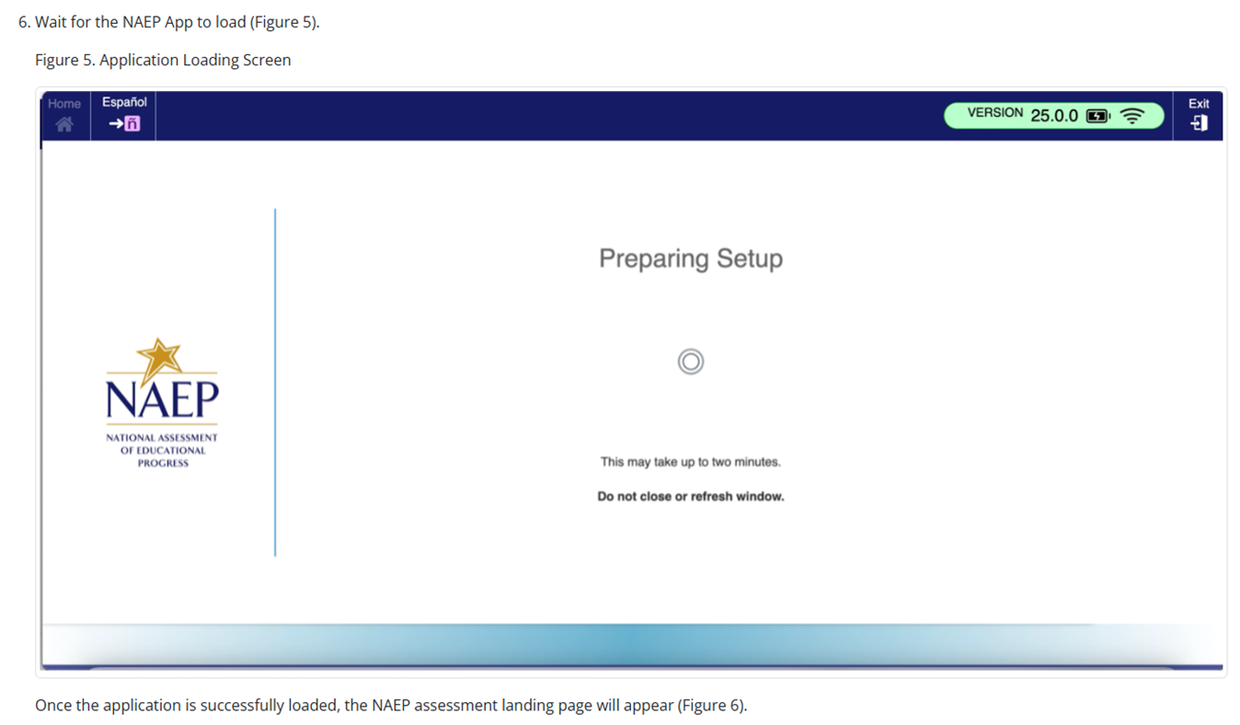
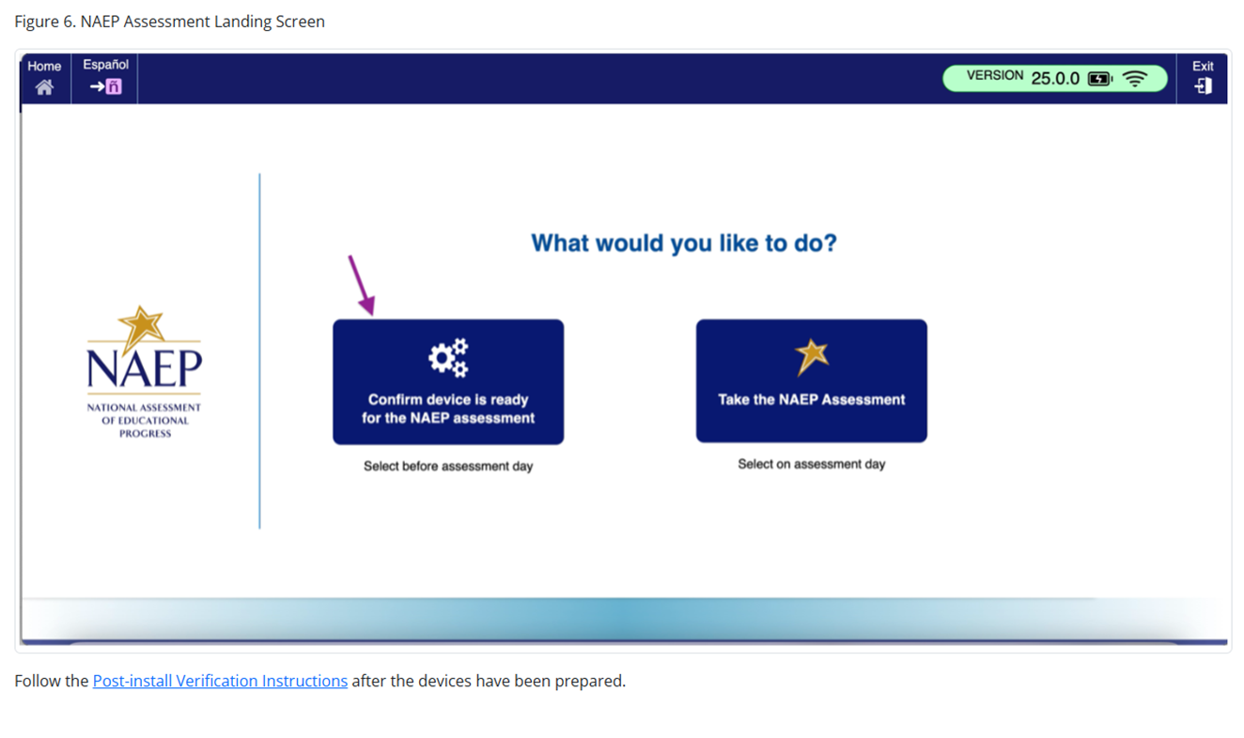

NAEP App Installation Instructions > Windows > At Scale Installation Instructions
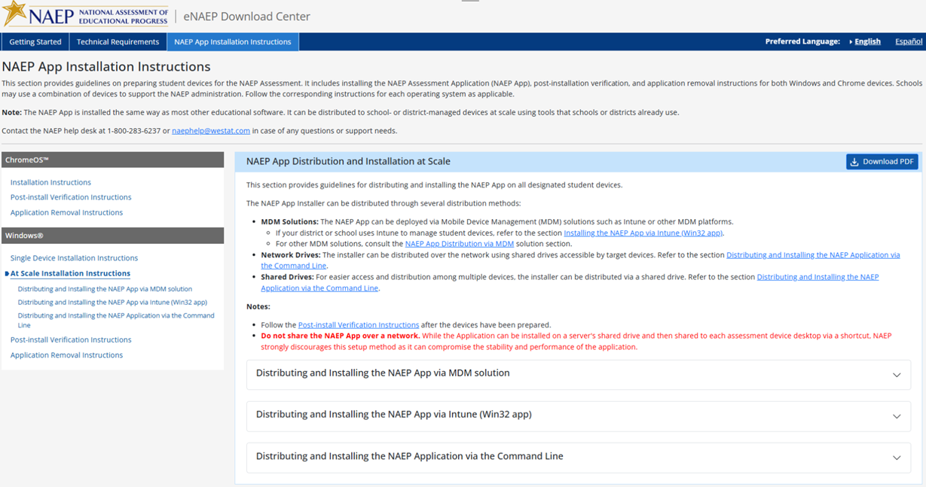

NAEP App Installation Instructions > Windows > At Scale Installation Instructions > Distributing and Installing the NAEP App via MDM Solution

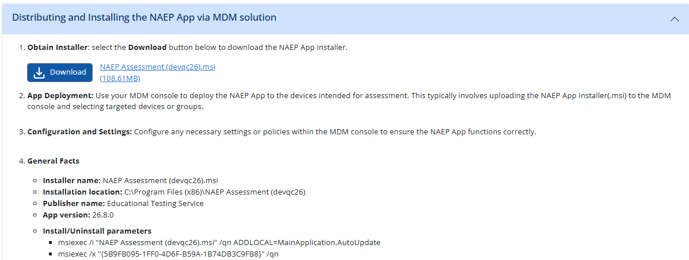

NAEP App Installation Instructions > Windows > At Scale Installation Instructions > Distributing and Installing the NAEP App via Intune (Win32 app)
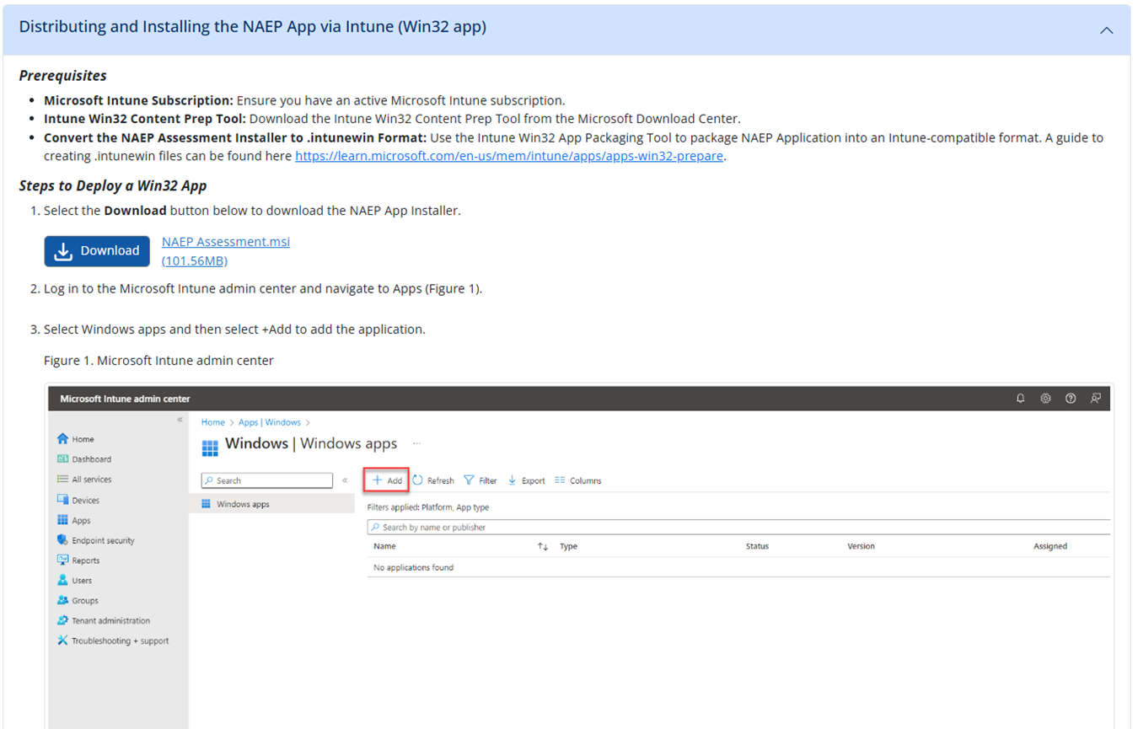
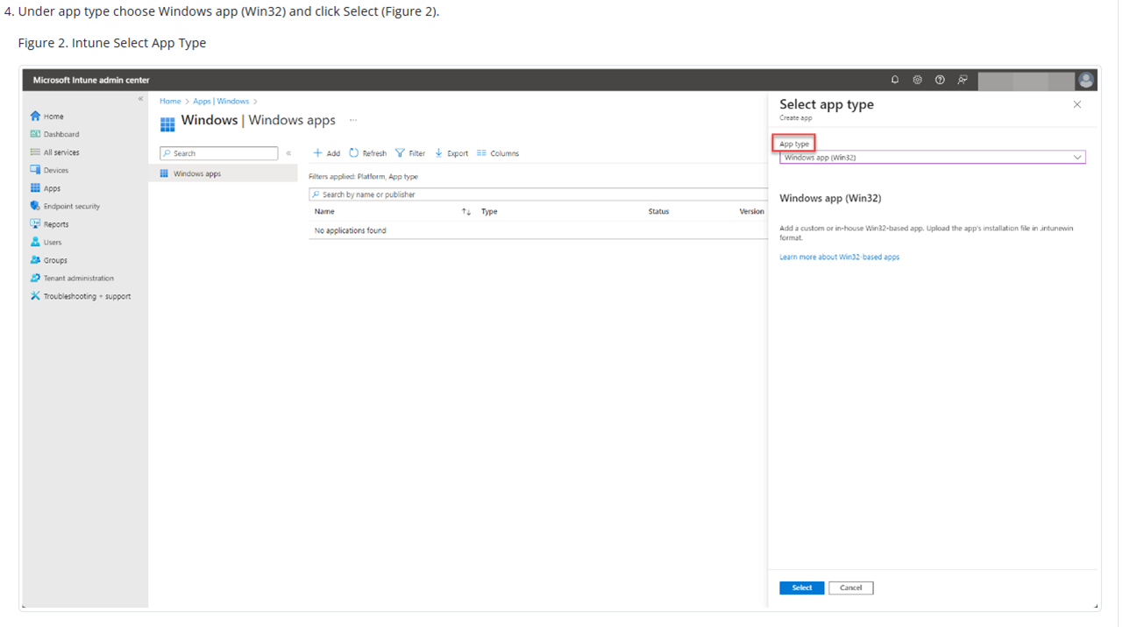
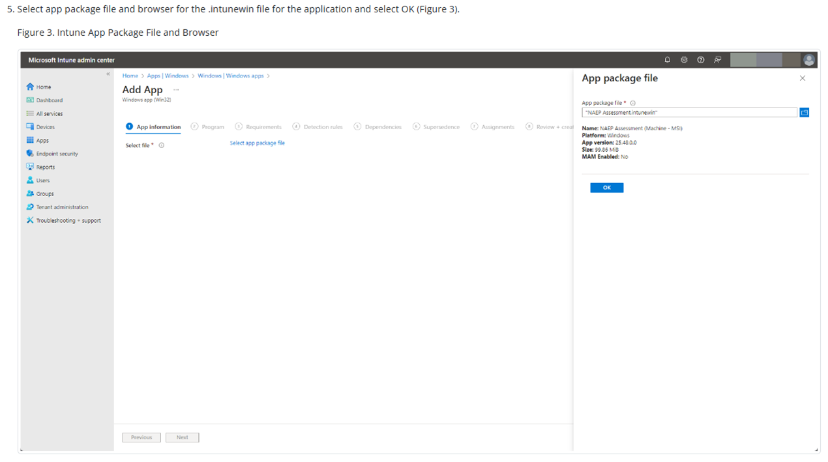
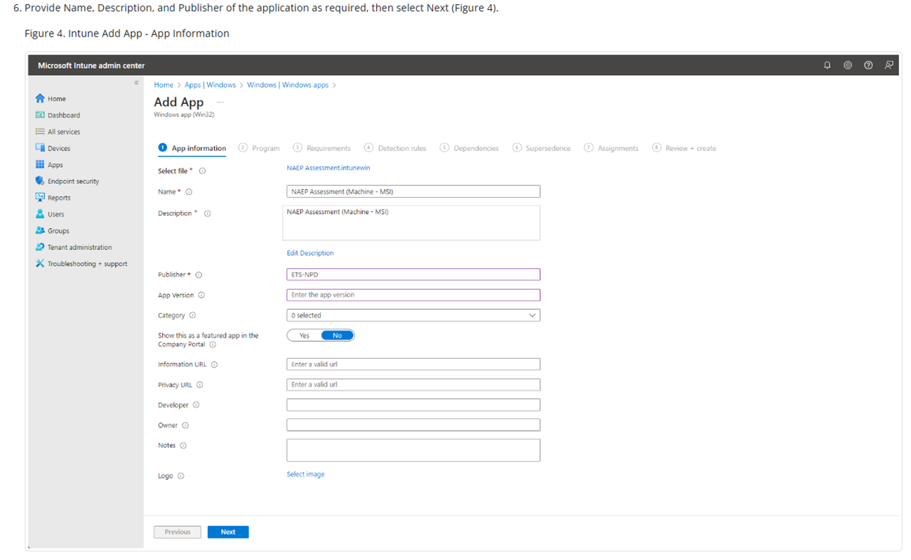
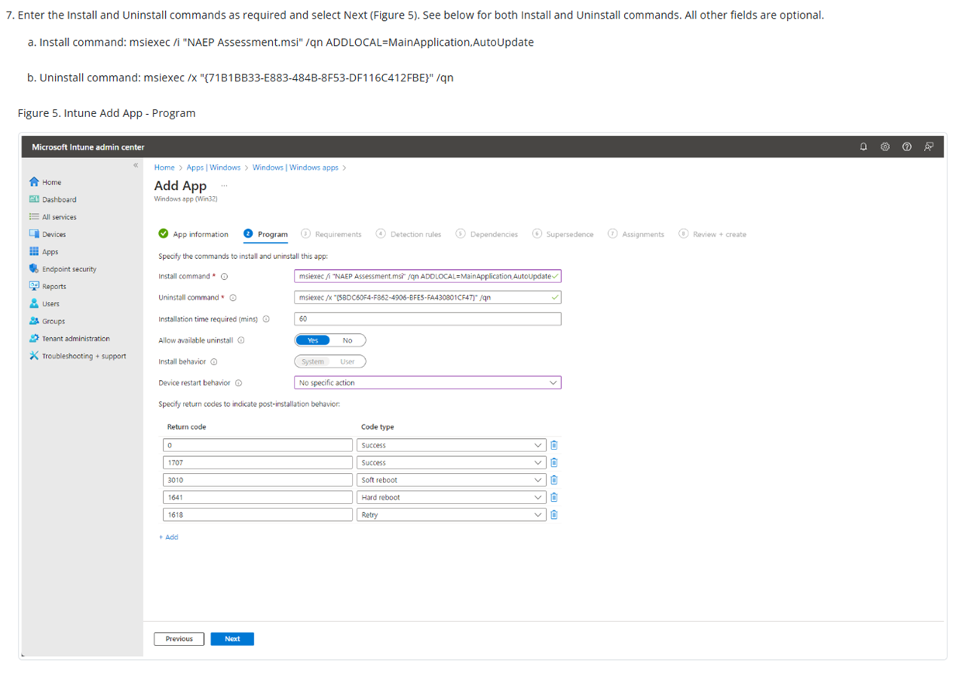
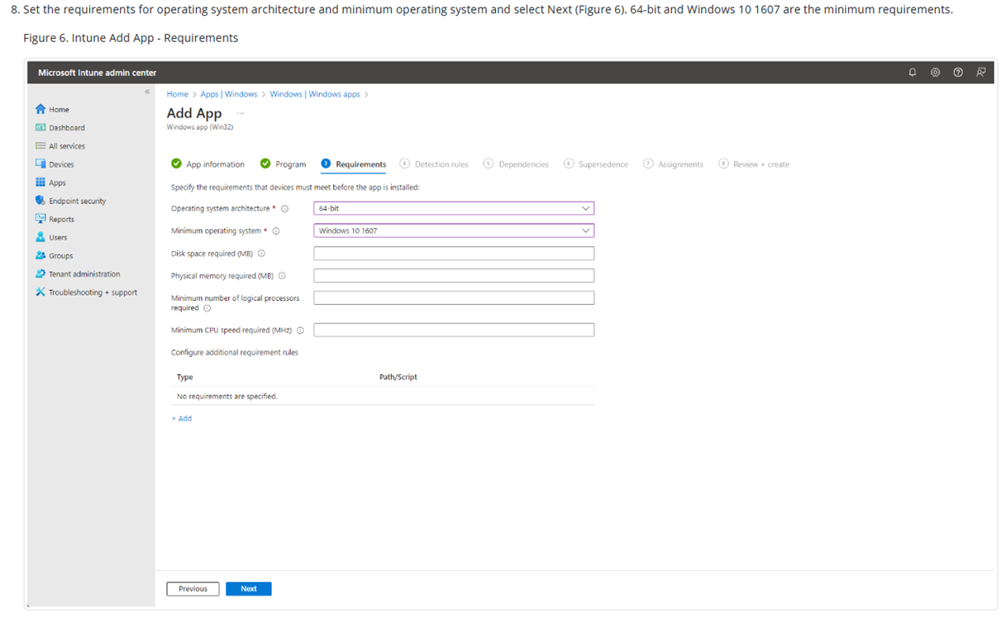
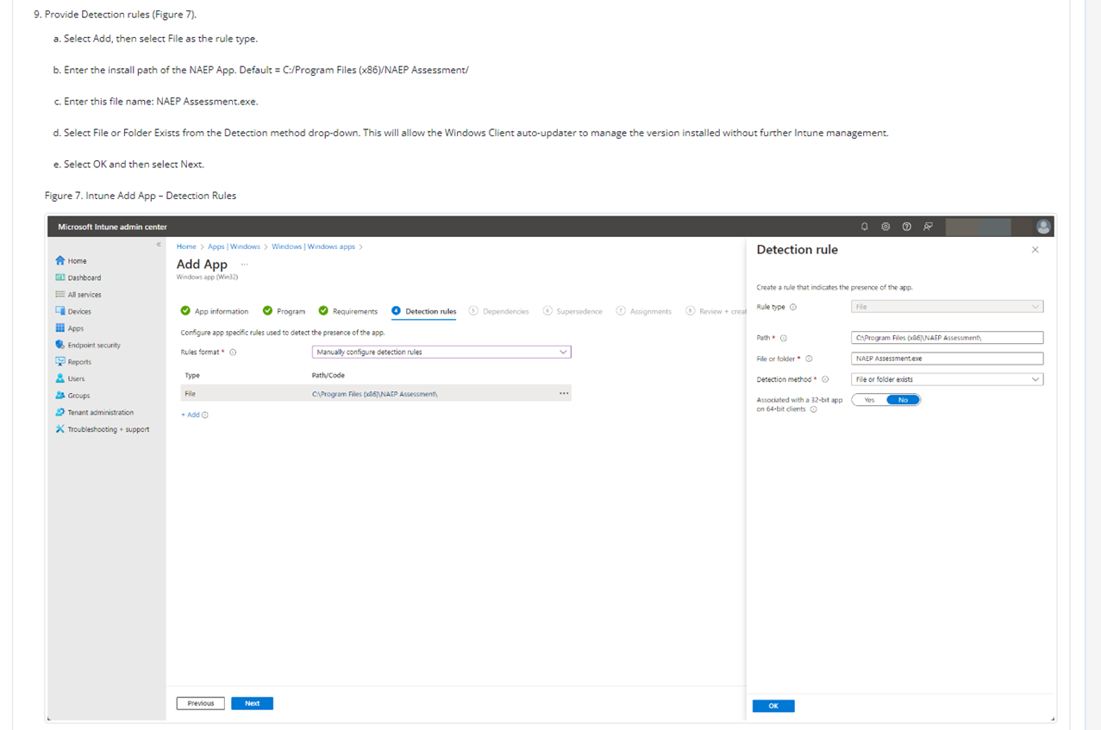
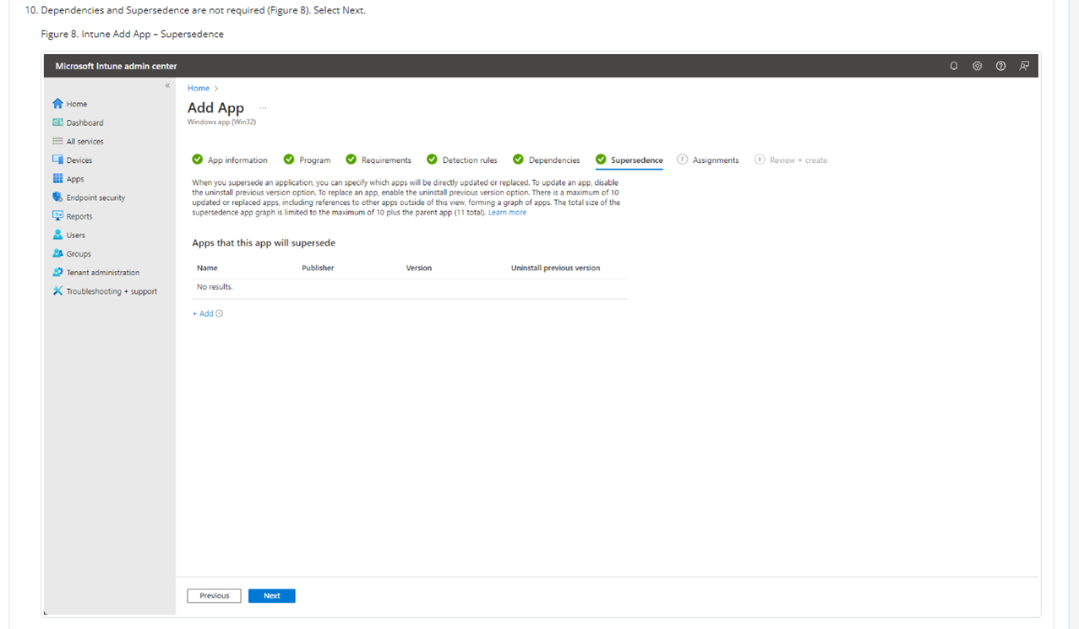
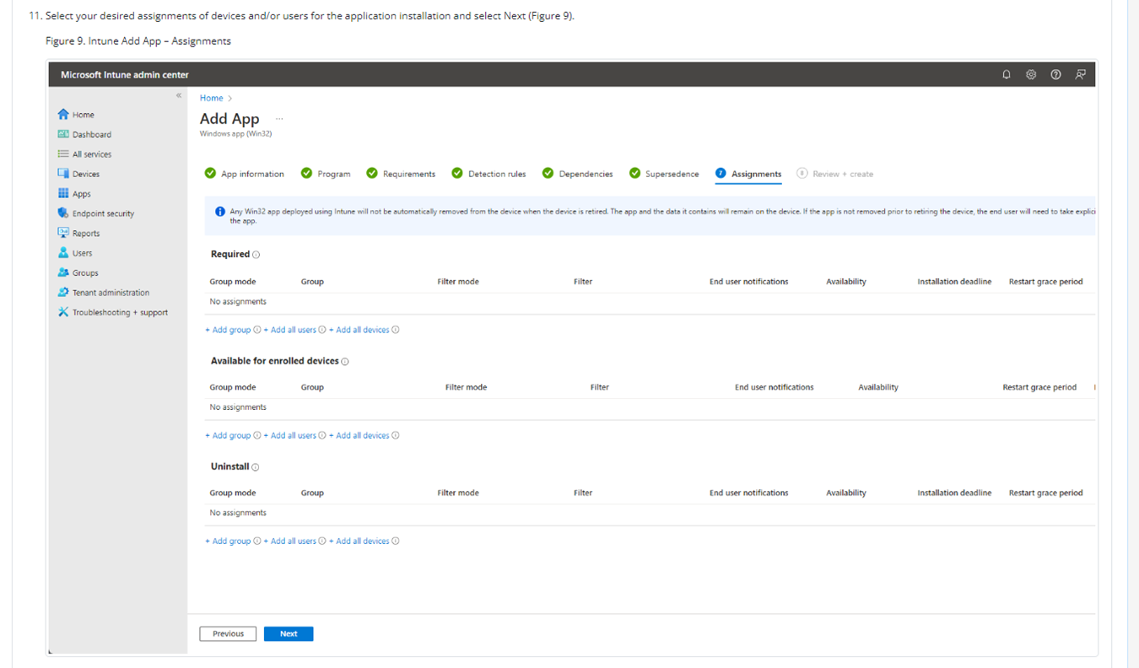
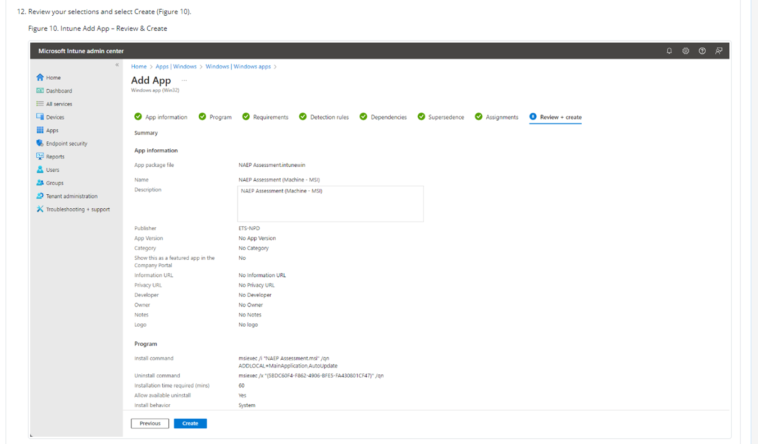
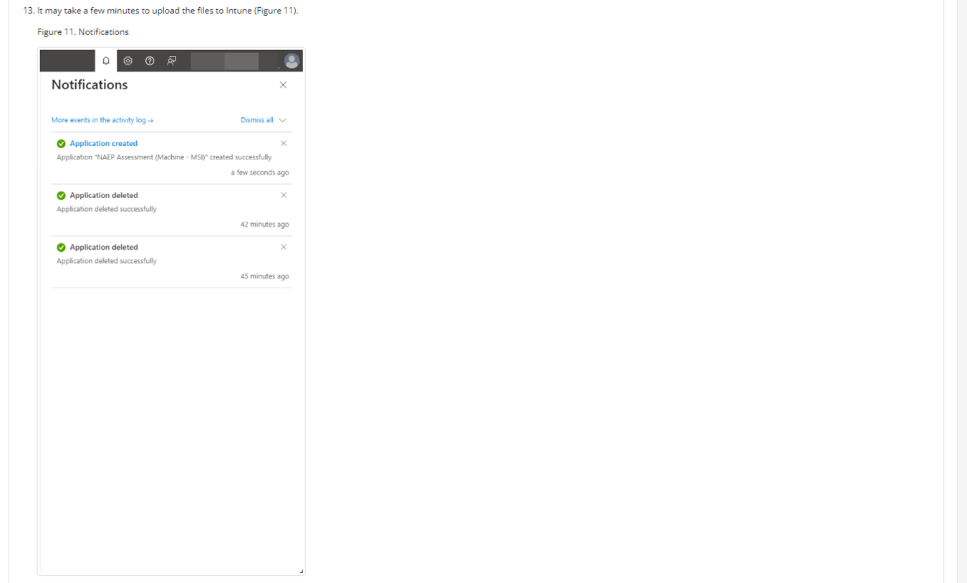
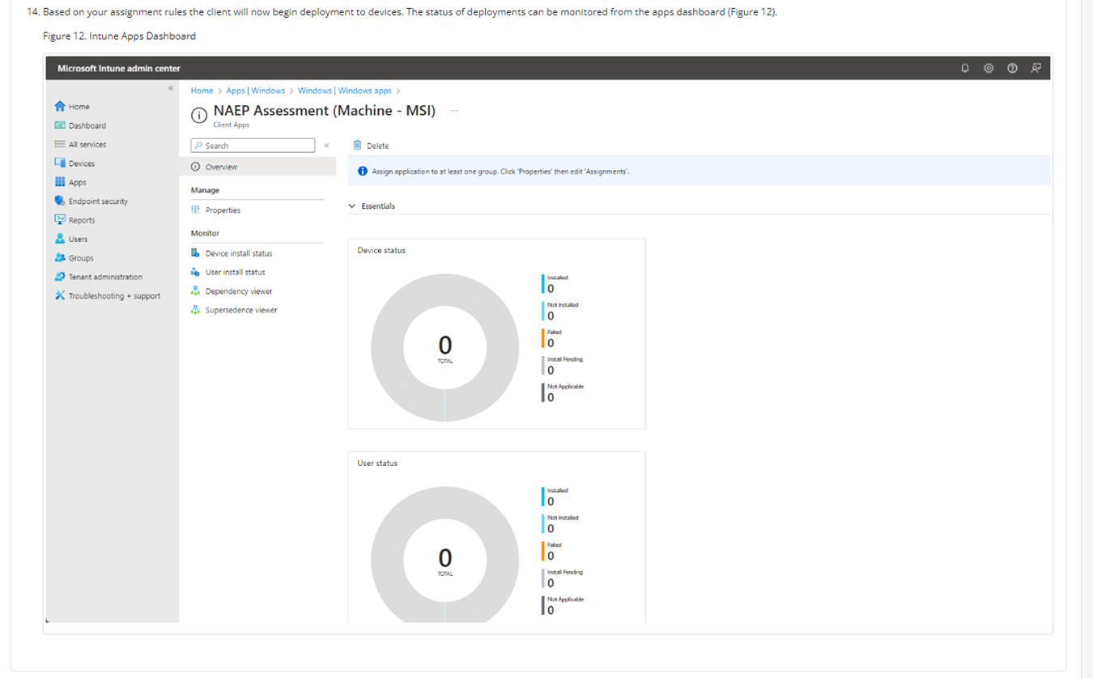

NAEP App Installation Instructions > Windows > At Scale Installation Instructions > Distributing and Installing the NAEP App via the Command Line
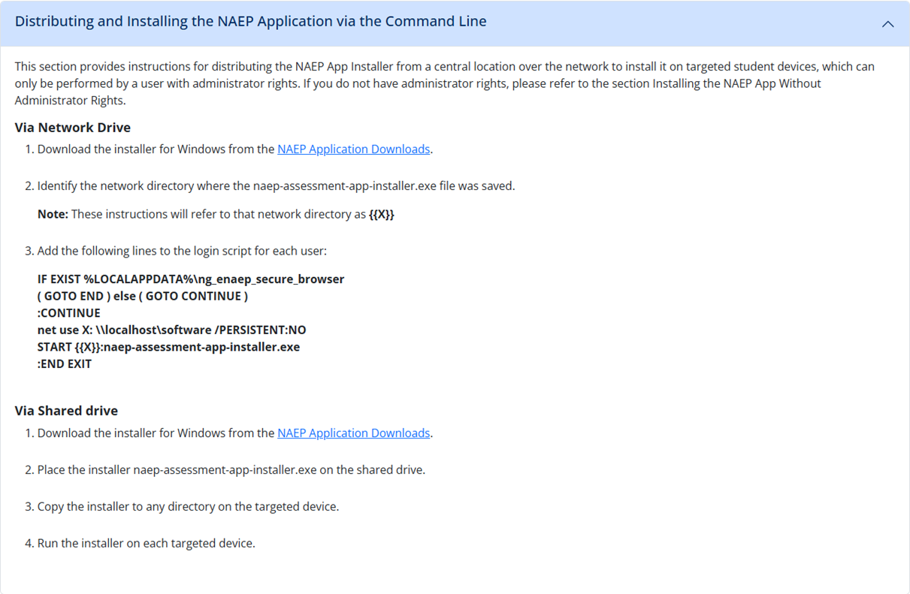

NAEP App Installation Instructions > Windows > Post-Install Verification Instructions
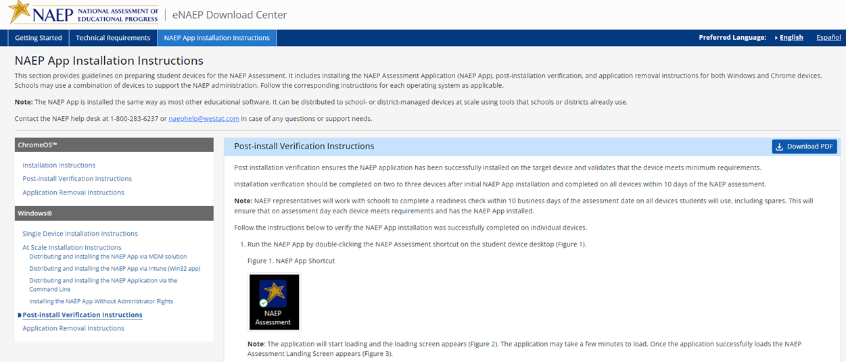
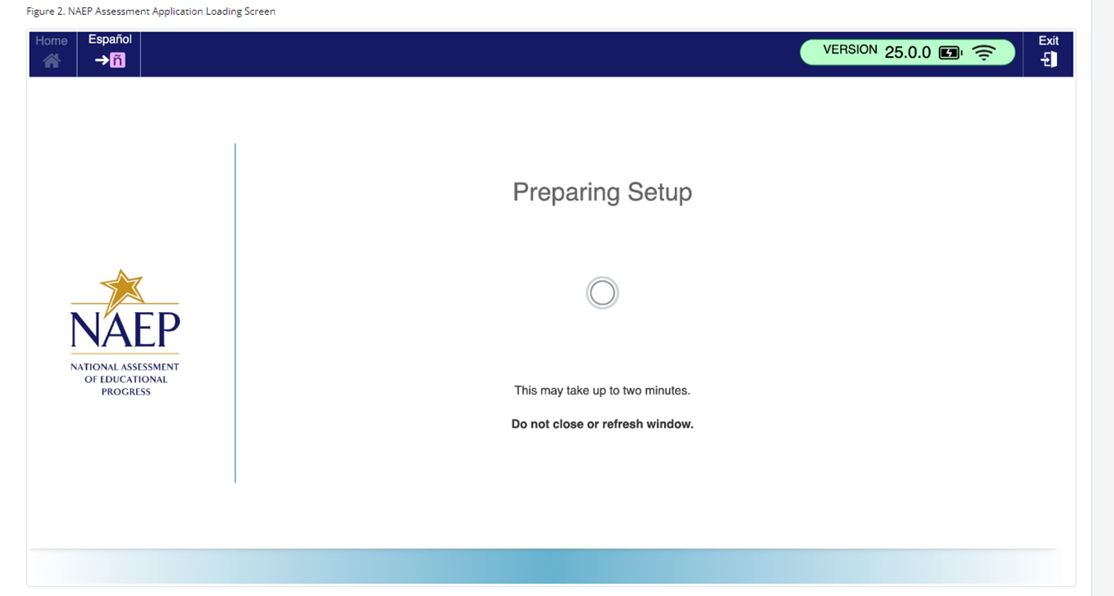
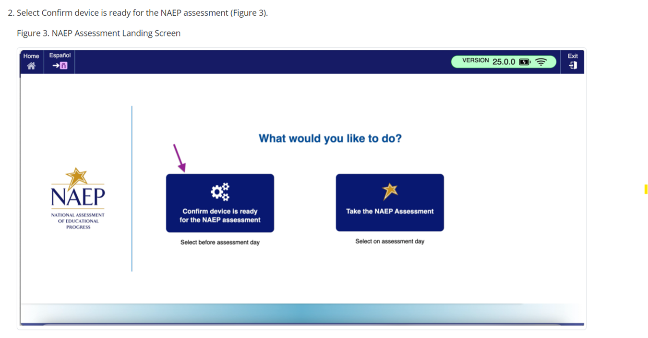
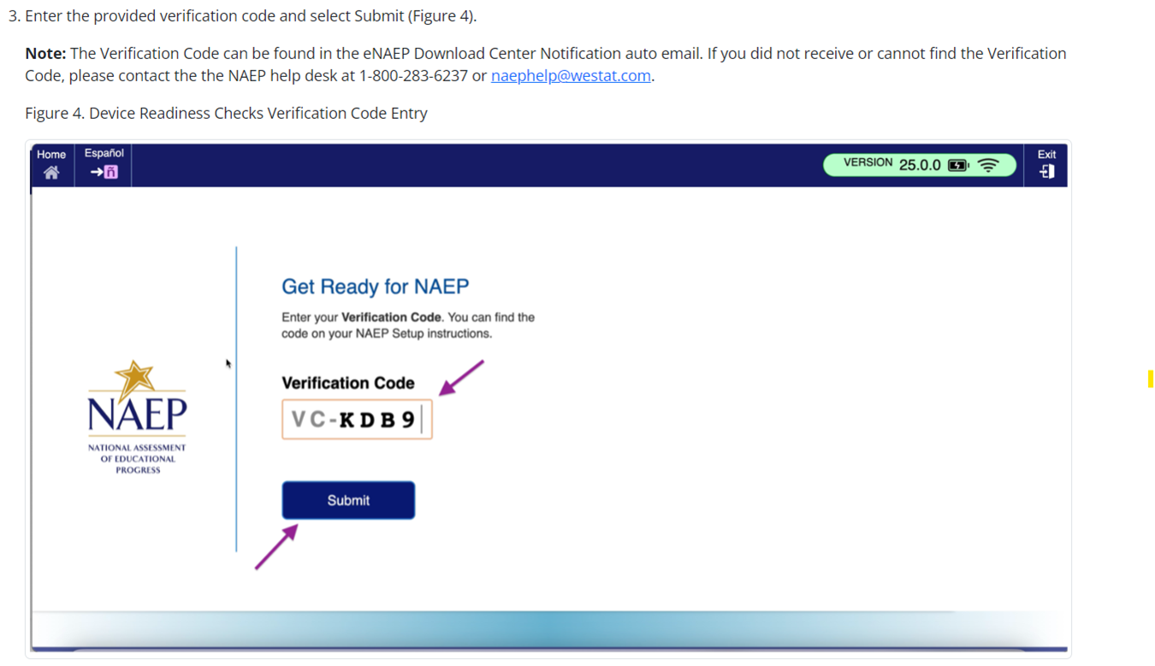
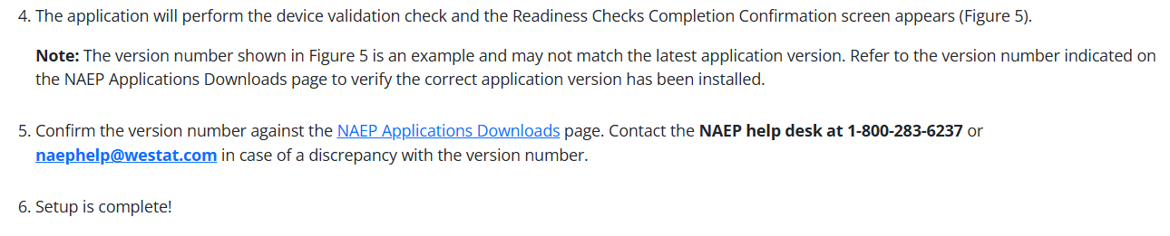
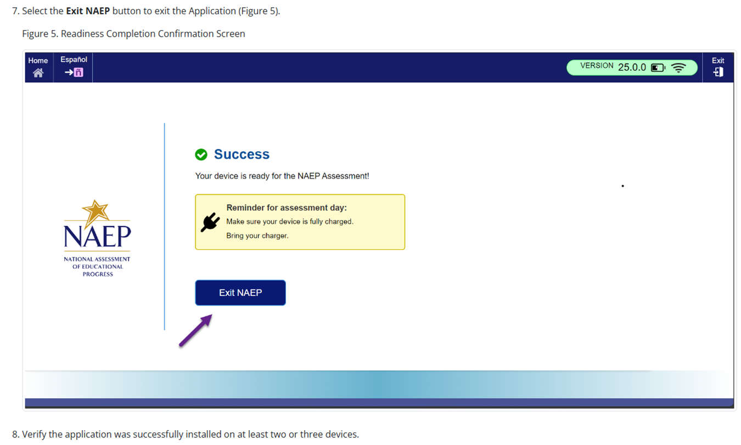

NAEP App Installation Instructions > Windows > Application Removal Instructions
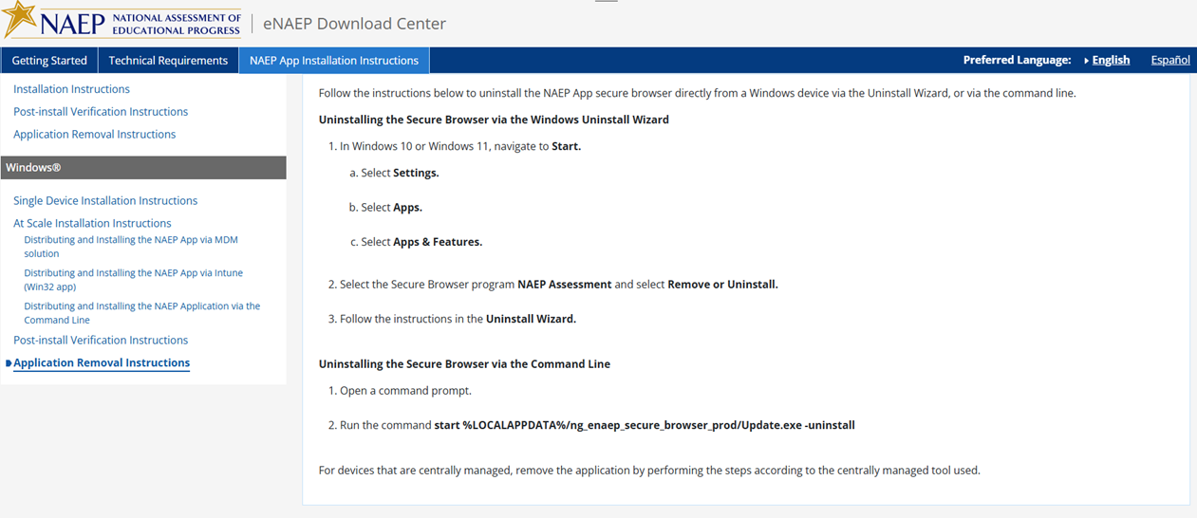

Appendix D-104: NAEP 2026 eNAEP Download Center, Spanish (NEW)

Inicio > Preparación para la evaluación > Herramientas de preevaluación
Herramientas de preevaluación
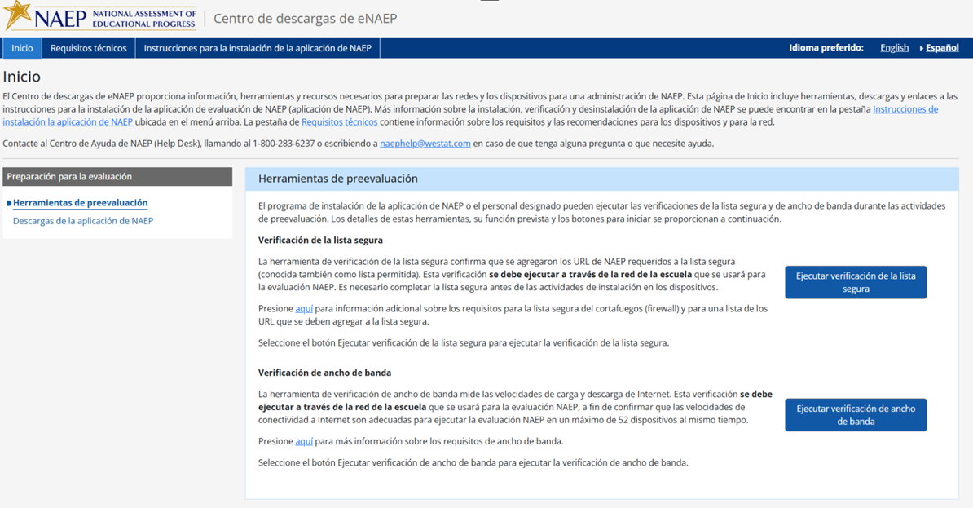

Inicio > Preparación para la evaluación > Descargas de la aplicación de NAEP

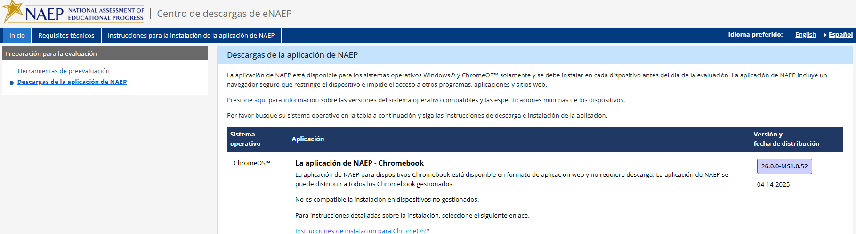
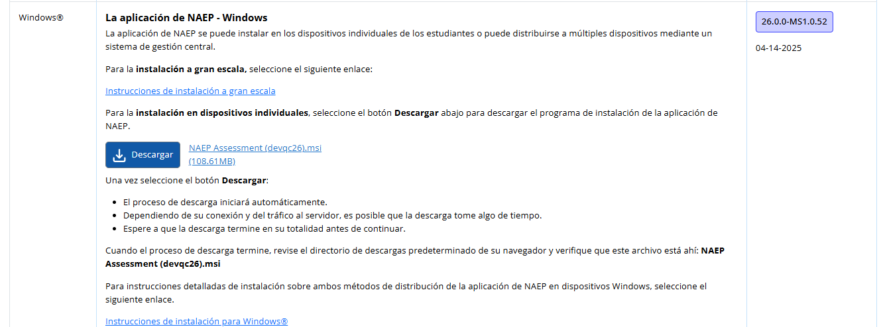

Requisitos técnicos > Requisitos del sistema > Requisitos de los sistemas operativos y del equipo
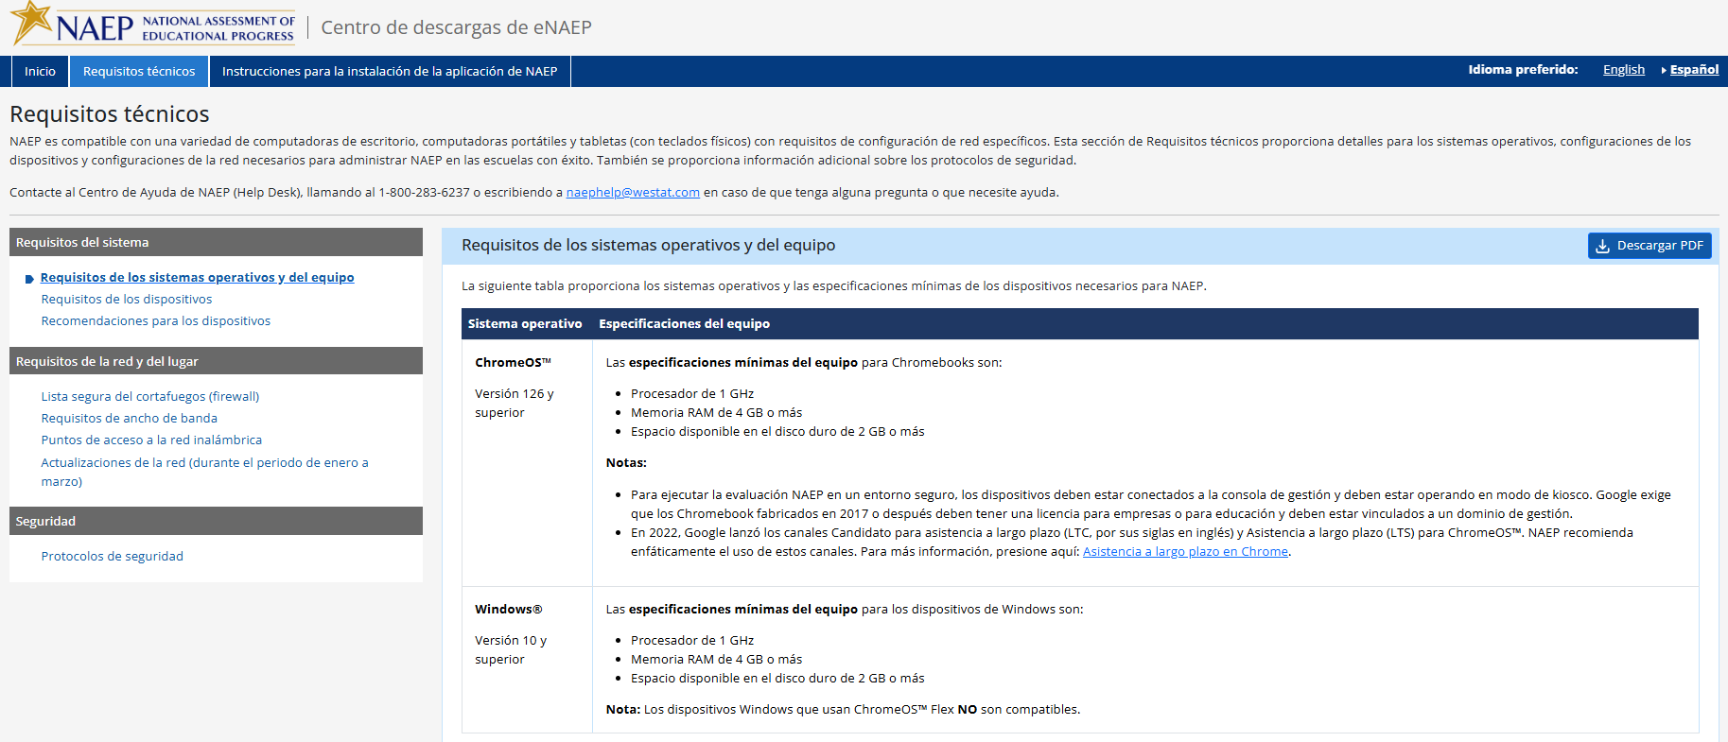

Requisitos técnicos > Requisitos del sistema >Requisitos de los dispositivos
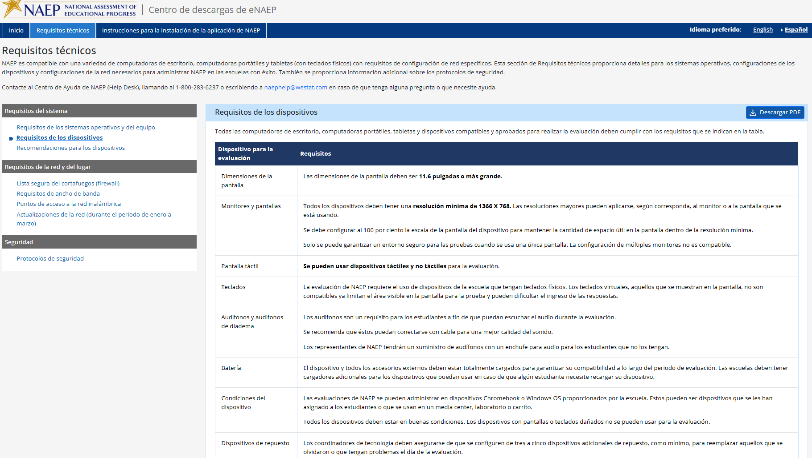

Requisitos técnicos > Requisitos del sistema > Recomendaciones para los dispositivos
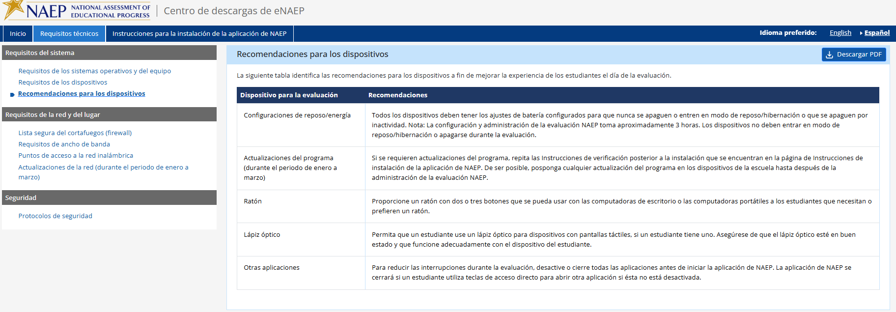

Requisitos técnicos > Requisitos de la red y del lugar >Lista segura del cortafuegos (firewall)

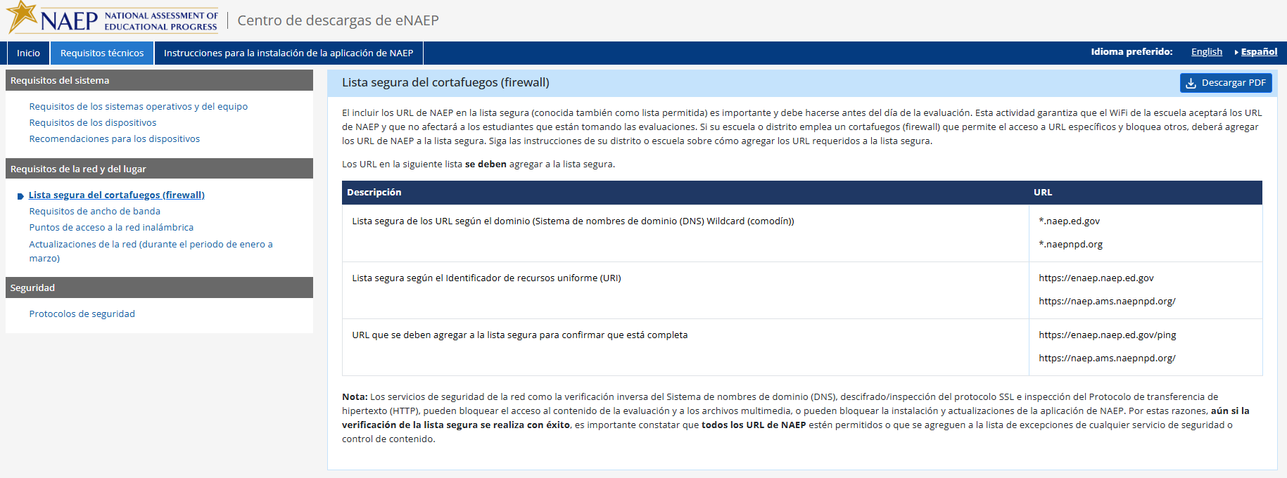

Requisitos técnicos > Requisitos de la red y del lugar > Requisitos de ancho de banda
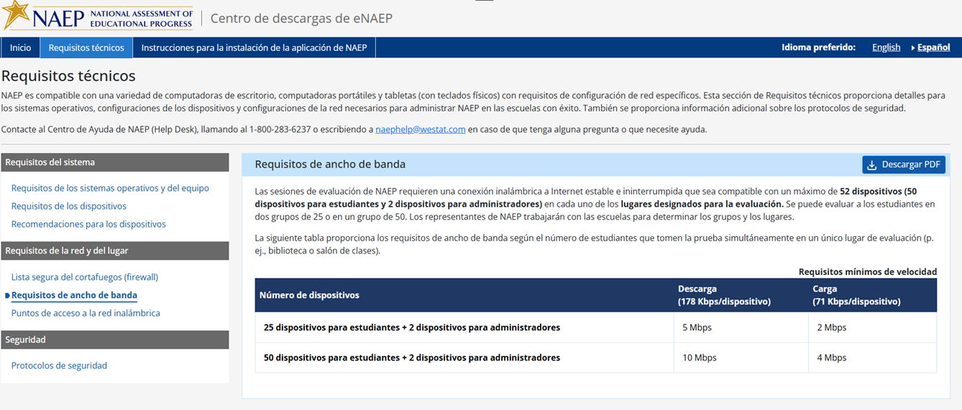

Requisitos técnicos > Requisitos de la red y del lugar > Puntos de acceso a la red inalámbrica
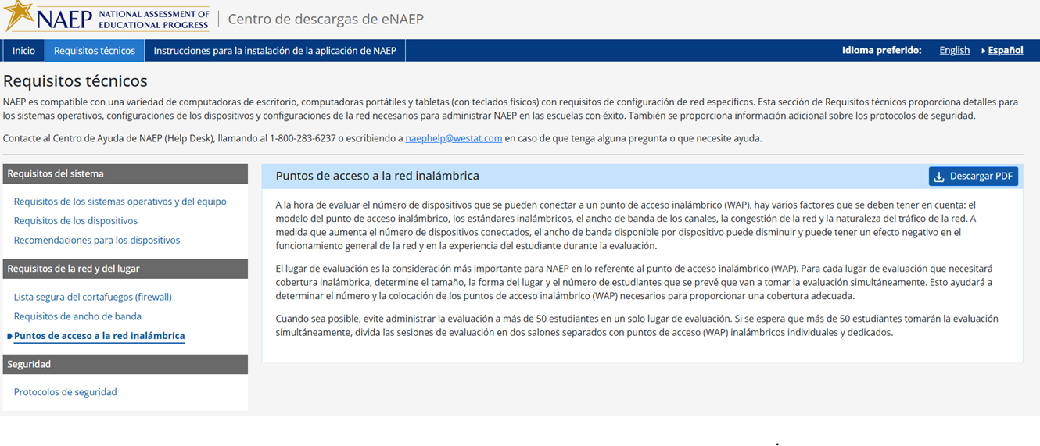

Requisitos técnicos > Seguridad > Protocolos de seguridad
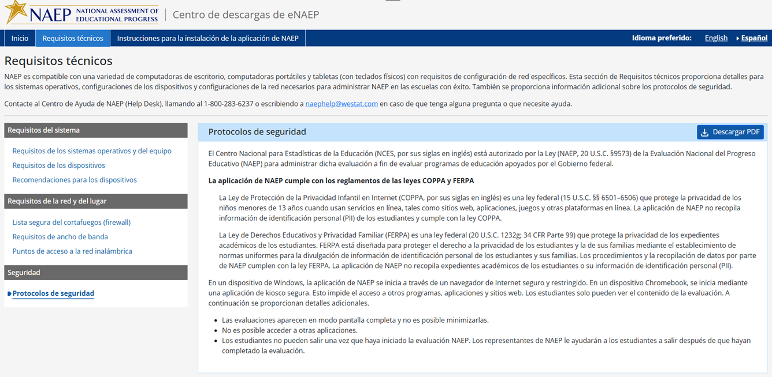

Instrucciones para la instalación de la aplicación de NAEP > ChromeOS > Instrucciones de instalación
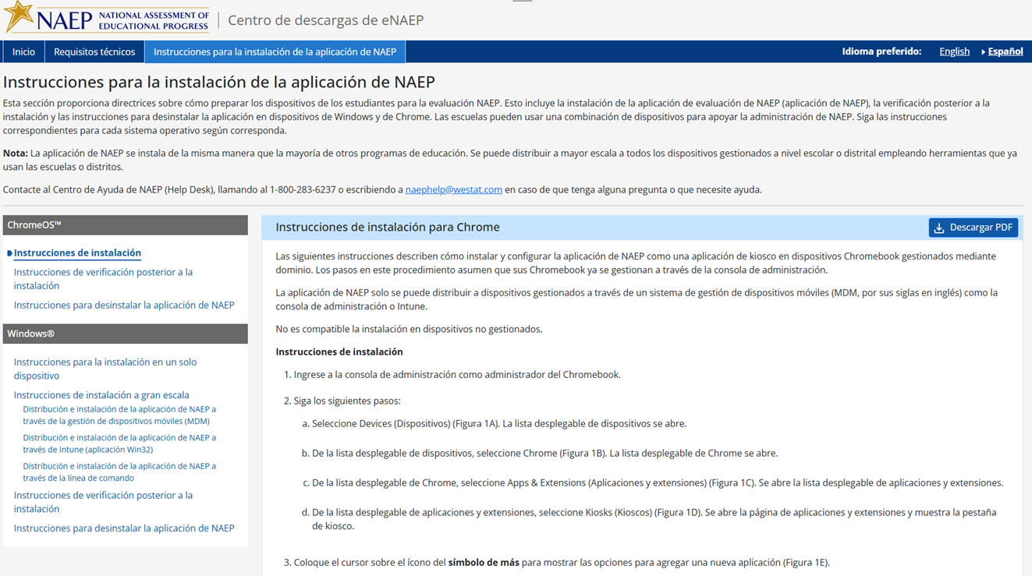
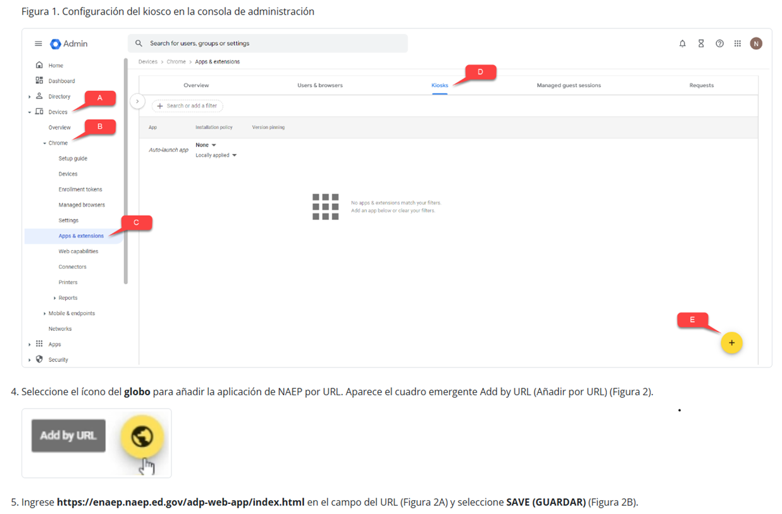
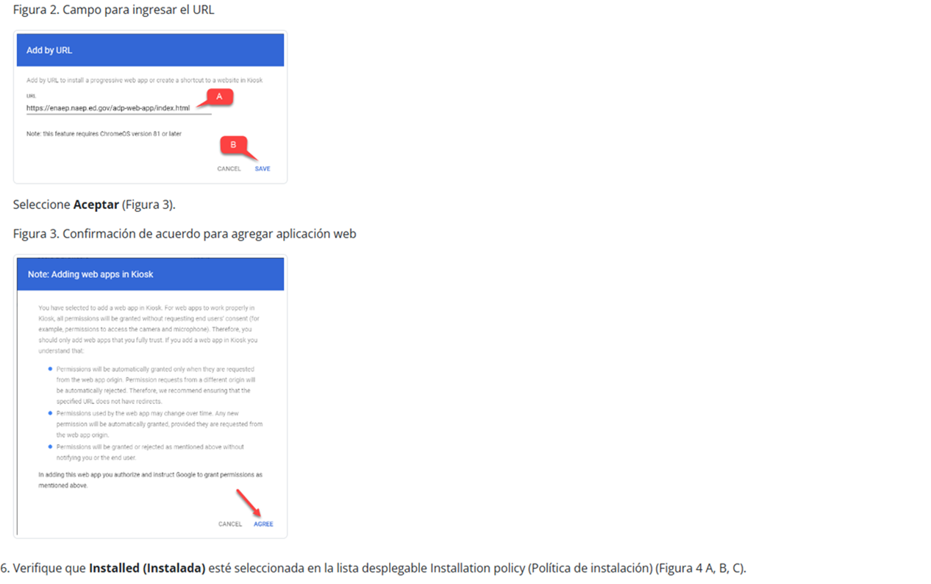
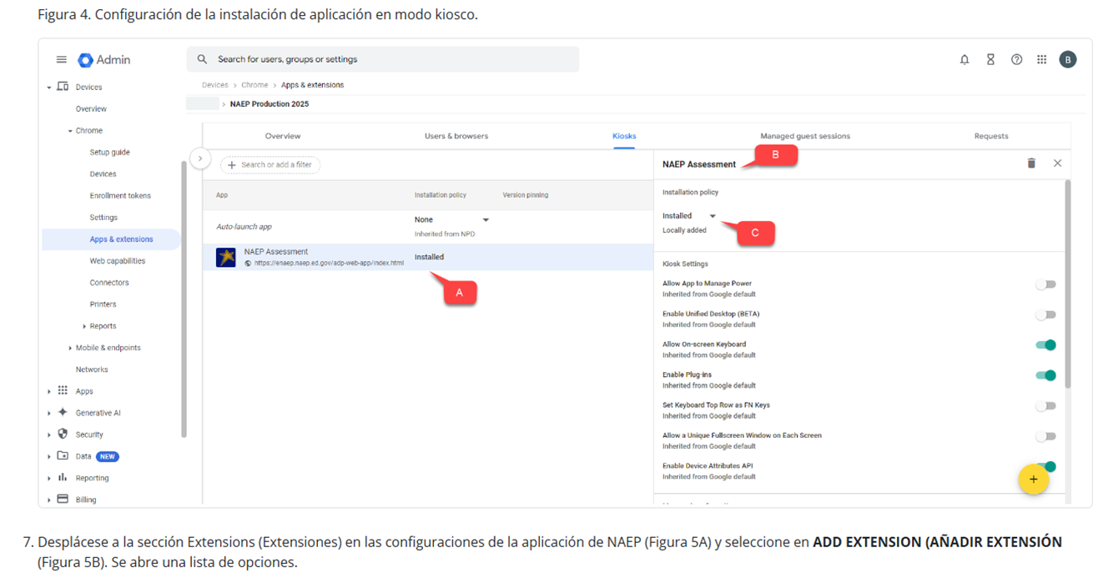
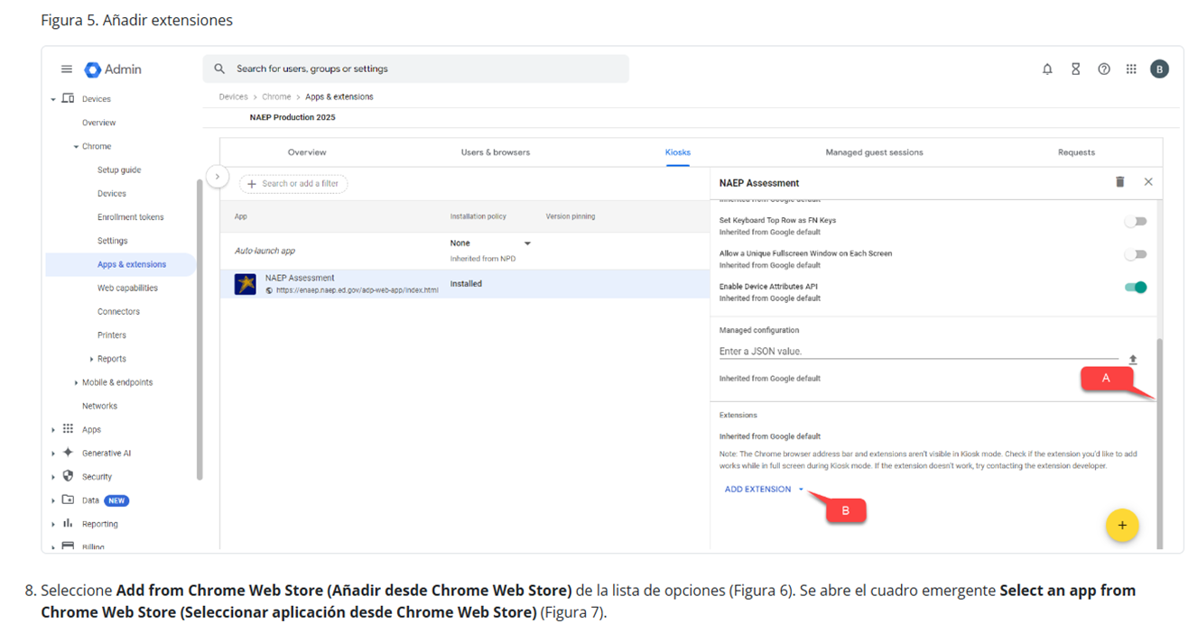
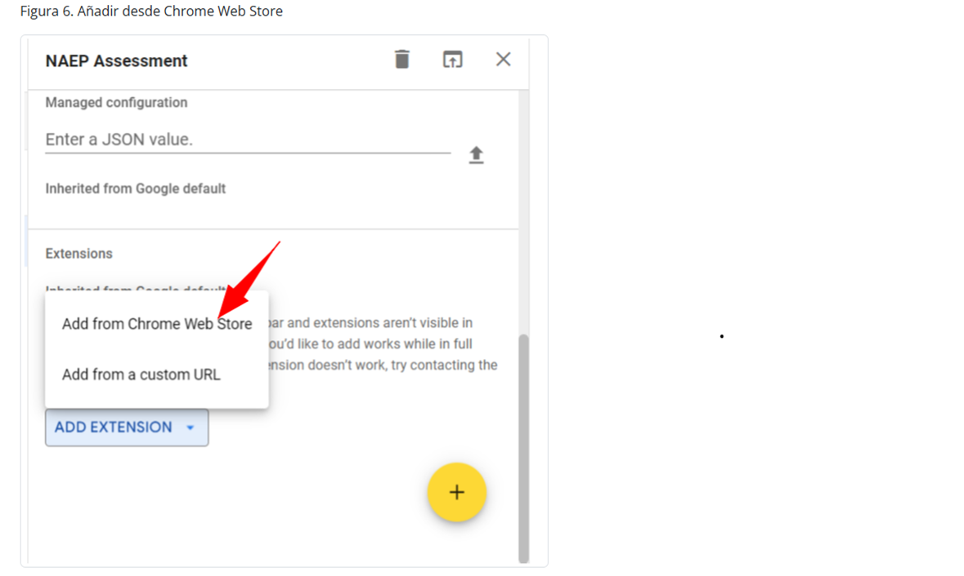
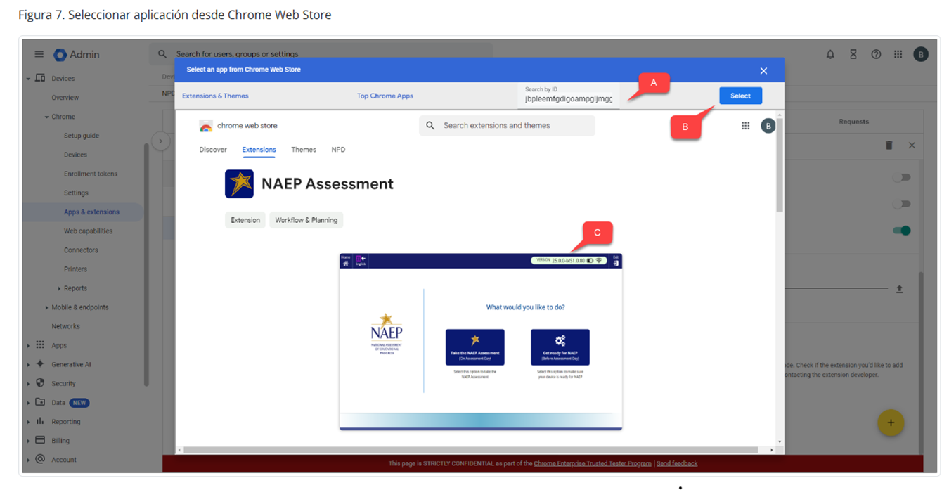
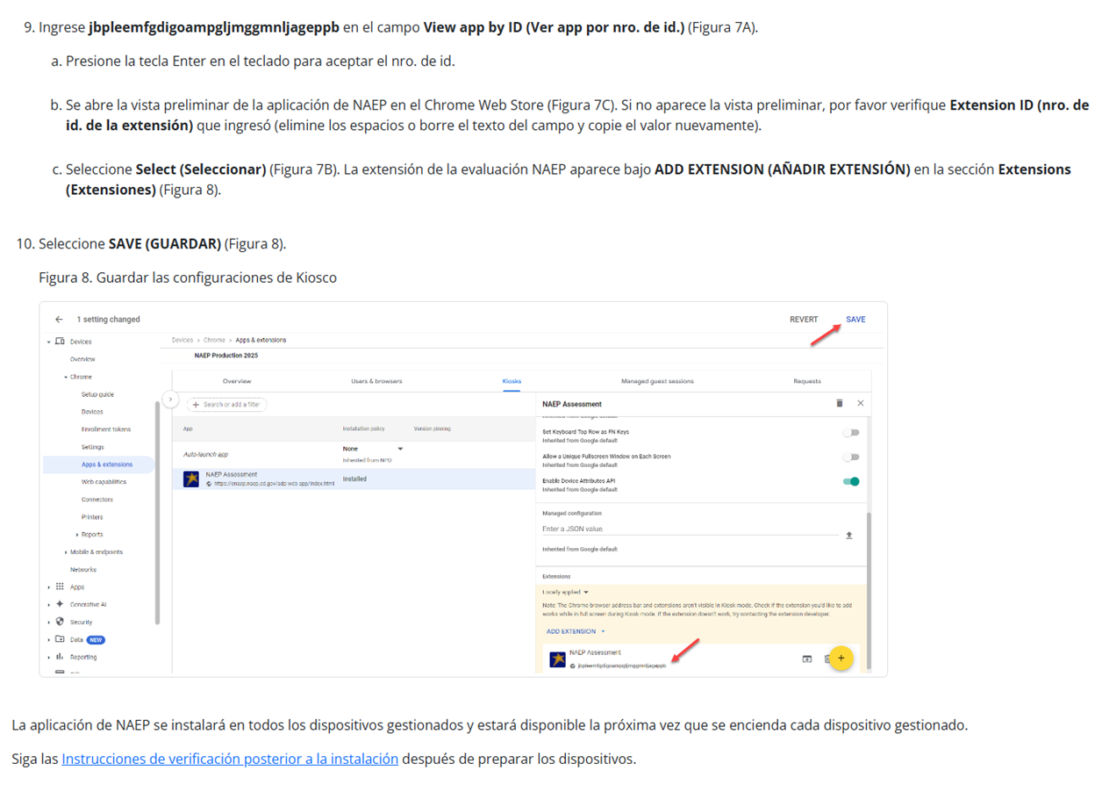

Instrucciones para la instalación de la aplicación de NAEP > ChromeOS > Instrucciones de verificación posterior a la instalación

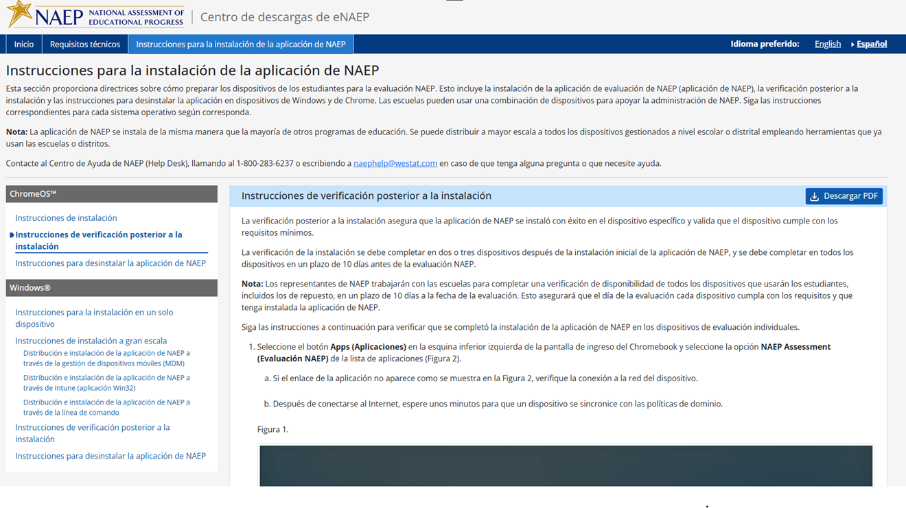

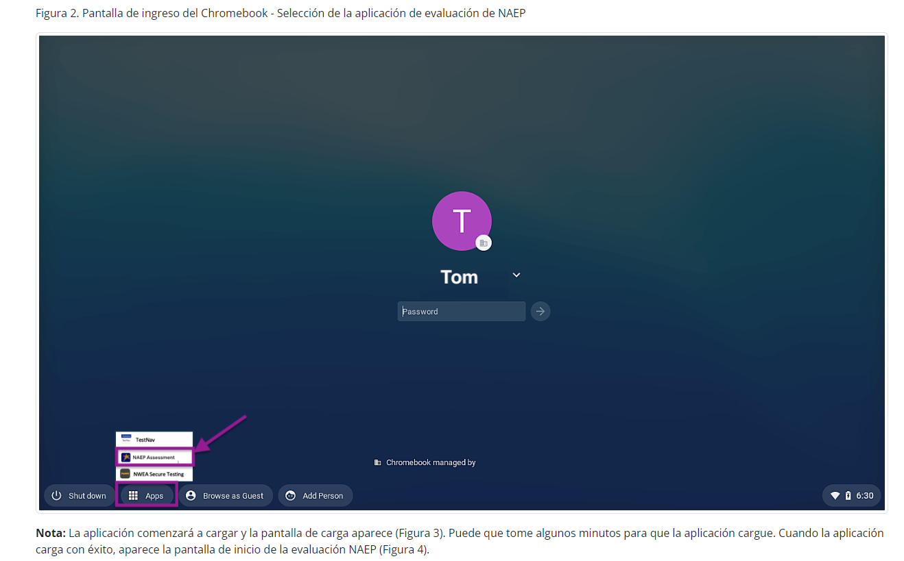
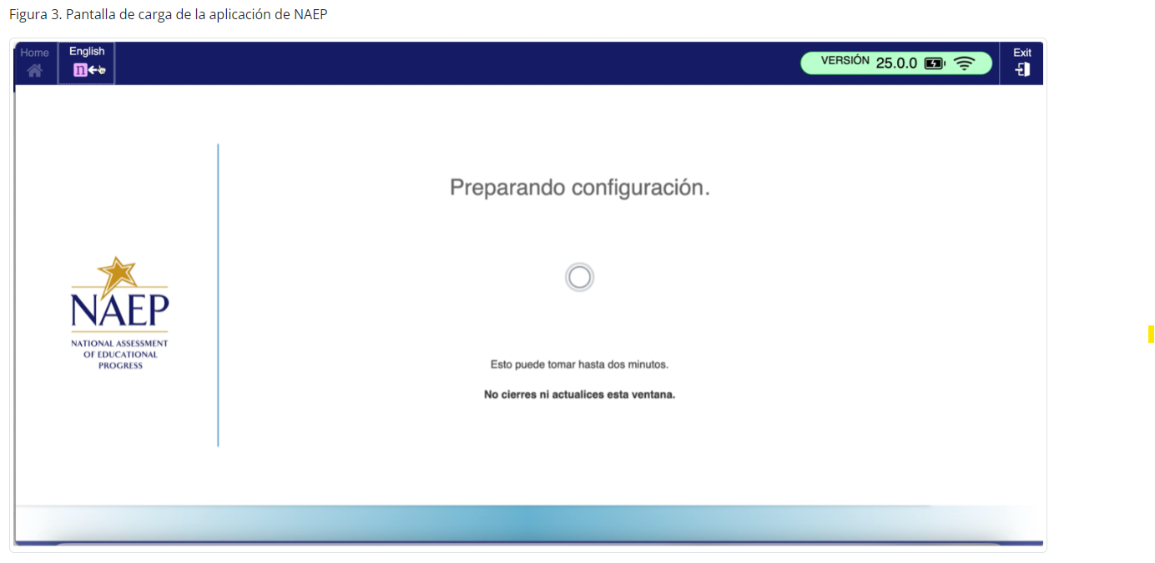
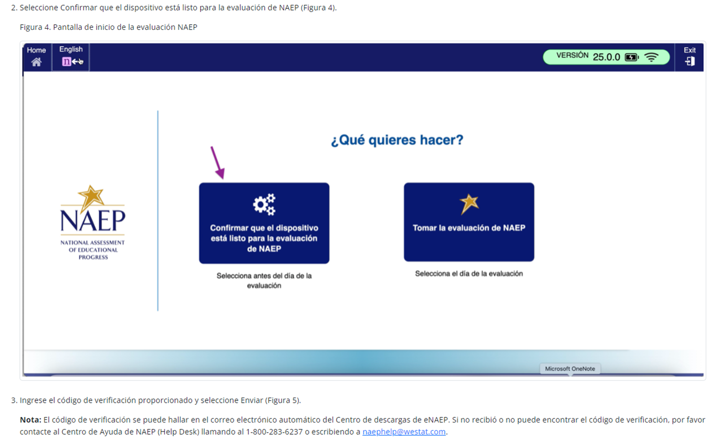

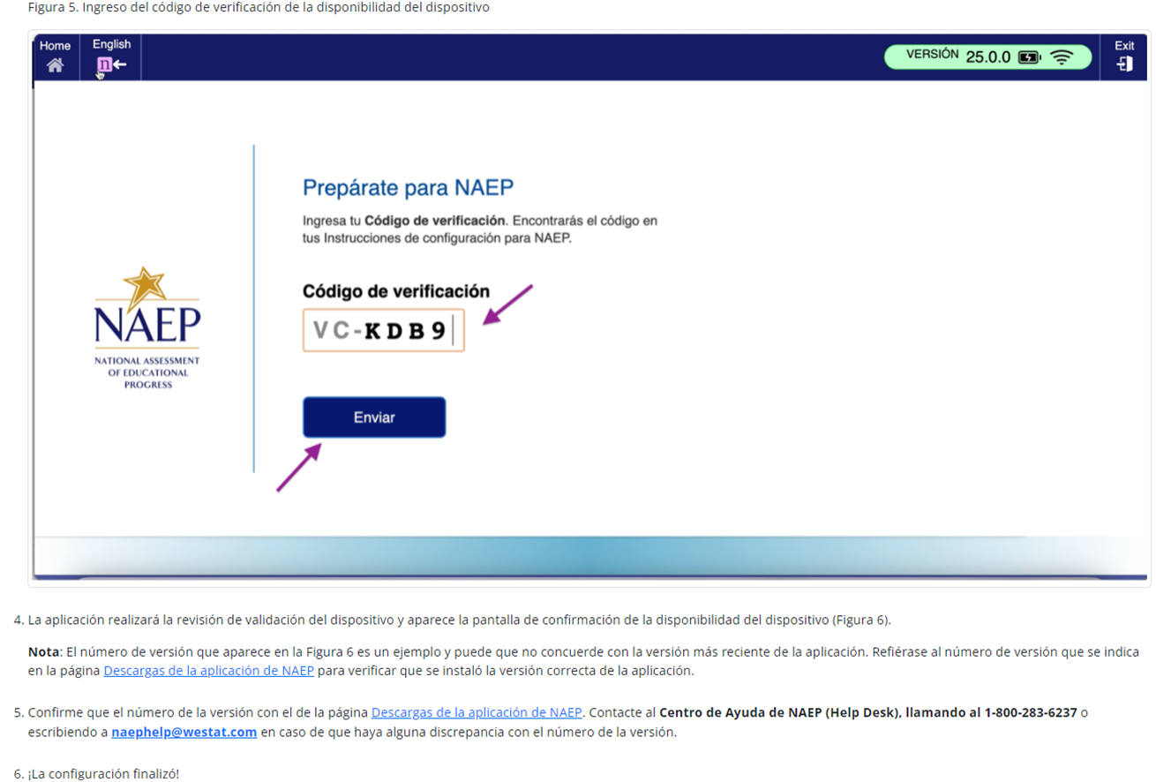
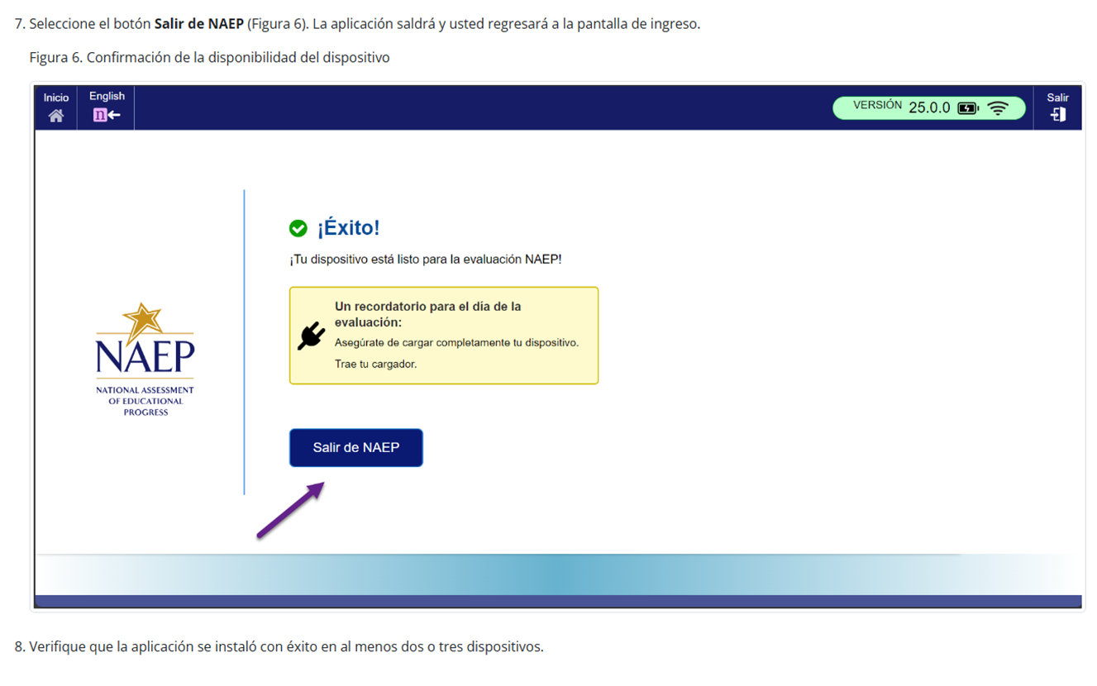

Instrucciones para la instalación de la aplicación de NAEP > ChromeOS > Instrucciones para desinstalar la aplicación de NAEP

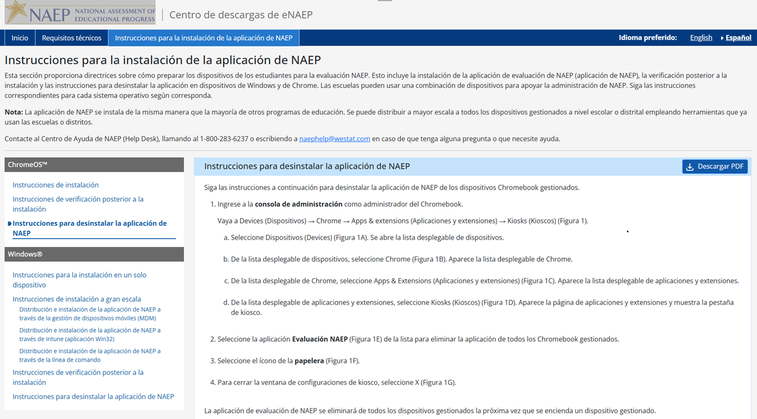
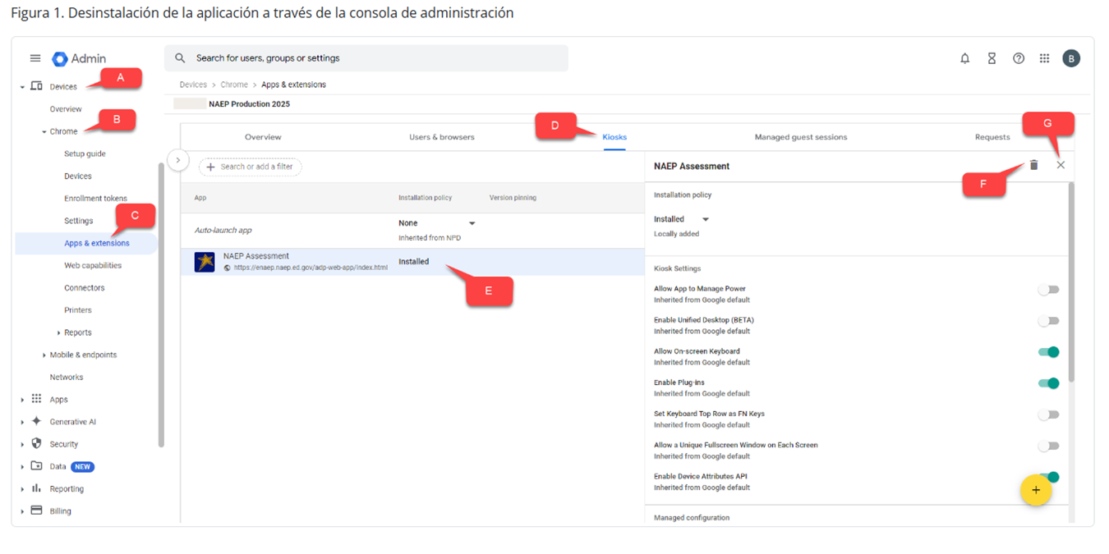

Instrucciones para la instalación de la aplicación de NAEP > Windows > Instrucciones para la instalación en un solo dispositivo
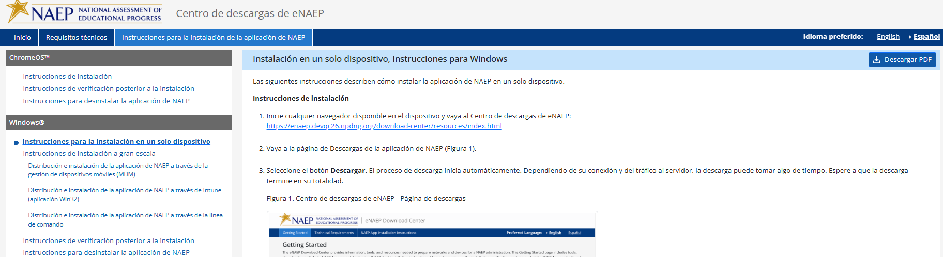
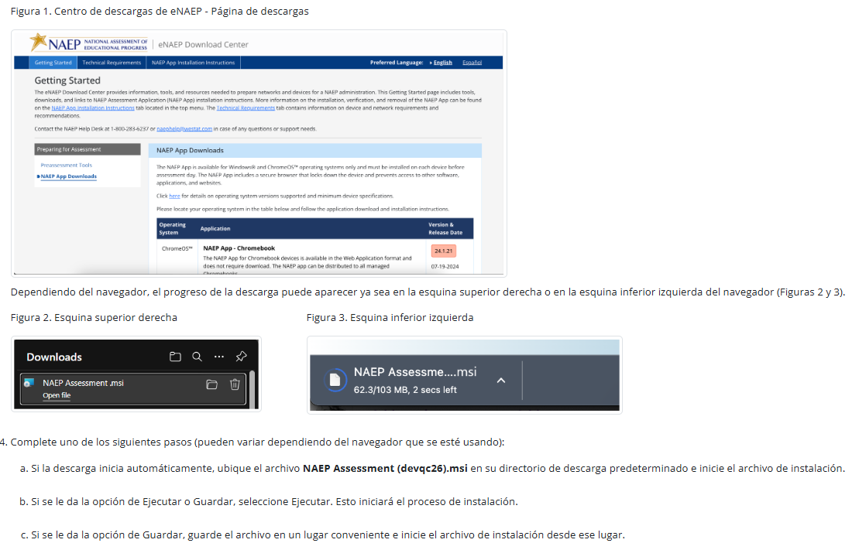
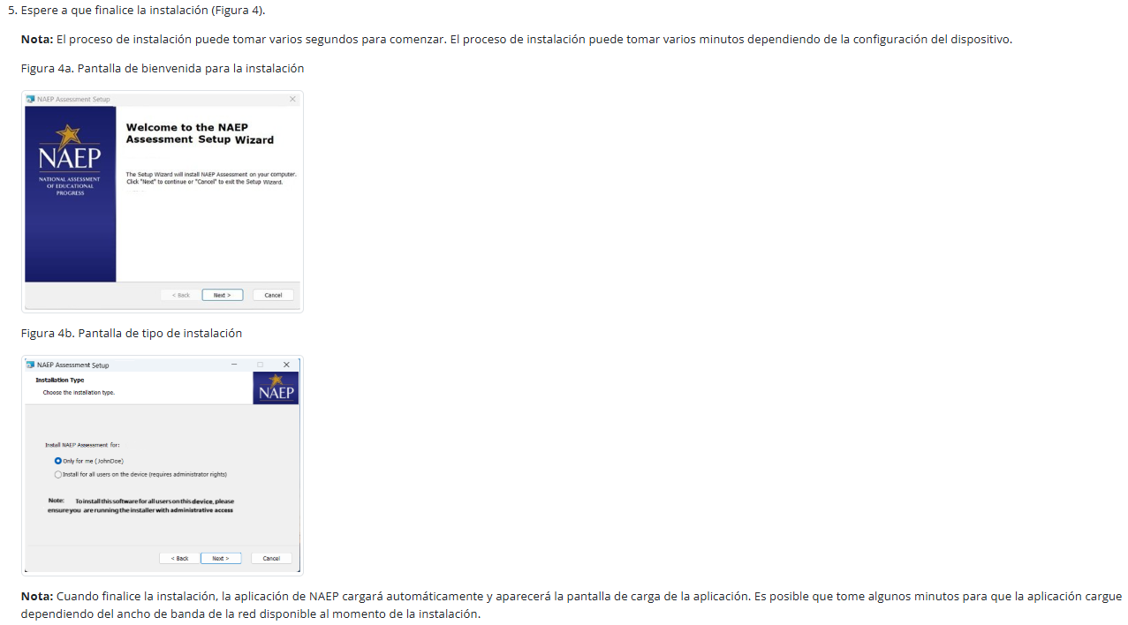
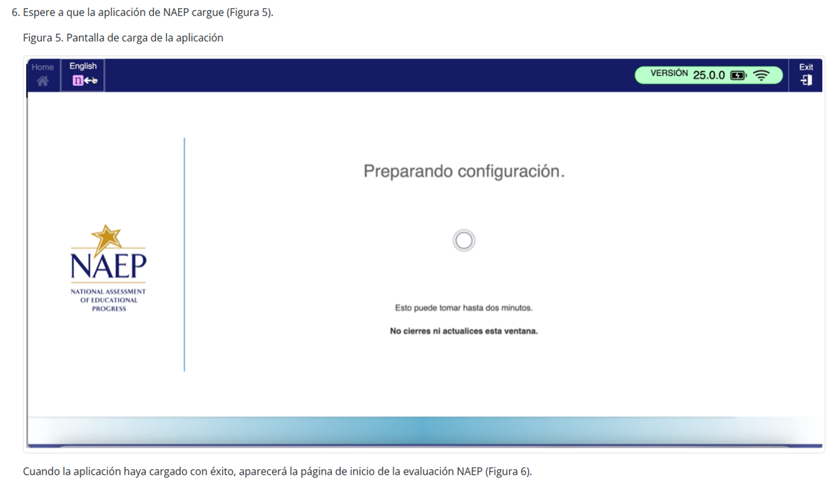
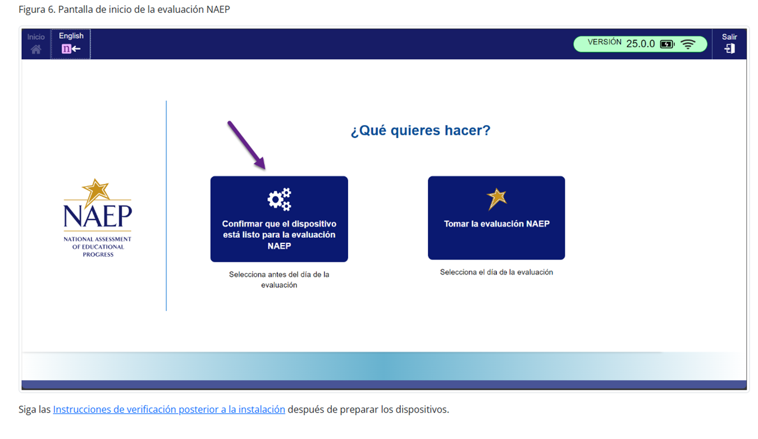

Instrucciones para la instalación de la aplicación de NAEP > Windows > Instrucciones de instalación a gran escala

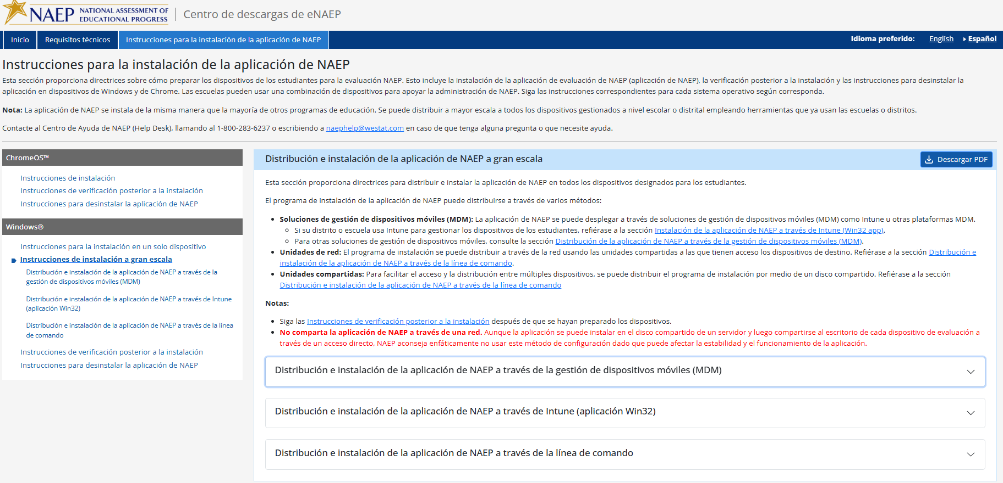

Instrucciones para la instalación de la aplicación de NAEP > Windows > Instrucciones de instalación a gran escala > Distribución e instalación de la aplicación de NAEP a través de la gestión de dispositivos móviles (MDM)

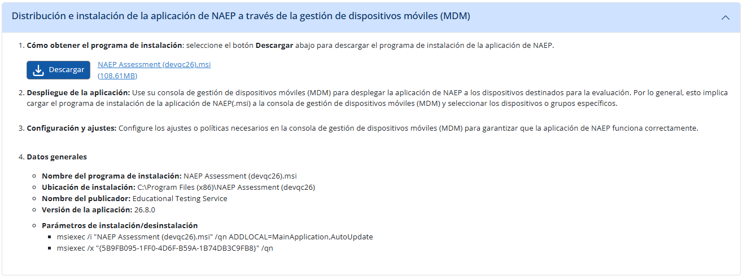

Instrucciones para la instalación de la aplicación de NAEP > Windows > Instrucciones de instalación a gran escala > Distribución e instalación de la aplicación de NAEP a través de Intune (aplicación Win32)
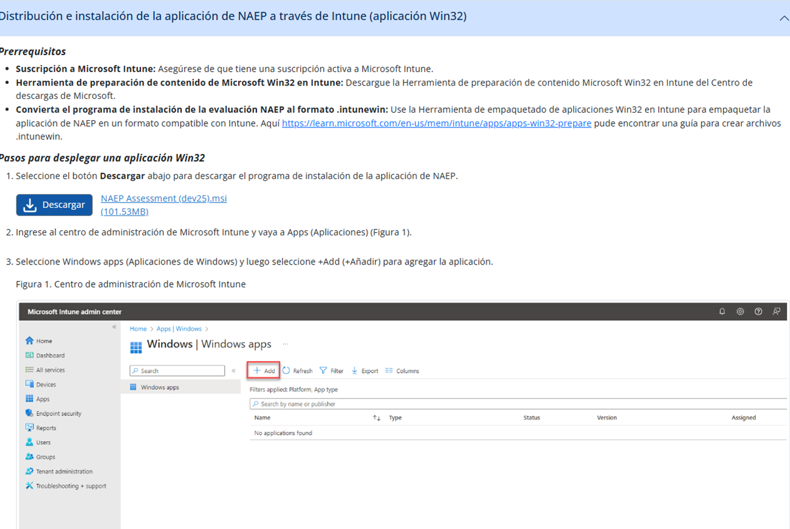
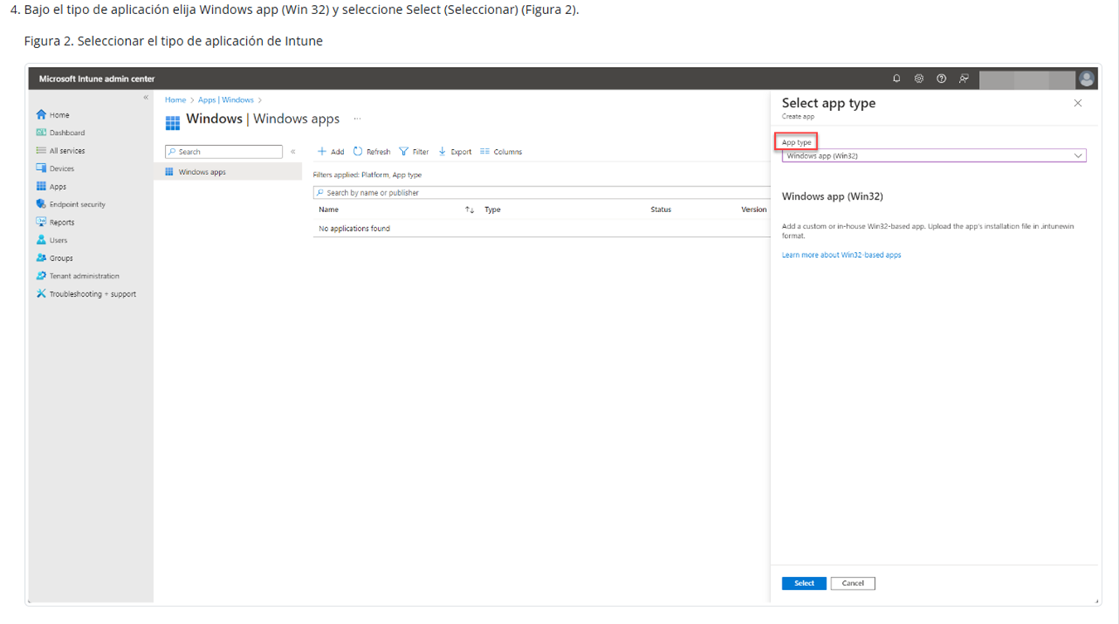
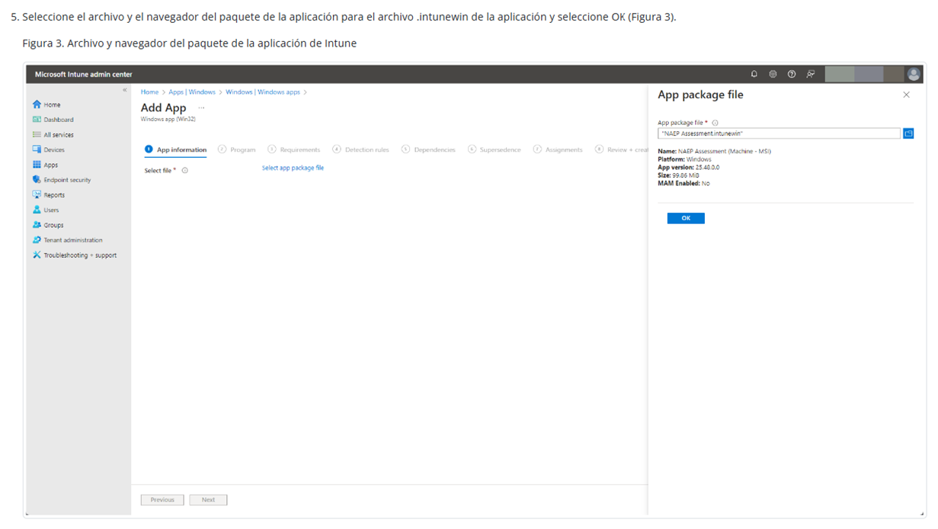
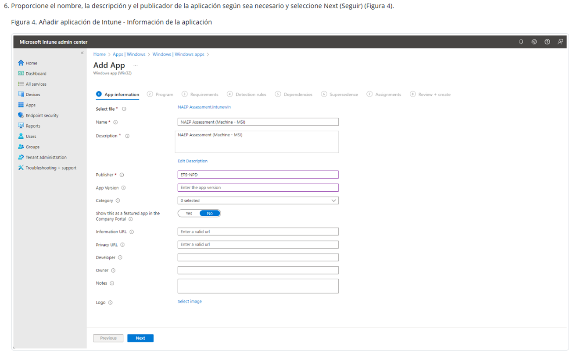
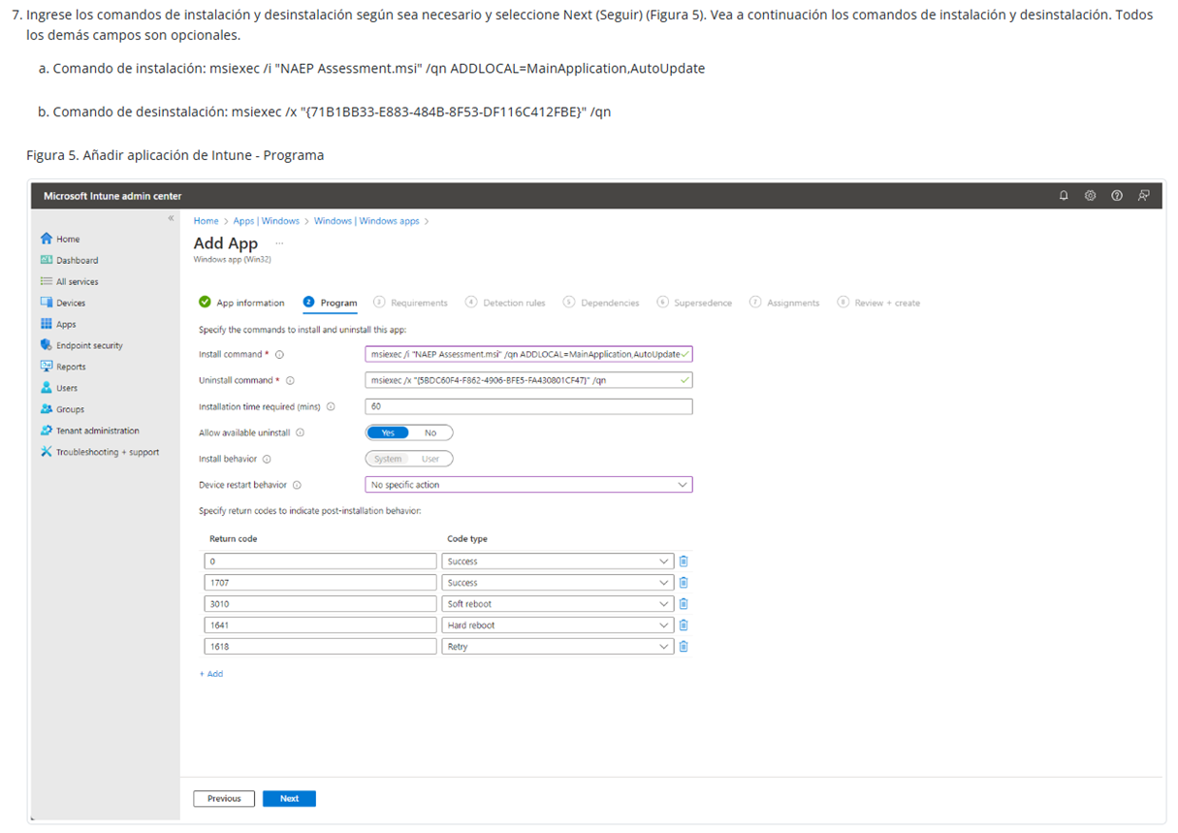
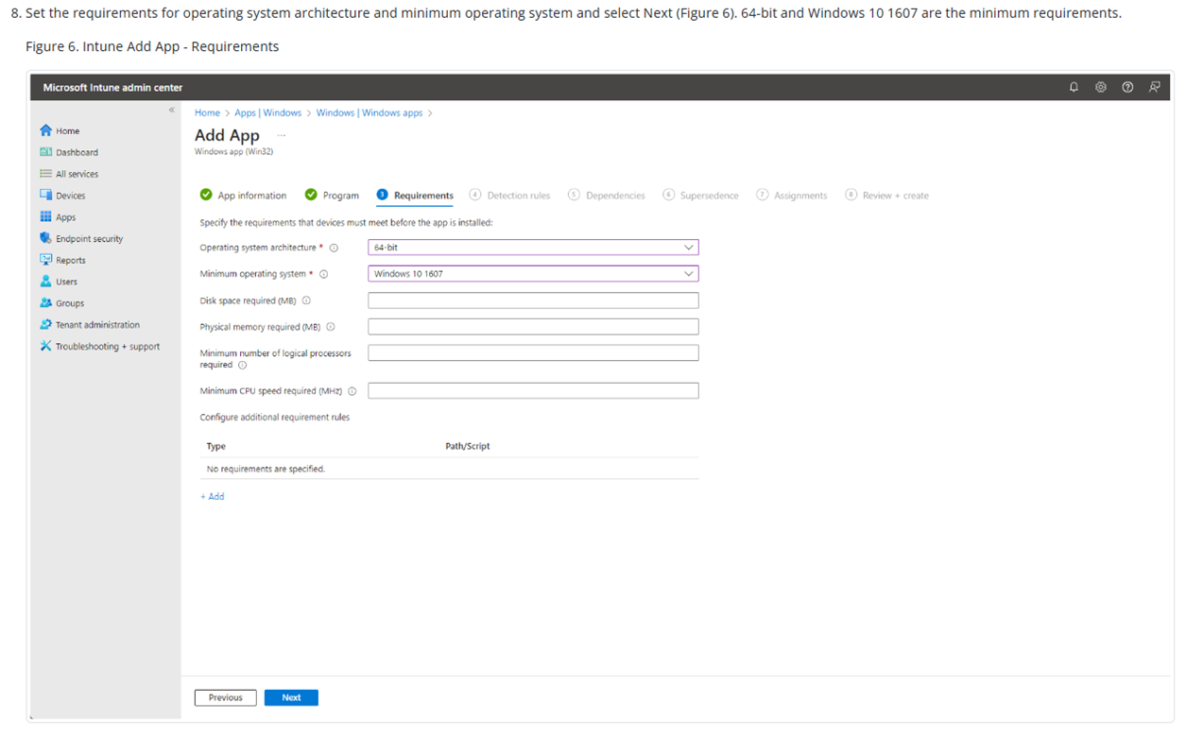
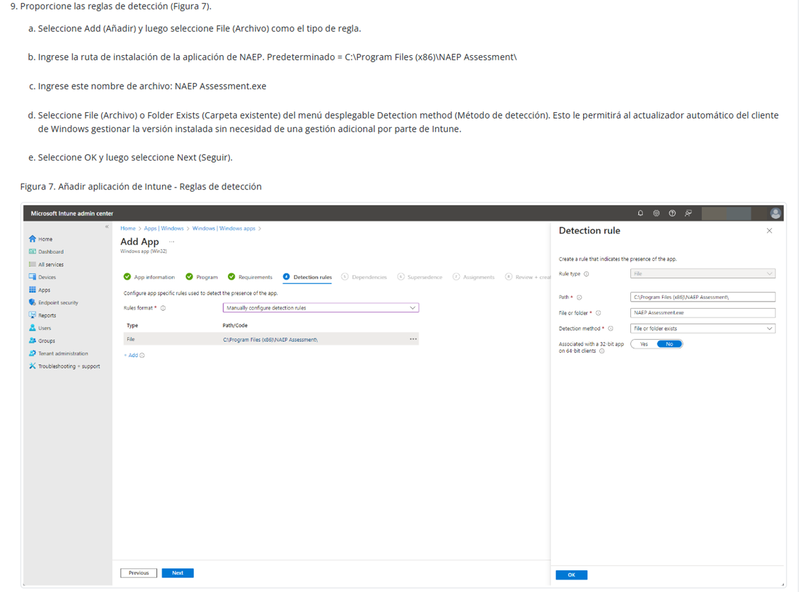
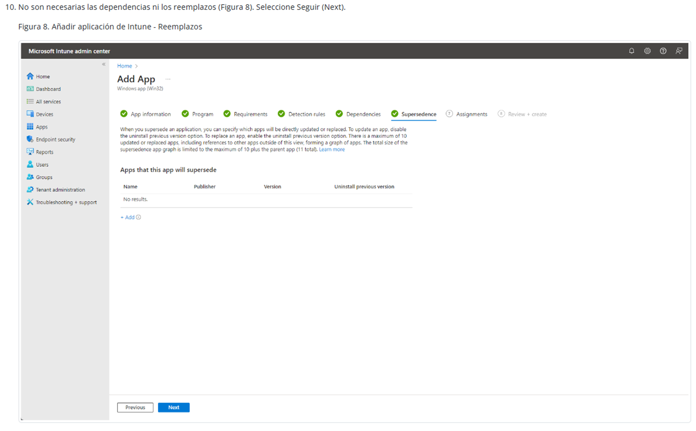
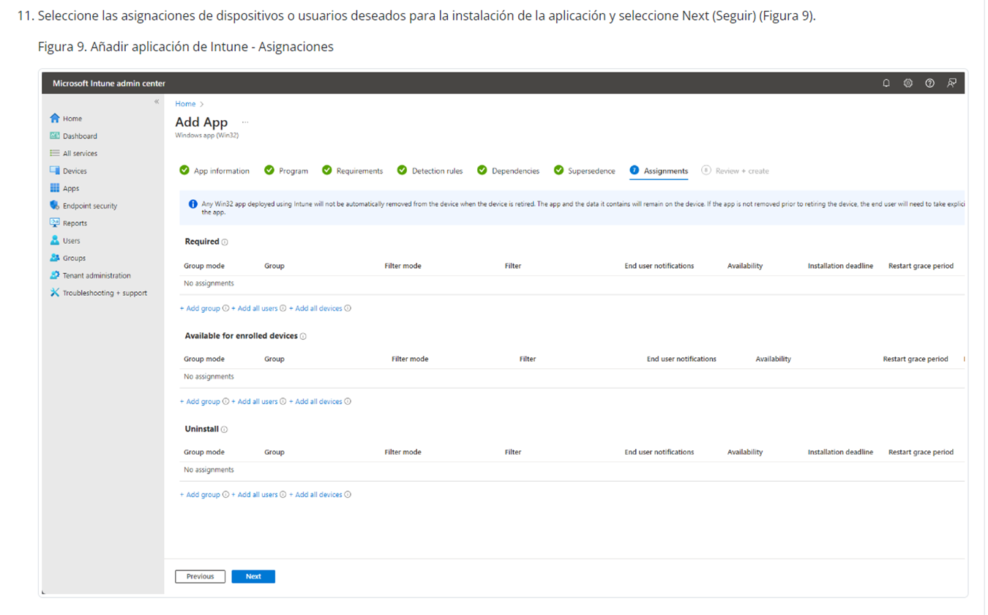
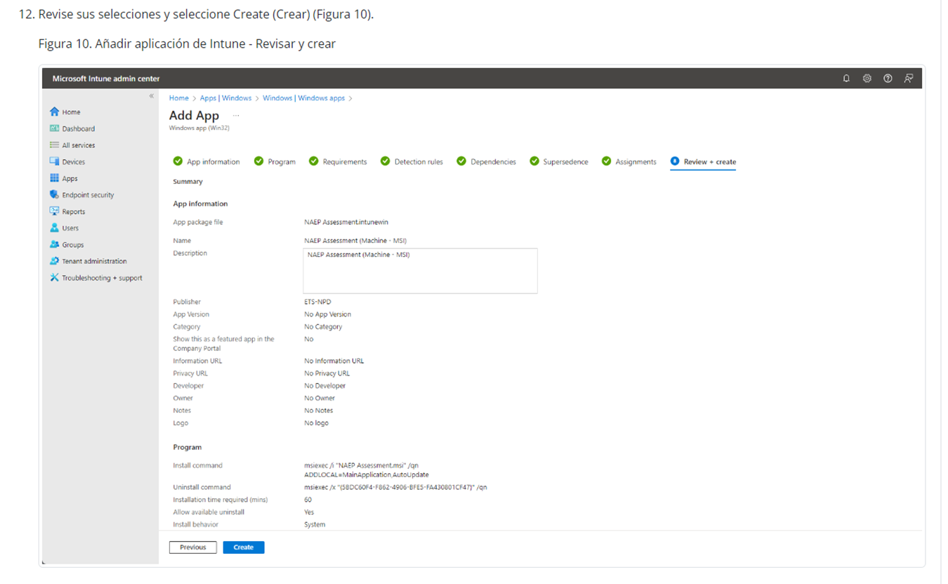
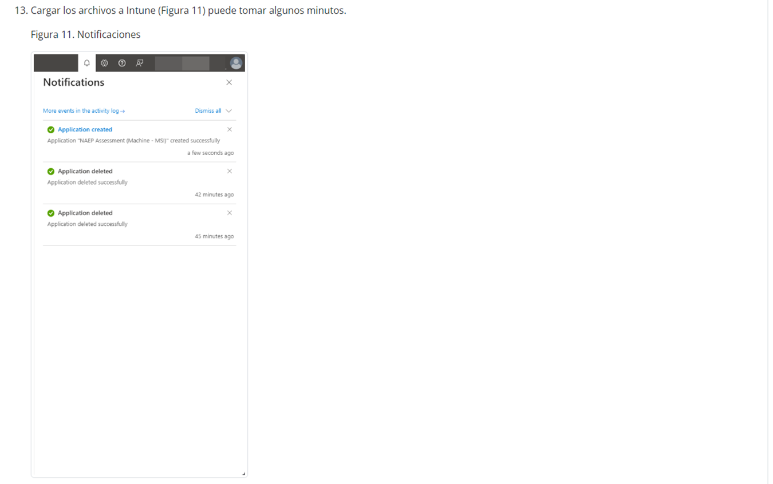
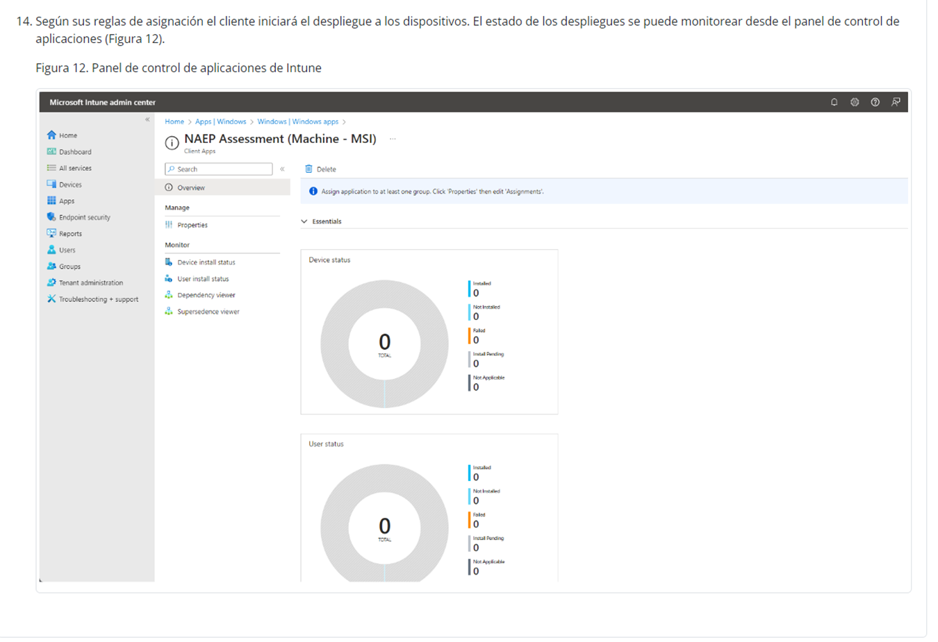

Instrucciones para la instalación de la aplicación de NAEP > Windows > Instrucciones de instalación a gran escala > Distribución e instalación de la aplicación de NAEP a través de la línea de commando

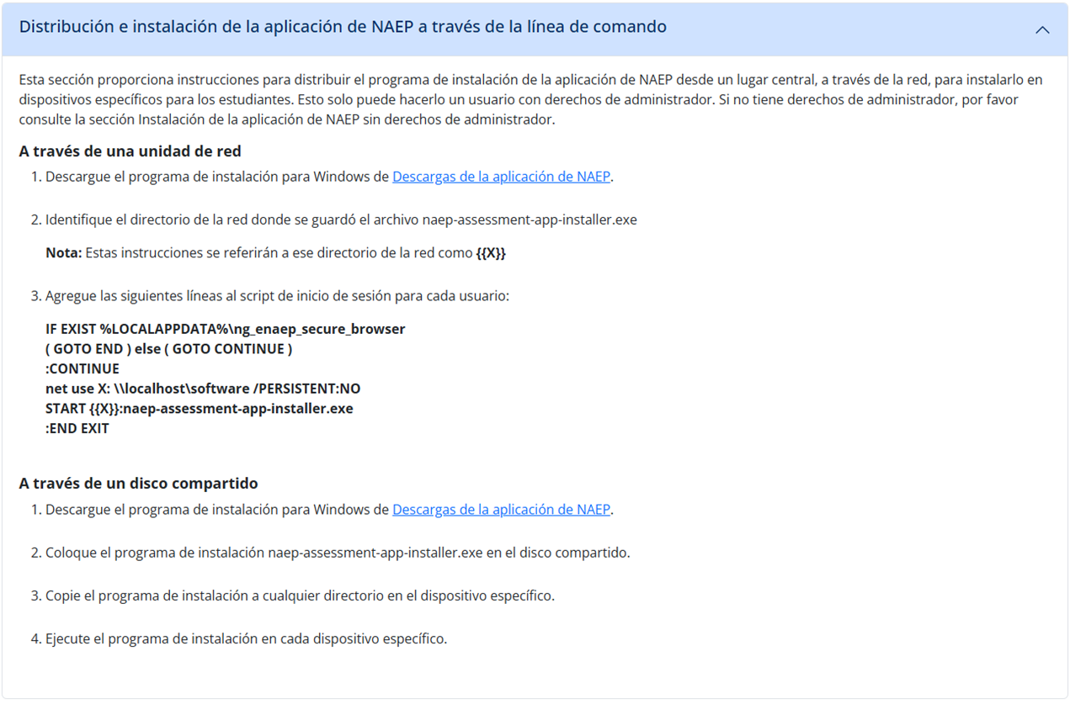

Instrucciones para la instalación de la aplicación de NAEP > Windows > Instrucciones de verificación posterior a la instalación
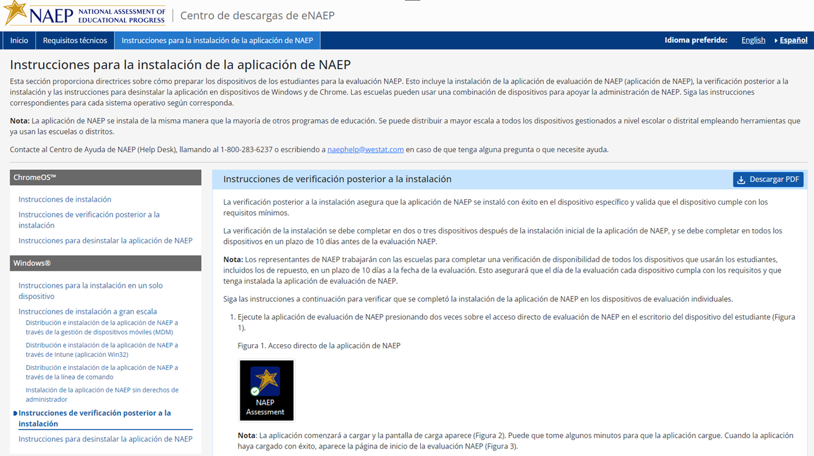
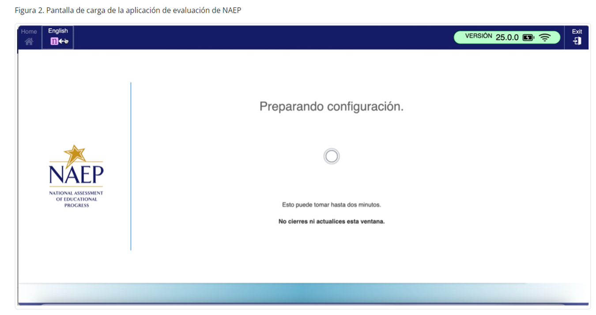
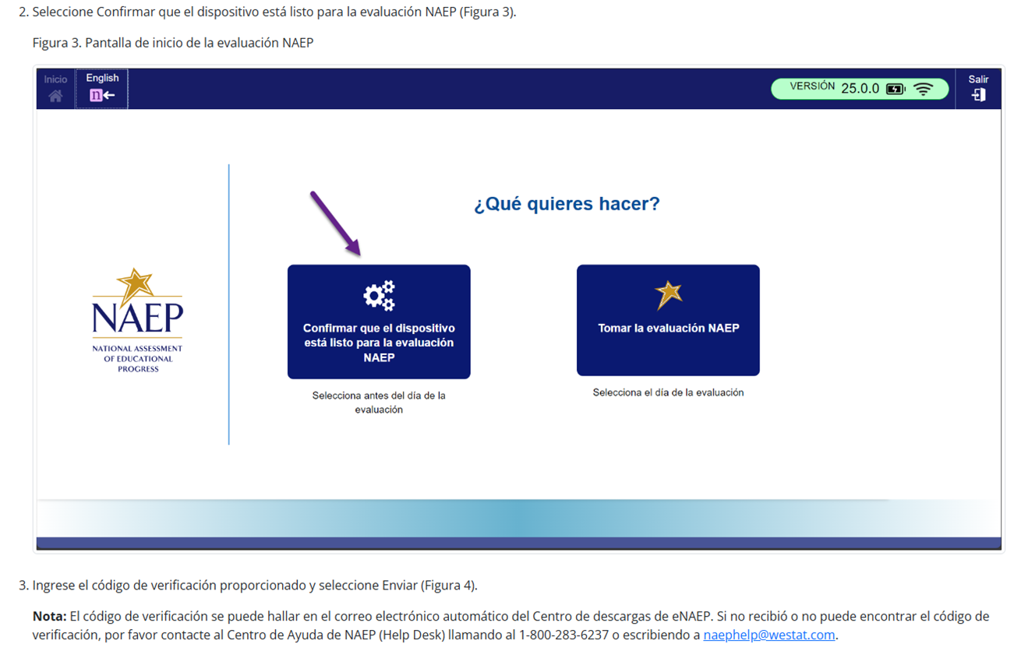
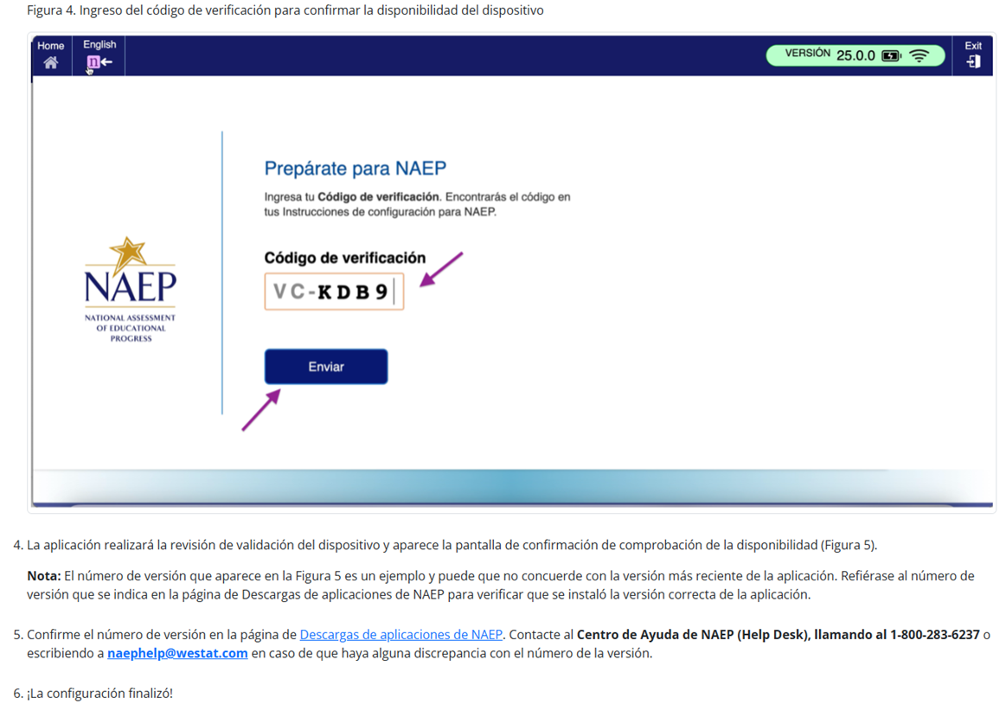
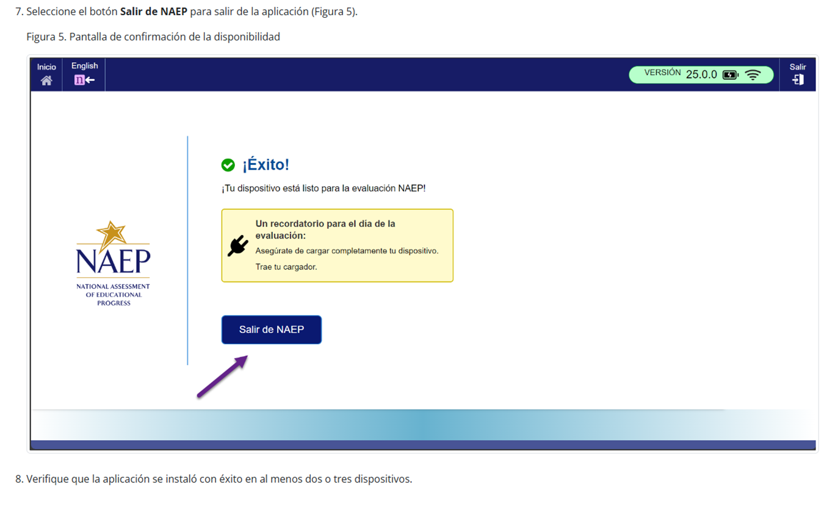

Instrucciones para la instalación de la aplicación de NAEP > Windows > Instrucciones para desinstalar la aplicación de NAEP
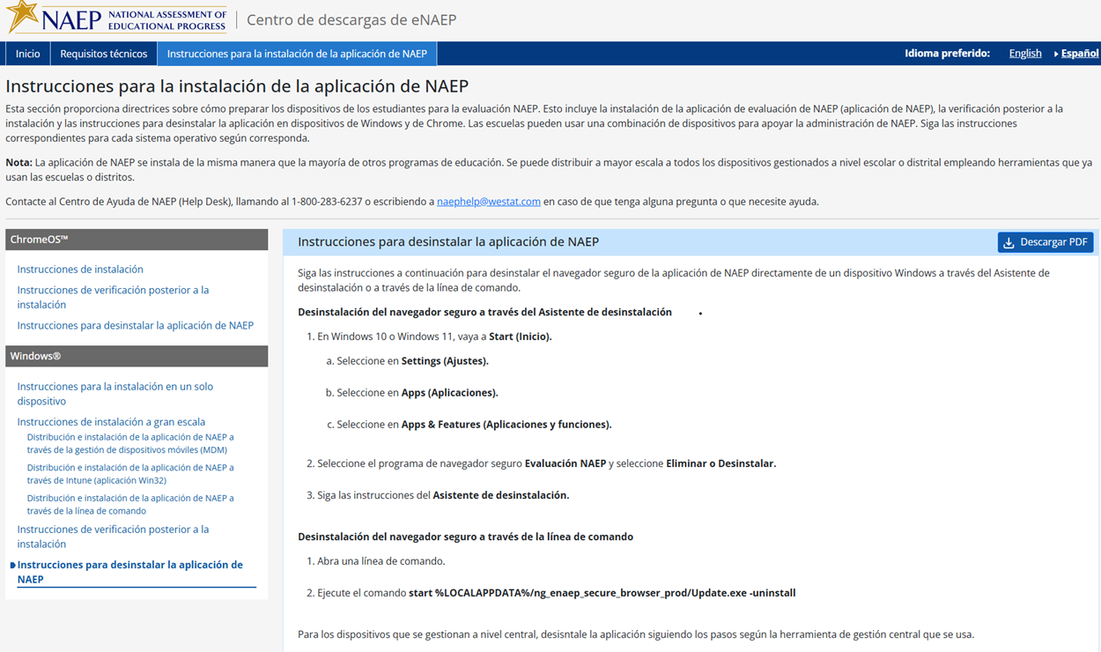

Appendix D-105: NAEP 2026 eNAEP Download Center – Maintenance Page in English (NEW)

Maintenance Page - English
The below maintenance page will communicate to users who access the eNAEP Download Center that it is not available yet for the 2026 administration. The page will be up starting May 1, 2025 through ~June 15, 2025. It will be inactivated when the School Technology Survey is available in the AMS.
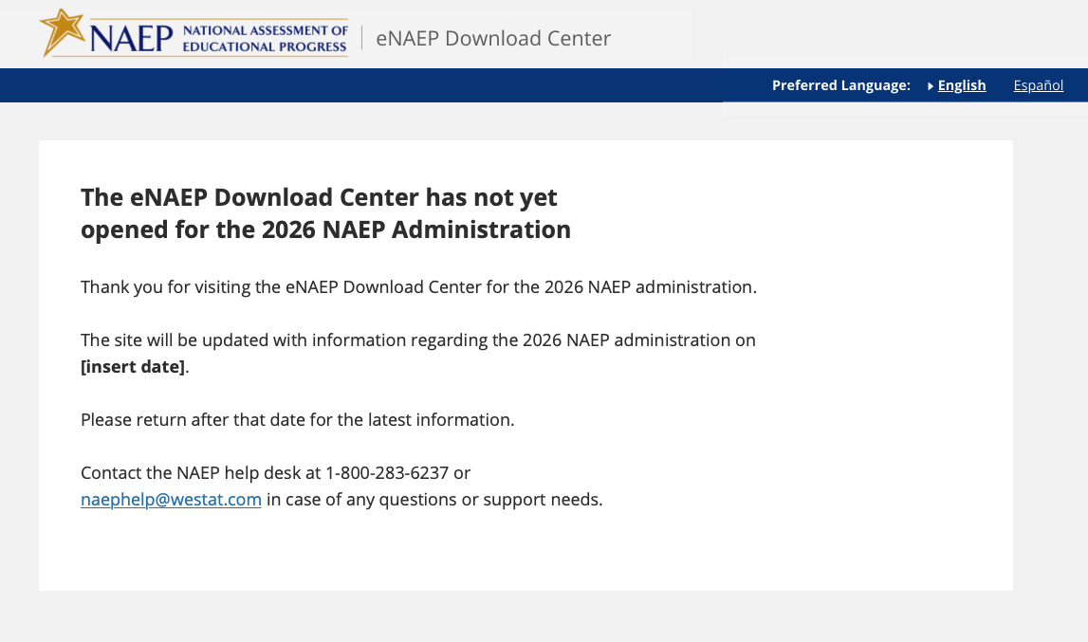

Appendix D-106: NAEP 2026 eNAEP Download Center – Maintenance Page in Spanish (NEW)

Maintenance Page – Spanish
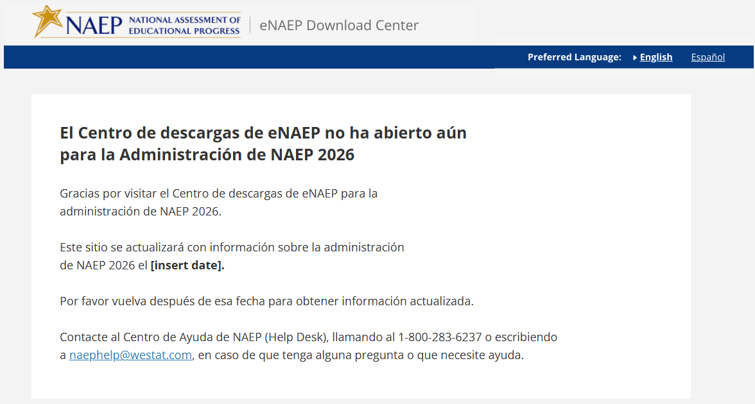

Appendix D-107: NAEP 2026 eNAEP Download Center – Page Not Found Error Page in English (NEW)

Page Not Found Error Page – English
A user will see the below page if the user attempts to access a link for the eNAEP Download Center that is not valid (e.g., mistype the link).
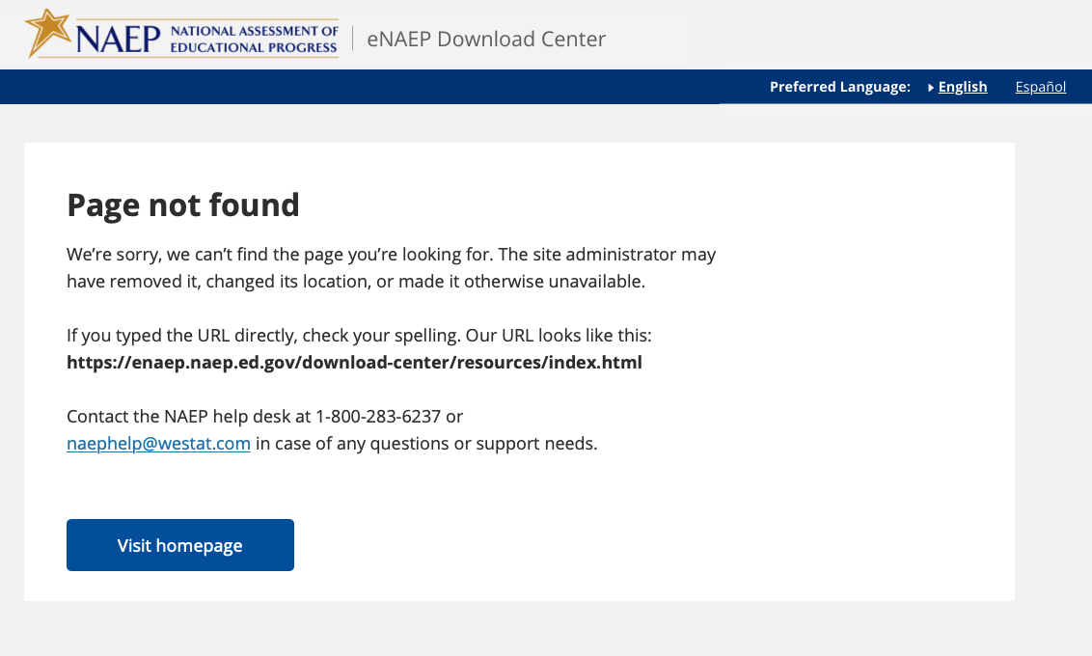

Appendix D-108: NAEP 2026 eNAEP Download Center – Page Not Found Error Page in Spanish (NEW)

Page Not Found Error Page – Spanish
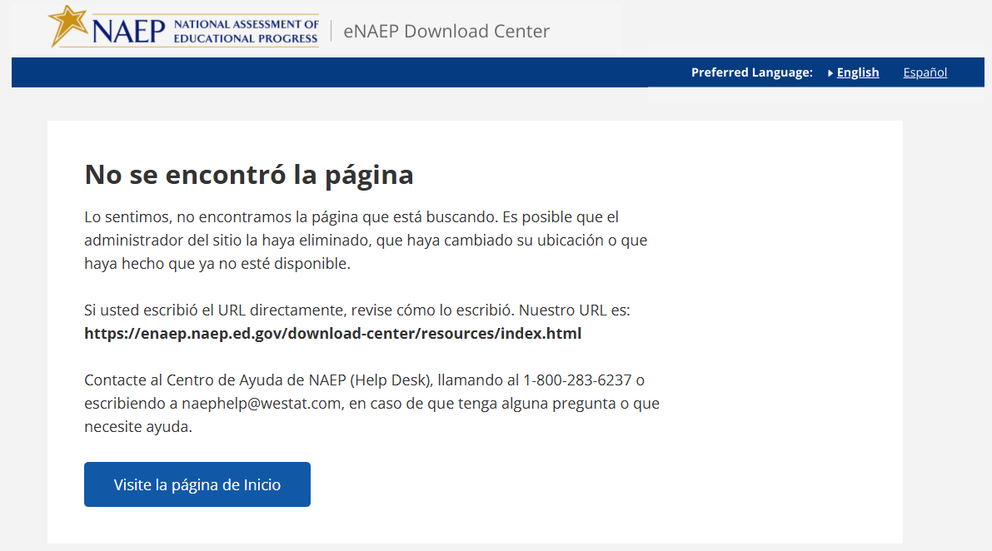

Appendix D-109: NAEP 2025 Best Practices Materials

Appendix D-110: NAEP 2025 Best Practices Introduction


This guide includes proven practices and strategies, from administrators like you, to make the National Assessment of Educational Progress (NAEP) a very positive and successful experience for our nation’s high schools.
NAEP results provide valuable feedback to educators, elected officials, and policymakers who work to maintain and improve the quality of our education system. Since NAEP is designed to assess a representative sample of our nation’s students, the accuracy of NAEP relies on the full participation of you, your teachers, and your students. One of the major purposes of NAEP is to show how education in the nation and our state is progressing. For that, we need a true picture of our students’ collective progress.

High school participation
Historically, high school student participation in NAEP has been a challenge. Both low participation and low motivation can undermine the validity and credibility of NAEP results for high school students. As the graph below demonstrates, NAEP participation increased with the implementation of the Best Practices Guide in 2007. However, the changing assessment landscape has led to declines in participation, and NAEP relies on principals like you more than ever.

NAEP School and Student Participation Rates for Public Schools: Grade 12

Recommendations from the Secondary School Principals’ Working Group
The Best Practices Guide was created after the National Center for Education Statistics convened a Secondary School Principals’ Working Group in 2005 to address high school participation rates. After discussing participation rates, student motivation, and student results, the working group concluded that the results did not reflect the true level of achievement of their students. The working group also concluded that high school principals and other school leaders could help improve participation rates by obtaining teacher buy-in and motivating students to take the assessment and do their best, and that best practices for achieving high participation should be shared with principals.
High school participation in NAEP improved after the implementation of these recommendations, but only because principals like you have used some or all the strategies included in the Best Practices Guide.

Preparing for NAEP 2025
This guide will provide the tools you need to communicate the importance of participating in NAEP to your students and teachers. Some of the resources available in the Best Practices Guide for Supporting High School NAEP Participation are as follows.
- Videos to introduce NAEP to students and teachers;
- PowerPoint presentations customized for the students, parents, and staff at your school;
- MS Word templates for student notification letters, morning announcements, and more;
- Talking points used by principals for communicating with teachers, students, and parents; and
- Social media posts announcing NAEP to various audiences.

In addition, you will receive three emails in the months leading up to the assessment. Each email will highlight effective strategies for encouraging participation and will link to the resources mentioned above.

Appendix D-111: NAEP 2025 Best Practices Notification

Notification Letter

For Students

Dear Student:
Congratulations! You have been selected to participate in this year’s National Assessment of Educational Progress, also known as NAEP. Very few students are selected, but you have been chosen to represent thousands of your peers in this important assessment.
NAEP is the most important measure of what students from across the country know and can do in a variety of subject areas. It is different from our state assessments because it represents high school students across the country, not just those here in [state]. Your participation will provide a snapshot of what students from across the country have learned in school, which will inform major decisions about how to improve education in the United States. In short, it’s important that you take part and give it your best effort!
- You will take NAEP at [time, date, location] with other selected students.
- You will take a mathematics or reading assessment.
- NAEP takes up to 120 minutes, and you don’t need to study for it.
- Your answers will be anonymous and will NOT affect your grades or academic record in any way.
- Upon completion of the assessment, you will receive a Certificate of Community Service.
If you have any questions or would like to review sample questions, [insert name of school contact person] will be happy to help. You can also visit http://nces.ed.gov/nationsreportcard/students for more information.
We are fortunate that our school has been selected to participate in NAEP, and we are excited to have you take the assessment. We know you will do your best and help us show what our students are capable of.
Sincerely,
(School Principal)
What students are saying about NAEP participation…


Appendix D-112: NAEP 2025 Best Practices Parent/Guardian Notification Letter

NAEP 2025 PARENT/GUARDIAN NOTIFICATION LETTER
(School Letterhead)
(Insert Date Here)

Dear Parent or Guardian:

(School name) will participate in the National Assessment of Educational Progress (NAEP) on (date). NAEP is the largest nationally representative and continuing assessment of what students know and can do in various subjects. NAEP is administered by the National Center for Education Statistics, within the U.S. Department of Education. NAEP is different from our state assessments because it is a common measure of achievement across the country. The results are released as The Nation’s Report Card, which provides information about student achievement to educators, parents/guardians, policymakers, and the public.
Your child (will/may) take a mathematics or reading assessment. In addition to subject-area questions, students voluntarily complete NAEP survey questions. These questions provide valuable information about participating students’ educational experiences and opportunities to learn both in and outside of the classroom. More information about NAEP survey questions is available at https://nces.ed.gov/nationsreportcard/parents under the section “What Questions Are on the Test?”

The assessment takes up to 120 minutes for most students, which includes transition time, directions, and completion of survey questions.

The information collected is used for statistical purposes only.
- Your child’s grades will not be affected.
- Students may be excused for any reason, are not required to complete the assessment, and may skip any question.
- While the assessment is voluntary, NAEP depends on student participation to help policymakers improve education. However, if you do not want your child to participate, please notify me in writing by (date).

There is no need to study in preparation for NAEP, but please encourage your child to do their best. Contact (name) at (telephone number) or at (email address) if you have any questions.
We are excited that our school is participating in NAEP. We know that (school name)’s students will show what our nation’s students know and can do.

Sincerely,
(School Principal’s Name)

The National Center for Education Statistics (NCES) conducts the National Assessment of Educational Progress to evaluate federally supported education programs. All of the information you provide may only be used for the purposes of research, statistics, and evaluation under the Education Sciences Reform Act of 2002 (ESRA; 20 U.S.C. § 9543) and may not be disclosed, our used, in identifiable form for any other purpose except as required by law. Every NCES employee as well as every NCES agent, such as contractors and NAEP coordinators, has taken an oath and is subject to a jail term of up to 5 years, a fine of $250,000, or both if he or she willfully discloses ANY identifiable information about you. Electronic submission of your information will be monitored for viruses, malware, and other threats by Federal employees and contractors in accordance with the Cybersecurity Enhancement Act of 2015.

Appendix D-113: NAEP 2025 Best Practices Storyboard for Introduction Video

Storyboard for Introduction to Best Practices Video
Section | Narration | Description of Video
1 - Introduction | Thank you for your school’s participation in NAEP, the National Assessment for Educational Progress, for 2025, in mathematics and reading. | Title slide.
2 - What is NAEP | NAEP is the largest nationally representative assessment in mathematics and reading. Results from this assessment help inform educators, policymakers, and elected officials about the state of education in the nation. | Image of US map and results from NRC site.
3 - Importance of Student Participation | It’s important for NAEP to assess as many students selected to participate as possible.. Assessing representative samples of students, including students with disabilities and English learners, helps ensure that NAEP results accurately reflect the educational performance of all high school students, so NAEP can continue to serve as a meaningful measure of U.S. students’ academic achievement over time. | Images depicting nationally representative sample.
4 – The grade 12 participation challenge | High school student participation in NAEP is a challenge. In 2005, when only 67 percent of sampled high school students participated, the Best Practices Guide for Supporting High School NAEP Participation was developed based on suggestions from principals like you to help address the challenge. | Graph of student participation rate over time.
5 – The Best Practices Guide | We need your help in encouraging your students to participate in NAEP to ensure high school results can be reported for 2025. To help you support greater student participation, your NAEP State Coordinator will present you with a copy of this Best Practices Guide. | Image of the front cover of the guide.
6 – Resources | This guide provides the tools, resources, and strategies to communicate to students, teachers, and parents the importance of participating in NAEP and to encourage students to show up and do their best on the assessment. | Show table of contents and some resources.
7– Thank you | We encourage you to review this guide and implement these best practices in your school. If you have questions, please reach out to your NAEP State Coordinator. Thanks again for your school’s participation. | Thank you slide.

Appendix D-114: NAEP 2025 Best Practices 2019 Infographic Grade 12 Mathematics and Reading Results
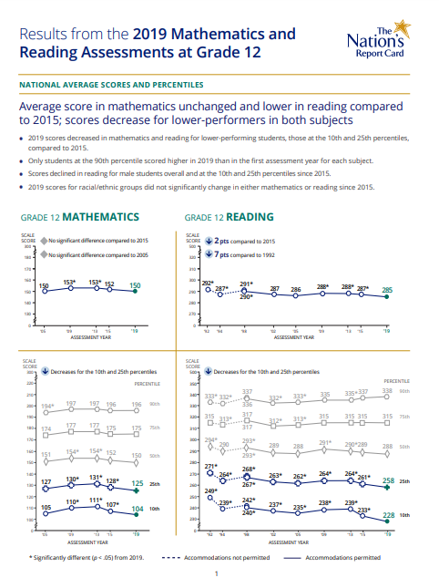
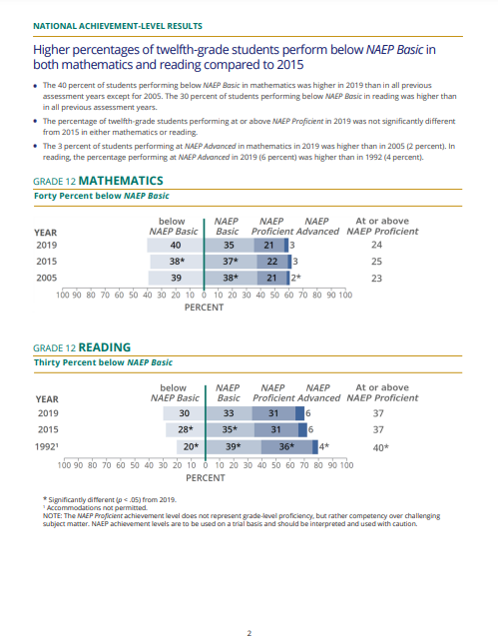
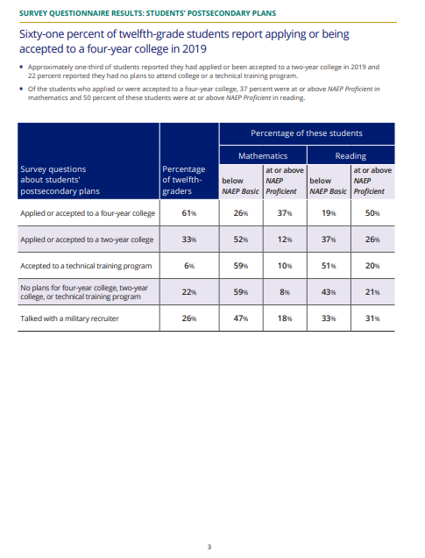

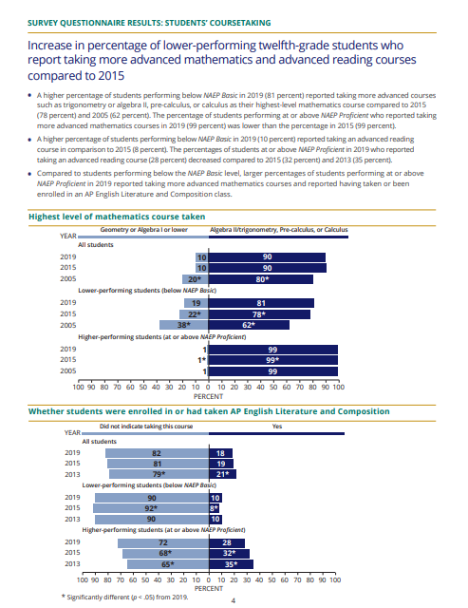

Appendix D-115: NAEP 2025 Best Practices PowerPoint Slide TV Monitor Announcement

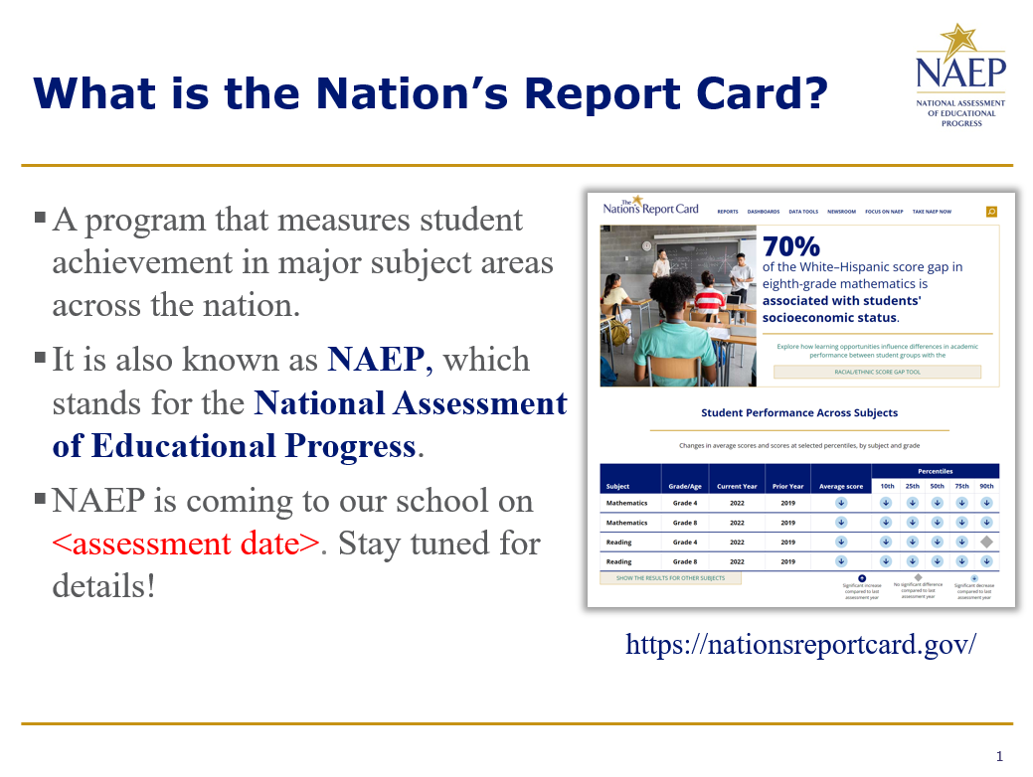

Appendix D-116: NAEP 2025 Best Practices PowerPoint Slides: Introducing NAEP to Parents

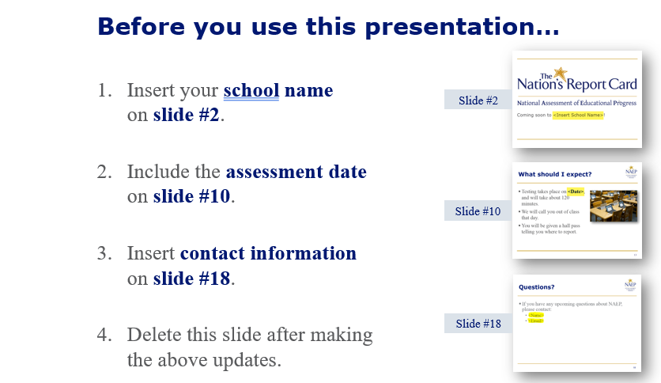

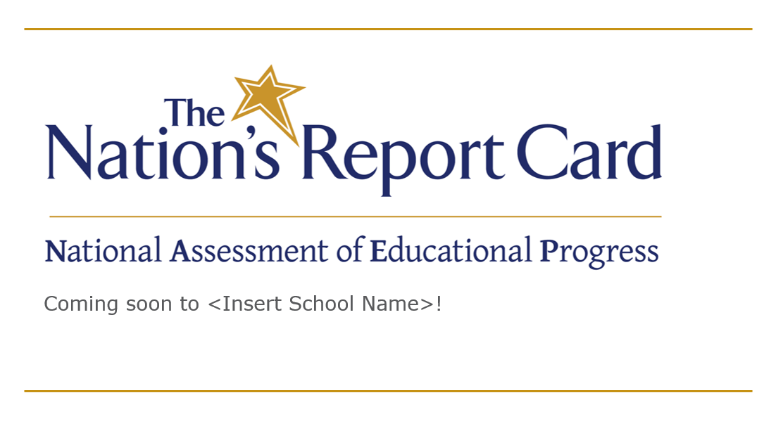

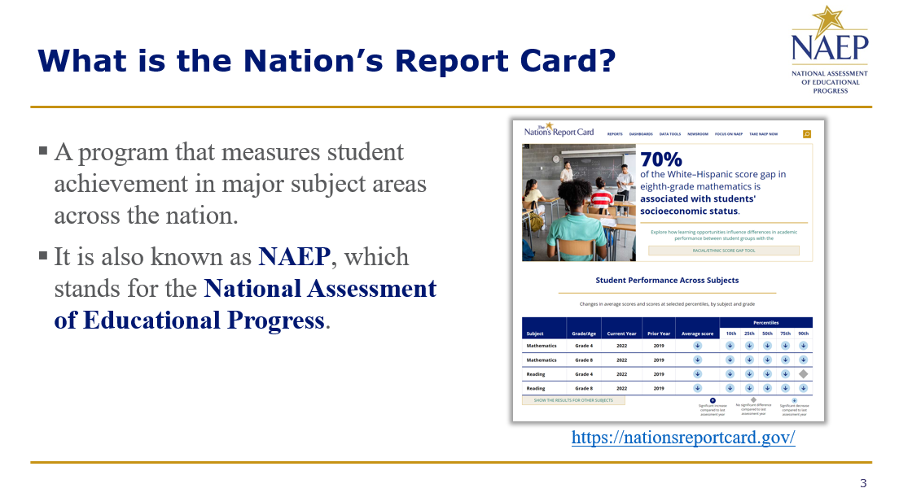

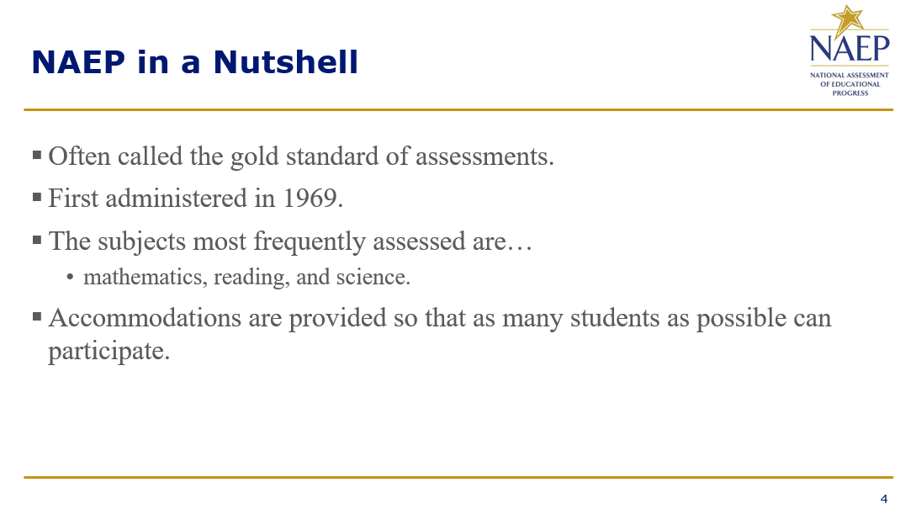

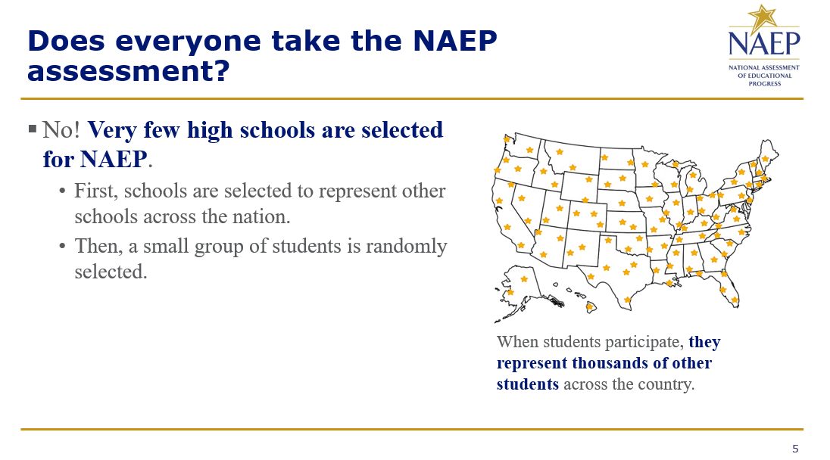
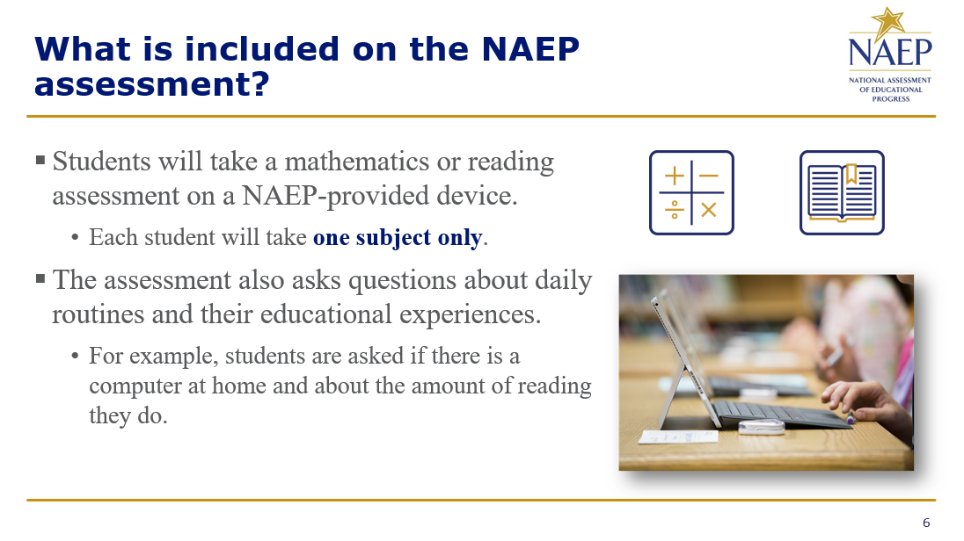

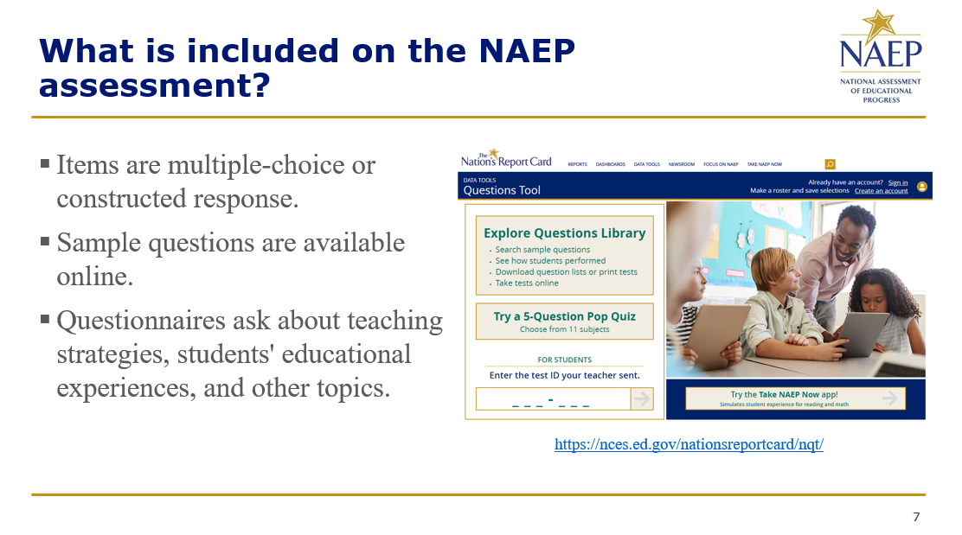
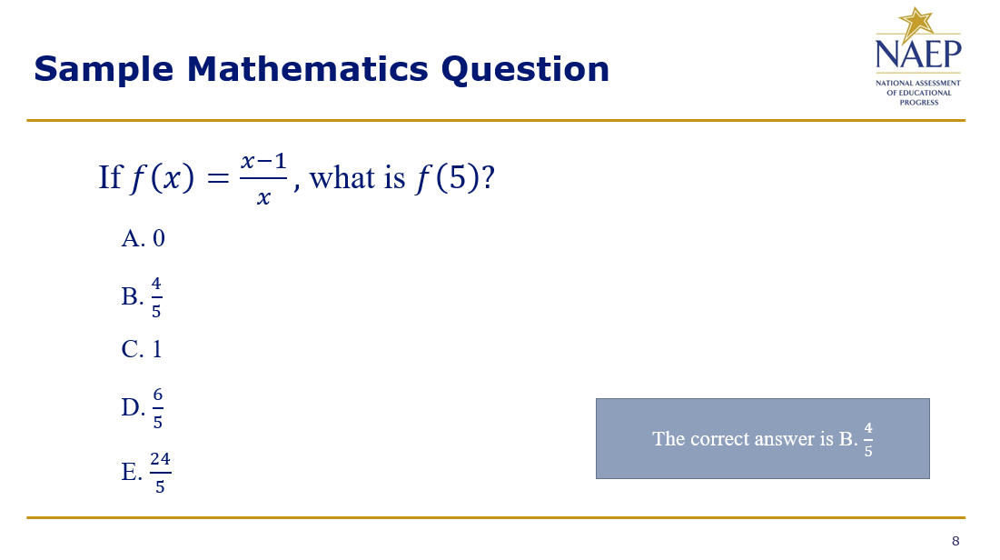

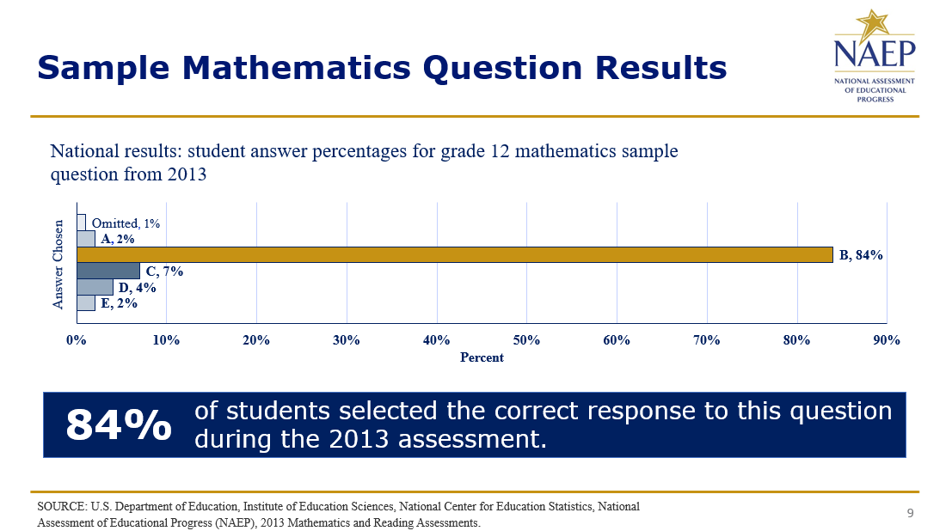
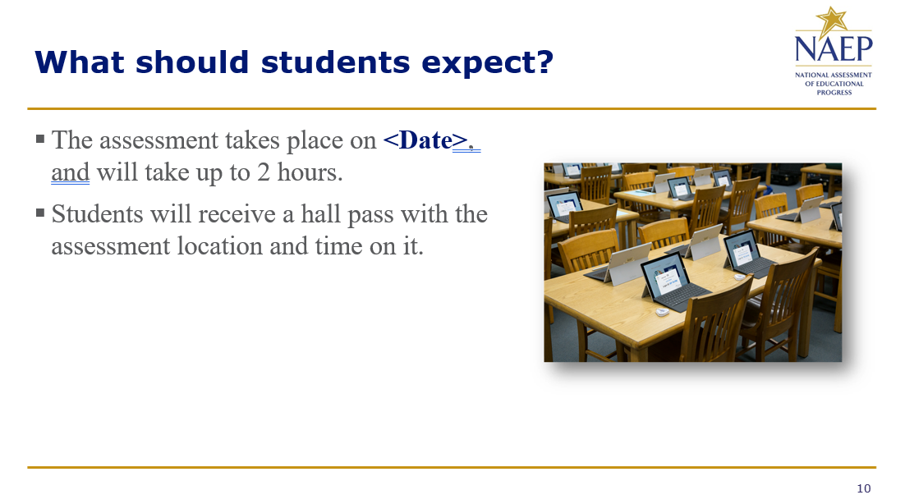

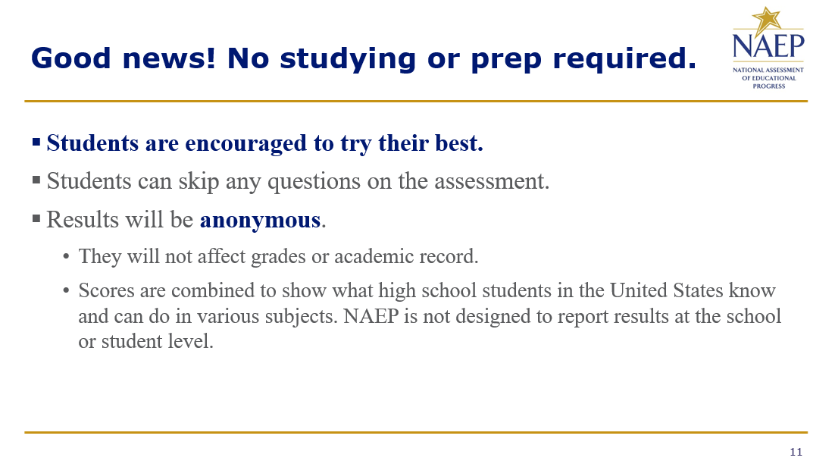

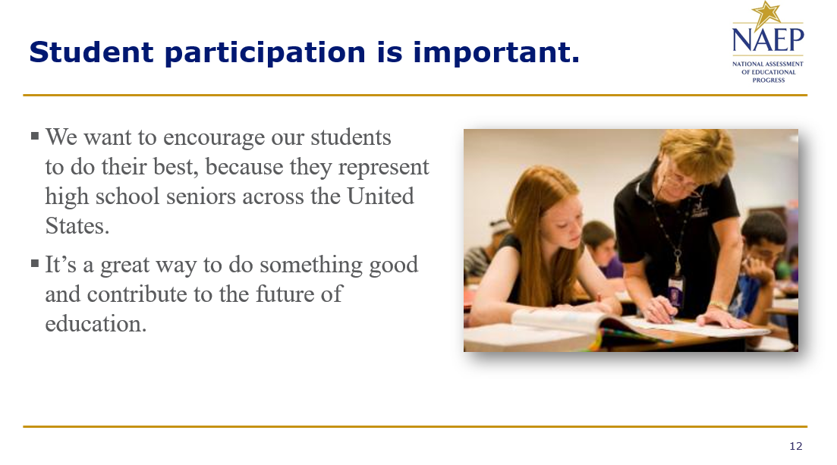

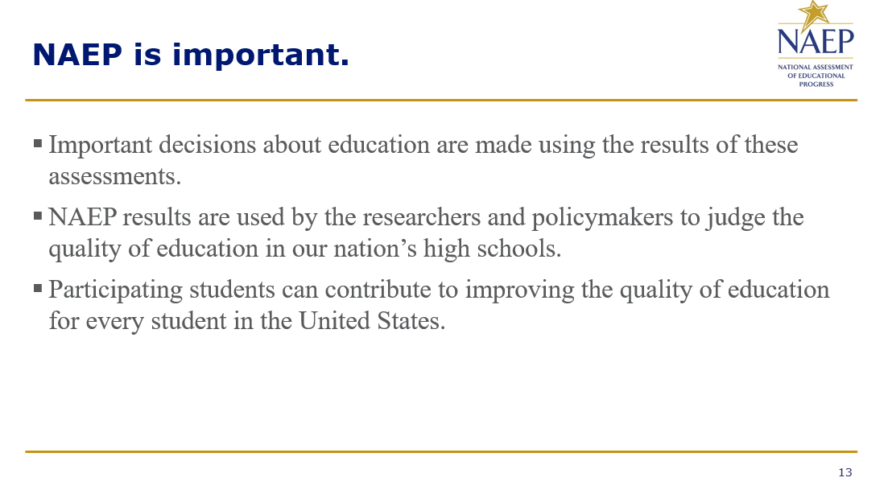
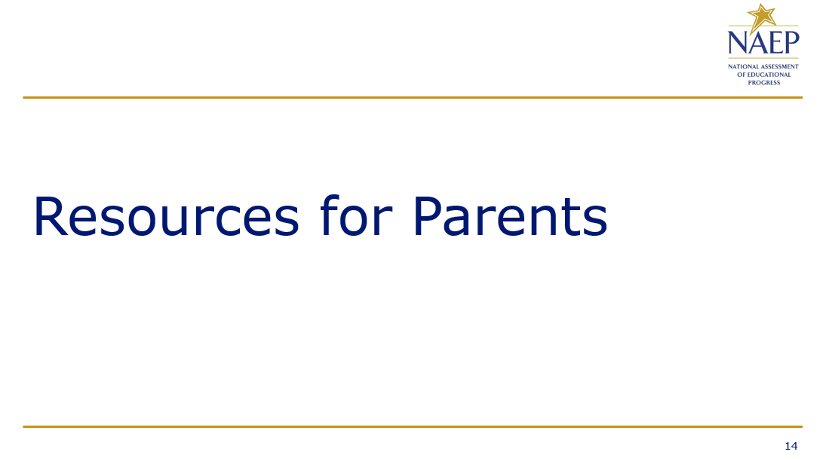

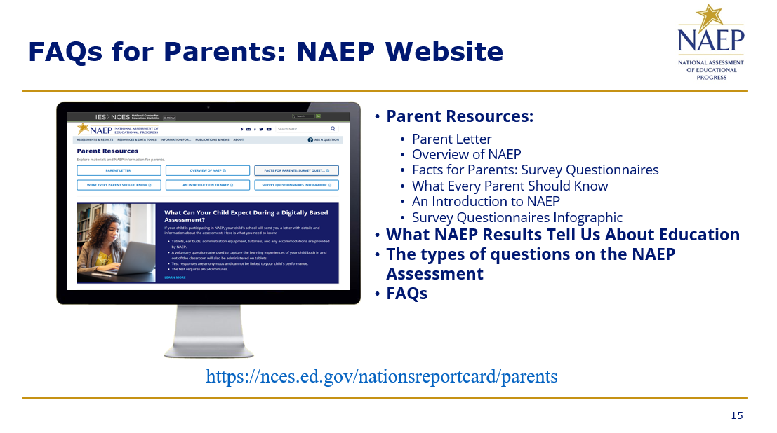
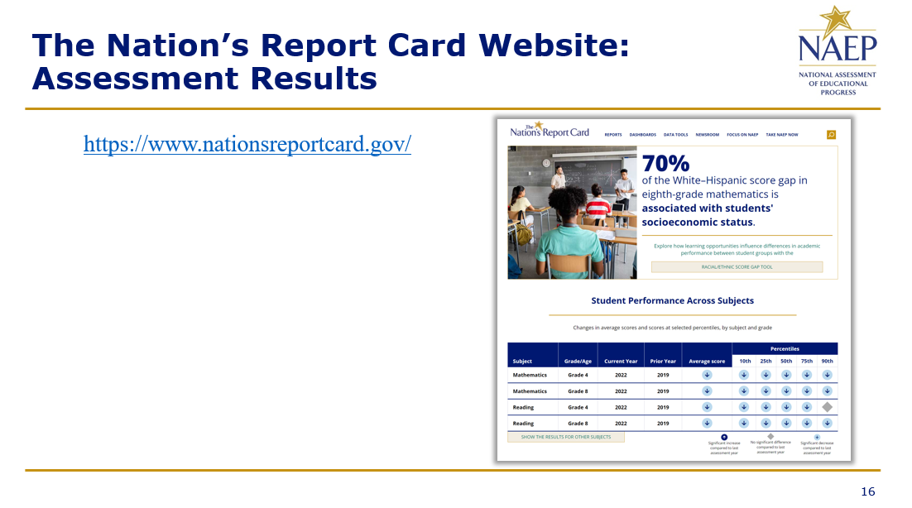

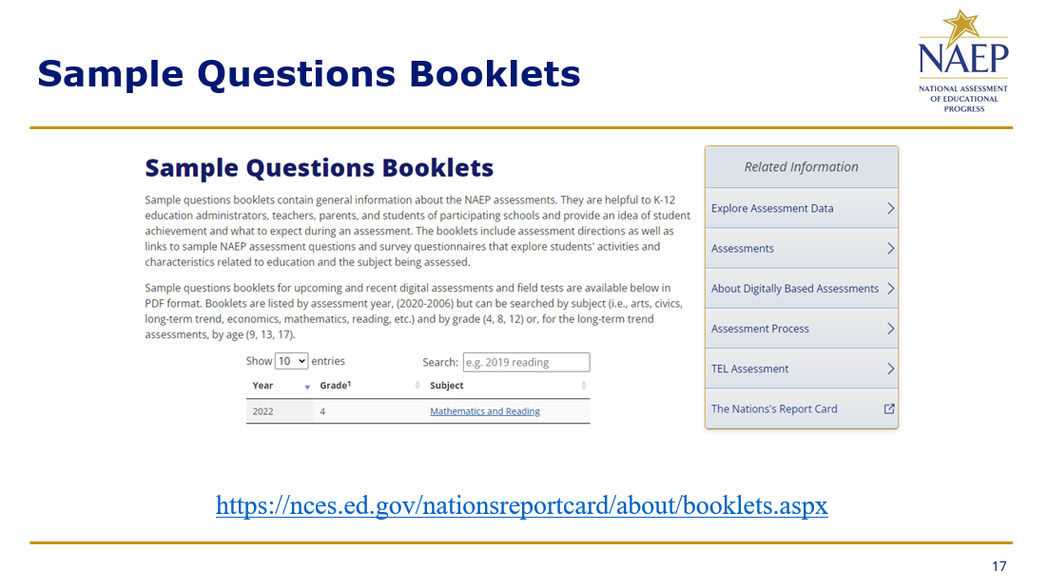
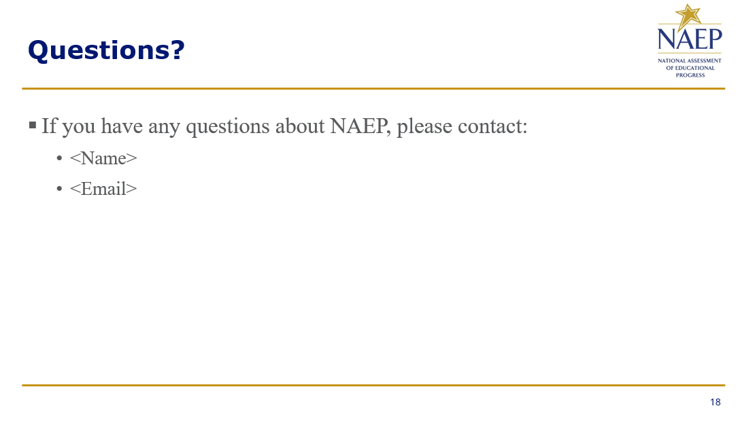

Appendix D-117: NAEP 2025 Best Practices PowerPoint Slides: Introducing NAEP to Students

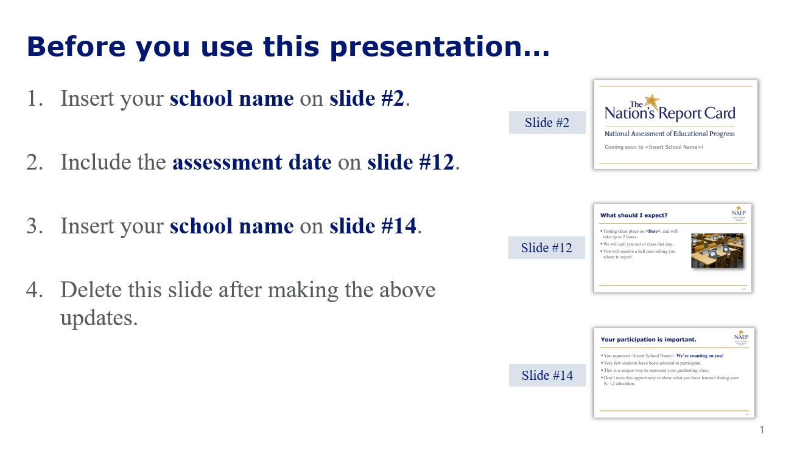
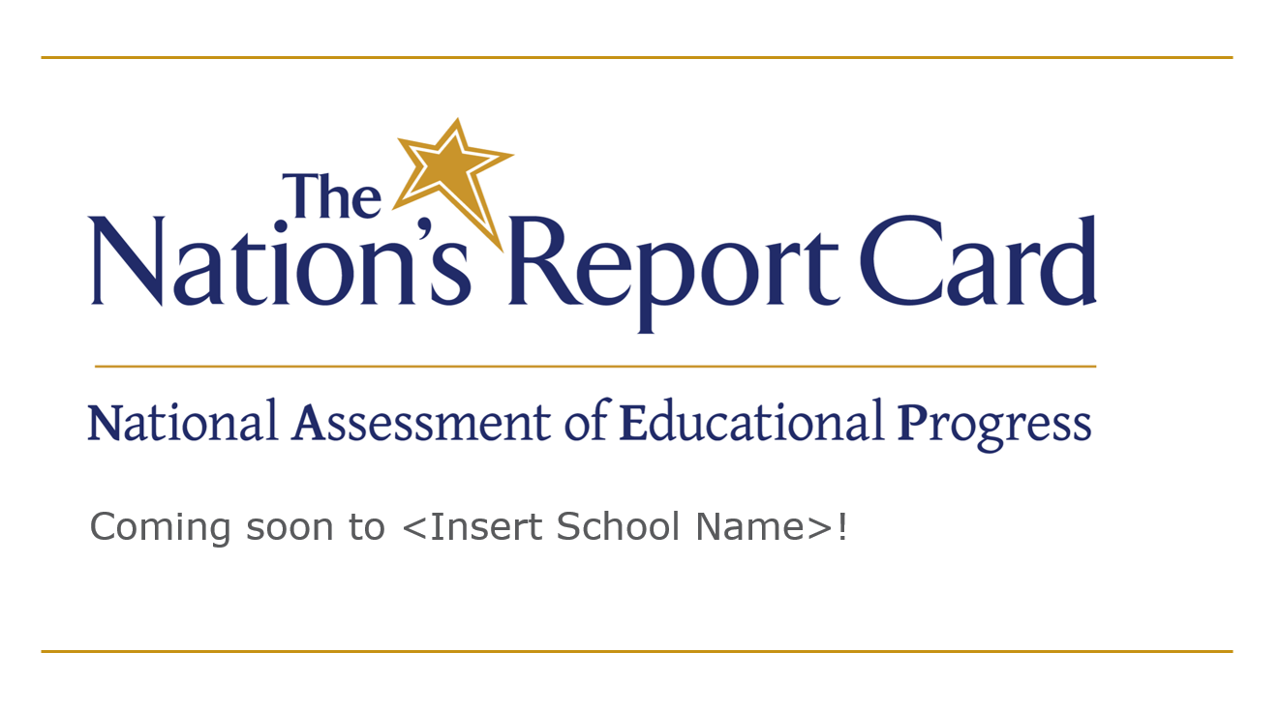

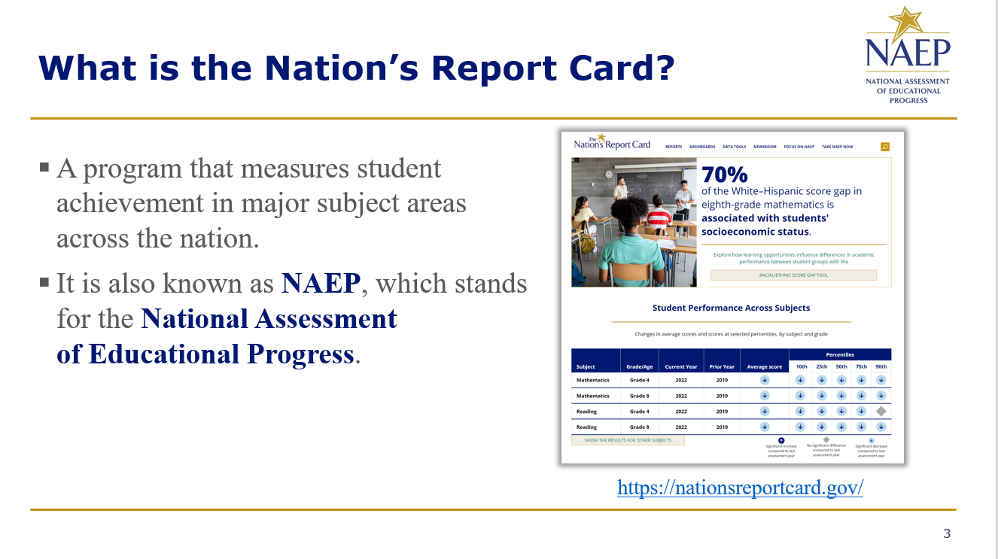
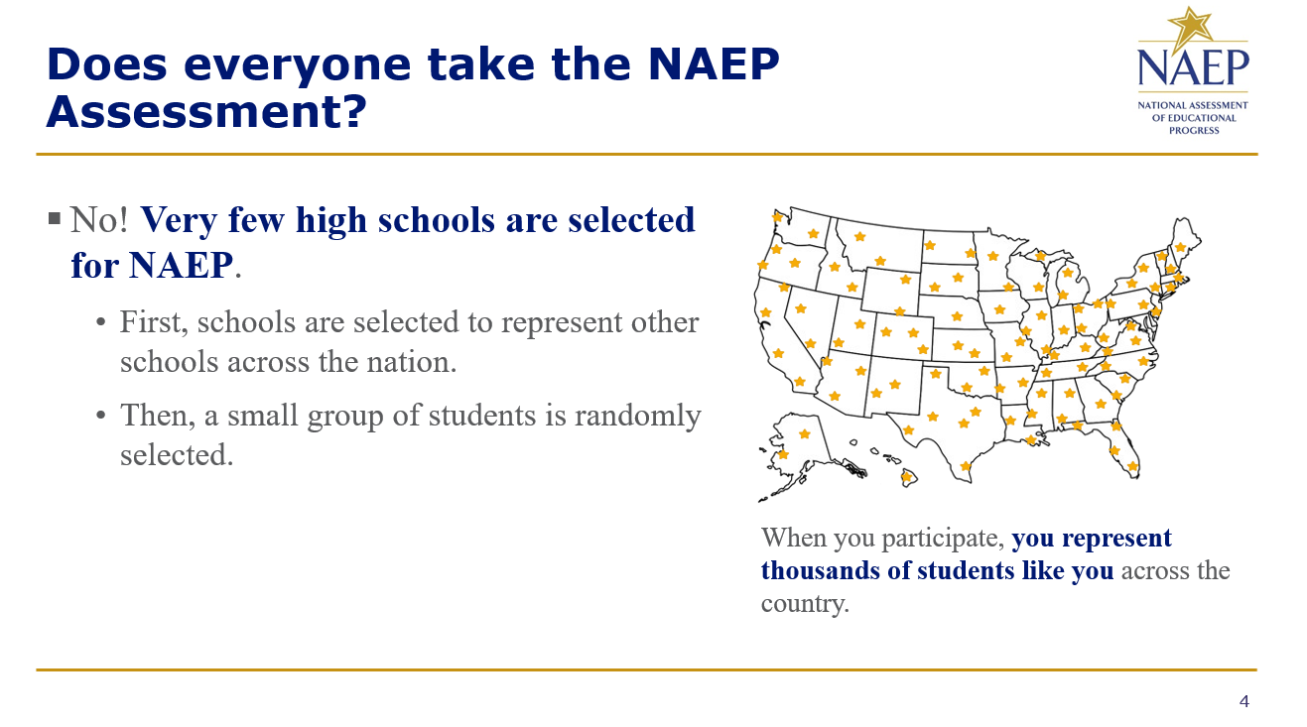

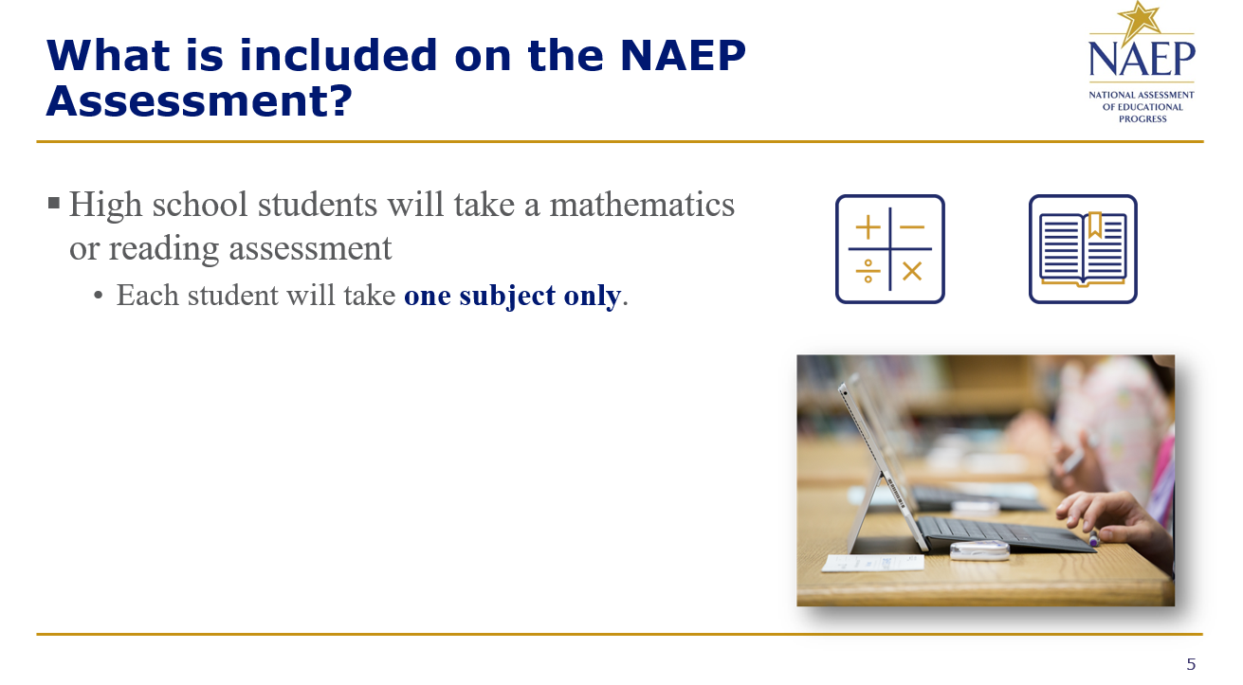
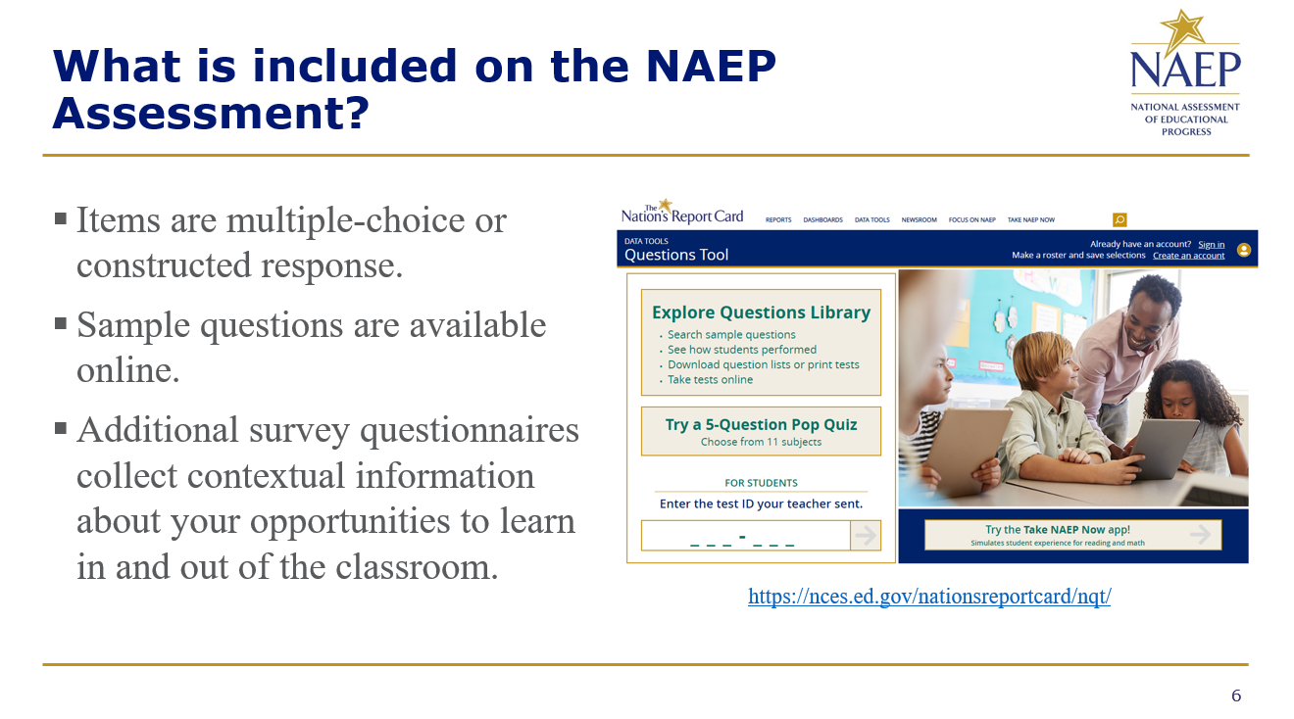

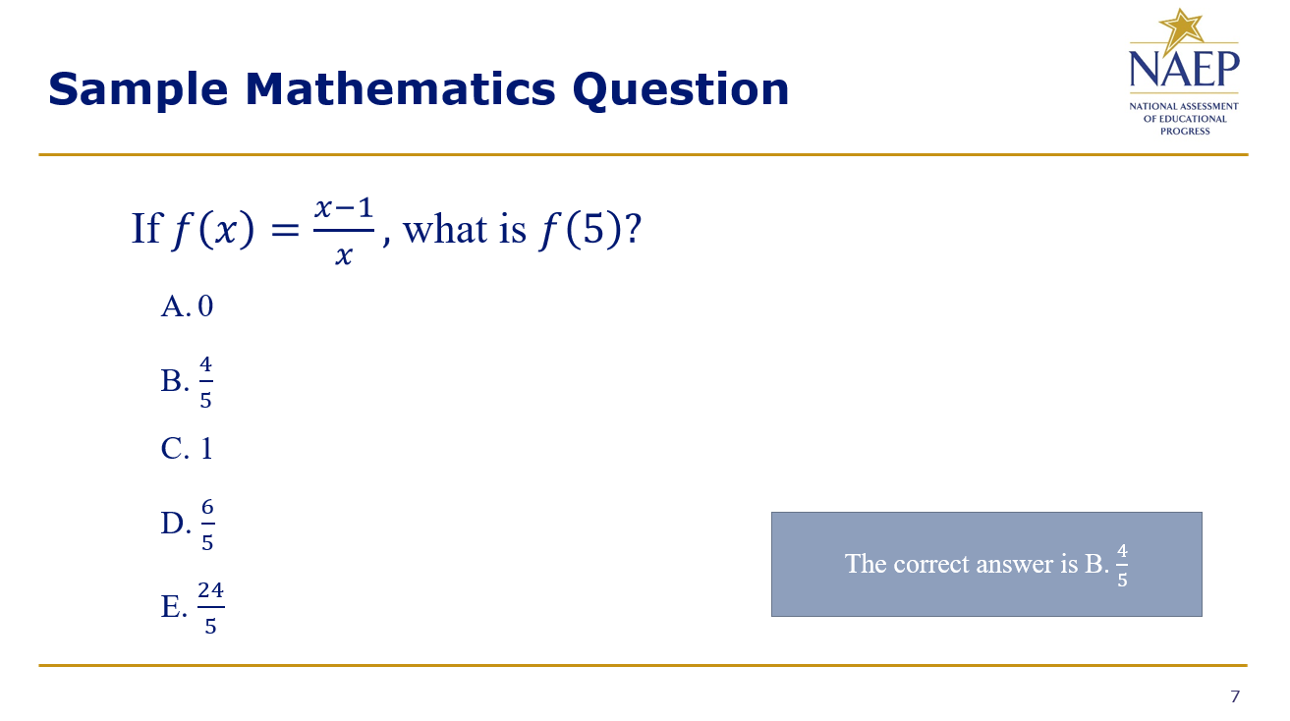
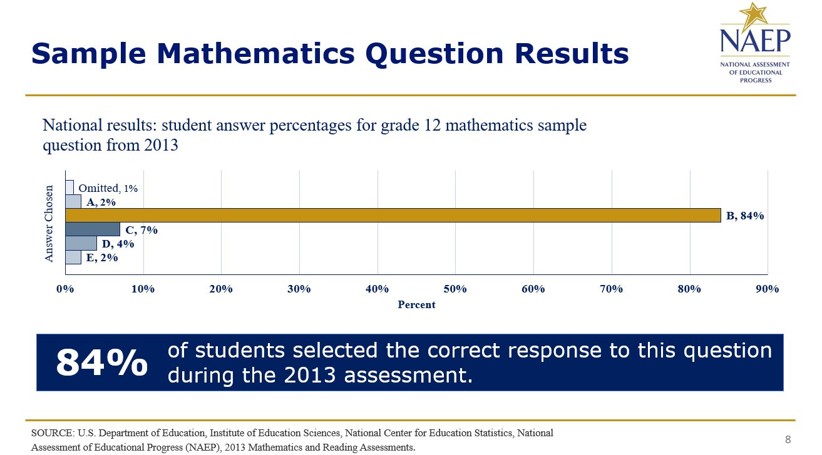

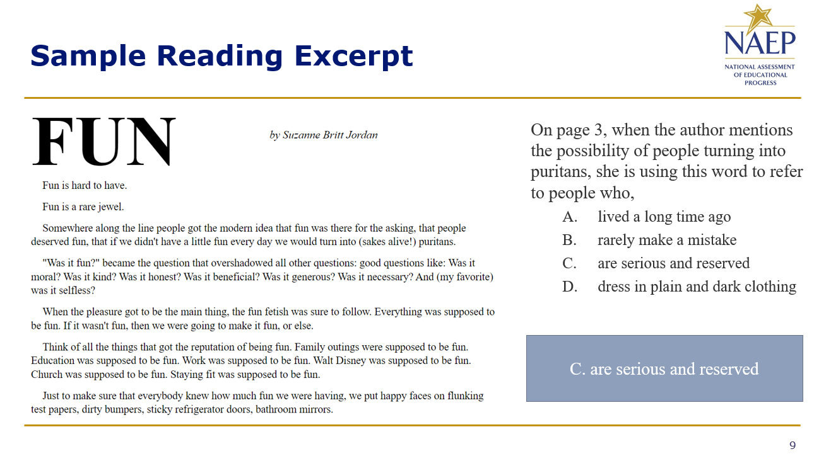
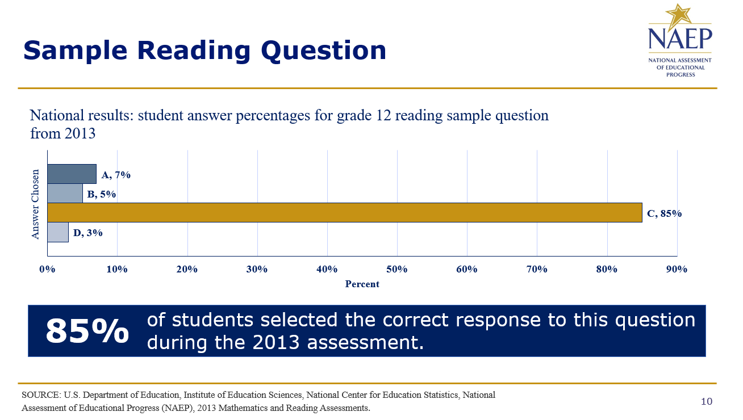

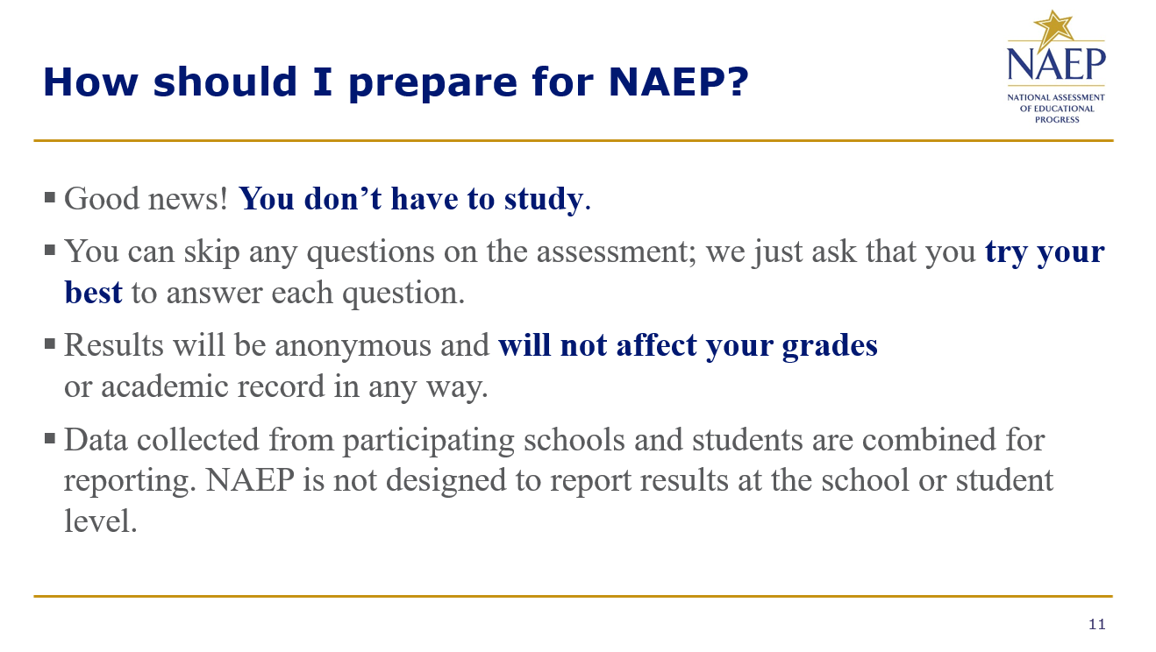
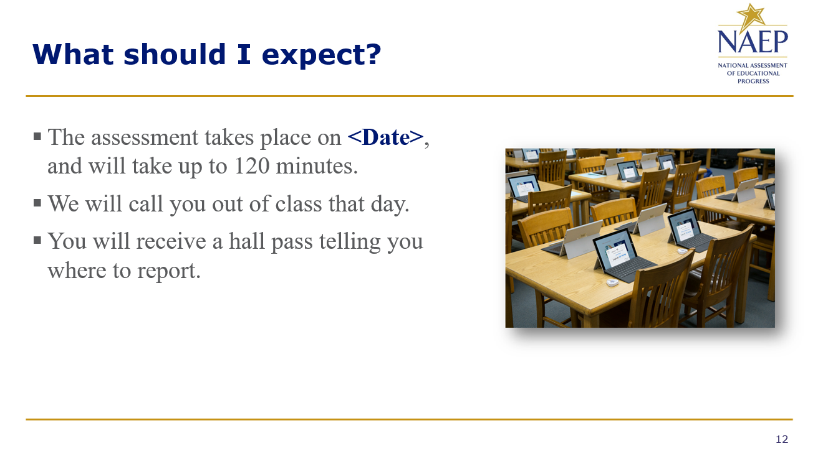

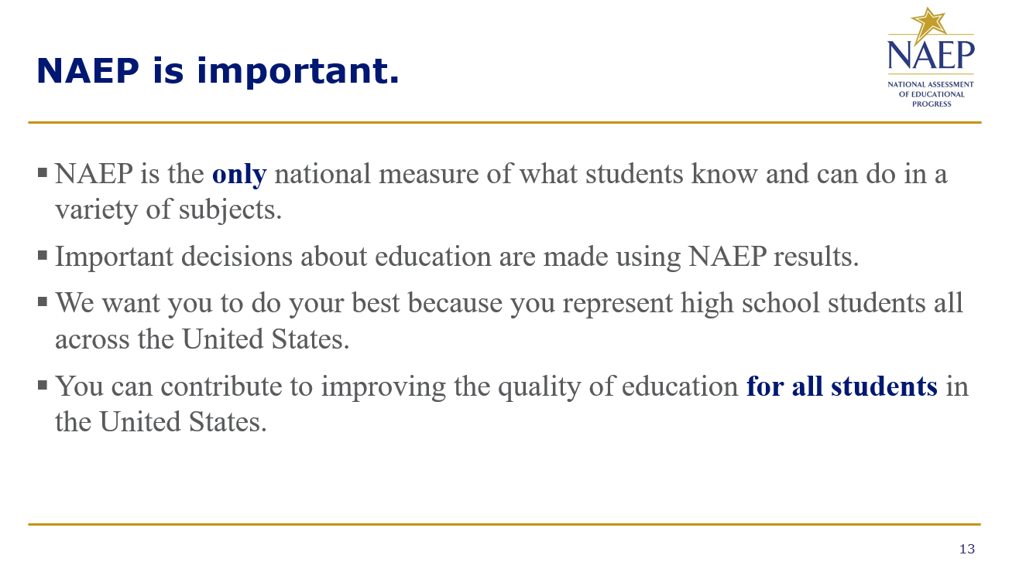
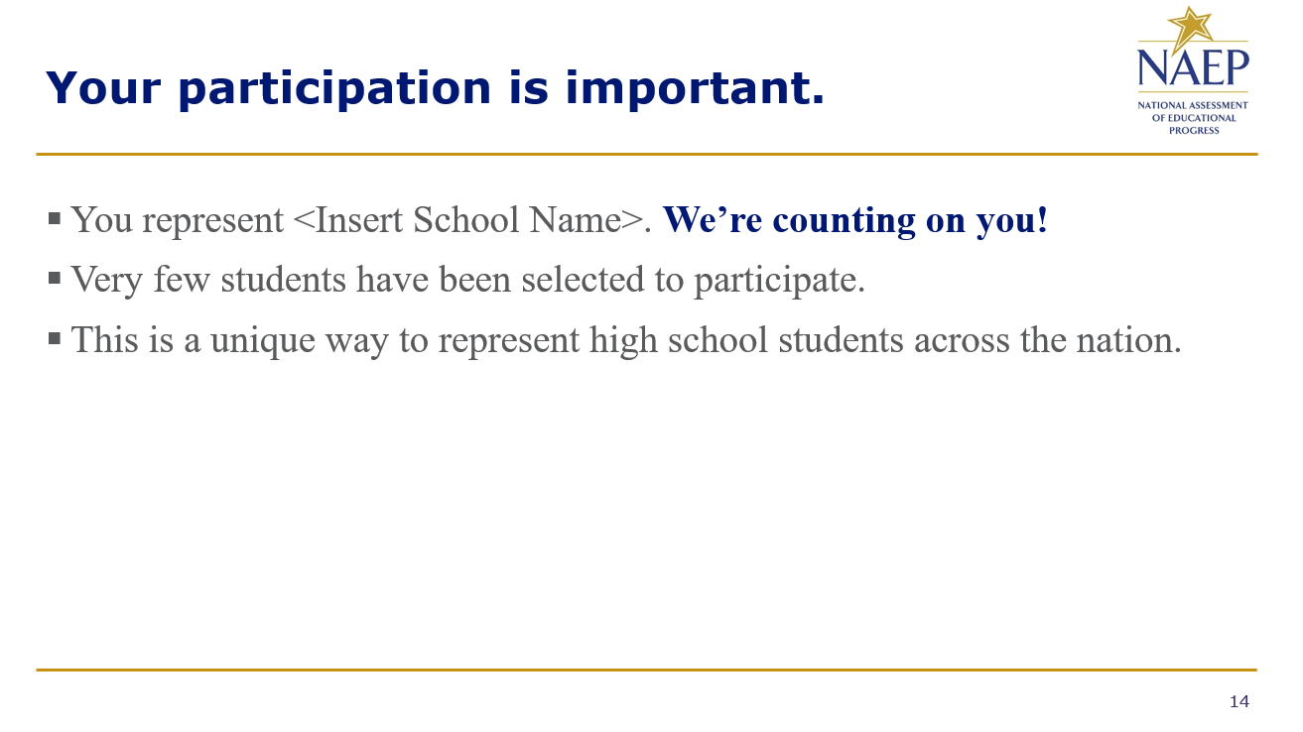

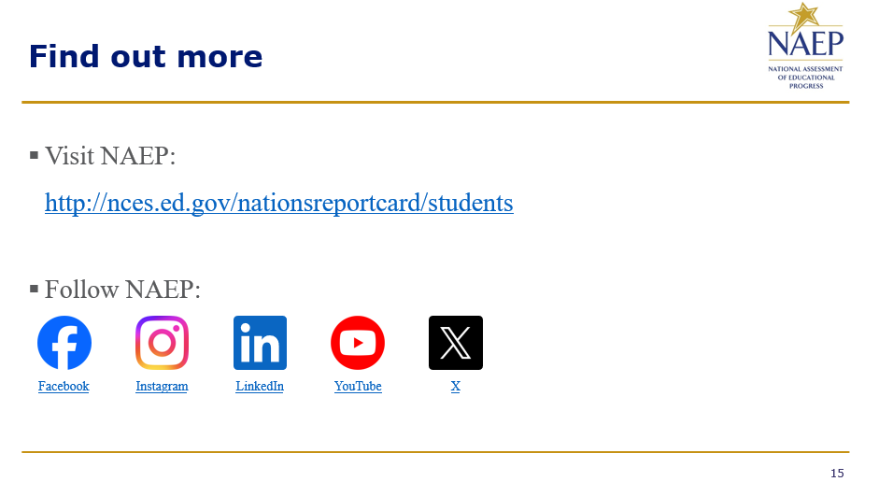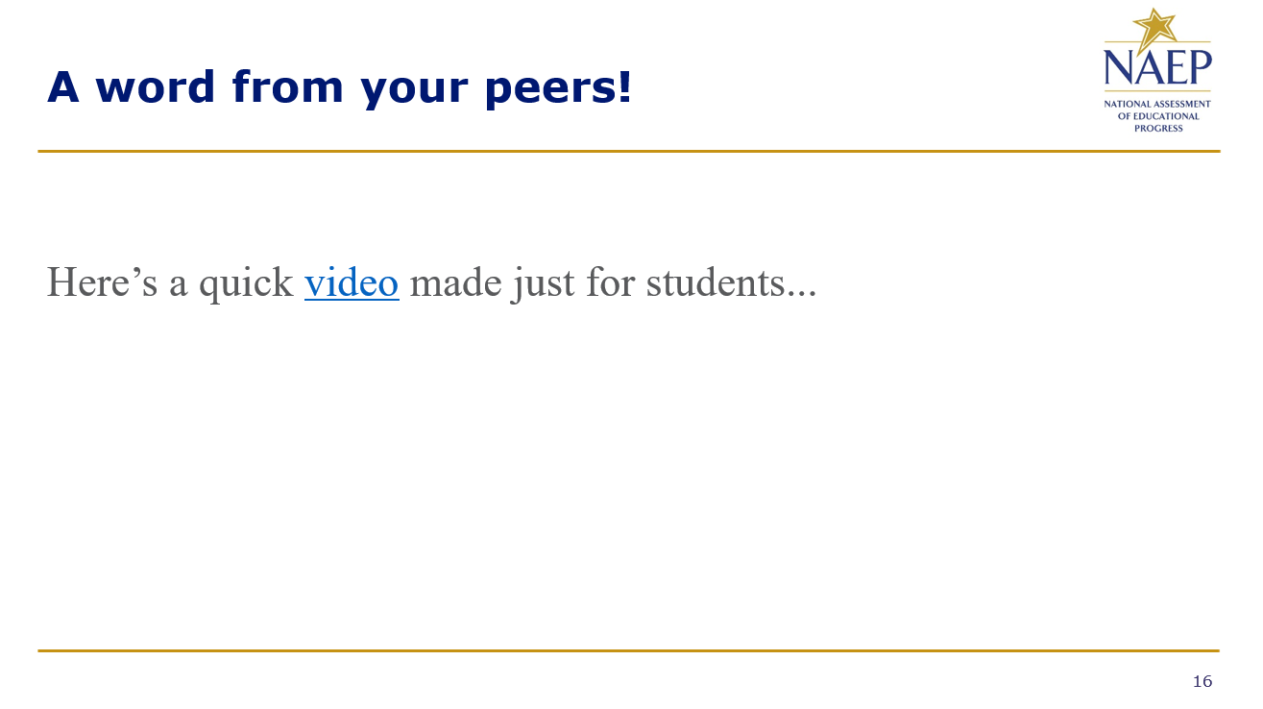

Appendix D-118: NAEP 2025 Best Practices PowerPoint Slides: Introducing NAEP to Teachers

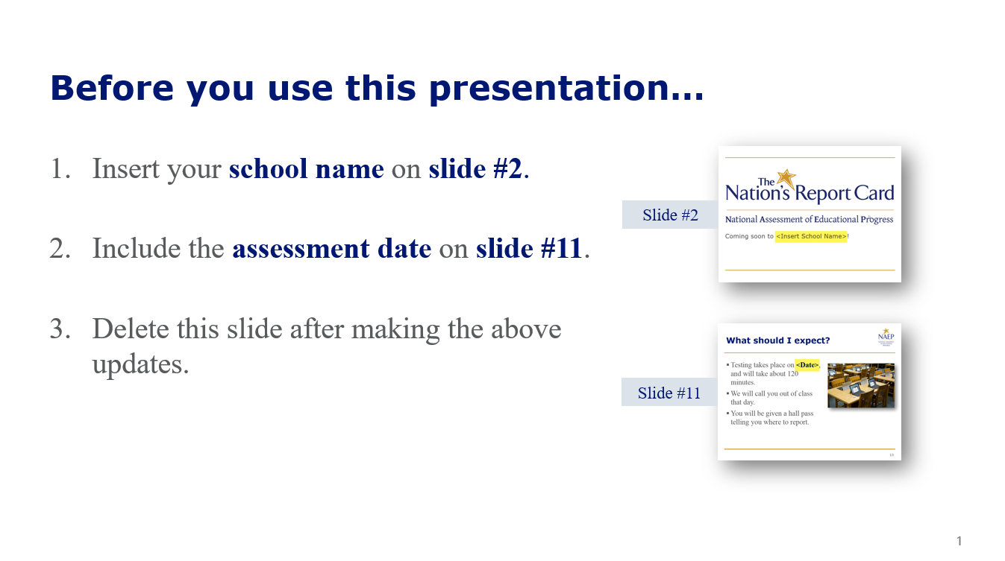
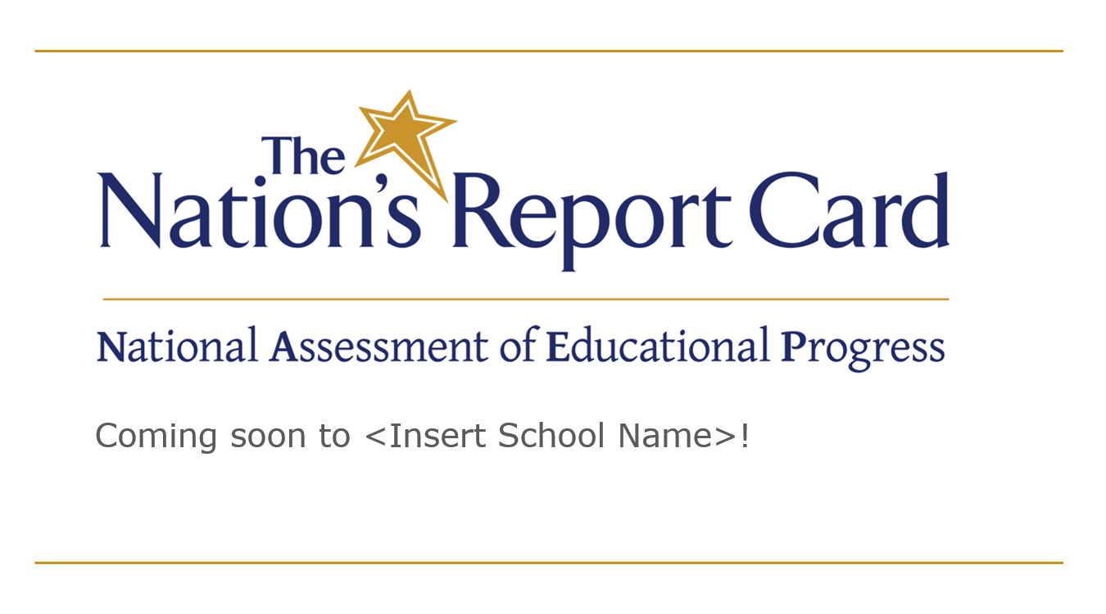

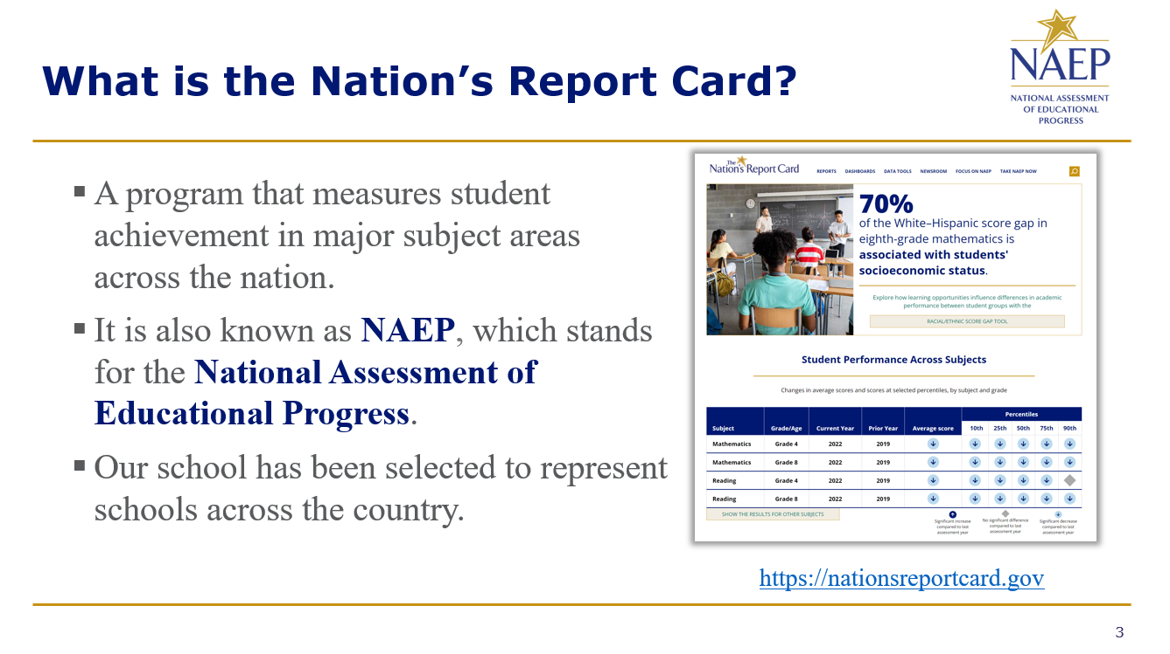
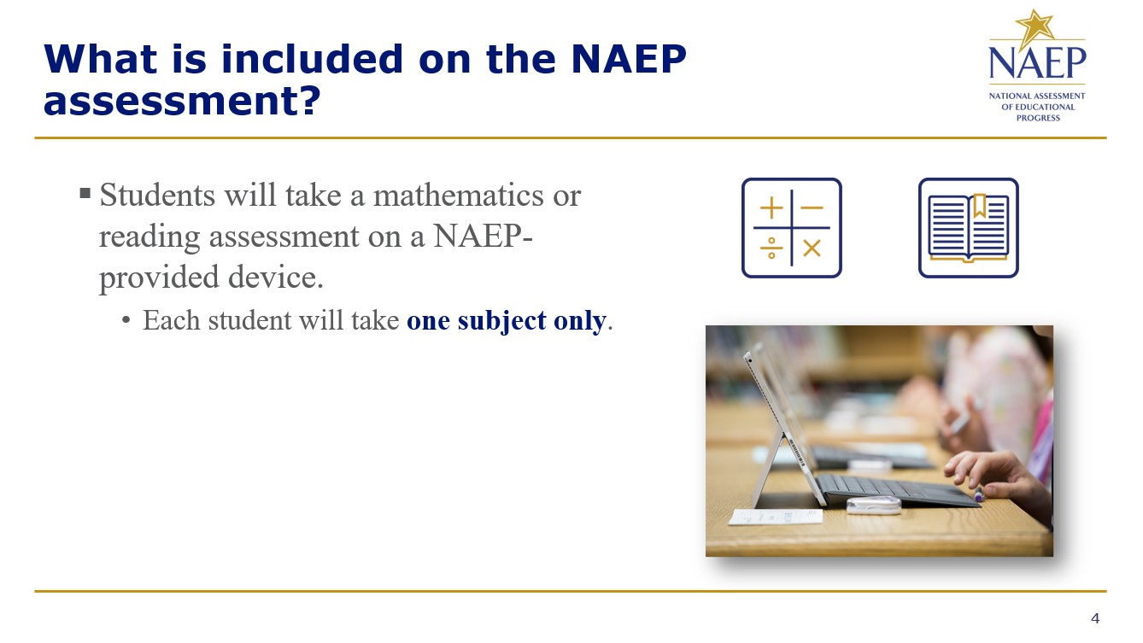

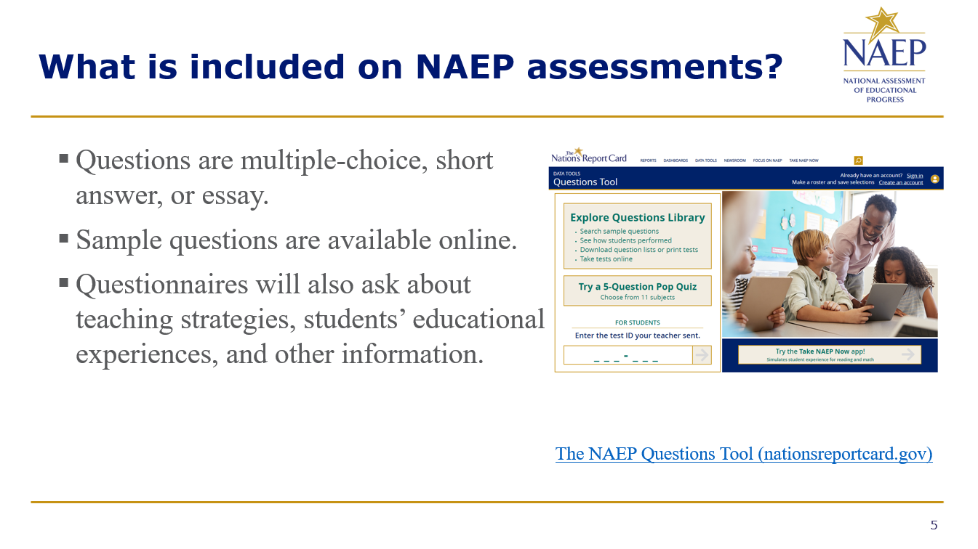
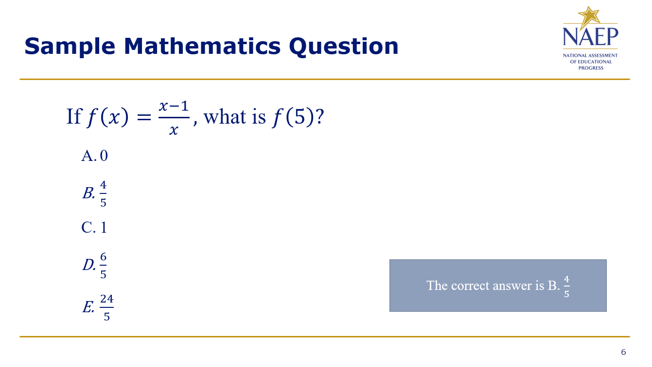

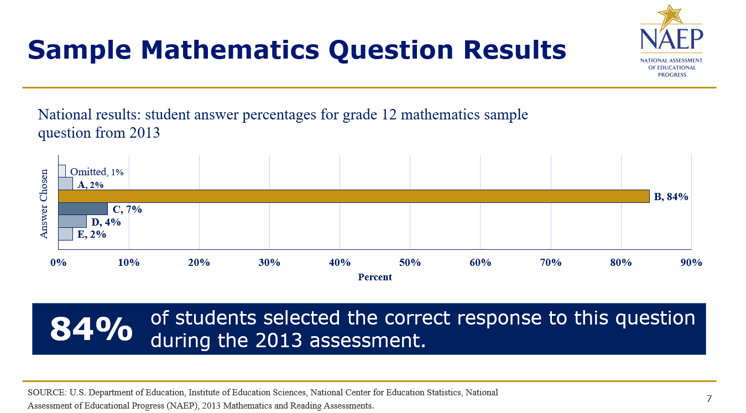
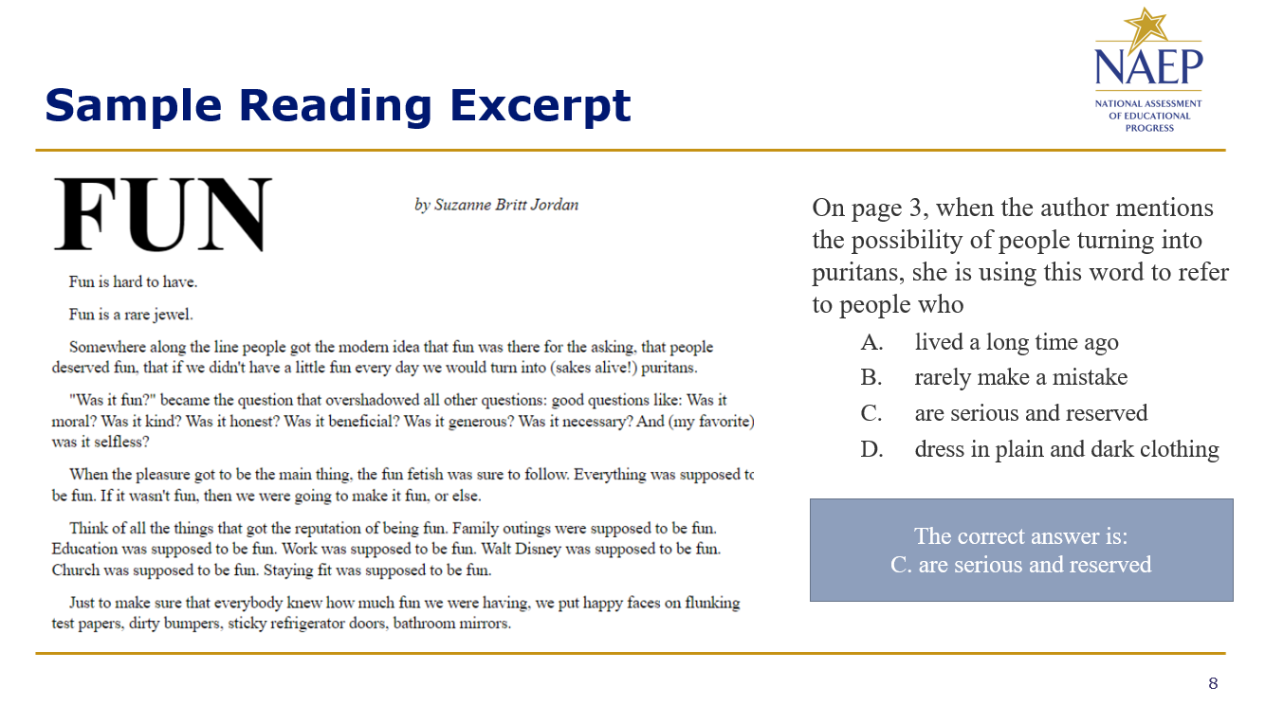

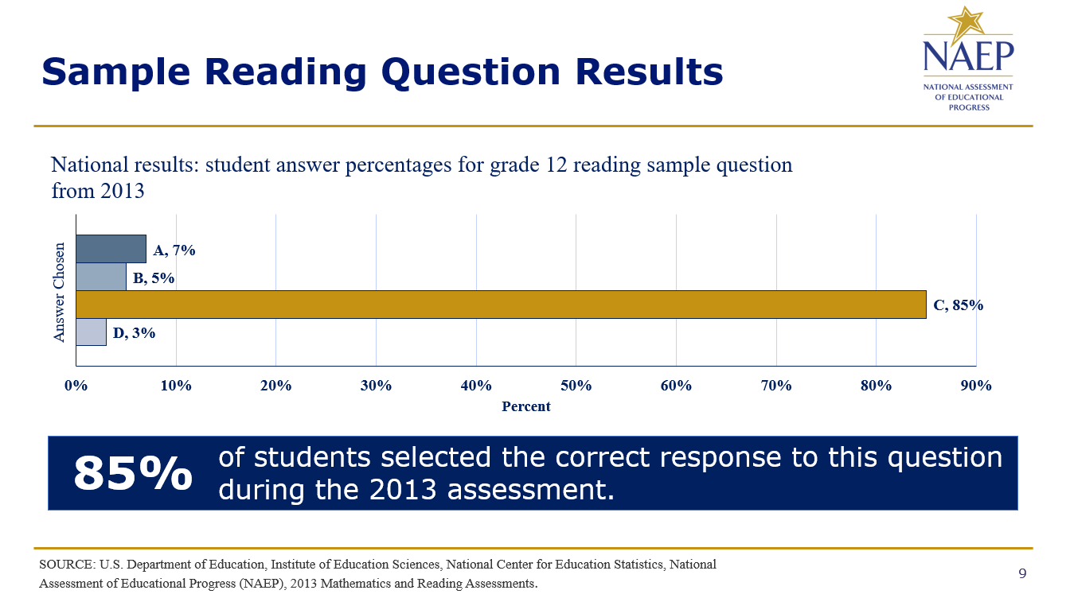
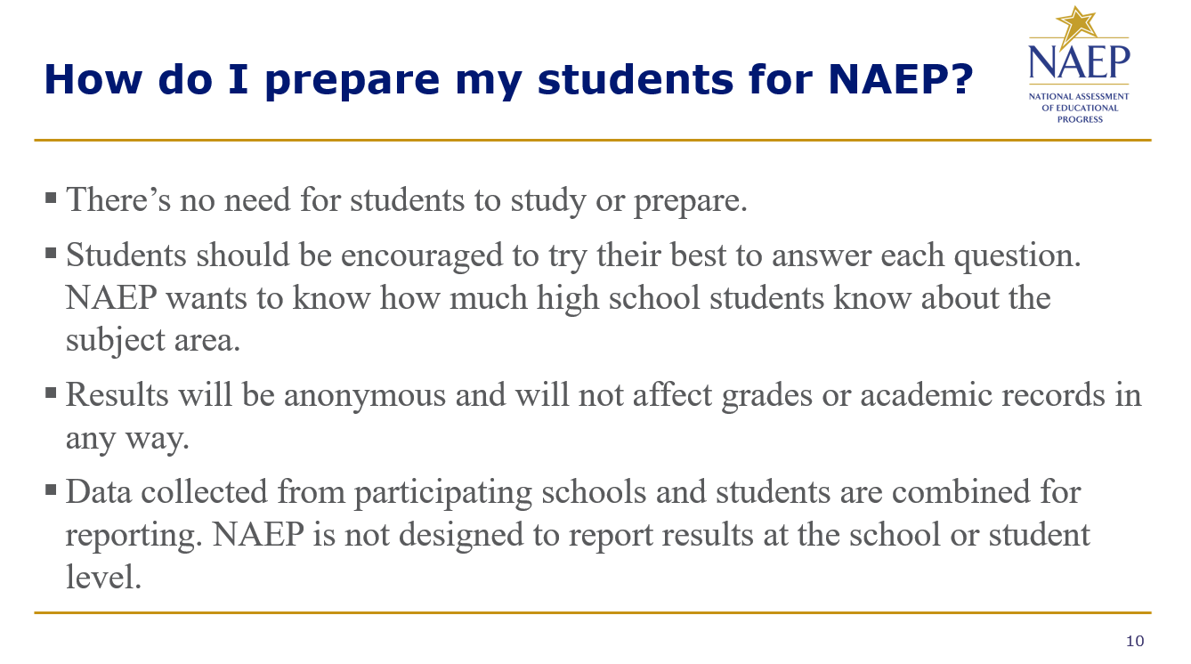

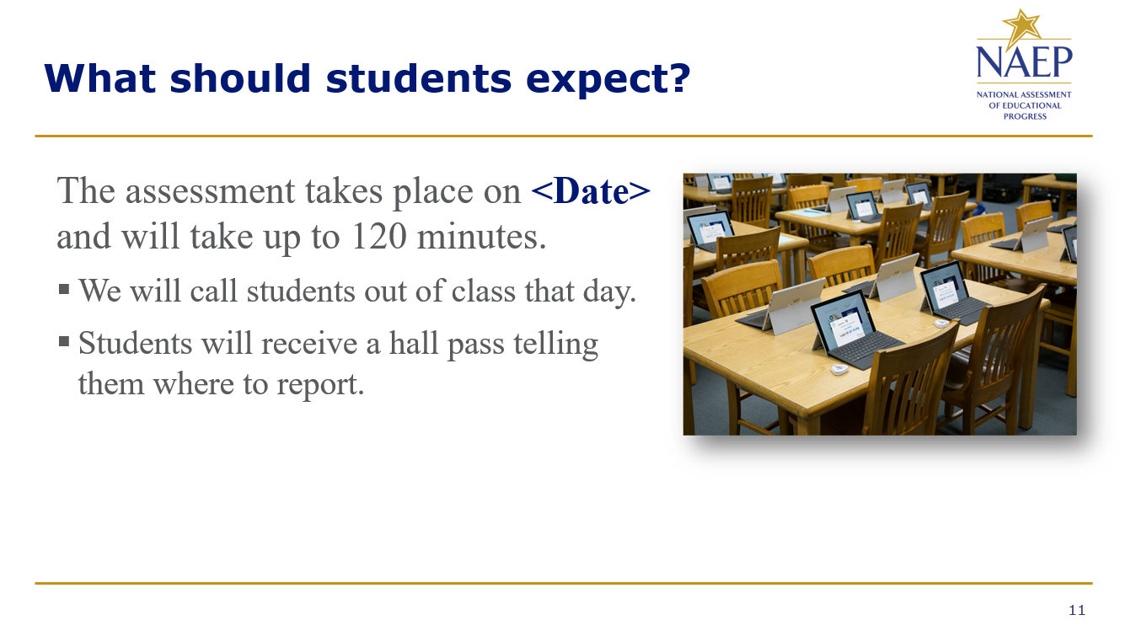
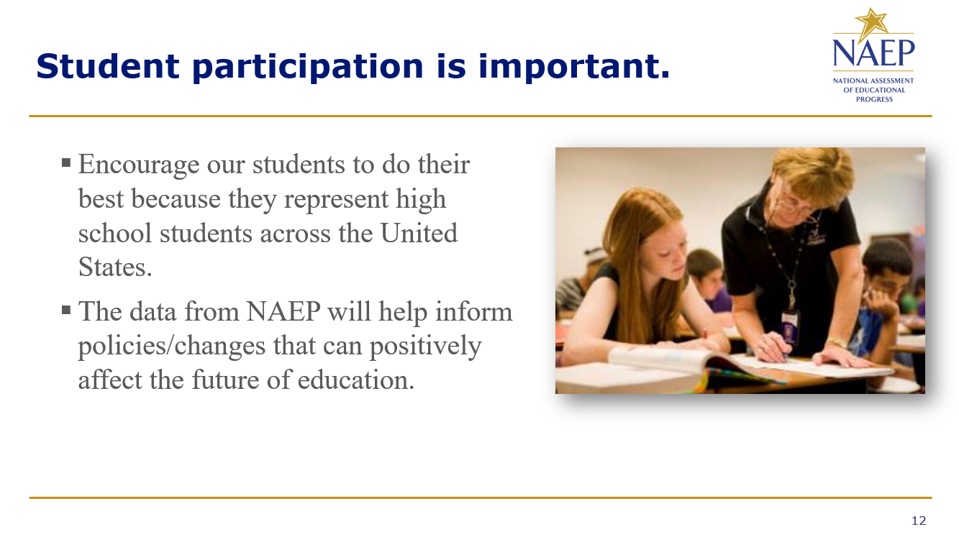

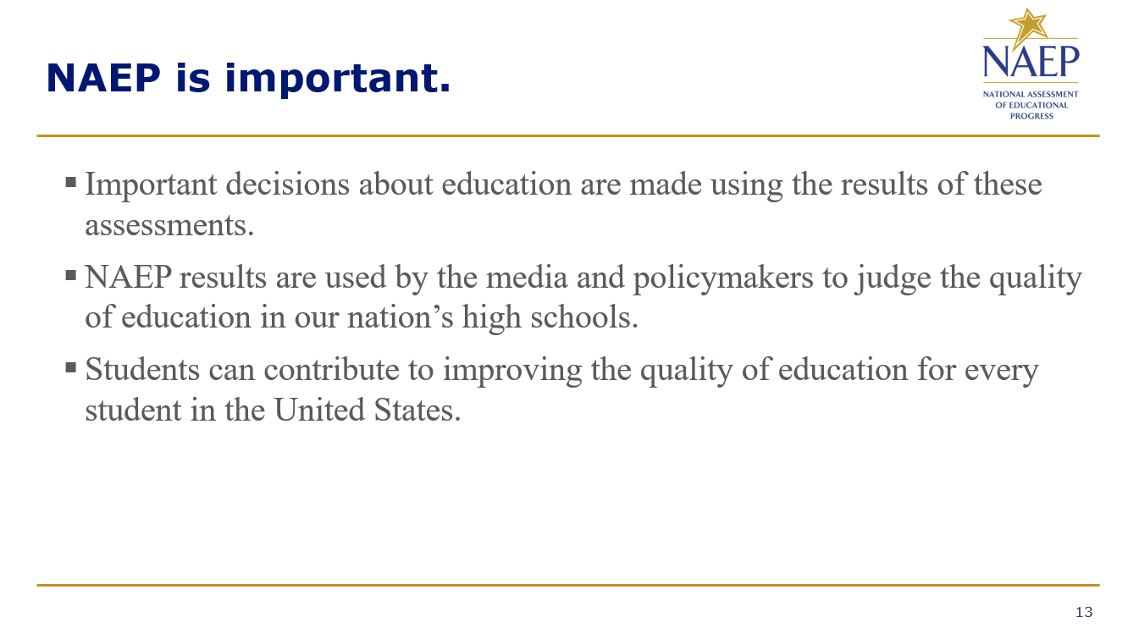
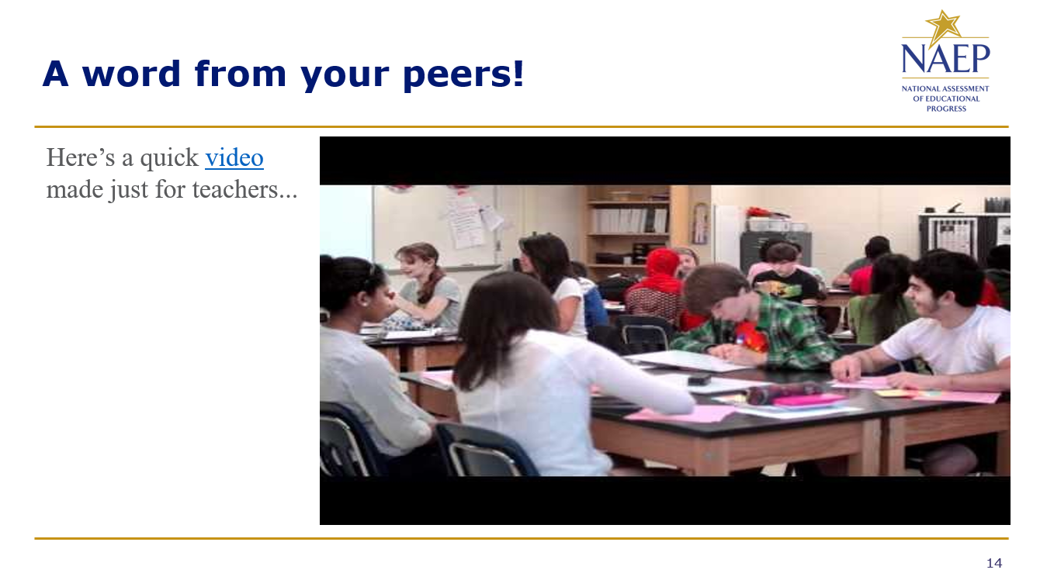

Appendix D-119: NAEP 2025 Best Practices HTML Emails

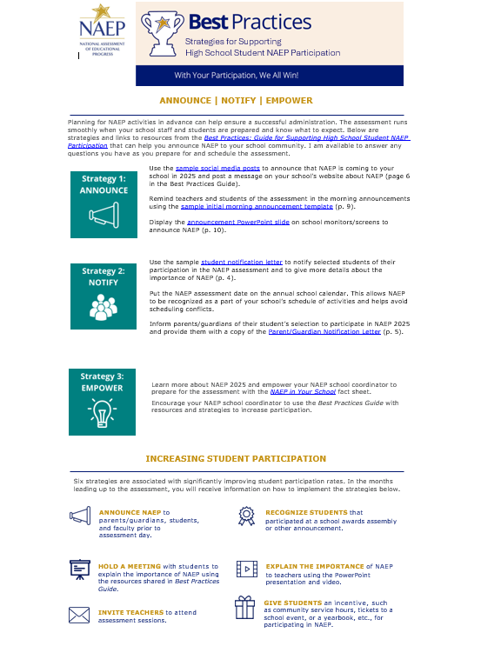
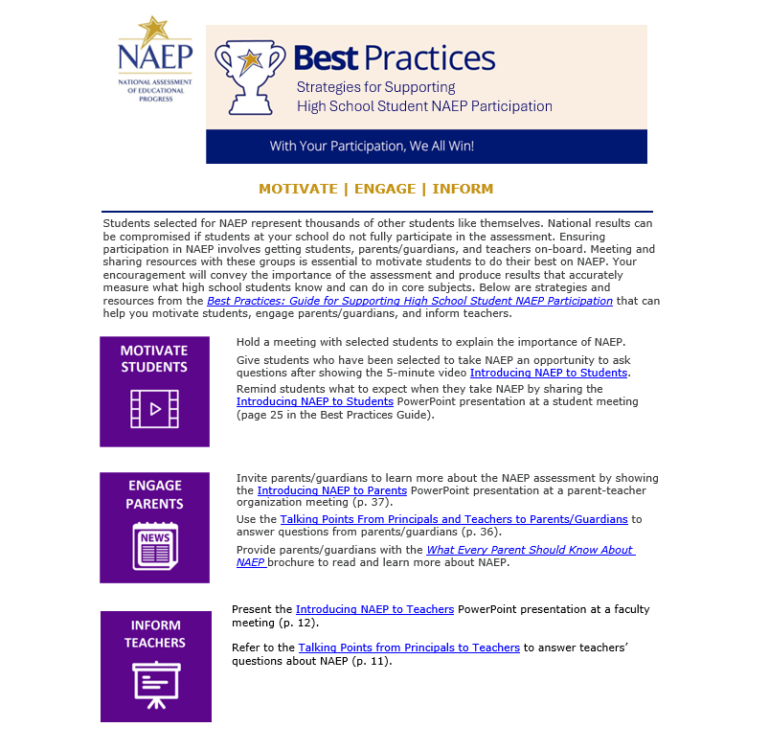

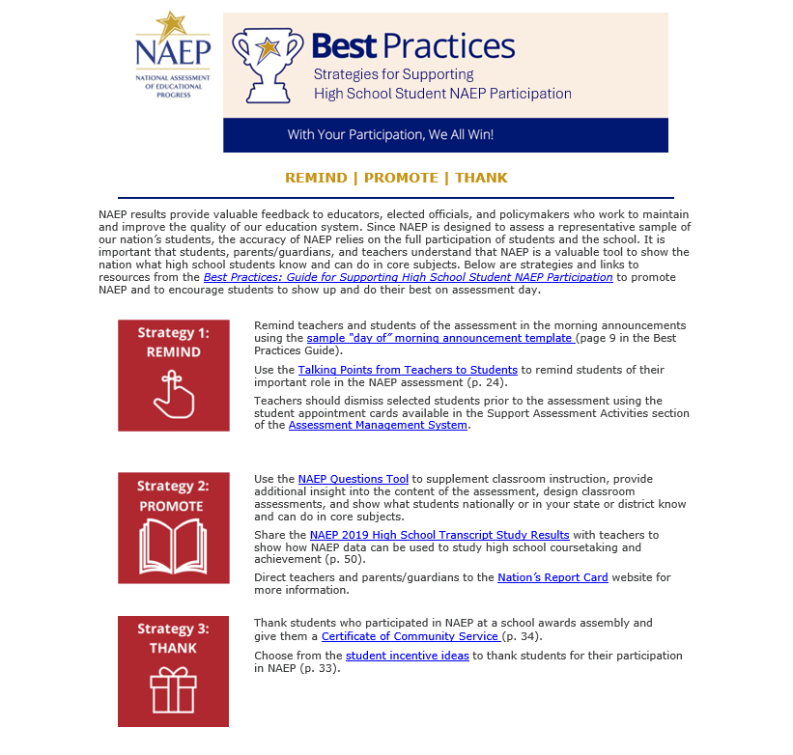

Appendix D-120: NAEP 2025 Best Practices Talking Points Principals and Teachers to Parents

Talking Points

Principals and Teachers to Parents

What is NAEP?
The National Assessment of Educational Progress, or NAEP, is often called the gold standard of assessments and has been around since 1969. It’s called The Nation’s Report Card because it tells us how students across the country are doing. It is different from any of the other tests your child takes in school, including state assessments and even the SAT and ACT. All high school students in the United States are represented in NAEP, not just those in our state or those who plan to go on to college. As the largest national test, the results make the headlines of national and local news stories all over the country.

Why should I encourage my child to participate?
NAEP is a window into the state of our educational system and what students are learning. It opens the door for parents to understand how well children like theirs are doing compared to other students in participating large urban districts, other states, the nation, and the rest of the world. Your child has been selected to represent other students like them across the country. Not every student or every school takes the test, and your child can help to show the country just how much all our high school students know and can do in a variety of subjects. NAEP results help the President, Congress, and educators make informed decisions about how to improve our education system. Your child can make a difference by participating.

What does my child have to do?
If your child is selected to participate in the assessment, your child will need to be out of class for about 120 minutes. The results are anonymous, and your child’s grades won’t be affected. We encourage students to get a good amount of sleep the night before and to eat breakfast that morning. Please encourage your child to do their best.

Where can I find more information on NAEP?
Visit The Nation’s Report Card online at https://nces.ed.gov/nationsreportcard/ and dig deeper into topics such as
- How your child was selected
- NAEP accommodations
- NAEP scoring

Also, access the NAEP parent brochure at http://nces.ed.gov/pubsearch/pubsinfo.asp?pubid=2012469.

Appendix D-121: NAEP 2025 Best Practices Talking Points Principals and Teachers to Students

Talking Points

Principals and Teachers to Students

What is NAEP?
NAEP stands for the National Assessment of Educational Progress. You may know it as The Nation’s Report Card. It’s the largest continuing and nationally representative assessment of what students across the country know and can do in various subjects. It is different from our state assessments and even the SAT and ACT because it represents all high school students across the country, not just those here in our state or those who plan to go on to college.

Why should I participate?
NAEP is important. The results of NAEP are released as The Nation’s Report Card and they help the President, Congress, and all our educators make decisions about how to improve our education system. By participating, you can influence those decisions and contribute to the quality of education for future students. Not all students take the assessment. You have been chosen to represent other high school students in our school, in our state, and across the country. It is important that you take part and put forth your best effort.

What do I have to do?
You will take the test with other selected students. The test takes only about 120 minutes. Students will be assessed in mathematics or reading. Each student will be assessed in only one subject. Your scores will be anonymous and will not affect your grades or academic record in anyway. Instead, they will be combined with the scores of other students to produce overall results. You should do your best because you were selected to represent students just like you across the country. When NAEP results are reported in the news, they influence the public’s opinion of what high school students across the United States know and can do in a variety of subjects.

Appendix D-122: NAEP 2025 Best Practices Talking Points Principals to Teachers

Talking Points

Principals to Teachers

What is NAEP?
The National Assessment of Educational Progress (NAEP) is the largest continuing and nationally representative assessment that shows what students across the country know and can do in various subjects. It is different from our state assessments and even the SAT and ACT because it represents high school students across the country, not just those here in our state or those who plan to go on to college.

Why should I encourage my students to participate?
NAEP is an important and integral part of education in the United States. The results of NAEP are released as The Nation’s Report Card. Encouraging your students to participate and do their best gives them the opportunity to show how well our nation’s students perform.
- Elected officials, policymakers, and educators all use NAEP results to develop ways to improve education.
- NAEP provides a common measure of student achievement across the country.
- NAEP data can be used to compare and understand the performance of demographic groups within your state, the nation, and select urban districts.
- Teachers can use sample NAEP questions and scoring guides as a resource for understanding student performance.

What do I have to do?
Your students will need to be out of class for about 120 minutes for the assessment. You do not have to do anything to prepare for the assessment; you just need to release students from class and encourage them to do their best. Each student represents thousands of other high school students across the nation, so it is important that they participate and do their best.

Appendix D-123: NAEP 2025 Best Practices School Announcement Templates

School Announcement

Templates

Initial morning announcement

Good morning, students and teachers. I am excited to announce that our school has been selected to participate in the 2025 National Assessment of Educational Progress, also known as NAEP. It is the largest continuing and nationally representative assessment of what students across the country know and can do in a variety of subjects. Some of our students have been selected to take assessments in mathematics and reading. To those who have been selected for this important test, you have all our support, and I have NO doubt that you will represent us well! More details to follow as we move closer to our school’s assessment day. Thank you in advance for your involvement.

Morning announcement used in the month leading up to NAEP assessment (possibly read once per week or biweekly)

Good morning, students and teachers. The countdown to the NAEP assessment is underway. We are only ___ days away from NAEP Day on [Date], when some of our students will take this important assessment to measure our nation’s educational progress. Students and teachers, if you have any questions, please reach out to ____, our School’s NAEP coordinator. Thank you.

Morning announcement used the day of the NAEP assessment
Good morning, students and teachers. NAEP Day is finally here! I would like to remind everyone that today some of our students will be participating in the National Assessment of Educational Progress. Teachers, please be sure to release those students 5 minutes before the assessment is scheduled to begin. For those students who are participating, please report to your designated locations on time. You are playing an important role in our nation’s ability to measure what students across the country are learning. What’s more, by taking the assessment, you are having an impact on the future of education for the students who follow you. Do your best and good luck. Thank you.

Appendix D-124: NAEP 2025 Best Practices High School Incentive Ideas

Incentive Ideas

For students who participate in NAEP

Student incentives can help boost NAEP participation rates in your school. Here are some examples of strategies used by school principals over the past 10 years.

Raffle for prizes
Students who choose to participate can be entered into a raffle for a special prize. Some possible prizes are listed below.
- Free prom tickets
- Special parking space for a day or week
- Free yearbook
- Free yearbook space/page
- Gift card(s) from local businesses

Free food

Some schools offer a simple breakfast as a thank you to participating students—bagels, donuts, coffee, and orange juice. Another option is pizza for lunch or snacks for after the assessment.

Graduation pin

Create and distribute a pin or honor tag to be worn during graduation.

Appendix D-125: NAEP 2025 Best Practices Social Media and Online Communication Sample Announcements

Social Media and Online Communication

Sample Announcements
If your school uses social media or other online communications to communicate with parents/guardians, students, and teachers, you can also use these methods to communicate the importance of the assessment to teachers and to encourage student participation. The messages on the following page are available for you to customize before posting to your school’s social media channels, school website, incorporated in school emails, or newsletters.
In addition, you can follow NAEP’s social media accounts as we regularly share resources, results, and tools for working with NAEP that states also share on their pages to prepare for participation in the assessments. Find our social media accounts below.
https://www.facebook.com/NationalAssessmentofEducationalProgress/

https://twitter.com/naep_nces?lang=en
https://www.youtube.com/user/TheNationsReportCard

Scheduling Information
Our school will have the chance to make a difference in education on [DATE]! Learn why our participation in NAEP is important at https://www.nationsreportcard.gov/.
A group of our students will represent thousands of others across the country on [DATE]! Known as The Nation’s Report Card, NAEP is the largest nationally representative and continuing assessment of what students in the United States know and can do in a variety of subjects. Learn more at https://www.nationsreportcard.gov/

We’re excited to announce our school will participate in #NAEP on [DATE]! Learn about this national assessment at https://www.nationsreportcard.gov/.

#NAEP will be administered to select students at our school on [DATE]. To learn more about the program, visit https://nces.ed.gov/nationsreportcard/students/

Something big is happening on [DATE]. A group of our students will participate in #NAEP that day! Learn more at https://nces.ed.gov/nationsreportcard/students/

Information for Teachers
Teachers, how much do you know about NAEP? What does NAEP mean for you and your students? Hear what other teachers are saying at https://nces.ed.gov/nationsreportcard/participating/schools.aspx
NAEP results help us better understand how our students are performing academically across the United States. Learn more about why participation is important at https://www.nationsreportcard.gov/focus_on_naep/participation/#/grade12
Some of our students have been selected to participate in #NAEP! Discover what other #teachers are saying at https://nces.ed.gov/nationsreportcard/participating/schools.aspx
#Teachers, do you know why our #student participation in #NAEP is important? Find out: https://www.nationsreportcard.gov/focus_on_naep/participation/#/grade12
#Teachers, find out the types of questions your #students will see on #NAEP with the NAEP Questions Tool: https://nces.ed.gov/nationsreportcard/nqt/

Information for Students
If you have been selected to take NAEP, your participation is essential for understanding what students across the country have learned in school. Curious about the types of questions you can expect to see on #NAEP? Check out the NAEP Test Yourself tool at https://www.nationsreportcard.gov/testyourself.aspx
What is NAEP? Learn the answer to this question and more at https://nces.ed.gov/nationsreportcard/students/
Curious about the types of questions you can expect to see on #NAEP? Check out the NAEP Test Yourself tool at https://www.nationsreportcard.gov/testyourself.aspx
You don’t have to study for #NAEP, but your participation is still important. Find out why: https://nces.ed.gov/nationsreportcard/students/
Information for Parents/Guardians
Parents, if your student has been selected to take NAEP, they will represent thousands of other students across the United States. Discover other reasons why participation is so important at https://nces.ed.gov/nationsreportcard/parents/
Do you have any questions about NAEP and your child’s involvement? Learn the answers to your questions and more by visiting https://nces.ed.gov/nationsreportcard/parents/
Mark your calendars, parents! Our school will participate in #NAEP on [DATE]. Learn more about the assessment at https://nces.ed.gov/nationsreportcard/parents/
If your child has been selected to participate in #NAEP, find more information about the assessment at https://nces.ed.gov/nationsreportcard/parents/
Why is your child’s participation in #NAEP important? Find out by visiting https://nces.ed.gov/nationsreportcard/parents/

Appendix D-126: NAEP 2025 Best Practices Certificate of Community Service

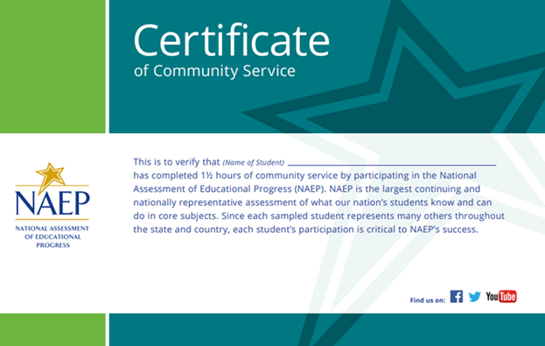

Appendix D-127: NAEP 2025 Best Practices Certificate of Appreciation

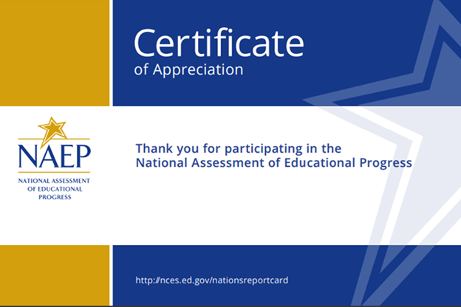
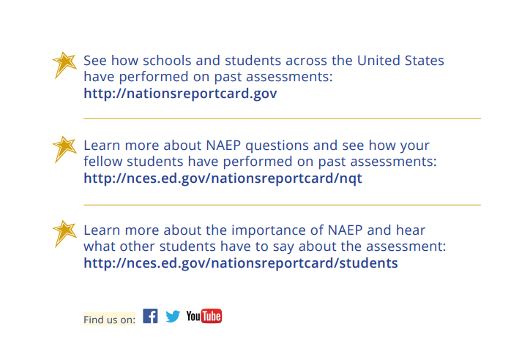

Appendix D-128: NAEP 2025 Best Practices NAEP Data, Tools, and Resources



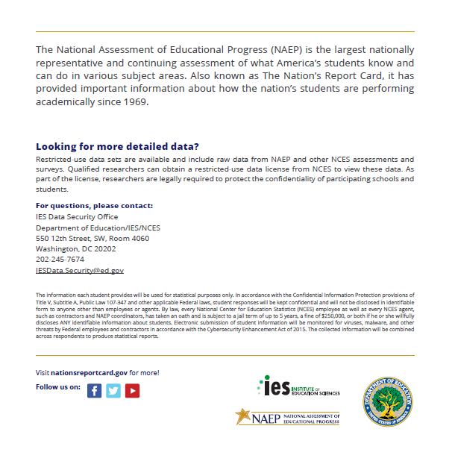
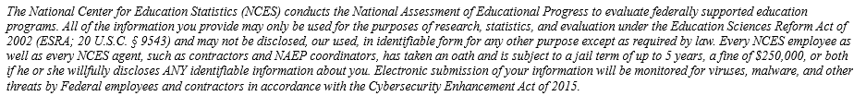

Appendix D-129: NAEP 2026 Facts for Districts (NEW)

2026 Facts for Districts

“NAEP is the only assessment providing half a century of performance data to measure what students know and can do. The state and national trends inform local, state, and national program and policy discussions that improve teaching and learning.”
– David Atherton, EdD, Principal, Clear Creek Middle School, Gresham, OR

What is NAEP?
The National Assessment of Educational Progress (NAEP) is an integral measure of academic progress across the nation and over time. It is the largest nationally representative and continuing assessment of what our nation’s students know and can do in various subjects such as civics, mathematics, reading, science, and U.S. history. The program also provides valuable insights into students’ educational experiences and opportunities to learn in and outside of the classroom.

NAEP is a congressionally mandated program administered by the National Center for Education Statistics (NCES), within the U.S. Department of Education’s Institute of Education Sciences.

How are NAEP results reported?
The results of NAEP are released as The Nation’s Report Card. NAEP results are available for the nation and may be available for states and select urban districts that participate in the Trial Urban District Assessment (TUDA), depending on the assessment. Additionally, results are reported for different student groups, based on factors such as race/ethnicity, sex, school location, and more. NAEP is not designed to report results for individual students, classrooms, or schools.

Why should my district participate in NAEP?
Your district’s participation is vitally important for several reasons.
- Results from the 2026 assessments will provide much needed information about the academic achievement and continued recovery of students whose elementary school experiences were impacted by the COVID-19 pandemic.
- Schools and students selected to participate in NAEP represent schools and students across the country. Each school’s participation is critical and contributes to the understanding of students’ educational progress across the U.S.

What NAEP assessments will be administered in 2026?
The 2026 program will include
- assessments in mathematics and reading at grades 4 and 8;
- assessments in civics and U.S. history at grade 8;
- pilot testing in mathematics and reading at grades 4, 8, and 12, to help improve future NAEP assessments; and
- survey questionnaires for participating students, teachers, and principals to provide a better understanding of factors that may be related to students’ learning.

The assessments will be administered between January 26 and March 6, 2026.

National, state, and select urban district results will be released for the mathematics and reading assessments at grades 4 and 8. National results will be released for the civics and U.S. history assessments at grade 8. Results from the pilot testing will not be released but will be used to inform future assessments.

What will students in my district do?
Participating students will complete
- assessment items in civics, mathematics, reading, or U.S. history; and, if applicable,
- survey questionnaires that provide valuable information about their educational experiences and opportunities to learn both in and outside of the classroom.

Students are given approximately 2 hours to complete the assessments unless accommodations are provided. This includes transition time, directions, and completion of survey questionnaires. A broad range of accommodations are provided for students with disabilities and English learners.

Students will take assessments using school devices or NAEP devices. NAEP representatives will contact your district in the coming months with more information.

Do teachers need to prepare students for the assessment?
Teachers do not need to prepare their students to take the assessment but should encourage them to do their best.

Who will administer NAEP? What do schools need to provide on the day of the assessment?
NAEP representatives will administer the NAEP assessment and provide significant support to schools on assessment day. Schools will need to provide space for students to take the assessment, desks or tables, and an adequate number of electrical outlets in the assessment location.
- In schools where the assessment will be administered using school devices, school and/or district staff who have experience with the devices and technology used by the school may be required to be available during the testing session(s).
- In schools where the assessment will be administered using NAEP devices, NAEP representatives will bring all necessary materials and equipment to assess the students.

How were schools in my district selected for NAEP?
Schools were selected as part of a carefully designed sampling process that ensures NAEP-selected schools and students are representative of your district, state, and the nation.

Under the Elementary and Secondary Education Act, districts and states that receive Title I funds are required to participate in the biennial assessments.

How can school administrators and teachers use NAEP data to help our students?
The NAEP Data Explorer (https://www.nationsreportcard.gov/ndecore) is a powerful tool that allows you to examine the relationships between student performance and factors such as instructional practices, school resources, and more.

Questions from previous NAEP assessments can also be used as a helpful educational resource in the classroom. Teachers can use the NAEP Questions Tool (http://nces.ed.gov/nationsreportcard/nqt) to see how their students’ performance compares to peers in your state and across the nation. Released NAEP questions come with a scoring guide, sample student responses, and performance data.

How long has NAEP been around?
NAEP was first administered in 1969 to measure student achievement nationally. In 1990, NAEP was administered at the state level for the first time. The NAEP TUDA program, which measures student achievement in some of the nation’s large urban districts, began in 2002.

Where can I find more information?
Learn more about the NAEP program at nces.ed.gov/nationsreportcard, and explore the latest NAEP results at nationsreportcard.gov.

You can also find NAEP on: <Facebook logo> <Instagram logo> <LinkedIn logo> <X logo> <YouTube logo>

The National Center for Education Statistics (NCES) conducts the National Assessment of Educational Progress to evaluate federally supported education programs. All of the information you provide may only be used for the purposes of research, statistics, and evaluation under the Education Sciences Reform Act of 2002 (ESRA; 20 U.S.C. § 9543) and may not be disclosed, our used, in identifiable form for any other purpose except as required by law. Every NCES employee as well as every NCES agent, such as contractors and NAEP coordinators, has taken an oath and is subject to a jail term of up to 5 years, a fine of $250,000, or both if he or she willfully discloses ANY identifiable information about you. Electronic submission of your information will be monitored for viruses, malware, and other threats by Federal employees and contractors in accordance with the Cybersecurity Enhancement Act of 2015.

This publication was prepared for the National Assessment of Educational Progress by Manhattan Strategy Group under contract 91990018C0001 to the National Center for Education Statistics, U.S. Department of Education.

Appendix D-130: NAEP 2026 Facts for Principals (NEW)

NAEP 2026
Facts for Principals
Grades 4 and 8 Mathematics and Reading

Page One Sidebar
NAEP is an integral part of education in the United States.
- Elected officials, policymakers, and educators all use NAEP results to inform ways to improve education.
- NAEP is a congressionally mandated program administered by the National Center for Education Statistics (NCES), within the U.S. Department of Education’s Institute of Education Sciences.
- NAEP serves a different role than state assessments. While states have their own unique assessments with different content standards, the same NAEP assessment is administered in every state, providing a common measure of student achievement.
- Depending on the type of NAEP assessment that is administered, NAEP data are available for the nation, your state, districts that participate in the Trial Urban District Assessment (TUDA), and student groups. NAEP is not designed to report results for individual students, classrooms, or schools.
- To provide a better understanding of educational experiences and factors that may be related to students’ learning, students, teachers, and principals who participate in NAEP are asked to complete survey questionnaires.

Page One Body
“NAEP is the only assessment providing half-a-century of performance data to measure what students know and can do. The state and national trends inform local, state, and national program and policy discussions that improve teaching and learning.”
- David Atherton, EdD, Principal, Clear Creek Middle School, Gresham, OR

What is NAEP?
The National Assessment of Educational Progress (NAEP) is the largest nationally representative and continuing assessment of what our nation’s students know and can do in various subjects such as civics, mathematics, reading, science, and U.S. history. The results of NAEP are released as The Nation’s Report Card.

What can principals and schools expect?
NAEP representatives will provide significant support to your school on assessment day. As principals, you make an important contribution to the program by selecting and empowering a NAEP school coordinator, meeting with teachers and participating students, and encouraging your students to participate and do their best. You are essential partners in NAEP. Each school’s participation is critical and contributes to the understanding of students’ educational progress across the U.S.

In 2026, students in grades 4 and 8 will take NAEP mathematics and reading assessments. Each student will be assessed in only one subject. The assessments will be administered by NAEP representatives on school devices or NAEP devices. NAEP representatives will contact your school in the coming months with more information.

Schools will need to provide space for students to take the assessment, desks or tables, and an adequate number of electrical outlets in the assessment location. NAEP representatives will use school devices and Internet—when possible—to conduct the assessment. They will work with you or your district to determine if this is feasible for your school.

As part of the assessments, students may be asked to complete NAEP survey questionnaires that provide valuable information about participating students’ educational experiences and opportunities to learn both in and outside of the classroom.

Results in mathematics and reading will be released for the nation, states, and selected urban districts.

For more information about NAEP, visit www.nces.ed.gov/nationsreportcard.

Page Two Body
NAEP was first administered in 1969 to measure student achievement nationally. In 1990, NAEP was administered at the state level for the first time. Students in grades 4 and 8 are currently assessed at the national and state level in mathematics and reading every 2 years and in other subjects periodically. The NAEP TUDA program, which measures student achievement in some of the nation’s large urban districts, began in 2002.

From the development of assessment frameworks and questions to the reporting of results, NAEP delivers high technical quality and represents the best thinking of assessment and content specialists, state education staff, and teachers from around the nation. NAEP is a trusted resource that measures student progress and helps inform policy decisions that improve education in the United States.

How are NAEP results reported? NAEP results are reported for different demographic groups rather than for individual students or schools. Within a school, just some of the student population participates, and student responses are combined with those from other participating students to produce the results.

How are schools and students selected for NAEP? A carefully designed sampling process ensures that NAEP-selected schools and students are representative of all schools and students in their district, state, and across the United States. To ensure the sample represents all students in the nation’s schools, a broad range of accommodations are allowed for students with disabilities and English learners.

What can teachers and students expect? Including transition time, directions and tutorials, and completion of survey questions, it takes approximately 2 hours for students to complete the assessment. Teachers do not need to prepare their students to take the assessment but should encourage them to do their best. NAEP representatives provide significant support to your school by working with the designated coordinator in your school to organize assessment activities.

How can educators use NAEP resources to help students? Released NAEP items can be used as a helpful educational resource in the classroom. Teachers and district staff can use the NAEP Questions Tool (http://nces.ed.gov/nationsreportcard/nqt) to create a test and see how your students’ performance compares nationally on specific items. Released NAEP items come with a scoring guide, sample student responses, and performance data.

Visit the NAEP website at http://nces.ed.gov/nationsreportcard to access this information and more.

The National Center for Education Statistics (NCES) conducts the National Assessment of Educational Progress to evaluate federally supported education programs. All of the information you provide may only be used for the purposes of research, statistics, and evaluation under the Education Sciences Reform Act of 2002 (ESRA; 20 U.S.C. § 9543) and may not be disclosed, our used, in identifiable form for any other purpose except as required by law. Every NCES employee as well as every NCES agent, such as contractors and NAEP coordinators, has taken an oath and is subject to a jail term of up to 5 years, a fine of $250,000, or both if he or she willfully discloses ANY identifiable information about you. Electronic submission of your information will be monitored for viruses, malware, and other threats by Federal employees and contractors in accordance with the Cybersecurity Enhancement Act of 2015.

Page Two Footer
Find us on: [insert social media icons]

This publication was prepared for the National Assessment of Educational Progress by Manhattan Strategy Group under contract 91990018C0001 to the National Center for Education Statistics, U.S. Department of Education.

NAEP 2026
Facts for Principals
Grade 8 Civics and U.S. History

Page One Sidebar
NAEP is an integral part of education in the United States.
- Elected officials, policymakers, and educators all use NAEP results to inform ways to improve education.
- NAEP is a congressionally mandated program administered by the National Center for Education Statistics (NCES), within the U.S. Department of Education’s Institute of Education Sciences.
- NAEP serves a different role than state assessments. While states have their own unique assessments with different content standards, the same NAEP assessment is administered in every state, providing a common measure of student achievement.
- Depending on the type of NAEP assessment that is administered, NAEP data are available for the nation, your state, districts that participate in the Trial Urban District Assessment (TUDA), and student groups. NAEP is not designed to report results for individual students, classrooms, or schools.
- To provide a better understanding of educational experiences and factors that may be related to students’ learning, students, teachers, and principals who participate in NAEP are asked to complete survey questionnaires.

Page One Body
“NAEP is the only assessment providing half-a-century of performance data to measure what students know and can do. The state and national trends inform local, state, and national program and policy discussions that improve teaching and learning.”
- David Atherton, EdD, Principal, Clear Creek Middle School, Gresham, OR

Visit https://nces.ed.gov/nationsreportcard/about/covid19.aspx for more information about NAEP health and safety protocols.

What is NAEP?
The National Assessment of Educational Progress (NAEP) is the largest nationally representative and continuing assessment of what our nation’s students know and can do in various subjects such as civics, mathematics, reading, science, and U.S. history. The results of NAEP are released as The Nation’s Report Card.

What can principals and schools expect?
NAEP representatives will provide significant support to your school on assessment day. As principals, you make an important contribution to the program by selecting and empowering a NAEP school coordinator, meeting with teachers and participating students, and encouraging your students to participate and do their best. You are essential partners in NAEP. Each school’s participation is critical and contributes to the understanding of students’ educational progress across the U.S.

In 2026, grade 8 students will take NAEP assessments in civics and U.S. history. The assessments will be administered by NAEP representatives on NAEP devices. NAEP representatives will contact your school in the coming months with more information.

Schools will need to provide space for students to take the assessment, desks or tables, and an adequate number of electrical outlets in the assessment location.

As part of the assessments, students may be asked to complete NAEP survey questionnaires that provide valuable information about participating students’ educational experiences and opportunities to learn both in and outside of the classroom.

Results in civics and U.S. history will be released for the nation.

For more information about NAEP, visit www.nces.ed.gov/nationsreportcard.

Page Two Body
NAEP was first administered in 1969 to measure student achievement nationally. In 1990, NAEP was administered at the state level for the first time. Students in grades 4 and 8 are currently assessed at the national and state level in mathematics and reading every 2 years and in other subjects periodically. The NAEP TUDA program, which measures student achievement in some of the nation’s large urban districts, began in 2002.

From the development of assessment frameworks and questions to the reporting of results, NAEP delivers high technical quality and represents the best thinking of assessment and content specialists, state education staff, and teachers from around the nation. NAEP is a trusted resource that measures student progress and helps inform policy decisions that improve education in the United States.

How are NAEP results reported? NAEP results are reported for different demographic groups rather than for individual students or schools. Within a school, just some of the student population participates, and student responses are combined with those from other participating students to produce the results.

How are schools and students selected for NAEP? A carefully designed sampling process ensures that NAEP-selected schools and students are representative of all schools and students in their district, state, and across the United States. To ensure that the sample represents all students in the nation’s schools, a broad range of accommodations are allowed for students with disabilities and English learners.

What can teachers and students expect? Including transition time, directions and tutorials, and completion of survey questions, it takes approximately 2 hours for students to complete the assessment. Teachers do not need to prepare their students to take the assessment but should encourage them to do their best. NAEP representatives provide significant support to your school by working with the designated coordinator in your school to organize assessment activities.

How can educators use NAEP resources to help students? Released NAEP items can be used as a helpful educational resource in the classroom. Teachers and district staff can use the NAEP Questions Tool (http://nces.ed.gov/nationsreportcard/nqt) to create a test and see how your students’ performance compares nationally on specific items. Released NAEP items come with a scoring guide, sample student responses, and performance data.

Visit the NAEP website at http://nces.ed.gov/nationsreportcard to access this information and more.

The National Center for Education Statistics (NCES) conducts the National Assessment of Educational Progress to evaluate federally supported education programs. All of the information you provide may only be used for the purposes of research, statistics, and evaluation under the Education Sciences Reform Act of 2002 (ESRA; 20 U.S.C. § 9543) and may not be disclosed, our used, in identifiable form for any other purpose except as required by law. Every NCES employee as well as every NCES agent, such as contractors and NAEP coordinators, has taken an oath and is subject to a jail term of up to 5 years, a fine of $250,000, or both if he or she willfully discloses ANY identifiable information about you. Electronic submission of your information will be monitored for viruses, malware, and other threats by Federal employees and contractors in accordance with the Cybersecurity Enhancement Act of 2015.

Page Two Footer
Find us on: [insert social media icons]

This publication was prepared for the National Assessment of Educational Progress by Manhattan Strategy Group under contract 91990018C0001 to the National Center for Education Statistics, U.S. Department of Education.

NAEP 2026
Facts for Principals
Pilot

Page One Sidebar
NAEP is an integral part of education in the United States.
- Elected officials, policymakers, and educators all use NAEP results to inform ways to improve education.
- NAEP is a congressionally mandated program administered by the National Center for Education Statistics (NCES), within the U.S. Department of Education’s Institute of Education Sciences.
- NAEP serves a different role than state assessments. While states have their own unique assessments with different content standards, the same NAEP assessment is administered in every state, providing a common measure of student achievement.
- Depending on the type of NAEP assessment that is administered, NAEP data are available for the nation, your state, districts that participate in the Trial Urban District Assessment (TUDA), and student groups. NAEP is not designed to report results for individual students, classrooms, or schools.
- To provide a better understanding of educational experiences and factors that may be related to students’ learning, students, teachers, and principals who participate in NAEP are asked to complete survey questionnaires.

Page One Body
“NAEP is the only assessment providing half-a-century of performance data to measure what students know and can do. The state and national trends inform local, state, and national program and policy discussions that improve teaching and learning.”
- David Atherton, EdD, Principal, Clear Creek Middle School, Gresham, OR

Visit https://nces.ed.gov/nationsreportcard/about/covid19.aspx for more information about NAEP health and safety protocols.

What is NAEP?
The National Assessment of Educational Progress (NAEP) is the largest nationally representative and continuing assessment of what our nation’s students know and can do in various subjects such as civics, mathematics, reading, science, and U.S. history. The results of NAEP are released as The Nation’s Report Card.

What can principals and schools expect?
NAEP representatives will provide significant support to your school on assessment day. As principals, you make an important contribution to the program by selecting and empowering a NAEP school coordinator, meeting with teachers and participating students, and encouraging your students to participate and do their best. You are essential partners in NAEP. Each school’s participation is critical and contributes to the understanding of students’ educational progress across the U.S.

In 2026, NCES will conduct pilot testing in mathematics and reading at grades 4, 8, and 12. This testing will help improve future NAEP assessments and ensure that they continue to be a reliable measure of student achievement. The pilot test will be administered by NAEP representatives on school devices or NAEP devices. NAEP representatives will contact your school in the coming months with more information.

Schools will need to provide space for students to take the assessment, desks or tables, and an adequate number of electrical outlets in the assessment location.

As part of the assessments, students may be asked to complete NAEP survey questionnaires that provide valuable information about participating students’ educational experiences and opportunities to learn both in and outside of the classroom.

Results from the field test will not be released but will be used to inform future NAEP assessments.

For more information about NAEP, visit www.nces.ed.gov/nationsreportcard.

Page Two Body
NAEP was first administered in 1969 to measure student achievement nationally. In 1990, NAEP was administered at the state level for the first time. Students in grades 4 and 8 are currently assessed at the national and state level in mathematics and reading every 2 years and in other subjects periodically. The NAEP TUDA program, which measures student achievement in some of the nation’s large urban districts, began in 2002.

From the development of assessment frameworks and questions to the reporting of results, NAEP delivers high technical quality and represents the best thinking of assessment and content specialists, state education staff, and teachers from around the nation. NAEP is a trusted resource that measures student progress and helps inform policy decisions that improve education in the United States.

How are NAEP results reported? NAEP results are reported for different demographic groups rather than for individual students or schools. Within a school, just some of the student population participates, and student responses are combined with those from other participating students to produce the results.

How are schools and students selected for NAEP? A carefully designed sampling process ensures that NAEP-selected schools and students are representative of all schools and students in their district, state, and across the United States. To ensure that the sample represents all students in the nation’s schools, a broad range of accommodations are allowed for students with disabilities and English learners.

What can teachers and students expect? Including transition time, directions and tutorials, and completion of survey questions, it takes approximately 2 hours for students to complete the assessment. Teachers do not need to prepare their students to take the assessment but should encourage them to do their best. NAEP representatives provide significant support to your school by working with the designated coordinator in your school to organize assessment activities.

How can educators use NAEP resources to help students? Released NAEP items can be used as a helpful educational resource in the classroom. Teachers and district staff can use the NAEP Questions Tool (http://nces.ed.gov/nationsreportcard/nqt) to create a test and see how your students’ performance compares nationally on specific items. Released NAEP items come with a scoring guide, sample student responses, and performance data.

Visit the NAEP website at http://nces.ed.gov/nationsreportcard to access this information and more.

The National Center for Education Statistics (NCES) conducts the National Assessment of Educational Progress to evaluate federally supported education programs. All of the information you provide may only be used for the purposes of research, statistics, and evaluation under the Education Sciences Reform Act of 2002 (ESRA; 20 U.S.C. § 9543) and may not be disclosed, our used, in identifiable form for any other purpose except as required by law. Every NCES employee as well as every NCES agent, such as contractors and NAEP coordinators, has taken an oath and is subject to a jail term of up to 5 years, a fine of $250,000, or both if he or she willfully discloses ANY identifiable information about you. Electronic submission of your information will be monitored for viruses, malware, and other threats by Federal employees and contractors in accordance with the Cybersecurity Enhancement Act of 2015.

Page Two Footer
Find us on: [insert social media icons]

This publication was prepared for the National Assessment of Educational Progress by Manhattan Strategy Group under contract 91990018C0001 to the National Center for Education Statistics, U.S. Department of Education.

Appendix D-131: NAEP 2026 Notification Letter to Chief State Officer to District Superintendent (NEW)

NAEP 2026 Notification Letter From
CHIEF STATE SCHOOL OFFICER TO DISTRICT SUPERINTENDENT
Red text should be customized before mail merge: highlighted text represents mail merge fields

Dear District Superintendent name,

Thank you for all you do to support education in state name. I am writing to notify you that number schools in your district have been selected to participate in the 2026 administration of the National Assessment of Educational Progress (NAEP). NAEP is the largest nationally representative and continuing assessment of what students in the United States know and can do in various subjects. It is administered by the National Center for Education Statistics (NCES), within the U.S. Department of Education. Selected schools represent schools across the nation, and their participation provides an accurate picture of student performance. School District will play an important role by participating, and your full support will help make this a positive experience for your schools and students.

Selected schools will be notified soon, so principals can include the assessment on their calendars and incorporate NAEP into the planned school program. Schools may work with the NAEP State Coordinator on the assessment date as needed. A few additional replacement schools within School District may also be selected at a later date; your NAEP State Coordinator will contact you if this happens.

NAEP representatives will reach out to schools or districts about using school devices and Internet.

NAEP 2026 Program Overview

The NAEP 2026 administration will assess students between January 26 and March 6, 2026. The attached list of district schools selected for NAEP shows the assessment program for each school. Students will respond to questions in mathematics, reading, civics, or U.S. history; each student will answer questions in only one subject.
- National- and state-level assessments
  - grades 4 and 8: mathematics and reading
- National-level only assessments
  - grade 8: civics and U.S. history

State and national results will be released as The Nation’s Report Card.

Pilot Tests and Special Studies

NAEP will also administer pilot tests and special studies for mathematics and reading at grades 4, 8, and 12 between January 26 and March 6, 2026. Results from pilots will not be released but will inform NAEP assessments.

Next Steps

Please include the NAEP assessment window (January 26 to March 6, 2026) on your district test calendar.

Information about NAEP can be found in the enclosures/attachments listed below and at http://nces.ed.gov/nationsreportcard. Name, our NAEP State Coordinator, will contact your staff with additional information and may reach out to district staff to answer technology questions about your schools.

Thank you for supporting this important assessment and helping us accomplish our goal of 100 percent participation.

Sincerely,

Name of Chief State School Officer

Enclosures/Attachments: List of district schools selected for NAEP
Facts for Districts

CC: State Testing Director
District Assessment Coordinator
NAEP State Coordinator

The National Center for Education Statistics (NCES) conducts the National Assessment of Educational Progress to evaluate federally supported education programs. All of the information you provide may only be used for the purposes of research, statistics, and evaluation under the Education Sciences Reform Act of 2002 (ESRA; 20 U.S.C. § 9543) and may not be disclosed, our used, in identifiable form for any other purpose except as required by law. Every NCES employee as well as every NCES agent, such as contractors and NAEP coordinators, has taken an oath and is subject to a jail term of up to 5 years, a fine of $250,000, or both if he or she willfully discloses ANY identifiable information about you. Electronic submission of your information will be monitored for viruses, malware, and other threats by Federal employees and contractors in accordance with the Cybersecurity Enhancement Act of 2015.

Appendix D-132: NAEP 2026 Initial Notification Letters from NAEP State Coordinator to School Principal (NEW)

NAEP 2026 Initial School Notification Letter From
NAEP STATE COORDINATOR TO SCHOOL PRINCIPAL: Operational
Red text should be customized before mail merge; highlighted text represents mail merge fields

Dear Principal,

Thank you for all you do to support education in state name. I am writing to inform you that school name
has been selected to represent schools across the nation by participating in the 2026 administration of the National Assessment of Educational Progress (NAEP).

Assessment Overview for Your School

- Subjects: [Mathematics and reading / Civics and U.S. history / Mathematics, reading, civics, and U.S. history]
- Students to be assessed: [Grade 4 / Grade 8 / Grades 4 and 8]
- Assessment window: January 26–March 6, 2026
- Assessment duration: About 120 minutes (including transition time, instructions, and
completion of survey questions)
- Assessment administrators: NAEP representatives

What do I need to know?

- Each student will answer questions in only one subject.
- Your school will be assigned to participate using school or NAEP devices later this year. I will identify and contact a district or school person to complete a School Technology Survey to help make that assignment.
- NAEP representatives will provide significant support to your school.
- Results will be released as The Nation’s Report Card.

What are the next steps?

- In [month], I will send you an assessment date. You may work with me on the assessment date as needed.
- I will ask you to identify a school coordinator to serve as the main point of contact, provide a student list, and submit additional information.

Additional information about NAEP can be found in the enclosed/attached copy of Facts for Principals and at http://nces.ed.gov/nationsreportcard. If you have questions, please contact me at NSC/NTC telephone number or via email at NSC/NTC email address.

Our chief state school officer, name, and your district superintendent, name, support NAEP and look forward to your school’s participation. We know that we can count on you to help us reach our goal of 100 percent participation.

Sincerely,

NAEP State Coordinator

Enclosure (or link for electronic mailing): Facts for Principals

CC: District Assessment Coordinator

The National Center for Education Statistics (NCES) conducts the National Assessment of Educational Progress to evaluate federally supported education programs. All of the information you provide may only be used for the purposes of research, statistics, and evaluation under the Education Sciences Reform Act of 2002 (ESRA; 20 U.S.C. § 9543) and may not be disclosed, our used, in identifiable form for any other purpose except as required by law. Every NCES employee as well as every NCES agent, such as contractors and NAEP coordinators, has taken an oath and is subject to a jail term of up to 5 years, a fine of $250,000, or both if he or she willfully discloses ANY identifiable information about you. Electronic submission of your information will be monitored for viruses, malware, and other threats by Federal employees and contractors in accordance with the Cybersecurity Enhancement Act of 2015.

Appendix D-133: NAEP 2026 Initial Notification Letters from NAEP State Coordinator to School Principal, Pilots (NEW)

NAEP 2026 Initial School Notification Letter From
NAEP STATE COORDINATOR TO SCHOOL PRINCIPAL: Pilots
Red text should be customized before mail merge; highlighted text represents mail merge fields

Dear Principal,

Thank you for all you do to support education in state name. I am writing to inform you that school name
has been selected to represent schools across the nation by participating in the 2026 administration of the National Assessment of Educational Progress (NAEP).

Assessment Overview for Your School

- Subjects: Mathematics and reading pilot testing
- Students to be assessed: [Grade 4 / Grade 8 / Grade 12]
- Assessment window: January 26–March 6, 2026
- Assessment duration: About 120 minutes (including transition time, instructions, and
completion of survey questions)
- Assessment administrators: NAEP representatives

What do I need to know?

- Each student will answer questions in only one subject.
- Your school will be assigned to participate using school or NAEP devices later this year. I will identify and contact a district or school person to complete a School Technology Survey to help make that assignment.
- NAEP representatives will provide significant support to your school.
- Pilot results will not be released but will inform future NAEP assessments.

What are the next steps?

- In [month], I will send you an assessment date. You may work with me on the assessment date as needed.
- I will ask you to identify a school coordinator to serve as the main point of contact, provide a student list, and submit additional information.

Additional information about NAEP can be found in the enclosed/attached copy of Facts for Principals and at http://nces.ed.gov/nationsreportcard. If you have questions, please contact me at NSC/NTC telephone number or via email at NSC/NTC email address.

Our chief state school officer, name, and your district superintendent, name, support NAEP and look forward to your school’s participation. We know that we can count on you to help us reach our goal of 100 percent participation.

Sincerely,

NAEP State Coordinator

Enclosure (or link for electronic mailing): Facts for Principals

CC: District Assessment Coordinator

The National Center for Education Statistics (NCES) conducts the National Assessment of Educational Progress to evaluate federally supported education programs. All of the information you provide may only be used for the purposes of research, statistics, and evaluation under the Education Sciences Reform Act of 2002 (ESRA; 20 U.S.C. § 9543) and may not be disclosed, our used, in identifiable form for any other purpose except as required by law. Every NCES employee as well as every NCES agent, such as contractors and NAEP coordinators, has taken an oath and is subject to a jail term of up to 5 years, a fine of $250,000, or both if he or she willfully discloses ANY identifiable information about you. Electronic submission of your information will be monitored for viruses, malware, and other threats by Federal employees and contractors in accordance with the Cybersecurity Enhancement Act of 2015.

Appendix D-134: NAEP 2026 State Guide (NEW)

State Guide to NAEP Participation 2026

The National Assessment of Educational Progress (NAEP), often called The Nation’s Report Card, is the largest nationally representative and continuing assessment of what students in the United States know and can do in various subjects. Since 1969, NAEP has been a common measure of student achievement across the country in civics, mathematics, reading, science, U.S. history, and many other subjects. NAEP report cards provide national results, as well as results for states, some districts, and various demographic groups, depending on the assessment. Federal and state policymakers, educators, and researchers use NAEP results to assess student progress and develop ways to improve education across the country and ensure that all students have the opportunity to succeed.

NAEP is congressionally mandated and administered by the National Center for Education Statistics (NCES), located within the U.S. Department of Education’s Institute of Education Sciences.

NAEP State Participation
Since its inception, NAEP has been a partnership between the federal government and the states, which have continued to support NAEP national assessments through their schools’ participation. In 1990, NAEP was administered at the state level for the first time. Since then, state-level results in mathematics, reading, science, and writing at grades 4 and 8 have been released, allowing for national and state-level comparisons over time. Beginning in 2003, all states have participated in the state NAEP mathematics and reading assessments at grades 4 and 8.

The NAEP 2026 Assessment Program
The 2026 NAEP program will include digitally based assessments in mathematics and reading at grades 4 and 8 and civics and U.S. history at grade 8. Schools and students may also be selected to participate in NAEP pilot testing in mathematics and reading to help improve future NAEP assessments and ensure that they continue to be a reliable measure of student achievement. Participating students, teachers, and principals will also be asked to complete survey questionnaires to provide a better understanding of factors that may be related to students’ learning.
The assessments will be administered between January 26 and March 6, 2026.
In 2026, state-level data will be collected in mathematics and reading assessments at grades 4 and 8. Under the Elementary and Secondary Education Act Reauthorization of 2001 and continuing with the Every Student Succeeds Act (ESSA), which was signed into law in December 2015, state applications for Title I funds must include an assurance that states will participate in the biennial NAEP mathematics and reading assessments at grades 4 and 8 and that state results will be reported.
Twenty-six districts will participate in the NAEP Trial Urban District Assessment (TUDA) in mathematics and reading in grades 4 and 8. A primary goal of NAEP TUDA is to focus attention on urban education by measuring what students in the nation’s large urban districts know and can do in mathematics and reading.
NAEP representatives will administer the NAEP assessment and provide significant support to schools on assessment day. Schools will need to provide space for students to take the assessment, desks or tables, and an adequate number of electrical outlets in the assessment location. NAEP representatives will use school devices and Internet—when possible—to conduct the assessment. NAEP representatives will contact districts and schools in the coming months with more information.

Additional information about the NAEP program and the data collection process is available from your state’s NAEP State Coordinator and through the NAEP website at http://nces.ed.gov/nationsreportcard.

Sidebar text:
This publication provides an overview of the NAEP 2026 assessments for state officials to promote understanding of the activities that will take place during the assessment cycle.

School and Student Participation
The NAEP 2026 state assessments will be administered to representative state samples of public school students in grades 4 and 8. States that have districts participating in NAEP TUDA will have more schools and students added to their samples to ensure a representative TUDA sample.

The NAEP contractor responsible for sampling and data collection will draw the sample for each state from the Common Core of Data (CCD), an NCES program that annually collects fiscal and other data about all public schools, public school districts, and state education agencies in the United States. The NAEP State Coordinator ensures the list of schools is current. As appropriate, demographic variables of racial and ethnic composition, type of school location, and school achievement on state assessments are used to help define which schools are selected within each state.

Within selected schools, students are randomly selected from a list of all students enrolled in the grade(s) to be assessed. The NAEP contractor works directly with the NAEP State Coordinators and districts on the submission of the student lists.

Parent Notification
Federal law requires that parents or legal guardians of students selected for the NAEP sample be notified about the assessment and informed that they may choose not to allow their children to participate. NAEP State Coordinators are responsible for ensuring that districts or schools provide this information to all parents of students selected to participate in NAEP. Sample letters will be provided for NAEP State Coordinators to customize to state needs.

NAEP 2026 Mathematics and Reading Assessment Content
Each NAEP assessment is based on a framework that describes the specific knowledge and skills that should be assessed. The National Assessment Governing Board oversees the creation of NAEP frameworks, with input from subject matter experts, practitioners, and members of the general public—including researchers, educators, business leaders, and policymakers. NAEP frameworks also describe the types of questions that should be included and how they should be designed and scored. NAEP frameworks are available at the National Assessment Governing Board website at https://www.nagb.gov.

In 2026, NAEP will use a new framework for mathematics assessments at grades 4 and 8. This framework, approved by the National Assessment Governing Board, replaces the last framework which was updated in 2006. Trends in student performance for participating states can be measured since 1992 for grade 4 and 1990 for grade 8.

The mathematics framework calls for questions based on five content areas: (1) number properties and operations; (2) measurement; (3) geometry; (4) data analysis, statistics, and probability; and (5) algebra. Questions are also categorized according to mathematical complexity, which describes what level of cognitive demand (low, moderate, or high) is required for students to answer each question correctly.

Students respond to both multiple-choice and constructed-response questions designed to assess the framework objectives.

In 2026, NAEP will use a new framework for reading assessments at grades 4 and 8. This framework, approved by the National Assessment Governing Board, replaces the last framework, which was updated in 2004. Trends in state achievement for participating states can be measured since 1992 for grades 4 and 8.

The reading framework specifies two types of texts be included on the assessment: literary and informational. The framework also specifies that vocabulary knowledge will be assessed. Vocabulary items function both as a measure of passage comprehension and as a test of readers’ understanding of how the text influences the meaning of the word. The framework also specifies three cognitive targets, or behaviors and skills, for items from both literary and informational texts: locate/recall, integrate/interpret, and critique/evaluate. To measure these cognitive skills, students respond to both multiple-choice and constructed-response items.

NAEP Reports and the Release of the Results
Prior to the NCES release of the NAEP 2026 national and state results, NAEP State Coordinators will receive selected data for review, which will include inclusion rates and demographic data. Because state participation is mandatory for the mathematics and reading assessments at grades 4 and 8, no formal approval process is required for results to be published; that is, a state is deemed to have given its permission to release its results if the state has submitted an application for Title I funds.

Results for each participating state will be analyzed and reported in a manner that permits comparisons both over time and to other participating states and the nation. To prepare for the release, NCES works with NAEP State Coordinators to analyze the data and assist in understanding the results.

The National Assessment Governing Board facilitates the initial public release of NAEP reports and determines the date and time for the release. To assist state participation in the release of the results, each state will be given the date and time of the national release so state releases can be coordinated with the release of national and state NAEP results. States may prepare and release reports of their state NAEP results either concurrently with or subsequent to the official public release.

All assessment results are embargoed until the NCES commissioner releases the national NAEP data. This means that no individual or party may share or disclose NAEP results prior to the initial public release of NAEP reports by NCES.

For More Information
For more information about participating in the 2026 state assessment program, contact your NAEP State Coordinator and/or Gina Broxterman (Gina.Broxterman@ed.gov), Assessment Division, NCES (202-245-7791). Additional information about NAEP is available at http://nces.ed.gov/nationsreportcard and http://www.nationsreportcard.gov. Information about the National Assessment Governing Board is available at http://www.nagb.org.

Sidebar text:
Find us on: [include updated social media icons]

Released questions from previous assessments are available online by using the NAEP Questions Tool at https://nces.ed.gov/nationsreportcard/nqt/. NAEP Item Maps can also be examined at the NAEP website at https://www.nationsreportcard.gov/itemmaps.

Back cover:
The National Center for Education Statistics (NCES) conducts the National Assessment of Educational Progress to evaluate federally supported education programs. All of the information you provide may only be used for the purposes of research, statistics, and evaluation under the Education Sciences Reform Act of 2002 (ESRA; 20 U.S.C. § 9543) and may not be disclosed, our used, in identifiable form for any other purpose except as required by law. Every NCES employee as well as every NCES agent, such as contractors and NAEP coordinators, has taken an oath and is subject to a jail term of up to 5 years, a fine of $250,000, or both if he or she willfully discloses ANY identifiable information about you. Electronic submission of your information will be monitored for viruses, malware, and other threats by Federal employees and contractors in accordance with the Cybersecurity Enhancement Act of 2015.

This publication was prepared for the National Assessment of Educational Progress by Manhattan Strategy Group under contract 91990018C0001 to the National Center for Education Statistics, U.S. Department of Education.

Appendix D-135: NAEP 2026 TUDA Guide to NAEP Participation (NEW)

Trial Urban District Assessment (TUDA) Guide to NAEP Participation 2026

The National Assessment of Educational Progress (NAEP), often called The Nation’s Report Card, is the largest nationally representative and continuing assessment of what students in the United States know and can do in various subjects. Since 1969, NAEP has been a common measure of student achievement across the country in civics, mathematics, reading, science, U.S. history, and many other subjects. NAEP report cards provide national results, as well as results for states, some districts, and various demographic groups, depending on the assessment. Federal and state policymakers, educators, and researchers use NAEP results to assess student progress and develop ways to improve education across the country and ensure that all students have the opportunity to succeed.

NAEP is a congressionally mandated project administered by the National Center for Education Statistics (NCES), located within the U.S. Department of Education’s Institute of Education Sciences.

NAEP TUDA Participation

The Trial Urban District Assessment (TUDA), a program within NAEP, uses the NAEP assessment to measure the performance of public school students at the district level. In 2001, after discussion with NCES, the National Assessment Governing Board, and the Council of the Great City Schools (CGCS), Congress appropriated funds for a district-level NAEP assessment on a trial basis. Data collected from the TUDA districts allow for comparisons with other participating districts, as well as with states and the nation. A primary goal of NAEP TUDA is to focus attention on urban education by measuring what students in the nation’s large urban districts know and can do in mathematics and reading.

The TUDA program has grown from six urban districts participating in the 2002 assessments to 26 districts participating in the 2024 assessments.

Information about the TUDA program is available on the NAEP website at https://nces.ed.gov/nationsreportcard/tuda/.

The NAEP 2026 Assessment Program
The 2026 NAEP program will include digitally based assessments in mathematics and reading at grades 4 and 8, and civics and U.S. history at grade 8. Schools and students may also be selected to participate in NAEP pilot testing in mathematics and reading to help improve future NAEP assessments and ensure that they continue to be a reliable measure of student achievement. Participating students, teachers, and principals will also be asked to complete survey questionnaires to provide a better understanding of factors that may be related to students’ learning.
The assessments will be administered between January 26 and March 6, 2026.
In 2026, state-level and TUDA data will be collected in mathematics and reading assessments at grades 4 and 8. Under the Elementary and Secondary Education Act Reauthorization of 2001 and continuing with the Every Student Succeeds Act (ESSA), which was signed into law in December 2015, state applications for Title I funds must include an assurance that states will participate in the biennial NAEP mathematics and reading assessments at grades 4 and 8 and that state results will be reported.
Twenty-seven districts will participate in the NAEP Trial Urban District Assessment (TUDA) in mathematics and reading in grades 4 and 8. A primary goal of NAEP TUDA is to focus attention on urban education by measuring what students in the nation’s large urban districts know and can do in mathematics and reading.
NAEP representatives will administer the NAEP assessment and provide significant support to schools on assessment day. Schools will need to provide space for students to take the assessment, desks or tables, and an adequate number of electrical outlets in the assessment location. NAEP representatives will use school-based devices and Internet—when possible—to conduct the assessment.

Additional information about the NAEP program and the data collection process is available from your NAEP State and TUDA Coordinators through the NAEP website at http://nces.ed.gov/nationsreportcard.

Sidebar text:
This publication provides an overview of the NAEP 2026 assessments for state and TUDA district officials to promote understanding of the activities that will take place during the assessment cycle.

Additional information on the NAEP program and its data collection process, including health and safety protocols, is available from NAEP State Coordinators and through the NAEP website at http://nces.ed.gov/nationsreportcard.

School and Student Participation
The NAEP 2026 state assessments will be administered to representative state samples of public school students in grades 4 and 8. States that have districts participating in NAEP TUDA will have more schools and students added to their samples in order to ensure a representative TUDA sample.

The NAEP contractor responsible for sampling and data collection will draw the sample for each state from the Common Core of Data (CCD), an NCES program that annually collects fiscal and other data about all public schools, public school districts, and state and TUDA education agencies in the United States. NAEP State and TUDA Coordinators ensures the list of schools is current. As appropriate, demographic variables of racial and ethnic composition, type of school location, and school achievement on state assessments are used to help define which schools are selected within each state and TUDA districts.

Within selected schools, students are randomly selected from a list of all students enrolled in the grade(s) to be assessed. The NAEP contractor works directly with the NAEP state and TUDA coordinators on the submission of the student lists.

Parent Notification
Federal law requires that parents or legal guardians of students selected for the NAEP sample be notified about the assessment and informed that they may choose not to allow their children to participate. NAEP State and TUDA Coordinators are responsible for ensuring that schools provide this information to all parents of students selected to participate in NAEP. Sample letters will be provided to NAEP State and TUDA Coordinators for tailoring to state and district needs.

NAEP 2026 Mathematics and Reading Assessment Content
Each NAEP assessment is based on a framework that describes the specific knowledge and skills that should be assessed. The National Assessment Governing Board oversees the creation of NAEP frameworks, with input from subject matter experts, practitioners, and members of the general public—including researchers, educators, business leaders, and policymakers. NAEP frameworks also describe the types of questions that should be included and how they should be designed and scored. NAEP frameworks are available at the National Assessment Governing Board website at https://www.nagb.gov.

In 2026, NAEP will use a new framework for mathematics assessments at grades 4 and 8. This framework, approved by the National Assessment Governing Board, replaces the last framework which was updated in 2006. Trends in student performance for participating states can be measured since 1992 for grade 4 and 1990 for grade 8.

The mathematics framework calls for questions based on five content areas: 1) number properties and operations; 2) measurement; 3) geometry; 4) data analysis, statistics, and probability; and 5) algebra. Questions are also categorized according to mathematical complexity, which describes what level of cognitive demand (low, moderate, or high) is required for students to answer each question correctly.

Students respond to both multiple-choice and constructed-response questions designed to assess the framework objectives.

In 2026, NAEP will use a new framework for reading assessments at grades 4 and 9. This framework, approved by the National Assessment Governing Board, replaces the last framework, which was updated in 2004. Trends in state achievement for participating states can be measured since 1992 for grades 4 and 8. Trends for TUDA achievement can be measured for grades 4 and 8 depending on the year the district began participation in the TUDA Program.

The reading framework specifies two types of texts be included on the assessment: literary texts and informational texts. The framework also specifies that vocabulary knowledge will be assessed. Vocabulary items function both as a measure of passage comprehension and as a test of readers’ understanding of how the text influences the meaning of the word. The framework also specifies three cognitive targets, or behaviors and skills, for items from both literary and informational texts: locate/recall, integrate/interpret, and critique/evaluate. To measure these cognitive skills, students respond to both multiple-choice and constructed-response items.

NAEP Reports and the Release of the Results
Prior to the NCES release of the NAEP 2026 national, state, and TUDA results, NAEP State and TUDA Coordinators will receive selected data for review, which will include inclusion rates and demographic data. Because state participation is mandatory for the mathematics and reading assessments at grades 4 and 8, no formal approval process is required for results to be published; that is, a state is deemed to have given its permission to release its results if the state has submitted an application for Title I funds.

Results for each participating state and TUDA district will be analyzed and reported in a manner that permits comparisons both over time and to other participating states and the nation. To prepare for the release, NCES works with NAEP Coordinators to analyze the data and assist in understanding the results.

The National Assessment Governing Board facilitates the initial public release of NAEP reports and determines the date and time for the release. To assist state and TUDA participation in the release of the results, states and TUDAs will be given the date and time of the national release so that state and TUDA releases can be coordinated with the release of national, state and TUDA NAEP results. TUDA districts may prepare and release reports of their NAEP results either concurrently with or subsequent to the official public release.

All assessment results are embargoed until the time of the national release of the NAEP data by the NCES commissioner. This means that no individual or party may share or disclose NAEP results prior to the initial public release of NAEP reports by NCES.

For More Information
For more information about participating in the 2026 state assessment program, contact your NAEP State Coordinator and/or Gina Broxterman (Gina.Broxterman@ed.gov), Assessment Division, NCES (202-245-7791). Further information about NAEP is available at http://nces.ed.gov/nationsreportcard and http://www.nationsreportcard.gov. Information about the National Assessment Governing Board is available at http://www.nagb.org.

Sidebar text:
Find us on: [include updated social media icons]

Released questions from previous assessments are available online by using the NAEP Questions Tool at https://nces.ed.gov/nationsreportcard/nqt/. NAEP Item Maps can also be examined at the NAEP website at https://www.nationsreportcard.gov/itemmaps.

Back cover:
The National Center for Education Statistics (NCES) conducts the National Assessment of Educational Progress to evaluate federally supported education programs. All of the information you provide may only be used for the purposes of research, statistics, and evaluation under the Education Sciences Reform Act of 2002 (ESRA; 20 U.S.C. § 9543) and may not be disclosed, our used, in identifiable form for any other purpose except as required by law. Every NCES employee as well as every NCES agent, such as contractors and NAEP coordinators, has taken an oath and is subject to a jail term of up to 5 years, a fine of $250,000, or both if he or she willfully discloses ANY identifiable information about you. Electronic submission of your information will be monitored for viruses, malware, and other threats by Federal employees and contractors in accordance with the Cybersecurity Enhancement Act of 2015.

This publication was prepared for the National Assessment of Educational Progress by Manhattan Strategy Group under contract 91990018C0001 to the National Center for Education Statistics, U.S. Department of Education.

Appendix D-136: NAEP 2026 Endorsement Letters to Private School Administrator (NEW)

NAEP 2026 Sample Endorsement Letter
From Council for American Private Education (CAPE) to Private School Administrator
Red text should be customized and letter should be finalized on CAPE letterhead

Spring 2025

Dear Administrator:

I am writing to encourage you to participate in the 2026 National Assessment of Educational Progress (NAEP). CAPE considers NAEP an essential measure of student achievement in the United States.

Private schools represent about 23 percent of schools in the nation and educate about 9 percent of all students. Your school’s participation will help make it possible for private school data to be reported and contributes to the picture of education across the nation and future policy decisions.

NAEP data have historically shown, across subjects and over time, that students in private schools on average score higher than students in public schools. With your support, private schools can achieve excellent participation, and private school results can be reported.

NAEP is different from other assessments.

- NAEP is administered at no cost to schools.
- NAEP representatives provide significant support to schools.
- Data collected from participating schools and students are combined for reporting. Because the burden on individual students and schools is far shorter than typical large scale assessment programs, NAEP is not designed to report results at the school or student level.

For the benefit of the private school community and to provide the most accurate information about student achievement in the United States, I strongly urge you to participate.

More information about private school participation in NAEP can be found at https://nces.ed.gov/nationsreportcard/participating/private_nonpublic.aspx.

If you have questions about NAEP, please contact [private school organization contact person and contact information] OR [NAEP Private School Recruiter, Contact Information].

Sincerely,

[Name]
Council for American Private Education
Title

NAEP 2026 Sample Endorsement Letter
From Private School Organization to Non-Religious Private School Administrator
Red text should be customized and letter should be finalized on organization letterhead

Spring 2025

Dear Administrator:

I am writing to encourage you to participate in the 2026 National Assessment of Educational Progress (NAEP). Your school’s participation in NAEP is an opportunity to help make it possible for private school data to be reported and compared with public school data.

First administered in 1969, NAEP is the largest continuing and nationally representative measure of student achievement in private and public schools across the country.

NAEP is different from other assessments.

- NAEP is administered at no cost to schools.
- NAEP representatives provide significant support to schools.
- Data collected from participating schools and students are combined for reporting. Because the burden on individual students and schools is far shorter than typical large scale assessment programs, NAEP is not designed to report results at the school or student level.

By participating in NAEP 2026, your school will contribute to the picture of education across the nation and future policy decisions.

For the benefit of the private school community and to provide the most accurate information about student achievement in the United States, I strongly urge you to participate.

More information about private school participation in NAEP can be found at https://nces.ed.gov/nationsreportcard/participating/private_nonpublic.aspx.

If you have questions about NAEP, please contact [private school organization contact person and contact information] OR [NAEP Private School Recruiter, Contact Information].

Sincerely,

[Name]
Private School Organization
Title

NAEP 2026 Sample Endorsement Letter
From Private School Organization to Religious Private School Administrator
Red text should be customized and letter should be finalized on organization letterhead

Spring 2025

Dear Administrator:

I am writing to encourage you to participate in the 2026 National Assessment of Educational Progress (NAEP). Your school’s participation in NAEP is an opportunity to help make it possible for private school data to be reported and compared with public school data.

First administered in 1969, NAEP is the largest continuing and nationally representative measure of student achievement in private and public schools across the country.

NAEP is different from other assessments.

- NAEP is administered at no cost to schools.
- NAEP representatives provide significant support to schools.
- Data collected from participating schools and students are combined for reporting. Because the burden on individual students and schools is far shorter than typical large scale assessment programs, NAEP is not designed to report results at the school or student level.

By participating in NAEP 2026, your school will contribute to the picture of education across the nation and future policy decisions.

For the benefit of the private school community and to provide the most accurate information about student achievement in the United States, I strongly urge you to participate. Participation in NAEP can become one of your building blocks for motivating students to contribute to the greater good as they model productive and faith-based lives.

More information about private school participation in NAEP can be found at https://nces.ed.gov/nationsreportcard/participating/private_nonpublic.aspx.

If you have questions about NAEP, please contact [private school organization contact person and contact information] OR [NAEP Private School Recruiter, Contact Information].

Sincerely,

[Name]
Private School Organization
Title

There is no teacher questionnaire at grade 12.
There is no teacher questionnaire at grade 12.

