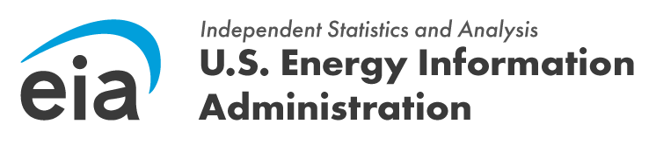
FROM: JOSEPH WILSON, DIRECTOR
OFFICE OF SURVEY OPERATIONS

SUBJECT: WELCOME TO THE EIA-112 SURVEY

REFERENCE: OMB NO. [XXXX-XXXX] (EXPIRATION DATE: [MM/DD/YYYY])
Dear [Respondent Name],

Welcome to the U.S. Energy Information Administration (EIA), the statistical and analytical agency within the U.S. Department of Energy. Your company has been selected by the EIA as a respondent to the Form EIA-112, Residential Utility Disconnections Survey. These data are collected pursuant to the Federal Energy Administration (FEA) Act of 1974, Public Law 93-275.

Form EIA-112 collects information on customer counts, final notices, disconnections, and reconnections in all 50 states plus the District of Columbia and Puerto Rico.
The reporting period for this iteration of data collection is for [Reporting Period], will begin on [Open Date] and data are due [Due Date].

Based on information gathered by EIA, you have been identified as the initial point of contact for providing information needed to complete the EIA-112 survey form. If you are not the appropriate contact, please forward the appropriate person's contact information to EIA4USA@eia.gov and we will contact them directly. Please provide the following information:

New Preparer’s Name New Preparer’s Address New Preparer’s Telephone
New Preparer’s Email Address

You can access the EIA-112 survey form here. Please include the EIA ID below in Part 1 of the form. Once you have completed the form, submit your data using our secure file transmission site. Visit our EIA-112 Instructions page for information on how to submit your data or for general information.

If you have any questions, please contact us directly at eia4usa@eia.gov or call 1-855-EIA-4USA (1-855- 342-4872) Monday through Friday, 8:00 a.m. - 6:00 p.m. ET.

Thank you for supporting EIA's data collection activities. Sincerely,
Joseph Wilson, Director Office of Survey Operations
U.S. Energy Information Administration
U.S. Department of Energy

