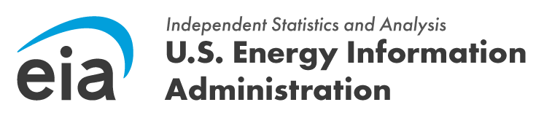

FROM: JOSEPH WILSON, DIRECTOR, OFFICE OF SURVEY OPERATIONS

SUBJECT: THE EIA-112 DATA COLLECTION CYCLE IS NOW OPEN REFERENCE: OMB NO. [XXXX-XXXX] (EXPIRATION DATE: [MM/DD/YYYY])

Dear [Respondent Name],

The U.S. Energy Information Administration (EIA) is now accepting data for the EIA-112, Residential Utility Disconnections Survey for [Reference Year]. The due date for your submission is [Due Date].

These data are collected pursuant to the Federal Energy Administration (FEA) Act of 1974, Public Law 93-275, and response to this survey is mandatory under the FEA Act.

You can access the EIA-112 survey form here. Please include the EIA ID number in Part 1 of the form. Once you have completed the form, submit your data using our secure file transmission site. Visit our EIA-14 Instructions page for information on how to submit your data or for general information.
If you have any questions, please contact us directly at eia4usa@eia.gov or call 1-855-EIA- 4USA (1-855-342-4872) Monday through Friday, 8:00 a.m. - 6:00 p.m. ET.
Thank you for supporting EIA's data collection activities. Sincerely,

Joseph Wilson, Director Office of Survey Operations
U.S. Energy Information Administration
U.S. Department of Energy

