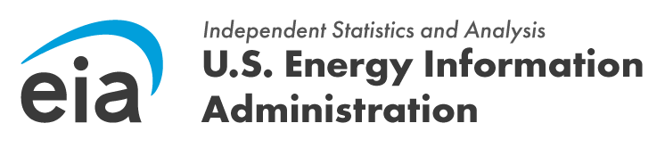
FROM: JOSEPH WILSON, DIRECTOR OFFICE OF
SURVEY OPERATIONS

SUBJECT: WELCOME TO THE EIA-112 SURVEY

REFERENCE: OMB NO. [XXXX-XXXX] (EXPIRATION DATE: [MM/DD/YYYY])

Dear [Respondent Name],

Thank you for your Form EIA-112, Residential Utility Disconnections Survey submissions. Due to the verified changes in your company, you are no longer required to file annual production information on the EIA-112 report.

This applies only to the facility with the following ID number:

Company Name | EIA ID
[Company1] | [ID1]
If you are currently submitting data for other EIA surveys, please continue doing so until you receive notification to discontinue reporting.

At present EIA does not anticipate any future requirement to file EIA-112 data for your company. However, changes in your production volumes, or the relative production of other operators may alter selection criteria, and once again require you to submit data. Should this happen, you will be contacted by the EIA to inform you of that obligation.

If you have any questions, please contact us directly at eia4usa@eia.gov or call -1-855-EIA- 4USA (1-855-342-4872) Monday through Friday, 8:00 a.m. – 6:00 p.m. ET.

Thank you for your cooperation in making the EIA-112 “Residential Utility Disconnections Survey” a success.

Sincerely,

Joseph Wilson, Director Office of Survey Operations
U.S. Energy Information Administration
U.S. Department of Energy

