# ATTACHMENT K

**Safer Choice Program: Cleaning Service Certification Audit Submissions in the Safer Choice Community Cloud-based Salesforce System**

**OMB Control No. 2070-0221**

**Approval expires 5/31/2024**

This collection of information is approved by OMB under the Paperwork Reduction Act, 44 U.S.C. 3501 et seq. (OMB Control No. 2070-0221). Responses to this collection of information are voluntary. An agency may not conduct or sponsor, and a person is not required to respond to, a collection of information unless it displays a currently valid OMB control number. The public reporting and recordkeeping burden for this collection of information is estimated to be 12 hours per response for cleaning service providers establishing Partnership Agreements with Safer Choice and three hours per response for cleaning service providers undergoing partnership renewals and audits, including the time for reviewing instructions, gathering information, and completing and reviewing the submission. Send comments on the Agency’s need for this information, the accuracy of the provided burden estimates and any suggested methods for minimizing respondent burden to the Information Engagement Division Director, U.S. Environmental Protection Agency (2821T), 1200 Pennsylvania Ave., NW, Washington, D.C. 20460. Include the OMB control number in any correspondence. Do not send the completed form to this address.

Following are screenshots from the cleaning service certification audit submission forms in the Safer Choice Community cloud-based Salesforce data system. Please refer to Section 12b, IC #1 for a full list of data items collected. Note that the specific details of the screenshots may change over time as the Safer Choice program improves and/or modifies the system. However, the general and fundamental components of the Salesforce system will be similar to what is presented in the following screenshots.

**Audit Submissions**

Quote or Formal Review Page

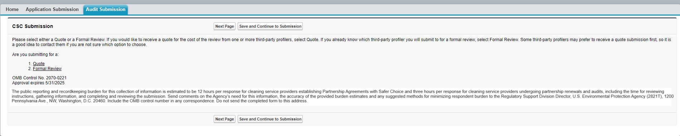

Product Information and Verification Page

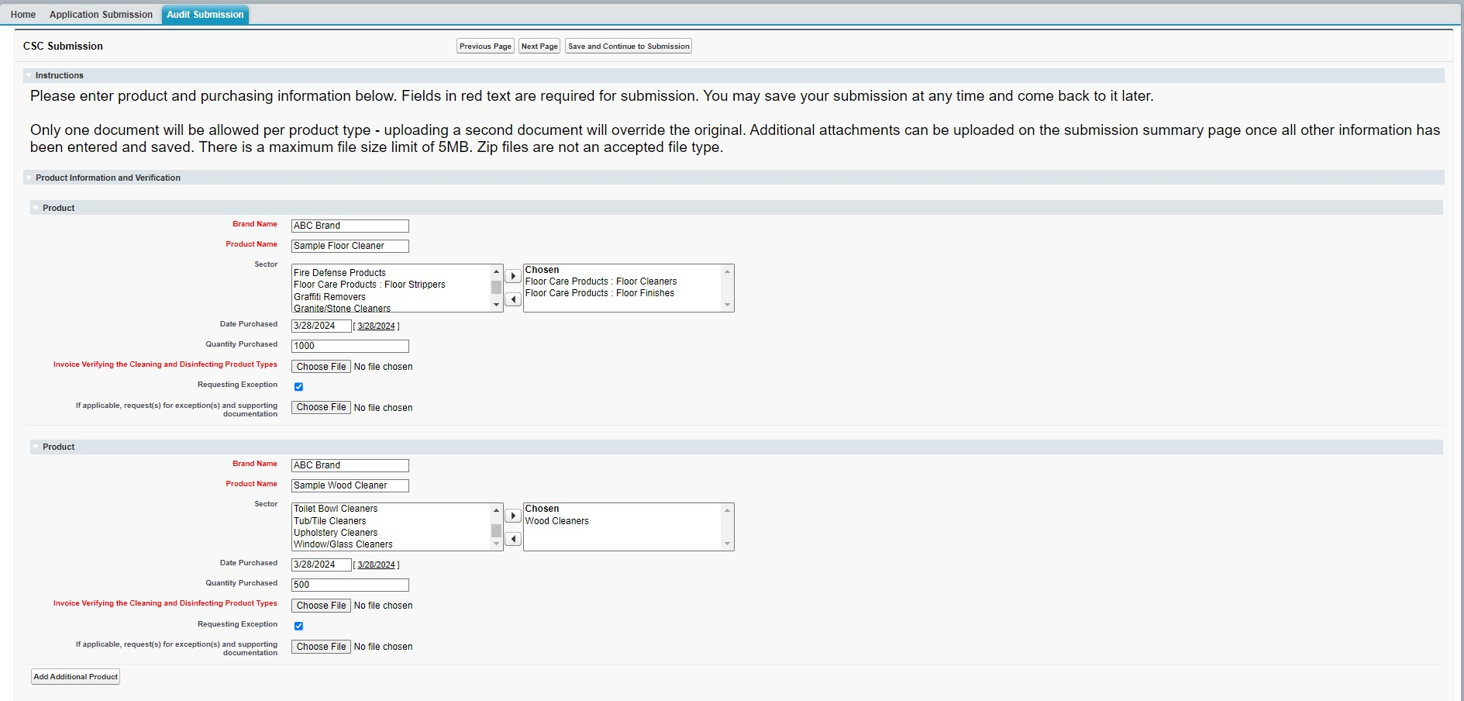

**Sector**: Pick list options are Air Conditioner Coil Cleaners; Aircraft Cleaning Products; All-Purpose Cleaners; Athletic Field Paints; Automatic Dishwasher Detergents; Bio: Bilge Maintainers; Bio: Bioremediators; Bio: Drain Maintainers; Bio: Grease Trap/Lift Station Maintainers; Bio: Septic System Treatments; Bio: Vehicle/Parts Wash Additives; Bio: Wastewater Inoculants; Brick and Masonry Cleaners; Car Care Products; Carpet Care Products: Carpet Cleaners; Carpet Care Products: Spot Removers; Degreasers; Deicers; Descalers; Dish Soaps; Dry Erase Board Cleaners; Fire-Fighting Products; Floor Care Products: Floor Cleaners; Floor Care Products: Floor Finishes; Floor Care Products: Floor Strippers; Graffiti Removers; Granite/Stone Cleaners; Grease Trap Products; Hand Soaps; Industrial Coating: Conversion Coatings; Industrial Coating: Pavement Treatments; Inkjet Printing Products; Kitchen/Countertop Cleaners; Laundry Products: Fabric Softeners; Laundry Products: Laundry Detergents; Laundry Products: Pre-Treaters; Leather Cleaners; Marine/RV Cleaners; Medical Instrument Cleaners; Metal Cleaner/Polishes; Odor Removers; Oven/Grill/Barbeque Cleaners; Parts Washers; Semiconductor/Microelectronics Cleaners; Soluble Films; Stainless Steel Cleaners; Tire Additives; Toilet Bowl Cleaners; Tub/Tile Cleaners; Upholstery Cleaners; Window/Glass Cleaners; Wood Cleaners; Other Industrial/Institutional Products; Other Consumer Products

Attestation Page

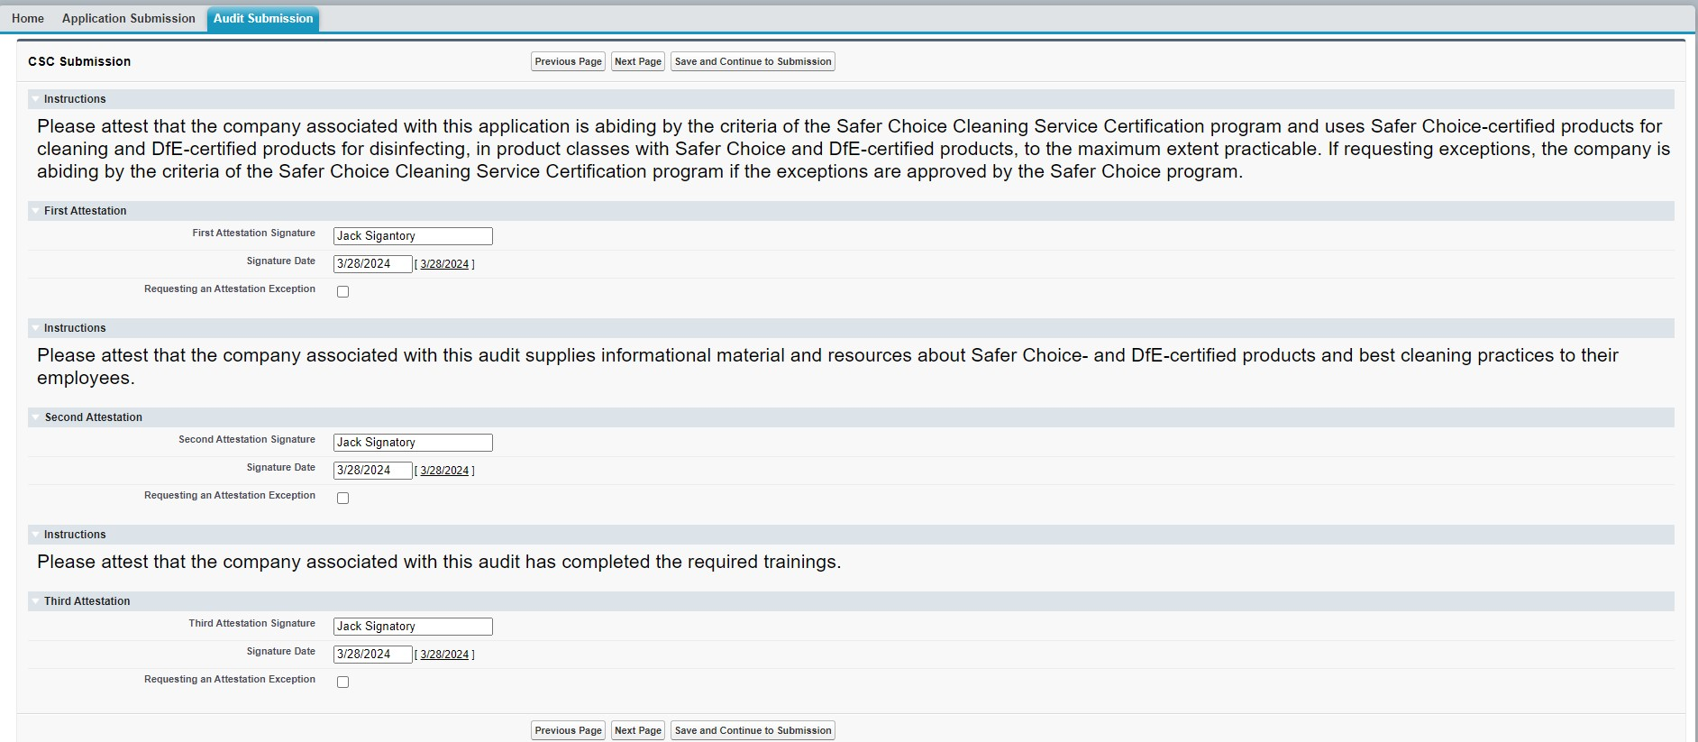

Materials with Logo and Customer type Page

