Online AEM 10-10SH Screenshots

State Home Workflow:
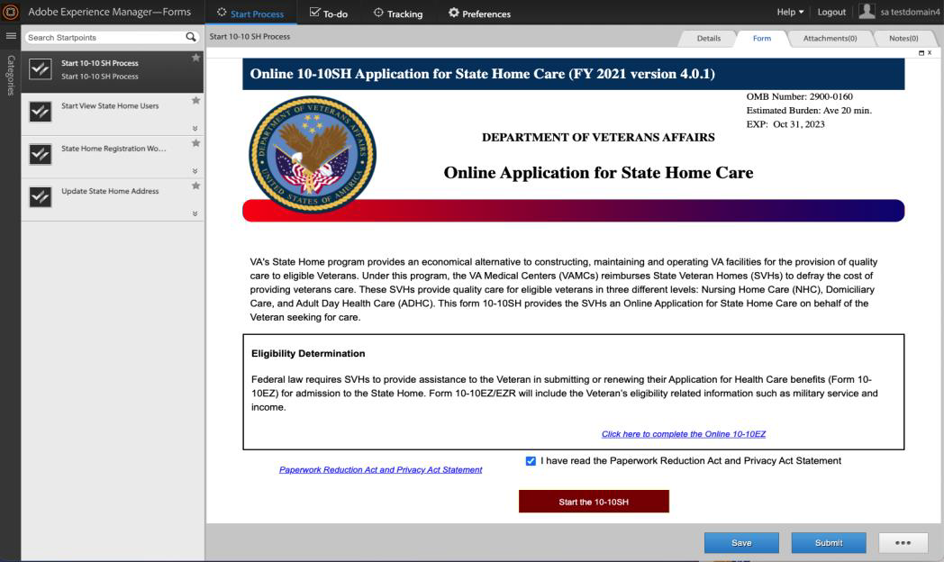

VAMC Workflow:
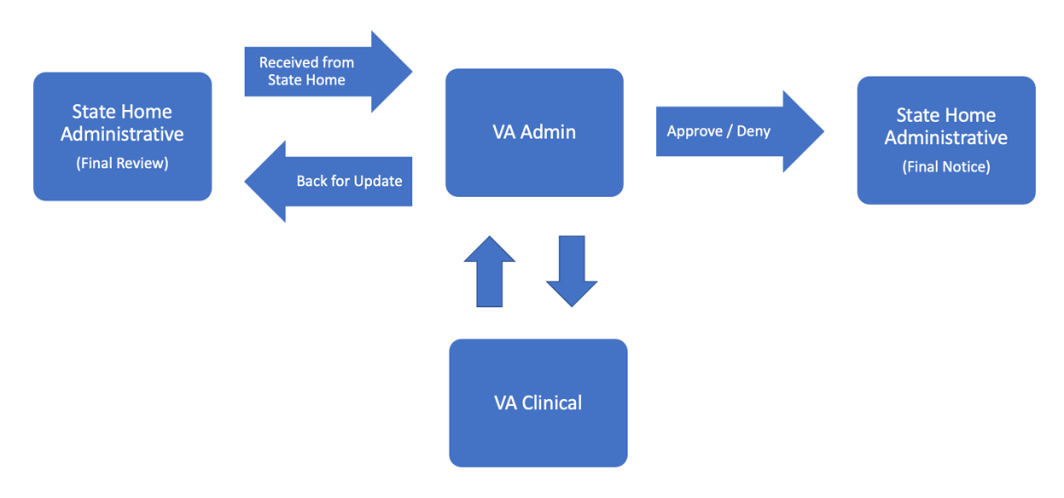

Entering data in these screens in the online AEM 10-10SH form populates all the fields and generate the 10-10SH.
