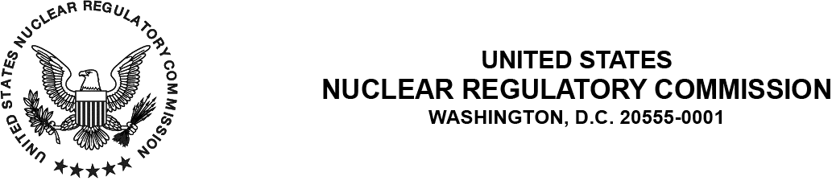

{{date:long}}

ALL AGREEMENT STATES
CONNECTICUT, INDIANA, WEST VIRGINIA
NRC NMSS, NRC REGIONS I, III, AND IV
NOTIFICATION OF OPPORTUNITY TO COMMENT ON DRAFT INSPECTION MANUAL CHAPTER (IMC) 1248, QUALIFICATION PROGRAMS FOR MATERIALS, DECOMMISSIONING, AND URANIUM RECOVERY PROGRAMS IN THE OFFICE OF NUCLEAR MATERIAL SAFETY AND SAFEGUARDS (STC‑25‑0XX):

Purpose: To inform the National Materials Program (NMP) community (States and U.S. Nuclear
Regulatory Commission (NRC)) that IMC 1248, “Qualification Programs for Materials, Decommissioning, And Uranium Recovery Programs in the Office of Nuclear Material Safety and Safeguards,” of the opportunity to provide comment on the interim guidance.

Background: The current qualification journals were last published on April 19, 2013, which relocated the training guidance to IMC 1248 (Agencywide Documents Access and Management Systems (ADAMS) Accession No. ML12240A129). Since 2013, there have been several changes to the materials program. The NRC established a working group in accordance with Management Directive 5.3, “Agreement State Participation in Working Groups,” to assess and revise the qualification requirements in IMC 1248 for license reviewers and inspectors. The IMC 1248 Working Group has revised the IMC and qualification journals for license reviewers and inspectors to reflect changes since the last publication of the IMC and qualification journals. The working group has developed Individual Study Activities (ISAs) and On‑The-Job Training (OJT) qualification cards to provide more focused training.

Discussion: The guidance in IMC 1248 has been revised to incorporate feedback from employees and supervisors (both new and experienced) to enable more rapid and effective qualifications. The revisions focus training on the practical application of knowledge and skills required to perform the job, versus memorization of information in the evaluation of staff proficiency. In addition, the working group developed a new Appendix J to help eliminate redundancy and overlap within/among qualification programs.

The comment period has been developed following consultation with the Organization of Agreement States and will end 30 days from the date of this letter. Please provide comments to the contact person listed at the end of this letter.

This IMC has been uploaded to the state communications portal (SCP) website for use,
and to provide for your review and comment: https://www.nrc.gov/reading-rm/doc-collections/nmss-procedures/state-agreement.html. The IMC can be also found in ADAMS
under Accession No. ML25198A143.

If you have any questions regarding this communication, please contact the individual named
below:

POINT OF CONTACT: Jennifer Dalzell E‑MAIL: Jennifer.dalzell@nrc.gov
TELEPHONE: 630‑829-9607

Sincerely,

{{signature: ASG2}}

Adelaide S. Giantelli, Branch Chief
State Agreement and Liaison Programs
Division of Materials Safety, Security, State,
and Tribal Programs
Office of Nuclear Material Safety
and Safeguard

This information request has been approved by OMB 3150-0029 expiration December 31, 2027. The estimated burden per response to comply with this voluntary collection is approximately 90 minutes. Send comments regarding the burden estimate to the FOIA, Library, and Information Collections Branch (T-6 A10M), U.S. Nuclear Regulatory Commission, Washington, DC 20555-0001, or by e-mail to infocollects.resource@nrc.gov, and to OMB Office of Information and Regulatory Affairs (3150-0029), Attn: Desk Officer for the Nuclear Regulatory Commission, 725 17th Street, NW Washington, DC 20503. An agency may not conduct or sponsor, and a person is not required to respond to, a collection of information unless it displays a currently valid OMB control number.

