TO: Laurel Havas, OMB Desk Officer
Office of Information and Regulatory Affairs
Office of Management and Budget (OMB)

THROUGH: Rachelle Ragland-Greene, Department Clearance Officer
United States Department of Agriculture
Office of Chief Information Office

FROM: B. Warren Brooks, Management and Program Analyst
Office of the Assistant Secretary for Civil Rights (OASCR)

SUBJECT: Justification and revision for non-substantive change to the USDA Program Complaint Form AD-3027, OMB Control No: 0508-0002 to include the renewal of the Spanish version and 18 additional languages of the form.
The Office of the Assistant Secretary for Civil Rights (OASCR) received approval for the renewal of Agriculture Department Form AD-3027.
The renewal of the English version of this data collection form was approved on September 30, 2024, under OMB Control No. 0508-0002 (expiration date 09/30/2027). Although the renewal of the English version of the form was executed without the Spanish version, Paperwork Reduction Act, indicators (burden hours or costs to the government) are not impacted with an increase in the number languages for which the form is intended to be made available. During the renewal process OASCR embarked on the opportunity to improve the content and structure of the form based on Stakeholder input. The rationale for producing the document at a minimum of 10 languages is based on the following information.
USDA provides funds an array of services that can be made accessible to otherwise eligible persons who are not proficient in the English language. USDA is committed to improving the accessibility of these services to eligible Limited English Proficiency (LEP) persons, as a goal that reinforces its equally important commitment to promoting program services. To this end, Executive Order 13166 requires each Federal agency shall examine the services it provides and develop and implement a system by which LEP persons can meaningfully access those services consistent with, and without unduly burdening, the fundamental mission of the agency. Based on guidance from the current administration, OASCR is requesting the approval of the attached documents translated into the following languages:
Form Name and Corresponding Languages attached:
 | Form Name | Language
1 | AD 3027S | Spanish
2 | AD 3027CHIS | Chinese Simplified
3 | AD 3027YID | Yiddish
4 | AD 3027VIE | Vietnamese
5 | AD 3027URD | Urdu
6 | AD 3027TAG | Tagalog
7 | AD 3027PUN | Punjabi
8 | AD 3027KOR | Korean
9 | AD 3027HEB | Hebrew
10 | AD 3027ARA | Arabic
11 | AD 3027GER | German
12 | AD 3027FRA | French
13 | AD 3027CHIT | Chinese Traditional
14 | AD 3027HTC | Creole Haitian
15 | AD 3027ITA | Italian
16 | AD 3027JAP | Japanese
17 | AD 3027POL | Polish
18 | AD 3027POR | Portuguese
19 | AD 3027RUS | Russian

The ability to have the form in multiple languages supports OASCR’s The Strategic Plan focus externally and internally on both USDA customers and employees. OASCR’s Strategic Plan will notably contribute to the following USDA goals and priorities:
1) Foster an equitable and competitive marketplace for all agricultural producers.
2) Foster a workplace environment that is physically, mentally, and emotionally safe.
3) Advancing racial justice, equity, opportunity, and rural prosperity.
Specific Regulations and Authorities Supporting this request.
Nondiscrimination in Programs or Activities Conducted by the United States Department of Agriculture, 7 C.F.R. §15d
Nondiscrimination in Federally Assisted Programs of the Department of Agriculture, 7 C.F.R. §15 Subpart A.
The Food and Nutrition Act of 2008, as amended, Supplemental Nutrition Assistance Program (SNAP), 7 U.S.C. §§2011 et seq.
USDA Guidance to Federal Financial Assistance Recipients Regarding the Title VI Prohibition Against National Origin Discrimination Affecting Persons with Limited English Proficiency, 79 Fed. Reg. 70771 (Nov. 28, 2014)
USDA Departmental Regulation (DR) 4330-02: Nondiscrimination in Programs and Activities Receiving Federal Financial Assistance from the USDA (July 27, 2021)
USDA Departmental Regulation (DR) 4330-003: Nondiscrimination in USDA-Conducted Programs and Activities (October 2022)

Attachment A

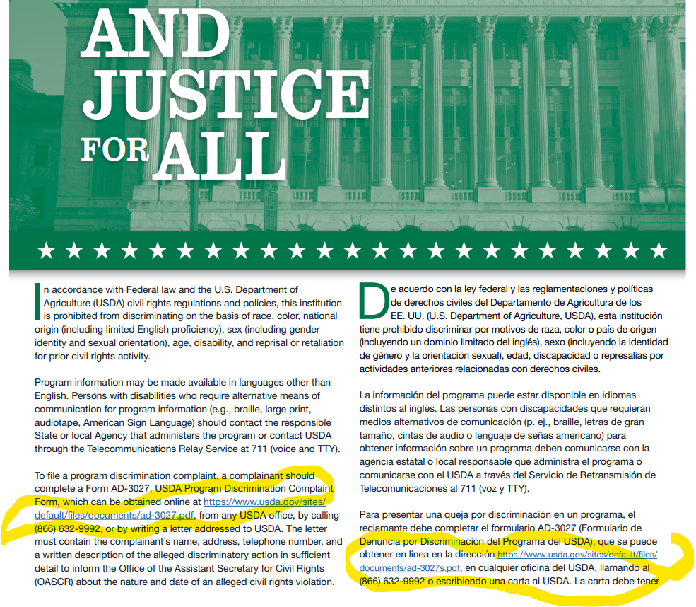
The yellow circles indicate links to AD 3027 the USDA Program Complaint Form in English and Spanish

AD 475 Series and Justice For All Posters are the bedrock for USDA to communicate to USDA Program participants

