**Non-substantive Change Request**

**0535-0039 – Fruit, Nut, and Specialty Crops Surveys**

**GRAPE INQUIRY & GRAPE PRODUCTION AND DISPOSITION INQUIRY**

NASS is requesting a non-substantive change to the surveys in NASS’ Grape Estimation Program. The changes resulted from the Census program changes approved with ICR 202402-0535-004 (April 2024) that added Oregon and New York to the grape estimation program.

The changes in this request require a New York/Oregon version that is separate from. The master questionnaire containing all questions for all versions have been loaded for the mid-season grape inquiry and end of season Production, Disposition, and Income Inquiry.

These changes will not impact the current sample size or respondent burden.

Revised Master questionnaires have been loaded to ROCIS.

Hazelnut publication tables:

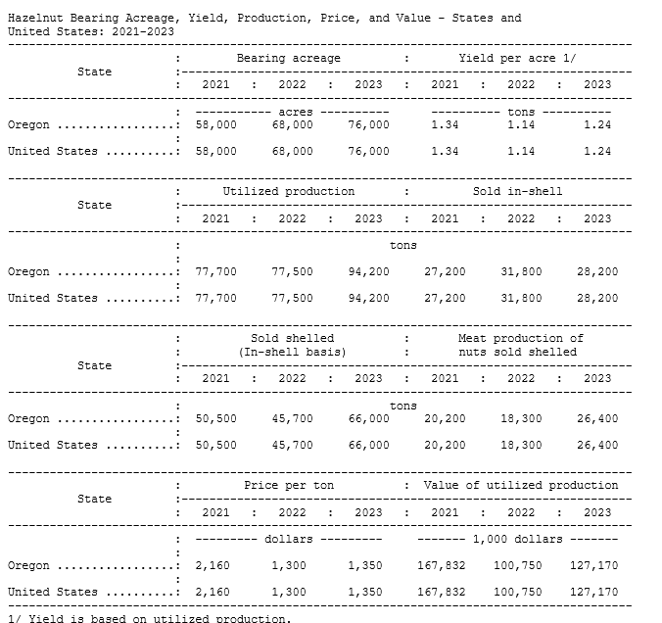

**Non-substantive Change Request**

**0535-0039 – Fruit, Nut, and Specialty Crops Surveys**

**Hop Questionnaires– 2025**

NASS is requesting a non-substantive change to all Hop questionnaires. The NASS Hop Survey Team proposes updating the titles of all Hops Survey questionnaires. The new titles will begin with the word "Hops," followed by the rest of the title. This change is purely administrative and will not alter the substance of the questionnaires.

From:

Hop Grower Survey - May

August Forecast of Hop Acreage and Production –

Hop Acreage and Production – November

To:

Hops Grower Survey - May

Hops Acreage and Production – August Forecast

Hops Production Disposition and Income – November

These changes will not impact the questionnaire content, current sample size or respondent burden.

The revised questionnaires have been loaded to ROCIS.